NFC Data Acquisition and Visualization System

Abstract—This project presents an advanced NFC-based
Data Acquisition and Visualization System designed for reliable, real-time, and wireless monitoring of sensor data. The system adopts a passive/active hybrid architecture, combining ultra-low-power sensing with efficient highperformance data retrieval. An ultra-low-power MSP430 microcontroller interfaces with sensors to acquire data and stores it in a dual-interface NFC memory, the M24LR04E, using the I2C communication protocol. This enables seamless data logging with minimal power consumption, making the system suitable for energy-constrained applications.
The acquired data is transmitted to a host computer via a USB/UART interface, where it is processed using a Qt-based Graphical User Interface (GUI). The GUI is designed to perform real-time data parsing, visualization, and storage, providing an interactive and user-friendly dashboard for monitoring and analysis.
Keywords—NFC, Data Acquisition, Embedded Systems, STM32, MSP430, Qt GUI, Real-time Monitoring, IoT.
I. INTRODUCTION
This system provides a wireless bridge for real-time data monitoring. It utilizes a Passive/Active Hybrid architecture where data is collected by an ultra-low-power node (MSP430) and retrieved by a high-performance reader (STM32), finally visualized on a professional Qtbased GUI.
The Data Generation Layer acts as a sensor node that captures and stores data locally using the MSP430F5659. The microcontroller reads data from connected sensors, processes it, and stores it in the EEPROM via the I2C protocol. The use of dual-interface memory allows both wired (I2C) and wireless (NFC) access to stored data. This enables flexible data retrieval without interrupting system operation. The layer supports energy-efficient or batteryless applications, enhancing its usability in constrained environments.
The Data Retrieval Layer functions as the transmitter node, responsible for wirelessly accessing stored data using the STM32F103 and CR95HF. It generates the RF field required for NFC communication and interacts with the EEPROM using the ISO/IEC 15693 protocol. The microcontroller controls the NFC transceiver through the SPI interface to initiate and manage data transfer. This setup enables efficient and reliable wireless data retrieval from the sensor node. The STM32 ensures fast processing and smooth communication handling. It acts as a bridge between the passive data storage unit and external systems. Overall, this layer enables seamless and contactless data access.
The Visualization Layer provides an interactive interface for monitoring and analyzing system data using the Qt framework. It receives raw data from the retrieval unit via USB or UART communication. The GUI processes and displays this data in real time through graphs, numerical values, and logs. Its cross-platform nature allows it to run on Windows, Linux, and embedded systems. The interface is designed for easy user interaction and efficient data interpretation.
II. LITERACTURE REVIEW
The development of wireless data acquisition and visualization systems has evolved significantly over the past two decades, driven by advancements in communication technologies, embedded systems, and user interfaces. In the early 2000s, RFID (Radio Frequency Identification) systems emerged as a fundamental technology for wireless identification and tracking. These systems enabled automatic data capture using electromagnetic fields, but were primarily limited to simple read/write operations and short data exchange.
Between 2004 and 2010, Near Field Communication (NFC) technology was introduced as an extension of RFID, operating at 13.56 MHz. NFC provided secure, short-range communication with improved reliability and bidirectional data transfer capabilities. This made it suitable for applications such as contactless payments, access control, and secure data exchange.
From 2010 to 2015, the focus shifted toward low-power embedded systems, particularly microcontrollers like MSP430. These systems enabled efficient data acquisition from sensors while minimizing power consumption. Communication protocols such as I2C and SPI played a crucial role in enabling reliable wired data transfer between components.
During the period of 2015 to 2020, dual-interface NFC memory devices were developed, allowing both wired (I2C) and wireless (RF) access to the same memory. This innovation significantly enhanced system flexibility by enabling data to be accessed either through a
microcontroller or wirelessly via NFC-enabled devices such as smartphones.
From 2020 to the present, the integration of IoT and wireless monitoring systems has become prominent. Modern systems combine sensors, microcontrollers, and wireless communication technologies to enable real-time monitoring and data acquisition. These systems are widely used in smart applications, including healthcare, industrial automation, and environmental monitoring.
In recent developments, emphasis has been placed on GUI-based visualization tools, particularly using frameworks like Qt. These tools allow real-time data display, logging, and user interaction, providing an intuitive interface for monitoring and analyzing acquired data. This integration of hardware and software forms the foundation of modern NFC-based data acquisition and visualization systems.
III. METHODOLOGY
The proposed system follows a three-tier architecture for efficient data acquisition, transmission, and visualization. The overall workflow of the system is illustrated in the methodology block diagram, described as follows:

A.Data Generation Layer
The proposed system consists of a Data Generation Layer that is responsible for collecting and storing sensor data in a low-power manner. Sensors continuously measure physical parameters such as temperature and voltage, and the MSP430 microcontroller converts these analog signals into digital form using its internal ADC. The microcontroller processes and formats the data before storing it in the NFC memory. The data is transferred using the I2C
communication protocol, which ensures simple and reliable communication with low power consumption. The M24LR04E NFC memory stores the data and allows access through both wired and wireless interfaces. The stored data is later retrieved using NFC communication based on the ISO/IEC 15693 protocol, where the memory operates passively using energy from the reader’s RF field.

B. Data Retrieval Layer
The Data Retrieval Layer (TX node) is responsible for reading data from the NFC memory and sending it to the host system. It works as an active system by generating an RF field required for NFC communication. The STM32 microcontroller and CR95HF transceiver are the main components used in this layer. The CR95HF communicates with the NFC memory using the ISO/IEC 15693 protocol and retrieves the stored data wirelessly. The STM32 processes the received data and sends it to the host system using SPI and serial communication.

C. Visualization Layer
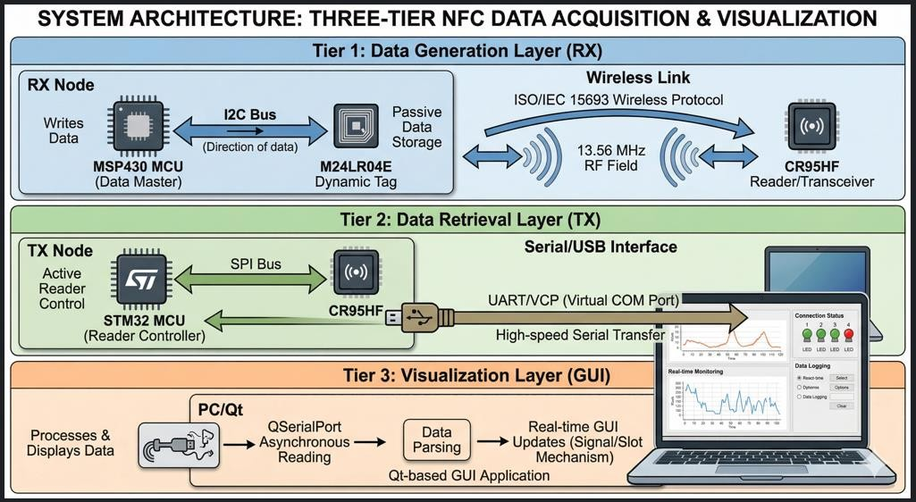
Figure 1 System Architecture
The Visualization Layer displays the acquired data to the user in an easy and understandable format using a Qtbased GUI. The STM32 sends data to the PC through UART or USB communication, acting as a Virtual COM Port. The GUI receives the data using QSerialPort and processes it without affecting system performance. The data is shown in real time using graphs, charts, and indicators for better understanding. It also supports data logging, helping users analyze trends and store information for future use.

D. Qt-Based GUI
The graphical user interface of the system is developed using the Qt framework in C++, providing a user-friendly platform for real-time data visualization and monitoring. The GUI communicates with the transmitter node (STM32) through a USB-to-UART interface using the QSerialPort module. This enables asynchronous data reception without blocking the main application thread.
Incoming raw data is continuously read from the serial port and passed to a data parsing module, where it is converted into meaningful parameters such as sensor values or processed signals. The parsed data is then displayed in real time using graphical plots, numerical indicators, and status panels. Qt’s signal-slot mechanism ensures smooth and responsive updates of the interface whenever new data is received.
The GUI also includes features such as connection status indication, start/stop controls, and data logging for storing historical records. Its cross-platform nature allows it to run on Windows, Linux, and embedded systems without major modifications. Overall, the Qt-based GUI provides an efficient and interactive way to monitor, analyze, and manage the acquired data.
IV. RESULTS AND DISCUSSION
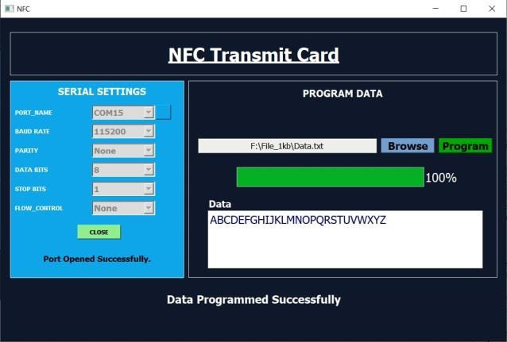

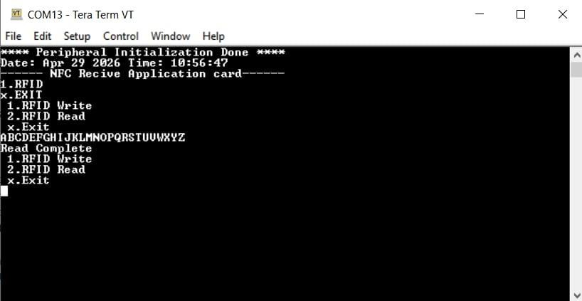
Figure 2 GUI Output 1

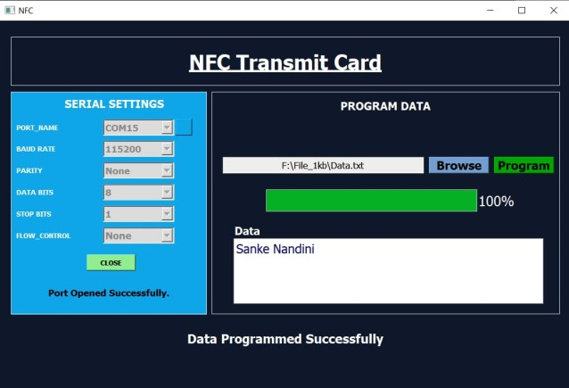
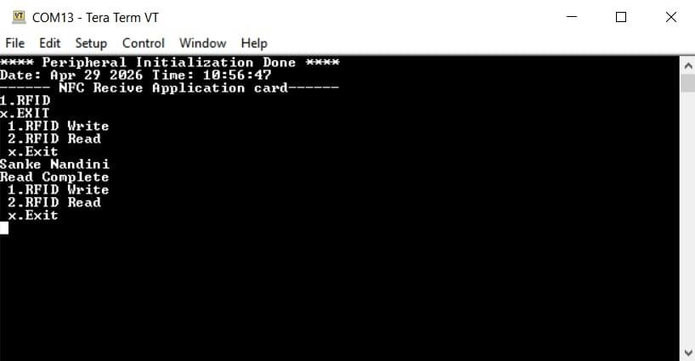 Figure 3 GUI Output 2
The interface includes graphical plots, numerical displays, and status indicators. The data is plotted dynamically, allowing users to observe trends and variations over time. The GUI updates continuously without lag, demonstrating efficient handling of incoming data.
Screenshots of the GUI show the real-time plotting of sensor values, along with system status information. The interface provides options for starting and stopping data acquisition, as well as logging data for further analysis.
The visualization enhances user interaction and simplifies the process of monitoring system performance.
V. CONCLUSION
This project successfully integrates three major domains: Ultra-low power firmware (MSP430), High-speed embedded control (STM32), and Modern Software
Engineering (Qt/C/C++). The result is a robust, industrialgrade NFC acquisition system. the system ensures reliable real-time data transfer with minimal power consumption and high efficiency.
It also provides scalability and flexibility, making it suitable for a wide range of IoT and industrial monitoring applications.
the system demonstrates high scalability and flexibility, allowing easy integration of multiple sensor nodes and expansion to larger monitoring systems. The modular architecture enables adaptability to various application domains, including industrial automation, IoT-based monitoring, and smart sensing environments. The Qtbased graphical user interface provides real-time data visualization, improving user interaction and simplifying system monitoring and analysis. Overall, the project presents a practical and innovative solution for modern data acquisition systems by combining low power operation, efficient communication, and user-friendly visualization, making it suitable for future advancements in embedded and wireless technologies.
VI. REFERENCES
- ISO/IEC 15693, Identification cards — Contactless integrated circuit cards — Vicinity cards, International Organization for Standardization, 2019.
- NFC Forum, NFC Forum Technical Specifications, 2020.
- Texas Instruments, MSP430F5659 Microcontroller Datasheet, 2021.
- STMicroelectronics, M24LR04E-R NFC EEPROM
Datasheet, 2022.
- STMicroelectronics, CR95HF NFC Transceiver Datasheet, 2021.
- STMicroelectronics, STM32F Series Reference Manual, 2022.
- Qt, Qt Documentation, The Qt Company, 2023.
- C. R. Kothari, Research Methodology: Methods and Techniques, New Age International Publishers, 2004.
- Joseph Yiu, The Definitive Guide to ARM Cortex-M3 and Cortex-M4 Processors, Elsevier, 2014.
- Klaus Finkenzeller, RFID Handbook: Fundamentals and Applications, Wiley, 2010.
- V. Coskun, K. Ok, and B. Ozdenizci, Near Field Communication (NFC): From Theory to Practice, Wiley, 2012.
- S. Madakam, R. Ramaswamy, and S. Tripathi, “Internet of Things (IoT): A Literature Review,” Journal of Computer and Communications, 2015.
- J. Gubbi et al., “Internet of Things (IoT): A Vision, Architectural Elements, and Future Directions,” Future Generation Computer Systems, 2013.
- A. Dunkels, “Low-Power Embedded Systems,” IEEE Internet Computing, 2011.
- H. Karl and A. Willig, Protocols and Architectures for Wireless Sensor Networks, Wiley, 2005.

