TRACEABILITY AND INVENTORY MANAGEMENT SYSTEM USING REAL-TIME DATA ANALYTICS

1stCH ANIL KUMAR
PG Student, School of CSA REVA University Bengaluru, India anilkumarchimaladinee999@gmail.com

Abstract – An effective inventory level and product tracking is an indispensable requirement in running a streamlined supply chain which limits wastage and preserves quality of products in today’s competitive fast paced supply chain system. The Traceability and Inventory Management system developed is an RFID based application for tracking, monitoring and management of the supply chain inventory at different supply chain levels. The system proposed here combines three basic technology based on IoT sensors, barcode/ RFID reading and cloud computing to maintain the information at various stages of the supply chain in real time.
Helps to prevent stock-outs and over-stocking, supports decisions based on predictive trends and allows demand to be predicted through the use of real-time data. Furthermore, through the traceability function it creates full visibility over the product from the starting point right through to the consumer, which is essential for regulations, quality control and recalls if a fault arises. The system also has features such as dashboards and automatic alerts to allow stakeholders a much better visibility and actionability of the system. Experimental findings also suggest that the proposed solution will lead to a better responsiveness of the supply chain and reduced operational costs and inventory accuracy.

Keywords: Violence detection, Live alerts, Confidence score recognition, Alarm systems.
I.INTRODUCTION

The globalization and digitalization of the modern world and extending supply chains require efficient systems for stock management and tracing products along the supply chain. Traditional inventory control tools, based on manual or periodic update, are subject to errors, delays and have no capability for tracking the supply chain. This can lead to loss or excess of stock, stock outs and difficulty in locating products in emergency situations, such as in the event of recall. The use of real-time data analytics is an increasingly common way to address these issues.

With the updated technologies like cloud computing, barcodes, internet of things, and radio frequency identification (RFID), the companies will improve the orientation of inventory and achieve more control. There is a need for the traceability in the whole product lifecycle including the procurement of the raw materials and the final delivery. It is especially useful in manufacturing, food and pharmaceuticals Industry where the compliance of regulations and quality control Paramount. An effective traceability system allows manufacturers to identify exactly where and when a product was generated or part of a product was made should any defects or safety issues arise.

The system proposed Traceability and Inventory Management System offers insight by providing factual and timely information through real-time data analytics which improves efficiency and decision making in the process. The system aids in minimizing human error, adjusting stock levels accordingly and improving the smoothness of the supply chain owing to its integration of intelligent analytics with automated data collection. Scalability and flexibility are improved in the face of changing business environments in addition to productivity gains.

The other benefits of this system is its capability to cut costs of operation and efficiency of resources. By maintaining the best quantities of stocks, companies can cut their storage costs, reduce wastage and prevent stock-outs. Also, automatism altogether reduces the use of manual work and the probability of a human mistake. Its scalability has allowed to be a flexible system which can be adaptable to varied sizes of businesses and industry demands. Some of these insights are demand forecasting, stock optimization, anomaly detection, performance analysis etc. and the system offers elaborate alerts and dashboards; thus allowing the stakeholder to make informed decisions In the maximum feasible time. It handles the time-consuming activities, ensures product safety, improves efficiency and visibility and provides the data for taking analyzable decisions. Deploying such intelligent system is vital at this stage to sustain growth and achieve operational excelencia in a highly competitive world.

Traceability will make sure that each product can be traced at every level, and this will allow organizations to detect problems fast, have control over quality and meet the regulatory requirements. Meanwhile, inventory management aims at keeping the best stock amounts, decrease the level of wastage, and enhance the efficiency.

The proposed system gathers and processes continuously by using technologies like IoT sensors, barcode/RFID systems, cloud computing, and data analytics tools. Live analytics can provide immediate information on inventory levels, product flow, demand trends, and any potential danger. It not only increases operational efficiency, but also increases the responsiveness to changes in the market and customer needs.
II.LITERATURE SURVEY

Kshetri, N. [1] describes the use of blockchain technology in supply chain management, especially its ability to improve traceability and transparency. The paper explains the way in which blockchain enables the ability to store information which cannot be altered or modified at any point in the chain of supply. It demonstrates how blockchain-based systems can greatly enhance product tracking from the point of origin to the end user. Nevertheless, real-time analytics and inventory optimization are not given much focus in the study, and the study primarily focuses on data security and transparency.

Ngai et al. [2] have done a comprehensive analysis of RFID technology regarding inventory management and supply chain systems. The authors analyze the effect of RFID on the warehouses, reduction in the number of manual mistakes, and identification of goods. The study also emphasizes the effectiveness of RFID in inventory systems in tracking products in real-time. Despite these advantages, there is a lack of proper consideration of the combination of advanced analytics to make decisions with RFID-generated data.

Ben-Daya et al. [3] Study the way in which the Internet of Things (IoT) can be utilized in supply chain management. To ensure the quality of products, especially those involved in food supply chains, the paper explains how IoT devices can be used to collect real-time information such as temperature, humidity and location of the product. Despite the importance of real-time monitoring as noted in the study, the study lacks a comprehensive framework of integration of IoT data with inventory and traceability systems.

Casino et al. [4] Discuss the impact of blockchain based systems of supply chains on transparency and traceability. The study indicates that blockchain enhances stakeholder trust through the provision of a decentralized platform to share data. It also focuses on food supply chain applications. However, this study does not pay sufficient attention to the integration of blockchain with real-time analytics systems and inventory management systems.

IBM Food Trust [5] is a convenient platform that amplifies food chain traceability on the basis of blockchain technology. The system has allowed stakeholders to access real time information about the products, which are sold to the consumer, as they leave the farm. It helps to enhance transparency, reduce being wasteful, and improve food safety. Although the platform offers robust traceability, advanced analytics for inventory optimization and predictive decision-making are not given much attention.

Walmart Supply Chain Case Study [6] demonstrates the possibility of enhancing food traceability through the use of digital systems and blockchain. The system enables recalling of products much faster as it takes just a few seconds to trace the origins of food products. The case study highlights the importance of transforming the supply chains digitally, yet it does not dwell much on how real-time data analytics can be applied to inventory systems.

The importance of traceability in ensuring sustainability and in international supply chain management is highlighted in Nestle Case Study [7]. The paper illustrates the use of traceability systems in the supply chain risk, regulatory compliance, and environmental impact monitoring. Nonetheless, there is not much focus on real-time inventory analytics and operational efficiency, with emphasis shifted towards sustainability and traceability.

III.METHODOLOGY

The research focuses on the creation of Traceability and Inventory Management System that makes use of real-time data analytics to drive the supply chain activities, especially in food and agricultural domain. The point of the system is to trace the products to the place where they might have been produced (either farm or supplier) to the end consumer and to maintain proper records of the inventory in the warehouses and distribution channels. The suggested system employs technologies such as RFID and barcode systems, IoT sensors, and real-time data analytics to keep the eye on things at any moment and make decisions fast.

A unique batch ID system keeps track of each item in the proposed system. Upon picking up products in the farms or at the suppliers, they are assigned the batch ID which connects all the information about the products, including their source of origin, quality requirements, processing of the products, and storage. This allows tracing things to the end of the supply chain. RFID readers, barcode scanners and IoT devices are always updated with the collected data, which means that you can always see where the products are and how much stock you have.

Radio Frequency Identification (RFID) is a device, which tracks goods in warehouses and logistics processes automatically. RFID tags monitor the information about products and allow you to update it on the fly without the need to physically scan it. Similarly, barcode and QR code systems are employed to locate the products and track customers at a minimal cost. These technologies ensure that all products are properly tracked at all the supply chain stages. Things such as temperature, humidity and quality of the storage are monitored using IoT sensors This is particularly vital in food supply chains where maintaining the quality of the products is of utmost priority.

This ensures that the system receives sensor data at any given time, which allows it to identify quality issues at an early stage and reduces the risk of wasting products. The main part of the proposed system is real-time data analytics. The system processes the incoming data streams of RFID, barcode and IoT devices to provide you with details such as stock quantities, demand patterns and supply chain activity.

The system traceability element ensures that there is a full trace of lifecycle of any product. It facilitates backward and forward tracing of products which gives organizations the opportunity to know the source of products and their path along the supply chain. This comes in handy especially in quality assurance, recall management and regulatory compliance.

In addition, the system has a user-friendly interface, which has dashboards and visualization tools that display data in the form of graphs, charts, and reports. This assists users to have an easy read of the system status and make decisions. A warning system is also inculcated to inform the users of some important conditions like low stock levels, shipment delays, or suspect activity in the inventory..

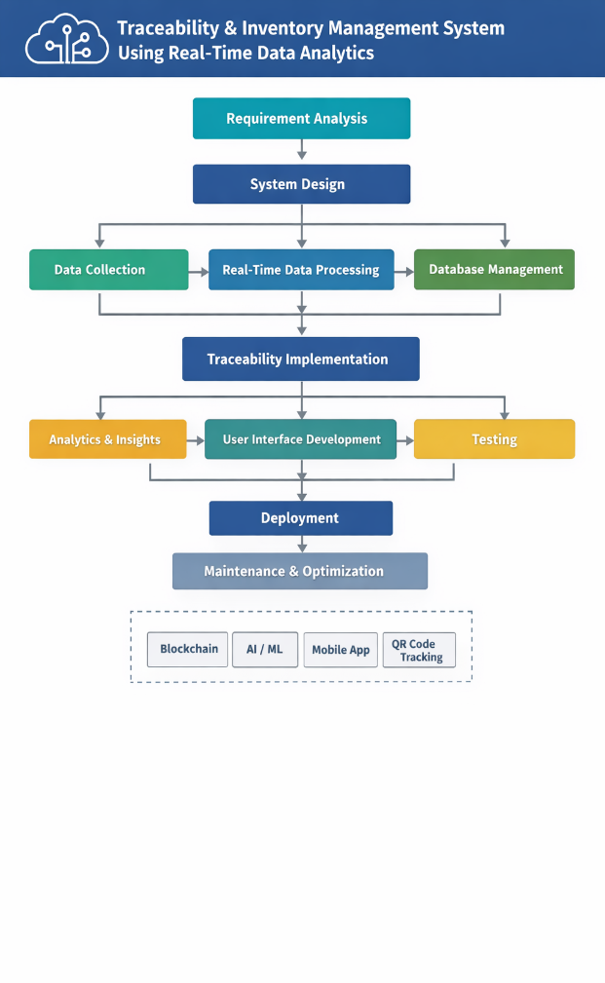

Fig 1:Traceability System Workflow

Step 1: Analyzing the Requirements

This also can be represented as a design of the objectives of the system. It can use the requests of the business, you can believe that I will need a product tracing and the inventory monitoring on real time. To make sure that the system will succecd in fulfilling real world requirements, we take into account user expectations, system constraints and operational issues.

Step 2: Design of system.

This is realized by segmenting the system architecture into 3 areas, the front end, the back end and the database. Appropriate technologies are chosen and overall information flow between modules is designed so that communication is not difficult and that the system can grow.

Step 3: Collecting Data

The data is captured using scanning devices like barcode scanner, RFID or IoT devices. The critical data, including product ID, number, position and time, are input properly so as to make sure the process of traceability and inventory record is not wrong.

Step 4: Processing Data in real time.

The data acquired are sent to the server by APIs and it is processed at the same time. Doing processing in live conditions makes sure that the stocks always be accurate and movement of products always be monitored.

Step 5: Managing the Database

All the processed data is stored in a central database. The inventory, transactions and product information are tracked in the database. System performance is enhanced and data is located when data is organized.

Step 6: Implement traceability;

And in order to keep track of the destination of eachproduct/batchthrough the process a unique identification number is assigned to it. This will prevent hiding anything to the supplier or the customer.

Step 7: Data and Insights

Using real-time data analytics, we will be able to find all the promising information like the stock counts, the desire and approach of the customers. It also gives warning that warn when there is an overstock or lack of stocks, which allow people to make a wise decision.

Step 8: Making the User Interface

The following is the interface used to display dashboards and reports. This interface is designed to be very easy to use and simple to navigate so that the full power of the system is accessible to all users.

Step 9: Testing

There were several options for testing the system such as, unit testing And integration testing. Through this process, the system is validated to ensure that each part is performing as intended, that data integrity is maintained and that it can cope under many different environments.

Step 10: Implementation

After testing, the application is placed on cloud or on a local server. Deployment ensures that the system is usable in the real world, easy to access, and is scalable.

Step 11: Upkeep

The system is continuously monitored and modified after its implementation. To maintain the system current and operating seamlessly, it is enhanced with performance improvements, bug fixes, and new features.

IV.RESULTS

The suggested Traceability and Inventory Management System to implement the real time data analytics to monitor the success of its implementation to enhance supply chain visibility, inventory accuracy and operational efficiency. The solution is a combination of RFID/barcode technologies, IoT data collection, and analytics to provide an all-encompassing solution to supply chain management in the modern world.

Among the most significant aspects that should be noted is the fact that traceability has become much faster. Traditional systems are slow in determining the source of a product since one has to check manually. This system allows easy access to the information in a short time, which is excellent in cases such as product recalls or quality issues.

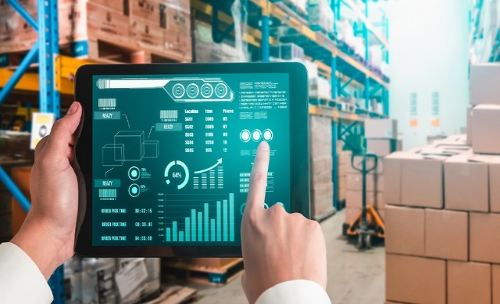

Fig 2: Smart Inventory Monitoring

Inventory management process also becomes more accurate and reliable. The system automatically gathers most of the data through RFID and barcode scanning, thus reducing chances of human error. On-the-fly updates on the stock levels will assist in maintaining accurate records of your stock. The two options that provide will be low stock warnings and expiration date tracking which will allow you to manage stock more efficiently, and reduce wastage of the product. The other major benefit is that it allow you to keep track of things and make decisions using data analytics. The system provide you data on how much stock you have, the movement within the system and the overall performance of the whole supply chain. This understanding will help managers to plan better, make sure they do not have too much, or too little stock and operate more efficiently.


Fig 3: Inventory Data Analysis

V.CONCLUSION

Implementing Traceability and Inventory Management System based on reall time data analytics can be seen as a great achievement in the modern supply chain management. The innovated system will be able to achieve the delivery of reall time visibility and accurate locating along the life cycle of an inventory by integrating reall time data analytics and technologies such as Internet of Things (IoT), RFID technology, barcode tracking system, cloud computing etc. There will be greater visibility, transparency and accountability for every aspect throughout the supply chain. Reall time data analytics will enable orgnizations to make more confident and rapid decisions by providing vital data about the stock is whether excess or deficient, the speed of the product iteration and trends of customer demand. As a result, the problem of overstocking, stock deficiency and product loss can be effectively eliminated. The traceability option once again improves quality control and improves the speed of problem detection and resolution and this is crucial for sensitive and premium outlets.

ACKNOWLEDGMENT

The authors extend their sincere thanks to their supervisor and other faculty members with warm regards for being very co-operative and guided us during the entire course of work. We are indebted to our institute and friends who assisted and motivated us throughout this research work.

REFERENCES

[1] B. Takawira and B. Duri, Integrating IoT and Blockchain to achieve Real-Time Inventory Visibility and Traceability: A Bibliometric-Systematic Review, Logistics, vol. 10, no. 3, p. 57, Mar. 2026, doi: 10.3390/logistics10030057.
[2] M. R. Bendhi, Supply Chain Transparency: Real-Time Analytics to Track Product, Detect Bottlenecks, and Optimize Logistics, Int. J. Sci. Res. Manag., vol. 13, no. 4, pp. 2125–2144, Apr. 2025, doi: 10.18535/ijsrm/v13i04.ec02.
[3] S. Vashishtha, “Real-Time Data Processing to Optimize the Inventory in Distributed Cloud Systems, Journal of Quantum Science and Technology, vol. 2, no. 4, pp. 67–82, 2025, doi: 10.63345/jqst.v2i4.357.
[4] S. Bekkouche and T. de-Magistris, Digitalization in the Agri-Food Supply Chain: Traceability, Transparency, and Sustainability, Frontiers in Blockchain, vol. 8, 2025, doi: 10.3389/fbloc.2025.1701872.
[5] W. Li, R. Song, and K. Yu, Consumer Adoption of Food Blockchain Traceability: Insights into TAM and TR Models, Frontiers in Sustainable Food Systems, vol. 9, 2025, p. 1515188, doi: 10.3389/fsufs.2025.1515188.
[6]P. Cecil, “Supply Chain Visibility and Real-Time Tracking: Transforming Inventory Management and Customer Trust, Global Business and Economics Journal, Jun. 2025.
[7]S. Sallam, M. Mohamed, and A. W. Mohamed, Internet of Things (IoT) in Supply Chain Management: Challenges, Opportunities, and Best Practices, Sustainable Machine Intelligence Journal, vol. 2, 2023.
[8]I. A. Adeniran et al., Optimization of the Logistics and Supply Chain Management by Advanced Analytics, Engineering Science and Technology Journal, vol. 5, no. 8, 2024.
[9] M. Kashem et al., Supply Chain Disruption versus Optimization: A Review on Artificial Intelligence and Blockchain, Knowledge, vol. 3, no. 1, pp. 80–96, 2023.
[10] B. Unhelkar et al., “Improving Supply Chain Performance through RFID Technology and Decision Support Systems in Industry 4.0. J. Information Management Data Insights, vol. 2, no. 2, 2022.
[11] V. Roy, Contrasting Supply Chain Traceability and Supply Chain Visibility, Int. J. Logistics Management, vol. 32, no. 3, pp. 942–972, 2021.
[12] L. Yeung Ping, P. Wong and T. C. Han, A Study of Data-Driven Methods to Inventory Optimization.

