A BRIEF REVIEW OF HERBAL MEDICINES IN MEDICAL AND VETERINARY PRACTICE

Abstract:
Pharmacognosy is the branch of pharmacy that focuses on medicines derived from natural sources, specifically applying scientific methods to the identification, standardization, and efficacy of traditional herbal products. It forms the vital bridge between traditional folk medicine and modern, evidence-based pharmaceutical care. Modern pharmacognosy includes the application of molecular, genomic, and metabolomic techniques, providing a significant increase in knowledge on the biological and clinical applications of herbal medicines. Secondary plant metabolites serve numerous roles in plant biology, including innate immunity, defence against herbivores and pathogens, antioxidant activity, and attraction of pollinators for cellular communication. These compounds have been used by humans throughout recorded and prerecorded history as various commodities, including pigments, condiments, nutrition sources, and medicines.
Introduction:
This article considers some of the major and well-defined groups of secondary plant metabolites, specifically terpenoids, glycosides, saponins, phenols (including flavonoids, phenolic acids, stilbenes, lignans), tannins, alkaloids, and essential oils. Currently, an interdisciplinary approach is needed in basic and clinical research for the identification and standardized extraction of secondary metabolites from suitable herbs, and for the development of medicines for clinical practice.
Core Concepts of Herbal Pharmacognosy
- Active Principles: Plants contain secondary metabolites (e.g., alkaloids, glycosides, terpenoids, and tannins) that are responsible for their medicinal properties.
- Synergistic Action: Unlike single-molecule synthetic drugs, many herbal medicines rely on the combined activity of multiple compounds to produce their therapeutic effect. (Ahmad & Ahamad, 2020).
Botanical and Analytical Evaluation:
To ensure that herbal medicines are safe, pure, and effective, they must undergo rigorous pharmacogenetic evaluation:
- Macroscopic Identification: Examining the morphological and sensory features of the raw drug (e.g., shape, size, colour, Odor, and taste).
- Microscopic Evaluation: Using transverse sections and powder microscopy to identify cellular structures, trichomes, and stomata.
- Physicochemical Analysis: Testing for moisture content, ash values, and extractive values to detect adulteration or inferior quality. (Javed Ahamad, 2021).
Modern Quality Control:
In modern pharmacognosy, verifying the chemical profile of a botanical drug is essential:
- Chromatography: Techniques like Thin-Layer Chromatography (TLC), High-Performance Liquid Chromatography (HPLC), and Gas Chromatography (GC) are used to fingerprint and quantify the active constituents.
- Spectroscopy: Used to determine the molecular structure and concentration of active components.
- Biological Assays: Screening the extract for specific pharmacological activities. Evans, W. C. (2009).
The Science of Herbal Medicines
Modern pharmacognosy shifts herbal remedies from traditional folklore to evidence-based medicine through several key processes:
- Botanical Authentication: Ensures the correct species and plant parts are used, often employing DNA barcoding, chromatography, and microscopy to prevent adulteration.
- Pharmacological Testing: Evaluates herbs using modern in vitro and in vivo models to determine mechanisms of action, pharmacokinetics, and potential toxicity.
- Phytochemical Profiling: Isolates and studies the plant’s secondary metabolites. These are the bioactive compounds (e.g., alkaloids, glycosides, terpenoids) that exert therapeutic effects in the human body.
- Standardization: Quantifies the exact concentration of active constituents in an herbal extract to ensure consistent potency and safety.
Clinical Application and Research Standards:
In contemporary medicine, applying pharmacognosy to herbal products requires overcoming standard challenges like variable potency and interactions:
- Standardization: Validating the exact amount of active markers to ensure consistent therapeutic doses from batch to batch (Javed, 2021).
- Clinical Trials & Evidence-Based Medicine: Subjecting herbal interventions to rigorous, randomized controlled trials (RCTs) utilizing CONSORT reporting guidelines to verify clinical outcomes.
- Pharmacokinetic/Pharmacodynamic (PK/PD) Studies: Understanding how the human body absorbs, distributes, metabolizes, and excretes herbal compounds, as well as their mechanism of action (Javed, 2021).
For further exploration of natural product research and medicinal plant databases, you can consult authoritative resources such as the NIH National Center for Complementary and Integrative Health or the World Health Organization Traditional Medicine portal (Javed, 2021).

Core Categories of Active Plant Constituents
Medicinal plants contain specific groups of secondary metabolites that act on human physiological systems (Suleria et al. 2020) The primary categories include:
- Alkaloids: Potent nitrogen-containing compounds. Examples include Morphine (pain relief) and Atropine (anticholinergic) (Fig.1).
- Glycosides: Molecules bound to a sugar group. Includes Digoxin (used for heart failure) and Sennosides (laxatives) (Fig.1).
- Terpenoids (Isoprenoids): Large class of hydrocarbons often found in essential oils. Examples include Artemisinin (antimalarial) and Taxol (anticancer) (Fig.1).
- Phenolics (Flavonoids & Tannins): Compounds known for antioxidant, anti-inflammatory, and astringent properties (Fig.1).
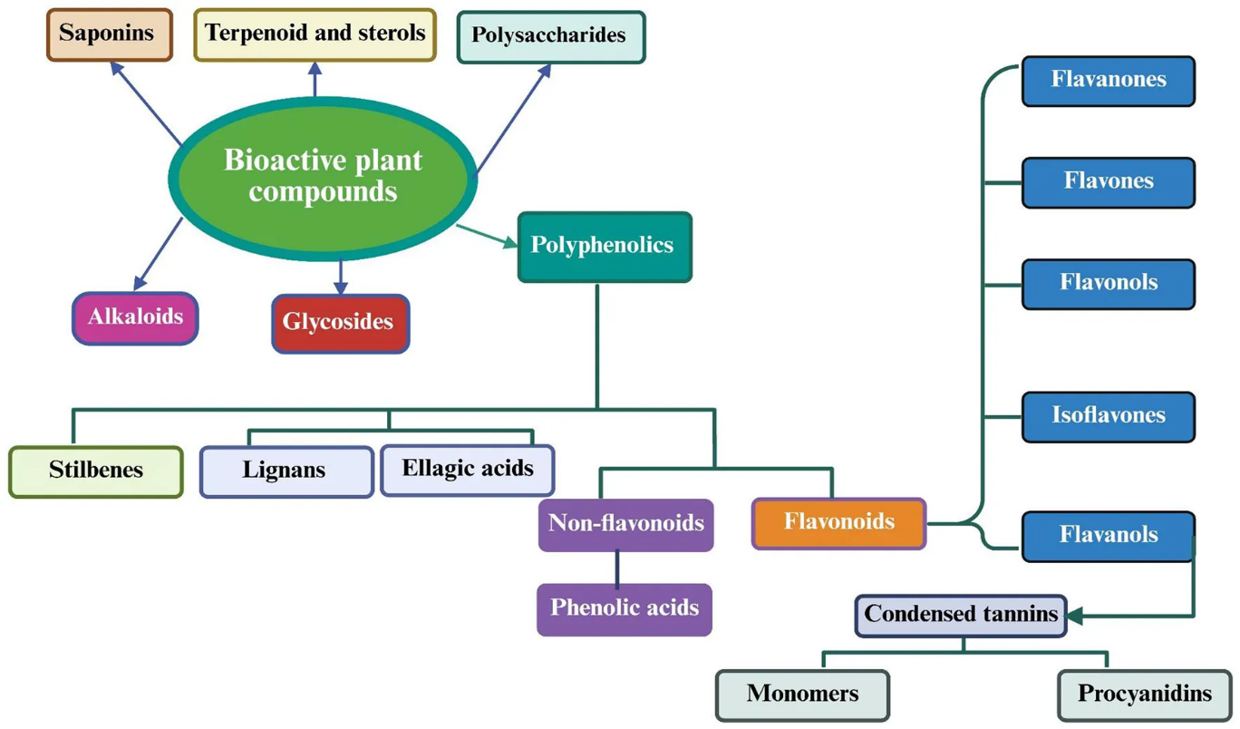
Fig:1 Classification of bioactive plant chemicals according to their chemical structure and biological function, encompassing polyphenols, alkaloids, terpenoids, glycosides, and organosulfur compounds.

Importance in Healthcare:
Herbal pharmacognosy provides a systematic way to preserve traditional healing systems—such as Ayurveda, Traditional Chinese Medicine (TCM), and Unani—while ensuring that the botanical-based therapeutics reaching the public are scientifically verified. A deep understanding of these botanical roots has also led to the discovery of many life-saving modern pharmaceuticals, such as the cancer drug Taxol (Leo et al. 2023). For a deeper dive into the educational and scientific framework of the field, you can review the comprehensive Textbook of Pharmacognosy and Phytochemistry or explore the World Health Organization's Traditional Medicine Guidelines.
The aim of reverse pharmacognosy is to find new biological targets for natural compounds by virtual or real screening and identify natural resources that contain the active molecules. (Vinod et al.2021).To demonstrate the applicability of this concept, we report here a study on epsilon-viniferin, an active ingredient for cosmetic development. Nevertheless, this natural substance is weakly defined in terms of biological properties (Fig.2).
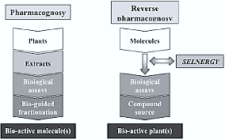
Fig: 2 Diagram showing the pharmacognosy and reverse pharmacognosy of the bio active molecule and bio active plants.

Pharmacognosy of drugs from animal origin: It involves the study of medicines, excipients, and biological products derived from animals. These range from whole organs and bodily fluids to extracted hormones, enzymes, and venoms. They serve critical roles in treating metabolic disorders, cardiovascular conditions, and serve as structural pharmaceutical aids
1. Hormones and Endocrine Secretions
Derived from the endocrine glands of slaughtered animals (like pigs, cows, and sheep), these proteins and peptides treat severe deficiencies (How and Chang, 2008).
- Insulin: Extracted from the pancreas of pigs (Sus domesticus) or cattle (Bos taurus); used to regulate blood sugar in diabetes mellitus.
- Thyroid Extract: Obtained from the thyroid gland of sheep or pigs; used in the treatment of hypothyroidism.
- Adrenaline (Epinephrine): Extracted from the adrenal medulla; widely utilized in emergency medicine to treat severe allergic reactions (anaphylaxis) and as a potent vasoconstrictor (How and Chang, 2008).

2. Enzymes and Biologicals
Proteins extracted from animal tissues that act as catalysts or therapeutic agents.
- Pepsin: An enzyme obtained from the glandular layer of a pig’s stomach; utilized as a digestive aid.
- Pancreatin: A mixture of enzymes (amylase, lipase, protease) from the pancreas of hogs or cattle; used to treat pancreatic enzyme insufficiency.
3. Blood Products and Anticoagulants
Fluids and active proteins extracted directly from mammalian blood.
- Heparin: An anticoagulant extracted from the lungs or intestinal mucosa of cattle or pigs; used to prevent and treat blood clots, including in deep vein thrombosis.
- Sera and Antitoxins: Blood serums from hyperimmunized animals (e.g., horses) containing antibodies to treat conditions like tetanus, diphtheria, or various snake venoms.
4. Lipids, Fats, and Waxes
Often used as ointment bases, dietary supplements, or formulation excipients. (Fig.3).
- Cod Liver Oil: Extracted from the fresh livers of cod (Gadus morhua); rich in Vitamin A and Vitamin D, utilized as a dietary supplement.
- Beeswax: Obtained from the honeycomb of the honeybee (Apis mellifera); used to provide consistency and stiffness to ointments and cerates.
- Wool Fat (Lanolin): Purified fat from the wool of sheep (Ovis aries); serves as an excellent emollient and water-in-oil emulsifier in dermatological creams.
5. Toxins and Venoms
Peptides and proteins derived from animal venoms, which have been miniaturized or engineered into highly targeted modern drugs.
- Captopril: An ACE inhibitor initially developed based on the peptide structures found in the venom of the Brazilian arrowhead viper (Bothrops jararaca); used to treat hypertension and heart failure.
- Bivalirudin: A synthetic derivative of hirudin, an anticoagulant originally found in the salivary glands of medicinal leeches (Hirudo medicinalis); used as an anticoagulant during coronary angioplasty. (How and Chang, 2008), (Fig.3).
6. Tissue Extracts and Structural Agents
Biomaterials often used in wound care, surgical applications, or dosage forms.
- Gelatin: Derived from the collagen in animal skin, bones, and connective tissues through partial hydrolysis; primarily utilized for manufacturing capsules, as a plasma substitute, and in wound dressings. (How and Chang, 2008). (Fig.3).
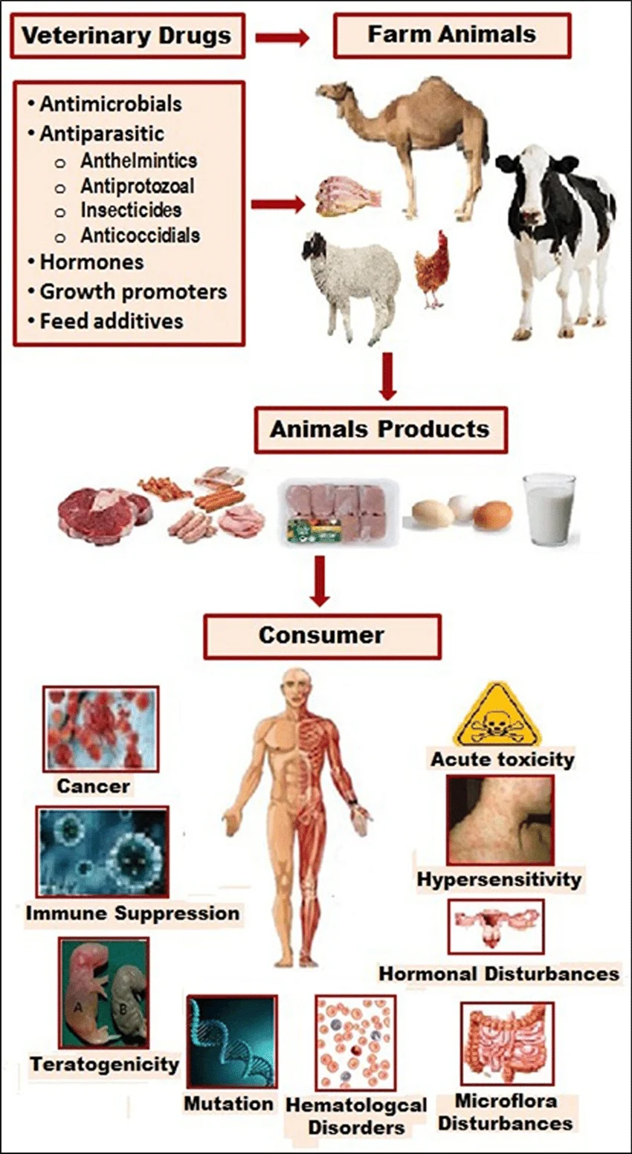
Fig: 3 Photograph showing the animal origin drugs and its effect on human body.
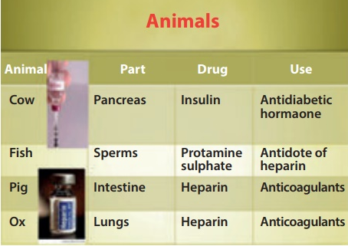
Fig: 4 Photograph of the drug originates from different parts of the animal with its specific use.
Conclusion:
Herbal medicines are complex compounds with multiple synergistic mechanisms of action that modulate (patho) physiological functions. Pharmacognosy is the study of medicine derived from natural sources that include plants, animals, and microorganisms, and the scope of the field depends on knowledge about the safety, purity, and efficacy of complex multi-compound products. Herbal pharmacognosy is the application of this science specifically to traditional herbal medicine sources. Traditional medicines, particularly herbal medicine, remain the primary source of medicine in many countries and cultures globally. Although the root of this field is within traditional medicine, there is increased scientific focus on herbal pharmacognosy in recent years for novel therapeutic molecules.
Reference:
- Evans, W. C. (2009). Trease and Evans' pharmacognosy. Elsevier Health Sciences.
- Ahmad, J., & Ahamad, J. (Eds.). (2020). Bioactive phytochemicals: drug discovery to product development. Bentham Science Publishers.
- Javed Ahamad. (2021). Text Book of Advanced Pharmacognosy and Natural Products. Mahi Publication, Ahmedabad, India.
- Leo M.L. Nollet, Javed Ahmad, and Javed Ahamad. (2023). Analysis of Food Spices: Identification and Authentication. Editors: CRS Press, Taylor & Francis Group; USA
- Suleria HAR, BarrowCJ and Dunshea FR. (2020) Screening and characterization of phenolic compounds and their antioxidant capacity in different fruit peels. Foods. (2020) 9:1206. doi: 10.3390/foods9091206
- Vinod Matole, Yogesh Thorat, Shrishail Ghurghure, Suyash Ingle, Avinash Birajdar, Gajanand Nangare, Moulavi Safwan, Saili Madur, Smeeta Patil, Zainab Bagalkote, Aishwarya Sakhare (2021) A Brief Review on Herbal Medicines. Research Journal of Pharmacognosy and Phytochemistry. 13(2):101-2. doi: 10.52711/0975-4385.2021.00016
- How S. C., Chang M. (2008). Adaptive design methods in clinical trials - a review. Orphanet J. Rare Dis. 3, 11. 10.1186/1750-1172-3-11

