Flood Hazard and Risk Assessment of Lower Magat River Basin using Geospatial Technologies: Basis for developing flood hazard map

ABSTRACT
This study provides a comprehensive geospatial assessment of flood susceptibility in the Lower Magat River Basin, focusing on the municipalities of Solano, Bayombong, Quezon, and Bagabag in Nueva Vizcaya. The study addresses the escalating threat of inundation by utilizing the Analytic Hierarchy Process (AHP) to evaluate and weight six critical parameters: distance to rivers, precipitation, elevation, slope, soil type, and land use/land cover (LULC). Results indicate that Distance to Rivers (36.1%) and Precipitation (25.4%) are the primary drivers of flood hazard in the region. The integration of these factors through weighted overlay analysis reveals a heterogeneous distribution of risk, with Solano exhibiting the most pervasive vulnerability, as 71.72% (48.04 sq.km) of its land area is classified as high susceptibility. In contrast, Bayombong and Quezon harbor the most extreme localized risks, with Barangays Casat, Darubba, and Runruno emerging as critical "Very High" hazard hotspots. The findings demonstrate that high-risk zones are concentrated within a 600-meter buffer of the Magat River, particularly where low-gradient slopes (0–5.8%) and heavy clay soils impede drainage. The study achieved a high consistency ratio (CR < 0.10), validating the model's reliability for land-use planning. It is recommended that local government units integrate these susceptibility maps into their Comprehensive Land Use Plans (CLUP), enforce strict river easement zones, and implement nature-based solutions like reforestation to mitigate runoff. This research serves as a critical baseline for disaster risk reduction, providing a data-driven framework for enhancing community resilience against future flooding events.
Keywords – flood susceptibility mapping, analytic hierarchy process (AHP), weighted overlay analysis, Nueva Vizcaya, disaster risk reduction (DRR), land use planning
INTRODUCTION
Flooding is one of the most recurrent and destructive natural hazards in the Philippines, primarily due to the country’s geographic location within the Pacific typhoon belt and its exposure to intense monsoon rainfall and strong tropical cyclones. Each year, flooding causes significant damage to lives, infrastructure, agriculture, and local economies, particularly in river basin areas where settlements are concentrated near waterways. Effective flood hazard assessment and mapping are therefore essential tools for disaster risk reduction, land-use planning, and sustainable development, especially in flood-prone regions.
The Lower Magat River Basin, located in Nueva Vizcaya, is one of the areas frequently affected by flooding during the rainy season and periods of intense typhoon activity. Several municipalities within the basin, namely Bagabag, Solano, Bayombong, and Quezon are traversed by tributaries such as the Nangalisan River, Lamut River, Sta. Cruz River, Bayombong River, as well as various creeks and seasonal rivers. These water systems, combined with low-lying topography and varying land cover conditions, contribute to increased flood susceptibility in the area. As population growth and land-use changes continue, the potential impacts of flooding are expected to intensify, highlighting the need for accurate and up-to-date flood hazard information.
Geospatial technologies, particularly Geographic Information Systems (GIS), have become vital tools in flood hazard assessment due to their ability to integrate, analyze, and visualize spatial data from multiple sources. GIS allows for systematic evaluation of physical and environmental factors that influence flooding, such as elevation, slope, precipitation, land cover, soil type, and proximity to river systems. By combining these parameters, flood hazard maps can be generated to identify areas with varying levels of flood risk. These maps serve as valuable references for local government units, planners, and disaster management agencies in formulating mitigation strategies and emergency preparedness plans.
However, despite the availability of flood hazard maps for the Lower Magat River Basin, a critical gap exists in terms of the timeliness and relevance of the geospatial data being used. Information obtained from the Provincial Disaster Risk Reduction and Management Office (PDRRMO) and the Provincial Planning and Development Office (PPDO) indicates the most recent authoritative dataset is the 2015 MGB Hazard Map. Given the dynamic nature of flood-related factors including land-use changes, urban expansion, river morphology alterations, and climate variability these datasets may no longer accurately reflect present conditions on the ground. The continued reliance on outdated spatial information may lead to misinformed planning decisions, inefficient allocation of resources, and reduced effectiveness of flood mitigation strategies.
This gap underscores the need for an updated and more comprehensive flood hazard assessment that incorporates recent and higher-resolution spatial data. Addressing this limitation is crucial to improving the accuracy and reliability of flood risk identification and to ensuring that local government units are equipped with relevant and evidence-based tools for disaster preparedness and land-use planning.
This study utilized GIS-based techniques to develop a contemporary flood hazard map for the tributaries of the Lower Magat River Basin. Updated secondary data, including digital elevation models, rainfall data, land use, and soil information, were processed using ArcGIS software and the Analytic Hierarchy Process (AHP). The analysis focuses on low-lying areas characterized by high susceptibility due to their topographic features and proximity to river networks. By bridging the gap between the 2015 baseline and present-day conditions, this research provide a scientifically grounded spatial assessment essential for improved flood risk management in Nueva Vizcaya.
A. Objective of the study
To assess the flood susceptibility of Nueva Vizcaya using GIS by identifying flood hazard zones, determining the key environmental and physical factors influencing flood risk, and developing a GIS-based flood hazard map.
METHODS
A. Research Design
This study employed a quantitative-evaluative research design using Geospatial Multi-Criteria Decision Analysis (MCDA) to assess flood hazard levels in the Lower Magat River Basin, Nueva Vizcaya. This design was appropriate as it allowed for the systematic integration of six key environmental and physical drivers, elevation, slope, land use/land cover, soil type, precipitation, and distance from rivers which collectively governed the hydrological response of the basin. To ensure high-resolution accuracy, secondary datasets were sourced from verified repositories: IfSAR or SRTM-DEM for topographic derivatives (elevation and slope), Sentinel-2 imagery for land cover mapping, CHRS Data Portal for rainfall data, and FAO/UNESCO for soil parameters.
The core of the methodology utilized the Analytic Hierarchy Process (AHP) to determine the relative influence of each parameter. Through a pairwise comparison matrix, weights were assigned to each factor for instance, prioritizing high precipitation and low elevation as dominant drivers of inundation while ensuring a Consistency Ratio (CR) of less than 0.10 to maintain mathematical rigor. These parameters were processed as standardized thematic layers in ArcGIS and integrated using the Weighted Linear Combination (WLC) method. This process calculated a Flood Susceptibility Index for every pixel in the study area, which was then categorized into low, moderate, and high hazard zones using the Natural Breaks (Jenks) classification method.
To validate the model's reliability, the research design incorporated a spatial verification phase where the generated hazard map was cross-referenced with historical flood footprints and GPS-tagged disaster records from the PDRRMO of Nueva Vizcaya. This evaluative approach ensured that the “Basis for Developing Flood Hazard Map” cited in the title was scientifically grounded. The final output was designed as a high-resolution decision-support tool for local government units and disaster management agencies, providing an evidence-based framework for land-use zoning, infrastructure prioritization, and sustainable disaster risk reduction strategies within the Lower Magat River Basin.
B. Conceptual Framework
Figure 1 shows the conceptual framework of the study. This research adopted the Input–Process–Output (IPO) Framework to illustrate the development of a GIS-based flood hazard map for Nueva Vizcaya. The input consists of six flood-conditioning factors: elevation, slope, precipitation, land use/land cover (LULC), soil type, and distance from rivers, derived from various geospatial and remote sensing data sources. These datasets were processed using Geographic Information System (GIS) techniques, including raster conversion, reclassification, and standardization. The Analytical Hierarchy Process (AHP) was then employed to assign weights to each factor, followed by the weighted overlay analysis in ArcGIS 10.3 to integrate the thematic layers. The output of the study is a GIS-based flood hazard map that classifies the Province of Nueva Vizcaya into low, moderate, and high flood susceptibility zones.
Figure 1: Conceptual Framework of the study
INPUT PROCESS OUTPUT
Data Collection and Preparation
Data Processing and Analysis
Validation and Accuracy Assessment
Flood Hazard Map
- Digital Elevation Model (DEM)
- Rainfall data
- Land cover/land use
- Soil type maps
- River and tributary network
- Administrative boundary shapefiles

C. Research Respondents and Sampling Procedures
The population of this study consists of the entire Lower Magat River Basin, covering the municipalities of Bagabag, Solano, Bayombong, and Quezon in the province of Nueva Vizcaya. This population includes all geographic areas, river systems, and environmental features within the basin that may influence flood occurrence and susceptibility. As the study focuses on spatial and environmental analysis rather than human respondents, the population is defined in terms of geographic extent and environmental units rather than individuals.
D. Statistical Tools and Analysis
Flood susceptibility was assessed using a Geographic Information System (GIS)-based Multi-Criteria Decision Analysis (MCDA) integrated with the Analytic Hierarchy Process (AHP). Six flood-conditioning factors, elevation, slope, precipitation, land use/land cover (LULC), soil type, and distance from rivers were standardized and processed in ArcGIS 10.3 through raster conversion, reclassification, and spatial analysis.
The relative importance of each factor was determined using AHP through pairwise comparison matrices. The consistency of the assigned weights was evaluated using the Consistency Index (CI) and Consistency Ratio (CR), with a CR value of less than 0.10 indicating acceptable consistency. The validated weights were then applied using the Weighted Linear Combination (WLC) method through the ArcGIS Weighted Overlay tool to compute the Flood Susceptibility Index (FSI).
The resulting continuous FSI raster was classified into low, moderate, and high flood hazard zones using the Natural Breaks (Jenks) classification method, which identifies optimal class boundaries by minimizing within-class variance and maximizing between-class variance. The final GIS-based flood hazard map served as the primary output for identifying flood-prone areas in Nueva Vizcaya.
RESULTS AND DISCUSSION
A. Spatial Assessment of Flood Hazard Susceptibility Across Nueva Vizcaya Municipalities
Quezon contains the largest overall physical area susceptible to flooding, with a combined 172.55 sq.km across moderate to very high levels. This is followed closely by Bagabag with 164.73 sq.km. However, Solano faces the most pervasive threat relative to its size, with 99.91% of its territory classified within moderate and high hazard zones. This comparison underscores that while Quezon and Bagabag deal with the largest absolute scale of flooding, Solano is the most universally vulnerable municipality, and Bayombong and Quezon harbor the most dangerous "Very High" risk pockets.
Table 1: Summary of areas affected by floods in the Lower Magat Basin
Category | Solano |  | Bayombong |  | Bagabag |  | Quezon
Category | Area (sq.km) | % | Area (sq.km) | % | Area (sq.km) | % | Area (sq.km) | %
Very Low | 0 | 0 | 1.34 | 0.94 % | 0 | 0 | 0 | 0
Low | 0.06 | 0.09 % | 20.16 | 14.16 % | 1.02 | 0.62 % | 1.23 | 0.71%
Moderate | 18.88 | 28.19 % | 81.40 | 57.15 % | 67.67 | 40.83 % | 106.64 | 61.36 %
High | 48.04 | 71.72 % | 39.23 | 27.55 % | 97.06 | 58.56 % | 65.68 | 37.79%
Very High | 0 | 0 | 0.29 | 0.20 % | 0 | 0 | 0.23 | 0.13 %
B. Flood-Conditioning Factors and Criteria Weights
As indicated in Table 2, Each factor’s sub-criteria were assigned a rating from 1 (Very Low) to 5 (Very High) based on their relative influence on flood hazard. For instance, areas within 0-609.18 meters of the river system and regions receiving 2,450-2,506 mm of annual precipitation were assigned the maximum rating of 5, reflecting their critical role in inundation.

Table 2: Flood Suceptibility Criteria and Sub-criteria Ranges
The relative importance of the six flood-conditioning factors was determined using the Analytic Hierarchy Process (AHP) through a pairwise comparison matrix. The resulting normalized weights assigned the highest influence to Distance to Rivers (36.1%) and Precipitation (25.4%), followed by Land Use/Land Cover (16.1%), Slope (10.0%), Soil Type (6.4%), and Elevation (6.0%). The consistency of the pairwise comparisons was evaluated using the Consistency Index (CI) and Consistency Ratio (CR), with the computed CR remaining below the acceptable threshold of 0.10, indicating reliable and consistent expert judgments. The validated weights were subsequently integrated with the reclassified spatial layers using the Weighted Overlay technique in ArcGIS to generate the final GIS-based flood susceptibility map.

Table 3: Pairwise comparison of five flood factors

 | E | S | LULC | Soil | P | DR
E | 1 | 1/2 | 1/3 | 1 | 1/4 | 1/5
S | 2 | 1 | 1/2 | 2 | 1/3 | 1/4
LULC | 3 | 2 | 1 | 2 | 1/2 | 1/2
Soil | 1 | 1/2 | 1/2 | 1 | 1/4 | 1/5
P | 4 | 3 | 2 | 4 | 1 | 1/2
DR | 5 | 4 | 2 | 5 | 2 | 1
Table 4: Normalized pairwise comparison matrix and calculated criteria weight for each factor

 | E | S | LULC | Soil | P | DR | Row Avg (Weight) | Percentage (%)
E | 0.063 | 0.045 | 0.053 | 0.067 | 0.058 | 0.075 | 0.060 | 6%
S | 0.125 | 0.091 | 0.079 | 0.133 | 0.077 | 0.094 | 0.100 | 10%
LULC | 0.188 | 0.182 | 0.158 | 0.133 | 0.115 | 0.189 | 0.161 | 16%
Soil | 0.063 | 0.045 | 0.079 | 0.067 | 0.058 | 0.075 | 0.064 | 7%
P | 0.250 | 0.273 | 0.316 | 0.267 | 0.231 | 0.189 | 0.254 | 25%
DR | 0.313 | 0.364 | 0.316 | 0.333 | 0.462 | 0.377 | 0.361 | 36%

C. Cartographic Presentation and Analysis of Flood Thematic Layers
1. Distance from Rivers (Hydrographic Proximity)
Spatial analysis indicates that proximity to the drainage network is the primary determinant of flood vulnerability (AHP weight: 36.1%). As shown in Figure 3, the urban cores of Solano and Bayombong fall within the critical 0–609.18 m buffer zone. This low-lying terrain is subject to frequent overbank flow during peak discharge events along the Magat River’s active floodplain, where historical inundation points confirm the mechanical dominance of riverine proximity.

Figure 2: Distance from river Map of the Study Area
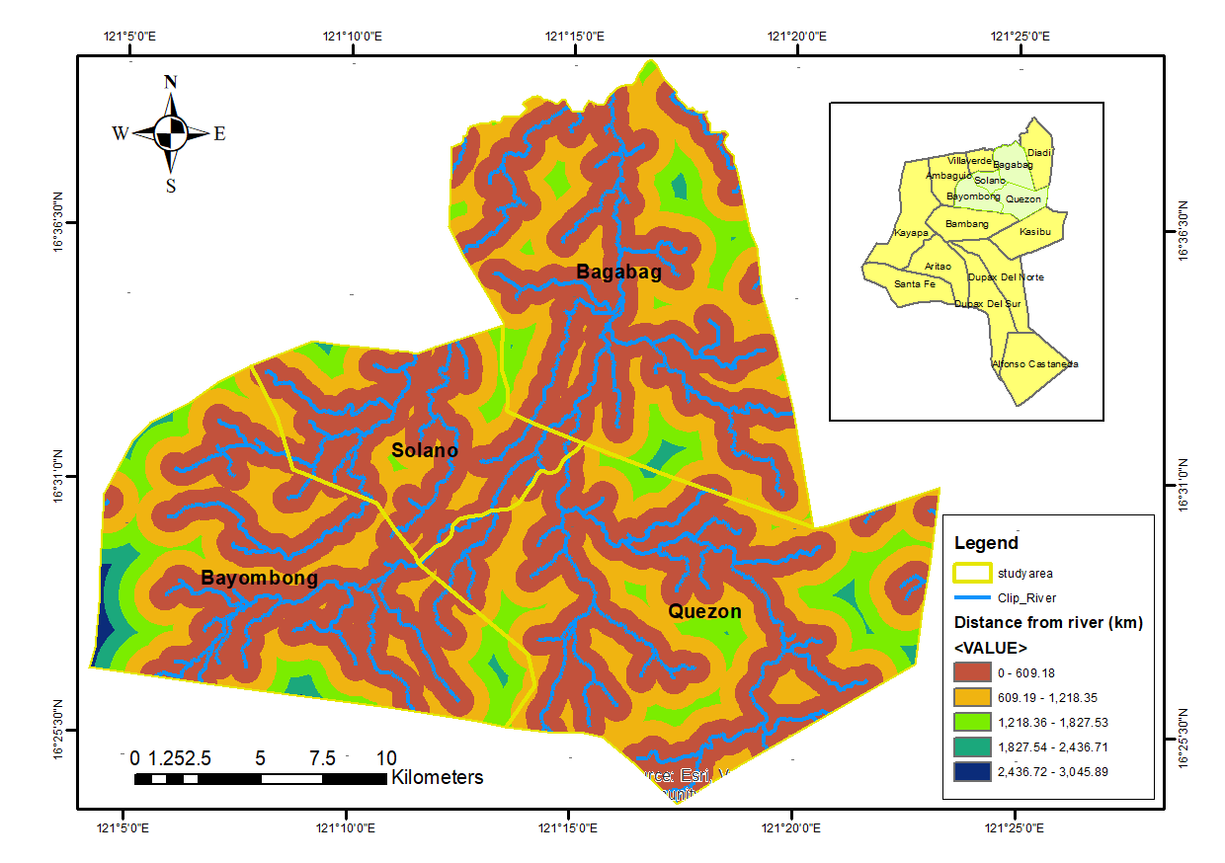
2. Average Annual Precipitation (Hydro-Meteorological Forcing)
Hydro-meteorological forcing acts as the primary atmospheric driver of flood dynamics (Figure 3). The central and southern sectors (Bayombong and Quezon) exhibit the highest precipitation gradients, reaching 2,450–2,506 mm/year. This intensive rainfall regime serves as the critical triggering mechanism that overwhelms natural channels and municipal drainage infrastructure during high-magnitude storm events.
Figure 3: Average Annual Rainfall (mm) Map of the Study Area
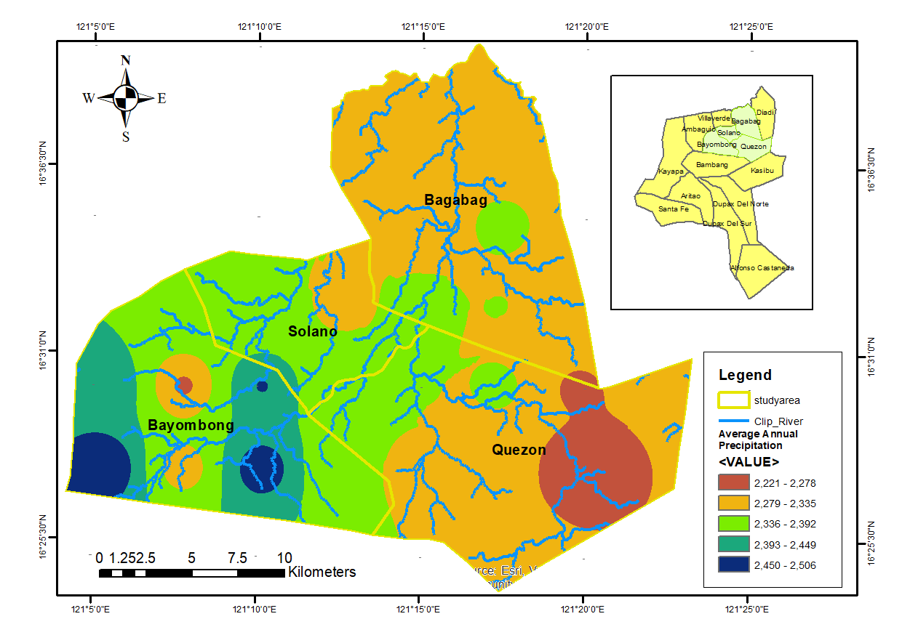
3. Land Use and Land Cover (Surface Roughness and Infiltration)
The LULC map (Figure 4) shows that agricultural and urban development significantly alter regional runoff coefficients. While "Trees/Crops/Rangeland" offers moderate initial interception, urban expansion in Solano and Bayombong introduces extensive impermeable surfaces that accelerate overland flow. Additionally, "Flooded Vegetation" along the Magat River main stem indicates zones where natural drainage is chronically impaired by anthropogenic land use.
Figure 4: Land Use and Land Cover (LULC) Thematic Map of the Study Area
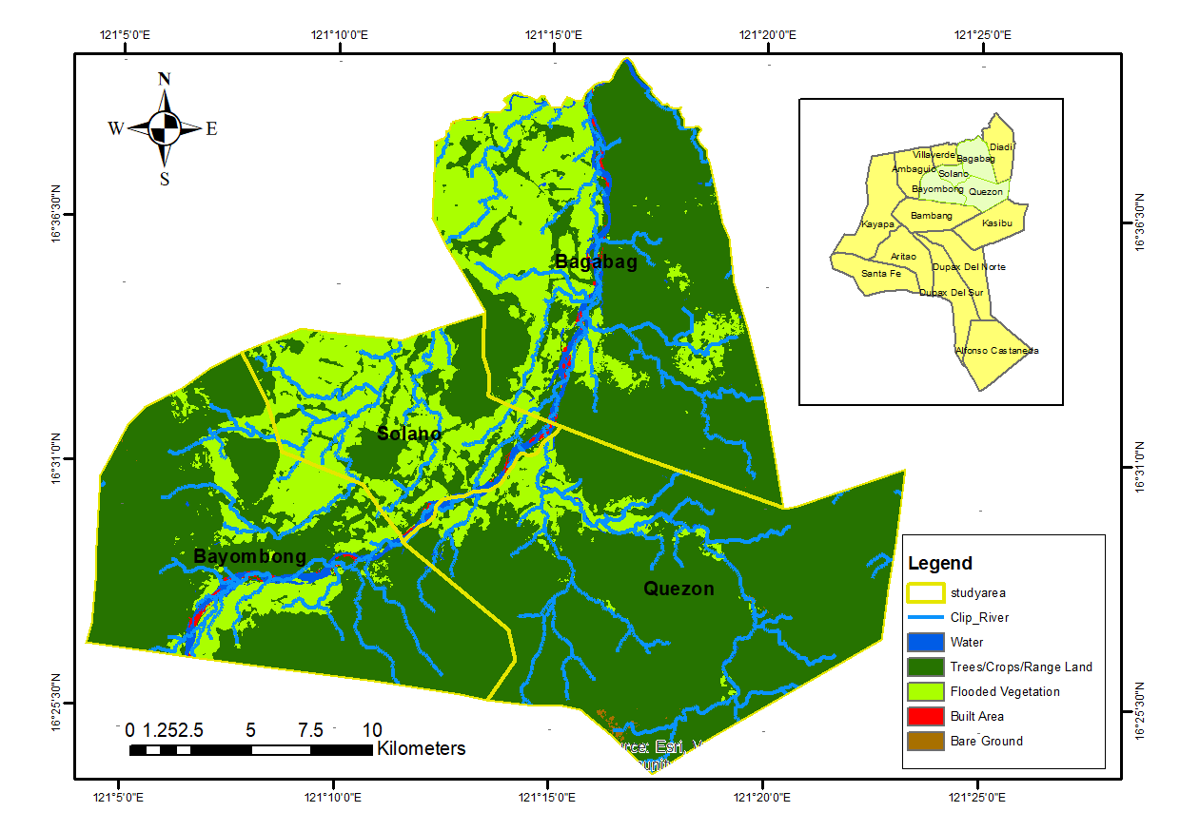
4. Topographic Slope (Terrain Gradient)
The Slope map (Figure 5) highlights the contrast between the rugged highlands and the flat valley floor. Solano and Bagabag are dominated by low-gradient slopes (0°–5.8°), acting as collection sinks for runoff from surrounding mountainous terrain. This lack of relief minimizes flow velocities, leading to prolonged floodwater residence times and drainage stagnation in commercial and residential districts.
Figure 5: Topographic Slope (Degrees) Map of the Study Area
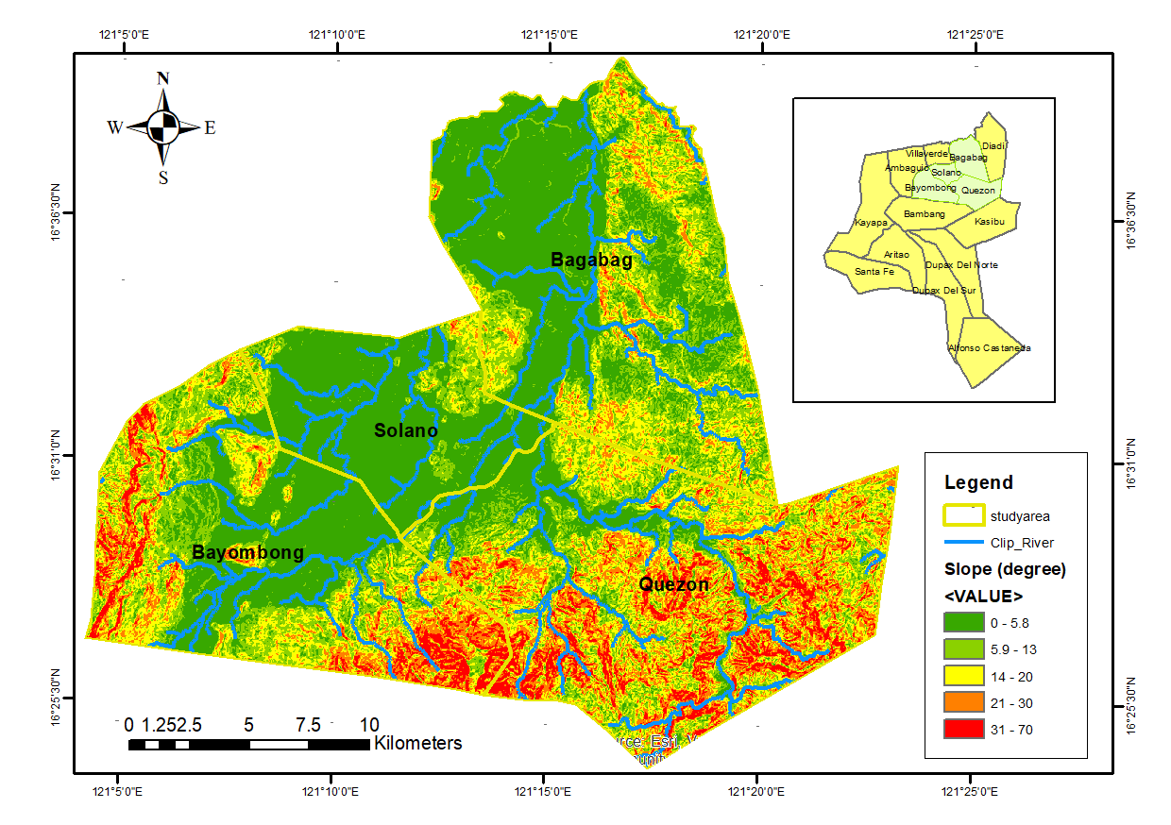
5. Elevation (Hypsometric Relief)
Hypsometric analysis (Figure 6) confirms that low-lying valley regions below 94 m are highly vulnerable to water accumulation. While flanked by high-elevation terrain that promotes rapid upland drainage, the basin floor functions as a primary topographic sink. This localized depression effect creates a natural trap for surface water during concurrent high-river stages and heavy monsoonal rainfall.
Figure 6: Elevation (Meters) Map of the Study Area
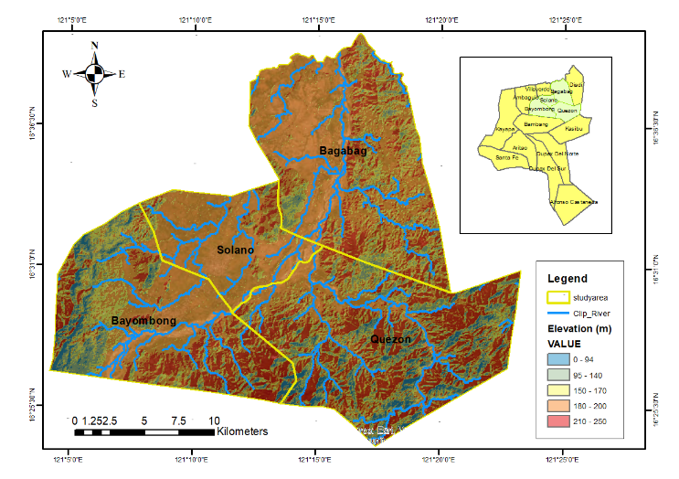
6. Soil Type (Pedological Permeability)
The soil distribution (Figure 7) indicates a significant presence of "Heavy Clay" and "Stable Clay" across Quezon and parts of Solano. These clay-dominated soils exhibit low hydraulic conductivity and high saturation potential. Once field capacity is reached, infiltration drops to near zero, triggering immediate surface runoff and limiting the earth's natural capacity to absorb excess water.
Figure 7: Soil Type Map of the Study Area
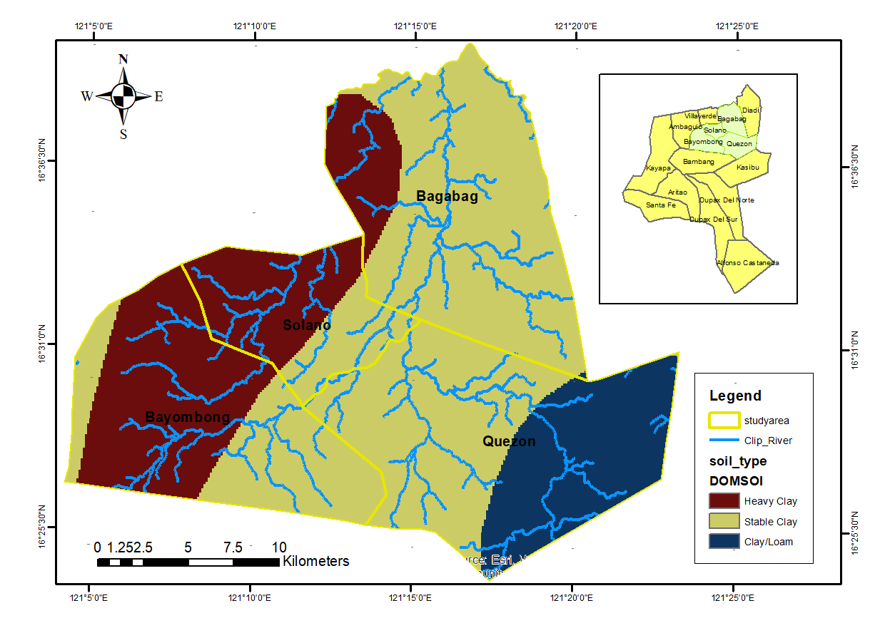

D. GIS-Based Flood Hazard Map of the Lower Magat River Basin
The GIS-based flood hazard map revealed varying levels of flood susceptibility across the Lower Magat River Basin. Among the four municipalities, Solano exhibited the highest proportion of high-susceptibility areas (71.72%; 48.04 km²), followed by Bagabag (58.56%; 97.06 km²), reflecting their low-lying terrain and proximity to major river systems. Quezon was predominantly classified as moderately susceptible (61.36%; 106.64 km²), while Bayombong displayed the most balanced distribution, with the largest extent of low and very low susceptibility areas (21.50 km²; 15.1%) due to its relatively higher elevations.
At the barangay level, Casat in Bayombong recorded a 100% very high susceptibility index, making it the most flood-prone area in the basin. Other highly vulnerable barangays included Darubba and Runruno in Quezon, Pilar D. Galima in Solano, Paitan in Bayombong, and Baretbet in Bagabag. Moderate flood susceptibility was concentrated in Aggub and Curifang (Solano), Bonfal East (Bayombong), Baretbet (Bagabag), and Maddiangat (Quezon). In contrast, safer zones were primarily located in Uddiawan (Solano), Buenavista and Magsaysay (Bayombong), Villa Coloma (Bagabag), and Maddiangat (Quezon), where higher elevations reduced flood susceptibility.
Figure 8: Flood Hazard Map of Lower Magat River
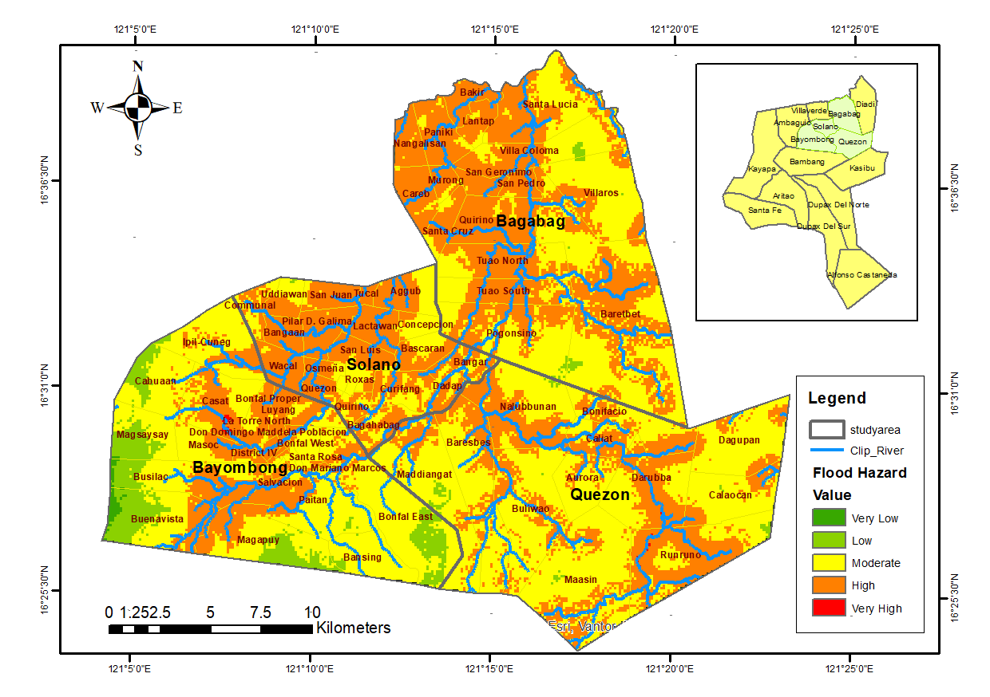
CONCLUSION
Based on the results of this study, the following conclusion were drawn:
- The GIS–AHP analysis identified distance to rivers (36.1%) and precipitation (25.4%) as the dominant factors influencing flood susceptibility in the Lower Magat River Basin.
- High flood hazard areas are primarily located near the Magat River and in zones with high annual rainfall, highlighting the combined influence of hydrological and climatic conditions on flood occurrence.
- Low-gradient terrain and heavy clay soils further increase flood susceptibility by limiting infiltration and promoting surface water accumulation.
- The acceptable Consistency Ratio (CR < 0.10) confirms the reliability of the AHP-derived weights, demonstrating that the generated GIS-based flood hazard map provides a scientifically sound basis for flood risk assessment and disaster risk reduction planning in the study area.
RECOMMENDATION
Based on the conclusion derived from the results of this study, the following are the recommendations:
- Local government units (LGUs) should integrate the GIS-based flood hazard map into their Comprehensive Land Use Plans (CLUP) and Disaster Risk Reduction and Management (DRRM) plans to support evidence-based planning and flood risk mitigation.
- Development within identified high-risk flood zones, particularly areas adjacent to major river systems, should be strictly regulated through the enforcement of river easements and appropriate land-use policies.
- Nature-based solutions, including watershed reforestation and the expansion of urban green infrastructure, should be promoted to reduce surface runoff and improve water infiltration.
- Future studies should incorporate high-resolution LiDAR data, hydraulic modeling, and climate change scenarios to improve the accuracy and predictive capability of flood hazard assessments.
- Community-based flood awareness and preparedness programs should be strengthened, particularly in highly susceptible barangays, to enhance disaster resilience and early warning response.
ACKNOWLEDGEMENT
The researcher would like to extend her sincere appreciation to the University of La Salette, Inc. for providing a supportive academic environment, quality education, and opportunities that made this research possible. She also expresses her heartfelt gratitude to the Provincial Planning and Development Office (PPDO) of Nueva Vizcaya and the Provincial Disaster Risk Reduction and Management Office (PDRRMO) of Nueva Vizcaya for providing the essential data, maps, and technical information that greatly contributed to the successful completion of this study.
REFERENCES
- Addis, A. (2023). GIS-based flood susceptibility mapping using frequency ratio and information value models in Upper Abay River Basin, Ethiopia. Natural Hazards Research, 3(2), 247–256.
- Adjei-Darko, P. (2017). Remote sensing and geographic information systems for flood risk mapping and near real-time flooding extent assessment in the Greater Accra Metropolitan Area (Master’s thesis). KTH Royal Institute of Technology, Stockholm, Sweden.
- Alarifi, N., Alshammari, F., & Alghamdi, S. (2020). Flash flood vulnerability mapping using GIS and AHP: A case study in southwestern Saudi Arabia. Environmental Earth Sciences, 79, 654. https://doi.org/10.1007/s12665 020-09332-8
- Ali, A., Solomatine, D. P., & Di Baldassarre, G. (2015). Assessing the impact of different sources of topographic data on 1-D hydraulic modelling of floods. Hydrology and Earth System Sciences, 19, 631–643. https://doi.org/10.5194/hess-19-631-2015
- Ali, K., Bajracharya, R. M., & Koirala, H. L. (2016). A review of flood risk assessment. International Journal of Environment, Agriculture and Biotechnology, 1, 1065–1077.
- Ali, S. (2020). Geographic Information Systems: Principles and applications. Springer.
- Alcantara, R., & Christopher, J. (2019). Flood hazards and community vulnerability assessment. International Journal of Disaster Risk Reduction, 34, 33–45. https://doi.org/10.1016/j.ijdrr.2018.12.008
- Alfonso, C. D. Q., Sundo, M. B., Zafra, R. G., Velasco, P. P., Aguirre, J. J. C., & Madlangbayan, M. S. (2019). Flood risk assessment of major river basins in the Philippines. International Journal of GEOMATE, 17, 201–208.
- Al-Omari, A. A., Shatnawi, N. N., Shbeeb, N. I., Istrati, D., Lagaros, N. D., & Abdalla, K. M. (2024). Utilizing remote sensing and GIS techniques for flood hazard mapping and risk assessment. Civil Engineering Journal, 10(5), 1423–1436. https://doi.org/10.28991/cej-2024-010-05-05
- Anusha, N., & Bharathi, B. (2019). Flood detection and flood mapping using multi temporal synthetic aperture radar and optical data. Egyptian Journal of Remote Sensing and Space Science, 23, 207–219. https://doi.org/10.1016/j.ejrs.2019.01.001
- Argaz, A., Ouahman, B., Darkaoui, A., Bikhtar, H., Ayouch, E., & Lazaar, R. (2019). Flood hazard mapping using remote sensing and GIS tools: A case study of Souss Watershed. Journal of Materials and Environmental Science, 10(2), 170–181.
- Ballado, A. H., Bentir, S. A. P., Lazaro, J. B., & Macawile, M. J. P. (2017). Depth perception analysis of LiDAR digital elevation model for low-lying areas using Delaunay triangulation algorithm. In Proceedings of the 9th International Conference on HNICEM (pp. 1–5).
- Bolstad, P. (2016). GIS fundamentals: A first text on geographic information systems (5th ed.). XanEdu Publishing.
- Cabrera, J. S., & Lee, H. S. (2019). Flood-prone area assessment using GIS based multi-criteria analysis: A case study in Davao Oriental, Philippines. Water, 11(11), 2203. https://doi.org/10.3390/w11112203
- Cabrera, J. S., & Lee, H. S. (2020). Flood risk assessment for Davao Oriental in the Philippines using GIS-based multi-criteria analysis and the maximum entropy model. Journal of Flood Risk Management, 13, e12607. https://doi.org/10.1111/jfr3.12607
- Cai, S., Fan, J., & Yang, W. (2021). Flooding risk assessment and analysis based on GIS and the TFN-AHP method: A case study of Chongqing, China. Atmosphere, 12, 623. https://doi.org/10.3390/atmos12100623
- Chan, F., Lee, J., & Tan, W. (2021). GIS-based flood vulnerability and impact assessment in urban areas. Journal of Flood Risk Management, 14, e12715. https://doi.org/10.1111/jfr3.12715
- Climate Technology Center and Networks. (n.d.). Flood risk assessment using GIS and hydrological models. https://www.ctc-n.org
- CBS News. (2025, November 15). Super Typhoon Fung-Wong moves out of northwestern Philippines, causing floods and landslides. https://www.cbsnews.com/news/typhoon-fung-wong-philippines-floods/
- CNN. (2025, October 10). Typhoon Kalmaegi (Tino) devastates parts of Cebu, Philippines. https://www.cnn.com/2025/10/10/asia/typhoon-kalmaegi philippines-intl-hnk/index.html
- Danumah, J., Mensah, R., & Owusu, A. (2021). GIS-based flood risk mapping using AHP: Hazard and vulnerability assessment. Environmental Monitoring and Assessment, 193, 302. https://doi.org/10.1007/s10661-021-09011-7
- Davies, R. (2021). Philippines—Thousands hit by more floods in central regions. FloodList. http://floodlist.com
- Efraimidou, A., & Spiliotis, P. (2020). Integrating remote sensing and GIS for flood extent mapping and vulnerability analysis. ISPRS International Journal of Geo-Information, 9(8), 460. https://doi.org/10.3390/ijgi9080460
- Elkhrachy, I. (2020). Flash flood mapping using AHP and satellite imagery. Remote Sensing Applications: Society and Environment, 17, 100275. https://doi.org/10.1016/j.rsase.2019.100275
- ESCAP IDD. (2015). Disasters in Asia and the Pacific: 2015 year in review. United Nations ESCAP. https://www.unescap.org
- Edamo, T., Santos, R., & Villanueva, L. (2022). Flood risk assessment in riverine communities: Impacts and mitigation strategies. Journal of Environmental Management, 310, 114745. https://doi.org/10.1016/j.jenvman.2022.114745
- Ford, H. (1979). Remote sensing: Principles and applications. McGraw-Hill.
- Gigović, L., Pamučar, D., Bajić, Z., & Drobnjak, S. (2017). Application of GIS interval rough AHP methodology for flood hazard mapping in urban areas. Water, 9, 360. https://doi.org/10.3390/w9050360
- Gustafson, J. (1982). Remote sensing of natural hazards. Photogrammetric Engineering and Remote Sensing, 48(9), 1379–1389.
- Hagos, Y. G., Andualem, T. G., Yibeltal, M., & Mengie, M. A. (2022). Flood hazard assessment and mapping using GIS integrated with multi-criteria decision analysis in Upper Awash River Basin, Ethiopia. Applied Water Science, 12(7), 148. https://doi.org/10.1007/s13201-022-01663-9
- Holz, R. (1973). Introduction to remote sensing. Photogrammetric Engineering, 39(12), 1309–1315.
- Hussein, A., Zhang, Q., & Li, K. (2023a). Urban flood risk assessment using GIS and multi-criteria decision analysis: Case studies from coastal cities. Water, 15(4), 564. https://doi.org/10.3390/w15040564
- Hussein, A., Zhang, Q., & Li, K. (2023b). Enhancing flood risk modeling using remote sensing and GIS: Mainland cities perspective. Journal of Flood Risk Management, 16(1), e12987. https://doi.org/10.1111/jfr3.12987
- Kettner, A., Syed, T. H., & Brakenridge, G. R. (2016). Global flood monitoring using SAR data: A one-stop-shop portal for flood prediction and assessment. Remote Sensing, 8(9), 759. https://doi.org/10.3390/rs8090759
- Kumar, A., & Jha, M. (2021). GIS-based flood risk mapping in Kosi River Basin, Bihar, India using AHP. Natural Hazards Research, 6, 145–160.
- Lagmay, A. M. F., Racoma, B. A., Aracan, K. A., Alconis-Ayco, J., & Saddi, I. L. (2017). Disseminating near-real-time hazards information and flood maps in the Philippines through Web-GIS. Journal of Environmental Sciences, 59, 13–23. https://doi.org/10.1016/j.jes.2017.04.004
- Lopez, S., Hannah, M., & Guimbongan. (2024). Flood susceptibility mapping in the Municipality of Bayombong, Province of Nueva Vizcaya, Philippines. International Journal for Multidisciplinary Research, 6(3).
- Madi, A., Bensaid, S., & Benyahia, H. (2020). Flood mapping of extreme river events using HEC-RAS 1D and GIS: Tamanrasset Valley watershed, Algeria. Water, 12(9), 2504. https://doi.org/10.3390/w12092504
- M Amen, T., Khalid, R., & Hussein, A. (2021). GIS-based flood susceptibility mapping using AHP in Duhok, Iraq. Journal of Flood Risk Management, 14(2), e12689. https://doi.org/10.1111/jfr3.12689
- Monjardin, C. E. F., Tan, F. J., Uy, F. A. A., Bale, F. J. P., Voluntad, E. O., & Batac, R. M. N. (2020). Assessment of the existing drainage system in Infanta, Quezon Province for flood hazard management using analytical hierarchy process. In Proceedings of the IEEE Conference on Technologies for Sustainability (pp. 1–6). https://doi.org/10.1109/TFS.2020.9312345
- Munawar, H. S., Hammad, A. W. A., & Waller, S. T. (2022). Remote sensing methods for flood prediction: A review. Sensors, 22(3), 960. https://doi.org/10.3390/s22030960
- NOAA. (2022). Storm surge and coastal flooding. National Oceanic and Atmospheric Administration. https://www.noaa.gov/storm-surge
- NDRRMC (National Disaster Risk Reduction and Management Council). (2021, April 19). SitRep No. 5 re: Tropical Cyclone Surigae (Bising). https://www.ndrrmc.gov.ph/reports/sitrep-surigae-2021.pdf
- Ouma, Y., & Tateishi, R. (2014). Urban flood vulnerability and risk mapping using integrated multi-parametric AHP and GIS. Water, 6, 1515–1545. https://doi.org/10.3390/w6061515
- Pruitt, W. (1983, personal communication). Early history of remote sensing.
- Raadgever, G., & Hegger, D. (2018). Strengthening and redesigning European flood risk management (STAR-FLOOD): Principles and strategies. Springer. https://doi.org/10.1007/978-3-319-64470-0
- Reeves, C. (1975). Remote sensing principles. Remote Sensing of Environment, 4(2), 101–113.
- Rhind, D. (1992). Geographic information systems: An introduction. Longman Scientific & Technical.
- Rincón, L., Khan, S., & Armenakis, C. (2018). GIS and multi-criteria decision analysis for flood risk mapping. Natural Hazards, 92, 1171–1190. https://doi.org/10.1007/s11069-018-3282-7
- Sabins, F. (1978). Remote sensing: Principles and interpretation. W.H. Freeman & Co.
- Saaty, T. L. (1980). The analytic hierarchy process: Planning, priority setting, resource allocation. McGraw-Hill.
- Siddayao, C., Valdez, L., & Fernandez, P. (2014). Flood hazard mapping using GIS and AHP: A case study in the Philippines. Journal of Environmental Science and Management, 17(2), 50–61.
- Siegal, B., & Gillespie, A. (1980). Remote sensing in Earth sciences. Science, 210, 1285–1290.
- USAID. (2011). Philippines disaster risk reduction and management assessment report. United States Agency for International Development. https://www.usaid.gov/philippines
- World Bank. (2021). Philippines: Disaster risk profile. World Bank Group. https://www.worldbank.org/en/country/philippines/overview
- Yu, D., Xie, P., Dong, X., Hu, X., Liu, J., Li, Y., Peng, T., Ma, H., Wang, K., & Xu, S. (2018). Improvement of the SWAT model for event-based flood simulation on a sub-daily timescale. Hydrology and Earth System Sciences, 22, 5001 5019. https://doi.org/10.5194/hess-22-5001-2018
- Zou, Q., Zhou,J., Zhou, C., Song, L., & Guo, J. (2013). Comprehensive flood risk assessment based on fuzzy AHP. Stochastic Environmental Research and Risk Assessment, 27, 525–546. https://doi.org/10.1007/s00477-012-0661 5

