Developing Named Entity Recognition Model For Guragigna Language Using Deep Learning Approach

ABSTRACT
Named entity recognition (NER) being a key application that extracts and classifies information from text. Guragigna, one of Ethiopia's languages, has a complex morphology but lacks adequate computational linguistic tools. Some NER research has been conducted in Ethiopia utilizing various approaches and classification techniques, but since there was a lack of study conducted on NER for the Guragigna language. Developing a Guragigna Named Entity Recognition (GNER) system encounters several challenges, primarily the lack of annotated datasets which limits model training and evaluation. The unique linguistic features of Guragigna, including complex morphology and syntax, complicate the use of traditional NER techniques. Additionally, limited computational resources and data imbalance adversely affect model performance in identifying various entity types.The proposed study seeks to create a named entity recognition model for the Guragigna Language, utilizing a newly tagged dataset of 24,608 words derived from sources such as the Guragigna New Testament, educational materials, and Wolkite FM. The study used various methods Currently, researchers are using four algorithms convolutional neural networks, long short-term memory, bi-directional long-short-term memory, and Gated Recurrent Unit to identify four primary named entities people, places, dates, and organizations from unstructured Guragigna text. SMOT and RUS sampling techniques are used for the data balancing. For the feature engineering work, Word2vec and one-hot encoding are employed. I have run a number of experiments to determine which model performs the best. The Bi-LSTM algorithm outperforms other algorithms with accuracy, precision, recall, and f1-score of 95.4%, 92.4%, 95.4%, and 91.3%, respectively, prior to sampling and word embedding, and 97.3%, 94.4%, 95.2%, and 96.2%, respectively, following sampling and word embedding. Lastly, I have made the Guragigna language dataset available to other scholars. Thus, I may infer from the experiment that the Bi-LSTM model works well for locating the Named Entities needed to create the Guragigna NER model
Keywords: Deep Learning, Guragigna Language, Natural Language Processing, Named Entity Recognition

ABBREVIATIONS AND ACRONYMS
BiLSTM | Bidirectional Long Short-Term Memory
CBOW | Continuous Bag-of-Words
CNN | Convolutional Neural Network
CoNLL | Conferences on Natural Language Learning
CRF | Conditional Random Fields
GNER | Guragigna Name Entity Recognition
GRU | Gated Recurrent Unit
IE | Information Extraction
IES | Information Extraction System
LOC | locations name
LSTM | Long Short-Term Memory
NE | Named Entity
NER | Named Entity Recognition
NLP | Natural Language processing
ORG | Organizations name
PER | Persons name
POS | Part Of Speech
RNN | Recurrent Neural Network
RUS | Random Under-Sampling
SBG | Sebat Bet Gurage
SMOTE | Synthetic Minority Over-sampling Technique
SVM | Support Vector Machine
SVM | Support Vector Machine

Introduction
Many years ago, information and communication technology faced a lot of challenges because of the specific language operability of computers. Hence, these challenges put limitations on the promotion of computers too. Most of world language remain under-resource due to lack of language processing tools and resources[1] [2]. Natural Language Processing is one of the most emerging and hot technologies in AI. It programs the computer to understand and interpret natural languages as humans do. Various applications in NLP play a vital role in analyzing large amounts of textual data. One of these applications is called Named Entity Recognition, which is performed on large amounts of textual data. One of the crucial sub-tasks of Information Extraction is known as Named Entity Recognition and Classification which is the recognition of the entities in text[3].
Named Entity Recognition (NER), also called entity identification or extraction, is a task in information extraction that aims to find and categorize specific names or entities in unstructured text into predefined groups, including things like numbers, percentages, time expressions, and medical codes [1] [2]. Generally, the identification and classification of named entities pose significant challenges for NLP researchers. The ambiguity in named entity recognition makes it hard to achieve human-level performance. Developers of Information Extraction Systems (IES) specifically address and benchmark the issue of correctly identifying named entities[4]. This means of places organization, people, and other entities, making them difficult to recognize and interpret in unstructured text. The challenges of NER vary by language. For instance, in English, named entities typically start with a capital letter, making them easier to recognize. However, in Guragenga, there are no such rules, making named entity recognition more challenging compared to English.
Here, our focus is developing a named entity recognition model for the Guragigna language, which is one of the Semantic languages. The Guragigna language, in older publications, also called Guragigna is a south Semitic language spoken by the Gurage people, living in southwestern Ethiopia. Thus, news in the Guragigna language acts as a means of communication for over 1 million individuals. The language is written as Amharic does, left to right. Hence, the language serves as the medium of instruction throughout educational institutions like primary and secondary schools.
Named Entity Recognition (NER) for Guragigna, involves identifying and categorizing entities within the text. NER is crucial for various natural language processing tasks, like information retrieval, question answering, and machine translation, among others. Creating an effective NER system for Guragigna presents both challenges and opportunities. Guragigna lacks extensive annotated datasets and language-specific resources, making it challenging to develop robust NER models. Guragigna exhibits rich morphological variations and agglutination, where words change forms based on tense, gender, number, etc. This complexity complicates entity recognition. Guragigna may have named entities unique to its culture, history, and geography, which may not be readily recognized by models trained in other languages.
Similar words or phrases in Guragigna may have different meanings based on context, posing difficulties in accurately identifying entities. For example sentences one ‘የአፍያ ሚኒስቴር ዴኤታ ዶ/ር ደረጀ ድጉማ ያፍያ ሜና ቤት በትት ያምሮት የቋነሺ ሜና ቲጀቡሪ ያፍያ አጘጝሮት ውጤ ገን ያሪ የረፕረ ይዠብር ኸማ አትኸሮም ፡፡’ A precise NER system would identify two named entities from the sentence above. የአፍያ B-ORG ,ሚኒስቴር I-ORG ,ደረጀ B-PER, ድጉማ I-PER ፡፡ in sentences two‘የጅወካም 𞟦ቴል ቡር አራባሪ ባራባራስ ጠንክር ንማጋ ቢቸን ዘበር ንቅ ሜና ይቾቺ ኸማ ዝረከዎም።’ from sentences two የጅወካም B-ORG and ጠንክር B-PER ንማጋ I-PER . Sentences three ‘የጅወካም ቀያ ይረብሮ ጋዝመነ ብማት ኸሮም ታነ በቀበሌ ንቅ ቡችር ቡችር ሜና ቲቾቶ ያነዎ ኸማ ዝረከዎም።’ in sentences three የጅወካም consider as B-LOC. The Core Challenge is revealed in Sentences Two and Three. The same word, የጅወካም, must be classified differently based on its context. In Sentence Two, it is the beginning of an Organization (B-ORG) because it is followed by a word like 𞟦ቴል (Hotel), forming "Jewokam Hotel" but in Sentence Three, it is correctly identified as a Location (B-LOC) on its own, as the context describes a place (with words like ቀያ - street, ቀበሌ - neighborhood). Therefore, the objective of this research work is not just to tag obvious names, but to develop train deep Learning model that understands meaning from context. This thesis will demonstrate that a Deep Learning model can effectively perform this disambiguation by learning the complex, contextual patterns of the Guragigna language.
Most recent article such as[6] [8] Developing Named Entity Recognition systems for the differenet language faces several challenges. One major issue is data imbalance, which makes it hard to recognize minority entity types. Techniques like Synthetic Minority Over-sampling Technique (SMOTE ) and Random Undersampling (RUS) have been successful in other fields, but it’s unclear how well they work for low-resource languages like Guragega, so testing on the Guragega NER dataset is needed. Additionally, there is a shortage of annotated datasets and tools for Guragigna, which makes creating effective NER systems difficult and Choosing the right feature extraction methods is important because those that work for high-resource languages may not suit Guragigna’s unique structure. The language's agglutinative nature and inconsistent spelling add to this complexity. Without proper evaluation, poor feature selection could lead to low performance, highlighting the need to find effective methods for building a strong NER model for Guragega.

Related Literature
Named Entity Recognition (NER) has been extensively researched using deep learning, hybrid, and statistical methods for both high-resource and low-resource languages. Research on Ethiopian languages is still scarce, though, especially when it comes to the application of sophisticated deep contextual models. Boosting Afaan Oromo Named Entity Recognition with Multiple Methods, which was published in the I.J. Information Engineering and Electronic Business in 2021, suggested a hybrid strategy for Afaan Oromo NER. The study integrated Word Sense Disambiguation with Conditional Random Fields (CRF), rule-based methods, pattern matching, and voting mechanisms. The hybrid model obtained an overall F1-score of 86.01% using a dataset of 44,120 tokens with 7,809 named entities. Token context (previous and next words), word shape, capitalization, and n-grams were among the handcrafted features that the system relied on. Despite the encouraging results, the study did not investigate end-to-end deep learning architectures and did not specifically address dataset imbalance. Similarly, a CRF-based statistical approach was used in an MSc thesis at Bahir Dar University (2020) to develop an Amharic NER system. Part-of-speech (POS) tags, prefix and suffix features (length 2–4), contextual words, and the BIO tagging format were all included in the model. Combining POS tags with contextual information and prefix/suffix features of length four produced the best results (F1 = 78.24%). However, performance dropped to 68.29% when POS features were removed, indicating a strong dependence on manually created linguistic features. Neural network models and deep contextual embeddings were not evaluated in this study.

For Amharic NER, deep learning techniques have also been investigated. The authors of Named Entity Recognition for Amharic Using Deep Learning used bi-directional LSTM and RNN architectures. In addition to Continuous Bag-of-Words (CBOW) embeddings, the model employed word suffixes and prefixes, word frequency information, and local context features. The system's overall accuracy, using 10-fold cross-validation, was 69.7%. Limited dataset size and restricted exploration of deep learning model variants were cited as the reasons for the comparatively poorer performance. Arabic NER systems have been found to perform better than Ethiopian languages. Using pre-trained word embedding’s and character-based representations, a neural architecture comprising Bi-LSTM, CNN, and CRF was used in Arabic Named Entity Recognition Using a Deep Learning Approach. The study's F1-score on the ANER corpus was 90.6%. Despite the system's use of skip-gram and GloVe embedding’s, more research into different embedding techniques and attention-based mechanisms was recommended. In 2022, a BiLSTM-CRF model was made for the Hadiyya language. It got precision, recall, and F1-scores of 95.49%, 94.93%, and 95.21%, respectively. The architecture had three parts: a word-level encoder, a context encoder, and a tag decoder. The study used one-hot encoding, which can't represent meaning, and was trained on a small dataset, even though it did well. The authors suggested that semantic word embedding’s like Word2Vec be added for future improvements.
Overall, previous research shows that when handcrafted linguistic features are used to support traditional statistical models like CRF, they perform fairly well. Nonetheless, deep learning techniques in particular, BiLSTM-CRF architectures in conjunction with character-level representations and pre-trained embedding’s perform better. However, there are still significant gaps for Ethiopian languages in the areas of dataset size, contextual embedding’s, transformer-based architecture evaluation, and data imbalance management. These drawbacks encourage more investigation into reliable, end-to-end NER systems that make use of cutting-edge representation learning methods.

Table 1: Related work about Named Entities
citation | Title & Journal  Name | Main Findings | Remark/Gap
[6] | Boosting Afaan Oromo Named Entity Recognition with Multiple Methods  Journal: I.J. Information Engineering and Electronic Business, Vol.13, No.5, 2021 | The researcher used 44,120 total dataset and out of dataset 7,809 name entity. Hybrid model (rule-based + pattern + ML) achieved 86.01% F1 score overall | -Dataset imbalance not explicitly addressed  -used end to end model  -does not evaluate feature extraction
[41] | Amharic Named Entity Recognition System Using Statistical Method", MSc Thesis, Bahir Dar University , 2020 | The best result (F1 = 78.24%) was achieved using POS + prefix/suffix (length 4) + context. Removing POS reduced F1 to 68.29%. The model successfully classified Person, Location, Organization, | -Expand the annotated dataset to improve model generalization.  -did not incorporate deep contextual features such as word embeddings  -did not evaluate deep learning methods
[1] | Named Entity Recognition for Amharic Using Deep Learning | Using 10-fold cross-validation achieved  an overall result of 69.7% accuracy. | -The model achieved an accuracy of 69.7%. Using a larger dataset could improve accuracy, as deep learning algorithms perform better with more data.  -used Continuous Bag-of-Words (CBOW)  - Limited Model Variants
[3] | Arabic-named entity recognition using a deep learning Approach | Achieved top performance on the standard ANER corpus with an F1 score of 90.6%. | The researcher used skip-gram and GloVe Only If using the word2Vec feature extraction technique is better in deep learning to understand semantic liner relationship between words.  - Used Attention-based
 | Named Entity Recognition for Hadiyya Language using BiLSTM-CRF Model  (2022) | precision, recall, and F1-measure scores of respectively 95.49%, 94.93%, and 95.21% | -One-hot lacks semantic understanding  -suggest future improvement by integrating word embeddings like Word2Vec.  -Small Dataset Size

Summary
The crucial and fundamental step for any research on a specific focus area is reviewing various already completed publications, research works, and papers in proceedings on that particular subject field. As a result, we have carefully examined the problem area in this chapter by reading a variety of academic works. To address and achieve the present Guragigna NER model, we have evaluated a variety of publications. A few fundamental topics that were covered in our review of the literature were the development of the NER system, its general architecture, the behavior of named entities, earlier NER approaches, the use of named entities, the kinds of feature sets that were used in a particular NER model, and evaluation metrics from previous studies. Various NER models were created internationally and described in the relevant work section. The recent review paper on Named Entity Recognition (NER) systems noted that hand-crafted rules were used, but these rules cannot adapt to new cases and struggle with data imbalance. This imbalance happens when some entity classes have many fewer examples than others, which affects their effectiveness. In low-resource languages, the effectiveness of these systems is still unclear. Most articles used the same feature extraction techniques and did not compare the effects of different techniques against each other. The development of effective NER systems in low-resource languages is still in its early stages.

Modeling and Methods

Approach
In this study experimental approach were employed. The appropriate data sources, data sampling, data collection, and tool selection, were used to address research questions and objectives. The overall methodology and research process are shown in Figure 4 below, from problem identification to conclusion.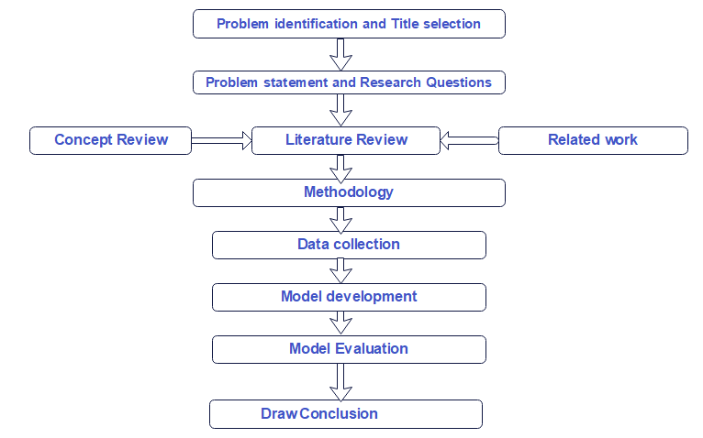
Figure 1: Overall methodology and research procedures

Design
In The Proposed GNER Designed Model Architecture, the corps preparation, data preprocessing, design approaches, model design, model selection, and are employed throughout the research study to respond to and address the research questions and study objectives. The architecture begins with data source identification, where diverse textual materials such as fiction books, textbooks, and Gurage testaments are gathered. This variety creates a rich corpus, ensuring that the model can learn to recognize entities across different contexts and linguistic styles. The first step of the architecture is to preprocess input data from a given path or directory. After preprocessing, the text is transformed into vectors using methods like one-hot encoding, padding, and word embeddings, which help reduce the data's dimensionality.
For Named Entity Recognition tasks, the encoder-decoder model is frequently employed. The encoder and the decoder are its two components. The encoder transforms an input sequence, like a Guragenga sentence, into a fixed-length vector by examining each token individually and updating its hidden state at each step. The decoder then uses this encoded vector.

The Proposed GNER Designed Model Architecture
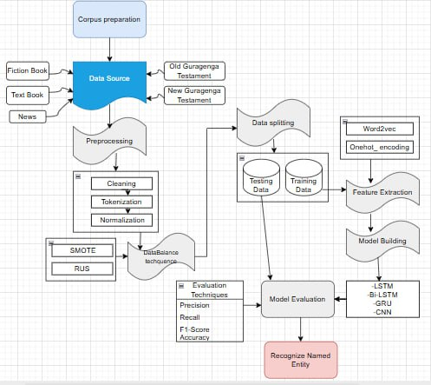
Figure 2: The Proposed GNER model

Corpus Preparation
Any kind of research conducted in NLP requires resources and among those resources the most important and vital one is data. As it has been defined in NLP that uses a Deep learning approach needs a huge amount of data. The success or failure of most NLP applications depends on the quality and availability of appropriate data. It is clear why data is crucial since the majority of state-of-the-art research uses a corpus-based approach with various deep learning techniques. Nevertheless, this type of pre-trained model that is widely acknowledged as language representation is absent from low-resource languages like Garaging. Because of this issue, we have gathered the corpora from various sources, such as the Holy Bible, the Guragigna Zone Education Office's Level 1 and Level 2 student books, and news sources like Wolkite FM. To construct GNER, gather a total of 3000 phrases, each of which must have a minimum of one entity type. In this case, data that had undergone processing was given to human annotators. We have relied on manual annotation because current annotator software solutions are incompatible with our native language. Although it was a laborious process, human annotation is rarely used. To annotate our dataset from the Guraga Zone Chalcheral Office, we selected three annotators based on their Guragigna language proficiency and educational background. It is crucial to use several annotators and consider annotator agreement in order to get the best results.

Data collection and data sources
We have collected 3000 sentences to utilize the NER (Name Entity recognition) method in the Guragigna language. The corpus, we have prepared is from the religious book and Guraga‟e zone education office, specifically textbooks spanning from grade 1 to grade 2 and Guragigna _Level 1 and Level 2 student book other from Guragigna fiction called የጫሙት ሽካ sources, including News such as wolkite FM, check werda and emdber city communication office. The data set used from each portion is specified in Table 2.
Table 2: Data collection process flow
Data source | Expressed In Numbers in Sentence
religious book | 1591
Guraga‟e zone educ.office | 500
News | 900
Another book | 300
Total | 3000

Model Building
There are various types of LSTM that are one directional and bidirectional LSTM. As different scholar findings were indicated, from these Bi-directional LSTM have the ability to understand not only long-term dependencies, but also the relationships of words in a sentence, from both sides of a sentence [58]. In this research study, both LSTM and Bi-LSTM were applied to create a NER model for Guragigna. Accordingly, in this research a deep learning-based method that incorporates LSTM and Bi-LSTM to determine and develop the most appropriate model architecture. A publicly available benchmark dataset showed that the combination of Convolutional Neural Network, Long-Short Term Memory, Bidirectional LSTM and Gated Recurrent Unit outperformed many other deep learning frameworks[59]. In Figure 3.3shows the General architecture of NER model.

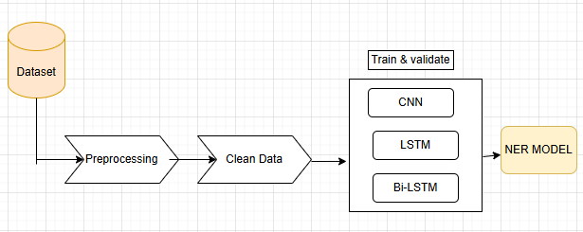
Figure 4: General architecture of NER model

The Tag Distributions
Here, we've made an effort to outline how entity classes are distributed throughout our collection. The dataset has also been annotated in the same way because the planned research's challenge was a classification issue. Our model is created by feeding an algorithm a set of training data for which the classes are already labeled. As a result, the created GNER model is capable of classifying new data into preset separate entity types. As a result, we made sure the dataset was clear, pertinent, and easy for a machine to interpret to achieve the categorization aim.
3.6. GNER Tag distribution without “Other” non-named entities
As we have seen in Figure 5 below the distribution without the "O" designation (by removing non-named entities). Along with the exclusion of other tags, the distribution of the four tags Person, Location, Date, and Organization in the annotated GNER dataset before sampling is made can be seen
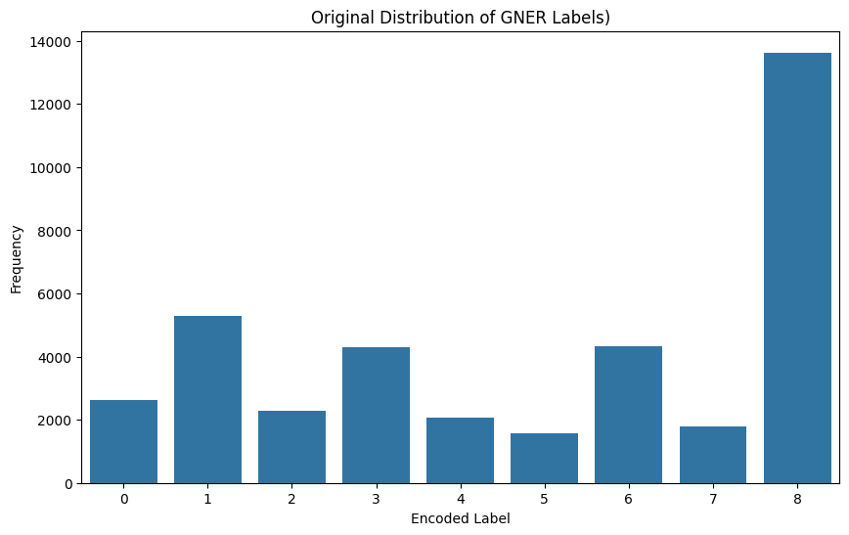
Figure 5: GNER Tagger before over Sampling and under Sampling
in Figure 5 above, But after sampling has been done with “other” tags, the graph seems the following as shown below.
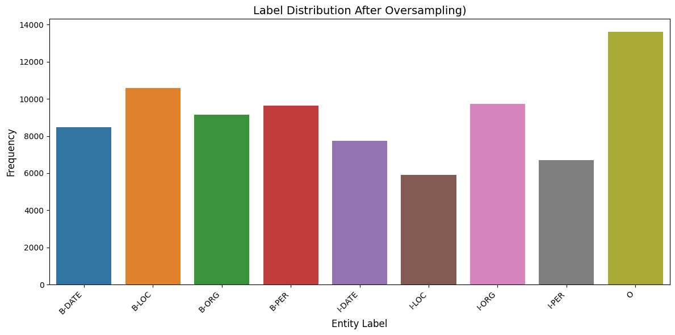
Figure 6: GNER Tagger after Sampling

Implementation environment
To implement our proposed model, we selected Python as our programming language due to its extensive libraries. We used Python 3.8 and Jupyter Notebook for coding, along with the Keras and TensorFlow 2.12 libraries, both freely available. Google Colab was chosen as our primary development environment because it provides GPUs with 32GB RAM, significantly speeding up training compared to CPUs. We prepared the dataset on a desktop computer and saved it as TXT files, which were then uploaded to Google Drive. In Google Colab, we mounted Google Drive to access the dataset and began preprocessing, which will be detailed later. For architecture design and diagramming, we used Draw.io, a user-friendly tool that allows easy creation of various diagrams like system architectures and flowcharts. It offers a range of pre-built shapes and customization options, and supports collaboration among team members. Diagrams can be exported in formats like PDF, PNG, and SVG, making it easy to share designs. Overall, Draw.io is an effective tool for creating professional architecture designs.

Preprocessing

Data Cleaning
In Figure 7, the first step in data preprocessing is data cleaning. The code begins with the importation of the re module. Regular expressions are essential tools for string manipulation, allowing for complex pattern matching and substitutions. The script is structured into two primary functions ‘ clean_text ‘and ‘preprocess_data’.
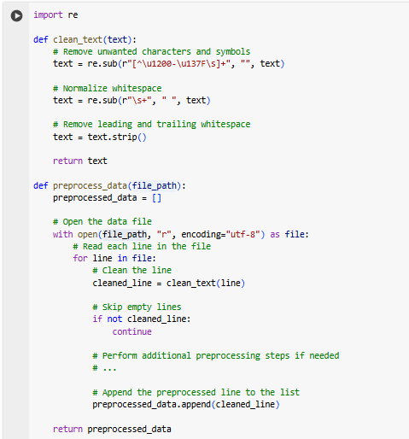
Figure 8: sample code to show cleaned data

Tokenization
In Figure 9 code snippet, demonstrates the process of tokenization and padding using ‘TensorFlow's Keras library’, which is essential for preparing text data for machine learning models. Initially, two instances of the Tokenizer class are created one for the sentences and another for the labels.
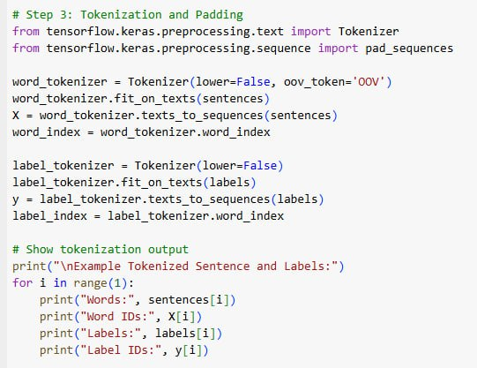
Figure 10: tokenization for Sample code

Data balances sampling process

In Figure 11 code snippet, the application of SMOTE (Synthetic Minority Over-sampling Technique) and RUS (Random Under-Sampling) is demonstrated to address class imbalance in the dataset. Initially, the necessary libraries are imported, including NumPy for numerical operations and the RandomOverSampler and RandomUnderSampler from the imbalearn library.

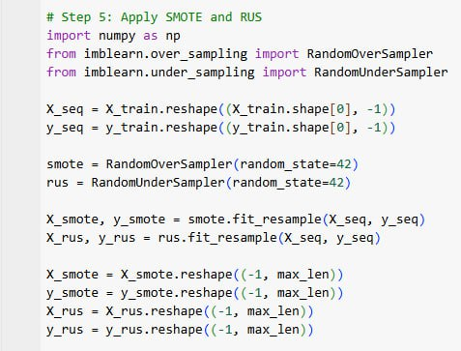
Figure 12: Data balances sample code

Parameter Selection
Table 3: Hyper-parameters and values proposed studies models
Models | Parameters | Search space | Selected Parameters Value
CNN  LSTM  Bi-LSTM | Activation function | Softmax,ReLu and tanh | Softmax in Last layer ReLu in hidden layer
CNN  LSTM  Bi-LSTM |  | Adam and SGD | Adam
  Optimizer | Adam and SGD | Adam
CNN  LSTM  Bi-LSTM | No of hidden layers | 2 ,3 &4 | 4
CNN  LSTM  Bi-LSTM | Epoch | 20, 50 & 100 | 20
CNN  LSTM  Bi-LSTM | Dropout | 0.1 , 0.2 & 0.3 | 0.1
CNN  LSTM  Bi-LSTM | Batch size | 32, 64 & 128 | 32
CNN  LSTM  Bi-LSTM | Learning rate | 0.1, 0.01 & 0.001 | 0.001
CNN  LSTM  Bi-LSTM | Loss function | Catagorical cross entropy | Catagorical cross entropy

The researcher used the parameters and search space mentioned earlier for various model architectures, including CNN, LSTM, Bi-LSTM and GRU. Each model considers specific parameters like the activation function, optimizer, number of hidden layers, epochs, dropout rate, batch size, learning rate, and loss function. The activation functions include Softmax, ReLU, and tanh, with Softmax applied in the last layer and ReLU in the hidden layers. The Adam optimizer is chosen for all models due to its effectiveness in training neural networks. Each model has four hidden layers and is trained for 20 epochs. A dropout rate of 0.1 is included to reduce overfitting, and a batch size of 32 is used for efficient learning. The learning rate is set at 0.001 to ensure stable convergence, and the loss function is categorical cross-entropy, which is suitable for multi-class classification. This careful selection of parameters aims to enhance the models' performance during training and evaluation.

Experiments
As stated in previous section, 24,608 Guragigna words were utilized in the prepared and chosen corpus for GNER, and the suggested model assessment methods (accuracy, precision, recall, and f1-score) were employed to assess the GNER model. The researcher used an 80:20 dataset ratio in each experiment to partition the data into train and testing data in order to build a model. The study used four algorithms, including CNN, LSTM, GRU and BiLSTM with an 80:20 split, in the suggested model. The number of epochs, learning rates, batch size, number of hidden layers, optimizer, activation function, loss function, ratio of training and testing datasets, and feature extraction techniques are just a few of the hyperparameters that the researcher used in each experiment to improve the suggested GNER model.
The experiment's outcomes led to the selection of a high-performing algorithm with good accuracy. Batch size 32 and 64, epoch 20, 50, and 100, number of hidden layers 2, 3, and 4, optimizer Adam and SGD, dropout 0.1, 0.2, and 0.3, learning rate 0.1, 0.01 and 0.001, activation function ReLu and Softmax, and loss function categorical cross entropy were among the highly recommended and well-liked hyperparameters that the researcher used to train the models. Because Cross-Entropy Loss is frequently used in classification tasks and works well for NER, where each token must be classified into one of numerous classes (e.g., person, organization, place, Date, etc.), the researcher merely utilized one categorical cross-entropy loss function search space. By calculating the discrepancy between the actual label distribution and the expected probability distribution, cross-entropy loss penalizes incorrect classifications. The hyperparameters listed above are the most often used and recommended hyperparameters for building a NER model and obtaining correct results, according to several researchers [2]. Then based on the different researcher’s points of view the selected hyper parameters were used and checked by the researcher to train the model then it also gives us a better result accordingly. Then the researcher ultimately chosen the model that performed the best accuracy.
Experiment 1: implementation on BI-lstm model experiment Results using SMOT, RUS, data balances sampling technique using baseline of original
The graph Figure 13 below illustrates training accuracy over multiple epochs for three different datasets: one balanced using SMOTE, one utilizing Random Undersampling, and the original dataset. The SMOTE dataset, shown in blue, achieves the highest accuracy, steadily increasing to around 0.8, indicating strong model performance. In contrast, the Random Undersampling dataset, represented in orange, exhibits a slower rise, reaching approximately 0.5, which suggests limited improvement. The original dataset, depicted in green, shows a gradual increase in accuracy but remains the lowest among the three, ending at about 0.4. This visualization highlights the varying effectiveness of different sampling techniques in enhancing model training accuracy over time.
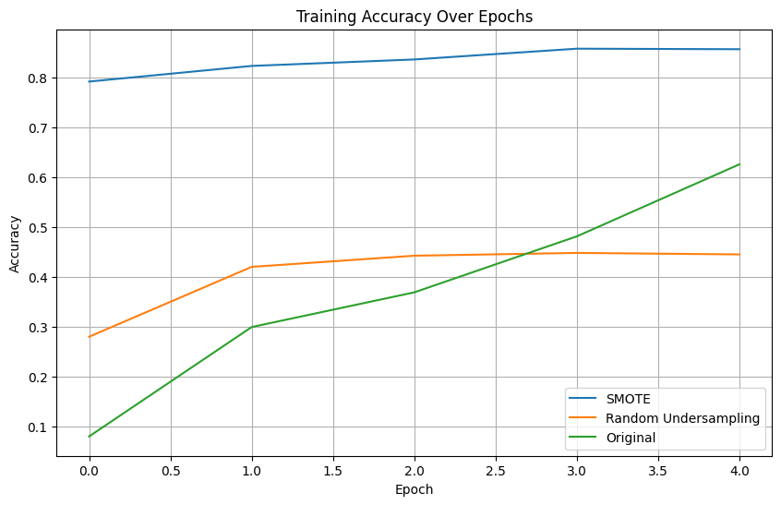
Figure 14: Training accuracy over Epochs Data Balances sampling technique
From below Figure 15, it is evident that the SMOTE-based model consistently achieves the highest accuracy, maintaining values around 0.82–0.84 throughout training. This indicates that SMOTE’s synthetic oversampling effectively balances the dataset and improves the model’s ability to generalize across entity classes. The Random Undersampling method shows moderate and relatively stable accuracy near 0.38–0.40, suggesting that while undersampling reduces data imbalance, it also removes valuable training examples, limiting the model’s learning capacity. In contrast, the Original dataset (without balancing) yields the lowest accuracy, fluctuating between 0.05 and 0.25, showing that the model struggles to learn from an imbalanced dataset dominated by non-entity tags. Overall, the graph demonstrates that SMOTE significantly enhances test accuracy, Random Undersampling provides moderate improvement, and unbalanced data leads to poor model performance. This visually supports the conclusion that data balancing especially oversampling is essential for improving NER model accuracy in low-resource languages like Guragega
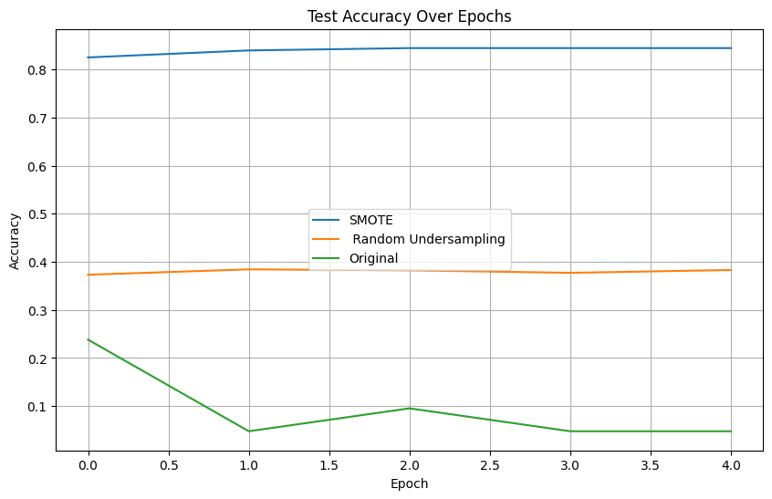
Figure 16: Test accuracy over Epochs Data Balances sampling technique
The Training loss over epochs graph presents the training loss over multiple epochs for three datasets: one balanced using SMOTE, one utilizing Random Undersampling, and the original dataset. The SMOTE dataset, represented in blue, shows a significant and steady decrease in loss, indicating effective learning and model performance. In contrast, the Random Undersampling dataset, depicted in orange, demonstrates a more gradual reduction in loss, suggesting some improvement but less efficiency in learning. The original dataset, shown in green, maintains the highest loss throughout the epochs, highlighting the challenges posed by class imbalance. Overall, this visualization emphasizes the impact of different sampling techniques on training loss, underscoring the benefits of using SMOTE for enhanced model training.
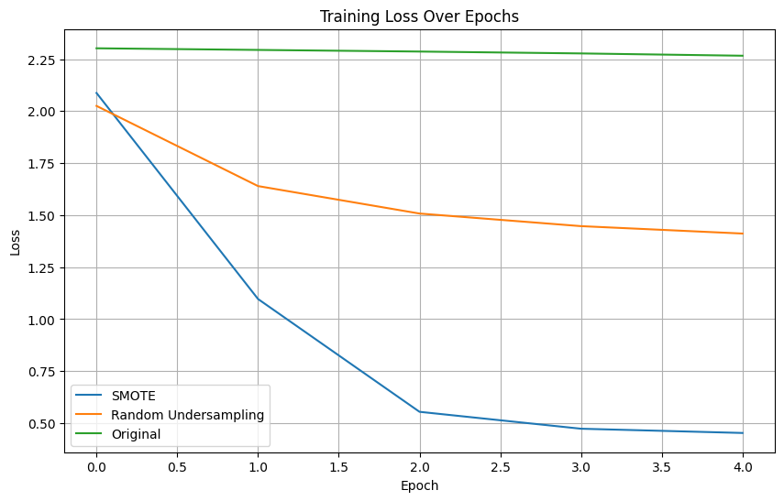
Figure 17: Training Loss over Epochs Data Balances sampling technique
These experiment show classification reports for three datasets Original, Random Under sampling (RUS), and SMOTE reveal significant disparities in model performance across different metrics. In the Original dataset, the highest precision and recall scores are for the "I-DATE" class, with values of 0.14 and 0.23, respectively, leading to an overall accuracy of 0.25. The RUS dataset shows improved performance, especially for the "I-DATE" class, which has a precision of 0.35 and a recall of 0.55, resulting in an accuracy of 0.50. In contrast, the SMOTE dataset exhibits the best performance, particularly for the "O" class, achieving a high precision of 0.86 and an overall accuracy of 0.68. This analysis highlights the effectiveness of different sampling techniques in enhancing classification metrics, with SMOTE yielding the most favorable results.
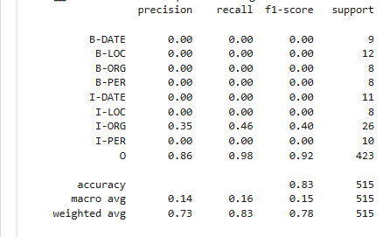
Figure 18: Classification Report for SMOT
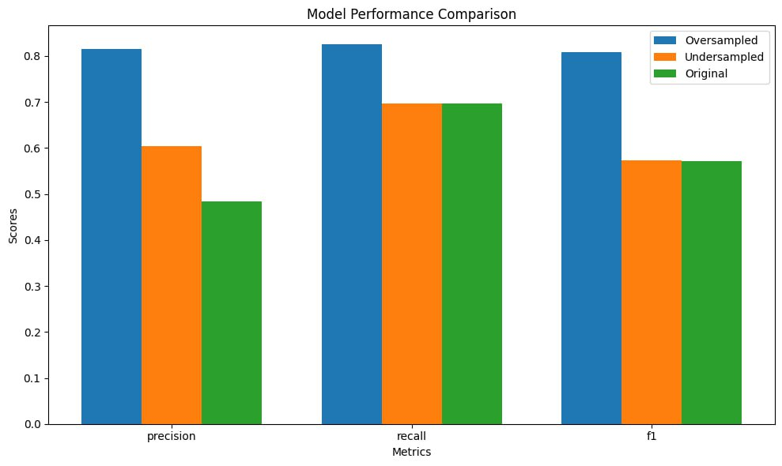
Figure 19: Comparison of Data Balances sampling technique in Bar graph
Three essential metrics precision, recall, and F1 score are used in the bar graph to assess model performance across three datasets: original, oversampled, and undersampled. Superior model performance is indicated by the Oversampled dataset, which is shown in blue and routinely receives the best ratings across all criteria. With middling scores, the Undersampled dataset (orange) shows some improvement over the Original dataset (green), which has the lowest scores across all categories. With the Oversampled dataset showing the greatest gains in precision, recall, and F1 score, this comparison demonstrates how well sampling strategies can improve model performance.
Experiment 2: implementation CNN model experiment Results With and Without Data Balances sampling technique used and word Embedding
As seen in Table 5-2 above, we employed an 80:20 train-test split with a number of hyper-parameters. The CNN algorithm's total experiment outcome based on the optimal parameters chosen is displayed in the following table. As seen in Table 6-2 below, the researcher employed an 80:20 train-test split with many hyper-parameters. According to the experimental findings, a batch size of 32, an epoch of 20, a learning rate of 0.001, a dropout of 0.2, an activation function of softmax, and an Adam optimizer that makes use of the CNN algorithm all produced good performance. The experimental findings therefore show that the model performed well in this experiment, with training accuracy of 94.0% and validation accuracy of 88% prior to sampling and word embedding, and training accuracy of 95% and validation accuracy of 89% following Data Balances sampling and word embedding. Before word embedding and Data Balances sampling, CNN's training and validation accuracy and loss curve.
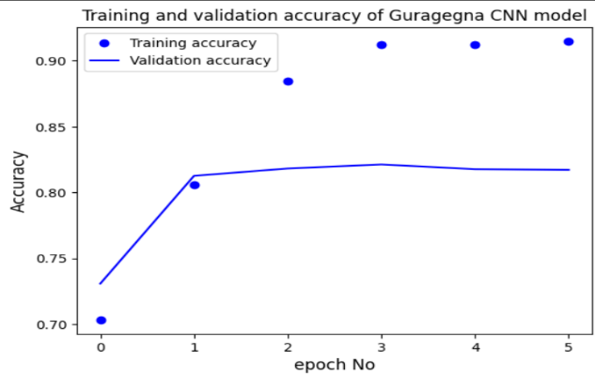
Figure 20: a) Training and validation accuracy
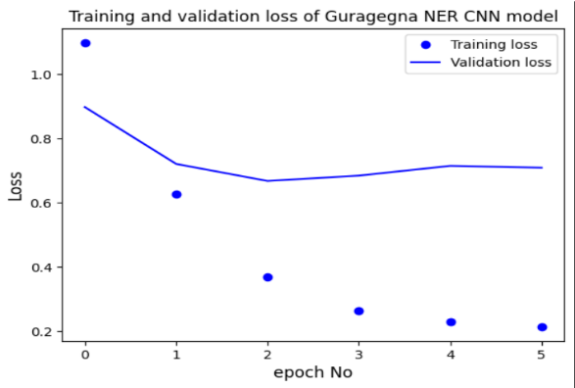
Figure 21:(b) Training and validation loss
After word embedding and Data Balances sampling, CNN's training and validation accuracy and loss curve
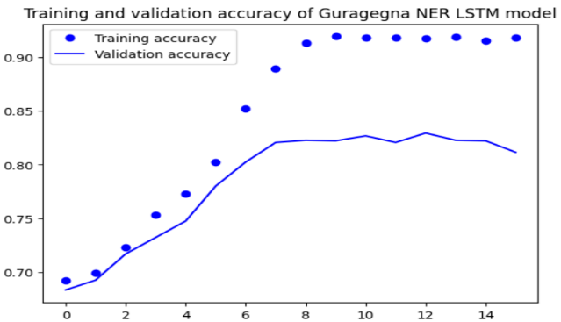
Figure 22:a) Training and validation accuracy
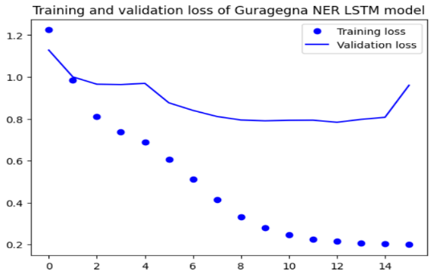
Figure 23: Training and validation loss
The Figure 6 10 below illustrates the test accuracy progression of the Guragega CNN-based Named Entity Recognition (NER) model trained using Word2Vec embeddings. From the figure, it is evident that the model experiences a steady improvement in accuracy during the initial training epochs, starting at approximately 71.5% and quickly rising above 80% by the second epoch. The accuracy continues to increase gradually, stabilizing around 82% in the later epochs.
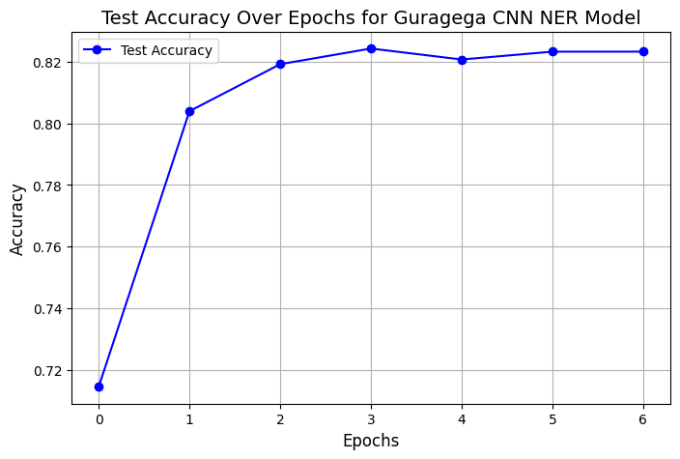
Figure 24: Test accuracy
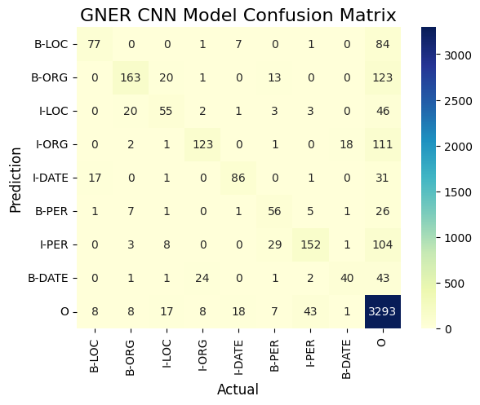
Figure 25: Confusion matrix after embedding and Sampling for CNN
Experiment3: implementation LSTM GNER Model Results Discussion With and Without Data Balances sampling technique used and word Embedding
As seen in Table 6-2 below, the researcher employed an 80:20 train-test split with a number of hyper-parameters. According to the experimental findings, a batch size of 32, an epoch of 20, a learning rate of 0.001, a dropout of 0.2, an activation function of softmax, and an Adam optimizer that makes use of the LSTM algorithm all produced good performance. The experimental results therefore show that the model performed well in this experiment, with training accuracy of 95.0% and validation accuracy of 89% prior to sampling and word embedding, and training accuracy of 96% and validation accuracy of 90% following Data Balances sampling and word embedding.
Before word embedding and data balances sampling, the LSTM's training and validation accuracy and loss curve
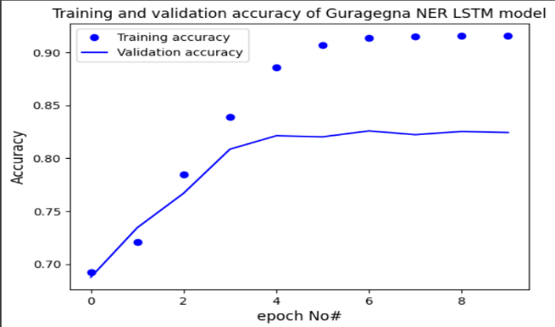
Figure 26: (a) Training and validation accuracy
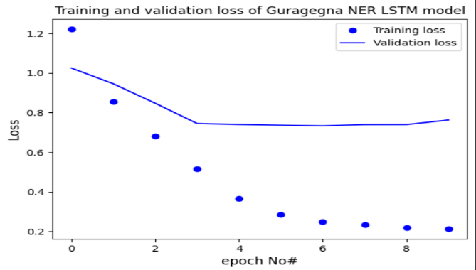
Figure 27:(b) Training and validation loss
After word embedding and data balances sampling, the LSTM's training and validation accuracy and loss curve
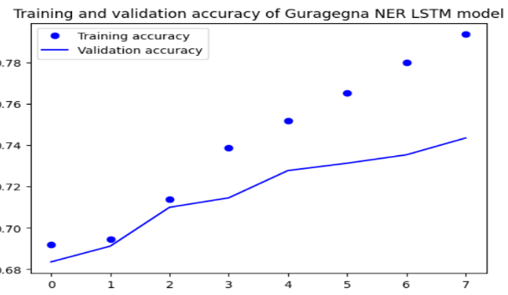
Figure 28:(a) Training and validation accuracy
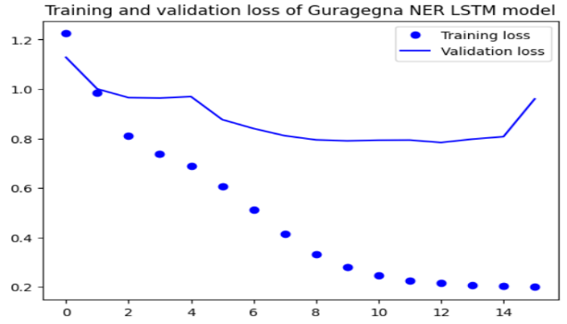
Figure 29: (b) Training and validation loss
The Figure 6 17 presents the test accuracy trend of the Guragega LSTM-based Named Entity Recognition (NER) model trained using Word2Vec embeddings. The model shows a consistent improvement in performance across the training epochs, beginning with an accuracy of around 69% and steadily rising above 82% by the fifth epoch. This upward trend indicates that the LSTM architecture effectively captures long-term dependencies and contextual information in the Guragega language when supported by the semantic richness of Word2Vec embeddings. The slight stabilization toward the later epochs suggests that the model has reached convergence, maintaining strong generalization without significant overfitting. Overall, the results demonstrate that the integration of LSTM with Word2Vec provides a robust framework for accurately identifying named entities in low-resource languages like Guragega, highlighting the model’s capability to learn and generalize linguistic patterns efficiently.
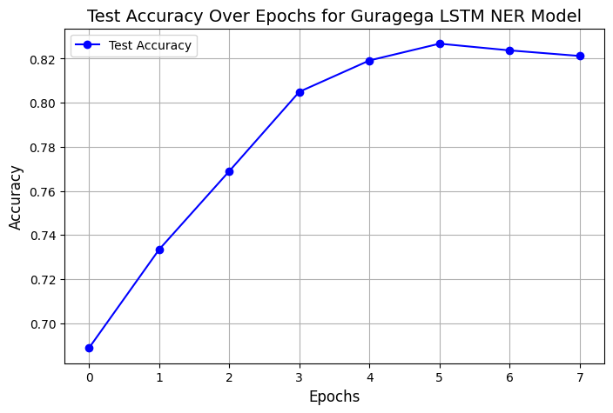
Figure 30: Test Accuracy
Confusion matrix for outperforming LSTM model
The confusion matrix for the GNER LSTM model indicates a model with competent learning capabilities but clear limitations in contextual understanding. It performs strongly in identifying non-entity tokens ('O' class) and shows respectable accuracy for distinct, self-contained tags. However, the model exhibits significant difficulty with two core NER challenges: entity boundary detection and class discrimination. A pronounced confusion exists between the beginning (B-) and inside (I-) tags of the same entity, such as B-ORG vs. I-ORG and B-PER vs. I-PER, revealing a struggle to correctly segment multi-word entities.
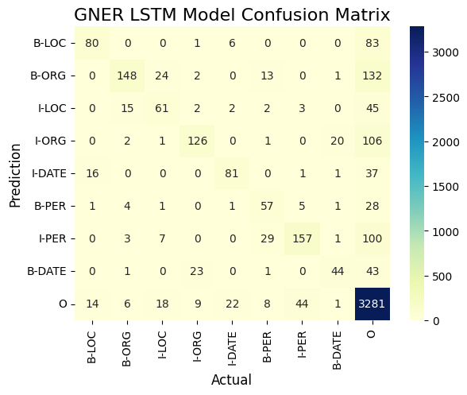
Figure 31: Confusion matrix after embedding and Sampling
Experiment4: implementation Bi-LSTM Model Results Discussion With and Without Sampling technique used and word Embedding
As seen in Table 6-2 below, the researcher employed an 80:20 train-test split with a number of hyper-parameters. According to the experimental findings, a batch size of 32, an epoch of 20, a learning rate of 0.001, a dropout of 0.2, an activation function of softmax, and an Adam optimizer that makes use of the Bi-LSTM algorithm all contributed to a decent performance. The experimental results therefore show that the model performed well in this experiment, with training accuracy of 96.0% and validation accuracy of 90% prior to sampling and word embedding, and training accuracy of 97% and validation accuracy of 92% following sampling and word embedding.
Before word embedding and data balances sampling, the Bi-LSTM's training and validation accuracy and loss curve
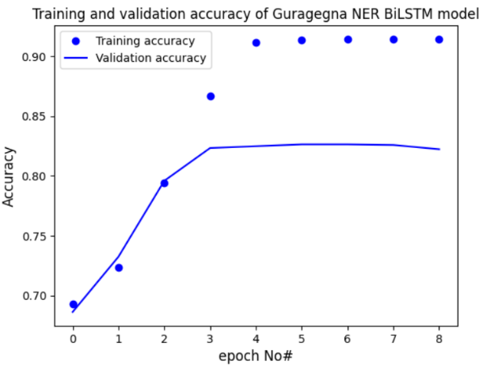
Figure 32:(a) Training and validation accuracy
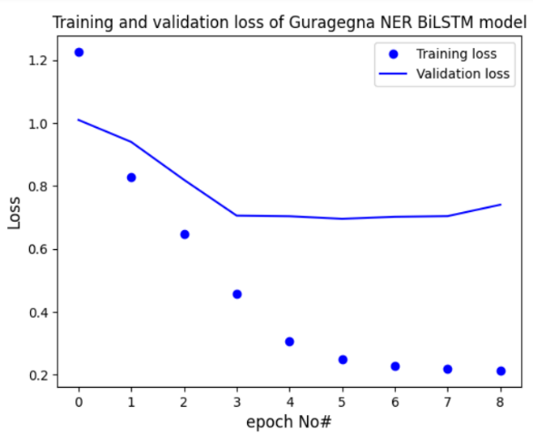
Figure 33:(b) Training and validation loss
After word embedding and data balances sampling, the Bi-LSTM's training and validation accuracy and loss curve
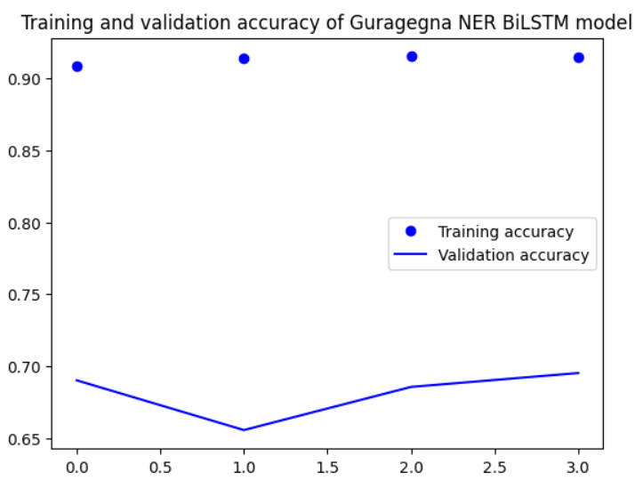
Figure 34:(a) Training and validation accuracy
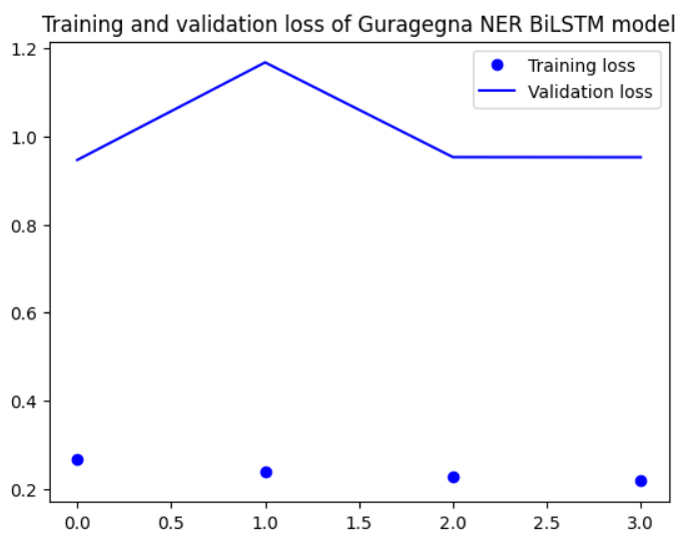
Figure 35:(b) Training and validation loss
The Guragega Bi-LSTM Named Entity Recognition (NER) model, utilizing Word2Vec embeddings, demonstrates strong learning performance across training epochs. As shown in the Figure 6 23, the model’s test accuracy steadily increases from around 0.69 in the first epoch to approximately 0.82 by the fourth epoch, after which it stabilizes with only minor fluctuations. This trend indicates that the Bi-LSTM architecture effectively captures contextual word representations from the Word2Vec embeddings, enabling it to better identify entities in the Guragega language text. The plateau in accuracy after several epochs suggests that the model has reached a point of convergence, achieving robust generalization without significant overfitting. Overall, the integration of Word2Vec with Bi-LSTM provides a solid foundation for sequence labeling tasks in low-resource languages like Guragega.
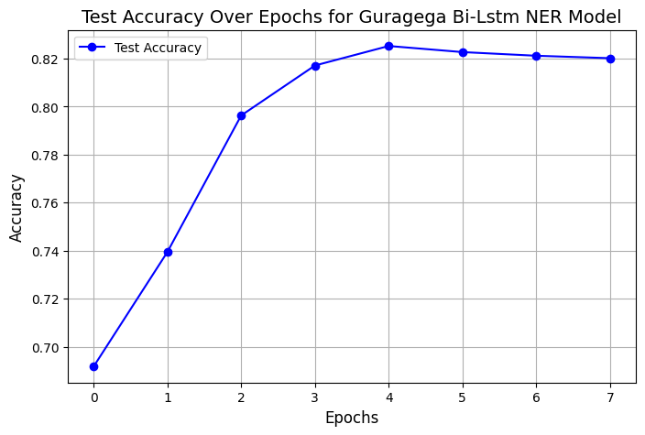
Figure 36: Test Accuracy
Confusion matrix for outperforming Bi-LSTM model
The confusion matrix for your Guragigna Named Entity Recognition (GNER) BiLSTM model reveals a model with strong overall performance . The most prominent success is the model's exceptional ability to identify non-entity words (the 'O' tag), correctly classifying 3,295 instances with very few false positives, which is crucial for the overall stability of the system. The model also demonstrates high proficiency in recognizing the beginnings of Organizations (B-ORG), with 169 correct identifications, and the internal parts of Person names (I-PER), with 145 correct hits.
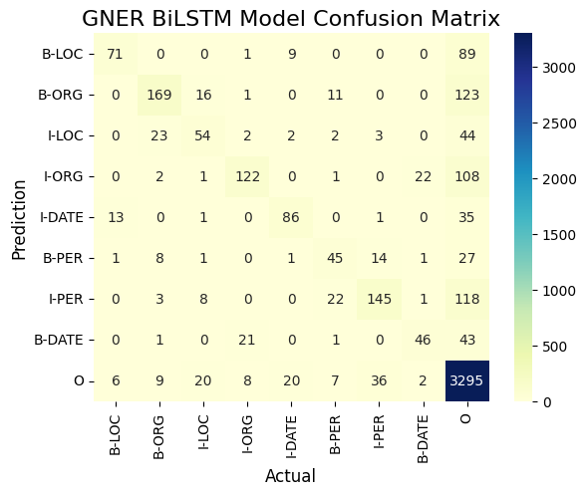
Figure 37: Confusion matrix Bi-Lstm after embedding and Sampling
Table 4: Summary of result for CNN,LSTM, Bi-LSTM,GRU
Model | Training accuracy | Testing Acuracy
CNN | 95% | 80%
LSTM | 96% | 82%
Bi-LSTM | 97% | 82.5%
GRU | 96% | 79.8%

Results and Discussions
In our conclusion, the experiments are conducted in the model to determine the proportion of training and test datasets. The researcher splited the data into 80:20.
CNN, LSTM, and Bi-LSTN GRU were the four algorithms used to train the model. employing a number of hyper-parameters, such as the number of hidden layers (2, 3, and 4), batch size (32, 64, and 118), optimization (Adam), activation function (ReLu and Soft max), dropout (0.1 and 0.2), learning rate (0.1, 0.01 and 0.001), loss function categorical cross-entropy, and epoch (20, 50, and 100). The accuracy of the model's training and validation was then assessed in an 80:20 split. Each model's loss during training and validation was also evaluated.
On datasets with longer sequences, CNN and LSTM GRU are generally reliable; however, Bi-LSTM is the most accurate method among the three. Bidirectional LSTM is better than all other algorithms since it checks faults in both directions and removes the vanishing gradient and exploding problem during training.[9]
Bi-LSTM is state-of-the-art for NLP applications and performs better than deep learning algorithms, according to numerous previous research. The researcher must address the research problems outlined in the first chapter in order to construct and develop a Named Entity Recognition model for the Guragigna language using a Deep Learning Approach and to meet the study's overall objective. To the best of our knowledge, this study is the first effort to use a deep learning approach to create a named entity recognition model for the Guragigna language. The researcher has tested the four deep learning models CNN, LSTM, Bi-LSTM, and GRU with the aid of the current dataset. 24,608 examples were collected for model training and validation in this study.
Furthermore, the experimental findings demonstrate that Bi-LSTM outperforms those other algorithms, and numerous prior investigations have also indicated that Bi-LSTM is better than other algorithms. Additionally, it is the most advanced technique for natural language processing applications. The researcher selected the Synthetic Minority Oversampling Technique data balances sampling technique and word embedding feature extraction methods after observing a number of data balances sampling techniques and feature extraction techniques.
In experiment one, SMOTE and Random Undersampling were employed, demonstrating that SMOTE is the most advantageous sampling technique for improving model performance. In experiment two, up to four Word2vec and one-hot encoding were used in this technique. Based on their performance in the experiment results for this research study, the word2vec feature extraction techniques were the most suitable and effective for creating a Named Entity Recognition model for the Guragigna language. Lastly, the researcher used the optimal hyperparameter value mentioned above in the experiment's results. Furthermore, the study evaluated the four models displayed in Table 6.2 above and achieved the maximum accuracy for the ideal values of the hyperparameters. Bi-LSTM models attained a 97% final training accuracy at that point. Thus, the researcher used performance assessment criteria to study these models. Lastly, the model shows an 84.5% validation accuracy.
Table 6: Results of LSTM ,Bi-LSTM and CNN
Train/Test split | Hyper parameters | Values | CNN Model Result
Train/Test split | Hyper parameters | Values | Before |  |  |  |  | After
Train/Test split | Hyper parameters | Values | Accuracy |  | Loss |  |  | Accuracy |  | Loss
Train/Test split | Hyper parameters | Values | Train | Val | Train | Val |  | Train | Val | Train | Val
80:  20 | Epoch | 20 | 94% | 88% | 0.12 | 0.59 |  | 95% | 89% | 0.10 | 0.41
80:  20 | Batch size | 32
80:  20 | Optimizer | Adam
80:  20 | Hidden Layer | 4 | LSTM Model Result
80:  20 | Hidden Layer | 4 | Before |  |  |  |  | After
80:  20 | Learning Rate | 0.001 | 95% | 89% | 0.13 | 0.51 |  | 96% | 90% | 0.09 | 0.30
80:  20 | Activation function | Soft-max
80:  20 | Activation function | Soft-max | Bi-LSTM Model Result
80:  20 | Activation function | Soft-max | Before |  |  |  | After
80:  20 | Los function | Categorical Crossentropy | 96% | 90 | 0.04 | 0.10 |  | 97% | 92% | 0.02 | 0.04

Summary
The study aimed to develop a Named Entity Recognition model for the Guragigna language using deep learning techniques. The dataset was split into 80:20 for training and testing, employing four algorithms: CNN, LSTM, Bi-LSTM, and GRU, with various hyperparameters such as hidden layers, batch size, optimization methods, activation functions, dropout rates, learning rates, and loss functions. The results indicated that the Bi-LSTM model outperformed the others in both accuracy and loss metrics. While CNN LSTM and GRU were reliable for longer sequences, Bi-LSTM's bidirectional approach effectively mitigated issues like vanishing and exploding gradients, making it the most accurate method. This study also marked the first attempt to create a deep learning-based NER model for the Guragigna language. The researcher selected the Synthetic Minority Oversampling Technique (SMOTE) as the most effective data balancing method, and Word2Vec was identified as the best feature extraction technique. Ultimately, the Bi-LSTM model achieved a final best training accuracy, demonstrating the effectiveness of the chosen methodologies and hyperparameter settings.

Conclusion
One use of natural language processing that aims to extract and categorize relevant information from text is named entity recognition. Ethiopia has carried out some NER research using a variety of approaches and classification algorithms. However, according to our thorough literature study, not much research has been done on NER for the Guragigna language. One of the languages spoken in Ethiopia is Guragigna. It has a vast morphology, but it is severely lacking in computational linguistic tools. The proposed research aims to devlop and construct a named entity recognition model for the Guragigna Language.
We used a range of techniques and procedures, such as literature reviews, data collection, model selection, identifying development tools, and performance analyses, to finish the research process for this work. People, places, dates, and organizations are the four primary named entities that we are now driven to extract from Guragigna literature. Convolutional neural networks, long short-term memory, and bi-directional long short-term memory Gated Recurrent Unit are the four algorithms we used to accomplish this.
With 95.4%, 92.4%, 95.3%, and 91.2% accuracy, precision, recall, and f1-score, respectively, and 99.4%, 97.3%, 99.2%, and 97.2% accuracy, precision, recall, and f1-score, respectively, following sampling and word embedding, we conclude that the experimental results show that Bi-LSTM performs better than those other algorithms. It is also the most sophisticated method for natural language processing applications. The experiment shows that the Bi-LSTM model can be used to find Named Entitles for Guragigna NER model construction.

References
[1] U. K. Sikdar and B. Gambäck, “Named entity recognition for amharic using stack-based deep learning,” Lect. Notes Comput. Sci. (including Subser. Lect. Notes Artif. Intell. Lect. Notes Bioinformatics), vol. 10761 LNCS, pp. 276–287, 2018, doi: 10.1007/978-3-319-77113-7_22.
[2] J. Li, A. Sun, J. Han, and C. Li, “A Survey on Deep Learning for Named Entity Recognition,” IEEE Trans. Knowl. Data Eng., vol. 34, no. 1, pp. 50–70, 2022, doi: 10.1109/TKDE.2020.2981314.
[3] A. S. Genemo, “School of Graduate Studies College of Natural Sciences Department of Computer Science Afaan Oromo Named Entity Recognition Using School of Graduate Studies College of Natural Sciences Department of Computer Science,” no. March, 2015.
[4] A. Ekbal and S. Bandyopadhyay, “Bengali named entity recognition using support vector machine,” IJCNLP 2008 Work. NER South South East Asian Lang. Proc. Work., no. January, pp. 51–58, 2008.
[6] A. Ababor Abafogi, “Boosting Afaan Oromo Named Entity Recognition with Multiple Methods,” Int. J. Inf. Eng. Electron. Bus., vol. 13, no. 5, pp. 51–59, 2021, doi: 10.5815/ijieeb.2021.05.05.
[8] D. Ashebir and G. Tadesse, “Named Entity Recognition for Hadiyya Language using BiLSTM-CRF Model,” Indian J. Sci. Technol., vol. 15, no. 47, pp. 2612–2618, 2022, doi: 10.17485/ijst/v15i47.1090.
[9] I. El Bazi and N. Laachfoubi, “Arabic named entity recognition using deep learning approach,” Int. J. Electr. Comput. Eng., vol. 9, no. 3, pp. 2025–2032, 2019, doi: 10.11591/ijece.v9i3.pp2025-2032.
[10] E. C. Jibril and A. C. Tantug, “ANEC: An Amharic Named Entity Corpus and Transformer Based Recognizer,” IEEE Access, vol. 11, pp. 15799–15815, 2023, doi: 10.1109/ACCESS.2023.3243468.
[11] T. Haile, “Devloping Automatic Character Recoginition System for Guragigna Printed Real-Life Document Addis Ababa, Ethiopia,” no. July, 2020.
[12] M. Ahimed, “Named Entity Recognition for Amharic Language Named Entity Recognition for Amharic,” L. LAMBERT Acad. Publ. (, no. October, p. Angeles, L., Advocacy, S., Location, O. (2002)., 2010.
[13] B. F. Shirko, “Part of Speech Tagging for Wolaita Language using Transformation Based Learning (TBL) Approach,” vol. 10, no. 9, pp. 27214–27222, 2020.
[14] A. R. Martinez, “Natural language processing,” Wiley Interdiscip. Rev. Comput. Stat., vol. 2, no. 3, pp. 352–357, 2010, doi: 10.1002/wics.76.
[15] Automatic Spoken Language Identification, “Natural Language Processing Course Guide,” pp. 2003–2004, 2004.
[16] J. Cowie and W. Lehnert, “Information Extraction,” Commun. ACM, vol. 39, no. 1, pp. 80–91, 1996, doi: 10.1145/234173.234209.
[17] N. Miranda, R. Raminhos, P. Seabra, and T. Gon, “Named Entity Recognition using Machine Learning techniques,” pp. 978–989, 2011.
[18] M. Ahmed, “NAMED ENTITY RECOGNITION FOR AMHARIC LANGUAGE,"," in International Conference on Computational Linguistics., Addis Abeba, 2010.”
[19] A. Bhandari, “https://www.analyticsvidhya.com/blog/2020 extraction/Information extraction: 29 June Published On 2020.”
[20] L. W. Augh, “Introduction to Linguistics’," New York: McGraw-Hill Book Company, , no. New York, 1977.”
[21] P. J. Masche, “Multilingual Information Extraction,” Science (80-. )., no. February, p. 58, 2004.
[22] A. Mansouri, L. S. Affendey, and A. Mamat, “Named Entity Recognition Approaches,” J. Comput. Sci., vol. 8, no. 2, pp. 339–344, 2008.
[23] G. D. Zhou and J. Su, “Named entity recognition using an HMM-based chunk tagger,” Proc. Annu. Meet. Assoc. Comput. Linguist., vol. 2002-July, no. July, pp. 473–480, 2002, doi: 10.3115/1073083.1073163.
[24] S. Naz, A. I. Umar, S. H. Shirazi, S. A. Khan, I. Ahmed, and A. A. Khan, “Challenges of Urdu named entity recognition: A scarce resourced language,” Res. J. Appl. Sci. Eng. Technol., vol. 8, no. 10, pp. 1272–1278, 2014, doi: 10.19026/rjaset.8.1095.
[25] B. Sundheim, G. Road, S. Diego, R. Grishman, and N. York, “Message U n d e r s t a n d i n g C o n f e r e n c e - 6 : A Brief History Ocean Surveillance Center Evaluation Division ( NRaD ) Short-term subtasks Portability,” New York.
[26] L. Kaplow and S. Shavell, “Summary of Contents,” Fairness versus Welf., pp. vii–viii, 2022, doi: 10.4159/9780674039315-001.
[27] S. G. Small and L. Medsker, “Review of information extraction technologies and applications,” Neural Comput. Appl., vol. 25, no. 3–4, pp. 533–548, 2014, doi: 10.1007/s00521-013-1516-6.
[28] G. Talukdar, P. P. Borah, and A. Baruah, “Supervised named entity recognition in Assamese language,” Proc. 2014 Int. Conf. Contemp. Comput. Informatics, IC3I 2014, no. November 2014, pp. 187–191, 2014, doi: 10.1109/IC3I.2014.7019728.
[29] P. Vadapalli, “https://www.upgrad.com/blog/machine-translation-innlp/.”
[30] S. Gebeyehu, W. Wolde, and Z. S. Shibeshi, “Information extraction model from Ge’ez texts,” Indones. J. Electr. Eng. Comput. Sci., vol. 30, no. 2, pp. 787–795, 2023, doi: 10.11591/ijeecs.v30.i2.pp787-795.
[31] R. Sriramulu, A. Yadav, and S. B. Pal, “Fast and ef fi cient indoor navigation : a hybrid path fi nding approach using rapidly-exploring random tree ( RRT ) - connect and Dijkstra ’ s algorithm,” 2025, doi: 10.7717/peerj-cs.3028.
[33] P. T. Dozier, “Name searching and information retrieval," in Proceedings of," National," Research Council Canada,, Vols. vol. 9,, no. Canada,, pp. no. 12, pp. pp. 134-140,, 1997.”
[34] L. T. B. L. Approach, “Part of Speech Tagging for Wolaita Language using Transformation based Part of Speech Tagging for Wolaita Language using Transformation Based Learning ( TBL ) Approach,” no. November, 2020.
[35] B. A. Benali, S. Mihi, I. El Bazi, and N. Laachfoubi, “New approach for Arabic named entity recognition on social media based on feature selection using genetic algorithm,” Int. J. Electr. Comput. Eng., vol. 11, no. 2, pp. 1485–1497, 2021, doi: 10.11591/ijece.v11i2.pp1485-1497.
[36] N. Kannaiya Raja, N. Bakala, and S. Suresh, “NLP: Rule based name entity recognition,” Int. J. Innov. Technol. Explor. Eng., vol. 8, no. 11, pp. 4285–4290, 2019, doi: 10.35940/ijitee.K2047.0981119.
[37] A. G. Ayana, “A. G. Ayana, ‘ Improving Brill’s Lexical Transformation Rule For Afan Oromo Language,’ MSc Thesis, no. Addis Ababa, , 2013.”.
[38] H. Woldemariam, “Revisiting Gamo : Linguists ’ classification versus self identification of the community,” vol. 5, no. 9, pp. 373–380, 2013, doi: 10.5897/IJSA2013.0471.
[39] F. F. Menuta, H. Universtiy, and F. A. Gobena, “L2/21-037,” no. January, 2021.
[40] F. Menuta, “The Morpheme j ə - in Gurage Morpho-Syntax,” vol. 24, no. 1, pp. 1–10, 2019, doi: 10.9790/0837-2401020110.
[41] Omer, “Amharic Named Entity Recognition System Using Statistical Method,” 2020, [Online]. Available: http://dspace.orghttp//hdl.handle.net/123456789/10756
[43] N. A. Chinchor, “OVERVIEW OF MUC-7/MET-2 Overviews of English and Multilingual Tasks,” Sci. Appl. Int. Corp., 1998.
[44] S. B. T. D. Singh, “S. B. Thoudam Doren Singh, ‘“Named Entity Recognition for Manipuri Using Support,” Vector Machine,’ 23rd Pacific Asia Conference on Language, Information and Computation, , p. p. 233 pp.,”
[45] A. MOGES, “School of Graduate Studies Faculty of Computer and Mathematical Sciences Department of Computer Science Named Entity Recognition for Amharic Language Named Entity Recognition for Amharic,” Sch. Grad. Stud. Fac. Comput. Math. Sci. Dep. Comput. Sci. Named Entity Recognit. Amharic Lang. Named Entity Recognit. Amharic, no. October, p. Angeles, L., Advocacy, S., Location, O. (2002)., 2010.
[47] B. Gardie and Z. Solomon, “INDIAN JOURNAL OF SCIENCE AND TECHNOLOGY Afan-Oromo Named Entity Recognition Using Bidirectional RNN,” no. 1, pp. 736–741, 2022.
[48] T. Fawcett and F. Provost, “Combining Data Mining and Machine Learning for Effective User Profiling,” Proc. - 2nd Int. Conf. Knowl. Discov. Data Mining, KDD 1996, pp. 8–13, 1996.
[49] N. V Chawla, K. W. Bowyer, L. O. Hall, and W. S. Philip Kegelmeyer, “synthetic minority over-sampling Technique,” J Artif Intell Res, vol. 16, p. 16, 2018.
[50] T. Wongvorachan, S. He, and O. Bulut, “A Comparison of Undersampling, Oversampling, and SMOTE Methods for Dealing with Imbalanced Classification in Educational Data Mining,” Inf., vol. 14, no. 1, 2023, doi: 10.3390/info14010054.
[51] G. Arboit and J. M. Robert, “From fixed-length messages to arbitrary-length messages practical rsa signature padding schemes,” Lect. Notes Comput. Sci. (including Subser. Lect. Notes Artif. Intell. Lect. Notes Bioinformatics), vol. 2020, pp. 44–51, 2001, doi: 10.1007/3-540-45353-9_4.
[52] T. Mikolov, K. Chen, G. Corrado, and J. Dean, “Efficient estimation of word representations in vector space,” 1st Int. Conf. Learn. Represent. ICLR 2013 - Work. Track Proc., pp. 1–12, 2013.
[53] E. Brill, “A Simple Rule-Based Part of Speech Tagger,” pp. 152–155.
[54] K. Samuel, “Randomized Rule Selection In Transformation-Based Learning :,” no. June, 2014, doi: 10.1017/S1351324901002662.
[55] “Yuunivarsiitii Haramaayaa , Haramaaya,” 2022.
[56] A. Ratnaparkhi, “Maximum Entropy Models for Natural Language Ambiguity Resolution,” 1998.
[57] K. Simran, S. Sriram, R. Vinayakumar, and S. Kp, “Deep Learning Approach for Intelligent Named Entity Recognition of Cyber Security,” pp. 1–10.
[58] Y. Dianti, “済無No Title No Title No Title,” Angew. Chemie Int. Ed. 6(11), 951–952., pp. 5–24, 2017.
[59] A. M. Tekla, “DEVELOPING PART-OF-SPEECH TAGGER MODEL FOR AFAAN OROMO LANGUAGE,” 2023.
[60] A. E. Richman and P. Schone, “Mining wiki resources for multilingual named entity recognition,” ACL-08 HLT - 46th Annu. Meet. Assoc. Comput. Linguist. Hum. Lang. Technol. Proc. Conf., no. June, pp. 1–9, 2008.
[61] A. Ratnaparkhi, “A Simple Introduction to Maximum Entropy Models for Natural Language Processing,” IRCS Tech. Reports Ser., no. May, p. 81, 1997.
[62] “T. Jalaj T. Jalaj, “T. Jalaj, Python, Natural Language Processing, Birmingham, Livery Place: Published by Packt Publishing Ltd. 2017,” Packt Publ. Ltd..
[63] A. Ayalew, “Design Event Extraction Model From Amharic Texts,” 2021.
[64] K. Choudhary et al., “Recent advances and applications of deep learning methods in materials science,” npj Comput. Mater., vol. 8, no. 1, 2022, doi: 10.1038/s41524-022-00734-6.
[65] A. Andualem and T. Tegegne, “Model From Amharic Texts,” no. October 2021, 2022.

