THE INFLUENCE OF GOAL ORIENTATIONS ON ONLINE MOTIVATION:
A PLS-SEM ANALYSIS

^{*1}Noor Hanim Rahmat (noorh763@uitm.edu.my)
²Haryana Mohd Hairi (haryana.hairi@uitm.edu.my)
³Nurazlina Samsudin (nuraz191@uitm.edu.my)
⁴ Nur Hazirah Rozali Annuar(nurha8558@uitm.edu.my)
⁵Hairul Amiza Binti Azman (hairulamiza@uitm.edu.my)
⁶Nurul Hasanah Binti Mohd Ta’at (nurulhasanah@uitm.edu.my)
⁷Normaizura Binti Mat Rom (normaizura@alam.edu.my)

Affiliation
¹Akademi Pengajian Bahasa, Universiti Teknologi MARA, Shah Alam, Malaysia
^{2,3,4,5}Faculty of Applied Sciences, Universiti Teknologi MARA Cawangan Johor, Kampus Pasir Gudang
⁶Faculty of Built Environment, Universiti Teknologi MARA Shah Alam
⁷Centre for Liberal Studies, Akademi Laut Malaysia

*CORRESPONDING AUTHOR: Noor Hanim Rahmat (noorh763@uitm.edu.my)

ABSTRACT
This study investigates the influence of intrinsic and extrinsic goal orientations on online motivation using Partial Least Squares Structural Equation Modeling (PLS-SEM). Grounded in Expectancy-Value Theory, Social Cognitive Theory, and Self-Determination Theory, the study examines how goal orientations affect three motivational dimensions: expectancy, value, and social support in online learning environments. A quantitative research design was employed, and data were collected through a questionnaire distributed to students from different academic clusters. The instrument measured expectancy, value, social support, intrinsic goal orientation, and extrinsic goal orientation using a five-point Likert scale. Data were analyzed using SmartPLS 4 through measurement and structural model assessments. The findings revealed that both intrinsic and extrinsic goal orientations significantly influenced expectancy, value, and social support. Intrinsic goal orientation showed a large effect on expectancy and a medium effect on value, indicating that internally motivated learners possess stronger confidence and perceive online learning as meaningful and beneficial. Extrinsic goal orientation demonstrated a large effect on value and a medium effect on social support, suggesting that external rewards and recognition positively encourage students’ participation in online learning. The model also showed strong predictive relevance and satisfactory reliability and validity. The findings support previous studies emphasizing the importance of motivation, self-efficacy, and supportive learning environments in enhancing online learning engagement. This study contributes to the understanding of online motivation and provides practical implications for educators in designing motivating and supportive digital learning environments.

KEYWORDS: Goal Orientation; Online Motivation; Intrinsic Motivation; Extrinsic Motivation; PLS-SEM

- INTRODUCTION.
Online learning has become increasingly important in modern education, especially following the rapid digital transformation in higher education after the COVID-19 pandemic. In online learning environments, students are required to demonstrate higher levels of self-regulation, persistence, and motivation to achieve academic success. Previous studies have shown that goal orientation plays a significant role in shaping students’ online learning experiences and outcomes. (Sudarnoto et al., 2025) found that learning motivation positively influenced students’ well-being in online learning and emphasized the importance of creating engaging online environments to enhance motivation. Similarly, (Husni, 2026) reported that intrinsic motivation significantly predicted students’ online learning performance, while extrinsic motivation showed a weaker but meaningful relationship with engagement. The study further highlighted the importance of autonomy-supportive digital learning environments that encourage students’ internal motivational processes. In addition, (Beik & Cho, 2024) revealed that goal orientation had significant relationships with learning immersion, participation, self-efficacy, and task value in online learning contexts.
Despite the growing body of literature on online motivation, several gaps remain in understanding how intrinsic and extrinsic goal orientations influence online motivation through expectancy, value, and social-support factors. Existing studies have primarily focused on general academic performance, engagement, or well-being without comprehensively examining the combined influence of goal orientations on motivational constructs in online learning environments. For example, (Han et al., 2025) investigated the mediating role of self-efficacy between achievement goal orientation and online engagement, while (Yeh et al., 2019) examined the relationship between achievement goal orientations, self-regulated learning strategies, and expected academic outcomes. However, limited studies have simultaneously explored expectancy, value, and social support as motivational dimensions within a single structural framework. Furthermore, few studies have employed Partial Least Squares Structural Equation Modeling (PLS-SEM) to examine the complex relationships among these variables. Therefore, this study seeks to address these gaps by investigating how intrinsic and extrinsic goal orientations influence online motivation using a PLS-SEM approach.
The research questions will be answered using SmartPLS analysis using both measurement and structural models. With reference to Table 1 below, 8 research objectives are mapped out to test the goodness of the model formed.

Table 1- Distribution of Research Objectives, Questions, and Hypotheses.

RO | RQ | RESEARCH  HYPOTHESIS
To investigate if there is a significant relationship between Extrinsic goal orientation and Expectancy | Is there a significant relationship between Extrinsic goal orientation and Expectancy? | Ho1: There is no significant relationship between Extrinsic goal orientation and Expectancy
To investigate if there is a significant relationship between Extrinsic goal orientation and Value | Is there significant effect between Extrinsic goal orientation and Value | Ho2: There is no significant between Extrinsic goal orientation and Value
To investigate if there is a significant relationship between Extrinsic goal orientation and Social Support | Is there effect significant between Extrinsic goal orientation and Social Support | Ho3: There is no significant between Extrinsic goal orientation and Social Support
To investigate if there is a significant relationship between Intrinsic goal orientation and Expectancy | Is there a significant relationship between Intrinsic goal orientation and Expectancy? | Ho4: There is no significant relationship between Intrinsic goal orientation and Expectancy
To investigate if there is a significant relationship between Intrinsic goal orientation and Value | Is there a significant relationship between Intrinsic goal orientation and Value? | Ho5: There is no significant relationship between Intrinsic goal orientation and Value
To investigate if there is a significant relationship between Intrinsic goal orientation and Social Support | Is there a significant relationship between Intrinsic goal orientation and Social Support? | Ho6: There is no significant relationship between Intrinsic goal orientation and Social Support
To investigate if there is a significant effect between Extrinsic goal orientation and all other motivational components (Expectancy, Value & Social Support) | Is there significant effect between Extrinsic goal orientation and all other motivational components (Expectancy, Value & Social Support) | Ho7: There is no significant effect between Extrinsic goal orientation and all other motivational components (Expectancy, Value & Social Support)
To investigate if there is a significant effect between Intrinsic goal orientation and all other motivational components (Expectancy, Value & Social Support) | Is there significant effect between Intrinsic goal orientation and all other motivational components (Expectancy, Value & Social Support) | Ho8: There is no significant between Intrinsic goal orientation and all other motivational components (Expectancy, Value & Social Support)

- LITERATURE REVIEW
  - Theoretical Framework
This study is anchored on three main theories. The theories are (i) Expectancy-Value, (ii) Social Cognitive, and (iii) Self-Determination.
    - Expectancy-Value Theory

Expectancy-Value Theory, developed by (Wigfield & Eccles, 2000) explains that learners’ motivation is influenced by two main factors: their expectation of success and the value they place on a task. According to the theory, students are more motivated to engage in learning activities when they believe they can succeed and when they perceive the task as useful, enjoyable, or important for their future goals. In the context of online learning, this theory is highly relevant because learners often study independently and require strong self-motivation to remain engaged. For example, online learners are more likely to participate actively in virtual classes, complete assignments, and persist through challenges when they feel confident in using digital platforms and believe that the course content will benefit their academic or career development. Conversely, if learners lack confidence in their abilities or perceive online activities as uninteresting or irrelevant, their motivation and participation may decline. Therefore, educators should design meaningful, interactive, and achievable online learning experiences to enhance students’ motivation and engagement.

    - Social Cognitive Theory and Online Motivation

Social Cognitive Theory, introduced by Bandura, 1971) emphasizes that learning occurs through the interaction of personal factors, behavior, and environmental influences. A key concept of this theory is self-efficacy, which refers to an individual’s belief in their ability to successfully perform a task. According to Bandura, learners who have high self-efficacy are more likely to set goals, persist in difficult tasks, and remain motivated despite challenges. In the context of online learning, Social Cognitive Theory is highly relevant because students often need to manage their own learning independently in virtual environments. Learners who feel confident in using technology and completing online tasks are more likely to participate actively in discussions, complete assignments on time, and stay engaged throughout the course. In addition, online motivation can be enhanced through social interaction, observation, and feedback from instructors and peers. For example, seeing classmates succeed in online activities can encourage other learners to believe they can also achieve success. Therefore, supportive online environments, positive feedback, and opportunities for collaboration are important in strengthening learners’ motivation and self-confidence in digital education.

    - Self-Determination Theory
One major theory that supports both intrinsic and extrinsic goal orientation in online motivation is the Self-Determination Theory (SDT) developed by (Ryan & Deci, 2000). SDT explains that learners are motivated by intrinsic factors, such as personal interest, enjoyment, curiosity, and satisfaction, as well as extrinsic factors, such as grades, rewards, recognition, or career advancement. In online learning environments, intrinsic motivation encourages learners to participate actively because they genuinely enjoy learning and value the knowledge gained. Meanwhile, extrinsic motivation can drive learners to complete online tasks to achieve external outcomes, such as certificates, academic success, or job opportunities. The theory also emphasizes the importance of autonomy, competence, and relatedness in maintaining motivation. When online courses provide learners with flexibility, supportive feedback, and meaningful interaction with instructors and peers, students are more likely to develop both intrinsic and extrinsic motivation. Therefore, Self-Determination Theory is widely used to explain how different goal orientations influence learners’ engagement, persistence, and success in online education.

  - Past Studies on Online Motivation
Past studies on online motivation have emphasized the important influence of intrinsic goal orientation on learners’ expectancy, value, and social support in online learning environments. (Husni, 2026) examined the roles of intrinsic and extrinsic motivation in students’ engagement and academic performance in online learning using Self-Determination Theory as the guiding framework. The findings revealed that intrinsic motivation had a positive and significant relationship with students’ online learning performance and engagement. Students who were internally motivated by personal interest, enjoyment, and self-development were more confident in completing online tasks, demonstrating stronger expectancy beliefs toward academic success. In addition, intrinsic motivation increased the value students attached to online learning activities because they perceived learning as meaningful and beneficial for personal growth. The study also highlighted the importance of autonomy-supportive online environments, suggesting that encouragement and interaction from instructors and peers strengthened learners’ motivation and participation. Similarly, (Sudarnoto et al., 2025) found that intrinsic motivation contributed significantly to students’ engagement and persistence in digital learning contexts, particularly when learners received positive academic and emotional support.
In contrast, previous studies also showed that extrinsic goal orientation plays an important role in influencing online motivation, although its effects may differ from intrinsic motivation. (Beik & Cho, 2024) reported in their meta-analysis that external rewards such as grades, recognition, and future career opportunities motivated students to engage in online learning activities. Learners with strong extrinsic goal orientations were more likely to participate actively when they expected positive academic outcomes and valued the external benefits associated with course completion. Extrinsic motivation was also influenced by social-support factors, as feedback, encouragement, and recognition from teachers, peers, and family members enhanced students’ willingness to remain engaged in online courses. However, the studies suggested that although extrinsic factors can increase participation and short-term persistence, intrinsic motivation remains a stronger predictor of long-term engagement, self-regulated learning, and sustained online academic success.
  - Conceptual Framework and Proposed Model of the Study
The conceptual framework (refer to Figure 1 below) for this study examines how goal orientations influence online motivation among learners using Partial Least Squares Structural Equation Modeling (PLS-SEM). The framework proposes that online motivation is shaped by three key motivational constructs: expectancy, value, and social support, which are grounded in the Expectancy-Value Theory developed by (Wigfield & Eccles, 2000) According to this theory, learners are more motivated to engage in online learning when they believe they can successfully perform learning tasks (expectancy) and when they perceive the tasks as meaningful, useful, or enjoyable (value). In addition, social support from instructors, peers, and family members can positively influence learners’ confidence, persistence, and participation in online learning environments. These constructs are therefore expected to contribute significantly to students’ online motivation and learning engagement.
The framework also incorporates intrinsic and extrinsic goal orientations as independent variables influencing online motivation, supported by the Self-Determination Theory (SDT) proposed by (Ryan & Deci, 2000). SDT explains that intrinsic goal orientation refers to learners’ internal desire to learn for personal satisfaction, curiosity, and self-development, whereas extrinsic goal orientation refers to engaging in learning activities for external rewards such as grades, recognition, or career advancement. In online learning contexts, learners with strong intrinsic and extrinsic motivations are more likely to remain engaged, self-regulated, and persistent in completing online tasks. Therefore, the proposed framework suggests that both goal orientations significantly influence learners’ online motivation through expectancy, value, and social-support factors.
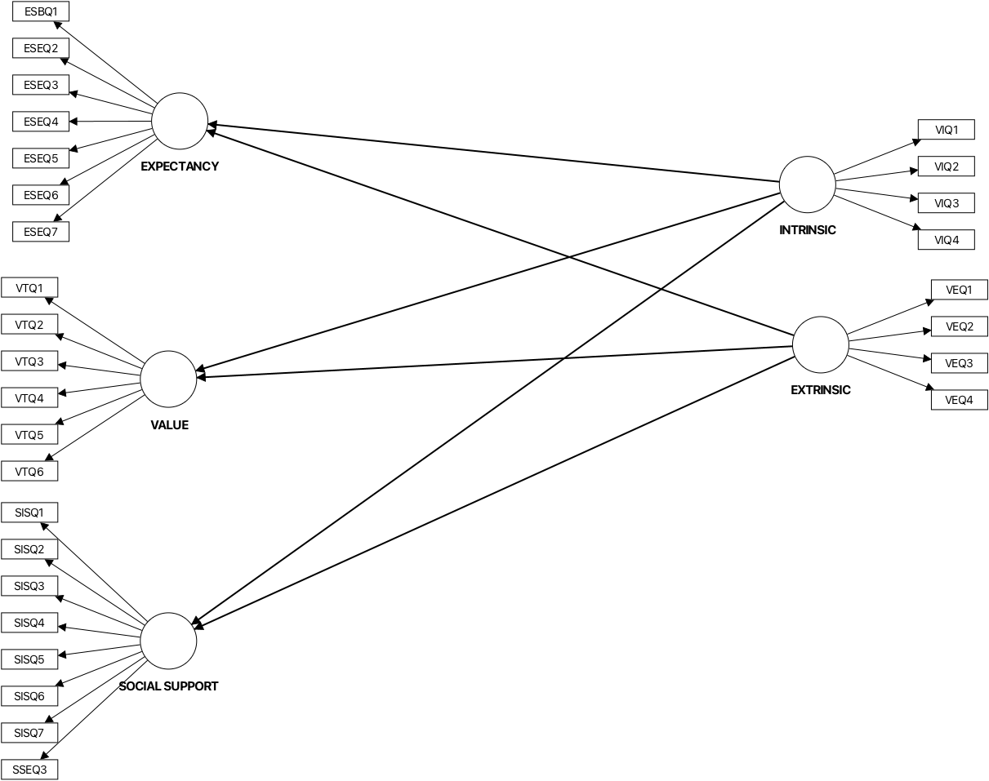
Figure 1- The Conceptual Framework of the Study

- METHODOLOGY
  - Research Design
This study employs a quantitative design. The research goal is to explore the influence of goal orientations on online motivation using PLS-SEM analysis. The model (Figure 1) chosen for this study is a hierarchical component model, Type II, which utilizes a combination of reflective-reflective models. According to (Fornell & Bookstein, 1982), a reflective model is employed when the construct is a trait and explains the indicators. This section presents an explanation for (i) the population and sample, (ii) the instrument used, and (iii) data collection and analysis.

    - Population and Sample
The demographic analysis of 305 participants is presented in percentages. According to Ziegenfuss (2021), researchers report demographic data in percentages to establish sample representatives and allow for generalizability to a larger population. Presenting in percentages also provides an overview of participants’ characteristics and offers a clear and understandable picture of the sample makeup

Table 2- Percentage for Demographic Profile
Question | Demographic Profile | Categories | Percentage (%)
1 | Gender | Male | 51%
 |  | Female | 49%
2 | Cluster | Science & Technology | 28%
 |  | Social Sciences, Humanities & Business | 72%

Table 2 above presents the demographic profile of the respondents based on gender and academic cluster. In terms of gender, the respondents were almost equally distributed, with males representing 51% and females accounting for 49% of the sample. This indicates a balanced participation between male and female students in the study. Regarding the academic cluster, most respondents were from the Social Sciences, Humanities, and Business cluster, comprising 72% of the participants, while 28% were from the Science and Technology cluster. The findings suggest that most respondents came from non-science academic backgrounds, which may influence perspectives and experiences related to online learning motivation.
    - Instrument

Table 3 presents the distribution of items included in the questionnaire. The instrument used a 5-point Likert scale, with scale 1 is never. Scale 2 represents rarely. Scale 3 represents sometimes, while scale 4 is often, and scale 5 is almost always.

Table 3- Distribution for Item in Instrument

SECTION | VARIABLE  MOTIVATION | CONSTRUCT | NO OF ITEMS
B | EXPECTANCY | Self-Efficacy | 7
C | VALUE | Task Value | 6
D | SOCIAL SUPPORT | Social Engagement & Instructor Support | 8
E | GOAL ORIENTATION | Intrinsic Goal Orientation | 4
 |  | Extrinsic Goal Orientation | 4
 |  |  | 29

The questionnaire (Table 3) , adapted from Fowler (2018)comprises variables representing the Expectancy (7 items) , Value (6 items) , Social Support 8 items) , and Goal Orientation (8 items).

    - Data Collection and Data Analysis
Data is collected via a Google Form. The data is then analyzed using SmartPLS 4 through two main stages. As suggested by Hair,et.al. 2017), data analysis is done at two levels: the measurement and structural model. The first stage is the measurement model, which measures the outer model. The second stage is the structural model, which measures the inner model. The analyzed data is used to answer the research questions and to confirm the model chosen.

- FINDINGS
The findings are presented in two stages. The first stage presents the measurement model, and the third stage reveals the structural model as well as answers research questions.

  - Measurement Model
In SmartPLS, the measurement model assesses the reliability and validity of the constructs. This is done by examining the relationships between them and their observable behavior. The measurement model measures the outer model. Figure 3 below shows the measurement model for this study. Further detailed explanation of this model is elaborated in the tables below.

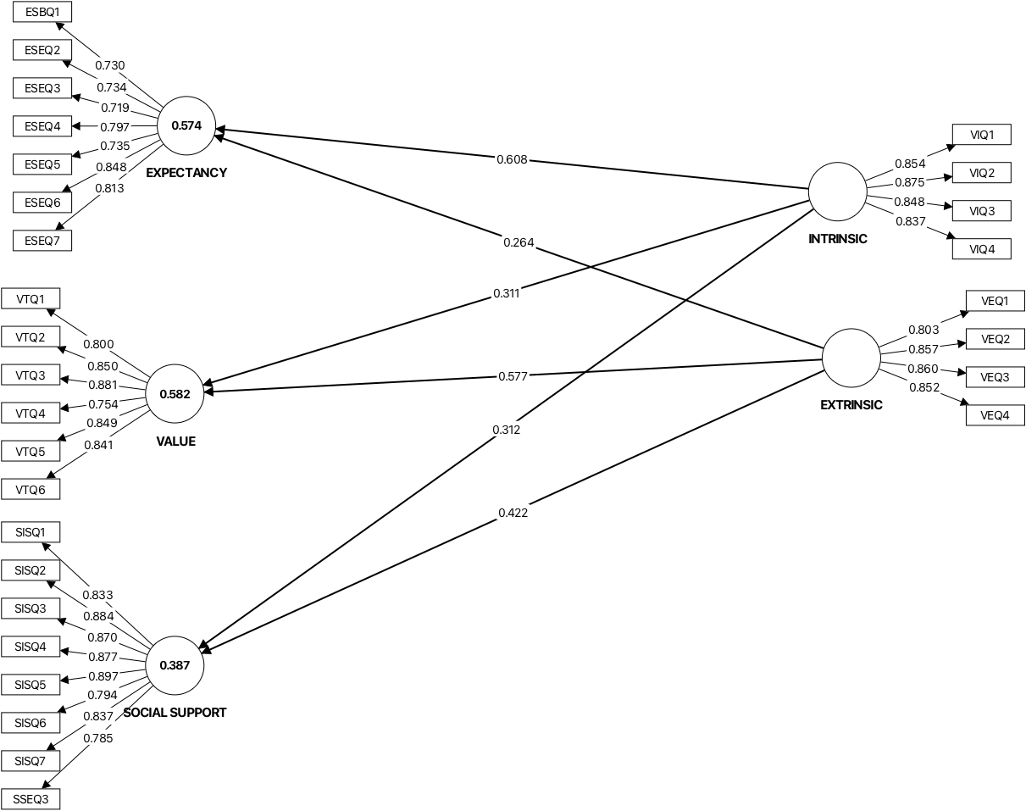
Figure 3- Measurement Model

    - Reliability

According to Ringle & Sarstedt (2016), reliability is assessed by checking indicator reliability and internal consistency reliability. Internal consistency is done using Composite reliability (rho_c) and Cronbach’s Alpha. The cut-off value for Cronbach’s Alpha is 0.70 to 0.90. The cut-off values for composite reliability (rho_c) are 0.70-0.90. For indicator reliability, the factor loadings cut-off values are >0.70 and squared loadings ≥0.50. Finally, the cut-off values for Average Variance Extracted (AVE) ≥0.50. Results presented below are categorized into (i) Extrinsic Motivation, (ii) Intrinsic Motivation, (iii) Expectancy, (iv) Value, and (v) Social Support.

- Table 4 -Results for Reliability- Extrinsic Motivation

CONSTRUCT/  ITEM | FACTOR LOADING | CRONBACH’S ALPHA | COMPOSITE RELIABILITY (rho_c) | AVERAGE VARIANCE EXTRACTED (AVE)
 |  | 0.864 | 0.908 | 0.711
VEQ1 | 0.803
VEQ2 | 0.857
VEQ3 | 0.86
VEQ4 | 0.852

Table 4 presents the reliability results for Extrinsic Motivation. Factor loading of all items was found to be between 0.803 and 0.86. The loadings comply with the indicator reliability of more than 0.7. Next, the Cronbach’s Alpha for Extrinsic Motivation is 0.864, composite reliability is 0.908 and AVE is 0.711.

- Table 3 -Results for Reliability- Intrinsic Motivation

CONSTRUCT/  ITEM | FACTOR LOADING | CRONBACH’S ALPHA | COMPOSITE RELIABILITY (rho_c) | AVERAGE VARIANCE EXTRACTED (AVE)
 |  | 0.876 | 0.915 | 0.729
VIQ1 | 0.854
VIQ2 | 0.875
VIQ3 | 0.848
VIQ4 | 0.837

Table 3 presents the reliability results for Intrinsic Motivation. Factor loading of all items was found to be between 0.837 and 0.875. The loadings comply with the indicator reliability of more than 0.7. Next, the Cronbach’s Alpha for Intrinsic Motivation is 0.876, the composite reliability is 0.915, and the AVE is 0.729.

- Table 5 -Results for Reliability- Expectancy

CONSTRUCT/  ITEM | FACTOR LOADING | CRONBACH’S ALPHA | COMPOSITE RELIABILITY (rho_c) | AVERAGE VARIANCE EXTRACTED (AVE)
 |  | 0.884 | 0.91 | 0.592
ESBQ1 | 0.73
ESEQ2 | 0.734
ESEQ3 | 0.719
ESEQ4 | 0.797
ESEQ5 | 0.735
ESEQ6 | 0.848
ESEQ7 | 0.813

Table 5 presents the reliability results for Expectancy. Factor loading of all items was found to be between 0.719 and 0.848. The loadings comply with the indicator reliability of more than 0.7. Next, the Cronbach’s Alpha for Expectancy is 0.884, the composite reliability is 0.91, and the AVE is 0.592.

- Table 6 -Results for Reliability- Value
CONSTRUCT/  ITEM | FACTOR LOADING | CRONBACH’S ALPHA | COMPOSITE RELIABILITY (rho_c) | AVERAGE VARIANCE EXTRACTED (AVE)
 |  | 0.909 | 0.93 | 0.689
VTQ1 | 0.8
VTQ2 | 0.85
VTQ3 | 0.881
VTQ4 | 0.754
VTQ5 | 0.849
VTQ6 | 0.841

Table 6 presents the reliability results for the Value. Factor loading of all items was found to be between 0.8 and 0.881. The loadings comply with the indicator reliability of more than 0.7. Next, the Cronbach’s Alpha for Value is 0.909, the composite reliability is 0.93, and the AVE is 0.689.

- Table 7 -Results for Reliability- Social Support
CONSTRUCT/  ITEM | FACTOR LOADING | CRONBACH’S ALPHA | COMPOSITE RELIABILITY (rho_c) | AVERAGE VARIANCE EXTRACTED (AVE)
 |  | 0.944 | 0.953 | 0.719
SISQ1 | 0.833
SISQ2 | 0.884
SISQ3 | 0.87
SISQ4 | 0.877
SISQ5 | 0.897
SISQ6 | 0.794
SISQ7 | 0.837

Table 7 presents the reliability results for the Social Support. Factor loading of all items was found to be between 0.794 and 0.884. The loadings comply with the indicator reliability of more than 0.7. Next, the Cronbach’s Alpha for Social Support is 0.944, the composite reliability is 0.953, and the AVE is 0.719.

    - Validity

According to Ramayah et al. (2018), for validity, the Discriminant validity (HTMT) needs to be <0.85 or <0.90.

Table 8- Discriminant Validity (HTMT)
 | EXPECTANCY | EXTRINSIC  Goal Orientation | INTRINSIC  Goal Orientation | SOCIAL SUPPORT
EXTRINSIC  Goal Orientation | 0.593
INTRINSIC  Goal Orientation | 0.81 | 0.483
SOCIAL SUPPORT | 0.664 | 0.608 | 0.537
VALUE | 0.701 | 0.795 | 0.622 | 0.726

Table 8 presents the discriminant validity of the model. The HTMT for connectedness and autonomy is 0.889 and is therefore valid.
The HTMT for Extrinsic Goal Orientation and Expectancy is 0.593. HTMT for Intrinsic Goal orientation and Expectancy is 0.81, Intrinsic Goal orientation and Extrinsic Goal Orientation is 0.483. Next, the HTMT for Social Support and Expectancy is 0.664, for Social Support and Extrinsic Goal Orientation is 0.608, and for Social Support and Intrinsic Goal Orientation is 0.537. Lastly, The HTMT for Value and Expectancy is 0.701, for Value and Extrinsic Goal Orientation is 0.795, for Value and Intrinsic Goal Orientation is 0.622, and for Value and Social Support is 0.726.

  - Structural Model

In SmartPLS, the structural model visualizes the hypothesized causal relationships between constructs. The structural model is thus formed after the researcher has established the reliability and validity of the measurement model. For the analysis of the structural model, the researcher runs bootstrapping and examines the (i) collinearity, (ii) path coefficients of determination, (iii) effect size, (iv) PLS predict, and (v) IPMA. In addition to that, the analysis in the structural model allows the researcher to answer research questions 1-8 and hypotheses 1-8. Figure 4 below shows the structural model for this study. Detailed explanation is elaborated in the tables below.

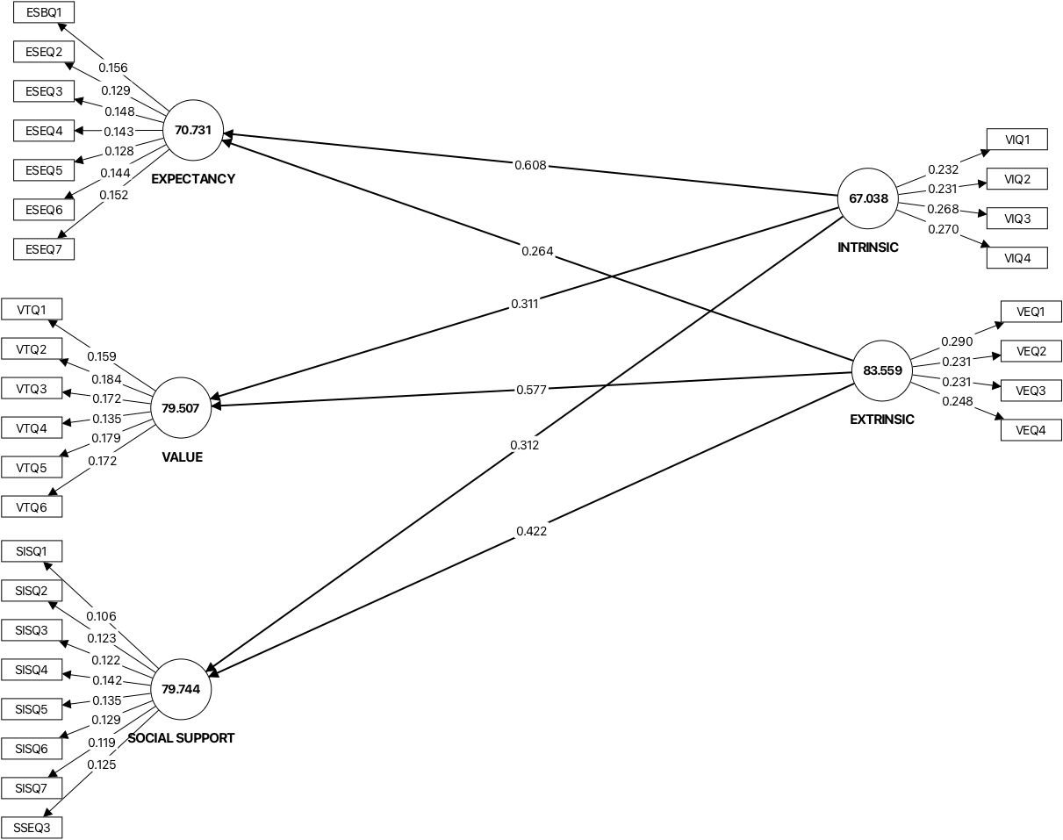

Figure 4- Structural Model

    - Collinearity

According to Ringle & Sarstedt (2016), the cut-off value for collinearity inner model VIF is ≤ 5.0.

Table 8- Collinearity
 | Original sample (O)
EXTRINSIC -> EXPECTANCY | 1.216
EXTRINSIC -> SOCIAL SUPPORT | 1.216
EXTRINSIC -> VALUE | 1.216
INTRINSIC -> EXPECTANCY | 1.216
INTRINSIC -> SOCIAL SUPPORT | 1.216
INTRINSIC -> VALUE | 1.216
EXTRINSIC -> EXPECTANCY | 1.216

Table 9 above presents the collinearity results for this study. According to Ringle et al. (2024), the inner model VIF must be less than or equal to 5.0. All interactions met the threshold for Collinearity.

    - Coefficients of determination (R²)

According to (Ramayah et al., 2018)For coefficients of determination (R²) range from 0.2 to 0;7, depending on the field of study. Social Sciences & Economics follows the range above.

Table 10-R²

 | Original sample (O)
EXPECTANCY | 0.574
SOCIAL SUPPORT | 0.387
VALUE | 0.582

Table 10 shows the results for coefficients of determination (R²). Results indicate that the R² for Expectancy is 0.574(57%), for Social Support is 0.387 (39%), and Value is 0.582 (58%).

    - P-Value

Table 11- Interpretation for p-value
Thresholds | Interpretation | Decision
p ≤ 0.05 | Often considered statistically significant | Reject H₀
p ≤ 0.01 | Indicates very strong evidence against H₀ | Reject H₀
p> 0.05 | Weak or no evidence against H₀ | Fai to reject H₀

According to Goodman (1999), a threshold of p-value is the cut-off for determining statistical significance, most commonly set at 0.05. Below is the table that interprets the threshold.
Table 11 shows the interpretation for p=value. According to Goodman (1999), if the p-value is p ≤ 0.05, the data is often considered statistically significant, and the null hypothesis is rejected. If it is p ≤ 0.01, then it indicates very strong evidence to reject the null hypothesis (H₀₎. However, a p> 0.05 is considered weak, and there is no evidence to reject the null hypothesis.

Table 11- Interpretation for p-value
Thresholds | Interpretation | Decision
p ≤ 0.05 | Often considered statistically significant | Reject H₀
p ≤ 0.01 | Indicates very strong evidence against H₀ | Reject H₀
p> 0.05 | Weak or no evidence against H₀ | Fail to reject H₀

Table 12-Path Coefficient for the current study

 | T statistics (|O/STDEV|) | P values
EXTRINSIC -> EXPECTANCY | 4.664 | 0
EXTRINSIC -> VALUE | 13.523 | 0
EXTRINSIC -> SOCIAL SUPPORT | 5.424 | 0
INTRINSIC -> EXPECTANCY | 11 | 0
INTRINSIC -> VALUE | 7.031 | 0
INTRINSIC -> SOCIAL SUPPORT | 3.927 | 0

Table 12 presents data to answer research questions and hypotheses. Path coefficients are presented in beta and t-value. The significant value (t-statistic) must be more than 1.65, and p-values must be less than 0.05 to show significant relationships.
The p-value for EXTRINSIC -> EXPECTANCY is p=0 (t=4.664); for EXTRINSIC -> SOCIAL SUPPORT is p=0 (t=5.424); for EXTRINSIC -> VALUE is p=0 (t=13.523), and INTRINSIC -> EXPECTANCY is p=0 (t=11). The p-value for INTRINSIC -> SOCIAL SUPPORT is p=0 (t=3.927), and for INTRINSIC -> VALUE, p=0 (t=7.031). Hence, all paths indicate significant relationships

    - Effect Size (f²)

According to Ramayah et al. (2018), the cutoff values for effect sizes (f²) are 0.02 (small), 0.15 (medium), and 0.35 (large). This section presents data to answer research questions and hypotheses.

According to (C. M. Ringle & Sarstedt, 2016) for effect size, values from 0.02 to 0.15 are considered small. Values between 0.15 to 0.35 are considered medium while values 0.35 and above are considered large.

Table 13- Effect Size
 | Original sample (O) | Interpretation
EXTRINSIC -> EXPECTANCY | 0.134 | small
EXTRINSIC -> SOCIAL SUPPORT | 0.239 | medium
EXTRINSIC -> VALUE | 0.655 | large
INTRINSIC -> EXPECTANCY | 0.714 | large
INTRINSIC -> SOCIAL SUPPORT | 0.131 | small
INTRINSIC -> VALUE | 0.19 | medium

With reference to Table 12 above, H₀₇ and H₀₈ are rejected. Results indicate that there are small effect sizes for EXTRINSIC -> EXPECTANCY, and INTRINSIC -> SOCIAL SUPPORT. There are medium effect sizes for EXTRINSIC -> SOCIAL SUPPORT, and INTRINSIC -> VALUE. Lastly, there are large effect sizes for EXTRINSIC -> VALUE, and INTRINSIC -> EXPECTANCY.

    - PLS Predict (Q²)

In PLS-SEM, it is stated that Q² ≥ 0 (Ringle et.al., 2024). Table 18 below reveals the PLS Predict (Q²) for the dependent variable. The analysis reveals the Q² for all items in the dependent variable -connectedness.

Table 14- PLS Predict (Q²)
 | Q²predict | RMSE | MAE
EXPECTANCY | 0.561 (large) | 0.672 | 0.486
SOCIAL SUPPORT | 0.363 (large) | 0.811 | 0.582
VALUE | 0.576 (large) | 0.661 | 0.508

Table 14 above shows the results for Q² Predict in the study. According to Cohen (1988), Q² Predict is used to interpret the magnitude of the predictive relevance. For Q² > 0 indicates the model has predictive relevance. Secondly, 0.02 indicates small predictive relevance. Next, 0.15 indicates medium predictive relevance. Finally, 0.35 indicates large predictive relevance. Results for Table 14 that all variables indicate predictive relevance. There was a large predictive relevance for Expectancy, Social Support, and Value. The results, therefore, confirm the goodness of the model predicted in this study.

    - IPMA

IPMA or Importance-Performance Matrix Analysis. According to (C. M. Ringle & Sarstedt, 2016), IPMA is used to evaluate the performance and importance of the chosen constructs or indicators within a model. In the context of this study, individual IPMA analysis was done on each construct and reported in Tables 14 & 15.

Table 14- PLS PREDICT for Importance
Interaction | Total effects
EXTRINSIC -> EXPECTANCY | 0.264
INTRINSIC -> EXPECTANCY | 0.608
EXTRINSIC -> VALUE | 0.577
INTRINSIC -> VALUE | 0.311
EXTRINSIC -> SOCIAL SUPPORT | 0.422
INTRINSIC -> SOCIAL SUPPORT | 0.312

Table 15- Latent Variables Average Performance (Performance)
Variable | LV performance value, average
EXTRINSIC | 83.559
INTRINSIC | 67.038
EXPECTANCY | 70.731
VALUE | 79.507
SOCIAL SUPPORT | 79.744

According to (Hauf, 2024), for PLS-SEM IPMA (Importance-Performance Map Analysis), there isn’t a single "good score," but rather constructs with high importance (total effects) but low performance scores (rescaled 0-100) are key areas for improvement, indicating high potential for managerial action, while high importance/high performance is good, and low importance/low performance means less priority. Performance scores range from 0 to 100, with higher values showing better attainment, but you interpret them relative to their importance.

Figure 5- Importance -Performance Map for Expectancy
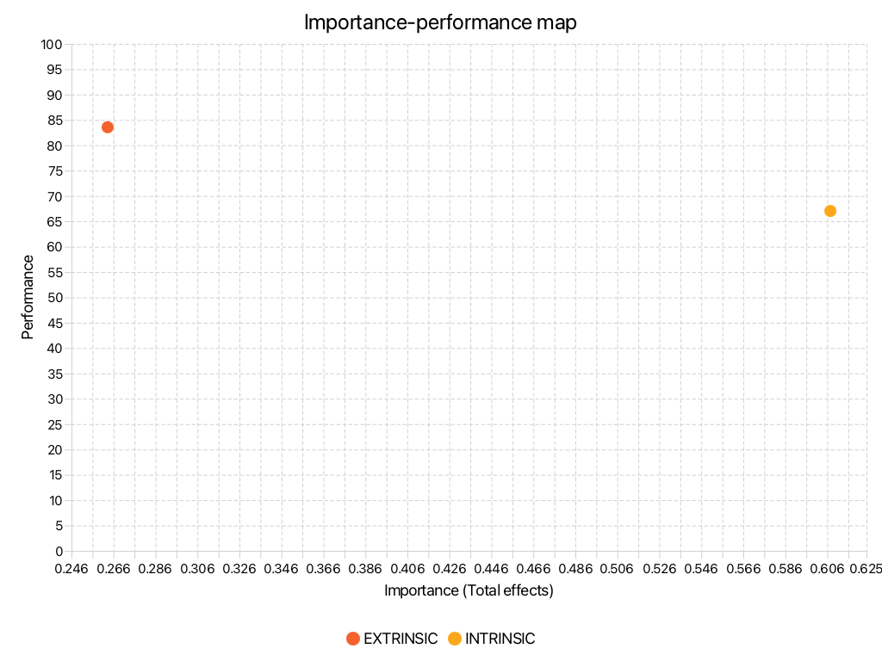

Figure 5 above shows of the importance and performance analysis for Expectancy. When paired with Extrinsic Goal Orientation, there is Low Importance/High Performance (Importance = 0.264; Performance = 83.559). When Expectancy is paired with Intrinsic Goal Orientation, there is High Importance/High Performance (Importance = 0.608; Performance = 67.030).

Figure 6- Importance-Performance Map for Value

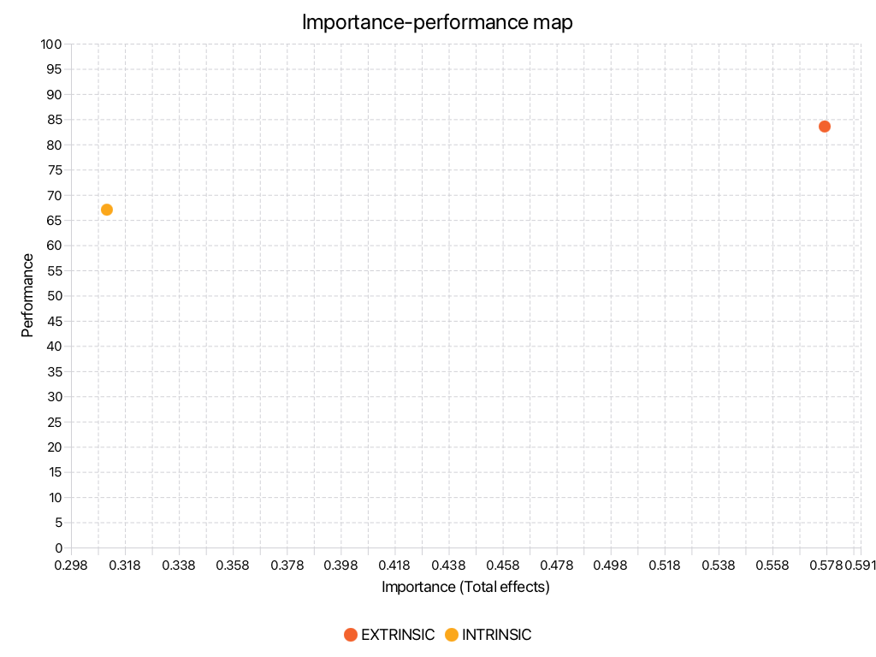
Figure 6 above shows the importance and performance analysis for Value. When paired with Extrinsic Goal Orientation, there is High Importance/High Performance (Importance = 0.577; Performance = 83.559). When Value is paired with Intrinsic Goal Orientation, there is Low Importance/Moderate Performance (Importance = 0.311; Performance = 67.038).

. Figure 7- Importance-Performance Map for Social Support
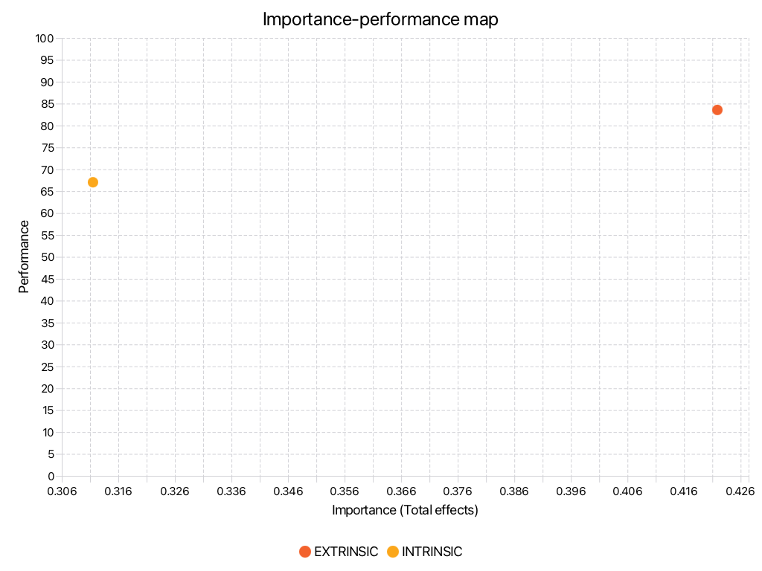

Figure 7 above shows the importance and performance analysis for Social Support. When paired with Extrinsic Goal Orientation, there is Moderate Importance/High Performance (Importance = 0.422; Performance = 83.559). When Social Support is paired with Intrinsic Goal Orientation, there is Low Importance/Moderate Performance (Importance = 0.312; Performance = 67.038).

5.0 CONCLUSION
5.1 Summary of Findings and Discussions

Table 14- Outcome of Research Hypothesis
NO | Research Question | Research Hypothesis | Outcome
1 | Is there a significant relationship between Extrinsic goal orientation and Expectancy? | Ho1: There is no significant relationship between Extrinsic goal orientation and Expectancy | Reject null hypothesis. There is a significant relationship between Extrinsic goal orientation and Expectancy.
2 | Is there significant effect between Extrinsic goal orientation and Value | Ho2: There is no significant between Extrinsic goal orientation and Value | Reject null hypothesis. There is a significant relationship between Extrinsic goal orientation and Value.
3 | Is there effect significant between Extrinsic goal orientation and Social Support | Ho3: There is no significant between Extrinsic goal orientation and Social Support | Reject null hypothesis. There is a significant relationship between Extrinsic goal orientation and Social Support.
4 | Is there a significant relationship between Intrinsic goal orientation and Expectancy? | Ho4: There is no significant relationship between Intrinsic goal orientation and Expectancy | Reject null hypothesis. There is a significant relationship between Intrinsic goal orientation and Expectancy.
5 | Is there a significant relationship between Intrinsic goal orientation and Value? | Ho5: There is no significant relationship between Intrinsic goal orientation and Value | Reject null hypothesis. There is a significant relationship between Intrinsic goal orientation and Value.
6 | Is there a significant relationship between Intrinsic goal orientation and Social Support? | Ho6: There is no significant relationship between Intrinsic goal orientation and Social Support | Reject null hypothesis. There is a significant relationship between Intrinsic goal orientation and Social Support
7 | Is there significant effect between Extrinsic goal orientation and all other motivational components (Expectancy, Value & Social Support) | Ho7: There is no significant effect between Extrinsic goal orientation and all other motivational components (Expectancy, Value & Social Support) | Reject null hypothesis. There is a significant effect between Extrinsic goal orientation and all other motivational components (Expectancy, Value & Social Support)  Extrinsic-> Expectancy=small  Extrinsic->Value=medium  Extrinsic->Social Support= Large
8 | Is there significant effect between Intrinsic goal orientation and all other motivational components (Expectancy, Value & Social Support) | Ho8: There is no significant between Intrinsic goal orientation and all other motivational components (Expectancy, Value & Social Support) | Reject null hypothesis. There is a significant relationship between Intrinsic goal orientation and all other motivational components (Expectancy, Value & Social Support)  Extrinsic-> Expectancy=large  Extrinsic->Value=small  Extrinsic->Social Support=medium

Table 14 above shows the presentation of the outcome of the research questions and hypotheses. The null hypothesis is rejected for all 1-8. The findings of this study confirm that both intrinsic and extrinsic goal orientations significantly influence online motivation through expectancy, value, and social-support factors. Using PLS-SEM analysis, all eight hypotheses were supported, indicating significant relationships between goal orientations and the motivational constructs examined. The results showed that intrinsic goal orientation had a large effect on expectancy and a medium effect on value, suggesting that students who are internally motivated are more confident in their ability to succeed and perceive online learning as meaningful and beneficial. Extrinsic goal orientation, on the other hand, demonstrated a large effect on value and a medium effect on social support, indicating that external rewards such as grades, recognition, and achievement can encourage learners to engage actively in online learning environments. These findings are consistent with the studies by Husni (2026), who reported that intrinsic motivation was the strongest predictor of online learning performance, and Beik and Cho (2024), who found significant relationships between goal orientation, task value, self-efficacy, and participation in online learning. Furthermore, the findings also support the work of Yeh et al. (2019) and Han et al. (2025), which emphasized the importance of self-efficacy, supportive learning behaviors, and achievement goals in enhancing online learning engagement.

5.2 Implications and Suggestions for Future Research
Figure 8 below presents the proposed model for the influence of goal orientations on online motivation using PLS-SEM analysis. This study has shown that Extrinsic and Intrinsic goal orientations bear influence on Expectancy, Value and Social Support in online learning.

Figure 8- The Proposed Model
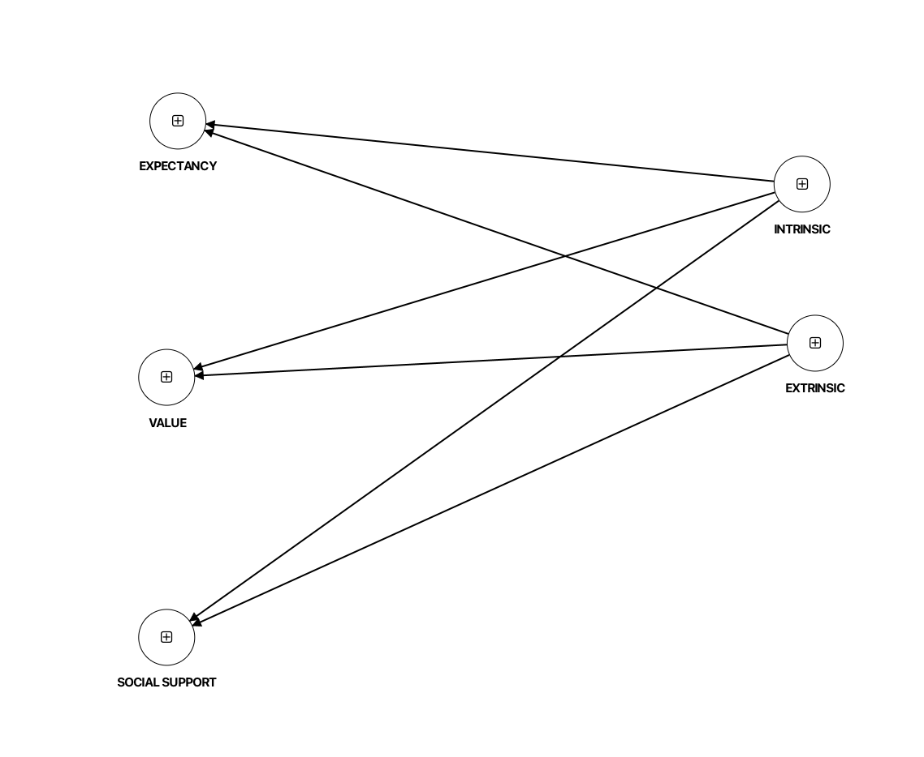

This study contributes theoretically and practically to the understanding of online motivation in higher education. The integration of Expectancy-Value Theory, Social Cognitive Theory, and Self-Determination Theory provides a comprehensive framework for explaining how motivational factors influence students’ engagement in online learning. Practically, the findings suggest that educators and institutions should design online learning environments that foster both intrinsic and extrinsic motivation. Instructors can enhance intrinsic motivation by promoting autonomy, curiosity, and meaningful learning experiences, while extrinsic motivation can be strengthened through constructive feedback, recognition, and clear academic goals. In addition, supportive online interactions and instructor guidance should be emphasized to improve students’ expectancy beliefs and persistence in digital learning contexts.
Future research may expand this study by including larger and more diverse samples from different educational institutions and cultural settings to improve the generalizability of the findings. Researchers may also examine additional motivational variables such as self-regulated learning, academic resilience, or technological readiness to better understand online learning behavior. Moreover, future studies could employ longitudinal or mixed-method approaches to explore changes in students’ motivation over time and gain deeper insights into learners’ experiences in online education.

References

Bandura, A. (1971). Social Learning Theory. General Learning Press.
Beik, A., & Cho, Y. (2024). Effects of goal orientation on online learning: A meta-analysis of differences in Korea and US. Current Psychology, 43(2), 1496–1506. https://doi.org/10.1007/s12144-023-04389-4
Cohen, J. (1988). Statistical Power Analysis for the Behavioral Sciences (2nd ed). Lawrence Erlbaum Associates.
Fornell, C., & Bookstein, F. L. (1982). Two Structural Equation Models:LISREL and PLS Applied to Consumer Exit-Voice Theory. Journal of Marketing Research, 19(4), 440–452.
Hair, J. F. , Mathews, L. , M., Mathews, R. L., & Sarstedt, M. (2017). PLS-SEM or CB-SEM: updated guidelines on which method to use. International Journal of Multivariate Data Analysis, 1(2), 107–123.
Han, T., Xu, G., & Lu, W. (2025). Examining the Effects of Different Types of Achievement Goal Orientation on Undergraduate Students’ Engagement in Distance Learning: The Mediating Effect of Self-Efficacy. Behavioral Sciences, 15(1), 39. https://doi.org/10.3390/bs15010039
Hauf, S. , R. N. F. , S. M. , R. C. M. (2024). The Importance and Performance in PLS-SEM. Journal of Retailing and Consumer Services, 78(2024)(100723).
Husni, D. (2026). Intrinsic versus Extrinsic Motivation in Online Learning: A Self-Determination Theory Approach. Global Perspectives in Education Journal, 2(1), 11–20. https://doi.org/10.64008/gpej.v2i1.51
Ramayah, T. , Cheak, F., Ting, H., & memon, M. A. (2018). Partial least Squares Structural Equation Modeling (PLS-SEM) using Smart PLS 3.0: An Updated Guide and practical guide to statistical analysis (2nd ed). . Pearson.
Ringle, C. M. , S. M. (2016). Gain more insights from your PLS-SEM results: The Importance-performance map analysis. . Industrial Management & Data System, 116(9), 1865–1886.
Ringle, C. M., & Sarstedt, M. (2016). Using importance-performance matrix analysis (IPMA) in PLS-SEM: Using SmartPLS 3. . Journal of Business Research, 69(8), 3169–3177.
Ryan, R. M., & Deci, E. L. (2000). Self-Determination theory and the facilitation of intrinsic , social development , and well-being. American Psychologist, 55(1), 68–78.
Sudarnoto, L. F. N., Handoko, M. T., Riyanto, A., & Arini, D. P. (2025). The impact of online learning, learning motivation, and interpersonal relationships on students’ wellbeing. Social Sciences and Humanities Open, 11(2025), 101485. https://doi.org/10.1016/j.ssaho.2025.101485
Wigfield & Eccles. (2000). Expectancy-Value Theory of Achievement Motivation. Contemporary Educational Psychology, 25, 68–81.
Yeh, Y. C., Kwok, O. M., Chien, H. Y., Sweany, N. W., Baek, E., & McIntosh, W. A. (2019). How college students’ achievement goal orientations predict their expected online learning outcome: The mediation roles of self-regulated learning strategies and supportive online learning behaviors. Online Learning Journal, 23(4), 23–41. https://doi.org/10.24059/olj.v23i4.2076
Ziegenfuss, J. Y. , C. A. E. , J. M. D. M. M. J. T. E. K. , M. C. (2021). Impact of Demographic Surevy Questions on Response Rate and Measurement: A Randomized Experiment:A Randomized Experiment. Survey Practice, 14(1).

APPENDIX
MOTIVATION TO LEARN ONLINE QUESTIONNAIRE

SECTION | VARIABLE  MOTIVATION | CONSTRUCT | NO OF ITEMS
B | EXPECTANCY | Self-Efficacy | 7
C | VALUE | Task Value | 6
D | SOCIAL SUPPORT | Social Engagement & Instructor Support | 8
E | GOAL ORIENTATION | Intrinsic Goal Orientation | 4
 |  | Extrinsic Goal Orientation | 4
 |  |  | 29

LIKERT SCALE TO BE USED

1 | Never
2 | Seldom
3 | Sometimes
4 | Often
5 | Almost Always

SECTION B – EXPECTANCY(E)

- SELF- EFFICACY (ESE) /EXPECTANCY

No | Statement | 1 | 2 | 3 | 4 | 5
1 | ESEQ 1 I believe I'll receive excellent grades in my classes.
2 | ESEQ2I'm certain I can understand the most difficult material presented in the readings.
3 | ESEQ3I'm confident I can learn the basic concepts that are being taught.
4 | ESEQ4I'm confident I can understand the most complex material presented by the instructor online.
5 | ESEQ5I'm confident I can do an excellent job on assessments online
6 | ESEQ6 I'm certain I can master the skills being taught online.
7 | ESEQ7 Although online classes can be challenging, I think I can do well.

SECTION C- Value (V)

No | Statement | 1 | 2 | 3 | 4 | 5
1 | VTQ1I think I will be able to use what I learn in this course in other courses.
2 | VTQ2It is important for me to learn the course material in this class.
3 | VTQ3I am very interested in the content area of this course.
4 | VTQ4I think the course material in this class is useful for me to learn.
5 | VTQ5I like the subject matter of this course.
6 | VTQ6Understanding the subject matter of this course is very important to me.

SECTION D – SOCIAL SUPPORT (S)

No | Statement | 1 | 2 | 3 | 4 | 5
1 | SISQ1I feel like I can freely communicate with the instructor in this class.
2 | SISQ2The instructor responds to questions, clearly, completely, and in a timely manner.
3 | SISQ3The instructor’s expectations for me in this class are clear.
4 | SISQ4The instructor provides the guidance I need to be successful in this class.
5 | SISQ5The instructor presents the material in a way that makes it relevant to me.
6 | SISQ6In this course, I have the freedom to guide my own learning
7 | SISQ7The instructor provides regular feedback that helps me gauge my performance in this class.
8 | SSEQ3I enjoy class discussions

SECTION E- GOAL ORIENTATION
- Intrinsic Goal Orientation (VI)
No | Statement | 1 | 2 | 3 | 4 | 5
1 | VIQ1I prefer online material that really challenges me, so I can learn new things.
2 | VIQ2I prefer online material that arouses my curiosity, even if it's difficult to learn.
3 | VIQ3The most satisfying thing for me is trying to understand the online content as thoroughly as possible.
4 | VIQ4I choose assignments that I can learn from even if they don't guarantee a good grade.

- Extrinsic Goal Orientation(VE)

No | Statement | 1 | 2 | 3 | 4 | 5
1 | VEQ1Getting a good grade is the most satisfying thing for me.
2 | VEQ2 I want to do well in my classes so that I can get awards and recognition.
3 | VEQ3I want to get better grades than most of the other students in my classes.
4 | VEQ4I want to do well in my classes because it's important to show my ability to my family, friends, employer, or others.

