“EFFECTIVENESS OF SNAKE AND LADDER GAME ON KNOWLEDGE AND PRACTICE REGARDING HEALTHY HABITS AMONG SCHOOL GOING CHILDREN IN SELECTED SCHOOLS.”

ABSTRACT:
Introduction and Background: Healthy habits physical health play pivotal role, according to CDC recommended physical health habits for school going children are aerobic, muscle strengthening and bone strengthening. Physical health habits help to prevent many diseases like heart disease, cancer, diabetes, osteoporosis and obesity. Physical inactivity leads to many consequences like energy imbalance, increase risk for cardiovascular diseases and increased risk for cancers. Objectives: 1) To assess the knowledge regarding healthy habits among school going children before and after interventions 2. To assess the practice regarding healthy habits among school going children before and after interventions 3. To evaluate the effectiveness of snake and ladder game on knowledge and practice regarding healthy habits among school going children. 4. To assess the relation between knowledge and practice of healthy habits among school going children 5. To find the association between selected demographic variables and pretest level of knowledge scores on healthy habits among school going children. 6. To find the association between selected demographic variables and pretest level of practice scores on healthy habits among school going children. Methodology: The research methodology adopted for the study was quantitative research approach. The investigator used pre-experimental one group pretest post-test design. The setting for the study was selected schools of Pune city. Accessible population selected for this study consisted, school going children from 10 to 12 years of age in selected schools and who are available during the course of the study. Sample size was 100 school going children aged from 10 to 12 years with Simple random sampling technique then sampling as per the inclusion criteria from the selected schools. Results: The pre-test mean score is 8.41 along with 1.96 SD. In post-test mean score is 11.1 mean score along with 1.14 SD. DF is 99, t value is 12.88 and p value is 0.00001 which shows a strong significant effectiveness of snake and ladder XI game on knowledge regarding healthy habits in school going children, the pre-test mean score was 24.89 along with 3.47 SD. In posttest mean score was 26.30 along with 2.00 SD. DF was 99, t value 4.49 with 0.00002 P value which shows a strong significant effectiveness of snake and ladder game on practices regarding healthy habits in school going children. Discussion and Conclusion: The findings of the present study indicate that the school going children had adequate knowledge regarding knowledge and practice on healthy habits. The study found that school going children have a good knowledge of healthy habits, but their practice of these habits is not always consistent. Overall, the study provides valuable insights into the knowledge and practice of healthy habits in school going children.
Keywords: Snake and ladder, knowledge & practice, healthy habits, school going children

INTRODUCTION: Early in the 20th century, a number of infectious diseases that were mostly brought on by poor personal hygiene were the main cause of child death in the age range of 5 to 14 years. So, practicing proper personal cleanliness can help stop the emergence and spread of infections. Childhood is vital for forming and growing a person's personality as well as for encouraging intellectual development.
RESEARCH METHODOLOGY: The research methodology adopted for the study was quantitative research approach. The investigator used pre-experimental one group pretest post-test design. The setting for the study was selected schools of Pune city. Accessible population selected for this study consisted, school going children from 10 to 12 years of age in selected schools and who are available during the course of the study. Sample size was 100 school going children aged from 10 to 12 years with Simple random sampling technique then sampling as per the inclusion criteria from the selected schools
.

RESULTS: DATA ANALYSIS AND INTERPRETATION: The study result were analyses as per five sections.
SECTION-I
DISTRIBUTION OF SAMPLES ACCORDING TO DEMOGRAPHIC VARIABLES:

Table 1.1 Distribution of subjects in relation to the socio- demographic data using frequency and percentage in experimental group
n = 100

Demographic variables | Frequency | Percentage
1. Age
a) 10 years | 45 | 45%
b) 11 years | 20 | 20%
c) 12 years | 35 | 35%
2. Gender
a) Male | 46 | 46%
b) Female | 54 | 54%
c) Other | 0 | 0%
3. Education of parents
a) No formal education | 7 | 7%
b) Primary | 28 | 28%
c) Higher Secondary | 33 | 33%
d) Graduate and above | 32 | 32%
4. Occupation of parents
a) Both parents working | 34 | 34%
b) One parent working | 66 | 66%
5. Number of children in the family
a) 1 | 8 | 8%
b) 2 | 41 | 41%
c) 3 and above | 51 | 51%
6. Area of residence
a) Urban area | 88 | 88%
b) Rural area | 8 | 8%
c) Semi Urban | 4 | 4%
7. Type of family
a) Joint Family | 37 | 37%
b) Nuclear Family | 51 | 51%
c) Extended Family | 12 | 12%
d) Single parent | 0 | 0%

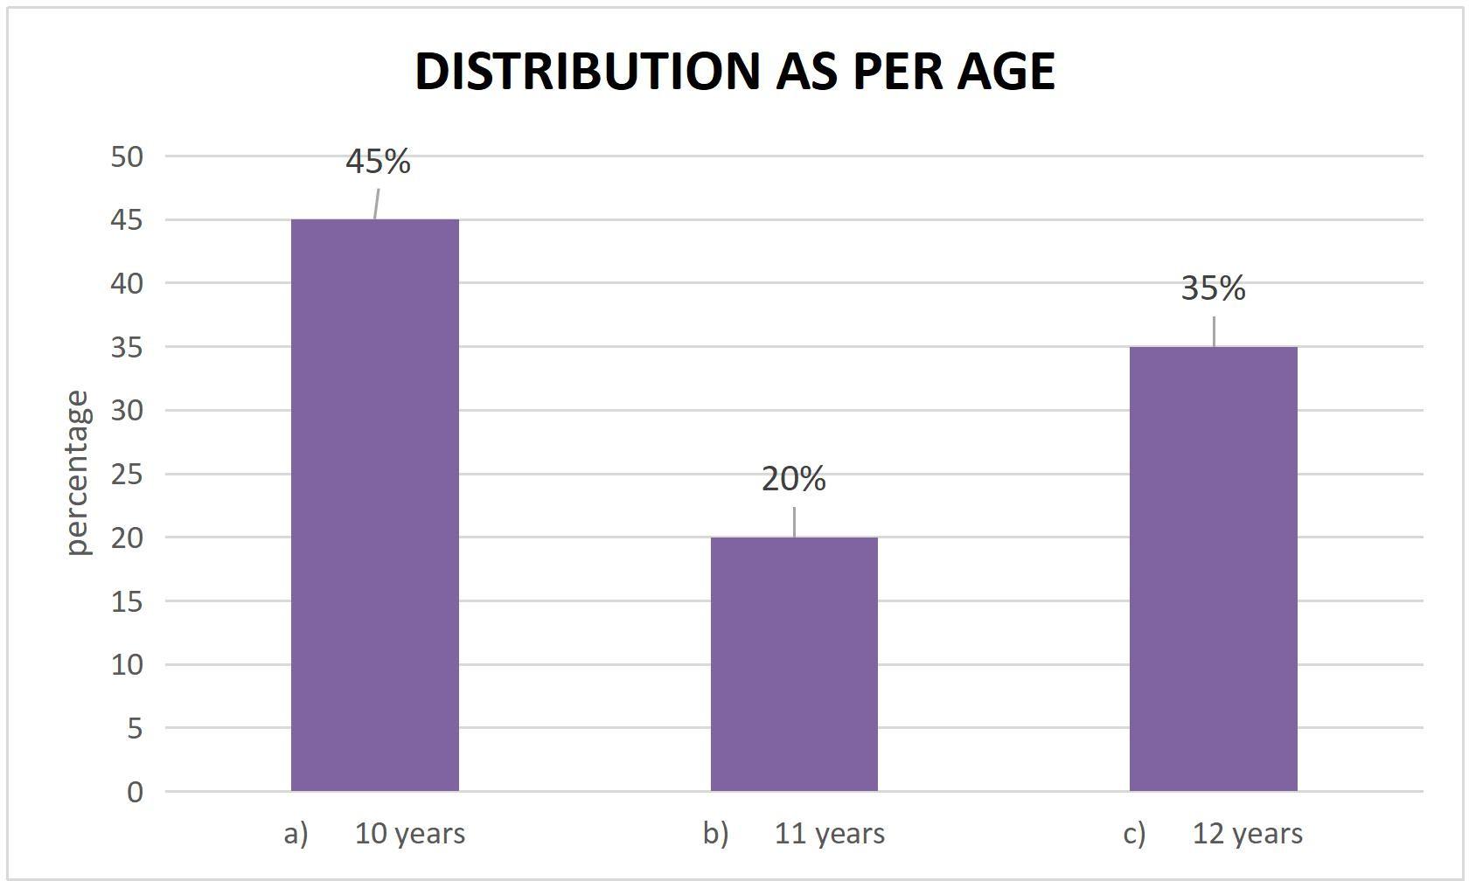

Figure 1.1 Distribution as per age: The Majority 45% of participants were in 10 years of age and 35% participants were in 12 years of age group and 20% participants were 11 years of age group.
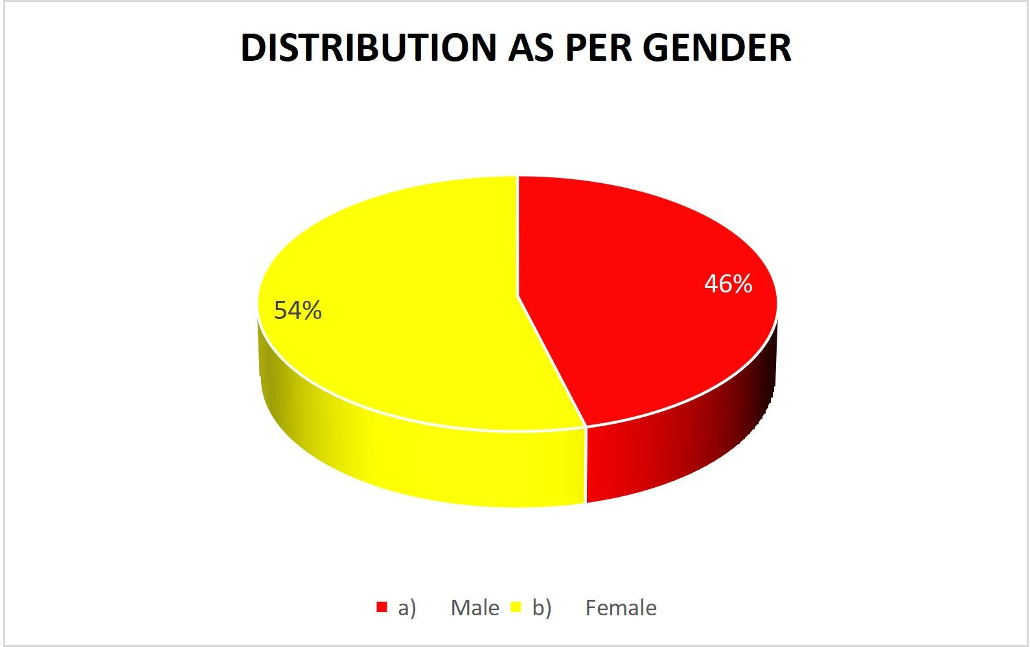
Figure 1.2 Distribution as per Gender: The Majority 54% of participants were female and 46% were male.

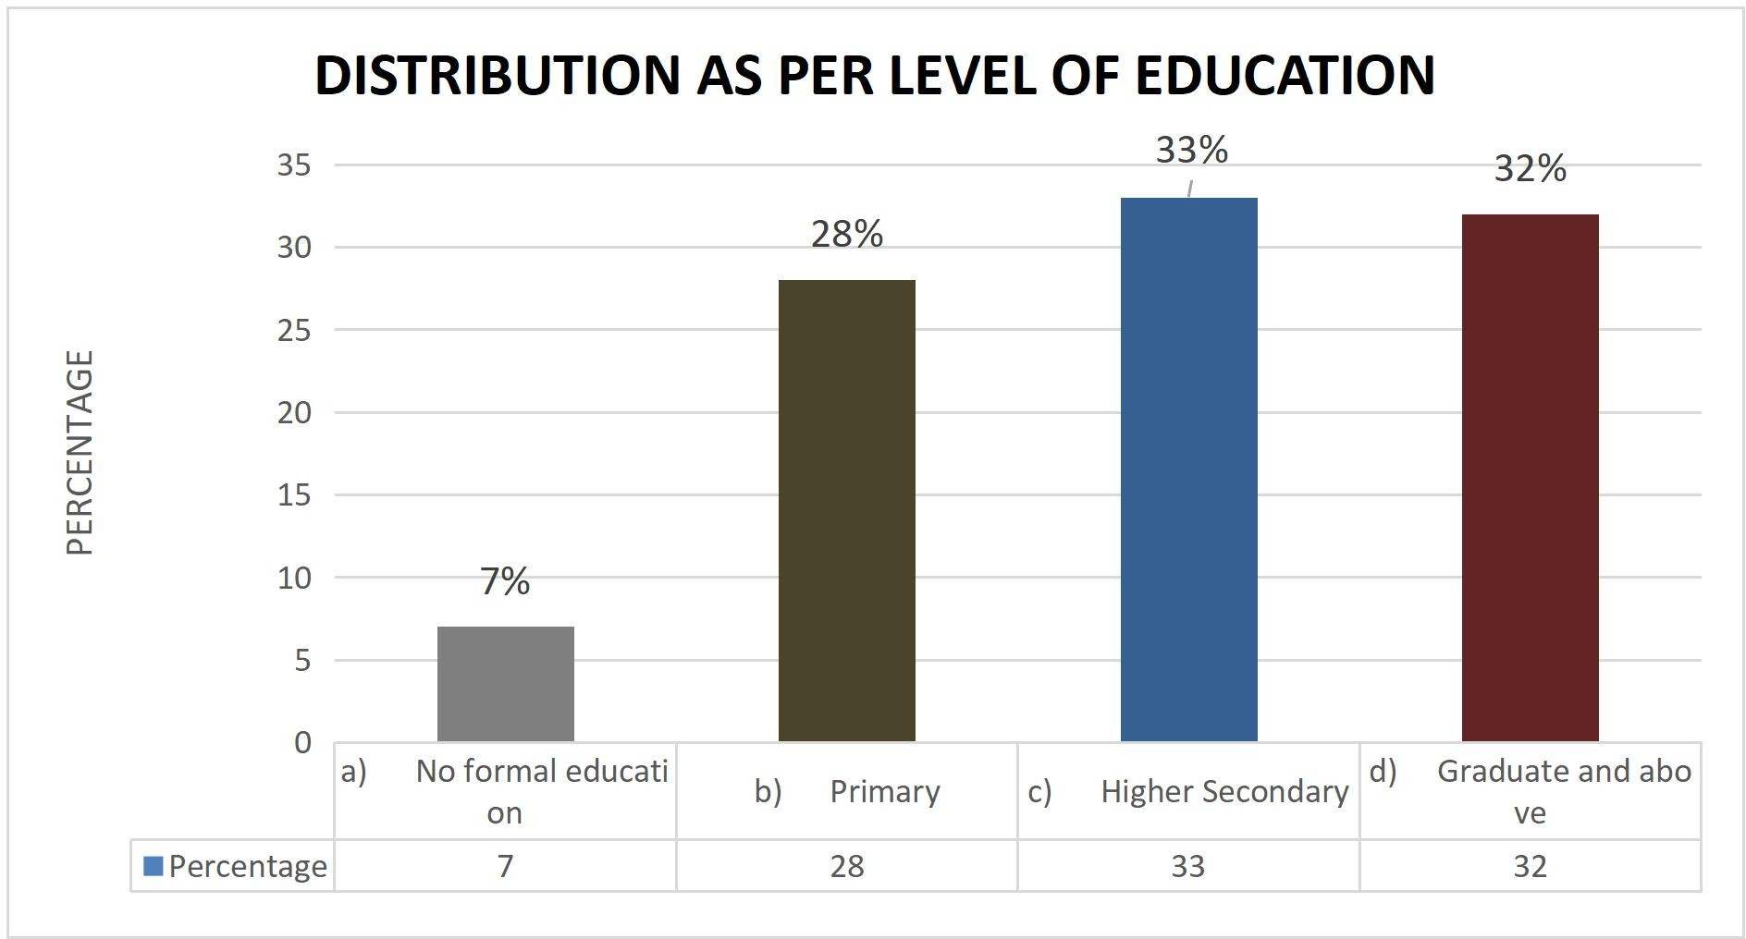
Figure 1.3 Distribution as per level of education: The Majority 33% of participant completed higher secondary education, 32% completed graduate and above, 28% of participant completed primary education and remaining 7% did not get any formal education.
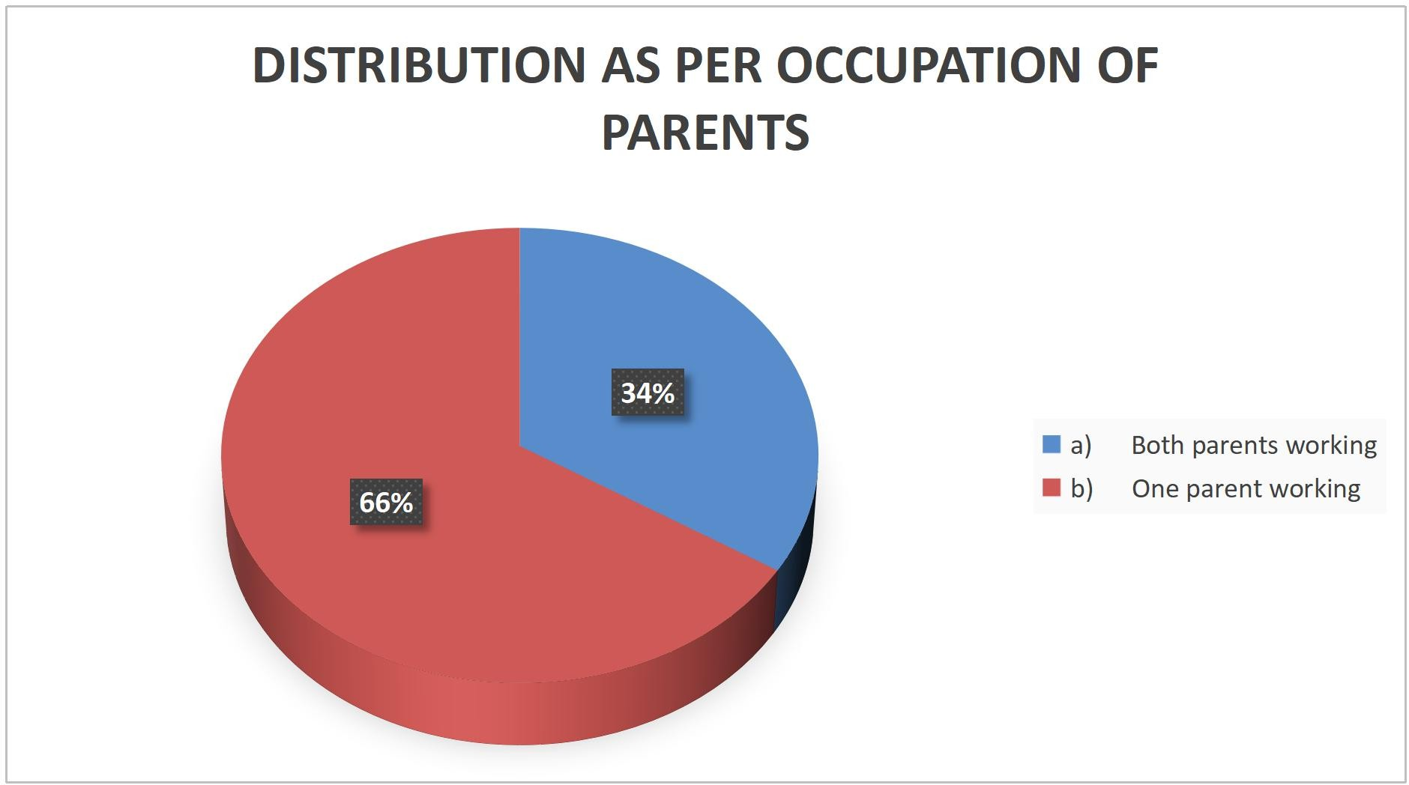

Figure 1.4 Distribution as per Occupation of parents: shows that Parents of majority 66% children only one parent working and in 34% samples both parents working.

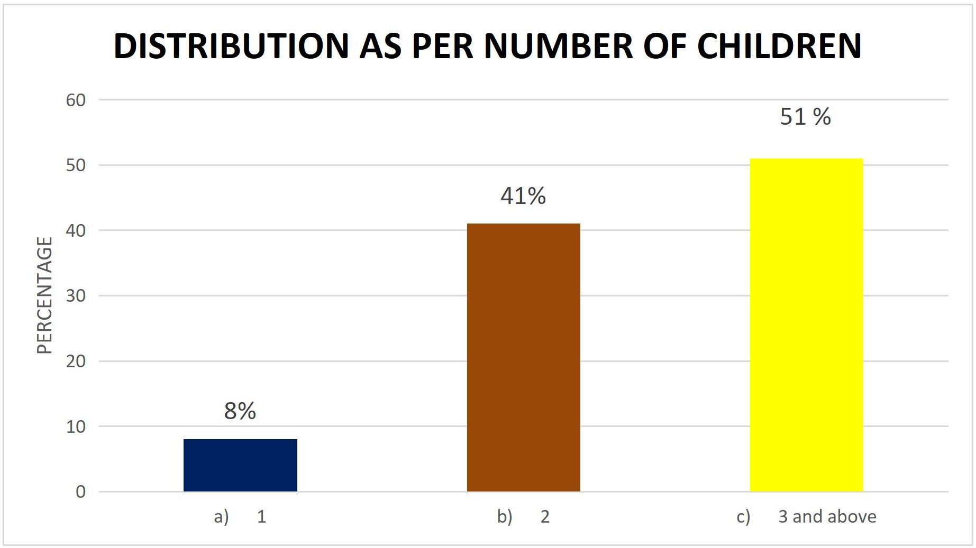
Figure 1.5 Distribution as per Number of children: shows that Majority 51% of parent having 3 children and above and 41% having 2 children and 8% 1 children.
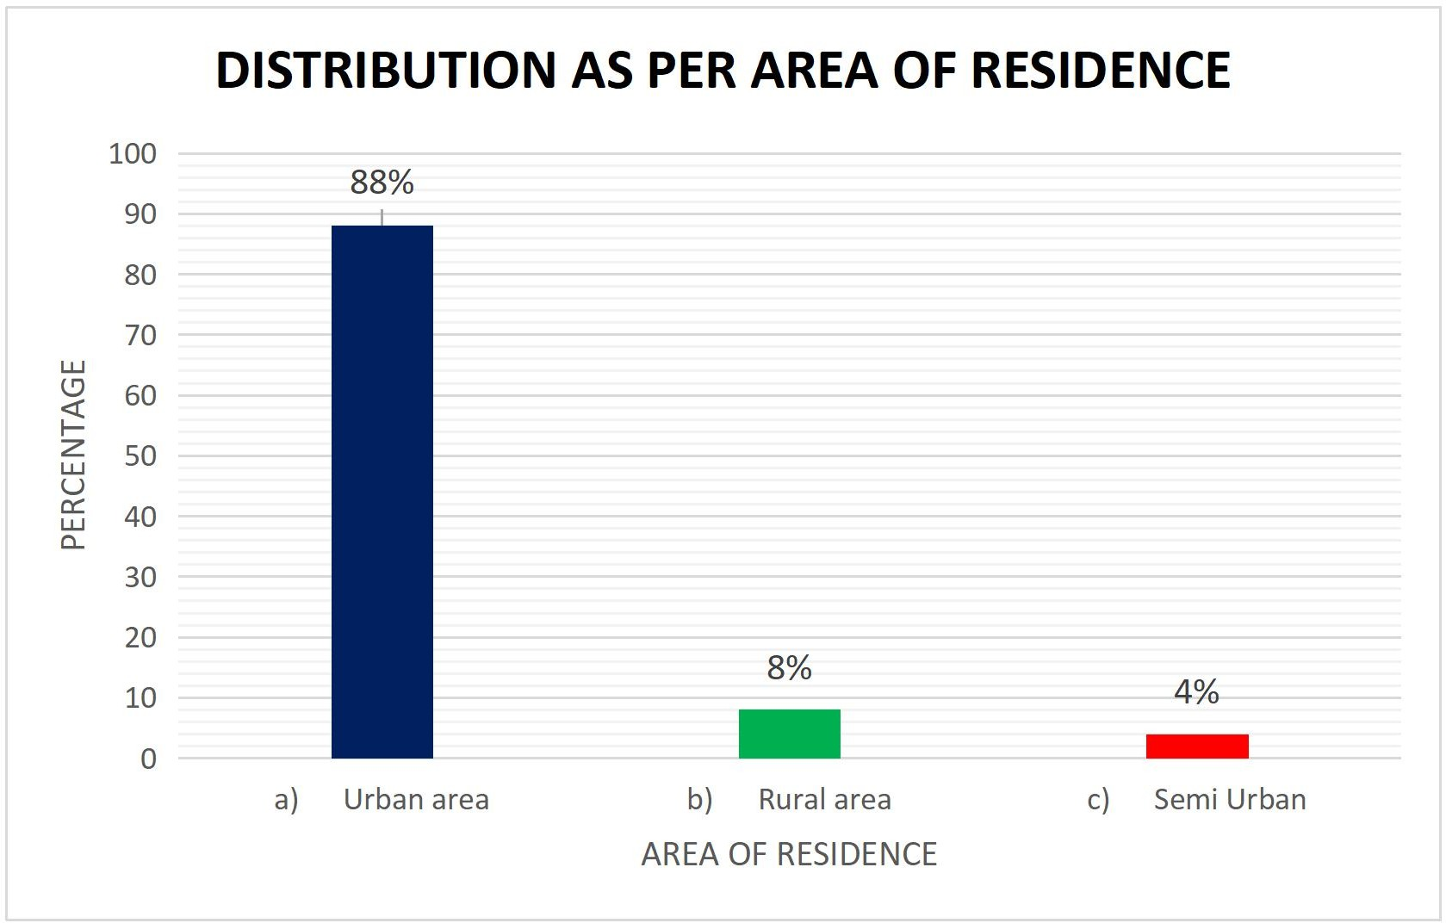
Figure 1.6 Distribution as per area of residence: shows that Majority 88% of parents living in urban areas, 8% in rural and 4% in suburban areas.

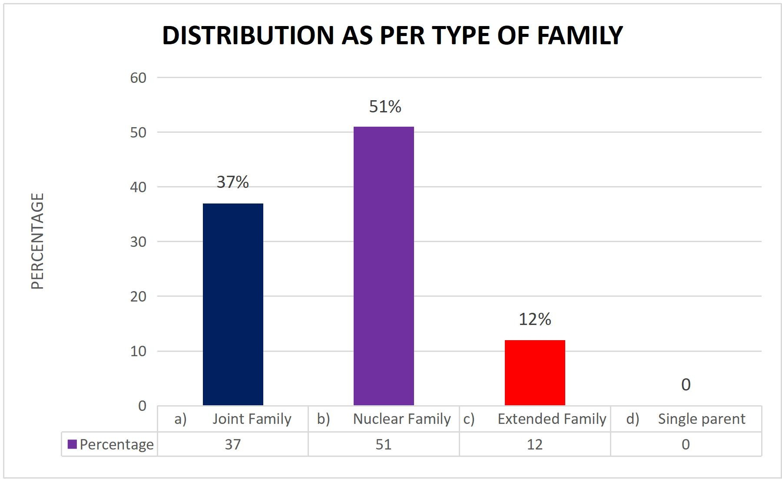
Figure 1.7 Distribution as per type of family: shows that Majority 51% is belong to nuclear family, 37% from Joint family and 12% from extended family.

SECTION II:

ANALYSIS OF DATA AS PER PRE AND POST-TEST KNOWLEDGE AND PRACTICE REGARDING HEALTHY HABITS AMONG SCHOOL GOING CHILDREN.
SECTION IIA:
PRE AND POST-TEST KNOWLEDGE REGARDING HEALTHY HABITS AMONG SCHOOL GOING CHILDREN n=100
Knowledge | Pretest Knowledge |  |  |  | Post-Test Knowledge
Knowledge | Frequency | Percentage | Mean | SD | Frequency | Percentage | Mean | SD
Poor | 6 | 6% | 8.41 | 1.96 | 0 | 0% | 11.1 | 1.14
Average | 80 | 80% | 8.41 | 1.96 | 30 | 30% | 11.1 | 1.14
Good | 14 | 14% | 8.41 | 1.96 | 70 | 70% | 11.1 | 1.14
Table 1.2 shows that in pre-test majority 80% of children have average knowledge, 14% good knowledge and 6% having poor knowledge along with 8.41 mean score and 1.96 SD. In post-test majority 70% of children have good knowledge and 30% of children have average knowledge along with 11.1 mean score and 1.14 SD.

SECTION II B:
PRE AND POST-TEST PRACTICE REGARDING HEALTHY HABITS AMONG SCHOOL GOING CHILDREN n=100
Practice | Pre- intervention Practice |  |  |  | Post-intervention Practice
Practice | Frequency | Percentage | Mean | SD | Frequency | Percentage | Mean | SD
Poor | 2 | 2% | 24.89 | 3.47 | 0 | 0% | 26.3 | 2
Average | 8 | 8% | 24.89 | 3.47 | 2 | 2% | 26.3 | 2
Good | 90 | 90% | 24.89 | 3.47 | 98 | 98% | 26.3 | 2
Table 1.3 shows that in pre-test majority 90% of children have good practices, 8% average practices and 2% having poor practices along with 24.89 mean score and 3.47 SD. In post-test majority 98% of children have good knowledge and 2% of children have average knowledge along with 26.3 mean score and 2 SD.

SECTION III:

ANALYSIS RELATED TO EFFECTIVENESS OF SNAKE AND LADDER GAME ON THE LEVEL OF KNOWLEDGE AND PRACTICE REGARDING HEALTHY HABITS AMONG SCHOOL GOING CHILDREN
SECTION III A
EFFECTIVENESS OF SNAKE AND LADDER GAME ON THE LEVEL OF KNOWLEDGE REGARDING HEALTHY HABITS AMONG SCHOOL GOING CHILDREN n = 100
Level of knowledge | Mean | SD | DF | T value | P value | Remark
Pretest | 8.41 | 1.96 | 99 | 12.88 | 0.00001 | Significant
Post test | 11.10 | 1.14
NS= Not significant S= Significant
Table: 1.4 shows that in pre-test mean score is 8.41 along with 1.96 SD. In post-test mean score is 11.1 mean score along with 1.14 SD. DF is 99, t value is 12.88 and p value is 0.00001 which shows a strong significant effectiveness of snake and ladder game on knowledge regarding healthy habits in school going children.
Hence research hypothesis H1 Is accepted

SECTION IIIB: EFFECTIVENESS OF SNAKE AND LADDER GAME ON THE PRACTICES REGARDING HEALTHY HABITS AMONG SCHOOL GOING CHILDREN
n =100
Level of Practice | Mean | SD | DF | T value | P value | Remark
Pretest | 24.89 | 3.47 | 99 | 4.49 | 0.00002 | Significant
Post test | 26.30 | 2.00
NS= Not significant S= Significant
Table 1.5 shows that in pre-test mean score was 24.89 along with 3.47 SD. In post-test mean score was 26.30 along with 2.00 SD. DF was 99, t value 4.49 with 0.00002 P value which shows a strong significant effectiveness of snake and ladder game on practices regarding healthy habits in school going children.
Hence Research Hypothesis H2 Is accepted

SECTION IV:
ANALYSIS RELATED TO RELATION BETWEEN THE KNOWLEDGE AND PRACTICE REGARDING HEALTHY HABITS WITH SELECTED DEMOGRAPHIC VARIABLES
n =100
Variable Pretest | Mean | SD | r value | Remark
Knowledge | 8.41 | 1.95 | 0.61 | Not significant
Practice | 26.08 | 2.01 | 0.61 | Not significant
NS= Not significant S= Significant

Table 1.6 shows that there is no significant relationship between knowledge and practice regarding healthy habits as r value is 0.61. that is less than 0.7
Hence research Hypothesis H3 is rejected

SECTION V:
ANALYSIS RELATED TO ASSOCIATION BETWEEN THE KNOWLEDGE REGARDING HEALTHY HABITS WITH SELECTED DEMOGRAPHIC VARIABLES
n=100
Demographic variables | Average Knowledge | Good Knowledge | Poor Knowledge | DF | Chi Table Value | Chi Calculated Value | P  value | Remark
1. Age
a) 10 years | 45 | 0 | 0 | 4 | 9.4  8 | 29.74 | 1E-  06 | S
b) 11 years | 19 | 1 | 0
c) 12 years | 16 | 13 | 6
2. Gender
a) Male | 38 | 2 | 6 | 4 | 9.4  8 | 9.54 | 0.0  49 | S
b) Female | 42 | 12 | 0
c) Other | 0 | 0 | 0
3. Education of parents
- No formal education | 6 | 1 | 0 | 6 | 12.  59 | 13 | 0.0  43 | S
b) Primary | 22 | 0 | 6
- Higher Secondary | 27 | 6 | 0
- Graduate and above | 25 | 7 | 0
4. Occupation of parents
- Both parents working | 28 | 6 | 0 | 2 | 5.9  9 | 1.57 | 0.4  7 | NS
- One parent working | 52 | 8 | 6
5. Number of children in the family
a) 1 | 8 | 0 | 0 | 4 | 9.4  8 | 11.63 | 0.0  2 | S
b) 2 | 39 | 2 | 0
c) 3 and above | 33 | 12 | 6
6. Area of residence
a) Urban area | 68 | 14 | 6 | 4 | 9.4  8 | 1 | 0.9 | NS
b) Rural area | 8 | 0 | 0
c) Semi Urban | 4 | 0 | 0
7. Type of family
a) Joint Family | 31 | 0 | 6 | 6 | 12.  59 | 19.18 | 0.0  04 | S
b) Nuclear Family | 43 | 8 | 0
c) Extended Family | 0 | 0 | 0
d) Single parent | 6 | 6 | 0

Table 1.7 shows that age, gender, education of parent, number of children in family and type of family has significant association with pre-test knowledge as p value is less than 0.05.

Hence Research Hypothesis H4 Is Accepted
whereas occupation of parents and area of residence does not have any association with knowledge score as p value is more than 0.05 level of significance. Hence Research Hypothesis H4 Is Rejected

SECTION V: A
ASSOCIATION OF PRACTICE SCORE WITH SELECTED DEMOGRAPHIC VARIABLES
n=100
Demographic variables | Average Knowledge | Good Knowledge | Poor Knowledge | DF | Chi Table Value | Chi Calculated Value | P  value | Remark
1. Age
a) 10 years | 3 | 41 | 1 | 4 | 9.4  8 | 1.19 | 0.8  7 | NS
b) 11 years | 2 | 17 | 1
c) 12 years | 3 | 32 | 0
2. Gender
a) Male | 3 | 42 | 1 | 4 | 9.4  8 | 0.26 | 0.9  9 | NS
b) Female | 5 | 48 | 1
c) Other | 0 | 0 | 0
3. Education of parents
a) No formal education | 1 | 6 | 0 | 6 | 12.  59 | 2.65 | 0.9  5 | NS
b) Primary | 2 | 25 | 1
c) Higher Secondary | 4 | 29 | 0
d) Graduate and above | 1 | 30 | 1
4. Occupation of parents
a) Both parents working | 2 | 30 | 2 | 2 | 5.9  9 | 2.86 | 0.2  3 | NS
b) One parent working | 6 | 60 | 0
5. Number of children in the family
a) 1 | 0 | 8 | 0 | 4 | 9.4  8 | 0.31 | 0.9  8 | NS
b) 2 | 4 | 36 | 1
c) 3 and above | 4 | 46 | 1
6. Area of residence
a) Urban area | 7 | 79 | 2 | 4 | 9.4  8 | 0.28 | 0.9  9 | NS
b) Rural area | 1 | 7 | 0
c) Semi Urban | 0 | 4 | 0
7. Type of family
a) Joint Family | 2 | 34 | 1 | 6 | 12.  59 | 0.64 | 0.9  9 | NS
b) Nuclear Family | 5 | 45 | 1
c) Extended Family | 0 | 0 | 0
d) Single parent | 1 | 11 | 0

Table 4.8 shows that there is no association of practice score with any demographic variables as p value is more than 0.05 level of significance. Hence research Hypothesis H5 Is Rejected

Implications of the study: For the nursing practitioner, in addition to giving more significance for interventional studies on different aspects. The present study has tested the effect of snake and ladder game on knowledge and practice regarding healthy habits among school children. In nursing administration, the the Nurse administrator can draw written policy to employ snake and ladder game as a one of the interventions to teach the hospitalized children. In nursing education, Administration of snake and ladder game is an effective method of teaching children to improve their knowledge and practice on healthy habits. In the field of nursing research, the advance research can be conducted in future to review the merits of snake and ladder game over other methods of health education to improve knowledge and practice of healthy habits.

ETHICAL CONSIDERATION: The present study focuses on ethical guidelines as follows:
- The study was evaluated and approved by the ethics committee of the institution.
- The formal Permission obtained from the hospital authority
- Participants have the right to withdraw from the study at any time.
- Written informed consent/assents were obtained from each participant/ parent of both groups before commencement of the study.
- Anonymity and confidentiality of the participants were ensured by coding the data.
- Information acquired from the participants was used only for the study and was kept confidential.
RECOMMENDATIONS: The present author recommended to A similar study can be replicated on a larger sample and in a different setting. Nurses working in any set up can utilize this snake and ladder game as a play way method to teach children about various healthy habits. Teachers and special trainers in special schools can practice, snake and ladder game as one of the routine teaching techniques to teach the additional health related information to school children.

DISCUSSION: Overall, the study provides valuable insights into the knowledge and practice of healthy habits in school going children.

CONCLUSION: The findings of the present study indicate that the school going children had adequate knowledge regarding knowledge and practice on healthy habits. The study found that school going children have a good knowledge of healthy habits, but their practice of these habits is not always consistent.
REFERENCES:
- Effect of snake and ladder game on knowledge regarding personal hygiene among school children at selected school, Coimbatore. 1library.net. Available fromhttps://1library.net/document/1y9dn0dq-effect-knowledge-regarding-personal-hygiene-children-selected-coimbatore.htm
- Effectiveness of snake and ladder game on level of knowledge regarding oral hygiene among school children in selected schools, Salem.Repository-tnmgrmu.ac.in. Available from:http://repository-tnmgrmu.ac.in/3841/1/3002217saraswathyj.pdf
- Indimedo.com. Available from: https://indimedo.com/blog/teaching-healthy-habits-to-children
- Samiksha C, Kalmath S. A study to evaluate the effectiveness of snake and ladder game on knowledge regarding nutritional practices among children in selected school at Hubballi. Vol. 3, International Journal of Recent Innovations in Medicine and Clinical Research (ISSN: 2582-1075). Zenodo; 2021.p. 1–6. Available from: https://ijrimcr.com/index.php/ijrimcr/article/view/95
- Physical activity for school-age children. Raising Children Network. 2023.

Available from: https://raisingchildren.net.au/school-age/play-media-technology/active-play/activity-for-school-children
- Sleep in school-aged children. Nationwidechildrens.org.Available from: https://www.nationwidechildrens.org/specialties/sleep-disorder-center/sleep-in-school-aged-children
- Kaushal M, Jammu IPS. A study to assess the health habits among the school children (6-10) yrs of age in selected schools of Kurali District. Ropar, Punjab. Ijrti.org. Available from: https://ijrti.org/papers/IJRTI1809030.pdf
.

