Investigation the Performance of Colour Oxide on the PS/CNSO Oil Paint Production
Osemeahon S. Aª., Onoja A^{b}., Apolmi G^{c}., Aminu A^{d}., and Dimas B^{e}.
ªChemistry department, Faculty of Physical Science, Modibbo Adama University. Yola, Adamawa State. Nigeria.
^{b}Department of Chemistry, Federal College of Education (Tech.) Bichi, Kano State.
^{c}Department of Pure and Industrial Chemistry, Nnamdi Azikiwe University Akwa. Nigeria
^{d}Department of Chemistry, Federal College of Education, Yola.
^{e}Department of Chemical Science, Taraba State University, Jalingo.
Correspondence: onoja.ameh2015@gmail.com
Orcid Number : 0009-0008-8228-3038

Abstract
This study investigated the effect of colour oxide pigments on the production of environmentally sustainable oil paints utilizing a novel bio-based binder. Solid waste polystyrene was efficiently converted into liquid polystyrene (PS) and subsequently blended with cashew nut shell oil (CNSO) extracted from waste cashew nuts to produce a composite binder, designated as PS/CNSO. The physicochemical analysis of the PS/CNSO binder was carried out which including pH, melting point, refractive index, density and moisture uptake. Also the instrumental analysis was carried out such as: differential thermal analysis (DTA), X-ray diffraction (XRD), and Fourier-transform infrared spectroscopy (FTIR) were thoroughly characterized to assess its suitability for paint formulation. Oil paints were then formulated using the PS/CNSO binder, incorporating varying concentrations of natural colour oxide pigments (1g, 1.5g, 2g, 2.5g, 3g, 3.5g, and 4g). The influence of pigment concentration on the physical, chemical, and aesthetic properties of the resulting paints was systematically evaluated. The findings demonstrate that the bio-based binder, combined with natural pigments, offers a sustainable alternative for oil paint production, with pigment concentration significantly affecting the performance and quality of the final product. This work highlights the potential of waste-derived materials in developing eco-friendly coating solutions.
Keywords: CNSO, Coating Solution, Eco-friendly, PS/CNSO, Polystyrene, Recycling waste,

Introduction
The increasing accumulation of solid waste, particularly polystyrene, poses significant environmental challenges, necessitating innovative strategies for waste management and resource recovery. Recycling waste polystyrene into useful materials offers a sustainable solution, reducing environmental impact while creating value-added products. In this context, the transformation of solid waste polystyrene into liquid polystyrene (PS) and its subsequent blending with natural oils represent promising avenues for sustainable material development (Liem et al., 2017).
In recent years, there has been growing interest in developing eco-friendly materials from natural resources and waste byproducts. Cashew nut shell oil (CNSO), obtained from the abundant waste cashew nuts, is a renewable, biodegradable, and environmentally benign material with potential applications in polymer and coating industries. Its unique chemical properties make it suitable as a natural resin component in binder formulations (Liem et al., 2017).
Cashew nut shell oil (CNSO), a byproduct of cashew nut processing, is a renewable and biodegradable resource with potential applications in polymer and coating industries. Its incorporation as a natural resin component in composite binders can enhance the environmental friendliness of paint formulations. By blending liquid PS derived from waste with CNSO, a novel composite binder (PS/CNSO) is formulated, which serves as a sustainable alternative to conventional synthetic binders in oil paint production (Onoja et al., 2019).
This research investigates the physicochemical and instrumental properties of the PS/CNSO composite binder, including pH, melting point, turbidity, viscosity, moisture uptake, DTA, TGA, XRD, and FTIR. Furthermore, the study examines the effect of varying concentrations of colour oxide pigments on the properties and quality of the oil paint produced. The integration of waste-derived materials and natural pigments aims to promote eco-friendly practices in the paint industry, contributing to sustainable development and waste valorization.
Materials and Method
Sample Collection
The method described by Onoja et al., (2019). The waste polystyrene were collected from the trash dumps of the various electronics stores in Yola city. The impurities were removed from the waste PS, the collected waste PS were processed, cleaned, size and dried and pyrolyzed to liquid PS pyrolysis oil using the pyrolysis plant.
Extraction of CNSO using Soxhlet extraction
The cashew nut were obtained from Jimeta market and washed with cleaned water and dried, the edible seed inside was carefully separated, and the shell (waste) was ground into a tiny particles using a metalic pestle and mortar. The soxhlet extractor and gasoline was used as the solvent for the extraction process Onoja et al., (2019).
Blending of PSPO with CNSO
The procedure described by Onoja et al., (2019), was used with little modification, which calls for measuring 12 % of cashew nutshell oil in 100 % of PS binder with constant stirring for 10 mins at room-temperature in order to combine the two materials. A glass rod was used to completely mix the fluid together. The final blended was kept in storage as PS/CNSO binder.

Results and Discussion
Table 1: physiochemical properties of PS/CNSO composite
Physiochemical properties Value
Density 1.280 g/cm³
pH 2.78
Melting point 139 ⁰C
Refractive index 1.556
Moisture uptake 0

Density of the PS/CNSO composite
The density of a binder influences such properties as the dispersion and stability of pigment which can be used to determine the critical pigment volume concentration, spreading capacity and consistency of the paint. The incorporation of CNSO in the PS/CNSO composite may attributed to the change in the morphology give rise to formation of a new macro structure reestablish a morphology with good packing nature leading to increase in the density of the composite. Usually, the density of a paint resin has a profound influence on factors such as flow, leveling, sagging, pigment dispersion and brushability of paint (Osemeahon and Archibong, 2011).
Moisture uptake of the PS/CNSO composite
Table 1, show zero tolerance to water uptake, this implies there will be no fear of film degradation, this may be associated with the hydrophobic nature of PS/CNSO taken dominancy (Sohel et al., 2015). Possible interaction between PS and CNSO can also lower the OH groups in the copolymer resin, hence eliminating affinity for water molecules and also the crosslinks produced by this interaction may also result in good resistance to water and alkali.
Refractive Index of the PS/CNSO composite
Table 1, show that the PS/CNSO composite give higher refractive index compare to PS binder this can be attributed to the changes in proportion of the amorphous and crystalline phases in the copolymer composites as this primarily arouse light scattering. It may also be due to the orientation and a state of aggregation established by PS/CNSO, thereby creating light scattering boundaries and discontinuities in the molecular structure of the copolymer composite. PS/CNSO is coloured (dark brown), and hence its ability to impact haze and increase the refractive index and also due to surface enrichment of certain chain constituents and/or surface induced phase hence the high refractive index observed (Liem et al., 2017). Gloss is one of the intrinsic qualities of oil-based paints which the PS/CNSO has shown or impacted

pH of the PS/CNSO composite
The pH values of the PS/CNSO composite is 2.78 which indicates that the paint is acidic. The PS/CNSO composite which is within acidic range is not a favourable condition for bacteria to strive in it; therefore, it is not susceptible to bacteria attack (Surajudeen et al., 2015). The high in acidic level may be attributed to the fact that the two constituents (PS - 2.73 and CNSO - 3.00) are highly acidic. The results of the pH for PS/CNSO composite produced is presented in Table 1. This shows a slight reduction in pH values from PS concentrations, which means that Paint formulation, will take place in acidic conditions.

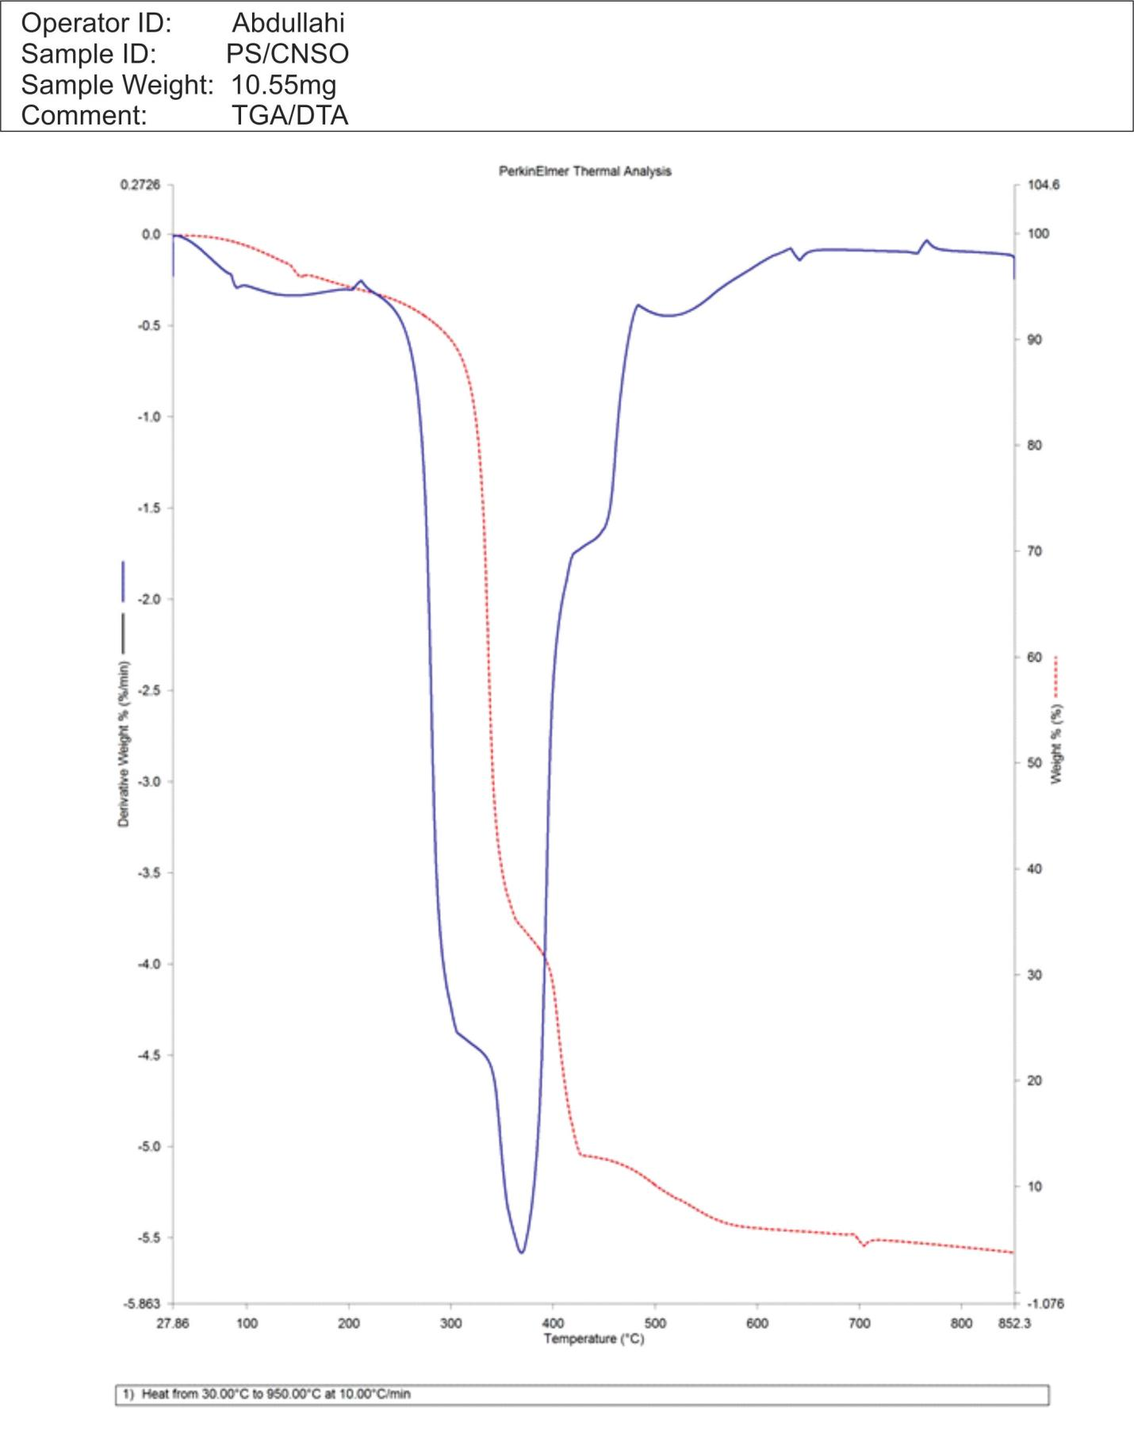
Figure 1 DTA analysis of PS/CNSO
The thermal analysis of the PS/CNSO sample reveals that the composite is thermally stable up to approximately 300°C, with the primary decomposition occurring between 350°C and 450°C, as indicated by a sharp weight loss in the TGA curve and a corresponding endothermic peak in the DTA curve. This degradation is attributed to the breakdown of the polystyrene matrix and the organic components of CNSO. A secondary, slower decomposition occurs between 500–700°C, possibly due to residual crosslinked materials or charring. The residual mass (~5–7%) at 950°C suggests the presence of thermally stable char or inorganic content. The absence of early weight loss confirms the low moisture content, making the composite suitable for high-temperature applications such as paint binders or coatings. (Homa et al., 2020).
The PS/CNSO composite's TGA curve shows a multi-step thermal deterioration characteristic. The evaporation of surface-adsorbed moisture or volatiles is responsible for the initial slight or nonexistent weight loss below 150°C. The breakdown of polystyrene chains and the organic components of cashew nutshell oil is most noticeable between 200°C and 600°C.

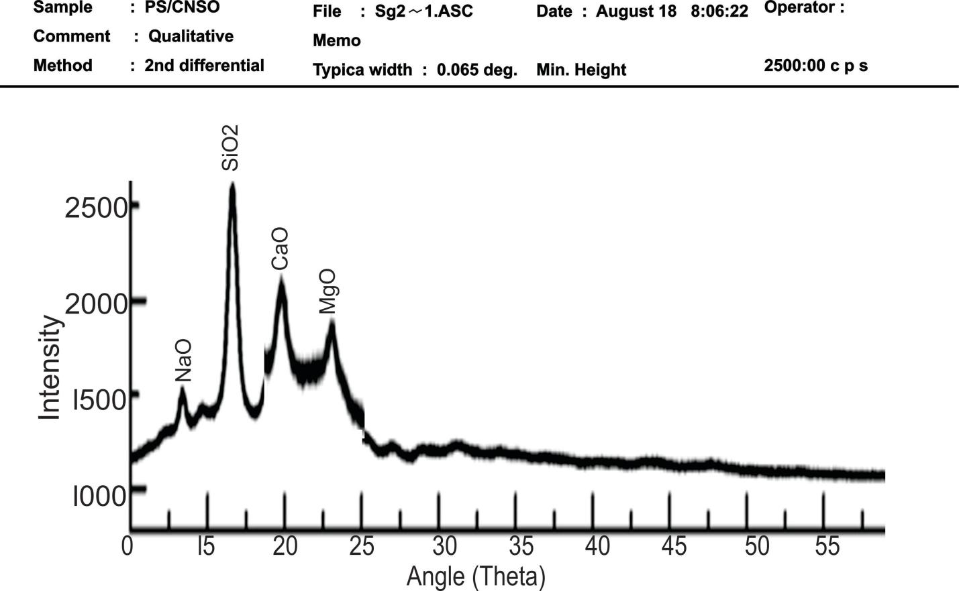
Figure 2 XRD analysis of PS/CNSO
The XRD pattern of the PS/CNSO composite reveals a combination of amorphous and crystalline phases. The broad background hump between 15° and 25° 2θ is characteristic of the amorphous polystyrene matrix. Superimposed on this are sharp peaks corresponding to SiO₂, NaO, CaO, and MgO, indicating the presence of crystalline inorganic phases likely originating from cashew nutshell oil (CNSO) or its ash content. These oxides are commonly observed in biomass residues, and their presence may enhance the thermal, mechanical, or barrier properties of the composite material. The XRD data confirm that the composite is partially crystalline, with the crystalline content attributed to mineral-rich components in CNSO, while the polystyrene remains largely amorphous. This hybrid structure can be advantageous in applications like paint binders or coatings, where a balance of flexibility (amorphous) and durability (crystalline fillers) is desirable (Mark et al., 2020).

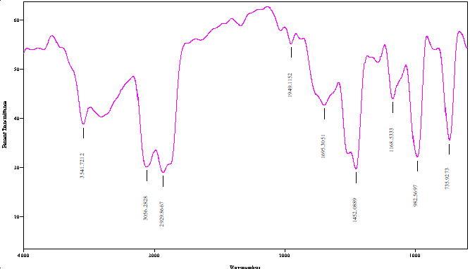
Figure 3 FTIR analysis of PS/CNSO
The absorption peak at 3541.72 cm⁻¹ in the FTIR spectrum of PS/CNSO is the Phenolic (O-H) Stretching. This is the OH group from cardanol from the CNSO. Its presence confirms that the CNSO (or its derivatives) is part of the component. The absorption peak observed in the FTIR spectrum of PS/CNSO composite binder at 3056.28 cm⁻¹ is highly characteristic of sp² C-H stretching\ vibrations. This region, specifically above 3000 cm⁻¹, is typically associated with C-H bonds where the carbon atom is part of a double bond or an aromatic ring. Both components composite, Polystyrene (PS) and Cardanol from Cashew Nut Shell Oil (CNSO), contain the chemical structures that give rise to a peak in this region (Adewale et al., 2024).
The absorption peak observed in the FTIR spectrum of PS/CNSO composite binder at 2929.87 cm⁻¹ is an indicator of the presence of saturated aliphatic C-H bonds. This is one of the most prominent and characteristic strong peaks from the polymer chain backbone. The 2929.86 cm⁻¹ peak confirms the fundamental presence of the saturated polymer structure that forms the bulk of the binder. The FTIR peak observed in the PS/CNSO composite binder at 1949.1152 cm⁻¹ is C=C stretching of Alkene Present, due to the unsaturated nature of the side chain in Cardanol/CNSO and the aromatic ring of both components. The absorption peak in the FTIR spectrum of the PS/CNSO composite at 1695.30 cm⁻¹ is most likely attributed to the stretching vibration of a carbonyl C=O group, characteristic of a ketone and aldehyde, or a conjugated ester/carboxylic acid derivative. Through the modification of CNSO to create the binder (e.g., reaction with aldehydes, epoxidation, or esterification) or during the curing/drying/aging process of the binder (e.g., oxidative polymerization of the unsaturated side chain, which creates alpha, beta-unsaturated ketones or esters) (Jaafar et al., 2017).
The FTIR absorption band at 1452.08 cm⁻¹ in the PS/CNSO composite binder is primarily attributed to C-H vibrations from the components. Is mainly a combined signal from both Polystyrene and Cardanol (major component of CNSO). The strong peak at 1452.08 cm⁻¹ is a superimposed feature representing the presence of C-H groups from both the Polystyrene backbone/ring and the aliphatic side chains of the Cardanol (CNSO). It confirms the presence of these fundamental structural units from both binder components. The FTIR absorption band at 1168.53 cm-1 in a PS/CNSO composite binder is most likely attributed to the C-O stretching vibration. Given that the components, the peak at 1168.53 cm⁻¹ is most reliably assigned to the C-O stretching of the cardanol (CNSO) component. Its presence confirms the incorporation of the cardanol moiety into the composite binder and it might indicate a chemical interaction (like an etherification or cross-linking reaction) occurring between the PS and CNSO components (Jaafar et al., 2023).
The FTIR absorption band at 982.57 cm⁻¹ in the PS/CNSO composite binder is most likely associated with the vibrations of the unsaturated double bonds present in the cardanol component of CNSO. The presence of the peak at 982.57 cm⁻¹ confirms that CNSO is present in the composite and C=C double bonds are intact because these C=C bonds are the sites for oxidative cross-linking (curing) (Adewale et al., 2024).
Finally, the absorption band observed at 735.93 cm⁻¹ in the FTIR spectrum of the PS/CNSO composite binder is the characteristic C-H peak of Polystyrene (PS). C-H Aromatic. The clear presence of this peak serves two main purposes in the context of composite binder: It demonstrates that the PS component has been successfully incorporated into the binder matrix. And this band relates to the core aromatic structure of the PS polymer. The phenolic (O-H) band at 3541 cm⁻¹ indicates that a substantial amount of the CNSO active groups are either free or hydrogen-bonded, suggesting the material is a physical blend or a grafted copolymer with many unreacted CNSO hydroxyl groups remaining (Milena et al., 2017). The presence of the C=O peak at 1695 cm⁻¹ is a notable feature. It's likely due to blending, cross-linking, modification or oxidation of either the {PS} or, more commonly, the CNSO component during processing (Milena et al., 2017). The spectral data shown that the main component of this sample (PS/CNSO) is from PS and CNSO.

Effect of colour oxide (pigment) on the viscosity of the paint produced

Figure 4 Effect of colour oxide (pigment) on the viscosity of the paint produced
The effect of color oxide pigments on the viscosity of paint produced with a PS/CNSO binder is the ability to control and increase the viscosity of the paint, particularly the low shear viscosity. This effect is essential for achieving proper rheology in the final coating. Color oxide pigments are particulate solids, and their impact on paint viscosity is governed by the principles of suspension rheology. The introduction of color oxides, increases the total volume of the paint. The presence of these dispersed particles physically impedes the flow of the liquid PS/CSNO paint, leading to a general increase in the bulk viscosity of the paint. The surface of color oxide pigments is often chemically active. The PS/CNSO binder molecules adsorb onto the surface of these pigment particles. This adsorption effectively removes some of the liquid binder from the continuous phase, further concentrating the remaining binder and increasing its viscosity (Zou and Manthiram, 2020).
Color oxide acts as a rheology modifier and pigment structuring agent, resulting in a consistent and proportional increase in viscosity in the PS/CNSO binder systems. This viscosity increase translates directly into better handling and film-forming properties for the oil paint. Colour oxide is successfully wetting and dispersing in the PS/CNSO binder, creating a stable suspension where the solid pigment particles interact with the polymer chains to build structure (increase internal friction), leading to a thicker paint. Colour oxide particles contribute to the solid content and internal structure of the binder, leading to a denser, more cohesive, and potentially more durable final paint film (Choi, 2022).
Colour oxide helps create the necessary internal friction and structure to physically suspend all pigment particles. This ensures excellent storage stability and prevents the formation of a hard, un-mixable sediment (hard settling). Higher viscosity is necessary for achieving a high quality, protective coating. Higher viscosity prevents the wet paint film from running or sagging (flowing downwards) when applied to vertical or curved surfaces. The color oxide builds the structure needed to keep the wet film exactly where it's applied, leading to a uniform, thick film (Doroszkowski, 2020).
The interaction between the colour oxide and the binder (PS/CNSO) is what gives the paint its ideal flow properties. Color oxide pigment is performing its role perfectly by acting as a structuring agent. The consistent increase in viscosity ensures the paint has the body required for stability, high film build, and proper application. PS/CNSO binder is demonstrating a superior ability to achieve high viscosity and may be preferred for a high-quality, stable, and textured oil paint. The viscosity values increase as the concentration of the color oxide pigment increases in the PS/CNSO oil paint formulation is a classic and highly good effect. The consistent proportional increase in viscosity suggests the color oxide particles are being well-dispersed and fully wetted by the binder (PS/CNSO) (Doroszkowski, 2020).

Effect of colour oxide on the pH of the paint produced

Figure 5 Effect of colour oxide on the pH of the paint produced
Color oxides are chemically stable inorganic compounds, because of this inertness, they do not release acidic or basic species into the oil or solvent. This prevents any undesirable chemical reactions that could lead to increase in the acidity of the paint (Pataki-Hundt and Hummert, 2016).
The effect of adding colour oxide is the increase in the paint's pH, effectively making the highly acidic binders (PSPO) less acidic and improving the paint's stability and performance. In both paint systems (PS/CNSO), the pH rises directly with increasing colour oxide concentration, shifting the overall mixture away from a highly acidic state. The observed increase in pH is likely due to the chemical nature of the color oxide pigment (typically iron oxide, Fe₂O₃). Iron oxides are generally considered to be alkaline or neutral in their chemical behavior and have a buffering capacity. When the solid colour oxide particles are dispersed into the acidic binder (PS/CNSO), they act as a base to neutralize some of the acid in the system, causing the overall pH to rise (Pataki-Hundt and Hummert, 2016).
The shift in pH from the strong acid range pH toward the weaker-acid/near-neutral range pH approx 5.5 provides several crucial benefits for the paint. A lower pH (higher acidity) dramatically increases the risk of metal corrosion when the paint is applied to a metal substrate (like in anti-corrosive primers). Colour oxide significantly reduces the corrosivity of the paint by reducing the acidity of the paint, improving the long term protection of the painted material. Extremely low pH can lead to the degradation or breakdown of certain components in the binder. Bringing the pH closer to the pH range where resins are stable (pH > 4) helps preserve the integrity of the binder, leading to a more durable paint film (Bresser et al., 2018).
The effect is the neutralization and stabilization of the paint's acidity, which is crucial for long term stability and performance. Color oxide pigments are often alkaline or possess sufficient acid neutralizing capacity. The colour oxide is consuming or reacting with the acidic components in the formulation. Oil-based binders (PS/CNSO) naturally produce free fatty acids during their production (pyrolysis), making the paint acidic. The color oxide acts as an acid scavenger, raising the pH closer to neutral (Bresser et al., 2018).
Reducing the paint's acidity is vital when the paint is applied to sensitive substrates, especially metal. High acidity leading to flash rusting or corrosion of the substrate itself. The color oxide's ability to raise the pH provides a corrosion inhibiting function. Maintaining a stable pH contributes directly to the paint's shelf life. Extremely acidic or alkaline conditions can destabilize the polymer chain of the binder, leading to unwanted chemical reactions. High acidity, in particular, can accelerate polymerization or cross-linking, causing the paint to rapidly increase in viscosity and eventually gel or form a solid mass (livering) (Torrent, 2024).

Effect of colour oxide on the refractive index of the paint produced

Figure 6 Effect of colour oxide on the refractive index of the paint produced
The effect of color oxide pigments on the refractive index of paint produced with a PS/CNSO binder is the ability to precisely control the optical properties specifically, the opacity and tinting strength of the colored film. Color oxides (yellow, red, black), have a significantly higher refractive index (n) than the PS/CNSO binder. Opacity (hiding power) in a paint film relies on the ability of the pigment particles to scatter light. The efficiency of light scattering is directly proportional to the refractive index difference between the pigment and the surrounding binder medium (Azani, and Hassanpour, 2024).
While TiO₂ scatters all light, color oxide scatters and absorbs specific wavelengths of light, which is what creates the color we see. High efficiency light scattering ensures that the incident light interacts with the pigment particles effectively. This efficient interaction maximizes the colour oxide tinting strength (the intensity of the color) and ensures the final dried paint film achieves the deepest and most saturated hue intended by the formulator. Without a high change in refractive index, the color would appear dull, weak, or semi-transparent (Lade, 2017).
An increase in the concentration of the color oxide (pigment) in PS/CNSO composite binder consistently leads to an increase in the refractive index of the PS/CNSO oil paint. This effect is generally desired for improving the PS/CNSO paint's hiding power (opacity) and brilliance/color intensity. PS/CNSO paint results show a clear and consistent trend; as the concentration of the color oxide increases from 1g to 4g, the refractive index of the resulting oil paint produced steadily rises. These rise in refractive index (RI) of the PS/CNSO paint increases as the concentration of the color oxide pigment increases, that confirms the colour oxide pigment is contributing to the paint's optical function. The effect of the color oxide on the PS/CNSO paint's RI is its role in providing the desired opacity and hiding power through light manipulation. The most critical effect is that the color oxide pigment dramatically increases the paint's ability to scatter light, thereby providing color and hiding power (Longoni, 2022).
Higher refractive index in the PS/CNSO paint has direct, positive effects on the final coating's appearance; Opacity is primarily determined by the difference between the refractive index of the pigment particles and the refractive index of the surrounding binder medium ($\text{∆}$n = n_{pigment} - n_{binde}r). A higher paint refractive index, especially when driven by a high RI pigment, generally indicates greater scattering of light. This translates to better hiding power and a paint that requires fewer coats to cover the substrate (Müller and Schackmann, 2023).
The predictable, continuous increase in RI as pigment concentration rises is a strong quality control indicator. The consistent trend suggests that the colour oxide is being uniformly dispersed by the PS/CNSO binders across all tested concentrations. If the pigment were poorly wetted or flocculated, the light scattering would be less efficient, and the RI trend would be erratic or lower than expected. It confirms that the binder system is successfully maintaining the large change in RI required for hiding power, allowing the paint's optical property to be accurately tuned by adjusting the color oxide loading (Boyd, 2015).

Table 2 Effect of colour oxide on the water resistance of the paint produced
Colour Oxide (g) | PS/CNSO Paint  Water Resistance
1 | Pass
1.5 | Pass
2 | Pass
2.5 | Pass
3 | Pass
3.5 | Pass
4 | Pass

The effect of color oxide on the water resistance of paint produced with a PS/CNSO binder is the creation of a more effective physical barrier against moisture penetration. This enhancement is primarily due to the chemical inertness of the oxides and the reinforcement they provide to the dried film. The solid, inorganic nature of the color oxides mechanically strengthens and densifies the cured PS/CNSO film, making it less prone to cracking and prevent micro pores that would otherwise allow water ingress. Most color oxides, are highly stable and chemically inert. They are insoluble in water and do not react with moisture or atmospheric pollutants. This prevents the colour oxide itself from degrading or creating water soluble by-products that could draw water into the film (a process called osmotic blistering). Their chemical stability ensures they do not accelerate the hydrolysis (water induced degradation) of the PS/CNSO binder, thereby helping the binder maintain its own inherent water repellent qualities over time (Kolya, and Kang, 2024).
The result show that all the PS/CNSO paint samples produced, across various concentrations of color oxide are hydrophobic in nature (PS/CNSO), all the concentrations passed the water resistance test is a strong confirmation that the color oxide pigment is successfully integrated into the protective film. The effects of the color oxide on water resistance stem from its chemical inertness, its role in film density, and its ability to buffer acidity, which protects the hydrophobic binder matrix (Rojtman et al., 2024).
Colour oxide displaces volume that could otherwise be occupied by minor water sensitive components, ensuring the final film is composed overwhelmingly of water resistant material. The solid colour oxide contributes to a tighter, less permeable barrier against water ingress. Colour oxide physically occupying space and packing tightly within the binder matrix, the colour oxide pigment helps minimize microscopic voids and channels, significantly reducing the film's overall Water Vapor Permeability (WVP). This prevents water from easily penetrating the film and reaching the substrate or the binder (Buchman, 2025).
The color oxide, by shifting the pH towards neutral, protects the binder from acid catalyzed hydrolysis. Water combined with high acidity (H⁺ ions) can chemically attack the ester bonds and other linkages in the oil binders, leading to rapid degradation and loss of adhesion/strength when exposed to the water resistance. Colour oxide neutralizing acidity, the colour oxide ensures the paint film maintains a stable interface with the substrate. This prevents the loss of adhesion that commonly occurs when a highly acidic film is exposed to water, which lead to blistering and peeling (Buchman, 2025). Color oxide acts as a chemically inert stabilizer that helps the hydrophobic PS/CNSO binders form a durable, dense, and pH stabilized barrier that successfully withstands the water resistance challenge (Azani, and Hassanpour, 2024).

Table 3 Effect of colour oxide on the adhesion of the paint produced
Colour Oxide (g) | PS/CNSO Paint  Adhesion
1 | Pass
1.5 | Pass
2 | Pass
2.5 | Pass
3 | Pass
3.5 | Pass
4 | Pass

The effect of color oxide on the adhesion of paint produced with a PS/CNSO binder is primarily through mechanical interlocking and enhancement of the film's cohesive strength. Color oxide pigments, due to their fine particle size and generally irregular morphology, physically enhance the connection between the PS/CNSO binder and the substrate. The result show that all the PS/CNSO paint samples produced, across various concentrations of color oxide, pass the adhesion test is a crucial success. It confirms that the color oxide pigments are fully compatible with the hydrophobic binders (PS/CNSO) and actively contribute to the long term bond strength of the film to the substrate. The effects of the color oxide on adhesion are linked to substrate interaction, film reinforcement, and chemical stability. Good adhesion begins when the liquid paint makes intimate contact with the surface (wetting) (Hang et al., 2024).
Adhesion is the attractive force that keeps the PS/CNSO paint film attached to the substrate or Adhesion is the bond to the substrate, cohesion is the internal strength of the paint film itself. High adhesion is useless if the film is weak (poor cohesion). Color oxide pigments act as reinforcing fillers. Their solid, rigid particles increase the tensile strength and hardness of the cured PS/CNSO film, making it less likely to crack, tear, or pull away from the surface when subjected to stress (like temperature changes or physical impact) (Algellai, 2018).
Adhesion is only as strong as the film's internal strength (cohesion) when color oxide act as micro reinforcements within the cured polymer matrix. They increase the film's cohesive strength and toughness. A stronger film is better able to resist internal stresses (from drying shrinkage) and external mechanical stresses (like impact or flexing) without tearing itself away from the substrate, thereby preventing adhesion failure. Colour oxide pigment which is a non-volatile solids and replace volatile solvents by reducing the overall volume shrinkage of the film during curing. Lower shrinkage minimizes the tensile stress exerted at the paint/substrate interface, helping to preserve the adhesive bond. Color oxide pigment is not just a colorant; it is a functional additive that structurally reinforces the film and chemically stabilizes the system, allowing the hydrophobic binders to achieve maximum, long-lasting adhesion (Randhawa, 2024).

Table 4 Effect of colour oxide on the gloss of the paint produced
Colour Oxide (g) | PS/CNSO Paint  Gloss
1 | Pass
1.5 | Pass
2 | Pass
2.5 | Pass
3 | Pass
3.5 | Pass
4 | Pass

Gloss is the degree to which a surface reflects light directionally (specularly). It relies on a smooth, uninterrupted surface finish. All the concentrations of color oxide pass the gloss test, with a distinct concentration in gloss occurring around 2.5g to 3g, confirms that the colour oxide pigment is successfully incorporated into the binders (PS/CNSO) without causing surface roughness. The effects of the color oxide on gloss are related to its ability to create a smooth, continuous surface film, which is maximized at the optimal concentration. High gloss requires a paint film surface that is perfectly smooth at a microscopic level, causing light to reflect directionally (specular reflection). When color oxides, are incorporated into the liquid PS/CNSO binder, they protrude slightly from the drying film's surface. These tiny, rough particles cause light to be scattered diffusely rather than reflected cleanly. This light scattering leads to a reduction in the film's gloss. When the color oxide is at a moderate concentration, it aids in the formation of a smooth surface. The color oxide particles are effectively wetted and dispersed by the PS/CNSO binder. This ensures a homogeneous liquid paint that flows out smoothly when applied, eliminating surface defects like brush marks or irregularities that would scatter light and reduce gloss. The colour oxide contributes to the paint produced overall viscosity, helping it maintain a stable film thickness that allows for good leveling before curing (Maile, 2021).
The paint samples produced show the best gloss at 2.5 g to 3 g concentration and then starts to decrease (though still very good) highlights the concept of Optimal Pigment Volume Concentration (OPVC) for gloss. Above 3 g is just wasting of resources because it does not show any significant changes or effect in the paint formulation. The 2.5g to 3g range represents the OPVC where the pigment is perfectly covered by the binder. The colour oxide particles are seated just below the surface, and the maximum volume of excess binder is available to form a continuous, thick, glass like layer over the top. This glossy top layer reflects the light most efficiently (Maile, 2021). Color oxide effect on gloss is to enable the formation of a highly smooth, reinforced surface, with the 2.5g to 3g range providing the ideal balance of pigment strength and binder coverage necessary for the highest sheen.

Table 5 Effect of colour oxide on the weather stability of the paint produced
Colour Oxide (g) | PS/CNSO Paint  Weather Stability
1 | Pass
1.5 | Pass
2 | Pass
2.5 | Pass
3 | Pass
3.5 | Pass
4 | Pass

The effect of color oxide on the weather stability of the paint produced with a PS/CNSO binder is their ability to act as heat and UV shields, thereby preventing thermal and photo-oxidative degradation of the binder. Color oxides, being inorganic mineral compounds (metal oxides), are inherently stable and have a very high decomposition temperature compared to binder materials. Colour oxide do not degrade or change structure when exposed to high temperatures. This stability contributes to the overall thermal integrity of the PS/CNSO paint film, ensuring the colour oxide pigments themselves don't become a weak point under heat stress (Pfaff, 2022).
Colour oxide pigment particles reflect a portion of the infrared (heat) radiation, reducing the amount of thermal energy absorbed by the film. This helps lower the surface temperature of the paint, mitigating damage from excessive heat. Shielding the binder (PS/CNSO) from UV and excessive heat, the pigments help the PS/CNSO binder retain its original chemical structure, flexibility, and strong adhesion for a longer period, preventing the early failure that high temperatures and sunlight would otherwise cause (Rossi et al., 2021).
The result shows all the PS/CNSO paint samples produced, across various concentrations of color oxide, pass the weather stability test is a crucial success for the durability of the formulation. It confirms that the color oxide pigments are compatible with the hydrophobic binders (PS/CNSO) and actively contribute to the film's long term resistance to environmental stress. Color oxides are inorganic and highly stable, which enhances the film's resistance to environmental chemicals (Zhang and Naebe, 2021).
Weathering often involves moisture (rain, dew) combined with atmospheric acids. The colour oxide acid buffering capacity protects the PS/CNSO binder from acid catalyzed hydrolysis (chemical breakdown by water), which would otherwise weaken the polymer chain and lead to embrittlement, cracking, and premature film failure. The color oxide provides physical reinforcement, increasing the film cohesive strength. This allows the film to better resist the enormous tensile stresses caused by thermal cycling (heating and cooling) and moisture cycling (swelling and shrinking), preventing the formation of micro-cracks that initiate full film failure. Color oxide acts as a multifunctional ingredient such as UV shield, chemical stabilizer, and a structural reinforcer, all of which are essential for achieving the high bar of weather stability (Zhang and Naebe, 2021).
Conclusion
This research successfully demonstrated the conversion of solid polystyrene waste and cashew nut shell oil waste into a sustainable and effective composite binder through a blending process. The resulting PS/CNSO composite binder was effectively utilized in the production of oil-based paints, showcasing a promising approach to waste valorization and environmentally friendly manufacturing. Additionally, the investigation into the effects of varying concentrations of color oxides revealed that these additives significantly influence the properties of the resulting oil paints. The findings indicate that optimizing the concentration of color oxides can enhance the performance characteristics of the paint, thereby offering valuable insights for future development and application of sustainable paint formulations. Overall, this study contributes to the advancement of eco-friendly materials in the coatings industry while addressing waste management challenges

REFERENCE
Adewale George Adeniyi, Sulyman A. Abdulkareem, Ebuka Chizitere Emenike, Ashraf M.M. Abdelbacki, Mubarak A. Amoloye, Kingsley O. Iwuozor, Abdelrahman O. Ezzat, Favour O. Eleregbe & Ifeoluwa Peter Oyekunle (2024). Mechanical and chemical characterization of biochar-reinforced polystyrene composites. BMC Chemistry volume 18, Article number: 246 (2024) Cite this article1491 Accesses 1 Citations.
Algellai, A. A. (2018). Adhesion Properties of UV-Curing Methacrylate-Alumina Particles Composite Films for Use in Dentristy (Doctoral dissertation, University of Belgrade (Serbia)).
Azani, M. R. & Hassanpour, A. (2024). Nanotechnology in the fabrication of advanced paints and coatings: dispersion and stabilization mechanisms for enhanced performance. ChemistrySelect, 9(19), e202400844.
Boyd, C. E. (2015). Particulate matter, color, turbidity, and light. In Water quality: an introduction (pp. 101-112). Cham: Springer International Publishing.
Bresser, D., Buchholz, D., Moretti, A., Varzi, A. & Passerini, S. (2018). Alternative binders for sustainable electrochemical energy storage–the transition to aqueous electrode processing and bio-derived polymers. Energy & Environmental Science, 11(11), 3096-3127.
Buchman, A. (2025). Failure Cases in Adhesive Joints and Coatings. Progress in Adhesion and Adhesives, 9, 317-367.
Choi, S. B. (2022). Sedimentation stability of magnetorheological fluids: the state of the art and challenging issues. Micromachines, 13(11), 1904.
Doroszkowski, A. (2020). Paints. In Technological Applications of Dispersions (pp. 1-68). CRC Press.
Hang, J., Yan, X. & Li, J. (2024). A review on the effect of wood surface modification on paint film adhesion properties. Coatings, 14(10), 1313.
Homa, M. Sobczak, N., Hodor K. & Gezgin S. (2020). Simultaneous Differential Thermal Analysis and Thermogravimetric Analysis of Si-30B Alloy, Journal of Materials Engineering and Performance Volume 29, pages 7073-7079, (2020)
Jaafar, Y., Ramirez, G.C.A., Abdelouahed, L., El Samrani, A., El Hage, R. & Taouk, B. (2023). Upgrading Pyrolytic Oil via Catalytic Co-Pyrolysis of Beechwood and Polystyrene. Molecules 2023, 28, 5758. https://doi.org/10.3390/ molecules28155758

Kolya, H. & Kang, C. W. (2024). Toxicity of metal oxides, dyes, and dissolved organic matter in water: implications for the environment and human health. Toxics, 12(2), 111.
Lade, R. (2017). Flow and Drying Dynamics in Gravity-and Capillary-Driven Coating Processes.
Liem, H., Etchegoin, P. & Whitehead, K. S. (2017). Raman Scattering as a Probe of Morphology in Conjugated Polymer Thin Films. Journal of Applied Phys. 2017; 92(2): 115461 p
Longoni, M. (2022). The non-invasive analysis of organic materials in cultural heritage: development of strategies based on molecular spectroscopies.
Maile, F. J. (2021). Colorants in coatings. Physical Sciences Reviews, 6(11), 707-789.
Mark R., Witkowski & Kelsey DeWitt (2020). The Use of X-Ray Powder Diffraction (XRD) and Vibrational Spectroscopic Techniques in the Analysis of Suspect Pharmaceutical Products: Spectroscopy-07-01-2020Volume35 Issue 7 Pages: 41–48
Milena N. Miljković, Dragan Đorđević, Miloš Đokić, Vojkan Miljković & Kristina Stoilkovski (2017). Qualitative Analysis of Pigments and Binders in paint colours used in “Gvozden” by Mica Popovic. Advanced technologies 6(2) (2017) 56-59 The manuscript received: April, 25, 2017. Paper accepted: May,22, 2017.
Müller, B. & Schackmann, M. (2023). Coatings formulation. Lack in Vincentz GmbH & Company KG.
Onoja, A., Adamu, H. M. & Jauro, A. (2019). Production of Emulsion Paint Using Polystyrene Waste/Cashew nutshell Liquid Copolymer as a Binder. International Journal of Scientific & Engineering Research Volume 10, Issue 5, May-2019 1130 ISSN 2229-5518
Osemeahon, S. A. & Archibong, C. A. (2011). Development of Urea formaldehyde and polyethylene waste as a copolymer binder for emulsion paint formulation. Journal of Toxicology and Environmental Health Sciences, 3(4), 101-108 retrieved jan. 15 2012 at http://www.academicjournals.org/JTEHS.
Pataki-Hundt, A. & Hummert, E. (2016). Colour stability of natural adhesives–light ageing of adhesive films and colour changes of pigment layers after aerosol application. Restaurator. International Journal for the Preservation of Library and Archival Material, 37(2), 137-156.
Pfaff, G. (2022). Mixed metal oxide pigments. Physical Sciences Reviews, 7(1), 7-16.
Rojtman, E., Denis, M., Sirvent, C., Lapinte, V., Caillol, S. & Briou, B. (2024). Polyols from Cashew Nutshell Liquid (CNSL), corner-stone building blocks for cutting edge biobased additives and polymers. Polymer Chemistry.
Randhawa, K. S. (2024). Synthesis, Properties, and Environmental Impact of Hybrid Pigments. The Scientific World Journal, 2024(1), 2773950.
Rossi, S., Simeoni, M. & Quaranta, A. (2021). Behavior of chromogenic pigments and influence of binder in organic smart coatings. Dyes and Pigments, 184, 108879.
Sohel, S., Ali, A. & Esam, H. Z. (2015). Synthesis and Solution Properties of Poly(Acrylamide-Styrene) Block Copolymers with High Hydrophobic Content. The Free library: Society of Plastic Engineers; 2015).
Surajudeen, A. & Zebulu, D. M. (2015). Production of emulsion house paint using Polyvinyl Acetate and Gum Arabic as binder. International Journal of Material Science and Applications 4(5): 350 – 353 ISSN:2327 - 2635
Torrent Sola, E. (2024). Process standardization for car interior paint production: a comprehensive study on the paint production transfer from Offenbach to Barcelona.
Zhang, Y. & Naebe, M. (2021). Lignin: A review on structure, properties, and applications as a light-colored UV absorber. ACS Sustainable Chemistry & Engineering, 9(4), 1427-1442.
Zou, F. & Manthiram, A. (2020). A review of the design of advanced binders for high‐performance batteries. Advanced Energy Materials, 10(45), 2002508.

