GSM-Based Wireless Display System
Saraswati¹, Shrusti², Soumya³, Sushmita⁴
November 2025
Department of Electronics and Communication Engineering
Sharnbasva University, Kalaburagi, Karnataka, India
- Abstract
Most existing display systems require human labor to update all modified content. This means in real-time, the majority of all modifications will be delayed, resulting in a large number of mistakes and increased inefficiencies because of the manual process required to update each display device whenever updates are necessary. The GSM-based Wireless Display System's goal was to develop a system that would receive messages through the GSM (Global System for Mobile Communications) via a wireless display system, receive information from the wireless display system, and provide that information on a display without any manual operation or effort needed by the operator. The result is a real-time GSM Wireless Display System that is affordable and a way to simplify the need for manual input or communication; therefore, useful in providing fast, effective, and economical ways of communicating announcements via these systems to schools, offices, and other public areas, as well as demonstrating how to apply GSM technology to a Microcontroller through Wireless Display System.
Keywords:
GSM Module, Wireless Communication, Display System, Microcontroller, Real-Time Display, Embedded Systems
Introduction
The growth of ICT (Information and Communication Technology) has created an increasing demand for fast and effective dissemination of information. Most schools, colleges, offices, and other public places use traditional display systems to convey important messages; however, manual updates tied to these traditional systems create delays in the delivery of information. In addition, the updating of several display systems over large areas also adds complexity and wasted time. Additionally, the rapid advancement of wireless communication technologies has facilitated a deeper understanding of the concept of remote information display. The utilization of GSM (Global System of Mobile Communication) provides a user-friendly, widely accessible, and dependable means of messaging over large distances by sending text messages. As a result, the application of a GSM for messaging systems will permit the administrator to deliver the message from his or her mobile telephone regardless of location.

Methodology
- Admin SMS the GSM module's SIM number.
- GSM module receives SMS. Then sends the SMS to the microcontroller via serial communication.
- The microcontroller saves the SMS extract and then formats it in the required format.
- The microcontroller will then send the processed SMS to the display.
- The system will automatically clear the previous message and save the new message in the memory.
Block Diagram
Arduino
SIM900A
GSM module

16×2 LCD Display
Mobile

Figure 3.1: Block diagram

Hardware Requirements

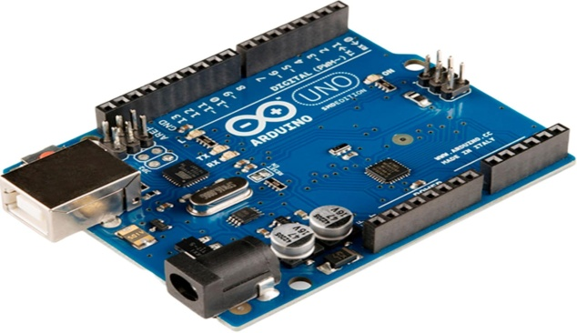

Figure 3.2: Arduino Uno

The GSM module will act as the main controller of the texting function, so upon receiving a new SMS, it will process the message and display it on the display system.
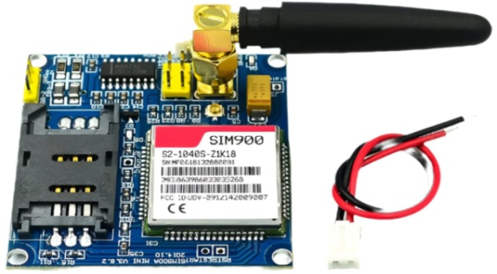

Figure 3.3: SIM900A GSM Module

Using AT commands, the GSM module will accept an SMS message and convert it into serial data for Arduino.
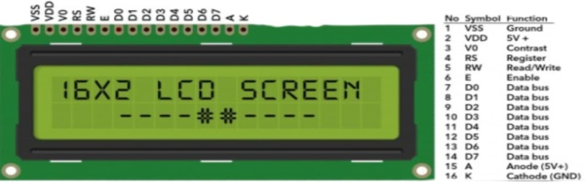

Figure 3.4: 16×2 LCD Display

The LCD will display messages formatted for 16 characters and two lines.
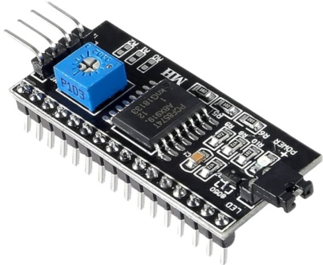

Figure 3.5: I2C LCD Driver

Allows a simplified wiring configuration for the LCD display (16 pins versus 4 pins).
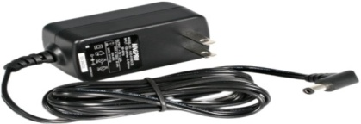
Figure 3.6: 5V DC Adapter
Provides a consistent amount of power to the entire system to ensure the operation of the Arduino and GSM module.

Software

- Embedded C or Arduino IDE
- GSM AT Commands for SMS control
- Serial Communication Interface

- Circuit Diagram
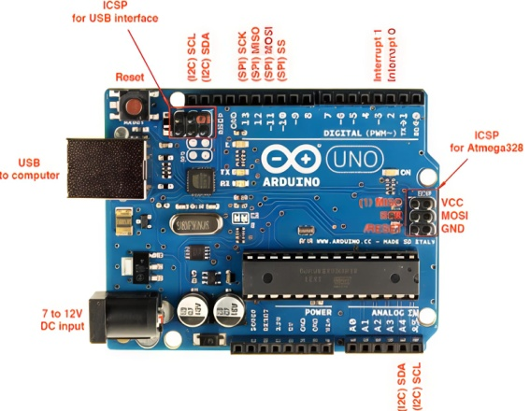
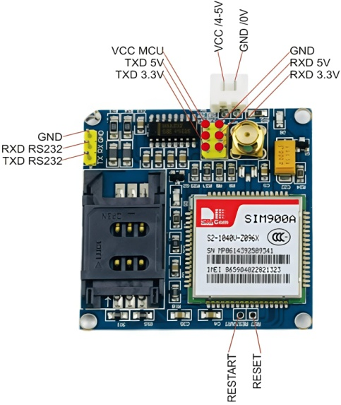
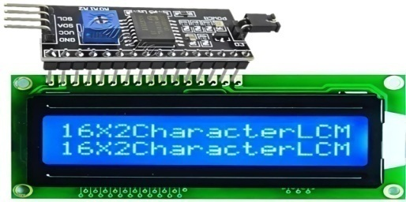
Figure 4.1: Circuit diagram
Explanation
All of the components of the WDSS are connected in a single circuit diagram. The circuit diagram divides the WDSS into three main functional blocks: the GSM module, microcontroller section, and display section.
1. SIM900A GSM Module Section-SIM900A is used as the communication interface for the WDSS. It operates on 12V DC power supplied to the module from a regulated power supply. The SIM900A's TX (Transmit) pin and RX (Receive) pin are connected to the microcontroller's RXD and TXD pins, respectively, to establish UART serial communications. SMS messages sent from registered mobile numbers are delivered to SIM900A via the GSM network via the SIM900A. The SIM900A can also be viewed as a wireless message receiver and acts as a bridge between the user and the WDSS.
2. Microcontroller (MCU) Section -This is the main processing area of the device. The MCU constantly checks for incoming serial data being transmitted from the SIM900A module. In the event of receiving an SMS message, the MCU uses AT commands to extract the message content from the message. Circuitry includes reset circuitry to ensure stable operation, an oscillator crystal, and decoupling capacitors to help stabilize operation. Once the processing of the message is completed, the MCU transmits the processed message to the display for an up-to-date display. The MCU interprets the SMS data received and converts it to displayable data for the display.
3. Display (LCD or LED) Section -Depending on your design, you may be using either 16×2 LCD or LED matrix boards. The display will be connected to the MCU via the MCU's data and control line connections (RS, RW, and EN pins). If you are using an I2C LCD module, only the SDA and SCL connections to the MCU will be made. Once the processing of the message has been completed in the MCU, the message will be displayed in real-time in a readable format in the display section.
4.Regulated Power Supply Section - The device requires two different voltages to operate properly: a 12V DC supply for the SIM900A GSM module and a 5V DC power supply for the MCU and LCD. A combination of voltage regulators and adapters is used: a 7805 (5V) voltage regulator and a 12-volt power supply. Filter capacitors help to smooth out any voltage fluctuations. Proper grounding is used to eliminate electrical noises, allowing optimal function of all the electronic equipment and providing more acceptability to normal operation inherent.
- Results and Discussion
The prototype unit was tested successfully, with messages appearing to respond virtually immediately after an SMS command was sent. Messages were generally displayed within 2-5 seconds after being delivered via an SMS command.
- Excellent accuracy for message display.
- Functionality on all mobile network carriers.
- Very easy to use when formatting text messages.
- Reliable signal during all of the testing of the system.
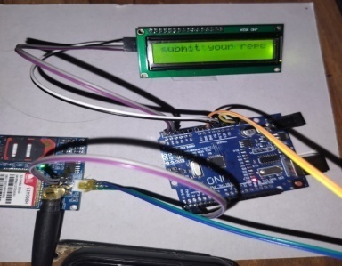

Conclusion
The GSM-based wireless display system (WDSS) is a modern, efficient solution for institutions and public areas to communicate via electronic displays instead of through manual displays. The WDSS allows for quick, inexpensive, and reliable access to electronically displayed information in public areas such as schools, colleges, offices, bus/station, train stations, etc.
References
- A. Kumar & R. Singh, “GSM-Based Wireless Display System,” International Journal of Engineering Research, 2020.
- P. Sharma, “Wireless Notice Display System,” IEEE Conference on Communication Systems, 2019.
- S. Reddy, “Embedded Design of GSM Controlled Display System,” IJERT, 2021.
- “Wireless Electronic Display System Using GSM,” International Journal of Research in Engineering and Science, 2018.

