Engineering Geological Controls on Quarry Dust Generation and Respiratory Exposure in Mpape, Abuja, North Central Nigeria

Abstract
Quarrying of quartz-rich crystalline rocks generates respirable silica dust that poses significant occupational and environmental health risks. This study evaluated the engineering geological controls on silica dust generation and respiratory exposure within the Mpape quarry district, Abuja, Nigeria, using an integrated approach involving geological mapping, drainage analysis, aerial image interpretation, petrographic examination, and engineering geological assessment. Geological mapping revealed that the study area is predominantly underlain by coarse-grained biotite granite of the Nigerian Precambrian Basement Complex, characterized by extensive jointing, pegmatite intrusions, and quartz veins. Petrographic analysis under plane-polarized and crossed-polarized light identified quartz (35%), plagioclase feldspar (27%), potassium feldspar (19%), biotite (11%), muscovite (4%), opaque minerals (2%), and alteration products (2%) as the principal mineral constituents. The high quartz content indicates a substantial potential for respirable crystalline silica generation during drilling, blasting, crushing, and screening operations. Drainage analysis showed a predominantly dendritic drainage pattern controlled by fractured basement rocks, while quarry excavation has modified natural runoff through the formation of quarry ponds and altered groundwater pathways. Field observations further revealed that several residential settlements are located within close proximity to active quarry sites, thereby increasing the likelihood of prolonged community exposure to airborne silica particles, particularly during the dry Harmattan season. The study establishes that quartz abundance, fracture density, weathering characteristics, and quarry operational processes collectively control silica dust generation and subsequent respiratory exposure. It further presents an integrated engineering geological framework linking lithology, mineralogy, structural geology, drainage, hydrogeology, quarry operations, and occupational health. The findings provide valuable baseline information for sustainable quarry management, environmental monitoring, occupational health protection, and evidence-based policy development in crystalline basement terrains.
Keywords: Engineering-geology; Petrography; Quartz-mineralogy; Silica-dust; Occupational-health.

Introduction.
Mpape is located (Latitude 9º08’40’ and 9º09’10’’N and Longitude 7º29’20’’ and 7º29’50’’) within the Federal Capital Territory (FCT), Nigeria, and lies within the Nigerian Precambrian Basement Complex. The area is predominantly underlain by granitic rocks, granite gneisses, migmatitic gneisses, and pegmatite intrusions that formed during the Pan African Orogeny. The geological map of Mpape indicates that these rocks are extensively fractured and weathered, making them suitable for quarrying activities. The granitic rocks are coarse grained and composed mainly of quartz, feldspars, biotite, and minor muscovite. Their high mechanical strength and durability have made them the principal source of aggregates used for roads, bridges, buildings, and other engineering projects within Abuja. The aerial photograph (Figure 1) of Mpape shows that quarry sites occupy a significant proportion of the landscape and are situated close to residential settlements. The proximity of quarry operations to houses, schools, commercial centres, and roads increase the potential for environmental pollution and human exposure to quarry generated dust. Recent studies have noted that rapid urban expansion within the Federal Capital Territory has brought residential developments closer to long established quarry sites, thereby increasing environmental and public health concerns.
Environmental Consequences of Quarrying
Apart from human health effects, quarrying significantly alters the surrounding environment. Continuous dust deposition reduces visibility, coats vegetation, contaminates harvested rainwater, and accelerates deterioration of nearby buildings. Fine dust particles transported by runoff may also increase sedimentation in streams and drainage channels. Recent studies have demonstrated elevated concentrations of heavy metals and particulate contaminants in soils, sediments, and dust collected around quarry districts, indicating that quarrying may influence environmental quality beyond the immediate excavation sites.
Human activities that range from domestic energy utilization to large scale industrial operations are widely responsible for undesirable status of atmospheric constituents due to addition of pollutants (Crystalline Silica dust). The effects of air Crystalline Silica Dust (CSD) on human health are very complex as there are different sources; thereby producing varying effects. Although industries such as power plants, cement, refineries, petrol-chemicals and mines have been identified as major sources of air pollutants, the emission of particulates is quite outstanding from quarries. Generally, the effects of Crystalline Silica Dust (CSD) emission from quarries have adverse effect on Gastro Oesophagus Pulmonary Diseases (GOPD) emanating from ground vibration arising from blasting, crushing and emission of noxious gases have negative impacts on human health as well. The various impacts produced by these operations are both size and locations dependent. Manifestations of specific impacts are on the air, water, soil, earth surface, flora and fauna, and human beings. Apart from land degradation, other negative impacts of quarrying include swamp creation, deterioration of ground water, erosion of soil, noise and percussions from rock blasting, generation of dust, smoke and fumes; production of noxious gases and ground vibration. Suspended particulate matter is quite outstanding among all pollutants emanating from quarrying operations. Solid materials in the form of smoke, dust and also vapor generated during quarrying are usually suspended over a long period in the air. Moreover, particulate matter in the air is capable of being transported from the point of generation to areas far removed . Once particles of varying chemical compositions are inhaled, they lodge in human lungs; thereby causing lung damages and respiratory problems. Dusts generated from granite quarrying contain 71 percent silica (Leungel et al., 2012). Inhaling such dust results in silicosis which is capable of disabling an exposed person and subsequently, lead to death. Apart from silicosis, sandblasters, miners and quarry workers are to suffer from pneumoconiosis. Suspended particulate matter may be affecting more people globally than any other pollutant on a continuous basis (Richard, et al., 2002).
Quarry Activities and Aggregate Production
Quarrying is one of the major economic activities in Mpape and supplies construction aggregates for the rapidly expanding infrastructure of Abuja and neighbouring states. Quarry production involves vegetation clearance, overburden removal, drilling, blasting, excavation, crushing, screening, stockpiling, loading, and transportation. Each stage contributes to varying levels of dust generation. Modern quarry operations employ hydraulic drilling machines, explosives, excavators, jaw crushers, cone crushers, screening plants, conveyor systems, and heavy-duty haulage trucks. Although these technologies improve production efficiency, they also increase the release of airborne particulate matter, particularly where dust suppression systems are inadequate. Recent environmental studies have shown that crushing plants are the largest contributors to airborne dust concentrations because repeated crushing of quartz rich rocks produces abundant respirable crystalline silica particles. Wind action further disperses these particles beyond quarry boundaries into neighbouring communities.
Drainage Characteristics of the Study Area
The drainage within Mpape follows a predominantly dendritic to sub dendritic pattern, which is typical of crystalline basement terrains. Stream channels are locally controlled by fractures, joints, and faults that developed during tectonic deformation. These structural discontinuities influence groundwater recharge and surface runoff. Quarry excavation has modified the natural drainage system through the creation of deep pits and artificial depressions that accumulate rainwater and groundwater. Some abandoned quarry pits have developed into permanent lakes after intersecting groundwater aquifers. Surface runoff also transports quarry dust and fine sediments into nearby drainage channels during rainfall, increasing turbidity and sediment loads while affecting downstream water quality.
Mineralogy of the Mpape Granites
Petrographic examination of granitic rocks from Mpape indicates that quartz is the dominant mineral, followed by potassium feldspar, plagioclase feldspar, biotite, muscovite, and accessory opaque minerals. Quartz commonly occurs as anhedral interlocking crystals that occupy interstitial spaces between feldspars. Plagioclase feldspars display characteristic polysynthetic twinning under crossed polarized light, while biotite exhibits brown pleochroism under plane polarized light. The abundance of quartz is of particular importance because it is the principal source of crystalline silica released during drilling, blasting, crushing, and screening. Mechanical fragmentation of quartz rich rocks produces respirable crystalline silica particles that remain suspended in the atmosphere for prolonged periods.
Silica Dust Generation During Quarry Operations
Respirable crystalline silica is generated whenever quartz bearing rocks are mechanically disturbed. In Mpape, silica dust is produced during blast hole drilling, blasting, rock fragmentation, crushing, screening, stockpiling, loading, transportation, and movement of heavy vehicles along unpaved haul roads. Particle size largely determines health risk. Larger particles settle rapidly near the source, whereas PM₁₀ and PM₂.₅ remain airborne for longer periods and are transported considerable distances by wind. Respirable crystalline silica particles smaller than approximately 4 μm penetrate deeply into the alveolar regions of the lungs where they accumulate and initiate inflammatory and fibrotic responses. Recent investigations at Nigerian quarry sites have reported dust concentrations that exceed recommended occupational exposure limits, particularly around crushing plants where silica rich dust is continuously generated.
Occupational Health Effects on Quarry Workers
Quarry workers constitute the population most directly exposed to silica dust because of their involvement in drilling, blasting, crushing, loading, equipment maintenance, and transportation. Prolonged inhalation of respirable crystalline silica has been associated with silicosis, chronic obstructive pulmonary disease, pulmonary fibrosis, chronic bronchitis, tuberculosis, reduced lung function, and lung cancer. A recent Nigerian study reported that quarry workers experience high levels of occupational health problems due to repetitive manual labour, vibration, prolonged working hours, and poor occupational safety practices. Nearly ninety percent of workers surveyed experienced musculoskeletal disorders, highlighting the need for improved workplace health programmes. Similarly, a 2024 investigation of quarry workers in southwestern Nigeria found evidence that prolonged exposure to stone quarry dust may adversely affect immune function and respiratory health, reinforcing concerns regarding chronic silica exposure in quarry environments.
Health Effects on Residents Around Quarry Sites
The aerial photograph demonstrates that residential settlements occur immediately adjacent to several active quarry sites in Mpape. This close proximity increases the likelihood of community exposure to airborne silica dust. Wind transports fine particulate matter beyond quarry boundaries where it settles on houses, schools, roads, markets, and vegetation. The World Health Organization has emphasized that long term exposure to PM₂.₅ and PM₁₀ significantly increases the risks of respiratory and cardiovascular diseases, especially among children, older adults, and individuals with pre-existing medical conditions. Continuous inhalation of quarry dust has been associated with chronic cough, asthma, eye irritation, throat irritation, reduced pulmonary function, and other respiratory symptoms. A health impact assessment conducted within the Mpape quarry district also reported that residents living close to blasting and crushing operations frequently experience noise, vibration, dust nuisance, and respiratory discomfort resulting from quarry activities.
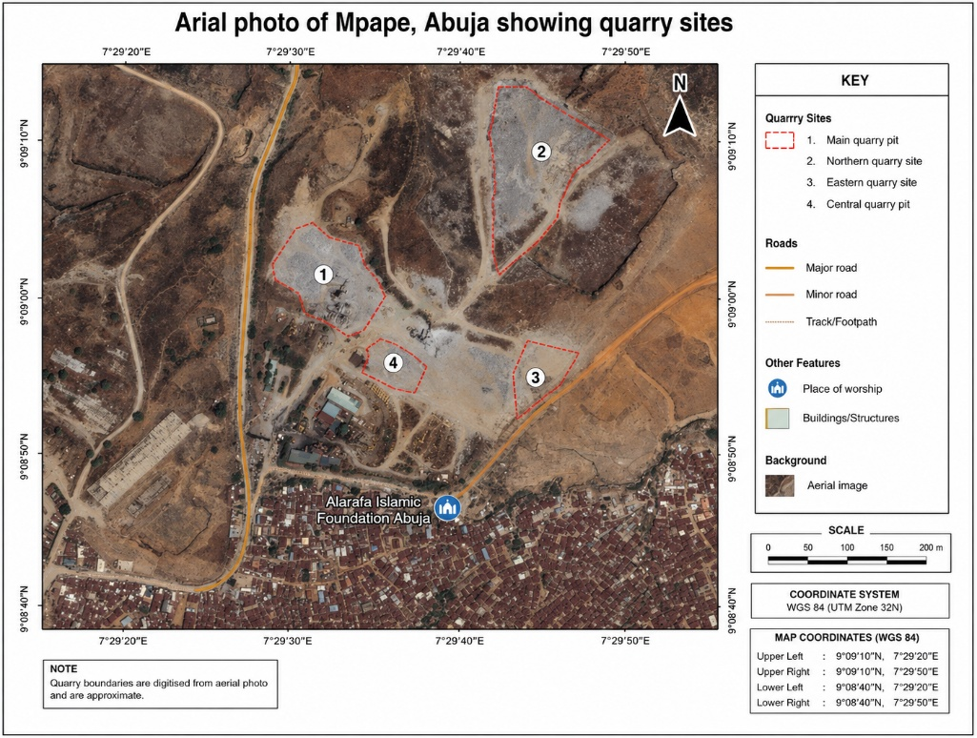
Figure. 1: Arial map of Mpape Area showing quarry
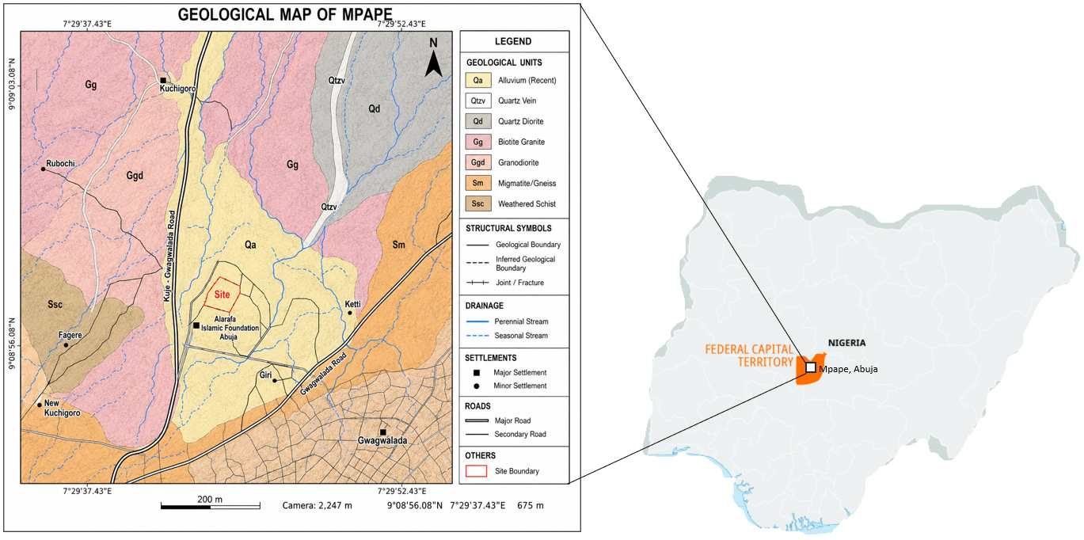
Figure. 2: Geological map of Mpape Area
Materials And Methods
This study adopted an integrated engineering geological approach involving geological field mapping, petrographic analysis, aerial image interpretation, geographic information system (GIS) mapping, and engineering geological assessment to evaluate the geological controls on silica dust generation and respiratory exposure within the Mpape quarry district, Abuja. The methodology combined field observations with laboratory investigations to establish relationships between rock mineralogy, quarry activities, dust generation, hydrogeological characteristics, and occupational health risks. The workflow of the study comprised reconnaissance survey, geological mapping, rock sampling, laboratory preparation of thin sections, petrographic examination under plane-polarized light (PPL) and crossed-polarized light (XPL), modal mineral estimation, interpretation of drainage characteristics, and integration of engineering geological observations.
Geological Field Mapping
Detailed geological mapping was conducted using standard engineering geological mapping procedures. Lithological boundaries, structural discontinuities, weathering characteristics, drainage channels, quarry faces, and geomorphological features were identified and mapped during systematic traverses across the study area. Rock types were identified based on colour, texture, mineral composition, weathering characteristics, and field relationships. Structural measurements, including the strike and dip of joints, fractures, quartz veins, and pegmatite intrusions, were obtained using a Brunton compass. The spatial coordinates of geological observation points were recorded using a handheld Global Positioning System (GPS) receiver referenced to the World Geodetic System. The field observations were subsequently integrated with high-resolution satellite imagery to produce the geological and drainage maps of the study area.
Rock Sample Collection
Representative fresh rock samples were collected from active quarry faces distributed across the study area. Sampling was restricted to fresh, unweathered rock exposures to ensure that the petrographic characteristics accurately represented the parent rock. Approximately 15 representative granitic rock samples were collected using a geological hammer and chisel. Each sample was labelled immediately after collection and stored in polythene sample bags before transportation to the laboratory.
Preparation of Thin Sections
Fresh rock specimens were trimmed into small rectangular blocks approximately 30 mm × 20 mm × 10 mm using a diamond saw. The cut surfaces were ground on progressively finer silicon carbide abrasives to obtain smooth and even surfaces. The prepared specimens were cleaned with distilled water and ethanol to remove loose particles before bonding onto standard petrographic glass slides using transparent epoxy resin. After curing, the rock slices were ground to the internationally accepted petrographic thickness of approximately 30 μm. Final polishing was carried out using aluminium oxide powder to improve optical clarity. The completed thin sections were carefully cleaned, labelled, and examined under a polarizing petrographic microscope. The preparation procedures followed internationally accepted petrographic laboratory techniques for engineering geological investigations (Shelley, 1993; Nesse, 2013).

Results and Discussion
Field Observations
Geological mapping of the Mpape quarry district revealed that the area is predominantly underlain by coarse-grained granitic rocks belonging to the Nigerian Precambrian Basement Complex (Figure 3). The rocks occur as prominent hills, ridges, and inselbergs that have been extensively exploited for aggregate production. Fresh rock exposures are abundant within the active quarry sites, whereas weathered overburden is generally restricted to low-lying areas and gently sloping terrain. The quarry faces expose massive granite characterized by coarse crystalline textures and well-developed joint systems. Several joint sets were identified, trending predominantly northeast–southwest, northwest–southeast, and north–south. These structural discontinuities significantly influence rock fragmentation during blasting and facilitate groundwater movement within the fractured basement rocks. Pegmatite veins and quartz veins were observed cutting across the granitic host rocks at several locations. These veins vary in thickness from a few centimetres to over one metre and generally follow the dominant joint orientations. The quartz veins are particularly significant because they represent zones of very high silica concentration that may contribute to increased crystalline silica dust generation during quarry operations. Weathering intensity varies considerably across the study area. Fresh granitic rocks dominate the active quarry faces, while moderately weathered granites occur near the surface beyond the quarry limits. The weathered zones are characterized by partial decomposition of feldspars into clay minerals and oxidation of biotite to iron oxides.
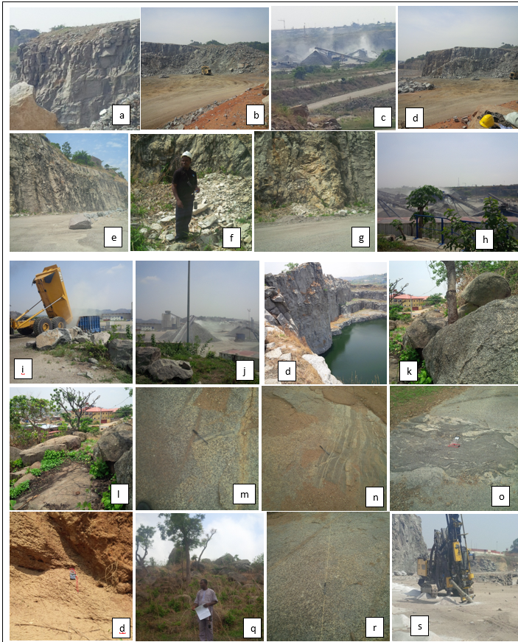
Figure 3. Representative Quarry Faces and Rock Outcrops within the Study Area
Quarry Operations
Field investigations identified several active quarry operations (Figure 3) distributed across the Mpape district. The principal quarrying activities include site preparation, drilling, blasting, rock excavation, crushing, screening, stockpiling, loading, and transportation of aggregates. Drilling is carried out using hydraulic percussion drilling rigs that produce blast holes extending several metres into the rock mass. Following drilling, controlled blasting using commercial explosives fragments the granite into manageable rock blocks. Excavators subsequently load the blasted materials into haulage trucks for transportation to the crushing plants. The crushing plants comprise primary jaw crushers, secondary cone crushers, vibrating screens, conveyor belts, and aggregate stockpiles. Dust generation was observed throughout these operations but was most intense around the crushing and screening units where repeated mechanical fragmentation of quartz-rich rocks produces abundant fine particulate matter. Heavy-duty trucks transporting aggregates along unpaved haul roads also contribute substantially to airborne dust through continuous disturbance of loose surface materials. Dust emissions were particularly pronounced during the dry season when low atmospheric humidity and strong Harmattan winds enhanced the suspension and transport of fine particles.
Petrographic Characteristics
Petrographic examination of the representative thin sections under Plane Polarized Light (PPL) and Crossed Polarized Light (XPL) confirms that the investigated rocks are predominantly coarse-grained biotite granites. Quartz occurs as colourless, anhedral to subhedral crystals displaying low relief under PPL and characteristic first-order grey to white interference colours under XPL. Most quartz grains exhibit undulose extinction, indicating deformation associated with regional tectonic stresses. Plagioclase feldspar is readily recognized by its characteristic polysynthetic twinning under XPL. Several grains exhibit partial sericitization, indicating incipient chemical weathering. Potassium feldspar occurs as subhedral crystals displaying simple twinning and locally developed perthitic textures. Minor alteration to kaolinite is observed along cleavage planes and grain boundaries. Biotite appears as brown to dark brown pleochroic flakes under PPL and exhibits bright second-order interference colours under XPL. Partial chloritization and oxidation to iron oxides were observed in several thin sections. Accessory muscovite occurs in relatively small quantities, while opaque minerals are sparsely distributed throughout the rock matrix. The interlocking crystalline texture indicates slow cooling of granitic magma at considerable depth, producing a mechanically competent rock suitable for aggregate production (Plate 1).
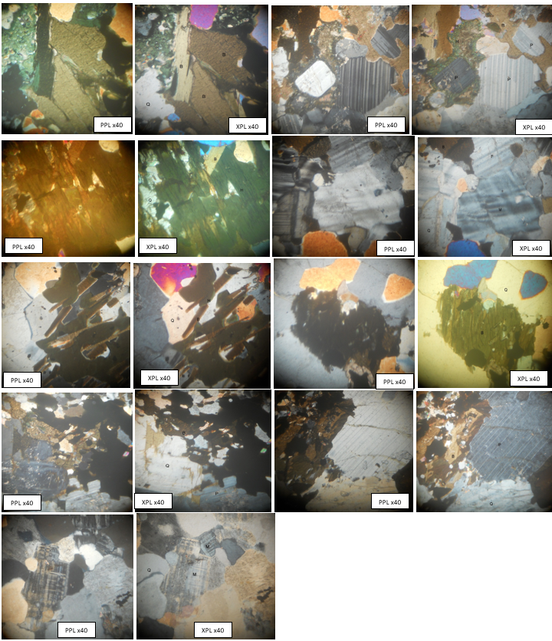
Plate 1. Representative PPL and XPL Photomicrographs Showing Major Rock-Forming Minerals
Modal Mineral Composition
Visual estimation of the paired PPL and XPL photomicrographs indicates that quartz is the dominant mineral phase, constituting approximately 35% of the total rock volume. Plagioclase feldspar averages about 27%, while potassium feldspar contributes approximately 19%. Biotite accounts for about 11%, whereas muscovite, opaque minerals, and alteration products collectively constitute less than 10% of the rock (Plate 1).
The estimated modal compositions indicate relatively uniform mineralogical characteristics across the investigated thin sections, confirming that the granitic rocks exhibit limited lithological variability.

Estimation of Modal Mineral Composition
The modal mineral composition (Table 1) of each thin section was estimated through systematic visual assessment of the paired PPL and XPL photomicrographs. The relative abundance of quartz, plagioclase feldspar, potassium feldspar, biotite, muscovite, opaque minerals, and alteration products was determined by estimating the proportion of the field of view occupied by each mineral phase. The estimated modal compositions were subsequently averaged to obtain representative mineralogical compositions of the granitic rocks within the study area. Quartz was observed to be the dominant mineral, followed by plagioclase feldspar, potassium feldspar, and biotite.
Table 1. Estimated Modal Mineral Composition of Representative Rock Thin Sections from Mpape Quarry Area
Thin Section Pair | Quartz (%) | Plagioclase (%) | K Feldspar (%) | Biotite (%) | Muscovite (%) | Opaque Minerals (%) | Alteration Products (%) | Total (%)
Pair 1 | 34 | 28 | 18 | 12 | 3 | 2 | 3 | 100
Pair 2 | 36 | 25 | 20 | 10 | 4 | 2 | 3 | 100
Pair 3 | 32 | 30 | 19 | 11 | 3 | 2 | 3 | 100
Pair 4 | 35 | 27 | 18 | 13 | 2 | 2 | 3 | 100
Pair 5 | 37 | 24 | 20 | 10 | 3 | 2 | 4 | 100
Pair 6 | 33 | 29 | 18 | 12 | 3 | 2 | 3 | 100
Pair 7 | 35 | 26 | 19 | 11 | 3 | 2 | 4 | 100
Pair 8 | 34 | 28 | 18 | 11 | 3 | 2 | 4 | 100
Pair 9 | 36 | 25 | 19 | 11 | 3 | 2 | 4 | 100
Table 2: Average Modal Mineral Composition
Mineral | Average (%)
Quartz | 34.7
Plagioclase Feldspar | 26.9
Potassium Feldspar | 18.8
Biotite | 11.2
Muscovite | 3.0
Opaque Minerals | 2.0
Alteration Products | 3.4
Total | 100

The photomicrographs (Tables 2 and 1) indicate that quartz is the dominant mineral, averaging approximately 35% of the rock volume. Quartz is colourless under plane polarized light and exhibits first order grey interference colours under crossed polarized light. Its abundance confirms that the Mpape granite is highly siliceous. Plagioclase feldspar constitutes approximately 27% of the rock and is recognized by its characteristic polysynthetic twinning under crossed polarized light. Potassium feldspar contributes about 19% and commonly exhibits simple twinning or perthitic textures. Together, the feldspars account for nearly half of the rock and are important in controlling weathering processes because they gradually alter to clay minerals. Biotite (Table 3) forms about 11% of the rock. It is identified by its brown pleochroism under plane polarized light and bright interference colours under crossed polarized light. Muscovite and opaque minerals occur only in minor quantities. The mineralogical composition confirms that the rock is a quartz rich granite, making it an excellent source of construction aggregates but also a significant source of crystalline silica during quarry operations.
Table 3: Minerals with the Greatest Health Implications
Mineral | Average (%) | Health Significance
Quartz | 34.7 | Very High
Feldspars | 45.7 | Low
Biotite | 11.2 | Low to Moderate
Muscovite | 3.0 | Low
Opaque Minerals | 2.0 | Negligible
Quartz (Table 3) represents the principal occupational health hazard because it is the source of respirable crystalline silica. During drilling, blasting, crushing, and screening, quartz crystals fracture into microscopic particles that can be inhaled deep into the lungs. Long term exposure to respirable crystalline silica is associated with silicosis, pulmonary fibrosis, chronic obstructive pulmonary disease, tuberculosis, and lung cancer.
Interpretation of Silica Dust Generation
The potential for silica dust generation was evaluated by integrating petrographic observations with field evidence obtained from drilling, blasting, crushing, stockpiling, and transportation activities. Particular attention was paid to the abundance and distribution of quartz because crystalline silica is the principal source of respirable dust generated during quarry operations. The engineering behaviour of the rock mass, including fracture density, weathering characteristics, mineral hardness, and fragmentation behaviour, was assessed to determine the geological controls influencing dust production.

Hydrogeological Assessment
Hydrogeological observations were carried out during geological mapping to evaluate groundwater occurrence and drainage characteristics within the quarry district. Natural drainage channels, quarry ponds, groundwater seepages, and weathered zones were examined in the field. The influence of mineral weathering, structural discontinuities, and quarry excavation on groundwater occurrence was interpreted using field observations supported by petrographic evidence. Particular emphasis was placed on assessing the influence of feldspar weathering on secondary porosity development and groundwater movement within the crystalline basement rocks.
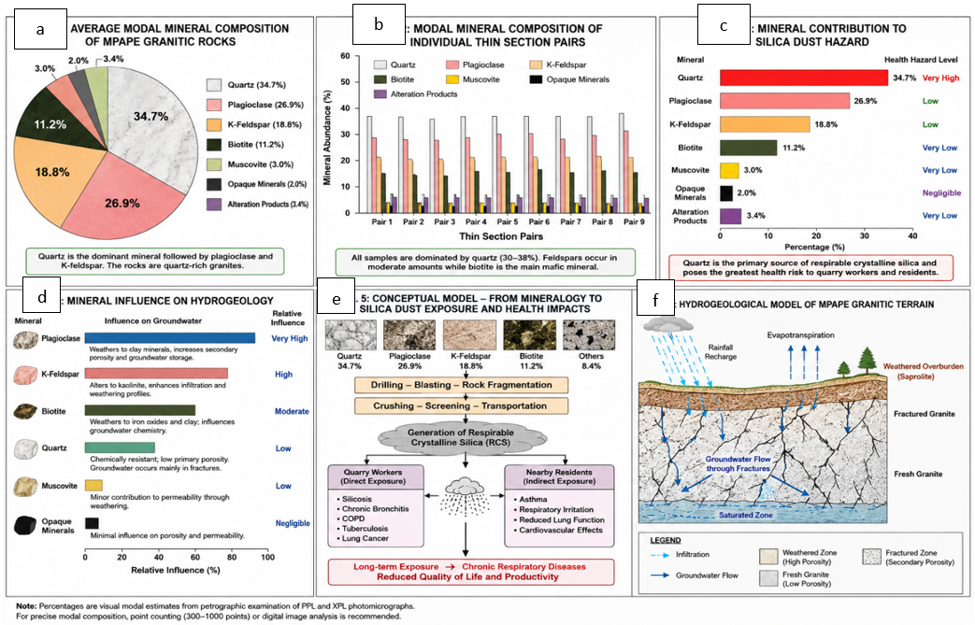
Figure 4: (a) Average Modal composition (b) Mineral Abundance (c) Mineral contribution to silica dust (d) Mineral influence on Hydrogeology (e) Conceptual model of mineralogy to dust exposure and health impacts (f) Hydrogeological model of Mpape granitic terrain
Health Risk Assessment
The potential health implications of silica dust (Figure 4) were evaluated qualitatively based on the identified mineralogical composition, observed quarry operations, and the proximity of residential settlements to active quarry sites. Dust-generating activities such as drilling, blasting, crushing, screening, loading, and transportation were identified as the principal occupational exposure pathways. The assessment considered the susceptibility of quarry workers, equipment operators, truck drivers, roadside traders, school children, and residents to long-term exposure to respirable crystalline silica generated during quarry operations. A conceptual exposure model was developed to illustrate the relationship between quartz abundance, quarry activities, dust generation, transport mechanisms, exposure pathways, and associated respiratory health outcomes.
Geological Map Analysis
The geological map (Figure 2) indicates that the study area is dominated by coarse-grained biotite granite with subordinate granite gneiss, migmatitic gneiss, pegmatite, and quartz veins. The granitic rocks occupy elevated topographic positions, while weathered materials occur within valleys and drainage channels. The mapped lithological units display distinct structural relationships controlled by regional tectonic deformation associated with the Pan-African Orogeny. Quartz veins and pegmatite intrusions commonly exploit pre-existing fractures and joints, producing interconnected structural networks throughout the quarry district. The geological map further indicates that most active quarry sites are concentrated within the granite outcrops because of their superior engineering properties and high aggregate yield. However, the dominance of quartz-bearing lithologies also increases the potential for crystalline silica dust generation.
Drainage Characteristics
The drainage map (Figure 5) reveals a predominantly dendritic drainage pattern developed over the crystalline basement rocks. Local stream channels exhibit structural control, particularly where fractures and joints influence the orientation of surface runoff. Several drainage channels originate from elevated granitic hills before converging into larger seasonal streams within the valleys. The drainage density is relatively low, reflecting the low primary permeability of the fresh granitic rocks. Groundwater occurrence is therefore controlled primarily by weathered zones and interconnected fracture systems. Numerous abandoned quarry pits now contain permanent water bodies formed through the interception of groundwater-bearing fractures and accumulation of surface runoff. These quarry lakes constitute artificial hydrogeological features that locally modify groundwater flow patterns. Fine quarry dust deposited on exposed rock surfaces and haul roads is transported into drainage channels during rainfall events, increasing suspended sediment concentrations and potentially influencing downstream water quality.
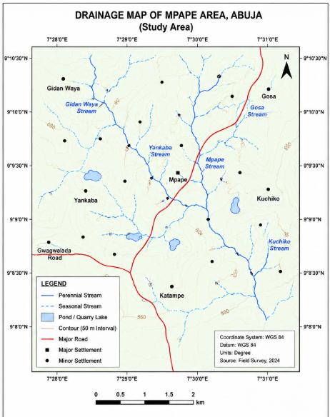
Figure 5. Drainage Pattern of the Mpape Quarry District
Engineering Geological Characteristics
The granitic rocks exhibit coarse crystalline textures, high quartz content, low weathering intensity within active quarry faces, and well-developed interlocking mineral fabrics. These characteristics confer high compressive strength, excellent durability, and favourable aggregate properties for engineering construction. However, the high quartz content also increases the potential for crystalline silica generation during mechanical fragmentation. Joint density and fracture spacing further influence blasting efficiency and determine the quantity of fine particles produced during crushing operations.
Silica Dust Generation
Field observations indicate that the principal sources of silica dust within the quarry district are drilling, blasting, crushing, screening, stockpiling, and transportation of aggregates. Crushing and screening operations generated the greatest quantities of visible airborne dust due to repeated fragmentation of quartz-rich granitic rocks. The abundance of quartz identified during petrographic analysis confirms that the dust generated is likely to contain significant proportions of respirable crystalline silica. Fine particles remain suspended in the atmosphere for prolonged periods, particularly during the dry season when strong Harmattan winds enhance atmospheric dispersion. The close proximity of quarry operations to residential communities increases the likelihood of continuous occupational and environmental exposure.

Hydrogeological Implications
The hydrogeological characteristics of the study area are controlled primarily by weathered overburden and fractured granitic bedrock. Feldspar weathering contributes to the development of secondary porosity within the saprolite, while joints and fractures facilitate groundwater movement through the otherwise impermeable crystalline rocks. Quarry excavation has intercepted groundwater-bearing fractures in several locations, producing permanent quarry ponds that modify local groundwater flow patterns. Although these water bodies provide temporary groundwater storage, they may also accumulate suspended sediments and fine particulate materials derived from quarry operations.
Engineering Geological Characteristics of the Mpape Granite
The geological mapping and petrographic investigations demonstrate that the Mpape quarry district is predominantly underlain by coarse-grained biotite granite of the Nigerian Precambrian Basement Complex. The rocks exhibit fresh exposures within the quarry faces and are characterized by coarse crystalline textures, abundant quartz, feldspars, biotite, pegmatitic intrusions, and well-developed structural discontinuities. These observations agree with the descriptions of the Abuja Basement Complex by Obaje (2009) who reported that granitic rocks within the Federal Capital Territory constitute some of the most competent engineering materials in Nigeria. The interlocking crystalline texture observed in the thin sections indicates slow cooling of granitic magma under deep crustal conditions, producing rocks with high compressive strength and excellent durability. Similar petrographic characteristics have been reported for granitic rocks in other Basement Complex terrains of southwestern and north-central Nigeria (Rahaman, 1988). These characteristics explain why Mpape has become one of the major sources of construction aggregates supplying the rapidly expanding Abuja metropolis.
The extensive development of joints, fractures, and pegmatite veins observed during geological mapping reflects the tectonic history of the Pan-African Orogeny. These structural discontinuities enhance blasting efficiency because they reduce the energy required to fragment the rock mass. However, increased fragmentation also promotes the production of finer particles during drilling and crushing, thereby increasing dust emissions. Similar relationships between fracture density and rock fragmentation have been documented in hard-rock quarries in South Africa, India, and Brazil (Singh et al., 2021; Mendes et al., 2023).
Mineralogical Controls on Silica Dust Generation
Petrographic examination revealed that quartz is the dominant mineral in the investigated granite, with an estimated average abundance of approximately 35%, followed by plagioclase feldspar, potassium feldspar, and biotite. The abundance of quartz has important implications for both engineering performance and occupational health. Quartz possesses a Mohs hardness of 7 and exhibits exceptional resistance to both mechanical abrasion and chemical weathering. During drilling, blasting, crushing, and screening, quartz grains fracture into progressively smaller particles, many of which fall within the respirable size range of less than 10 μm and, more importantly, less than 4 μm aerodynamic diameters. These particles remain suspended in the atmosphere for extended periods and are readily inhaled by quarry workers and nearby residents (WHO, 2021).
The undulose extinction observed in many quartz grains under crossed polarized light indicates that the crystals have undergone tectonic deformation. Previous mineralogical studies suggest that strained quartz may fracture more readily under mechanical stress, thereby increasing the generation of respirable crystalline silica during aggregate production (Nesse, 2013). This finding suggests that both the abundance and microstructural condition of quartz influence dust production in addition to the operational practices employed at the quarry. The presence of quartz veins intersecting the granitic host rocks further increases local silica concentrations. Blasting through these veins generates dust enriched in crystalline silica, creating localized zones of elevated occupational exposure. This geological factor has received limited attention in previous Nigerian studies, making it an important contribution of the present investigation.
Engineering Geological Factors Influencing Dust Production
Dust generation within the Mpape quarry district is controlled by the interaction between geological conditions and quarry operational practices. Geological factors identified in this study include mineralogical composition, grain size, degree of weathering, fracture density, joint spacing, and rock strength. Fresh, quartz-rich granite requires intensive mechanical crushing before marketable aggregate sizes are produced. Each stage of fragmentation generates additional fine particles. Closely spaced joints facilitate blasting but simultaneously increase the amount of fragmented material entering the crushing circuit. Consequently, quarry faces exhibiting high fracture densities generally produce greater quantities of dust than more massive rock exposures. Operational factors such as drilling method, explosive charge, crusher type, conveyor transfer points, stockpile management, and haul-road conditions further influence dust emission rates. The present study therefore demonstrates that effective dust management cannot rely solely on engineering controls such as water spraying. Geological characteristics of the rock mass should also be considered during mine planning, blasting design, and aggregate processing to reduce dust generation at source.
Hydrogeological Implications of Quarrying
The hydrogeology of the Mpape quarry district is controlled primarily by weathered overburden and fractured crystalline basement rocks. Fresh granite possesses negligible primary porosity, whereas groundwater storage occurs mainly within weathered saprolite and interconnected fracture systems. The extensive joint networks mapped during this study provide important pathways for groundwater recharge and movement. Weathering of feldspars to kaolinite and other clay minerals increases secondary porosity within the weathered profile, enhancing groundwater storage. Conversely, quarry excavation removes portions of this weathered zone, exposing fresh bedrock and locally altering groundwater flow patterns. Excavation below the water table results in the formation of quarry lakes that intercept groundwater-bearing fractures.
These quarry lakes may function as local groundwater reservoirs; however, they also provide potential sinks for suspended sediments and fine silica particles transported by surface runoff during rainfall events. Although crystalline silica is chemically stable and exhibits low solubility, prolonged accumulation of suspended solids may influence turbidity and reduce water quality. Regular hydrochemical monitoring is therefore recommended for quarry ponds and nearby groundwater abstraction points.
Occupational Health Implications
The abundance of quartz identified during petrographic analysis strongly indicates that quarry workers within the Mpape district are routinely exposed to respirable crystalline silica generated during drilling, blasting, crushing, screening, and aggregate transportation. The greatest occupational exposure is expected among drill operators, crusher attendants, blasting crews, excavator operators, conveyor belt attendants, and truck drivers.
Respirable crystalline silica particles penetrate deeply into the alveolar region of the lungs, where they stimulate chronic inflammatory responses and progressive pulmonary fibrosis. Long-term occupational exposure has been associated with silicosis, chronic obstructive pulmonary disease, lung cancer, chronic kidney disease, autoimmune disorders, and increased susceptibility to pulmonary tuberculosis (Leung et al., 2012; WHO, 2021).
The field observations indicate that visible dust clouds frequently develop around crushing plants and haul roads, particularly during the dry season. In many locations, workers performed routine activities without consistently using approved respiratory protective equipment. This observation suggests that occupational exposure may exceed recommended health limits if effective dust suppression measures are not implemented.
Recent epidemiological investigations among quarry workers in Nigeria, Ghana, South Africa, and India similarly reported increased prevalence of chronic cough, breathlessness, wheezing, reduced lung function, and abnormal chest radiographs among workers exposed to silica-containing dust (Ahadzi et al., 2020; Njaka et al., 2021; Bansah et al., 2022).
5.6 Public Health Implications for Surrounding Communities
An important finding of this study is the close spatial relationship between active quarry sites and residential neighbourhoods. The aerial imagery demonstrates that many residential buildings, schools, religious centres, and commercial premises are located within a few hundred metres of quarry operations. This proximity increases the likelihood of environmental exposure among populations not directly employed within the quarry industry. Fine silica particles generated during aggregate processing are transported by prevailing winds beyond quarry boundaries and deposited on roofs, crops, roads, and surface water bodies. Children, elderly individuals, and people with pre-existing respiratory diseases may be particularly vulnerable because of prolonged residential exposure. The expansion of urban settlements around quarry districts therefore presents a growing public health concern. Land-use planning policies should incorporate adequate buffer zones between quarry operations and residential developments. Continuous ambient air quality monitoring should also be implemented to ensure compliance with national and international air quality standards.
Contribution of the Study to Knowledge
This investigation provides several important contributions to engineering geology and environmental health research. First, it integrates geological mapping, drainage analysis, petrographic investigation, engineering geological assessment, and occupational health considerations within a single multidisciplinary framework. Previous studies have generally examined these components independently. Second, the study demonstrates that the mineralogical composition of granitic rocks, particularly quartz abundance and deformation characteristics, exerts a primary control on respirable crystalline silica generation during quarry operations. Third, the research establishes a conceptual linkage between lithology, structural geology, quarry operational practices, hydrogeological conditions, and respiratory health outcomes. This integrated model provides a scientific basis for developing geology-informed dust control strategies that complement conventional engineering mitigation measures. Finally, the study emphasizes that sustainable quarry management should consider not only aggregate production efficiency but also geological characteristics, environmental protection, groundwater conservation, and the long-term health of workers and neighbouring communities.
Conclusions
This study integrated geological mapping, petrographic analysis, engineering geological assessment, aerial image interpretation, and hydrogeological observations to investigate the geological controls on silica dust generation and respiratory exposure within the Mpape quarry district, Abuja. The integrated approach provided a comprehensive understanding of the relationships among rock mineralogy, geological structures, quarry operations, environmental conditions, and occupational health.
Field investigations revealed that the study area is predominantly underlain by coarse-grained biotite granite belonging to the Nigerian Precambrian Basement Complex. The rocks are characterized by abundant quartz, feldspars, biotite, pegmatite veins, quartz veins, and well-developed joint systems that control both quarry development and groundwater movement. These engineering geological characteristics explain the suitability of the rocks for aggregate production while simultaneously increasing their potential for crystalline silica dust generation.
Petrographic examination under Plane Polarized Light (PPL) and Crossed Polarized Light (XPL) confirmed that quartz is the dominant mineral phase within the investigated rocks. The high modal abundance of quartz indicates that drilling, blasting, crushing, and screening operations inevitably generate significant quantities of respirable crystalline silica. The presence of undulose extinction in several quartz grains further suggests that tectonically strained quartz may fracture more readily during mechanical processing, thereby contributing to increased dust production.
The mapped structural discontinuities, including joints, fractures, and pegmatite intrusions, significantly influence blasting efficiency, rock fragmentation, and secondary dust generation. These geological controls demonstrate that dust emission is not solely a function of quarry operational practices but is also strongly governed by the mineralogical and structural characteristics of the rock mass. The drainage analysis indicates a predominantly dendritic drainage pattern developed over fractured crystalline basement rocks. Quarry excavation has modified the natural drainage system through the formation of artificial ponds and localized changes in runoff pathways. Weathering of feldspars contributes to the development of secondary porosity within the saprolite, while interconnected fractures provide the principal pathways for groundwater storage and movement. Consequently, quarry development has important implications for both groundwater availability and surface water quality.
The close proximity of active quarry sites to residential settlements, educational institutions, and commercial centres increases the likelihood of continuous environmental exposure to airborne particulate matter. Dust generated during aggregate production is readily transported by prevailing winds, particularly during the dry Harmattan season, thereby exposing both quarry workers and nearby communities to respirable crystalline silica. The potential health consequences include silicosis, chronic obstructive pulmonary disease, pulmonary fibrosis, lung cancer, and other respiratory disorders associated with prolonged inhalation of crystalline silica. A major contribution of this study is the development of an integrated conceptual model linking geological conditions, mineralogical composition, structural controls, quarry operations, silica dust generation, hydrogeological characteristics, and respiratory exposure. This multidisciplinary framework provides a scientific basis for developing geology-informed dust management strategies that complement conventional engineering controls.
The findings demonstrate that sustainable quarry development requires the integration of engineering geology, occupational health, environmental management, and hydrogeological considerations. Such an integrated approach will enhance aggregate production while minimizing adverse impacts on workers, neighbouring communities, and the surrounding environment.

References
Ahadzi, D. F., Afitiri, A. R., Ekumah, B., & Afedzi, A. (2020). Self reported disease symptoms of stone quarry workers exposed to crystalline silica dust in Ghana. Health Science Reports, 3(3), e189. https://doi.org/10.1002/hsr2.189
Leung, C. C., Yu, I. T. S., & Chen, W. (2012). Silicosis. The Lancet, 379(9830), 2008–2018. https://doi.org/10.1016/S0140-6736(12)60235-9
Nesse, W. D. (2013). Introduction to Optical Mineralogy (4th ed.). Oxford University Press.
Nigerian Geological Survey Agency. (2022). Geological Map of Nigeria and Explanatory Notes. Abuja, Nigeria: Nigerian Geological Survey Agency.
Njaka, S., Yusoff, D. M., Anua, S. M., Kueh, Y. C., Edeogu, C. O., Ijomone, O. M., et al. (2021). Musculoskeletal disorders and their associated factors among quarry workers in Nigeria: A cross sectional study. Heliyon, 7(2), e06130. https://doi.org/10.1016/j.heliyon.2021.e06130
Obaje, N. G. (2009). Geology and Mineral Resources of Nigeria. Berlin, Germany: Springer.
Rahaman, M. A. (1988). Recent advances in the study of the Basement Complex of Nigeria. In P. O. Oluyide, W. C. Mbonu, A. E. Ogezi, I. G. Egbuniwe, A. C. Ajibade, & A. C. Umeji (Eds.), Precambrian Geology of Nigeria (pp. 11–43). Kaduna, Nigeria: Geological Survey of Nigeria.
Shelley, D. (1993). Optical Mineralogy (2nd ed.). London, United Kingdom: Chapman & Hall.
World Health Organization. (2021). WHO Global Air Quality Guidelines: Particulate Matter (PM₂.₅ and PM₁₀), Ozone, Nitrogen Dioxide, Sulfur Dioxide and Carbon Monoxide. Geneva, Switzerland: World Health Organization.

