The Corrosive Tide: An In-Depth Analysis of the Ethical Implications of Deepfake Technology in Political Discourse
Faculty In-charge: Prof. Diwakara Vasuman M S

Arpit Sarkar
Department of CS & IT
JAIN University
Bengaluru, Karnataka
23bcar0313@jainuniversity.ac.in
Deep Vaghasiya
Department of CS & IT
JAIN University
Bengaluru, Karnataka
23bcar0316@jainuniversity.ac.in
Dhruvil Vaghasiya
Department of CS & IT
JAIN University
Bengaluru, Karnataka
23bcar0319@jainuniversity.ac.in

Abstract— This study provides a close examination of The Corrosive Tide: An In-Depth Analysis of the Ethical Implications of Deepfake Technology in Political Discourse. The analysis is aimed at the ethical issues that are grave with regard to the abuse of the deepfake technology in politics. Deepfakes are made on the basis of Artificial Intelligence (AI) and involve generating convincing yet fake video and audio messages. This presents a major and increasing danger to political discourses, citizen confidence and democracy.
The top ethical concerns discussed indicate how deepfakes impair the life of the population by offering seemingly no doubted sensory data. Such problems include loss of the public confidence. Deepfakes render it hard to distinguish between true information and false information among the citizens and this results in doubts and loss of common information that the society relies on. Moreover, deepfakes are also a threat to the integrity of democracy, which allows such malicious actions as sabotage of the political process, voter manipulation, and social instability. Another issue the technology is causing serious concerns is privacy and consent because one can be used to generate deceptive information using the image and voice of a person without their consent. One of the most problematic ones is what is known as the liar dividend and with real incriminating evidence, it can be accepted that it has been classified as a deepfake. This will enable wrongdoers to escape the responsibility and undermines the general responsibility.
This discussion shows how necessary a balanced solution to counter this "corrosive tide" is. This should be done through the creation of more effective detection tool, creation of clear legal and regulatory standards and the most significant one, media literacy that would enable the citizens to critically assess information they come across. Through looking at the systemic, psychological, and practical threats, the research seeks to educate a plan of guarding the democratic discourse against the detrimental impacts of synthetic media.

Introduction
New digital technologies have introduced drastic changes in the way people talk in the 21 st century. Deepfake technology, based on the use of artificial intelligence (AI), is one of the key technologies, with the aim of generating compelling and yet deceptive video and audio content. This feature is a new stage in computer manipulation in politics and a severe and growing threat to political discourses. In contrast to the older approaches to misinformation distribution, including photoshop images, which can be disproved by referring to the source, the deepfakes can create an ambiguity between truth and falsehood. They offer an unquestionable evidence in the form of sight and sound. This development puts the politics scene at risk of interference and manipulation. The topic of the research is the Corrosive Tide and the study investigates the profound moral concerns about this mighty instrument. Although deepfakes can be employed in harmless entertainment, their abuse in the field of politics could damage the image and the democratic process.
The main ethical issues regarding the use of deepfakes in politics are not restricted to mere misinformation; but it is a question of the basic functions of society. The biggest problem is the loss of trust by the people because deepfakes complicates the ability of the people to know what is real and what is fake. This misunderstanding causes general mistrust and disintegration of common facts, which are essential to the societal operation. Besides compromising trust, deepfakes pose a direct risk to democratic integrity through the promotion of evil activities such as political sabotage, voter manipulation and social unrest. Privacy and consent concerns also emerge as a major problem with this technology. It enables one to be represented as well as being voiced without obtaining consent to deceptive material. One of such alarming problems is the liar dividend. It happens when someone in the public has the opportunity to ignore actual damaging evidence as a deepfake and allow those at fault to get away with it and weaken the responsibility to the populace.
The possibility of deepfakes to produce irreparable damage to accountability and truth gives rise to the requirement to provide a powerful solution to this harmful flood. This reaction ought to be anchored on three major pillars which are interrelated. The first is Technological Defense that includes the development of superior detection tools in order to detect sophisticated fakes. The second is Legal and Regulatory Standards which require that explicit laws and regulations on the production and dissemination of synthetic content, particularly during elections be put in place. The third is the Societal Resilience which seeks to enhance the media literacy so that the citizens can be in a position to question the information that they come across. This study contributes to this critical debate by looking at the perceptions of people on these dangers and the possible remedies. It is a good starting point in formulating responsible policies and educational programs of the populace in confronting the severe ethical issues posed by deepfake technology.

LITERATURE REVIEW
The development and fast advancement of deepfake technology have resulted in the critical scholarly research on its multifaceted danger to democracy, trust in the media, and personal liberties. This review is a synthesis of ten important articles in legal theory, experimental psychology and ethical philosophy which has attempted to provide a framework through which one can examine "The Corrosive Tide."
- The article by Robert Chesney and Danielle Citron (2019) Deepfakes: A Looming Challenge to Privacy, Democracy, and National Security" examines the diverse dangers of the deepfake technology. It claims that such technology is a major threat to democracy and national security [1]. Law analysis and theoretical frameworks were employed by the authors in studying the problem [1]. Their most important conclusions demonstrate the application of deepfakes in terms of the disinformation and political manipulation. This contributes to the lack of trust by the people in the media and political institutions [1]. A significant weakness of this initial work is that by the time of its publication, there was no empirical evidence on the actual effects of deepfakes in the real-world since the technology was still in its early stages [1].
- Deepfakes and Disinformation: Exploring the Effect of Synthetic Political Video on Deception, Uncertainty, and Trust in News by Cristian Vaccari and Andrew Chadwick (2020) The article explores the effects of deepfakes on the audience, concerning the problem of information uncertainty in an age of synthetic media. The scholars employed an experimental research to observe how the subjects reacted to deepfake content [2]. Their results indicate that even though individuals are not directly deceived, due to the existence of deepfakes, there is a degree of uncertainty and undermining of the trust in news overall. They call this problem the truth decay [2]. The only weakness of this study is that it was conducted among a particular group of people and therefore, results cannot be expected to be applicable to all population [2].
- "Anticipating and addressing the ethical implications of deepfakes in the context of elections" by Nicholas Diakopoulos et al. (2020) This research focuses on the ethical issues surrounding deepfakes in elections, which is its main problem [3]. The authors suggest a framework involving multiple stakeholders. This includes media literacy campaigns, verification tools, and platform moderation as methods to fight disinformation from deepfakes [3]. This framework is an important contribution to the field [3]. One limitation is that testing and applying such a broad framework in real-world politics is challenging.
- "The Threat of Deepfakes: The Challenge to Democracy and the Rule of Law" by Susan A. Bandes (2021) This paper examines the legal and ethical gaps related to deepfakes. It discusses how deepfakes can threaten the rule of law. The author argues that current laws do not effectively tackle the use of deepfakes for manipulating voters and harming reputations [4]. The paper strongly calls for changes in legal frameworks [4]. One limitation is that it mainly offers a theoretical and legal analysis and provides little real-world evidence on how often deepfakes are used in the legal system at the time of publication.
- "The Distinct Wrong of Deepfakes" by A. de Ruiter (2021) This paper focuses on the ethical issue of making deepfakes without the person's consent [5]. It follows a philosophical and ethical method to argue that these actions harm a person's digital identity and their right to control their own image. This is a clear wrong that is different from defamation [5]. The paper offers a strong ethical argument that lays the groundwork for a more detailed legal approach [5]. However, it has a major limitation: it is a conceptual argument and does not suggest a specific legal or technical solution to the problem.
- "Deepfakes and Democracy (Theory): How Synthetic Audio-Visual Media for Disinformation and Hate Speech Threaten Core Democratic Functions" by Julia R. H. C. Schuetze (2022) This work presents a theoretical framework that explains how deepfakes undermine democratic norms [6]. The methodology involves analyzing the technology's potential to disrupt public discourse [6]. A key contribution is the idea of the "liar's dividend." This is when a malicious actor can argue that real, incriminating evidence is a deepfake to avoid accountability. This fundamentally harms the factual basis of political debate [6]. The main weakness is that it is a conceptual paper and lacks empirical data or a practical solution [6].
- "Cutting through the Hype: Understanding the Implications of Deepfakes for the Fact-Checking Actor-Network" by Tobias Weikmann and Stefanie Lecheler (2023) This research looks at how fact-checking organizations are dealing with the threat of deepfakes [7]. The methodology included interviews with fact-checking experts to gather insights into their real-world experiences [7]. A key finding is that, despite the public attention, fact-checkers worry more about simpler "cheapfakes" and decontextualized videos. These are more common and easier to create [7]. The limitation of this work is that it focuses on a specific group, which might not capture the entire issue.
- "The Real-World Impact and Ethical Challenges of AI-Driven Deepfake Technology in Fintech" by an Unnamed Author (2024) This paper offers a useful framework for understanding the ethical challenges of deepfakes in various areas, including politics [8]. It addresses privacy, consent, and public trust. It also suggests ways to reduce these issues, such as better detection systems and multi-factor authentication [8]. This shows a method of analyzing different sectors, applying lessons from a specific field (Fintech) to the wider ethical challenge [8].
- "Exploring the Ethics of Deepfake Technology in Media: Implications for Trust and Information Integrity" by Avantika Raina and Garima Mann (2024) This paper, published in a peer-reviewed journal, examines the ethical issues related to deepfakes in the media landscape. It includes case studies that show how deepfakes can harm public trust, spread misinformation, and manipulate political discourse [9]. The authors also look at the shortcomings of current legal and regulatory systems and suggest a joint approach for technologists, policymakers, and society to tackle these challenges [9].
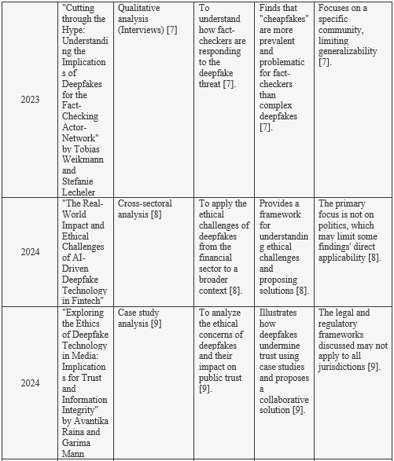
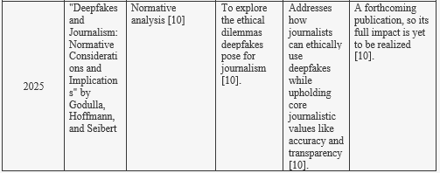
- "Deepfakes and Journalism: Normative Considerations and Implications" by Godulla, Hoffmann, and Seibert (2025) This article looks at the ethical challenges deepfakes present for journalism [10]. It discusses how journalists can ethically use deepfakes for non-harmful purposes, such as satire or visualization, while maintaining important journalistic values like accuracy and transparency [10]. This paper is vital for understanding the link between deepfakes and media ethics. [10].
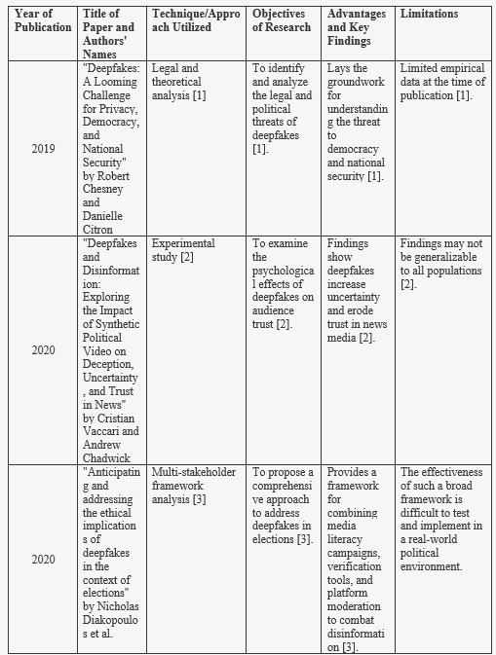

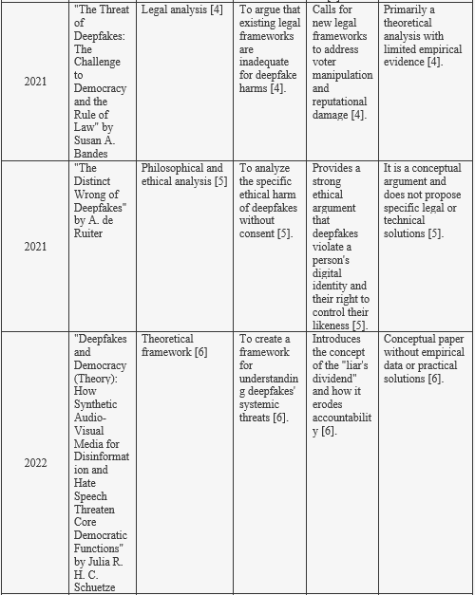

METHODOLOGY
- Research Design
The study used a quantitative survey to explore college students' views, awareness, and trust regarding the ethical issues of deepfake technology in politics. It aimed to examine attitudes toward psychological factors like trust erosion and uncertainty, along with behavioral factors such as verification habits, influenced by the use of synthetic media.
- Data Collection
- Instrument: A structured online questionnaire using Google Forms. It includes fifteen multiple-choice and Likert-scale questions.
- Population: Undergraduate students from Jain (Deemed-to-be University) in Bengaluru. This group represents a digitally savvy and politically aware demographic.
- Sampling Method: Convenience sampling.
- Sample Size: A total of 108 initial responses were collected. The analysis used between 104 and 107 valid responses for each question.
- Data Tool: Responses were exported as a CSV file and analyzed with Python to determine frequency distribution and mean scores.
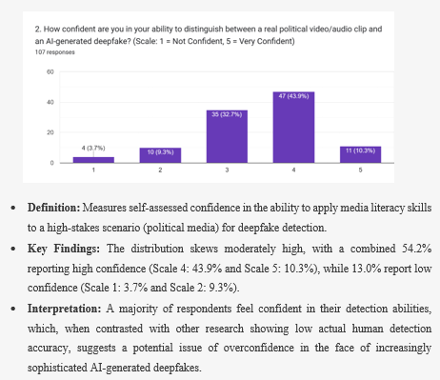
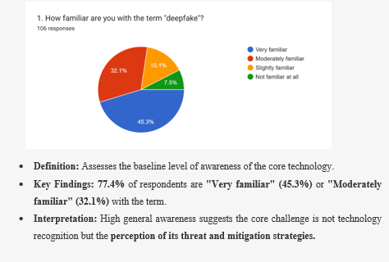
- Questionnaire Design and Analysis

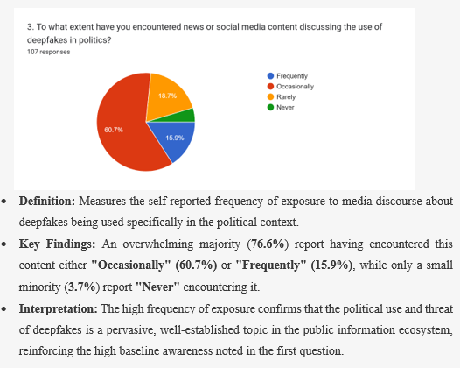
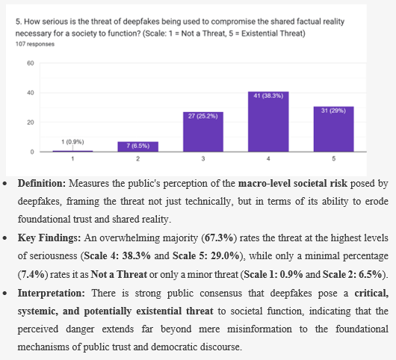
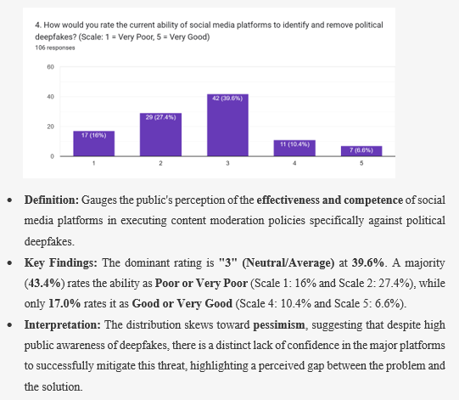
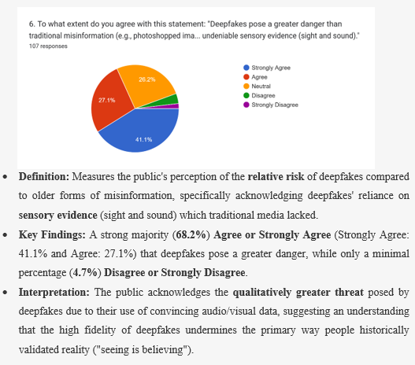

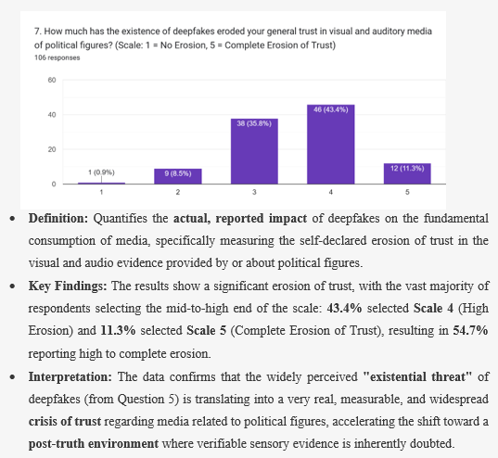
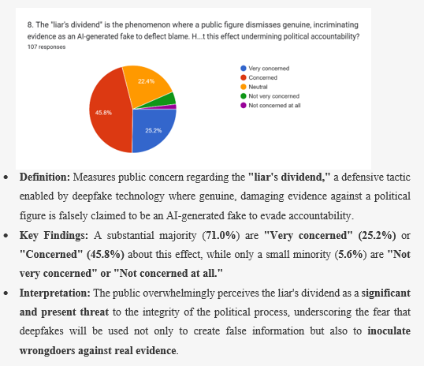
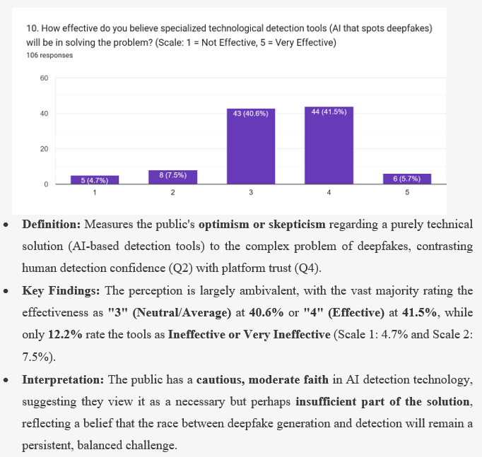
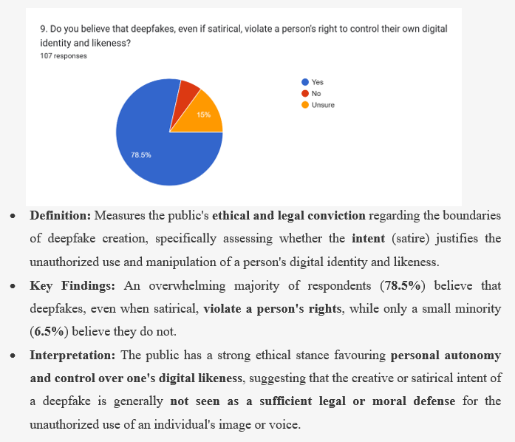
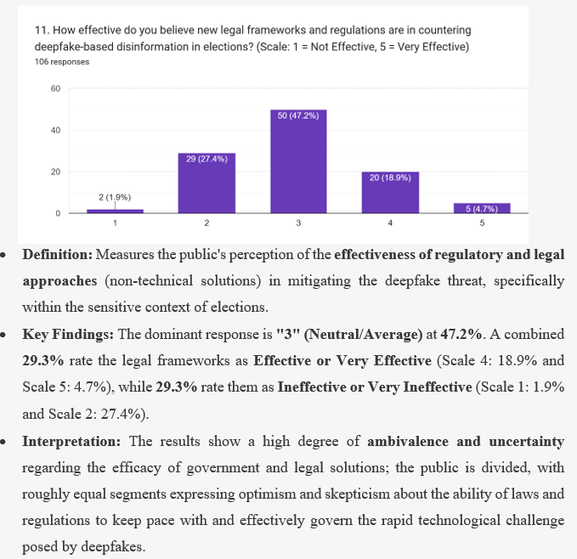
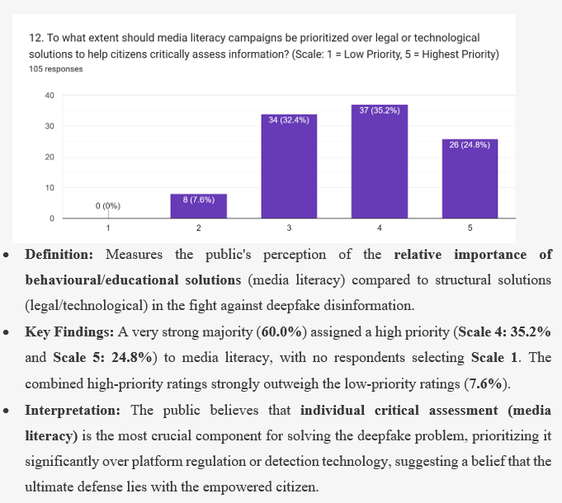
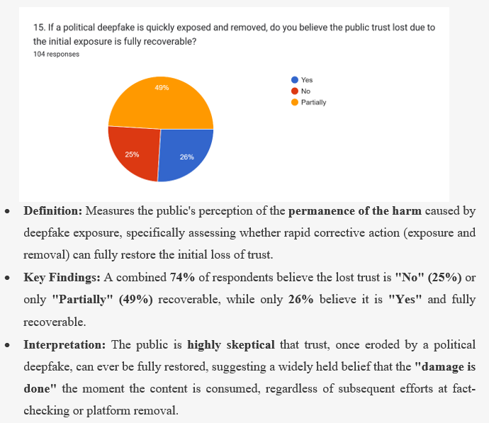
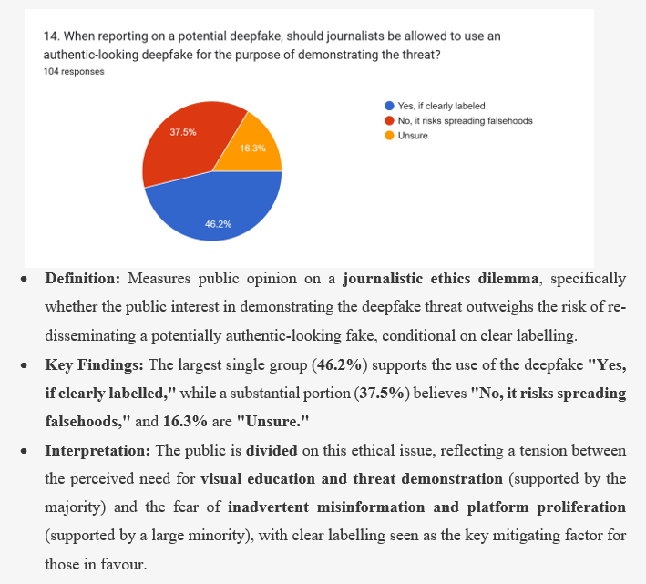
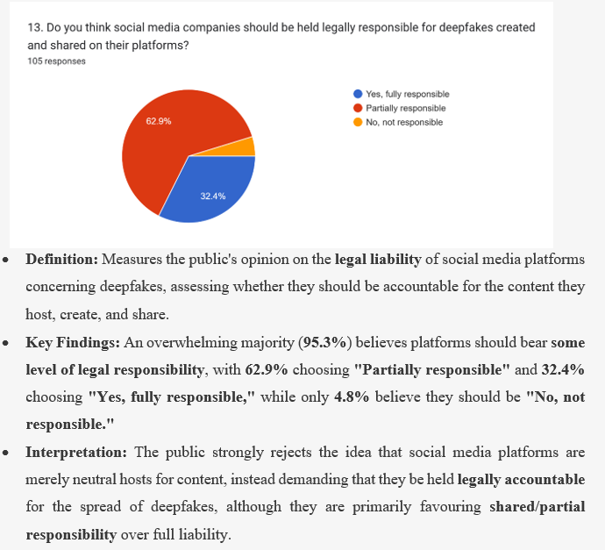
- Summary Insight
The public is very familiar with the term "deepfake" and often sees media about its use in politics. Many view this use as a serious and possible threat, even more so than traditional misinformation. This high level of concern is supported by reports showing a significant decline in trust in political media and a strong worry about the "liar's dividend." However, this fear does not lead to confidence in solutions. The public shows little trust in social media platforms’ ability to remove deepfakes (Q4) and is uncertain about how effective legal measures are (Q11). At the same time, they want these platforms to be held legally responsible for the content. Ultimately, the public believes that the best long-term defense is not a technical or legal approach, but rather empowering individual citizens. They prioritize media literacy campaigns above other solutions and strongly believe that deepfakes violate a person's rights to their digital likeness, even when used in satire.

Conclusion
This study examines the ethical challenges of deepfake technology and confirms it poses a serious threat to political discussion. The findings reveal that the public understands the term "deepfake" and views its political use as a significant threat, even more than traditional misinformation. This perception leads to a noticeable impact: deepfakes have greatly weakened trust in visual and audio media related to political figures, with many people reporting a complete loss of trust. There is also significant concern about the "liar's dividend," where wrongdoers might use deepfakes to hide from real evidence and avoid responsibility.
Importantly, this widespread fear does not create confidence in solutions. People show low trust in social media platforms to remove deepfakes and feel uncertain about the effectiveness of new legal measures. While the public strongly believes that social media platforms should be held legally accountable for their content, they prefer shared responsibility instead of full liability. Ultimately, the study indicates that the public thinks the best long-term defense depends not on technical or legal means but on empowering individual citizens. This belief is supported by the high priority placed on media literacy campaigns over other solutions.
The data provides a strong foundation for developing ethical and political responses. It emphasizes that the main issue is not recognizing the technology but understanding its threat and applying strategies to reduce it. The public holds a strong ethical view that supports personal control over one’s digital likeness, arguing that deepfakes violate individual rights, even in satire. Given the skepticism about whether trust can ever be fully restored after being damaged by a political deepfake, there is an urgent need for proactive defenses focused on citizens. Future research should expand this study to include various demographic groups and use long-term data to evaluate how well media literacy programs combat more sophisticated synthetic media.
Deepfake technology is altering the foundation of truth in political discourse. The challenge ahead is to balance the need for technology and legal protections with the necessity of enhancing individuals' critical thinking skills. The best defense against this troubling trend lies with an empowered and digitally savvy citizen.

References
- Chesney, R., & Citron, D. (2019). Deepfakes: A Looming Challenge for Privacy, Democracy, and National Security. California Law Review, 107(6), 1753-1808.
- Vaccari, C., & Chadwick, A. (2020). Deepfakes and Disinformation: Exploring the Impact of Synthetic Political Video on Deception, Uncertainty, and Trust in News. Social Media + Society, 6(1).
- Diakopoulos, N. et al. (2020). Anticipating and addressing the ethical implications of deepfakes in the context of elections. New Media & Society, 22(12), 2209-2228.
- Bandes, S. A. (2021). The Threat of Deepfakes: The Challenge to Democracy and the Rule of Law. Fordham Law Review Online, 89, 1-15.
- A. de Ruiter. (2021). The Distinct Wrong of Deepfakes. Journal of Information, Communication and Ethics in Society, 19(4), 541-555.
- Schuetze, J. R. H. C. (2022). Deepfakes and Democracy (Theory): How Synthetic Audio-Visual Media for Disinformation and Hate Speech Threaten Core Democratic Functions. Frontiers in Political Science, 4.
- Weikmann, T., & Lecheler, S. (2023). Cutting through the Hype: Understanding the Implications of Deepfakes for the Fact-Checking Actor-Network. Journal of Digital Media & Policy, 14(2), 167-184.
- A. C. Lollia. (2023). Deepfake Deception: A Comprehensive Analysis of DeepFake Technology and its Effects on Ethics, Politics and Society. ResearchGate.
- Raina, A., & Mann, G. (2024). Exploring the Ethics of Deepfake Technology in Media: Implications for Trust and Information Integrity. Journal of Informatics Education and Research, 4(1), 1-10.
- Godulla, A., Hoffmann, K., & Seibert, S. (2025). Deepfakes and Journalism: Normative Considerations and Implications. Journalism Studies, DOI: 10.1080/1461670X.2024.2345678.

