HUMAN-IN-THE-LOOP AI FOR PRECISION AGRICULTURE SCOPING REVIEW
R.N.I. Basnayake ¹*, G.M.S.C Gajendrasinghe ²

¹Department of Computer and Data Science, NSBM Green University, Sri Lanka
²Department of Software Engineering and Computer Security, NSBM Green University, Sri Lanka

ABSTRACT
This scoping study explores the role of Human-in-the-Loop Artificial Intelligence (HITL AI) in precision agriculture and evaluates the benefits of using human expertise in combination with Artificial Intelligence (AI) systems in decision-making within modern smart agricultural environments. The development of Artificial Intelligence, Machine Learning, Internet of Things, and robotics has significantly impacted modern agriculture by providing automated crop monitoring, disease detection, yield prediction, and smart farm management systems. However, Artificial Intelligence systems also face challenges in terms of understanding, interpretability, flexibility, and trustworthiness in modern smart agricultural environments. This study is based on the literature regarding human-in-the-loop systems, human-centric Artificial Intelligence systems, and collaborative robotics systems in the context of smart agriculture. The structured scoping study methodology has been followed to identify and evaluate studies regarding Artificial Intelligence systems in smart agricultural environments, with a focus on automation-centric Artificial Intelligence systems and human-centric Artificial Intelligence systems within the context of Agriculture 5.0 concepts. The study concludes that although automation-centric AI systems show high accuracy in simulated smart agricultural environments, Human-In-The-Loop (HITL) AI systems show higher robustness in smart agricultural environments. Explainability in AI has shown significant potential in supporting the effectiveness of HITL AI systems in decision-making within smart agricultural environments. The study also identifies some important gaps in the literature regarding HITL AI systems in smart agriculture. The study concludes that for the development of modern smart precision agriculture, collaborative intelligence within smart agricultural environments is necessary to create sustainable smart agriculture systems.
Keywords: Human-in-the-Loop AI; Precision Agriculture; Explainable Artificial Intelligence; Smart Farming; Agriculture 5.0

INTRODUCTION
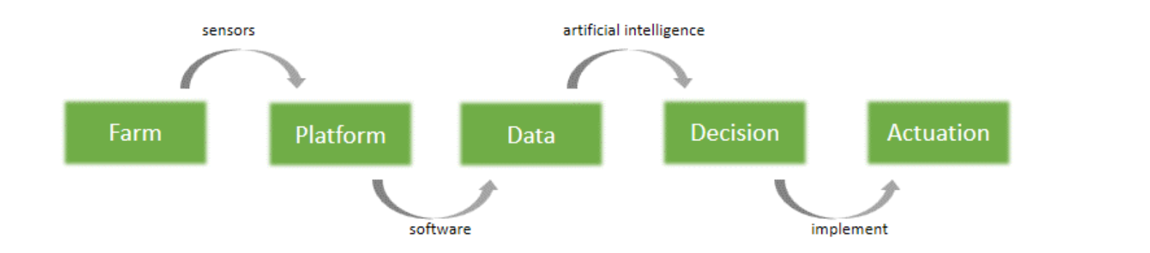
Agriculture currently faces a major revolution in terms of technology, mainly driven by the increased global demand for food, environmental factors, and the availability of resources. Precision agriculture was developed as a data-driven approach to address the aforementioned factors, mainly using sensing technologies, Machine Learning (ML), and automation systems. Previous reviews on ML in agriculture identified the significant use of data analytics on crop production, soil irrigation, and animal systems [1],[4]. However, there are also broader conceptual discussion on the agriculture 5.0 concept, highlighting the need for a shift from automation to a more human-centric and sustainable digital agriculture approach [2],[17]. Recent developments in deep learning methods show significant improvements in the performance of ML models for crop disease detection and plant health monitoring using images. The use of Convolutional Neural Networks (CNNs), EfficientNet, and transfer learning methods shows significant classification performance on standard benchmarks [5],[7]. The EfficientNet method achieves robust performance in crop disease recognition using a multi-class approach in controlled environments [6]. In addition, detailed performance analyses show that deep learning methods are more effective compared to ML methods, especially when the dataset used for training the models is well-balanced and high quality [5]. However, the evaluation of ML methods was performed in a controlled environment and does not reflect the variations that exist in a real-world environment. However, there are some limitations associated with fully automated systems, and some of the limitations are as follows: The agricultural environment is highly dynamic and varies due to climatic variations, heterogeneous soil, and region-wise agricultural practices. Fully automated systems might not perform well due to the lack of generalization associated with the use of the AI model, especially when the data set used for training the model is small. The use of fully automated systems does not guarantee robustness, as discussed in the cyber-physical agricultural systems research, where the environment is highly uncertain and dynamic [9]. The use of human expertise in the form of the Human-in-the-Loop(HITL) approach has gained significant interest, and the use of human expertise in the form of HITL approach has shown significant benefits in the fields of agricultural robotics and collaborative control systems, where the use of human expertise has improved the efficiency of the allocation process and the classification process[9],[10]. The use of human expertise in the form of the HITL approach in the context of human-guided large language model (LLM) pipelines for farm management insights has shown that human expertise is essential in the context of the agricultural intelligence system, as the use of human expertise can prevent unreliable recommendations and hallucinations [13]. Parallel to the progress achieved by human-in-the-loop systems, the concept of explainable artificial intelligence (XAI) has emerged as a research topic to improve the level of transparency and user trust. Actionable explanation frameworks and feature attribution techniques are being developed to make AI decisions more interpretable and operationally relevant to the user [2], [12], [16]. This is particularly important in the context of agriculture, where farmers/agronomists need to understand not only the predictions, but the explanations as well, before making management decisions. Without the explainability aspect, even high-performing AI systems may not be adopted due to the lack of understanding of the decision-making process. In addition to the algorithms, the infrastructure is another important aspect that affects the implementation of AI systems in agriculture. IoT-based sensing systems, along with various data modalities, are being used to develop real-time monitoring systems for the environment [4], [14]. However, the issue of data heterogeneity, the lack of reusable cyberinfrastructure, and machine learning training pipelines is still a barrier to the widespread implementation of AI systems. While a considerable body of literature has explored the applications of machine learning techniques in agriculture, relatively few studies have attempted to synthesize the interplay between precision agriculture, Human-in-the-Loop systems, and Explainable AI within the context of Agriculture 5.0. While many studies have explored the performance of automation systems, relatively little research has focused on collaborative approaches to intelligent systems, where both efficiency and expertise are important considerations.

Figure 1. Agriculture 5.0 concepts [11]

Therefore, the objective of this scoping review is to examine the existing research on the concept of Human-in-the-Loop AI systems, specifically under the context of precision agriculture. The objectives of the study are as follows: (1) to explore the development of AI systems in precision agriculture, (2) to evaluate the impact of the application of the concept of Human-in-the-Loop on the robustness of AI systems, (3) to evaluate the impact of Explainable AI on the establishment of trust, and (4) to explore the avenues for future research under the context of human-centric Agriculture 5.0

METHODS
Review Design
The research study utilizes a scoping review methodology to extensively examine the existing literature on the concept of Human-in-the-Loop Artificial Intelligence in the context of precision agriculture. The reason for selecting the scoping review methodology is the multidisciplinary and dynamic nature of the field, which includes areas such as machine learning, agricultural robotics, explainable AI, IoT-based sensor systems, and cyber-physical infrastructure. The multidisciplinary and dynamic nature of the field makes it suitable for conducting a scoping review, where the research study is more inclined towards conceptual intersections and research gaps, rather than conducting statistical analysis. The research study has followed the standard steps of conducting a scoping review, which includes framing research questions, conducting research, selecting studies, and synthesizing the literature.
Research Questions
This review is structured along the following four broad research questions. First, the existing applications of artificial intelligence and machine learning technologies are reviewed in the context of precision agriculture systems. Second, the inclusion of human-in-the-loop systems is reviewed as a component of artificial intelligence systems. Third, the place of Explainable Artificial Intelligence (XAI) is reviewed to improve the level of transparency and trust associated with precision agriculture systems. Lastly, the shortcomings of the existing literature on human-in-the-loop systems are reviewed as they relate to precision agriculture systems.
Eligibility Criteria
To ensure the relevance and academic credibility of the selected studies, the selection was based on certain predefined inclusion and exclusion criteria. For example, the inclusion criteria were set as follows: the selected studies were restricted to peer-reviewed journal articles and conference papers within a specified time frame from 2020 to 2026. Moreover, the selected studies were expected to focus on artificial intelligence, machine learning, deep learning, human-in-the-loop computing, explainable AI, IoT-based sensing solutions, robotics, and cyber-physical systems within an agricultural context. In addition, the selected studies were expected to focus on certain related themes such as precision agriculture, smart farming, and Agriculture 5.0 frameworks.
Information Sources and Search Strategy
Systemic search strategies on significant scientific databases, including IEEE Xplore, Springer Link, ScienceDirect, MDPI, Frontiers, and Wiley Online Library, are performed to collect the relevant studies. The search process includes a combination of keywords related to the research topic, such as “Human-in-the-Loop AI in Agriculture,” “Precision Agriculture using Machine Learning,” “Explainable AI in Smart Agriculture,” “Agricultural Robotics and Collaborative Intelligence,” “IoT and ML in Agriculture,” and “Agriculture 5.0,” using Boolean operators AND and OR to make the search more specific and relevant to the topic, focusing on the recent developments in AI-based agricultural systems and human-centric intelligence systems.
Study Selection
The initial database search results obtained a larger pool of literature works pertaining to artificial intelligence in agriculture. After filtering through the predefined criteria of both inclusion and exclusion, 17 studies were chosen for in-depth analysis. The selection of studies followed a pattern of initial screening of all titles and abstracts for clear irrelevance before proceeding to in-depth analysis of all relevant studies. Finally, validation of all selected studies ensured their alignment with the overarching themes of Human-in-the-Loop integration, precision agriculture, and explainability. The resultant dataset comprises a balanced collection of crop disease detection models using AI in crops, Human-in-the-Loop planning and controlling systems, explainable AI systems, IoT-based smart farming systems, and cyberinfrastructure systems for multimodal intelligence in agriculture.

Data Charting and Extraction
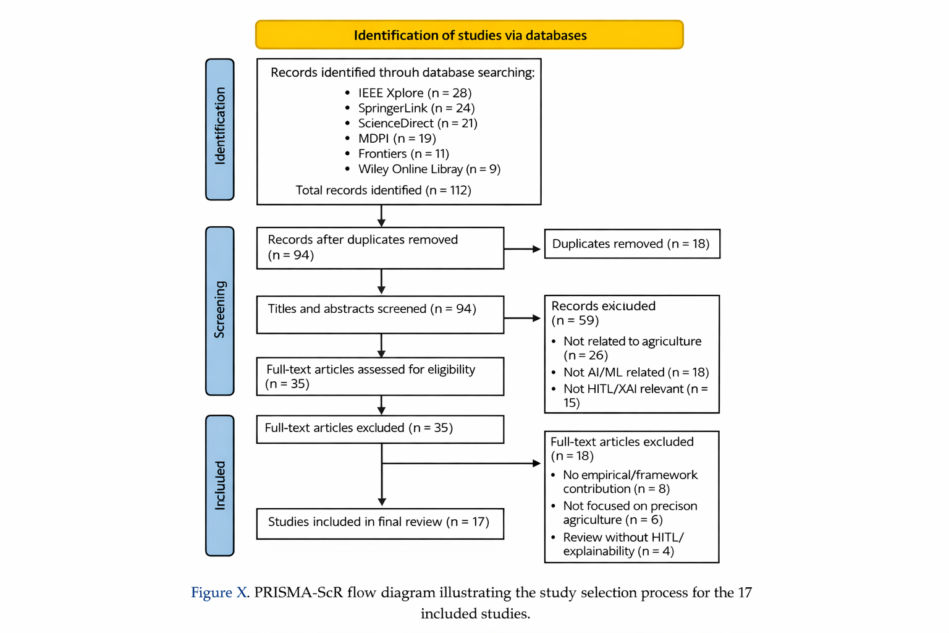
In the process of data extraction, a structured charting methodology was used to ensure consistency in the extraction process for the chosen studies. In the context of the studies, relevant information was recorded for each paper, which included the publication details, the domain of the application, the AI techniques used, the inclusion of Human-in-the-Loop integration, the inclusion of explainability mechanisms, the performance metrics used, and the limitations of the studies. The extracted data attributes were further clustered under thematic groupings for a comparative analysis in the Results section.

Figure 2. PRISMA-SCR flow diagram illustrating the study selection process for the 17 included studies.

RESULTS AND SYNTHESIZED FINDINGS
The analysis of the 17 studies reveals a clear pattern and trend in the use of artificial intelligence in precision agriculture, moving from fully automated systems towards more collaborative and human-centric approaches. The synthesized studies are revealing a set of four major themes, including automated crop monitoring, Internet of Things (IoT)-assisted systems, Human-in-the-Loop (HITL) architectures, and explainable artificial intelligence (XAI) mechanisms.
Several studies emphasize the use of deep learning mechanisms in crop disease detection using CNN, EfficientNet, and transfer learning methods [5],[8]. The studies show the effectiveness of the models, achieving a high classification accuracy, and are useful in the early detection of crop diseases. However, the synthesized studies reveal that the systems are primarily designed as part of fully automated systems and might face issues regarding the variability of the environment. Additionally, IoT-assisted smart farming systems, as revealed by the synthesized studies, use IoT and machine learning mechanisms for irrigation, yield estimation, and environmental monitoring [1], [4], [14]. The studies show the effectiveness of the systems, primarily focusing on the automation and efficiency of the systems.
However, a set of studies reveals the use of Human-in-the-Loop (HITL) mechanisms in the context of agricultural systems using artificial intelligence architectures [9], [10], [13]. The studies show the effectiveness and robustness of the systems.
Explainable artificial intelligence mechanisms are also becoming increasingly important in the context of agricultural systems, and the synthesized studies reveal the use of explainability mechanisms in the context of precision agriculture systems [2], [11], [12], [16]. As revealed by the synthesized studies, the use of explainability mechanisms facilitates the use of human intervention and can improve the overall acceptability of the systems.
As revealed by the synthesized studies, the use of artificial intelligence mechanisms in precision agriculture systems reveals a clear trend from fully automated systems towards more collaborative and human-centric systems, including human-in-the-loop and explainable mechanisms, and the use of IoT and deep learning mechanisms. However, the synthesized studies also reveal the lack of cohesion and adaptability between the mechanisms, highlighting the need for the use of more cohesive and adaptable Human-in-the-Loop architectures.

DISCUSSION

The synthesized results show that, on one hand, precision agriculture has witnessed rapid advancements through automation-driven artificial intelligence systems, yet the journey towards collaborative intelligence remains a work in progress. While the crop disease detection using deep learning and IoT-based systems show significant predictive accuracy and operational efficiency, as shown in [5],[8] and [14], the systems are also seen to operate on a fixed dataset and show poor contextual adaptability.
As the agricultural environment is highly dynamic, the automation-driven systems might face difficulty in generalizing the data and the decision-making process, as shown in [14]. The introduction of HITL systems also show promise in addressing some of the issues, as the systems are designed to incorporate human expertise in the decision-making process of the automation-driven systems, as shown in [9] and [10]. Moreover, the use of explainable artificial intelligence systems also shows significant promise in enhancing the collaborative intelligence of the systems, as shown in [13].

The literature suggests that the use of explainable systems, such as actionable explanations and feature attribution, are critical in enhancing the trustworthiness of the systems, as shown in [2], [11], and [12]. The use of highly accurate systems, such as the ones shown in [14] and [16], might also face difficulty in achieving the trust and buy-in of the stakeholders, as the stakeholders might want explanations for the decisions made by the systems on the crop yield and economic benefits.

As the literature suggests, the journey towards Agriculture 5.0, where human-centered, robust, and sustainable smart farming systems can be achieved, as shown in [2] and [17], yet the systems are also highly fragmented, and few studies show a unified approach towards the use of automation, HITL, and explainable systems. As the discussion suggests, the future of precision agriculture might not only focus on the automation-driven systems and the accuracy of the systems, but also on the use of collaborative intelligence systems, where human expertise, explainability, and robustness are also considered.

Table 1. Comparative analysis of fully automated artificial intelligence systems and Human-in-the-Loop architecture in precision agriculture.

Fully Automated AI System | Human-In-The-Loop AI System
High accuracy in structured environments | High accuracy with expert validation
Limited interpretability | Enhanced transparency through XAI
Weak Adaptability to environmental variability | Context-aware decision adjustment
Reduced user trust | Increased stakeholder confidence
Static deployment pipeline | Iterative feedback-driven refinement

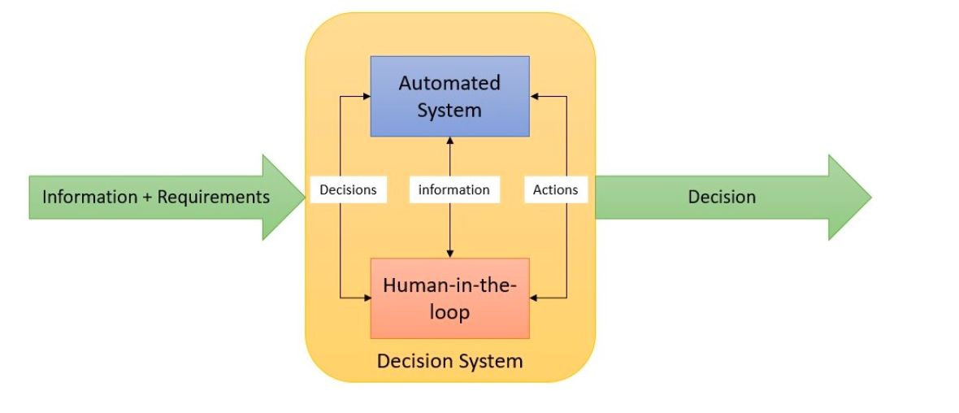

Figure 2. Partial Autonomy in HITL Systems [13]

LIMITATIONS AND FUTURE WORK

This review recognizes several limitations, including the fact that it relies on a pre-selected list of 17 peer-reviewed articles between 2020 and 2026. This may not represent the full scope of global research in this rapidly advancing field of Human-in-the-Loop AI and precision agriculture. A second limitation of the review is that, as a scoping review, it does not engage in any quantitative comparison of the accuracy of the models presented, nor their effectiveness in real-world implementations.

A further limitation of the review is that the field of Human-in-the-Loop frameworks in agriculture remains in its infancy, with many of the reviewed articles focusing on conceptual frameworks or small-scale implementations of the technology. This means that long-term operational effectiveness, scalability, and economic viability are still in their infancy.

Future research in the field of human-centered AI systems would benefit from developing frameworks that integrate automation, human interaction, and explainable AI into a unifying framework that can be scaled up into a cyberinfrastructure framework. Further emphasis would be placed on real-world field implementations, as well as the development of adaptive feedback systems that can dynamically adjust the AI model based on expert feedback. Further research into the socio-economic implications of human-centered AI systems would also benefit the development of Agriculture 5.0 systems.

CONCLUSION

This scoping review aims to examine the role of Human-in-the-Loop Artificial Intelligence in supporting precision agriculture through an examination of 17 studies on machine learning, IoT, collaborative robotics, and explainability in AI systems. The study finds that although automation-based AI systems have shown significant promise in enhancing crop monitoring, disease identification, and data-driven farm management, such systems have shown limited potential in handling dynamic and ever-changing agricultural systems.

The integration of human expertise through HITL has shown promise in enhancing the robustness, reliability, and adaptability of AI systems. Moreover, the role of explainability in AI systems has shown promise in enhancing trust among stakeholders in AI-driven decision-making systems. Despite such advancements, the integration of scalable infrastructure, adaptive human feedback, and explainability in AI systems is still in its nascent stages in the literature.

The study concludes that the future of precision agriculture is not in automation systems, but rather in collaborative intelligence systems that can address the challenges of sustainability, trust, and resiliency in smart farming systems. The study finds that Agriculture 5.0 will be possible through the development of cohesive AI systems that can address the challenges of sustainability, trust, and resiliency in smart farming systems.

REFERENCES
- Adve, S., et al. (2025). Advancing AI in agriculture through large-scale collaborative research. Communications of the ACM.
- Arafat, M. (2025). An explainable human-AI-in-the-loop framework for segmentation-aware hyperspectral image classification. International Journal of Web and Open Systems.
- Benos, L., et al. (2021). Machine learning in agriculture: A comprehensive updated review. Sensors, 21(11), 3758.
https://doi.org/10.3390/s21113758
- Benos, L., et al. (2025). Explainable AI-enhanced human activity recognition for human–robot collaboration in agriculture. Applied Sciences, 15, 650.
https://doi.org/10.3390/app15020650
- Deka, G., et al. (2025). Enhancing precision agriculture through human-in-the-loop planning and control. Proceedings of the IEEE Conference on Automation Science and Engineering (CASE 2024).
https://doi.org/10.1109/CASE59546.2024.10711319
- Dolatabadian, A., et al. (2025). Image-based crop disease detection using machine learning. Plant Pathology.
https://doi.org/10.1111/ppa.14006
- Emon, M., et al. (2025). Integration of IoT, machine learning, and sensors for intelligent environmental monitoring in agriculture. Journal of Computer Networks and Communications.
https://doi.org/10.1155/2025/ (Check article page for full DOI)
- Holzinger, A., et al. (2025). Human-centered AI in smart farming: Toward Agriculture 5.0.
- Mourtzinis, S., et al. (2025). A human-in-the-loop approach to applying large language models for farm management insight.
- Ngugi, L., et al. (2024). Machine learning and deep learning for crop disease diagnosis: A review. Agronomy, 14.
https://doi.org/10.3390/agronomy14123001
- Razak, N. A., et al. (2024). Agriculture 5.0 and explainable AI for smart agriculture: A scoping review. Emerging Science Journal.
- Saranti, A., et al. (2025). Actionable explainable AI (AxAI): A practical example with aggregation functions for adaptive classification.
https://doi.org/10.3390/make4040047
- Sreeram, V., & Nof, S. Y. (2021). Human-in-the-loop role in cyber-physical agricultural systems. International Journal of Computers Communications & Control, 16(2).
https://doi.org/10.15837/ijccc.2021.2.4166
- Subhan, F., et al. (2026). Crop disease detection using EfficientNetB0 deep learning architecture. Discover Computing.
https://doi.org/10.1007/s10791-025-09881-y
- Sudha, M., & Loret, J. L. (2026). Machine learning-based precision agriculture techniques integrated with IoT. Discover Environment.
https://doi.org/10.1007/s44274-025-00305-8
- Waltz, D., et al. (2025). Cyberinfrastructure for machine learning applications in agriculture. Frontiers in Artificial Intelligence, 7.
https://doi.org/10.3389/frai.2025.1496066
- Yakkala, K., et al. (2025). Deep learning-based crop health enhancement through early disease prediction. Cogent Food & Agriculture, 11(1).
https://doi.org/10.1080/23311932.2024.2423244

