Pedagogical Impact of the Vedic Duplex Method on Secondary School Students

Abstract:

The Duplex Method has a pretty important place in Vedic Mathematics, and it gets used quite often to get the square of numbers that have one or even more digits. The Duplex, or Dwandwa Yoga, comes from the third Vedic Sutra, Urdhva-Tiryagbhyam (Vertically and Crosswise) and honestly it feels like it’s all about that kind of motion. It gives a more or less organized, and speedy approach for squaring numbers, so the whole operation ends up being faster, and often more dependable, than what we usually do with normal, conventional techniques.
In the present study, the effectiveness of the Duplex Method was checked, mostly among secondary school students. An action research study was carried out with 32 students of Class IX, to compare the usual squaring method with the Vedic Duplex Method, while the attention stayed on calculation time , and accuracy too. The results suggested that a lot of students finished their calculations in a clearly shorter span of time when they used the Duplex Method, and at the same time they also managed to score better in terms of correctness.

Introduction: This present study is kind of action research, you could say, carried out with 32 students from Class IX , in order to check how effective the Vedic Mathematics Duplex Method is for getting squares of numbers. In simple terms it compared the Duplex Method with the conventional way of squaring, mostly by observing time consumption and also accuracy. The students who took part in this already knew arithmetic like addition and multiplication and how to use tables so the whole thing was not really starting from the beginning.
In the session the students were given an introduction to the history and the importance of Vedic Mathematics with the Duplex Method through some interactive teaching and a few classroom activities. The Duplex Method was described with some examples and the students were told to solve a few problems on the blackboard. Honestly the Duplex Method felt a lot like patterns such as Vedic Mathematics patterns so many of the students found Vedic Mathematics pretty easy to understand, not too hard. Then in the session the students had to solve eight questions, involving two digit numbers and for each question they used both approaches, the usual method and also the Duplex method of Vedic Mathematics. For the comparison we recorded the time the students used along with the correctness of their answers, to the Vedic Mathematics questions carefully. Vedic Mathematics, which is connected mainly with the Atharva Veda and later reconstructed by Jagadguru Swami Bharati Krishna Tirthaji, includes sixteen Sutras and thirteen Sub-Sutras. These are basically set of tools that help make mathematical calculations much easier, quicker.

From what the study observed, the Duplex Method helped students finish the computations faster and with better correctness, plus it seemed to lower the fear of such sums while raising a kind of curiosity and interest in mathematics overall, at least for this group.

What is Duplex:

The Duplex Method (Dwandwa Yoga) , denoted by (D) in Vedic Mathematics , is kind of a special mathematical approach used for getting the square of numbers quickly , and pretty accurately too. It leans on a simple but fairly plus systematic set of formulas, that work around how the digits are arranged inside a number. And yes , this can be applied to numbers that have any count of digits , no big issue. The Duplex Method is really good at helping us numbers quickly. It makes squaring numbers by breaking it down into smaller steps. This way it does not feel like a lot of work. We can get the answer fast and correctly. We get speed and accuracy with the Duplex Method. The Duplex Method uses something called duplex values. These duplex values are found by using math formulas for different combinations of digits in a number. Each duplex value is calculated based on where the digits are how they are paired up with other digits, in the Duplex Method. Those formulas are like the base , the core idea behind the rapid squaring technique in Vedic Mathematics. Now the duplex formulas for numbers with different digit groupings are given below:
For one digit “a”, its duplex number D(a) = a²
For two digits “ab”, duplex number D(ab)= 2ab
For three digits “abc”, duplex number D(abc)= b²+2ac
For four digits “abcd”, duplex number D(abcd)=2bc+2ad
For five digits “abcde”, duplex number D(abcde)= c²+2bd+2ae

For Example: Consider the number 76.
Solve: D(7)=49, D(76)=84, D(6)=36
Writing these in sequence:
49 | 84 | 36
Adding from right to left with carry-over gives:
5776
Hence, 76² = 5776.
This way takes just a small bit of practice, and honestly you can do it mentally or say it out loud, in a pretty simple manner. It lets students get quick , precise , and efficient results in just two or three steps, so the whole calculation feels quicker and more convenient than the older, traditional methods.

Advantages of the Duplex Method:

1. The Duplex Method is pretty easy to understand: it has an systematic way of doing things so students can learn the Duplex Method and use the Duplex Method without being too scared or confused.

2. The Duplex Method is based on math: it uses easy algebra formulas and a few basic steps, which works well for students of all levels from early grades to later on.

3. The Duplex Method makes calculations shorter: it breaks down the parts into smaller steps so the whole process is easier to handle and does not feel overwhelming in your head when you are using the Duplex Method.

4. The Duplex Method helps reduce mistakes: because the Duplex Method is organized in a way you are less likely to make calculation mistakes even when you are a bit tired which is a good thing about the Duplex Method.

5. The Duplex Method makes math more fun: it makes math feel more interesting. It gets students involved instead of just sitting and watching the Duplex Method being used.

6. The Duplex Method is fast and accurate: with the Duplex Method students can work quickly and still get the answers, which is a great benefit of using the Duplex Method.

7. The Duplex Method helps students feel good about math: when students can do math quickly and get it right they feel happy. Their confidence in math improves, which is really good, for students using the Duplex Method.

Working Process of the Duplex Method: First, just glance at the number you are given and try to notice its digits one by one, don’t rush. Then you start to make digit combos, kind of like putting them together step by step, by taking one digit and after that combining adjacent ones, in the style of the Duplex Method. Usually you do everything from right to left, so that every digit gets pulled into the calculation, even the ones at the very start. After that you apply the duplex formulas for each digit, or else for each combined group, depending on what it wants. When the rightmost part is done, you keep going by slowly leaving out digits starting from the right side until only the leftmost digit is left there. Next, put all duplex values in the required order, or split them into separate blocks, whichever the method demands. After that do the addition, from right to left again, and remember the carry over, like in regular arithmetic additions. Finally, when you finish, the last number you get, that final total , is the square of the original number. That’s it.

Methodology: In this research a group of students took part in a learning session about Vedic Mathematics, the Duplex Method of Squaring Numbers. The students were first taught about the history and background of Vedic Mathematics. Then they learned the Duplex method to get squares of numbers. The teacher used example cases to explain the procedure and main ideas. The teacher explained it again and again to ensure each person understood. Many students volunteered to solve squaring problems on the blackboard. Most of them finished the questions correctly. This showed that most students could quickly grasp the method. The Duplex method seemed simple and clear. Students worked with enthusiasm and attention. They were actively involved not just listening. During the session they got familiar with Vedic Mathematics and the Duplex Method. They showed interest in patterns, tricks, Sutras and routes in Vedic Mathematics. The students took part willingly and confidently without fear. Learned about Vedic Mathematics and the Duplex Method for squaring numbers. They were interested, in Vedic Mathematics and the Duplex Method. In a way it seemed like they were already comfortable from the very start, even if it was new for them. The study was planned as a two-day action research project and it included these activities:
1. An introductory lecture on Vedic Mathematics, the Duplex Method, and its practical uses with worked examples. This part turned out to be a helpful hands-on practice session for the students.
2. A test with eight questions based on two-digit numbers, where students had to compute squares using both the usual conventional method and the Vedic Duplex Method. This test was carried out during the second session after a proper review of the Duplex Method.
After submitting their test papers, the students showed keen interest in learning more about Vedic Sutras that are related to different branches of mathematics. They accepted, that the Vedic method is short, clear, easy to understand , and highly accurate. During the test, students recorded the time taken for their calculations using both the conventional approach and Vedic method, as instructed. They used their own watches, and a wall clock in the classroom was also available for time observation. The students had a good mathematical base, which helped them do the computations efficiently using the Duplex method.

Samples of Student Performance Sheets

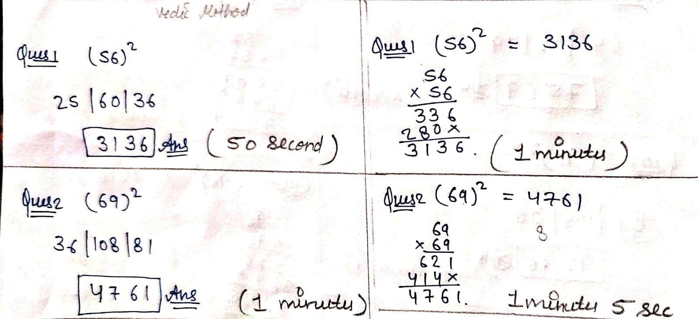

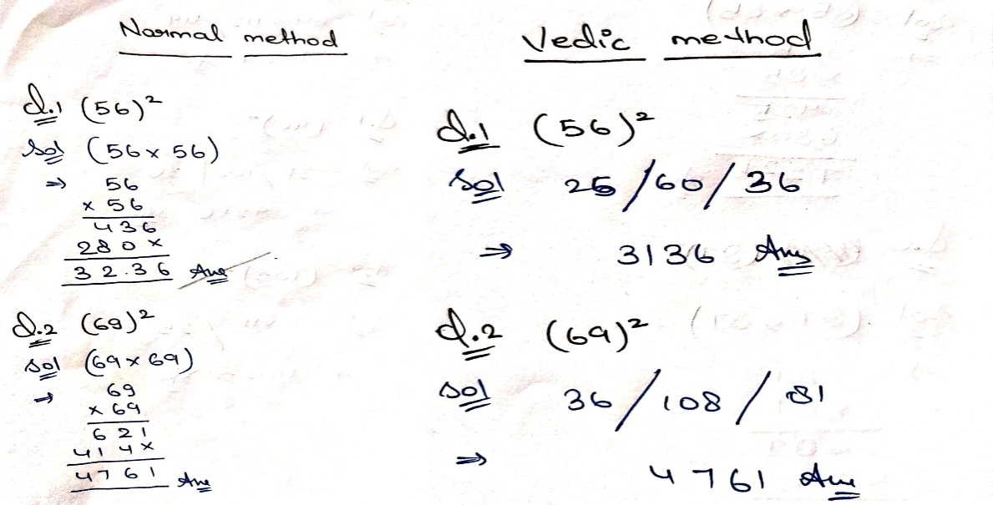

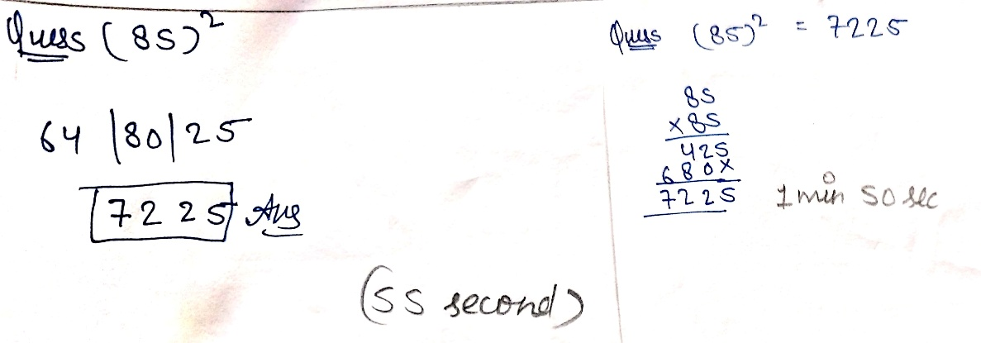

The table below presents representative samples of students’ performance, including the time taken (in minutes) and the accuracy obtained while solving the questions using both the conventional and Vedic Duplex methods:

S.No. | Name | Timings:  Normal Method(in Min) | Timings:  Vedic Method(in Min) | Accuracy  (Normal) | Accuracy  (Vedic)
1 | Mahima Goel | 12.47 | 7.75 | Yes | Yes
2 | Anushka | 10.0 | 6.0 | Yes | Yes
3 | Dev Rathi | 17.0 | 6.0 | Yes | Yes
4 | Manu Chauhan | 8.92 | 6.58 | Yes | Yes
5 | Akshay Kumar | 10.0 | 10.0 | Yes | Yes
6 | Aradhna Singh | 11.17 | 5.33 | Yes | Yes
7 | Priyanshi | 8.5 | 5.12 | No | Yes
8 | Paras Patel | 16.5 | 12.83 | Yes | Yes
9 | Jigyansh Goel | 3.7 | 2.03 | Yes | Yes
10 | Yashvinder Singh | 10.0 | 3.0 | Yes | Yes
11 | Aarav | 6.0 | 1.83 | No | Yes
12 | Ojas Sharma | 8.17 | 3.67 | No | Yes
13 | Aayush Garg | 9.0 | 2.08 | Yes | Yes
14 | Aarush Maheshwari | 11.33 | 3.7 | No | Yes
15 | Vanshika Ray | 10.0 | 2.5 | No | Yes
16 | Himani Nirala | 7.42 | 3.75 | No | Yes
17 | Anshika Ray | 15.0 | 2.33 | No | Yes
18 | Ram | 20.0 | 12.0 | No | Yes
19 | Navya | 15.0 | 3.0 | No | Yes
20 | Tanisha Rathi | 14.0 | 3.83 | Yes | Yes
21 | Jagdish Kushwaha | 20.0 | 10.67 | Yes | Yes
22 | Aarav Goel | 15.0 | 5.58 | No | Yes
23 | Aanya Singh | 14.0 | 8.0 | Yes | Yes
24 | Manya | 10.0 | 10.0 | Yes | Yes
25 | Krishna Singhal | 15.0 | 10.0 | No | Yes
26 | Divyanshi | 10.0 | 5.0 | Yes | Yes
27 | Azmi | 15.0 | 15.0 | Yes | Yes
28 | Chirag | 9.0 | 6.0 | Yes | Yes
29 | Raja Chauhan | 9.08 | 5.0 | Yes | Yes
30 | Akshit Kumar | 8.0 | 4.83 | Yes | Yes
31 | Shashank | 5.0 | 5.0 | No | Yes
32 | Jiya Chauhan | 10.0 | 10.0 | Yes | Yes

Graph 1: Comparison of Time Taken in Calculations Using Conventional and Vedic Methods

From the recorded time data, only five students finished the questions for about the same amount of time when they used both methods, pretty much. The rest of the class still managed to complete the paper in quite a bit less time, using that Vedic Duplex Method. Also, 14 students needed under 50% of the time compared to the conventional method while solving the questions with the Vedic Method.

Graph 2: Comparison of Accuracy in Conventional and Vedic Methods

So in this study there were 32 students, but only 20 managed 100% accuracy when they used the conventional method. Meanwhile, with the Vedic Duplex Method, every single student got 100% accuracy, even though it was totally new to them. This kind of result really shows that the Vedic Method feels straightforward, works well, and stays quite precise when you apply it in practice.

Conclusion: From the basis of this activity, its results ,and the feedback that came from the students, it was seen that the learners showed quite a lot of curiosity and also a kind of eagerness toward learning Vedic Mathematics ,and then using its techniques in their own everyday mathematical practice. When we look at accuracy, and also the time they needed for calculations, students generally did better with the Vedic Duplex Method compared to the usual or conventional method. Even though the students were given only two classroom sessions on Vedic Mathematics , they still formed a strong interest in learning more Vedic techniques connected with different mathematical operations, specially in arithmetic calculations. This study, in a clear way, showed that within a short period of time students could recognize, and in a sense experience, how effective the Vedic methods are when compared to traditional methods. So the outcomes of this study suggest that Vedic Mathematics can potentially make mathematics more interesting, simpler, and more involving for learners. Because of this, adding and also encouraging Vedic Mathematics in the current education system might be useful at every level, starting from primary, up to higher education too. Also, using Vedic Mathematics can help students boost computational speed, improve accuracy, strengthen logical thinking, and increase confidence. In the long run, this may prepare them more effectively for competitive exams, and for further advanced mathematical learning later on.

References:

- B.K. Tirthaji (1965). Vedic Mathematics Or Sixteen Simple Mathematical Formule from the Vedas. Indological Publishers & Booksellers ,Delhi .
- Agrawala, V. S. (1971). Vedic Mathematics. Delhi: Motilal Banarsidas. Ancient Multiplication Methods. (n.d.). Retreived February 17, 2010, from http://www.pballew.net/old_mult.htm
- .Bibhutibhushan, D., & Avadesh, N. S. (2001). History of Hindhu Mathematics. Delhi: Bharatiya Kala Prakashan.
- Booker, G., Bond, D., Sparrow, L., & Swan, P. (2004). Teaching Primary Mathematics. Malaysia: Pearson Education Australia. 6.Chapin, H. S., & Jhonson, A. (2000). Math Matter. USA: Math Solution Publication.
- Fennel, F. (2008). Curriculum Focal Points for Prekindergarten through Grade 8 Mathematics. The National Council of Teacher of Mathematics,1– 15. Retreived February 17, 2010, from http://www.nctm.org/standards/content.aspx?id=7564
- Jeniffer, S., Andrew, D., & Maria, G. (2006). Mathematical Knowledge for Primary Teacher (3rd ed.). Washington, DC: David Falton Publication.
- Kumar et al. (2022), Implementation of Vedic sutras to resolve division, International Transactions in Mathematical Sciences and Computer, https://doi.org/10.58517/ITMSC.2022.15102.
- N. Kumar, R. Yadav and S. R. Singh, Some important comparison by vedic and modern method, in: Proceedings of RDMOCS’21, Jhansi, India, pp. 132– 138 (2021)
- Robert, A. C., & Marilyn, J. C. (1974). Arithmetic of Whole Numbers. New York:John Wiley & Sons Inc.
- R. Yadav, S. R. Singh, Aaditya and R. Yadav, Ancient wisdom vs modern techniques: A comparative analysis of vedic and contemporary mathematics, International Journal of Recent Engineering Science 11(4) (2024), 76– 80, DOI: 10.14445/23497157/IJRES-V11I4P110.

