INSECT-BASED BIODIESEL: ORYCTES RHINOCEROS LARVAE AS FEEDSTOCK IN TROPICAL BIOREFINERIES FOR SUSTAINABLE ENERGY

Abstract
To meet increasing energy requirements, there has been growing interest in alternative fuels like biodiesel to provide a suitable diesel oil substitute for internal combustion engines. The purpose of this study was to produce biodiesel from insect larvae, particularly, the Oryctes rhinoceros, commonly referred to as dung beetle. The rhinocerous larvae were harvested, cleaned, sun-dried and then ground into fine powder. Larval lipids were extracted via soxhlet method (hexane, 6 hours, 65ºC) from the ground powder. Biodiesel was made by chemically reacting the resultant oils with methanol. The mixture was then combined with a catalyst: an alkaline chemical such as potassium hydroxide. The combination of the alcohol and catalyst, also known commonly as methoxide, is chemically a base. The transesterification reaction breaks the fat molecules in the oils into an ester, which is the biodiesel fuel, and glycerol. Because the biodiesel is not as dense as the glycerol, the biodiesel floats on top of the glycerol and may be poured or pumped off. Alternatively, the glycerol can be drained off the bottom. The biodiesel was then washed, filtered and characterized. Some physico–chemical properties of biodiesel, such as density, viscosity, water content, acid value, and its energy content were determined. Larvae yielded 38.2±1.7% lipids (dry weight), with 92.4% FAME conversion efficiency meeting EN 14214 standards for viscosity (4.1 mm²/s) and acid value (0.08 mg KOH/g). The study establishes rhinoceros beetle larvae (Oryctes rhinoceros) as a novel biodiesel feedstock, addressing the sustainability limitations of conventional oil crops.
Key Words: Biodiesel, oils, engine, beetle larvae, feedstock, transesterification.

1.0 Introduction
The rising oil prices and subsequent depletion of oil reserves dictates for better alternatives of energy from fossil fuels. Coupled with rising concerns for pollution caused by fossil fuels such as petroleum, coal and natural gas, alternative fuels and renewable sources of energy such as biodiesel are coming in vogue (Garlapati, et al., 2013). Additionally, the negative effect of petroleum based fuels is that over the years there has been a rapid increase in the levels of pollution caused by these fuels. Utilization of these energy sources for longer periods have resulted to the rise in global warming (Ogunwole, 2012). Biodiesel is proved to be the best alternative for diesel because of its unique properties like significant reduction in green-house gas emissions, non-sulfur emissions, non-particulate matter pollutants, low toxicity and biodegradability (Fan et al., 2009). Biodiesel is better than fossil diesel in terms of exhaust emissions, cetane number, flash point and lubricity properties, without any significant difference in heat of combustion of these fuels. Moreover, biodiesel returns about 90% more energy than the energy used to produce it. A mixture of biodiesel with conventional diesel in some proportions can be used to run existing conventional compression ignition engine without the engine undergoing any modifications (Javidialesaadi and Raeissi, 2013)
Biodiesel is a liquid fuel often referred to as B100, pure, or neat biodiesel in its unblended form. Like petroleum diesel, biodiesel is used to fuel compression-ignition engines. While 89% of global biodiesel derives from plant oils, insect larvae offer three times higher lipid yield per hectare than palm oil (Yang et al., 2022). On the same note, beetle larvae consume agricultural waste, creating circular bio-economy versus palm oil's deforestation impact. Biodiesels provides a promising alternative to conventional diesel oils since they are renewable and have similar properties (Gashaw and Teshita, 2014). The use of liquid fuels such as biodiesel produced from waste cooking oils by transesterification process represents one of the most promising alternatives for the use of conventional fossil fuels. However, as the biodiesel is produced from vegetable oils and animal fats, concerns about the biodiesel feedstock competing with food supply in the long-term may arise. Hence, the need to rely on insect larval lipids as the substantial feed stocks for biodiesel production (Gashaw and Teshita, 2014).
According to (Thirumarimurugan et al., 2012) vegetable oils from plant sources are the ideal material to produce biodiesel since the conversion of pure triglyceride to fatty acid methyl ester (FAME) is high and the reaction time is relatively short. The commonly used method of producing biodiesel is by transesterification, which is a catalyzed chemical reaction involving vegetable oil and an alcohol to yield fatty acid alky esters and glycerol. Utilization of edible vegetable oils and animal fats for biodiesel production has been of great concern because they compete with food supply materials for human consumption. With increasing demand for vegetable oils for food over the years, it is almost impossible to justify the use of these oils for fuel use purposes such as biodiesel production. Moreover, this could render the oils more expensive to use as fuel (Gashaw and Teshita, 2014). Reducing the cost of the feedstock is necessary for biodiesel’s long-term commercial viability. In order to achieve production cost reduction and make biodiesel more competitive with petroleum diesel, low cost feedstocks are to be used as raw materials. Thus, the contribution of insect lipids as a source for biodiesel production should be explored as a cheaper alternative.
Adult Oryctes rhinoceros is seasonal and they occur between the months of November and March in western Kenya . According to (Ayieko et al., 2012) this insect usually occurs at a period when most species of other edible insects are not available. However, the abundance of this insect varies from year to year and there is usually an outbreak of its population every two years. The larvae of the beetle, however, are available year round and can be gathered whenever need be.
The adult beetles like to burrow and make shelter in the hips of collected cow dung that is left to decay for a period of 3 to 4 months. Within this period, the adult insects deposit their eggs in the manure, a process called oviposition. The warmth and moisture content in the decaying animal waste facilitates the hatching process. Larvae emerges from the eggs and starts feeding on the substrate containing the required nutrients. The substrate can also be enriched with other nutrients from household waste like food remains. The larvae take an average of 3 to 6 months before changing into a nyimph and then to an adult beetle which is dark brown in colour (Ayieko and Oriaro, 2008). Harvesting is done by digging out the manure hips after being left to decompose for a period of 3 to 5 months. Like the adult beetles, the larvae are also found lying deep into the manure. They feed on the substrate in the decaying matter. Full-grown larvae are about 6 to 8cm long and about 1 to 2cm in diameter. It is roughly the size of an adult human finger in comparison (Ayieko et al., 2012).

2.0 Materials and Methods
2.1 Oryctes rhinoceros Larval Lipids
Rhinocerous beetle larvae were harvested from the colony-reared specimens fed on organic substrates. The larvae were cleaned to remove the internal wastes and then sun-dried for three days. They were then ground into fine powder before being mixed with an organic solvent. Grinding into fine powder increases the surface area for interaction with a solvent. Hexane and octane are the preferred solvents for fatty acids extraction.
500 grams of dried larval powder was measured into a round bottom volumetric flask. One litre of hexane was then added and the mixture homogenized. 500ml of ethanol was then added to the mixture and put on low heat at 65ºC while mixing using electromagnetic stirrer. The components were left undisturbed for 6 hours for the larval lipids to completely dissolve in the alcohol. Because the oils and the hexane have a higher boiling point than ethanol, the temperature of the mixture was raised to 77ºC for the ethanol to evaporate leaving behind a mixture of the solvent and the larval lipids. The two separates into two layers, the denser oils forming the bottom layer while the solvent forming the upper layer. The two can be separated by simple decantation (Boland et al., 1991)
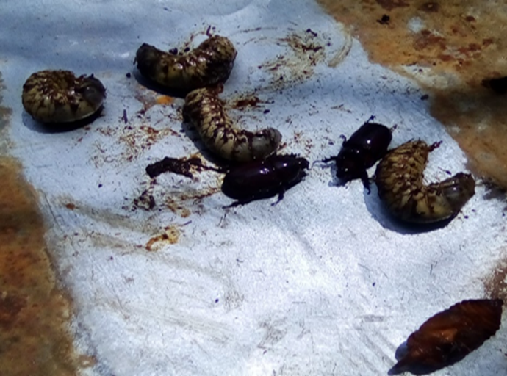
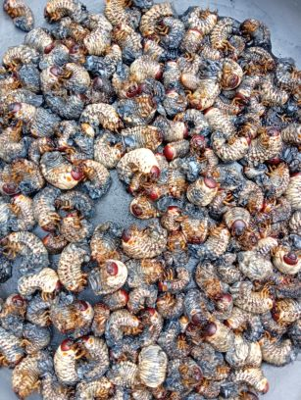
Fig 1: Harvested Oryctes rhinoceros Larvae from their culture media

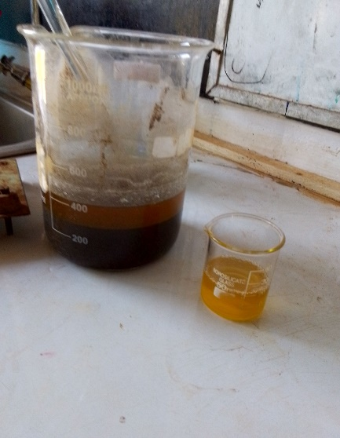
Fig 2: Larval Lipids Extraction
The percentage of lipid yields from crushed powder was 58.2±1.7% yield. The process was repeated for 2 batches which resulted in a total yield of 3 litres of oils from 5 kilograms of crushed larval powder.
2.2 Determination of Free Fatty Acids (FFA) and the Colour of the Larval Oils Produced
A sample of the generated larval oils was titrated against a standard solution in order to determine the concentration of free fatty acids (RCOOH) present in the larval lipids ((AOAC, 1995). The quantity of a base required to neutralize the acids was then calculated.
The colour of the oils was measured by a colourimeter to determine light absorbance in the visible region at 455nm. The technique involves matching the colour of light transmitted through a specific depth of oil with the colour of light transmitted from the same source and passing through a set of coloured glass slides. The reading of the colour is thus subjective and depends on the analytical skills of the person as well as the type and model of the colourimeter used (Djomdi et al., 2020). The resultant oils were yellow in colour.
2.3 Biodiesel Synthesis by Transesterification
The process of transesterification leading to producton of biodiesel is highly dependent on the quality of the feedstock, the amount of the catalyst, and the reaction temperature. With the amount of free fatty acids calculated in the sample, the amount of the catalyst to be added to the sample was 3.5g per litre of the oil with an acid value of less than one percent.
200ml of the refined larval oil acting as a feedstock was weighed using a precision balance and transferred to a 500ml round bottom flask serving as a bioreactor in accordance with the methods of Xiaohu et al., (2011). The contents were heated to 60ºC heater with a magnetic stirrer. The flask was mounted on a heating mantle and assembled with a condenser and the speed of the stirrer adjusted to 250 rpm. Meanwhile, 0.88% of KOH were homogenized with 99% potassium hydroxide and used as a catalyst. Putting in mind the amount of the oils, the catalyst was dissolved in pure methanol for the first batch and 97% ethanol for the second batch.
The resulting mixture was then added to the reactor in a 4:1 methanol-oil molar ratio. The overall mixture was maintained at 60ºC for three hours. A magnetic stirrer was used to maintan the temperature and the overall agitation rate of the reaction. Running tap water was connected to the condenser to prevent loss of solvent (alcohol) for three hours since it is very volatile. The resultant products from the reactor were transferred to a separating funnel and allowed to stand for 24 hours. The components separated into two distinct layers; a light yellow supernatant (ethyl ester) which is the biodiesel and a reddish brown bottom layer which is glycerol. The biodiesel obtained was cleaned for impurities like unconverted alcohol, catalyst and traces of glycerol by washing with warm distilled water and then dried at 120ºC in a microwave oven for 6 hours to remove residual moisture. The dried methyl/ethyl ester was filtered using a 5 micron filter.

Fig 3: Two-step Biodiesel production process.
The resultant alkyl esters have favorable properties as fuels for use in CI engines and therefore are the main product and glycerin is a by-product. With higher volume of alcohols, the chemical equation would change correspondingly (Gashaw, 2014). Abdelrahman et al, (2012) reports that after the separation of glycerol from the biodiesel, the purification of crude biodiesel using activated carbons can result in higher yield of the product and better fuel properties in comparison with the conventional methods of water washing and use of silica gel.
Fig 3: Biodiesel Production Process
Fig 4: Flow Chart for Biodiesel Production from Vegetable Oils (Mulimani, Hebbal, & Navindgi, 2012)
2.3 Determination of the Biodiesel Yield
To determine the proportion of the methyl or ethyl ester produced, the percentage is expressed as follows;
Percentage Yield of Biodiesel= Weight of Biodiesel (g) × 100
Weight of Oil (g)
2.4 Determination of the Chemical and Physical Characteristics of the Biodiesel
The produced biodiesel was characterized by ASTM (American Society for Testing Materials). The biodiesels produced under different acidic and basic conditions were analyzed by ASTM standards, including moisture content, viscosity, refractive index, soap content, specific gravity, density, pH, solidification rate, low calorific value, absorbance, and transmittance, using the same procedure as for the analysis of fat and oil samples. The following technical standards were used: ASTM D 2709 for water and sediments, ASTM D93 for flash point, ASTM D 664 for acid number, ASTM D 6217 for cold soak filtration, ASTM D 6584 for free and total glycerin, ASTM D 4176 for visual appearance, ASTM D445 for kinematic viscosity and EN 14110 for methanol content.

3.0 Results and Discusion
3.1 Yield of Biodiesel
Biodiesel production was carried out under varrying parameters such as catalyst concentration, different solvents (ethanol and methanol) and solvent concentration. In order to achieve maximum biodiesel yield using the larval feedstock, the optimum conditions were studied.
The amount of biodiesel produced using 200g of larval lipids was made using varied amounts potassium hydroxide as a catalyst. Methanol was used as a solvent for the transesterification process. The reaction time was measured for 3 hours. The reaction temperature was set at 65ºC and the stirrer stabilized at 250 rpm. The yield of methyl ester was between 70% to 88%. The results are as shown in the table 1. The transesterification yields depends on methanol-oil ratios and the amount of the basic catalysts (Andrew, 2011)

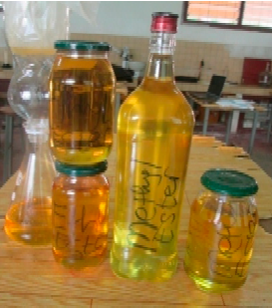
Fig 4: Final Products (B100)

Amount of Larval oil (g) | Catalyst Proportion (g) | Methanol-Oil Molar ratio | Biodiel Yield (%)
200 | 1.3 | 3:1 | 87
200 | 1.3 | 6:1 | 88
200 | 1.6 | 6:1 | 70
200 | 1.6 | 3:1 | 79
Table 1: Biodiesel Yied Basing on Varried Catalyst and Methanol Concentration.
3.2 Biodiesel Treatment
Untreated biodiesel contain impurities such as free glycerol, soap, free fatty acid, methanol, catalysts, metals and glycerides. Unreacted methanol has safety risks and can corrode the components of the engine, the residual catalyst can damage engine components and soap in the biodiesel can reduce fuel lubricity and bring about injector coking and other deposits (Ryan, 2004).
After the reaction time, biodiesel was transferred into a separating funnel and left to decant for at least two hours for the glycerine to be separated from the methyl ester. Then warm water at 50ºC was used to wash the biodiesel. 1% sulphuric acid solution was added during the second washing to neutralize the biodiesel.
3.3 Physico-Chemical Properties of the Methyl Esters
The physical and chemical properties of the methyl ester from the larval lipids are as shown in Table 2 below.
Property | Units | Methods | Limits | Results
Acid Number | mgKOH/g | D664 | 0.50 max | 0.13
Viscosity, 40ºC | Mm²/sec | D445 | 1.9-6.0 | 4.1
Flashpoint | ºC | D93 (closed cup) | 93 min. | >110
Water and Sediment | Vol.% | D2709 | 0.05 max | 0.10
Methanol Content | % | EN14110 | 0.2 max | 0.1
Total Glycerin | Mass % | D6584 | 0.24 max | 0.22
Free Glycerin | Mass % | D6584 | 0.02 max | 0.01
Visual Appearance | - | D4176 | Pass/Fail | Pass
Table 2: Characterization of Methyl Esters obtained from Larval Lipids of Oryctes rhynoceros
3.3.1 Water Content
Water contaminated biodiesel can cause engine corrosion or reaction with glycerides to produce soap and glycerol. Water can also act as a media for microbiological growths, leading to filter blockage. Because of these unwanted effects, ASTM D6751 set the maximum allowable content of 0.05% of water in B100. Water and sediment test gave 0.10% in the methyl esters produced from the larval lipids. This can be attributed to the drying process undergone.

3.3.2 Acid Number
The acid number, given in milligrams of potassium hydroxide per gram of sample, is a measure of acidic substance in the oil. The acid number is used as a guide in the quality control as well as monitoring oil degradation during storage. According to ASTM D664, the acid number of biodiesel is less than 0.5 mgKOH/g. As for the B100 obtained from larval lipids, the very low acid number of 0.13 was obtained.
3.3.3 Methanol Content
To monitor methanol residues in B100 is a safety concern since even small amounts of this chemical can reduce the flashpoint of the biodiesel. Residual methanol can affect fuel pumps, seals and elastomers resulting in poor combustion properties. EN14110 (2003) standard specifications requires the methanol content to be less than 0.2% . GC Chromatography analysis of larval lipid biodiesel gave a very low methanol content of 0.1%.
3.3.4 Free and Total Glycerol
Fuels with excess free glycerol can increase aldehydes and acrolein emissions and will also lead to problems with glycerol settling out in storage tanks, creating a viscous mixture that can plug fuel filters and cause combustion problems in the engine. GC chromatography was used to identify the free glycerol, mono-, di-, and triglyceride peaks. Free and total glycerol contents were found to be within the standard requirements according to D6584 standards.
3.4 Factors Affecting the Yield of Biodiesel
Biodiesel production in the process of transesterification is affected by several parameters such as presence of moisture and free fatty acids, reaction time, reaction temperature, catalyst and molar ratio of alcohol and oil (Gashaw and Teshita, 2014).
3.4.1 Reaction Temperature
Higher reaction temperature increases the reaction rate and shortens the time of reaction due to the reduction in the viscosity of the oils. However, increase in temperature beyond the optimal levels may lead to a decrease in biodiesel yield. This is because higher reaction temperature accelerates saponification and causes methanol to vapourize thus resulting to a decreased yield (Anitha and Dawn, 2010).
The transesterification reaction temperature should be below the boiling point of alcohol in order to prevent the vapourization of alcohol. Optimal reaction temperature range varies from 50ºC to 65ºC depending on the oils used. Various literatures recommend a reaction temperature near the boiling point of alcohol for faster conversion.
3.4.2 Time of Reaction
Fatty acid conversion increases when there is an increase in the time of reaction. At the beginning, the reaction is slow due to the mixing and dispersion of alcohol and oil. Thereafter, the reaction proceeds very fast. Maximum ester conversion was achieved at less than 90 minutes.
3.4.3 Alcohol to Oil Molar Ratio
Methyl esters yield is elevated by introducing an excess amount of methanol to shift the reaction equilibrium to the right hand side (Anitha and Dawn, 2010). Both methanol, ethanol, propanol, butanol and amyl alcohol can be used in the transesterification reaction. Amongst these alcohols methanol is used more frequently as its cost is low and it is also physically and chemically advantageous (polar and shortest chain alcohol) over the other alcohols. Results exhibit that highest yield of B100 is nearly 88.5% at 1:6 oil/methanol. The yield of biodiesel continuously increases with the rise of methanol to oil molar ratio.
3.4.4 Amount of Catalyst
Methyl esters formation is also affected by the amount of catalyst present. The most commonly used catalysts for biodiesel production are sodium hydroxide (NaOH) and Potassium hydroxide (KOH). The yield of biodiesel generally increases with the increasing amount of catalyst.

4.0 Conclusions
While 89% of global biodiesel derives from plant oils, insect larvae offer three times higher lipid yield per hectare than palm oil. Additionally, beetle larvae consume agricultural waste, creating circular bioeconomy versus palm oil's deforestation impact. This paper focused on the production of biodiesel, utilizing insect larvae, particularly from Oryctes rhinoceros as the novel feedstock. The refined larval lipids were used in the production of biodiesel using methanol and as a reagent while potassium hydroxide was used as catalyst. The highest biodiesel yield obtained was 88%. The American Society for Testing Materials (ASTM) and other standards established various parameters for establishing the phisico-chemical properties of the fuels. The ASTM parameters were employed in determining the quality of the biodiesel obtained. The results are close to that of petroleum diesel. The main advantage of biodiesel usage is that it has low exhaust emission in terms of carbon monoxide, hydrocarbons and particulate matter. Therefore, insect larvae can be exploited as a novel raw feedstock for biodiesel production in tropical biorefineries.

Conflict of Interest: The author declares no conflict of interest.

References and Bibliography
Association of Official Analytical Chemists(AOAC), (1995). Official Methods of Analysis. AOAC. Washington DC.
Abdelrahman B. & Fadhil, M. M. (2012). Biodiesel Production from High Free Fatty Acid-Content Oils. Journal of the Association of Arab Universities for Basic and Applied Sciences, 45-49.
Andrew, L. (2011). Basics of Alkali Refining and Water Washing of Vegetable Oils. Alfa Laval Copenhagen A/S, 1-27.
Anitha, A. & Dawn. (2010). Performance Characteristics of Biodiesel Produced from Waste Groundnut Oil using Supported Heteropolyacids. International Journal of Chemical Engineering and Applications, 1(3), 261-265.
Ayieko M. A., a. K. (2012). Nutritional value and consumption of black ants (Carebara vidua Smith) from the Lake Victoria region in Kenya. Advance Journal of Food Science and Technology, 4(1), 39-45.
D.J., B., J.J., B., & A.P., a. H. (1991). Eucalyptus Leaf Oils. 8-9.
Djomdi, M. L. (2020). Purification and Valorization of Waste Cotton Seed Oil as an Alternative Feedstock for Biodiesel Production. www.mdpi.com/journal/bioengineering, 7(41), 2-4.
Fan, X., R. B., & Austic. G. (2009). Preparation and Characterization of Biodiesel Produced from Recycled Canola Oil. The Open Fuels & Energy Science Journal, 113-118.
Garlapati, V., Kant, R., Kumari, A., Mahapatra, P., Das, P., & Banerjee, R. (2013). Lipase mediated transesterification of Simarouba glauca oil: a new feedstock for biodiesel production. Sustainable Chemical Processes, 1(11), 1-6.
Gashaw, A. (2014). Production of biodiesel from waste cooking oil and factors affecting its formation: A review. International Journal of Renewable and Sustainable Energy, 3(5), 92-98. doi: 10.11648/j.ijrse.20140305.12.
Mulimani, H., Hebbal, O. D., & Navindgi, M. C. (2012). Extraction of Biodiesel from Vegetable Oils and Their Comparisons. International Journal of Advanced Scientific Research and Technology, 2(2), 242-250.
Ogunwole, O. (2012). Production of Biodiesel from Jatropha Oil (Curcas Oil). Research Journal of Chemical Sciences, 2(11), 30-33.
R., M. A. (2015). Biodiesel production from waste cooking oil. Journal of Chemical and Pharmaceutical Research, 7(12), 670-681.
S, J. A. (2013). Biodiesel Production from High Free Fatty Acid-Content Oils: Experimental Investigation of the Pretreatment Step. APCBEEProcedia, 474-478.
Thirumarimurugan, M., Sivakumar, V. M., Merly Xavier, A., Prabhakaran, D., & Kannadasan, T. (2012). Preparation of Biodiesel from Sunflower Oil by Transesterification,. International Journal of Bioscience, Biochemistry and Bioinformatics, 2(6), 441-444.
V, A. M. (2008). Consumption, indigeneous knowledge and cultural values of the lakefly species within the Lake Victoria region. African Journal of Environmental Science and Technology, 282-289.
Xiaohu, F., & Xi, W. a. (2011). Biodiesel Production from Crude Cottonseed Oil: An Optimization Process Using Response Surface Methodology. Open Fuels Energy Sci. J., 4, 1-8.

