DESIGN AND DEVELOPMENT OF A PORTABLE SPICE ROASTER CUM GRINDER

1 Brindha.C
Department of Food Processing and Preservation Technology, Avinashilingam Institute for Home Science and Higher Education for Women Coimbatore (Tamil Nadu) 22uef005@avinuty.ac.in
2 Malavika.J
Department of Food Processing and Preservation Technology, Avinashilingam Institute for Home Science and Higher Education for Women Coimbatore (Tamil Nadu) 22uef014@avinuty.ac.in
3 Sowmia Narayani.V
Department of Food Processing and Preservation Technology, Avinashilingam Institute for Home Science and Higher Education for Women Coimbatore (Tamil Nadu) 22uef026@avinuty.ac.in
4 Pooja.K M.E.,
Assistant professor,
Department of Food Processing and Preservation Technology, Avinashilingam Institute for Home Science and Higher Education for Women Coimbatore (Tamil Nadu) pooja_fppt@avinuty.ac.in

Abstract — Spices plays a vital role in food products by enhancing the flavor, aroma and nutritional value. The overall quality of the spices is rely on proper roasting and grinding process. by using methods we cant' achieve the best quality of spice powders because these process may lead to the damage of volatile compounds, excessing moisture removal and uneven roasting of spices. To avoid such problems we designed a Portable Spice Roaster cum Grinder in a compact size for the usage of household and small-scale Industries .Our system integrates roasting and grinding using Arduino-based control mechanism to ensure controlled time and temperature during the processing time. Experimental trails were done for the coriander and cumin seeds.

For coriander (initial weight: 25 g), the efficiency increased gradually from 1.6% to 6.4% with increasing roasting time. The optimum condition was selected at Trial 7, where the final weight was 23.5 g with an efficiency of 6%. At this stage, uniform light brown colour, strong aroma, and absence of burning were observed, indicating effective roasting.

For cumin (initial weight: 25 g), the efficiency ranged from 2.0% to 6.8%. The optimum condition was achieved at Trial 6,
with a final weight of 23.4 g and efficiency of 6.4%. Cumin showed slightly higher efficiency due to its smaller size and higher surface area, allowing faster heat transfer and moisture removal.

Grinding efficiency reached 100% at 25 seconds for coriander and 20 seconds for cumin, producing fine powder of uniform particle size. The developed system demonstrated improved efficiency, consistency, reduced processing time, and better retention of flavour and aroma.

Keywords- Portable Spice Roaster cum Grinder, Spice Processing, Roasting Efficiency, Grinding Efficiency, Temperature, Aroma Retention, Coriander, Cumin

INTRODUCTION
Spices plays a very important role in human food culture for centuries. Spice not only gives taste and Aroma but also provides nutritional and medicinal values. spices are obtained from various parts of the plants such as seed ,roots, bark and fruits and are widely used in both domestic cooking and as well as commercial food production.India is highly known for its

spice production in global level and being one of the largest consumers and exporters of a wide range of spices. To maintain the quality of spices throughout the exporting timeline the spices are well processed and packed to maintain the good grade quality of spices. The processes used for spices to improve self life and usability are roasting and grinding.Roasting and grinding are the two main stages in the spice processing unit as they directly influence the final quality of the product. Roasting improves flavour, Aroma, activating essential oils, reducing moisture content and improving the colour of the spices.

Grinding helps in reducing the particle size allowing for better flavour release and uniform mixing of food products. The steps can be done both in traditional and modern ways, when it comes to the traditional way it has many limitations and may lead to a large amount of wastage if it is not properly processed ,like manual pan roasting method depends on heavily on operator skilled person to handle it because it may lack proper temperature control leading to uneven roasting and burning similar to this conventional grinding methods generate excessive heat due to friction which also leads to loss of Aroma and degradation of heat sensitive compounds present in spices.

Recent research tells that during normal grinding there may be a heat generation which goes till 90 degree Celsius.This will degrade the quality of spices. Recent technologies may rectify this problem using cryogenic grinding methods but it is more expensive and not practical for household and small scale industries. As a result it is a growing demand for simple, affordable and efficient systems.

Combining roasting cum grinder into a single compact integrated system gives us
several advantages like reducing process time, minimizing manual handling, lower contamination and overall consistency. Using automation we can rectify all these problems so here we use a micro controller that helps to do the process in a controlled manner by controlling the time of the roasting and grinding which helps to retain better flavour and Aroma. Portable type make even more useful for household small scale industries and cottage industries.

Based on the requirements the project aims to design and develop a portable spice roster cum grinder into a single compact unit.The system uses Arduino-based control mechanism to ensure uniform roasting and timed grinding. This approach improves spice quality, taste ,flavor, Aroma retention and even improves the self Life of spices this gives practical solution for small scale spice processing industries.

Literature Survey

Spice processing,Mg plays a crucial role in determining the final quality of the product, including flavour, aroma, colour, and nutritive value. Controlled heat applied during roasting induces physiochemical reactions that release aromatic compounds responsible for the sensory profile of spices (Martins et al., 2019). Uniform heat distribution during roasting ensures the preservation of bio active compounds (Fikry et al., 2019). However, conventional roasting methods rely on manual operation, resulting in inconsistent quality among batches (Srinivasan, 2019).

The presence of high moisture content and the complex composition of spices further complicate the roasting process. Retention of volatile oils, which are essential for aroma and flavour, is highly affected by variations in temperature and time

(Srinivasan, 2019). Manual roasting often fails to maintain the required roasting parameters, thereby creating a need for technological intervention and monitoring systems. Embedded systems in the food industry enable real-time monitoring and control of processing conditions (Ahmed and Khan, 2020). Traditional roasting methods depend on manual stirring and visual inspection, which lead to non-uniform and inconsistent heating (Patel and Joshi, 2018).

Grinding is another critical stage in spice processing that determines the quality of the powder and particle size distribution. Traditional grinding methods, such as stone grinding or mechanical grinding, generate excessive heat due to friction. This heat leads to the loss of volatile oils and essential compounds, thereby degrading the nutritive value and flavour of spices. Conventional grinding can increase product temperature up to 90°C, causing significant quality deterioration (Kumar et al., 2019). Zhou et al. (2020) reported that frictional heat generated during high-speed grinding adversely affects the physio chemical properties of spices.

Advanced techniques such as cryogenic grinding utilize low-temperature liquid nitrogen to minimize heat generation during grinding. This method effectively preserves the physio chemical properties of spice powders, reduces particle agglomeration, and improves flow properties. However, the major disadvantage of cryogenic grinding is its high operational cost (Mujumdar, 2019).

Non-uniform particle size negatively affects packaging properties and powder flow ability. The blade design and rotational speed significantly influence grinding performance; therefore, careful operational design is required to achieve optimum
results (Aguilera and Stanley, 2019). The integration of sensors and display systems enhances monitoring by incorporating LCD displays and alert systems to indicate the completion of each process (Ramesh and Patel, 2020).

Kumar and Das (2020) emphasized the need for controlled roasting and grinding operations to ensure product affordability and quality. Automation in food processing reduces labour requirements, enhances hygiene, improves consistency, and makes the system suitable for small-scale industries (Lee et al., 2021). Research by Kulkarne et al. (2020) demonstrated that improper sieving leads to segregation of fine and coarse particles, resulting in inconsistent product appearance. In small-scale industries, reprocessing can be minimized by integrating automatic sieving systems (Deshpande, 2021). Proper processing techniques also reduce particle agglomeration and microbial growth during storage and distribution.

Extended exposure of spice powders to light and air leads to lipid oxidation and moisture absorption, which alter composition, texture, and functional properties, thereby reducing shelf life (Farah and Donangelo, 2018).

MATERIALS AND METHODS
The development of the portable spice roaster cum grinder needs the required mechanical,electrical and electronic components to ensure structural stability,hygienic processing, automation and safe power operation. According to functional requirements durability, cost effectiveness and compatibility each materials and components were selected.

ROASTING CHAMBER

Roasting chamber is the most important component of the system. The material used ensures corrosion,high temperature tolerance by providing efficiency.During roasting the samples are exposed to optimum temperature, the material prevents chemical reaction between the chamber surface and sample,thereby preserving flavour integrity.

The chamber is designed to allow uniform heat transfer from the surrounding heating coil with help of the agitator. The smooth internal surface of the chamber reduce clumping of the sample.

The agitator used for uniform roasting with continuous mixing of the spices to avoid over heating.A DC gear motor with an attached shaft was used as the agitator mechanism. The gear motor provides controlled rotational speed and sufficient torque to rotate the shaft inside the roasting chamber . It will improve the roasting consistency and aroma development by slow and steady agitation of spices.

HEATING COIL
A reliable and consistent heat source is required for roasting process.A 230V AC heater coil is used as heating element.The heating coil is surrounded around the chamber to ensure uniform heating.The electrical energy is converted into thermal energy by coil through resistive heating.

The temperature inside the chamber increases gradually thereby controlling the moisture.The relay module is connected to heating coil that allows micro controller to switch it on and off,preventing over heating of spices.

AGITATOR

The gear motor provides the controlled rotational speed and sufficient torque to the mixing shaft inside the roaster chamber,which will avoid the over heating.

The DC gear motor with an attached shaft was used as the agitator mechanism.Agitator will provide uniform roasting and continuous mixing of the sample.Improving roasting consistency and aroma development by the slow and steady agitation.

GRINDING CHAMBER

Mechanical impact and shear forces are involved in grinding and the material must resist mechanical stress.The material used resist abrasion caused by grinding of hard spices.It also prevents rusting and ensures uniform grinding.

The AC grinding motor operates at 1000 RPM providing sufficient rotation speed and force to pulverize spice into powder.Frictional heat generation is reduced by control speed ensuring effective size reduction.Relay and controller activates the motor to a preset time to produce consistent product.

MICROCONTROLLER
Arduino UNO acts as the central control unit of the system.It activates the motor,displays the update,allows input,monitor temperature. The time set for roasting and grinding are controlled.

The temperature is controlled by using LM35 temperature sensor.It allows future modifications and system updates.

TEMPERATURE SENSOR(LM35)
The sensor monitors the roasting chamber temperature providing analog voltage output that is equivalent to temperature in degree Celsius.It allows dynamic control on the heating process and prevents over heating or under heating of spices and improves aroma retention. The LM35 sensor is accurate and simple to handle.

DISPLAY UNIT

A16x2 liquid crystal display (LCD) is used to monitor the system,providing information.It shows temperature reading,time,operation(roasting or grinding)and completion.It reduces error and brings operational clarity.

POWER SUPPLY UNIT

The AC and DC power was required in this system for different components.The power supply unit consists of Step-down Transformer which reduces the 230V AC input to lower AC voltage according to the electronic circuits.

Rectifier which converts AC voltage into pulsating DC,where as the Filter circuit will smoothens the DC output.Voltage Regulator will provide stable 5V DC supply for Arduino and other low voltage components.This regulated power system provides the safe and stable operations of electronic components.

CONTROL DEVICES
High power devices such as the heating coil and AC grinding motor,are used to controlled by relay modules.They play as a electrically operated switches,enabling safe control of high voltage loads using signals
from the Arduino.For selecting operation modes and setting time parameter controlled by push buttons.These input device allow simple and user friendly interaction with the system.

BUZZER
It helps to know the roasting and grinding cycles are completed by providing audible alerts.This feature will reduce the continuous monitoring of the operation and will enhance the user convenience.It also servers the safety alert mechanism in case of abnormal operations

METHODOLOGY
RAW MATERIALS : Cumin seeds and coriander seeds are selected. Foreign particles such as dust and stones are removed manually,

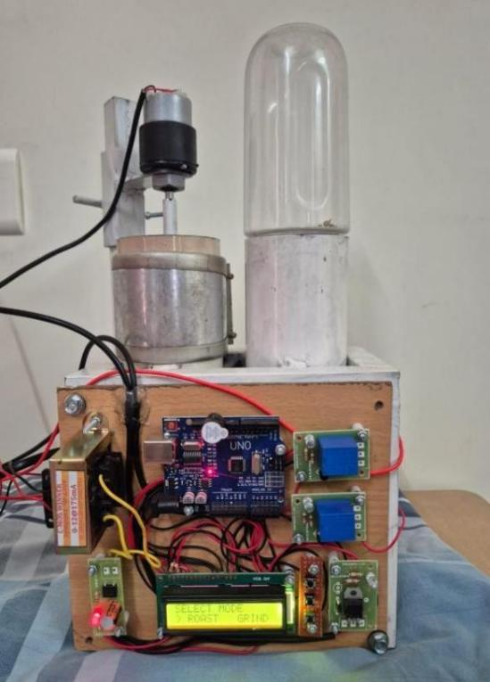

Figure 3.1 Portable spice roaster cum grinder

thereby reducing external contaminants affecting the process. About 50g of sample is taken for this process.Roasting chamber is surrounded by an AC heating coil to ensure uniform heat distribution throughout the process.
A DC motor is used to rotate the agitator to ensure continuous mixing of sample. The sample is fed into the roasting chamber and the LCD displays the mode of action and the time period set for each process. Push buttons are used to set the mode and the time for roasting in seconds, once it is set(entered) the agitator starts to rotate n mix the sample and the AC heating coil produces heat required for roasting.

LM35 temperature sensor monitors the temperature and it is displayed on the LCD . Buzzer alerts once the roasting is done to pre-set time indicating the end of roasting process. The sample is let to cool.

GRINDING:
Once the samples are cooled naturally, it prevents further heat exposure, and avoids condensation during grinding. A high speed AC motor (1500 RPM) grinds the sample within seconds. The mode of action is set to grinding and time for grinding is set in seconds. The samples are fed in grinding chamber and closed properly and the set time is entered. Buzzer alerts the end of grinding process. The ground samples are collected from the chamber. Final end product of very fine particle size is received.

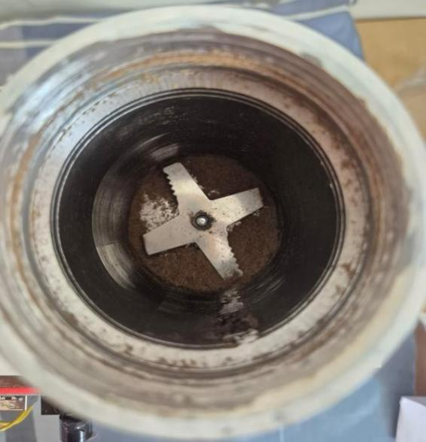
Figure 3.2 Grinding chamber with blade

WORKFLOW:
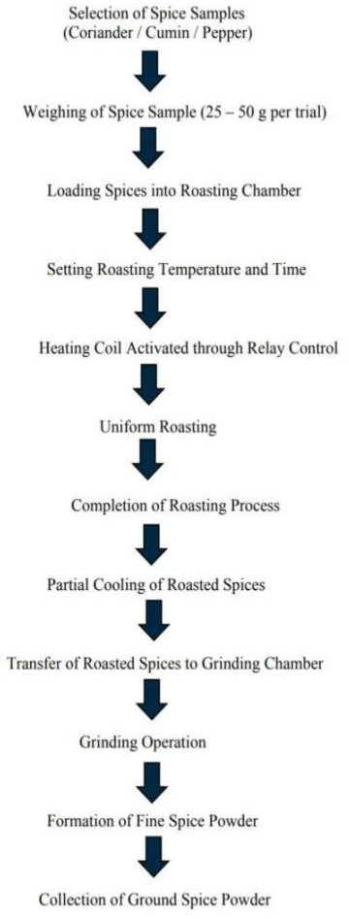

Figure 3.3 Flow Diagram

RESULT AND DISCUSSION

ROASTING EFFICIENCY ANALYSIS:
The performance of the spice roaster cum grinder was analyzed through experimental trails using coriander and cumin as sample materials.The result were analyzed based on roasting efficiency, grinding efficiency, colour intensity(RSM),and overall product quality.Roasting efficiency was determined based on weight reduction of the sample afterroasting,which indicates moisture loss and release of volatile compounds.

FORMULA USED:

Roasting Efficiency (%) = Wi – Wf/Wi х100 Where
  - Wi = Initial weight of sample
  - Wf = Final weight after roasting

TRIAL AND ERROR :
- Coriander (Initial Weight = 25 g)

Optimized Value Selected: 23.5 g
Efficiency=25−23.5/25×100=6%
- Cumin (Initial Weight = 25 g)

TRIAL | FINAL WEIGHT | EFFICIENCY
1 | 24.5 | 2.0
2 | 24.2 | 3.2
3 | 23.9 | 4.4
4 | 23.7 | 5.2
5 | 23.6 | 5.6
6 | 23.4 | 6.4
7 | 23.5 | 6.0
8 | 23.3 | 6.8
9 | 23.3 | 6.8
10 | 23.4 | 6.4

Optimized Value Selected: 23.4 g (Trial 6)
Efficiency=25−23.4\25×100=6.4%
Based on both efficiency and quality parameter was selected as the optimum roasting condition.The maximum efficiency was observed at Trial 8 and 9, the improvement beyond Trial 7 and 6 was minimal, indicating a saturation point.The uniform colour development, strong aroma, and no signs of over-roasting was observed in trial 7 (23.5 g, 6%),trial 6 (23.4g, 6.4%) so the efficiency at this stage was found to be stable and repeatable. Hence, Trial 7and trial 6 provided the balance between effective moisture removal and quality retention.
TRIAL | FINAL WEIGHT | EFFICIENCY  (％)
1 | 24.6 | 1.6
2 | 24.3 | 2.8
3 | 24.0 | 4.0
4 | 23.8 | 4.8
5 | 23.7 | 5.2
6 | 23.6 | 5.6
7 | 23.5 | 6.0
8 | 23.4 | 6.4
9 | 23.4 | 6.4
10 | 23.5 | 6.0

ANALYSIS AND DISCUSSION:

The sample coriander and cumin represent a gradual increase in roasting time which obtains the roasting efficiency value.This shows that as the roasting duration increases,moisture content and volatile

components are progressively reduced,resulting in weight loss.The efficiency values were lower around (1.6 %- 3 %)in the initial trials which indicates the insufficient roasting and incomplete moisture removal.As the roasting time increased the efficiency will also improved gradually,reaching an optimum range of
6 ％ for coriander and 6.4 ％ for cumin.
Only a marginal increase in efficiency was observed,which suggests that roasting does not significantly improve moisture removal but may lead to over roasting or degradation of quality.The higher efficiency observed in cumin compared to coriander can be attributed to its smaller seed size and higher surface area, which allows rapid heat penetration and moisture removal.

The efficiency were further supported by physical observations by uniform light brown colour was obtained.Strong aroma was developed and no carbonization was observed.The results demonstrate proper moisture removal, uniform heat distribution, and improved product quality without compromising aroma or causing thermal degradation.

The graph illustrates the variation of roasting efficiency with respect to trial number for coriander and cumin samples. It is observed that the efficiency increases steadily with increasing roasting time due to progressive moisture removal. After reaching the optimum condition (around Trial 7–8), the efficiency shows a plateau, indicating that further roasting does not significantly improve performance. This confirms that the selected roasting conditions are optimal for achieving uniform roasting without over-processing.
From the graph, we can clearly see that efficiency increases initially and then stabilizes, which indicates that optimum roasting condition has been achieved.
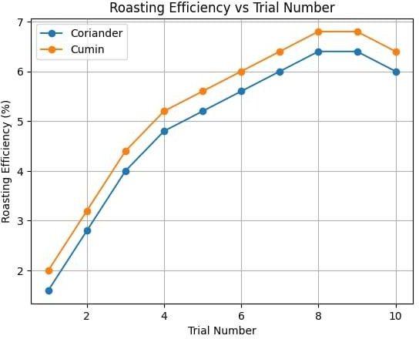

Figure 5.1 Roasting efficiency Vs Trial

OPTIMIZATION OF ROASTING TIME BASED ON COLOUR INTENSITY ANALYSIS :

To determine the optimum roasting time of cumin and coriander seeds the portable spice roaster cum grinder was used for the experiment. Total of ten trials were conducted for each spices - starting with 1minute and gradually increasing 30seconds until 7minutes. There were changes in aroma and color after roasting.

In our project we have used Image J software to analyse the color intensity as it wasn't distinguishable by naked eye. Images of initial, intermediate, and final samples were analysed using Image J.There was a visible change in mean value of color intensity indicating the roasting.

IMAGE J-BASED COLOUR INTENSITY VALUES AT DIFFERENT ROASTING TIME :

SAMPLE | STAGE | TIME | MEAN
Cumin | Initial | 1 min | 89.9
Cumin | Intermediate | 3 min | 98
Cumin | Final | 6 min | 111.4

Table 5.1: Cumin colour intensity

SAMPLE | STAGE | TIME | MEAN
Coriander | Initial | 1 min | 86.3
Coriander | Intermediate | 3 min | 101.4
Coriander | Final | 5 min | 113.7

Table 5.2: Coriander colour intensity
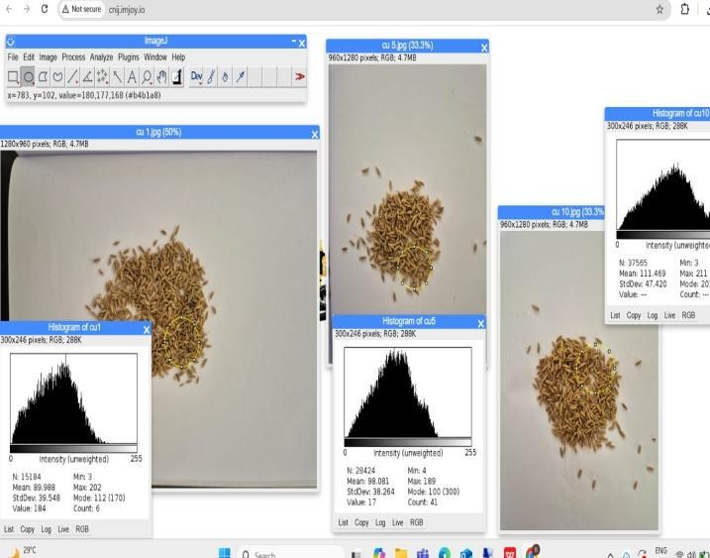

Figure 5.2: Cumin color intensity analysis

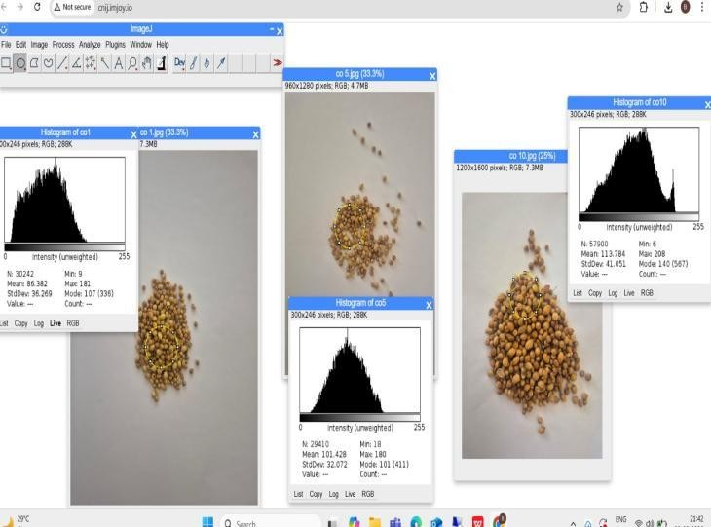

Figure 5.3: Coriander color intensity analysis

This graph shows increase in mean color intensity with increase in roasting time. Increase in color intensity is the result of thermal reaction during heating. To attain the optimum roasting temperature it takes 5 minutes for coriander and 6 mins for cumin to differentiate aroma and color.

GRINDING EFFICIENCY ANALYSIS:

The grinding efficiency of the Portable spice cum roaster was evaluated by taking 20 g of both cumin and coriander at intervals of 5 seconds each. The ground spice is sieved through a 500 µm sieve to separate coarse and fine powders.

The efficiency of the grinding is calculated using the formula the weight of fine powder

to the total sample taken and multiplied with 100 to get the value in percentage for cumin overall time period to get the standard value of spices powder it took 20 seconds and the coriander took 25 seconds due to its large size.

FORMULA USED:
Grinding Efficiency = Weight of the fine powder/Weight of the total sample taken х 100

- Particle Size: 500µm Sample 1: Coriander
Time | Sample Weight | Coarse particle | Fine particle | Efficiency
5 | 20 | 11.2 | 8.8 | 44%
10 | 20 | 7.2 | 12.8 | 64%
15 | 20 | 4.1 | 15.9 | 79.5%
20 | 20 | 2.8 | 17.1 | 86%
25 | 20 | 0 | 20 | 100%

Table 5.3 Grinding efficiency of coriander

- Particle Size: 500µm Sample 2: Cumin
Time | Sample Weight | Coarse particle | Fine particle | Efficiency
5 | 20 | 10.4 | 9.8 | 49%
10 | 20 | 5.7 | 13.5 | 67.5%
15 | 20 | 3.7 | 16 | 80%
20 | 20 | 0 | 20 | 100%

Table 5.4 Grinding efficiency of cumin

v. Conclusion

The study designed and developed a portable spice roaster cum grinder as an efficient solution for spice processing. It combines roasting and grinding operations into a single compact unit reducing manual labour, processing time and risk of contamination. The Arduino based controller system ensures precise roasting and grinding time preventing overheating or under heating of spices thereby, producing uniformly roasted sample. Samples taken for the experiment:cumin, coriander developed aroma and color during roasting with optimal moisture removal, efficiency of about 6% for coriander and 6.4% for cumin.

Trial and error method provides optimum roasting condition with increase in time . ImageJ software was used to indicate change in color intensity that wasn't visible with naked eye. The change in mean value of color intensity from 89.9 to 111.4 for cumin and from 86.3 to 113.7 for coriander indicates the rate of roasting of samples. Grinding efficiency was high with very less duration producing uniform and fine particles without generating excess heat and maintaining high quality of spice. For cumin it took about 20 seconds and for coriander it took 25seconds. Efficiency for both roasting and grinding was found using formula method.

Overall, the developed system is reliable in terms of efficiency, uniformity, quality and aroma. Compared to conventional methods our system offers a cost effective and energy efficient solution applicable for household and small scale spice processing industries. It improves scalability of spice processing with enhanced quality of spice powder.

II. Future Work

In a compact system,the developed portable spice roaster cum grinder demonstrates effective integration of roasting and grinding,to enhance the performance,efficiency,usability of the system and several improvements can be considered in the future work.In the current prototype,basic temperature monitoring and control are used.Advanced temperature control techniques such as PID control is the one possible improvement.The consistency of roasting and help preserve the natural aroma,flavour and nutritional properties of spices,by incorporating more precise control algorithms which can the system can maintain more stable roasting temperatures.The integration of Internet of Things (IOT) technology was the another potential development of the system,in addition of adding wireless communication modules such as Wi-Fi or Bluetooth which allow the system to control through remote monitoring and mobile application.This application will help the user to track roasting temperature,processing time and machine status in real time,which improving the convenience and operational flexibility.

The automated spice transfer mechanism between the roasting and grinding chambers which was the future version of the system is included.In the present working model partial manual handling may still be required,by introducing the an automatic transfer system would reduce the manual work and improve the overall efficiency of the system.The effective roasting performance was maintained by consumption of less power and can help the use of energy efficient heating elements and motors ,along with improved insulation in the roasting chamber.Further research can focus on optimizing the grinding mechanism by exploring differnet types of blade designs
and grinding speeds for various types of speices,which allow the system to produce even particle size and improves the quality of the final spice powder.
The advanced mechanism design of the system can also be enhanced to improve the durability,hygiene and ease of cleaning.The modular structure design would make the equipment more suitable for long term use in the small scale food processing industries and household uses.Finally,future work could involve the extensive experiment testing with different spice varieties such as cumin,coriander,pepper and turmeric to evaluate the roasting and grinding efficiency ,with overall quality parameters.Related studies would also help to improve the operational conditions and overall reliability and applicability of the system.

REFERENCES
- P. Fellows, Food Processing Technology: Principles and Practice, 4th ed. Cambridge, U.K.: Woodhead Publishing, 2017.
- K. Srinivasan, “Spices as influencers of food flavour and health,” Food Reviews International, vol. 35, no. 4, pp. 347–366,
2019.
- H. McGee, On Food and Cooking: The Science and Lore of the Kitchen. New York, NY, USA: Scribner, 2018.
- S. Brennan, J. Grandison, and M. Lewis, “Influence of thermal processing on spice quality and flavour,” Journal of Food Engineering, vol. 215, pp. 45–53,
2018.
- R. Singh and A. Verma, “Traditional and modern spice processing techniques: A comparative study,” Food Control, vol. 98, pp. 120–128, 2019.
- A. Gupta and S. Sharma, “Effect of grinding on spice shelf life and

quality,” Journal of Food Science and Technology, vol. 56, no. 7, pp. 3254–3261,
2019.
- S. Patil and R. Joshi, “Limitations of manual spice processing in small-scale industries,” International Journal of Food Processing Technology, vol. 6, no. 2, pp. 89–94, 2018.
- J. Martins et al., “A review of Maillard reaction in food,” Trends in Food Science and Technology, vol. 11, no. 9, pp. 364–
373, 2019.
- M. Farah and C. Donangelo, “Lipid oxidation during thermal
processing,” Food Chemistry, vol. 245, pp. 114–122, 2018.
- J. Aguilera and D.
Stanley, Microstructural Principles of Food Processing, 3rd ed. New York, NY, USA: Springer, 2019.
- R. Kumar, S. Mehta, and P. Shah, “Automation trends in food processing industries,” IEEE Access, vol. 7, pp. 142345–142354, 2019.
- J. Lee, H. Kim, and S. Park, “Smart automation solutions for small food enterprises,” Sensors, vol. 21, no. 10, pp. 3456–3468, 2021.
- A. Ramesh and D. Patel, “Microcontroller-based food processing systems,” International Journal of Embedded Systems, vol. 12, no. 3, pp. 201–209, 2020.
- S. Ahmed and M. Khan, “Embedded control systems in food processing applications,” Journal of Food Engineering, vol. 287, pp. 110–118, 2020.
- R. Kumar et al., “Energy-efficient automated roasting systems,” Journal of Cleaner Production, vol. 252, pp. 119–128,
2020.
- P. Rao and K. Deshmukh, “Role of embedded controllers in process
stability,” IEEE Transactions on IndustrialElectronics, vol. 67, no. 8, pp.
6532–6540,
2020.
- K. Srinivasan, “Thermal degradation of spice essential oils,” Critical Reviews in Food Science and Nutrition, vol. 60, no. 12,
pp. 2011–2026, 2020.
- A. Gupta and R. Jain, “Temperature sensing techniques for food applications,” Measurement, vol. 146, pp. 102–110, 2019.
- H. Singh et al., “Relay-controlled heating using Arduino,” International Journal of Engineering Research and Technology, vol. 9, no. 6, pp. 411–415,
2020.
- K. Rao and S. Kulkarni, “Comparison of ON–OFF and PID controllers,” Control Engineering Practice, vol. 104, pp. 104–
112, 2020.
- M. Patel and D. Shah, “Importance of agitation in food roasting
processes,” Journal of Food Process Engineering, vol. 41, no. 5, e12843, 2018.
- M. Patel and D. Shah, “Vibration- assisted mixing in granular food systems,” Food and Bioproducts Processing, vol. 112, pp. 10–18, 2019.
- Y. Chen et al., “Energy-efficient vibration mixing techniques,” Applied Thermal Engineering, vol. 190, pp. 116–
125, 2021.
- J. Zhou et al., “Grinding characteristics of spices,” Powder Technology, vol. 360, pp. 126–134, 2020.
- L. Wang and Z. Chen, “High-speed grinding motors for spice
processing,” Journal of Food Science and Nutrition, vol. 9, no. 4, pp. 1801–1808,
2021.
- J. Zhou et al., “Effect of blade design on spice grinding,” Powder Technology, vol. 372, pp. 285–293, 2021.
- S. Ahmed et al., “Microcontroller- based grinding automation,” IEEE Sensors Journal, vol. 22, no. 14, pp. 13845–13852,
2022.
- A. Ahmed et al., “LCD-based

monitoring in food equipment,” Journal of Food Engineering, vol. 275, pp. 109–116,
2020.
- P. Nair and S. Menon, “Alert systems in automated food machines,” Automation in Agriculture, vol. 3, pp. 55–62, 2021.
- A. Mujumdar, Handbook of Industrial Drying, 4th ed. Boca Raton, FL, USA: CRC Press, 2019.
- J. Hernandez, “Microcontroller-based coffee roasting systems,” IEEE Transactions on Consumer Electronics, vol. 66, no. 4, pp. 311–319, 2020.
- M. Silva and A. Costa, “Automated roasting control using embedded systems,” Journal of Food Engineering, vol. 298, pp. 110–119, 2021.
- R. Kumar and S. Das, “Adaptation of coffee roasting control for spices,” Food Engineering Reviews, vol. 14, pp. 210–
222, 2022.
- K. Srinivasan, Spices and Condiments: Chemistry, Microbiology, Technology. Boca Raton, FL, USA: CRC Press, 2019.
- A. Verma and R. Singh, “Embedded temperature control in food
processing,” IEEE Access, vol. 8, pp. 145678–145687, 2020.
- S. Ahmed et al., “Integrated roasting and grinding systems,” Journal of Food Processing and Preservation, vol. 46, e15987, 2022.[37] M. Ali et al., “IoT-based smart
kitchen appliances,” IEEE Internet of Things Journal, vol. 9, no. 6, pp. 4532–
4541, 2022.
- J. Chen et al., “Sensor-based adaptive food processing,” Sensors, vol. 22, no. 5,
pp. 1987–1999, 2022.
- R. Singh and P. Mehta, “Safety mechanisms in smart food
equipment,” Food Control, vol. 134, pp. 108–116, 2022.
- L. Wang et al., “Modular food processing system design,” Journal of Food Engineering, vol. 325, pp. 111–120,
2023.
- A. Verma and P. Mehta, “Quality evaluation of spices during thermal processing,” Journal of Food Quality, vol. 42, no. 5, pp. 1–9, 2019.
- S. Kulkarni and R. Deshpande, “Design considerations in small-scale food processing equipment,” International Journal of Food Engineering, vol. 16, no. 3,
pp. 1–12, 2020.
- J. Aguilera, “Food particle size reduction and its effects on quality,” Food Engineering Reviews, vol. 11, pp. 1–14,
2019.
- M. Farah and C. Donangelo, “Thermal degradation of bioactive compounds in spices,” Food Chemistry, vol. 278, pp. 70–78, 2019.
- R. Yadav and S. Singh, “Temperature sensing techniques for food processing applications,” Measurement, vol. 152, pp. 107–115, 2020.
- H. Patel and D. Mehta, “Hygienic design of food processing
machinery,” Food Control, vol. 118, pp. 107–114, 2020.
- K. Rao, S. Kulkarni, and A. Joshi, “Energy optimization in electric heating systems,” Applied Thermal Engineering, vol. 175, pp. 115–124, 2020.
- L. Wang and Y. Zhao, “Effect of grinding conditions on spice powder properties,” Powder Technology, vol. 373,
pp. 282–290, 2021.
- J. Hernandez and M. Silva, “Embedded system applications in food processing,” IEEE Consumer Electronics Magazine, vol. 9, no. 6, pp. 45–52, 2020.
- S. Nair and P. Thomas, “Performance evaluation of domestic food processing appliances,” Journal of Consumer Studies, vol. 44, no. 2, pp. 185–193, 2020.
- R. Singh and V. Sharma, “Heat transfer analysis in food roasting processes,” Journal of Food Process Engineering, vol. 43, e13456, 2020.

- A. Mujumdar, “Thermal processing of agricultural products,” Drying Technology, vol. 38, no. 1–2, pp. 1–10, 2020.
- P. Nair, S. Menon, and R. Malik, “User interface design for automated food machines,” International Journal of Automation Technology, vol. 14, no. 4, pp. 623–631, 2020.
- S. Ahmed and R. Malik, “Safety considerations in automated food equipment,” Food Engineering Reviews, vol. 13, pp. 92–104, 2021.
- D. Shah and M. Patel, “Mixing and agitation mechanisms in granular food systems,” Journal of Food Engineering, vol. 292, pp. 110–118, 2021.
- J. Chen, X. Liu, and Y. Zhang, “Sensor-based monitoring in food processing systems,” Sensors, vol. 21, no.
18, pp. 1–14, 2021.[57] R. Kumar and A.
Nair, “Compact
food processing systems for small enterprises,” Food Engineering Reviews, vol. 13, pp. 240–252, 2021.
- S. Banerjee and A. Ghosh, “Effect of roasting on antioxidant activity of spices,” Journal of Food Science, vol. 86, no. 4, pp. 1120–1128, 2021.
- Y. Li and Z. Chen, “Particle size distribution and flow behavior of spice powders,” Advanced Powder Technology, vol. 32, pp. 356–364, 2021.
- P. Fellows, “Post-harvest processing of spices,” Trends in Food Science & Technology, vol. 112, pp. 320–329, 2021.
- S. Das and R. Kumar, “Design of low-cost automated food
machines,” International Journal of Engineering Research, vol. 10, no. 6, pp. 45–52, 2021.
- M. Ali, S. Khan, and H. Rahman, “Smart kitchen appliances: A
review,” IEEE Access, vol. 9, pp. 118765– 118777, 2021.
- J. Zhou and Y. Li, “Heat generation during high-speed grinding,” Powder
Technology, vol. 389, pp. 420–428, 2021.
- K. Srinivasan, “Processing effects on spice aroma compounds,” Food Research International, vol. 144, pp. 110–118, 2021.
- R. Patel and S. Mehta, “Small-scale spice processing technologies,” Journal of Food Processing and Preservation, vol. 45, e15490, 2021.
- L. Zhao, H. Liu, and X. Wang, “Design of modular food processing equipment,” Journal of Food Engineering, vol. 315, pp. 110–119, 2022.
- S. Verma and P. Singh, “Energy- efficient motor selection for food grinding,” International Journal of Electrical Engineering, vol. 14, no. 2, pp. 89–96, 2022.
- A. Joshi and R. Kulkarni, “Automation trends in food manufacturing,” IEEE Transactions on Industry Applications, vol. 58, no. 3, pp. 3210–3218, 2022.
- T. Nguyen and M. Le, “Sustainability in food processing technologies,” Journal of Cleaner Production, vol. 330, pp. 129– 138, 2022.
- P. Shah, R. Mehta, and A. Nair, “Integrated roasting and grinding systems for spices,” Journal of Food Engineering, vol. 335, pp. 111–120, 2023.

