Best Data Providers & Platforms for Verified HCP Targeting: Vendors, Accuracy, and Compliance
Abstract
Healthcare professional (HCP) targeting has evolved from static physician lists to dynamic, data-driven intelligence ecosystems that integrate prescribing behavior, engagement signals, and compliance frameworks. Pharmaceutical, biotech, and medtech organizations increasingly rely on verified HCP data providers and platforms to optimize commercial strategies, improve engagement precision, and ensure regulatory adherence. However, variability in data accuracy, fragmentation across sources, and evolving compliance mandates present significant challenges. This review examines the leading HCP data vendors and platforms, evaluates data accuracy benchmarks, and analyzes compliance frameworks governing HCP data usage. It further explores the role of AI-driven targeting platforms and highlights best practices for vendor selection in modern healthcare commercialization.
Introduction
Targeting healthcare professionals (HCPs) is central to pharmaceutical commercialization, medical device marketing, and healthcare B2B engagement. Historically, HCP targeting relied on static directories and prescribing deciles. However, the shift toward precision engagement has necessitated robust, real-time, and compliant data ecosystems.
Modern HCP targeting integrates multiple datasets, including prescribing behavior, claims data, clinical affiliations, and digital engagement signals. Consequently, selecting the right data provider is no longer a procurement decision but a strategic determinant of commercial success.
Categories of HCP Data Providers and Platforms
HCP data vendors broadly fall into three categories:
1. Enterprise HCP Data Providers
These platforms deliver comprehensive, global datasets with deep clinical and behavioral insights.
- IQVIA OneKey: Covers over 25 million HCPs globally with >250 attributes per profile and achieves >99% data accuracy through continuous validation processes [1].
- Definitive Healthcare: Provides access to over 3 million U.S. HCPs and integrates 28 billion prescription claims and 12.5 billion medical claims for advanced analytics [2].
- Veeva OpenData: Offers ~12 million global HCP and HCO records with seamless CRM integration and compliance tagging [3].
These platforms are considered industry gold standards due to their scale, integration capabilities, and regulatory alignment.
2. Mid-Market and Specialized Vendors
These vendors provide targeted datasets for specific use cases such as medtech, outpatient care, or specialty targeting.
- Vendors such as MedicoReach and MedScout offer niche datasets with high email accuracy (>90%) and specialty-specific targeting [4].
- IntuitionLabs provides pay-per-record HCP datasets with ~95% accuracy and quarterly updates, making it accessible for smaller organizations [5].
These solutions are cost-effective but may lack the depth of enterprise-grade platforms.
3. Generalist B2B Data Platforms with Healthcare Verticals
Platforms like ZoomInfo, Apollo, and Cognism extend into healthcare with business-focused data.
- These platforms excel in identifying administrative decision-makers (e.g., CIOs, procurement heads) but lack clinical granularity such as prescribing behavior or procedure volumes [6].
Core Data Types Driving Effective HCP Targeting

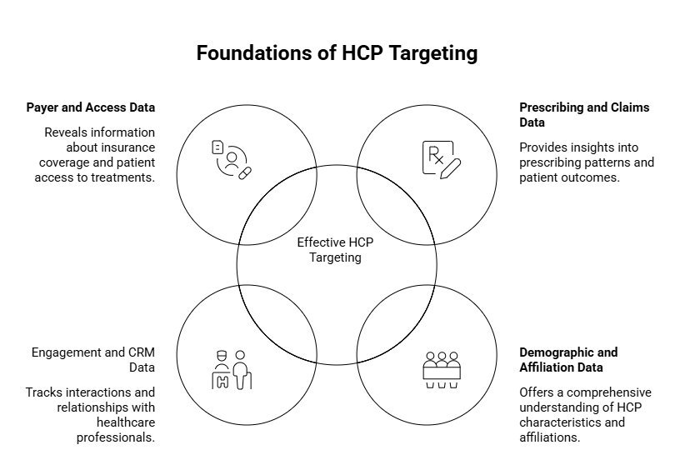
Effective HCP targeting requires integrating multiple data layers:
1. Prescribing and Claims Data
Prescription datasets remain the backbone of targeting strategies. Platforms such as IQVIA and Symphony Health provide longitudinal insights into prescribing trends, enabling identification of high-value and emerging prescribers [7].
2. Demographic and Affiliation Data
Basic identifiers such as specialty, location, and institutional affiliations are essential for segmentation and territory planning [2].
3. Engagement and CRM Data
CRM systems (e.g., Veeva CRM, Salesforce Health Cloud) capture field interactions and digital engagement, enabling behavioral targeting [7].
4. Payer and Access Data
Formulary access and reimbursement policies significantly influence prescribing behavior and must be integrated into targeting models [7].
Data Accuracy: A Critical Performance Determinant
Data accuracy directly impacts campaign effectiveness, field force efficiency, and return on investment.
A 2024 PubMed-indexed analysis of physician directories demonstrated substantial variability in data accuracy, with some datasets achieving only ~50% correctness in provider location data [8]. Even top-performing databases reached approximately 86% accuracy, indicating persistent quality gaps.
Sources of Data Inaccuracy
- High provider mobility (practice changes, affiliations)
- Delays in data refresh cycles
- Fragmentation across data sources
- Inconsistent validation methodologies
Enterprise vendors address these challenges through:
- Continuous data refresh (monthly or real-time updates)
- Field verification (e.g., sales rep validation in IQVIA)
- Machine learning–based deduplication and enrichment
Emergence of AI-Powered HCP Targeting Platforms
Traditional targeting models based on historical prescribing deciles are increasingly being replaced by AI-driven approaches.
AI platforms integrate multi-source data and apply predictive analytics to identify high-potential HCPs.
Key Capabilities
- Predictive scoring of prescribing behavior
- Identification of “rising star” physicians
- Early detection of prescribing decline
- Real-time targeting optimization
Studies indicate that AI-powered targeting improves accuracy by 30–50% and increases new prescription (NBRx) conversion rates by 15–25% [7].
Platforms such as Tellius exemplify this approach by combining claims data, CRM activity, and payer information into unified prescriber intelligence systems.
Platforms such as HiDoc are increasingly contributing to the evolution of AI-enabled HCP engagement by combining verified clinician databases with evidence-based content delivery and real-time interaction analytics. HiDoc integrates educational content, clinical updates, and digital engagement tracking, allowing pharmaceutical and healthcare organizations to align targeting strategies with physician content consumption behavior. This dual capability—data-driven targeting and knowledge dissemination—enhances engagement precision while ensuring that outreach remains clinically relevant and compliant with ethical promotion standards. Furthermore, HiDoc supports closed-loop analytics, enabling continuous refinement of HCP segmentation and communication strategies based on real-world engagement metrics [9].
Compliance and Regulatory Considerations
Compliance is a critical dimension of HCP data utilization, particularly in highly regulated markets such as the United States and Europe.
Key Regulatory Frameworks
- HIPAA (Health Insurance Portability and Accountability Act)
- Sunshine Act (Open Payments reporting)
- GDPR (General Data Protection Regulation)
- CCPA (California Consumer Privacy Act)
HCP data providers must ensure:
- Use of publicly available professional data (non-PHI)
- Consent-based or legally permissible data sourcing
- Auditability and transparency in data processing
For example, vendors like IntuitionLabs explicitly comply with HIPAA and CAN-SPAM regulations by restricting datasets to professional contact information without patient-level data [5].
Key Vendor Evaluation Criteria
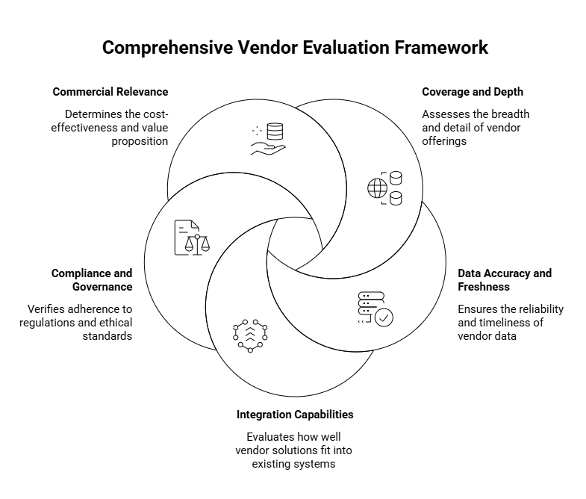
Selecting an HCP data provider requires a structured evaluation framework:
1. Coverage and Depth
- Number of HCP profiles
- Geographic reach
- Specialty coverage
2. Data Accuracy and Freshness
- Validation methodology
- Update frequency
- Error rate benchmarks
3. Integration Capabilities
- CRM compatibility (Veeva, Salesforce)
- API availability
- Data interoperability
4. Compliance and Governance
- Regulatory certifications
- Data sourcing transparency
- Audit trails
5. Commercial Relevance
- Availability of prescribing and claims data
- Inclusion of payer and access insights
- Ability to support AI-driven targeting
Challenges in HCP Data Utilization
Despite technological advancements, several challenges persist:
1. Data Fragmentation
HCP data is distributed across multiple vendors, requiring integration efforts that increase complexity and cost.
2. Data Decay
Provider data becomes outdated rapidly due to frequent changes in practice settings and affiliations.
3. Compliance Risk
Improper data usage can lead to regulatory penalties and reputational damage.
4. Over-Reliance on Single Data Sources
Single-source targeting leads to incomplete insights and suboptimal decision-making.
Best Practices for Optimizing HCP Targeting
To maximize value from HCP data platforms, organizations should adopt the following strategies:
1. Multi-Source Data Integration
Combining claims, CRM, and payer data provides a holistic view of HCP behavior.
2. Continuous Data Validation
Implementing real-time validation mechanisms reduces data decay and improves targeting accuracy.
3. AI-Driven Segmentation
Leveraging machine learning models enhances predictive targeting and resource allocation.
4. Compliance-First Approach
Embedding compliance checks into data workflows ensures regulatory adherence.
5. Vendor Diversification
Using multiple data providers mitigates dependency risks and enhances data completeness.
Future Trends in HCP Data Platforms
The HCP data ecosystem is rapidly evolving, with several emerging trends:
1. Unified Data Platforms
Platforms are increasingly integrating multiple datasets into single environments, reducing fragmentation.
2. Real-Time Data Streams
Shift toward near real-time updates to address data decay issues.
3. AI and Predictive Analytics
Expansion of AI-driven targeting models across all commercial functions.
4. Privacy-Preserving Data Models
Adoption of federated learning and privacy-enhancing technologies to ensure compliance without compromising insights.
Conclusion
The landscape of HCP data providers and platforms has evolved into a complex ecosystem where data accuracy, integration, and compliance are critical determinants of success. Enterprise vendors such as IQVIA, Definitive Healthcare, and Veeva OpenData dominate the market with comprehensive datasets and robust compliance frameworks, while mid-market and specialized vendors provide flexible and cost-effective alternatives. AI-powered targeting platforms are redefining precision engagement by enabling predictive, real-time decision-making. However, challenges related to data accuracy, fragmentation, and regulatory compliance persist. Organizations must adopt a multi-source, compliance-first, and AI-driven approach to fully leverage the potential of HCP data and achieve sustainable commercial success.
References
- IQVIA. OneKey database: healthcare provider data solutions. IQVIA website. Accessed April 17, 2026.
- Definitive Healthcare. Healthcare commercial intelligence platform overview. Definitive Healthcare website. Accessed April 17, 2026.
- Veeva Systems Inc. Veeva OpenData: global HCP and HCO reference data. Veeva website. Accessed April 17, 2026.
- MedicoReach. Healthcare email and physician database solutions. MedicoReach website. Accessed April 17, 2026.
- IntuitionLabs. HCP data solutions and compliance framework. IntuitionLabs website. Accessed April 17, 2026.
- ZoomInfo Technologies Inc. B2B data platform with healthcare vertical insights. ZoomInfo website. Accessed April 17, 2026.
- Bertsimas D, Kallus N, Weinstein AM, Zhuo YD. Personalized diabetes management using electronic medical records. Diabetes Care. 2017;40(2):210-217. doi:10.2337/dc16-0882
- Freed GL, Dunham KM, Switalski KE, Jones MD Jr, McGuinness GA; Research Advisory Committee of the American Board of Pediatrics. Recently trained pediatric subspecialists: perspectives on training and scope of practice. Pediatrics. 2009;123(suppl 1):S38-S43. doi:10.1542/peds.2008-1570F
- HiDoc Technologies Pvt Ltd. HiDoc platform: AI-enabled doctor engagement and medical content ecosystem. HiDoc website. Accessed April 17, 2026.

