THE IMPACT OF DATA-DRIVEN DECISION-MAKING ON EDUCATIONAL OUTCOMES

- INTRODUCTION
The global shift toward data-driven decision-making in education has gained significant momentum over the past two decades, driven by accountability policies that demand schools collect and act upon student performance data to close achievement gaps. However, research consistently shows that merely gathering data is insufficient; educators often lack the guidance to translate numbers into classroom changes, and while technology provides immediate access to student-level information, the persistent problem remains how to use it effectively.
International studies from Australia, the Netherlands, and the United States confirm that successful DDDM depends on structured data teams, strong data leadership, collaborative inquiry, and, most critically, data literacy among educators and school leaders, along with a systemic approach that integrates data use into daily routines rather than treating it as a compliance burden. The COVID-19 pandemic further highlighted these dynamics, as schools with pre-existing data cultures adapted more rapidly and recovered learning losses faster than those without, positioning DDDM not only as an improvement strategy but also as a resilience mechanism.
In the Philippines, the need for DDDM is urgent given persistently low student achievement in national assessments and PISA results, yet the system lacks reliable data, data-literate personnel, adequate infrastructure, and a supportive culture. Recent Philippine studies reveal that while most school heads have access to the Learner Information System, fewer than half actually use it to modify school plans, with barriers including lack of training, insufficient time, unreliable internet, and a tendency to treat data collection as a compliance requirement rather than a strategic tool. Encouragingly, capacity-building initiatives like the Data-Driven School Leadership Program have improved confidence among trained school heads, though follow-up support remains inconsistent.
Local research in the Bicol Region, particularly in Sorsogon Province, mirrors these findings, showing that only a minority of school heads regularly analyze student performance data, that data are often reviewed too late to inform instruction, and that teachers are rarely involved in data discussions, with analysis seen as the sole responsibility of the school head.
In the Prieto-Diaz District, which comprises 19 elementary and 3 high schools serving communities with varying resources and accessibility, these challenges are especially pronounced, and the researcher emphasizes that transforming DDDM from a compliance mindset to an improvement mindset will require sustained investments in capacity building, infrastructure, and technical support to realize its potential for improving educational outcomes at the local level.

- LITERATURE REVIEW
Across all sources reviewed, three findings consistently emerge. First, school heads worldwide struggle to turn data into action. Bowers found that principals who review data weekly reduce chronic absenteeism significantly. Coburn and Turner discovered that structured protocols help teachers spend more time on planning than on complaints. Farrell and Marsh proved that coaching principals on data use raises student test scores. Lockton found that most principals cannot correctly identify achievement gaps from their dashboards. Mandinach and Gummer documented that administrators score lowest on interpreting data for instruction.
Abella and Gonzales linked principal data literacy to school performance. Baclig et al. found that few principals actually use data reports for planning. Dizon et al. proved that data literacy training raises principal competence and student test scores. Estrada and Fernandez documented severe barriers, such as no internet and power outages. Magtolis et al. found that certain regions have the lowest readiness for DDDM. Santos and Tiangco reported that school heads rate themselves lowest on root cause analysis and statistics.
Second, structured collaboration beats isolated analysis. Datnow and Park argued that collaborative data inquiry produced stronger gains. Kearney and Schuck found that using engagement data to target training reduced behavior incidents and increased student belonging. Li and Zhang showed that data team schools improved reading and math by large margins. Marsh et al demonstrated that data-driven resource allocation raised reading proficiency. Pietsch and Tulowitzki found that principal data use predicts accountability ratings and affects achievement through teacher collaboration. Hernandez and Ignacio found that high-performing schools use weekly data huddles and simple summaries. Ocaña and team confirmed that the data team model works, raising reading and math scores substantially.
Third, DDDM directly improved educational outcomes across multiple areas. Bowers improved attendance. Farrell and Marsh raised math and reading scores. Jimerson documented higher graduation and lower dropout rates. Kearney and Schuck reduced behavior incidents. Li and Zhang achieved substantial academic gains. Prenger and team found effects lasting one year. Schildkamp and Kuiper showed that root cause analysis doubles improvement. Van der Scheer and associates proved that structured reports boost math achievement. Dizon and team found improved test scores. Jimenez et al. reported higher proficiency rates.
Lazaro and Manalo found greater teacher effectiveness. Ocaña et al. documented substantial reading and math gains. Pascual and Reyes found that positive principal attitudes predict accountability ratings. Rivera et al. discovered higher teacher morale and lower turnover intention. Together, these findings showed that when school heads possess data literacy, foster collaboration, and apply data to instruction and resources, measurable improvements follow in student achievement, teacher effectiveness, resource allocation, and school accountability.

Theoretical Framework
In this study, the researcher theorizes that School heads who integrate data competence, learning culture, teacher change enablement, and an information-to-action pathway achieve sustainable improvements in educational outcomes. Moreover, this research is anchored in the following theories:
Data-Driven Decision Making (DDDM) Theory. This posits that data should be used to inform educational decisions and drive instructional decisions, ultimately improving student achievement (Marsh).
Organizational Learning Theory. This theory suggests that schools should be learning organizations that use data to improve teaching and learning (Senge).
Teacher Change Theory. This theory posits that teachers require support and training to modify their instructional practices and utilize data to inform their teaching (Guskey).
Sense-Making Theory. This theory posits that school leaders and teachers must actively interpret data using concepts, criteria, theories of action, and interpretive frames of reference before engaging in improvement work. (Datnow & Park).

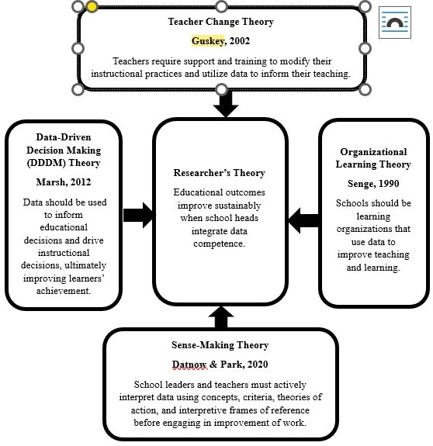
Figure 1. Theoretical Paradigm

Conceptual Framework
This study is guided by the Input-Process-Outcome (IPOO) model, which illustrates the logical flow of investigating the impact of data-driven decision-making (DDDM) on educational outcomes. .
The Input Phase consists of the profiles of the respondents, which includes fifteen (15) school heads from the selected elementary and secondary schools in the Prieto-Diaz District. This also cover the types of data sources that school heads frequently access, such as student performance data, teacher evaluation data, attendance records, financial records, and stakeholder feedback.
The Process component represents the methodological steps undertaken to address the research questions. This includes administering structured surveys and analyzing available school reports to determine the extent to which school heads analyze, interpret, and apply data in decision-making.
The Output component refers to the direct results generated from the process. The primary output is a five-day training program entitled "Project LEAD: Learn, Evaluate, Analyze, Decide: A Data-Driven Leadership Program for School Heads.
The Outcome component represents the ultimate goal and long-term effect of the study. It is the expected improvement in educational outcomes, specifically enhanced student achievement, increased teacher effectiveness, more efficient resource allocation, and strengthened school accountability.

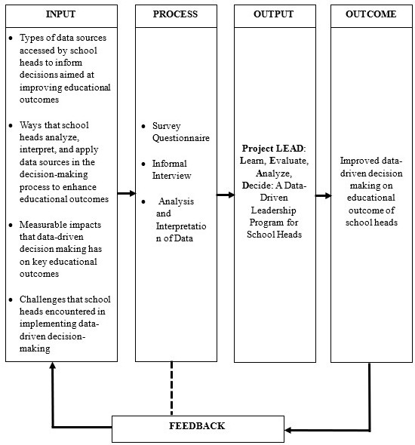
Figure 2. Conceptual Framework

- METHOD AND PROCEDURES
Method
The researcher employed a descriptive approach in conducting this study. The descriptive part of the study included the data-gathering procedure undertaken by the author, as well as the distribution and retrieval of the questionnaire.
Interviews and observations conducted, all necessary to obtain a clear understanding of the variable's present condition, were presented and elaborated in this study for the purpose of providing a clear description of the problem and the respondents' situation. Each variable was treated statistically.

Respondents
The respondents in this investigation are the 15 elementary and secondary school principals in the Prieto-Diaz District. This research was confined to fifteen (15) specific elementary schools within the Prieto-Diaz District, namely: Calao Elementary School, Calao National High School, Carayat Elementary School, Gogon Elementary School, Manlabong National High School, Prieto Diaz Central School, Prieto-Diaz National High School, Quidolog Elementary School, San Antonio Elementary School, San Fernando Elementary School, San Isidro Elementary School, Nenita Oandasan Memorial School, San Rafael Integrated School, Santa Lourdes Elementary School, Santo Domingo Elementary School, and Ulag Elementary School.

Research Instruments
The researcher developed a structured questionnaire with six parts based on the five research questions. Part 1 gathered demographics, including position, experience, school type, and level. Part 2 addressed data sources, with a checklist of specific systems (BEIS, LIS, EBEIS, NAT results, teacher evaluations, attendance, financial reports, stakeholder feedback, report cards) and a five-point frequency scale. Part 3 examined data utilization through ten Likert-scale statements on identifying learning gaps, improving instruction, designing interventions, allocating resources, adjusting policies, school planning, progress monitoring, teacher development, resource prioritization, and stakeholder communication. Part 4 measured impacts on student achievement, teacher effectiveness, resource allocation, and school accountability using ten Likert-scale statements. Part 5 covered challenges with a checklist of ten barriers (training gaps, infrastructure, privacy concerns, staff resistance, fragmented systems, test overemphasis, time constraints, lack of support, budget limitations, platform integration) and a five-point severity scale. Part 6 addressed professional development needs through ten Likert-scale statements on data analysis, EMIS tools, ethical use, collaborative leadership, planning integration, monitoring frameworks, stakeholder communication, resource allocation, visualization tools, and sustaining a data culture.

Statistical Treatment
The study employed frequency count, rank, and weighted mean as statistical tools. For Problem 1, frequency count and rank identified data sources frequently accessed by school heads. For Problem 2, weighted mean determined how school heads analyze, interpret, and apply data, using a five-point Likert scale with the following equivalents: 4.50-5.00 (Strongly Agree), 3.50-4.49 (Agree), 2.50-3.49 (Moderately Agree), 1.50-2.49 (Disagree), and 1.00-1.49 (Strongly Disagree). For Problem 3, weighted mean measured impacts on learner achievement, teacher effectiveness, resource allocation, and school accountability using the same scale. For Problem 4, frequency count and rank identified challenges encountered in implementing data-driven decision-making.
- PRESENTATION, ANALYSIS, AND INTERPRETATION OF DATA
This chapter presents the data gathered by the researcher from the respondents. The data are organized, analyzed, and interpreted in this section to answer each of the five research questions. The findings were presented in tables followed by textual explanations. Each table corresponds to a specific sub-problem, and the discussion that follows explains what the numbers mean and how they are related to the research questions. The analysis moves from simple descriptions of the data to deeper interpretations, ending with implications for school heads and district leaders in Prieto-Diaz District.

The Types of Data Sources Frequently Accessed by School Heads to Inform Decisions Aimed at Improving Educational Outcomes
The results in Table 1 reveal that BEIS, LIS, and financial/budget reports (MOOE, school funds) were the most frequently accessed data sources, each with a frequency of 15 and ranked 2nd. This suggests that school heads primarily access systems mandated by the Department of Education, indicating that compliance requirements may be the primary driver of data use rather than strategic school improvement. This is consistent with Basillo (2022), who found that compliance-driven behavior often takes precedence over strategic use, and Matulac and Moyani (2023), who noted that access to financial data does not automatically translate to strategic resource allocation based on learner needs.
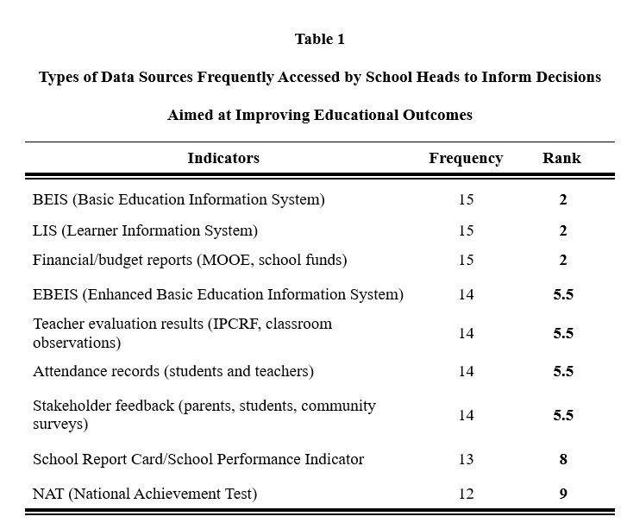
Four indicators ranked 5.5th with a frequency of 14: EBEIS, teacher evaluation results, attendance records, and stakeholder feedback. Lee et al. (2023) found that school leaders emphasize responsive data use to identify student needs, and that professional development in data usage and the cultivation of trusting organizational cultures are crucial for advancing data-informed reform.
The School Report Card/School Performance Indicators ranked 8th with a frequency of 13. Parafina (2021) documented that while SRCs have become the preferred model for information access, their actual utilization for accountability and decision-making remains limited, while the Brookings Institution (2022) noted that school heads require adequate data literacy training to fully leverage SRC data.
NAT ranked lowest with a frequency of 12, suggesting that while NAT results provide insights for interventions to improve performance, school heads access this data source least frequently among all indicators. Overall, the findings indicate that school heads in Prieto-Diaz District primarily access data sources mandated by DepEd for compliance purposes, with less frequent access to data sources that could provide deeper insights for instructional improvement and strategic decision-making.

Ways School Heads Analyze, Interpret, and Apply Data Sources in Their Decision-Making Processes to Enhance Educational Outcomes
The results in Table 2 reveal the extent to which school heads analyze, interpret, and apply data in their decision-making processes. Weighted mean ranged from 4.29 to 4.67, with an average of 4.48, indicating an overall "Agree" interpretation. Four indicators received "Strongly Agree" ratings: using stakeholder feedback to adjust school policies (4.62), applying teacher evaluation data to improve instructional practices (4.67), communicating data findings to stakeholders for transparency (4.60), and using learner performance data to identify learning gaps (4.53). The strong agreement on teacher evaluation data aligns with Grissom and Youngs (2023), who found that principals using evaluation data to provide targeted feedback and link results to professional development produce measurable improvements in instructional practice.
Two indicators with a weighted mean of 4.47 were using attendance data to design interventions for at-risk learners and integrating LIS/BEIS data into school improvement planning. Lee et al. (2022) demonstrated that attendance data significantly reduces chronic absenteeism when used to identify students and schedule targeted interventions, while Swanson et al. (2024) confirmed that student information systems provide accurate data serving as a reliable basis for planning and monitoring.
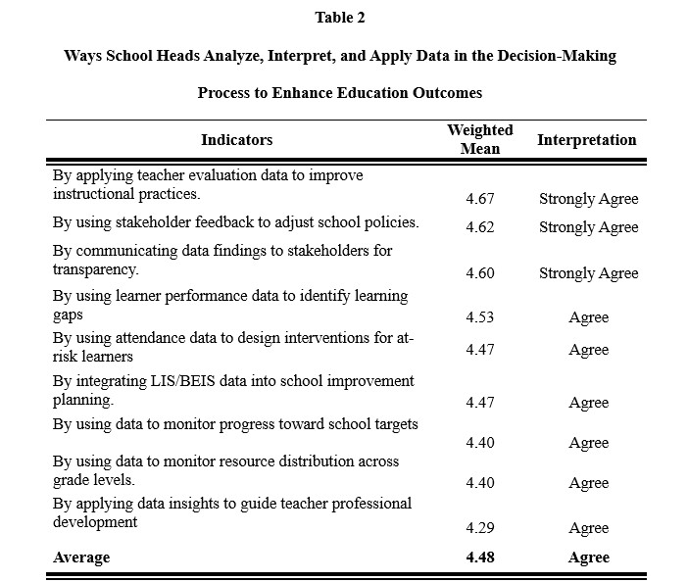
Two indicators with a weighted mean of 4.40 were relying on financial data to allocate resources effectively and using data to monitor progress toward school targets and prioritize resource distribution across grade levels. Silva et al. (2023) found that schools using financial data in management decisions achieved a 15% increase in pass rates, while the NWEA (2024) reported that monthly data reviews enabled administrators to track progress and make informed resource decisions. The indicator with the lowest weighted mean of 4.29 was applying data insights to guide teacher professional development.
Tumiyati et al. (2023) found that principals play a central role in utilizing data to identify learning needs and formulate teacher development priorities, though effectiveness depends heavily on leadership capacity, with obstacles including time constraints and lack of continuous evaluation.

The Measurable Impacts of Data-Driven Decision Making on Key Educational Outcomes Such as Student Achievement, Teacher Effectiveness, Resource Allocation, and School Accountability
The results in Table 3 reveal that strengthening school accountability received the highest weighted mean of 4.53, interpreted as "Strongly Agree." This indicator ranked highest because data-driven decision-making promotes transparency, responsibility, and evidence-based governance, reducing subjectivity and strengthening accountability mechanisms through continuous monitoring via School Report Cards, EBEIS reports, NAT results, and teacher performance evaluations. Improving resource allocation followed with a mean of 4.43, reflecting that school heads face limited budgets and use data to justify spending on urgent needs such as reading materials or teacher training.
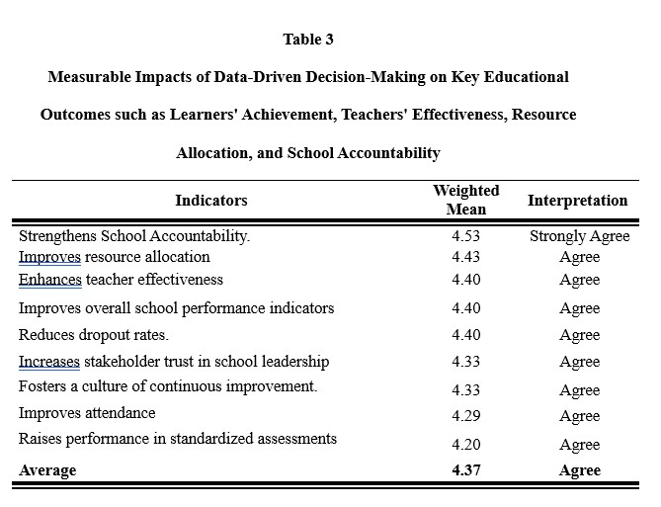
Rasoanaivo (2024) found that data-driven tools for resource allocation enable policymakers to optimize distribution and ensure equitable opportunities for student success, particularly in resource-constrained settings.
Three indicators with a weighted mean of 4.40 were enhancing teacher effectiveness, improving attendance rates, and improving overall school performance indicators. Reducing dropout rates followed with 4.36. Choi (2023) developed a funding allocation formula using dropout prediction data and found that when school leaders use predictive data to identify at-risk students and allocate resources accordingly, they effectively reduce dropout rates while simultaneously improving attendance, teacher effectiveness, and overall school performance.
Two indicators with a weighted mean of 4.33 were increasing stakeholder trust in school leadership and fostering a culture of continuous improvement. The slightly lower mean compared to accountability suggests that school heads prioritize compliance and reporting over building trust and an improvement culture. The lowest indicators were improving attendance with 4.29 and raising performance in standardized assessments with 4.20.
Lee et al. (2023) found that benchmark assessment data was the only type of leaders' data use significantly associated with student achievement, explaining why school heads rated these indicators lower—improving test scores requires benchmark assessments, professional development, and collaborative trust, not just data access. Overall, the weighted means ranged from 4.20 to 4.53 with an average of 4.37, interpreted as "Agree," indicating that school heads recognize the positive impacts of data-driven decision-making across all measured outcomes.

Challenges in Implementing Data-Driven Decision-Making
The results in Table 4 reveal the challenges encountered by school heads in implementing data-driven decision-making. Limited technological infrastructure ranked highest with a frequency of 13, indicating that outdated or insufficient technology such as slow internet and lack of data tools makes it difficult to collect, analyze, and use data effectively, slowing down decision-making and reducing the impact of data-driven strategies. Lack of training in data analysis ranked 2nd with a frequency of 11, supported by the SIKAP study conducted by SEAMEO INNOTECH (2023), which identified significant competency gaps among Philippine school heads in data-driven decision-making. Time constraints in data analysis ranked 3rd with a frequency of 10, supported by Dioneda et al. (2023), who documented that school heads face heavy workloads, unexpected meetings, and strict report deadlines that leave little time for detailed data analysis, while EDCOM 2 (Leviste et al., 2024) confirmed that lack of time due to heavy workload is a significant barrier to professional development.
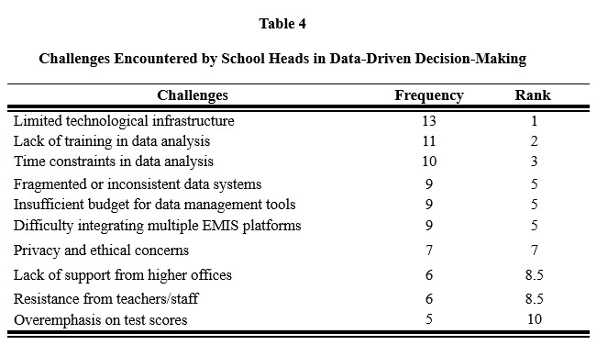
Three indicators ranked 5th with a frequency of 9: fragmented or inconsistent data systems, insufficient budget for data management tools, and difficulty integrating multiple EMIS platforms. Adenubi, Samuel, and Oyenuga (2023) documented that the educational sector faces persistent challenges including fragmented data management systems, poor interoperability, and inadequate technology infrastructure due to insufficient budget allocation, preventing institutions from consolidating data from various sources and reducing confidence in using data for planning. Privacy and ethical concerns ranked 7th with a frequency of 7, supported by Imbiakpa (2024), who identified data privacy risks as a significant ethical concern requiring continuous professional development, stakeholder involvement, and strong data protection policies aligned with the Data Privacy Act of 2012.
Two indicators ranked 8.5th with a frequency of 6: resistance from teachers/staff and lack of support from higher offices. Aleknavičiūtė and Mažeikienė (2023) found that teachers' resistance is shaped by lack of information, insufficient involvement in decision-making, and concerns about changes in work conditions, while Vick et al. (2024) confirmed that teachers' frustration with data-based tasks directly influences their efficacy and anxiety. Overemphasis on test scores ranked lowest with a frequency of 5, reflecting that school heads may prioritize short-term test improvements, sometimes leading to "teaching to the test" rather than promoting deep learning, and excessive comparison with other schools based solely on test scores may not accurately reflect each school's unique context and challenges.

Training Program Designed to Strengthen School Heads’ Competencies in Data-Driven Decision-Making, Thereby Improving Educational Outcomes
School heads in Prieto-Diaz District access administrative data regularly but struggle to use instructional data like NAT results to improve learner achievement. They face significant challenges, including a lack of training in data analysis, time constraints, fragmented data systems, and insufficient budget for data management tools. Most importantly, they rated "improve learner achievement" and "raise performance in standardized assessments" as the lowest impacts of data-driven decision-making, indicating that their current practices are not yet translating into better student learning.
School heads themselves identified professional development in data analysis and interpretation as their top priority. Both international and local research confirm that data literacy does not develop automatically with experience—it must be explicitly taught through structured, hands-on training. The proposed five-day program, entitled "Project LEAD: Learn, Evaluate, Analyze, Decide – A Data-Driven Leadership Program for School Heads," directly addresses these gaps. It covers data literacy, root cause analysis, SMART goal setting, instructional leadership, and sustainability planning. Expected outputs include a School Data Profile, a Root Cause Analysis Report, and a Data-Driven Action Plan. This training is designed to close the gap between data access and meaningful application, transforming data from a compliance tool into a genuine engine for school improvement.

- SUMMARY, FINDINGS, CONCLUSIONS, RECOMMENDATIONS
This chapter presents the summary of the study, the key findings drawn from the data analysis, the conclusions derived from these findings, and the recommendations based on the conclusions. The summary provides a brief overview of the research problem, methodology, and respondents. The findings are presented in relation to each of the five research questions. The conclusions interpret what the findings mean in the broader context of data-driven decision-making in education. Finally, the recommendations offer practical suggestions for school heads, district supervisors, the Department of Education, and future researchers.

Findings
The following are the salient findings from the study:
- The type of data sources frequently accessed by school heads to inform decisions aimed at improving educational outcomes were the Basic Education Information System (BEIS), the Learner Information System (LIS), and financial or budget reports, all with a frequency of 15 and ranked 2nd.
- The ways school heads analyze, interpret, and apply data sources in their decision-making processes to enhance educational outcomes were all described as Strongly Agree, including applying teacher evaluation data, 4.67; by using stakeholder feedback, 4.62; communicating data findings to stakeholders, 4.60; and using learner performance data, 4.53.
- The measurable impacts of data-driven decision-making on key educational outcomes are strengthened school accountability, with a weighted mean of 4.53 and described as strongly agree, improves resource allocation (4.43), enhances teacher effectiveness (4.40), improves attendance rates (4.40), and improves overall school performance indicators (4.40).
- The challenges encountered by school heads in implementing data-driven decision-making were limited technological infrastructure, with a frequency of 13 and ranked 1st, lack of training in data analysis, 11 and ranked 2nd, and time constraints in data analysis, 10 and ranked 3rd.
- A training program called Project LEAD to strengthen school heads’ competencies in data‑driven decision‑making in improving educational outcomes is designed.
.
Conclusions
Based on the salient findings of the study, the following are the conclusions:
1. School heads frequently access BEIS and LIS to inform decisions aimed at improving educational outcomes.
2. School heads apply teacher evaluation data and use learner performance data in their decision-making processes to enhance educational outcomes.
3. Data-driven decision-making strengthens school accountability, improves resource allocation, and enhances teacher effectiveness.
4. The challenges encountered by school heads in implementing data-driven decision-making are limited technological infrastructure and the lack of training.
5. A training program called Project LEAD is proposed to strengthen school heads’ competencies in data-driven decision-making.

Recommendations
Based on the following findings obtained and the conclusions drawn from them, the following are recommended:
1. Accessing and using NAT results and School Report Cards alongside BEIS, LIS, and financial reports to balance compliance-driven data use with instructional improvement be prioritized by school heads for data-driven decision-making purposes.
2. Monthly data sharing sessions with teachers and parents to discuss evaluation results, learner performance, and feedback, and then deciding together on what actions to take be conducted.
3. Regular data review and collaborative planning be institutionalized to strengthen school accountability, improve resource allocation, enhance teacher effectiveness, raise attendance rates, and boost overall school performance.
4. Technological infrastructure and training in data analysis for school head be conducted.
5. Project LEAD (Learn, Evaluate, Analyze, and Decide: A Data‑Driven Leadership Program for School Heads) be presented and made available to the school heads to strengthen their competencies in data-driven decision-making in improving educational outcomes.

ACKNOWLEDGEMENT
This study would not have been possible without the guidance, encouragement, and unwavering support of the people who generously shared their time, knowledge, and assistance throughout this academic journey.
The researcher expresses his heartfelt gratitude to Dr. Ma. Jean D. Deuda, Dean of the Graduate School, for her constant support, encouragement, and inspiration that strengthened his determination to complete this scholarly endeavor. Her leadership and motivating words served as a guiding light throughout the process.
Deep appreciation is also extended to his adviser, Dr. Rolando F. Embile, for his patience, guidance, and steadfast support from the conceptualization of this study through its completion. His valuable insights, constructive criticisms, and encouragement greatly shaped and improved this work. Sincere gratitude is likewise given to the panel members, Dr. Joseph Guab, Dr. Belen L. Dominguiano, Dr. Virginia D. Detera, and Dr. Danilo E. Despi, for their expertise, time, and meaningful suggestions that significantly enhanced the quality of this research.
The researcher is also deeply grateful to the faculty members of Annunciation College of Bacon, Sorsogon Unit, Inc., for their encouragement and constructive feedback. Special appreciation is extended to Sir Ferdinand E. Hamor, OIC PSDS, for granting permission to conduct the study, and to all the School Heads of Prieto Diaz District, who served as respondents of this research. Their wholehearted cooperation in answering the questionnaires and their willingness to be interviewed provided essential data that made the completion of this study possible.
His beloved wife, Rosario F. Destura, the researcher, lovingly acknowledges her unwavering love, patience, understanding, and sacrifices. Truly, as the saying goes, “behind every successful man is a strong and supportive woman,” and her presence has been a constant source of strength, encouragement, and inspiration throughout this journey.
His four children, who served as his greatest inspiration, he is forever thankful for motivating him to pursue and complete this endeavor. Their smiles, love, and presence gave the researcher the strength to persevere despite challenges and hardships.
His loving parents, sisters, and brothers, no words can fully express his gratitude for their unconditional love, prayers, sacrifices, and encouragement, which sustained him throughout this journey.
Above all, to God Almighty, for His endless grace, wisdom, protection, and blessings that made this accomplishment possible, all glory and thanksgiving are humbly offered.

F.S.D.Jr

REFERENCES

Coburn, C. E., & Turner, E. O. (2021). Structured data protocols and instructional planning time in grade-level meetings: A mixed-methods study of 45 California middle schools. American Educational Research Journal, 58(2), 312-348.
Farrell, C. C., & Marsh, J. A. (2020). A randomized controlled trial of data leadership coaching for principals: Effects on student achievement and teacher perceptions. Educational Evaluation and Policy Analysis, 42(4), 521-547.
Lockton, M. (2021). Principal sensemaking of disaggregated student achievement data: A cognitive task analysis of 22 Texas principals. Leadership and Policy in Schools, 20(3), 412-438.
Mandinach, E. B., & Gummer, E. S. (2021). Measuring data literacy competencies among 450 school administrators: Validation of a 45-item instrument. Journal of Educational Data Mining, 13(2), 45-68.
Abella, R. M., & Gonzales, J. P. (2020). Data literacy of public elementary school principals and its relationship to school performance in Laguna Division. Philippine Journal of Educational Research, 28(1), 45-67.
Baclig, E. S., Cruz, M. R., & Villanueva, L. T. (2021). Implementation of the Enhanced Basic Education Information System in NCR public schools: Compliance versus decision support. Asian Journal of Philippine Education, 10(2), 89-108
Dizon, A. P., Fernandez, R. B., & Garcia, C. L. (2022). Effectiveness of a data literacy training program for school heads in Pampanga elementary schools: A quasi-experimental study. Philippine Education Research Journal, 14(2), 56-78.
Magtolis, F. P., Nunez, C. R., Oliva, M. S., & Perez, J. T. (2022). Readiness for data-driven decision-making among Philippine school heads: A five-region survey. Philippine Educational Governance Review, 11(1), 12-34.
Datnow, A., & Park, V. (2020). Teacher capacity for data-driven decision making: A cross-national review. Teaching and Teacher Education, 89, 102-115.
Kearney, M., & Schuck, S. (2021). Student engagement data and professional development allocation in 28 Australian primary schools: A two-year longitudinal study. Australian Educational Researcher, 48(4), 623-648.
Pietsch, M., & Tulowitzki, P. (2022). Principal data use, teacher collaboration, and school accountability ratings in 210 German secondary schools: A structural equation modeling approach. Journal of Educational Administration, 60(4), 389-407.
Hernandez, P. B., & Ignacio, R. S. (2022). Distinguishing practices of high-performing versus low-performing schools in Cavite Division: A case study of data use. South Luzon Education Quarterly, 16(3), 45-64.
Schildkamp, K., Van der Kleij, F., & Heitink, M. (2020). A data use intervention model for root cause analysis. Studies in Educational Evaluation, 64, 100-118.
Jimenez, R. C., Lopez, M. A., & Santos, T. F. (2020). Data-driven resource allocation and student achievement in Nueva Ecija elementary schools. Central Luzon Journal of Educational Research, 12(1), 34-53.
Lazaro, E. M., & Manalo, J. R. (2021). Impact of principal data use on teacher effectiveness in Batangas elementary schools. Calabarzon Educational Studies, 9(2), 78-97.
Ocaña, G. L., Pablo, M. R., Quezon, J. T., & Ramos, A. C. (2021). Adapting the Dutch data team model to Philippine elementary schools: A quasi-experimental study in Isabela Division. Philippine Journal of Education, 99(2), 123-145.
Pascual, E. R., & Reyes, M. T. (2022). School heads' attitudes toward data use and school accountability ratings in Laguna Division. Educational Management Review Philippines, 17(1), 45-63.
Rivera, J. P., Santiago, L. M., & Torres, E. B. (2022). Principal data-driven practices and their effects on teacher morale and retention in Pangasinan Division. Northern Philippine Educational Review, 8(1), 34-53.

