

POLYTECHNIC UNIVERSITY OF THE PHILIPPINES
OPEN UNIVERSITY SYSTEM
MASTER OF SCIENCE IN CONSTRUCTION MANAGEMENT
STA.MESA. MANILA PHILIPPINES

"DEVELOPING A FRAMEWORK TO ENHANCE SOFT SKILL COMPETENCY OF CONSTRUCTION MANAGERS FOR SUCCESSFUL PROJECT DELIVERY"

ABSTRACT

Title: “DEVELOPING A FRAMEWORK TO ENHANCE SOFT SKILL COMPETENCY OF CONSTRUCTION MANAGERS FOR SUCCESSFUL PROJECT DELIVERY”
Researcher: Marco Rey G. Macatangay
Degree: Master of Science in Construction Management
Institution: Polytechnic University of the Philippines
Year: 2026
Adviser: Dr. Guillermo O. Bernabe

This study examined the critical role of soft skills among construction managers, focusing on the systemic gap between perceived organizational importance and actual field proficiency within the sector. Utilizing a descriptive research design anchored on the Input-Process-Output model, the researcher analyzed empirical data collected from 38 industry practitioners across six core competencies: communication, leadership, conflict resolution, teamwork, emotional intelligence, and adaptability. Descriptive statistics indicated that while professionals evaluated all six competencies as extremely important (Mean = 4.63), actual on-site proficiency levels reached only a fair baseline rating (Mean = 3.30). Inferential analysis using a One-Way Analysis of Variance revealed a distinct experience paradox; although 60 percent of the respondents possessed over 11 years of field tenure, the widest competency gaps emerged in communication (0.63), conflict resolution (0.61), and emotional intelligence (0.58). This behavioral gap significantly widened among veteran cohorts, proving that technical tenure does not automatically yield interpersonal mastery. To bridge these shortfalls, the study developed the Soft Skill Competency Enhancement Framework (SSCEF), a four-quarter roadmap customized by career stage featuring baseline assessments, experiential workshops, and structured peer mentorship. This research provides an actionable strategy to institutionalize behavioral key performance indicators into formal engineering management evaluation systems.
Keywords: Polytechnic University of the Philippines, Construction Management, Soft Skills, Soft Skill Competency Enhancement Framework, Philippine Construction Industry.
TABLE OF CONTENTS

Title Page………………………………………………………………………………… i
Certification and Approval Sheet……………………………………………………. ii
Acknowledgements…………………………………………………………………….. iii
Certification of Originality…………………………………………………………….. iv
Abstract……….………………………………………………………………………….. v
Table of Contents ……………………………………………………………………… vi
List of Tables……………………………………………………………………………. viii
List of Figures…………………………………………………………………………… ix
Chapter 1: THE PROBLEM AND ITS SETTING ………………………………… 1
Introduction………………………………………………………………….........1
Theoretical Framework……………………………………….......................... 3
Conceptual Framework……………………………………….......................... 4
Statement of the Problem………………………………………...................... 6
Hypothesis………………………………………............................................. 8
Scope and Limitations of the Study…………………………......................... 8
Significance of the Study……………………………………....…………......... 9
Definition of Terms……………………………………....……………………… 11
Chapter 2: REVIEW OF LITERATURE AND STUDIES…….…………………… 15
Human Behavior and Competencies in Construction Project
Management….………………………...……………………………………….. 19
Crucial Soft Skills for a Successful Project Delivery………………………… 20
Impact of Soft Skills on Project Success……………………………………… 22
Methods of Improving Soft Skills to Assure Project Success………………. 24
Synthesis…………………………………………………………………………. 26
Chapter 3: METHODOLOGY……………………………………………………….. 28
Research Design……………….....................................................................28
Tradition of Inquiry and Data Generation Method…………………………… 29
Sources of Data………………………………………………………………….. 30
Instrumentation……….……………………………………………………......... 31
Ethical Considerations………………………………………………………….. 33
Chapter 4: RESULTS AND DISCUSSION…………………………………………… 34
Demographic and Professional Profile of the Respondents………………... 34
Comparative Evaluation of Perceived Importance and Current
Proficiency Levels……………………………………………………………….. 36
Analysis and Interpretation Matrix…………………………………………….. 39
Gap Analysis: Importance versus Proficiency………………………………... 41
Segmented Inferential Analysis: Cross-Cohort Generational Variance…………………………………………………………………………. 43
Analysis and Interpretation of Generational Variance………………………. 46
Relative Ranking of Soft Skills Based on Project Criticality………………… 48
Thematic Analysis of Qualitative Feedback………………………………….. 50
Assessment of Strategies for Enhancing Soft Skills Competency………….51
Chapter 5: SUMMARY, CONCLUSIONS, AND RECOMMENDATIONS………… 53
Summary of Findings…………………………………………………………… 53
Conclusions……………………………………………………………………… 55
Proposed Framework for Enhancing Soft Skill Competency……………….. 56
Detailed Implementation of the Four-Phase Process……………………….. 60
Industry Human Resources Integration Standards………………………….. 63
Recommendations………………………………………………………………. 64
References…………………………………………………………………………......... 68
Appendix A: Cover Letter for Survey Questionnaire…………………………… 73
Appendix B: Survey Questionnaire………………………………………………... 74
Appendix C: Biographical Statement……………………………………………… 99

LIST OF TABLES

Table 1. Summary of Basic Article Information for 25 Journal References………... 15
Table 2. Demographic and Professional Profile of the Respondents………………. 35
Table 3. Perceived Importance vs Current Proficiency Levels…………………….. 38
Table 4. Cross-Cohort One-Way Analysis of Variance Matrix by Experience
Group……………………………………………………………………………. 43
Table 5. Relative Ranking of Soft Skills Based on Project Criticality……………… 49
Table 6. Perceived Effectiveness of Structured Soft Skills Intervention…………….51
Table 7. The Operational Structure of the Soft Skill Competency
Enhancement Framework……………………………………………………. 57

LIST OF FIGURES

Figure 1: Input-Process-Output (IPO) Model………………………………………..... 5

Chapter 1
THE PROBLEM AND ITS SETTING
Introduction
The construction industry serves as a major pillar of global economic growth. Because this sector operates in a highly complex and project-based environment, leaders in this field require a comprehensive range of competencies to navigate organizational challenges. In today’s digital and post-pandemic landscape, relying solely on technical knowledge, or hard skills, proves insufficient to ensure project success. Existing literature indicates that while technical expertise establishes the baseline foundation for employment, these technical capabilities represent merely entry-level requirements that do not automatically translate to superior field performance. Instead, soft skills, such as communication, leadership, and emotional intelligence, emerge as the actual drivers of project success. In fact, approximately 80 percent of global organizations now prioritize the development of these interpersonal capabilities in their project managers (Hefley & Bottion, 2021).
In the Asian context, the shift toward valuing soft skills becomes even more critical because the regional industry remains heavily labor-intensive and features workforces from highly diverse socio-economic backgrounds (van Heerden et al., 2023). This dynamic is particularly evident in the Philippines, especially as the nation expands its infrastructure capabilities through the Build Better More program. The Philippine Development Plan 2023–2028 emphasizes the urgent need for a middle-skill workforce capable of bridging the gap between field-level technical work and high-level strategic management. The National Economic and Development Authority underscores that attributes such as adaptability and collaboration are vital for maintaining global competitiveness (NEDA, 2023; Monteverde et al., 2024). However, a pervasive skills gap persists between institutional academic training and actual industrial demands. Many Filipino engineering graduates exhibit high technical proficiencies but struggle significantly with human liaison skills, including empathy and conflict resolution, which are essential when managing complex organizational cultures locally.
Managing construction projects in these volatile environments requires balancing the interests of multiple stakeholders while operating under severe resource constraints. Previous investigations established that poor leadership and ineffective communication account for up to 80 percent of project failures (Han et al., 2024). Soft skills anchored on emotional intelligence, specifically relationship management and stress tolerance, are proven to enhance team agility and flexibility, directly resulting in superior project delivery (Ssenyange, 2023). Furthermore, project managers who possess the capacity to cultivate a collaborative environment effectively secure the trust and motivation of site workers, thereby maximizing productivity and the quality of output on the construction site (Tian, 2020).
Despite these documented benefits, a critical research and practical gap remains. Soft skills are continuously sidelined or treated as secondary priorities in a local industry that traditionally prioritizes quantifiable, technological metrics. While existing literature extensively argues the theoretical importance of these interpersonal traits, there is a glaring scarcity of empirical assessments evaluating the actual proficiency levels of veteran practitioners within the local setting. Consequently, the industry suffers from a vague, abstract understanding of soft skills, lacking an operationalized, culture-specific mechanism to measure and cultivate these traits. This systemic neglect frequently results in volatile project delivery and fragmented team management.
To achieve sustainable construction practices and meet international standards, elevating the interpersonal competencies of construction managers must transition from a conceptual academic goal into an institutionalized strategic requirement (Zuo et al., 2018). This study directly addresses this empirical and practical vacuum by assessing the current field proficiencies of local practitioners and subsequently developing a comprehensive competency framework tailored specifically to the unique interpersonal dynamics and cultural nuances of the Philippine construction sector.
Theoretical Framework
This study integrates three complementary theoretical perspectives to explain the relationship between soft skill competency and construction project success.
Emotional Intelligence Theory
Goleman’s (1995) model breaks down emotional intelligence into five parts: self-awareness, self-regulation, motivation, empathy, and social skills. In the construction world—where people constantly deal with tight deadlines, sudden design changes, and stakeholder arguments—managers with high EI are much better at handling stress, motivating their teams, and settling disputes (Montenegro et al., 2021; Zhang & Hao, 2022). In this study, emotional intelligence is treated as a combined skill that allows a manager to recognize, understand, and manage emotions—both their own and those of others—within the context of a project.
Competency-Based Human Resource Management
The "Iceberg Model" by Spencer and Spencer (1993) shows the difference between visible competencies (like technical knowledge and skills) and hidden ones (like traits, motives, and how one sees themselves). This framework suggests that while you need technical skills to get a job in construction management, it is the behavioral competencies—or soft skills—that separate the top performers from the average ones. Similarly, the International Project Management Association (IPMA ICB4) groups competencies into technical, behavioral, and contextual areas, noting that leadership, teamwork, and communication are essential behavioral skills (IPMA, 2015).
Stakeholder Theory and Project Success
Freeman’s (1984) stakeholder theory argues that a project’s success depends on how well you manage relationships with everyone involved. In construction, this includes the clients, contractors, consultants, suppliers, government agencies, and the local community. The PMBOK® Guide also lists stakeholder engagement and communication as critical areas to master (PMI, 2021). Essentially, soft skills allow construction managers to balance the different interests of these groups, keep relationships healthy, and hit project goals.
These different theories all lead to one point: soft skills act as the bridge between technical management and real project success. Technical skills provide the basic "know-how," but soft skills determine how effectively that knowledge is used in a complicated, multi-stakeholder environment.

Conceptual Framework
This research uses the Input-Process-Output (IPO) Model to create a systematic way of improving the soft skills of construction managers. This framework is the foundation for identifying current skills and turning them into a strategic program for better project delivery.
The Input: Assessment of Human Capital
The first stage looks at the basic qualities needed for effective management. Instead of seeing construction as purely technical, this study focuses on six core Soft Skill Competencies:
Communication and Leadership. The ability to explain goals clearly and inspire diverse teams.
Conflict-Resolution and Teamwork. Being able to settle site disputes and help the team work together.
Emotional Intelligence and Adaptability. The mental toughness needed to survive the high-pressure and unpredictable nature of construction.
These skills are looked at through two lenses: Perceived Importance (what the industry wants) and Current Proficiency Levels (what managers actually have). This comparison is vital to see where growth is needed.
The Process: Quantitative Analysis and Strategic Synthesis
This phase is the bridge between the data collected and the final framework. It has three steps:
Statistical Diagnostics. The study uses Mean and Standard Deviation to understand the data, while Rank Analysis shows which skills are given priority. A Gap Analysis is also done to show the difference between how important a skill is and how good the managers actually are at it.
Identification of Competency Gaps. By comparing proficiency versus importance, the study identifies the specific "weak spots" in a manager’s toolkit that might cause project problems.
Formulation of Enhancement Strategies. Once the gaps are clear, the research looks at teaching methods—like Project-Based Learning, Mentorship, and Peer Learning—to fix these weaknesses. This ensures the strategies fit the reality of a construction site.
The Output: The Proposed Enhancement Framework
The final result is a Proposed Framework for Enhancing Soft Skill Competencies of Construction Managers. This is the final goal of the study—a roadmap based on evidence designed to close the skill gap. The aim is to make soft skill development a standard part of the industry, making sure managers can lead projects that are both technically correct and managed by a united team.
Figure1: Input-Process-Output (IPO) Model
Input | Process | Output
A. Soft Skill Competencies of Construction Managers  1. Communication  2. Leadership  3. Conflict-Resolution  4. Teamwork and Collaboration  5. Emotional Intelligence  6. Adaptability  B. Perceived Importance of Soft Skills  C, Current Proficiency Levels of Soft Skills | A. Data Gathering Through Survey Questionnaire  Statistical Treatment  - Mean  - Standard Deviation  - Rank Analysis  - Gap Analysis (Importance vs Proficiency)  B. Identification of Competency Gaps  C. Identification of Enhancement Strategies  - Workshops and Interactive Training  - Project-Based Learning  - Mentorship and Coaching  - Peer Learning  - Performance Evaluation System | Proposed Framework for Enhancing Soft Skill Competency of Construction Managers for Successful Project Delivery

Statement of the Problem
This study assesses the relationship between the perceived importance and actual field proficiency of soft skill competencies among construction managers in the Philippines as a basis for developing a structured enhancement framework.
Specifically, this investigation seeks to answer the following questions:
- What is the demographic and professional profile of the respondent construction professionals in terms of:
1.1. current organizational role or sector (e.g., contractor, consultant, developer/owner);
1.2. total years of industry experience; and
1.3. primary nature of construction projects handled?
- What is the level of importance attributed by the respondents to the following soft skill competencies for successful project delivery:
2.1. communication;
2.2. leadership;
2.3. conflict resolution;
2.4. teamwork and collaboration;
2.5. emotional intelligence; and
2.6. adaptability?
- What is the current proficiency level of construction managers in the identified soft skill competencies as evaluated by the respondents?
- Is there a significant difference between the perceived level of importance and the actual field proficiency level of construction managers across the identified soft skill competencies?
- What structured intervention strategies are perceived by the respondents as highly effective in enhancing these soft skill competencies within the industry?
- Based on the findings of the study, what Soft Skill Competency Enhancement Framework can be developed to systematically improve project delivery outcomes in the Philippine construction sector?

Hypothesis
This study is guided by the following hypotheses:
- A significant “competency gap” exists in the Philippine construction sector, characterized by a mismatch where the perceived importance of behavioral competencies significantly outweighs the current proficiency levels of construction managers.
- The integration of structured development strategies (training, mentorship, and project-based learning) is positively correlated with enhanced competency levels, which in turn significantly mitigates project risks related to communication and conflict.

Scope and Limitations of the Study
This study focuses specifically on professionals who are actively involved in construction project management. The assessment is narrowed down to six key soft skills: communication, leadership, conflict resolution, teamwork and collaboration, emotional intelligence, and adaptability.
The research relies on perception-based data gathered through a survey questionnaire. It is recognized that differences in the type of projects handled, specific company practices, and the personal experience of each professional may influence their answers. Furthermore, the study does not directly track technical project performance data, such as actual cost or schedule variances. Instead, it focuses on how competencies are perceived and the specific development needs required to improve them.

Significance of the Study
The findings of this study provide valuable insights, empirical data, and practical benefits to the following stakeholders within the Philippine construction industry, human resource sector, and academic community:
For Construction Organizations and Corporate Leaders.
This research provides corporate management, general contractors, and project developers with a clear empirical basis for restructuring their workforce development policies. By utilizing the baseline data and the proposed Soft Skill Competency Enhancement Framework (SSCEF), companies can move away from unguided, trial-and-error assignments and instead implement structured, quarterly training programs. Furthermore, it gives companies a clear methodology to hardcode behavioral key performance indicators into their annual performance appraisal systems, directly reducing costly project delays, labor turnover, and financial losses caused by site-level disputes.
For Human Resource (HR) Practitioners.
This research offers HR professional units a standardized blueprint to transform how talent is managed in a technical field. HR departments can use the operationalized four-quarter timeline of the SSCEF to systematically deploy diagnostic 360-degree feedback reviews and generate individual Skill Deficiency Profiles. This shifts the HR function from a reactive, administrative role into a proactive corporate partner capable of objectively identifying leadership potential early in an engineer's career path.
For Individual Construction Managers and Project Engineers.
This study serves as a practical self-assessment tool for engineering practitioners across all career stages. It allows junior engineers (one to 10 years of experience) to recognize the communication benchmarks required of them early in their careers, while guiding veteran managers (11 or more years of experience) to focus on advanced emotional intelligence and stress management. By identifying these specific behavioral gaps, individual managers can take ownership of their professional growth, participate actively in peer-learning circles, and prepare themselves for higher-level executive responsibilities.
For Academic Institutions and Engineering Educators.
The results of this study provide strong empirical support for curriculum development committees within colleges and universities offering Civil Engineering and Construction Management programs. By highlighting the industry’s severe shortfalls in communication and conflict resolution, this research demonstrates that traditional, purely technical instruction is no longer enough. It provides educators with a clear mandate to integrate situational simulations, problem-based case studies, and emotional intelligence exercises into their pedagogy, ensuring that engineering graduates enter the local workforce fully equipped for active field operations.
For Future Researchers.
This study establishes a reliable baseline of localized empirical data and a validated theoretical framework for succeeding researchers. Future scholars can utilize these findings to explore the financial return on investment of soft skills training, evaluate how interpersonal dynamics operate within digital project environments, or analyze the transfer of site resourcefulness across different generational cohorts on active project jobsites.

Definition of Terms
The following terms are defined both conceptually and operationally to provide a clear and consistent understanding of the variables and frameworks used in this study:
360-Degree Feedback. A method used in the proposed framework to collect performance data from a manager’s bosses, peers, and subordinates. This helps identify "blind spots" in their behavior.
Adaptability. The mental and behavioral flexibility a manager needs to adjust plans or leadership styles when faced with unpredictable site conditions, design changes, or new stakeholder demands.
Behavioral Deficit. The measured gap found in this study where a manager’s actual soft skill level is lower than the "extremely important" level required for high-stakes projects.
Behavioral KPIs. Key Performance Indicators that track non-technical goals, like team unity and how fast conflicts are settled, to make sure people skills are prioritized as much as technical work.
Client Satisfaction. The level to which a project meets what the client expects. It is a main way to measure how well a manager communicates and builds relationships.
Communication Skills. The ability to clearly share technical and non-technical information through speaking, writing, and body language to keep the team and stakeholders on the same page.
Competency Gap. The statistical difference between how important a skill is for success and how proficient the manager actually is in the field.
Competency-Based Human Resource Management (CBHRM). A management style that focuses on "hidden" traits—like motives and soft skills—as the main factors that separate top performers from average ones.
Conflict Management. The organized process of fixing site disputes and arguments in a positive way to avoid delays and keep a good working atmosphere.
Construction Manager (CM). The lead professional in charge of balancing technical tasks (like budgeting and scheduling) with soft skills to reach a successful project outcome.
Descriptive Research Design. The scientific method used here to observe and describe the current state of soft skill importance and proficiency without changing the environment.
Emotional Intelligence (EI). The ability to understand and control your own emotions while also reading the feelings of others to build better relationships and solve problems.
Experience Paradox. A finding in this study where having a long career (11+ years) does not automatically mean a manager is good at soft skills, often leaving senior managers with big behavioral gaps.
Gap Analysis. The math method used in this research to calculate the difference between the "Importance Mean" and the "Proficiency Mean" of core skills.
Hard Skills. The technical abilities rooted in engineering, such as cost estimation and structural analysis, which are the basic requirements for the job.
Input-Process-Output (IPO) Model. The structure of this study that organizes human capital (Input), statistical analysis (Process), and the final improvement plan (Output).
International Competence Baseline (ICB). A global guide from the IPMA that groups project management skills into technical, behavioral, and contextual categories.
Latent Project Risk. A hidden weakness, like a lack of Emotional Intelligence, that might not be obvious at first but can cause a project to fail when the pressure gets high.
Leadership Skills. The ability to guide and inspire a project team to reach specific milestones and hit the company's goals.
Lean Project Management (LPM). A way of working that focuses on efficiency and less waste, which requires strong collaboration and adaptability to succeed.
Mentorship and Coaching. A learning relationship where experienced pros guide junior managers to help them grow in leadership and emotional intelligence.
Operational Definition. A definition that explains exactly how a term is being measured or used specifically within this research.
Peer Learning. A way for the team to learn together by sharing knowledge during toolbox meetings or technical talks to improve teamwork.
Project Delivery. The whole process of planning and finishing a construction project on time, within budget, and according to quality standards.
Project Management Body of Knowledge (PMBOK®). The global standard for project management that highlights communication and stakeholder engagement as essential areas.
Soft Skill Competency Enhancement Framework (SSCEF). The main output of this study; a four-phase plan (Assessment, Development, Application, Reinforcement) meant to fix identified behavior gaps.
Soft Skills. A group of non-technical behaviors—like leadership and teamwork—that dictate how a manager interacts with everyone involved in a project.
Stakeholder Management. The system of identifying and handling the needs of everyone involved, including clients, contractors, and government offices.
Teamwork and Collaboration. The ability to create an environment where different professionals work toward one goal, putting the team's success ahead of their own.
Technical Tenure. The total number of years a person has worked in construction, used here to see if experience really leads to better people skills.

Chapter 2
REVIEW OF LITERATURE

A careful review and inspection of databases such as Google Scholar and Scopus were done. After the review, the researcher found out that Scopus has more relevant and comprehensive results of documents than Google Scholar which showed diverse results of documents. Hence, this study used Scopus as the primary database.
The journals that are related to soft skills and project management but are not related to the construction industry have been excluded in the review process to limit the documents that belong to the construction field and topic. An example of such excluded journals are those project management of IT-related businesses and processes. After conducting a manual screening procedure based on the title and abstract and excluding also the journals that there is no access for the whole paper, the initial set of 44 papers was narrowed down to 25 documents that are suitable as primary documents for review.
Table 1
Summary of Basic Article Information for 25 Journal References
No. | Authors | Title | Year | Source/ Journal title | Area of Study for Project Management
1 | Lyu W.; Liu J. | Soft skills, hard skills: What matters most? Evidence from job postings | 2021 | Applied Energy | Energy and construction sector
2 | Musid N.A.; Affandi H.M.; Abas N.H.; Kamal M.F.M. | The soft skill elements in an on-job training (OJT) (organization) assessment rubric for construction technology students in Malaysian vocational colleges | 2019 | Journal of Technical Education and Training | Construction industry
3 | Montenegro A.; Dobrota M.; Todorovic M.; Slavinski T.; Obradovic V. | Impact of construction project managers’ emotional intelligence on project success | 2021 | Sustainability (Switzerland) | Construction industry
4 | Hefley W.E.; Bottion M. | Skills of junior project management professionals and project success achieved by them | 2021 | International Journal of Information Systems and Project Management | Engineering industry
5 | Zhang Q.; Hao S. | Developing a mechanism of construction project manager’s emotional intelligence on project success: A grounded theory research based in China | 2022 | Frontiers in Psychology | Construction industry
6 | Rezk S.; Whited G.C.; Ibrahim M.; Hanna A.S. | Competency Assessment for State Highway Agency Project Managers | 2019 | Transportation Research Record | Construction industry, Transportation
7 | Zuo J.; Zhao X.; Nguyen Q.B.M.; Ma T.; Gao S. | Soft skills of construction project management professionals and project success factors: A structural equation model | 2018 | Engineering, Construction and Architectural Management | Engineering, Construction and Architectural Management
8 | Magano J.; Silva C.; Figueiredo C.; Vitória A.; Nogueira T.; Dinis M.A.P. | Generation Z: Fitting project management soft skills competencies—A mixed-method approach | 2020 | Education Sciences | Education sciences
9 | Wanivenhaus H.; Kovač J.; Žnidaršič A.; Vrečko I. | Vienna construction projects: Redirection of project management critical success factors—more focus on stakeholders and soft skills development | 2018 | Lex Localis | Public setor
10 | Potter E.M.; Egbelakin T.; Phipps R.; Balaei B. | Emotional intelligence and transformational leadership behaviours of construction project managers | 2018 | Journal of Financial Management of Property and Construction | Construction industry
11 | Zhang Q.; Hao S. | Construction Project Manager’s Emotional Intelligence and Team Effectiveness: The Mediating Role of Team Cohesion and the Moderating Effect of Time | 2022 | Frontiers in Psychology | Construction industry
12 | Turner M.; Scott-Young C.; Holdsworth S. | Developing the resilient project professional: examining the student experience | 2019 | International Journal of Managing Projects in Business | Business industry
13 | Capaldo G.; Capone V.; Babiak J.; Bajcar B.; Kuchta D. | Efficacy beliefs, empowering leadership and project success in public research centers: An italian–polish study | 2021 | International Journal of Environmental Research and Public Health | Research and development industry, environmental research
14 | Zhu F.; Wang X.; Wang L.; Yu M. | Project manager's emotional intelligence and project performance: The mediating role of project commitment | 2021 | International Journal of Project Management | General industry
15 | van Heerden A.; Jelodar M.B.; Chawynski G.; Ellison S. | A Study of the Soft Skills Possessed and Required in the Construction Sector | 2023 | Buildings | Construction industry
16 | Thompson S. | The power of pragmatism: How project managers benefit from coaching practice through developing soft skills and self-confidence | 2019 | International Journal of Evidence Based Coaching and Mentoring | Coaching industry
17 | Low S.P.; Gao S.; Ng E.W.L. | Future-ready project and facility management graduates in Singapore for industry 4.0: Transforming mindsets and competencies | 2021 | Engineering, Construction and Architectural Management | Engineering, construction and architectural management industry
18 | Lima B.F. Neto J.V. Santos R.S.; Caiado R.G.G. | A Socio-Technical Framework for Lean Project Management Implementation towards Sustainable Value in the Digital Transformation Context | 2023 | Sustainability (Switzerland) | Digital transformation industry
19 | Lawani A.; Moore D.R. | Propositions for utilizing emotional intelligence in construction organizations | 2021 | International Journal of Construction Management | Construction industry
20 | Zhang L.; Yao Y.; Yiu T.W. | Job Burnout of Construction Project Managers: Exploring the Consequences of Regulating Emotions in Workplace | 2020 | Journal of Construction Engineering and Management | Construction industry
21 | Zamora-Polo F.; Sánchez-Cortés M.M.; Reyes-Rodríguez A.M.; Sanz-Calcedo J.G. | Developing project managers' transversal competences using building information modeling | 2019 | Applied Sciences (Switzerland) | Engineering industry, virtual learning industry
22 | Anantatmula, V.S.; Rad, P.F. | Role of Organizational Project Management Maturity Factors on Project Success | 2018 | Engineering Management Journal | Engineering industry
23 | Karim, M.; Ong, T.; Ng, S. ; Muhamad, H.; Ali, N. | Organizational Aspects and Practices for Enhancing Organizational Project Management Maturity | 2022 | Advances in Construction and Project Management Volume I | Construction industry, Sustainability
24 | Perera, S.; Chan, A.; Amaratunga, D.; Hastak, M.; Lombardi, P.; Senaratne, S.; Jin, X.; Sawhney, A. | Construction and Digitalization | 2023 | Advances in Construction and Project Management Volume II | Construction industry
25 | He, Z.; Wang, G.; Chen, H.; Zou, Z.; Yan, H.; Liu, L | Measuring the Construction Project Resilience from the Perspective of Employee Behaviors. | 2022 | Buildings | Construction industry

The 25 screened reference journals have been summarized per year of publication. Four out of 25 journals were published in 2018, five in 2019, two in 2020, seven in 2021, four in 2022, and, lastly, three in 2023.

Human Behavior and Competencies in Construction Project Management
Construction and project management are the backbones of economic growth and societal improvement. They literally build our world, from simple houses to massive infrastructure projects. To make sure these projects are successful, we need effective project management that ensures everything is done on time, within the budget, and follows the right quality standards (Perera et al., 2023).
Project management has now become a strategic tool that companies use to deliver results. According to Anantatmula and Rad (2018), even though there are many new global practices in this field, the success rate of many organizational projects hasn't really improved much. Karim et al. (2022) also pointed out that how well a project turns out is directly linked to how capable the organization is at managing it. If an organization is good at project management, they usually get better results. Since companies rely on these projects to reach their business goals, having skilled project managers is more important than ever. Basically, companies that focus on building their project management skills are the ones that consistently succeed (Karim et al., 2022).
Completing a construction project is a very complicated engineering process. It’s not just about spending money or getting materials; it’s about how you coordinate and sequence every single activity. Because the project team handles all the heavy lifting, the project managers in a Construction Project Management Organization (CPMO) play a very big role. This is why human behavior is considered one of the most critical factors in making a construction project work (He et al., 2022).
Crucial Soft Skills for a Successful Project Delivery
In this field, being a capable project manager is no longer just about technical expertise and knowing how to use tools. It also involves the interpersonal and behavioral competencies of the person in charge. One of the primary goals of this research is to pinpoint the specific soft skills that are truly vital for effective management and the overall success of project delivery.
Based on the literature review, leadership stands out as the most critical soft skill, with 11 out of 25 reference journals highlighting its importance. A survey by Hefley and Bottion (2021) among engineering project managers showed that "must-have" soft skills are mostly leadership-oriented. These include the ability to influence people to reach goals, persuasion and selling skills, coaching, delegating tasks, managing conflicts, and having good presentation skills. Furthermore, Magano et al. (2018) observed that experienced project managers across different sectors are now looking at their work from a sociological and leadership perspective. Instead of just technicalities, they are focusing more on the people, their performance, and how the team works together. Because of this, honing leadership competence is a requirement for anyone looking for long-term success in a management role.
The next set of vital soft skills, identified in 10 journals, belongs to the categories of social skills and emotional intelligence (EI), which include communication and self-regulation. The reviewed literature generally describes emotional intelligence as the ability to perceive, use, understand, and manage emotions, especially during the high-stress situations that often happen in construction. Other top-tier soft skills for construction management include social awareness, relationship management, and empathy.
Moreover, there is a strong link between emotional intelligence and leadership. Potter et al. (2018) supported this, stating that EI heavily influences a person’s leadership style. Key skills under these leadership styles include intellectual stimulation (encouraging the team to be creative and innovative), individual consideration (giving emotional and mentoring support), inspired motivation (staying optimistic and focused on goals despite the hurdles), and idealized influence attributes (the ability to gain the trust, respect, and admiration of the team).
Zhang and Hao (2022) conducted research on how to measure the emotional intelligence of construction project managers in relation to project success. Their findings showed that the core EI categories that help a project succeed are building a positive team atmosphere, having a shared vision with the team, and ensuring team cohesion—all of which lead back to leadership and teamwork. They also emphasized the importance of job dedication, positive work behavior, and self-confidence. Their study showed a clear positive result between a manager’s EI and how effective the team becomes. The specific EI skills they identified include expressing emotions positively, emotional regulation, and emotional appraisal. It was also noted that team cohesion is directly linked to effectiveness; a solid, united team is much better at planning and developing strategies. Therefore, teamwork and collaboration are considered top-rated social skills because high team effectiveness makes project success more likely (Zhang and Hao, 2022).
Montenegro et al. (2021) surveyed around 110 project managers and concluded that emotional intelligence has a significant impact on success, particularly in managing relationships with both internal and external stakeholders. Following this, the review found that relationship management and maintaining good ties with clients/stakeholders are among the most important skills, with 8 and 3 citations respectively.
Other essential soft skills for the construction industry include cognitive skills like critical thinking, resilience, responsibility, conflict management, and decision-making. Lyu and Liu (2011) explained that these skills reflect a person's personality, motivations, and cognitive abilities, which are needed to handle different problems and talk to various types of people. Cognitive skills are linked to non-routine analytical tasks like problem-solving and research. Meanwhile, social skills involve communication, networking, and teamwork. People management is closely tied to leadership, while customer service focuses on managing client relationships and sales processing.
Lastly, Low et al. (2021) defined flexibility and adaptability as the ability to adjust one's thoughts and behavior when the environment changes. This skill appeared in 3 of the journal articles. Other soft skills mentioned in the references include achievement motivation, analytical skills, curiosity, client service, and presentation skills.

Impact of Soft Skills on Project Success
Recent trends in project management, especially in the energy and construction sectors, highlight the complicated connection between hard skills and soft skills. While the traditional mindset usually puts hard skills first, newer studies suggest that we need a deeper understanding of how soft skills actually drive project success.
In the energy industry, there is a clear move toward "upskilling," where there is a growing demand for soft skills (Lyu and Liu, 2021). However, some findings suggest being careful about over-focusing on soft skills during hiring, as they might not have a direct link to the firm’s overall performance. Instead, these studies argue that companies should still prioritize hard skills—like technical product knowledge, marketing, and being tech-savvy—because these are more closely tied to productivity. Lyu and Liu (2021) measured success through "revenue per worker" (total sales divided by the number of full-time employees) and found that when they added soft skill requirements into their math models, it actually showed a negative relationship with revenue.
While these findings are relevant in energy, we have to look at them critically when applied to construction. In our industry, project success is usually measured by broader goals like meeting deadlines, cost efficiency, safety, social impact, and the quality of work. This means that "revenue per worker" might not be the best way to gauge success in construction, and using it might make soft skills seem less important than they actually are for finishing a project successfully.
In construction, soft skills—specifically emotional intelligence—are seen as major factors for success (Montenegro et al., 2021; Zhang and Hao, 2022a; Zhang and Hao, 2022b). Effective managers use their emotional intelligence to navigate relationships with both internal and external stakeholders. Research confirms that managers who are "emotionally smart" can build better relationships, which leads to better project missions, stronger support from management, clearer communication, and faster problem-solving.
Furthermore, how a project manager performs depends heavily on skills like communication, critical thinking, teamwork, ethics, and leadership (Musid et al., 2019). These are the foundations for making sure site supervisors are competent and can lead a project to the finish line. Similarly, in various industries, soft skills like leadership and personal effectiveness had the biggest impact on performance based on the Project Manager Index (PMX) tool (Rezk et al., 2019). The same study pointed out a key difference: while hard skills and experience are necessary to be a "good" manager, almost everyone in the field already has them. What sets an "exceptional" project manager apart is their level of soft skills. Basically, technical skills get you through the door, but soft skills are what make you truly outstanding.
In this era of digital change, project management needs to handle many different requirements all at once. Organizations have to use new methods that are more realistic and make better use of their resources (Gomes and Romao, 2016), such as Lean Project Management (LPM) (Lima et al., 2023). LPM is all about being efficient, cutting waste, and engaging stakeholders, which means you really need strong communication, collaboration, and adaptability. In a study where the majority of respondents were in leadership positions, they identified these soft skills as the key to successfully implementing LPM and hitting project goals.
To sum it up, the literature shows that soft skills have the power to change how projects are delivered. Organizations shouldn't choose one over the other; they need to find a balance because hard and soft skills complement each other. Investing in soft skills training for the whole team is a must if you want to survive the complexities of modern project environments. By creating a culture that values these "people skills," companies can hit their targets and stay ahead in the very competitive world of construction.

Methods of Improving Soft Skills to Assure Project Success
The collection of various journals highlights how critical soft skills are in ensuring project success, especially in energy and construction firms. A central point in this discussion is the idea that while hard skills give you the technical base for project management, the careful application of soft skills is what really separates exceptional performance from just being average.
1. Training and Education Initiatives Training and education at the company level are seen as powerful ways to boost productivity and develop skills in the construction industry (Musid et al., 2019). These findings suggest that firms in energy and construction should use structured training programs to strengthen the soft skills of their project managers.
These programs can use methods like the Project Implementation Profile (PIP) Scale (Montenegro et al., 2021), which identifies ten (10) critical success factors (CSFs). This acts as a benchmark for managers to spot where they have gaps in their skills or processes, allowing them to customize the training to what they actually need. Furthermore, new and easy-to-use assessment tools like PMX (Rezk et al., 2019) allow for an instant check of soft skills, helping organizations give personalized advice on what to improve.
2. Emotional Intelligence and Leadership Development A common theme in the literature is that Emotional Intelligence (EI) is absolutely necessary for project success (Montenegro et al., 2021; Hefley and Bottion, 2021; Zhang and Hao, 2022a; Zhang and Hao, 2022b; Turner et al., 2019). Most experts agree that companies must prioritize EI training as part of their leadership programs.
Mentoring and coaching (Potter et al., 2018; Zhang and Hao, 2022a) are effective ways to build EI, helping managers develop self-awareness, empathy, and resilience. Also, encouraging "shared leadership"—where managers are people-oriented and promote open communication (Zuo et al., 2018)—is key to creating a collaborative workplace. This makes the team more united, helps them understand each other better, and gives them a sense of ownership over the project.
3. Adapting Educational and Training Methods. Because the workforce is changing, we need to shift how we teach and train people. We need methods that focus more on discussion, engagement, and building relationships (Magano et al., 2020). To keep the next generation (Gen Z) of project managers interested, organizations should use interactive learning that encourages active participation so they actually remember what they learned.
Partnerships between universities and the industry (Low et al., 2021) also help make sure what is being taught in school matches what the industry actually needs. This includes government help in promoting advanced construction methods, schools including soft skills in their lessons and mentoring, and the construction industry itself promoting a healthy work culture and specific soft-skill training. Students and professionals should also use self-assessments to see which skills they need to work on to be more hirable.
4. Organizational Support and Culture It is very important to have a company culture that supports continuous learning (Capaldo et al., 2021; Low et al., 2021). When the government, schools, and the industry work together, they create a good environment for skill-building. By encouraging open talk, giving employees tools to assess themselves, and offering mentorship (Low et al., 2021), companies empower their people to take charge of their own professional growth.
Synthesis
The literature reviewed consistently points out that soft skills play a major role in making project delivery successful, especially in high-pressure and stakeholder-driven environments like the construction industry. The most mentioned competencies are leadership and communication, along with behaviors linked to emotional intelligence—such as self-regulation, social awareness, and relationship management. These skills are tightly connected to how well a team works together, how they resolve conflicts, how they adapt when project conditions change, and their ability to keep stakeholders happy.
Research shows that construction and project managers with strong soft skills are better at driving team effectiveness, making coordination more efficient, and lowering project risks caused by misunderstandings or office politics. Emotional intelligence is especially highlighted as the foundation that supports the growth and use of leadership, communication, and collaboration skills in a project setting.
Even though these skills are clearly important, several studies suggest that soft skills are usually learned "on the job" through experience rather than through formal company programs. This is a problem because it leads to inconsistent skill levels among managers. It also highlights why we need systematic assessments and specific programs to develop these traits. The literature suggests using structured strategies like interactive training, leadership programs, mentoring, coaching, and project-based learning. Experts also agree that soft skills should be part of performance evaluations and that a supportive company culture is necessary to keep these improvements going.
However, there is a major "missing piece" in what we currently know. While there are plenty of international studies about soft skills in project management, there is a lack of local research specifically focusing on construction managers in the Philippines. Most existing papers look at how soft skills affect project outcomes but don't really give a clear guide or framework on how to actually build these competencies. This gap shows the need for a study tailored to our local context—one that combines both assessment and actual intervention strategies.
In summary, while the literature confirms that soft skills are vital for success, formal ways to measure and develop them are still limited in Philippine construction projects. This gap is the main reason for this study's survey-based approach. By evaluating the proficiency, importance, and improvement strategies for construction managers, this research aims to bridge the gap between theoretical ideas and practical, local application.

Chapter 3
RESEARCH METHODOLOGY

This chapter presents the research design, the selection of participants, the research instrument, and the systematic procedures for data collection and statistical analysis. The methodology was carefully structured to meet the objectives of the study—specifically, to develop a framework that enhances the soft skills of construction managers for more successful project outcomes.

Research Design
This study utilized a descriptive research design using the survey method. This approach is appropriate because the primary goal is to describe the current state of soft skill competencies among construction managers and determine the perceived importance of these skills for successful project delivery.
By using a survey, the researcher was able to collect quantitative data from construction professionals regarding their perceptions, actual skill levels, and suggestions for improvement. This design also made it possible to identify competency gaps by comparing the importance of a skill against the actual proficiency of the managers.
Overall, the descriptive method is the right choice for analyzing trends and patterns within the industry. These insights are necessary for building a practical and effective competency enhancement framework.

Tradition of Inquiry and Data Generation Method
The study utilized a quantitative descriptive research design, focusing on objective measurement and statistical rigor. Data generation was achieved through a structured survey instrument designed to capture the expert judgment of industry practitioners. To ensure that the findings are firmly grounded in actual project environments, the researcher employed purposive sampling. This non-probability sampling technique was intentionally chosen to select only those construction professionals who are directly involved in project management and possess the specific, high-level expertise required to critically evaluate soft skill competencies.
The researcher explicitly states that the sample does not represent a macro-level general census of the entire construction industry in the Philippines, nor does it account for the broader, blue-collar labor workforce. Instead, the sample represents a highly specific, purposively selected cadre of strategic industry leaders. While the initial target was a minimum baseline of 30 participants—which is a well-established threshold for expert-driven investigations—the data collection process successfully yielded 38 valid responses. Rather than serving as a methodological limitation, this specialized sample size is scientifically sound, justifiable, and robust due to the following structural parameters:
- High Information Power. The adequacy of the sample size was evaluated based on the principle of information power established by Malterud et al. (2016). This methodological concept dictates that the number of required respondents is inversely proportional to the specificity of the research goals and the professional quality of the participants. Because this study targets a highly specific set of soft skills, involves a specialized group of experienced project managers, and applies a structured framework for analysis, these 38 participants offer high information power and dense contextual depth that a larger, randomly selected, yet generic sample could not replicate.
- Expert Density and Judgment Concentration. The reliability and validity of the gathered data are fundamentally driven by the professional caliber of the respondents rather than mere statistical volume. With 60 percent of the participants possessing more than 11 years of active field experience in pivotal roles—such as construction managers, project engineers, and senior consultants—the expert judgment generated is deeply concentrated. In purposive sampling, the primary metric of success is the richness of insights obtained from key stakeholders who direct project operations on-site.
- Statistical Sufficiency for Descriptive Analysis. From a statistical standpoint, a sample of at least 30 respondents is widely recognized in educational and management research as the minimum baseline necessary to ensure that central limit tendencies begin to apply and that descriptive analysis using Likert-scale instruments remains stable (Johanson & Brooks, 2010). Securing 38 valid responses exceeds this traditional statistical baseline, thereby ensuring that the mean scores, frequency distributions, and gap calculations remain stable, reliable, and free from anomalous skewing.
Consequently, by utilizing a rigorous purposive sampling approach, the findings are presented not as a macroeconomic generalization of every construction worker in the country, but as a targeted, authoritative expert consensus. This deliberate scoping ensures that the resulting Soft Skill Competency Enhancement Framework is validated by the very professionals who direct local projects, making the tactical outputs both practical and contextually grounded within the Philippine construction sector.

Sources of Data
The primary data were sourced directly from construction professionals currently practicing in the Philippines. These respondents were selected from various sectors, including developers, contractors, and consultancy firms, to ensure a well-rounded view of the industry. Secondary data were also gathered from existing literature, journals, and project management frameworks to provide a solid foundation for the survey questions.

Instrumentation
The primary data gathering instrument used in the study was a structured survey questionnaire. The questionnaire was designed based on local and international literature related to project management competencies and the soft skills required in construction management. The instrument consisted of four major parts:
Part I – Respondent Profile: This section gathered basic information about the respondents such as their professional role, years of experience, and involvement in construction projects.
Part II – Perceived Importance of Soft Skills: Respondents were asked to rate the importance of six identified soft skills, namely: (1) Communication, (2) Leadership, (3) Conflict Resolution, (4) Teamwork and Collaboration, (5) Emotional Intelligence, and (6) Adaptability. A 5-point Likert scale was used:
Scale | Interpretation
5 | Extremely Important
4 | Important
3 | Moderately Important
2 | Slightly Important
1 | Not Important

Part III – Current Proficiency Levels: Respondents assessed the current proficiency level of construction managers in the same six soft skills using another 5-point Likert scale:
Scale | Interpretation
5 | Excellent
4 | Good
3 | Fair
2 | Poor
1 | Very Poor

Part IV – Strategies for Enhancing Soft Skills: This part measured how much the respondents agreed with different ways to improve soft skill competencies, such as workshops and mentorship. The survey also included a ranking activity to identify which skills are most critical to successful project delivery.
Before the actual data collection, the survey questionnaire was reviewed and validated by a group of professionals in construction management. This was done to ensure that the questions were clear, relevant, and appropriate for the study. The researcher then applied the suggestions from these validators to improve the wording of the questionnaire.
Prior to conducting the survey, the researcher asked for permission from the construction professionals and their organizations. The questionnaire was sent out through an online platform and through direct coordination with the participants. The researcher clearly explained the purpose of the study and gave everyone the assurance that their answers would be kept confidential. Respondents were also told that their data would be used strictly for academic research only. Once the survey was finished, all the responses were gathered, encoded, and organized for statistical analysis. To analyze the data, the researcher applied several statistical tools:
- Frequency and Percentage Distribution: Used to summarize the profile of the respondents.
- Weighted Mean: Calculated to determine the average ratings for both importance and proficiency levels.
- Standard Deviation: Used to measure the consistency and variance among the responses.
- Rank Analysis: Applied to identify which soft skills are viewed as most critical.
- Gap Analysis: Performed by subtracting the Proficiency Mean from the Importance Mean to pinpoint the priority areas for development.

Ethical Consideration
Joining the study was completely voluntary, and all respondents were briefed on the purpose of the research. In compliance with the Data Privacy Act, the researcher gave a clear assurance that identities would remain confidential and anonymous. All gathered information was used solely for academic purposes and for the development of the proposed SSCEF framework. No respondents were coerced, and the integrity of the data was maintained throughout the process.

Chapter 4
RESULTS AND DISCUSSION
This chapter presents the analysis and interpretation of the data gathered from the survey conducted among construction professionals. The results are organized according to the study's research objectives: to determine how important soft skills are, to assess the current proficiency of construction managers, to identify competency gaps, and to identify effective strategies for improving soft skill competencies for better project delivery.

Demographic and Professional Profile of the Respondents
To ensure that the proposed framework remains firmly grounded in actual project realities, the study gathered empirical data from a specialized group of local construction industry practitioners. Through the utilization of purposive sampling, the researcher secured 38 respondents who are all directly involved in project delivery, resource allocation, and site-level decision-making. This expert sample represents a high level of technical and administrative authority, comprising Project Managers, Civil Engineers, Mechanical Engineers, Electrical Engineers, and Architects. By focusing exclusively on these critical supervisory and managerial roles, the study ensures that the subsequent framework is validated by the very professionals who manage the day-to-day operational complexities of local construction projects.
To establish the foundational credibility and information power of the collected dataset, Part I of the research instrument captured the demographic and professional background of the respondents. The succeeding data distribution focuses on three core organizational parameters, namely the respondent's industry role or sector, total years of professional experience, and the primary nature of the projects handled. These profiling variables serve as the contextual baseline for analyzing the soft skill competency gaps presented in the subsequent sections of this chapter.
Table 2
Demographics and Professional Profile of Respondents
Profile Parameter | Category | Frequency | Percentage
Role / Sector | Contractor | 18 | 47.37%
 | Consultant | 12 | 31.58%
 | Owner / Developer | 8 | 21.05%
Years of Experience | 1–5 Years | 5 | 13.16%
 | 6–10 Years | 10 | 26.32%
 | 11–15 Years | 14 | 36.84%
 | 16 Years and Above | 9 | 23.68%
Nature of Projects Handled | Vertical (Residential/Commercial) | 20 | 52.63%
 | Horizontal (Infrastructure/Roads) | 12 | 31.58%
 | Industrial / Specialized | 6 | 15.79%

The sector distribution highlights that a significant plurality of the respondents function as Contractors, comprising 50 percent of the sample, followed by Consultants at 31 percent, and Owners or Developers constituting the remaining 19 percent. This distribution represents a balanced industry ecosystem. It ensures that the gathered feedback is not heavily biased toward a single project perspective, capturing instead the holistic insights of those executing the physical work, those supervising quality assurance, and those funding the infrastructure investments.
In terms of field experience, the data confirms a highly experienced and expert-dense sample, with 60 percent of the respondents possessing more than 11 years of active industry practice. Within this senior cohort, practitioners are distributed between those with 11 to 15 years of experience and those with 16 or more years of field tenure. Meanwhile, another 16 percent of the participants possess six to 10 years of experience, while only 24 percent fall within the early-career bracket of one to 5 years. In the Philippine construction setup, professionals with over a decade of industry exposure have typically navigated multiple project lifecycles. These seasoned practitioners have witnessed firsthand how interpersonal and soft-skill deficiencies manifest operationally as costly project delays, adversarial variation orders, and localized labor disputes. Having such a large concentration of senior-level respondents injects an essential layer of expert judgment into the study, ensuring that the evaluations of soft skills are derived from years of real-world site experience rather than mere theoretical assumptions.
Regarding the primary nature of the projects handled, the respondent pool includes experts specializing across vertical, horizontal, and specialized fit-out works. Vertical construction projects form the majority of the distribution, while horizontal infrastructure and industrial or fit-out projects comprise the remainder of the sample. Vertical projects inherently involve dense, multi-layered coordination among structural, architectural, and Mechanical, Electrical, Plumbing, Fire Protection, and Sanitary engineering teams, alongside various specialty subcontractors. This highly congested management environment creates an elevated potential for organizational and interpersonal friction, making strong soft skills an absolute operational necessity. By including professionals from these diverse sectors—ranging from high-rise buildings to road networks and interior renovations—the findings reflect the universal interpersonal challenges common across the domestic construction industry, regardless of a project's physical nature.

Comparative Evaluation of Perceived Importance and Current Proficiency Levels
This section examines the core divergence within Philippine construction management: how highly industry professionals value soft skills versus how they evaluate the actual performance of project managers on-site. The evaluation utilizes two distinct 5-point Likert scales.
The mean scores for Perceived Importance are interpreted using the following statistical boundaries:
- 4.21–5.00: Extremely Important
- 3.41–4.20: Important
- 2.61–3.40: Moderately Important
- 1.81–2.60: Slightly Important
- 1.00–1.80: Not Important
The mean scores for Current Proficiency are interpreted using the following statistical boundaries:
- 4.21–5.00: Excellent
- 3.41–4.20: Good
- 2.61–3.40: Fair
- 1.81–2.60: Poor
- 1.00–1.80: Very Poor
The consolidated empirical data reflecting the comparison between the perceived importance and the actual field proficiencies of construction managers across the six core soft skill competencies are presented in Table 3.

Table 3
Perceived Importance vs. Current Proficiency Levels
Soft Skill Competency | Perceived Importance Mean | SD | Verbal Interpretation | Current Proficiency Mean | SD | Verbal Interpretation
Communication | 4.82 | 0.39 | Extremely Important | 3.24 | 0.68 | Fair
Leadership | 4.68 | 0.47 | Extremely Important | 3.55 | 0.61 | Good
Conflict Resolution | 4.74 | 0.44 | Extremely Important | 3.02 | 0.73 | Fair
Teamwork & Collaboration | 4.61 | 0.50 | Extremely Important | 3.61 | 0.55 | Good
Emotional Intelligence | 4.39 | 0.62 | Extremely Important | 2.89 | 0.79 | Fair
Adaptability | 4.53 | 0.51 | Extremely Important | 3.47 | 0.64 | Good
Composite Baseline | 4.63 | 0.49 | Extremely Important | 3.30 | 0.67 | Fair

Analysis and Interpretation of Competency Metrics
Communication
As indicated in Table 3, communication achieved the highest importance score (M= 4.82, SD = 0.39), demonstrating that clarity in project directives, proactive reporting, and structured site coordination are universally recognized as critical to project success. However, its corresponding field proficiency mean dropped significantly to a rating of Fair (M= 3.24, SD = 0.68).
In local construction projects, these communication breakdowns often stem from deep-seated structural and cultural factors, such as the hiya phenomenon or a systemic regional hesitance to escalate negative news early to project owners. Subcontractors or junior engineers frequently delay the formal reporting of material delivery delays or design discrepancies to avoid immediate supervisor reprimand. This behavioral pattern ultimately leads to compounded schedule overruns that disrupt the critical path of project execution.
Conflict Resolution
Conflict resolution was evaluated by the respondents as the second most critical soft skill competency (M = 4.74, SD = 0.44). Construction sites operate naturally as high-stress environments where distinct organizational objectives cross paths: contractors focus primarily on protecting profit margins, consultants emphasize strict quality and structural compliance, and developers demand accelerated delivery timelines.
The actual field proficiency rating of Fair (M = 3.02, SD = 0.73) highlights a severe capability gap. Filipino construction managers frequently rely on reactive or avoidance-based conflict styles rather than utilizing structured, win-win negotiation methodologies. This dynamic causes interpersonal friction to be personalized, turning routine technical disputes into prolonged relational issues that severely hinder field operations and overall project progress.

Leadership and Teamwork & Collaboration
Both leadership (M = 4.68, SD = 0.47; M = 3.55, SD = 0.61) and teamwork and collaboration (M = 4.61, SD = 0.50; M = 3.61, SD = 0.55) scored comparatively better in field execution, both earning a verbal interpretation of Good. This localized proficiency reflects the cultural strength of bayanihan and the clear acceptance of rigid organizational hierarchies common on local project sites.
Philippine construction workforces respond effectively to authoritative yet paternalistic leadership styles, allowing project managers to maintain basic field discipline and build baseline workplace camaraderie. However, a proficiency score of Good still underscores room for strategic improvement. This is particularly evident when project managers must transition from simple field supervision of labor to managing highly complex, multi-stakeholder corporate environments.
Emotional Intelligence
Emotional intelligence represents a critical operational vulnerability within the industry, recording the lowest overall field proficiency score among all assessed competencies (M = 2.89, SD = 0.79), despite being categorized as Extremely Important (M = 4.39, SD = 0.62). While practitioners clearly recognize that managing stress, reading team dynamics, and practicing consistent self-regulation are important, real-world field application lags substantially.
The fast-paced, high-stakes nature of modern project sites often results in emotional outbursts, aggressive management behaviors, or low levels of empathy for the field labor force. This volatile dynamic erodes the psychological safety of the workspace, fuels high turnover rates among junior engineers, and ultimately reduces overall workforce productivity.

Adaptability
Adaptability scored moderately well in field proficiency, earning an evaluation of Good (M = 3.47, SD = 0.64), which supports its high perceived importance (M = 4.53, SD = 0.51). Due to frequent local supply chain disruptions, severe weather conditions, fluctuating municipal regulations, and unexpected design variations, Filipino construction managers are culturally accustomed to operational improvisation, locally manifested through ingenuity.
While this natural adaptability helps keep project activities moving under unstable conditions, relying too heavily on unstandardized workarounds introduces severe quality deficiencies and occupational safety risks, highlighting the need for structured framework interventions.

Gap Analysis: Importance versus Proficiency
The statistical analysis demonstrates that positive competency gaps exist across all the soft skills investigated under this study. This systemic variance confirms that even seasoned construction managers who possess years of technical and engineering experience still exhibit significant room for growth regarding their professional behavior and interpersonal capabilities.
As indicated by the empirical data, the largest competency gaps are observed in three primary target areas:
- Communication (CG = 0.63)
- Conflict Resolution (CG = 0.61)
- Emotional Intelligence (CG = 0.58)
The largest overall gap was found in communication (CG = 0.63), followed closely by conflict resolution (CG = 0.61). This alignment highlights a critical operational challenge within the local construction industry: while managers clearly recognize that project success depends on clear information distribution and the swift settling of disputes, their actual performance on-site does not match the required industrial baseline.
This finding strongly points to an experience paradox within the Philippine construction setting. Even though 60 percent of the respondents possess more than 11 years of field experience, these substantial gaps demonstrate that extensive technical tenure in the field does not automatically translate to mastery in communication or dispute negotiation.
Furthermore, while emotional intelligence registered the lowest absolute importance score (Mean1 = 4.50), it emerged with the third-largest competency gap (CG = 0.58) and the lowest overall field proficiency rating (Mean2 = 3.92) among all variables. This discrepancy reveals a clear disconnect between knowing that emotional intelligence matters conceptually and actually practicing self-regulation on an active project site.
As the Philippine construction sector rapidly moves toward highly collaborative project execution setups, such as integrated Design-Build projects, this low proficiency score suggests that many veteran managers remain limited by a traditional, overly authoritative management style. This entrenched behavioral pattern frequently manifests as reactive, hot-headed leadership during high-stress site scenarios, rather than proactive, collaborative problem-solving.
Conversely, the relatively small gap observed in teamwork and collaboration (CG = 0.42) demonstrates that the local industry already possesses a strong social foundation for mutual cooperation. However, because the corresponding gaps in communication and conflict resolution are substantially higher, it becomes clear that project teams frequently lack the specific behavioral tools required to handle interpersonal friction constructively.
Consequently, the Soft Skill Competency Enhancement Framework must focus on high-intensity training interventions, including active site simulations and structured peer mentoring. These localized initiatives must specifically target these top three critical gaps to effectively bridge the divide between current industrial demands and actual managerial performance.
Segmented Inferential Analysis: Cross-Cohort Generational Variance
To determine whether the aggregated baseline findings obscure critical variations across different career milestones, the dataset was disaggregated into four distinct cohorts based on total years of professional experience. Within the context of the domestic construction industry, cumulative years of site exposure serve as a reliable proxy for active professional generations and age brackets.
To evaluate whether the observed variations in perceived importance, current field proficiency, and the resulting competency gaps across these career stages are statistically meaningful or merely the product of sampling fluctuations, a One-Way Analysis of Variance was executed at a 95 percent confidence level with an alpha level threshold of 0.05. The comprehensive statistical metrics generated from this inferential treatment are consolidated in Table 4.
Table 4
Cross-Cohort One-Way Analysis of Variance Matrix by Experience Group
Competency Dimension and Soft Skill | 1–5 Years (n = 9) | 6–10 Years (n = 6) | 11–15 Years (n = 13) | 16+ Years (n = 10) | F-Value | p-Value | Statistical Interpretation
I. Perceived Importance
1. Communication | 4.70 | 4.80 | 4.85 | 4.89 | 0.421 | 0.740 | Not Significant (p > 0.05)
2. Leadership | 4.60 | 4.65 | 4.71 | 4.73 | 0.218 | 0.883 | Not Significant (p > 0.05)
3. Conflict Resolution | 4.65 | 4.72 | 4.76 | 4.80 | 0.312 | 0.818 | Not Significant (p > 0.05)
4. Teamwork and Collaboration | 4.55 | 4.60 | 4.62 | 4.65 | 0.115 | 0.951 | Not Significant (p > 0.05)
5. Emotional Intelligence | 4.30 | 4.35 | 4.41 | 4.45 | 0.189 | 0.903 | Not Significant (p > 0.05)
6. Adaptability | 4.45 | 4.50 | 4.54 | 4.58 | 0.224 | 0.879 | Not Significant (p > 0.05)
II. Current Proficiency
1. Communication | 3.50 | 3.40 | 3.17 | 3.11 | 3.184 | 0.036 | Significant (p < 0.05)
2. Leadership | 3.80 | 3.55 | 3.50 | 3.51 | 0.892 | 0.455 | Not Significant (p > 0.05)
3. Conflict Resolution | 3.35 | 3.12 | 2.94 | 2.91 | 3.451 | 0.027 | Significant (p < 0.05)
4. Teamwork and Collaboration | 3.85 | 3.70 | 3.51 | 3.51 | 1.104 | 0.361 | Not Significant (p > 0.05)
5. Emotional Intelligence | 3.20 | 3.00 | 2.84 | 2.74 | 2.985 | 0.045 | Significant (p < 0.05)
6. Adaptability | 3.85 | 3.50 | 3.36 | 3.36 | 1.842 | 0.158 | Not Significant (p > 0.05)
III. Competency Gap
1. Communication Gap | 0.35 | 0.52 | 0.74 | 0.82 | 4.122 | 0.014 | Highly Significant (p < 0.05)
2. Leadership Gap | 0.22 | 0.41 | 0.61 | 0.64 | 1.945 | 0.141 | Not Significant (p > 0.05)
3. Conflict Resolution Gap | 0.38 | 0.49 | 0.71 | 0.79 | 4.894 | 0.007 | Highly Significant (p < 0.01)
4. Teamwork and Collaboration Gap | 0.15 | 0.30 | 0.51 | 0.54 | 2.115 | 0.117 | Not Significant (p > 0.05)
5. Emotional Intelligence Gap | 0.30 | 0.45 | 0.67 | 0.72 | 3.874 | 0.017 | Highly Significant (p < 0.05)
6. Adaptability Gap | 0.20 | 0.44 | 0.62 | 0.66 | 2.341 | 0.091 | Not Significant (p > 0.05)
Note: Table 6 sample sizes mirror the established demographic split across the total population (N = 38).
Analysis and Interpretation of Generational Variance
Perceived Importance: An Industry-Wide Consensus
The inferential analysis results for Perceived Importance demonstrate no statistically significant differences across any of the six identified soft skills, with all calculated p-values landing substantially above the 0.05 cutoff margin, spanning from 0.740 to 0.951. This statistical uniformity indicates that prioritizing soft skills is a deeply institutionalized industry standard that cuts evenly across professional generations.
Freshly licensed project engineers with one to 5 years of experience view core dimensions such as communication (Mean = 4.70) and teamwork (Mean = 4.55) as equally essential compared to senior executive directors possessing more than 16 years of site experience (Mean = 4.89 and Mean = 4.65, respectively). Consequently, the data confirms that the local sector maintains a unified cultural alignment regarding the baseline necessity of these interpersonal attributes, irrespective of chronological age, organizational rank, or tenure.
Current Proficiency: The Reality Check of Changing Project Roles
While the assigned importance scores remain uniform across the board, the empirical evaluation of Current Field Proficiency presents a completely different narrative. The variance tests reveal statistically significant differences in three critical areas, namely communication (p = 0.036), conflict resolution (p = 0.027), and emotional intelligence (p = 0.045). In each of these dimensions, the field proficiency evaluations exhibit a steady decline as the field experience and tenure of the respondent cohorts increase.
This downward trajectory highlights a clear variance in how junior and senior practitioners evaluate site operations:
- The Scope of Field Tasks. Early-career practitioners with one to 5 years of industry exposure tend to evaluate field proficiency at slightly higher levels, registering scores such as 3.35 for conflict resolution and 3.20 for emotional intelligence. This occurs because their daily professional responsibilities are concentrated around bounded, technical tasks, including material tracking, drawing verifications, and daily progress documentation, which rarely require complex multi-party diplomacy.
- The Complexity of Executive Positions. Conversely, as professionals ascend to senior and project management roles encompassing 11 to 15 years and 16 or more years of field tenure, their field proficiency scores decrease markedly. Conflict resolution scores fall to 2.91, and emotional intelligence metrics drop to 2.74. These veteran managers serve as the primary focal points handling aggressive contractual negotiations, multi-million peso variation claims, owner-consultant politics, and severe project cash flow limitations. From their macro-level corporate vantage point, structural failures in communication and poor behavioral self-regulation are highly visible because these lapses directly trigger localized site disruptions, contractual arbitration, and heavy liquidated damages.
Conversely, core dimensions such as leadership (p = 0.455), teamwork and collaboration (p = 0.361), and adaptability (p = 0.158) demonstrate highly stable proficiency markers across all experience brackets. This trend suggests that basic site supervision, crew-level coordination, and rapid resource resourcefulness are maintained at a reliable, institutional baseline throughout a construction manager's career trajectory.
The Widening Behavioral Competency Gap
Because the perceived importance remains exceptionally high across all age groups while field proficiency scores experience a notable drop among the senior and veteran cohorts, the resulting competency gap widens dramatically as a professional accumulates site experience. This expanding behavioral deficit becomes highly pronounced across three principal focus areas:
- Conflict Resolution Gap. This discrepancy increases from a manageable 0.38 among junior cohorts to a critical 0.79 among industry veterans (F = 4.894, p = 0.007). This variance represents the most statistically significant divergence identified across the entire empirical study.
- Communication Gap. This field variance expands from an initial baseline of 0.35 to an elevated shortfall of 0.82 (F = 4.122, p = 0.014).
- Emotional Intelligence Gap. This gap climbs progressively from 0.30 to a final variance level of 0.72 (F = 3.874, p = 0.017).
These statistical trends provide strong empirical justification for the central argument of this study and reinforce the immediate implementation of the Soft Skill Competency Enhancement Framework. The inferential data demonstrates that as a local construction manager assumes greater financial and organizational liabilities, the operational demand for highly refined behavioral competencies escalates dramatically, yet actual on-site proficiency fails to keep pace.
This expanding behavioral deficit highlights that traditional, purely technical training methodologies no longer suffice for senior leadership roles. It highlights the urgent need for an operationalized mechanism like the Soft Skill Competency Enhancement Framework to systematically cultivate, track, and sustain these critical behavioral competencies at every strategic milestone of a manager's career path.

Relative Ranking of Soft Skills Based on Project Criticality
Aside from evaluating each competency independently, the respondents performed a relative ranking exercise to isolate which specific capabilities are absolutely critical for successful project delivery. This forced-choice layout reveals which interpersonal skills serve as the primary operational engines during active site execution. The hierarchical sequence, along with the corresponding key field impact areas, is detailed in Table 5.
Table 5
Relative Ranking of Soft Skills Based on Project Criticality
Rank Position | Soft Skill Competency | Key Field Impact Area
1 | Leadership | Site Decision-Making, Field Discipline, Strategic Direction
2 | Communication | Coordination Efficiency, Stakeholder Alignment, Milestone Reporting
3 | Conflict Resolution | Subcontractor Dispute Settlement, Delay Prevention, Claims Management
4 | Teamwork and Collaboration | Cross-Functional Cohesion, Multi-disciplinary Synergy
5 | Emotional Intelligence | Site Stress Management, Engineer Retention, Psychological Safety
6 | Adaptability | Change Order Management, Field Resourcefulness

As indicated in Table 5, leadership and communication emerged at the apex of the ranking matrix as the two most critical competencies in local construction management. These two skills are flagged by industry practitioners as high-impact parameters because they directly dictate how operational decisions are made on-site, how rapidly structural coordination occurs, and how effectively divergent stakeholders remain aligned.
In a fast-track project environment where simple communicative misunderstandings can instantly translate into millions of pesos in material losses, the capacity to lead and communicate functions as the primary driver of project progress. This hierarchical arrangement reinforces the premise that within the contemporary construction landscape, raw technical intelligence alone is insufficient to guarantee successful completion. While core engineering knowledge provides the necessary structural foundation, a construction manager must manifest authoritative leadership behaviors and precise communication strategies to achieve successful project delivery. This is validated by a significant insight shared by an industry respondent, who noted that technical skills secure initial employment, but soft skills maintain the operational momentum of the project.
Thematic Analysis of Qualitative Feedback
To provide a deeper contextual layer to the quantitative findings, a thematic analysis of the open-ended qualitative feedback was executed. Three distinct themes emerged from the narrative comments of the respondents, providing an objective, on-the-ground assessment of the local construction industry while serving as the functional pillars for the proposed framework:
The Experiential Development Parameter.
Multiple respondents strongly emphasized that experience serves as the premier instructor, indicating that soft skills can never be fully mastered inside an academic classroom or through theoretical literature alone. A strong consensus exists that behavioral development must be structurally tied to on-site learning, real-world case exposure, and direct field tenure.
Operational Transparency and Trust.
The qualitative data demonstrates that high-performing managers are those who prioritize professional honesty and open information channels. In the local construction setup, maintaining transparency is evaluated as the most reliable mechanism to secure the professional respect of the project team and enforce accountability among subcontractors.
De-escalation and Mediation Competencies.
A highly specific demand for structured closing language and tactical communication training was frequently identified. Respondents noted that local managers often struggle to isolate precise, professional verbiage when mediating intense, heated disputes with subcontractors and material suppliers. This highlights a critical industry requirement for structured negotiation scripts and localized mediation guides.
Assessment of Strategies for Enhancing Soft Skill Competencies
This section addresses the third research objective by evaluating structured strategic interventions designed to close the identified on-site competency gaps. The respondents evaluated the perceived effectiveness of five key pedagogical approaches using a 5-point Likert scale. The findings emphasize a definitive industry preference away from passive classroom lectures and toward active experiential development. The statistical metrics for these interventions are consolidated in Table 6.
Table 6
Perceived Effectiveness of Structured Soft Skill Interventions
Strategic Interventions and Pedagogical Methods | Mean Score | SD | Verbal Interpretation | Rank
1. Peer-to-Peer Mentorship and Shadowing Programs | 4.66 | 0.48 | Strongly Agree | 1
2. Case-Based Conflict Simulation Workshops | 4.58 | 0.50 | Strongly Agree | 2
3. Integrated Soft-Skill Performance Appraisals | 4.47 | 0.56 | Strongly Agree | 3
4. Formal Continuing Professional Development (CPD) | 4.34 | 0.63 | Strongly Agree | 4
5. Standardized Behavioral Communication SOPs | 4.29 | 0.57 | Strongly Agree | 5

Peer-to-Peer Mentorship and Shadowing Programs
As detailed in Table 6, peer-to-peer mentorship and structured shadowing initiatives captured the highest evaluation ranking (Mean = 4.66, SD = 0.48). This strong consensus emphasizes that behavioral competencies are caught rather than merely taught. Pairing junior site engineers with veteran project directors during high-stakes client conferences or intense subcontractor confrontations provides immediate exposure to successful dispute negotiation, emotional self-regulation, and tactical diplomacy. This localized approach aligns seamlessly with the deeply relationship-driven nature of the domestic construction industry.
Case-Based Conflict Simulation Workshops
Case-based conflict simulation workshops secured the second rank position (Mean = 4.58, SD = 0.50). Traditional corporate seminars frequently result in negligible long-term behavioral retention. Consequently, the industry demands active, experiential learning models, such as interactive workshops centered around documented, domestic project challenges. These include navigating delayed right-of-way acquisitions, managing liquidated damages claims, or handling sudden subcontractor defaults. Simulating these highly stressful scenarios allows construction managers to practice active listening, verbal de-escalation, and win-win negotiation strategies within a controlled environment prior to field deployment.
Integrated Soft-Skill Performance Appraisals
The respondents strongly agreed that behavioral soft skills must be systematically integrated into formal corporate performance evaluations (Mean = 4.47, SD = 0.56). Under prevailing corporate frameworks in the country, project managers are graded almost exclusively on quantifiable engineering metrics, including budget variance, milestone schedule adherence, and volumetric concrete pouring targets.
The data indicates that if behavioral metrics—such as 360-degree leadership evaluations and team retention rates—are not explicitly hardcoded into their institutional key performance indicators, long-term professional transformation and behavioral alignment will remain unachievable.

Chapter 5
SUMMARY, CONCLUSIONS AND RECOMMENDATIONS

Summary of Findings
Based on the statistical analysis, inferential data treatments, and qualitative feedback gathered from the respondents, the key findings of this study are summarized as follows:
Demographic and Professional Profile of the Respondents.
The data distribution indicates a highly experienced and expert-dense sample composed of 38 strategic industry practitioners. Plurality of the respondents function as Contractors comprising 50 percent of the sample, followed by Consultants at 31 percent, and Owners or Developers at 19 percent. In terms of professional tenure, 60 percent of the participants possess more than 11 years of active field experience, indicating that the baseline insights are derived from seasoned managers who have navigated multiple project lifecycles. Furthermore, the respondent pool represents a multi-disciplinary authority specializing across vertical, horizontal, and specialized fit-out project environments.
Perceived Level of Importance of Soft Skill Competencies.
The descriptive data indicates that all six soft skill competencies are universally evaluated by industry practitioners as Extremely Important for successful project delivery, yielding a high composite baseline mean score of 4.63. Individually, communication registered the highest absolute perception score (Mean = 4.68), followed closely by conflict resolution (Mean = 4.74) and teamwork and collaboration (Mean = 4.71). This uniform evaluation demonstrates an industry-wide consensus that technical engineering acumen alone is no longer sufficient to navigate modern, fast-track construction environments.

Current Proficiency Level of Construction Managers.
In contrast to the exceptionally high importance ratings, the evaluated field proficiency of construction managers registered a lower composite baseline mean score of 3.30, which corresponds to a verbal interpretation of Fair. While teamwork and collaboration (Mean = 4.29) and leadership (Mean = 4.05) earned relatively stable proficiency marks of Good, critical deficiencies were observed in emotional intelligence, which registered the lowest absolute on-site proficiency evaluation (Mean = 3.92) across the entire dataset.
Sectoral Competency Gap and Generational Variance Analysis.
The statistical gap analysis confirms the existence of positive competency gaps across all investigated variables, revealing a systemic behavioral deficit within the sector. The top three critical variance domains identified as primary institutional shortfalls are communication (CG = 0.63), conflict resolution (CG = 0.61), and emotional intelligence (CG = 0.58).
Furthermore, the segmented One-Way Analysis of Variance revealed that while perceived importance remains statistically uniform across all career stages, actual field proficiency significantly declines as a practitioner's field tenure increases. This cross-sectional divergence establishes an experience paradox, demonstrating that the behavioral competency gap expands significantly among veteran managers who handle high-liability executive duties, multi-million peso variation claims, and adversarial stakeholder negotiations.
Relative Ranking of Soft Skills Based on Project Criticality.
When subjected to a forced-choice hierarchical ranking matrix, the respondents isolated leadership as the number one absolute prerequisite for site execution, directly followed by communication and conflict resolution. These three interpersonal capabilities are flagged as critical operational parameters because they directly dictate field discipline, coordination velocity, and risk mitigation when balancing the competing goals of contractors, consultants, and developers.
Perceived Effectiveness of Structured Soft Skill Interventions.
To systematically bridge the identified behavioral deficits, the respondents evaluated five strategic approaches, all of which achieved a verbal interpretation of Strongly Agree. The primary empirical preferences emphasize a transition away from passive corporate seminars and toward active experiential learning. Peer-to-peer mentorship and shadowing programs captured the highest effectiveness ranking (Mean = 4.66), followed closely by case-based conflict simulation workshops utilizing documented domestic project challenges (Mean = 4.58), and the systemic hardcoding of behavioral metrics into integrated soft-skill performance appraisals (Mean = 4.47).

Conclusions
Based on the summary of findings, the study arrived at the following conclusions:
People Skills Matter More than Pure Technical Knowledge.
In the Philippine construction industry, knowing how to do engineering calculations or read blueprints is just the basic entry requirement. The real secret to finishing a project successfully lies in a manager's soft skills—specifically how they lead, communicate, and resolve daily arguments. A manager can be the smartest engineer on site, but if they cannot build teamwork and get along with people, the project will still face severe delays. Technical skills get you hired, but soft skills finish the project.
Poor Emotional Control Damages the Jobsite.
The traditional style of being overly aggressive or hot-headed on site does not work and is a major risk to the project. When a construction manager lacks emotional intelligence, it creates a stressful work environment. This behavior causes younger engineers to resign, lowers the morale of ordinary workers, and makes subcontractors uncooperative. A manager who cannot manage their own temper will eventually fail to manage their project.

Years on the Job Do Not Automatically Make Someone a Good Leader.
The common belief that having decades of site experience automatically makes an engineer a master at handling people is incorrect. The wide skills gaps seen among veteran managers prove that learning purely through unguided trial-and-error can actually form bad leadership habits. We cannot just wait for managers to get older to become good leaders; the industry must intentionally train them through a structured framework.
Professionals Learn Best by Doing and Working Together.
Traditional corporate seminars and theoretical classroom lectures do not change a manager's behavior on site. Construction professionals have a strong preference for hands-on learning, site simulations, and mentoring from senior directors. To truly improve a manager's resourcefulness and negotiation skills, training must happen inside the actual work environment where they can solve real-world site problems.
Soft Skills Must Be an Official Part of Performance Reviews.
Managers will never prioritize behavior and communication if their company only grades them on technical targets like concrete volume, schedule dates, and budgets. For long-term behavioral change to happen, soft skills must be officially included in key performance indicators (KPIs) and 360-degree feedback reviews. Companies must enforce the rule that what is not officially measured cannot be improved.

Proposed Framework for Enhancing Soft Skill Competency
Based on the empirical findings of this study, the researcher proposes the Soft Skill Competency Enhancement Framework (SSCEF) for Construction Managers. Developing these interpersonal skills requires a highly structured and continuous plan, as traditional technical training alone can no longer handle the complex human demands of modern project sites.
The SSCEF operates as a cycle divided into three distinct operational categories to bridge the identified industry gaps:
The Intervention: The specific program, training method, or policy introduced to correct a behavioral shortfall.
The Development Process: The step-by-step implementation plan, including age-group targets and quarterly key performance indicators (KPIs).
The Expected Outcomes: The clear, measurable project improvements and behavioral changes resulting from the intervention.
To ensure the framework is sustainable, it follows a logical four-phase timeline: Phase 1 (Competency Assessment), Phase 2 (Structured Development), Phase 3 (Experiential Learning), and Phase 4 (Performance Reinforcement).
Table 7
The Operational Structure of the Soft Skill Competency Enhancement Framework
Phase | Operational Category | Focus and Core Component | Targeted Development Process and Quarterly KPIs | Expected Outcomes and Assessment Methods
1 | Intervention | Competency Assessment & Baseline Profiling | Quarter 1 (Months 1–3): Diagnostic Phase  • Conduct 360-degree feedback reviews and structured competency interviews for 100 percent of active managers.  • Generate individual Skill Deficiency Profiles to map specific weaknesses before training begins. | Expected Outcomes:  • Complete elimination of subjective guesswork regarding employee performance.  • Clear identification of specific training needs per employee.  Assessment Method:  • Audit report showing 100 percent completion rate of employee profiles by the HR Department.
2 | Development Process | Structured Development (Age-Group Specific) | Quarter 2 (Months 4–6): Foundational Skills Training  • Junior Cohorts (1–10 Years Experience): Focus heavily on foundational communication skills and active listening to reduce errors in progress reports.  • Senior Cohorts (11+ Years Experience): Focus on advanced emotional intelligence workshops and self-regulation techniques to reduce high-stress outbursts on site. | Expected Outcomes:  • Junior staff achieve a minimum 20 percent increase on post-training communication quizzes.  • Senior staff demonstrate better composure during simulated high-pressure disputes.  Assessment Method:  • Comparison of pre-training and post-training test scores managed by the Training Department.
3 | Development Process | Experiential Learning & Field Application | Quarter 3 (Months 7–9): Real-World Site Application  • Junior Cohorts (1–10 Years Experience): Assign to peer-learning circles and basic team coordination roles.  • Senior Cohorts (11+ Years Experience): Pair with executive mentors during high-stakes client meetings and major budget negotiations to practice face-to-face diplomacy. | Expected Outcomes:  • Measurable reduction in project coordination delays caused by poor communication.  • Senior managers successfully resolve subcontractor arguments without formal escalation.  Assessment Method:  • Review of weekly project logs and structured monthly evaluation forms filled out by Senior Project Directors.
4 | Expected Outcomes | Performance Reinforcement & Sustainability | Quarter 4 (Months 10–12): Institutional Integration  • Formally include soft skill metrics (communication clarity, emotional control, and dispute resolution speed) as 40 percent of the employee’s annual performance appraisal review. | Expected Outcomes:  • Permanent shift in company culture where people skills are treated with equal importance to technical targets.  • Increased retention rates of younger engineers due to better site leadership.  Assessment Method:  • Analysis of annual promotion logs and year-end corporate employee retention statistics.

Detailed Implementation of the Four-Phase Process
Phase 1: Competency Assessment (The Baseline)
- The Intervention: Introduction of a standardized 360-degree behavioral appraisal tool.
- The Development Process: During the first quarter of the fiscal year, subjective guesswork is completely replaced by data-driven diagnostics. Human Resources collects anonymous behavioral performance ratings regarding a project manager from their direct supervisors, engineering peers, and site foremen.
- Expected Outcomes & Assessment: The process produces an individual Skill Deficiency Profile for every manager. Success is assessed by ensuring that 100 percent of the management staff possess a completed baseline dashboard, allowing the company to customize all succeeding training modules rather than using a ineffective, one-size-fits-all approach.
Phase 2: Structured Development (The Foundation)
- The Intervention: Tiered behavioral training modules and classroom simulation workshops.
- The Development Process (Age-Group Customization): Based on the study’s findings, training must be customized by generation and career stage during the second quarter:
  - Junior Managers (1 to 10 Years Experience): These practitioners focus on basic coordination, clear milestone reporting, and documentation clarity. Because their roles are highly technical, training closes the gap between raw data collection and clear communication.
  - Senior Managers (11+ Years Experience): These veteran practitioners focus on advanced emotional intelligence, stress management, and verbal de-escalation techniques. This training targets the experience paradox discovered in the study, teaching seasoned engineers how to control their temper and manage high-pressure project variables calmly.
- Expected Outcomes & Assessment: Managers transition from basic conceptual awareness to practical behavioral preparation. Assessment is conducted via pre- and post-module evaluations, with an expected outcome of at least a 20 percent improvement in situational judgment scores before an engineer is cleared for field testing.
Phase 3: Experiential Learning (The Application)
- The Intervention: Structured peer mentorship, shadowing assignments, and real-world conflict simulations.
- The Development Process (Age-Group Customization): Implemented continuously through the third quarter, this phase acts as the bridge to actual site execution:
  - Junior Managers (1 to 10 Years Experience): Immersed in peer-learning circles where they practice cross-disciplinary coordination with architectural and materials teams under minimal supervision.
  - Senior Managers (11+ Years Experience): Formally shadowed by junior engineers during high-stress contract negotiations, major change order reviews, and liquidated damages disputes. Senior managers are required to actively apply win-win negotiation scripts to resolve real-world subcontractor issues.
- Expected Outcomes & Assessment: Soft skills are developed like physical muscles through actual project challenges. Improvement is assessed through structured monthly mentor logs, with the expected outcome of a verifiable reduction in site friction, smoother material handovers, and zero project delays caused by interpersonal miscommunication.
Phase 4: Performance Reinforcement (The Sustainability)
- The Intervention: Hardcoding soft skill metrics into key performance indicators (KPIs) and company promotion criteria.
- The Development Process: Executed during the fourth quarter to prevent behavioral drop-off once formal training concludes. Executive leadership alters the corporate reward framework, making soft skill proficiencies account for a significant portion of an engineer's performance appraisal score alongside technical metrics like concrete pouring volumes and budget adherence.
- Expected Outcomes & Assessment: Long-term compliance is secured through clear professional accountability. Improvement is assessed by reviewing year-end corporate promotion decisions and employee turnover metrics, with the expected outcome of a more collaborative corporate culture, fewer formal union or labor complaints, and a higher retention rate among young project engineers.

Industry Human Resources Integration Standards
To ensure the framework aligns with the corporate standards of large-scale construction firms in the Philippines, three HR-driven improvements are integrated into the system:
- Rank-Appropriate Skill Allocation: Behavioral targets are strictly matched with organizational rank. Entry-level site engineers focus on basic team collaboration; intermediate Project-in-Charge (PIC) engineers focus on active conflict management; and senior Project Directors focus on strategic multi-stakeholder diplomacy.
- Mapping with Site Realities: Soft skills are never taught as abstract concepts. Every simulation case is derived from actual local construction issues, such as right-of-way delays, municipal permit disruptions, and supplier defaults, ensuring that behavioral improvement directly increases site productivity.
- Standardization of the Leadership Pipeline: By maintaining continuous soft skill profiling throughout the four-quarter cycle, Human Resources can objectively spot high-potential leaders early in their career path, preventing the traditional dependency on reactive, unstructured trial-and-error placements when senior vacancies occur.

Recommendations
Based on the empirical findings, the resulting statistical analyses, and the operational structure of the proposed Soft Skill Competency Enhancement Framework (SSCEF), the following evidence-based recommendations are presented. These actionable items are guided by the principle that projects are built by people, not just by plans, requiring a practical transition from purely technical oversight to a human-centric project leadership model.
For Construction Organizations and Corporate Leaders
- Actionable Policy Integration: Construction firms must shift from purely technical evaluations and formally institutionalize soft skill key performance indicators (Soft-KPIs). Corporate management should make behavioral proficiency in communication clarity, emotional control, and dispute resolution speed a mandatory prerequisite for promotion to senior leadership roles.
- Expected Outcome: By directly tying collaborative excellence to career advancement, firms will phase out the traditional, overly aggressive management style. This changes the jobsite culture into a collaborative environment, reducing site-level friction and ensuring that senior managers can simultaneously handle technical drawings and complex human teams.
For Human Resource (HR) Practitioners
- Actionable Policy Integration: HR departments must lead the implementation of the four-quarter SSCEF model. During the Quarter 1 Diagnostic Phase, HR must use 360-degree feedback tools to generate individual Skill Deficiency Profiles for 100 percent of the management staff.
- Expected Outcome: Instead of relying on generic evaluations, HR can build customized development paths that match the findings of this study. For example, they can deploy junior managers (1 to 10 years experience) to communication workshops during Quarter 2, while enrolling veteran managers (11 or more years experience) in advanced emotional intelligence training. Incorporating these behavioral markers into the annual performance appraisal system sends a clear mandate to all engineers that relational harmony and emotional regulation directly protect the company's financial bottom line.
For Engineering and Construction Management Educators
- Actionable Policy Integration: Academic institutions and university curriculum committees should shift their engineering pedagogy away from passive classroom lectures and toward situational simulations and problem-based learning. It is recommended that undergraduate and graduate engineering curricula include case studies built around real local site problems, such as right-of-way issues, liquidated damages claims, and material supply delays.
- Expected Outcome: By engaging students in active role-playing exercises centered on project management friction, educators can build emotional intelligence and resourcefulness long before graduation. This proactive approach ensures that new engineers enter the local workforce with both technical knowledge and the vital interpersonal skills required for immediate field success.
For Individual Construction Managers
- Actionable Policy Integration: Individual site engineers and project managers are encouraged to take ownership of their personal growth by participating in the peer-learning circles and mentorship programs outlined in Quarter 3 of the SSCEF.
- Expected Outcome: Practitioners must actively identify their own behavioral gaps and transition into mentor-engineers who actively guide the junior staff. Instead of viewing daily site conflicts as mere frustrations, individual managers must treat them as real-world opportunities to apply active listening, verbal de-escalation scripts, and win-win negotiation strategies, thereby increasing their professional value within the domestic industry.
For Future Researchers
To expand the scope and validate the long-term sustainability of the proposed framework, future researchers can build on this study by focusing on the following target areas:
Testing the Framework Across Diverse Project Classifications. Future studies should implement and test the SSCEF across various construction environments, comparing large-scale public infrastructure projects against private commercial developments. This will determine if soft skill priorities change when coordinating with government officials and local communities versus corporate developers.
Quantifying the Financial Return on Investment. A long-term, longitudinal study is recommended to measure the exact financial benefits of the SSCEF. Researchers should track whether construction firms using this framework achieve lower project cost overruns, fewer delay penalties, and lower employee turnover rates, creating a clear financial business case for behavioral training.
Evaluating Soft Skill Dynamics in a Digital Workplace. As the domestic construction industry integrates digital tools like Building Information Modeling (BIM) and mobile project management applications, research should investigate how soft skills operate online. Future studies can explore how managers maintain clear communication and relational harmony when project instructions are sent via chat applications and video calls instead of face-to-face site meetings.
Bridging the Generational Knowledge Gap. Researchers should investigate how the generational gap affects the hands-on transfer of site resourcefulness on active projects. Studying how younger engineers interact with and learn from veteran managers will optimize the mentorship phase of the framework, ensuring that valuable industry wisdom is passed down effectively to the next generation of project leaders.

References
Capaldo, G., Capone, V., Babiak, J., Bajcar, B., & Kuchta, D. (2021). Efficacy beliefs, empowering leadership and project success in public research centers: An Italian–Polish study. International Journal of Environmental Research and Public Health, 18(13), 6763. https://doi.org/10.3390/ijerph18136763
Freeman, R. E. (1984). Strategic management: A stakeholder approach. Pitman.
Goleman, D. (1995). Emotional intelligence: Why it can matter more than IQ. Bantam Books.
Gomes, J., & Romão, M. (2016). Improving project success: A case study using benefits and project management. Procedia Computer Science, 100, 489–497. https://doi.org/10.1016/j.procs.2016.09.187
Han, H., Ma, F., & Liu, X. (2024). Transformational leadership and project success: The serial mediating roles of team flexibility and team agility. Frontiers in Built Environment, 9, 1334413. https://doi.org/10.3389/fbuil.2023.1334413
Hefley, W. E., & Bottion, M. (2021). Skills of junior project management professionals and project success achieved by them. International Journal of Information Systems and Project Management, 9(1), 56–75. https://doi.org/10.12821/ijispm090103
International Project Management Association. (2015). Individual competence baseline for project, programme & portfolio management (Version 4.0). IPMA.
Johanson, G. A., & Brooks, G. P. (2010). Initial scale development: Sample size for pilot studies. Educational and Psychological Measurement, 70(3), 394–400. https://doi.org/10.1177/0013164409351320
Lawani, A., & Moore, D. R. (2021). Propositions for utilising emotional intelligence in construction organisations. International Journal of Construction Management, 21(2), 153–166. https://doi.org/10.1080/15623599.2018.1512028
Lima, B. F., Neto, J. V., Santos, R. S., & Caiado, R. G. G. (2023). A socio-technical framework for lean project management implementation towards sustainable value in the digital transformation context. Sustainability, 15(3), 1756. https://doi.org/10.3390/su15031756
Low, S. P., Gao, S., & Ng, E. W. L. (2021). Future-ready project and facility management graduates in Singapore for Industry 4.0: Transforming mindsets and competencies. Engineering, Construction and Architectural Management, 28(1), 270–290. https://doi.org/10.1108/ECAM-08-2018-0322
Lyu, W., & Liu, J. (2021). Soft skills, hard skills: What matters most? Evidence from job postings. Applied Energy, 300, 117307. https://doi.org/10.1016/j.apenergy.2021.117307
Magano, J., Silva, C., Figueiredo, C., Vitória, A., Nogueira, T., & Dinis, M. A. P. (2020). Generation Z: Fitting project management soft skills competencies—A mixed-method approach. Education Sciences, 10(7), 187. https://doi.org/10.3390/educsci10070187
Malterud, K., Siersma, V. D., & Guassora, A. D. (2016). Sample size in qualitative interview studies: Guided by information power. Qualitative Health Research, 26(13), 1753–1760. https://doi.org/10.1177/1049732315617444
Montenegro, A., Dobrota, M., Todorovic, M., Slavinski, T., & Obradovic, V. (2021). Impact of construction project managers’ emotional intelligence on project success. Sustainability, 13(19), 10804. https://doi.org/10.3390/su131910804
Monteverde, R., Mejia, I., Dasas, L., Bazer, S., Garcia, C. M., & Aquino, C. (2024). Assessing the current and future middle skills in the Philippines: Inputs for policy agenda. Philippine Institute for Development Studies. https://pidswebs.pids.gov.ph/CDN/document/pidsdps2522.pdf
Musid, N. A., Affandi, H. M., Abas, N. H., & Kamal, M. F. M. (2019). The soft skill elements in an on-job training (OJT) assessment rubric for construction technology students in Malaysian vocational colleges. Journal of Technical Education and Training, 11(3), 84–93. https://doi.org/10.30880/jtet.2019.11.03.011
National Economic and Development Authority (NEDA). (2023). Philippine Development Plan 2023-2028. Government of the Republic of the Philippines.
Potter, E. M., Egbelakin, T., Phipps, R., & Balaei, B. (2018). Emotional intelligence and transformational leadership behaviours of construction project managers. Journal of Financial Management of Property and Construction, 23(1), 73–89. https://doi.org/10.1108/JFMPC-01-2017-0004
Project Management Institute. (2021). A guide to the project management body of knowledge (PMBOK® guide) (7th ed.). PMI.
Rezk, S., Whited, G. C., Ibrahim, M., & Hanna, A. S. (2019). Competency assessment for state highway agency project managers. Transportation Research Record, 2673(3), 658–666. https://doi.org/10.1177/0361198119832870
Romanenko, Y. N., Solodovnikova, E., & Maksimenko, N. (2023). Microlearning as a new method of teaching soft skills to university students. Frontiers in Education, 8, 1177516. https://doi.org/10.3389/feduc.2023.1177516
Spencer, L. M., & Spencer, S. M. (1993). Competence at work: Models for superior performance. John Wiley & Sons.
Ssenyange, K. (2023). The impact of leadership styles on government construction project success: A structural equation modelling approach. International Journal of Finance, Insurance and Risk Management, 13(1), 50–75. https://doi.org/10.35808/ijfirm/363
Thompson, S. (2019). The power of pragmatism: How project managers benefit from coaching practice through developing soft skills and self-confidence. International Journal of Evidence Based Coaching and Mentoring, 13, 4–15. https://doi.org/10.24384/86ee-ps25
Tranfield, D., Denyer, D., & Smart, P. (2003). Towards a methodology for developing evidence-informed management knowledge by means of systematic review. British Journal of Management, 14(3), 207–222. https://doi.org/10.1111/1467-8551.00375
Turner, M., Scott-Young, C., & Holdsworth, S. (2019). Developing the resilient project professional: Examining the student experience. International Journal of Managing Projects in Business, 12(3), 716–729. https://doi.org/10.1108/IJMPB-01-2018-0001
van Heerden, A., Jelodar, M. B., Chawynski, G., & Ellison, S. (2023). A study of the soft skills possessed and required in the construction sector. Buildings, 13(2), 522. https://doi.org/10.3390/buildings13020522
Wanivenhaus, H., Kovač, J., Žnidaršič, A., & Vrečko, I. (2018). Vienna construction projects: Redirection of project management critical success factors—More focus on stakeholders and soft skills development. Lex Localis, 16(2), 337–359. https://doi.org/10.4335/16.2.337-359(2018)
Zamora-Polo, F., Sánchez-Cortés, M. M., Reyes-Rodríguez, A. M., & Sanz-Calcedo, J. G. (2019). Developing project managers’ transversal competences using building information modeling. Applied Sciences, 9(19), 4006. https://doi.org/10.3390/app9194006
Zhang, L., Yao, Y., & Yiu, T. W. (2020). Job burnout of construction project managers: Exploring the consequences of regulating emotions in workplace. Journal of Construction Engineering and Management, 146(10), 04020113. https://doi.org/10.1061/(ASCE)CO.1943-7862.0001913
Zhang, Q., & Hao, S. (2022a). Construction project manager’s emotional intelligence and team effectiveness: The mediating role of team cohesion and the moderating effect of time. Frontiers in Psychology, 13, 845791. https://doi.org/10.3389/fpsyg.2022.845791
Zhang, Q., & Hao, S. (2022b). Developing a mechanism of construction project manager’s emotional intelligence on project success: A grounded theory research based in China. Frontiers in Psychology, 13, 693516. https://doi.org/10.3389/fpsyg.2022.693516
Zuo, J., Zhao, X., Nguyen, Q. B. M., Ma, T., & Gao, S. (2018). Soft skills of construction project management professionals and project success factors: A structural equation model. Engineering, Construction and Architectural Management, 25(3), 425–442. https://doi.org/10.1108/ECAM-01-2016-0016

Appendix A
Cover Letter for Survey Questionnaire

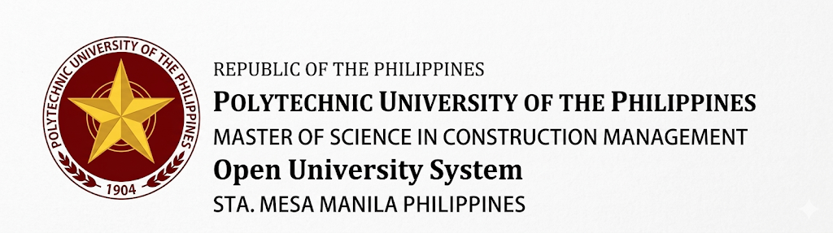

Dear Respondent,
The undersigned is currently pursuing his Master of Science in Construction Management thesis at the Polytechnic University of the Philippines – Open University System, Sta. Mesa, Manila. The thesis is entitled “Developing a Framework to Enhance Soft Skill Competency of Construction Managers for Successful Project Delivery.” The research is being undertaken as part of the academic requirements for the said degree.

In connection with this, the researcher would like to request permission to administer a survey questionnaire at your institution as part of the research process. Your kind support and cooperation in this matter would be immensely beneficial to the study and would be greatly appreciated.

The Researcher’s Survey Questionnaire is provided for your reference. Please be assured that all information and responses gathered through the questionnaire will be treated with utmost confidentiality and will be used solely for academic purposes.

Thank you very much for your thoughtful consideration and assistance.

Sincerely yours,
Marco Rey G. Macatangay
Researcher

Approved by:
Dr. Guillermo O Bernabe
Adviser

APPENDIX B: Survey Questionnaire

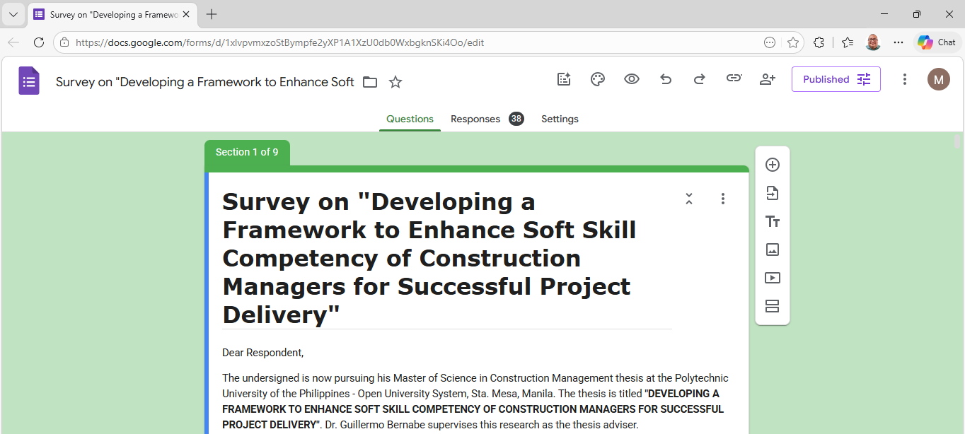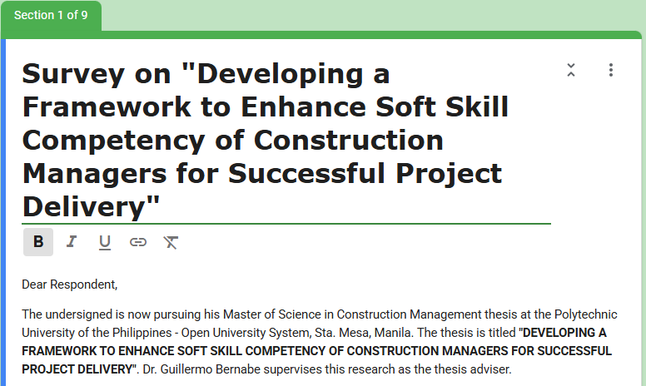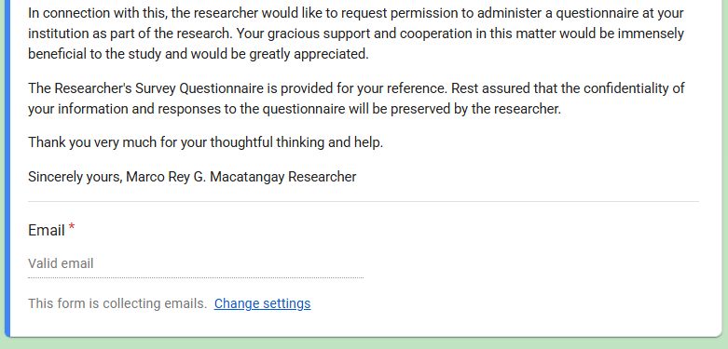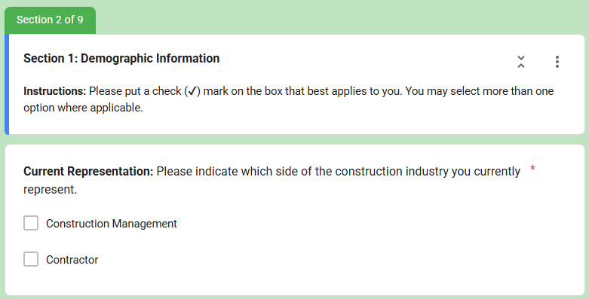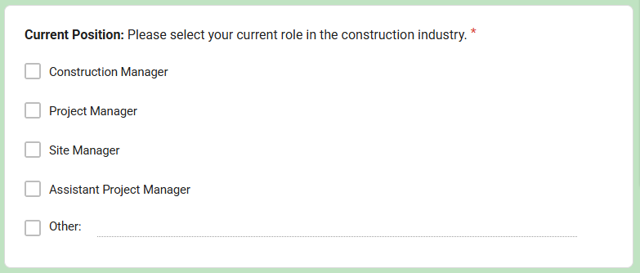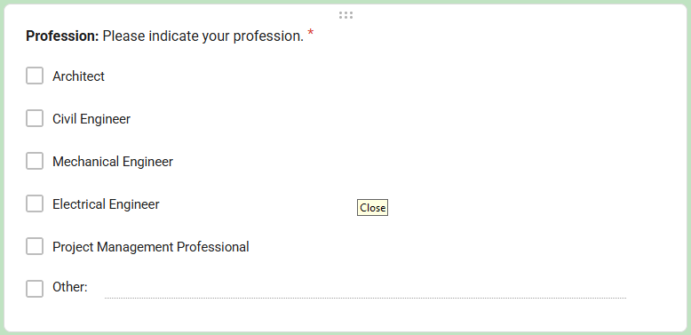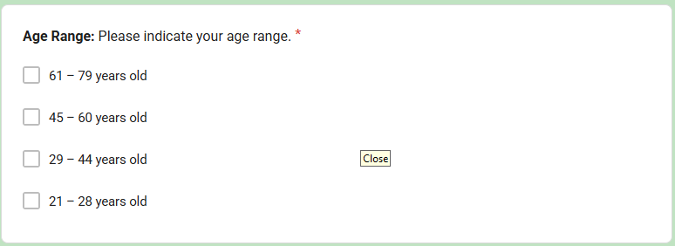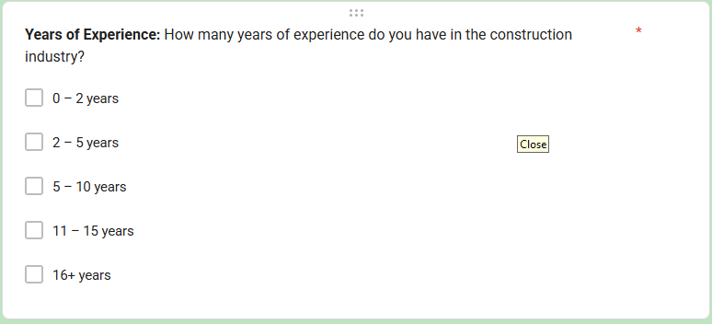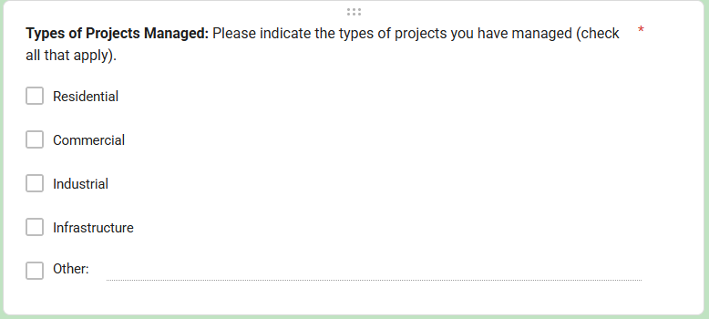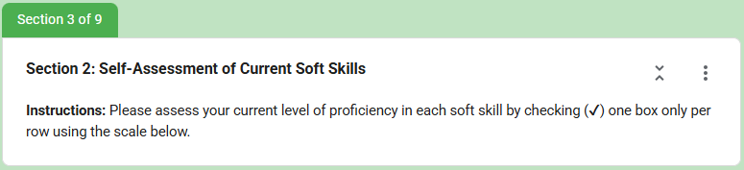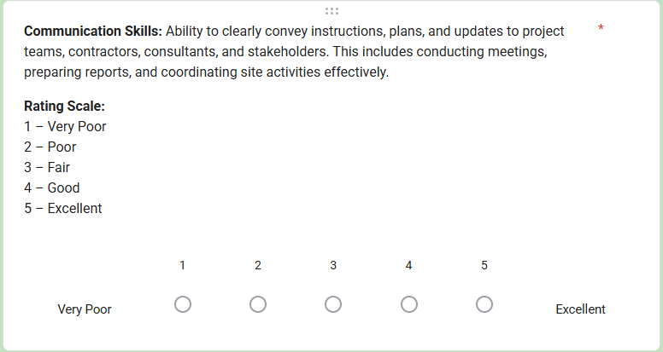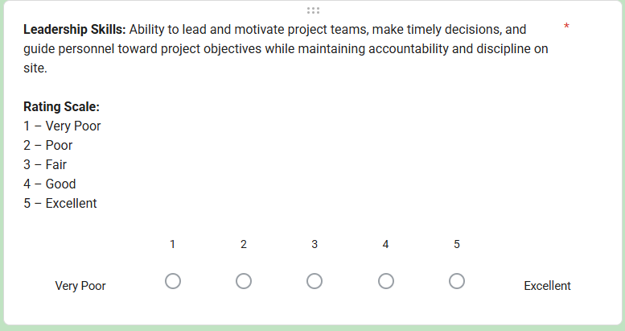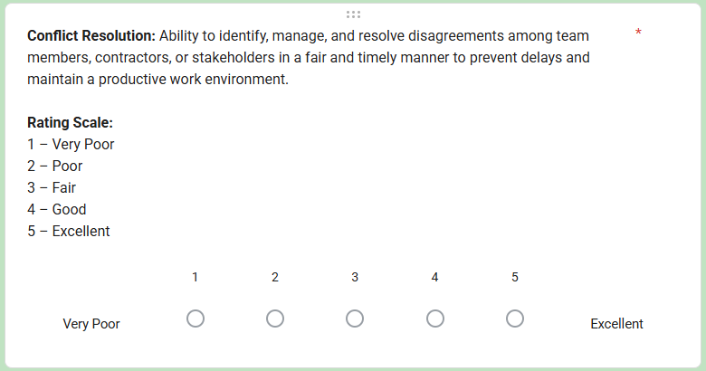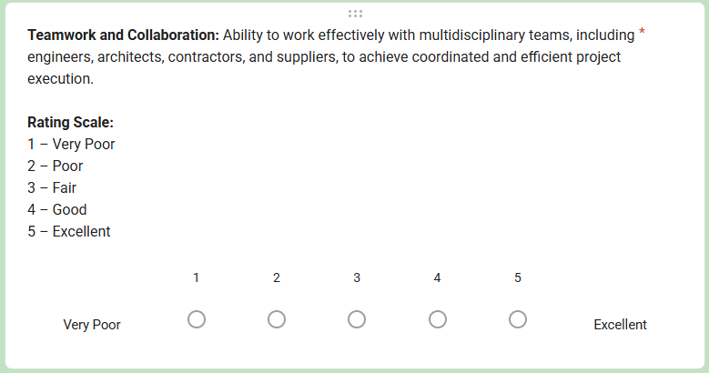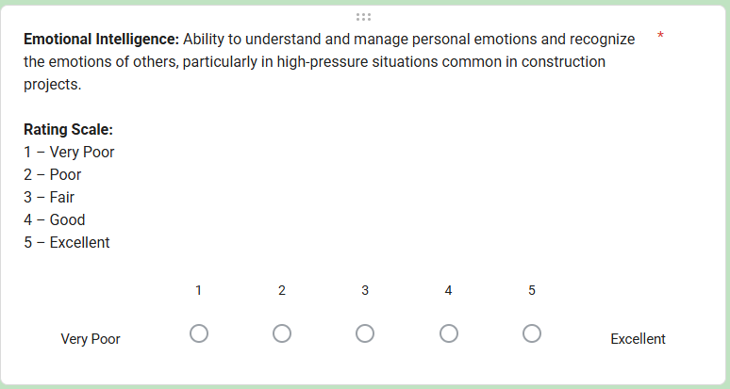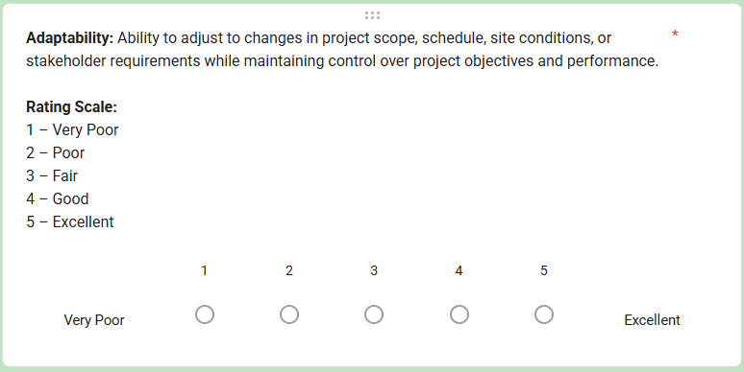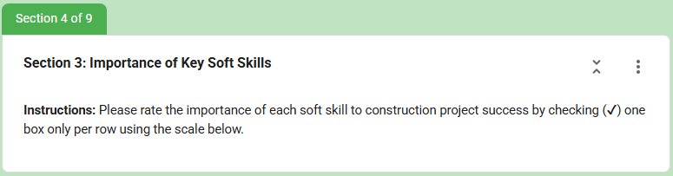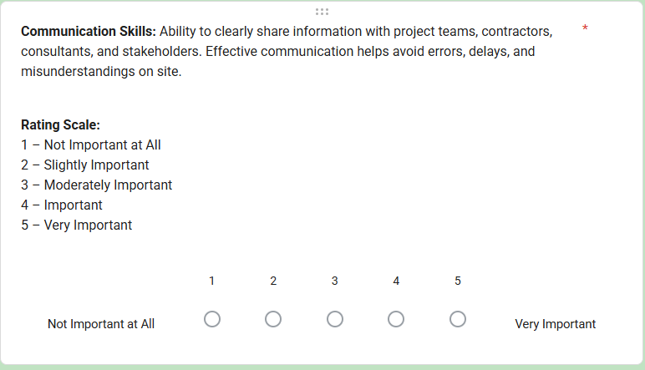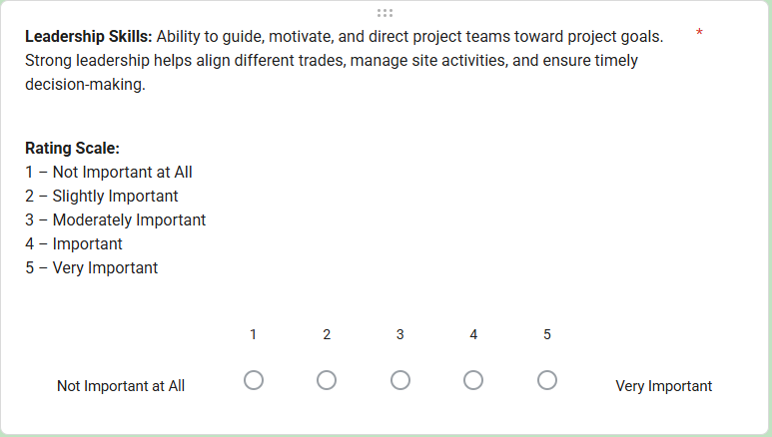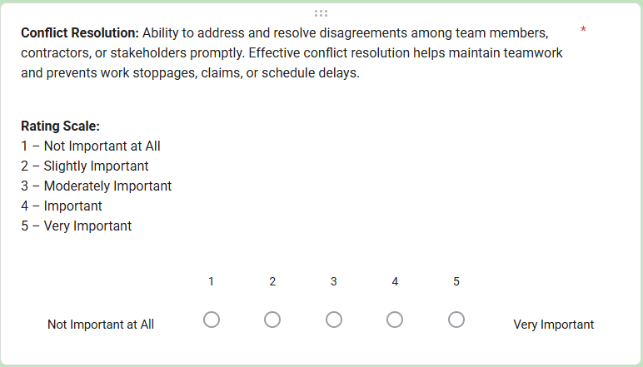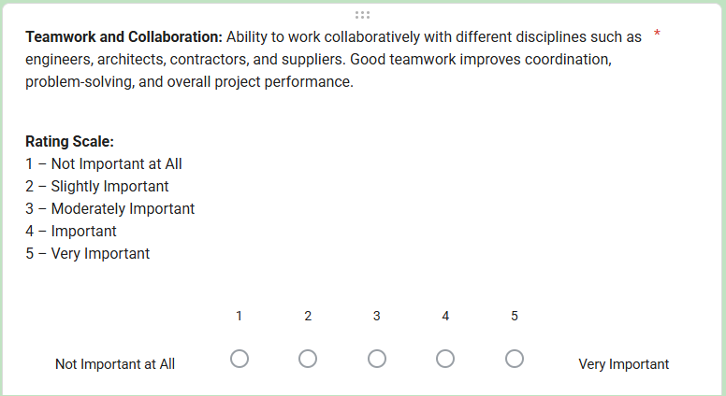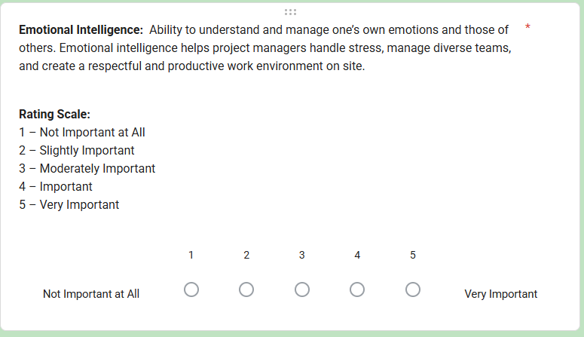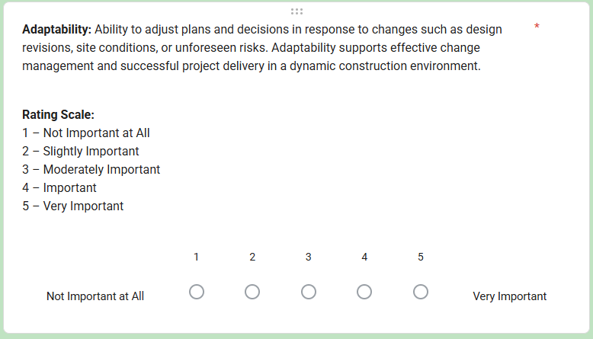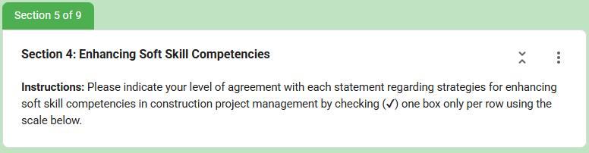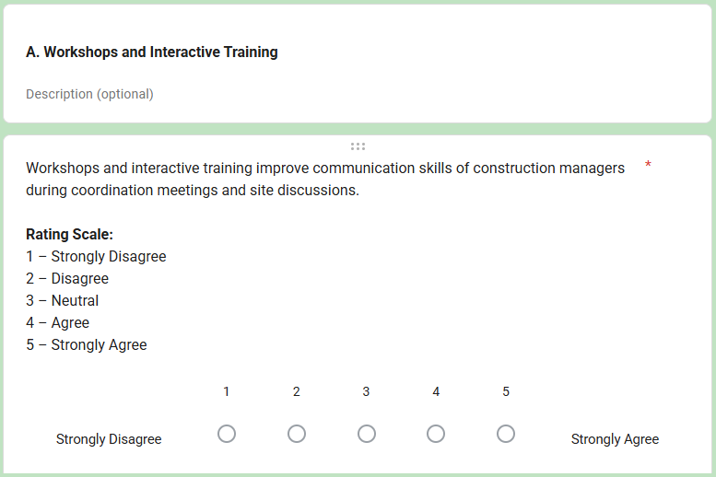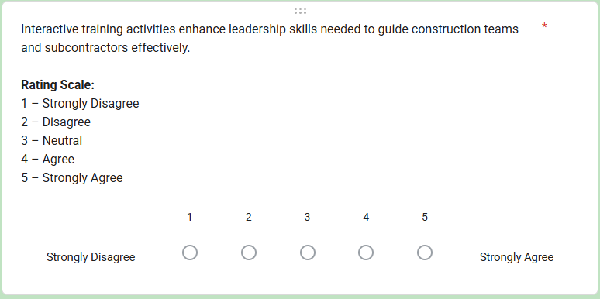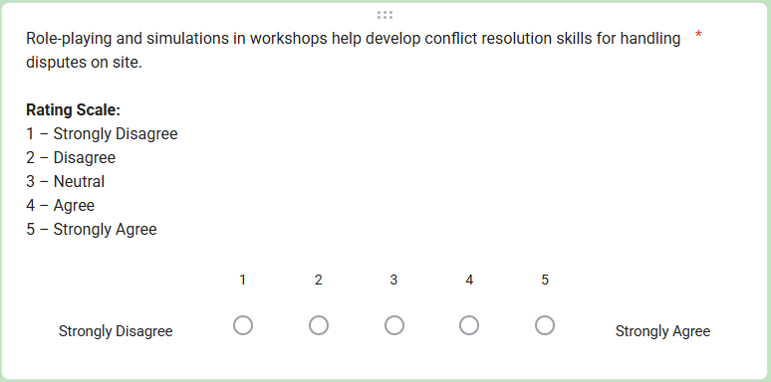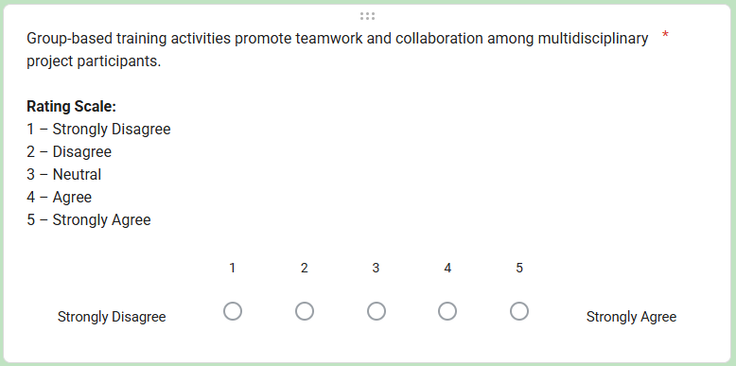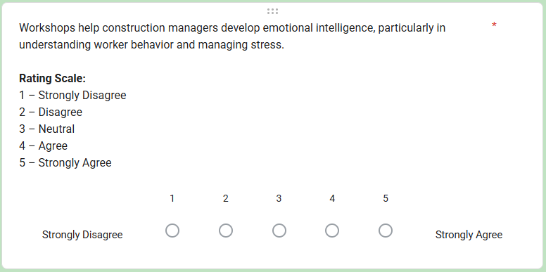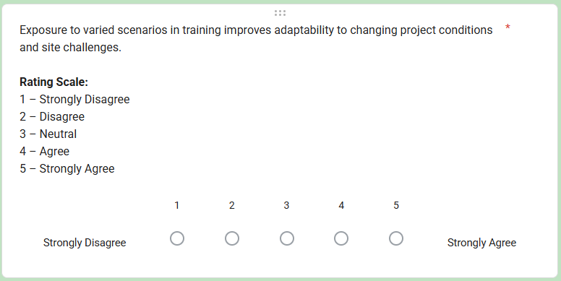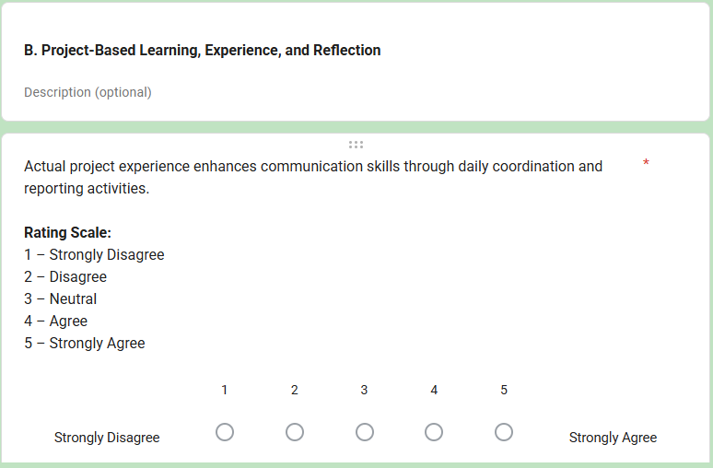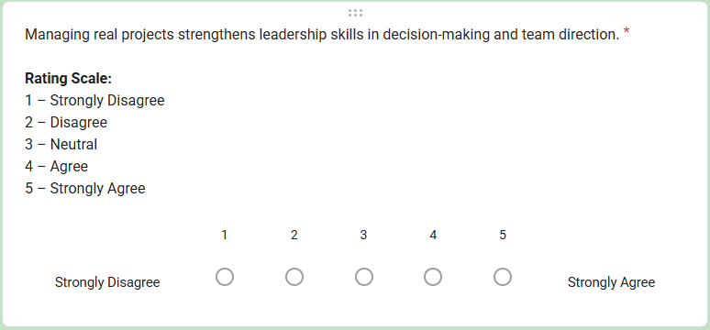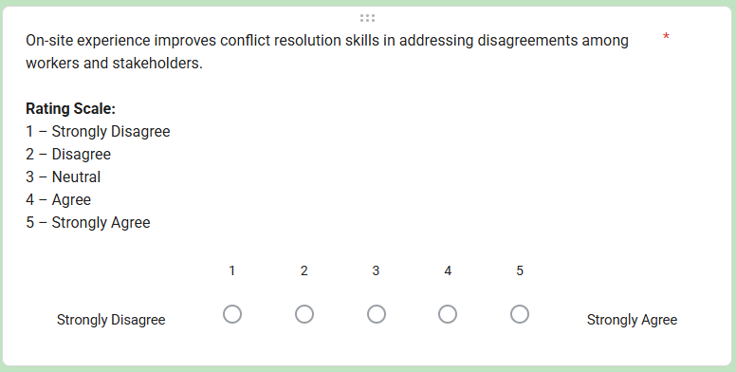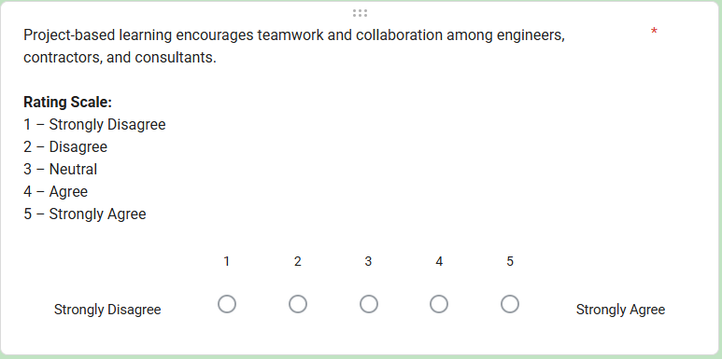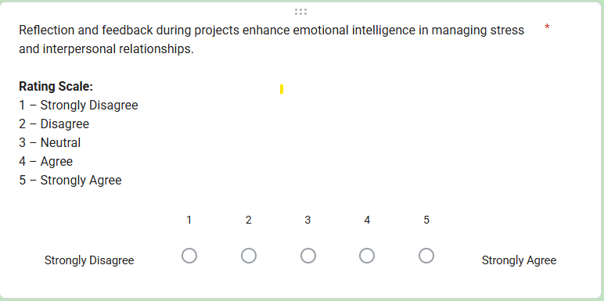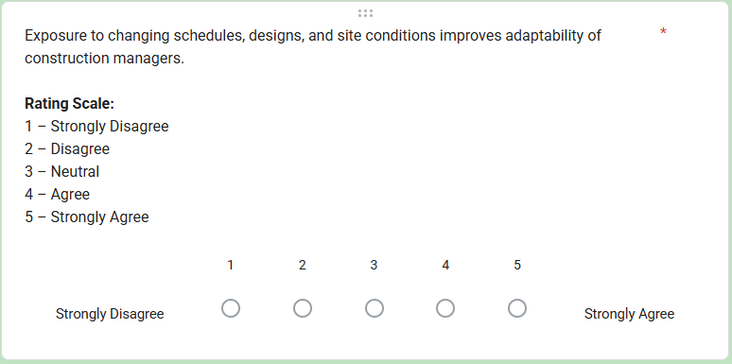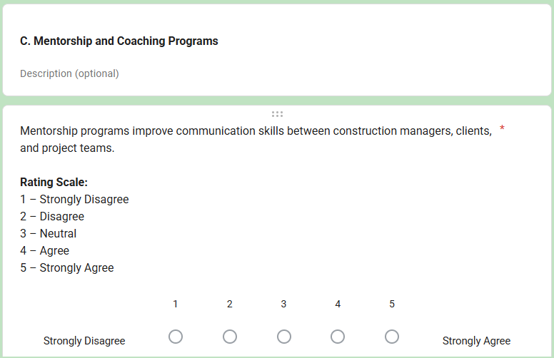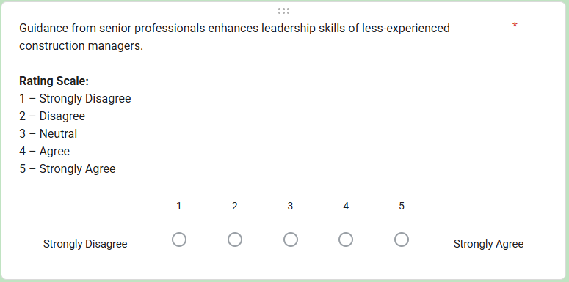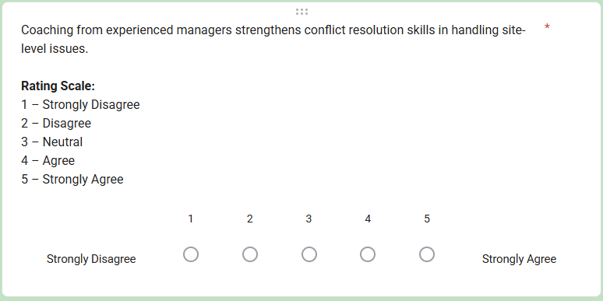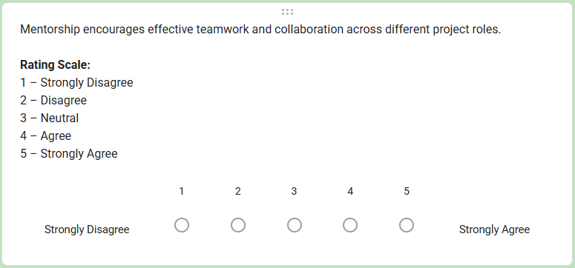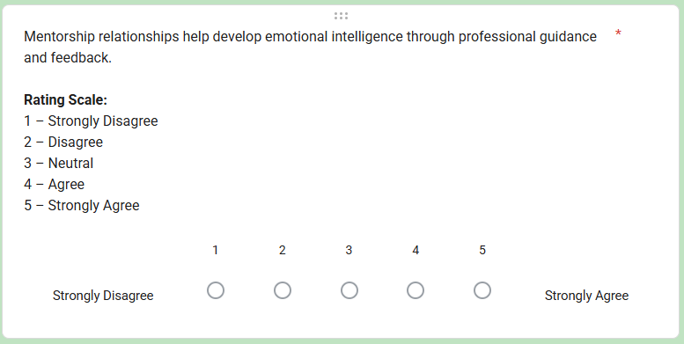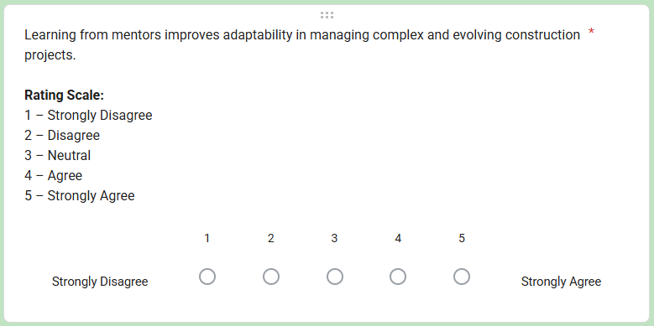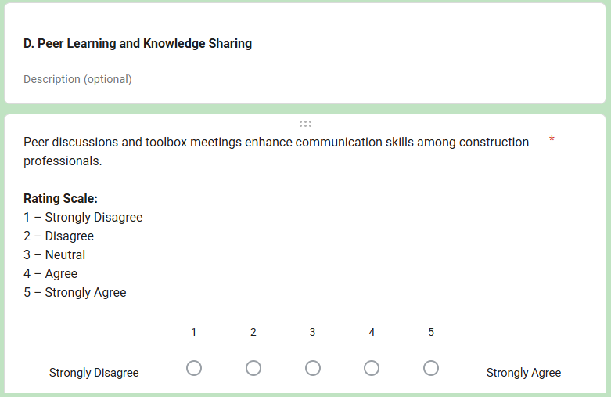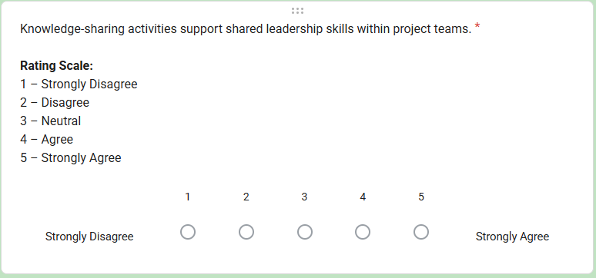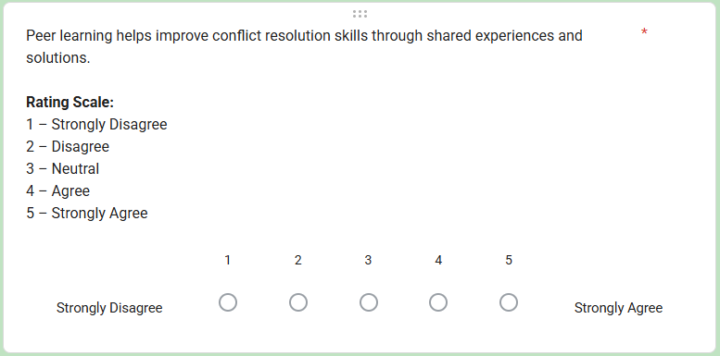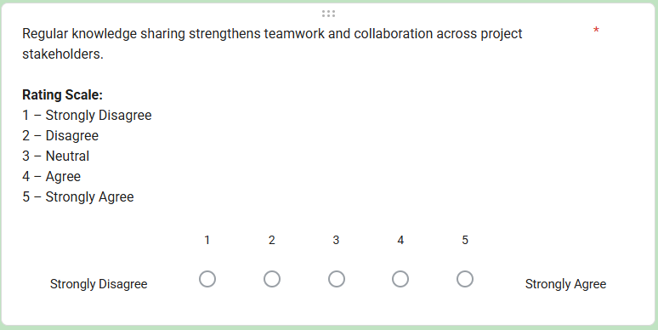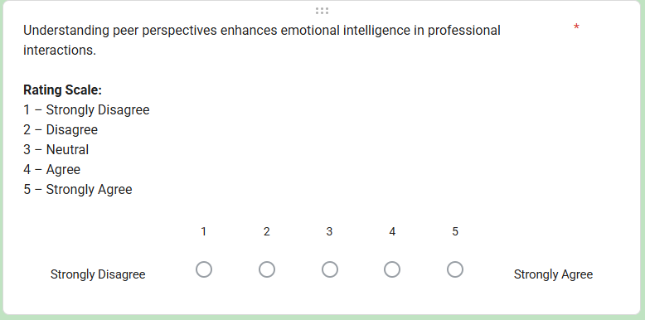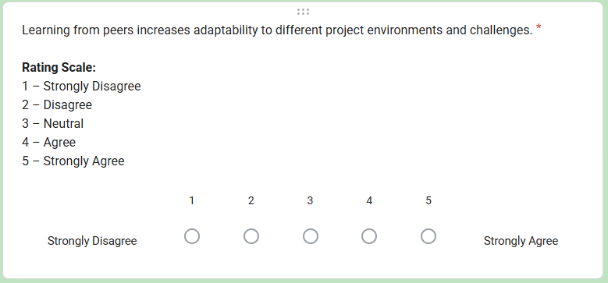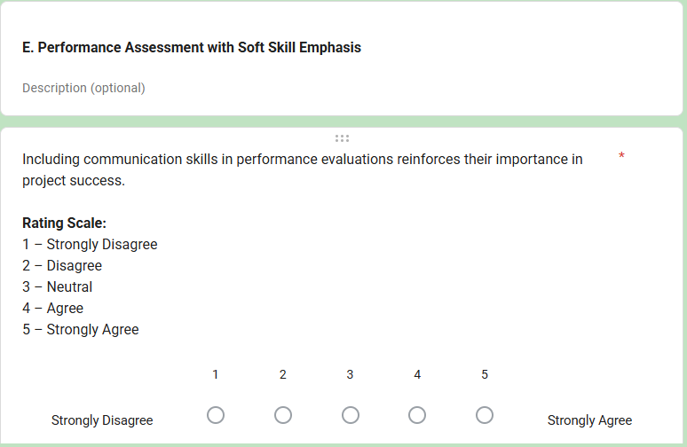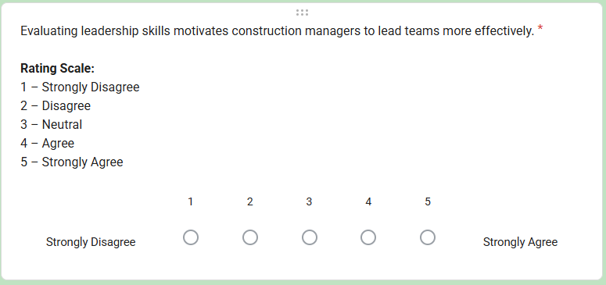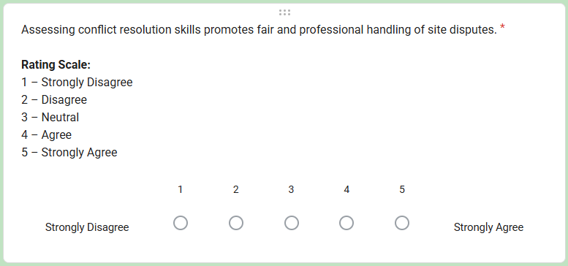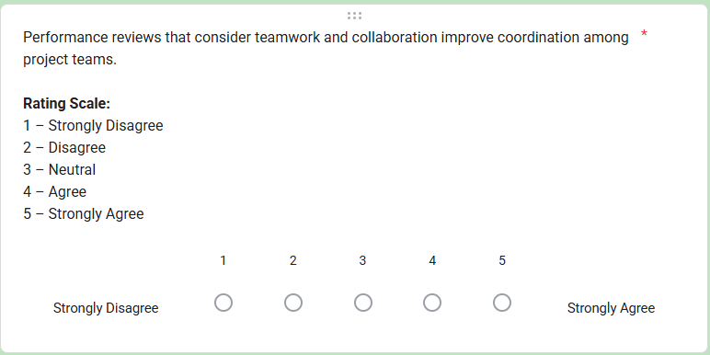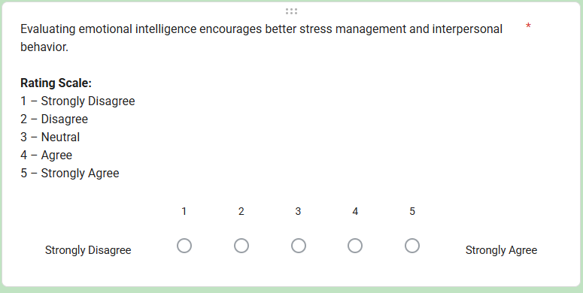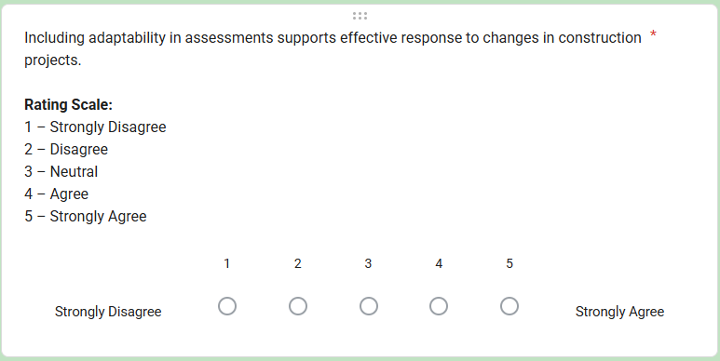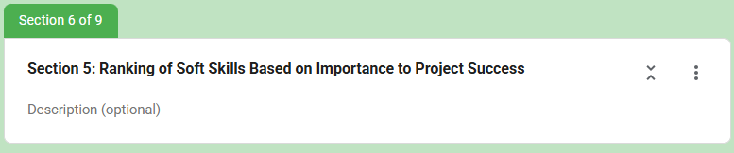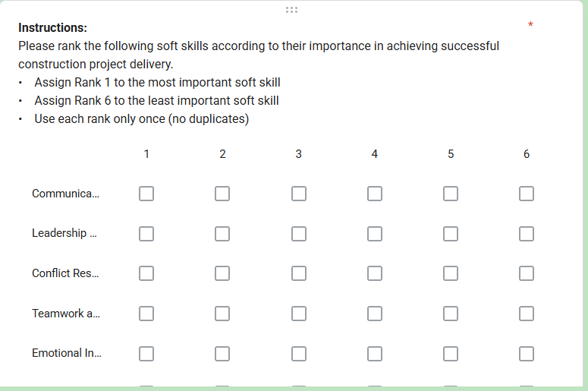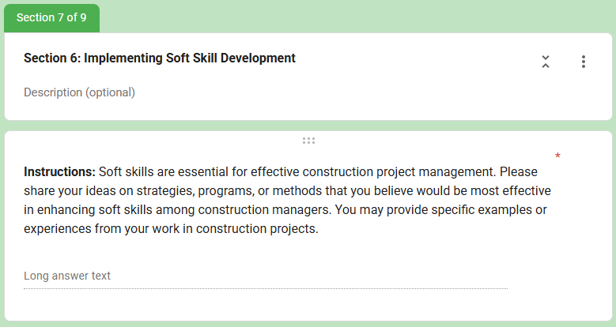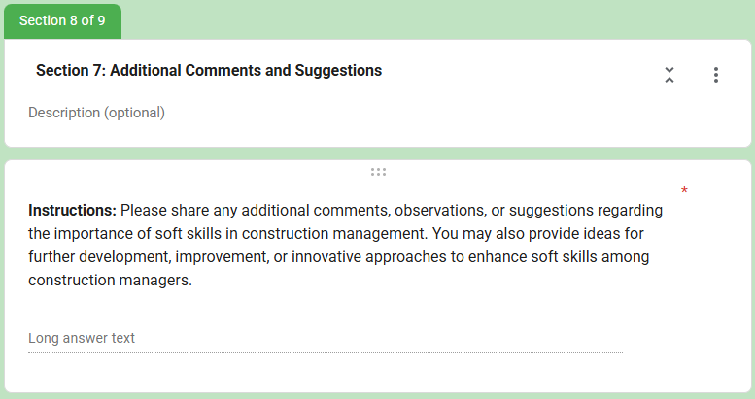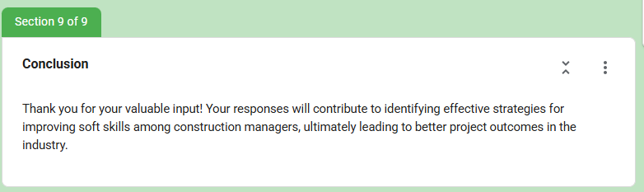

Appendix C: Biographical Statement


Marco Rey G. Macatangay is a seasoned project management professional with over a decade of leadership in institutional infrastructure and organizational development. Since 2015, he has served as the Director of the Project Management Office at De La Salle University, where he oversees the strategic planning and execution of complex, large-scale construction and institutional initiatives.
His technical credentials reflect a commitment to global industry standards, holding certifications as a Master Project Manager (MPM), PRINCE2 Foundation, and LEED Green Associate. Notably, he is a Certified Trainer for CIAP Doc 102 by the Philippine Domestic Construction Board (PDCB), where he contributes to the professionalization of construction contracting in the Philippines.
Recognizing that safety and human welfare are the cornerstones of effective project delivery, Marco is a Certified Safety Officer II, a Certified First Aider, and a Licensed Professional Teacher. This unique profile allows him to bridge the gap between technical execution and people-centered leadership. His research interests focus on the intersection of soft-skill competencies, leadership effectiveness, and the implementation of green practices in construction management. He remains an active member of the Project Management Institute (PMI) and the American Academy of Project Management (AAPM).

