Finora: AI-Assisted Communal Financial Monitoring and Governance Analytics Framework Using Natural Language Transaction Parsing and Cloud-Based Aggregation
Ananth Ram S, Dr. S. Saraswathi
Student, Department of Computer Science (Data Science), Nehru Arts and Science College, Tamil Nadu, India.
Head Of The Department, Department of Computer Science (Data Science), Nehru Arts and Science College, Tamil Nadu, India.

Abstract
Continuous understanding of household financial behaviour is essential for effective economic planning and welfare decision-making. However, financial activities in most communities remain undocumented or recorded in inconsistent formats, forcing administrative authorities to depend on delayed surveys and approximate statistical reports. Existing expense tracking applications primarily support individual budgeting and require structured input, limiting adoption among non-technical users and providing no collective insight.
This paper presents Finora, an applied artificial intelligence framework that converts conversational financial statements into structured community-level economic intelligence. The system integrates natural language transaction parsing, cloud-based storage, and real-time analytics to capture daily financial activity in an accessible manner. Each transaction is modelled as a discrete financial event contributing to a continuously evolving household financial state. A mathematical representation based on cumulative balance estimation, expense distribution probability, financial stress ratio, and sector demand intensity enables aggregation of micro-level transactions into macro-level indicators.
The implemented prototype demonstrates reliable interpretation of informal financial text, dynamic balance tracking, and multi-household aggregation capable of revealing spending priorities and demand concentration patterns. Results indicate that decentralized human communication can serve as a continuous socio-economic sensing mechanism while preserving user privacy through pattern-level analysis.
The proposed framework establishes a scalable approach for transforming everyday communication into actionable governance intelligence using applied artificial intelligence and cloud synchronization.

Keywords - Natural Language Processing, Financial Data Modeling, Community Analytics, Governance Decision Support, Applied Artificial Intelligence, Cloud-Based Monitoring, Transaction Parsing, Socio-Economic Data Analysis, Real-Time Data Aggregation, Human-Centered AI.

- Introduction
Knowledge of financial behavior at the household level is critical for economic planning and welfare policy formulation. Administrative agencies usually rely on surveys, census data, and periodic research to approximate consumption patterns and living standards. These approaches are time-consuming, costly, and sometimes inaccurate since they involve sampling rather than continuous observation. As a result, many socio-economic trends are identified with considerable delay.
Personal expense management apps are available at the individual level but require systematic data input and manual coding. These requirements are usability hurdles for non-technical users, resulting in incomplete data and poor adoption rates. Furthermore, these apps are strictly for personal financial management and cannot provide collective insights for community-level analysis.
Recent breakthroughs in artificial intelligence make it possible to interpret natural language as structured data. If financial transactions such as payments, purchases, and incomes can be systematically documented through conversational input and aggregated at the household level, they can provide a continuous flow of microeconomic behavioural data. This data can provide insights into spending habits, economic stress, and sector demand trends in real time.
This paper presents Finora, an artificial intelligence application framework that translates informal financial discourse into structured collective intelligence. Each transaction is treated as an economic event contributing to a continuously evolving household financial state, and aggregated states provide governance-level indicators.
The objective of this work is therefore:
To transform informal financial communication from multiple households into structured real-time economic intelligence suitable for governance analysis.
The proposed approach enables continuous observation rather than periodic estimation, supporting predictive decision making based on daily financial activity.

- System Interface Overview
The proposed framework provides a unified platform designed to support both individual financial monitoring and administrative analytics within the same environment. The system is structured around role-based access, allowing residents to record personal financial activity while enabling authorities to observe aggregated economic indicators across multiple households.
At the entry stage, users select their operational mode and associated household identity. Each household is treated as an independent financial entity within the monitored locality. This design allows financial data to be collected in a decentralized manner while still contributing to a centralized analytical model. The interface minimizes technical complexity by guiding the user through simple selections rather than structured accounting forms.
The platform distinguishes between two primary operational perspectives. The first is the household user perspective, which emphasizes personal tracking and individual financial awareness. The second is the governance perspective, which aggregates data from multiple households to enable community-level interpretation and policy-making. By combining both perspectives within a single architecture, the framework fills the gap between microeconomic activity and macroeconomic analysis.
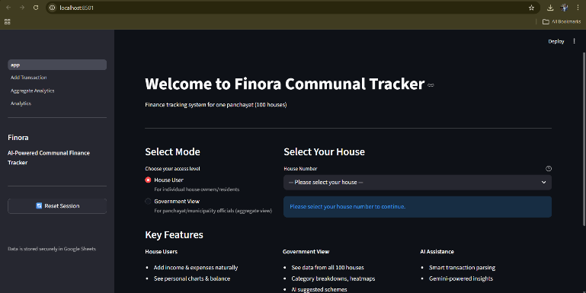
Fig. 1. System landing dashboard displaying mode selection and household identification for accessing the communal financial monitoring platform
The household interface enables residents to access individual tracking features by selecting their house number. Each entry recorded by the user contributes to the continuously evolving household financial state within the system.
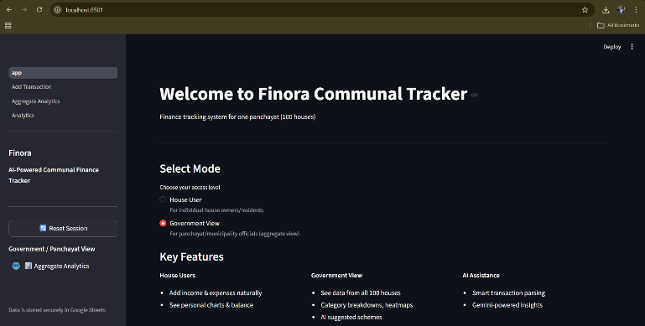
Fig. 2. Governance mode interface providing access to aggregated communal financial analytics
The governance interface provides administrators with aggregated access across all households in the locality, forming the foundation for community-level economic observation and analysis.

3. Related Work
Personal finance applications mainly support budgeting discipline and lack aggregation capability. Financial technology research focuses on banking integration rather than interpretation of conversational input.
Natural language processing has been applied to document classification and accounting automation, but short informal transaction statements have received limited attention. Smart governance research aggregates census and sensor data but does not continuously observe microeconomic household behaviour.
Thus, existing solutions lack:
- Accessible input mechanism
- Continuous structured collection
- Governance-level aggregation
Finora addresses these limitations by combining natural language interaction with financial state modelling and community analytics.
4. Problem Statement and Research Gap
Despite widespread digital tools, there is no system that converts daily household financial communication into collective economic intelligence.
Current limitations include:
• Users avoid structured accounting interfaces
• Financial data remains fragmented across individuals
• Authorities lack real-time microeconomic indicators
The research gap is the absence of a framework that automatically transforms conversational financial activity into measurable socio-economic signals.
The problem addressed:
Convert unstructured financial communication from multiple households into structured, real-time governance analytics.
5. Methodology
The system interprets each transaction as a financial event signal.
Transaction tuple:
$$T_{i}=(h_{i},t_{i},a_{i},c_{i},s_{i},τ_{i})$$
Where
h = household,
t = type (+income, −expense),
a = amount,
c = category,
s = subcategory.
Signed financial impact:
$$ΔF_{i}=t_{i}⋅a_{i}$$
Household financial state:
$$F_{h}(k)=\sum_{i=1}^{k}{Δ}F_{i}$$
Income and expense:
$$I_{h}=∑incomes,E_{h}=∑expenses$$
Balance:
$$F_{h}=I_{h}-E_{h}$$
Expense distribution probability:
$$P(c∣h)=\frac{∑a_{i}⋅1(c_{i}=c)}{E_{h}}$$
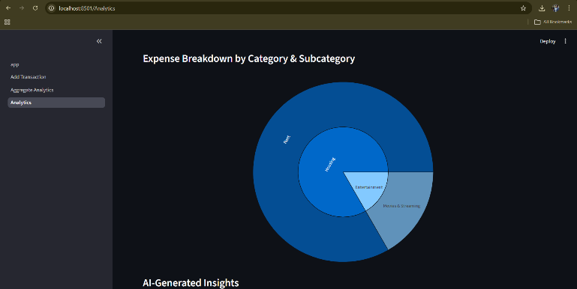
Fig. 3. Category and subcategory expenditure distribution chart generated from aggregated financial records

This distribution indicates spending priorities within the household.

Financial stress indicator:
$$S_{h}=\frac{E_{h}}{I_{h}}$$
Community demand:
$$D_{c}=\sum_{h=1}^{N}{∑}a_{i}⋅1(c_{i}=c)$$
Mapping function:
$$Φ:L→T$$
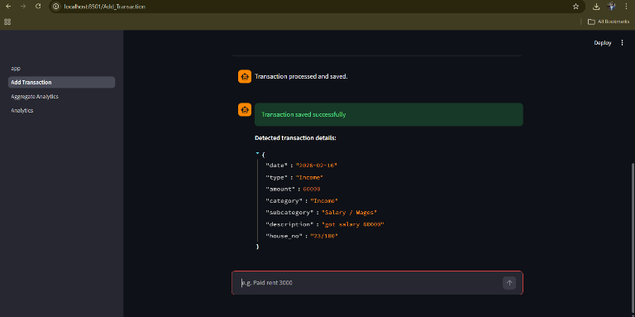
Fig. 4. Structured transaction generated from natural language input by the semantic interpreter
This converts natural language input into structured economic variables.
The system automatically extracts transaction type, amount, and category from informal user statements.

6. System Architecture and Workflow
The system operates through a transformation pipeline:
User Text → AI Parsing → Structured Record → Cloud Storage → Aggregation → Visualization
Users enter conversational transactions such as salary receipt or bill payment. The AI parser extracts amount and category and stores the record in a centralized dataset.
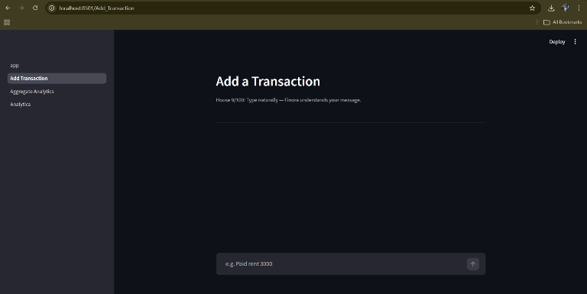
Fig. 5. Conversational transaction input interface allowing users to record financial events in natural language
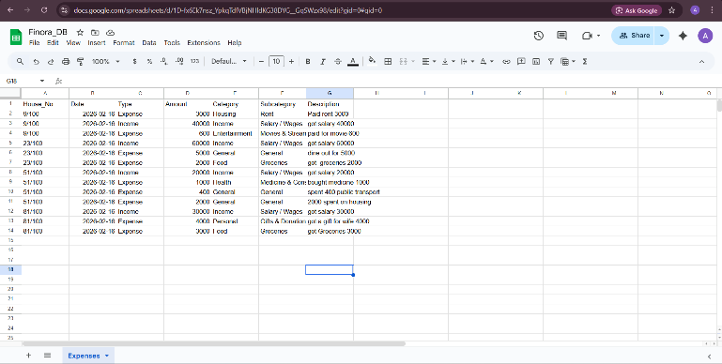
Fig. 6. Cloud database storing structured financial records for multiple households
Each row represents a verified financial event enabling persistent and synchronized storage.
The interface removes structured form dependency and improves accessibility for non-technical users.

Individual balance:
$$F_{h}=∑Income_{h}-∑Expense_{h}$$
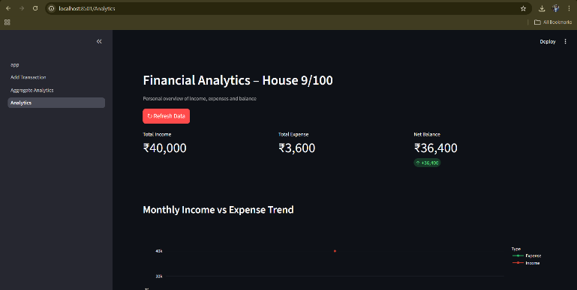
Fig. 7. Individual household financial dashboard displaying balance and transaction statistics
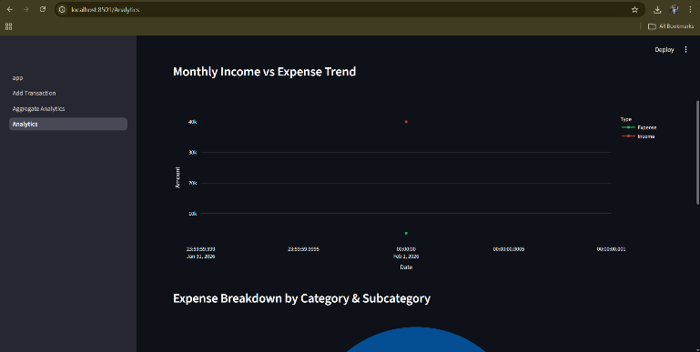
Fig. 8. Monthly income versus expense trend visualization generated from recorded financial transactions
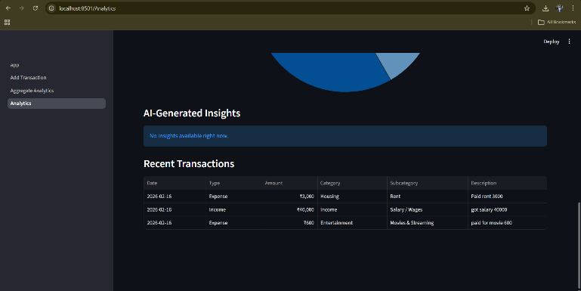
Fig. 9. Recent transaction log and AI-generated insights panel displaying recorded financial activities
The dashboard dynamically updates financial state after every transaction.
Community aggregation:
$$F_{community}=\sum_{h=1}^{N}{F_{h}}$$
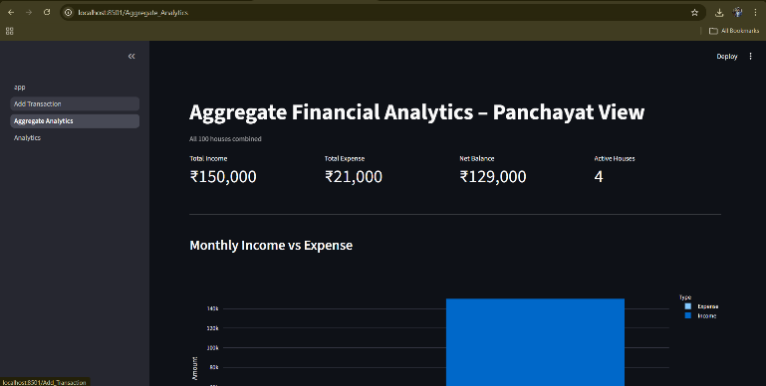
Fig. 10. Aggregated community financial analytics across multiple households
Aggregation enables governance-level economic observation without accessing personal details.
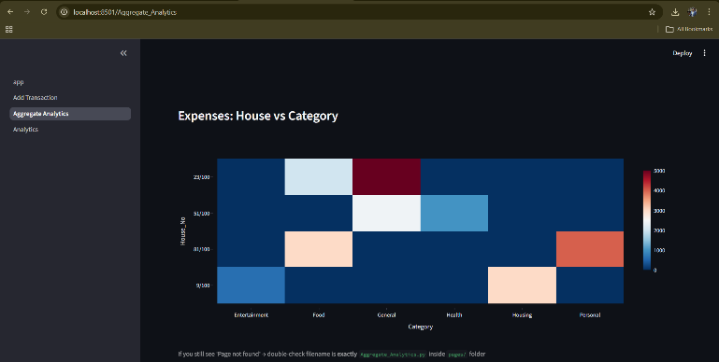
Fig. 11. Household versus category expenditure comparison heatmap
The visualization emphasizes sector demand patterns in the locality.
The visualization module provides category distribution and household comparison dashboards.
Cloud authentication for secure synchronization of multiple devices without local database installation.

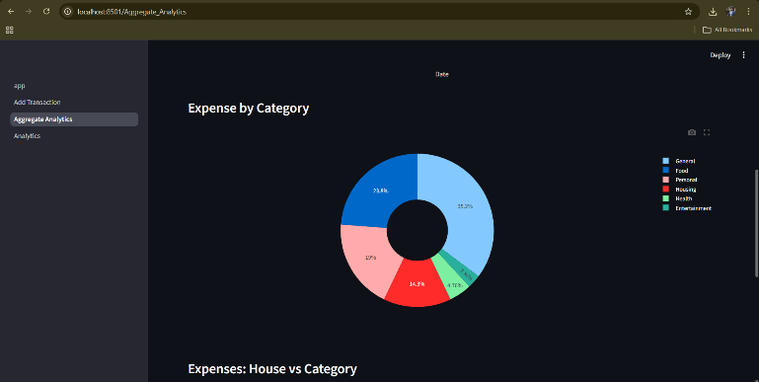
Fig. 12. Aggregated expense distribution across categories for the monitored community
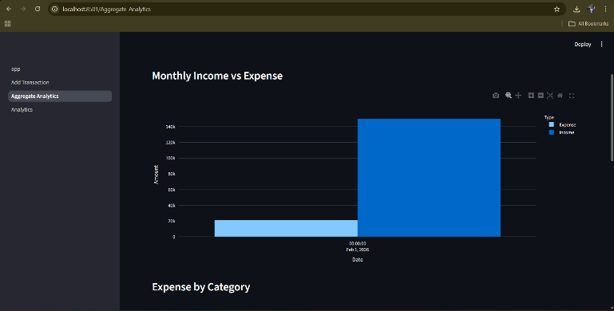
Fig. 13. Community-level monthly income and expense comparison chart
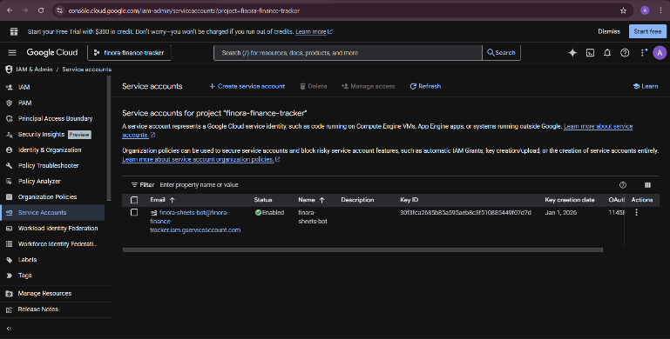
Fig. 14. Cloud service authentication configuration used for secure database communication
The system uses credential-based authorization to protect financial records.
Automated synchronization allows real-time analytics generation.

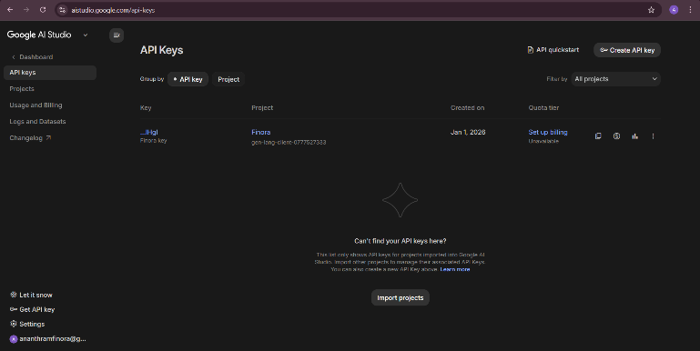
Fig. 15. API integration enabling automated read and write operations to cloud storage

7. Experimental Setup, Results, and Discussion
The system was tested using multiple simulated households entering conversational financial records.
Observations:
• Transactions interpreted correctly into structured entries
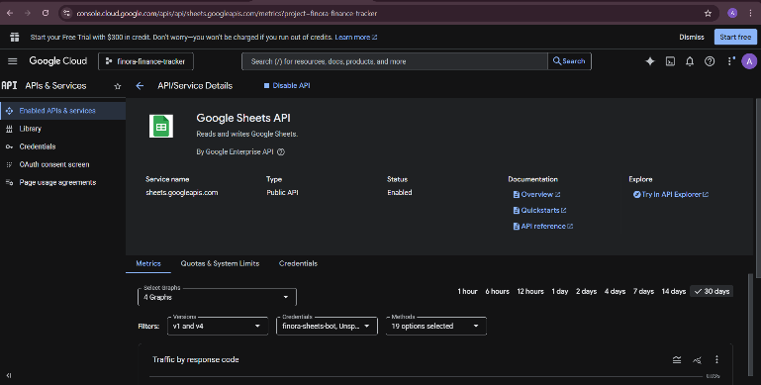
Fig. 16. AI service configuration used for semantic transaction interpretation
The parser converts conversational financial statements into machine-readable attributes.
• Household balances updated dynamically
• Category charts revealed spending priorities
• Aggregated dashboard produced sector demand indicators
The results confirm that conversational financial input can generate reliable socio-economic analytics.
The framework converts personal bookkeeping into collective intelligence and enables predictive governance insights while preserving privacy because analysis depends on aggregated patterns rather than identity.
Limitations include dependence on accurate user reporting and scalability for very large populatio

8. Conclusion
This paper introduced Finora, an applied artificial intelligence framework that converts conversational household financial statements into structured community-level economic intelligence. By modelling each transaction as a discrete financial event, the system continuously estimates household balance, expense distribution, and financial stress indicators, and aggregates them to generate governance-oriented analytics.
Experimental outcomes show that natural language inputs can be accurately decoded into structured form, facilitating real-time financial tracking without the need for accounting knowledge. Aggregated graphics illustrate expenditure trends and sector demand, confirming that decentralized financial activity can serve as a constant socio-economic data feed.
The system upgrades financial tracking from a periodic observation to a constant one while maintaining privacy through pattern analysis. Future developments will focus on adaptive decoding models, anomaly identification, and predictive expenditure analysis for various communities.
Overall, the proposed approach establishes a scalable method for transforming everyday communication into actionable governance intelligence using applied artificial intelligence and cloud synchronization.

9. References

[1] Z. Bodie, A. Kane, A. Marcus, Investments, McGraw-Hill, 2018.
[2] T. Puschmann, Fintech, Business & Information Systems Engineering, 2017.
[3] E. Liddy, Natural Language Processing, Encyclopaedia of LIS, 2001.
[4] M. Batty et al., Smart Cities of the Future, EPJ Special Topics, 2012.
[5] S. Russell and P. Norvig, Artificial Intelligence: A Modern Approach, 2020.
[6] I. Goodfellow et al., Deep Learning, MIT Press, 2016.
[7] T. Mitchell, Machine Learning, McGraw-Hill, 1997.
[8] S. Haykin, Neural Networks and Learning Machines, 2009.

