EPIC: Electro-Physical & Chemical Model

By Dr. Shishir Mishra (BNYS, MD, AMIE, ASCO Member) – Bio-Physics Scientist
Dr. Manoj Prabhakar (BHMS, DBEMF) – Clinical Consultant & Researcher

Subtitle: A Bio-Energy Framework for Human Functional Output

Abstract

The human body functions as an integrated bio-electrical system in which physical electrical activity and electro-chemical processes operate together. This paper proposes the EPIC (Electro-Physical & Chemical) Model, conceptualized by Dr. Shishir Mishra and Dr. Manoj Prabhakar, in which overall human energy behavior is described as the sum of bio-electro-physical frequency (FBEP) and bio-electro-chemical frequency (FBEC). The model emphasizes that the human body accepts minimal external energy input but produces a disproportionately strong functional output through internal amplification, resonance, and non-linear coupling mechanisms. This output manifests as cognitive performance, intelligence, stamina, alertness, and occasional electrical sensations perceived within the body.

Keywords

Bio-electricity, Bio-electro-chemistry, Human energy frequency, Neural amplification, Functional output energy, EPIC Model, Shishir Mishra, Manoj Prabhakar

- Introduction

Modern physiology recognizes that electrical and chemical processes are inseparable in living systems. Neural signaling, cardiac rhythm, muscular contraction, and hormonal regulation are all mediated through electrical potentials and ionic exchanges. Despite this understanding, these processes are often studied in isolation. The present paper proposes the EPIC Model, conceptualized by Dr. Shishir Mishra and Dr. Manoj Prabhakar, to explain how low-level energy input can result in high-intensity functional output in the human body.

- Conceptual Framework

The total functional frequency of the human body is expressed as:

Human Energy Frequency (HF) = FBEP + FBEC

Where:

FBEP (Bio-Electro-Physical Frequency): Electrical activity generated by the heart, brain, and nervous system.

FBEC (Bio-Electro-Chemical Frequency): Electrical behavior arising from charged biochemical substances such as hormones, electrolytes, blood constituents, and metabolic products.

In this model:

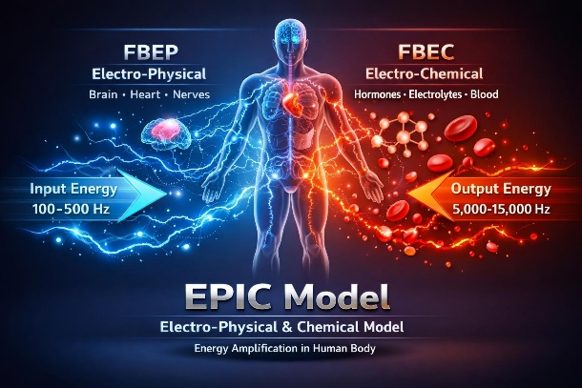
FBEP ≈ 300 Hz (effective functional domain)

FBEC ≈ 200 Hz (effective functional domain)

Total base functional input ≈ 500 Hz

These frequencies are defined as effective or functional domains rather than single measurable oscillations.

- Bio-Electro-Physical Component (FBEP)

The bio-electro-physical domain includes:

Cardiac electrical rhythms

Brain electrical oscillations

Peripheral and central nerve conduction

These systems rely on synchronized electrical signaling and electromagnetic interactions that maintain coherence across organs. FBEP governs rhythm, timing, coordination, and signal transmission.

- Bio-Electro-Chemical Component (FBEC)

The bio-electro-chemical domain includes:

Electrolytes (Na⁺, K⁺, Ca²⁺)

Hormonal signaling

Blood chemistry and pH balance

Metabolic by-products such as urea

All biochemical reactions in the body involve charged particles and electro-chemical gradients. FBEC governs modulation, adaptation, endurance, and metabolic efficiency.

- Input–Output Energy Principle

A key feature of this model is the non-linear relationship between energy input and output:

Input energy: 100–500 Hz (environmental, nutritional, physiological, or informational input)

Functional output: Equivalent high-order harmonic or informational output in the range of 5,000–15,000 Hz

The human body behaves as a biological amplifier, where minimal external input triggers strong internal responses through resonance, synchronization, and electro-chemical coupling.

- Functional Manifestations of High Output Energy

The amplified output energy manifests as:

Increased cognitive clarity and intelligence (IQ)

Enhanced focus, alertness, and decision-making

Improved stamina and physical endurance

Sensations of internal electrical flow during heightened neural or physiological states

These manifestations are not dependent on the quantity of energy absorbed but on the efficiency of internal bio-electrical processing.

- Discussion

The proposed EPIC Model aligns with emerging concepts in systems biology, non-linear dynamics, and bio-field science. By framing human physiology as an energy-efficient amplification system, this approach provides a theoretical basis for understanding consciousness, performance enhancement, and energy-based therapeutic interventions.

- Conclusion

The human body is neither purely chemical nor purely electrical; it is a coupled bio-electro-physical and bio-electro-chemical system. Through internal amplification mechanisms, the body converts minimal external energy input into powerful functional output. The EPIC Model, conceptualized by Dr. Shishir Mishra and Dr. Manoj Prabhakar, offers a foundational framework for future experimental validation and interdisciplinary research.

- Future Scope

Future work may include:

Quantitative measurement of effective frequency domains

Controlled experimental validation

Application to energy-based diagnostics and therapies

Integration with behavioral and cognitive models

- References

- Guyton, A. C., & Hall, J. E. (2021). Textbook of Medical Physiology (14th ed.). Elsevier.

- Bear, M. F., Connors, B. W., & Paradiso, M. A. (2020). Neuroscience: Exploring the Brain (4th ed.). Wolters Kluwer.

- Purves, D. et al. (2018). Principles of Neural Science (6th ed.). McGraw-Hill.

- Nicholls, D. G., & Ferguson, S. J. (2013). Bioenergetics 4. Academic Press.

- Alberts, B. et al. (2022). Molecular Biology of the Cell (7th ed.). Garland Science.

- McCraty, R., & Childre, D. (2010). Coherence: Bridging personal, social, and global health. Alternative Therapies in Health and Medicine, 16(4), 10–24.

- Popp, F. A., Li, K. H., & Gu, Q. (2002). Recent Advances in Biophoton Research and Its Applications. World Scientific.

- Becker, R. O., & Selden, G. (1985). The Body Electric: Electromagnetism and the Foundation of Life. William Morrow.

- Oschman, J. L. (2016). Energy Medicine: The Scientific Basis (2nd ed.). Elsevier.

- Fröhlich, H. (1988). Biological coherence and response to external stimuli. Springer Series in Synergetics.

