HORTICULTURAL NURSERY WORKFORCE DYNAMICS: A FUNDAMENTAL VIEW

ABSTRACT
Horticultural nurseries are sequential dependent on human resource capital to do various operations. This paper addresses multidimensional challenges in labour management in nursery operations. The paper analyzes the problem involved and developed strategies for improving labour utilization through structured training, adoption of appropriate technologies, and strengthened policy support. According to the findings of India Today it highlights that enhancing workforce proficiency by integrating modern management approaches with technology and human-centric management can significantly ameliorate task performance by ensuring labour welfare in compliance with labour laws. The study advances the development of more robust and efficient and sustainable nursery systems by offering better morale into effective labour management.
KEYWORDS — Automation, High–Tech nursery, Seasonal labour, SOP (Standard Operating Procedure), Sustainability
INTRODUCTION
Agriculture is the driving force of our country’s economy. Horticultural nursery aims to produce huge volume of plants in a controlled environment; it plays a vital factor contributing to agrarian economy guaranteeing food security and rural livelihoods. Nursery works include nurturing, propagation, pruning, maintenance and selling plants; to do these activities a strong dynamic workforce is required. Labours participate in various activities ensuring safety growth mechanisms from sapling to plant and its dispersal. Hence streamlined labour management is essential to enhance productivity, survival and ensure plant quality.
OBJECTIVES OF THE STUDY
- To conduct analysis of labour utilization in nursery.
- To establish worker safety and welfare.
- To benchmark the application of technology in minimizing labour dependency.
- To propose strategies for improving workforce output efficiency.
LITERATURE REVIEW
The former studies indicate that labour inefficiency brings about increased production costs and reduced profitability. [2]Factors that limited new nursery hires included increased wages (26%), insufficient availability of qualified labour (32%), financial limitations (28%), and added automation systems/processes (9%). Survey results did not specify if the addition of automation limited new hires because it reduced labor needs or because it allowed operators to allocate existing labor more efficiently, reducing the need for new workers.The research points out that mechanization and training significantly improve labour productivity. The studies also draw attention about the importance of skilled labour in modern nursery operations. Employers embraced a range of multi prolonged strategies; neutral, “wait-it-out,” approaches included producing less manpower intensive crops, downsizing expansion plans, leaving fields fallow, or assigning manual tasks to high-skilled workers.
RESEARCH METHODOLOGY
Effective management begins with a "Labour Calendar" that aligns manforce with the essential growth requirement of the plants. A nursery calendar to help plan necessary actions and purchases of seed, supplies and equipment.
Peak Periods
Labour is concentrated during seed sowing, watering, preparing beds, grafting, transplanting, packing and distributing.
Off-Peak Tasks
Shifting to maintenance, weeding, foliar spraying, pot cleaning, soil sterilization, packaging of seeds and fertilizers and infrastructure repair during slower growth months.
Standard Operating Procedures (SOPs)
SOPs ensure that every worker, regardless of experience, maintains the same quality and speed during their process.

Table1: Classification of Labour Activities

Activity Type | Percentage (%)
Staffing | 50
Manure production | 15
Pot department | 10
Health care | 10
Outdoor work | 10
Weed maintenance | 5
TYPES OF LABOUR IN NURSERY
[1] Nursery operation are dependent on staff who are professional, careful and honest; although the casuals or technical workers do most of the work described here, everyone in the nursery must have as much knowledge about agro forestry tree propagation as possible. Labour in nursery can be categorized into:
- Family Labour: Common in small/large farms. They are from the family in need of wages or a means of support.
- Highly Skilled Labour: Dedicated to grafting, budding, and laboratory-based tissue culture. These workers require specialized training and often command higher wages.
- Semi-Skilled: Focused on irrigation management, pest identification, and fertigation.
- General Labour: Handling heavy lifting, weeding, pot filling, and loading/unloading for transport.
- Seasonal Labour: Labour who work only for a particular time period or during emergency situation when need arises.
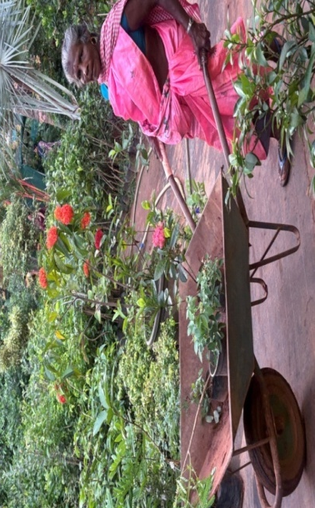
Fig 1: Workforce in loading and unloading
ROLE OF TECHNOLOGY
Technological advancements such as automated systems, watering machines, and plant management software increase efficiency and also improve monitoring and decision-making processes. Labour-augmented investments increase capacity of existing workers by training them to use the new software or potting machine attachments, fabricate repair parts for machines, or take on increased responsibilities managing workers operating the various automations.[3]Automation solves the problem of lack of workers and harvesting problems.
- IoT Driven Irrigation: IoT sensors and automated systems deliver water and nutrients only when needed, reducing waste.
- Climate Regulation: Automated greenhouses use sensors to manage temperature, humidity, and CO2 levels for healthy growth.
- Robotic System Automation: Machines handle labour-intensive tasks like soil filling, seed sowing, transplanting, and pruning.
- AI & Computer Vision: Cameras and apps recognize early signs of pests, diseases, and nutrient deficiencies.
- Precision Lighting: Specialized LED systems generate a specific spectrum output to drive up plant development.
- E-Inventory: Software and QR codes track plant health and stock levels in real-time for better business planning.
- Drones: It is employed for large-scale monitoring, spraying, and mapping of outdoor nursery beds.
CHALLENGES IN LABOUR MANAGEMENT
- Labour shortages occur due to urban migration in need of high paid jobs and sophisticated lifestyle changes
- Lack of skilled workers leads to increase in cost and time.
- High labour costs make it difficult to sustain labours and manage nursery operations.
- Seasonal fluctuations in labour demand affect the efficiency and nursery productivity.
- Poor working conditions leading to low motivation.
FINDINGS AND DISCUSSION
As an essential part of agricultural systems, horticulture confronts several obstacles that affect its marketability, sustainability, and production. Continuous innovation and adaptation are required due to rapidly changing customer expectations, technology improvements, and environmental changes. The effects of climate change, post-harvest losses, obstacles to technology adoption, and the changing role of cutting-edge digital technologies in horticulture management.
The study finds that nurseries adopting high-tech labour management practices achieve:
- higher productivity
- better plant health
- enhances labour attendance
- safety and better payroll.
CONCLUSION
Effective labour management is essential for successful operation of nursery. By integrating technology, improving skills, and implementing proper management practices, labours can enhance productivity and profitability of nursery enterprises. Further to strengthen this digital labour management and comparative tools could be used.
REFERENCES
- Singh, R. R., Meena, L. K. & Singh, P. (n.d.). High Tech Nursery Management in Horticultural Crops: A Way for Enhancing Income. Department of Pomology; Department of Horticulture (Vegetable and Floriculture), BAU, Sabour-813210, Bhagalpur, India.
- LeBude, A. V., Fulcher, A., Altland, J. E., Velandia, M., Turner, Z., Rihn, A., Warner, L., Hu, D., Bumgarner, N., Marble, C. & Shreckhise, J. H. (2026). Current Labor Challenges and Opportunities in Nursery Crops Production.
- Khushal B. Muradi. (n.d.). Empowering Horticulture: Transforming Income Generation with Technology and Allied Innovations. Department of Vegetable Science, College of Agriculture, Vellanikkara, Kerala Agricultural University, Thrissur, Kerala–680656.

