Dynamic Multi-Objective Optimization of Elliptic-Core Geometries for High-Efficiency Distribution Transformer

Anthony Ekow Sey¹, Solomon Nunoo², Joseph Cudjoe Attachie³
¹Department of Electrical and Electronic Engineering, Cape Coast Technical University, Cape Coast, Ghana
²Department of Electrical and Electronic Engineering, University of Mines and Technology, Tarkwa, Ghana
³Department of Electrical and Electronic Engineering,University of Mines and Technology, Tarkwa, Ghana

ABSTRACT

The growing demand for reliable and efficient electrical power distribution has intensified the need for transformer designs that can withstand overload conditions while minimizing energy losses. This study presents the design and optimization of a three-phase elliptical core type distribution transformer aimed at improving load handling capability and thermal efficiency under varying operating conditions. The elliptical core geometry is selected for its superior flux distribution and reduced localized saturation compared to conventional rectangular and circular cores. To achieve optimal performance, three distinct optimization methodologies were applied: Deterministic Optimization (DOA), Evolutionary and Swarm Intelligence Algorithms (ESIA), and Advanced AI-Based Approaches (AABA). The deterministic method provided a stable baseline solution, while the evolutionary and swarm algorithms, such as Genetic Algorithm (GA) and Particle Swarm Optimization (PSO), achieved superior global search performance. The AI-based hybrid model further enhanced design accuracy by learning nonlinear correlations between core geometry, material utilization, and loss components. Simulation and analytical results demonstrated that the optimized elliptical core distribution transformer reduced total loss by up to 10-15%, improved efficiency during overload conditions, and maintained acceptable temperature rise levels compared to standard core designs. The proposed approach establishes a robust framework for intelligent transformer design, ensuring enhanced reliability, reduced copper and core losses, and extended operational life under fluctuating load profiles.

Keywords: Distribution transformer, elliptic core, load profile, energy efficiency, optimisation.

INTRODUCTION

The global shift toward renewable energy has become a central pillar of sustainable electricity generation, supported by technological innovations, favorable economic conditions, and urgent environmental considerations [1]-[2]. Improvements in the efficiency of renewable technologies [3], declining costs [4], and their contributions to economic growth and employment [5] have accelerated adoption. Additional benefits include significant reductions in greenhouse gas emissions [6] and the influence of public awareness alongside supportive policy frameworks [5]. However, challenges such as resistance to new infrastructure development must be addressed to maintain this momentum [7]-[8].

Within this evolving energy landscape, transformers are indispensable components of modern electrical networks, enabling efficient voltage conversion to meet diverse transmission and distribution demands [9]-[11]. Oil-immersed transformers, in particular, remain widely used due to their superior insulation and heat dissipation characteristics [12]-[14]. Transformer insulating oil plays a dual role: protecting winding and the core from electrical faults while facilitating the dissipation of heat generated during operation. This continuous cooling cycle driven by oil circulation between the tank and radiators and supported by air convection over external fins is vital for maintaining operational reliability and preventing premature degradation of insulation materials [1]. Effective thermal management in oil-immersed transformers is critical, as excessive temperatures can damage insulation, reduce service life, and increase the likelihood of catastrophic failure [15]-[17]. The efficiency of the cooling system directly determines a transformer’s ability to handle high loads without overheating. Recent advancements have focused on improving the thermal performance of radiator systems, exploring optimized configurations, enhanced oil circulation techniques, and novel cooling fluids [1],[2],[10,18]-[20].

Despite these developments, the literature lacks a comprehensive, quantitative review assessing the performance of primary cooling methods Oil Natural Air Natural (ONAN), Oil Natural Air Forced (ONAF), Oil Directed Air Forced (ODAF), and Oil Forced Air Forced (OFAF) and their associated radiator designs. Most existing studies address either predictive temperature modeling, as in [8], or condition monitoring and fault diagnostics, as in [9], without integrating detailed performance metrics into cooling system evaluation. This article addresses that gap by presenting the first systematic, data-driven review of advancements in transformer cooling systems. It examines analytical, numerical, and experimental approaches to evaluating radiator performance, oil circulation, and thermal dynamics, with an emphasis on innovative strategies such as hybrid ventilation, alternative cooling fluids, and optimized radiator geometries. By synthesizing current research, the review provides a foundation for advancing transformer thermal management, enhancing reliability, extending service life, and supporting the adoption of sustainable, cost-effective cooling solutions.

MATERIAL AND METHOD

Transformer design requires the detailed calculation of the transformer’s components such as winding, core, insulation, tank, and cooling materials. A transformer design engineer is responsible to consider all performance constraints, customer specifications, and national/international standards to meet the desired specifications using available materials to achieve minimum manufacturing cost, lower weight, and higher efficiency. Transformer design is a non-convex, Mixed Integer Nonlinear Programming (MINLP) problem with continuous and discrete variable types with both linear and nonlinear constraints [21]. Transformer design engineers input hundreds of customer specifications parameters, performance limitation parameters, and many design variables with different step sizes to do the design calculations. These parameters are generally driven from materials data sheets, graphs, and lookup tables. Due to the extensive number of design variables and conflicting functions, there is a wide optimization search space that makes the empirical methods unable to find the optimal solution. Some of the conflicting factors affecting a transformer’s load losses and no-load losses [1]. It is observed that decreasing one design parameter to reduce no-load losses increases the load losses of the transformer and vice versa. Thus, the optimal design variable must be chosen in a way to not only the losses are reduced, but also the manufacturing cost is minimized and the other performance constraints are satisfied.

Design Variables

In the proposed method, there is a total of 14 independent design variables. These variables are integer and continuous variable types which have their specific lower and upper limits. The detail of transformer design variables is given in Table 1 [22].. The common core materials used in low-frequency transformers manufacturing industry is Cold Rolled Grain Oriented (CRGO) silicon steel. To reduce the eddy loss resulting from the circulating current, the core material is laminated in thin sheets. The laminated steel with a thickness of 0.23 mm is commonly known as M3 graded material and lamination with thicknesses of 0.27 mm and 0.30 mm are known as M4 and M5 graded materials respectively. The test result of specific losses of these materials for different values of magnetic induction at an operating frequency of 50 Hz is shown in Figure 1.

Table 1 Transformer Design Variables
Variable | Definition | Unit
x₁ | Core Cross Section Area | cm²
x₂ | Core sheet length | mm
x₃ | Core sheet thickness | mm
x₄ | HV conductor length | mm
x₅ | LV conductor lengh | mm
x₆ | LV number of turns | turns
x₇ | Transformer cooling | K
X₈ | Magnetic flux density | T
X₉ | Turns ratio | -
X₁₀ | Core material type | M3,M4,M5

Objective Function

The objective of transformer ellipse design is minimization of load losses and no-load losses of the transformer considering national/international standards and regulations while achieving the most economic design in terms of total owning cost, manufacturing cost, and the total weight of the transformer (1), (2).
(1)
(2)
,
Where: Decision variables: A (core cross-section, m²), N₁ (primary turns). Copper loss (per phase) computed using N₁(rounded up to integer turns) and conductor area chosen by current density J. Core mass = AL_{stack}⋅ρ_{steel} = A and core loss estimated as specific loss × mass Flux relation: induced emf per turn E_{turn} = 4.44fBA rearranged to compute B for given A,N₁. Magneto-motive force (MMF): f = N x I_{phase}

No-load Losses

No-load losses of the transformer are independent of the load connected to the secondary side of the transformer and core temperature. These losses occur mainly in the core of the transformer due to time-varying magnetization force. No-load losses is sum of hysteresis loss (3) and eddy current loss (4) in the core (5).
P_{h} = K_{h} · f · B _{n m} (3)
Pe = Ke · f ² · t ² · B_{m} ² (4)
P_{NLL} = P_{h} + P_{e} (5)
where P_{h} is the hysteresis loss and P_{e} is the eddy current loss. K_{h} and K_{e} are hysteresis coefficient and eddy current coefficients respectively, f is the operating frequency of the transformer (50 Hz in Ghana), t is the thickness of core lamination strips (the thickness of grain-oriented steel type with grade M3 is 0.23 mm, M4 is 0.27 mm and M5 is 0.3 mm), n is the steinmetz coefficient having a value ranging from 1.5 to 2.5 depending on core material type, and B_{m} is the maximum flux density (Yu and Zhao, 2024).

Load Losses

Load losses occur due to load currents at both primary and secondary winding of the transformer. When Alternating Current (AC) is applied to the winding, the measured losses are always greater than the losses measured when Direct Current (DC) is applied to the winding. The measured losses from the current DC current are called dc losses, copper losses, joules losses, or I 2R losses in different books and papers. The difference between calculated AC losses and DC losses is called Stray Losses. The stray losses are also divided into two portions. Eddy losses of the winding due to current circulating in the winding and other stray losses due to the leakage magnetic flux from winding affecting the structure of the transformers such as tank and bushings (Arya and Robert, 2023). To reduce load losses in a transformer, the use of low resistivity conductor material and proper conductor dimensions is essential.
P_{LL} = P_{DC} + P_{eddy} + P_{stray} (6)
P_{DC} = P_{W_LV} + P_{W_HV} + P_{lead_LV} + P_{lead_HV} (7)
(8)
Where, P_{W_LV} is the dc loss at LV winding, P_{W_HV} is the dc loss at LV winding, P_{lead_LV} is the dc loss at LV leads (the conductors between the bushings and the winding and P_{lead_HV} is the dc loss at HV leads. The dc loss of a conductor is calculated is shown in equation (8). I is the current passing through the conductor in ampere (A), R is the resistance of the conductor in ohm, ρ is the resistivity of the conductor material in ohm-meters, A_{w} is the cross-sectional area of the conductor in square meters and l is the length of the conductor in meter.
(9)
In the calculation (9) of losses in conductors, several parameters are considered, including a constant value represented by α (α = 9 for copper and α = 19 for aluminum winding), β which is another constant value (β = 1 for rectangular conductors and β = 0.49 for round conductors), B_{m} which is the maximum flux density, t_{w} represents the thickness of the conductor, and w which denotes the weight of the winding without any covering. When using Alternating Current (AC) to determine the losses in conductors, the results are always higher compared to when Direct Current (DC) is applied. The discrepancy between the losses measured using AC and DC is due to eddy current losses and stray losses as in (10). It is widely acknowledged that stray losses are generally proportional to the square of the load current and to the frequency raised to the power of 0.8.
(10)
Where h is the harmonic order, I_{h} is the Real Mean Square (RMS) value of the h^{th} harmonic, and I₁ is the RMS value of the fundamental load current.

THE PROPOSE ELLIPTICAL CORE DESIGN

This section presents the proposed design of elliptical core type distribution transformer to enhance energy efficiency optimization under variable load profiles as shown in figure 1 with ‘a’, ‘b’ and ‘c’. Mathematical modeling techniques by IEEE standard C57.12.80 which will not exceed 0.05 per unit harmonic factor is applied to develop the redesigned core; Thickness of sheet plates: 0.5mm, number of sheets: 85, primary number of turns: 3500 turns, secondary number of turns: 150 turns and the thickness of winding wire: 0.25mm

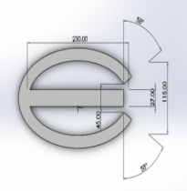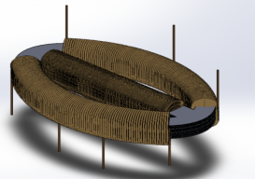
a b c
Fig. 1 The Distribution Transformer Elliptical Core Design

Numerical Assumptions By IEEE std.91-2011 and IEC 60076-7:2005; Three-phase rating S_{total} = 100 kVA, V_{LL} = 415V , f = 50 Hz, B_{max} =1.4T, copper resistivity Ρ_{cu} =1.724×10⁻⁸ Ωm, current density J = 3 A/mm² (i.e. 3×10⁶ A/m²), Mean turn length L_{turn} = 0.6 m, stacking length Lstack = 0.25 m and the steel density = 7650 kg/m³. The area as in (11) consideration of the elliptical core design is;
(11)
But , , if , (12)
, (13)

Where A is cross-sectional area, R as in (12) is winding resistance, l is circumference, N is number of turns, ‘a’ and ‘b’ are minor and major radius of the ellipse, I is current, H as in (13) is magnetic field strength, is co-efficient of resistivity, i_{L} load current i_{n} and is no-load current.

Thermal model of the Elliptical Core

A standard lumped two-node thermal network for an oil-immersed transformer winding (winding and oil nodes) is (14):
(14)
Where ; θ_{w}(t) = winding temperature (ºC), θ_{o}(t) = bulk oil temperature (ºC), θ_{amb} = ambient temperature (ºC), P_{w} = winding copper loss, C_{w}, C_{o} = thermal capacitance (J/K) of winding and oil, R_{w} = thermal resistance from winding to oil (K/W) and R_{o} = thermal resistance from oil to ambient (K/W)

Expression for R_{w} from Geometry

Winding to oil thermal resistance is dominated by convective heat transfer to oil across the wetted surface area A. A simple model as in (15):
(15)
where h_{oil} is an effective convective heat-transfer coefficient of oil (W/m²K) and A is the external surface area of the winding envelope that exchanges heat with the oil (m²). Thus geometries with larger wetted surface area for the same winding volume will have smaller R_{w} and generally lower winding temperature under the same loss. Perimeters/circumferences used to estimate side surface area as in (16), (17) and (18):

ellipse perimeter, (16)
rectangle perimeter, p = 2(W+H) (17)
Circle perimeter,p = 2πr (18)

Hot-spot factor H
A common simplified engineering IEEE approach uses a hot-spot factor H which relates hottest-spot rise to the average winding rise:
Θ_{h} = θ_{amb} + HΔθ_{w}​ (19)
where Δθ_{w} = average winding temperature rise above ambient H is dimensionless, typically H ≳1.0

OPTIMIZATION ALGORITHMS

When designing distribution transformers, optimization algorithms are often applied to balance efficiency, cost, size, weight, material usage, and performance under load conditions. These algorithms can be broadly grouped into classical (mathematical) and modern (meta-heuristic) approaches.

Deterministic Optimization, DOA

These rely on mathematical formulations and gradients.
Linear Programming (LP): For problems with linear cost and constraint functions (e.g., material cost minimization).
Nonlinear Programming (NLP): Used when objective/constraints are nonlinear (e.g., efficiency–loss tradeoffs).
Quadratic Programming (QP): For quadratic cost functions, such as minimizing copper and core losses.
Dynamic Programming (DP): Suitable for multi-stage decision problems (e.g., winding design across sections).
Gradient Descent / Newton Methods: For continuous optimization when an analytical gradient exists.

Evolutionary and Swarm Intelligence Algorithms, ESIA

This is useful since the distribution transformer design problems are nonlinear, multi-modal, and constrained.
Genetic Algorithms (GA): Popular in transformer design for optimizing winding, insulation, and loss minimization.
Particle Swarm Optimization (PSO): Efficient for finding optimal design parameters like core dimensions, conductor size, etc.
Differential Evolution (DE): Strong in handling real-valued optimization problems in transformer design.
Artificial Bee Colony (ABC): Mimics bee foraging to optimize cost–loss balance.
Ant Colony Optimization (ACO): Can be applied to layout/connection optimization in winding design.
Simulated Annealing (SA): Good for avoiding local minima in transformer design search spaces.

Advanced AI Based Approaches, AABA

Hybrid GA - PSO / GA–SA: Combine strengths of multiple metaheuristics. = Fuzzy Logic + Optimization . This is useful for handling uncertainty in load profiles.

Neural Network - Based Optimization: Predict distribution transformer performance quickly and integrate with GA/PSO for faster optimization.
Multi-Objective Evolutionary Algorithms (MOEAs): Such as NSGA-II (Non-dominated Sorting Genetic Algorithm) balances trade-offs between cost, losses, and efficiency.

Transformer in Non-Linear

A transformer is classified as non-linear when its behavior does not obey the superposition and homogeneity principles. This happens mainly due to the magnetic properties of the core and certain operating conditions. Key Causes of Non-linearity in Transformers are Magnetic Core Saturation, Hysteresis Effect, Eddy Current and Skin Effect and Leakage Flux Saturation in Structural Parts

Effects of Transformer Non-Linearity

Output voltage/current is no longer a pure sinusoidal hence harmonic distortion. Non-linearity causes large transient currents known as inrush current. This in effect increased in core losses hysteresis + eddy currents. This thesis seeks to address all these anomalies.

Linear Model of the elliptical core Transformer

In the linear case, the elliptical core distribution transformer is modeled with turns ratio law, winding resistance, leakage reactance, magnetizing branch equations. For a transformer with turns ratio refer to (20);
​ (20)
Equivalent Circuit Equations referred to the primary side is: . The no-load or excitation current is:

Non-Linear Model of the elliptical core Transformer

When non-linear effects such as core saturation, hysteresis, and eddy currents have been considered, the magnetic behavior of the distribution transformer always deviates from linearity.

Nonlinear Flux Current Relation is . However, in the non-linear case, this relationship becomes: where f() is a nonlinear function derived from the B - H curve of the core.
That means the magnetizing inductance L_{m} is not constant but depends on flux as in

Nonlinear Magnetizing Current

From Faraday’s Law is Since Φ(t) is a nonlinear function of I_{m}(t) is (21):
(21)
This means that even if v_{m}(t) is sinusoidal, the resulting i_{m}(t) will contain harmonics, due to the nonlinear magnetic characteristics.

Hysteresis Modeling

Hysteresis introduces memory into the magnetic behavior. A simplified expression for the magnetic flux density is: B(t) = μ(H)H(t), where μ(H) is a nonlinear

Full Nonlinear Equivalent Circuit

In the nonlinear model,the total magnetizing current is expressed as: , where Hysteresis current is Saturation current and is nonlinear B - H relation. Nonlinear primary voltage equation gives the instantaneous voltage at the primary winding is:

(22)

RESULTS AND DISCUSSION

The mathematical model of the proposed method is used to design a three-phase, elliptical core type, kVA distribution transformer for Ghana’s economy. The objective function of design distribution transformers is the minimization of losses in order to have more possible core inductance during the life span of the transformer. The optimization problem is then solved by cross-sectional area consideration integral in comparison with the rectangular and the circular method employing DOA, ESIA and AABA optimization algorithms. The technical specification of the test elliptical core distribution transformer is given in Table 5. The robustness of the proposed method is compared with that of the empirical method currently being used in the manufacturing lines. Two main drawbacks of the conventional method is i) very time-consuming process of calculation which may take hours to find a solution complying with all design restrictions and ii) the conventional methods never guarantee the global optimum solution. To overcome the aforementioned drawbacks, the use of heuristic elliptical methods not only guarantee a near-optimal solution but also the calculation time decreases significantly. The average execution time required to perform the transformer design optimization, minimum and maximum value of the solution obtained after 40 executions as well as percentage of Standard Deviation. Figure 2 show that thermal stress (H) increases with load current for all cases. However, for an elliptical-core transformer, the values of H are lower and increase more gradually with current. This is due to the smoother magnetic flux path, reduced flux concentration, shorter winding length, and lower copper losses, which result in better heat distribution and lower hotspot temperatures.

In contrast, the rectangular (EI) core transformer exhibits higher H values and a steeper increase with current. The sharp corners and longer flux path cause flux crowding, higher losses, and localized heating, leading to increased thermal stress and reduced insulation life.

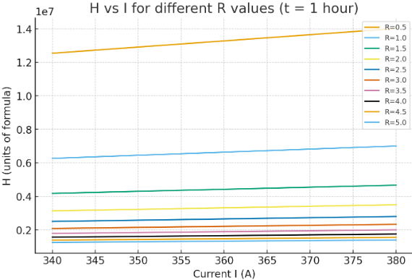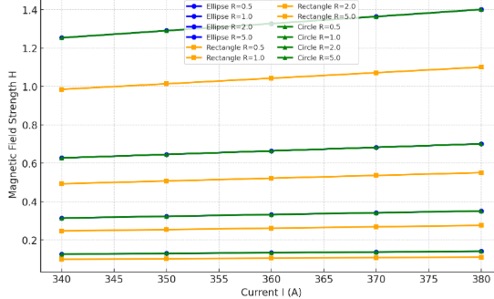
Fig. 3 Comparison of H vs I for Elliptical, Rectangular and Circular Core
Fig. 2 H vs I for Elliptical Core of Distribution Transformer

Figure 3 shows that, the elliptical-core transformer consistently exhibits lower magnetic field strength (H) for the same current compared with the rectangular (EI) core, across all resistance values. This is due to the smoother and more continuous magnetic path in the elliptical core, which reduces flux crowding and magnetizing requirements. The rectangular core shows higher H values and a steeper increase with current because sharp corners and non-uniform flux distribution lead to higher magnetizing force and increased losses.

The temperature–load plot shows that temperature rise increases non-linearly with load for all core geometries. The elliptical core exhibits the lowest temperature rise across the entire load range, followed by the circular core, while the rectangular (EI) core shows the highest temperature rise. This behavior is due to the elliptical core’s smoother flux path and more uniform heat distribution, which reduce core losses, copper losses, and hotspot formation. The rectangular core, with sharp corners and flux concentration, experiences higher localized losses and poorer thermal performance.

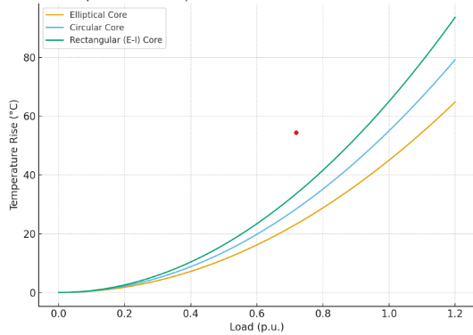
Fig. 4 Comparison of Temperature Rise for three core Geometries

Figures 5 compares the temperature rise of a transformer with rectangular and elliptical cores over a 24-hour period. The elliptical core (solid lines) shows lower core and winding temperatures throughout the day compared to the rectangular core. The rectangular core (dashed lines) reaches higher peak temperatures, especially during peak load hours. This indicates that the elliptical core dissipates heat more effectively, likely due to better flux distribution and reduced losses. Ambient temperature remains nearly constant, so the differences are mainly due to core geometry, not environmental changes. In all, the elliptical core offers better thermal performance and efficiency than the rectangular core.

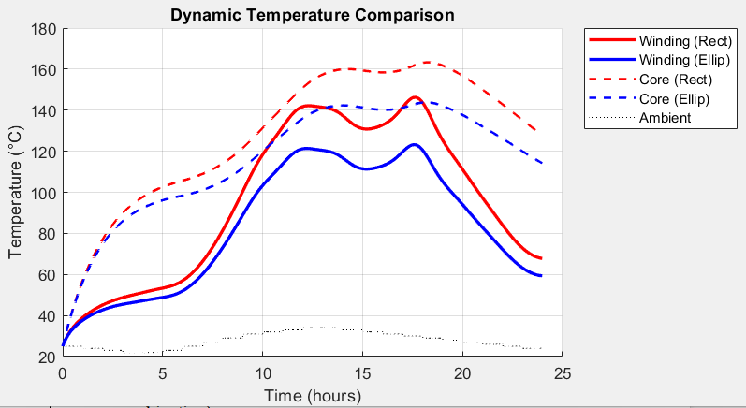
Fig. 5 Rectangular and Elliptical winding and Core Temperature with Time Characteristics

Figure 6 shows the dynamic load, power factor (PF), and thermal response of a transformer with an elliptical core over a 24-hour period. As the load (real and RMS current) increases during the day, the core and winding temperatures rise correspondingly. The power factor improves during higher load periods, indicating more efficient operation. Peak temperatures occur during peak load hours, but the temperature rise is smooth and controlled, showing good thermal stability. When the load decreases, both current and temperature drop accordingly. In all the graph demonstrates that the elliptical core handles load variations efficiently, maintaining stable thermal behavior and improved performance throughout the day.

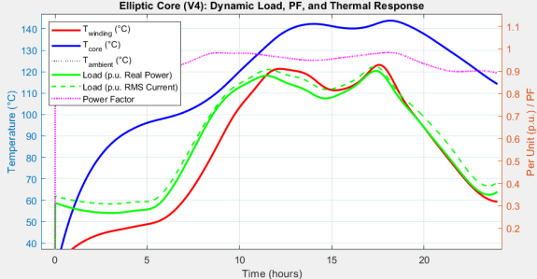,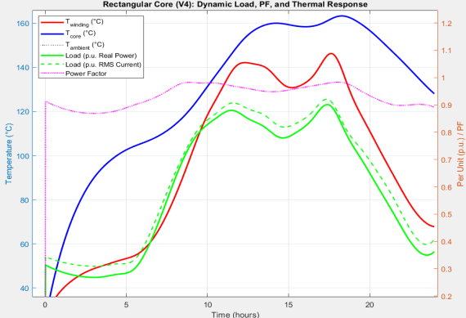
Fig. 7 Rectangular Core Dynamic Load, PF, and Thermal Response

Fig. 6 Elliptical Core Dynamic Load, PF, and Thermal Response

Figure 7 is the comparison of rectangular core dynamic load, power factor, and thermal response with time. As the load and RMS current increase, the core and winding temperatures of the rectangular core rise more sharply compared to an elliptical core. The power factor improves during higher load periods but is generally less stable, showing slightly poorer efficiency under fluctuating loads. Peak temperatures are higher during peak load hours, indicating greater thermal stress and less effective heat dissipation. Temperature changes tend to be more pronounced, meaning the rectangular core responds less smoothly to load variations. In all, the rectangular core shows higher thermal response and losses under dynamic loading, making it less thermally efficient than an elliptical core under same operating conditions.

Figure 8 compares the total daily energy losses of a transformer with elliptical and rectangular cores, broken down by loss components. The elliptical core shows lower losses in both core losses (hysteresis and eddy current) and winding losses. The rectangular core has higher core losses, especially eddy current loss, and also higher ohmic winding loss (I²R). Loss due to stray harmonics is small for both designs but is still slightly higher in the rectangular core. The graph indicates that the elliptical core is more energy-efficient, mainly because its shape reduces magnetic flux concentration and resistive losses compared to the rectangular core.

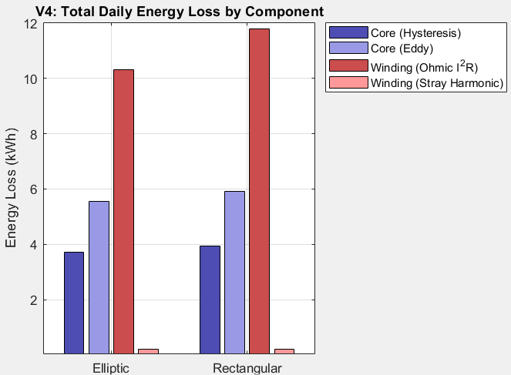
Fig. 8 Total Daily Energy Loss by Component

Figure 9 shows the characteristics comparison of dynamic power loss with time of regular and elliptical core with its load profile. This graph demonstrate an improve character of ellipse core shape over a rectangular in terms of total and load losses of distribution transform.

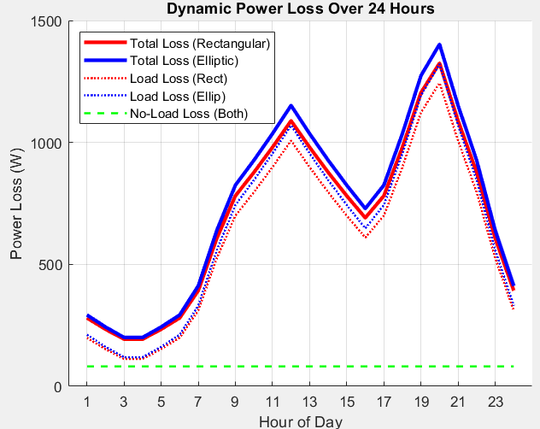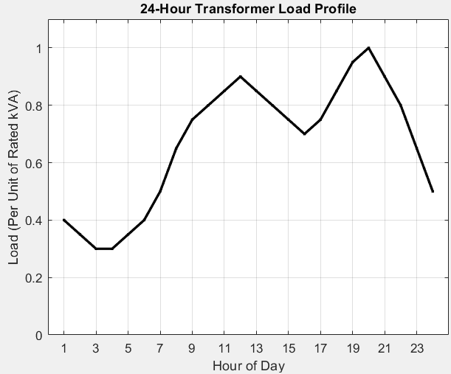
Fig. 9 Dynamic power Loss Over 24 Hours with its Load Profile

Evolutionary & Swarm-Based Elliptical Core Transformer Optimization

Step 1: Define the Optimization Problem

Objective: minimize a weighted cost function,
Where P_{cu} = Copper loss, P_{core} = Core loss, T = Temperature change, C_{total} = Total cost and = Weighting factors

Step 2: Create the Objective Function File
function F = transformer objective(x), x = [N1, N2, A_cond, A_core, Cooling Mode]

Table 2 gives the details of genetic algorithm and particle swarm optimization comparisons

Table 2 Genetic Algorithm and Particle Swarm Optimization comparisons
Metric | GA | PSO
Search behavior | More exploratory (diverse search) | Faster convergence
Computation time | Higher | Lower
Final loss value | Often slightly lower | Close but faster
Stability | Can vary with mutation | Generally consistent
Best for | Complex discrete design tuning | Continuous variable tuning

Deterministic optimization

Design variables: semi-major axis a and semi-minor axis b of the elliptical core cross-section (continuous variables).
Objective: minimize total estimated loss = copper loss (all 3 phases) + core loss (all 3 phases).
Method: deterministic Hooke Jeeves pattern search (no randomness; repeatable given the same start and parameters). Bounds: a ∈ [0.02, 0.08] m, b ∈ [0.01, 0.05] m. Deterministic optimization is used to design a three phase elliptical core distribution transformer to give a total loss as shown in figure 11.

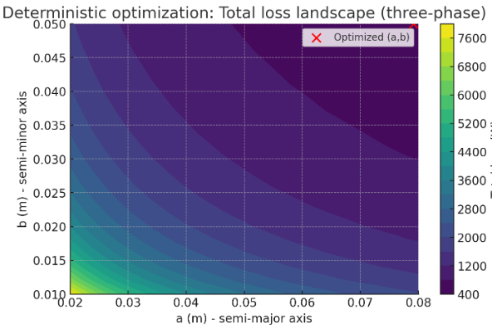
Fig. 11 Deterministic Optimization: Total Loss of Distribution Transformer

Evolutionary And Swarm Intelligence Algorithms

Evolutionary (Genetic Algorithm) and swarm intelligence (Particle Swarm Optimization) methods is used to design a three phase elliptical core distribution transformer, and produced tables, convergence plots, population spreads, and a loss-landscape contour with the best points marked.
Convergence plot comparing GA vs PSO best fitness over generations/iterations shown figure 10. Scatter population spread (core mass per phase vs copper loss) is shown in figure 12. Contour: total loss landscape over the (a,b) space with GA and PSO best points marked.

Observations from the Runs

Both algorithms converged quickly to low-loss regions; PSO reached a stable solution faster in this run, GA continued improving early but matched PSO later as shown in figure 12 ‘a’ and Core mass vs Copper Loss Characteristics is shown on ‘b’. Best solutions are near larger core area (higher a & b) where copper loss drops, but core loss increases the algorithms balanced that trade off under the assumed core-loss model. The results are algorithm-dependent (random initialization); you can re-run with different seeds or larger populations for robustness.

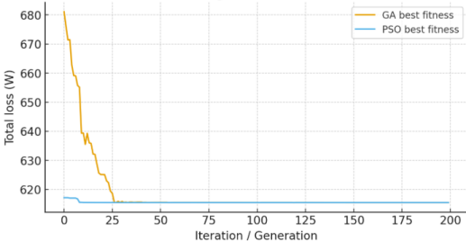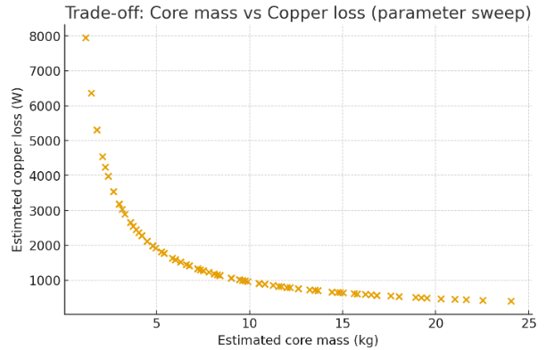
Fig. 12 ‘a’ GA, PSO Interpretation of Transformer Total Losses ‘b’ Core mass vs Copper Loss

Figure 14 Shows the trade-offs for an elliptical-core distribution transformer. I used a simplified, transparent engineering model (assumptions listed in the computation) and swept the ellipse semi-axes to reveal how geometry affects required turns, copper loss and estimated core loss.

Key assumptions used Rating: 50 kVA, single-phase, V1 = 415 V, f = 50 Hz., Peak flux density Bmax = 1.4 T, Mean turn length ≈ 0.6 m, stacking (core) length 0.25 m, Copper current density 3 A/mm², Copper resistivity 1.724e−8 Ω·m, Core specific loss (empirical placeholder) 3 W/kg at 1.4 T, 50 Hz and the Geometry: elliptical core cross section A = π·a·b with a in [0.02,0.08] m and b in [0.01,0.05] m.

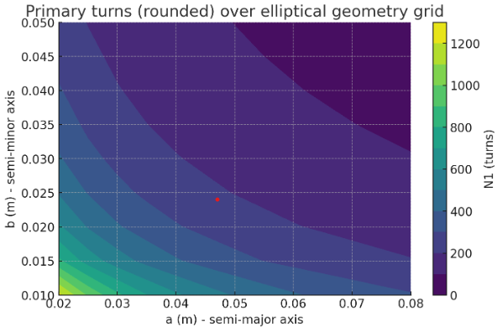
Fig. 14 Trade-offs for an Elliptical Core Distribution Transformer

Table 3 explains the distribution transformer elliptical core itemised cost estimate. Table 4 also gives the details of the elliptical core distribution transformer manufacturing and services cost estimates. Hence the grand total cost for manufacturing an elliptical core type distribution transformer is $14,555.27 USD per 100 kVA

Table 3 Itemized cost Estimate
Item | Quantity | Unit price (USD) | Cost (USD)
Core silicon steel laminations | 350 kg | $0.85 / kg | $297.50
Copper (windings) | 120 kg | $10.851 / kg | $1,302.12
Tank / structural steel (raw) | 220 kg | $0.85 / kg | $187.00
Transformer oil | 200 L | $1.80 / L | $360.00
Insulation paper/pressboard/varnish | lump | — | $400.00
Bushings & fittings | lump | — | $800.00
Tap changer / regulator (off-load) | lump | — | $1,200.00
Paint, small parts | lump | — | $150.00
Materials subtotal |  |  | $4,696.62

Table 4 Manufacturing and Services Cost Estimates
Item | Cost (USD)
Winding labour (winder, insulation, leadings) | $1,500.00
Tank fabrication & welding | $1,200.00
Assembly, filling, fitting | $800.00
Routine testing & type/acceptance tests | $1,200.00
Quality/certification paperwork | $300.00
Packaging & skids | $200.00
Domestic transport (to yard / port) | $500.00
Direct costs subtotal | $10,396.62

General charges are;
Overhead (factory, admin, insurances): 20% of direct costs = $2,079.32
Manufacturer profit margin (typical) 10% of direct costs = $1,039.66
Contingency / spare parts allowance 10% of direct costs = $1,039.66
Grand Total : $14,555.27 USD per 100 kVA

CONCLUSIONS

This paper addresses the issue of overloading-induced distribution transformer failures. The proposed energy efficiency optimization algorithm for distribution transformer core redesign of elliptical cross-sectional area is examined. The objective function and constrains are formulated mathematically and implemented in MATLAB environment. In comparative analysis of optimization results, the algorithm’s performance is assessed. A detailed analysis of the gap at various core steps is conducted. Findings suggest that taking into account manufacturing constraints and the time gain to construct each core step, the optimal number of steps falls within the range of 7 to 10. The results show that this approach is significant enough to mitigate the adverse effects of load increase above 50 % load capacity on distribution transformers, improving system reliability and reducing maintenance costs. Rectangular core design is most effective at lower load ranges, reaching its optimal energy efficiency at 50 load capacity meanwhile elliptical core type provides superior performance at higher loads, maintaining higher efficiency at 70 approximate load capacity. For future work, the implementation of Finite Element Method to analyze the performance of the number of steps and gap percentage on the distribution transformer core during short circuit events is recommended. This paper analyses the under efficiency-caused distribution transformer failures in attempt to find the optimal solution for the distribution transformer overload failures.

REFERENCES

- Koca, A.; Senturk, O.; Ömer, A.; Özcan, H. Techno-Economic Optimization of Radiator Configurations in Power Transformer Cooling. Designs 2024, 8, 15.
- Kim, Y.J.; Jeong, M.; Park, Y.G.; Ha, M.Y. A numerical study of the effect of a hybrid cooling system on the cooling performance of a large power transformer. Appl. Therm. Eng. 2018, 136, 275–286.
- Bandyopadhyay, S. The first step towards energy revolution. Clean Technol. Environ. Policy 2019, 21, 227–228.
- Telles, A.; Morera-Hernández, M.; Eneldo López-Monteagudo, F.; Villela-Varela, R. Prospectiva de las energías eólica y solar fotovoltaica en la producción de energía eléctrica. CienciaUAT 2017, 11, 105–117.
- Kumar, S.S.; Rathore, K. Renewable Energy for Sustainable Development Goal of Clean and Affordable Energy. Int. J. Mater. Manuf. Sustain. Technol. 2023, 2, 1–15.
- Kennedy, M.W.; Stanić, Z. The Role of Renewable Energy Sources in Future Electricity Supply. J. Energy-Energija 2006, 55, 292–327.
- Li, H.; Peng, W.; Adumene, S.; Yazdi, M. Attention Towards Energy Infrastructures: Challenges and Solutions. In Intelligent Reliability and Maintainability of Energy Infrastructure Assets; Springer Nature Switzerland: Cham, Switzerland, 2023; pp. 137–148.
- Guo, Y.; Chang, Y.; Lu, B. A review of temperature prediction methods for oil-immersed transformers. Measurement 2025, 239, 115383.
- Jin, L.; Kim, D.; Abu-Siada, A.; Kumar, S. Oil-Immersed Power Transformer Condition Monitoring Methodologies: A Review. Energies 2022, 15, 3379.
- Medeiros, L.H.; Oliveira, M.M.; Beltrame, R.C.; Bender, V.C.; Marchesan, T.B.; Marin, M.A. Thermal Experimental Evaluation of a Power Transformer Under OD/OF/ON Cooling Conditions. In Proceedings of the 2023 15th Seminar on Power Electronics and Control, SEPOC 2023, Santa Maria, Brazil, 22–25 October 2023.
- Ahmed, E.E.; Poyrazoglu, G.; Celikpence, M.; Keles, M.; Kozalioglu, S.; Sevim, Y. Enhancing Energy Efficiency in Distribution Grids through Load Profile-Driven Mutual Displacement of Transformers. In Proceedings of the 2024 6th Global Power, Energy and Communication Conference (GPECOM), Budapest, Hungary, 4–7 June 2024; pp. 630–634.
- Xu, Z.; Ma, N.; Li, B.; He, Z.; Wang, Y.; Wang, S. Analysis of the Influence of Insulation Oil Type on Temperature Rise of Oil-immersed Power Transformer. In Proceedings of the 2024 9th Asia Conference on Power and Electrical Engineering (ACPEE), Shanghai, China, 11–13 April 2024; pp. 1968–1972.
- Li, Y.; Zhou, Z.; Lin, B.; Zhang, H.; Huo, W.; Deng, H.; Liu, G. Analysis of external heat dissipation enhancement of oil-immersed transformer based on falling film measure. Therm. Sci. 2022, 26 Pt A, 4519–4533.
- Tsili, M.A.; Amoiralis, E.I.; Kladas, A.G.; Souflaris, A.T. Power transformer thermal analysis by using an advanced coupled 3D heat transfer and fluid flow FEM model. Int. J. Therm. Sci. 2012, 53, 188– 201. ]
- Sun, C.c.; Xiao, C.; Hou, J.; Kong, L.; Ye, J.; Yu, W.j. Analysis of Factors Affecting Temperature Rise of Oil-immersed Power Transformer. J. Phys. Conf. Ser. 2020, 1639, 012087.
- Li, M.; Yao, W.; Gao, X.; Ren, Y. Temperature simulation of oil-immersed transformer based on fluid-thermal coupling. J. Phys. Conf. Ser. 2023, 2503, 012060.
- Gao, M.; Ding, Y.; Wang, T.; Wen, T.; Zhang, Q. Study on bubble evolution in oil-paper insulation during dynamic rating in power transformers. In Proceedings of the 2016 IEEE International Power Modulator and High Voltage Conference (IPMHVC), San Francisco, CA, USA, 6–9 July 2016; pp. 341–344.
- Galletti, B.; Blaszczyk, A.; Wu, W. CFD Based Sensitivity Study of Cooling Performance of Transformer Radiators. In Proceedings of the 2019 6th International Advanced Research Workshop on Transformers (ARWtr), Cordoba, Spain, 7–9 October 2019; pp. 1–6.
- Zhao, S.; Liu, Q.; Wilkinson, M.; Wilson, G.; Wang, Z. A Reduced Radiator Model for Simplification of ONAN Transformer CFD Simulation. IEEE Trans. Power Deliv. 2022, 37, 4007–4018.
- Tian, Y.; Si, W.; Fu, C.; Tian, Y.; Yuan, P.; Yang, J.; Wang, Q. Numerical Study on Hydrodynamic and Heat Transfer Performances for Panel-Type Radiator of Transformer Using the Chimney Effect. Chem. Eng. Trans. 2023, 103, 163–168.
- Roger, D., Napieralska, E., Komeza, K., & Napieralski, P. (2022). Design of high-power solid-state transformers with grain-oriented electrical steel cores. Electronics, 11(15), 2398.
- Telli, S., İskender, I., & Yükselen, E. (2024). Cost optimization of oil-type distribution transformer using multi-objective genetic algorithm. Journal of Energy Systems, 8(1), 53-62.
- Arya Venugopal, & Robert, F. (2023). Finite element study of core materials of a planar transformer and comparison of its electromagnetic properties with a high-frequency transformer. Journal of Engineering Science and Technology Review, 16(3), 123-128.
- Yu, C., & Zhao, L. (2024). Optimization design of medium-voltage high-frequency transformers based on parallel sampling Kriging surrogate model. Academic Journal of Science and Technology, 10(1), 186-191.
- Liu, Y. (2023). High-frequency transformers optimized design for power electronic transformers. Applied and Computational Engineering, 10, 196-202. (Conference proceeding)

