Nanofluids in Flat Plate Solar Collectors: Performance Evaluation, Emerging Trends, and Future Research Directions

Abstract
This review critically examines the application of flat-plate solar collectors (FPSCs) using nanofluids, synthesizing findings from experimental, numerical, and hybrid studies published between 2015 and 2025. Key parameters influencing performance-including nanoparticle type, base fluid, and volume concentration-are systematically analyzed. Results indicate that Al2O3, CuO, and TiO2 are the most widely used nanoparticles, while water remains the dominant base fluid (~83%). Most studies employ low concentrations (0–0.5 vol%), demonstrating that significant thermal enhancement can be achieved without excessive viscosity penalties.
Keywords: Flat plate solar collectors; Nanofluids; Thermal efficiency; Hybrid nanofluids; Exergy analysis

Nomenclature
$A$: Area $\left[m^{2}\right]$
$C_{p}$: Specific heat capacity $\left[kJ/(kg⋅K)\right]$
$k$: Thermal conductivity $\left[W/(m⋅K)\right]$
$T$: Temperature $\left.[^{∘}C\right]$
Greek Symbols
$μ$: Dynamic viscosity $\left[kg/(m⋅s)\right]$
$ρ:$ Density $\left[kg/m^{3}\right]$
$ϕ:$ Solid volume fraction
Dimensionless Parameters
$Nu$: Nusselt number
$Re:$ Reynolds number
Subscripts
$nf$: Nanofluid
$bf$: Base fluid
$np$: Nanoparticle
$hnf:$ Hybrid nanofluid
Abbreviations
Al₂O₃: Aluminum oxide
CeO₂: Cerium oxide
CuO: Copper oxide
Fe₃O₄: Iron oxide
SiO₂: Silicon dioxide
TiO₂: Titanium dioxide
ZnO: Zinc oxide
MWCNTs: Multi-walled carbon nanotubes
SWCNTs: Single-walled carbon nanotubes
GNPs: Graphene nanoplatelets
h-BN: Hexagonal boron nitride
CNC: Crystal nanocellulose
CF: Covalent functionalized
FPSCs: Flat Plate Solar Collectors
ETSCs: Evacuated Tube Solar Collectors
PTSCs: Parabolic Trough Solar Collectors
LFSCs: Linear Fresnel Solar Collectors
PDC: Parabolic Dish Collector
1. Introduction
The worldwide energy demand continues to rise at an accelerating pace. This increasing consumption has intensified reliance on fossil fuels, which carry significant environmental and economic burdens. Factors including the limited supply of conventional energy resources, the rising prices of fossil fuels, stringent environmental regulations, and the global drive towards sustainable development have collectively focused the attention of both developing and developed nations on renewable energy systems. Renewable energy technologies convert sunlight, wind, and geothermal heat into useful forms of energy while avoiding the emission of greenhouse gases and other pollutants.
Most of the energy available on Earth comes from sunlight. The Sun emits photons as a result of its natural nuclear reactor, and they travel approximately 150 million kilometers to reach Earth in about 8.5 minutes. Solar energy provides a clean, widely available, pollution-free source for supplying heating, cooling, and electricity needs. Solar energy can be used directly (e.g., for heating and lighting) or indirectly (e.g., via wind energy or hydroelectric power), making it the most versatile renewable resource.
Solar collectors function as heat-transfer devices that convert solar radiant energy into thermal energy within a carrier fluid. These devices are classified into two primary categories: non-concentrating (fixed) and concentrating collectors. Non-concentrating collectors absorb solar energy across a single flat surface and are generally employed in low- to medium-temperature applications. In contrast, concentrating collectors utilize reflective or refractive surfaces to direct solar radiation onto a reduced receiver area, thereby achieving higher operating temperatures appropriate for power generation and industrial processes.
FPSCs are among the most widely installed and commercially mature technologies worldwide. Between 2011 and 2021, 15% increase in the flat plate solar collectors (FPSCs) utilization, 35 % of all solar collectors deployed during the period. In Europe, FPSCs constituted nearly 72% of solar thermal installations, highlighting their predominant role in both domestic and commercial heating sectors.
Despite their widespread use, FPSCs have a limited thermal efficiency in comparison with conventional heat transfer liquids such as water, ethylene glycol and mixtures thereof. This has stimulated considerable research into the use of nanofluid suspensions of particles at the nanometre scale in conventional base fluids to enhance the thermal transfer efficiency of solar collectors. More than 100 experimental and numerical studies on the application of nanofluids in FPSCs are methodically examined in this review, which covers publications from 2015 through 2025. The review is organized to cover the following topics: the kinds of base fluids and nanoparticles used; the volume concentrations examined; the reported thermal, energy, and exergy efficiencies; the developing role of hybrid nanofluids and passive enhancement devices; and the use of machine learning and artificial intelligence for performance modeling and optimization.
2. Flat Plate Solar Collectors
In comparison to concentrating systems, the flat plate solar collector (FPSC) is the most popular and extensively used solar collector configuration. It is also the most straightforward in design, the easiest to install, the least maintenance-intensive, and the least expensive to manufacture. In order to let solar radiation in with the least amount of reflection and absorption losses, an FPSC is essentially a flat, rectangular box with a transparent cover, usually made of tempered glass or polycarbonate (see Figure 1). An absorber plate, typically composed of steel, copper, or aluminum and coated with a, intercepts the solar radiation that passes through the transparent cover.
FPSCs are typically installed in a fixed orientation to maximize the incident solar radiation over the course of a year. The tilt angle from the horizontal is adjusted by ±10–15° depending on the seasonal application emphasis, and it is approximately equal to the local latitude in the northern hemisphere. The face of the collector is facing south. Because FPSCs perform well in both direct and diffuse radiation, they can be used in a wide range of geographic locations. FPSCs are primarily used in solar-assisted heat pumps, solar desalination, industrial process heat, space heating, and domestic hot water production.
3. Nanofluids
Nanotechnology is an emerging field in many industrial sectors, as the physical, chemical, and thermal properties of materials change at the nanometre-scale. Nanofluids are one of the major applications of nanotechnology in thermal engineering and are a class of engineered heat-transfer fluids containing nanometre-sized solid particles (nanoparticles) stably dispersed in a conventional base fluid.
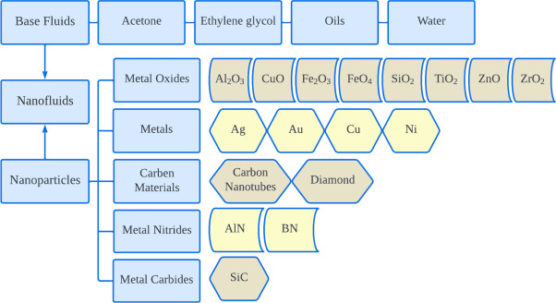
The concept of nanofluids was first formally introduced in 1995 by S.U.S. Choi at the Argonne National Laboratory (USA), who demonstrated that suspending nanoparticles in a base fluid could substantially enhance the fluid’s effective thermal conductivity. Since then, nanofluids have attracted extensive research interest, particularly for applications in solar energy systems, heat exchangers, refrigeration, electronics cooling, and biomedical devices.
Figure 2. Visual depiction of base fluids and nanomaterials
The majority of nanoparticles used in nanofluids come from metals (e.g. The g. Cu, Ag), metal oxides (e.g. The g. carbon allotropes (e.g., Al₂O₃, CuO, TiO₂, ZnO, Fe₃O₄, CeO₂, SiO₂, MgO) see Figure 2. And the graphene nanoplatelets, single-walled carbon nanotubes (SWCNTs), multi-walled carbon nanotubes (MWCNTs), and new materials like nanodiamond and rare-earth oxides (e.g. Er₂O₃), hexagonal boron nitride (hBN), and silicon carbide (SiC), in addition to specialized fluids like therminol, glycerol, and triethanolamine, the most widely used base fluids are water, ethylene glycol, propylene glycol, and their binary mixtures. Nanofluids have several key thermophysical properties of interest for solar thermal applications, including increased effective thermal conductivity, modified viscosity and density, altered specific heat capacity, improved surface wettability, and radiation absorption characteristics. Well-formulated nanofluids possess a number of advantages over traditional fluids: high colloidal stability, a large specific surface area of nanoparticles that enhances heat transfer, lower particle clogging than traditional slurries, and controllable thermal properties by varying particle type, size, shape, and volume concentration.
However, the practical deployment of nanofluids is also subject to several challenges, including long-term stability and particle sedimentation; increased viscosity and associated pumping penalties at higher concentrations; potential toxicity and environmental concerns; scale-up and production costs; and inconsistencies in reported thermophysical property data across laboratories. These challenges motivate continued research into surface functionalization, surfactant selection, and the development of green synthesis methods for nanoparticles, as reflected in several recent studies reviewed here.
4. Literature Review
The main conclusions from research on the application of nanofluids in FPSCs are summarized in the following subsections, which are arranged by theme. The research includes numerical simulations (such as CFD and finite element methods), experimental investigations, and hybrid approaches that also use artificial neural networks (ANN) for predictive modeling.
4.1 Early Studies (2015-2017): Establishing Baselines
The period from 2015 to 2017 was characterized by systematic experimental evaluations of single-component nanofluids in FPSCs, establishing the fundamental performance improvements achievable through their adoption. He (2015) carried out one of the early comparative experimental studies, reporting that Cu nanoparticles dispersed in water at 0.1-0.2 vol% produced the highest temperature rise, with base fluid temperature increases reaching 12.24% and 24.52%, respectively. While Meibodi (2015) demonstrated that SiO₂ nanoparticles in an ethylene glycol-water mixture at concentrations up to 1 vol% yielded collector efficiency improvements of 4-8%. Shojaeizadeh (2015) reported that an Al₂O₃-water nanofluid allowed a reduction in optimal inlet temperature and fluid mass flow rate of approximately 2% and 68%, respectively, indicating the potential for more compact and energy-efficient collector configurations.
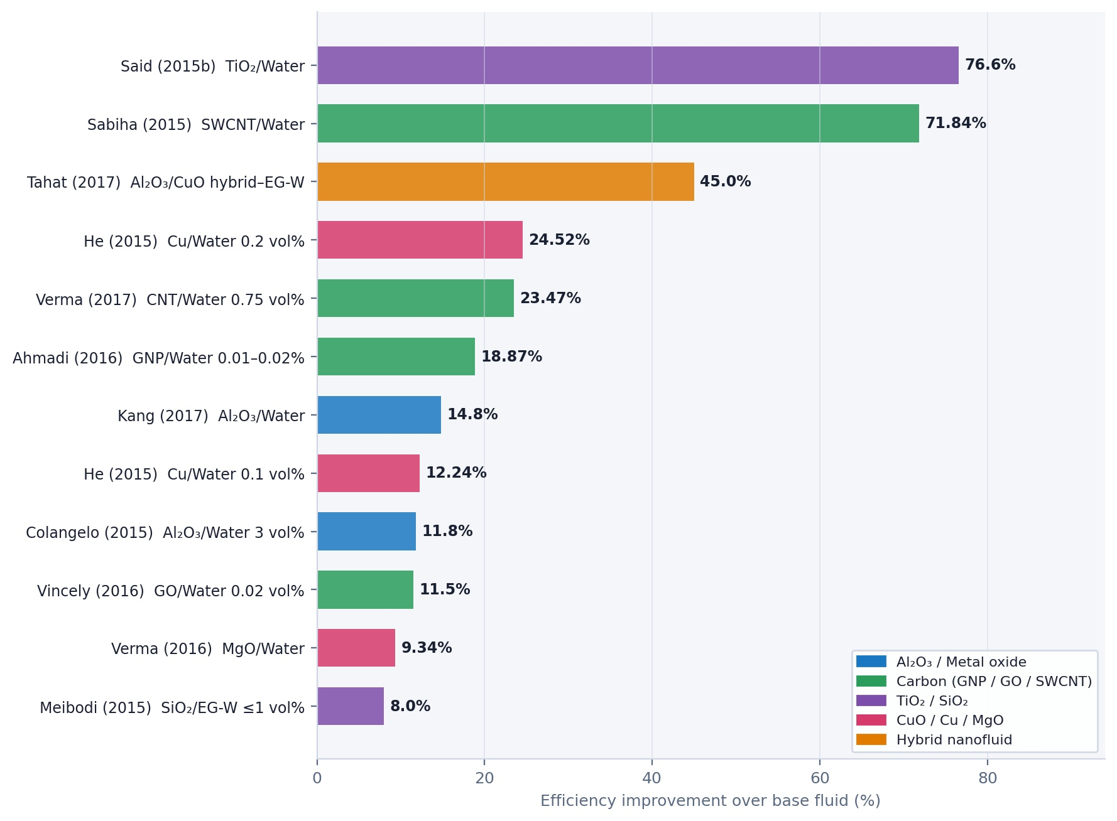
Colangelo (2015) investigated Al₂O₃ at a 3 vol% concentration and reported a notable thermal efficiency increase of 11.8%. Said (2015) performed numerical modelling of SWCNTs in water, exergy and energy efficiencies demonstrated at maximum of 26.25% and 95.12%, respectively, among the highest reported for single-component nanofluids at that time. Sabiha (2015) experimentally demonstrated that efficiencies can be increased up to 71.84% using nanofluid in SWCNT compared to pure water, while Said (2015) showed that thermal conductivity can be enhanced by 6% and energy and exergy efficiencies can be increased by 76.6% and 16.9% using TiO₂-water nanofluids. Verma (2016) investigated MgO nanoparticles in water and reported 9.34% and 32.23% enhancements in thermal and exergetic efficiencies, respectively. Ahmadi (2016) reported 18.87% enhancement in thermal efficiency at very low concentrations of 0.01-0.02 vol% for graphene nanoplatelets. Vincely (2016) confirmed 11.5% collector efficiency increase at 0.02 vol% for graphene oxide, while Salavati Meibodi (2016) reported exergy efficiencies of 62.7% for SiO₂ in ethylene glycol-water mixtures. Verma (2017) Conducted a comprehensive comparative experimental study across five nanoparticle types (Al₂O₃, SiO₂, TiO₂, CuO, and graphene) in water at 0.75 vol%, finding that carbon nanotubes delivered the highest exergy and energy efficiencies of 29.32% and 23.47%. Tahat (2017) investigated a hybrid Al₂O₃/CuO nanofluid in ethylene glycol-water and reported collector efficiency improvements of up to 45%, which is one of the highest gains reported for the 2015-2017 period. Kang (2017) achieved a heat efficiency of 74.9%, representing a 14.8% improvement over the base fluid with Al₂O₃ nanoparticles, Figure 3 showing the improvement in efficiency for the listed studies.
Figure 3. Thermal/energy efficiency gains
4.2 Expanding Investigations (2018-2019): Hybrid Nanofluids and Diverse Nanoparticles
In order to take advantage of synergistic improvements in thermal properties, research into hybrid nanofluids made up of two or more different nanoparticles increased during the 2018–2019 period. The hybrid nanofluid concept for FPSCs was validated by Farajzadeh (2018), who showed that combining Al₂O₃ and TiO₂ nanoparticles in a hybrid configuration at 0.1 vol percent led to a 26 percent increase in thermal efficiency. According to Ameri and Eshaghi (2018), a Fe3O4-water nanofluid achieved a historic result for single-component nanofluids by increasing system thermal efficiency to 83.97 percent. Ziyadanogullari and associates. (2018) discovered a maximum collector performance improvement of 63.71 percent when comparing Al₂O₃, CuO, and TiO₂, while Kiliç et al. (2018) found that TiO₂ at 2 vol percent raised peak efficiency to 48.67 percent as opposed to pure water's 36.20 percent.
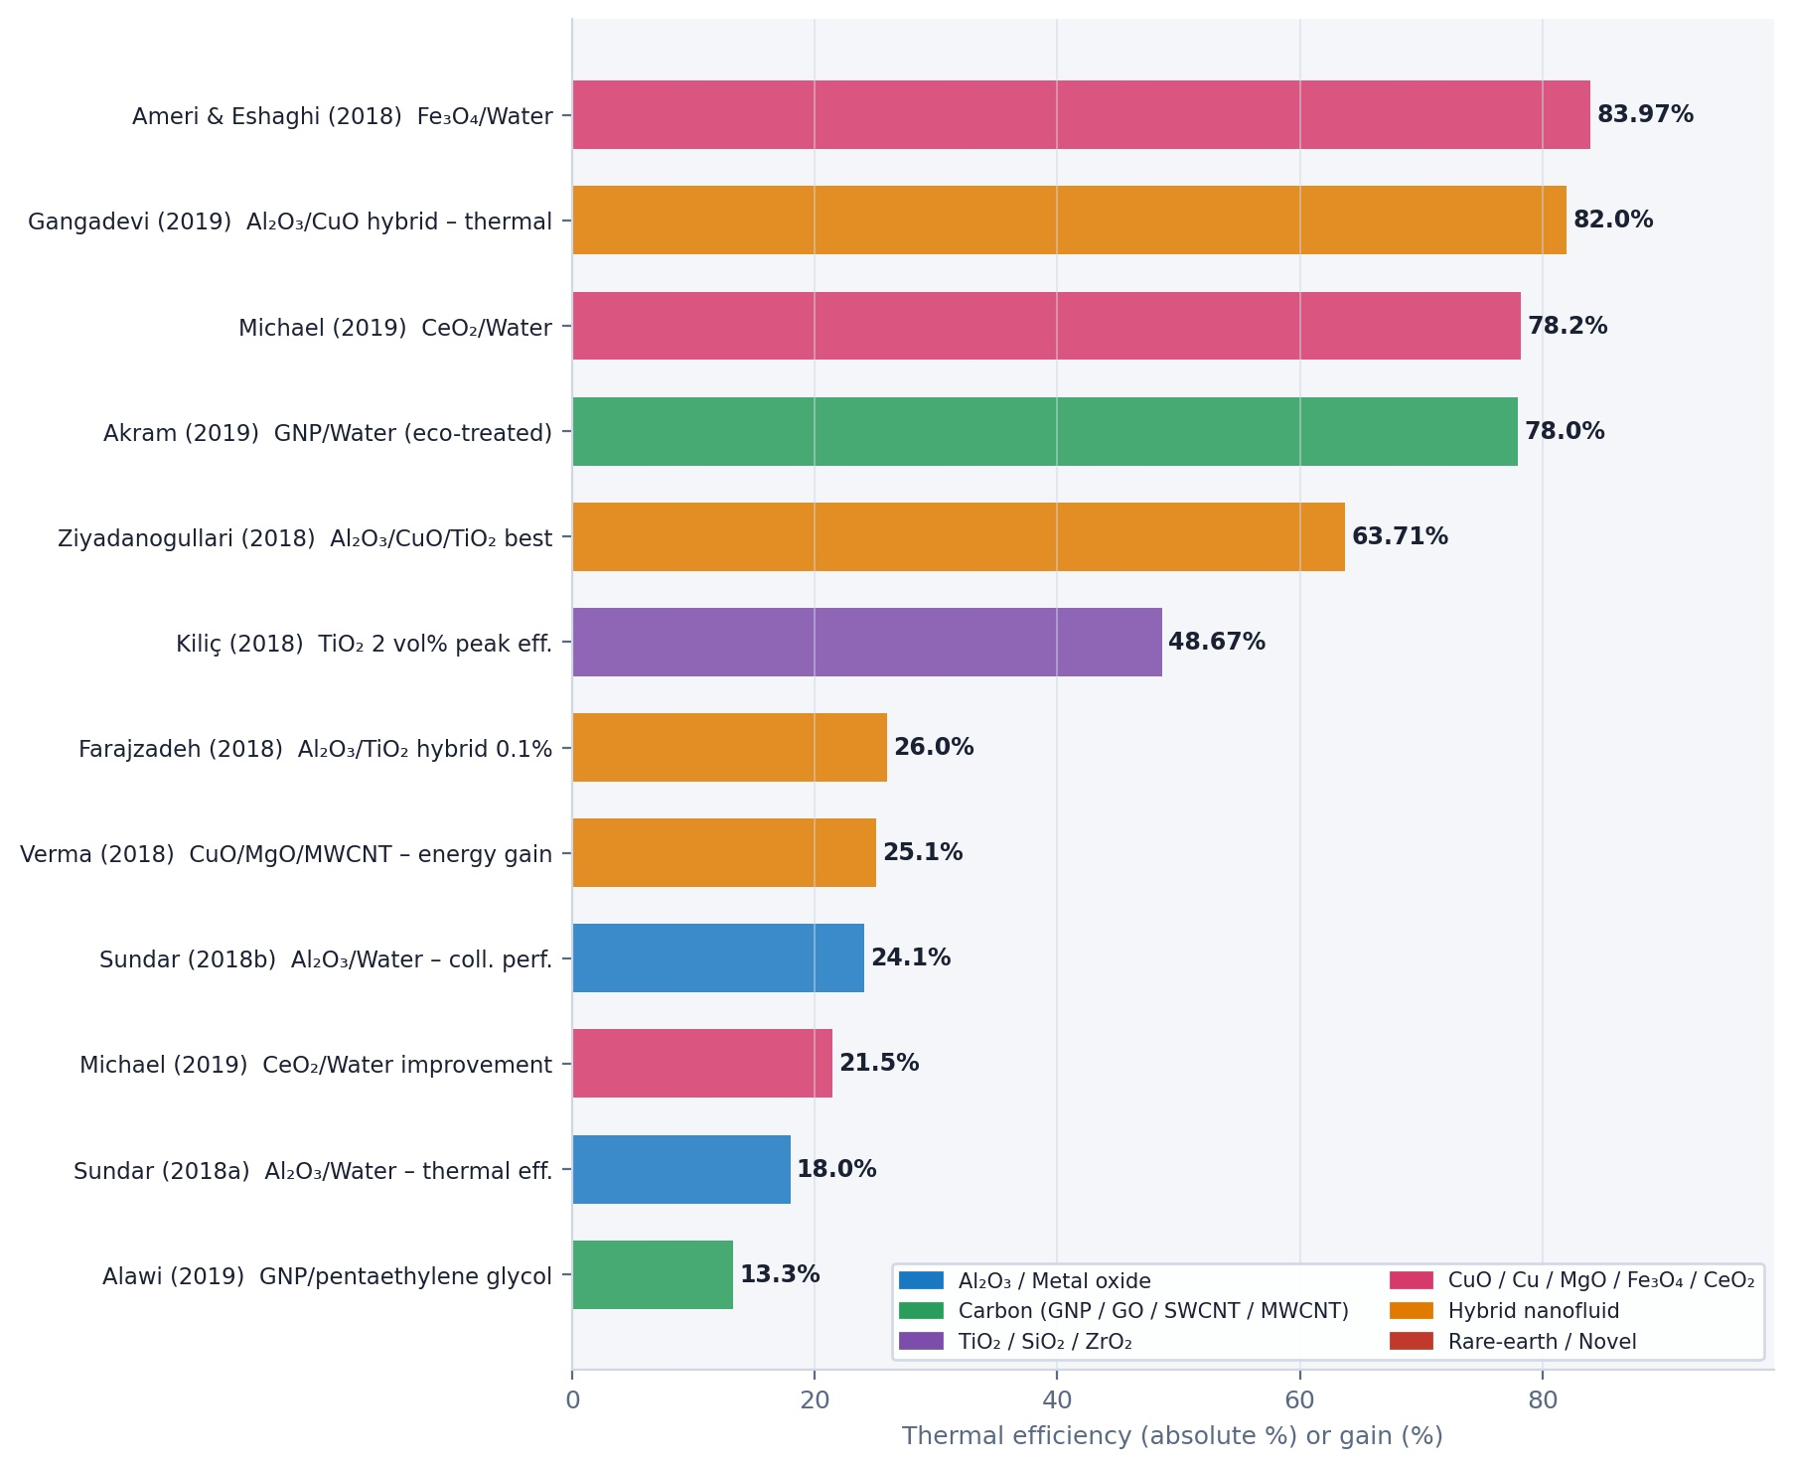
Verma and associates. (2018) reported energy-efficiency and collector-energy improvements of 25.1 percent and 16.28 percent, respectively, by numerically simulating a hybrid CuO/MgO/MWCNT nanofluid, extending their previous work. Sundar and associates. (2018a, 2018b) carried out extensive experimental studies with Al2O3-water nanofluids, showing improvements in collector performance of up to 24.1 percent and increases in thermal efficiency of 18%. Michael and associates. (2019) used CeO₂ nanoparticles in water to reach a maximum efficiency of 78.2 percent, which is 21.5 percent better than pure water. Akram and associates. (2019) assessed environmentally friendly treated graphene nanoplatelets and achieved a maximum thermal efficiency of 78%. With a hybrid Al2O3/CuO nanofluid, Gangadevi and Vinayagam (2019) reported peak electrical and thermal efficiencies of 15% and 82%, respectively, while Alawi et al. (2019) used treated graphene nanoplatelets in pentaethylene to increase efficiency by 13.3%, Figure 4 showing the improvement in efficiency for the listed studies.
Figure 4. Thermal/energy efficiency gains
4.3 Advancing Performance (2020-2021): High-Efficiency Hybrid Systems
The 2020-2021 period is notable for a significant number of studies documenting collector efficiencies exceeding 80%, particularly from hybrid nanofluid formulations, and for the increasing use of numerical modelling to complement experimental findings.
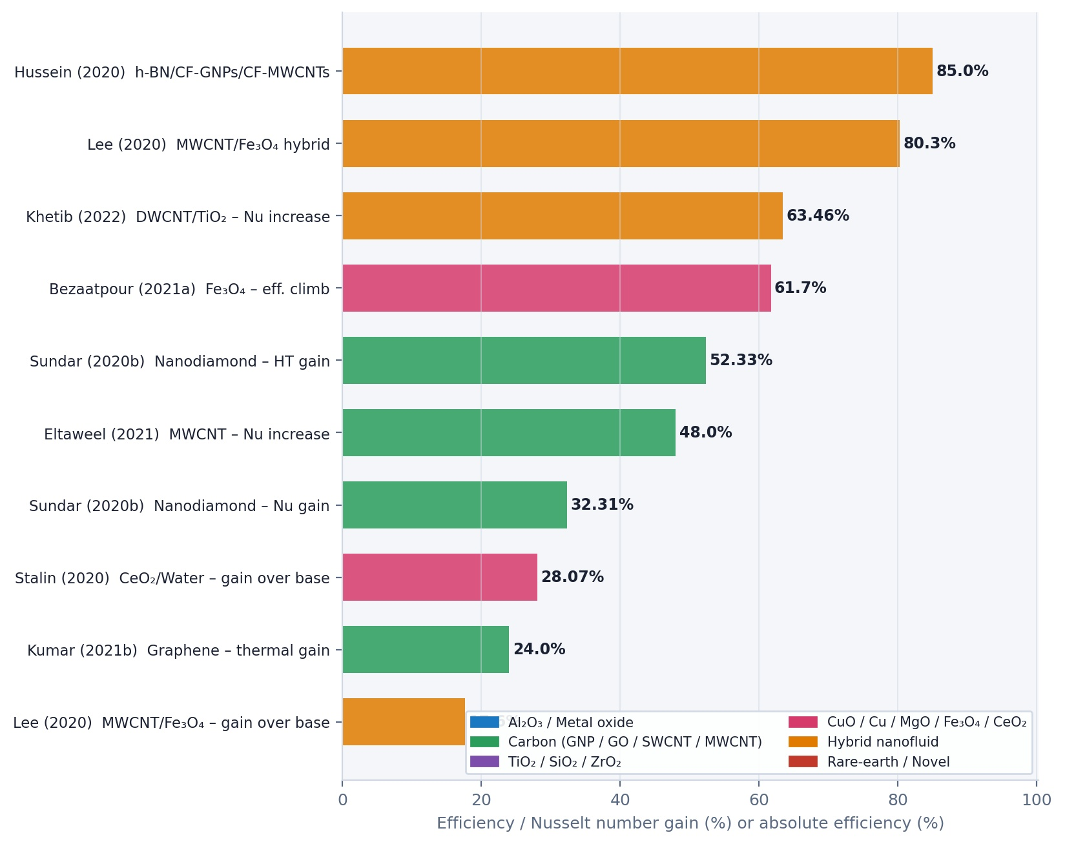
Hussein et al. (2020) reported a landmark result: an h-BN/CF-GNPs with CF-MWCNTs hybrid nanofluid in distilled water achieved a collector efficiency of up to 85%, with increasing nanoparticle concentration boosting both thermal energy output and outlet temperature. Lee and associates. (2020) used a hybrid MWCNT/Fe₃O₄ nanofluid in water at concentrations of 0.003-0.015 vol percent to achieve a maximum efficiency of 80.3 percent, which is 17.6 percent better than the base fluid. Sundar et al. (2020b) studied nanodiamond-based nanoparticles in water. They reported increases in heat transfer and the Nusselt number of 52.33% and 32.31%, respectively, highlighting the considerable potential of non-traditional carbon-based nanoparticles. Stalin et al. (2020) found that CeO₂ in water achieved efficiencies 28.07% higher than those of the base fluid.
Figure 5. Heat transfer enhancement
Bezaatpour and Rostamzadeh (2021a, 2021b) numerically investigated Fe₃O₄ nanofluids at different concentrations and found energy efficiency of the collector improved from 44.4% to 61.7% and energy efficiency increases of 5.83-3.21%. Eltaweel et al. (2021) reported that MWCNT nanofluids at very low concentrations (0.005-0.05 vol%) raised the average Nusselt number by nearly 48%. Kumar et al. (2021b) demonstrated 24% thermal efficiency gains with graphene nanofluids, while Khetib and associates. (2022) found that increasing of Nusselt number by 63.46% while using a double-walled carbon nanotube (DWCNT)-TiO₂ hybrid, Figure 5 showing the improvement in efficiency and Nusselt number gain for the listed studies.
4.4 Recent Advances (2022-2023): Machine Learning and Emerging Nanoparticles
Between 2022 and 2023, the research landscape shifted towards more sophisticated nanofluid formulations, integration with auxiliary thermal storage technologies, and the application of machine learning for modelling and optimization.
Suthahar and associates. (2022) achieved an average instantaneous thermal efficiency of 84.85% using Al₂O₃ in water at 0.1-0.5 vol%, which represents one of the highest reported efficiencies for this commonly used nanoparticle type. Stalin and associates. (2022) reported that a hybrid Zn-Fe₂O₄ nanofluid reached a maximum energy efficiency of 80.1%, while Ashour and associates. (2022) documented an average efficiency of 81.64% with a ZnO-CuO hybrid combination. Elshazly and associates. (2022) made an important contribution to hybrid nanofluid economics by demonstrating that a 50:50 MWCNT/Al₂O₃ hybrid mixture offered efficiency increases of up to 29%, while also recommending this combination for better environmental safety relative to pure MWCNT-based nanofluids.
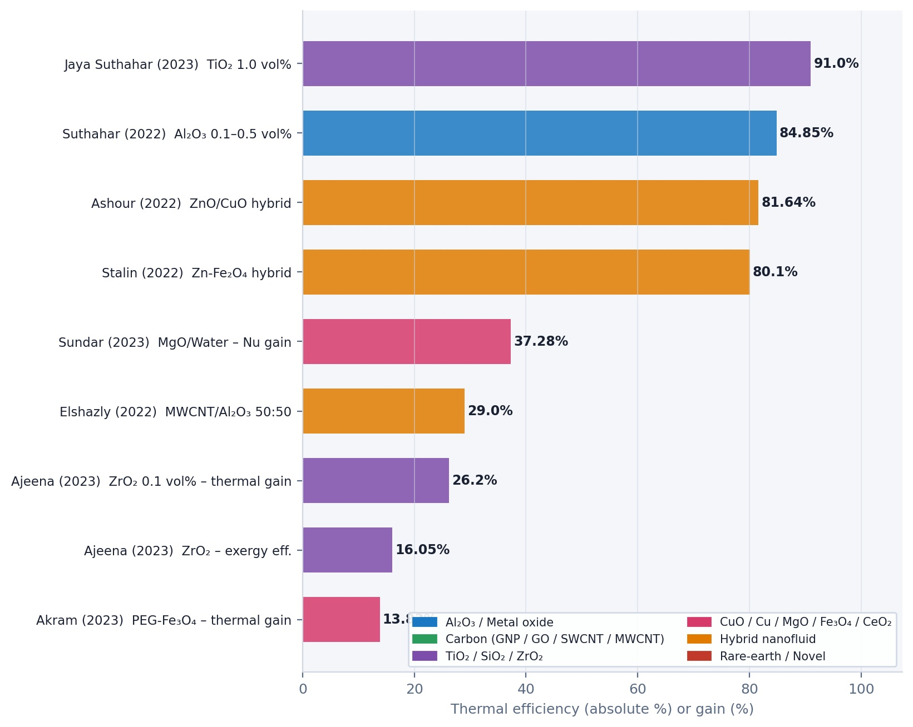
Sundar and associates. (2023) combined experimental investigation with artificial neural network (ANN) modelling, using the Levenberg-Marquardt algorithm to predict the performance of an MgO-water nanofluid system, and reported a maximum increase in Nusselt number of 37.28% at 1.0 vol%. This approach exemplifies the growing role of machine learning in nanofluid research for FPSCs. Akram and associates. (2023) demonstrated the importance of nanoparticle stability by showing that covalent functionalization of Fe₃O₄ magnetite with polyethene glycol (PEG) maintained suspension stability for 30 days, achieving a 13.83% enhancement in thermal efficiency.
Figure 6. Thermal/energy efficiency gains
Ajeena and associates. (2023) achieved a 26.2% thermal efficiency improvement and an exergy efficiency of approximately 16.05% using ZrO₂ nanoparticles at 0.1 vol%, while Jaya Suthahar and associates. (2023) reported a maximum instantaneous efficiency of 91% at 1.0 vol% TiO₂, one of the highest instantaneous efficiencies documented in the reviewed literature, Figure 6 showing the improvement in efficiency for the listed studies.
4.5 State of the Art (2024-2025): Integration, Green Synthesis, and Rare-Earth Nanofluids
The most recent studies from 2024 to 2025 reflect a maturing research field that is increasingly focused on integration with complementary technologies (PCMs, vortex generators, thermosyphons), sustainability considerations (green synthesis, CO₂ savings), and the exploration of novel nanoparticle chemistries.
Bashirnezhad and associates. (2025) achieved a peak energy efficiency of 86.34% and an exergy efficiency of 32.7% using a hybrid CuO-MWCNT nanofluid with perforated twisted-tape inserts, representing one of the highest combined efficiencies reported in the reviewed literature. This study underscores the synergistic benefit of combining nanofluid enhancement with passive turbulence-inducing devices.
Chen and associates. (2025) optimised a solar water heating system by combining nanofluids with phase change materials (PCMs), finding that a CuO nanofluid with 20 vol% PCM achieved a thermal storage efficiency of 94.2%, the highest reported in this review. Alktranee and associates. (2025) corroborated the PCM-nanofluid integration approach, demonstrating 26% efficiency enhancement with an MWCNT-Al₂O₃ hybrid at 0.2 vol%.
Khan and associates. (2025) employed a two-phase CFD mixture model to study FPSCs with vortex generators and a hybrid GO/SiO₂ nanofluid in Therminol VP-1, reporting Nusselt number enhancements of up to 107.4%, the highest enhancement factor for this parameter in the reviewed literature. This result highlights the compounding benefits of geometry-based flow enhancement combined with improved nanofluid thermal conductivity.
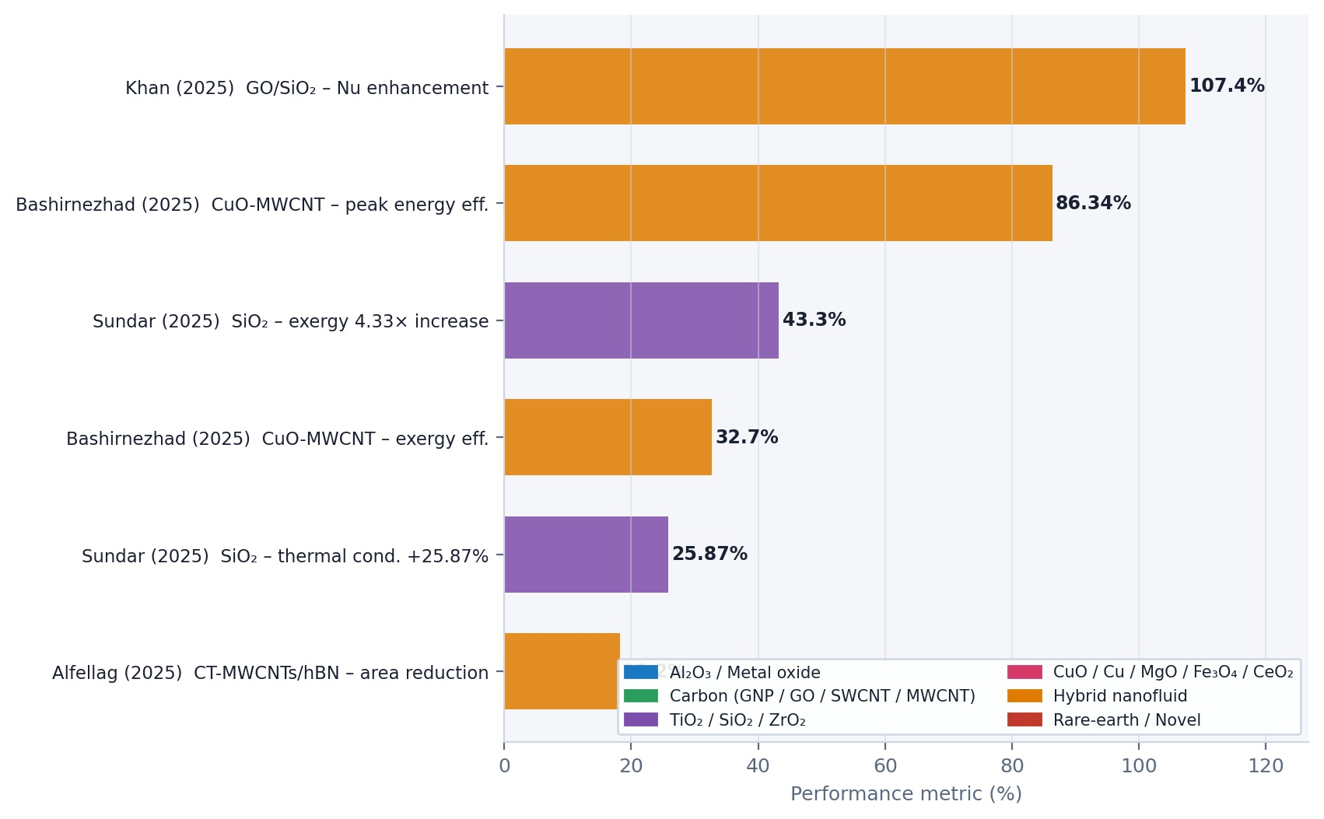
Alfellag and associates. (2025) introduced a green-synthesised hybrid nanofluid combining clove-treated MWCNTs (CT-MWCNTs) and hexagonal boron nitride (hBN), achieving an 18.33% energy efficiency gain and, notably, an 18.2% reduction in the required collector area, a significant practical benefit. Hassaan (2025) reported efficiency improvements of up to 31.6% at a 1.0 vol% concentration using an MWCNT-Al₂O₃ hybrid.
Figure 7. Enhancements in the latest studies
Sathish and Santhosh (2025) conducted the first study to employ rare-earth erbium(III) oxide (Er₂O₃) nanoparticles in FPCs, finding that higher concentrations yielded significant gains in thermal efficiency (peaking at 61.6% at the highest concentration) alongside measurable CO₂ mitigation benefits. Sundar and associates. (2025) investigated a SiO₂-glycerol/water nanofluid in a thermosyphon configuration using ANN modelling, reporting a 25.87% increase in thermal conductivity at 100°C and a 4.332-fold increase in exergy efficiency at midday compared to the base fluid.
Abu-Zeid and associates. (2024) conducted a direct comparative study of FPSCs and parabolic trough solar collectors (PTSCs) using MWCNT/ethylene glycol nanofluids, reporting average thermal efficiencies of 64.1% and 80.6%, respectively, and significant CO₂ emission savings for both. Ajeena and associates. (2024) demonstrated that SiC nanoparticles increased thermal conductivity by 30.3% and achieved a peak thermal efficiency of 77.43%, a 35.53% improvement over the base liquid, Figure 3 showing the enhancements for the listed studies.
5. Mathematical Modelling
5.1 Type of Study
Experimental investigations account for approximately 69.5% of the studies reviewed. This dominance reflects the empirical nature of nanofluid research, where real-world validation of thermal performance is essential, given the complexity of nanofluid behaviour. However, the proportion of purely numerical and combined experimental-numerical studies has grown significantly in the post-2020 period, accounting for approximately 40% of recent publications. The integration of computational fluid dynamics (CFD) tools and machine learning frameworks, particularly artificial neural networks (ANNs), represents a notable methodological evolution in the field.
5.2 Type of Base Fluid
Water remains the most prevalent base fluid in FPSC nanofluid studies, accounting for approximately 83% of all studies reviewed. Its dominance reflects its excellent heat capacity, wide availability, low cost, low viscosity, and environmental compatibility. Ethylene glycol-water mixtures are the second most commonly used base fluid, particularly in studies designed for cold climates where freeze protection is required. Other base fluids explored include distilled water, pentaethylene glycol, triethanolamine, Therminol VP-1, glycerol-water mixtures, and sodium carboxymethyl cellulose (CMC) solutions. The choice of base fluid significantly influences the nanofluid’s viscosity, stability, and overall heat transfer performance, and selecting fluids with appropriate rheological characteristics is critical for optimising pumping power requirements.
5.3 Type of Nanoparticle
Al₂O₃ is the most extensively studied nanoparticle in FPSCs, appearing in approximately 26% of studies, followed by CuO (approximately 12%) and TiO₂ (approximately 10%). Graphene-based materials (graphene, graphene nanoplatelets, graphene oxide) collectively constitute approximately 9% of studies, reflecting their exceptional thermal conductivity. Carbon nanotubes (SWCNTs, MWCNTs, DWCNTs) are investigated in approximately 8% of studies, while CeO₂, SiO₂, Fe₃O₄, ZnO, Cu, and MgO account for the remaining share of single-component nanoparticle studies.
Hybrid nanofluids account for approximately 10-12% of the reviewed studies and are among the fastest-growing research areas. Hybrid combinations that have shown particularly strong results include MWCNT-Al₂O₃, CuO-MgO-MWCNT, Al₂O₃-CuO, DWCNT-TiO₂, and GO-SiO₂. Novel nanoparticle types introduced in recent studies include SiC, nanodiamond, Er₂O₃, hBN, CT-MWCNTs, ZrO₂, and bio-functionalized graphene, expanding the material palette available for solar thermal applications.
5.4 Nanofluids Volume Concentration
The volume concentration of nanoparticles is one of the key elements influencing the thermal performance of nanofluids. The findings demonstrate that even at very low particle loadings, thermal performance can be significantly improved. Nanofluids with volume concentrations in the range of 0-0.5 vol % are used in about 62% of the reviewed studies, while 63% use concentrations of 0-0.1 vol %. About 17% of studies look at the 0.5-1.0 vol % range, and 11% look at the 1-2.0 vol % range. About 10% of studies look into higher concentrations (above 2 vol%).
5.5 Thermal and Exergy Efficiency of FPSCs Utilising Nanofluids
The reviewed studies reveal a wide range of thermal efficiency improvements, from as little as 2% to as high as 107% in Nusselt number enhancement Khan and associates. (2025). The percentage distribution of collector efficiency increases indicates that approximately 44% of studies report efficiency gains in the 0-15% range, approximately 37% report gains in the 15-30% range, approximately 10% report gains in the 30-45% range, and a smaller proportion document gains exceeding 45%.
The highest absolute thermal efficiencies documented in the reviewed literature include: 91% instantaneous efficiency Jaya Suthahar and associates. (2023); 86.34% peak energy efficiency with hybrid nanofluid and perforated twisted tape Bashirnezhad and associates. (2025); 85% with h-BN/CF-GNPs/CF-MWCNTs hybrid Hussein and associates. (2020); 84.85% with Al₂O₃ Suthahar and associates. (2022); 83.97% with Fe₃O₄ Ameri & Eshaghi (2018); and 82% with hybrid Al₂O₃/CuO Gangadevi & Vinayagam (2019).
Exergy efficiency analyses are reported in a significant proportion of studies and provide a thermodynamically rigorous measure of the quality rather than just the quantity of energy converted. Notable exergy efficiency values include: 62.7% exergy efficiency with SiO₂ in ethylene glycol-water Salavati and associates. (2016); 32.7% with hybrid CuO-MWCNT and perforated tape Bashirnezhad and associates. (2025); 32.23% with MgO Verma and associates. (2016); and 26.25% with SWCNTs Said and associates. (2015b).
6. Comparative Analysis
The table below provides a comprehensive survey of all reviewed studies, encompassing over 100 publications using experimental, numerical, and combined methodologies. The entries are organized chronologically to allow the reader to trace the evolution of nanofluid research in FPSCs from the early foundational studies of 2015 to the most recent state-of-the-art investigations of 2025.
Table 1 Comprehensive survey of nanofluid studies in flat plate solar collectors (2015–2025)
Author / Year | Study Type | Medium Fluid | Nanoparticle | NP Concentration | Main Notes
Abu-Zeid et al. (2024). | Exp. | Water and EG | MWCNTs | 1 wt% | MWCNT/Ethylene glycol: substantial CO2 emission savings; average FPSC thermal efficiency of 64.1 percent and PTSC of 80.6 percent.
Aghili & Kasaeian (2020). | Num. | Water | (Al₂O₃/CuO) | 0.05, 0.1 % | When a combined nanofluid was used, thermal efficiency increased.
Ahmadi et al. (2016). | Exp. | Water | Graphene nanoplatelets | 0.01, 0.02 | 18.87% increase in thermal efficiency
Ajeena et al. (2023). | Exp. | DW | ZrO₂ | 0.025, 0.05, 0.075, 0.1 vol% | Maximum thermal efficiency is +26.2 % at 0.1 %; maximum energy efficiency is approximately 16.05 %.
Ajeena et al. (2024). | Exp. | DW | Silicon carbide (SiC) | 0.025, 0.05, 0.075, 0.1 vol% | Maximum thermal efficiency is 77.43 % at 0.1 vol percent, a 35.53 % increase over base liquid; thermal conductivity is +30.3 %.
Akram et al. (2019). | Exp. | Water | Eco-friendly graphene nanoplatelets | 0.025-0.1 % | With additives, the maximum thermal efficiency was 78%.
Akram et al. (2021). | Exp. | Water | Graphene nanoplatelets, ZnO, SiO₂ | 0.025-0.2 | Highest thermal conductivity growth: 25.68%.
Akram et al. (2023). | Exp. & Num. (ANSYS-CFD) | DW | PEG-Fe₃O₄ magnetite | 0.025, 0.05, 0.075, 0.1 wt% | Stable for 30 days; highest thermal efficiency enhancement 13.83%
Alawi et al. (2019). | Exp. | Pentaethylene glycol | Treated graphene nanoplatelets | 0.025-0.1 | Collector efficiency increased by a maximum 13.3%
Alfellag et al. (2025). | Exp. | DW | CT-MWCNTs and hBN (Hybrid) | 0.025, 0.05, 0.075, 0.1 wt% | Green-synthesised hybrid; 18.33 % increase in energy efficiency and 18.2 % decrease in collector size.
Alklaibi et al. (2021) | Exp. | DW | Nanodiamond | 0.2-1 | The maximum collector thermal efficiency, at 69.85 percent, is 12.7 % greater than that of pure water.
Alktranee et al. (2025) | Exp. | Deionized water | MWCNT-Al₂O₃ (Hybrid) | 0.15, 0.2 vol% | Thermal efficiency is enhanced by up to 26% with PCM bags at 0.2% concentration.
Allouhi & Amine (2021). | Num. | Water | CuO, Al₂O₃, TiO₂ | 01-Mar | Max energy and exergy improvements for CuO: 2.7 and 11.1%
Alzahrani et al. (2021). | Exp. | Water | Hybrid (MgO, CuO, MWCNTs) | 0.01, 0.02, 0.003 | Nanoparticle volume fraction boosts solar absorption and transmission
Ameri & Eshaghi (2018). | Exp. | Water | Fe₃O₄ | 1, 2 | System thermal efficiency reached 83.97%
Aselebe et al. (2024). | Num. | EG | CuO and Al₂O₃ (Hybrid) | Varying | Williamson hybrid nanofluid over a stretching plate; increasing volume fraction enhanced the Nusselt number and skin friction
Ashour et al. (2022). | Num. | Water | ZnO and CuO | 0.05, 0.1, 0.15% | The best average efficiency reached 81.64%
Asker & Gadanya (2019). | Num. | Water | Al₂O₃, CeO₂, Cu, SiO₂, TiO₂ | 2 | Maximum increase in SiO₂ nanofluid efficiency: 10%
Bashirnezhad et al. (2025). | Exp. | Water and Sodium CMC | CuO, MWCNTs, Hybrid CuO-MWCNTs | 0.1 wt% | Peak energy efficiency of 86.34 % and exergy efficiency of 32.7 % for hybrid CuO-MWCNT with perforated twisted tape.
Bazdidi-Tehrani et al. (2018). | Num. | Water | CuO and TiO₂ | 0.99, 2.04 | Collector efficiency increased by approximately 10%
Bellos & Tzivanidis (2018). | Exp. | Water | Cu | 2 | A 3.99 percent increase in energy was provided by nanofluid.
Bezaatpour & Rostamzadeh (2021a) | Num. | Water | Fe₃O₄ | 2 | Exergetic performance and energy both rose by 3.21 percent and 5.83 percent, respectively.
Bezaatpour & Rostamzadeh (2021b). | Num. | Water | Fe₃O₄ | 0.2 | The energy efficiency of the collector rose from 44.4% to 61.7%.
Bianco et al. (2018). | Num. | Water | Al₂O₃ | 2, 4, 6 | Heat transfer coefficient and Nusselt number both rose by 2–15%.
Chen et al. (2025). | Num. (Simulation) | Water | Al₂O₃ and CuO | Levels | PCM-optimized solar water heating: 94.2% thermal storage efficiency with CuO nanofluid and 20% PCM volume.
Choudhary et al. (2020a). | Exp. | Water | ZnO | 1% | Maximum thermal efficiency 69.24%
Choudhary et al. (2020b). | Exp. | EG-DW | MgO | 0.08-0.4 | Thermal efficiency +16.36%; absorbed energy +16.74%
Choudhary et al. (2020c). | Exp. | Triethanolamine | Graphene nanoplatelets | 0.025-0.1 | Efficiency increased up to 10.53%
Colangelo et al. (2015). | Exp. | Water | Al₂O₃ | 3% | The thermal efficiency rose to 11.8%.
Darbari & Rashidi (2021). | Num. | Water | Cu, CuO | 0.01-0.05 | Adding Cu and CuO nanoparticles (5 vol%) increased collector energy by 6% and 3%
Edalatpour & Solano (2017). | Num. | Water | Al₂O₃ | 01-May | The coefficient of heat transfer increased from 10 to 65%.
Elshazly et al. (2022) | Exp. | Water | MWCNT, Al₂O₃, Hybrid MWCNT/Al₂O₃ | 0.005, 0.01, 0.025, 0.5 wt% | Hybrid (50:50) efficiency increases to 29%; recommended for economy and environmental safety.
Eltaweel & Abdel-Rehim (2019). | Exp. | DW | MWCNTs | 0.01, 0.05, 0.1 | Maximum exergy efficiency ~23.35%, increased by ~9%
Eltaweel et al. (2021) | Exp. | Water | MWCNT | 0.005, 0.01, 0.05 | The average Nusselt number increased by nearly 48%
Farajzadeh et al. (2018). | Exp. & Num. | Water | Al₂O₃/TiO₂ | 0.1 | A combination of two nanofluids resulted in a 26% increase in thermal efficiency.
Farhana et al. (2021). | Exp. | Water | Al₂O₃, crystal nano-cellulose (CNC) | 0.1, 0.3, 0.5 | Performance was improved by 2.48 % and 8.46 %, respectively, by Al2O3 and CNC.
Gad et al. (2021). | Exp. | Water | Al₂O₃ and TiO₂ | 2 | Max increase for Al₂O₃ and TiO₂: ~22% and 30% vs water
Gangadevi & Vinayagam (2019). | Exp. | Water | Hybrid (Al₂O₃/CuO) | 0.05, 0.1, 0.2 | Maximum electrical and thermal efficiencies: 15% and 82%
Genc et al. (2018). | Num. | Water | Al₂O₃ | 1, 2, 3 | By adding nanofluid, the output temperature rose by 7.2%.
Hassaan (2025) | Exp. | DW | MWCNT-Al₂O₃ (Hybrid) | 0.3, 0.5, 0.8, 1.0 vol% | Efficiency gains of up to 31.6 % at 1 % concentration were accompanied by increases in the Nusselt number and heat transfer coefficient.
Hawwash et al. (2018). | Exp. & Num. | Water | Al₂O₃ | 0.1-3 | Efficiency improved by about 18.3%
He et al. (2015) | Exp. | Water | Cu | 0.1, 0.2 | The greatest increases in temperature were 12.24 % and 24.52 %, respectively.
Hussein et al. (2020). | Exp. | DW | h-BN/CF-GNPs with CF-MWCNTs (hybrid) | 0.05, 0.08, 0.1 | Collector efficiency increased up to 85% with hybrid nanofluids
Jaya Suthahar et al. (2023). | Exp. | Water | TiO₂ | 0.1, 0.3, 0.5, 0.7, 1.0 vol% | Max instantaneous efficiency reached 91% at 1% concentration
Jayaprakash & Govindan (2025). | Num. | Water, EG, Sodium CMC | Fe₃O₄, Cu, and TiO₂ | Varying | Sodium CMC with TiO₂ provided superior heat-transfer efficiency and mass distribution in Casson nanofluids.
Jouybari et al. (2017). | Exp. | DW | SiO₂ | 0.2, 0.4, 0.6 | Thermal efficiency enhanced up to 8.1%
Kang et al. (2017) | Exp. | Water | Al₂O₃ | 0.5, 1, 1.5 | Heat efficiency 74.9%, which was 14.8% higher than the base fluid
Kashyap et al. (2018). | Num. | EG & water | ZnO | 0.02 | 39.17% increase in exergy efficiency
Khan et al. (2022) | Num. | DW | TiO2–Ag nanocomposite | 0.1 and 0.2 | The exergy efficiency is improved by roughly 1.25 and 2.54 %, respectively, while the energy efficiency is improved by roughly 0.5 and 1.27 %.
Khan et al. (2025). | Num. (CFD) | Therminol VP-1 | GO and SiO₂ (Hybrid) | 1.25, 3.25 vol% | Vortex generators with hybrid nanofluid; Nusselt number enhancement up to 107.4%
Khetib et al. (2022). | Num. & Exp. | Water | Hybrid (DWCNTs-TiO₂) | 1, 2, 3 | The average Nusselt number increased by 63.46%
Kiliç et al. (2018). | Exp. | Water | TiO₂ | 2 | The efficiency of nanofluids is highest at 48.67 %, while pure water has a efficiency of 36.20%.
Kim et al. (2017). | Exp. | Water | Al₂O₃ | 1 | Maximum efficiency 24.1% higher than base fluid; highest 72.4%
Kumar et al. (2021b). | Exp. | Water | Graphene | 0.025, 0.05, 0.1 | Thermal efficiency increased to 24%
Kumar et al. (2022). | Exp. | DW | Bio-functionalized graphene | 0.025, 0.05, 0.1 | The maximum thermal efficiency is +21.48%, while the pressure drop and pumping power increase by a small amount.
Lee et al. (2020). | Exp. | Water | MWCNT/Fe₃O₄ | 0.003-0.015 | Maximum efficiency 80.3% for hybrid; 17.6% higher than base fluid
Madadi et al. (2025). | Exp. | Water | SiC and Graphene | 0.2, 0.4 vol% | When integrated with PCM and flat-back fins, graphene nanofluid showed higher power output than SiC.
Mahamude et al. (2022). | Exp. | Water | Hybrid (graphene/waste cotton) | 0.1, 0.3, 0.5 | Highest efficiency 16.88% higher than the base state
Meibodi et al. (2015) | Num. | Water | Al₂O₃, TiO₂, SiO₂, GNP, SWCNT | 0.04-4 | Collector efficiency increased with increasing concentration
Meibodi et al. (2015). | Exp. | EG-water | SiO₂ | 0.5, 0.75, 1 | Nanofluid led to an efficiency increase of approximately 4 to 8%
Michael & Iniyan (2015). | Exp. | Water | CuO | 0.05 | Thermal performance improved by up to 6.3%
Michael et al. (2019). | Exp. | Water | CeO₂ | 0.01 | Maximum efficiency 78.2%, which is 21.5% higher than water
Mirzaei et al. (2018). | Exp. | Water | Al₂O₃ | 0.1 | Average efficiency elevated by 23.5%
Moravej et al. (2020). | Exp. | Water | TiO₂ | 1, 3, 5 | Maximum collector efficiency is approximately 78%
Munuswamy et al. (2020) | Exp. & Num. | Water | Al₂O₃/CuO | 0.2, 0.4 | Nanofluid increased collector efficiency by 2.16%
Mustafa et al. (2021). | Num. | Water | CuO | 0.1 | Solar process efficiency improved by 12.8%
Nabi et al. (2022). | Num. | Water | Hybrid MWCNT and SWCNT-CuO | 1, 3, 5 | The average Nusselt number increased by 8.79%
Okonkwo et al. (2020). | Exp. | Water | Hybrid (Al₂O₃, Fe₃O₄) | 0.05, 0.1, 0.2 | Nanofluid increased the heat in the collector by 2.16%
Purohit et al. (2018). | Num. | Water | Al₂O₃ | 1, 4, 6 | 25.2% improvement in heat transfer coefficient
Rajput et al. (2019). | Exp. | Water | Al₂O₃ | 0.1, 0.2, 0.3 | With increasing volume fraction, 21.32% increase in efficiency
Sabiha et al. (2015). | Exp. | Water | SWCNTs | 0.05, 0.1, 0.2 | The collector efficiency 71.84% higher than that of pure water
Said et al. (2015a). | Exp. | Water | TiO₂ | 0.1, 0.3 | Thermal conductivity +6%; exergy and energy efficiency improved by 16.9% and 76.6%
Said et al. (2015b). | Num. | Water | SWCNTs | 0.1, 0.3 | Maximum energy and exergy efficiency: 95.12% and 26.25%
Said et al. (2016a). | Exp. | Water | Al₂O₃ | 0.1 | Highest energy and exergy efficiency: 73.7% and 20.3%
Said et al. (2016b). | Exp. | Water | Al₂O₃ | 0.1, 0.3 | Energy efficiency improved by 83.5%
Salavati et al. (2016). | Exp. | EG-water | SiO₂ | 0.5, 0.75, 1 | Exergy efficiency at the highest concentration reached 62.7%
Saleh et al. (2022). | Exp. | Water | Al₂O₃ | 0.1, 0.2, 0.3 | Thermal efficiency increased from 53% to 65%; Nusselt number +23.22%
Sathish & Santhosh (2025). | Exp. | DW | Er₂O₃ (Erbium oxide) | 0.3, 0.6, 0.9 wt% | First study using rare-earth Er₂O₃ in FPCs; thermal efficiency reached 61.6% at peak concentration.
Shamshirgaran et al. (2018). | Num. | Water | Cu | 01-Apr | Exergy and energy efficiency increased by 10.5% and 8%
Sharafeldin & Gróf (2018). | Exp. | Water | CeO₂ | 0.017, 0.033, 0.067 | Efficiency improved by 10.74%
Sharafeldin et al. (2017). | Exp. | Water | WO₃ | 0.016, 0.033, 0.067 | The highest collector efficiency increased by 13.48%
Sharma et al. (2020). | Exp. | Water | CeO₂ | 0.25-2 | Maximum collector efficiency increased to 57.1%
Shojaeizadeh et al. (2015). | Exp. | Water | Al₂O₃ | 0.0906-0.1423 | Optimal inlet temperature and fluid mass flow decreased by ~2% and 68%
Sint et al. (2017). | Exp. | Water | CuO | 0.1, 0.5, 1, 2 | Collector efficiency improved by up to 5%
Stalin et al. (2020). | Exp. | Water | CeO₂ | 0.01, 0.05, 0.1 | Efficiency 28.07% higher than water
Stalin et al. (2022). | Num. | Water | Hybrid (Zn-Fe₂O₄) | 0.02-0.5 | Maximum energy efficiency reached 80.1%
Sundar et al. (2018a). | Exp. | Water | Al₂O₃ | 0.5, 1, 1.5 | Maximum collector performance +24.1%; thermal efficiency +18%
Sundar et al. (2018b). | Exp. | Water | Al₂O₃ | 0.1, 0.3 | Collector efficiency increased from 0.3% to 58%
Sundar et al. (2020b). | Exp. | Water | Nanodiamond-based | 0.2-1 | Heat transfer and Nusselt number increased by 52.33% and 32.31%
Sundar et al. (2020b). | Exp. | Water | Cu | 0.1, 0.3 | Efficiency increased from 52% to 58%
Sundar et al. (2021). | Exp. | Water | Cu | 0.1, 0.3 | Thermal conductivity increase compared to water: 23.56%
Sundar et al. (2023). | Exp. & Num. (ANN) | Water | MgO | 0.1, 0.5, 1.0 vol% | Maximum Nusselt number rise of 37.28% at 1.0 vol%; Levenberg-Marquardt algorithm predicted values with high accuracy.
Sundar et al. (2025). | Exp. & Num. (ANN) | Glycerol (30%) + Water (70%) | SiO₂ | 0.25, 0.5, 0.75, 1.0 vol% | Thermosyphon study; 1.0 vol% increased thermal conductivity by 25.87% at 100°C; exergy efficiency 4.332x at midday
Suthahar et al. (2022). | Num. | Water | Al₂O₃ | 0.1, 0.3, 0.5 | Average instantaneous thermal efficiency reached 84.85%
Tahat & Benim (2017). | Exp. | EG & water | Al₂O₃/CuO | 0.5, 1, 1.5, 2 | Collector efficiency improved by up to 45%
Talugeri et al. (2023) | Exp. | DW | MWCNT | 0.0158, 0.0238, 0.0317 vol% | SDBS surfactant used for stability; max efficiency 11% higher than distilled water
Tang et al. (2010). | Exp. | Water | Al₂O₃/CuO | 0.5, 1 | Thermal efficiency increased by 16%
Verma et al. (2016). | Exp. | Water | MgO | 0.25-1.5 | Thermal efficiency +9.34%; exergetic efficiency +32.23%
Verma et al. (2017). | Exp. | Water | Al₂O₃, SiO₂, TiO₂, CuO, Graphene | 0.75 | Highest exergy and energy efficiencies for CNTs: 29.32% and 23.47%
Verma et al. (2018). | Num. | Water | Hybrid CuO, MgO with MWCNTs | 0.25-2 | Energy efficiency and collector energy for hybrid: +25.1% and +16.28%
Vincely & Natarajan (2016). | Exp. | Water | Graphene oxide | 0.02 | Maximum collector efficiency increased by 11.5%
Xiong et al. (2021a). | Num. | Water | Hybrid Ag-Al₂O₃ | 0.1 | Use of hybrid nanofluids increased collector performance
Ziyadanogullari et al. (2018). | Exp. | Water | Al₂O₃, CuO, TiO₂ | 0.2, 0.4, 0.8 | Maximum collector performance improvement 63.71%
Note. Studies are listed alphabetically. Abbreviations: vol% = volume percent concentration; Exp. = Experimental; Num. = Numerical; EG = Ethylene Glycol; DW = Distilled. Color and shading are not used in this table. Parts highlighted in bold indicate hybrid nanofluid formulations.
8. Conclusions
This comprehensive review evaluates more than 100 experimental and numerical studies on the application of nanofluids in flat-plate solar collectors (FPSC) from 2015 to 2025. It draws attention to several significant trends and findings:
- Integration with Passive Devices: The combination of nanofluids with passive heat-transfer enhancement devices like twisted tapes and vortex generators has emerged as a prominent trend. These devices effectively disrupt the laminar sub-layer, thereby increasing the Nusselt number and enhancing the overall convective heat transfer coefficient. Notably, a hybrid CuO-MWCNT nanofluid with perforated twisted-tape inserts achieved an impressive energy efficiency of 86.34% Bashirnezhad et al. (2025).
- Phase Change Materials (PCM): The integration of PCMs with nanofluid-based FPSC systems is suggested to decouple solar collection from thermal demand, allowing for the storage and release of latent heat. Recent optimisations resulted in notable thermal storage efficiencies, reaching 94.2% through a CuO nanofluid and 20 vol% PCM, as noted by Chen et al. (2025).
- Machine Learning and AI Applications: The adoption of machine learning tools for predicting nanofluid properties has significantly increased. Artificial neural networks, specifically utilising the Levenberg-Marquardt algorithm, have shown high accuracy in modelling the relationship between nanofluid parameters and performance metrics, while enhancing FPSC efficiency, alongside methods such as ANSYS-CFD simulations.
- Sustainability Trends: Environmental sustainability has influenced research directions, with a focus on green and bio-derived sources for nanofluid synthesis. This includes utilising eco-friendly methods for synthesising graphene and other nanoparticles, highlighting the importance of life-cycle assessments in future studies.
- Exploration of Rare-Earth Nanoparticles: Novel rare-earth nanoparticle chemistries present an area with substantial potential. For instance, the introduction of Er₂O₃ nanoparticles has markedly improved thermal efficiency, while hybrid combinations such as hBN/CT-MWCNT have also been recognised for enhancing performance.
In conclusion, there is a strong emphasis on integrating novel materials and methodologies, sustainable practices, and advanced analytics to maximise the performance and environmental benefits of nanofluid-enhanced FPSC systems. Future research should prioritise these areas to enhance thermal performance further and mitigate environmental impact.
Acknowledgements
The authors are especially thankful to Dr. K V Sharma, & Center for Energy Studies, Jawaharlal Nehru Technological University, for helping & reviewing this manuscript.

Authors’ contributions
Each author has made substantial contributions to all aspects of preparing and drafting of this paper.

Funding
No funds have been received for financial support.

Availability of data and materials
The data generated and/or analyzed during this study are available upon reasonable request from the corresponding author.

Declarations
Ethics approval and consent to participate
The participants had given their consent.

Competing interests
The authors declare that they have no competing interests.

References
1. Abu-Zeid, M. A., Elhenawy, Y., Bassyouni, M., Majozi, T., Toderas, M., Al-Qabandi, O. A., & Kishk, S. S. (2024). Performance enhancement of flat-plate and parabolic trough solar collector using nanofluid for water heating application. Results in Engineering, 21, 101673. https://doi.org/10.1016/j.rineng.2023.101673
2. Ahmadi, A., Ganji, D. D., & Jafarkazemi, F. (2016). Analysis of utilizing graphene nanoplatelets to enhance thermal performance of flat plate solar collectors. Energy Conversion and Management, 126, 1–11. https://doi.org/10.1016/j.enconman.2016.07.061
3. Ajeena, A. M., Farkas, I., & Víg, P. (2023). Experimental approach on the effect of ZrO₂/DW nanofluid on flat plate solar collector thermal and exergy efficiencies. Energy Reports, 10, 4733–4750. https://doi.org/10.1016/j.egyr.2023.11.036
4. Ajeena, A. M., Farkas, I., & Víg, P. (2024). Energy and exergy assessment of a flat plate solar thermal collector by examine silicon carbide nanofluid: An experimental study for sustainable energy. Applied Thermal Engineering, 236, 121844. https://doi.org/10.1016/j.applthermaleng.2023.121844
5. Akram, N., Sadri, R., Kazi, S. N., Ahmed, S. M., Zubir, M. N. M., Ridha, M., & Tong, G. B. (2019). An experimental investigation on the performance of a flat-plate solar collector using eco-friendly treated graphene nanoplatelets–water nanofluids. Journal of Thermal Analysis and Calorimetry, 138(1), 609–621. https://doi.org/10.1007/s10973-019-08153-4
6. Akram, N., Montazer, E., Kazi, S. N., Soudagar, M. E. M., Ahmed, W., Zubir, M. N. M., Afzal, A., Muhammad, M. R., Ali, H. M., García Márquez, F. P., & Sarsam, W. S. (2021). Experimental investigations of the performance of a flat-plate solar collector using carbon and metal oxides-based nanofluids. Energy, 227, 120452. https://doi.org/10.1016/j.energy.2021.120452
7. Akram, N., Shah, S. T., Abdelrazek, A. H., Khan, A., Kazi, S. N., Sadri, R., García Márquez, F. P., & Soudagar, M. E. M. (2023). Application of PEG-Fe₃O₄ nanofluid in flat-plate solar collector: An experimental investigation. Solar Energy Materials and Solar Cells, 263, 112566. https://doi.org/10.1016/j.solmat.2023.112566
8. Alawi, O. A., Mohamed Kamar, H., Mallah, A. R., Kazi, S. N., & Sidik, N. A. C. (2019). Thermal efficiency of a flat-plate solar collector filled with pentaethylene glycol-treated graphene nanoplatelets: An experimental analysis. Solar Energy, 191, 360–370. https://doi.org/10.1016/j.solener.2019.09.011
9. Alfellag, M. A., Kazi, S. N., Hasnain, S. U., Nawaz, R., & Shaikh, K. (2025). Green-synthesised CT-MWCNTs/hBN hybrid nanofluid for flat plate solar collector performance enhancement: An experimental study. Applied Thermal Engineering. https://doi.org/10.1016/j.energy.2025.139070
10. Alim, M. A., Abdin, Z., Saidur, R., Hepbasli, A., Khairul, M. A., & Rahim, N. A. (2013). Analyses of entropy generation and pressure drop for a conventional flat plate solar collector using different types of metal oxide nanofluids. Energy and Buildings, 66, 289–296. https://doi.org/10.1016/j.enbuild.2013.07.027
11. Alkhazaleh, A. H., Almanaseer, W., & Alkhazali, A. (2023). Experimental investigation of flat plate solar collector using titanium dioxide nanofluid with varying volume fractions. Sustainable Energy Technologies and Assessments, 56, 103059. https://doi.org/10.1016/j.seta.2023.103059
12. Alklaibi, A., Sundar, L. S., & Sousa, A. C. (2021). Experimental analysis of exergy efficiency and entropy generation of diamond/water nanofluids flow in a thermosyphon flat plate solar collector. International Communications in Heat and Mass Transfer, 120, 105057. https://doi.org/10.1016/j.icheatmasstransfer.2020.105057
13. Alktranee, M., Al-Yasiri, Q., Al-Furaiiji, M. A., Al-Hamzawi, H. A. H., Bencs, P., & Szabó, M. (2025). Dual influence of PCM bags and hybrid MWCNT–Al₂O₃ nanofluid on the thermal efficiency enhancement of flat plate solar collectors. Energy Conversion and Management: X. https://doi.org/10.1016/j.rineng.2025.106972
14. Allouhi, A., & Benzakour Amine, M. (2021). Heat pipe flat plate solar collectors operating with nanofluids. Solar Energy Materials and Solar Cells, 219, 110798. https://doi.org/10.1016/j.solmat.2020.110798
15. Alzahrani, A. K., Ullah, M. Z., Alshomrani, A. S., & Gul, T. (2021). Hybrid nanofluid flow in a Darcy-Forchheimer permeable medium over a flat plate due to solar radiation. Case Studies in Thermal Engineering, 26, 100955. https://doi.org/10.1016/j.csite.2021.100955
16. Ameri, M., & Eshaghi, M. S. (2018). Exergy and thermal assessment of a novel system utilizing flat plate collector with the application of nanofluid in porous media at a constant magnetic field. Thermal Science and Engineering Progress, 8, 223–235. https://doi.org/10.1016/j.tsep.2018.08.009
17. Aselebe, L. O., Adeosun, A. T., Kasali, K. B., Yisa, B. M., Salaudeen, K. A., & Adesina, R. O. (2024). Investigation of thermal properties of ethylene glycol-based Williamson hybrid-nanofluid over stretchable/shrinking flat plate and their effects on solar panels. International Journal of Thermofluids, 24, 100892. https://doi.org/10.1016/j.ijft.2024.100892
18. Ashour, A. F., El-Awady, A. T., & Tawfik, M. A. (2022). Numerical investigation on the thermal performance of a flat plate solar collector using ZnO & CuO water nanofluids under Egyptian weathering conditions. Energy, 240, 122743. https://doi.org/10.1016/j.energy.2021.122743
19. Asker, M., & Gadanya, T. S. (2019). Performance assessment of flat plate solar collector using different nanofluids. Hittite Journal of Science and Engineering, 6(3), 193–200. https://doi.org/10.17350/HJSE19030000149
20. Bashirnezhad, K., Kargaran, M., Zeinali Heris, S., & Mohammadfam, Y. (2025). Improvement of thermal, energy and exergy performance of flat panel solar collector by insertion of perforated strips and hybrid CuO-MWCNTs nanofluid. Results in Engineering, 27, 106120. https://doi.org/10.1016/j.rineng.2025.106120
21. Bazdidi-Tehrani, F., Khabazipur, A., & Vasefi, S. I. (2018). Flow and heat transfer analysis of TiO₂/water nanofluid in a ribbed flat-plate solar collector. Renewable Energy, 122, 406–418. https://doi.org/10.1016/j.renene.2018.01.056
22. Bellos, E., & Tzivanidis, C. (2018). Performance analysis and optimization of an absorption chiller driven by nanofluid based solar flat plate collector. Journal of Cleaner Production, 174, 256–272. https://doi.org/10.1016/j.jclepro.2017.10.313
23. Bezaatpour, M., & Rostamzadeh, H. (2021a). Design and evaluation of flat plate solar collector equipped with nanofluid, rotary tube, and magnetic field inducer in a cold region. Renewable Energy, 170, 574–586. https://doi.org/10.1016/j.renene.2021.02.001
24. Bezaatpour, M., & Rostamzadeh, H. (2021b). Simultaneous energy storage enhancement and pressure drop reduction in flat plate solar collectors using rotary pipes with nanofluid. Energy and Buildings, 239, 110855. https://doi.org/10.1016/j.enbuild.2021.110855
25. Bianco, V., Bonomo, M., Guerriero, E., Iasiello, M., Mauro, G. M., & Nardini, S. (2018). Numerical analysis of the Al₂O₃-water nanofluid forced laminar convection in an asymmetric heated channel for application in flat plate PV/T collector. Renewable Energy, 116, 9–21. https://doi.org/10.1016/j.renene.2017.09.067
26. Chai, S., Mei, X., Gao, F., Xie, Y., & Lu, L. (2023). Experimental investigation of MWCNT nanofluid with SDBS surfactant in a solar parabolic collector: Stability and thermal performance. Case Studies in Thermal Engineering, 49, 103302. https://doi.org/10.1016/j.csite.2023.103302
27. Chen, G.-R., Liao, T.-W., Hsieh, C.-C., Barman, J., Huang, C.-Y., & Kuo, C.-F. J. (2025). Using the Taguchi method and grey relational analysis to optimize the parameter design of flat-plate collectors with nanofluids, and phase change materials in an integrated solar water heating system. Energy Conversion and Management: X, 26, 100910. https://doi.org/10.1016/j.ecmx.2025.100910
28. Choudhary, S., Sachdeva, A., & Kumar, P. (2020a). Influence of stable zinc oxide nanofluid on thermal characteristics of flat plate solar collector. Renewable Energy, 152, 1160–1170. https://doi.org/10.1016/j.renene.2020.01.142
29. Choudhary, S., Sachdeva, A., & Kumar, P. (2020b). Investigation of the stability of MgO nanofluid and its effect on the thermal performance of flat plate solar collector. Renewable Energy, 147, 1801–1814. https://doi.org/10.1016/j.renene.2019.09.126
30. Choudhary, S., Sachdeva, A., & Kumar, P. (2021). Time-based analysis of stability and thermal efficiency of flat plate solar collector using iron oxide nanofluid. Applied Thermal Engineering, 183, 115931. https://doi.org/10.1016/j.applthermaleng.2020.115931
31. Colangelo, G., Favale, E., Miglietta, P., de Risi, A., Milanese, M., & Laforgia, D. (2015). Experimental test of an innovative high concentration nanofluid solar collector. Applied Energy, 154, 874–881. https://doi.org/10.1016/j.apenergy.2015.05.031
32. Darbari, B., & Rashidi, S. (2021). Thermal efficiency of flat plate thermosyphon solar water heater with nanofluids. Journal of the Taiwan Institute of Chemical Engineers, 128, 276–287. https://doi.org/10.1016/j.jtice.2021.09.017
33. Edalatpour, M., & Solano, J. P. (2017). Thermal-hydraulic characteristics and exergy performance in tube-on-sheet flat plate solar collectors: Effects of nanofluids and mixed convection. International Journal of Thermal Sciences, 118, 397–409. https://doi.org/10.1016/j.ijthermalsci.2017.05.004
34. Elshazly, E., Abdel-Rehim, A. A., & El-Mahallawi, I. (2022). 4E study of experimental thermal performance enhancement of flat plate solar collectors using MWCNT, Al₂O₃, and hybrid MWCNT/Al₂O₃ nanofluids. Results in Engineering, 16, 100723. https://doi.org/10.1016/j.rineng.2022.100723
35. Eltaweel, M., & Abdel-Rehim, A. A. (2019). Energy and exergy analysis of a thermosiphon and forced-circulation flat-plate solar collector using MWCNT/water nanofluid. Case Studies in Thermal Engineering, 14, 100416. https://doi.org/10.1016/j.csite.2019.100416
36. Eltaweel, M., Abdel-Rehim, A. A., & Attia, A. A. (2021). A comparison between flat-plate and evacuated tube solar collectors in terms of energy and exergy analysis by using nanofluid. Applied Thermal Engineering, 186, 116516. https://doi.org/10.1016/j.applthermaleng.2020.116516
37. Farajzadeh, E., Movahed, S., & Hosseini, R. (2018). Experimental and numerical investigations on the effect of Al₂O₃/TiO₂-H₂O nanofluids on thermal efficiency of the flat plate solar collector. Renewable Energy, 118, 122–130. https://doi.org/10.1016/j.renene.2017.10.102
38. Farhana, K., Kadirgama, K., Mohammed, H. A., Ramasamy, D., Samykano, M., & Saidur, R. (2021). Analysis of efficiency enhancement of flat plate solar collector using crystal nano-cellulose (CNC) nanofluids. Sustainable Energy Technologies and Assessments, 45, 101049. https://doi.org/10.1016/j.seta.2021.101049
39. Gangadevi, R., & Vinayagam, B. (2019). Experimental determination of thermal conductivity and viscosity of different nanofluids and its effect on a hybrid solar collector. Journal of Thermal Analysis and Calorimetry, 136(1), 199–209. https://doi.org/10.1007/s10973-018-7742-5
40. Genc, A. M., Ezan, M. A., & Turgut, A. (2018). Thermal performance of a nanofluid-based flat plate solar collector: A transient numerical study. Applied Thermal Engineering, 130, 395–407. https://doi.org/10.1016/j.applthermaleng.2017.10.166
41. Gupta, S., Rajale, S., Raval, F., Sojitra, M., Tiwari, A. K., Joshi, A., & Singh, R. (2021). Comparative performance analysis of flat plate solar collectors with and without aluminium oxide-based nanofluid. Materials Today: Proceedings, 46, 5378–5383. https://doi.org/10.1016/j.matpr.2020.08.797
42. Hawwash, A., Abdel Rahman, A. K., Nada, S. A., & Ookawara, S. (2018). Numerical investigation and experimental verification of performance enhancement of flat plate solar collector using nanofluids. Applied Thermal Engineering, 130, 363–374. https://doi.org/10.1016/j.applthermaleng.2017.11.036
43. He, Q., Zeng, S., & Wang, S. (2015). Experimental investigation on the efficiency of flat-plate solar collectors with nanofluids. Applied Thermal Engineering, 88, 165–171. https://doi.org/10.1016/j.applthermaleng.2014.09.053
44. Hussein, O. A., Habib, K., Muhsan, A. S., Saidur, R., Alawi, O. A., & Ibrahim, T. K. (2020). Thermal performance enhancement of a flat plate solar collector using hybrid nanofluid. Solar Energy, 204, 208–222. https://doi.org/10.1016/j.solener.2020.04.034
45. Jayaprakash, J., & Govindan, V. (2025). Impacts of diffusion and chemical reaction on heat transfer in Casson nanofluids flow over a flat plate with accretion. Case Studies in Thermal Engineering, 72, 106309. https://doi.org/10.1016/j.csite.2025.106309
46. Jouybari, H. J., Saedodin, S., Zamzamian, S. A. H., Nimvari, M. E., & Wongwises, S. (2017). Effects of porous material and nanoparticles on the thermal performance of a flat plate solar collector: An experimental study. Renewable Energy, 114, 1407–1418. https://doi.org/10.1016/j.renene.2017.07.008
47. Kang, W., Shin, Y., & Cho, H. (2017). Economic analysis of flat-plate and U-tube solar collectors using an Al₂O₃ nanofluid. Energies, 10(11), 1911. https://doi.org/10.3390/en10111911
48. Kashyap, Y., Singh, A., & Raja Sekhar, Y. (2018). Exergy analysis of a flat plate solar collector with grooved absorber tube configuration using aqueous ZnO–ethylene glycol. Journal of Solar Energy Engineering, 140(6), 061011. https://doi.org/10.1115/1.4040582
49. Khan, I. A., & Amirtham, V. A. (2023). Theoretical energy and exergy analysis of flat plate solar collector with TiO₂–Ag/water nanocomposite fluid. Iranian Journal of Science and Technology, Transactions of Mechanical Engineering, 47, 921–939. https://doi.org/10.1007/s40997-022-00565-2
50. Khan, R., Hassan, W. H., Alizadeh, A., Singh, P. K., Hussein, A. A., Hajlaoui, K., Dixit, S., & Singh, A. (2025). Improving the thermal performance of flat-plate solar collectors for building applications through hybrid nanofluids and vortex-inducing geometries. Case Studies in Thermal Engineering, 72, 106377. https://doi.org/10.1016/j.csite.2025.106377
51. Khetib, Y., Alzaed, A., Tahmasebi, A., Sharifpur, M., & Cheraghian, G. (2022). Influence of using innovative turbulators on the exergy and energy efficacy of flat plate solar collector with DWCNTs-TiO₂/water nanofluid. Sustainable Energy Technologies and Assessments, 51, 101855. https://doi.org/10.1016/j.seta.2021.101855
52. Kiliç, F., Menlik, T., & Sözen, A. (2018). Effect of titanium dioxide/water nanofluid use on thermal performance of the flat plate solar collector. Solar Energy, 164, 101–108. https://doi.org/10.1016/j.solener.2018.02.002
53. Kim, H., Kim, J., & Cho, H. (2017). Experimental study on performance improvement of U-tube solar collector depending on nanoparticle size and concentration of Al₂O₃ nanofluid. Energy, 118, 1304–1312. https://doi.org/10.1016/j.energy.2016.11.010
54. Kumar, L. H., Kazi, S. N., Masjuki, H. H., Zubir, M. N. M., Jahan, A., & Bhinitha, C. (2021). Energy, exergy and economic analysis of liquid flat-plate solar collector using green covalent functionalized graphene nanoplatelets. Applied Thermal Engineering, 192, 116916. https://doi.org/10.1016/j.applthermaleng.2021.116916
55. Kumar, L. H., Kazi, S. N., Masjuki, H. H., & Zubir, M. N. M. (2022). Experimental study on the effect of bio-functionalized graphene nanoplatelets on the thermal performance of liquid flat plate solar collector. Journal of Thermal Analysis and Calorimetry, 147(2), 1657–1674. https://doi.org/10.1007/s10973-020-10527-y
56. Lee, M., Kim, H., Kim, J., Diaz-Penafiel, A., & Cho, S. (2020). Performance evaluation of flat plate and vacuum tube solar collectors by applying a MWCNT/Fe₃O₄ binary nanofluid. Energies, 13(7), 1715. https://doi.org/10.3390/en13071715
57. Mahamude, A. S. F., Harun, W. S. W., Kadirgama, K., Ramasamy, D., Farhana, K., Saleh, K., & Yusaf, T. (2022). Experimental study on the efficiency improvement of flat plate solar collectors using hybrid nanofluids graphene/waste cotton. Energies, 15(7), 2309. https://doi.org/10.3390/en15072309
58. Meibodi, S. S., Kianifar, A., Niazmand, H., Mahian, O., & Wongwises, S. (2015). Experimental investigation on the thermal efficiency and performance characteristics of a flat plate solar collector using SiO₂/EG–water nanofluids. International Communications in Heat and Mass Transfer, 65, 71–75. https://doi.org/10.1016/j.icheatmasstransfer.2015.02.011
59. Meibodi, S. S., Kianifar, A., Mahian, O., & Wongwises, S. (2016). Second law analysis of a nanofluid-based solar collector using experimental data. Journal of Thermal Analysis and Calorimetry, 126(2), 617–625. https://doi.org/10.1007/s10973-016-5522-7
60. Michael, J. J., & Iniyan, S. (2015). Performance of copper oxide/water nanofluid in a flat plate solar water heater under natural and forced circulations. Energy Conversion and Management, 95, 160–169. https://doi.org/10.1016/j.enconman.2015.02.017
61. Michael, J. J., Iniyan, S., & Goic, R. (2019). Experimental investigation and numerical simulation of a flat plate solar collector using CeO₂/water nanofluid. Solar Energy, 189, 383–396. https://doi.org/10.1016/j.solener.2019.07.054
62. Mirzaei, M., Hosseini, S. M. S., & Moradi Kashkooli, A. M. (2018). Assessment of Al₂O₃ nanoparticles for the optimal operation of the flat plate solar collector. Applied Thermal Engineering, 134, 68–77. https://doi.org/10.1016/j.applthermaleng.2018.01.104
63. Moravej, M., Saffarian, M. R., Doranehgard, M. H., & Li, L. K. B. (2020). Enhancing the efficiency of a symmetric flat-plate solar collector via the use of rutile TiO₂-water nanofluids. Sustainable Energy Technologies and Assessments, 40, 100783. https://doi.org/10.1016/j.seta.2020.100783
64. Munuswamy, D. B., Madhavan, V. R., Krishnamohan, K. S., & Pavithrakumar, K. (2020). Experimental investigation on lowering the environmental hazards and improving the performance patterns of solar flat plate collectors by employing the internal longitudinal fins and nano additives. Environmental Science and Pollution Research, 27(36), 45390–45404. https://doi.org/10.1007/s11356-020-10311-3
65. Mustafa, J., Alqaed, S., & Sharifpur, M. (2021). Challenging of using CuO nanoparticles in a flat plate solar collector-energy saving in a solar-assisted hot process stream. Journal of the Taiwan Institute of Chemical Engineers, 124, 258–265. https://doi.org/10.1016/j.jtice.2021.04.003
66. Nabi, H., Sajjad, U., Salehin, S., Wang, C.-C., & Takamatsu, H. (2022). Increasing heat transfer in flat plate solar collectors using various forms of turbulence-inducing elements and CNTs-CuO hybrid nanofluids. Case Studies in Thermal Engineering, 33, 101909. https://doi.org/10.1016/j.csite.2022.101909
67. Okonkwo, E. C., Wole-Osho, I., Kavaz, D., & Abid, M. (2020). Thermodynamic evaluation and optimization of a flat plate collector operating with alumina and iron mono and hybrid nanofluids. Sustainable Energy Technologies and Assessments, 37, 100636. https://doi.org/10.1016/j.seta.2020.100636
68. Purohit, N., Jakhar, S., Gullo, P., & Dasgupta, M. S. (2018). Heat transfer and entropy generation analysis of alumina/water nanofluid in a flat plate PV/T collector under equal pumping power comparison criterion. Renewable Energy, 120, 14–22. https://doi.org/10.1016/j.renene.2017.12.066
69. Rajput, N. S., Singh, S. K., & Shrivastav, P. K. (2019). Performance analysis of flat plate solar collector using Al₂O₃/distilled water nanofluid: An experimental investigation. Materials Today: Proceedings, 10, 52–59. https://doi.org/10.1016/j.matpr.2019.02.188
70. Sabiha, M. A., Saidur, R., Mekhilef, S., & Mahian, O. (2015). Energy performance of an evacuated tube solar collector using single walled carbon nanotubes nanofluids. Energy Conversion and Management, 105, 1377–1388. https://doi.org/10.1016/j.enconman.2015.09.009
71. Safarian, M. R., Moravej, M., & Doranehgard, M. H. (2020). Heat transfer enhancement in a flat plate solar collector with different flow path shapes using nanofluid. Renewable Energy, 146, 2316–2329. https://doi.org/10.1016/j.renene.2019.08.081
72. Said, Z., Saidur, R., Rahim, N. A., & Alim, M. A. (2014). Analyses of exergy efficiency and pumping power for a conventional flat plate solar collector using SWCNTs based nanofluid. Energy and Buildings, 78, 1–9. https://doi.org/10.1016/j.enbuild.2014.03.061
73. Said, Z., Sabiha, M. A., Saidur, R., Hepbasli, A., Rahim, N. A., Mekhilef, S., & Ward, T. A. (2015a). Performance enhancement of a flat plate solar collector using titanium dioxide nanofluid and polyethylene glycol dispersant. Journal of Cleaner Production, 92, 343–353. https://doi.org/10.1016/j.jclepro.2015.01.007
74. Said, Z., Saidur, R., Sabiha, M. A., Rahim, N. A., & Anisur, M. R. (2015b). Thermophysical properties of single wall carbon nanotubes and its effect on exergy efficiency of a flat plate solar collector. Solar Energy, 115, 757–769. https://doi.org/10.1016/j.solener.2015.02.037
75. Said, Z., Saidur, R., & Rahim, N. A. (2016a). Energy and exergy analysis of a flat plate solar collector using different sizes of aluminium oxide based nanofluid. Journal of Cleaner Production, 133, 518–530. https://doi.org/10.1016/j.jclepro.2016.05.178
76. Said, Z., Saidur, R., Sabiha, M. A., Hepbasli, A., & Rahim, N. A. (2016b). Energy and exergy efficiency of a flat plate solar collector using pH treated Al₂O₃ nanofluid. Journal of Cleaner Production, 112, 3915–3926. https://doi.org/10.1016/j.jclepro.2015.07.115
77. Saleh, B., Sundar, L. S., Sharma, K. V., Ansari, I., Kazi, S. N., & Ahmed, W. (2022). The combined effect of Al₂O₃ nanofluid and coiled wire inserts in a flat-plate solar collector on heat transfer, thermal efficiency and environmental CO₂ characteristics. Arabian Journal of Science and Engineering. https://doi.org/10.1007/s13369-021-06478-7
78. Sarsam, W. S., Kazi, S. N., & Badarudin, A. (2020). Thermal performance of a flat-plate solar collector using aqueous colloidal dispersions of graphene nanoplatelets with different specific surface areas. Applied Thermal Engineering, 172, 115142. https://doi.org/10.1016/j.applthermaleng.2020.115142
79. Sathish, T., & Santhosh, A. J. (2025). Experimental investigation of erbium oxide (Er₂O₃) nanofluid on flat plate solar collector thermal efficiency and CO₂ mitigation. Sustainable Energy Technologies and Assessments. https://doi.org/10.1016/j.ijft.2025.101478
80. Shamshirgaran, S. R., Al-Kayiem, H. H., Sharma, K. V., & Ghasemi, M. (2018). Upper limits for the work extraction by nanofluid-filled selective flat-plate solar collectors. Energy, 160, 875–885. https://doi.org/10.1016/j.energy.2018.06.154
81. Sharafeldin, M., & Gróf, G. (2018). Experimental investigation of flat plate solar collector using CeO₂-water nanofluid. Energy Conversion and Management, 155, 32–41. https://doi.org/10.1016/j.enconman.2017.10.070
82. Sharafeldin, M. A., Gróf, G., & Mahian, O. (2017). Experimental study on the performance of a flat-plate collector using WO₃/water nanofluids. Energy, 141, 2436–2444. https://doi.org/10.1016/j.energy.2017.11.068
83. Sharma, S., Tiwari, S., Tiwari, A. K., Nandan, G., & Prakash, R. (2020). Thermal performance enhancement of flat-plate solar collector using CeO₂-water nanofluid. In Advances in solar power generation and energy harvesting (pp. 109–118). Springer. https://doi.org/10.1007/978-981-15-3635-9_12
84. Shojaeizadeh, E., Veysi, F., & Kamandi, A. (2015). Exergy efficiency investigation and optimization of an Al₂O₃–water nanofluid based flat-plate solar collector. Energy and Buildings, 101, 12–23. https://doi.org/10.1016/j.enbuild.2015.04.048
85. Sint, N. K. C., Choudhury, I. A., Masjuki, H. H., & Aoyama, H. (2017). Theoretical analysis to determine the efficiency of a CuO-water nanofluid based-flat plate solar collector for domestic solar water heating system in Myanmar. Solar Energy, 155, 608–619. https://doi.org/10.1016/j.solener.2017.06.055
86. Sridharan, M. (2024). Performance augmentation study on a solar flat plate water collector system with modified absorber flow design and its performance prediction using the XGBoost algorithm: A machine learning approach. Iranian Journal of Science and Technology, Transactions of Mechanical Engineering, 48, 133–144. https://doi.org/10.1007/s40997-023-00648-8
87. Stalin, M. J. P., Arjunan, T. V., Matheswaran, M. M., & Sadanandam, N. (2019). Experimental and theoretical investigation on the effects of lower concentration CeO₂/water nanofluid in flat-plate solar collector. Journal of Thermal Analysis and Calorimetry, 135(1), 29–44. https://doi.org/10.1007/s10973-017-6865-4
88. Stalin, M. J. P., Arjunan, T. V., Matheswaran, M. M., Dolli, H., & Sadanandam, N. (2020). Energy, economic and environmental investigation of a flat plate solar collector with CeO₂/water nanofluid. Journal of Thermal Analysis and Calorimetry, 139(5), 3219–3233. https://doi.org/10.1007/s10973-019-08617-7
89. Sundar, L. S., Singh, M. K., Punnaiah, V., & Sousa, A. C. M. (2018a). Effectiveness analysis of solar flat plate collector with Al₂O₃ water nanofluids and with longitudinal strip inserts. International Journal of Heat and Mass Transfer, 127, 422–435. https://doi.org/10.1016/j.ijheatmasstransfer.2017.12.128
90. Sundar, L. S., Singh, M. K., Punnaiah, V., & Sousa, A. C. M. (2018b). Experimental investigation of Al₂O₃/water nanofluids on the effectiveness of solar flat-plate collectors with and without twisted tape inserts. Renewable Energy, 119, 820–833. https://doi.org/10.1016/j.renene.2017.10.056
91. Sundar, L. S., Punnaiah, V., Singh, M. K., Sharma, K. V., & Sousa, A. C. M. (2020a). Efficiency, energy and economic analysis of twisted tape inserts in a thermosyphon solar flat plate collector with Cu nanofluids. Renewable Energy Focus, 35, 10–31. https://doi.org/10.1016/j.ref.2020.06.004
92. Sundar, L. S., Ramana, E. V., Punnaiah, V., Singh, M. K., & Sousa, A. C. M. (2020b). Properties, heat transfer, energy efficiency and environmental emissions analysis of flat plate solar collector using nanodiamond nanofluids. Diamond and Related Materials, 110, 108115. https://doi.org/10.1016/j.diamond.2020.108115
93. Sundar, L. S., Punnaiah, V., Sharma, K. V., & Sousa, A. C. M. (2020c). Energy, efficiency, economic impact, and heat transfer aspects of solar flat plate collector with Al₂O₃ nanofluids and wire coil with core rod inserts. Sustainable Energy Technologies and Assessments, 40, 100772. https://doi.org/10.1016/j.seta.2020.100772
94. Sundar, L. S., Punnaiah, V., Sharma, K. V., Singh, M. K., & Sousa, A. C. M. (2021). Solar energy absorbed thermosyphon flat plate collector analysis using Cu/H₂O nanofluid–an experimental study. Energy and Climate Change, 2, 100028. https://doi.org/10.1016/j.egycc.2021.100028
95. Sundar, L. S., & Chandra Mouli, K. V. V. (2023). Experimental analysis and Levenberg-Marquardt artificial neural network predictions of heat transfer, friction factor, and efficiency of thermosyphon flat plate collector with MgO/water nanofluids. International Journal of Thermal Sciences, 194, 108555. https://doi.org/10.1016/j.ijthermalsci.2023.108555
96. Sundar, L. S., et al. (2025a). Second law efficiency and thermal entropy generation of 30:70% of glycerol + water based SiO₂ nanofluids in a thermosyphon flat plate collector: Experimental and Bayesian artificial neural network algorithm. International Journal of Thermofluids, 25, 101013. https://doi.org/10.1016/j.ijft.2024.101013
97. Sundar, L. S., et al. (2025b). Thermosyphon flat plate collector with SiO₂/glycerol–water nanofluid: Experimental study and ANN predictions of exergy efficiency. Applied Thermal Engineering. https://doi.org/10.1109/GPECOM65896.2025.11062009
98. Suthahar, S. T. J., Jaisankar, S., & Saravanan, S. (2022). Experimental investigation on solar flat plate collector using alumina nanofluid with tube inserts. Materials Technology, 37(3), 179–189. https://doi.org/10.1080/10667857.2020.1824146
99. Tahat, M. S., & Benim, A. C. (2017). Experimental analysis on thermophysical properties of Al₂O₃/CuO hybrid nano fluid with its effects on flat plate solar collector. Defect and Diffusion Forum, 374, 148–156. https://doi.org/10.4028/www.scientific.net/DDF.374.148
100. Tang, R., Cheng, Y., Wu, M., Li, Z., & Yu, Y. (2010). Experimental and modeling studies on thermosiphon domestic solar water heaters with flat-plate collectors at clear nights. Energy Conversion and Management, 51(12), 2548–2556. https://doi.org/10.1016/j.enconman.2010.05.020
101. Tong, Y., Chi, X., Kang, W., & Cho, H. (2019). Energy and exergy comparison of a flat-plate solar collector using water, Al₂O₃ nanofluid, and CuO nanofluid. Applied Thermal Engineering, 159, 113959. https://doi.org/10.1016/j.applthermaleng.2019.113959
102. Verma, S. K., Tiwari, A. K., & Chauhan, D. S. (2016). Performance augmentation in flat plate solar collector using MgO/water nanofluid. Energy Conversion and Management, 124, 607–617. https://doi.org/10.1016/j.enconman.2016.07.007
103. Verma, S. K., Tiwari, A. K., & Chauhan, D. S. (2017). Experimental evaluation of flat plate solar collector using nanofluids. Energy Conversion and Management, 134, 103–115. https://doi.org/10.1016/j.enconman.2016.12.037
104. Verma, S. K., Tiwari, A. K., Tiwari, S., & Chauhan, D. S. (2018). Performance analysis of hybrid nanofluids in flat plate solar collector as an advanced working fluid. Solar Energy, 167, 231–241. https://doi.org/10.1016/j.solener.2018.04.017
105. Vincely, D. A., & Natarajan, E. (2016). Experimental investigation of the solar FPC performance using graphene oxide nanofluid under forced circulation. Energy Conversion and Management, 117, 1–11. https://doi.org/10.1016/j.enconman.2016.03.015
106. Xiong, Q., Hajjar, A., Alshuraiaan, B., Izadi, M., Altnji, S., & Shehzad, S. A. (2021). A comprehensive review on the application of hybrid nanofluids in solar energy collectors. Sustainable Energy Technologies and Assessments, 47, 101341. https://doi.org/10.1016/j.seta.2021.101341
107. Yousefi, T., Veysi, F., Shojaeizadeh, E., & Zinadini, S. (2012). An experimental investigation on the effect of Al₂O₃–H₂O nanofluid on the efficiency of flat-plate solar collectors. Renewable Energy, 39(1), 293–298. https://doi.org/10.1016/j.renene.2011.08.056
108. Ziyadanogullari, N. B., Yucel, H. L., & Yildiz, C. (2018). Thermal performance enhancement of flat-plate solar collectors by means of three different nanofluids. Thermal Science and Engineering Progress, 8, 55–65. https://doi.org/10.1016/j.tsep.2018.07.005

