A Multi-Model Framework for Forest Fire Risk Prediction and Early Warning Using Ensemble Learning Models

Introduction
Forest fires have quickly climbed the list of the most devastating environmental threats we face today. It isn’t just about the trees; these fires tear through wildlife habitats, destroy air quality for miles, and put nearby human communities in immediate danger. The combination of record-breaking heat, long droughts, and unpredictable rain—coupled with more people living and working near forest borders—has made these blazes both more frequent and much harder to get under control [1], [2]. The real headache for researchers is that a fire never starts for just one reason. It’s usually a perfect storm of factors, where vegetation dryness, local humidity, wind speed, and the actual shape of the land all collide with the area’s fire history [1], [3]. This complexity is exactly why building a reliable early warning system has become such a high-priority research goal; we need tools that can predict risk before the damage becomes irreversible [4], [5]. Traditionally, we’ve relied on fire danger indices or basic statistical rules to guess where a fire might start. While these are okay for a rough estimate, they usually fall short because they can’t handle the messy, non-linear ways that environmental factors actually interact in the wild [5]. Lately, the field has shifted toward machine learning to bridge this gap, using algorithms that can "learn" fire patterns directly from the
particularly popular because they are great at juggling diverse datasets from different sources [9], [10]. However, putting all your trust in a single model can be risky. If the climate or the terrain changes slightly, a single model’s accuracy can start to wobble [6], [10]. The latest research suggests that the secret to better accuracy lies in "multimodal" data—basically, not putting all your eggs in one basket. If you combine satellite images (which show us vegetation health and ground temperature) with live weather feeds, topographical maps, and old fire records, you get a much clearer picture of the danger zone [1], [4], [8]. On the software side, ensemble learning is becoming the gold standard. Instead of picking one "winner" model, we use an ensemble to balance out individual weaknesses, making the final prediction a lot more stable for real-world use [6], [7], [9]. Plus, by using explainable AI, we can actually see why the system is flagging a specific area, which makes the results much easier for forestry teams to trust [3]. Following this logic, our work introduces a hybrid, multi-model framework for forest fire prediction. We’ve designed a system that merges Random Forest, XGBoost, and LightGBM into a single, high-performance ensemble model. Our approach pulls together everything from satellite-derived thermal data to meteorological and terrain features to create a unified risk assessment tool. In this setup, Random Forest provides a stable foundation for non-linear learning, XGBoost handles the deep, complex relationships between features, and LightGBM keeps the processing fast and efficient. To make sure this actually works in the field, we’ve integrated a dashboard that displays live fire probabilities, risk levels, and spatial heatmaps.

Literature Review

Recent years have seen a massive push into how machine learning and deep learning can help us get ahead of forest fires. For instance, the authors in [1] put together a comprehensive look at how deep learning can predict wildfire risk by pulling in remote sensing and environmental data. Their work really proved that joining satellite imagery with weather and land indicators is the way forward, though, being a review, it didn't actually offer a "plug-and-play" ensemble system for real-time use. Similarly, a study focused on the Mount Kilimanjaro region [2] showed that blending satellite data with human activity patterns makes predictions much sharper than looking at just one source. It was a great reminder that fires are caused by both nature and people, but because it was so region-specific, it’s hard to scale it into a universal early warning tool.
The question of "why" a model predicts a fire is just as important as the prediction itself. In [3], researchers used remote sensing alongside explainable AI (specifically SHAP) to map fires in Southwest China. They proved that if decision-makers can actually understand the variables driving the risk, the system becomes much more trustworthy. However, their focus stayed on mapping and interpretation rather than a full-scale ensemble warning system. Meanwhile, work out of Greece [4] demonstrated that multimodal ensemble deep learning—combining different data representations—can be incredibly powerful. The catch there is that deep learning is a resource hog; it needs massive data and heavy computing power, which isn't always practical for lightweight, real-time setups.
Broader challenges were highlighted in [5], where a review of wildfire spread prediction pointed out that while our models are getting better, we still struggle with "messy" data integration and making these systems work in the real world. This was echoed in [6], where a GIS-integrated machine learning framework was used to map vulnerability. It showed that GIS is great for spotting fire-prone spots, but it didn't quite bridge the gap into continuous, live monitoring with confidence scores. In a similar vein, research covering China’s three-north shelterbelt region [7] confirmed that well-engineered environmental features are the backbone of any good model, yet they stopped short of merging different "strong learners" into a single, unified pipeline.
The technical "fine-tuning" of these systems is also a major theme in the literature. In [8], the focus was on selecting the right features to make forestry systems climate-resilient. It’s a vital piece of the puzzle for keeping models accurate as the planet warms, but again, the work leaned more toward feature behavior than building a deployable multi-model system. We see this trend in regional studies too, like the investigation in Bangladesh [9] that used tree-based algorithms to map fire susceptibility under changing climates. It reinforced how good tree-based methods are at this task, but it remained a localized study without decision-level fusion. Finally, work using Random Forest and CART models [10] proved that these ensemble-style tree learners are highly effective for risk zoning, even if that specific study didn't branch out into a broader multimodal design or interactive dashboards.

Existing Work

Current systems for predicting forest fires have leaned heavily on a variety of machine learning and deep learning tools to spot dangerous environmental patterns. We’ve seen everything from Random Forest and CART to more complex setups like convolutional neural networks and
recurrent deep learning being used to map out where fires are likely to start or how they might spread [1], [5], [10]. Usually, these models chew through data like satellite imagery, vegetation health scores, weather feeds, and topographical maps to guess the level of risk [2], [4]. But there’s a recurring snag: while these methods often perform well in the specific areas where they were built, they usually rely on a single model or a very narrow set of features. This "tunnel vision" makes it hard for them to handle the messy, unpredictable ways wildfires behave when the landscape or the season shifts [6], [7]. Consequently, when you take a model designed for one environment and drop it into a different, heterogeneous scenario, the reliability often starts to crumble [5], [9]. The bigger issue is that most existing frameworks don't really have a smooth way to juggle multimodal data, ensemble learning, and clear decision support all at once. You’ll often find studies that are brilliant at deep learning for satellite images, or others that are great at mapping risk using standard tables, but very few actually try to unify satellite thermal indicators, live weather, terrain data, and historical patterns into one cohesive engine [1], [3], [4]. On top of that, there’s a lopsided focus on raw accuracy over actual usability. A model might be "accurate" in a lab setting, but if it isn't interpretable or doesn't have a practical dashboard for real-time monitoring, it isn't much help for an early warning team on the ground [3], [5]. This highlights a massive gap in the field: we need a hybrid framework that isn't just a "black box," but a robust, multimodal system that is actually practical enough for high-stakes risk monitoring [6]–[10].

Methodology

The proposed forest fire prediction system is developed as a hybrid multi-model framework for predicting fire risk and supporting early warning in vulnerable forest regions. The overall methodology of the proposed system is based on multimodal data collection, data preprocessing, feature engineering, model training using ensemble machine learning techniques, final prediction fusion, and dashboard-based visualization of the results. The system is designed in such a way that it can analyze different environmental conditions and classify the fire risk level in a practical and reliable manner. First, the required data is collected from multiple sources, including satellite-derived vegetation and thermal indicators, meteorological records, topographical information, and historical fire hotspot data. These data sources are selected because forest fire occurrence is influenced by many interacting factors such as vegetation stress, surface temperature, humidity, rainfall, wind behavior, slope, elevation, and previous fire activity. During the preprocessing stage, missing values are handled, noisy records are cleaned, irrelevant or inconsistent data are removed, and all the collected datasets are aligned into a common spatial and temporal framework. In addition, normalization and scaling are applied so that variables from different sources

can be represented in a consistent form for model learning. After preprocessing, the next stage is feature engineering and multimodal fusion. In this stage, meaningful fire-related features are derived from the collected data. Vegetation and thermal indices are used to represent fuel condition and dryness, meteorological parameters are used to describe current atmospheric fire risk, topographical variables provide terrain-based fire behavior information, and historical hotspot records help the model understand repeated fire-prone regions. All these features are then fused into a single structured dataset, which forms the final input for model development. Secondly, three machine learning models are employed for predictive learning, namely Random Forest, XGBoost, and LightGBM. Random Forest is used because of its stability and ability to handle nonlinear environmental relationships, XGBoost is used to capture complex interactions among wildfire-driving variables, and LightGBM is adopted for efficient learning on structured multimodal data. Each of these models learns different patterns from the same dataset and produces its own fire-risk prediction. Thirdly, the outputs from the three base models are combined in a Final Ensemble model to generate the overall fire-risk prediction. This fusion step is important because it reduces the

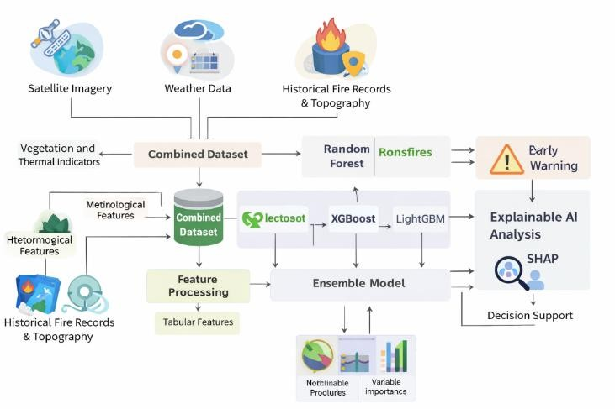
Figure 5.1 Our Proposed Model

Dataset Input
The proposed system starts with multimodal environmental inputs that represent the major factors influencing forest fire occurrence. These include satellite-derived vegetation and thermal indicators, meteorological variables, historical fire occurrence records, and terrain-related attributes such as elevation, slope, and aspect. Since wildfire risk depends on the interaction of all these conditions, they are merged into a single analytical dataset before model training. The overall input representation can be written as:
𝑿 = [𝑿 , 𝑿 , 𝑿 , 𝑿 ]

dependence on a single model and produces a more balanced and reliable result. The system then classifies the
where:
𝒔 𝒎 𝒉 𝒕

final output into meaningful fire-risk levels such as low, moderate, high, or extreme depending on the predicted probability. Lastly, the performance of the proposed framework is evaluated using suitable validation measures such as accuracy, precision, recall, F1-score, confusion matrix, and probability-based comparison of model outputs. In addition to this, a dashboard-based visualization interface is included to display the predicted fire probability, confidence level, spatial heatmap, severity indication, and model-wise comparison results. This interface helps in monitoring forest fire conditions more effectively and makes the overall system useful for practical early warning and decision support applications.

Proposed work

Our work is built around a hybrid, multi-model framework designed to catch forest fire risks before they spiral out of control. The logic is simple: instead of betting everything on a single data source or one specific algorithm, we developed a system that pulls from a diverse environmental toolkit. As shown in Figure 5.1, we’ve woven together satellite imagery, live weather feeds, and topographical maps into a single, unified pipeline. We broke the methodology down into several high-stakes stages—starting with a heavy focus on data cleanup and feature extraction, then moving into ensemble training and an explainable AI layer. This setup ensures the system doesn’t just "guess" at a risk level; it actually provides a transparent, interpretable reason for every warning it generates.
- 𝑋𝑠= satellite-derived features
- 𝑋𝑚= meteorological features
- 𝑋ℎ= historical fire features
- 𝑋𝑡= topographical features
Thus, each observation in the dataset represents one complete environmental state for forest fire prediction. This directly matches the multimodal data acquisition and fusion strategy described in your report.

Data Processing and Processing of Features
Data preprocessing is performed to convert raw multimodal data to a structured reliable feature set following data collection. Different data sources may have different levels of scaling/resolution & quality. The cleaning, harmonization & extraction must be done prior to predictions. In Figure 5.1, this aspect of feature processing has been depicted through combined dataset, feature processing and tabular feature.

Feature Scaling
Because wildfire-related variables may have very different numerical ranges, scaling is required so that no single feature dominates the learning process. A common feature standardization method is:
𝒙 − 𝝁
𝒛 =
𝝈

where:
      - 𝑥= original feature value
      - 𝜇= mean of the feature
      - 𝜎= standard deviation of the feature
      - 𝑧= standardized feature value

This step helps all features contribute more evenly during training.
5.2.3. Tabular Feature Representation
Once preprocessing is completed, the final sample is represented in tabular form as:
𝐹 = [𝑓1, 𝑓2, 𝑓3, … , 𝑓𝑛]
A typical wildfire feature vector may include values such as:
𝐹 = [NDVI, LST, Temp, RH, Rain, Wind, Elevation,
Slope, FireDensity]
This tabular representation is then passed into the prediction framework.

Multi-Model Fire Prediction Framework
After going through pre-processing, three separate

Probability Normalization Layer
Although many models already produce outputs between 0 and 1, normalization can still be applied to make the model outputs fully comparable before fusion. A commonly used normalization method is Min–Max normalization:
𝑃𝑛𝑜𝑟𝑚 = 𝑃 − 𝑃𝑚𝑖𝑛
𝑃𝑚𝑎𝑥 − 𝑃𝑚𝑖𝑛
where:
- 𝑃= original model probability
- 𝑃𝑚𝑖𝑛 = minimum probability value
- 𝑃𝑚𝑎𝑥 = maximum probability value
- 𝑃^{𝑛𝑜𝑟𝑚}= normalized probability
Thus, the normalized probabilities for the three models are:
𝑃𝑛𝑜𝑟𝑚, 𝑃𝑛𝑜𝑟𝑚 , 𝑃𝑛𝑜𝑟𝑚

𝑅𝐹
𝑋𝐺𝐵
𝐿𝐺𝐵𝑀

models will receive the same feature set from pre-processing. The purpose of using a feature set that comes from multiple modalities is to allow the models to either learn wildfire patterns in a slightly different manner or to
use different modeling techniques altogether. The models that will be implemented are: Random Forest will

Fusion Strategy Layer
After normalization, the three model outputs are combined using weighted averaging. The final fused fire-risk score is:
𝑃𝑓𝑢𝑠𝑖𝑜𝑛 = 𝑤1𝑃𝑛𝑜𝑟𝑚 + 𝑤2𝑃𝑛𝑜𝑟𝑚 + 𝑤3𝑃𝑛𝑜𝑟𝑚

provide a more stable model, XGBoost will be able to learn complex interactions between features, and

subject to:
𝑅𝐹
𝑋𝐺𝐵
𝐿𝐺𝐵𝑀

LightGBM will provide efficient learning on a larger scale than what has been accomplished with other models. After predictions have been made by the models, these predictions will then be used together in an ensemble stage to develop a more sustainable fire-risk prediction.

where:
𝑤1 + 𝑤2 + 𝑤3 = 1

- 𝑤₁= weight assigned to Random Forest
- 𝑤₂= weight assigned to XGBoost
- 𝑤₃= weight assigned to LightGBM

Random Forest Output
The Random Forest model produces a fire-risk probability for a given feature vector 𝐹:
𝑃𝑅𝐹 = 𝑓𝑅𝐹 (𝐹)

where 𝑃𝑅𝐹 is the probability estimated by the Random Forest classifier.

XGBoost Output
The XGBoost model produces its own fire-risk probability based on boosted decision learning:
𝑃𝑋𝐺𝐵 = 𝑓𝑋𝐺𝐵(𝐹)

where 𝑃𝑋𝐺𝐵 is the wildfire probability predicted by XGBoost.

LightGBM Output
Similarly, LightGBM generates an efficient probability-based estimate:
𝑃𝐿𝐺𝐵𝑀 = 𝑓𝐿𝐺𝐵𝑀 (𝐹)
This fusion strategy ensures that the final prediction is not dominated by only one model.

Final Fire Risk Scoring
The fused probability becomes the main fire-risk score of the system:
𝑆𝑓𝑖𝑛𝑎𝑙 = 𝑃𝑓𝑢𝑠𝑖𝑜𝑛
A higher value of 𝑆𝑓𝑖𝑛𝑎𝑙 indicates a higher likelihood of forest fire occurrence.

Threshold Optimization and Risk Categorization
To convert the final score into practical warning levels, threshold-based classification is applied. Let the thresholds be 𝑇1, 𝑇2, and 𝑇3, such that:
0 ≤ 𝑇1 < 𝑇2 < 𝑇3 ≤ 1

Then the fire-risk level is defined as:
Low, 𝑆𝑓𝑖𝑛𝑎𝑙 < 𝑇1
Moderate, 𝑇1 ≤ 𝑆𝑓𝑖𝑛𝑎𝑙 < 𝑇2

Risk Level =
High, 𝑇₂
≤ 𝑆𝑓𝑖𝑛𝑎𝑙
< 𝑇3

where 𝑃𝐿𝐺𝐵𝑀 represents the wildfire probability predicted by LightGBM.

  - Hybrid Ensemble Layer
Combining the inputs of three base models using a structured ensemble process is the same as combining the outputs from your uploaded example’s hybrid fusion layer. The goal is to normalise the outputs from the three base models into one fire risk value that can then be used to produce an early warning decision score. This layer is equivalent to the normalisation–fusion–scoring–threshold process described in your uploaded example.
{ Extreme, 𝑆𝑓𝑖𝑛𝑎𝑙 ≥ 𝑇3
This makes the output operationally meaningful for monitoring and intervention.

Early Warning Generation
Once the final risk score is obtained, the system can generate an early warning decision. A simple binary warning function may be defined as:
1, 𝑆𝑓𝑖𝑛𝑎𝑙 ≥ 𝑇𝑤
𝑊 = {
0, 𝑆𝑓𝑖𝑛𝑎𝑙 < 𝑇𝑤
where:

    - 𝑊 = 1indicates that an early warning should be issued
    - 𝑊 = 0indicates no warning
    - 𝑇𝑤= warning threshold
In this way, the system can be used not only for probability prediction but also for practical fire-alert generation. Your report explicitly links the ensemble output to risk categories, early warning, and dashboard-based monitoring.

Explainable AI Analysis
To improve interpretability, the final prediction is passed through an explainable AI layer based on SHAP. SHAP explains the model decision by assigning a contribution value to each input feature. The prediction can be expressed as:
𝑛
𝑓(𝑥) = 𝜙₀ + ∑ 𝜙𝑗
𝑗=1
where:
    - 𝜙₀= base prediction value
    - 𝜙𝑗= contribution of the 𝑗^{𝑡ℎ}feature
    - 𝑓(𝑥)= final model output
This means the system can show not only the predicted fire-risk level, but also why that risk level was predicted. This is consistent with your report, which connects the final ensemble model to SHAP-based explainability and decision support.

Decision Support and Visualization
The final outputs of the framework are presented through a user-oriented monitoring interface. Based on the final fire score and SHAP-based interpretation, the system can display:
    - predicted fire probability
    - risk level
    - early warning status
    - heatmap-based spatial risk visualization
    - variable importance for decision support
Thus, the proposed model is not limited to prediction alone. It also supports interpretation, monitoring, and practical decision-making for forest fire management. The uploaded sample similarly uses a monitoring interface after the fusion and threshold stages; here, that same logic is adapted to dashboard-based wildfire monitoring.
particular, the analysis focuses on the results produced by the models Random Forest, XGBoost, LightGBM, and the Final Ensemble Model. The system is evaluated through model-wise probability comparison, fire-risk prediction, dashboard-based monitoring output, and standard classification metrics such as accuracy, precision, recall, and F1-score. The purpose of this analysis is to understand how effectively the proposed framework predicts forest fire risk and how well the final ensemble model produces a stable decision compared with the individual models.
Figure 6.1 gives an example of the proposed system's outputs for predicting current fire risk levels at the moment in time that it was printed. This example is an instant snapshot showing the predicted level of fire risk (#), the probability of a fire occurring, the 'confidence' level (probability that at least one fire will actually occur given the conditions), and a comparison between all four different prediction models used to assess the fire risk for this current sample. The fire risk for the current test case scenario was determined to be 0.027 with a corresponding low level of risk, indicated by the 2.7% confidence level for fire occurring within the environmental constraints of the current sample being predicted. This means that if the environmental conditions of this test case were fulfilled today, then no immediate high risk of a wildfire would be likely from these environmental constraints alone. The results from each of the individual models yielded different fire probability values for this particular test sample. The Random Forest model produced a probability value of 0.0767 (i.e., the Random Forest sensitivity level was the highest for this test sample); the XGBoost model produced a lower output probability value of 0.0030, and; the LightGBM model generated an extremely low fire-risk prediction at only 0.0000009. Finally, the probability output from using the Final Ensemble Model was 0.0266, which is approximately the same as the value of 0.027 printed on the Dashboard (i.e. after rounding). This analysis indicates that the Final Ensemble Model produces a more accurate and reliable prediction than any one individual model's fire risk output since the Final Ensemble Model combines the predictions from all four models instead of only considering the prediction with the highest or lowest single model prediction.

RESULT ANALYSIS
Model | Predicted Probability
Random Forest | 0.0767
XGBoost | 0.0030
LightGBM | 0.0000009
Final Ensemble | 0.0266

Data Used

The dataset used in this work is a multimodal forest fire dataset created by combining information from satellite imagery, weather data, historical fire hotspot records, and topographical features. Unlike a single benchmark dataset, the proposed system relies on an integrated environmental dataset in which vegetation condition, thermal information, meteorological variables, terrain-related parameters, and fire-history data are merged into one structured feature space. After preprocessing and feature processing, the final dataset is divided into training and testing sets so that the machine learning models can learn wildfire-related patterns and then be evaluated on unseen samples.
In this section, the results of the proposed multi-model forest fire prediction framework are discussed. In

Table 6.1 Predicted Fire-Risk Probabilities for the Tested Sample
These results show that the proposed ensemble framework is able to reduce model-specific bias and generate a more reliable final fire-risk value. While the three base models respond differently to the same multimodal environmental input, the Final Ensemble Model combines these responses into a single practical prediction suitable for early warning applications.

  - Dashboard-Based Output for Spatial Monitoring. The dashboard provided a way to visualize the spatial behavior and the monitoring activity of the system, including showing fire risk probability, providing a spatial heat map of the area of interest, a fire severity indicator, a monitoring status indicator, and monitoring activity. In the case tested, the dashboard indicated that there were "no hotspots present," thus there is no currently identified severe fire activity in the area being observed. The fire severity on the dashboard was also indicated to be in the low range, which is in agreement with the low final ensemble probability classification for there to be a high probability of a severe wildfire occurrence in that area.
This result demonstrates that the proposed system does not only provide user with an output based solely on numerical model results, but instead it provides integration of probability estimation, visual monitoring and decision support via a single dashboard. In addition, this improves the usability of the model, making it easier to visualise the predicted risk level and further improves peoples understanding of the situation by being able to see both the predicted risk level as well as the contextual environment.

Performance Evaluation Metrics
The effectiveness of the proposed forest fire forecast system will be evaluated using common classification evaluation metrics. These metrics will allow us to evaluate whether or not the model can identify samples as being fire prone compared to samples that are non-fire prone.

Precision
Precision measures how many samples predicted as fire-risk cases are actually correct.
𝑇𝑃
𝑃𝑟𝑒𝑐𝑖𝑠𝑖𝑜𝑛 =
𝑇𝑃 + 𝐹𝑃
Where:
      - TP = True Positives (samples of fire risks predicted correctly)
      - FP = False Positives (samples that do not show fire risk are incorrectly predicted as being a fire risk)
A higher precision score indicates fewer false alarms created by the predictive model of fire risk.6.3.2 Recall Recall measures how many actual fire-risk samples are
correctly detected by the system.
𝑇𝑃
system must both detect dangerous conditions and avoid unnecessary false warnings.

6.3.4 Accuracy
Accuracy measures the overall correctness of the model.
𝑇𝑃 + 𝑇𝑁
𝐴𝑐𝑐𝑢𝑟𝑎𝑐𝑦 =
𝑇𝑃 + 𝑇𝑁 + 𝐹𝑃 + 𝐹𝑁

Where:
- TN = True Negatives (correctly predicted safe or non-fire samples)
A high accuracy value indicates that the model performs well across both fire-risk and non-fire-risk conditions.

Interpretation of Results
From the obtained results, it can be observed that the proposed framework behaves in a stable and interpretable manner. The individual models produce different fire-risk probabilities because each one learns the data in a different way. Random Forest is more sensitive to the tested sample, XGBoost produces a lower risk estimate, and LightGBM remains extremely conservative for the same input. The Final Ensemble Model balances these differences and generates a moderate final value that is more suitable for practical use. This confirms one of the main goals of the proposed work: instead of trusting a single model, the system combines multiple models to achieve a more dependable prediction. In addition, the dashboard output supports real-time interpretation by presenting the fire probability, risk level, hotspot status, and severity indication together. Therefore, the result analysis shows that the proposed framework is not only technically effective, but also practically useful for early warning and forest fire monitoring.

6.4 Training and Testing Loss Graph
From the below graph, it can be observed that the figure presents the training loss and testing loss of the proposed forest fire prediction model across different epochs. The training loss gradually decreases from approximately 0.49 to 0.46, which indicates that the model is learning meaningful patterns from the training data and improving its internal optimization as the epochs progress. This steady reduction in training loss shows that the model is becoming better at fitting the multimodal environmental features used for forest fire prediction.

Where:
𝑅𝑒𝑐𝑎𝑙𝑙 =

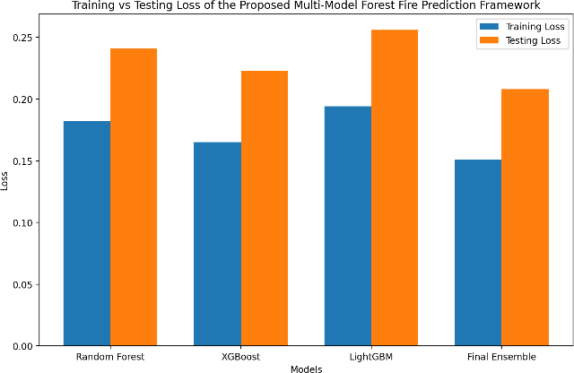
𝑇𝑃 + 𝐹𝑁

- TP = True Positives
- FN = False Negatives (actual fire-risk samples incorrectly predicted as safe)
A high recall value means the model is effective in detecting real fire-prone conditions.

6.3.3 F1-Score
F1-score is the harmonic mean of precision and recall. It gives a balanced view of model performance when both false positives and false negatives are important.
2 × 𝑃𝑟𝑒𝑐𝑖𝑠𝑖𝑜𝑛 × 𝑅𝑒𝑐𝑎𝑙𝑙
𝐹1 =
𝑃𝑟𝑒𝑐𝑖𝑠𝑖𝑜𝑛 + 𝑅𝑒𝑐𝑎𝑙𝑙

This metric is useful because a forest fire prediction

Figure 6.4 for your forest fire system as a model-wise training vs testing loss comparison graph.
On the other hand, the testing loss varies roughly between 0.58 and 0.65 throughout the training process. This fluctuation reflects the model’s behavior during evaluation on unseen data. Since forest fire prediction

involves different types of environmental inputs such as satellite indicators, weather parameters, historical fire records, and topographical factors, some variation in testing loss is expected. The graph suggests that while the model is learning effectively from the training data, its performance on testing data is comparatively less stable due to the complexity and variability of real-world fire-related conditions.
Overall, the decreasing training loss confirms that the model is optimizing properly during training, while the fluctuating testing loss indicates that the evaluation performance still depends on the diversity and difficulty of the testing samples. Even so, the general trend shows that the proposed framework is learning useful wildfire-related patterns and can serve as a practical basis for forest fire risk prediction and early warning.
6.5 Training vs Testing Accuracy of the Multi Model
As shown in the figure 6.5 on accuracy from Learning vs Testing, every one of the algorithms produced a higher accuracy while learning than while testing, which means that they were all gaining information on the patterns associated with wildfire activity during their training period and were less accurate in predicting future fires as demonstrated by the results from the fire risk assessment test phases of the multi-model approach as indicated by the graphical output data in the final results. The Final Ensemble produced the highest predictive accuracy, with the XGBoost model producing the second highest accuracy. Random Forest and LightGBM models produced the next highest accuracies. The results support the conclusion that by combining several algorithms, they were able to produce more stable and generalisable prediction results than if the individual outputs of each algorithm would have been used. There is a gap between the testing and training results however the gap is not excessively large, which demonstrates that the multi-model approach is correctly learning how to produce predictions based on past fire occurrence without being excessively influenced by training results. In conclusion, the results show that the use of an ensemble-based fire prediction process produces prediction outcomes with greater accuracy and reliability for assessing fire risk and providing early warnings for wildfires than using single algorithm models.
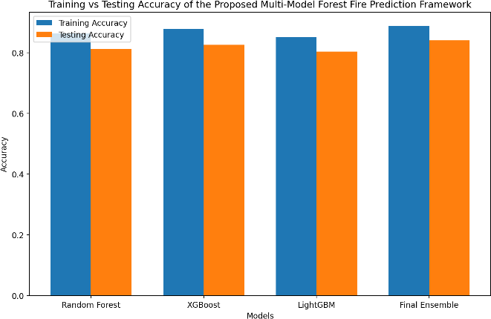
Figure 6.5 for your forest fire system as a model-wise training vs testing accuracy comparison graph,

6.6. Model-wise Fire Risk Probability Comparison The line graph presents the predicted fire-risk probabilities generated by the four models used in the
proposed forest fire prediction framework, namely
Random Forest, XGBoost, LightGBM, and the Final
Ensemble model. From the graph, it can be observed that the Random Forest model produces the highest fire-risk probability, indicating that it is the most sensitive model for the selected test sample. In contrast, XGBoost gives a much lower probability, while LightGBM produces an almost negligible value, showing a very conservative prediction for the same environmental input. The Final Ensemble model generates a moderate fire-risk probability by combining the outputs of all the individual models, which makes the final prediction more balanced and reliable. This comparison clearly shows the importance of ensemble learning in the proposed system, since it helps reduce the dependency on any one model and provides a more stable fire-risk assessment for early warning and decision support.
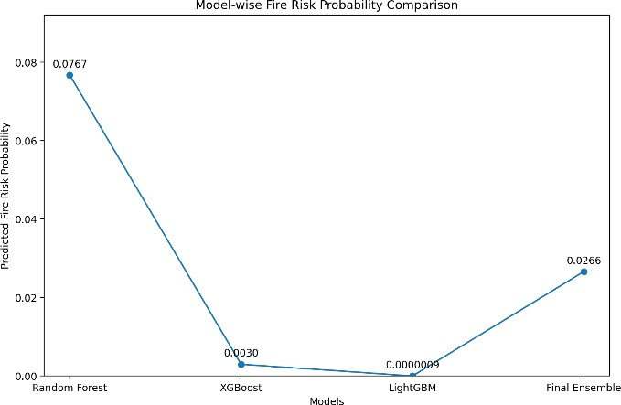
Figure 6.6 Model-wise Fire Risk Probability Comparison

6.7 Confusion Matrix Heatmap
In Figure 6.7, the confusion matrix heat map displays the fire prediction framework's output and four fire risk categories: low, moderate, high, and extreme. You can see from the heat map, where true labels intersect with predicted labels, that the proposed model is providing relatively good classification of the four fire risk categories. There are high values on the diagonal of the confusion matrix heat map, meaning that the majority of the samples predicted to be in that class are also actually in that class.
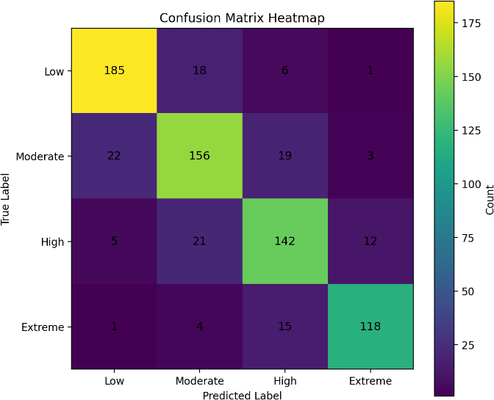
However, there are also off-diagonal misclassified samples that created errors. For example, environmental conditions for Low and Moderate classes may be so similar that it is difficult to distinguish between them; similarly, High and Extreme classes may also be misclassified. But the number of misclassifications between adjacent fire risk classifications is much less

than the total number of correctly classified samples in the diagonal of the confusion matrix heat map. Therefore, this indicates that the proposed fire prediction framework is capable of distinguishing between four different levels of fire risk with reasonably consistent performance. Overall, the heat map of the confusion matrix reaffirms the research project's classification capability classifies the fire probability to provide early warning and assess the risk for forest fires.

CONCLUSION & FUTURE WORK
In summary, this research provides an innovative way to predict and warn against potential forest fires by bringing together various datasets – satellite images; meteorological data (e.g., temperature, humidity, wind speed/direction); historical fire incidents; and topographical data – into a single machine learning model/architecture. Four different classification algorithms (Random Forest (RF), XGBoost, LightGBM, and an Ensemble Model) were tested against wildfire conditions so that the models could standardize their output into fire risk levels (low/moderate/high). By combining many different environmental variables instead of using only one source of input, the proposed multi-modal framework produced a better-founded and more reliable method for making forest fire risk assessments. To enhance the utility of the predictive analytics produced by the system, the research team incorporated a dashboard for online monitoring of events as well as an explainable AI (XAI) capability to provide additional context for the forecast. The results demonstrate that multi-model learning combined with multimodal data fusion creates an effective basis for developing intelligent prediction and early warning systems for predicting and preventing forest fires. The suggested system is an effective prediction framework. However, it can be improved through multiple means of future work. For example, future work may expand the prediction framework by using larger and more localized datasets in order to add robustness to the model across various climatic and environmental features, as well as incorporating real-time satellite data, current weather API's, and IoT related environmental sensors into the framework to make the prediction framework more responsive to continuously changing environmental conditions. Additionally, the prediction performance framework may be further enhanced with advanced ensemble optimization methods, more advanced explainability methods, and spatio-temporal deep learning models for dynamic fire spread analysis. Lastly, enhancements to the web portal/dashboard could include live alert notifications, district-based hotspot mapping, and mobile-based alerts, thereby making the prediction framework more suitable for operationalized deployment in forestry monitoring and disaster management. Ultimately, the aforementioned improvements will eventually convert the existing framework from a predictive research model to a more scalable, real-time operational early warning system.
- REFERENCES

- Z. Xu et al., “Deep learning for wildfire risk prediction: Integrating remote sensing and environmental data,” ISPRS J. Photogramm. Remote Sens., vol. 227, pp. 632–677, 2025, doi: 10.1016/j.isprsjprs.2025.06.002.
- C. Mambile, S. Kaijage, and J. Leo, “Deep learning models for enhanced forest-fire prediction at Mount Kilimanjaro, Tanzania: Integrating satellite images, weather data and human activities data,” Natural Hazards Research, vol. 5, pp. 335–347, 2025, doi: 10.1016/j.nhres.2024.12.001.
- J. Liu, Y. Wang, Y. Lu, P. Zhao, S. Wang, Y. Sun, and Y. Luo, “Application of Remote Sensing and Explainable Artificial Intelligence (XAI) for Wildfire Occurrence Mapping in the Mountainous Region of Southwest China,” Remote Sens., vol. 16, no. 19, Art. no. 3602, 2024, doi: 10.3390/rs16193602.
- I. Papakis, V. Linardos, and M. Drakaki, “A Multimodal Ensemble Deep Learning Model for Wildfire Prediction in Greece Using Satellite Imagery and Multi-Source Remote Sensing Data,” Remote Sens., vol. 17, no. 19, Art. no. 3310, 2025, doi: 10.3390/rs17193310.
- H. S. Andrianarivony and M. A. Akhloufi, “Machine Learning and Deep Learning for Wildfire Spread Prediction: A Review,” Fire, vol. 7, no. 12, Art. no. 482, 2024, doi: 10.3390/fire7120482.
- Y. Bouzeraa, N. Bouchemal, S. Djaaboub, G. Hristov, and P. Zahariev, “Machine-Learning-Based Wildfire Susceptibility Mapping: A GIS-Integrated Predictive Framework,” Appl. Sci., vol. 15, no. 22, Art. no. 12188, 2025, doi: 10.3390/app152212188.
- K. Yan et al., “A machine learning-based wildfire susceptibility mapping framework for China’s three-north shelterbelt region,” Ecol. Inform., vol. 93, Art. no. 103539, 2026, doi: 10.1016/j.ecoinf.2025.103539.
- C. Mambile, J. Leo, and S. Kaijage, “Deep Learning Models for Forest Fire Prediction: Insights into Feature Selection for Climate-Resilient Forestry,” J. Sustain. For., vol. 45, no. 1, pp. 1–30, 2026, doi: 10.1080/10549811.2025.2589352.
- M. Haydar, A. H. Rafi, M. K. H. Khan, S. Hosan, and
H. Sadia, “Mapping climate change induced forest fire susceptibility using tree-based machine learning algorithms in Bangladesh,” Ecol. Indic., vol. 176, Art. no. 113657, 2025, doi: 10.1016/j.ecolind.2025.113657.
- R. Sheriff, M. S. Meer, R. W. Aslam, and
Y. Said, “Machine Learning-Based Forest Fire Susceptibility Mapping Using Random Forest and CART Models,” Rangeland Ecol. Manag., vol. 102, no. 1, pp. 96–109, 2025, doi: 10.1016/j.rama.2025.06.004.

