A Geospatial Approach to Land Use/Land Cover Mapping
of Laveru Mandals, Srikakulam District, Andhra Pradesh
Y Padmini¹, P Jagadeeswara Rao², Y Vinay Kumar³, G Raja Rao⁴, M Srinivasa Rao⁵
¹Department of Civil Engineering, College of Engineering, Dr. B. R. Ambedkar University, Etcherla, Srikakulam, Andhra Pradesh, India
² Department of Geo Engineering, College of Engineering (A), Andhra University, Visakhapatnam, Andhra Pradesh, India
³Central Ground Water Board, Faridabad, Haryana, India
^{4,5}Department of Geology, Andhra University, Visakhapatnam, Andhra Pradesh, India

Abstract:
This study presents a comprehensive geospatial analysis of land use/land cover (LULC) in Laveru Mandal and the surrounding regions of Srikakulam District, Andhra Pradesh, India, using Sentinel-2A satellite imagery (February 25, 2019) with 10 m spatial resolution. Standard visual interpretation techniques and GIS-based spatial analysis were employed to classify and map LULC features at a scale of 1:50,000. A total of fourteen LULC classes were identified, including cropland, agricultural plantations, fallow land, scrubland, water bodies, and built-up areas. The results indicate that cropland dominates the study area (53.67%), followed by agricultural plantations (24.08%) and scrubland (4.26%). The study highlights significant anthropogenic pressure on land resources and emphasizes the role of remote sensing and GIS in sustainable land resource management and environmental monitoring.
Keywords: Land Use/Land Cover, Remote Sensing, GIS, Sentinel-2A, Visual Interpretation, Sustainable Land Management

INTRODUCTION
Land and water have been the fundamental components of life-supporting frameworks on our planet since the beginning of human progress [1]. All extraordinary civilizations prospered where these assets were abundant, and they declined or died with their consumption. As of late, the land asset has been exposed to an assortment of pressing factors; at this point, it is enduring and supporting humankind. The matter of concern is how land is being overexploited, which is posing a danger to the climate. Out of the relative multitude of species on the earth, man is the main offender in this debasement. He sees land as far as its utility to meet his apparent necessities and needs. The most handily arranged assortments of land from the utility perspective are land fit for use, land with potential for use, and land which seem futile within a reasonable time frame.
Land cover change can influence the capacity of the land to support human activities through the arrangement of various environmental services, and because the resultant financial activities cause criticisms influencing the environment and different features of global change. Land use/land cover planning serves as an essential stock of land assets for all degrees of government, ecological organizations, and private enterprises throughout the country.
Land use and land cover have some crucial contrasts. Land use refers to the reason the land serves. For example, entertainment, natural life territory, or farming it doesn't portray the surface cover on the ground. For example, a sporting area use could happen in a timberland, bushland, prairie, or on manicured yards. Land cover alludes to the surface cover on the ground, regardless of whether vegetation, metropolitan framework, water, exposed soil, or other; it doesn't portray the utilization of land and the utilization of land might be distinctive for lands with a similar cover type. All land use planning measures in a large portion of the nations depend on geomorphologic units (Dragut and Blaschke, 2006). Understanding both the land use and the land front of a track of land gives a complete image of a specific territory. This information is a basic segment of the planning and dynamic cycles for some networks since it helps them to better understand where to prepare for various kinds of development and where to protect it; additionally assists them with understanding the availability or fracture of different highlights locally.
Land use/Land cover data is the fundamental imperative for the change of spatial examples of various classes. Man's exercises and different uses for day-to-day exercises which are covered on the land are referred to as land utilizes where as the land has been covered by normally called land covers. This examination uncovered that normal observing with the assistance of far-off detecting may fill in as an exceptionally basic device to evaluate the magnitude and rate of nearby ecological changes and to measure cooperations among neighborhood land use and land cover changes with ground water potential and quality. The land use/land cover examinations have been outlined by a standard visual understanding strategy as proposed by NRSC. In this investigation, IRS Resourcesat-1, LISS IV satellite imagery (Figure 1) is utilized to outline land use/land cover of the examination region, keeping standard visual understanding procedures.
STUDY AREA
The study area is in Laveru Mandal and the adjacent regions of Srikakulam District, Andhra Pradesh, India. It lies between 83°40′11″E to 83°55′21″E longitude and 18°05′22″N to 18°21′13″N latitude, covering approximately 536.74 km². The study area falls in the Toposheet Nos. 65N/11, 65N/15, 65N/12, and 65N/16. It is located 13 km east of the district headquarters, Srikakulam. The rural area of the Laveru mandal surrounds the Etcherla and Ranastalam mandals. The study consists of Laveru mandal and three mandals. The study area covers an area of around 536.74 sq.km. The study area, Laveru Mandal, covers Etcherla Mandal towards the east, Ranastalam Mandal towards the north, Ranastalam Mandal towards the west, and Etcherla Mandal and Ranastalam Mandal towards the west. Total population of Laveru and surrounding mandals 4,03,552 (2011 Census).
The region experiences a humid to sub-humid climate with an average annual rainfall of about 1200 mm, primarily received during the southwest monsoon. The terrain is characterized by agricultural plains, scrublands, and coastal features. The study area includes multiple villages and is predominantly rural, with agriculture as the main livelihood.
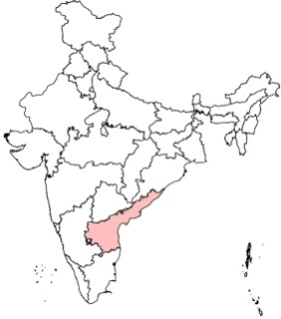
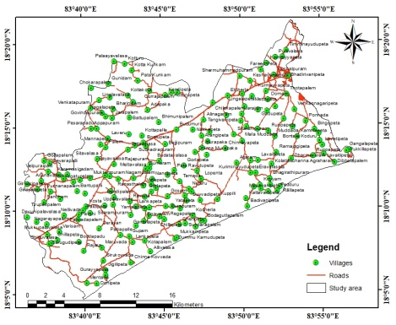
Figure1. Location map of the study area (SENTINEL - 2A satellite (February -25, 2019)
MATERIALS AND METHODS
The investigation zone covers 2 sequences of the Survey of India (SOI) toposheets, which are Numbers 65N/11 & 65N/12, scale 1:50,000. These toposheets are geo-rectified and projected to a polyconic projection (the Metric system units – meters are used as in the present study). The Catchment Area toposheet map has been scanned and saved in .jpg format, and then it is imported into image format, which is then referenced to polyconic projection using ArcGIS software.
The study area boundary is digitized and overlaid on Mosaic; the study area boundary on the 1:50000 toposheet and later verified by ground truthing. Necessary corrections were made and checked in the field with the help of GPS. Image processing was carried out for the Sentinel-2A satellite (February -25, 2019), Spatial Resolution 10m, Multispectral, Digital data imagery on a 1:50,000 scale by visual interpretation techniques. After applying necessary image enhancement, the landforms are delineated from geo-coded satellite imagery along with the available geological and geomorphology details. The geomorphic units are delineated based on the Standard visual interpretation techniques as per the norms given by NRS and represented on screen digitizations of features. In these terrain elements, nearly ten geomorphic erosional and fluvial classes have been delineated. The major features of the area are pediplain shallow, pediplain moderate, etc., as shown in Figure 2. The run-of-the-river features of hills are exposed prominently in the northern part of the area.
RESULTS AND DISCUSSIONS
In this study, land use/land cover is a prerequisite for an effective conservation strategy is a continuous and consistent monitoring program. Use of the remotely sensed data for monitoring purposes requires periodic updates of two basic sources of information on LULC. Twenty-five land use and ten land cover categories have been observed. The image interpretation elements for observing the above classes are given in the output as shown in Figure 2 and Table 1.
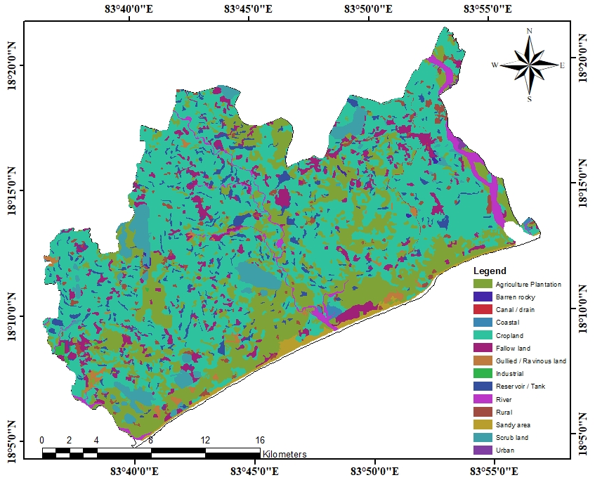
Figure 2: Land use/ Land cover
Table 1: Land use/ Land cover classes in the study area
S. No. | Name | Area (sq. km.) | Area (%)
1 | Agriculture Plantation | 129.74 | 24.08
2 | Barren rocky | 0.65 | 0.12
3 | Canal / drain | 0.51 | 0.09
4 | Coastal | 1.12 | 0.21
5 | Cropland | 289.21 | 53.67
6 | Fallow land | 36.45 | 6.76
7 | Gullied / Ravinous land | 4.4 | 0.82
8 | Industrial | 0.79 | 0.15
9 | Reservoir / Tank | 21.83 | 4.05
10 | River | 11.58 | 2.15
11 | Rural | 11.93 | 2.21
12 | Sandy area | 7.21 | 1.34
13 | Scrub land | 22.98 | 4.26
14 | Urban | 0.45 | 0.08
 | Total | 538.85 | 100.00

From the above table, out of all these features, the maximum area is covered by Cropped in 2 seasons (14.18%), followed by Kharif (single crop) (38.40%), Agriculture Plantation (22.86%), and Wastelands, hills with scrub (0.39%).

Agriculture Plantation
These are the areas under agricultural tree crops planted, adopting agricultural management techniques. These also include the areas of land use systems and practices wherein cultivation of herbs, shrubs, and vegetable crops are deliberately integrated with crops, mostly in irrigated conditions for ecological and economic reasons. Permanent commercial crops: coffee, mulberry, tea, rubber, etc., which are normally grown in the hilly regions and are closely associated with forest cover; Plantations of berry shrubs, raspberries, gooseberries, blackberry crops are Agriculture Plantation at Galatula Chodavaram. These are the areas of tree species of forestry importance, raised and managed especially in the notified forest areas. Most of these are in uplands, coastal areas within notified areas. Many of these can be identified based on the sharp boundary exhibited by them. This also includes: Teak, Sal, Eucalyptus, Casuarinas, Bamboo, Ratthi, Rajipuram and Amlapadu.
Barren rock
This class contains areas that are either dominated by a continuous rock surface or covered with a coarse rock fragment. The rock surface is continuous, with some areas that may be covered by a shallow layer of soil are Somallapeta and S Libbigam.
Built up -Urban
Urban areas are non-linear built-up areas covered by impervious structures adjacent to or connected by streets. Hence, all places with a municipality, corporation, or cantonment, or which are notified town areas, and all other places which satisfy the criteria of a minimum population of 5000, at least 75% of whose male working population is non-agricultural, and having a density of population of at least 400 sq. km. are placed under this category. It comprises three Level-3 classes as discussed below. In this analysis, urban built-up land use includes residential colonies, industries, institutions, and commercial areas, temples, etc., Chennai to Howrah National Highway (NH-16) and Howrah to Chennai railway lines passing through this area are Ragolu and Natavalasa.
Canal / Drain
Canals are waterways, channels, or artificial waterways for water conveyance or to service. In contrast, a canal cuts across a drainage divide atop a ridge, generally requiring an external water source above the highest elevation. Canals and drains are artificial water courses constructed for irrigation, navigation, or to drain out excess water from agricultural lands.
Coastal
These are the areas that are submerged by high tides at some stage of the annual tidal cycle. Non-wooded areas tidally, seasonally, or permanently waterlogged with brackish or saline water (CORINE 2000). This includes: Estuaries, lagoons, creeks, backwaters, bays, tidal flat/mud flat, sand/beach, coral reef, rocky coast, mangrove, salt marsh/marsh with vegetation, and other hydrophytic vegetation are at Coastal area at Gollapeta.
Cropped in 2 seasons
These are the areas that are cropped during two cropping seasons that are often seen associated with irrigated areas. Three combinations are possible in this category, viz., Kharif + Rabi, Kharif + Zaid and Rabi + Zaid. Kharif and Rabi cropped areas. These are the areas mostly in command areas and have two crops grown in the kharif and Rabi seasons. Kharif and summer seasons are Devunl Palavalasa and Boppadam.
Dense / Closed
These are the areas with the plants evergreen in nature, halophytic, dense or woody in nature, occurring along tidal waters/creeks, estuaries, and along the delta in coastal areas. They are densely colonized in coastal areas on tidal flats, estuaries, salt marshes, etc. Delineation of two sub-categories is possible using satellite data under level III, viz., dense/ closed and open, based on the canopy cover/ density. This category includes all the areas where the canopy cover/density is more than 40% are Devunl Palavalasa and Boppadam.
Fallow land
These are the lands, which are taken up for cultivation, but are temporarily allowed to rest, uncropped for one or more seasons, but not less than one year, and for not more than five years. Avenue Fallow land in Ganguvari Singadam near the wastewater purification area are Pedatarimi and Galatula Chodavaram.
Industrial area
All the areas that are described above, except for the areas under ash/cooling/tailing pond, which are characterized by water saturation, are classified under this category. These are artificially surfaced areas (with concrete, asphalt, tar macadam, or stabilized, e.g., beaten earth) without vegetation, which also contain buildings and/or vegetation. These are areas where human activity is observed in the form of manufacturing, along with other supporting establishments of maintenance. Heavy metallurgical industry, thermal, cement, petrochemical, engineering plants, etc., and Urban built-up areas with units equal or larger than 2.25 ha inside commercial/industrial units are Pydibhimavaram and Ranasthlam.
Kharif
These are cultivated between June/July and September/October, coinciding with the SW monsoon season. It is associated with rain-fed crops under dry land farming with limited or no irrigation and areas of rain-fed paddy and other dry crops. Kharif crop is observed near Lankalapallipalem, Tirupatipalem, Gollapalem, Devunl Palavalasa, Agraharam, and Boppadam etc
Mining – Active
Mining/quarry areas encompass the area under surface operations. The recognizable impacts of these activities on the landscape are unmistakable, with giant pit mines covering vast areas. The presence of water bodies does not necessarily imply inactive or unused extractive areas; ponds or lakes are often an integral part of an extractive operation. (USGS, 1999). This also includes: Industrial complexes where the extracted material is refined, packaged, or further processed; Open-pit extraction often associated with heaps of extracted building material (gravel, sand, stone, or clays) or ore and non-ore mineral material (iron, manganese ores, magnetite, lignite, brown coal, kaolin, etc.) areas are Tekkali and Ravivala. Mining - Active are the areas where large-scale surface operations of removal of economically important ores are presently going on Kontalapalem and Ommi.
Non-Perennial
Rivers/streams are the natural course of water flowing on the land surface along a definite channel/slope regularly or intermittently towards a sea in most cases, or a lake or an inland basin in desert areas, such as the Nagavali river at Srikakulam. The water covers the surface for less than nine months in each year (FAO, 2005). This also includes the dry part of the river, generally characterized by the presence of sand or exposed rocks.
Open Scrub Forest
These are the forest areas that are generally seen on the fringes of dense forest cover and settlements, where there is biotic and abiotic interference. Most times, they are located closer to habitations. Forest blanks, which are the openings amidst forest areas, devoid of tree cover, observed as openings of assorted size and shapes as manifested in the imagery, are also included in this category. Avenue scrub forest in Galatula Chodavaram near the purification area.

Perennial
Rivers/streams are the natural course of water flowing on the land surface along a definite channel/slope regularly or intermittently towards a sea in most cases or a lake or an inland basin in desert areas, such as the Nagavali river at Srikakulam. Perennial are the rivers/streams flow continuously throughout the year.
Permanent
Perennial lakes/ponds are those that retain water in them either for more than one season (usually more than three months of a year, FAO, 2005) or throughout the year, and are usually not subjected to extreme fluctuation in water level. Ponds are bodies of water limited in size, either natural or artificial, regular in shape, smaller in size than a lake, and generally located near a settlement.
Quarry
These are manifestations of surface mining operations where small-scale excavation of land surface for sand, gravel, clay, phosphate mines, limestone quarries, etc., are taking place. They are mostly characterized by their nearness to urban areas. This also includes Surface rocks and stone quarries, sand and gravel pits, and brick kilns in Tekkali and Ravivala.
Rabi Crop
These areas are cultivated between November / December to February / March. It is associated with areas under assured irrigation, irrespective of the source of irrigation. However, Rabi cropped areas also occur in rain-fed regions, under residual soil moisture conditions, especially in black soil areas with high rainfall during Kharif season, such as Nellvada.
Mining / Quarry
Mining/quarry areas encompass the area under surface operations. The recognizable impacts of these activities on the landscape are unmistakable, with giant pit mines covering vast areas. The presence of water bodies does not necessarily imply inactive or unused extractive areas; ponds or lakes are often an integral part of an extractive operation. (USGS, 1999). This also includes: Industrial complexes where the extracted material is refined, packaged, or further processed; Open-pit extraction often associated with heaps of extracted building material (gravel, sand, stone, or clays) or ore and non-ore mineral material (iron, manganese ores, magnetite, lignite, brown coal, kaolin, etc.) areas are Tekkali and Ravivala.
Built up-Rural
The classification is based on the proportion of people living in settlements defined as rural (below 10,000 population) or living in certain hubs where more than 80% of the people are involved in the primary activity of agriculture. All the agricultural villages covering 5 hectares or more, including Artamoru and Tirupatipalem, are included in this category.
Scrub forest
These are the forest areas that are generally seen on the fringes of dense forest cover and settlements, where there is biotic and abiotic interference. Most times, they are located closer to habitations. Forest blanks, which are the openings amidst forest areas, devoid of tree cover, observed as openings of assorted size and shapes as manifested in the imagery, are also included in this category. Avenue scrub forest in Konuru near the purification area.
Reservoir / Tank
A reservoir is an artificial lake created by the construction of a dam across a river specifically for hydel power generation, irrigation, and water supply for domestic/ industrial needs, flood control, either singly or in combination. Tanks are small lakes of impounded waterways constructed on the land surface for irrigation, shown in the field Photo 4.14 Kandivalasa River at Kontalapalem.

Figure 3. Percentage area of land use/land cover classes
CONCLUSION
This study demonstrates the effectiveness of integrating Remote Sensing and GIS techniques for comprehensive Land Use/Land Cover (LULC) analysis in the Laveru region of Srikakulam district, Andhra Pradesh. The results reveal significant spatio-temporal changes between 2000 and 2020, characterized by an increase in water bodies (3.44%) and plantation areas, alongside a decline in vegetation cover, barren land, and built-up areas. Agricultural dynamics indicate a gradual shift from traditional cropping to horticultural plantations driven by erratic rainfall, declining groundwater levels, and reduced reservoir storage within the Kandivalasa River Basin.
The expansion of dunes and active sand migration in the northwestern sector has further altered land use patterns, contributing to land degradation and reduced agricultural productivity. Socio-economic impacts are evident through increased rural outmigration, leading to a rise in fallow and wasteland areas. Despite these changes, nearly 75% of the region remains under agricultural use, highlighting its continued dependence on agrarian activities.
Overall, the study underscores the critical role of remote sensing and GIS-based approaches in monitoring LULC dynamics and supporting sustainable land and water resource management. The findings provide a scientific basis for policy interventions aimed at climate-resilient agriculture, groundwater conservation, and mitigation of land degradation to ensure long-term environmental sustainability.

REFERENCES
- Redclift, M. (2002). Sustainable development: Exploring the contradictions. Routledge. https://doi.org/10.4324/9780203464554
- Lillesand, T. M., & Kiefer, R. W. (1994). Remote sensing and image interpretation (3rd ed.). John Wiley & Sons.
- Chauhan, H. B., & Nayak, S. (2005). Land use/land cover changes near Hazira region, Gujarat, using remote sensing satellite data. Journal of the Indian Society of Remote Sensing, 33(3), 413–420. https://doi.org/10.1007/BF02990733
- Drăguţ, L., & Blaschke, T. (2006). Automated classification of landform elements using object-based image analysis. Geomorphology, 81(3–4), 330–344. https://doi.org/10.1016/j.geomorph.2006.04.013
- Rao, D. P., Gautam, N. C., Nagaraja, R., & Ram Mohan, P. (1996). IRS-IC application in land use mapping and planning. Current Science, 72, 165–190.
- Naik, D. R., Raju, N. A., Rao, P. J., & Rao, T. C. (2015). Land use/cover mapping of Paderu Mandal of Visakhapatnam District, Andhra Pradesh using geospatial techniques. International Journal of Remote Sensing & Geoscience, 4(6), 23–28.
- Balaselvakumar, S., Kumaraswamy, K., Srileka, S., & Raj, N. J. (2003). Application of remote sensing data for land use/land cover mapping: A case study of Arjuna River Basin, Tamil Nadu. Biosciences, Biotechnology Research Asia, 1(1), 43–48.
- Doucette, P., Agouris, P., Stefanidis, A., & Musavi, M. (2001). Self-organised clustering for road extraction in classified imagery. ISPRS Journal of Photogrammetry and Remote Sensing, 55(5–6), 347–358. https://doi.org/10.1016/S0924-2716(01)00041-3
- Wawale, S. G., & Aher, A. B. (2005). Land use/land cover mapping using remote sensing data in Pravara River Basin, Akole, Maharashtra, India. International Research Journal of Environmental Sciences, 4(9), 53–58.
- Skidmore, A. K., Bijker, W., Schmidt, K., & Kumar, L. (1997). Use of remote sensing and GIS for sustainable land management. ITC Journal, 3–4, 302–315.
- Merolla, S., Mesto, G., Griseda, G., & Calvanese, G. (1994). A GIS application for assessing agricultural land. ITC Journal, 3, 264–269.
- Patel, N. K., Saxena, R. K., & Shiwalkar, A. (2007). Study of fractional vegetation cover using high spectral resolution data. Journal of the Indian Society of Remote Sensing, 35(1), 73–79. https://doi.org/10.1007/BF02991836
- Alaguraja, P., Durairaju, S., Yuvaraj, D., Sekar, M., Muthuveeran, P., Manivel, M., & Thirunavukkarasu, A. (2010). Land use land cover mapping of Madurai District, Tamil Nadu, India using remote sensing and GIS techniques. International Journal of Civil and Structural Engineering, 1(1), 91–100.
- Rao, T. C. S., Jaisankar, G., Allamraju, A., & Amminedu, E. (2018). Land use/cover mapping for Janjhavathi River Basin of Odisha and Andhra Pradesh using geospatial techniques. International Journal of Engineering, Science and Mathematics, 7(3), 171–177.

