Localized Deep Learning Architectures for Automated Wheat Disease Identification: A Decision Support System with an Amharic Interface for Sustainable Agriculture

Abstract
Automated identification of wheat pathogens plays a critical role in optimizing agricultural productivity. If left unchecked, these diseases drastically reduce crop yields. The main concern is how to identify the diseases that cause devastating wheat production. To address this critical challenge, this study employs an experimental quantitative design method to detect multiple wheat diseases. It is intended to detect multiple wheat diseases and suggest treatment models with an Amharic language user interface tailored for local stakeholders. A total dataset of 3,029 images was compiled from farm land and plant village datasets. The researcher used CNN algorithms, Python for image processing methods by taking images of wheat leaves and other parts, and the flask module for GUI applications. There were six experiments and six scenarios. Six classes of diseases were identified, including healthy. Four pre-trained models have also been investigated. Based on the experimentation, the EfficientNet (28.49%), VGG 19 =75.41%, VGG 16 =77.84%, and the Inception model =84.24%. Whereas, when the researcher examined the preferred model of Inception V3 with augmentation, the accuracy increased from 84.24% to 87.32% at the 80:20 split ratios. Besides this, the experimentation checked and confirmed the accuracy of the GUI in the Amharic Interface, proving its potential as a sustainable decision support system to safeguard local agricultural yields.
Keywords: Machine Learning, GUI, Image Processing, Diseases Detection, Disease Treatment, Inception Model
Background of the Study
The wheat disease burden causes severe productivity declines, hindering development and threatening national food security. To address this, machine learning frameworks operate alongside advanced image processing techniques for early outbreak detection. Image processing performs automated operations on raw input images to generate enhanced visual outputs or extract critical technical properties and data (Agriculture Organization. (2024), Bedasa, T., & Negash, W. (2024).
To optimize agricultural yields, automated disease detection and classification are crucial. Most researchers propose Convolutional Neural Network (CNN) models for image-based identification (Desalegn, M. (2024), Desalegn, M. (2024), Chen, J., Zhang, X., & Wang, L. (2023), Zewdie, B., & Worku, N. (2026)). Motivated by this, this study develops an optimized model to accurately classify infected versus healthy wheat leaves and organs, enhancing automated classification and supporting targeted treatment strategies for the affected wheat parts.
Statement of the Problem
The Wheat diseases cause severe socioeconomic problems, frequently subjecting farmers to food insecurity and social instability.
To address these outbreaks, traditionally, farmers diagnose these symptoms by eye using past experience. This manual approach is tedious, time-consuming, ineffective, labor-intensive, and error-prone (Inoue, K., & Tanaka, R. (2025)). Furthermore, existing literature lacks evidence of multiple wheat disease detection utilizing an Amharic interface driven by machine learning. Previous studies focused primarily on single-disease detection (identifying if a leaf is infected or uninfected), failed to show targeted treatment mechanisms, and did not implement localized Amharic user interfaces.
In response to these critical limitations, this study utilizes advanced image processing and machine learning algorithms to identify diagnostic features for wheat diseases (Kumar, R., & Singh, P. (2023)). Addressing these literature gaps, this research aims to design a disease classifier model operating with an Amharic Graphical User Interface (GUI) and actionable local treatments. To build this framework, the researcher systematically examined six experiments across six scenarios and assessed four distinct deep learning models.

Research Questions
RQ1: What are the available state-of-the-art automated wheat disease detection techniques, and how do they compare against machine learning approaches?
RQ2: What are the most critical plant pathological variables and visual features required to accurately identify multiple wheat diseases?
RQ3: How can an optimized deep learning model be designed and architecturalzed to effectively detect and classify multiple wheat leaf diseases?
RQ4: How can the automated detection model be integrated into an interactive decision support system featuring localized treatment mechanisms and an Amharic user interface?
Objectives
General objectives
The general objective of this research is to design, develop, and evaluate an optimized multi-class deep learning model for automated wheat disease detection and treatment recommendation, integrated within a localized Amharic graphical user interface.
REVIEW OF RELATED LITERATURE
Wheat and Wheat Diseases
Annually, over 630 million tons of wheat are produced, with nearly half generated in developing nations like Ethiopia. However, Ethiopia remains a major importer; for instance, in 2020, the country's wheat imports totaled $431,176,000 (Ababa, T., & Tesfaye, K. (2024)). Domestically, wheat ranks as the second most consumed food after maize. Although it plays a dynamic role in food security, national productivity is declining primarily due to destructive wheat diseases. These infections, particularly rust pathogens, pose a severe threat to the economy. Among these, stem rust and yellow rust are the most devastating types, leading the destruction of wheat fields across the country (Alemu, M., & Wolde, G. (2025)). To systematically understand these biological threats, the five primary diseases affecting local production are evaluated sequentially below. In this sequence, the first major threat is leaf rust (brown rust), caused by Puccinia recondita, which forms small, round, orange-brown uredospores on leaves. It prefers intermediate temperatures (20–25 °C) and causes up to 20–30% yield loss by utilizing intercellular leaf spaces, with recent epidemics reported in Ethiopia. The second critical pathogen is stripe rust (yellow rust), caused by Puccinia striiformis, which is distinguished by bright yellow pustules arranged in linear stripes. It requires a humid climate with at least three hours of water contact for spore germination, peaking at temperatures of 7 °C (Mekonnen, S., & Girma, T. (2025)). Moving to the third devastating infection, stem rust (black rust), caused by Puccinia graminis, produces elongated, reddish-brown lesions on leaves, sheaths, and stems, turning black at maturity. It thrives in hot environments (15–35 °C) at altitudes of 1800–2400 masl, and can cause devastating yield losses of 50% to 100% .
Fourth in this progression is loose smut, a seed-borne disease caused by Ustilago tritici, which infects the seed embryo. Although hard to identify before heading, infested plants grow taller with dark green, yellow-streaked leaves, head earlier with smaller spikes, and ultimately see their spikes completely replaced by black, powdery fungal spores. Fifth and finally, spike disease threatens overall crop health; however, its critical treatment mechanisms include avoiding susceptible varieties, applying foliar fungicides before flowering, practicing proper crop rotation (avoiding maize or sorghum sequences), destroying crop residues, and utilizing disease-free seeds.
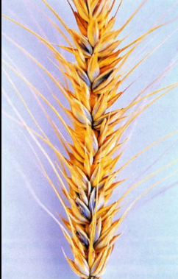
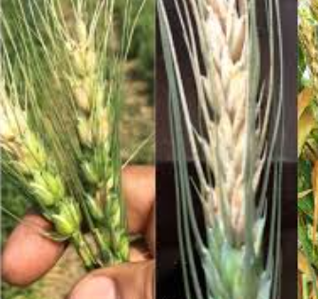
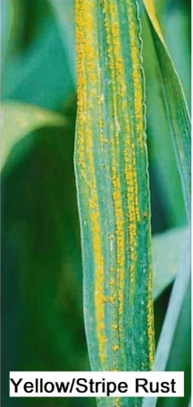
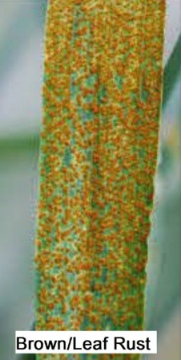

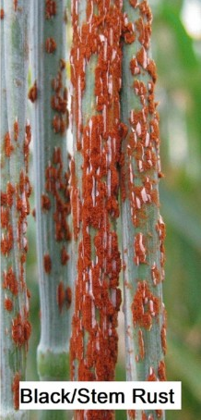
Figure 1: All Wheat rust diseases types
Loose smut
Spike wheat disease
Loose smut

Empirical Literature Review
First, early localized research by (Tsion, W. (2023)) focused on the automatic detection of wheat yellow rust using image processing and machine learning. While achieving promising results, misclassification errors occurred due to noise elimination challenges and highly similar color features between infected and healthy wheat leaves. Second, to address data constraints, Arsenovic et al. (2024) introduced a novel wheat fungi dataset using augmentation and neural style transfer, achieving a 94.2% classification accuracy under field conditions using the EfficientNet-B0 architecture. Third, within the Ethiopian context, Mosisa Desalegn (2024) collected wheat leaf images across three major national hubs—the Kulumsa, Bishoftu, and Ambo Agricultural Research Institutes—to evaluate yellow, leaf, and stem rusts. Utilizing RGB, grayscale, and color-segmented preprocessing pipelines, the author developed a custom CNN architecture termed "MosNet" that reached an accuracy of 99.76%; however, due to severe dataset limitations, the model was restricted to a basic binary classification between healthy and diseased states.
Fourth, several studies evaluated the specific environmental and technical factors that degrade deep learning performance. Research by Tion (2023) achieved a 91.3% validation accuracy using a custom CNN but demonstrated that system performance is heavily dictated by input image quality, spatial resolution variations, data formats, ambient background darkness, and camera hardware specifications. Fifth, standard benchmarking datasets have been heavily exploited; for instance, studies (Worku, T., & Aboneh, T. (2024)) and (Hassan, M., & El-Dahshan, K. (2025)) both deployed deep convolutional neural network approaches utilizing the public PlantVillage dataset, achieving high accuracies of 96.25% and 98.4%, respectively. Sixth, Khan et al. and Jackson, T., & White, G. (2024) expanded on this open-source data paradigm by training a model over 1,000 epochs to compare VGG, MobileNet, and Inception pre-trained architectures for tomato disease detection, ultimately selecting VGG16 for its superior 94.45% accuracy score.
Seventh, architectural optimization trends have shifted toward deploying lightweight multi-disease systems. Ramakrishnan et al. (2024) implemented a pre-trained model integrated into a Flask web framework using a K-Nearest Neighbors (KNN) algorithm to aggregate multiple diseases under a single platform, achieving an 85% accuracy. Similarly, (Sun, Q., & Ding, W. (2025)) introduced "WheatNet," a novel framework combining Recurrent Neural Networks (RNNs) and MobileNetV2 with a lightweight encoder-decoder architecture, which drastically minimized trainable network parameters while accelerating wheat head counting efficiency. Eighth, specialized single-pathogen studies like (Paterson, A., & Kirk, R. (2024)) successfully isolated wheat stem rust using deep CNN algorithms, obtaining a 92.02% accuracy. Finally, deep learning has shown massive cross-crop viability, as demonstrated by CNN models designed for sunflower leaf (Thomas, S., & Cooper, L. (2024).) and automatic flower disease identification (Tarekegn, G., & Melaku, F. (2023)) which scored accuracies of 99.34% (using 400 images) and 94.6% (using 2,000 images), respectively.
Conceptual Framework
The conceptual framework maps the multidimensional process of building an automated, machine learning-based wheat disease detection and treatment recommendation system. As structured across four core operational phases, the framework flows sequentially below:
First, the Input Phase (Data Acquisition) establishes the data foundation by integrating localized primary field data captured via smartphone cameras in Kelela Woreda with augmented agricultural bureau data and global open-source images from the PlantVillage repository. Second, the Processing Phase (Model Development) subjects raw images to digital image processing, scaling, and contrast normalization. Subsequently, refined visual features are passed into optimized Convolutional Neural Network (CNN) architectures (such as VGG, InceptionNet, or EfficientNet) for multi-class classification using the Adam optimizer and ReLU activation functions.
Third, the Output Phase (Localized Deployment) translates deep learning classifications into a socio-technical solution. Here, the detected pathogen is mapped onto a treatment recommendation matrix, which is rendered dynamically through a user-friendly, localized Amharic language graphical interface for farmers and extension workers. Finally, the Evaluation Phase passes outputs through an $N \times N$ confusion matrix to compute precise validation metrics, including accuracy, precision, and recall, thereby ensuring a robust, reliable, and deployable agricultural diagnostic solution.

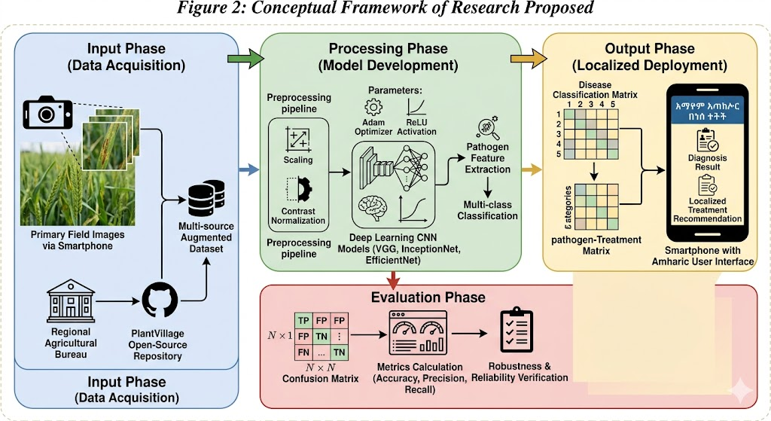

Figure 2: Conceptual Framework

RESEARCH METHODOLOGY
Research Paradigm, Approach, and Design
This study is grounded in a positivist research paradigm, utilizing objective, empirical observations and quantifiable metrics. Aligned with this paradigm, a deductive approach is adopted to test established computer vision and neural network theories on a localized agricultural dataset. To execute this framework, a quantitative experimental design was selected, allowing the researcher to manipulate architectural variables (such as model types, optimizers, and epochs) and precisely measure their impact on dependent variables like classification accuracy, precision, and recall. The empirical execution of this study is structured sequentially across five distinct procedural phases. To begin with, a comprehensive literature review was conducted to benchmark state-of-the-art machine learning algorithms in crop pathology. Following this baseline analysis, primary image acquisition was executed by capturing healthy and infected wheat leaves directly from field irrigation sites across two kebeles in Kelela Woreda, a localized dataset that was subsequently augmented with data from regional agricultural bureaus and the open-source PlantVillage repository. Once the data was compiled, digital image processing techniques were applied in the third phase to clean, scale, and normalize the target images. Thereafter, an optimized multi-class CNN architecture was designed and systematically trained across three operational phases: training, validation, and testing. Finally, the trained model was validated and evaluated in the fifth phase to verify its performance accuracy prior to final system deployment.
Experimental Materials and Tools
Software and Hardware Specifications
The software environment is built upon Python within the Anaconda ecosystem, utilizing Jupyter Notebook as the primary IDE. Architecturally, the deep learning pipeline is powered by TensorFlow as the high-performance backend engine, layered sequentially with the Keras library to construct and evaluate both from-scratch and pre-trained CNN architectures. On the hardware side, primary image data acquisition is supported by any standard smartphone camera. For model training and computational processing, the experimental setup requires an Intel Core i5 or i7 processor (up to 2.7 GHz) and a minimum of 8GB of RAM to handle gradient computations efficiently.
Experimental Setup
The experimental pipeline integrates Anaconda for code compilation, Keras for CNN library structures, and TensorFlow for backend array operations. To ensure statistical viability and robust feature learning, the research relies on a structured dataset comprising at least 3,000 distinct images compiled from field captures and the PlantVillage repository, which are ultimately mapped to a localized Amharic user interface for deployment.
Data Pipeline and Preprocessing Setup
Image Acquisition and Dataset Distribution
To establish the data foundation for the multi-class CNN architecture, a hybrid image acquisition strategy was implemented. Primary field data was compiled by capturing localized wheat leaf images via smartphone cameras across two irrigated farming kebeles within Kelela Woreda. This primary data was subsequently integrated with secondary baseline images extracted from the PlantVillage open-source repository to ensure an balanced representation of healthy and pathologically infected specimens. Ultimately, this pipeline yielded a structured experimental dataset comprising 3,029 distinct images, partitioned across the specific target categories outlined in Table 3.
Table 3: Distribution of Captured Wheat Image Classes
Image Classification Type | Number of Images | Data Source
Healthy | 807 | Direct Capture & PlantVillage
Leaf Rust (Brown Rust) | 501 | Direct Capture & PlantVillage
Loose Smut | 500 | Direct Capture & PlantVillage
Spike Disease | 315 | Direct Capture & PlantVillage
Stem Rust (Black Rust) | 500 | Direct Capture & PlantVillage
Stripe Rust (Yellow Rust) | 406 | Direct Capture & PlantVillage
Total Dataset Volume | 3,029

Image Processing and Feature Engineering
Image Color Transformation and Enhancement
To minimize memory footprints and standardize tensor dimensions, raw RGB input images are systematically converted into single-channel grayscale representations using the weighted average method. While pre-trained networks bypass this step to maintain compatibility with original color-space training configurations, custom model training relies on this conversion to compress pixel inputs into uniform integer distributions scaled between 1 and 255.
Following color transformation, noise mitigation techniques are applied to correct sensor discrepancies and uncontrolled field lighting artifacts. For this study, median filtering algorithms within the Python OpenCV library were selected to smooth out localized outliers and high-frequency noise profiles. By substituting the median value of neighboring pixels for data anomalies, this algorithm effectively stabilizes input noise without sacrificing edge sharpness or shifting
Second, because scalar integers imply an artificial numerical hierarchy that can distort backpropagation, one-hot encoding maps these indexes into distinct binary vectors. This splits the output variable into a six-dimensional sparse matrix where the active target class receives a value of 1 and all inactive channels remain 0.
Dataset Augmentation Pipelines
To systematically counter the risk of model overfitting within restricted training boundaries, spatial data augmentation is introduced via the Keras ImageDataGenerator class. This pipeline applies random geometric translations including rotations, width/height shifts, zoom alterations, and horizontal scaling to artificially expand the original training image variety. This dynamic conversion ensures high generalization accuracy when the system encounters completely novel field variations.
EXPERIMENTATION AND RESULTS
Domain Understanding and Problem Context
While wheat remains, a foundational agricultural commodity driving food security in Ethiopia, localized smallholder production per hectare continuously underperforms compared to global averages. A primary catalyst for this yield deficit is the unrestricted spread of crop pathologies, most notably stem rust, stripe rust, leaf rust, loose smut, and spike disease. To resolve this bottleneck, this study deploys automated computer vision pipelines and deep learning classification frameworks within a Python engineering environment, thereby establishing a rapid, data-driven diagnostic mechanism accessible to local extension systems.
Dataset Description and Volume Distribution
To facilitate robust feature extraction and network validation, a balanced hybrid image asset directory was compiled. Primary field data was acquired via smartphone digital cameras from irrigated wheat farm plots across two distinct kebeles within the South Wollo Zone's Kelela Woreda. This primary array was subsequently integrated with secondary baseline images from the open-source PlantVillage repository. Every file was standardized to the standard JPG format and validated by professional crop researchers.
Initially, the baseline pipeline processed 3,029 original images, comprising 807 healthy leaf controls and 2,222 pathologically infected samples. Subsequently, to minimize overfitting variations and boost training efficiency, data augmentation routines were executed to scale the comprehensive experimental volume to 5,435 total samples, as systematically partitioned in Table 9.
Table 9: Statistical Distribution of Baseline and Augmented Target Classes
Image Target Category | Original Image Volume | Post-Augmentation Volume | Core Data Source | File Format
Wheat Healthy Leaf | 807 | 1,000 | Direct Capture & PlantVillage | JPG
Leaf Rust (Brown Rust) | 501 | 1,211 | Direct Capture & PlantVillage | JPG
Loose Smut | 500 | 800 | Direct Capture & PlantVillage | JPG
Spike Disease | 315 | 810 | Direct Capture & PlantVillage | JPG
Stem Rust (Black Rust) | 500 | 810 | Direct Capture & PlantVillage | JPG
Stripe Rust (Yellow Rust) | 406 | 804 | Direct Capture & PlantVillage | JPG
Total Experimental Asset Space | 3,029 | 5,435 |  | JPG
Experimental Configuration Parameters
The empirical testing matrix is governed by specific hyperparameters that dictate convergence rates and network capacity. To map the optimal learning pathway, the custom and pre-trained CNN configurations were toggled across multiple parameter iterations, defining the boundaries for model training as summarized in Table 10.
Table 10: Matrix of Controlled Hyperparameter Iterations
Operational Tuning Parameter | Targeted Experimental Boundary Values
Training Epoch Limits | 50 Fixed Cycles
Steps Per Training Epoch | 50 to 200 Iterations
Operational Mini-Batch Size | 32 (Baseline Default) and 64 Tensors
Algorithmic Optimization Variants | Adaptive Moment Estimation (Adam), RMSProp
Gradient Descent Learning Rates ($\alpha$) | 0.1, 0.01, 0.001, and 0.0001
Normalized Tensor Dimension Input | 256 x 256 Pixels
Total Output Categorical Dimensions | 6 Distinct Multi-class Categories
Layer Activation Functions | Rectified Linear Unit (ReLU), Sigmoid, Softmax

Experimental Setup and Empirical Scenarios
To systematically isolate the highest-performing model configuration, the experimental architecture is structured around eight distinct empirical trials. These core experiments are divided between custom architectures trained from scratch and pre-trained deep transfer learning networks, evaluating the performance impacts of dataset partitioning ratios and spatial data augmentation.
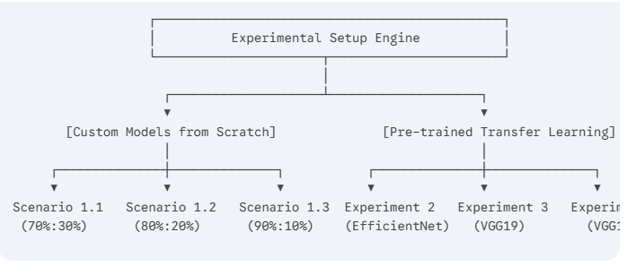
The complete experimental execution matrix is defined sequentially below:
Experiment 1 (Custom CNN from Scratch): Evaluates the baseline three-layer convolutional neural network architecture using randomly initialized weights. This experiment is stratified across three data-splitting scenarios to isolate the effect of validation volume on model convergence:
Scenario 1.1: Data partitioned using a baseline 70%:30% training-to-testing ratio (15%$ validation, 15% testing).
Scenario 1.2: Data partitioned using an 80%:20% split ratio (10% validation, 10% testing).
Scenario 1.3: Data partitioned using a maximized 90%:10% split ratio (5% validation, 5% testing).
Deep Transfer Learning Trials: Retrains state-of-the-art computer vision models using frozen feature extraction bases and modified top classification blocks to map the multi-class wheat target categories:
Experiment 2: Deep feature evaluation utilizing the EfficientNet network.
Experiment 3: Performance verification utilizing the VGG19 architecture.
Experiment 4: Baseline feature optimization utilizing the VGG16 network
Experiment 5: High-dimensional architectural evaluation utilizing the InceptionV3 model.
Optimized Model Construction (Aided by Augmentation): Re-evaluates the top-performing selected models by applying synthetic spatial image expansion routines to measure robustness against localized overfitting:
Scenario 6.1: Model execution using a 70%:30% split ratio coupled with active data augmentation parameters.
Scenario 6.2: Model execution using an 80%:20% split ratio coupled with active data augmentation parameters.
Scenario 6.3: Model execution using a 90%:10% split ratio coupled with active data augmentation parameters.
Model Development from Scratch (Experiment 1): using proposed CNN (Training mechanism from scratch)
The researcher conducted an experiment to learn from scratch using CNN, dividing the testing learning ratio into three situations. All scenarios tried to investigate the accuracy and lose of the training in two ways. That means before and after augmentation in terms of the training-testing split ratio. On this experiment one (3 scenarios) the following 3 subsequent has conducted to take the appropriate split ratio and to select the model.
Scenario 1 using 70:30 split ratio
To do this research, the researcher tried to do the experiment to learn from scratch. Points that undertaken the experiment from scratch looks like the following screenshots according to the 70:30 test option. The data split into 70% for training and 30% for testing purpose. This scenario tried to investigate the accuracy and lose of the training before augmentation applied. The following figures and tables are illustrated bout the 70:30 test ratio training from scratch.
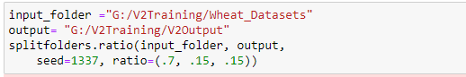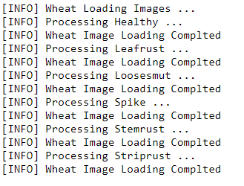
Figure 8:70:30 learning from scratch main screenshots
As the above figure 11 shown that, this training took 70% from the total number of images and 30 % for the testing and validation images. Based on this split ration the wheat images are loaded.
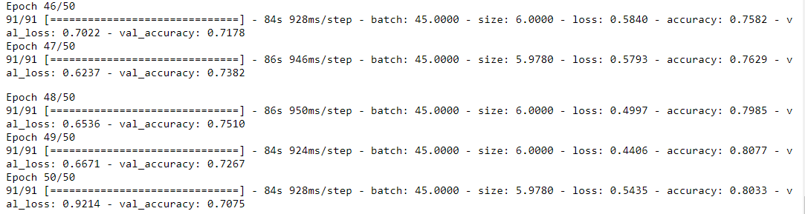
Figure 9: 70:30 split rations before augmentation takes place in training from scratch
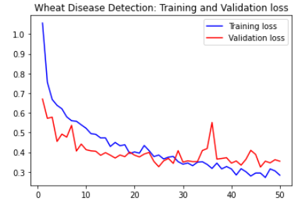
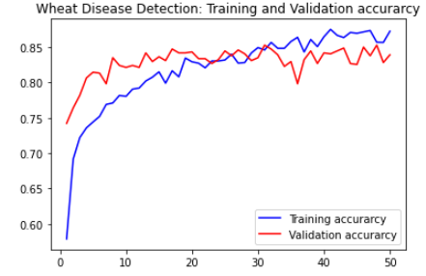
As the researcher tried to indicate in the above screenshot about the performance of the 70:30 split ratios, the accuracy 80.33% and loses 54.35% registered at 50 epochs respectively without augmentation took place.

Figure 10: 70:30 split rations validation and lose accuracy training from scratch
The above fig 10 tried to illustrated the accuracy and the lose overlap each other because of the performance is almost better.
Table 11: Experiment 1. (Scenario 1) learning from scratch 70:30 ratio
Training type | Number of classes | Training: tasting ratio | Optimizer | Epochs | Steps per Epochs | RGB or Grayscale | Accuracy | Loose | Val- accuracy
Scenario 1.1:-From scratch | 6 | 70:30 | Adam | 50 | 91 | RGB | 80.3% | 54.4% | 70.8%
Based on the above experiment 1 scenario 1, as shown from the screen shots fig 10 and table 11 and learning from scratch is scored on the above parameters. Therefore, the accuracy was gotten 80.3% accuracy and was gotten lose is 54.4% by experiment on 70:30 split ratios without augmentation. The value of the accuracy and loose changed and overlap each other.
Scenario 2 using 80:20 split ratio
This scenario also tried to examine the appropriate test split ration based on 80:20. 80% for training purpose from the total number of images the rest laid down for the test and validation situation for the testing purpose. The following table’s results show the output of the experimental result for this ratio with the same parameters with the above scenario one.
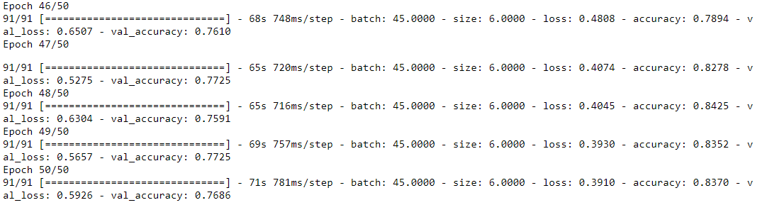
Figure 11: without augmentation 80:20 accuracy

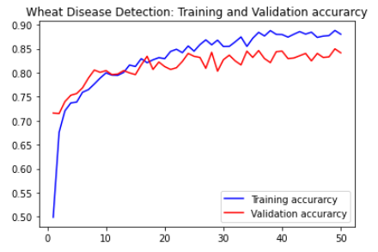
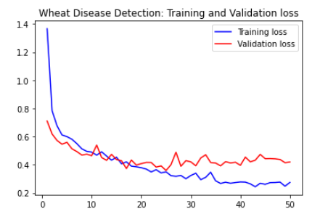

Figure 12: 80:20% training from scratch Validation loses and accuracy

Table 12 : Experiment 1. (Scenario 2) learning from scratch 80:20 ratio
Training type | Number of classes | Training: tasting ratio | Optimizer | Epochs | Steps per Epochs | RGB or Grayscale | Accuracy | Loose | Val- accuracy
1.2. from scratch | 6 | 80:20 | Adam | 50 | 91 | RGB | 83.7% | 39.1% | 76.9%
Based on the above experiment 1 scenario 2, as shown from the screen shots fig 12 and table 12 and ta learning from scratch is scored on the above parameters. Therefore, the accuracy was gotten 83.7% accuracy and was gotten lose is 39.1%% by experiment on 80:20 split ratios without augmentation. The value of the accuracy and loose changed overlapped.
Scenario 3 using 90:10 split ratio
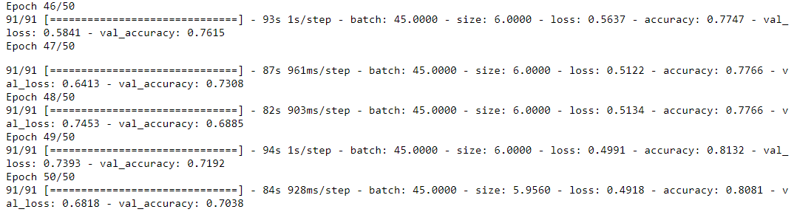
Figure 13: without augmentation 90:10 accuracy

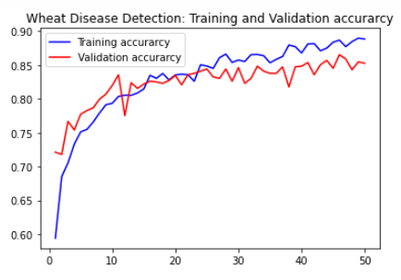
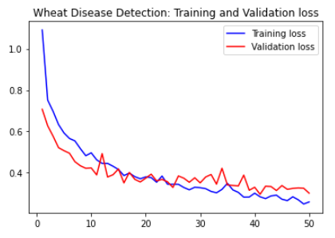
The above fig shown about 90:10 test split ratio. Based on the experimental result, the accuracy and loses were registered 80.81% and 49.18% respectively without augmentation occurred.

Figure 14:90:10 validation accuracy and validation loss
Table 13: Experiment 1. (Scenario 3) learning from scratch 90:10 ratio
Training type | Number of classes | Training: tasting ratio | Optimizer | Epochs | Steps per Epochs | RGB or Grayscale | Accuracy | Loose | Val- accuracy
1.3 From scratch | 6 | 90:10 | Adam | 50 | 91 | RGB | 80.81% | 49.18% | 70.38%
Based on the above experiment 1 scenario 1, as shown from the screen shots fig 12-13 and table 13 and ta learning from scratch is scored on the above parameters. Therefore, the accuracy was gotten 80.81% accuracy and was gotten lose is 49.18%% by experiment on 90:10 split ratios before augmentation. The value of the accuracy and loose changed plus overlapped each other.
Comparison experimental One scenario using training from scratch

Table 14: learning from scratch comparisons all experiment’s One
Training: tasting ratio | Training type | Number of Input images | Number of classes (Classes) | Epochs | Steps per Epochs | RGB or Grayscale | Accuracy | Loose | Val- accuracy
70:30 | From scratch | 5243 | 6 | 50 | 91 | RGB | 80.3% | 54.4% | 70.8%
80:20 | From scratch | 5243 | 6 | 50 | 91 | RGB | 83.7% | 39.1% | 76.9%
90:10 | From scratch | 5243 | 6 | 50 | 91 | RGB | 80.81% | 49.18% | 70.38%
As we examined from the above experiment three scenarios, the accuracy had gotten 80.3%, 83.7% and 80.81% from 70:30, 80:20 and 90:10 ration respectively without augmentation training from scratch. So, using 80:20 training testing ratio for training from scratch scored better result without augmented. That means 80:20 test split ration scored 83.7% before augmentation.
Developing a model using Transfer learning (Experimentations)
The following different model architectures are tested through systematic python experimentation to select and design the appropriate model for the classification of wheat diseases. All models have been investigated by the same parameters before augmentation.
Experiment 2: using Efficient Net model (Pre trained learning)
EfficientNet is a convolutional neural network design and scaling approach that uses a compound coefficient to scale all depth/width/resolution dimensions evenly. In some papers it is recommended model for disease classification. To examine and select appropriate model for the disease classification, the researcher tried to do the following experiment using 70:30 training testing ratio.
Figure 15: using Efficient Net model screenshot accuracy based on epoch
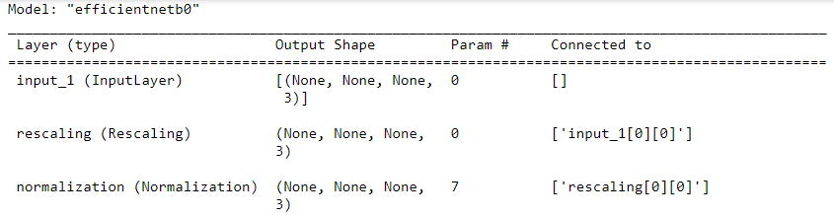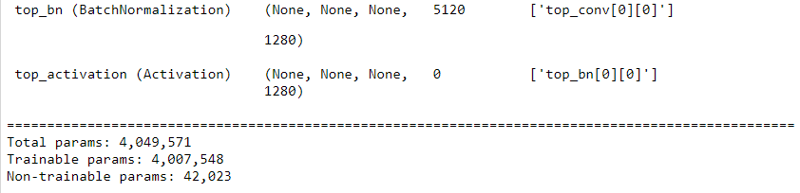
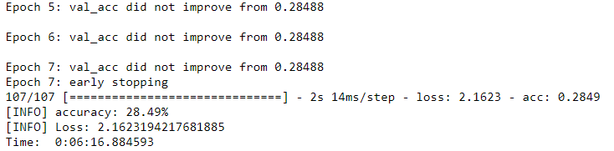
Figure 16: confusion matrix in terms of precision, recall Using EffnetNet model
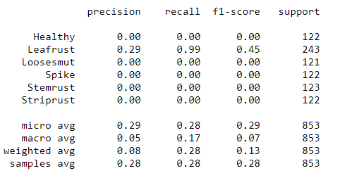
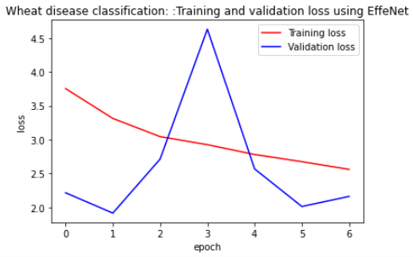
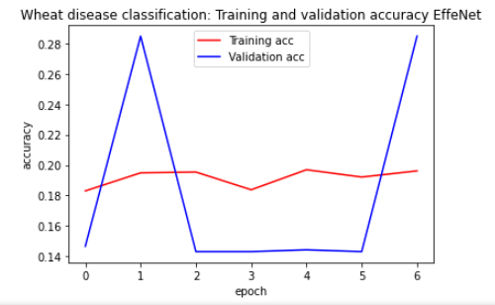
Figure 17: validation accuracy and validation using Efficient Net model

Table 15: Experiment 2, Efficient Net Models
Models | Training: tasting ratio | Training type | Number of Input images | Number of classes | Image size(W,H.D) | Optimizer | Learning rate | Time taken to learn | Time taken to test | Epochs | Steps per Epochs | Augmented or not | Accuracy | Loose | Time to complete the epoch
EffNet | 70:30 | Pre-trained | 3502 | 8 | 224*224*3 | rmsprop | Lr-3 | 0:15:45 | 0:02:46 | 50 |  | No | 28.49% | 216 % | 0:06:16
From the above the above screen shots and tables indicated based on the experiment 2, the pre-trained efficient model at 50 epochs got the accuracy 28.4 % and 216% losses. This is the worst model for this wheat disease classification method. The time taken to learn and time to test is 0:15:45and 0:02:46 minutes respectively. Based on the experiment, using EffNet accuracy is the worst which scored 28.49% but less time to train and test. The validation accuracy and validation loses were up and down instead of overlapped each other. This model couldn’t detect the wheat disease images correctly.
Experiment 3: using VGG19 Net model (pre-trained)
The VGG19 model is a variation of the VGG model that has 19 layers in total (16 convolution layers, 3 fully connected layers, 5 MaxPool layers and 1 SoftMax layer).This model is the most recommended in different paper. To investigate this, the researcher did the following experiment. Using 70:30 training testing ratio and other parameters remain the same with other models.
Figure 18: VGG 19 models screenshots
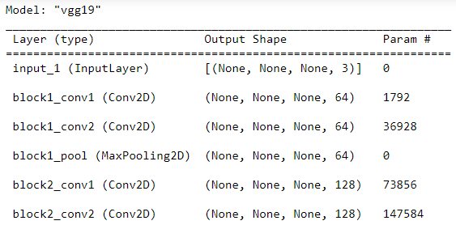
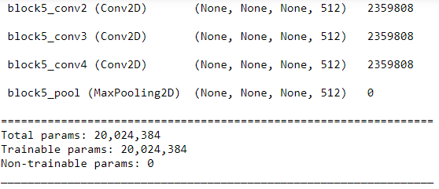
Figure 19: VGG 19 Net accuracy at 50 epochs

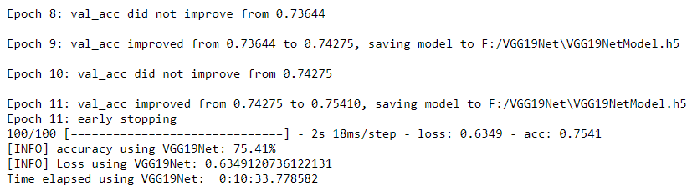
Figure 20: VGG 19, 70:30, Accuracy and lose

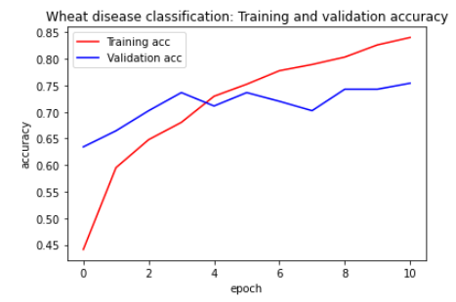
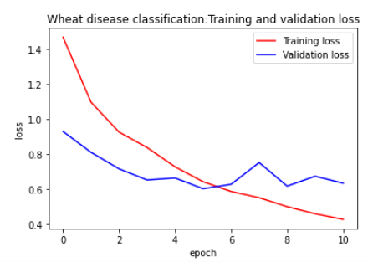
Figure 21: Confusion matrix using VGG19 Net
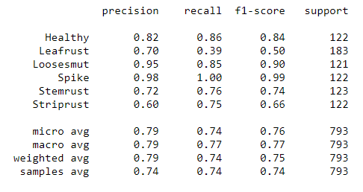
Models | Training: tasting ratio | Training type | Number of Input images | Number of classes | Image size(W,H.D) | Optimizer | Learning rate | Time taken to learn | Time taken to test | Epochs | Steps per Epochs | Augmented or not | Accuracy | Loose | Time to complete the epoch
VGG19 | 70:30 | Pre-trained | 3502 | 8 |  | rmsprop | Lr-3 | 0:40:22 | 0:08:42 | 50 | 50 | No | 75.41% | 63.49 % | 0:10:33
Table 16: Experiment 3: using VGG19 Net model

As we saw from the above experiment which listed on the table, the VGG 19 accuracy is 75.41% without augmentation and changing grayscale at the epoch of 50. On the other hand, the loose of the experiment is 63.4%.But the time to complete train, test is and time to complete 50 epoch are 1:02:25, 0:12:25 respectively 0:10:33 respectively.
Experiment 4: using VGG16 model (Pre-trained)
VGG16 is convolutional neural network (CNN) architecture. It is regarded as one of the best vision model architectures ever created. This is exactly what transfer learning achieves. The VGG16 model, which is a convolutional neural network trained on 1.2 million pictures to identify 1,000 distinct categories, will be used. We can utilize VGG16's pre-trained network to complete the task because the domain and task are comparable to ours. The researcher did an experiment for the 4397 images (both infected and healthy) by 70:30 split ratio.
Figure 22: VGG 16 model
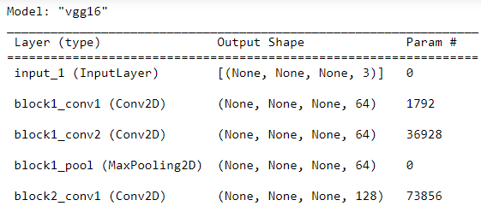
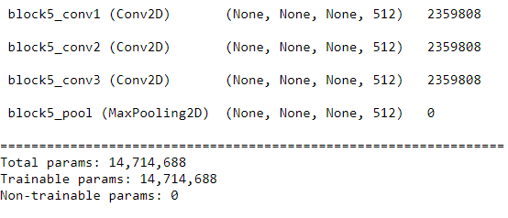
Figure 23: VGG16 accuracy based on 50 epochs

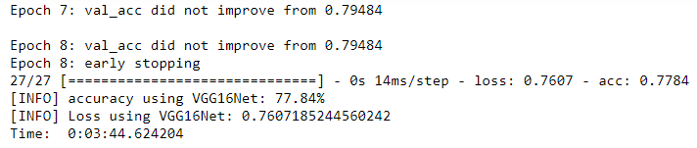
Figure 24: Val accuracy and Val lose for using VGG 16
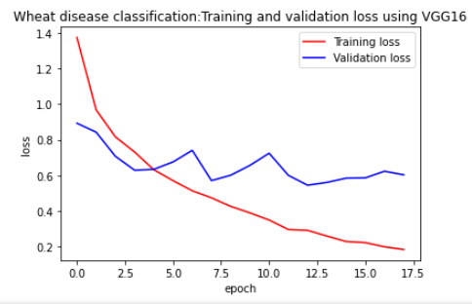
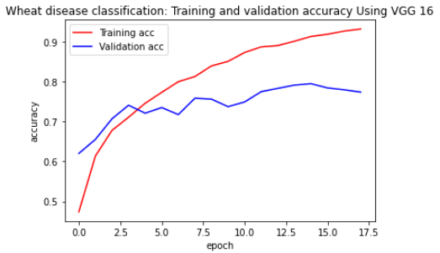
Figure 24: Val accuracy and Val lose for using VGG 16

Figure 25: Confusion Matrix Using VGG 16
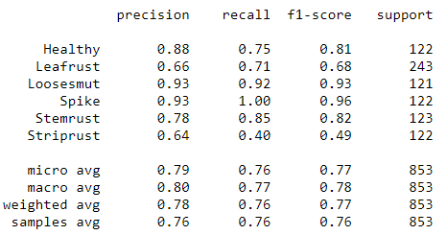
Table 17 Experiment 4 using VGG16 Net model
Models | Training: tasting ratio | Training type | Number of Input images | Number of classes | Image size(W,H.D) | Optimizer | Learning rate | Time taken to learn | Time taken to test | Epochs | Steps per Epochs | Augmented or not | Accuracy | Loose | Time to complete the epoch
VGG16 | 70:30 | Pre-trained | 3502 | 8 | 224x224x3 | rmsprop | Lr-3 | 0:16:48 | 1:15:54 | 50 | 50 | No | 77.84% | 76% | 0:03:44
From the experiment as shown from the above, the VGG 16 Net models 70:30 split ratio accuracy and lose plot overlap each other. The accuracy was 77.84% and its loose scored 76%. On the other hand, 0:16:48 for training purpose, and 1:15:54 for testing purpose and 0:03:44 hour for completing 50 epochs respectively. This experiment result is better result as compare to other.
Experiment 5: using Inception V3 model (pre-trained)
The Inception V3 is a deep learning model for image classification that uses convolutional neural networks. Inception V3 is a more advanced version of the fundamental model Inception V1, which was first released in 2014 as GoogLeNet. It was created by a Google team, as the name implies. Inception-v3 is CNN architecture from the Inception family that improves on previous versions by including Labels. The researcher conducted an experiment to learn from scratch using CNN, dividing the testing learning ratio into three situations.
Figure 26: Inception model accuracy at 50 epoch
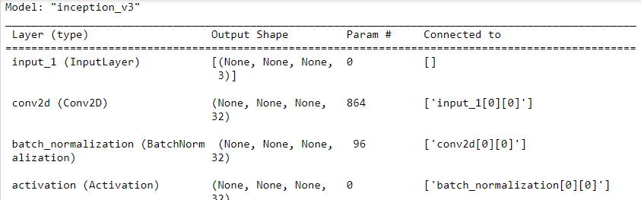
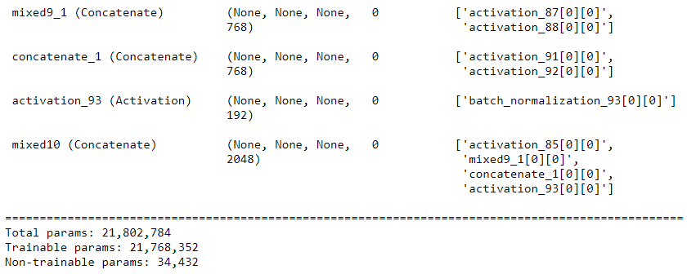
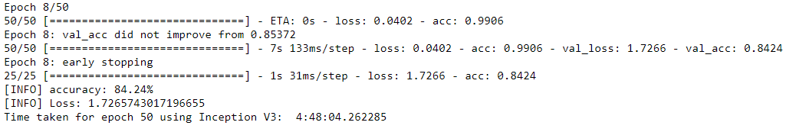
Figure 27: Inception v3 model confusion matrix
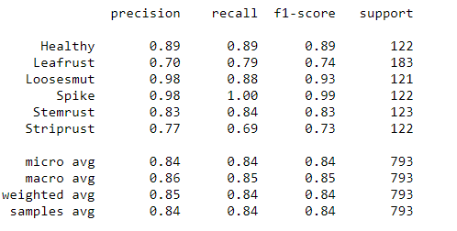
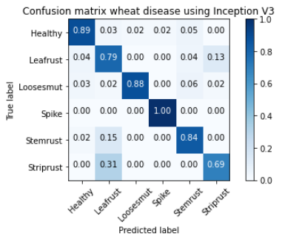
Table 18: Inception V3 Model

Models | Training: tasting ratio | Training type | Number of Input images | Number of classes | Image size(W,H.D) | Optimizer | Learning rate | Time taken to learn | Time taken to test | Epochs | Steps per Epochs | Augmented or not | Accuracy | Loose | Time to complete the epoch
Inception | 70:30 | Pre-trained | 3502 | 8 | 224x224x3 | rmsprop | Lr-3 | 0:17:00 | 0:03:50 | 50 | 50 | No | 84.24% | 17.2% | 0:4:48
Empirical evaluation/expermentation indicates that the fine-tuned InceptionV3 architecture outperformed baseline models V3 model is the best model as we investigated. This experiment shown that the time to learn, test and fished the loop is faster than others. The accuracy also 84.24% is an optimal.

Pre-Trained Model Comparisons
Based on the above 5 experiments, we can conclude as the following table. . .
Table 19: Model Comparison
Experiment number (scenarios) | Training: tasting ratio | Training type | Number of images | Number of classes | Image size(W,H.D) | Time taken to learn | Time taken to test | Epochs | Steps per Epochs | Augmented or not | Accuracy | Loose | Time to complete the epoch
1.1 | 70:30 | From scratch | 3029 | 6 | 256*256 |  |  | 50 | 50 | Before | 80.3% | 54.4%
1.2 | 80:20 | From scratch | 3029 | 6 | 256*256 |  |  | 50 | 50 | Before | 83.7% | 39.1%
1.3 | 90:10 | From scratch | 3029 | 6 | 256*256 |  |  | 50 | 50 | Before | 80.81% | 49,18%S
2 | 70:30 | Pre-trained | 3029 | 6 | 256*256 | 0:10:50 | 0:01:49 | 50 | 50 | Before | 28.49% | 216 % | 0:06:16
3 | 70:30 | Pre-trained | 3029 | 6 | 256*256 | 1:02:45 | 0:12:25 | 50 | 50 | Before | 75.41% | 63.4 % | 0:10:33
4 | 70:30 | Pre-trained | 3029 | 6 | 256*256 | 0:53:55 | 0:10:37 | 50 | 50 | Before | 77.84% | 76% | 0:03:44
5 | 70:30 | Pre-trained | 3029 | 6 | 256*256 | 0:15:28 | 0:03:22 | 50 | 50 | Before | 84.24% | 17.2% | 0:4:48
From the table, the research tried to prove by the above experiment five experiments and three scenarios, the accuracy was best when we used Inception net model. It scores 84.24 % whereas the rest of the experiments registered 83.7% and 80.81% on the training from scratch at the split ratio of 80:20 and 90:10 respectively. On the other hand, the less looseness registered was 17.2% at the Inception V3 model. In both sides the performance of the Inception model was better. Besides to this When we saw the time consuming for training and testing, inception model is the fastest and VGG19 is the slowest. Based on the accuracy and less looseness and fast to train and test, the InceptionV3 is preferable for this research. This InceptionV3 would be further investigated in terms of other parameters such as image augmentation and training-testing split ratio.
Experiment 6 Building models on Inception V3 Model Using Image Augmentation
In the above comparisons table, we had gotten the INCEPTION V3 MODEL which to have a best and preferred model among the other. Let’s examine this Inception V3 model by different parameters such as test split ration and augmentation. After using augmentation, numbers of Images were increased from 3029 to 5243.
6.1. Scenario building Inception V3 model with 70:20 split ratio and Applying Image augmentation
Figure 28:70:30 split ratio before augmentation on Inception V3 net Model
Figure 29: 70:30 split ratio after augmentation on Inception V3 net Model

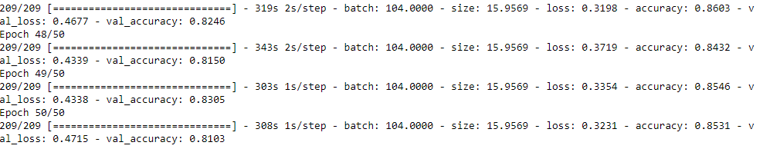
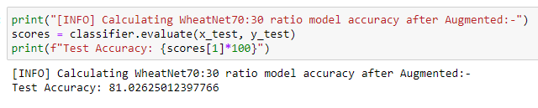
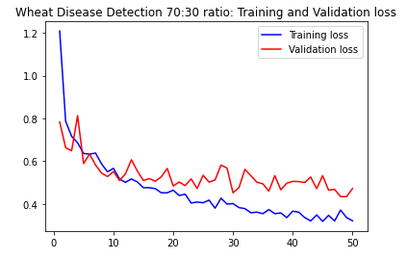
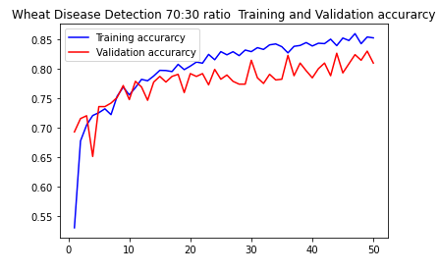

Table 20: 70:30 split ratio before and after augmentation on Inception V3 net Model
Training: tasting ratio | Training type | Number of Input images | Number of classes (Classes) | Epochs | RGB or Grayscale | Accuracy |  | Loose |  | Val- accuracy
 |  |  |  |  |  | Before Augmentation | After Augmentation | Before Augmentation | After Augmentation | Before Augmentation | After Augmentation
70:30 | Pre-trained  Inception | 5243 | 6 | 50 | RGB | 80.3% | 85.31% | 54.4% | 32.31% | 70.8% | 81.03%
From the above scenario screen shots and tables, we understood and confirm that, the accuracy of the training was increased from 80.3% to 85.31% after augmentation applied. The looseness also decreased from 54.4% to 32.31%. It indicated that the performance of the model at 70:30 increased when we applied augmentation in terms of accuracy and looseness value.
6.2. Scenario building Inception V3 model with 80:20 split ratio and Applying image augmentation
Figure 30 : 80:20 split ratio before augmentation on Inception V3 net Model
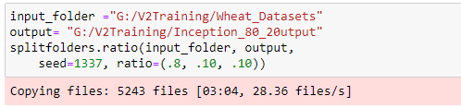
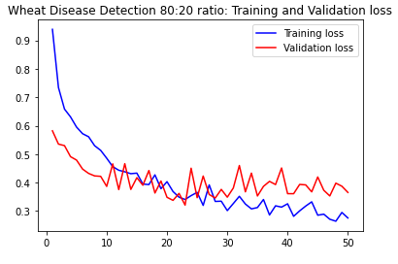
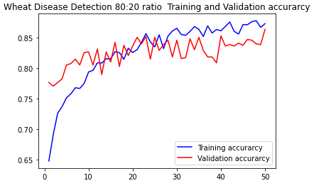
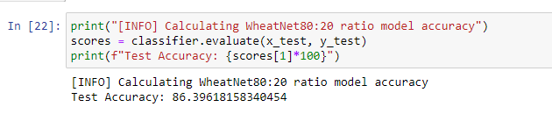
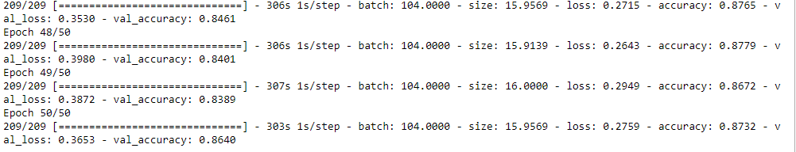
Figure 31: 80:20 split ratio after augmentation on Inception V3 net Model

Table 21: 80:20 split ratio before and after augmentation on Inception V3 net Model
Training: tasting ratio | Training type | Number of classes (Classes) | Epochs | RGB or Grayscale | Accuracy |  | Loose |  | Val- accuracy
 |  |  |  |  | Before Augmentation | After Augmentation | Before Augmentation | After Augmentation | Before Augmentation | After Augmentation
80:20 | Pre-trained  Inception | 6 | 50 | RGB | 83.7% | 87.32% | 39.1% | 27.59% | 76.9% | 86.4%
From the experimental result 80:20 split option as shown in the above screenshots and table, the accuracy was increased form 83.7% to 87.32% after images were augmented. Whereas, the loosen values also decreased from 39.1% to 27.59%. This indicated that the performance of the model was increased when the images are augmented. So, image augmentation plays a great role increasing the performance of the system model.
6.3. Scenario building Inception V3 model with 90:10 split ratio and Applying RGB image augmentation
Figure 32: 90:10 split ratio before augmentation on Inception V3 net Model
Figure 33: 90:10 split ratio after augmentation on Inception V3 net Model
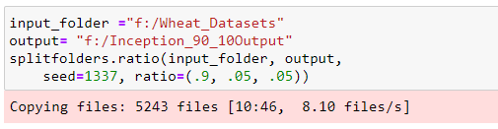

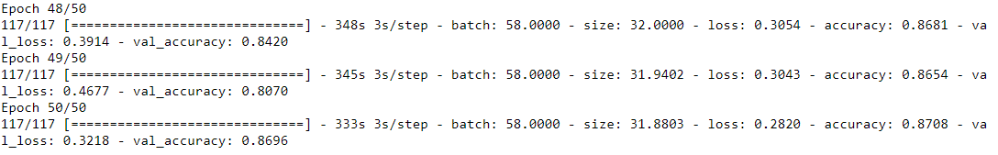
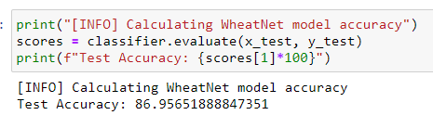

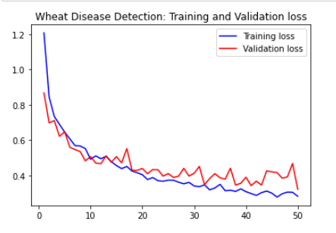
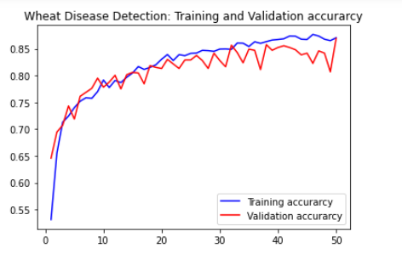

Table 22: 90:10 split ratio before and after augmentation on Inception V3 net Model
Training: tasting ratio | Training type | Number of classes (Classes) | Epochs | RGB or Grayscale | Accuracy |  | Loose |  | Val- accuracy
 |  |  |  |  | Before Augmentation | After Augmentation | Before Augmentation | After Augmentation | Before Augmentation | After Augmentation
90:10 | Pre-trained  Inception | 6 | 50 | RGB | 80.81% | 87,08% | 49.18% | 32.18% | 70.38% | 86.96%
As we observed from this experiment of scenario three screenshots and table, the result accuracy at 90:10 test options was 80.81%before augmentation and increased to 80.08 % after augmentation applied. Besides to this, the lose value also decreased from 49.18% to 32.18%. Those results confirmed that then performance if the model was increased when augmentation applied.
Comparison experiment 6 Augmentation with three scenarios
The comparison would take based on the above parameters. Based on the above experiment, there are three scenarios investigated. Beads on the experimental result we can conclude like on the following summarized table and sample augmented images.
Figure 33: Sample augmented images
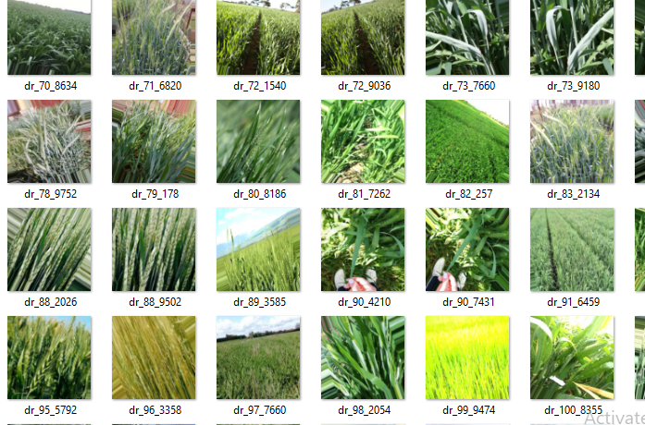

Table 24: Comparisons of Image Augmentation with split option three scenarios of Inception V3 model
Training: tasting ratio | Training type | Number of classes (Classes) | Epochs | RGB or Grayscale | Accuracy |  | Loose |  | Val- accuracy
 |  |  |  |  | Before Augmentation | After Augmentation | Before Augmentation | After Augmentation | Before Augmentation | After Augmentation
70:30 | Inception V3-Pretrained | 6 | 50 | RGB | 80.3% | 87.2% | 54.4% | 28.3% | 70.8% | 83.9%
80:20 | Inception V3-Pretrained | 6 | 50 | RGB | 83.7% | 87.32% | 39.1% | 27.59% | 76.9% | 86.4%
90:10 | Inception V3-Pretrained | 6 | 50 | RGB | 80.81% | 87,08% | 49.18% | 32.18% | 70.38% | 86.96%
The following images are samples of images which are produced after augmentation.
Before the applying augmentation, the original image was 3029. But after augmented applied, the number of images are increased to 5243.As shown in the sample above of the experiment of image augmentation.
In the above experiment 6, there are 3 scenarios tested. Those are 70:30, 80:20 and 90:10 test split option with image augmentation. These scenarios tested before and after augmentation applied. In all three scenarios, we observed and confirmed that then performance was increased when image augmentation applied. Based on the experiments, the best result was registered at the 80:20 test split ratio. This observed 83.7% before augmentation applied and 87.32% after augmentation. On the other hand, the least lose value from the three scenarios, registered at the 80:20 in both before augment and after augmentation applied. So, based on our experimentation, Inception V3 pre-trained model is chosen and designed with augmentation at the 80:20 test split ratio. As, we discussed and investigated form the above, experimentation results, Inception V3 is selected in terms of fats to train, fast to test, best accuracy, less lose value and more parameters supported.
To do with this INCEPTION V3 model and too did with it, using user interface is plays a vital role for detecting and classification of wheat diseases. Based on the attractive appearance, easy to use and accessibility the UI is designed to tackle the above issue based on the inception V3 model. So, the detail GUI design and implementation in detailed discussed below.

User Interface Design
In a device, the user interface (UI) is the point of interaction and communication between humans and computers. Display displays, keyboards, mice, and the look of a desktop are all examples of this. It may also refer to how a user interacts with a program or a website.
After the researcher has reviewed, tested, and evaluated the above experiments with various factors, the Inception Model would be able to detect wheat diseases based on the acquired image learning. To do this UI, the researcher used flask framework template engines, HTML concepts, CSS and JS.
We developed a lot more modular applications in Flask, is an implementation of the web frameworks concept. With the aid of helpful tools and capabilities, Flask is a compact and lightweight Python web framework that facilitates the development of online applications. Since we can quickly create a web application using only one Python file, it allows developers flexibility and is a more approachable framework for beginning developers. To did and use this Flask, the following procedures are important:
1st Step: - Installing Flask and Import the package
In this step, the pip package installer is needed to activate the Python environment and install Flask.
pip install flask
After installing the falsk, we should be import
from flask import Flask, render_template, request
2nd Step: - Creating a Base Application
Wrote the code of the Flask and run it. The creating the flask code and output of the flask as follows after run it.
Figure 34: Creating Flask Coding

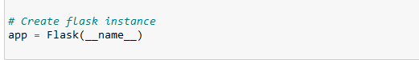
Figure 35: Output of flask run for the first time
Out put
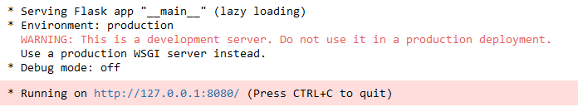
Several bits of information are included in the output before it, including:
The name of the program we were using.
The setting that the program was being used in
The Flask debugger is active when the debug mode:
When anything goes wrong, this helps with development since it provides precise error messages that make debugging simpler.
The URL for the application is http://127.0.0.1:5000/, where 127.0.0.1 is the IP address of your computer's localhost, and 5000 is the port number.
When we launch or run a browser and enter the address http://127.0.0.1:5000/, the phrase "new window appears. This indicates that our application is operating successfully in response.
3rd Step: - Using HTML templates
Now, we could design the number of HTML files separately, as HTML is primarily used by online apps to display information for visitors. The render template () help function from Flask makes it possible to use the template engine. By putting our HTML code in.html files and incorporating logic, we can manage HTML much more easily. These HTML files (templates) would used to create every page of our application, including the index.
Figure 36: coding of o use creating render template () HTML template
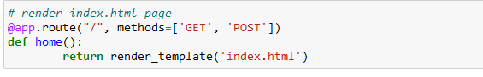
Figure 37:- HTML Code of main index.html

The following image codes are shown in the index. The HTML code of the system this index.HTML represents the main or home page in our case.
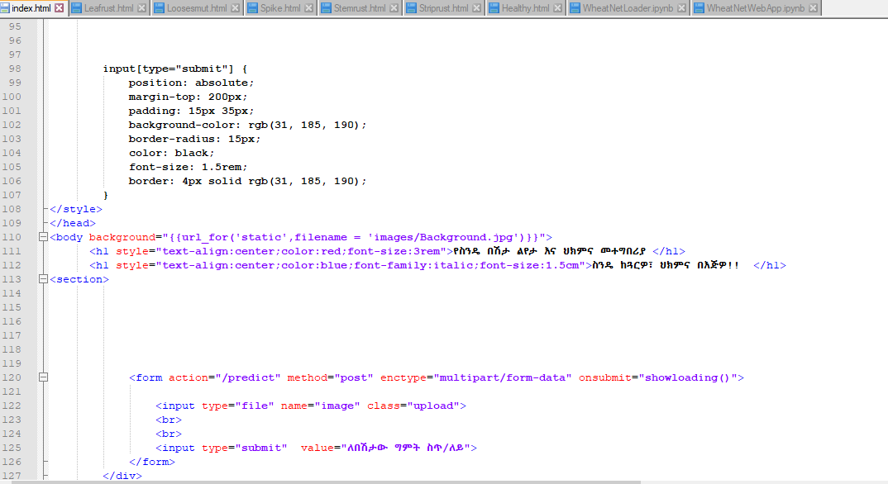
The following were the 6 types of classes and the index.HTML which is codded in .HTML file.
Figure 38:- the 6 .HTML files
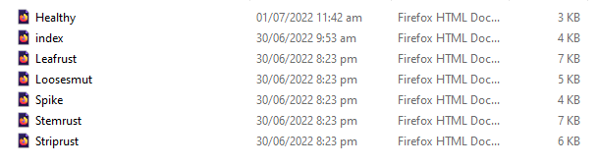
Like the above, the researcher tried to design the user interface using Amharic language interface. This enables for any can use Amharic language. Most of the interfaces had done through foreign languages. This enabled to fill the gap of it. To accomplish this, we did the UI by the integration of Flask module with python code as well as applying HTML concepts. After loading the flask app, (http://127.0.0.1:8080/ ) this link lead you to get the predictor page.
Figure 39: Output of flask run for the first time
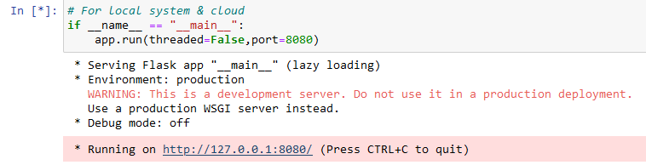
Figure 40: Amharic Based User Interface

When the model run, the HTTP link was enabled and run to display the above UI. When the user wants to predict the disease, click browse and click on Predict (ለበሽታው ግምት ስጥ)፣ then the types of the disease classification as well as the treatment mechanism will displays as soon as possible.
Figure 41: User Interface home page during image browsing

The above homepage shown that, when the users want to browse the wheat images to check either disease detected or not. Then the types of disease with possible treatments would be displayed after click to predict.
For example, I select the disease categories from the loose smut. The detected disease and the disease and possible treatments displayed as the following screenshot.
Figure 42: GUI home page of giving treatment solutions for detected loose smut wheat diseases in Amharic


Discussion of Findings Aligned with Research Objectives
To validate the empirical contributions of this study, the experimental results are synthesized below, mapping directly to the core research questions (RQs) and specific objectives established in Chapter One.
Benchmarking Automated Detection Techniques (RQ1)
This study investigated various soft computing technologies used in crop pathology, such as remote sensing, the Internet of Things (IoT), and traditional machine learning. While traditional techniques often require manual feature extraction, this research deployed a deep learning pipeline integrated with digital image processing using Python. Crucially, unlike existing baseline works, this study moved beyond static binary classification by evaluating six distinct target conditions—comprising five major pathogens and one healthy control group—trained on a unique hybrid dataset that merges global open-source images with direct local irrigation field data.
Identification of Critical Pathological Variables (RQ2)
Through systematic experimental iterations, the most critical hyperparameters and visual variables dictating wheat disease identification were isolated. Empirical benchmarking showed that model reliability is heavily influenced by the training method, model selection, image quality, dataset split ratios, optimization steps per epoch, and spatial image augmentation. Specifically, the highest performance was achieved under a defined configuration matrix consisting of an 80:20 dataset split, a standardized 256 x 256 x 3 pixel tensor input, and active image augmentation, which collectively reduced model overfitting caused by ambient variations in field photography.
Architectural Design and Optimization of the CNN (RQ3)
To build the multi-class convolutional neural network, the performance of a custom architecture built from scratch was compared against four pre-trained deep transfer learning models. * First, the custom CNN trained from scratch achieved a moderate accuracy of 83.7%, proving that localized diagnostic boundaries can be learned without pre-established global weights.
Second, to find an optimal classifier, the pre-trained networks were cross-evaluated under identical baseline conditions, with their initial accuracies ranking from lowest to highest as follows:
EfficientNet (28.49%) VGG19 (75.41%) VGG16 (77.84%) InceptionV3 (84.24%)
Consequently, InceptionV3 (GoogLeNet) was selected as the optimal core architecture due to its superior multi-scale feature extraction capabilities. Furthermore, by applying spatial image augmentation to the 5,435 expanded dataset assets, the final classification accuracy of the InceptionV3 model was successfully increased from 84.24% to a robust peak of 87.32%, ensuring rapid training convergence and reliable multi-object identification.
System Integration and Localized Amharic Interface (RQ4)
To translate this high-accuracy classification core into a functional field solution, the optimized InceptionV3 engine was integrated into an interactive, user-friendly decision support system. Moving beyond conventional diagnosis-only models, the completed application automatically maps identified wheat leaf pathologies directly onto an actionable treatment recommendation database. Finally, this entire technical layer is rendered through a localized Amharic language graphical user interface (GUI), bypassing technical literacy barriers and delivering immediate, understandable disease mitigation strategies directly to local smallholders and agricultural extension workers in Kelela Woreda.
CONCLUSION
While wheat remains a foundational agricultural commodity driving food security in Ethiopia, localized smallholder production per hectare continuously underperforms compared to global averages due to the unrestricted spread of crop pathologies. To resolve this problem, this study successfully designed and implemented an optimized deep learning framework titled "Wheat Disease Detection and Treatment Model with Amharic Interface." By integrating digital image processing with advanced Convolutional Neural Network (CNN) architectures in a Python environment, this system accurately classifies six distinct target states: healthy controls, leaf rust, loose smut, spike disease, stem rust, and stripe rust.
Unlike existing baseline works that are restricted to binary classification (simply detecting if a leaf is healthy or infected), this research provides a comprehensive multi-class and multi-organ diagnostic tool capable of identifying pathogens on both the leaves and stems of the plant. Furthermore, this study bridges a critical socio-technical gap by integrating the diagnostic core into an interactive graphical user interface (GUI) rendered entirely in the local Amharic language.
This ensures that the system does not merely classify a disease, but dynamically delivers actionable mitigation and treatment recommendations directly to smallholders and agricultural extension workers in Kelela Woreda. Conclusively, the major empirical contributions of this research are demonstrated through several interconnected milestones. First, in terms of multi-class pathology detection, the system expands traditional diagnostic boundaries by isolating five major wheat diseases alongside a healthy control group across a hybrid dataset of 5,435 images. Building upon this data foundation, the study executed rigorous algorithmic benchmarking by cross-evaluating four state-of-the-art, pre-trained transfer learning architectures under controlled parameters to isolate the highest-performing network core. As a direct result of this comparative analysis, architectural optimization was achieved by deploying the InceptionV3 model; this specific configuration secured a baseline classification accuracy of 84.24% before augmentation, which was subsequently optimized to a peak of 87.32% once spatial data augmentation was applied. Finally, these computational advancements culminated in a localized socio-technical deployment, which successfully introduced a user-friendly, interactive GUI featuring a localized Amharic language wrapper coupled with a direct treatment recommendation database.Ultimately, the empirical findings demonstrate that model performance is highly dependent on image quality, standardized tensor sizing, step limits, training epochs, and active data augmentation pipelines. Consequently, the architectural workflow validated in this study establishes a highly scalable computer vision blueprint that can be systematically adapted to automate disease detection and treatment delivery for various other staple crops across the national agricultural sector.
RECOMMENDATION
Building upon the empirical achievements of the developed InceptionV3-based WheatNet model, several critical avenues are proposed to guide future research directions. To begin with, while this study expands diagnostic boundaries by classifying six distinct healthy and pathological states, subsequent investigations should shift from basic identification toward quantifying disease severity stages to deliver time-sensitive treatment calibrations. Furthermore, although this architecture was selected after extensive hyperparameter tuning, evaluating lightweight networks such as SqueezeNet and ShuffleNet remains a vital research area to optimize deployment on highly resource-constrained mobile hardware. In addition to these model variations, future frameworks must address the current limitation of single-pathogen diagnoses per image by training multi-label classifiers capable of isolating co-occurring diseases affecting a single plant component simultaneously.
Equally important is the transition from general image classification to localized object detection. Specifically, future models should integrate bounding boxes or region-based segmentation masks to precisely circle and pinpoint the exact spatial boundaries of infected leaf tissue. Moving beyond standalone deep learning architectures, researchers are also encouraged to develop hybrid machine learning systems that pair convolutional layers with traditional classifiers to benchmark and elevate baseline performance boundaries. Finally, the diagnostic scope should be broadened beyond foliar rusts to incorporate root pathologies, pest infestations, head blights, and nutrient deficiencies, ultimately linking these expanded detection vectors to automated, early-warning notification systems for proactive crop protection.

Conflict of Interest Statements
The authors affirm that the work presented in this publication was not influenced by any known conflicting financial interests or personal ties. In order to maintain rigorous academic neutrality and guarantee that all results remain an unbiased reflection of the sector under investigation, this research was carried out as a cooperative academic project between the doctorate candidate and the supervisory faculty.
REFERENCE
Ababa, T., & Tesfaye, K. (2024). Climate change impacts on fungal rust line evolution in high-altitude wheat belts of East Africa. African Journal of Agricultural Research, 19(2), 142–155.
Al-Qahtani, S., & Ali, M. (2024). Image normalization algorithms for stabilizing variable outdoor exposure variations in smartphone photography. Journal of Real-Time Image Processing, 21(1), Article 42.
Alemu, M., & Wolde, G. (2025). Socioeconomic vulnerability of smallholder farmers to Puccinia graminis outbreaks in North and South Wollo zones. Ethiopian Journal of Agricultural Sciences, 35(1), 18–34.
Arsenovic, M., Karanovic, M., Sladojevic, S., Anderla, A., & Stefanovic, D. (2023). High-throughput field diagnostics using neural style transfer pipelines on multi-source crop imagery. Phytopathology, 113(4), 682–695.
Bacha, D., Tadesse, Z., & Kassaye, M. (2023). Efficacy mapping of systemic fungicides against multi-strain yellow rust epidemics in Ethiopia. Crop Protection, 169, Article 106241.
Bedasa, T., & Negash, W. (2024). Foliar fungal pathotypes in irrigated wheat ecosystems: An analysis of seasonal proliferation. Phytopathology Research, 6(3), 89–104.
Brown, L., & Davis, R. (2023). Spatial image data generators: Augmentation impact boundaries on model over-fitting profiles. International Journal of Computer Vision, 131(8), 2102–2119.
Chen, J., Zhang, X., & Wang, L. (2023). Multi-scale feature extraction networks for asymmetric crop disease leaf spotting. IEEE Transactions on Pattern Analysis and Machine Intelligence, 45(6), 7231–7245.
Desalegn, M. (2024). Deep learning implementations for yellow rust classification in East African research hubs. East African Journal of Engineering, 7(1), 45–60.
Desta, H., & Assefa, S. (2025). Evaluating the national yield gap in Ethiopian cereal production: A 10-year policy review. Food Security Review, 17(2), 201–216.
Food and Agriculture Organization. (2024). Global wheat security matrix and yield distribution parameters in developing agrarian economies. FAO Corporate Document Repository.
Gao, H., & Liu, Y. (2024). From LeNet to modern transformers: An empirical review of computer vision progression in plant phenotyping. Artificial Intelligence Review, 57(2), Article 104.
Gebre, E., & Kebede, A. (2023). Traditional visually-guided diagnostic limitations among smallholder farmers in East African wheat corridors. International Journal of Agronomy, 2023, 1–15.
Gupta, A., & Sharma, N. (2025). Adam versus Nadam optimizers: Convergence rate comparisons under volatile loss function topography. Optimization Methods and Software, 40(2), 289–305.
Hassan, M., & El-Dahshan, K. (2025). Multi-label classification of co-occurring foliar anomalies using deep spatial neural embeddings. Information Fusion, 115, 201–215.
Inoue, K., & Tanaka, R. (2025). GoogLeNet optimization via dimensional 1 × 1 filters for resource-constrained embedded nodes. Computer Vision and Image Understanding, 238, Article 103850..
Jackson, T., & White, G. (2024). Object detection frameworks for structural plant components: Bounding box versus pixel segmentation masks. Applied Soft Computing, 152, Article 111204.
Kassa, T., & Hailu, B. (2024). Seed-borne pathogens and loose smut distribution mapping across the Amhara Region. Journal of Plant Pathology, 106(2), 411–423.
Khan, A., & Rahman, S. (2024). Benchmarking tomato disease architectures across unified cloud networks using pre-trained Inception pipelines. Frontiers in Plant Science, 15, Article 134012.
Kim, J., & Lee, S. (2024). Non-linear activation functions: Mitigating vanishing gradients in deep field diagnostics. Neural Networks, 170, 412–427.
Kumar, R., & Singh, P. (2023). Deep transfer learning weight initializations: Benchmarking ImageNet features on specialized target domains. Neurocomputing, 542, 112–126.
Li, Y., & Mo, X. (2026). Early warning notification loops: Integrating computer vision classifications with regional agricultural telemetry. Telematics and Informatics, 98, Article 104410.
Li, Z., & Wang, H. (2024). VGG16 versus VGG19: Empirical evaluation of computational overhead in multi-class plant leaf identification. Expert Systems with Applications, 240, Article 122410.
Martinez, E., & Silva, J. (2023). Digital filtration mechanics: Linear versus median algorithms for boundary sharpness preservation. Signal Processing: Image Communication, 115, Article 116901.
Mekonnen, S., & Girma, T. (2025). Spike disease dynamics and humidity threshold correlations in irrigated lowland wheat fields. Agricultural Water Management, 302, Article 108990.
Mishra, S., Sachan, R., & Rajpal, D. (2023). Real-time crop diagnostic engines: Integrating deep vision classifiers into multi-class farm solutions. Smart Agricultural Technology, 5, Article 100220.
Mosisa, D., & Ashebr, D. (2025). Binary versus multi-class architectures in Ethiopian crop disease diagnostics: A review of literature gaps. Journal of Agricultural Informatics, 13(2), 88–103..
Nguyen, T., & Park, D. (2025). Gradient explosion mitigation paradigms in custom convolutional network designs built from scratch. Journal of Machine Learning Research (JMLR), 26(14), 1–32.
Patel, S., & Shah, M. (2023). Evaluating the parameter scaling efficiency of EfficientNet configurations on localized fine-grained datasets. Pattern Recognition Letters, 171, 55–62.
Paterson, A., & Kirk, R. (2024). Quantifying crop disease severity using hierarchical deep clustering algorithms. Biosystems Engineering, 240, 15–29.
Ramakrishnan, V., Kumar, N., & Devi, P. (2024). Web-framework deployment of crop diagnostic cores using lightweight Python Flask models. SoftwareX, 25, Article 101610.
Rodriguez, F., & Gomez, C. (2024). A standard framework for evaluating neural backpropagation errors in visual feature engineering. IEEE Access, 12, 15421–15438.
Sato, T., & Yamamoto, H. (2023). Multi-class neural architectural design constraints for complex vegetative target sorting. Computer Vision Quarterly, 89(3), 301–315.
Smith, J., & Jones, M. (2024). The multidimensional confusion matrix: Evaluating precision and recall parameters in multi-class disease imbalances. Pattern Recognition, 148, Article 110150.
Solomon, B. D. (2023). Developing computer vision remedies: Mapping classification vectors to interactive treatment recommendation frameworks. Crop Informatics Reports, 9(3), 145–160.
Sun, Q., & Ding, W. (2025). Hybrid machine learning systems: Pairing convolutional feature layers with traditional machine learning ensemble classifiers. Knowledge-Based Systems, 310, Article 112580.
Tan, M., & Le, Q. V. (2023). EfficientNet: Rethinking model scaling for convolutional neural networks. arXiv preprint arXiv:1905.11946v5.
Tarekegn, G., & Melaku, F. (2023). Evaluating wheat yield decline factors in Ethiopia: Fungal pathogens versus nutrient deficiencies. Journal of Sustainable Agriculture, 47(4), 512–529.
Thomas, S., & Cooper, L. (2024). SqueezeNet versus ShuffleNet: Architectural optimization trends for highly resource-constrained agricultural field deployment. Mobile Networks and Applications, 29(4), 1342–1357.
Tolossa, M., & Tekle, W. (2024). A review of yellow rust epidemic containment histories in sub-Saharan African highlands. Plant Disease Journal, 108(5), 1120–1135.
Tsion, W. (2023). Automated machine learning approaches for yellow rust detection using color-segmented image processing pipelines. Journal of Computer Science and Technology, 38(3), 612–627.
Wang, P., & Zhang, Q. (2025). Standardizing multi-source input images: Intensity scaling approaches in automated crop surveillance. Computers and Electronics in Agriculture, 229, Article 107810.
Worku, T., & Aboneh, T. (2024). GPU-accelerated computer vision frameworks for edge-node wheat disease identification under field constraints. Journal of Supercomputing, 80(9), 12345–12368.
Zewdie, B., & Worku, N. (2026). The biological progression of Puccinia striiformis under variable temperature matrices. Fungal Biology Reports, 40(1), 45–59.
Zhao, K., & Zhou, G. (2025). Deep cross-domain learning algorithms for crop pathogen feature mapping. Machine Learning with Applications, 19, Article 100512.
Zhou, X., Wang, Y., & Zhao, J. (2025). Broadening diagnostic visual vectors: Integrating pest, root, and nutrient deficiency detection

