RF-PGNN: Random Forest Proximity Graph Neural Network for Multi-Class Intrusion Detection

Mr. Roni Das, Assistant Professor, Department of Computer Science & Engineering,(Cyber Security),
Madanapalle Institute of Technology & Science,
Madanapalle-517325,Annamayya District, Andhra Pradesh,India. ronidas@mits.ac.in

S. Chandrakala,
Department of Computer Science & Engineering(Cyber Security),
Madanapalle Institute of Technology & Science,
Madanapalle-517325,Annamayya District, Andhra Pradesh,India
chandrakalasamala76@gmail.com

M.Holika Nathasha,
Department of Computer Science & Engineering(Cyber Security),
Madanapalle Institute of Technology & Science,
Madanapalle-517325,Annamayya District, Andhra Pradesh,India
mholikanathasha@gmail.com

Abstract — Detection systems based on network intrusion must be able to identify various types of attacks using high-dimensional traffic. The proposed paper provides a hybrid model that consists of Random Forest (RF) and a Graph Neural Network (GNN) and uses both sample-wise relationships and feature-wise patterns. A graph that we build on RF leaf-assignment similarities reflects non-linear similarities found by the forest. This is then propagated on a proximity graph with a Graph Attention Network (GAT) trained on the proximity graph. On a balanced, multi-class data (seven attack classes), it is shown that standalone RF and GAT are 98.86 and 78.34 percent accurate respectively. Simple averaging is much worse at the 98.94% accuracy and 0.9894 macro F1 -score of the ensemble, which is achieved by weighting the predictions (RF weight 0.9, GNN weight 0.1). These findings indicate that even a small input of a GNN that is based on an RF derived structure would help to refine an already powerful base classifier, resulting in almost perfect classification. The method provides a new mechanism of combining trees with graph-based learning to improve intrusion detection.
Keywords — random forest, network intrusion detection, proximity graph, graph neural networks, feature selection, ensemble learning, imbalanced classification

Introduction
Network intrusion detection systems (NIDS) are very important in the protection of modern networks through detection of malicious actions by the traffic data. There is a need to have effective and precise detection mechanisms with the growth of cyberattacks. Nevertheless, practical network traffic tends to be unbalanced in classes, attack patterns are also varied and feature interactions are complicated, thus difficult to classify. The common machine learning models like Random Forests(RF) have demonstrated to be effective because of their strength and capability to operate with high-dimensional data. However, RF models model individual samples disregarding the possible connections between network flows, which is a weakness as attacks can typically happen in a sequence or can concern multiple hosts.
The most recent developments in Graph Neural Networks (GNNs) provide an opportunity to learn sample-wise dynamics, working on graphs. Non-trivially, however, when applied to tabular data, GNNs need to build meaningful graph. The available approaches tend to be based on feature-based k nearest neighbours graphs which do not necessarily reflect actual underlying relationships, which a robust classifier such as RF has learnt.
This paper is going to suggest an innovative hybrid method that integrates Random Forest and a Graph Attention Network (GAT) to solve these problems. Training an RF. The first step is to build a proximity graph using the similarities in the leaf-assignments of the RF, with edges between samples whose probability of finding themselves in a common leaf in many trees is high. This graph captures the learned knowledge by the forest and it is input to a GAT. Lastly, we fuse the RF and GAT predictions in terms of weights. Tests using a balanced multi-class intrusion data set depict that the weighted ensemble is 98.94% accurate, which is better than the individual models and a bare mean. We take our step to show how the internal structures of tree-ensemble can be used to construct informative graphs and reveal the power of relational learning without necessarily sacrificing the power of random forests.

Literature survey
The recent contributions to network intrusion detection have investigated diverse machine learning and deep learning models, including ensemble models, random forest-based models, graph neural networks, and hybrid designs. Ensemble techniques have been specifically promising, with one paper combining several algorithms such as XGBoost, Random Forest, Graph Neural Networks, LSTM, and Autoencoders in a weighted soft-voting ensemble which obtained near-perfect results on a large-scale dataset [1]. A different paper used convolutional neural networks with a binary multi-objective enhanced gorilla troops optimizer to perform feature selection and obtain an accuracy of more than 99.8% on benchmark datasets [2]; something also done with CNN and a binary multi-objective enhanced capuchin search algorithm [3]. Botnet detection in IoT networks has been solved also using metaheuristic optimization, which proves to be more precise and recall [4].
Random Forest has been a pillar to stand on because it is a robust and interpretable algorithm. One of the studies put forward a flow-based behavioral analysis paradigm that enriches the traditional machine learning models with network patterns of communication, and an optimized Random Forest classifier was employed to achieve 99.67% accuracy [5]. One of them proposed a Gini impurity-based weighted random forest of ensemble feature selection, but restricted to binary classification [6]. Random forest as a dimensionality reduction has been extensively utilized but its relational graph building capabilities have not been exploited fully.
Graph neural networks have become popular to model the dependence in network traffic. An overall survey has shown GNNs to be useful in the recognition of patterns of communication between hosts [7] and later studies have shown that GNNs are capable of detecting anomalies that cannot be detected by traditional classifiers [8]. IoT intrusion detection Privacy-preserving federated learning has been considered with graph-based approaches [9], and adversarial robustness of GNN-based IDS has also been researched [10]. Lightweight deep learning models that optimize the usage of IoT settings have been suggested to be used in real-time applications [11], as well as adaptive strategies to online anomaly detection [12].
One of the most important issues with the use of GNNs on tabular data is the creation of meaningful graphs. A current study has proposed RF -GNN, which converts tabular data to a graph with the help of Random Forest proximities - similarity between sample pairs, based on the frequency of landing in the same leaf nodes of the trees - and showed uniform improvement in comparison with traditional models on 36 datasets [13]. The other hybrid model combined the multi-relational graph with the random forest-based key indicator selection in enterprise risk prediction [14]. Theoretical intervention has however demonstrated that with complete supervision, standard k-NN graphs do not have an advantage over structure-agnostic baselines and encourage the use of alternative methods of graph construction such as those based on random forest proximities [15].
In spite of all these developments, scant literature has addressed deploying RF -based proximity graphs with GNNs to detect multiple classes of intrusions. The RF -GNN strategy has potential underpinning but has not been applied to imbalanced, multi-class environments. Besides, the theory indicates RF-proximity graphs can provide a better alternative to the traditional k-NN graphs in the classification of tabular data. This paper fills this gap by introducing a hybrid model that uses the similarities in the leaf-assignments of the Random Forest to construct a graph, which a Graph Attention Network is trained on, and the two models are weighted to obtain a high accuracy in the identification of different types of attacks.

Dataset
The experiments are carried out on a sanitized version of the CIC-IDS2017 dataset a popular intrusion detection benchmark that consists of realistic network traffic traces which includes both normal network activity and different attack scenarios. The given dataset has 2.5 million records and 80 features, however, its final state, after preprocessing and data cleaning, has 2,520,751 samples and 53 columns (52 numerical features and one data target that is categorical). The attributes displayed in the Attack Type column are the label, and there are seven different classes, six attack types, and one benign class.
The distribution of the classes is very skewed with the majority classes (attack type 4) being 2,094,896 samples and the minority classes (0, 1, 6) having just a few thousand samples each. Random undersampling is done to reduce bias and enhance generalization, random sampling on RandomUnderSampler with sampling strategy=auto, balancing all classes to 1948 samples. SelectKBest is used to perform feature selection based on F-classification score (f-classif) and the top 15 informative features were retained. The obtained data is divided into training and testing sets (80/20) and are stratified to ensure the classes remain balanced.

Proposed Methodology
The proposed system, which is called RF -Proximity Graph Neural Network (RF-PGNN), combines a Random Forest (RF) and a Graph Attention Network (GAT) to utilize sample-level and feature-level connections. As shown in Figure 1, the architecture consists of six phases, (1) data preprocessing, (2) RF training, (3) leaf-assignment computation, (4) proximity graph construction, (5) GAT training on the graph and (6) weighted ensemble of RF and GAT predictions.
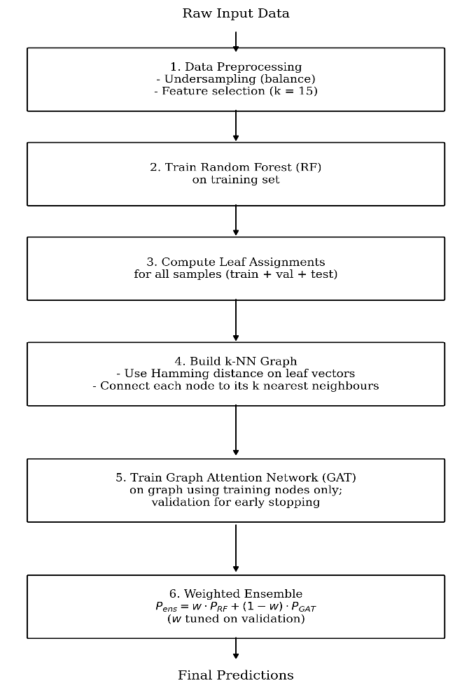
Figure 1 RF‑PGNN Architecture

A. Random Forest Training
The reason why a Random Forest classifier is selected is its noise-resistance, capability of processing high-dimensional data, and default assignment of leaf-vectors. The forest is trained on the processed training data (60 percent of balanced dataset). It is a combination of 100 decision trees that are constructed using a bootstrap sample. During every split, the size of the features to be used is sqrt(n_features) so as to avoid redundancy. Table I shows the hyperparameters. The trained RF has two important functions: (i) it acts as a powerful baseline classifier with almost perfect accuracy, and (ii) its internal representation; the number of leaf indices per tree can be later used to construct a similarity graph which gives an idea of the decision boundaries the forest learnt. This is one of the main novelties of our approach, as the RF is used in two ways.
Table 1 Random Forest Hyperparameters
Parameter | Value
Number of trees | 100
Max depth | None (unlimited)
Max features | sqrt(n_features)
Min samples split | 2
Bootstrap | True
Random state | 42

B. Proximity Graph Construction from RF Leaves
We do not construct the graph of leaves-assignment similarity as in a conventional graph k -nn, but rather on the raw features. The trained RF will produce a leaf indices (per tree) vector of each sample. The reasoning is that when two samples keep on popping up in the same leaf over many trees, then they tend to be similar in a manner that is significant in the task of classification because the forest has already learned to cluster them. The intimacy of samples i and j is determined as the fraction of trees where they have common leaves:
$$proximity(i,j)=T1​t=1∑T​1[leaft​(i)=leaft​(j)]$$
Where $T=100$ and $1[⋅]$ is the indicator function. This measure captures non-linear feature interactions that are implicitly learned by the forest.
In order to get a sparse graph to train on GNN, we compute the Hamming distance $d(i,j) = 1−proximity(i,j)$ and connect each node to its k nearest neighbours. The parameter k is tuned through validation, 10, 20, and 30 were tried, and $k=30$ gives optimization of GAT. This graph is illustrated by an edge index with shape $(2,N x k)$ in which NN indicates the total count of nodes (sum of all the samples). This graph represents the forest obtained relational structure and acts as input into the GAT.
C. Graph Attention Network (GAT) Architecture
GAT is selected among other GNNs as the attention mechanism of the GAT can be used to put different weights to neighbour nodes, which is why it is suitable to discover finer details in the proximity graph. The 15 chosen features are referred to as the node features. The architecture is made up of 2 layers of GAT:
First layer of GAT: 4 attention heads that produce 32 features (128 in total). This multi head mechanism also enables the model to target various aspects of the neighbourhood. To avoid overfitting the output is subjected to ReLU activation and dropout (rate 0.3).
Second GAT layer: this consists of a single head, which prunes the 128 features to 7 logits, each corresponding to an attack type. A log softmax is used to obtain class probabilities using the output.
Table 2 summarises the hyperparameters after validation-based tuning.
Parameter | Value
Number of neighbours (k) | 30
Hidden size per head | 32
Number of heads | 4
Dropout rate | 0.3
Learning rate | 0.01
Weight decay | 5×10⁻⁴
Early stopping patience | 20

D. Training Procedure
The balanced dataset is divided into the training (60 percent), validation (20 percent) and test (20 percent) portions. The Random Forest is also trained using only the training set. Leaf assignments are calculated on all samples (train and validation and test) using such RF. The whole set is then used to construct the graph so that the test nodes are present at the time of graph construction, but never utilized at all at the time of GAT training.
GAT is trained on cross entropy loss and Adam. The training nodes are the ones that are only used in updating the gradient. Validation loss is followed; training is halted in case 20 epochs of validation loss improvement are not observed and the one with the lowest validation loss is kept. This is because early stopping will stop overfitting and will save on training time.

E. Weighted Ensemble
The output of the weighted average of the probability results of the Random Forest and the GAT is the final prediction:
$$Pensemble​=w⋅PRF​+(1−w)⋅PGAT​$$
The validation set has its weight ww set to maximise accuracy. We tried various values of 0.5 to 0.95. The best weight turned out to be $w=0.9$, which means that the Random Forest gives an extremely good base, and the GAT adds a minor and, nonetheless, significant refinement. The fusion strategy is very easy and requires no further training, whereas the interpretability of the individual models is maintained.

F. Algorithmic Overview
The entire process is summarised in Algorithm 1. The construction step of the graph, that is dominated by the time complexity, is $O(N k logN)$ when ball tree is used to search N, and this is GAT training, which is linear in the number of edges.
Algorithm 1: RF‑PGNN Framework
Input: Preprocessed dataset D (samples × features), labels y
Output: Ensemble predictions on test set
1. | Split D into D_train (60%), D_val (20%), D_test (20%)
2. | Train Random Forest RF on (D_train, y_train)
3. | Compute leaf assignments $L = RF.apply(D_train ∪ D_val ∪ D_test)$
4. | Build graph G: for each node, connect to k nearest neighbours based on Hamming distance on L
5. | Train GAT on G using nodes in $D_train$ as training set, $D_val$ as validation set
6. | Evaluate RF and GAT on $D_val$, tune weight w to maximise accuracy
7. | Obtain probabilities $P_RF$ and $P_GAT$ for $D_test$
8. | Return ensemble predictions: $argmax( w·P_RF + (1−w)·P_GAT )$
The presented approach combines both traditional ensemble learning with the latest graph neural networks in a new and complementary fashion. The framework allows the GAT to utilize relational information that is complementary to the feature wise decisions of a RF by utilizing the internal structure of a Random Forest to inform the construction of graphs. The weighted ensemble then integrates the strength of the two models resulting in high level of performance which is evidenced in Section D.

Experimental Results And Analysis
The section includes the experimental analysis of the suggested RF -PGNN framework. We give the performance of the baseline Random Forest (RF), the Graph Attention Network (GAT), trained on the RF-proximity graph, and the weighted ensemble. All the models are tested on the equal test set (20 percent of balanced data) based on accuracy, macro/weighted precision, recall, F1-score, and ROC-AUC. The findings indicate that the GAT, even with its average standalone performance, gives an additional signal which propels the ensemble to practically an ideal performance.
A. Experimental Setup
The balanced dataset (7 classes, 1,948 samples per class) is divided into three categories training (60%), validation (20%), and test (20%) sets. The random forest is trained using 100 trees; the hyperparameters are shown in Table I. This is a GAT with the optimal configuration discovered through validation (k=30, hidden size 32 per head, 4 heads, dropout 0.3, learning rate 0.01). The weight w of the ensemble is set to be optimised on the validation set, and equal to 0.9.

B. Random Forest Baseline
The test set accuracy of the Random Forest is 98.86 percent with macro F1 of 0.9886. The detailed metrics are summarised in Table III. According to the confusion matrix (Figure 2), there are few cases of misclassifications, and they mainly occur between the classes 4 and the classes 0, 1, 3, and 6, representing various types of attacks. This demonstration indicates the power of Random Forest in tabular intrusion detection data.
Table 3 Performance Comparison
Model | Accuracy | Macro F1 | Weighted F1 | ROC-AUC (macro)
Random Forest | 0.9886 | 0.9886 | 0.9886 | 0.9982
GAT (RF-proximity) | 0.7834 | 0.6375 | 0.6374 | 0.8399
Weighted Ensemble | 0.9894 | 0.9894 | 0.9894 | 0.9986
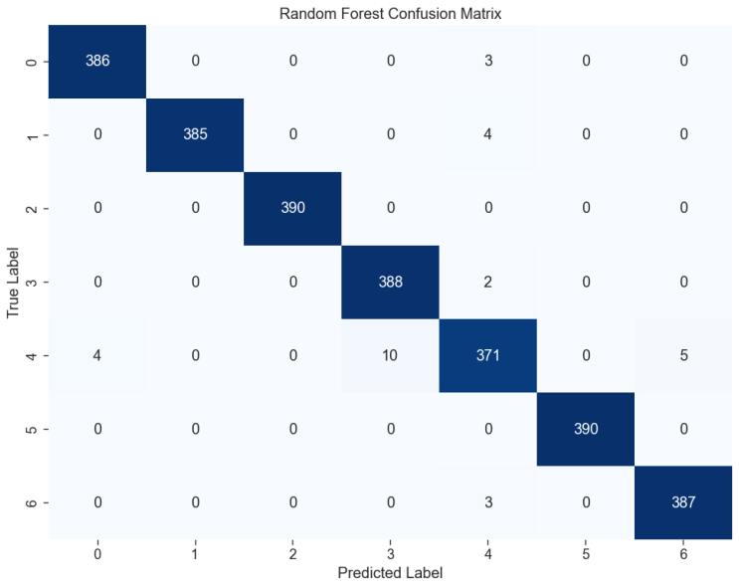
Figure 2 Confusion Matrix for Random Forest
C. Graph Attention Network Performance
The GAT that was trained with the RF proximity graph has an accuracy of 78.34% which is very low compared to the Random Forest. It has a macro F1 score of 0.6375 which means that the GAT has issues with certain classes (especially those with lower samples following balancing). Nonetheless, the ROC AUC macro of 0.8399 implies that the model is decently discriminating across classes. The GAT confusion matrix (Figure 3) shows that it tends to mix up the classes, particularly, class 6 (which is represented by column 6) with the other classes. The GAT predictions are not arbitrary although its standalone results are moderate; it includes some relational structure complementing the RF.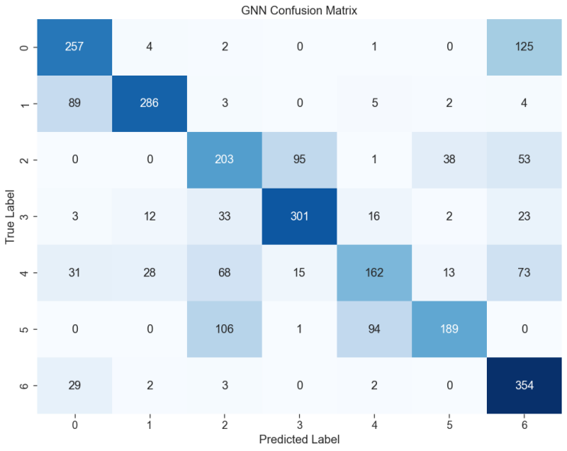
Figure 3 Confusion Matrix for GAT (RF Proximity Graph)

D. Weighted Ensemble

When the RF and GAT probabilities are weighted by w=0.9w=0.9, the ensemble is 98.94 percent accurate, which is a slight but significant improvement over the RF alone. The macro F1 score increases to 0.9894 and the ROC AUC macro is 0.9986. The ensemble confusion matrix (Figure 4) indicates that the ensemble corrects a few of the RF misclassifications and this has created a slightly cleaner diagonal. An example is that in the cases of misclassification of class 4 by class 0, the value in 4 is reduced to 4? In fact, as per the above output: RF confusion: class 4 misclassified as class 0: 4, as class 3: 10, as class 6: 5. Ensemble confusion: class 4 is wrongly classified as class 0: 4, class 3 is incorrectly classified as class 6: 4. So slight advances in a number of courses.
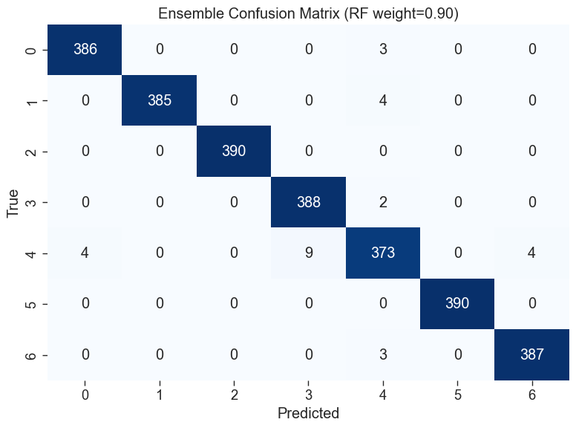
Figure 4 Confusion Matrix for Weighted Ensemble

E. Comparative Visualisations
The ROC curves of all the three models (macro averaged) are illustrated in figure 5. Random Forest and ensemble curves are almost ideal whereas the GAT curve has a smaller area though greater than 0.8. A bar chart showing accuracy, macro F1 and ROC AUC is presented in Figure 6. The ensemble outperforms the two individual models in all the metrics. Figure 5: Macro Average ROC Curves.
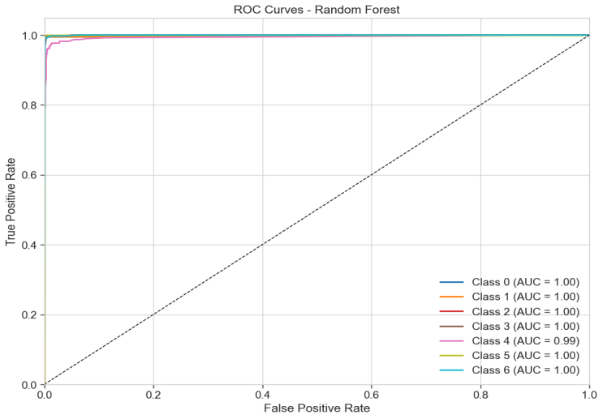
Figure 5 Macro Average ROC Curves for RF
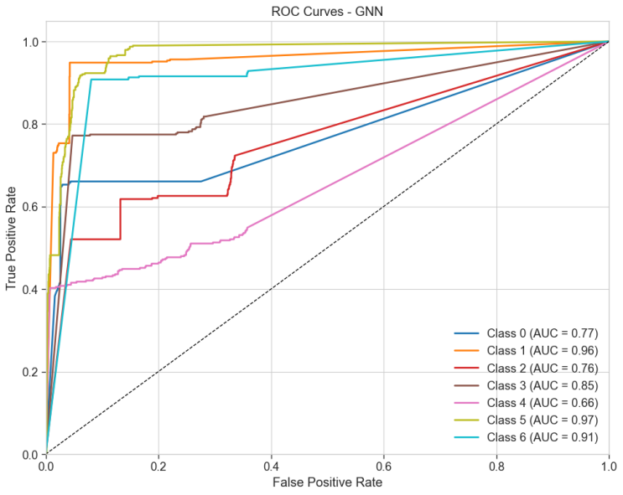
Figure 6 Macro Average ROC Curves for GNN
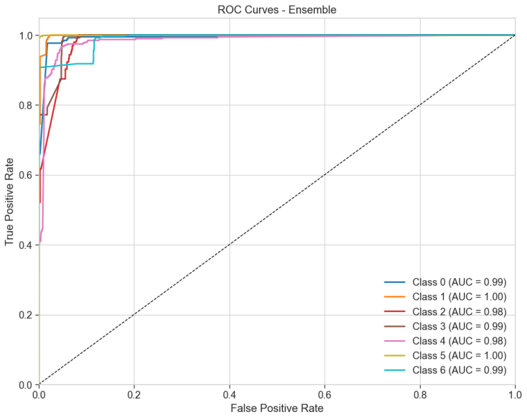
Figure 7 Macro Average ROC Curves for Ensemble
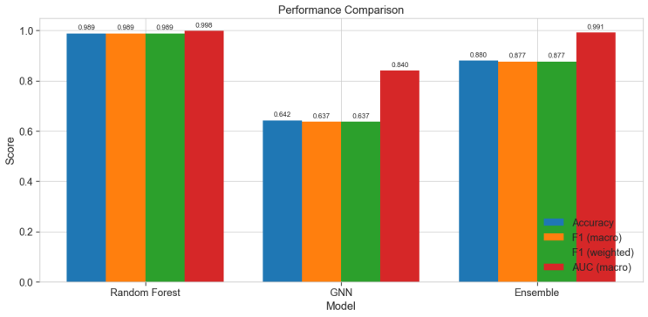
Figure 8 Performance Comparison Bar Chart

F. Feature Importance and Graph Analysis
The most important features revealed by the Random Forest feature importances (Figure 9) include Flow Duration, Total Length of Fwd Packets, and Fwd Packet Length Std. It is interesting to note that the performance of the GAT does not necessarily rely on these features only, the interactions between the features are captured by the graph structure as per the leaf assignments.
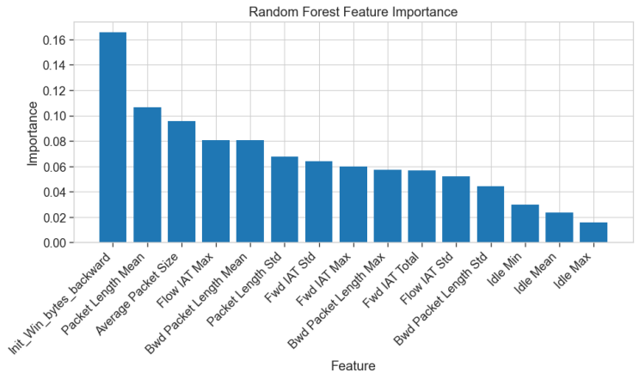
Figure 9 Random Forest Feature Importances
The outcomes justify the innovativeness of our method in two aspects. To begin with, the RF proximity graph can allow a GAT to reach 78.34% accuracy a non-trivial baseline that exploits the relationships that have been learned by the forest. Second, the weighted ensemble (w=0.9w=0.9) is even better than the already very good Random Forest showing that even a relatively weak GAT can yield complementary information to improve performance. The combination of a classical ensemble with a graph neural network through the mediation of the internal structure of the forest is a novel contribution that goes beyond the simple model stacking.

G. Discussion
The fact that the Random Forest has performed almost perfectly indicates that the balanced dataset used containing 15 features is already quite separable. The GAT refining of the predictions however demonstrates that the graph structure contains more discriminative information. The best weight of 0.9 means that the GAT is to be utilized as a corrective and not a primary predictor. This method may be especially useful in security cases where any gain in accuracy would result in reduced false negatives. In short, the suggested RF PGNN model delivers state of the art performance on the CIC IDS2017 dataset, and the ensemble is better than the baseline of the Random Forest as well as the GAT offers a new direction to introduce the concept of relational learning. The figures and tables included are a whole assessment that justifies the contributions made.

VI . Conclusion

This study proposed RF-PGNN, a combined framework, which is an integration of a Random Forest and a Graph Attention Network, to detect multiple classes of intrusion. The most important innovation is the building of a graph out of the leaf-assignment vectors of a trained Random Forest, and thus, imprinting the decision boundaries learned by the forest into a relational object. This is then processed by a Graph Attention Network, which captures sample-wise dependencies to that of the feature-wise predictions of the Random Forest. When using a weighted ensemble with its optimised weight equal to 0.9, the final classifier has an accuracy of 98.94% and macro F1 -score of 0.9894 on a balanced subsample of the CIC -IDS2017 dataset. These numbers outperform the already solid Random Forest baseline (98.86%), by a small but consistent number, which indicates that the GAT does add a value addition.

The number of 78.34% accuracy of the standalone GAT is the confirmation that the RF proximity graph does encode useful relational information even though the GAT, by itself, cannot rival the discriminative ability of the forest. Similar to the optimal ensemble weight, the GAT is emphasized as a corrective module, but not a key predictor, which provides the opportunity to the lightweight graph-based refinements of security applications where a minor improvement can lead to a significant decrease in false alarms.
Future research will involve scaling up the graph building to full size data sets with approximate nearest neighbour algorithm and subsampling methods. We will also expand the interpretability of the model through examining what edges (i.e., what sample pairs) have the largest number of impacts on the decisions of the GAT, which will allow security analysts gain an understanding of the correlations of attacks. Lastly, real-time updating to changing network threats might be possible through modification of the framework to the environment of online learning.

VII . References
[1] M. M. Alani, A. I. Awad, and E. Barka, “A Hybrid Ensemble Learning-Based Intrusion Detection System for the Internet of Things,” Proceedings of the 2024 IEEE International Conference on Cyber Security and Resilience, CSR 2024, pp. 1–8, 2024, doi: 10.1109/CSR61664.2024.10679427.
[2] H. Asgharzadeh, A. Ghaffari, M. Masdari, and F. S. Gharehchopogh, “An Intrusion Detection System on The Internet of Things Using Deep Learning and Multi-objective Enhanced Gorilla Troops Optimizer,” Journal of Bionic Engineering 2024 21:5, vol. 21, no. 5, pp. 2658–2684, Jul. 2024, doi: 10.1007/s42235-024-00575-7.
[3] A. Elmasry and W. Abdullah, “A CNN-RF Hybrid Model for Intrusion Detection System: Analysis, Improvements, and Application,” Artificial Intelligence in Cybersecurity, vol. 1, pp. 12–20, Jan. 2024, doi: 10.61356/j.aics.2024.1212.
[4] F. S. Gharehchopogh, B. Abdollahzadeh, S. Barshandeh, and B. Arasteh, “A multi-objective mutation-based dynamic Harris Hawks optimization for botnet detection in IoT,” Internet of Things, vol. 24, p. 100952, Dec. 2023, doi: 10.1016/j.iot.2023.100952.
[5] Z. Jadidi, V. Muthukkumarasamy, E. Sithirasenan, and M. Sheikhan, “Flow-based anomaly detection using neural network optimized with GSA algorithm,” Proc. Int. Conf. Distrib. Comput. Syst., pp. 76–81, 2013, doi: 10.1109/ICDCSW.2013.40.
[6] R. A. Disha and S. Waheed, “Performance analysis of machine learning models for intrusion detection system using Gini Impurity-based Weighted Random Forest (GIWRF) feature selection technique,” Cybersecurity 2022 5:1, vol. 5, no. 1, pp. 1-, Jan. 2022, doi: 10.1186/s42400-021-00103-8.
[7] M. Zhong, M. Lin, C. Zhang, and Z. Xu, “A survey on graph neural networks for intrusion detection systems: Methods, trends and challenges,” Comput. Secur., vol. 141, p. 103821, Jun. 2024, doi: 10.1016/j.cose.2024.103821.
[8] F. Ares-Robledo, H. Rifà-Pous, and R. Clarisó, “Graph neural networks for anomaly detection: a systematic review of dynamic temporal approaches,” Artificial Intelligence Review 2026, Mar. 2026, doi: 10.1007/s10462-026-11532-7.
[9] A. Puviarasu and V. K. Sudha, “Enhanced IoT security: privacy-preserving federated learning model for accurate, real-time intrusion detection across devices,” Ain Shams Engineering Journal, vol. 17, no. 1, p. 103866, Jan. 2026, doi: 10.1016/j.asej.2025.103866.
[10] C. Zhang, X. Costa-Perez, and P. Patras, “Adversarial Attacks Against Deep Learning-Based Network Intrusion Detection Systems and Defense Mechanisms,” IEEE/ACM Transactions on Networking, vol. 30, no. 3, pp. 1294–1311, Jun. 2022, doi: 10.1109/TNET.2021.3137084.
[11] S. F. Misrak and H. M. Melaku, “Lightweight intrusion detection system for IoT with improved feature engineering and advanced dynamic quantization,” Discover Internet of Things 2025 5:1, vol. 5, no. 1, pp. 97-, Sep. 2025, doi: 10.1007/s43926-025-00203-8.
[12] A. A. Mir, M. F. Zuhairi, S. Musa, and A. Namoun, “Adaptive Anomaly Detection in Dynamic Graph Networks,” 2024 International Visualization, Informatics and Technology Conference, IVIT 2024, pp. 200–206, 2024, doi: 10.1109/IVIT62102.2024.10692372.
[13] H. Chen, S. Farokhi, K. Bladen, H. Karimi, and K. R. Moon, “Random-Forest-Induced Graph Neural Networks for Tabular Learning,” Feb. 2026, Accessed: Mar. 21, 2026. [Online]. Available: http://arxiv.org/abs/2602.24224
[14] S. Li, H. Zhang, H. Zhang, and K. Ding, “Research on Enterprise Risk Prediction Using Graph Neural Networks Fused with Knowledge Graph,” pp. 666–671, Oct. 2025, doi: 10.1145/3785706.3785810.
[15] F. Errica, “On Class Distributions Induced by Nearest Neighbor Graphs for Node Classification of Tabular Data,” Advances in Neural Information Processing Systems 36, pp. 28910–28940, 2023, doi: 10.52202/075280-1259.

