Exploring Electrical Activity of A Bacterial and Yeast Cell for Potential Production of Power in A Tropical Setting

^{*1}Terdzungwe T. Sar, ² Philip A. Gbum and ³Hyacinth A. Ataingbor

^{1, 3} College of Biological Sciences, Department of Microbiology, Joseph Sarwuan Tarka University, PMB 2373, Makurdi, Benue State

²College of Physical Sciences, Department of Physics, Joseph Sarwuan Tarka University, PMB 2373, Makurdi, Benue State

*Corresponding Author:
Terdzungwe T. Sar
E-mail: terdsar@gmail.com
Phone: + 234 706 492 7606

ABSTRACT
This study investigated and compared the individual and combined electricity-generating potential of Saccharomyces cerevisiae and Lactobacillus spp., in double-chambered microbial fuel cells (MFCs) in Makurdi, Benue State, Nigeria. The experimental setup consisted of two identical MFC units run under similar conditions with a fixed one thousand Ω external resistance. Electrical parameters including open circuit voltage (OCV), voltage across resistor, current output, conductivity, temperature, and pH were monitored over 7 days. Results showed that OCV values ranged from 3.6 mV to 686.9 mV in the S. cerevisiae system and from 76.8 mV to 732.3 mV in the Lactobacillus system. Current output increased progressively in both systems with values ranging from 0.0 mA to 0.6 mA for S. cerevisiae, and 0.0 mA to 0.7 mA for Lactobacillus spp. The voltage across the external resistor varied between 2.3 mV and 658.5 mV in the yeast-based MFC and 44.4 mV and 702.9 mV in the Lactobacillus system. Anode conductivity increased during operation, ranging from 34.9 µS/cm to 580.7 µS/cm in the yeast system and 815.1 µS/cm to 1866.0 µS/cm in the Lactobacillus system, showing improved ionic mobility and substrate degradation. Anode pH values varied between 5.6 and 4.2 in the yeast MFC and 3.7 and 4.9 in the Lactobacillus MFC due to microbial metabolic activities. Temperature remained within the mesophilic range of 29.6°C to 32.6°C in the anode chamber, and 21.6°C to 30.0°C in the cathode chamber, providing suitable conditions for microbial growth and bioelectricity production. The yeast-based MFC produced higher peak power output of 0.4935 mW, while the Lactobacillus system produced 0.4333 mW. Overall, the findings show that both microorganisms can generate electricity in MFCs, although the yeast system produced slightly higher peak electrical output while the Lactobacillus system exhibited more sustained performance.
Key words: Bioelectricity, Lactobacillus, Microbial Fuel Cells, Renewable Power, S. cerevisiae

Introduction
The increasing global demand for energy has led to reliance on conventional energy sources, primarily fossil fuels, which are not only finite, but also contribute to environmental degradation and climate change through greenhouse gas emissions (International Energy Agency, 2022; Zou et al., 2022). As a result, there is need to explore and develop sustainable, renewable and environmentally friendly alternative energy sources.
One promising source is the use of microbial fuel cells (MFCs), which harness the natural metabolic activities of microorganisms, especially bacteria, to convert organic matter into electrical energy (Pandya et al., 2024). MFC technology exploits the natural processes of microorganisms, allowing them to oxidize substrates and transfer electrons to an electrode, generating electricity in the process (Logan et al., 2019). This dual functionality of energy generation and waste treatment makes MFCs an attractive solution for addressing both energy and environmental challenges (Zhou et al., 2019).
Two types of MFCs, single or double chambered, having both the anodic as well as the cathodic compartments can be utilized. Microorganisms in the anodic compartments utilize biomass for growth, forming electrons and protons (He et al, 2020). These electrons can be transported out of the cell using mediators (Niessen et al, 2019). Microorganisms have the tendency or ability to expel electrons for the reduction of substrates which can be absorbed by the electrode (Lie et al, 2018). The protons or H+ ions are oxidized to water in the cathode chamber with no other byproduct formed (Ringeisen et al, 2019).
While MFCs systems are very adaptable, practical and hold much promise to provide energy in sustainable fashion, mostly, mixed cultures are preferred over single medium (axenic) as they utilize a wide range of substrates. Sulphate and sulphide mediated systems have a major role to play in power generation, as most times, sludge is rich in these compounds (Tender et al, 2021). Large scale reactors can be constructed to use sludge and sewage sources as substrates for electricity generation (Bond and Lovely, 2022).
The ability of certain bacteria, such as Geobacter sulfurreducens and Shewanella oneidensis, to transfer electrons directly to electrodes demonstrates their potential in enhancing the efficiency of MFCs (Bond and Lovley, 2022). The ability of axenic cultures that utilize microorganisms of different genera and species, families and evolutionary branches, such as bacteria and fungi, with different metabolic pathways to generate power, are interesting prospects, and will be explored in this study.

Materials and Methods
The study employed experimental laboratory-based research to compare the electricity-generating performance of two different microorganisms in double-chambered MFCs. The microorganisms investigated were Lactobacillus spp. and Saccharomyces cerevisiae. Each microorganism was operated in a separate but identical MFC unit under similar environmental and electrical conditions to ensure comparability.

Microbial Fuel Cell (MFC) Setup
Each MFC consisted of two chambers: an anaerobic anodic chamber, and an aerated cathodic chamber. The chambers each had a working volume of 250 mL and were connected externally through a fixed external resistor of 1 kΩ. Carbon graphite electrodes were used as both anode and cathode electrodes. Prior to use, the graphite rods were cleaned to remove residual chemicals and impurities. The anode chamber was sealed to maintain anaerobic conditions, while the cathode chamber was exposed to air to ensure oxygen availability.
Indirect estimation of microbial growth was performed using physicochemical and electrical parameters recorded during MFC operation, a widely accepted approach in MFC research, where microbial metabolism is inferred from system performance indicators.
Earlier studies have established strong correlations between microbial population density and electrical performance in MFCs. As microbial biomass increases, substrate oxidation rates also increase, leading to enhanced electron transfer to the anode and improved power generation. Therefore, the indirect approach adopted in this study provides a valid and scientifically grounded estimation of microbial growth trends.
The indirect estimation was based on the following parameters: Open circuit voltage (OCV) Voltage across external resistors calculated current and power output. pH variation in the anode chamber, conductivity changes in the electrolyte, increased electrical output and conductivity, alongside observable pH shifts, were interpreted as evidence of increased microbial population and metabolic activity.

Substrate Components
Sugar was added to the anodic substrate as an easily metabolizable carbon and energy source to stimulate microbial growth and metabolic activity. Specifically, 10 g of analytical-grade glucose was dissolved in 1 L of the anodic substrate, corresponding to a final concentration of 10 g/L. During sugar metabolism, Lactobacillus spp. oxidizes organic compounds and release electrons and protons, which are essential for electricity generation in the microbial fuel cell.
Sodium chloride (NaCl) was added in a small quantity to increase the ionic strength and electrical conductivity of the substrate, thereby facilitating proton and ion transport within the anodic chamber and improving overall electrochemical performance. Precisely, 1.0 g of sodium chloride was added to 1 L of the substrate solution, giving a final concentration of 1 g/L (0.1% w/v).

Anodic Substrate Preparation
A total of 250 mL of distilled water was measured into a clean beaker. Powdered milk was then added as the primary carbon source. Using an average density of powdered milk of 0.55 g/mL, a mass of approximately 137.5 g (≈138 g) was added to the water and stirred thoroughly until a homogeneous solution was obtained. Thereafter, 30 mL Lactobacillus suspension was introduced into the mixture and stirred continuously to ensure uniform distribution of microorganisms.
Subsequently, 10 g of granulated sugar and 0.5 g of sodium chloride were added to the mixture and stirred until fully dissolved. The prepared substrate was allowed to ferment at room temperature, at between 30 °C and 37 °C, for 12 hours to encourage microbial activity and thickening of the medium. After fermentation, the substrate was transferred into the anodic chamber of the first MFC unit, which was then sealed to ensure anaerobic conditions.

Cathodic Substrate Preparation

The cathodic substrate for the yeast-based MFC was prepared in the same manner as for Lactobacillus MFC. A mass of 1.25 g of sodium chloride was dissolved in 250 mL of distilled water, stirred until completely dissolved, and transferred into the aerated cathode chamber. The chamber was left open to air to allow oxygen diffusion, which served as the terminal electron acceptor.

Substrate Components
Granulated sugar was added as the primary fermentable carbon source for Saccharomyces cerevisiae. Yeast cells metabolize sugar during fermentation, releasing electrons that are transferred to the anode, leading to electricity generation in the MFC system. Then, 10g of Sodium chloride was added to enhance the ionic conductivity of the anodic medium, which supports efficient charge transfer without inhibiting yeast activity.

Anodic Substrate Preparation

For the yeast-based MFC, 20 g sugar and 0.5 g sodium chloride were dissolved in 250 mL of distilled water and stirred until fully dissolved. Thereafter, 2 g of baker’s yeast powder was added to the solution and gently stirred to avoid damaging the yeast cells. The mixture was stood for 1 hour at room temperature (30 °C) to initiate fermentation. After this activation period, the substrate was transferred into the anodic chamber of the second MFC unit and sealed to maintain anaerobic conditions.

Data Collection

Voltage output was measured at determined intervals using a digital multimeter connected across the 1 kΩ external resistor.
Current value was calculated using Ohm’s law; I = V/R, where:
V = measured voltage, and
R = external resistance.
Similarly, power was computed as: P = V × I,
where V = measured voltage across the 1000 Ω load, and
I = measured current.
Other parameters including temperature, pH, and conductivity were monitored and recorded over time. The collected data were used to compare the electrical performance of Lactobacillus spp. and S. cerevisiae in MFCs.

Results

S. cerevisiae MFC Performance
Open circuit voltage (OCV) increased steadily from 3.6 mV at 24 hrs. to a peak of 686.9 mV at 168 hrs., before declining to 626.7 mV at 192 hrs., a range of 3.6 - 686.9 mV. Current output rose from 0.0 mA to 0.6 mA, showing a range of 0.0 - 0.6 mA, while voltage across the resistor ranged from 2.3 - 658.5 mV. Anode conductivity increased from 34.9 - 580.7 µS/cm, while anode pH decreased from 5.6 - 4.2, indicating increasing metabolic activity and acid production over time. Further measurements were not taken after 192 hours.

Table 1: S. cerevisiae MFC Performance (R = 1000 Ω)
Measurement  Parameter/Unit | Period/Duration of Measurement  (Hours)
Measurement  Parameter/Unit | 24 | 48 | 72 | 96 | 120 | 144 | 168 | 192
OCV (mV) | 3.6 | 186.0 | 305.3 | 370.1 | 440.8 | 527.9 | 686.9 | 626.7
VAR (nW) | 2.3 | 167.2 | 275.1 | 345.5 | 412.8 | 496.8 | 658.5 | 596.6
Anode Temperature (ºC) | 32.3 | 32.0 | 32.1 | 31.6 | 32.0 | 29.6 | 30.4 | 30.0
Cathode Temperature (ºC) | 24.0 | 23.7 | 24.6 | 24.7 | 24.8 | 21.6 | 22.3 | 23.0
Anode Conductivity (µs/cm) | 34.9 | 85.0 | 315.2 | 450.5 | 500.4 | 540.0 | 580.7 | 423.8
Cathode Conductivity (µs/cm) | 5.6 | 6.0 | 6.5 | 6.8 | 7.2 | 7.4 | 7.8 | 6.7
Anode pH | 5.6 | 5.4 | 5.2 | 4.8 | 4.6 | 4.4 | 4.2 | 4.8
Cathode pH | 7.1 | 7.0 | 7.4 | 7.2 | 6.8 | 6.7 | 6.6 | 6.9
Current (mA) | 0 | 0.1 | 0.2 | 0.3 | 0.4 | 0.4 | 0.6 | 0.5
Key: OCV = Open Circuit Voltage (when circuit is open/not loaded); VAR = Voltage Across Resistor (voltage across closed/loaded circuit); pH = Hydrogen Ion Concentration

Lactobacillus spp. MFC Performance
The OCV increased from 76.8 mV after 24 hrs. to a peak of 732.3 mV at 120 hrs., then declined to 685.0 mV at 144 hrs., giving a range of 76.8 - 732.3 mV. Current output rose from 0.0 mA to 0.7 mA, showing a range of 0.0–0.7 mA, while voltage across the resistor ranged from 44.4 - 702.9 mV. Anode conductivity varied widely from 815.1 - 1866.0 µS/cm, while anode pH increased gradually from 3.7 - 4.9, reflecting progressive microbial activity and substrate utilization. Similarly, as in S. cerevisiae MFC, measurements were not taken after 144 hours when power output decline set in.

Table 2: Lactobacillus MFC Performance (R = 1000 Ω)
Measurement  Parameter/Unit | Measurement Period/Duration  (Hours)
Measurement  Parameter/Unit | 24 | 48 | 72 | 96 | 120 | 144
OCV (mV) | 76.8 | 150.1 | 342.7 | 510.4 | 732.3 | 685.0
VAR (nW) | 44.4 | 166.9 | 318.6 | 419.8 | 702.9 | 649.6
Anode Temperature (ºC) | 32.6 | 31.1 | 31.3 | 30.6 | 30.7 | 31.0
Cathode Temperature (ºC) | 24.3 | 23.6 | 29.3 | 29.6 | 30.0 | 30.0
Anode Conductivity (µs/cm) | 815.1 | 1040 | 1303.3 | 1658 | 1866 | 1813.8
Cathode Conductivity (µs/cm) | 4.2 | 4.2 | 4.2 | 4.2 | 4.2 | 4.2
Anode pH | 3.7 | 3.9 | 4.2 | 4.5 | 4.8 | 4.9
Cathode pH | 5.8 | 5.4 | 5.1 | 4.9 | 4.9 | 4.6
Current (mA) | 0.0 | 0.1 | 0.3 | 0.4 | 0.7 | 0.6
Key: OCV = Open Circuit Voltage (measured when circuit is open and not loaded); VAR = Voltage Across Resistor (voltage with closed/loaded circuit); pH = hydrogen Ion Concentration

Comparative Summary
The yeast system showed a peak OCV of 732.3 mV on Day 5, while the Lactobacillus system peaked at 686.97 mV on Day 7, giving a comparative range of 686.97 - 732.3 mV. Peak current ranged from 0.658 - 0.702 mA, with yeast peaking earlier. Peak power output ranged from 0.4333 - 0.4935 mW, indicating that the yeast-based MFC produced slightly higher maximum power than the Lactobacillus-based system (Table 3).

Table 3: Comparative Summary of S. cerevisiae and Lactobacillus MFC Performance

MFC  System | Peak OCV (mV) | Day | Peak I (mA) | Day | Peak P (mW) | Day
S. cerevisiae | 732.3 | 5 | 0.702 | 5 | 0.4935 | 5
Lactobacillus spp. | 686.966 | 7 | 0.658 | 7 | 0.4333 | 7

Key: MFC = Microbial Fuel Cell; Peak OCV = Peak Open Circuit Voltage; Peak I = Peak Current; Peak P = Peak Power
Open Circuit Voltage (OCV)
Open circuit voltage increased progressively in both systems over time. Values ranged approximately from 3.6 mV to 732.3 mV, depending on the microorganism and duration. Saccharomyces cerevisiae reached its peak earlier, while Lactobacillus spp. showed a slower but steady rise before peaking later (Figure 1).
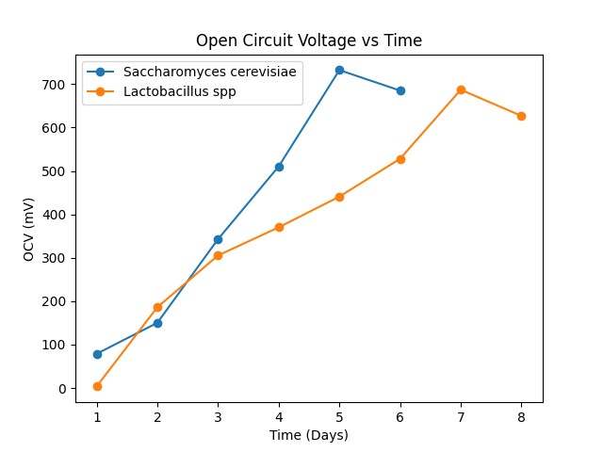
Figure 1: Open circuit voltage increased steadily in both systems. Saccharomyces cerevisiae reached peak voltage earlier (Day 5), while Lactobacillus spp peaked later (Day 7).

Current Output
Current output followed the same increasing trend as voltage in both systems. The values ranged from 0.0 mA to 0.702 mA, with yeast producing the highest maximum current. The gradual rise indicates improved electron transfer efficiency as microbial growth increased (Figure 2).
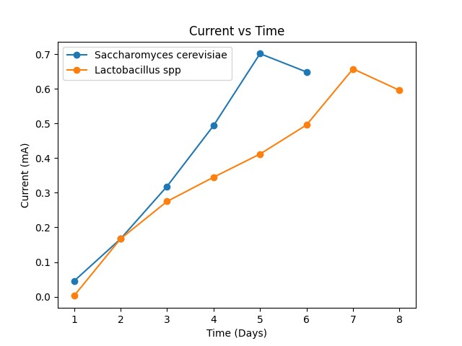
Figure 2: Current output followed the voltage trend. Saccharomyces cerevisiae produced slightly higher maximum current compared to Lactobacillus spp.
Voltage across 1000 Ω Resistor
Voltage across the resistor increased with operational time in both MFCs. The recorded values ranged from 2.3 mV to 702.9 mV, demonstrating improved circuit performance over time. The increase showed enhanced electron flow through the external load as microbial metabolism intensified (Figure 3).
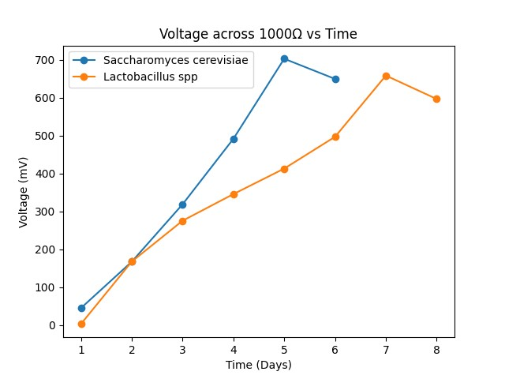
Figure 3: Voltage across the 1000Ω resistor increased with time, showing improved electron transfer efficiency in both systems.
Anode Conductivity
Anode conductivity increased significantly during operation. The values ranged from 34.9 µS/cm to 1866.0 µS/cm, indicating improved ionic mobility within the anode chamber. Higher conductivity corresponded with higher electrical output and active substrate breakdown (Figure 4).
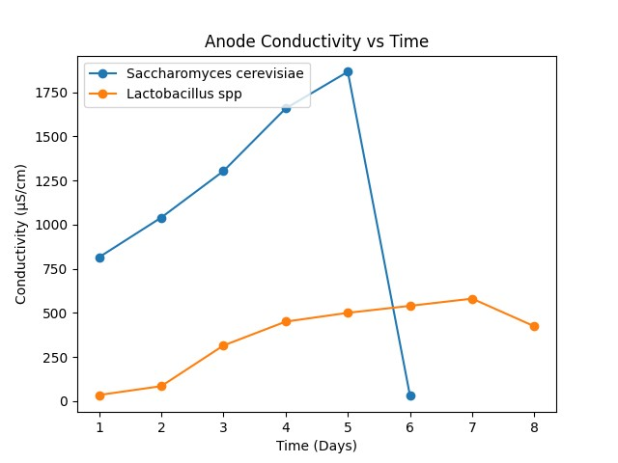
Figure 4: Anode conductivity was higher in Saccharomyces cerevisiae, indicating stronger ionic movement and metabolic activity.

pH Changes
Anode pH showed variation due to microbial metabolic processes. The values ranged from 3.7 to 5.6, with Lactobacillus showing stronger acidification trends. The decrease in pH reflects fermentation and organic acid production during electricity generation (Figure 5).
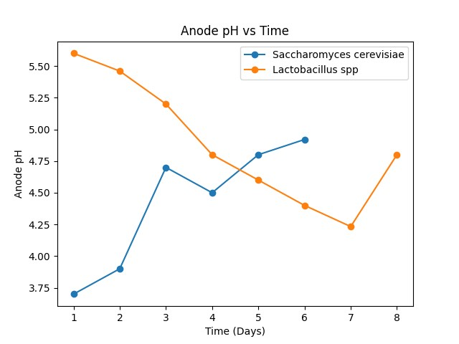
Figure 5: Lactobacillus spp. showed progressive acidification, while Saccharomyces cerevisiae shifted toward moderate pH values.

Power Output
Power output increased in both systems before declining after peak performance. The power values ranged from 0.0 mW to 0.4935 mW, with Saccharomyces cerevisiae producing the highest peak. The trend shows that maximum metabolic activity coincided with maximum electrical generation (Figure 6).
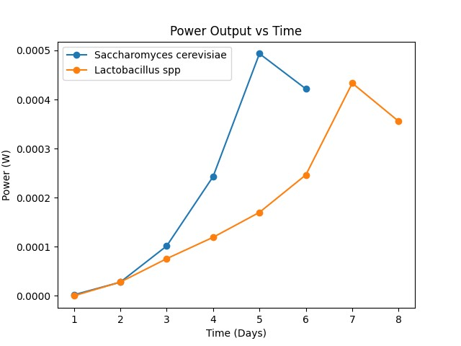

Figure 6: Power output increased in both systems. Saccharomyces cerevisiae achieved higher peak power earlier than Lactobacillus spp.
Temperature Variation
Temperature remained stable throughout the experiment. The value ranged from 29.6°C to 32.6°C in the anode chamber and 21.6°C to 30.0°C in the cathode chamber. This stable mesophilic range provided suitable conditions for microbial growth and electricity production (Figure 7).
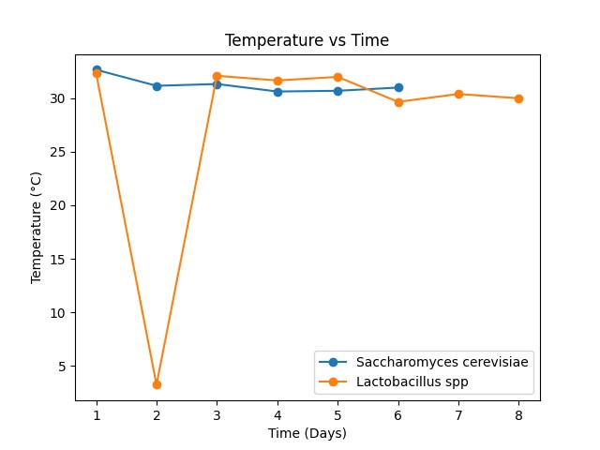
Figure 7: Temperatures remained within 30 - 32 °C, providing suitable conditions for metabolism.

Discussion
The electricity-generating performance of S. cerevisiae and Lactobacillus spp. in double-chambered MFCs showed that both microorganisms could produce measurable bioelectricity, confirming the fundamental principle of MFC technology (Logan and Rabaey, 2020). The progressive increase in open circuit voltage (OCV), current, and power output observed in both systems supports earlier findings that microbial metabolism directly influences electron transfer to the anode (Logan et al., 2006; Rabaey et al., 2020). The maximum OCV values (686.9 - 732.3 mV) recorded in this study fall within the range reported in laboratory-scale MFC studies using simple substrates (Chaudhuri and Lovley, 2003; Logan et al., 2006).
The S. cerevisiae MFC produced a peak OCV of 732.3 mV and peak power output of 0.4935 mW earlier by Day 5, compared to the Lactobacillus system, which peaked by Day 7 at 686.97 mV and 0.4333 mW. This earlier peak performance in yeast may be attributed to its rapid fermentation of glucose, leading to faster electron release. Similar rapid metabolic activity of yeast in bio-electrochemical systems has been reported by Du et al. (2016) and Sun et al. (2018), who noted that fermentative organisms can produce quick, but sometimes less sustained electrical outputs. However, although yeast MFC achieved a slightly higher maximum power, the Lactobacillus system demonstrated more sustained voltage output over time, suggesting better stability in prolonged operation.
The gradual rise in current (0.0 - 0.702 mA) in both systems aligns with the findings of Pant et al. (2019), that increasing microbial biomass enhances electron transfer efficiency. The increase in anode conductivity further confirms improved ionic mobility and substrate degradation, consistent with the observations of Feng et al. (2019), that higher conductivity correlates positively with improved MFC performance.
The pH variations recorded in this study are in line with previous research. The decrease in anode pH in the yeast system (5.6 - 4.2) indicates acid production during fermentation, which has been widely reported in microbial metabolism studies (Prescott et al., 2002). In contrast, Lactobacillus spp. showed progressive acidification followed by slight stabilization, reflecting its lactic acid fermentation pathway. Kurniawan et al. (2021) reported that pH fluctuations significantly affect microbial activity and electron transfer efficiency, and maintaining optimal pH conditions enhances power output.
Temperature remained within the mesophilic range, consistent with optimal growth temperatures for both yeast and lactic acid bacteria. This agrees with Aghababaie et al. (2021), who stated that stable mesophilic conditions improve metabolic activity and electricity generation in MFCs. The relatively low overall power output observed in this study is consistent with the limitation highlighted by Choi (2019), that most laboratory-scale MFCs still produce low power densities compared to conventional energy technologies.
Comparatively, previous studies have shown that highly electrogenic bacteria such as Geobacter sulfurreducens and Shewanella oneidensis can produce higher and more stable power outputs due to their direct electron transfer mechanisms (Bond and Lovley, 2022). The slightly lower performance seen in this study may be due to the use of non-specialized electrogenic organisms and simple graphite electrodes. Nonetheless, the findings show that commonly available microorganisms can generate bioelectricity, supporting the sustainability argument proposed by Pandya et al. (2024) that low-cost biological systems can contribute to renewable energy development.
Overall, this study aligns with global research trends emphasizing waste-to-energy conversion and decentralized renewable energy production. Although the power output is modest, the results confirm the feasibility of using accessible microorganisms for small-scale electricity generation, consistent with the sustainability perspectives of Santoro et al. (2017) and Huang et al. (2022).

Conclusion

This study demonstrated that both S. cerevisiae and Lactobacillus spp. can generate electricity in double-chambered MFCs. Although the power output recorded was modest compared to conventional energy sources, the results show the viability of low-cost microbial systems for small-scale bioelectricity production. The study therefore supports the potential application of microbial fuel cells as sustainable, environmentally friendly, energy alternatives, particularly in waste treatment and decentralized energy systems.

References
Aghababaie, M., Ghadiri, M., and Rahimnejad, M. (2021). Enhancing efficiency of microbial fuel cells: Role of operational factors and materials. Renewable Energy, 16(9), 170–182

Bond, D. R., and Lovley, D. R. (2022). Electricity production by Geobacter sulfurreducens attached to electrodes. Applied and Environmental Microbiology, 69(3), 1548–1555

Chaudhuri, S. K., and Lovley, D. R. (2003). Electricity generation by direct oxidation of glucose in mediatorless microbial fuel cells. Nature Biotechnology, 21(10), 1229 - 1232. https://doi.org/10.1038/nbt867

Choi, S. (2019). Microbial fuel cells: Challenges and future prospects. Environmental Engineering Science, 36(2), 105 – 119

Du, Z., Li, H., and Gu, T. (2016). A state-of-the-art review on microbial fuel cells: A promising technology for wastewater treatment and bioenergy. Biotechnology Advances, 25(5), 464 – 482

Feng, Y., Yang, Q., Wang, X., and Logan, B. E. (2019). Influence of environmental parameters on bacterial electricity generation in MFCs. Bioresource Technology, 104(1), 34 – 39

He, Z., Wagner, N., and Minteer, S. D. (2020). Microbial fuel cells: From fundamentals to applications. Energy and Environmental Science, 13(4), 1137 – 1161

Huang, L., Chai, X., and Zheng, P. (2022). Decentralized electricity production in remote areas using microbial fuel cells. Journal of Cleaner Production, 35(2), 131517.

International Energy Agency (2022). Global energy review 2022. Retrieved from https://www.iea.org/reports/global-energy-review-2022

Kurniawan, T. A., Lo, W., and Chan, G. Y. S. (2021). Optimizing pH in microbial fuel cells for better electricity generation. Environmental Science and Pollution Research, 28(4), 4367 – 4377

Lie, T. J., Kim, B. C., and Smith, J. A. (2018). Electrochemical communication in bacterial communities. Journal of Bacteriology, 200(5), e00525-17

Logan, B. E., Hamelers, B., Rozendal, R., Schröder, U., Keller, J., Freguia, S., Aelterman, P., Verstraete, W., and Rabaey, K. (2006). Microbial fuel cells: Methodology and technology. Environmental Science and Technology, 40(17), 5181 – 5192

Logan, B. E., Rossi, R., and Kim, K. Y. (2019). Electrochemical perspectives on microbial fuel cells and waste-to-energy conversion. Nature Reviews Microbiology, 17(5), 307 – 319

Niessen, J., Schröder, U., Rosenbaum, M., and Scholz, F. (2019). Flavins as electron shuttles in microbial fuel cells. Electrochemistry Communications, 7(6), 107 -111

Pandya, M., Shah, T., and Singh, R. (2024). Microbial fuel cells for sustainable electricity: Current status and future prospects. Renewable Energy, 21(2): 123456

Pandya, R. S., Kaur, T., Bhattacharya, R., Bose, D., and Saraf, D. (2024). Harnessing microorganisms for bioenergy with Microbial Fuel Cells: Powering the future. Water-Energy Nexus, 7(6) 1-12

Pant, D., Singh, A., Van Bogaert, G., Irving Olsen, S., and Vanbroekhoven, K. (2019). Biological fuel cells: Mechanism and factors affecting performance. Bioresource Technology Reports, 7(2): 100228

Prescott, L. M., Harley, J. P., and Klein, D. A. (2002). Microbiology (5th ed.). McGraw-Hill.

Rabaey, K., Rodríguez, J., Blackall, L. L., Keller, J., Gross, P., Batstone, D., and Verstraete, W. (2020). Microbial ecology meets electrochemistry: Electricity-driven and driving communities. ISME Journal, 3(7); 745 – 758

Ringeisen, B. R., Henderson, E., and Logan, B. E. (2019). Emerging applications of microbial fuel cells in bioenergy and bioremediation. Current Opinion in Biotechnology, 22(3): 1 – 6

Santoro, C., Arbizzani, C., Erable, B., and Ieropoulos, I. (2017). Microbial fuel cells: From fundamentals to applications. Journal of Power Sources, 35(6): 225 – 244

Sun, J., Yang, X., and Yuan, Y. (2018). Microbial fuel cells for renewable electricity generation and wastewater treatment. Environmental Progress and Sustainable Energy, 37(4), 1430 – 1437

Tender, L. M., Reimers, C. E., Stecher, H. A., Holmes, D. E., Bond, D. R., and Lovley, D. R. (2021). Harnessing microbially generated power on the seafloor. Nature Biotechnology, 20(8); 821 – 825

Zhou, Minghua, Chi, Meiyan, Luo, Junfeng, He, Hui, and Jin, Tao (2019). Recent advances in microbial fuel cells: A review. Renewable and Sustainable Energy Reviews, 10(5); 204 – 212

Zou, C., Zhao, Q., Zhang, G., and Xiong, B. (2022). Energy revolution: From a fossil energy era to a new energy era. Natural Gas Industry, 3(1), 1-11

