An Empirical Reassessment of the Impact of Small and Medium Scale Agricultural Enterprises on Household Welfare: Evidence from Kariji, Southern Kaduna, Nigeria

S.O. Akinmurele¹ · Z. S. Saheed² · I.O Jude³ M.C Duru⁴
¹⁻³ Department of Economics, Nigerian Defence Academy, Kaduna, Nigeria.
⁴Department of Economics, Amadu Bello University, Zaira, Nigeria.
Corresponding author: akinmurelesamuel@nda.edu.ng | Received: | Revised: | Accepted:

ABSTRACT
Small and medium-scale agricultural enterprises (SMAEs) are widely recognised as a foundational component of rural economic life in sub-Saharan Africa, yet their specific effects on household welfare within localised farming communities remain insufficiently examined. This study empirically investigates the impact of SMAEs on household welfare and employment generation in Kariji, Southern Kaduna, a predominantly livestock-farming community in north-central Nigeria. Adopting a descriptive survey design, primary data were collected through structured questionnaires administered to 348 purposively selected respondents from a registered population of 2,650 SMEs in Kaduna State and analysed using descriptive statistics and chi-square hypothesis testing at a 5% significance level. Descriptive findings reveal moderately positive perceptions of SMAE contributions across six household welfare dimensions, namely financial well-being, improved living standards, reduced external dependency, healthcare access, food security, and education cost coverage, with means ranging from 2.99 to 3.14, alongside four employment dimensions with means between 2.92 and 3.02. However, chi-square analysis indicates no statistically significant impact on either household welfare or employment creation, with all p-values substantially exceeding the 0.05 threshold. These outcomes are attributed to compounding structural barriers including limited access to affordable finance, inadequate rural infrastructure, unfavourable regulatory conditions, poor market linkages, and insufficient entrepreneurial capacity. Grounded in Social Capital Theory and the Resource-Based View, the study recommends targeted microcredit expansion, rural infrastructure investment, entrepreneurial capacity building, regulatory reform, and cooperative market development as pathways to unlocking the developmental potential of agricultural SMEs in rural Nigeria.
Keywords: Small and medium enterprises; agricultural enterprises; household welfare; job creation; Southern Kaduna; Nigeria; chi-square analysis

1. Introduction
Small and medium-scale enterprises (SMEs) represent the dominant organisational form of economic activity across developing economies, functioning simultaneously as engines of employment generation, conduits of poverty reduction, and incubators of entrepreneurial innovation. Their significance in Nigeria's economic history is long-established: the formal recognition of small-scale enterprise in national planning dates to the Ten-Year Plan of Development and Welfare of Nigeria presented in 1946, which acknowledged the indispensable role of small businesses in national reconstruction (Basil, 2005). Since that colonial-era foundation, SMEs—and agricultural SMEs in particular—have grown progressively in strategic importance, attracting sustained policy attention as governments across sub-Saharan Africa recognise that SME-led rural transformation may offer the most viable pathway to inclusive economic development.
The empirical case for SME primacy in employment creation is compelling at the global level. Approximately 26 million SMEs operating within the European Union provide employment for 109 million people (EuroStat, 2019). In the United States, SMEs account for 87 percent of the national workforce; German SMEs employ 72.6 percent of the labour force; and in South Korea and Taiwan, SME-driven manufacturing and export strategies have underpinned sustained national prosperity. In EU countries in 2016 specifically, SMEs constituted 9.63 percent of total enterprises, provided 45.18 percent of total employment, held a 48.54 percent share in manufacturing industry employment, and registered total employment of 83.6 million workers—with a 42.5 percent share of total manufacturing industry employment (Statista, 2017). In Pakistan, SMEs dominate the fastest-growing export sectors, generate employment for 78 percent of the industrial labour force, and account for 53 percent of all SME activities in trade, retail, and wholesale sectors (Pakistan Bureau of Statistics, 2011).
In Nigeria, the agricultural sector which employs approximately 60 percent of the national labour force and contributes up to 35 percent of GDP is predominantly structured around small and medium-scale enterprises engaged in crop cultivation, livestock rearing, agro-processing, and rural commodity trading (Adewumi, 2008). The country ranks among the world's leading producers of cassava, yam, cowpea, cocoa, cashews, sweet potato, mango, papaya, millet, sorghum, and sesame, with the bulk of output originating from SMEs. Yet the sector is undermined by post-harvest losses estimated at 50 percent for vegetables, 30 percent for roots and tubers, and 20 percent for grains (FMARD, 2001) losses attributable to inadequate agro-machinery, poor infrastructure, and weak institutional support. Moreover, 95 percent of Nigeria's export earnings derive from petroleum and related products, a structural dependency that has historically diverted investment and policy attention away from agriculture, leaving the sector severely under-resourced.
The Nigerian government has implemented several policy frameworks to stimulate SMAE growth. The National Enterprises Development Programme (NEDEP) targeted the creation of 5.0 million direct and indirect jobs between 2013 and 2015, aiming to revitalise rural economies, alleviate poverty, facilitate entrepreneurial culture, enhance industrial cluster development, and increase MSMEs' contribution to GDP. The Small and Medium Enterprises Development Agency of Nigeria (SMEDAN) exists to facilitate MSME access to finance, markets, and capacity-building resources. The Bank of Industry (BOI) established in 2001 as Nigeria's oldest and largest development finance institution provides loans, grants, equity financing, and guarantees to MSMEs. Tax incentives, waivers, and reduced corporate tax rates have additionally been deployed to incentivise SME growth. Yet despite this institutional architecture, SMAE performance in rural communities like Kariji in Southern Kaduna remains persistently constrained, and the measurable impact of agricultural enterprises on household welfare remains inadequately documented at community level.
This study addresses this critical gap by empirically investigating the impact of small and medium-scale agricultural enterprises on household welfare and job creation in Kariji, Southern Kaduna, Nigeria. Theoretically grounded in Social Capital Theory (Lin, 1999) and the Resource-Based View (Stacey, 2011), and methodologically anchored in descriptive survey research and chi-square inference, the study advances community-level, sector-specific evidence from a rural livestock-farming context that has received negligible academic attention. This study examines the role of small and medium-scale agricultural enterprises (SMAEs) in influencing household outcomes in Kariji, Southern Kaduna. It explores how these enterprises affect household welfare, particularly in terms of financial well-being, living standards, reduced external dependency, healthcare access, food security, and the ability to cover educational expenses. Furthermore, the study evaluates the contribution of SMAEs to employment by assessing their role in job creation, unemployment reduction, business expansion through funding, and income diversification within the community. It tests the null hypotheses that agricultural SMEs have no significant impact on household welfare in Kariji, Southern Kaduna, and no significant effect on job creation in Nigeria.
The remainder of the paper proceeds as follows: Section 2 reviews conceptual, theoretical, and empirical literature. Section 3 presents the methodology. Section 4 reports and analyses results. Section 5 discusses findings. Section 6 concludes with policy recommendations.
2. Literature Review
2.1 Conceptual Literature
2.1.1 SMEs as Development Agents
SMEs are characterised across disciplines by their size-related constraints limited capital, confined market reach, and restricted managerial capacity yet are simultaneously celebrated for their flexibility, labour-intensiveness, and proximity to community needs. In Nigeria, SMEs are largely dominated by agro-based enterprises specialising in the production of bulk commodities for domestic consumption and export promotion, particularly cash crops and processed agricultural products. Nigeria is one of the world's leading producers of fruits, cassava, yam, cowpea, and cocoa, with the bulk of this output traceable to SMEs (Adewumi, 2008). Post-harvest losses, however, remain a major structural liability reaching 50 percent for vegetables, 30 percent for roots and tubers, and 20 percent for grains (FMARD, 2001) a reflection of the inadequate agro-machinery, cold-chain infrastructure, and storage facilities that characterise rural agricultural SME environments in Nigeria.
The contributions of SMEs to household welfare operate through five primary channels: employment creation; rapid adaptability to demand changes through organisational flexibility; the stimulation of entrepreneurship; product differentiation through boutique and specialised production; and functioning as supplier sub-industries within larger enterprise ecosystems (EuroStat, 2019; Statista, 2017). According to Peterise (2003), SMEs in both the formal and informal sectors employ over 60 percent of Nigeria's labour force, while 70 to 80 percent of daily necessities consumed in the country are basic materials produced with minimal automation by small and medium enterprises. Odubanjo (2000), Onwumere (2000), and Nnanna (2001), as cited in Wahab and Ijaiya (2006), further affirm that SMEs contribute to rural infrastructure improvement, elevation of rural living standards, and employment creation through the utilisation of indigenous technology.
2.1.2 Entrepreneurship
The conceptual ecosystem of SMEs is inseparable from entrepreneurship. Dollinger (2003) identifies three foundational elements common across definitional traditions: creativity and innovation; resource gathering and the founding of economic organisations; and operation under conditions of risk and uncertainty. For entrepreneurship to flourish, Dollinger further stipulates two enabling conditions freedom to establish ventures and innovate, and an economic environment sufficiently prosperous to reward entrepreneurial effort. Ulhoi (2004) extends this analysis by arguing that entrepreneurship is not a purely individual disposition but is shaped decisively by the social network context surrounding the entrepreneur, the availability of market opportunities, and the institutional environment within which ventures operate.
In rural agricultural communities such as Kariji, the convergence of constrained social capital networks, limited opportunity sets, and an unfavourable regulatory climate severely depresses entrepreneurial potential among SMAE operators. The Portuguese proverb "the occasion creates the thief" aptly captures this dynamic: the scarcity of enabling conditions in rural Nigeria systematically suppresses the entrepreneurial activity that might otherwise transform agricultural SMEs into engines of household welfare improvement.
2.1.3 Agriculture and the Nigerian Economy
Agriculture is the most important sector in the Nigerian economy employing 60 percent of Nigerians, particularly rural dwellers, and contributing up to 35 percent of GDP. Despite this foundational role, Nigeria remains a net importer of food, a paradox attributable to several structural failures: the overwhelming majority of agricultural operators work at subsistence level, with minimal innovation in inputs, harvesting, processing, distribution, or market access; 95 percent of the country's exports are dominated by petroleum; and the arable land base 39.6 million hectares, of which 60 percent is under cultivation is chronically under-capitalised (Adewumi, 2008).
Nigeria possesses substantial agricultural potential, ranking among the world's largest producers of cassava, cashews, sweet potato, yams, mango, papaya, millet, sorghum, and sesame. A domestic population that represents a vast market for locally produced food, and a strategic position within West African regional value chains, provides further structural advantage. The fundamental constraint, however, remains the peasant nature of the production system characterised by low productivity, poor adoption of improved technologies, and weak returns on investment. Agricultural commercialisation and targeted investment in SMEs are accordingly recognised as the key strategies for promoting accelerated modernisation and poverty reduction in the sector.
2.1.4 Household Welfare
Household welfare is conceptualised as the general condition of life of household members, operationally measured through consumption expenditure, food and non-food expenditure, and the incidence of poverty (Arouri et al., 2015; Unnikrishnan & Imai, 2020). Asmah and Avenue (2011) define it as the household's command over market goods and services. Welfare creation is the central objective of the Sustainable Development Goals (SDGs) 2030 encompassing freedom from poverty (SDG 1), freedom from hunger and food insecurity (SDG 2), and decent employment (SDG 8). In developing countries, where the agricultural sector absorbs a majority of the workforce, well-managed agricultural development is recognised as uniquely capable of simultaneously advancing economic growth, reducing poverty, curtailing unemployment, and improving general social welfare (Setboonsarng, 2006).
2.2 Theoretical Literature
2.2.1 Social Capital Theory
Social Capital Theory (Lin, 1999) posits that individuals and organisations participate in social networks primarily to maximise utility, and that the density, strength, and quality of those networks determine access to resources, information, and opportunity. Three foundational assumptions underpin the theory: (i) greater networking generates greater social capital; (ii) greater social capital elevates the priority of equality norms; and (iii) greater social capital facilitates collective problem-solving. Schmid and Robison (1995) identify the conceptual content of social capital as comprising expectations, obligations, information channels, trustworthiness of structures, norms, and effective sanctions.
Applied to agricultural SMEs, social capital networks provide critical advantages in overcoming the information asymmetries that impede access to formal credit (Kasekende & Opondo, 2003). Davidsson and Honig (2003) demonstrate that SMEs maintaining strong social network associations are more likely to secure growth financing. Coleman et al. (2013) further identify social capital as a vital resource that enhances intra-organisational trust and bridges external networks for financial resource acquisition—functions of particular relevance in rural Nigeria, where cooperative structures and community networks frequently substitute for absent formal institutional support mechanisms. Social Capital Theory's critics—notably Bourdieu and Wacquant (1992)—observe that social capital can serve as an exclusionary instrument reinforcing elite advantage; Quillian and Redd (2006) additionally note the risk of criminal network formation within densely bonded communities. These limitations must be acknowledged in interpreting the applicability of social capital frameworks to SMAE contexts in Kariji.
2.2.2 The Resource-Based View (RBV)
The Resource-Based View (RBV) frames the firm as a bundle of strategic resources whose effective deployment determines competitive advantage and growth trajectory (Stacey, 2011). Financial resources are conceptualised as the 'lifeblood' of enterprise operations: the financial system is the vessel that carries this lifeblood through the economic system, and faulty vessels—inadequate banks, constrained credit markets, excessive collateral requirements, prevent it from reaching the vital organs of the enterprise ecosystem (Sowah, 2003; Degravel, 2012).
For agricultural SMEs, RBV predicts that the absence of adequate financial resources is directly and causally associated with growth failure. Gill and Biter (2012) confirm that sufficient finance has a significant positive effect on small business survival and growth. Yallapragada and Buoyant (2011) identify adequate financial resources as the primary determinant of SME success. Chong (2012), using survey data from SME owners, finds financial resources imperative to enterprise survival. Brinckmann et al. (2011) document that small businesses systematically encounter difficulty in financial resource acquisition—a difficulty rooted in information asymmetry between enterprise owners and external financiers. Byrd et al. (2013) and Nofsinger and Weicheng (2011) identify this financial resource constraint as the primary driver of the high failure rates observed among small businesses globally. Ucbasaran et al. (2013) introduce a counterpoint, noting that business failure itself discharges knowledge and resources to surviving firms through vicarious learning—but acknowledge that this mechanism operates at aggregate rather than individual enterprise level, and provides no comfort to the household whose welfare depends on a specific SMAE.
2.2.3 Theoretical Framework
The agricultural sector has become one of the most important sectors in Nigeria. UNIDO (2017) statistically found that only 20 percent of SMEs that start their business manage to survive, underscoring the severity of structural constraints faced by SMAEs in Nigeria. This study is anchored on Social Capital Theory and the Resource-Based View because these two frameworks, taken in combination, provide the most comprehensive explanatory architecture for understanding why SMAEs in rural Nigeria—despite their latent developmental potential—fail to generate statistically measurable improvements in household welfare and employment. Social Capital Theory explains the network-mediated mechanisms of resource access, trust formation, and information sharing that could theoretically enable SMAE growth; RBV explains why the absence of financial and physical capital prevents that potential from being realised.
2.3 Empirical Review
Abdulai and Emmanuel (2021) analysed the impact of technology adoption on smallholder farmer welfare in Ghana, applying propensity score matching to data from 461 technology adopters and non-adopters. Results demonstrated that regional location, educational attainment, age, and Farmer Base Organisation membership were the primary determinants of technology adoption. Crucially, technology adoption had a positive but statistically insignificant impact on welfare overall—consumption and clothing expenditure increased with adoption, but healthcare outcomes did not improve—a finding that resonates strongly with the insignificant chi-square results obtained in the present study.
Ojiya, Andohol, and Doki (2021), using descriptive statistics and OLS in Ukum Local Government Area, Benue State, found that inadequate storage facilities and insufficient pest and disease control were the dominant constraints on yam producer welfare, with post-harvest losses directly depressing farmer income. Bayode, Olagunju, Onikoyi, Oginni, and Kazeem (2021) examined agro-allied SME impacts on Nigerian economic growth between 1976 and 2020 using OLS and Error Correction Models, finding a positive and significant relationship between agro-allied SMEs and real GDP (R² = 0.586; Adjusted R² = 0.577; p = 0.02)—a macroeconomic result that contrasts with the community-level insignificance documented in this study, illustrating the importance of analytical scale.
Olarinde et al. (2020), investigating social capital effects on food security across 775 cassava farming households in four Nigerian zones, found that 41 percent were food secure and 59 percent food insecure, recommending cooperative formation and group investments to reduce manual labour input as pathways to improved food security. Anugwa and Agwu (2019), using a 120-respondent multistage sample from six rural districts in Kano State, found that despite widespread engagement in food crop production, cash crop cultivation, and livestock rearing, households remained food insecure—pointing to the inadequacy of agricultural activity alone, without supportive institutional and market infrastructure, in addressing welfare deficits.
Saleh and Mustafa (2018), in a cross-sectional study of urban farmers in Kaduna State using two-stage sampling and multiple regression models, found that 54.5 percent of households were food insecure during the study period. John-Akamelu and Muogbo (2018) evaluated SME contributions to poverty reduction in Anambra State using chi-square analysis on 150 SME employees, finding that SMEs provided employment, training, and local resource utilisation opportunities that contributed to poverty reduction. Bello, Jibir, and Ahmed (2018), using simple regression on 1986–2016 data, demonstrated a direct and significant association between SMEs and economic output growth. Abbade (2017) assessed food availability, access, and utilisation across 57 developing nations, finding food security dimensions to be substantially and positively correlated, and recommending global policy alignment to reduce food waste, lower logistics costs, and lower food prices.
Ayodeji and Ajala (2017), using ARDL on 2000–2016 data, found a long-run relationship between microfinancing and rural poverty reduction in Nigeria, with microfinance credit significantly negatively related to the rural poverty index. Charan and Wasdani (2016) found in Lusaka a positive correlation between lack of collateral assets and credit rejection (r = 0.727) and between interest rates and access constraints (r = 0.202), recommending cooperative group partnering and 'Village Banking' crowd-funding as alternative financing mechanisms. Ojong, Arikpo, and Ogar (2015) established that bank credit had a significant relationship with SME growth in Cross River State, recommending increased deposit money bank lending volumes and elimination of multiple taxation. Oyeniran, David, and Ajayi (2015), using ARDL on 1983–2013 Nigerian data, found that SME capital investment would directly and significantly contribute to economic advancement, with credit accessibility, capacity building, and infrastructure development facilitating long-run growth.
Akugri, Bagah, and Wulifan (2015), using 160-respondent primary data from Ghanaian SMEs, found that SMEs were not providing substantial employment for youth, with most preferring family labour to minimise input costs—a finding directly mirrored in Kariji. Hussain, Bhuiyan, and Said (2015), reviewing Malaysian MSME literature, found that enterprise development depends on innovativeness, family background, government support, and training, with government-university-industry collaboration generating employment and alleviating poverty. Kadiri (2012), using binomial logistic regression, found that Nigerian SMEs had not impacted positively on economic growth partly due to poor financing and government commitment. Akingunola (2011) found a significant positive Spearman Rho correlation (ρ = 0.643; p < 0.10) between SME financing and economic growth in Nigeria through investment level. Dada (2014), using OLS regression on 1992–2011 data, found commercial bank credit positively influenced SME development while exchange rate and interest rate exerted negative effects.
Existing literature on SMEs and welfare in Nigeria is dominated by macroeconomic analyses employing OLS regression, ARDL models, panel data methods, and T-test analysis, with aggregate economic growth—proxied by GDP components—as the primary outcome variable. Community-level, sector-specific investigations of the welfare impacts of agricultural SMEs in rural settings are sparse. Studies that specifically disaggregate household welfare dimensions—financial well-being, living standards, healthcare access, food security, education costs—and test their statistical relationship with SMAE activity at the community level are effectively absent from the literature for Southern Kaduna. Methodologically, chi-square inference applied to Likert-scale survey data on SMAE welfare impacts in rural Nigerian agricultural communities represents a substantive contribution to the empirical literature. This study addresses these gaps directly, providing granular evidence on SMAE welfare outcomes in Kariji that advances understanding of the micro-level mechanisms—and systemic barriers—through which agricultural SMEs influence household welfare in rural Nigeria.
3. Methodology
3.1 Research Design
This study adopts a descriptive survey research design, which is appropriate for systematically capturing the characteristics, behaviours, and perceptions of a defined population without experimental manipulation (Babbie, 2005). A descriptive design enables rigorous documentation of the relationship between SMAE activity and household welfare and employment outcomes, based on structured self-reported data from SME owners and operators in Kariji, Southern Kaduna.
3.2 Study Area
The study was conducted in Kariji, located in the Southern Kaduna zone of Kaduna State, Nigeria. Southern Kaduna is a predominantly rural, agrarian region characterised by smallholder farming, livestock rearing, and small-scale agro-processing. The study is specifically limited to livestock farming within the small and medium-scale enterprise spectrum. The area reflects the typical constraints of rural SME operating environments in Nigeria—limited access to financial services, poor road infrastructure, unreliable electricity, and constrained market access—making it a representative and contextually appropriate setting for this investigation. Individual households served as the primary unit of analysis.
3.3 Population and Sample Size
The total study population comprises 2,650 registered SMEs in Kaduna State, as documented in the National Survey of Micro, Small and Medium Enterprises (MSMEs). The sample size was determined using the Taro Yamane (1967) formula:
n = N / [1 + N(e)²]
Where: n = sample size; N = population = 2,650; e = margin of error = 0.05 (95% confidence)
n = 2,650 / [1 + 2,650(0.05)²] = 2,650 / 7.625 ≈ 348 respondents
3.4 Sampling Method
Purposive (judgmental) sampling was employed, targeting SME owners and operators engaged in livestock farming and agricultural SME activities in Kariji. This approach ensures that respondents possess direct knowledge of the phenomena under investigation—specifically the contributions of SMAEs to household welfare and employment—and are capable of providing informed assessments on all survey dimensions.
3.5 Data Collection
Primary data were collected using structured questionnaires administered to respondents in Kariji. A five-point Likert scale (1 = Strongly Disagree to 5 = Strongly Agree) was employed to measure perceptions of SMAE impacts on household welfare, employment generation, and operational challenges. A pre-test was conducted prior to full deployment to verify instrument reliability and internal consistency.
3.6 Method of Data Analysis
Survey data were analysed using descriptive statistics—including frequencies, means, standard deviations, variances, and coefficients of variation (CV)—to characterise sample distributions and summarise key variables. Chi-square (χ²) tests were applied to evaluate the research hypotheses. The chi-square statistic is computed as:
χ² = Σ [(Oᵢ – Eᵢ)² / Eᵢ]
Where Oᵢ = observed frequency and Eᵢ = expected frequency. Degrees of freedom were calculated as df = k − 1, where k = number of response categories; with five response options (k = 5), df = 4. The critical chi-square value at df = 4 and α = 0.05 is χ²-critical = 9.488. The null hypothesis was rejected where the computed χ² ≥ 9.488 (equivalently, where p < 0.05). All analyses were conducted using SPSS Version 25 and verified in Microsoft Excel.
4. Results and Analysis
This section presents the empirical findings of the study in three sequential layers: descriptive statistics characterising SMAE impacts on household welfare and employment; descriptive statistics on the challenges constraining SMAEs; and inferential chi-square hypothesis testing for both research hypotheses. Graphical representations complement each analytical table to facilitate comparative interpretation.
4.1 Impact of SMAEs on Household Welfare
Table 1 presents descriptive statistics for respondents' assessments of SMAE contributions across six household welfare dimensions, and Figure 1 provides the corresponding graphical representation of mean scores.
Table 1: Descriptive Statistics — Impact of SMAEs on Household Welfare (n = 348)
Household Welfare Dimension | Mean | Std. Dev. | Variance | CV | Range
Income contributes to financial well-being | 2.99 | 1.40 | 1.96 | 0.47 | 1–5
Improved standard of living | 3.02 | 1.46 | 2.13 | 0.48 | 1–5
Reduced reliance on external support | 3.14 | 1.40 | 1.96 | 0.45 | 1–5
Access to better healthcare | 3.01 | 1.45 | 2.10 | 0.48 | 1–5
Ensured food security | 3.03 | 1.37 | 1.88 | 0.45 | 1–5
Covered education costs | 3.02 | 1.42 | 2.02 | 0.47 | 1–5
Source: Authors' Field Survey and Computation, 2025
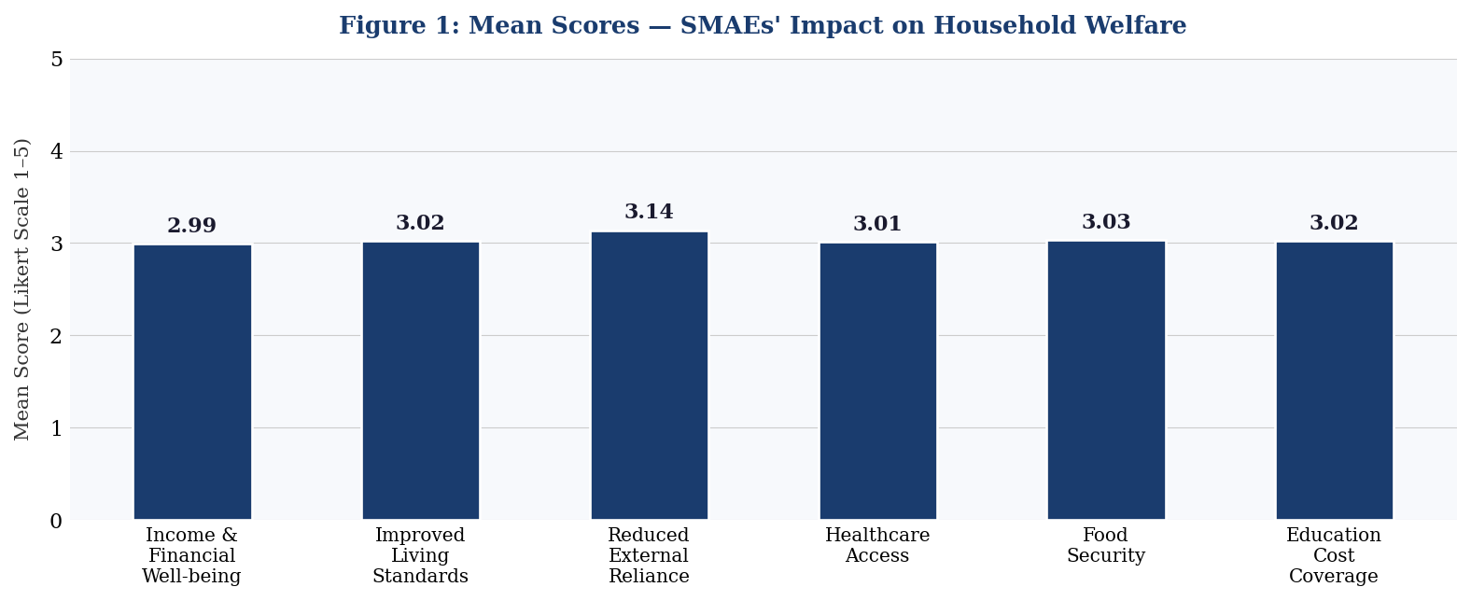
Figure 1: Mean Scores — SMAEs' Impact on Household Welfare Dimensions
Mean scores across all six welfare dimensions cluster narrowly around the Likert mid-point (range: 2.99–3.14), reflecting moderate and broadly consistent agreement that SMAEs contribute positively to household welfare. The highest mean is recorded for 'Reduced reliance on external support' (mean = 3.14; SD = 1.40; CV = 0.45), suggesting that income generated through agricultural SME activities confers a modest but perceptible degree of economic autonomy on participating households—enabling them to reduce dependence on external transfers, remittances, or government support. 'Ensured food security' records the lowest variance (1.88) and CV (0.45) of any dimension, signalling the greatest degree of inter-respondent consensus: almost irrespective of household characteristics, SMAE engagement is perceived as moderately food-security-enhancing.
Standard deviation values ranging from 1.37 to 1.46 reflect the moderate heterogeneity of household welfare experiences within Kariji—expected in a community where livestock farming enterprises vary considerably in scale, management capacity, and market orientation. The coefficient of variation for 'Improved standard of living' (CV = 0.48) and 'Access to better healthcare' (CV = 0.48) indicates relatively greater diversity of opinion on these dimensions, likely reflecting variation in household proximity to healthcare facilities and the idiosyncratic manner in which incremental SMAE income is allocated across competing consumption priorities. The full response range (1–5) across all six dimensions confirms that the survey instrument captured the complete spectrum of respondent experience—from households experiencing no discernible SMAE welfare benefit to those experiencing clear improvement.
4.2 Impact of SMAEs on Job Creation and Employment
Table 2 presents descriptive statistics for respondents' assessments of SMAE contributions across four employment dimensions. Figure 2 provides graphical comparison of mean scores across these dimensions.
Table 2: Descriptive Statistics — Impact of SMAEs on Job Creation and Employment (n = 348)
Employment Dimension | Mean | Std. Dev. | Variance | CV | Range
Creates employment opportunities | 2.93 | 1.40 | 1.96 | 0.48 | 1–5
Reduced local unemployment | 2.92 | 1.45 | 2.10 | 0.50 | 1–5
Access to funding allows business expansion | 3.02 | 1.40 | 1.96 | 0.46 | 1–5
Diversified income sources in the community | 3.01 | 1.40 | 1.96 | 0.47 | 1–5
Source: Authors' Field Survey and Computation, 2025
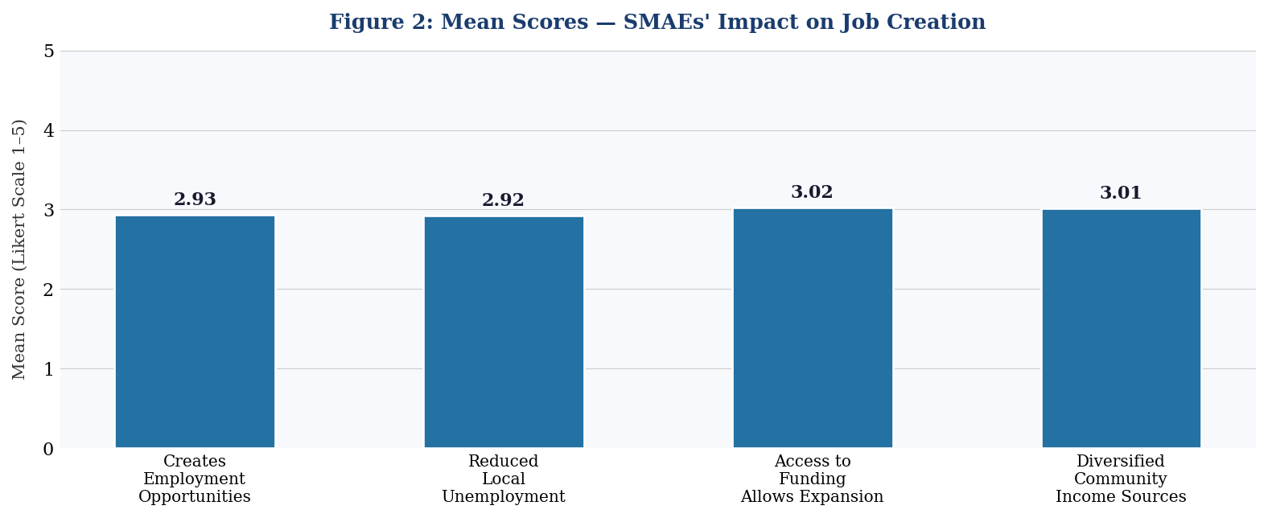
Figure 2: Mean Scores — SMAEs' Impact on Job Creation and Employment Dimensions
Mean values range from 2.92 to 3.02—slightly lower than the welfare dimension means—suggesting that respondents perceive SMAEs' employment generation performance as marginally weaker than their household welfare contributions, albeit only narrowly. 'Access to funding allows business expansion' records the highest mean (3.02; SD = 1.40; CV = 0.46), affirming—consistent with the Resource-Based View—that respondents identify financial access as the single most important enabling lever for SMAE-driven employment growth. 'Reduced local unemployment' records both the lowest mean (2.92) and the highest coefficient of variation (CV = 0.50) of any dimension in the study, indicating simultaneously the weakest average perceived performance and the greatest dispersion of opinion: some households may have experienced modest unemployment relief through SMAE employment opportunities, while others have observed no change. This polarisation is consistent with the literature's documentation of SMAEs' preference for family labour over community-wide employment creation (Akugri et al., 2015).
4.3 Challenges Facing SMAEs in Kariji
Table 3 presents descriptive statistics for respondents' assessments of five constraints on SMAE operations in Kariji. Figure 3 provides graphical comparison of mean challenge severity scores.
Table 3: Descriptive Statistics — Challenges Constraining SMAEs in Kariji (n = 348)
Challenge | Mean | Std. Dev. | Variance | CV | Range
Lack of funding is a significant obstacle | 3.05 | 1.48 | 2.19 | 0.49 | 1–5
Inadequate infrastructure limits growth | 3.05 | 1.40 | 1.96 | 0.46 | 1–5
Limited market access is a major challenge | 3.01 | 1.47 | 2.16 | 0.49 | 1–5
Unfavourable regulatory policies impact SMEs | 3.09 | 1.44 | 2.07 | 0.47 | 1–5
Lack of skilled labour affects productivity | 2.89 | 1.44 | 2.07 | 0.50 | 1–5
Source: Authors' Field Survey and Computation, 2025
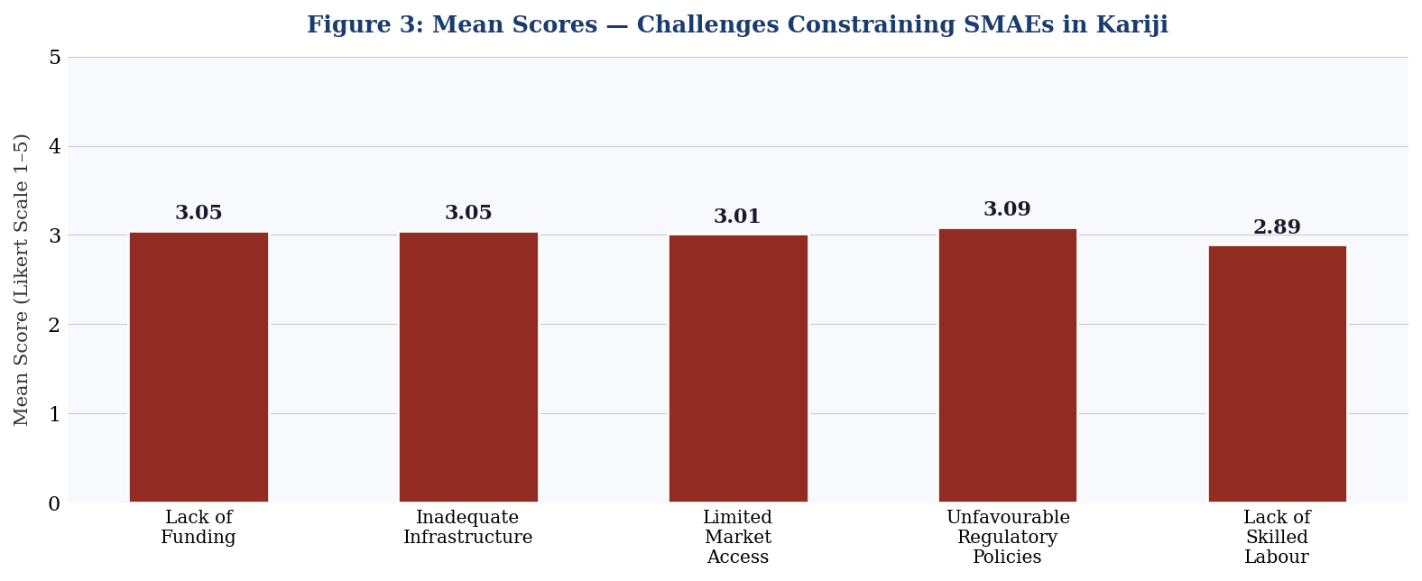
Figure 3: Mean Scores — Challenges Constraining SMAEs in Kariji
'Unfavourable regulatory policies impact SMEs' records the highest mean (3.09; SD = 1.44; CV = 0.47), identifying regulatory burden as the most widely acknowledged operational constraint in Kariji—aligning with Ojong, Arikpo, and Ogar (2015), who found multiple taxation and inadequate government policy frameworks to be significant impediments to SME growth in rural Nigeria. 'Lack of funding' and 'Inadequate infrastructure' are jointly ranked second (mean = 3.05 each), reflecting the compounding nature of the financial and physical capital constraints that the Resource-Based View identifies as primary growth inhibitors. 'Limited market access' (mean = 3.01; SD = 1.47; variance = 2.16) confirms that poor integration of rural agricultural producers into broader commodity markets remains a persistent structural failure. 'Lack of skilled labour affects productivity' records the lowest mean (2.89) but the highest coefficient of variation (CV = 0.50), suggesting that while labour quality is a broadly recognised concern, its severity varies considerably across the diverse livestock and agro-processing activities represented within the SMAE sector in Kariji.
4.4 Hypothesis Testing
4.4.1 Hypothesis 1: Impact of SMAEs on Household Welfare
H₁₀: SMEs in the agricultural sector have no significant impact on household welfare in Kariji, Southern Kaduna.
Table 4 presents chi-square results for all six household welfare dimensions. Figure 4 visually compares computed χ² values against the critical threshold of 9.488 (df = 4; α = 0.05).
Table 4: Chi-Square Test Results — SMAEs' Impact on Household Welfare (df = 4; α = 0.05; χ²-critical = 9.488)
Household Welfare Dimension | χ² Value | p-value | df | Statistical Decision
Income contributes to financial well-being | 2.12 | 0.7137 | 4 | Fail to Reject H₁₀
Improved standard of living | 0.76 | 0.9440 | 4 | Fail to Reject H₁₀
Reduced reliance on external support | 1.79 | 0.7738 | 4 | Fail to Reject H₁₀
Access to better healthcare | 0.90 | 0.9245 | 4 | Fail to Reject H₁₀
Ensured food security | 0.44 | 0.9789 | 4 | Fail to Reject H₁₀
Covered education costs | 0.82 | 0.9358 | 4 | Fail to Reject H₁₀
Source: Authors' SPSS Computation, 2025
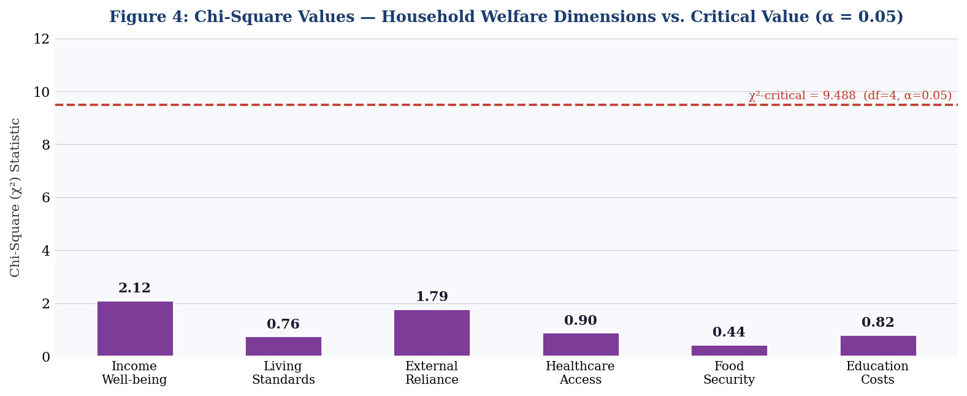
Figure 4: Chi-Square Values — Household Welfare Dimensions vs. χ²-Critical Value (df = 4, α = 0.05)
Chi-square analysis reveals that none of the six household welfare dimensions produces a statistically significant result. All computed χ² values fall substantially below the critical value of 9.488, and all corresponding p-values far exceed the 0.05 significance threshold (range: p = 0.7137 to p = 0.9789). The largest chi-square value (χ² = 2.12; p = 0.7137) corresponds to 'Income contributes to financial well-being'—the dimension with the greatest potential to manifest SMAE income effects—yet even this dimension provides no statistical evidence of a significant impact. The smallest chi-square value (χ² = 0.44; p = 0.9789) corresponds to 'Ensured food security', indicating that observed response distributions on this dimension are almost perfectly aligned with expected distributions under the null hypothesis of no SMAE impact.
These results lead to a consistent statistical conclusion: observed frequencies across all welfare dimension response categories do not deviate significantly from the expected frequencies under the null hypothesis. The null hypothesis H₁₀—that SMEs in the agricultural sector have no significant impact on household welfare—is therefore retained across all six dimensions at the 5% level of significance.
Decision: We fail to reject H₁₀. There is no statistically significant impact of SMEs in the agricultural sector on household welfare in Kariji, Southern Kaduna, Nigeria (all p > 0.05).
4.4.2 Hypothesis 2: Impact of SMAEs on Job Creation
H₂₀: SMEs in the agricultural sector have no significant impact on job creation in Nigeria.
Table 5 presents chi-square results for all four employment dimensions. Figure 5 visualises computed χ² values against the critical threshold.
Table 5: Chi-Square Test Results — SMAEs' Impact on Job Creation (df = 4; α = 0.05; χ²-critical = 9.488)
Employment Dimension | χ² Value | p-value | df | Statistical Decision
Creates employment opportunities | 2.04 | 0.7293 | 4 | Fail to Reject H₂₀
Reduced local unemployment | 1.45 | 0.8363 | 4 | Fail to Reject H₂₀
Access to funding allows business expansion | 1.84 | 0.7656 | 4 | Fail to Reject H₂₀
Diversified income sources in the community | 0.63 | 0.9593 | 4 | Fail to Reject H₂₀
Source: Authors' SPSS Computation, 2025
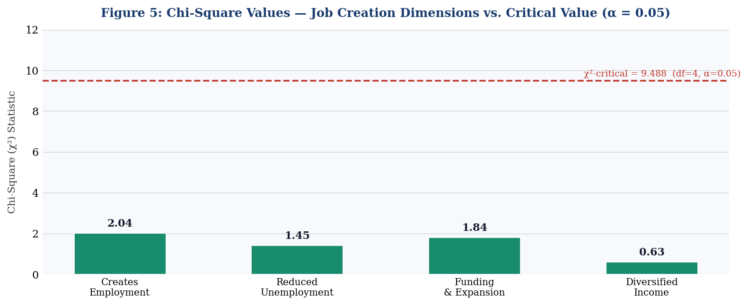
Figure 5: Chi-Square Values — Job Creation Dimensions vs. χ²-Critical Value (df = 4, α = 0.05)
Chi-square results for all four employment dimensions are equally devoid of statistical significance. All p-values substantially exceed 0.05 (range: p = 0.7293 to p = 0.9593), and all χ² values fall far below the critical threshold of 9.488. 'Diversified income sources in the community' records the lowest chi-square value (χ² = 0.63; p = 0.9593)—indicating the most complete alignment between observed and expected response distributions—while 'Creates employment opportunities' records the highest (χ² = 2.04; p = 0.7293). Notwithstanding this variation, no dimension approaches statistical significance. Observed response distributions align closely with expected distributions under the null hypothesis of no SMAE job creation impact.
Decision: We fail to reject H₂₀. There is no statistically significant impact of SMEs in the agricultural sector on job creation in Nigeria at the 5% level of significance (all p > 0.05).
5. Discussion of Findings
The statistical findings of this study that, SMAEs produce no statistically significant impact on household welfare or job creation in Kariji are simultaneously striking and, upon reflection, entirely consistent with the weight of contextually relevant empirical literature. Three interpretive layers warrant careful unpacking: the disconnect between moderate descriptive perceptions and inferential insignificance; the structural mechanisms that explain this disconnect; and the qualitative dimensions of SMAE contributions that remain invisible to chi-square inference.
The moderate descriptive means observed across welfare (2.99–3.14) and employment (2.92–3.02) dimensions indicate that respondents do perceive SMAEs as contributing positively however modestly to household economic life. This perception is real and should not be dismissed. What the chi-square analysis reveals is that these perceived contributions are not of sufficient magnitude or consistency to produce statistically detectable distributional shifts in Likert response patterns within the survey population. This aligns with Abdulai and Emmanuel (2021), whose propensity score matching analysis found technology adoption's welfare impact to be positive but statistically insignificant a finding the authors attributed to the mediation of impact through channels (advisory services, extension outreach, input support) that are absent in structurally disadvantaged rural contexts. In Kariji, where all such mediating channels are weak or absent, a similar dynamic operates with respect to SMAE welfare impacts.
The structural mechanisms underlying this outcome are clearly identified in the challenge data: unfavourable regulatory policies (mean = 3.09), limited funding (mean = 3.05), inadequate infrastructure (mean = 3.05), limited market access (mean = 3.01), and insufficient skilled labour (mean = 2.89) collectively constitute a compounding barrier complex that prevents SMAEs from realising their welfare generation potential. These findings align precisely with the analytical framework constructed by the Resource-Based View: without adequate financial resources prevented by stringent collateral requirements and high interest rates consistent with Charan and Wasdani's (2016) correlation of r = 0.727 between collateral absence and credit rejection—SMAEs in Kariji cannot accumulate the resource base necessary to expand operations, absorb external workers, or generate distributable welfare improvements at household level. Bello et al. (2018) and Somoye (2013) reinforce this interpretation, identifying affordable credit access as the critical input that Nigerian SMEs require to translate operational activity into meaningful household welfare contributions.
The finding that 'Access to funding allows expansion' records the highest employment mean (3.02) and the lowest CV (0.46) indicating both the strongest average assessment and the greatest respondent consensus is particularly revealing. It suggests that SMAE operators in Kariji are not merely aware of their funding constraints; they have a clear and shared understanding that financial access is the binding constraint on employment growth. This is a sophisticated and accurate diagnosis that policymakers would do well to take seriously. The literature corroborates it: Ojong et al. (2015), Oyeniran et al. (2015), Kadiri (2012), and Akingunola (2011) all converge on credit access as the primary institutional enabler of Nigerian SME growth.
The absence of statistically significant job creation impacts is further explained by the structural preference for family labour that characterises smallholder agricultural enterprises globally. Akugri et al. (2015) documented precisely this pattern among Ghanaian SMEs enterprises preferring family labour to minimise input costs and the same dynamic prevails in Kariji's livestock farming community. Seasonal agricultural cycles compound this structural preference: employment demand peaks during planting and harvest seasons but contracts sharply in the dry season, creating temporal employment patterns that are not captured as sustained reductions in unemployment in cross-sectional survey instruments.
Despite the inferential null results, the qualitative significance of SMAEs in Kariji's community economic life must not be ignored. Through informal employment, local market participation, supply chain engagement, and micro-entrepreneurship enabling, SMAEs serve as foundational anchors of economic resilience for rural households that have no alternative income sources. Hussain et al. (2015) caution that the qualitative, informal contributions of SMEs to community welfare are systematically understated by quantitative evaluation frameworks. Arouri et al. (2015) and Abdulai and Emmanuel (2021) emphasise that agricultural enterprise welfare impacts frequently materialise over longer time horizons through indirect channels human capital accumulation, social network strengthening, entrepreneurial learning—that cross-sectional chi-square tests are structurally incapable of detecting. These considerations underscore the urgent need for longitudinal and mixed-methods research designs in future studies of SMAE welfare impacts in rural Nigeria.
6. Conclusion and Policy Recommendations
6.1 Summary of Findings
This study examined the impact of small and medium-scale agricultural enterprises on household welfare and job creation in Kariji, Southern Kaduna, Nigeria, using descriptive statistics and chi-square hypothesis testing on structured primary survey data from 348 respondents drawn from a registered population of 2,650 Kaduna State SMEs. The study focused on livestock farming within the SMAE spectrum and employed Social Capital Theory and the Resource-Based View as its theoretical anchors.
Descriptive findings confirm moderate positive perceptions of SMAE contributions across six household welfare dimensions (mean range: 2.99–3.14) and four employment dimensions (mean range: 2.92–3.02). The most positively assessed welfare dimension was 'Reduced reliance on external support' (mean = 3.14), while 'Access to funding allows expansion' recorded the highest employment mean (3.02) and the greatest respondent consensus (CV = 0.46). Challenge data identified unfavourable regulatory policies (mean = 3.09), inadequate funding and infrastructure (mean = 3.05 each), and limited market access (mean = 3.01) as the primary structural constraints on SMAE performance.
Inferential chi-square analysis, however, yields no statistically significant impact on any welfare or employment dimension. All ten chi-square values fall substantially below the critical threshold of 9.488 (df = 4; α = 0.05), and all p-values far exceed 0.05 ranging from p = 0.7137 to p = 0.9789 for welfare dimensions and p = 0.7293 to p = 0.9593 for employment dimensions. Both null hypotheses are accordingly retained.
6.2 Conclusion
The principal conclusion of this study is that the structural barriers constraining SMAEs in Kariji regulatory burden, financial exclusion, infrastructure deficits, market isolation, and human capital constraints collectively prevent agricultural enterprises from translating their latent developmental potential into statistically measurable improvements in household welfare and employment. This is not evidence that SMAEs are irrelevant to household welfare; it is evidence that SMAEs operating under severe structural disadvantage cannot generate the scale of impact required to produce statistically detectable welfare improvements in community-level survey analyses. The gap between the developmental potential of SMAEs and their measured welfare output is not a market failure it is a policy failure. Addressing the identified structural barriers through targeted, community-sensitive interventions is therefore the most urgent priority for stakeholders committed to inclusive rural development in Southern Kaduna.
6.3 Policy Recommendations
Based on the foregoing findings, the following recommendations are advanced:
(i) Expanded Agricultural Microfinance: Financial institutions and government agencies through SMEDAN and BOI regional offices should design and deploy microcredit products tailored to rural agricultural SMEs, featuring low interest rates (not exceeding single-digit per annum), reduced or alternative collateral requirements (including group guarantees and crop insurance instruments), and seasonal repayment schedules aligned with agricultural cash flows. The Village Banking cooperative financing model identified by Charan and Wasdani (2016) merits active piloting in Southern Kaduna communities.
(ii) Priority Rural Infrastructure Investment: Federal and Kaduna State governments should designate Southern Kaduna agricultural communities including Kariji as Priority Rural Infrastructure Zones, committing to time-bound investments in all-season road networks, reliable electricity supply, and post-harvest storage facilities. Public-private partnerships should be actively mobilised to accelerate delivery, with outcomes linked to community-level SME welfare indicators.
(iii) Entrepreneurial Capacity Building: Structured capacity-building programmes covering financial literacy, agribusiness management, livestock productivity, post-harvest technology, and digital market tools should be implemented through partnerships between NDA's Faculty of Management Sciences, Kaduna State's agricultural extension system, and relevant NGOs. Agricultural extension officers should be retrained to provide integrated business advisory and agronomic support.
(iv) Regulatory Simplification and Tax Reform: The Kaduna State government should implement a single-window regulatory interface for agricultural SMEs, eliminating multiple taxation, streamlining business registration, and providing targeted tax holidays for first-generation agricultural enterprises in rural communities. The cost of regulatory compliance—documented as the leading perceived challenge (mean = 3.09) must be systematically reduced.
(v) Technology Adoption Facilitation: Government and private sector actors should develop and deploy affordable agricultural technology packages including post-harvest processing equipment, digital livestock management tools, and e-commerce platforms for Kariji's SMAE operators. Technology adoption should be sequenced to match the absorptive capacity and financial resources of target enterprises.
(vi) Cooperative Market Infrastructure: Community cooperative societies and producer associations should be promoted and supported technically and logistically to enable SMAEs to achieve economies of scale, negotiate collectively with buyers, access regional commodity markets, and pool resources for shared infrastructure investments. Government agencies and community leaders should actively facilitate cooperative formation in Kariji.
6.4 Contribution to Knowledge
This study makes four distinct contributions to the literature. First, it provides the first systematic empirical investigation of SMAE welfare impacts at community level in Kariji, Southern Kaduna—a region absent from the academic literature despite its agricultural significance. Second, it demonstrates, through chi-square inference, that moderate positive perceptions of SMAE contributions can coexist with an absence of statistically detectable welfare impacts—a methodological insight with important implications for how SMAE impact is evaluated and communicated to policymakers. Third, it advances a dual theoretical framework—integrating Social Capital Theory and the Resource-Based View—that provides a more comprehensive explanatory architecture for SMAE welfare dynamics than either theory provides in isolation. Fourth, it documents the challenge profile of SMAEs in rural Southern Kaduna with sufficient granularity to serve as a baseline for future longitudinal and comparative studies.
6.5 Directions for Future Research
Future research should adopt longitudinal designs to track SMAE welfare impacts over multiple agricultural seasons, enabling detection of cumulative effects invisible to cross-sectional analysis. Mixed-methods approaches—integrating in-depth interviews, focus group discussions, and participatory rural appraisals with quantitative surveys—would illuminate the qualitative welfare mechanisms that chi-square tests cannot capture. Comparative studies across rural communities in Kaduna State and other Northern Nigerian states would identify the contextual factors that enable or constrain SMAE welfare contributions. Research examining the distinct roles of women and youth in Kariji's SMAE ecosystem would generate evidence critical for inclusive development policy design. Larger sample sizes and multivariate regression frameworks would improve statistical power and enable disaggregation of welfare impacts by enterprise age, type, scale, and financing status.

References
Abdulai, A., & Jumpah, E. T. (2021). Impact of technology adoption on smallholder farmers' welfare. Agricultural Economics, 52(3), 45–58.
Abor, J., & Quartey, P. (2010). Issues in SME development in Ghana and South Africa. International Research Journal of Finance and Economics, 39, 218–228.
Abubakar, S. (2013). Strengthening small and medium enterprises (SMEs) as a strategy for poverty reduction in North Western Nigeria. Journal of Business and Management, 8(2), 1–12.
Adebiyi, M. A. (2004). Small and medium enterprises financing and economic growth in Nigeria. European Journal of Business and Management, 4(16), 1–8.
Adewumi, M. O. (2008). Agriculture and rural development in Nigeria. Ibadan: University Press.
Afolabi, M. O. (2013). Growth effect of small and medium enterprises (SMEs) financing in Nigeria. Journal of African Macroeconomic Review, 3(1), 193–205.
Agupusi, P. (2007). Small business development and poverty alleviation in Alexandra, South Africa. Second Meeting of the Society for International Development, 1–14.
Akugri, M. S., Bagah, D. A., & Wulifan, J. K. (2015). The contributions of small and medium enterprises to economic growth and development in Ghana. European Journal of Business and Management, 7(3), 1–15.
Akingunola, R. O. (2011). Small and medium scale enterprises and economic growth in Nigeria: An assessment of financing options. Pakistan Journal of Business and Economic Review, 2(1), 78–97.
Anugwa, I. Q., & Agwu, A. E. (2019). Perceived reasons of household food insecurity in rural Kano, Nigeria. Journal of Agricultural Extension, 23(4), 45–57.
Anthony, E., & Arthur, S. (2008). Micro, small, and medium enterprises and per capita income growth in the United States. Journal of Economics and Finance, 10(2), 34–47.
Arouri, M., Ben Youssef, A., & Nguyen, C. (2015). Does urbanization reduce rural poverty? Evidence from Vietnam. Economic Modelling, 60, 253–270.
Asmah, E. E., & Avenue, U. (2011). Rural livelihood diversification and agricultural household welfare in Ghana. Journal of Development and Agricultural Economics, 3(7), 325–334.
Audretsch, D. B. (2002). The dynamic role of small firms: Evidence from the US. Small Business Economics, 18(1), 13–40.
Audretsch, D. B., & Keilbach, M. (2005). Entrepreneurship capital and regional growth. Annals of Regional Science, 39(3), 457–469.
Ayodeji, A., & Ajala, O. (2017). Micro-financing and rural poverty reduction in Nigeria (2000–2016). Journal of Poverty, Investment and Development, 33, 1–12.
Babbie, E. (2005). The practice of social research (10th ed.). Belmont, CA: Wadsworth.
Basil, A. N. O. (2005). Small and medium enterprises (SMEs) in Nigeria: Problems and prospects (Doctoral dissertation). St. Clements University.
Bayode, O., Olagunju, F. I., Onikoyi, I. A., Oginni, O. A., & Kazeem, A. O. (2021). Impact of agro-allied small and medium scale business on economic growth of Nigeria: 1976–2020. International Journal of Research in Business and Social Science, 10(4), 1–14.
Beck, T., Demirgüç-Kunt, A., & Maksimovic, V. (2002). Financial and legal constraints to growth: Does firm size matter? World Bank Policy Research Working Paper No. 2784.
Bello, M. B., Jibir, A., & Ahmed, I. (2018). Impact of small and medium scale enterprises on economic growth: Evidence from Nigeria. Global Journal of Economics and Finance, 2(1), 26–34.
Bourdieu, P., & Wacquant, L. J. D. (1992). An invitation to reflexive sociology. Chicago: University of Chicago Press.
Brinckmann, J., Grichnik, D., & Kapsa, D. (2011). Should entrepreneurs plan or just storm the castle? Journal of Business Venturing, 25(1), 24–40.
Byrd, W., & Zhuang, J. (2013). Rural enterprise finance in China. Washington, DC: World Bank.
Charan, P. L., & Wasdani, K. P. (2016). Factors affecting SME access to finance in Lusaka. International Journal of Entrepreneurship and Small Business, 28(4), 451–467.
Chong, W. Y. (2012). Critical success factors for small and medium enterprises: Perceptions of entrepreneurs in urban Malaysia. Journal of Business and Policy Research, 7(4), 204–215.
Coleman, J., Giesler, R., & Heath, T. (2013). Social capital, trust, and SME performance. Business Review, 4(2), 19–34.
Dada, R. M. (2014). Commercial bank credit and development of SMEs in Nigeria (1992–2011). Developing Country Studies, 4(14), 47–55.
Davidsson, P., & Honig, B. (2003). The role of social and human capital among nascent entrepreneurs. Journal of Business Venturing, 18(3), 301–331.
Degravel, D. (2012). Toward a resource-based view reconciliation of SME strategy. Journal of Management Policy and Practice, 13(5), 11–27.
Dollinger, M. J. (2003). Entrepreneurship: Strategies and resources (3rd ed.). Upper Saddle River, NJ: Prentice Hall.
Eliot, J., et al. (2022). Agribusiness development and its societal impacts. London: Routledge.
EuroStat (2019). SME statistics for Europe. Luxembourg: European Commission.
FMARD (2001). Agricultural policy for Nigeria. Abuja: Federal Ministry of Agriculture and Rural Development.
Gill, A., & Biger, N. (2012). Barriers to small business growth in Canada. Journal of Small Business and Enterprise Development, 19(4), 656–668.
Hu, Y. (2010). SME sector performance and economic growth: A panel data analysis. International Journal of Economics and Finance, 2(4), 56–65.
Hussain, J., Bhuiyan, A. B., & Said, J. (2015). Micro, small and medium enterprises and their role in eradicating poverty in Malaysia. International Journal of Economics and Financial Issues, 5(Special Issue), 103–109.
Imoughele, L. E., & Ismaila, M. (2013). Commercial bank credit accessibility and sectoral output growth in Nigeria. Journal of Finance and Bank Management, 1(2), 36–59.
John-Akamelu, R. C., & Muogbo, U. S. (2018). Assessing the contribution of SMEs in poverty eradication in Nigeria. International Journal of Academic Research in Business and Social Sciences, 8(4), 174–187.
Kadiri, I. B. (2012). Small and medium scale enterprises and employment generation in Nigeria. Kuwait Chapter of Arabian Journal of Business and Management Review, 1(9), 79–93.
Kanitkar, A. (1994). Entrepreneurs and micro-enterprises in rural India. Economic and Political Weekly, 29(9), M13–M23.
Kasekende, L., & Opondo, H. (2003). Financing small and medium-scale enterprises: Uganda's experience. Africa Journal of Business and Economic Research, 2(1), 56–69.
Knack, S., & Keefer, P. (1997). Does social capital have an economic payoff? Quarterly Journal of Economics, 112(4), 1251–1288.
Kongolo, M. (2010). Job creation versus job shedding and the role of SMEs. African Journal of Business Management, 4(11), 2288–2295.
Leegwater, A., & Shaw, A. (2008). The role of micro, small, and medium enterprises in economic growth. USAID Micro Report No. 135.
Lin, N. (1999). Building a network theory of social capital. Connections, 22(1), 28–51.
Myslimi, G., & Kaçani, J. (2016). Impact of SMEs in economic growth in Albania. European Journal of Sustainable Development, 5(3), 151–162.
Nofsinger, J. R., & Weicheng, W. (2011). Determinants of start-up firm external financing worldwide. Journal of Banking and Finance, 35(9), 2282–2294.
Ogujiuba, K. K., Ohuche, F. K., & Adenuga, A. O. (2004). Credit availability to small and medium scale enterprises in Nigeria. AIAE Research Paper.
Ojiya, E. A., Andohol, J., & Doki, N. O. (2021). Post-harvest losses and welfare of yam producers in Benue State. Asian Journal of Agricultural Extension, Economics and Sociology, 39(3), 1–12.
Ojong, C. M., Arikpo, O. F., & Ogar, A. (2015). The role of deposit money banks on the growth of SMEs in Cross River State, Nigeria. IOSR Journal of Humanities and Social Science, 20(4), 37–52.
Olarinde, O. S., et al. (2020). Effects of social capital on food security: Evidence from cassava farming households in Nigeria. Journal of Agriculture and Food Security, 9(1), 1–13.
Onakoya, A. B., Fasanya, I. O., & Abdulrahman, H. D. (2013). Small and medium scale enterprises financing and economic growth in Nigeria. European Journal of Business and Management, 5(4), 130–136.
Oregu, J., & Chima, P. (2013). Small scale enterprises and poverty reduction in Nigeria (2001–2011). International Journal of Business and Social Science, 4(8), 178–185.
Oyeniran, I. W., David, O. O., & Ajayi, O. A. (2015). SMEs and economic growth for Nigeria: An ARDL approach. Research Journal of Economics and Business Studies, 4(5), 1–15.
Pakistan Bureau of Statistics (2011). Census of small and medium enterprises. Islamabad: PBS.
Peterise, N. (2003). SMEs in the Nigerian economy. Lagos: University of Lagos Press.
Quillian, L., & Redd, R. (2006). The friendship networks of multiracial adolescents. Social Science Research, 35(2), 526–551.
Saleh, A. S., & Mustafa, N. A. (2018). Food security and productivity among urban farmers in Kaduna State, Nigeria. Journal of Agricultural Research, 4(2), 34–45.
Schmid, A. A., & Robison, L. J. (1995). Applications of social capital theory. Journal of Agricultural and Applied Economics, 27(1), 59–66.
Setboonsarng, S. (2006). Millennium development goals and agricultural development in Asia. ADBI Policy Paper.
Somoye, R. O. C. (2013). The impact of finance on entrepreneurship growth in Nigeria. ACRN Journal of Entrepreneurship Perspectives, 2(2), 21–45.
Sowah, N. K. (2003). Financial sector development and economic growth in Africa. IMF Working Paper.
Stacey, R. (2011). Strategic management and organisational dynamics (6th ed.). London: Prentice Hall.
Statista (2017). SME employment statistics for the European Union. Hamburg: Statista Research Department.
Stephen, B., Denis, O., Irene, A., & Venancio, T. (2014). Commercial bank lending terms and SME access to formal credit in Uganda. Journal of Developmental Entrepreneurship, 19(1), 1–21.
Tersoo, P. (2013). National poverty eradication programme and wealth creation in Benue State. International Journal of Humanities and Social Science, 3(16), 147–153.
Ucbasaran, D., Shepherd, D. A., Lockett, A., & Lyon, S. J. (2013). Life after business failure. Journal of Management, 39(1), 163–202.
Ulhoi, J. P. (2004). The social dimensions of entrepreneurship. Technovation, 25(8), 939–946.
UNIDO (2017). SME competitiveness outlook 2017. Vienna: United Nations Industrial Development Organization.
Unnikrishnan, V., & Imai, K. S. (2020). Does the old-age pension scheme improve household welfare? World Development, 134, 105012.
Van Stel, A., Wennekers, S., Thurik, R., & Reynolds, P. (2004). Explaining nascent entrepreneurship across countries. SCALES Research Reports H200401.
Wahab, S. A., & Ijaiya, G. T. (2006). Small and medium scale enterprises and poverty reduction in Nigeria. International Journal of Business Management, 1(1), 1–8.
Yallapragada, R. R., & Buoyant, M. (2011). Small business management and financing. Journal of Applied Business Research, 27(4), 9–14.
Yamane, T. (1967). Statistics: An introductory analysis (2nd ed.). New York: Harper & Row.

