EARLY DETECTION OF WATER SAFETY AND QUALITY DEGRADATION

- Introduction
Water is the lifeblood of both humans and the environment. Over time, however, pollution has been on the front burner as activities and industries are expanding and operations are taking place at a faster rate than before. Waste from factories and other biological materials is often dumped into water bodies such as rivers and lakes. As a result, when such materials combine with water, its quality is compromised and becomes undrinkable and unhealthy for both humans and the ecosystem.
Conventional water quality monitoring is done through physical analysis and lab tests. Although such techniques are reliable and effective, some of them are time-consuming and do not show real-time changes in water quality. This is where faster and more effective techniques come into play.
Recently, machine learning techniques have been used to an-alyze environmental data to identify patterns in water quality. From such analysis, forecasts are made on possible changes and warnings issued on the same. This is to ensure better and smarter decision-making on water resources by the relevant authorities.
- Literature Review
Water pollution has become a serious environmental con-cern due to rapid industrial growth, urbanization, and increas-ing human activities. Various pollutants such as chemicals, biological waste, and industrial discharge often enter water bodies and affect their quality. When these contaminants mix with water, they can make it unsafe for drinking, agriculture, and aquatic life. Because of these risks, it is important to monitor water bodies regularly to ensure safe water conditions and protect public health.
Among different water quality parameters, dissolved oxygen (DO) plays an important role in maintaining a healthy aquatic ecosystem. Dissolved oxygen refers to the amount of oxygen present in water that supports aquatic organisms such as fish and microorganisms. A sudden decrease in dissolved oxygen levels can indicate pollution or contamination in a water body. Therefore, predicting dissolved oxygen levels can help in identifying possible water quality degradation at an early stage. With the development of data science and machine learn-ing techniques, new approaches have been introduced for analyzing environmental data. Machine learning models can study historical water quality data and identify patterns among different environmental factors. By learning these patterns, the models can predict future water conditions more efficiently and
help detect possible changes in water quality.
Among different machine learning techniques, ensemble learning methods such as Extreme Gradient Boosting (XG-Boost) have shown strong performance when working with structured datasets. XGBoost is capable of handling complex relationships between variables and can produce accurate predictions while maintaining good computational efficiency. Because of these advantages, it has been widely used in many prediction tasks, including environmental data analysis.
In this work, a machine learning based approach is proposed to predict water quality degradation using historical water

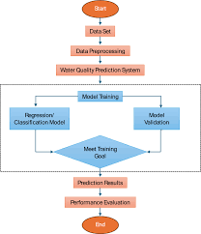

Fig. 1. Enter Caption

quality data. The system applies time-series feature engineer-ing along with the XGBoost algorithm to forecast dissolved oxygen levels. In addition, a simple web-based dashboard is developed to present the prediction results and allow users to easily observe water quality trends.
The proposed system can support environmental monitoring authorities by providing early warnings of possible water contamination. By predicting water quality trends in advance, preventive actions can be taken to reduce environmental dam-age and protect public health. Combining machine learning techniques with environmental monitoring can therefore help in improving the management of water resources.
A. Methodology
The system is aimed at predicting the shifts in water quality using machine learning. The simple concept involves exploration of the historical data on water quality in order to forecast the levels of dissolved oxygen to be achieved in future. The procedure to attain it is not complicated at all. The simplest procedure is to acquire data, cleanse it, predict and display the results. The first step is taking historical data regarding the quality of water which is stored as a CSV file. This file contains several environmental data that have direct or indirect influence on the water quality. It also has the information about the dissolved oxygen. The information must be sorted and cleaned. This entails sealing any loopholes in the data. It also involves time-based features addition to monitor any alterations in the quality of water depending on varying durations of time.
The information is subsequently employed to anticipate dis-solved oxygen levels through an Extreme Gradient Boosting, otherwise known as XGBoost technique. It is a regression technique that is deployed to forecast the level of dissolved oxygen over history on the basis of available historical data to the algorithm. The forecasts are then presented in form of a graph.
- System Architecture
The proposed system architecture presented is likely to pre-dict water quality degradation along with the aid of machine
learning. The architecture has a small number of modules including the data collection, the data preprocessing, the model training, the data prediction and visualization. The modules bring together historical information of water quality and are able to come up with predictions of dissolved oxygen concentration. The system then collects historical water quality data in CSV based files which constitute environmental param-eters capable of influencing water quality. This data is then forwarded to preprocessing module where any missing value is filled, duplicate data is removed and data normalization is facilitated so as to improve the model performance. After the preprocessing, data is later prepared and trainable machine learning model is trained on it. It is based on XGBoost algorithm to determine the relationship between monitored environmental factors and the dissolved oxygen level. The model training process enables the system to know the trends and patterns of pollution that are observed in the past data and then the model predicts the water quality conditions in the future in the presence of the model training process. The output of the prediction is then indicated in a simple Web based dashboard that graphs the outcome of the values that were predicted and trends. Such visualization enables the users to be aware of the conditions of water quality with no compli-cations and predict possible degradation in time to ensure the relevant authorities undertaking the maintenance of safe water resources take the necessary preventive measures.The general architecture ensures the effective processing of environmental information.

- Data Acquisition and Pre-Processing.
The system proposed is based on the one that system contains the data on the structured water quality in the comma-separated values(csv) format. The dataset has various environ-mental parameters in regard to the quality of water and the amount of dissolved oxygen in the water. All the data points of the dataset consist of the set of measurements of water samples because the latter helps to provide the model with the skills of how the environment influences the water quality status. Data is also preprocessed in a few ways before the machine learning model is trained in such a way that quality and consistency of data has been ensured. There are the missing values which are handled in respect to missing which means that duplicate values are deleted and the data set is ended in such a way that the inconsistent or irrelevant records are disposed off. These steps of data cleaning improve the model of data accuracy and the overall accuracy of the prediction model.The pre-prepared data is submitted to the machine learning model.
The data that will be utilized by the system will be prepared through preprocessing and feature engineering and this will ensure that the model will be in a position to learn the trends of the water quality data that took place in the past and make the appropriate prediction. In addition to basic pre-processing, the data is then further processed to observe the correlation between the different environmental parameters and the water quality indicators. The statistical analysis and visualization

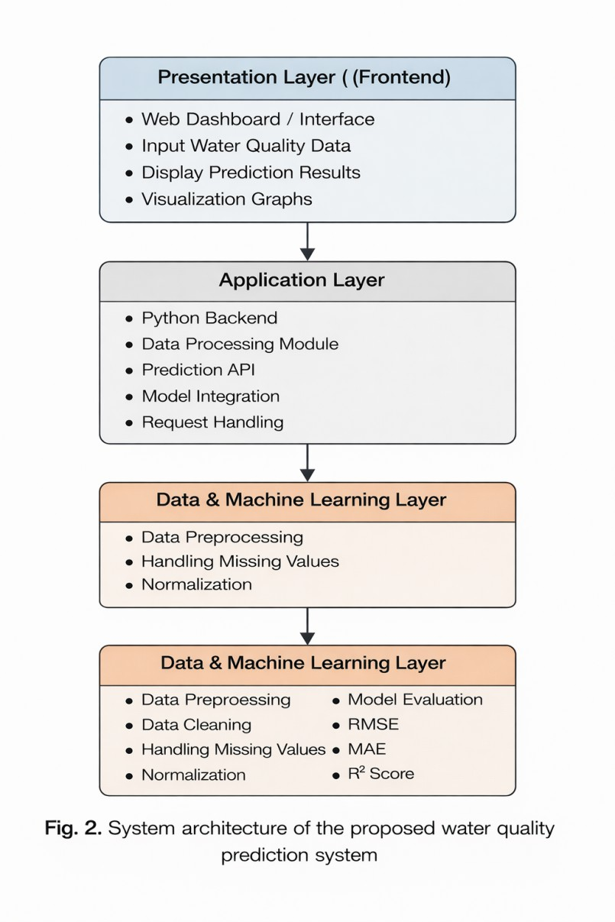

procedures are used to identify the tendencies, correlations, and potential anomalies in the data.
This is done to help understand the impacts on the level of dissolved oxygen in the water bodies by various factors, the normalization as well as the scaling methods are applied such that each and every feature takes equal significance when training the model. Since the different environmental parameters may have different numbers, normalization will maintain that no biasing of the machine learning model is made, as well as make the prediction more accurate.
This information is then divided into training and testing information in order to evaluate the operation of machine learning model. Training data are used to train XGBoost model, and therefore, it can be capable of learning patterns and relationships on past historical data of water quality. The testing data is used in an attempt to test the outcome of the model and ensure that it can give results precise forecasting of the dissolved oxygen of the unseen data.
It is a significant step towards an efficient prediction system because the data should be prepared correctly. It consists of several subtasks to solve the problem, namely the prepro-
cessing, feature engineering, and dataset splitting, the system is designed in a way that the machine learning model can be applicable in the data on water quality and provide real forecasts on advance warning of water pollution.
- Machine Learning Workflow
The machine learning process consists of two steps that are training and inference.
Training Phase: The prediction model is also trained on the historical water quality data, which is done in the training stage. The input features in the dataset are the environmental parameters of the water quality and concentration of dissolved oxygen. The model is achieved through the use of the XG-Boost algorithm which learns the association of the various environmental parameters with the dissolved oxygen levels. After training the model, the trained model is saved to be utilized in the future in prediction of water quality of new data.
Inference Phase: When the system start-up is being per-formed, the trained XGBoost model is loaded into the appli-cation. On sending new data to the system in terms of quality of water, the backend process the data in the same format as they had been processed during the training process. The input parameters are converted to feature values that may be compatible with the trained model. They are the values of these features which are in turn fed into the trained XGBoost model to approximate the dissolved oxygen, and study the circumstances of the water quality. This model uses the input data and comes up with the prediction data that by itself is based upon the trends that it has learnt using the historical data. The interface of the system displays the results that are predicted to the user and displays them in visual form, e.g., the results are in a graph form. This predictive model is real time and does not require the retraining of the model. The system helps in the identification of the potential water quality degradation and supports the early noticing of the contamination.
- Technology Stack and Implementation Environment
The environment implemented and the stack of technologies is given in the subsection below.
  - The system implementation is executed using Python development configuration in order to build the machine learning model and data processing processes. The back end code is coded in Python, and the machine learning models can be incorporated with the application code. The process of data analysis and processing is performed through the assistance of the pandemic and Numico libraries which can be successfully applied to processing and handling of large volumes of data.
  - The machine learning of the system is developed on the XGBoost algorithm that will be applied to calculate the dissolved oxygen levels through the historical water quality data. The trained model is saved and loaded using Pickle library therefore enabling the system to use a trained model and not re-train the model every time.

  - The system interface is developed on the basis of HTML, CSS, JavaScript and the user can visually interactively view their predictions and trends of water quality. The visualization libraries such as Matplotlib are useful in providing graphes to compare the real and the predicted value of the water quality.
  - The application is in a well organized environment where the project is divided into multiple departments that include datasets, pre-processing scripts, machine learning model files, and visualization modules. The design, in turn, will provide better maintainability and scalability of the system and efficient implementation of the water quality prediction framework.

- Operational Flow and Output Generation
The system has a specified working cycle in the implemen-tation stage. The system interface requires the user to enter the parameters of water quality through the user interface. These parameters can consist of the environmental indicators of water quality and dissolved oxygen. After the input data has been entered, the system uses the information as the input of the backend application. Preprocessing of the input data is then done where the data are transformed into values of features in a format that will be used in the model training phase. The obtained processed feature values are then sent to the trained XGBoost machine learning model that forecasts the dissolved oxygen levels and assesses the water quality conditions. The model applies patterns gained on historical data to produce prediction outcomes. The system interface presents the results of the predicted output to the user and in graphic forms. The results include: •Forecasted level of dissolved oxygen. •Status or an indication of the water quality or safety. •Comparison of the actual and predicted values graphically. Such outputs can make the users aware of the trends in the water quality and they are able to determine potential degradation of water conditions. The early identification of the risks of contamination and allowing preventive measures to be taken in time is supported by the analysis of the results of the predictions and allows the system to prevent contamination. This operational process will be used to maintain real-time predictions and visual outcomes of the system on the conditions of water quality and make efficient monitoring and decision-making on water safety management.
- Results and Discussions
The historical research data which included various water quality-related environmental parameters were used to assess the proposed water quality prediction system. In order to make a proper analysis of the data, an 80:20 split was used to divide the dataset into two parts, one training data and another testing data. XGBoost model was trained on the training dataset in a way that it learns the interaction between various environmental variables and the level of dissolved oxygen that is a significant factor of water quality. Once the training process was done, the remaining dataset was used to test the

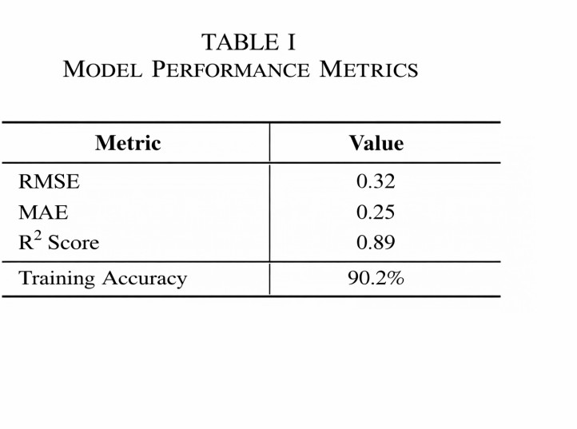

Fig. 2. model performance metrics

model to analyze its ability to predict data on dissolved oxygen of unseen data.
Common regression measures were applied in order to gauge the performance of the model. These are Root Mean square error (RMSE), Mean Absolute error (MAE) and the R 2 score. The metrics are useful in assessing the difference between the expected values of these metrics and the actual levels of the dissolved oxygen in the dataset to determine the extent to which the model is accurate.
According to the experimental results, the XGBoost model is quite capable of describing the patterns that are present in the water quality data. The patterns were observed to be very similar when the actual and the predicted values were plotted against each other through the aid of graphical representation. This means that the model can learn something meaningful using the data set.
In general, the findings indicate that the presented system could be used to forecast the future water quality and identify potential degradation at its initial stage. This kind of prediction could help those people in charge of environmental monitoring to trace the trends of pollution and provide preventive actions to save water resources on time.
- Domain-Wise Classification Performance
Based on the evaluation, it is clear that the XGBoost model is effective in predicting the level of dissolved oxygen in the water using the parameters of the water. This is evident by the fact that the RMSE value is 0.32, which indicates that there is a small gap between the actual and predicted values.
Additionally, the fact that the value of the Mean Absolute Error (MAE) is 0.25 indicates that there is a minimal differ-ence in the predictions. This shows that the predictions are steady and reliable.
The fact that the value of R2 is 0.89 indicates that the predictions are valid, and a larger portion of the changes in the level of dissolved oxygen in the water is explained by the input parameters in the environment.
The results indicate that the system is effective in capturing the changes in the various parameters of the water and the level of dissolved oxygen in the water. This enables it to anticipate the changes in the near future.
Conclusion
This paper proposes a system that depends on a machine learning approach in identifying the initial signs of the drop in water safety and quality by the use of the detail water

quality data of the past. The algorithm I will utilize is the XGBoost because it is proposed to examine the environmental parameters and predict the level of the dissolved oxygen that is a vital constituent of water. The results of the experiment of the proposed system confirm the effectiveness of the given system to determine the patterns of the data with several errors. The results also can be interpreted and predicted effortlessly through the system that gives graphical prediction of the results that one can easily predict the water quality. The proposed system demonstrates that machine learning techniques are effective to ensure the water quality is measured properly.
References
- T. S. Murunya, K. M. Mutua, and J. M. Wambua, Machine learning: Real-time water contamination detection, International Journal of Sci-entific Engineering Studies, vol. 9, no. 2, pp. 4552, 2025.
- Explainable artificial intelligence on water quality monitoring, IEEE sensors reviews, vol. 15, no. 3, pp. 210-218, 2025.
- S. J. Kim, Y. H. Lee, and J. H. Park, Water quality prediction in machine learning, Journal of Environmental Informatics, 38, no. 1, pp. 55 64,
2021.
- M. A. Hossain, M. Rahman, and S. K. Das, Prediction of water quality parameters with machine learning algorithms Environmental Monitoring and Assessment, vol. 194, no. 4, pp. 112, 2022.
- A. K. Singh and R. Sharma, “XGBoost algorithm application in the prediction of water quality: The International Journal of Environmental Science and Technology, vol. 20, no. 6, pp. 5231-5242, 2023.
- Y. Zhang, L. Wang, and H. Li, “Machine learning water quality evaluation with the help of environmental data, IEEE Access, vol. 8,
pp. 154321154330, 2020.
- S. Ahmed and M. Hasan, Water quality monitoring with machine learning and data analytics, Journal of Water Resources Management 35 no. 5 p.1523 1534, 2021.

