Digital Marketing Strategies Adopted by the FMCG Sector: A Study
Gouri Sandhya¹, Shreshta Satheesh² & Dr. Somasekharan T M ³
¹ Student (KH.AH.U3BBA23014), Department of Commerce and Management, School of Arts, Humanities and Commerce, Amrita Vishwa Vidyapeetham, Kochi, Kerala, India - 682 024. Email: kh.ah.u3bba23014@kh.students.amrita.edu
²Student (KH.AH.U3BBA23027), Department of Commerce and Management, School of Arts, Humanities and Commerce, Amrita Vishwa Vidyapeetham, Kochi, Kerala, India - 682 024. Email: kh.ah.u3bba23027@kh.students.amrita.edu
³ Assistant Professor, Department of Commerce and Management, School of Arts, Humanities and Commerce, Amrita Vishwa Vidyapeetham, Kochi, Kerala, India - 682 024. ORCID ID: 0009-0005-6359-0903: Email: somasekharan@kh.amrita.edu

Abstract

This study examines the role of digital marketing in influencing consumer behaviour within the Fast-Moving Consumer Goods (FMCG) sector. With the rapid advancement of technology and increased internet penetration, digital platforms have become a significant medium for promoting FMCG products. The purpose of this research is to understand how digital marketing strategies impact consumer awareness and purchasing decisions. The study adopts a descriptive research design, utilising both primary and secondary data. Primary data is collected through structured questionnaires from respondents, while secondary data is gathered from journals, websites, and industry reports. The findings indicate that digital marketing significantly enhances brand visibility, customer engagement, and purchase intention, particularly among younger consumers. The study contributes to existing literature by focusing specifically on the effectiveness of digital marketing in the FMCG sector and highlighting consumer perceptions. It provides valuable insights for marketers aiming to optimise digital strategies.

Keywords: Digital Marketing, FMCG, Marketing strategies, Consumer Behaviour

Introduction

In the contemporary world, digitalisation has transformed the manner in which businesses operate and connect with consumers. Digital marketing has proved to be one of the most effective tools in this regard, particularly within the realm of Fast-Moving Consumer Goods (FMCG), where stiff competition prevails, and consumer preferences evolve quickly. FMCG products tend to be relatively cheap, frequently purchased, and extensively used. In terms of marketing, conventional methods include using media such as television and newspapers, along with in-store promotions. With the advent of the internet and the popularity of mobile phones and social networking websites, the importance of digital marketing cannot be overlooked. Digital marketing encompasses a variety of aspects, which include social media marketing,

search engine optimisation, email marketing, influencer marketing, and online advertisements, among others. Digital marketing enables firms to interact with a wide array of consumers and influence them through personalised advertising techniques. The present study will examine how digital marketing influences consumer awareness and buying behaviour within the FMCG industry.

Review of Literature

Utkarsh Kumar et al. (2025) analysed the role of digital innovations such as Artificial Intelligence (AI), big data analytics, social media marketing, and e-commerce in improving consumer engagement and sales performance within the FMCG sector. The study highlighted the importance of data-driven marketing, especially in emerging economies. Although specific methodologies and sample sizes were not clearly stated, the research emphasised digital transformation as essential for sales growth. Dinesh Kumar Mishra & Dr Pramod Gupta (2024), This study examines the transformation of digital marketing strategies in the FMCG sector after COVID-19, using secondary data and industry insights. The research highlights the growing role of DTC, O2O marketing, social media, SEO, chatbots, and personalised advertising in influencing consumer buying behaviour. It emphasises increased online engagement, digital ad spending, and data-driven customer relationship building in the post-pandemic era. The study concludes that integrated digital strategies are essential for sustaining competitiveness in the evolving FMCG market. Clarita Obeid (2023)— This study employed a qualitative research methodology using semi-structured interviews with 15 FMCG industry professionals in Lebanon to examine digital marketing optimisation. No statistical tools were used; instead, thematic analysis was conducted to explore relationships between perceived ease of use, perceived usefulness, user experience, consumer engagement, and company performance. The findings reveal that user-friendly and useful digital marketing tools significantly enhance consumer engagement and overall company performance. The study concludes that optimising digital strategies is crucial for competitive advantage in Lebanon’s FMCG sector. Abhilash Babu & Dr Amit K. Srivastav, (2021) — This mixed-method study examined the impact of digital marketing on FMCG consumer behaviour using qualitative interviews and quantitative online surveys. Statistical analysis software was used to identify relationships between digital marketing exposure and purchasing behaviour. The findings show that social media marketing, personalised emails, and digital advertisements significantly influence brand loyalty and purchase decisions. The study concludes that well-planned digital strategies are essential for enhancing consumer engagement and competitiveness in the FMCG

sector. Kannan & Li (2017). Using a literature synthesis and secondary data from US marketing journals, this study explores how digital tools influence FMCG consumer decision-making without primary surveys or statistical modeling. Focused on the American market, it highlights social media campaigns and SEO as key engagement drivers but warns of data privacy risks eroding trust; findings stress the need for ethical data use to maintain long-term consumer relationships in competitive fast-moving sectors.

Objectives of the study
  - To analyse the impact of digital marketing on consumer awareness in the FMCG sector.
  - To examine the influence of digital marketing on consumer purchasing behaviour.
- Statement of the Problem
In the present digital era, FMCG companies are increasingly adopting digital marketing strategies to promote their products and influence consumer buying behaviour. However, despite the growing use of social media, online advertisements, influencer marketing, and ecommerce platforms, it remains unclear how effectively these strategies impact consumer decisions, especially in a highly competitive market. Consumers are exposed to a large volume of digital content, which may lead to varying levels of influence, trust, and engagement. In regions like Ernakulam, Kerala, where internet usage and digital adoption are high, consumers interact frequently with digital marketing efforts. However, differences in age, income, awareness, and preferences may affect how individuals respond to these strategies. While some consumers may be highly influenced by digital advertisements, reviews, and promotional offers, others may remain neutral. Therefore, the problem lies in understanding the extent to which digital marketing strategies of FMCG companies influence consumer buying behaviour and identifying the key factors that drive or limit their effectiveness. This study seeks to analyse consumer perception, awareness, and response to digital marketing strategies in the FMCG sector in Ernakulam district, thereby providing insights into how these strategies can be improved for better engagement and impact.

Research Methodology

The study is based on a descriptive research design aimed at analysing the impact of digital marketing on consumer behaviour in the FMCG sector. Both primary and secondary data have been used, where primary data was collected through structured questionnaires from respondents selected using convenience sampling, with a sample size of around 50–100 participants. Secondary data was gathered from journals, websites, and industry reports to support the study. The collected data was analysed using simple statistical tools such as percentage analysis, tables, and basic comparison methods to interpret consumer awareness and purchasing behaviour influenced by digital marketing. The methodology ensures a systematic and objective approach to the study. It also helps in drawing meaningful and reliable conclusions based on the data collected.

Results and Discussions

TYPE OF PRODUCTS PURCHASED ONLINE

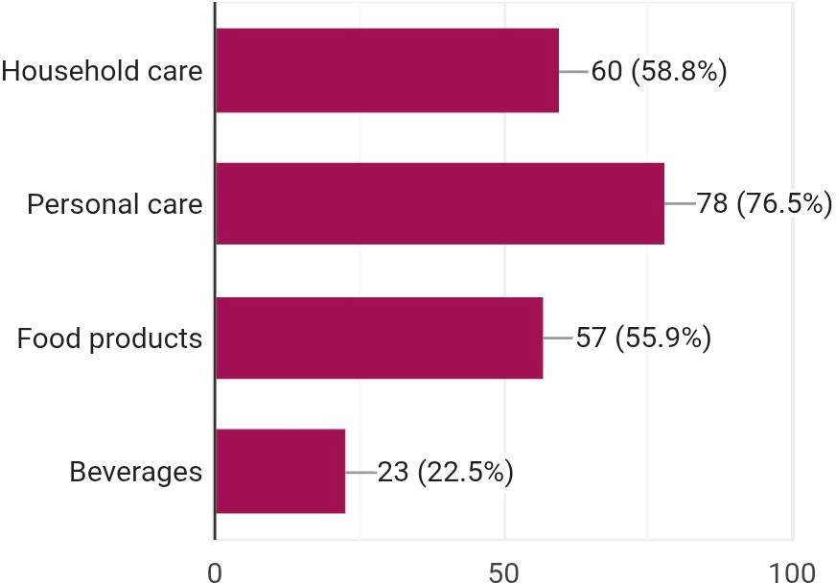

Fig no 5.1

The data shows that personal care products (76.5%) are the most commonly purchased online. Household care (58.8%) and food products (55.9%) also have high demand. Beverages (22.5%) are the least purchased category. Overall, essential and daily-use products dominate online purchases.

INFLUENCE OF DIGITAL ADVERTISING ON PURCHASING

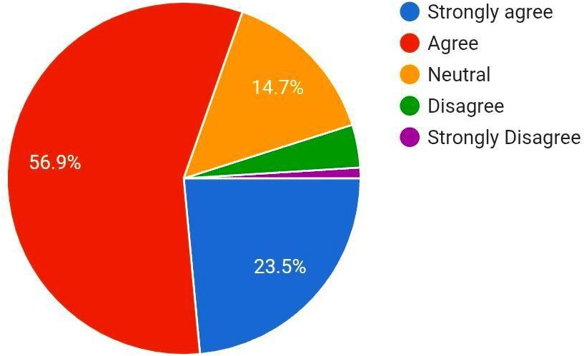

Fig no: 5.2

The majority of respondents agree (56.9%) and strongly agree (23.5%) that digital advertisements influence their purchase decisions. A smaller group remains neutral (14.7%), while very few disagree (3.9%) or strongly disagree (1%). This indicates that digital advertising has a strong impact on consumer buying behaviour.

PURCHASE AFTER SEEING FMCG PRODUCTS ON SOCIAL MEDIA

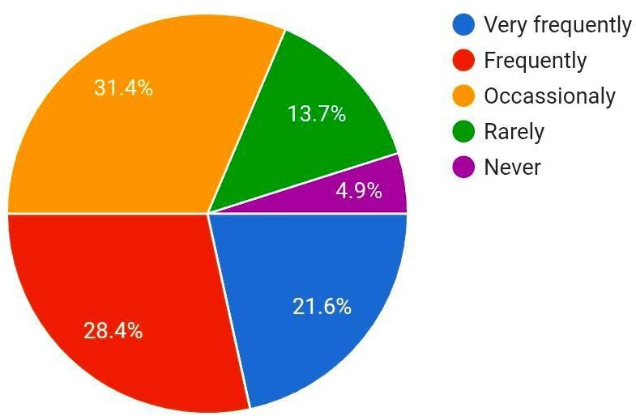

Fig no: 5.3

The data shows that a significant number of respondents purchase FMCG products after seeing them on social media. The highest proportion falls under occasionally (31.4%), followed by frequently (28.4%) and very frequently (21.6%), indicating a strong influence of social media. This suggests that social media platforms play an important role in shaping consumer purchase behaviour. A smaller group of respondents purchase products rarely (13.7%), while very few never (4.9%) do so. Overall, the findings highlight that social media marketing is effective in influencing FMCG purchases. It reflects changing consumer trends towards digital platforms. Businesses can leverage this influence for better marketing strategies.

INFLUENCE OF ONLINE DISCOUNTS AND PROMOTIONAL OFFERS

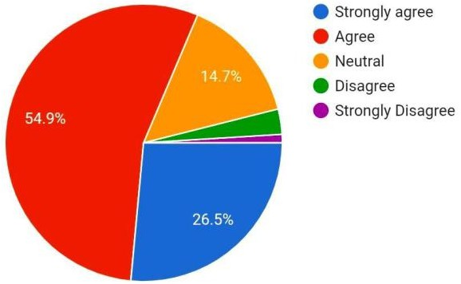

Fig no. 5.4

The majority of respondents agree (54.9%) and strongly agree (26.5%) that online discounts and promotional offers encourage them to purchase FMCG products. This indicates that price incentives play a crucial role in influencing buying decisions. A moderate number of respondents remain neutral (14.7%), suggesting some consumers are not strongly influenced. Very few respondents disagree (2.9%) or strongly disagree (1%), showing minimal resistance. Overall, the data highlights that discounts and offers are highly effective in attracting customers. It reflects the importance of competitive pricing in online markets.

IMPACT OF DIGITAL MARKETING ON BUYING PATTERN
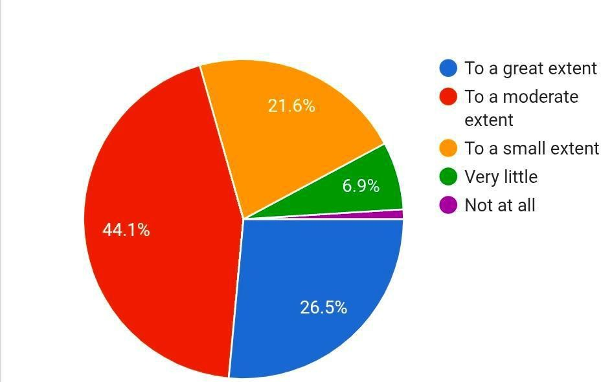

Fig no. 5.5

The data shows that digital marketing has significantly influenced the buying patterns of FMCG products. A majority of respondents (44.1%) feel it affects them to a moderate extent, followed by 26.5% to a great extent. This indicates a strong overall impact of digital marketing on consumer behaviour. A smaller group (21.6%) believes the influence is limited. Very few respondents feel little or no impact (6.9% and 1% respectively). Overall, digital marketing plays an important role in shaping purchasing decisions.

DIGITAL MARKETING HELPS COMPARE FMCG PRODUCTS
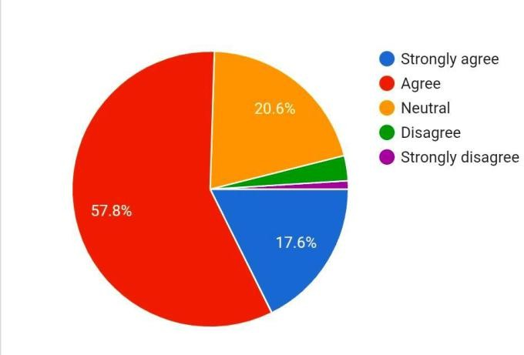

Fig no. 5.6

The data shows that a majority of respondents agree (57.8%) that digital marketing helps them compare FMCG products easily. A significant portion (17.6%) strongly agrees, indicating a positive perception. Some respondents remain neutral (20.6%), showing mixed opinions. Very few respondents disagree or strongly disagree, indicating minimal negative perception. Overall, digital marketing plays an important role in helping consumers make product comparisons.

MONTHLY SPENDING ON ONLINE PURCHASES

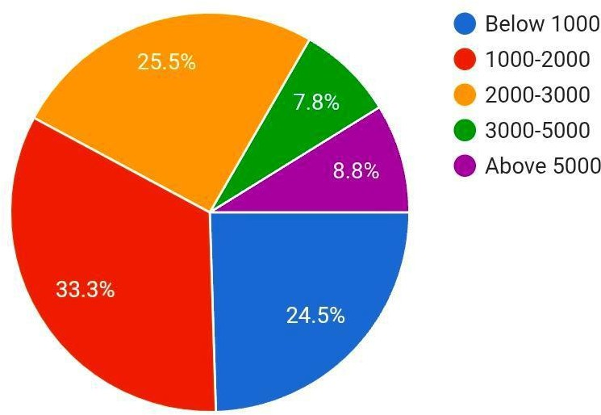

Fig no: 5.7
The data shows that most respondents spend Rs.1000–2000 (33.3%) monthly on online purchases. A significant number also spend below Rs.1000 (24.5%) and Rs.2000–3000 (25.5%), indicating moderate spending behaviour. Higher spending categories like Rs.3000–5000 (7.8%) and above Rs.5000 (8.8%) have fewer respondents. This suggests that most consumers prefer controlled and budget-friendly spending. Overall, the data reflects a trend of moderate online purchasing expenditure among respondents.

INFLUENCE OF RATINGS AND REVIEWS ON PURCHASE DECISION

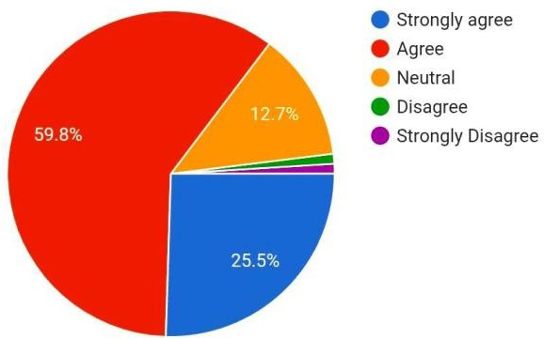

Fig no: 5.8

The data shows that a majority of respondents agree (59.8%) that ratings and reviews influence their purchase decisions. A significant portion (25.5%) strongly agree, highlighting strong trust in online feedback. Some respondents (12.7%) remain neutral. Very few respondents disagree or strongly disagree. Overall, ratings and reviews play a crucial role in shaping consumer buying decisions.

TRUST IN FMCG BRANDS THAT ADVERTISE ONLINE
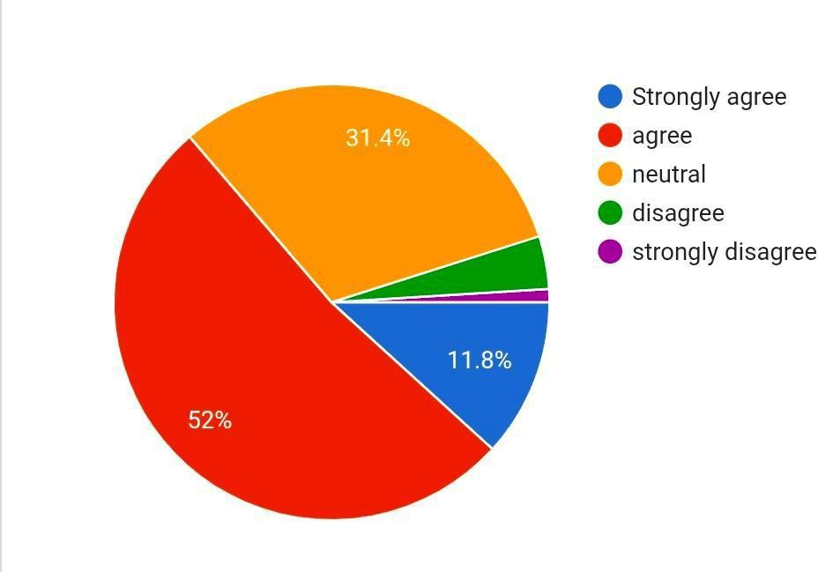

Fig no. 5.9

The data shows that a majority of respondents agree (52%) that they trust FMCG brands that actively advertise online. A smaller portion (11.8%) strongly agree, indicating positive trust levels. A considerable number (31.4%) remain neutral, suggesting uncertainty among some consumers. Very few respondents disagree or strongly disagree, showing limited negative perception. Overall, online advertising helps build trust among consumers to a moderate extent.

INFLUENCE OF PERSONALISED ADVERTISEMENTS

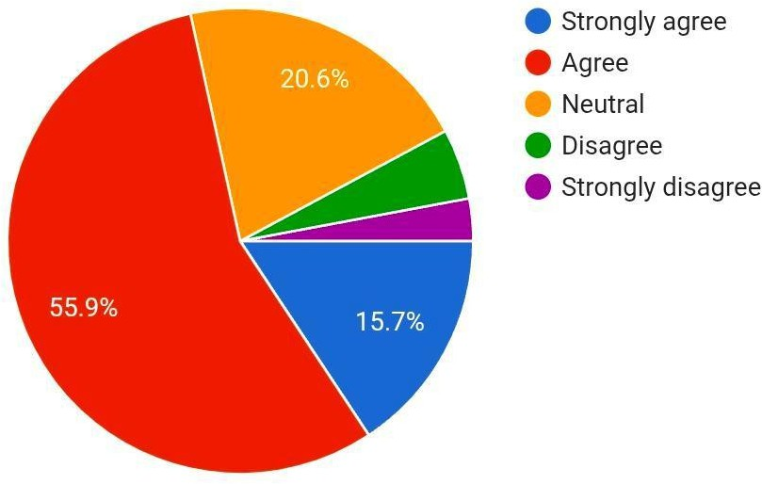

Fig. 5 .10

The data shows that most respondents agree (55.9%) that personalised advertisements influence their purchase decisions. A smaller portion (15.7%) strongly agrees, indicating a positive impact. Some respondents (20.6%) remain neutral, showing mixed opinions. A few respondents disagree or strongly disagree, indicating a limited negative perception. Overall, personalised advertising has a noticeable influence on consumer buying behaviour.

Conclusion

The study concludes that digital marketing plays a significant and transformative role in influencing consumer awareness and purchasing behaviour in the FMCG sector. With the increasing use of smartphones and internet accessibility, consumers are more exposed to online advertisements, social media campaigns, and influencer promotions, which greatly impact their buying decisions. The findings reveal that digital marketing not only enhances brand visibility but also helps in building stronger customer engagement and interaction. It is particularly effective among younger consumers who are more active on digital platforms and tend to rely on online information before making purchases. However, the study also highlights certain challenges, such as a lack of trust in online advertisements, misleading promotional content, and information overload, which can affect consumer perception negatively. Therefore, FMCG companies must focus on creating transparent, authentic, and customer-oriented digital marketing strategies to gain consumer trust and long-term loyalty. Overall, digital marketing

has become an essential tool for companies to remain competitive, expand their market reach, and effectively influence consumer behaviour in today’s dynamic business environment.

References

1. Abhilash Babu & Dr Amit K. Srivastav (2021). The Impact of Digital Marketing on FMCG Consumer Behaviour: A Mixed-Methods Study. International Journal of Marketing and Management Research Vol. 12, Issue 4.
2. Ayush Gupta (2025). Digital Marketing strategies and their influence on modern consumer purchase decisions. International Journal of Scientific Research in Engineering and Management Volume:09Issue:06.
3. Basimakopoulou et al. (2022). A literature review on digital marketing: the Evolution of a Revolution. Journal of Social Media Marketing ISSN 2669 – 2015.
4. Bhavesh Gattani & Shamik Saha (2023). Impact of digital marketing and AI on FMCG (e-commerce) consumer purchase patterns. International journal of scientific research and Engineering Trends, Vol. 09, issue 06.
5. Chaffey & Ellis-Chadwick (2022). Digital Marketing Excellence: Planning, Optimising, and Integrating Online Marketing. Retrieved from ResearchGate.net. https://www.researchgate.net/publication/367684873_Digital_Marketing_Excellence_Planning_Optimizing_and_Integrating_Online_Marketing
6. Clarita Obeid (2023). Exploring digital marketing optimisation: enhancing company performance with a focus on the FMCG industry in Lebanon. Dutch journal of finance and management 6(2) 25565.
7. Dinesh Kumar Mishra & Dr Pramod Gupta (2024). Digital Marketing System after COVID-19 in the Fast-Moving Consumer Goods Market. American Research Journal of Business and Management Volume 10, Issue 1.
8. M G Lakshmipathaiah (2024). An Empirical Study of AI Mechanism As Marketing Tool For FMCG Products. ShodhKosh: Journal of Visual and Performing Arts June 2024 5(6)
9. Manjula Srinivas & Bidyanand Jha, (2025). A study of the strategic branding techniques used by Indian FMCG companies in the digital era. Journal of Informatics Education and Research 5(1).
10. Meherun Nisa Nipa & Most. Sharmin Ara Chowdhury (2024). The Impact of Digital Marketing on Brand Awareness in the Multinational FMCG Sector. Article, National University of Bangladesh.

