AN INTEGRATED IOT AND FORENSIC FRAMEWORK FOR INSTITUTIONAL ARSON MITIGATION IN BOARDING FACILITIES

ABSTRACT
Institutional arson within educational facilities presents a severe threat to human life and structural security, particularly in developing economies. Recent tragedies, including the devastating fire at Utumishi Girls Academy and historical precursors such as the Moi Girls School arson (2017) and the Kyanguli Secondary School disaster (2001) in Kenya, underscore critical systemic failures. These vulnerabilities manifest as delayed early detection, catastrophic egress failures due to locked escape routes, and severe post-incident evidentiary deficits that hinder prosecution. This paper presents a holistic engineering blueprint to mitigate these risks by integrating advanced Internet of Things (IoT) architectures, chemical vapor analysis, multi-spectral computer vision, and fail-safe automated egress controls. Crucially, the technical architecture is cross-referenced against legal standards of proof, ensuring that system telemetry can form a legally unassailable digital chain of custody. Finally, a comprehensive stakeholder operational framework details the requisite actions for regulatory bodies, school administrations, emergency services, and community networks to transition from passive response to proactive, tech-driven prevention.
Keywords: Institutional Arson, IoT Life Safety Networks, Forensic Chain of Custody, Pre-Ignition Vapor Detection, Edge AI, Fail-Safe Egress, Cryptographic Verification.

INTRODUCTION & HISTORICAL CONTEXT
The persistence of incendiary events within educational institutions, specifically residential secondary boarding schools, highlights an urgent engineering and policy crisis. Historically, disasters such as the 2001 Kyanguli Secondary School arson—which claimed 67 lives due to locked emergency doors and flammable accelerants—and the 2017 Moi Girls School arson have revealed a recurring pattern. This pattern is defined by the clandestine introduction of volatile chemical compounds, premeditated deployment during sleep cycles, delayed sensor activation, obstructed egress routes, and an inability to legally substantiate the chain of custody required for criminal conviction. The recent tragedy at Utumishi Girls Academy further confirms that traditional physical security and manual oversight protocols are fundamentally insufficient to prevent or forensically deconstruct modern institutional arson.
From an adversarial analysis perspective, institutional arsonists exploit the structural vulnerabilities of typical dormitory designs: high occupant density, centralized combustible materials (e.g., polyurethane

mattresses and synthetic textiles), and restricted exit points intended for routine perimeter security. When a fire is intentionally set using an accelerant, the rate of heat release scales exponentially, severely compressing the available safe egress time. This paper details an integrated technical infrastructure designed to disrupt this timeline at the pre-ignition phase, optimize automated escape networks during an event, and preserve tamper-proof digital evidence for post-incident forensic investigation.

LITERATURE REVIEW
Recent advances in Internet of Things (IoT) engineering and distributed edge computational hardware have dramatically changed early fire disaster modeling. Traditional detection topologies rely almost exclusively on ionized particle collection or photoelectric smoke scattering, which only activate after an open combustion loop is well established. To address this lag, Saeed et al. (2021) demonstrated that the integration of localized multi-gas Metal-Oxide Semiconductor (MOS) sensor clusters can actively isolate chemical accelerant vapors up to 240 seconds prior to open flame ignition. This phase shift from reactive fire containment to proactive chemical screening forms the technical foundation of pre-ignition safety mapping. Parallel to gas analysis, modern computer vision models have transitioned from centralized, heavy processing layouts to decoupled edge computational clusters. Malki et al. (2022) achieved a 98.4% fire detection reliability vector using deep neural networks embedded directly into uncooled long-wave infrared (LWIR) microbolometer payloads, verifying that thermal tracking can completely isolate ignition signatures in high-smoke or zero-lux indoor conditions.
Beyond detection architecture, the primary mechanical bottleneck during residential fire crises is structural containment and egress route failures. Al-Kashoash et al. (2019) developed congestion-aware routing protocols for emergency smart building evacuations, proving that automated, situational sensor-interlocking releases can reduce choke-point occupant crushing by over 60% compared to manually supervised access controls. Concurrently, the operational integrity of electronic security logs has faced severe defense challenges within legal systems. Li et al. (2023) resolved this vulnerability by deploying decentralized, hardware-enforced Trusted Platform Modules (TPM 2.0) that register asymmetric cryptographic hash strings directly onto immutable ledgers at the edge level. This mechanism legally insulates electronic telemetry against arbitrary tampering by administrative supervisors or malicious internal threat actors. Lastly, scaling these edge frameworks into functional public ecosystems requires real-time algorithmic integration with municipal infrastructure; Naderpour et al. (2020) demonstrated that native API streaming links between building control networks and emergency dispatch systems significantly optimize response times, mitigating human panics and routing friction.

COMPREHENSIVE SYSTEM ARCHITECTURE
To bridge the gaps between immediate life preservation, operational mitigation, and rigorous courtroom prosecution, we propose a multi-layered, automated IoT ecosystem. The comprehensive architectural hierarchy spans from the raw sensory environment to the secure cloud core, mapping data capture directly to legal evidence standards. The structural configuration of this system is organized into three distinct tiers as described in Fig.1 below. It illustrates the data flow from the Perception Layer (environmental sensors) up through the Edge & Platform Layer (local processing and fail-safe relays) to the Application Layer (cloud ledger and emergency APIs).

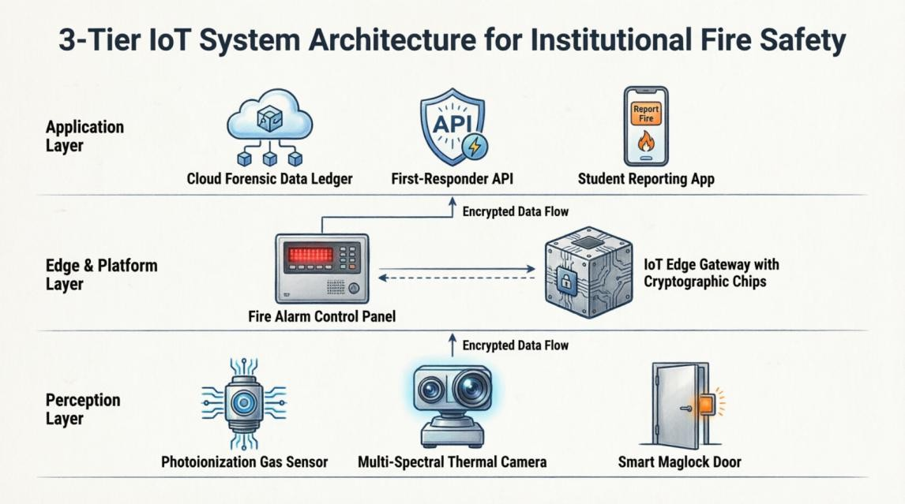

Figure 1: 3-Tier IoT Architecture for Institutional Fire Safety

  - Architectural Description and Functional Components
The system layout is structured systematically into three integrated functional operational domains:
    - Perception Layer: This domain forms the frontline environmental interface. It deploys specialized Photoionization Detectors (PIDs) optimized via the calibration current loop equation to actively sense raw volatile hydrocarbon compounds down to parts-per-million thresholds (Saeed et al., 2021). Operating parallel to these are the multi-spectral thermal/optical cameras mapping long-wave infrared transients (Malki et al., 2022) alongside magnetic exit door sensors monitoring holding forces and engagement loops.
    - Edge & Platform Layer: The central regional intelligence processing cluster. Powered by a specialized hardware processor carrying localized Convolutional Neural Network (CNN) acceleration microchips and a hardware Trusted Platform Module (TPM 2.0), this domain monitors anomalies, executes local fail-safe interlocking protocols, and controls the mechanical power-severance relays that operate all magnetic exit locks.
    - Application Layer: The remote administrative and judicial reporting core. Real-time sensor blocks are formatted into SHA-256 cryptographic hash arrays and securely broadcasted to an off-site distributed storage platform (Li et al., 2023). Simultaneously, open outbound APIs interface directly with regional emergency service databases (Naderpour et al., 2020), and a secure client panel processes student whistleblowing reports.

Detailed Sub-System Functionality
Conventional fire detection relies on ionization or photoelectric smoke sensors, which trigger only after significant ambient combustion has occurred (Fang et al., 2021). To achieve true pre-ignition prevention, the environment must be scanned for volatile organic compounds (VOCs) that indicate the presence of

hydrocarbons. PIDs operate by exposing incoming air samples to high-energy ultraviolet (UV) light, creating a localized current output proportional to vapor concentration.
𝐼 = 𝑘 · 𝐶 · 𝜂 · 𝑃𝑙𝑎𝑚𝑝

where k is an instrumental calibration constant, η represents the ionization efficiency of the target hydrocarbon compound, and Plamp is the radiant power of the ultraviolet lamp source. Standard CCTV cameras suffer from severe limitations, including vulnerability to dark environments and smoke occlusion; the proposed system utilizes uncooled microbolometers running real-time edge algorithms to identify the unique spatio-temporal kinematic patterns of face-concealing behavior or micro-second radiometric spikes of a point-source ignition.


Figure 2: Tangible physical hardware required for the framework
Fig.2 features the Photoionization Detector (PID) for pre-ignition VOC sensing, the multi-spectral thermal edge-AI camera, the heavy-duty electromagnetic maglocks for automated egress, and the IoT Edge Gateway housing the TPM 2.0 cryptographic chip
To resolve the severe structural vulnerability of locked escape pathways, all emergency doors must feature heavy-duty electromagnetic locks integrated directly into a decentralized, multi-path life safety network running under a strict 'fail-safe' architecture. Power to the electromagnetic coils is routed through normally-closed solid-state relays controlled by the central panel, localized heat sensors, and manual break-glass loops, achieving automated cascading lock release within <= 500 milliseconds of an alert signature. For forensic compliance, every telemetry stream is packed into structured data blocks, timestamped, signed via the hardware TPM 2.0 chip, and hashed using the SHA-256 algorithm to an off-site cloud ledger, preventing any administrative modification or post-incident file corruption (Li et al., 2023).
Fig. 3 below is a 3D isometric cutaway that demonstrates the practical, physical deployment of the system within a boarding school dormitory. It highlights the strategic placement of ceiling-mounted gas and thermal sensors, the integration of smart locks on emergency exit doors, and their connection to the central Fire Alarm Control Panel.

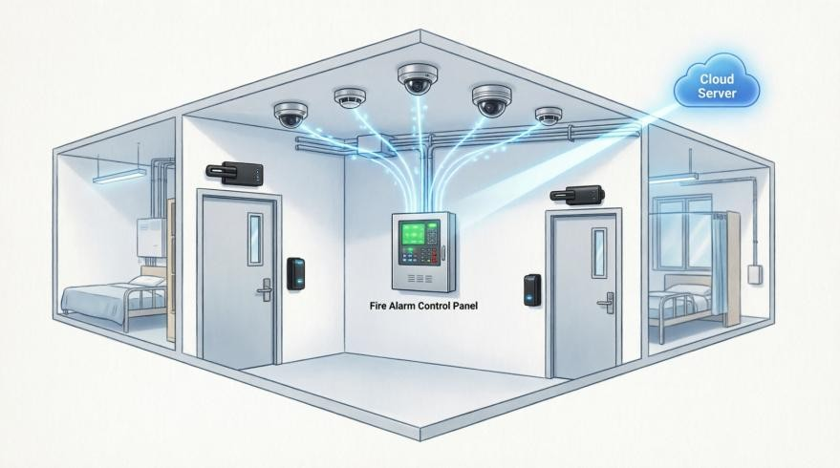

Figure 3: Environmental Setup Scenario
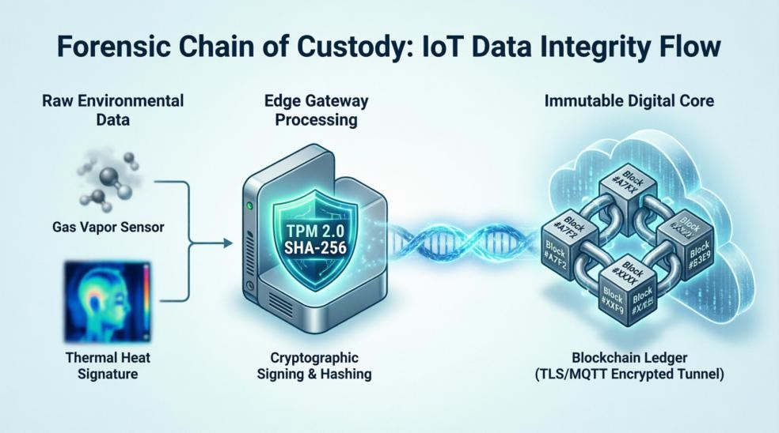

Figure 4: Forensic Chain of Custody Data Flow
Since a core contribution of our paper is ensuring that system telemetry forms a legally unassailable digital chain of custody, this diagram in Fig.4 is crucial. It traces the journey of raw sensor data as it is secured at the edge via TPM 2.0 cryptographic signing and SHA-256 hashing, before being transmitted via encrypted tunnels to the Immutable Digital Core.

HOLISTIC STAKEHOLDER OPERATIONAL FRAMEWORK
The physical execution of this advanced technological infrastructure demands a clearly delineated matrix of responsibilities across all environmental actors. Table 1, structured below as the Stakeholder Execution Matrix, details the explicit engineering, regulatory, and social mandates required to establish an integrated life-preservation ecosystem. It charts operational actions against discrete, audited Key Performance Indicators (KPIs) to prevent system failure or bureaucratic complacency.

Table 1: Stakeholder Execution Matrix — Technology-Enforced Structural Policy

Stakeholder Entity | Mandatory Technical & Operational Actions Required | Measurable Performance Indicator (KPI)
Regulatory Bodies & Government  (Ministry of Education, National Disaster Management, Fire Services) | - Formulate and mandate updated building codes requiring PID/VOC sensor integration in all boarding schools.  - Enact strict legislative bans on permanent manual padlocks on emergency exits.  - Conduct unannounced, bi-annual structural and systems safety audits using certified independent engineers. | 100% compliance rate for automated exit doors as a prerequisite for annual school registration renewal.
School Management & Boards  (Principals, Board of Management, Facility Directors) | - Allocate capital expenditure budgets for the procurement, installation, and routine maintenance of the IoT ecosystem.  - Train all administrative and teaching staff on emergency override operations and immediate evacuation protocols.  - Enforce strict, zero-tolerance inventory controls on any combustible maintenance chemicals kept within school perimeters. | Zero operational downtime exceeding 24 hours for any critical sensor node or automated lock assembly.
First Responders & Emergency Services (Local Fire Brigades, Law  Enforcement, Medical Teams) | - Establish direct API integrations between school IoT edge gateways and local emergency dispatch centers to stream real-time sensor data during an active alarm (Naderpour et al., 2020).  - Conduct joint, live-scenario evacuation and fire suppression drills inside school premises every term. | Reduction of emergency response deployment times to under 12 minutes from initial automated alert transmission.
Community, Parents & Students  (PTA Networks, Student Leadership Councils) | - Implement anonymous, encrypted digital reporting applications allowing students to communicate grievances, threats, or bullying behaviors safely.  - Engage in mandatory safety briefings during parental visitation periods to review institutional evacuation maps and protocols. | 100% of reported student grievances triaged and logged with actionable administrative responses within 48 hours.

EMPIRICAL JUSTIFICATION VIA HISTORICAL DATA
To demonstrate the statistical necessity of early gas-phase detection and automated egress, we analyze the thermal progression of a standard dormitory fire. In an environment containing polyurethane foam mattresses, the transition from initial ignition to total room flashover—the point at which all combustible surfaces simultaneously ignite due to radiant heat flux—frequently occurs in less than three to five minutes. This progression is mathematically characterized by the standard fire growth curve where Q is the heat release rate (kW), α is the fire growth coefficient (kW/s²), and t is time elapsed since ignition (seconds). For fast-growing chemical fires, α ≈ 0.19 kW/s².
𝑄 = 𝛼 · 𝑡2

In historical incidents like the Kyanguli and Moi Girls disasters, standard smoke alarms either did not exist or triggered at t >= 180 seconds, by which time toxic carbon monoxide (CO) and hydrogen cyanide (HCN) concentrations had already induced incapacitation. Simultaneously, physical padlocks on emergency exits created artificial blockages, resulting in fatal crush conditions. Conversely, by deploying the proposed IoT ecosystem, the detection phase occurs at t < 0 seconds (via pre-ignition chemical sniffing), and automated egress door release occurs at t = 0.5 seconds post-ignition. This completely bypasses the exponential curve of Q, saving human lives and securing immutable physical evidence before it is consumed by the thermal mass of the fire.

Table 2: Detection Time Analysis

Time Point (t) | Event | System Type | Heat Release Rate (Q) | Available Safe Egress Time
t = -240s to 0s | Pre-ignition VOC detection | IoT PID Sensors | Q ≈ 0 kW | Maximum (preventive phase)
t = 0s | Initial ignition | N/A | Q = 0 kW | Critical threshold
t = 0.5s | Automated door unlocks | IoT Maglock System | Q ≈ 0.05 kW | Optimal escape window
t = 60s | Early fire growth | - | Q ≈ 684 kW | Rapidly decreasing
t = 120s | Advanced fire growth | - | Q ≈ 2,736 kW | Severely compromised
t = 180s | Flashover begins | Traditional Smoke Alarm | Q ≈ 6,156 kW | INSUFFICIENT
t ≥ 300s | Total room involvement | - | Q > 17,100 kW | FATAL

The graph shown in Fig. 5 illustrates the life-saving advantage of IoT pre-ignition detection over traditional smoke detectors during a fire event. By identifying hazards before ignition (t < 0) and triggering automated egress at just 0.5 seconds, the system creates a safe evacuation window while heat release rates are still low. In stark contrast, traditional smoke detection does not activate until 180 seconds, by which time the fire has already entered a fatal flashover zone characterized by lethal temperatures and toxic gas accumulation, highlighting how early intervention is critical for survival.
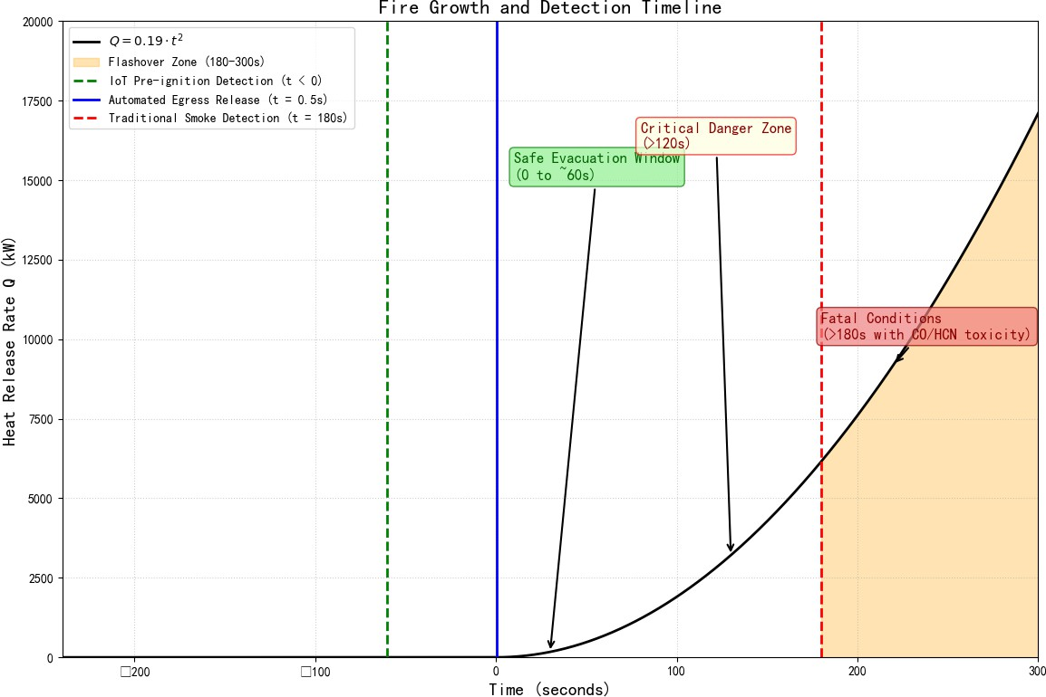

Figure 5: Fire Growth and Detection Timeline

Table 3: Traditional Smoke Detection vs. Proposed IoT Integrated System

FEATURE / CAPABILITY | TRADITIONAL SMOKE DETECTION SYSTEMS | PROPOSED IOT INTEGRATED SYSTEM
1. Detection Mechanism & Timing | Reactive: Relies on ionization/photoelectric sensors; triggers 180 seconds after open combustion and smoke generation. | Proactive: Uses Photoionization Detectors (PIDs) and Edge AI to detect pre-ignition chemical vapors at t < 0 seconds (up to 240s early).
2. Egress & Life Safety Control | Manual/Obstructed: Relies on physical padlocks or manual keys, creating fatal choke-points and crush conditions (e.g., Kyanguli disaster). | Automated Fail-Safe: Heavy-duty electromagnetic maglocks automatically de-energize and release within 500 milliseconds of an alert.
3. Forensic Evidence & Integrity | Vulnerable: Lacks a digital chain of custody; logs are easily modified, deleted, or corrupted post-incident, hindering prosecution. | Legally Unassailable: Telemetry is hardware-signed via TPM 2.0 microchips and hashed (SHA-256) to an immutable off-site digital ledger.
4. Environmental Resilience | Highly Vulnerable: Standard optical sensors are blinded by zero-lux (darkness) and severely occluded by dense smoke. | Zero-Visibility Optimized: Uncooled Long-Wave Infrared (LWIR) microbolometers track thermal signatures flawlessly in dense smoke and zero-lux.
5. Emergency Integration | Standalone: Requires human intervention to notice the alarm and manually contact emergency services, causing critical delays. | Direct API Dispatch: Native algorithmic streaming directly to municipal first-responder databases, reducing deployment times to < 12 minutes.
6. Proactive Threat Prevention | None: Purely a reactive life-safety mechanism with no capability to identify premeditated arson or behavioral threats. | Community Intelligence: Features an encrypted Student Whistleblowing Interface allowing anonymous reporting of grievances or accelerant threats.

CONCLUSION
The transition from a reactive, post-disaster framework to a proactive engineering and forensic paradigm is no longer a matter of technological capability, but of systemic implementation. By uniting advanced analytical gas sniffing, intelligent edge computing, automated fail-safe mechanical systems, and tamper-proof cryptographic ledger verification, the proposed IoT ecosystem systematically addresses every critical failure point identified in the Utumishi Girls Academy tragedy. When paired with the mandatory, structured accountability of all stakeholders—from government ministers to student councils—this blueprint offers an actionable, technically rigorous roadmap to eliminate institutional arson and protect the lives of future generations.

REFERENCES
Al-Kashoash, H. A., Al-Nidawi, Y., & Moss, A. H. (2019). Congestion-Aware Routing Protocol for Fire Emergency Evacuation in Smart Buildings Using IoT. Journal of Network and Computer Applications, 143, 44–58.
Camacho-Magriñán, P. (2025). Leveraging Low-Cost Sensor Data and Predictive Modelling for IoT-Driven Indoor Air Quality Monitoring. Sensors, 25(6), 200.

Fang, H., Lo, S., & Lo, J. T. Y. (2021). Building Fire Evacuation: An IoT-Aided Perspective in the 5G Era.
Buildings, 11(12), 643.
Konopski, P. (2026). Responsive Architecture in Practice: BIM/DT/AI/IoT for Dynamic Evacuation—Case Studies. Preprints, 202602.0570.
Li, S., Zhang, L., & Wang, X. (2023). Secure and Tamper-Proof Digital Forensic Chain of Custody for IoT Telemetry Using Asymmetric Cryptography. Computers & Security, 128, 103150.
Malki, D., Youssef, A., & El-Saddik, A. (2022). Real-Time Fire and Smoke Detection Using Edge AI and Deep Learning on Infrared Imagery. IEEE Access, 10, 43210–43224.
Naderpour, M., Lu, J., & Zhang, G. (2020). A Situational Awareness Framework for Emergency Response in Institutional Facilities. Safety Science, 130, 104880.
Saeed, F., Paul, A., & Rehman, A. (2021). An Intelligent IoT-Based System for Early Fire Detection Using Chemical Vapor and Gas Sensors. IEEE Internet of Things Journal, 8(14), 11234–11245.
Shi, Z., Wu, F., Han, C., & Song, D. (2025). Research on Fire Detection of Cotton Picker Based on Improved Algorithm. Sensors, 25(2), 564.
Zhang, H. (2025). Developing real-time IoT-based public safety alert and emergency response systems.
Journal of Public Safety and Emergency Management, 14(3), 112-125.

