Problems and Prospects of Rubber Farmers in Kerala: A Primary Survey-Based Study

Abstract
Natural rubber cultivation is one of the most important plantation-based economic activities in Kerala, contributing significantly to rural employment, income generation, and agricultural development. Despite Kerala accounting for the largest share of India's natural rubber production, rubber farmers have been facing several challenges arising from price volatility, rising production costs, labour shortages, climate change, and institutional constraints. This study examines the problems and prospects of rubber farmers in Kerala through a primary survey conducted between April 2026 and May 2026. Data were collected using a structured questionnaire from rubber cultivators selected through convenience sampling. The study focuses on four major dimensions: the socio-economic profile of farmers, labour and productivity-related challenges, the impact of economic uncertainties on crop diversification decisions, and the effectiveness of government support mechanisms.
The findings reveal that the majority of rubber cultivators are educated smallholders cultivating on self-owned land. Labour scarcity, rising wages, price fluctuations, and increasing production costs emerged as the most significant challenges affecting profitability. Climate change was also identified as a major concern due to its adverse impact on tapping operations and productivity. Although most farmers still perceive rubber cultivation as profitable and intend to continue cultivation, a considerable proportion remain uncertain about its long-term viability. The study further finds that awareness of government schemes is relatively high; however, procedural difficulties, lack of information, and delays in subsidy disbursement limit the effectiveness of policy support. The declining interest of the younger generation in rubber cultivation raises concerns regarding the future sustainability of the sector.
The study concludes that while rubber cultivation remains economically important in Kerala, its sustainability depends on effective government intervention, improved market stability, enhanced extension services, and measures to address labour shortages and climate-related risks.
Keywords: Rubber cultivation, Kerala, Rubber farmers, Labour shortage, Price fluctuation, Government support, Crop diversification, Agricultural sustainability.
JEL- Q12, Q13, R11

Introduction
The agricultural sector employs around 27% of the people of Kerala (Government of Kerala, Economic Review, 2022). Kerala has varying altitudes, soil types and varying climate according to the region; it is suitable for growing many agriculturally significant crops. One of the major crops produced by Kerala is rubber. Kerala is the leading producer of natural rubber in India. Kerala contributes over 90% of the total rubber production in the country. More than 20% of the gross cropped area in Kerala is under rubber cultivation, producing over 5 lakh tonnes of natural rubber annually. It is the most significant cash crop in Kerala (Kerala State Planning Board, Economic Review, 2023). Rubber is also a historically significant crop, as rubber plantations were initially introduced during the colonial period by the British to break the Brazilian monopoly over rubber. The first commercial Hevea brasiliensis plantations in India were established at Thattekadu, Kerala, in 1902. Post-independence, most plantations were divided into small holdings, but the owners of these plots chose to continue cultivating rubber as it has a higher value compared to paddy or coconut. By the 1980s, rubber cultivation became more popular as it provided a steady income throughout the year (Sinumon & Mahalakshmi, 2020). Natural rubber is obtained by tapping the Hevea brasiliensis tree by making an incision on the tree and allowing the milky latex to flow into a collection cup. This process usually begins after the tree has reached maturity, which is around 5–7 years after it has been planted. After this initial wait, the latex is harvested daily for 25–30 years. Rubber plantations help in carbon sequestration and micro-climate regulation. They also act as a soil anchor and help prevent soil erosion. Timber from these plantations also serves as an eco-friendly option for the furniture industry (Anuja et al., 2012). There are approximately 2,150 registered RPS units in Kerala (Down to Earth, 2025). Rubber processing units allow farmers to move up the value chain by processing field latex — which has a short shelf life — into sheets which can be stored for longer and sold when market prices are higher. The minimum support price (MSP) provided by the government for rubber is ₹180 per kg (Rural Voice, 2024). Crop diversification has also been adopted by many farmers to increase soil fertility and income (George & Sharma, 2020).
However, in recent years, with higher costs of production and market volatility, the industry is adapting. Even though the market value of rubber has increased, due to rising labour costs farmers' income seems to be stagnant. Since rubber is grown in countries like Thailand, Vietnam, and Ivory Coast, buyers prefer imports, which increases domestic competition (Rubber Board of India, 2025). Through this paper we will look into how much of the final market price actually reaches the farmer, how effective the government schemes supporting these farmers are, and whether rubber will continue to be a dominant crop or whether a shift to other crops will occur due to economic uncertainties.
Literature Review- Various studies explore the economic implications of natural rubber cultivation in Kerala, examining how price signals reach smallholder farmers, how effective government interventions have been, and whether rubber will remain the dominant crop in the state.
J Manag Res Anal (2024) discovered that when rubber prices were high in previous years, a surplus can be found in current years, causing a price drop that continues to form a cobweb pattern. This cyclical dynamic means that price signals reaching farmers are inherently lagged and distorted, making rational production decisions difficult and further eroding effective price realisation at the farm level. Nithin et al. described that transportation constitutes the largest marketing cost across all channels, ranging from ₹15 to ₹23 per quintal. Farmers selling through Rubber Producers' Societies tend to have higher marketing efficiency but face challenges with economies of scale compared to private dealers, limiting the practical benefits of cooperative marketing for many smallholders. Sinumon and Mahalakshmi (2020) observed that the rubber sector in Kerala is dominated by smallholders, making it vulnerable to price fluctuations, weak marketing systems, and exploitation by intermediaries. Their findings also indicate that productivity and quality issues further reduce farmers' competitiveness, meaning that even when market prices rise, the share reaching individual farmers is often diminished by structural inefficiencies throughout the supply chain. Anuja et al. (2019) assessed the economics of natural rubber production in Kerala and found that members of Rubber Producers' Societies incurred a 14 per cent lower cost of cultivation compared to non-members, and their gross return was approximately 10 per cent higher due to better price realisation through group processing and marketing facilities. The return per rupee of cost was 2.68 for RPS members versus 2.08 for non-members, confirming the economic advantage of cooperative participation for smallholders. The Comptroller and Auditor General of India noted that 63 per cent of growers did not apply for available subsidies due to lack of awareness. Furthermore, while India's subsidies range from ₹20,000 to ₹40,000 per hectare, they are significantly lower than those in competing nations like Thailand and Malaysia, which offer up to six times more support, placing Indian smallholders at a structural competitive disadvantage in global markets.
Odamkulath and Manoj (2018) found that falling rubber prices have had a severe impact on the livelihood of small farmers, leading to reduced production and economic instability. The study emphasised the urgent need for government policy intervention to stabilise the sector, particularly through mechanisms that provide a floor price and reduce farmers' exposure to global market volatility. Mathew (2022) examined the underlying causes of declining rubber cultivation in Kerala, highlighting that small farmers face the twin problems of low yield from ageing plantations and very low market prices for their produce. He noted that because farmers lack proper marketing channels and access to scientific practices, Rubber Producers' Societies were established to reduce bureaucratic obstacles and improve collective bargaining power, though their effectiveness remains constrained by limited funding and weak extension linkages. A study documented in Down to Earth (2025) found that approximately 20 per cent of Rubber Producers' Societies are now defunct and another 35 per cent dysfunctional, with the Rubber Board withdrawing approval to 336 societies in 2020–21 alone. The average annual revenue of an RPS stands at around ₹2.5 lakh, of which over 85 per cent derives from rubber and input sales, while nearly 27 per cent of RPSs rely on grants, loans, or subsidies for more than half their income, raising serious questions about their long-term institutional viability. George et al. found that due to falling prices, farmers have either reduced or stopped tapping entirely. In some regions a documented shift can be seen toward exotic fruits or real estate, as rubber is being seen as financially viable only when the final timber value of the trees is factored into calculations. This finding suggests that for many smallholders, rubber is transitioning from an active crop to a deferred asset rather than a reliable source of regular income. Ali and Manoj (2020), in a case study of Kothamangalam Taluk, found that the drastic crash in natural rubber prices since 2012, combined with rising production costs and declining yields from progressively ageing holdings, pushed the sector into a major crisis. Farmers were reluctant to maintain plantations, reduced tapping days, and in some cases abandoned cultivation entirely, resulting in increased indebtedness and overdue bank loans. Both large estates and smallholders were adversely affected, though the impact on those who depended primarily on rubber for their livelihoods was most severe. Mahesh et al. (2020), in a temporal analysis of crop diversification in Kerala covering 1987–88 to 2016–17, found that the area under food crops has been steadily declining while the area under commercial crops — particularly rubber, arecanut, and banana — has been increasing. Significantly, the study found that when wage rates rise, farmers tend to shift toward less labour-intensive perennial crops, suggesting that labour market conditions are a key determinant of cropping pattern evolution in the state. Joseph and Jacob (2021), writing in Economic and Political Weekly, presented a counter-intuitive finding using satellite-derived land-use data: despite the drastic fall in rubber prices since 2012, Kerala growers maintained their interest in the crop, with total area under rubber cultivation registering steady growth independent of market fluctuations. However, those growers with a substantial share of income from non-rubber sources abstained from tapping when prices were low, with their share of area estimated at 25 to 30 per cent, indicating a dual-track response within the smallholder community rather than a uniform shift away from rubber. Rajasekharan and Veeraputhran (2002), in a study of rubber smallholdings across three regions of Kerala, established that the availability of family labour and the type of intercrops were the most significant determinants of intercropping adoption, with banana, cassava, and pineapple showing the highest probability of uptake. This is consistent with later global evidence reviewed by Blare et al. (2022), who found that rubber agroforestry has the potential to reduce the vulnerability of smallholders to volatile rubber markets, particularly where income from secondary species constitutes a substantial share of total household income, suggesting that diversification within rubber holdings — rather than complete crop abandonment — may represent the most realistic path forward for Kerala's smallholder community.

Literature gap- Existing studies have predominantly focused on either price behaviour, marketing efficiency, government support, or crop diversification individually. Limited empirical evidence exists regarding how these factors simultaneously influence smallholder rubber farmers' livelihood decisions in Kerala. Moreover, recent post-pandemic market conditions and rising labour costs have not been adequately examined through primary survey-based studies. The present study attempts to address this gap.

Objectives- The basic intention of this paper is to
- examine the socio-economic profile of rubber farmers
- study labour, cost, and productivity issues
- analyse how economic uncertainties are causing a shift from rubber cultivation to other crops
- evaluate government support and policy effectiveness

Methodology
The present study adopts a descriptive and analytical research design to examine the problems and prospects of rubber farmers in Kerala. The study is primarily based on primary data collected through a structured questionnaire administered among rubber cultivators in Kerala during April–May 2026. A convenience sampling technique was employed to select the respondents, and a total of 81 valid responses were collected for analysis. The questionnaire was designed to gather information on the socio-economic characteristics of farmers, labour availability, production costs, productivity issues, future prospects of rubber cultivation, crop diversification tendencies, and awareness and effectiveness of government support schemes. In addition to primary data, secondary information was obtained from government reports, publications of the Rubber Board of India, the Economic Review of Kerala State Planning Board, research articles, and other relevant sources. The collected data were coded, tabulated, and analysed using descriptive statistical tools such as percentage analysis, frequency distribution, and graphical representation. The findings are presented objective-wise to provide insights into the socio-economic profile of rubber farmers, the major challenges affecting cultivation, the impact of economic uncertainties on future farming decisions, and the effectiveness of existing government support mechanisms. Although the use of convenience sampling may limit the generalisation of the findings, the study provides valuable empirical evidence regarding the current status, challenges, and future prospects of rubber cultivation in Kerala.

Result and analysis-
Objective 1 - examine the socio-economic profile of rubber farmers
Firstly, their education level, information about their land and income will be examined

Education level-
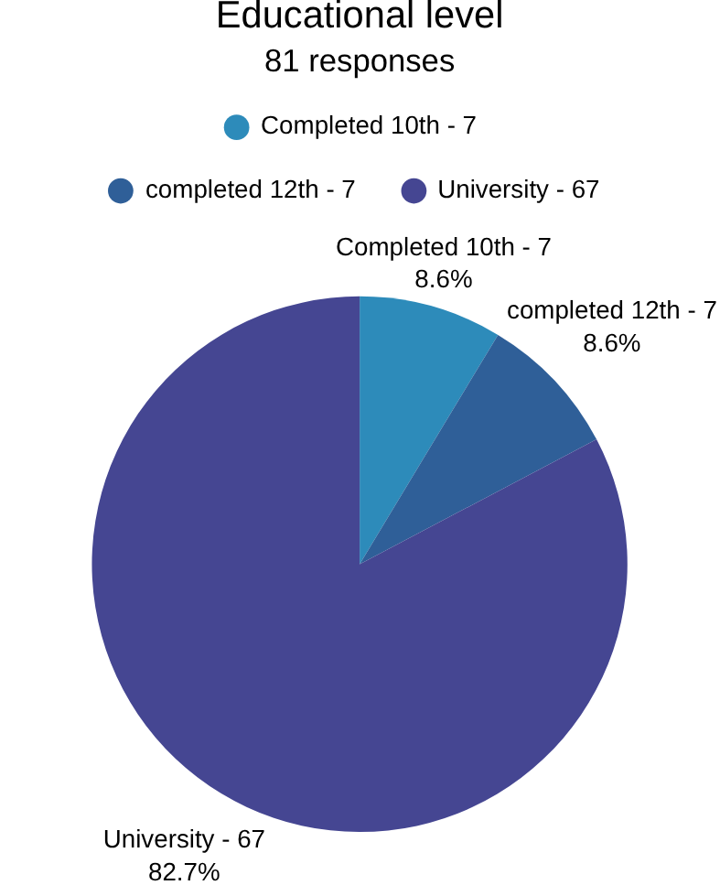

Figure 1 -Pattern of education levels of the respondents (Source- Primary Survey by the authors)

Most respondents have completed their universities, followed by people who have completed their 10th grade. Therefore, the majority of the respondents are highly educated with degrees.

Land-
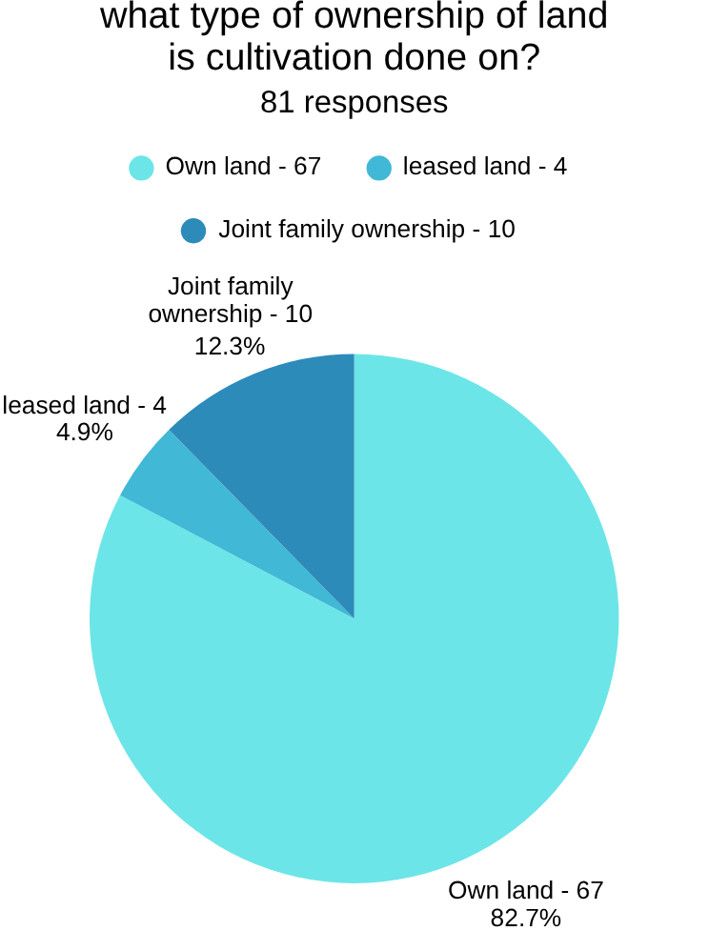

Figure 2 - Type of ownership of land cultivated on(Source- Primary Survey by the authors)

The majority of the respondents cultivate rubber on land owned by them, making up 82.7% of the total sample. Then, 12.3% of respondents work on lands owned as a joint family. The remaining 4.9% work on leased land.

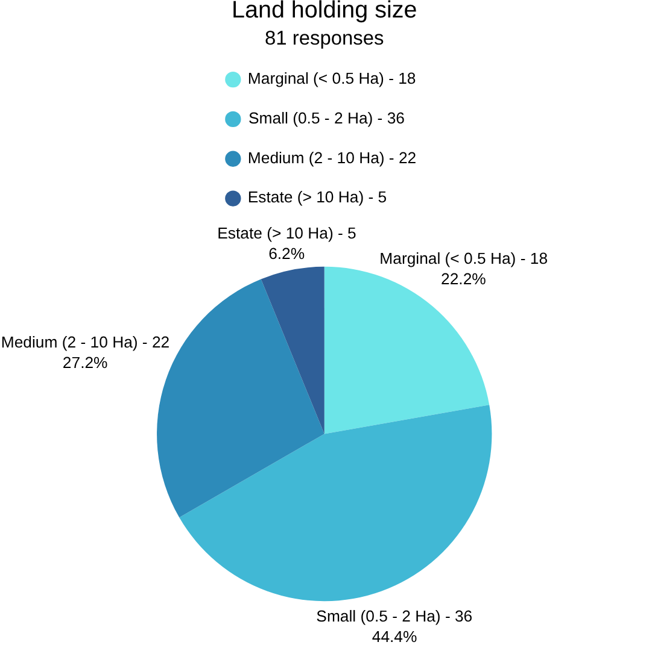
Figure 3 - Size of the land of the respondents (Source - primary survey by the authors)

Most respondents have a small plot (0.5 -2 Ha) on which they cultivate, followed by medium size plots (2-10 Ha) and Marginal size plots (< 0.5 Ha).

Experience-
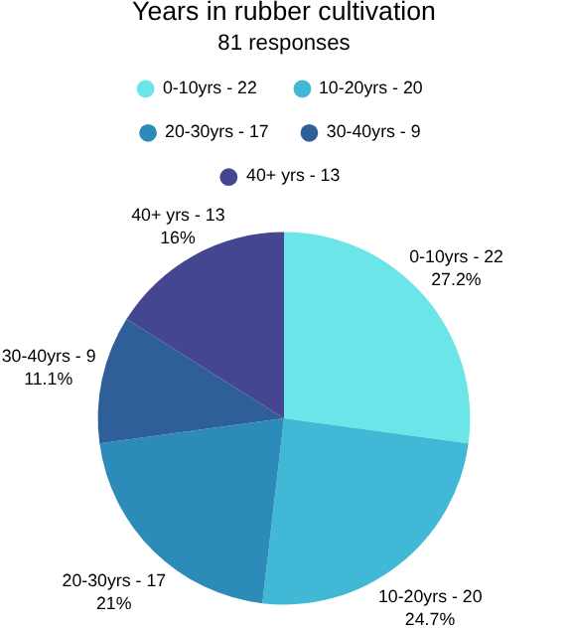
Figure 4- Years of experience in rubber cultivation of the respondents (Source - primary survey by the authors)
The majority 27.2% of the respondents had 0-10 years of experience, closely followed by 24.7% having 10-20 years and 21% having 20-30 years of expertise.
58% of responders consider rubber cultivation as their main job while the remaining 42% consider it as part time.

So, the first chapter deals with the socio-economic profile of the respondents. It indicates that rubber cultivation in Kerala is predominantly undertaken by educated farmers, with the majority possessing university-level education. This suggests that rubber farming is not merely a traditional occupation but is increasingly managed by individuals capable of understanding market trends, government schemes, and modern cultivation practices. The land ownership pattern reveals that most respondents cultivate rubber on their own land, demonstrating a strong sense of ownership and long-term commitment to the crop. The predominance of self-owned holdings reduces tenancy-related uncertainties and encourages investment in plantation maintenance. The distribution of land size indicates that smallholders constitute the largest segment of rubber growers. This finding aligns with earlier studies which identify Kerala's rubber sector as being dominated by small and marginal farmers. Consequently, fluctuations in income and production have a direct impact on household welfare.
The experience profile shows a balanced representation of both new and experienced farmers. The presence of younger entrants indicates continued interest in rubber cultivation, while the substantial share of experienced cultivators reflects the crop's historical importance in Kerala's agricultural economy. Further, 58 percent of respondents depend on rubber cultivation as their primary occupation, highlighting its continued significance as a livelihood source. Overall, the findings suggest that rubber cultivation remains an economically important activity among smallholder farmers despite emerging challenges.

Objective 2 - This chapter deals with the issues associated with labour, cost, and productivity issues

Labour-
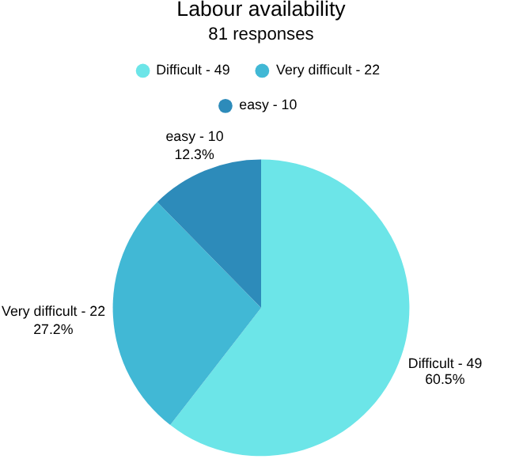
Figure 5- Labour availability (Source - primary survey by the authors)

An overarching amount of cultivators report labour availability as difficult to very difficult whilst only 12.3% of cultivators find it easily available.
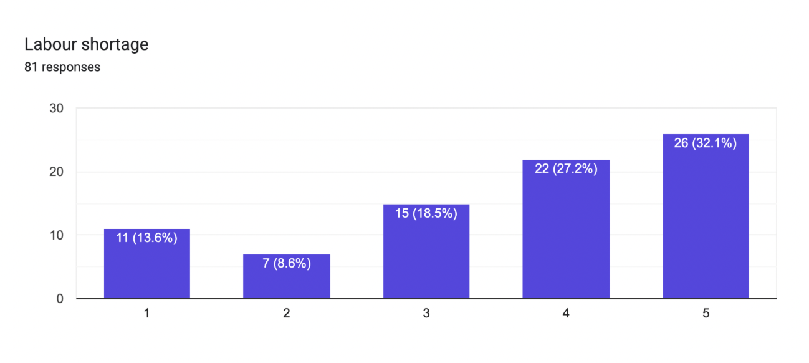
Figure 6- Labour shortage (Source - primary survey by the authors)
Most responders chose a high 4 and 5 out of 5 for how much labour shortages are affecting their production.

Costs-
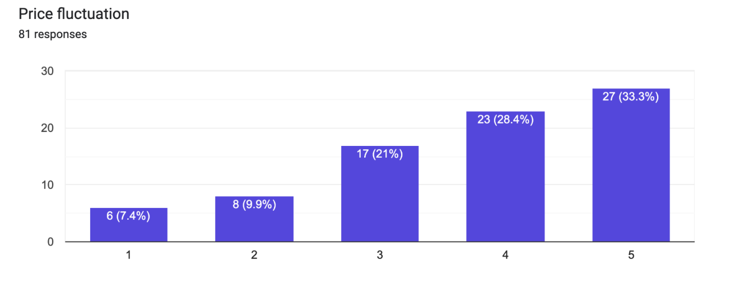
Figure 7- Labour shortage (Source - primary survey by the authors)

Price fluctuation of rubber in the global markets are a huge factor in the profits earned by the farmer. In economic conditions like sudden recessions and wars, uncertainty grows. The responders have reflected this through their answer as over one third of the response have noted this as a 5/5 problem.

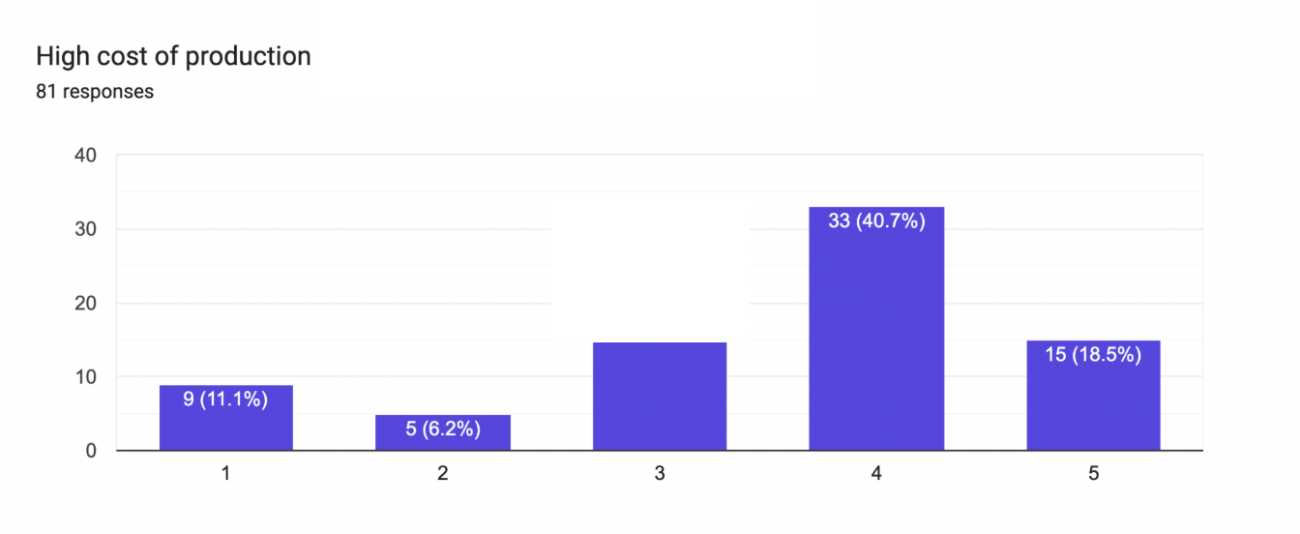
Figure 8- High cost of production (Source - primary survey by the authors)

over 40% of the respondents have described high costs of rubber production as a difficult problem. These high costs determine how profitable cultivation is and it is the reason why many farmers are deciding to abandon cultivating.

Environmental factors-
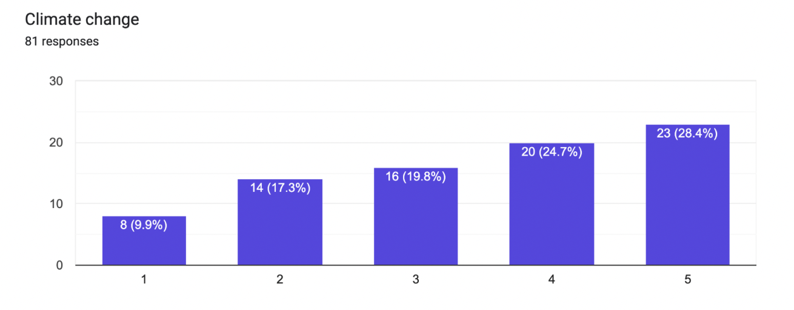
Figure 9- Climate change (Source - primary survey by the authors)

The effects of climate change are becoming more vivid day by day and it negatively affects these farmers in many ways. That is shown in their responses as 28.4% has labelled it with 5 on the scale and 24.7% as with 4 thus classifying it as a major problem.

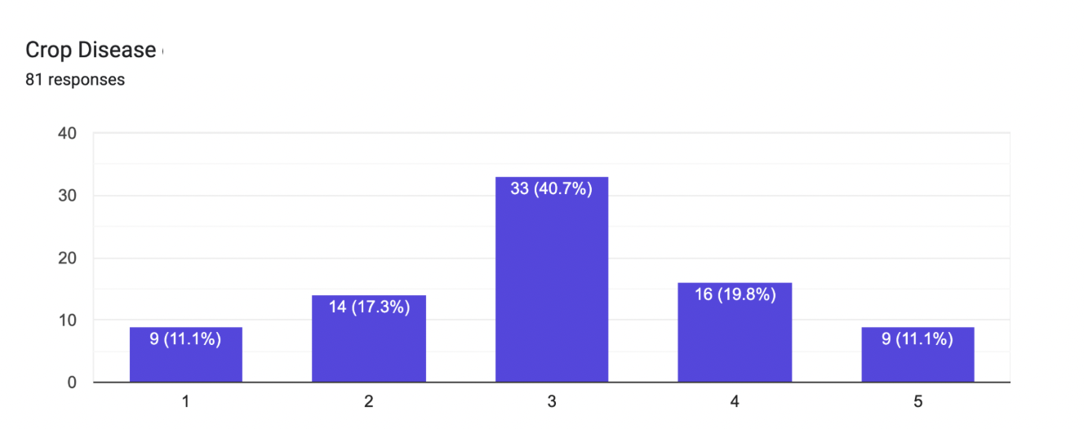

Figure 10- Crop disease (Source - primary survey by the authors)

Crop disease shows to be a manageable problem as it is mostly rated with a 3. The developments in technology and understanding various needs of the crop has helped in prevention and cure.

The findings from this second chapter, clearly indicate that labour-related problems constitute one of the most serious constraints faced by rubber cultivators. A large majority of respondents reported labour availability as difficult or very difficult, reflecting the growing shortage of skilled tappers in Kerala. Labour shortage has a direct effect on productivity because tapping operations require specialised skills and regular maintenance. Delays or interruptions in tapping reduce latex yield and consequently affect farmers' income. The high ratings assigned to labour shortages indicate that farmers perceive this issue as a major obstacle to efficient production.
Price fluctuation emerged as another critical concern. Since rubber prices are heavily influenced by global market conditions, farmers remain exposed to economic uncertainties beyond their control. The high severity ratings assigned to price fluctuations suggest that income instability remains one of the principal risks associated with rubber cultivation. The high cost of production also significantly affects profitability. Increasing wages, rising input costs, transportation expenses, and maintenance costs have reduced profit margins for many cultivators. This explains why some farmers are reconsidering the economic viability of rubber cultivation despite recent improvements in market prices. Environmental challenges further compound these difficulties. Climate change was identified as a major issue because irregular rainfall patterns reduce tapping days and adversely affect latex production. In contrast, crop diseases were viewed as a relatively manageable problem, possibly due to improvements in cultivation practices, extension services, and disease management technologies.
Overall, the findings demonstrate that labour scarcity, price volatility, production costs, and climatic uncertainties collectively pose significant threats to the sustainability and profitability of rubber cultivation.

Objective 3 - This chapter analyse how economic uncertainties are causing a shift from rubber cultivation to other crops

Future prospects-

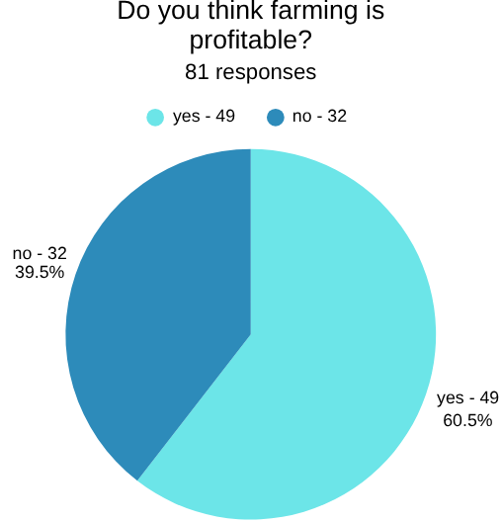
Figure 11- Profitability of rubber farming (Source - primary survey by the authors)

over 55% of respondents agree that rubber farming is a profitable trade.

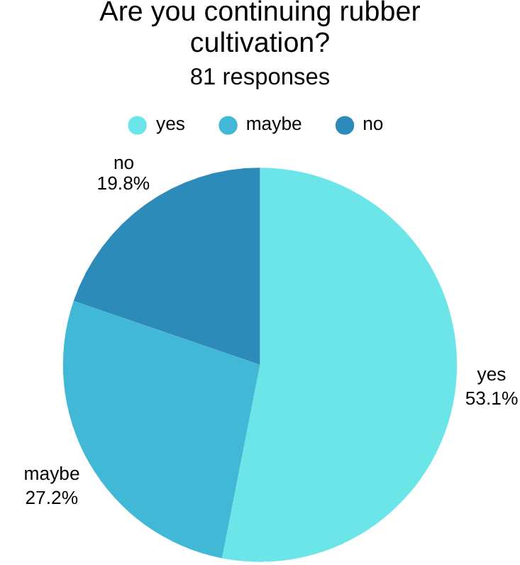

Figure 12- Continuation of rubber farming (Source - primary survey by the authors)

While most respondents have pointed out that they want to continue farming rubber a significant chunk of respondents are uncertain about the future of their rubber cultivation.

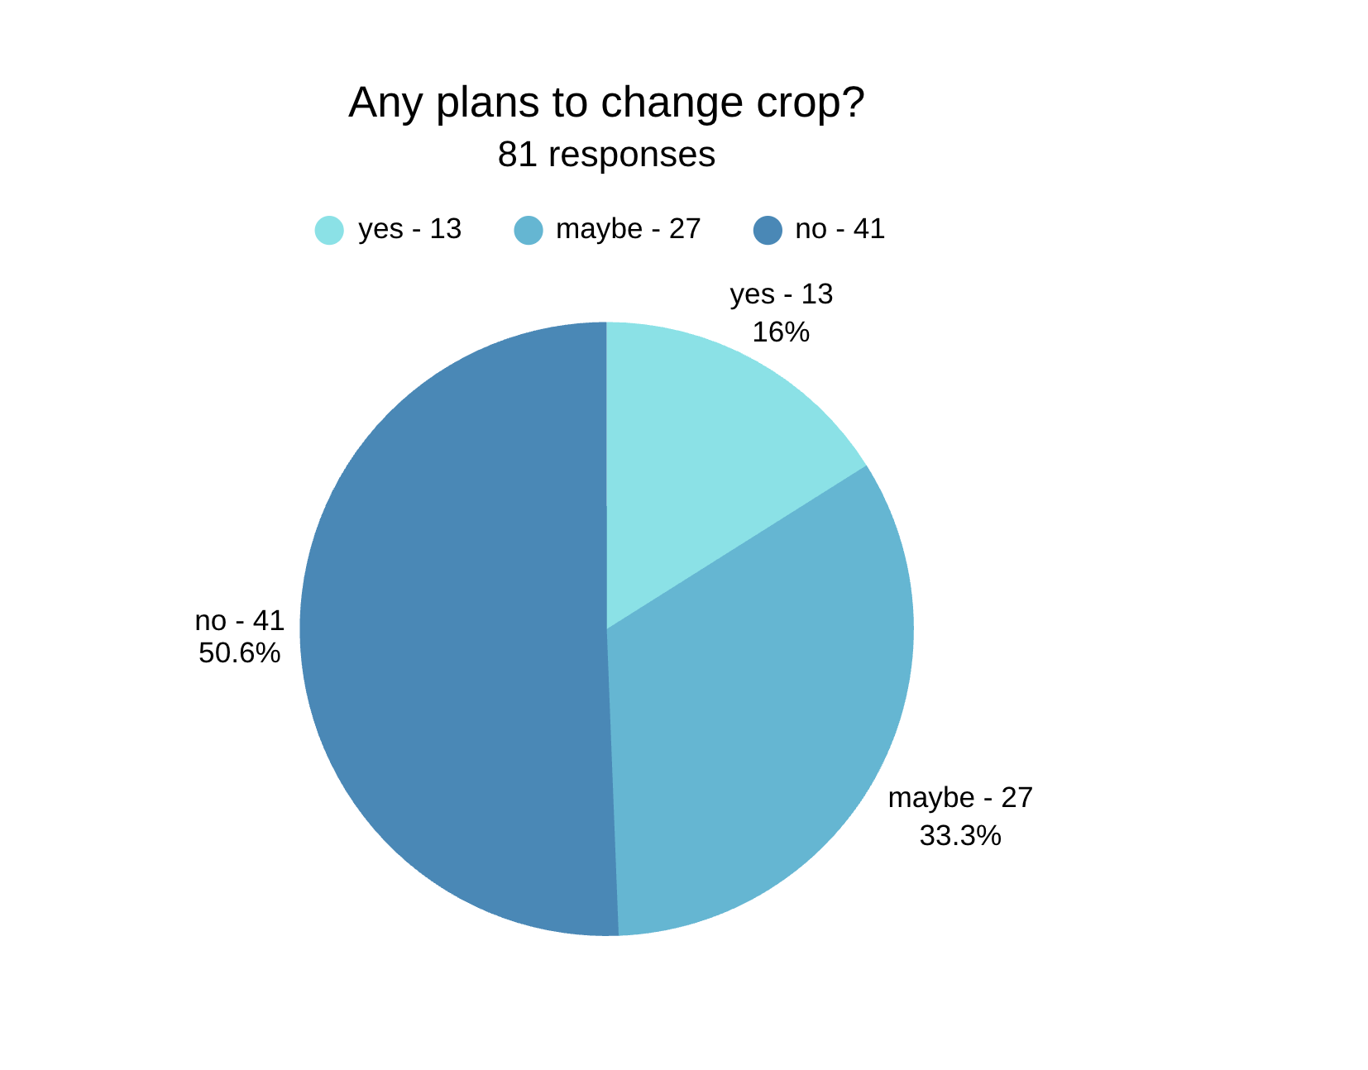

Figure 13- Crop change (Source - primary survey by the authors)

The majority of the respondents aren’t planning on changing crops but almost 1/3rd of them are uncertain.

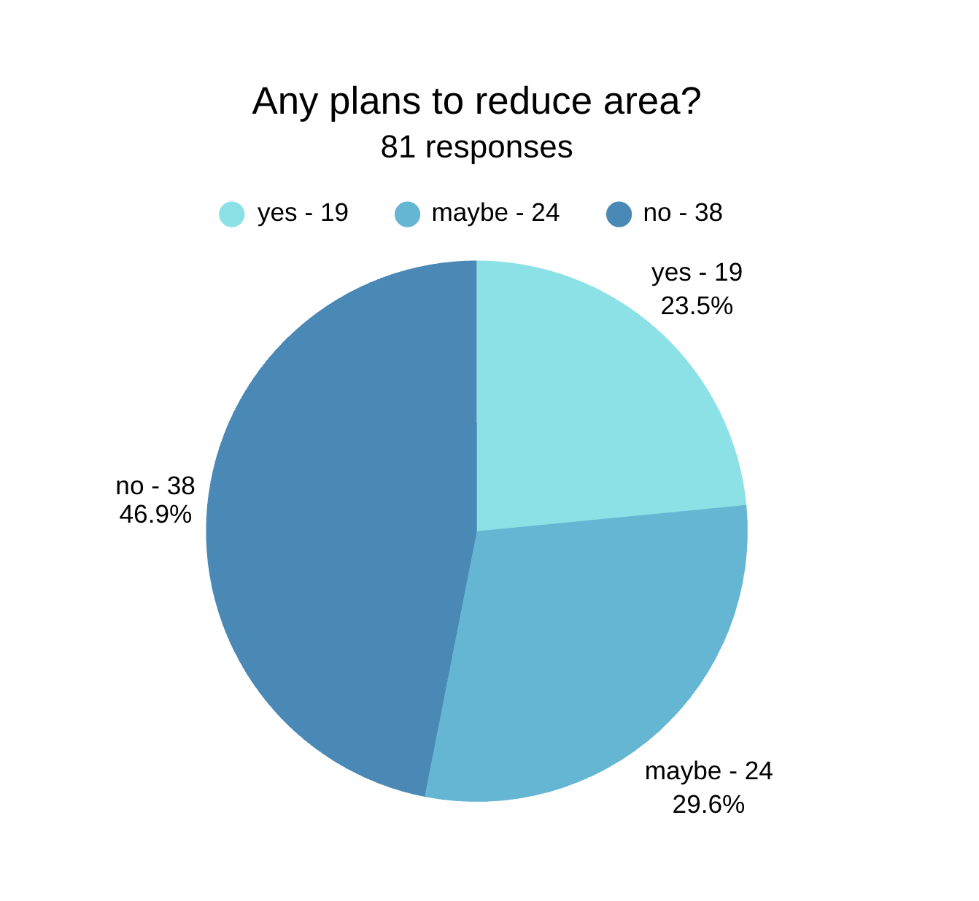

Figure 14- Area reduction (Source - primary survey by the authors)
Most farmers are not planning on reducing the area under cultivation.

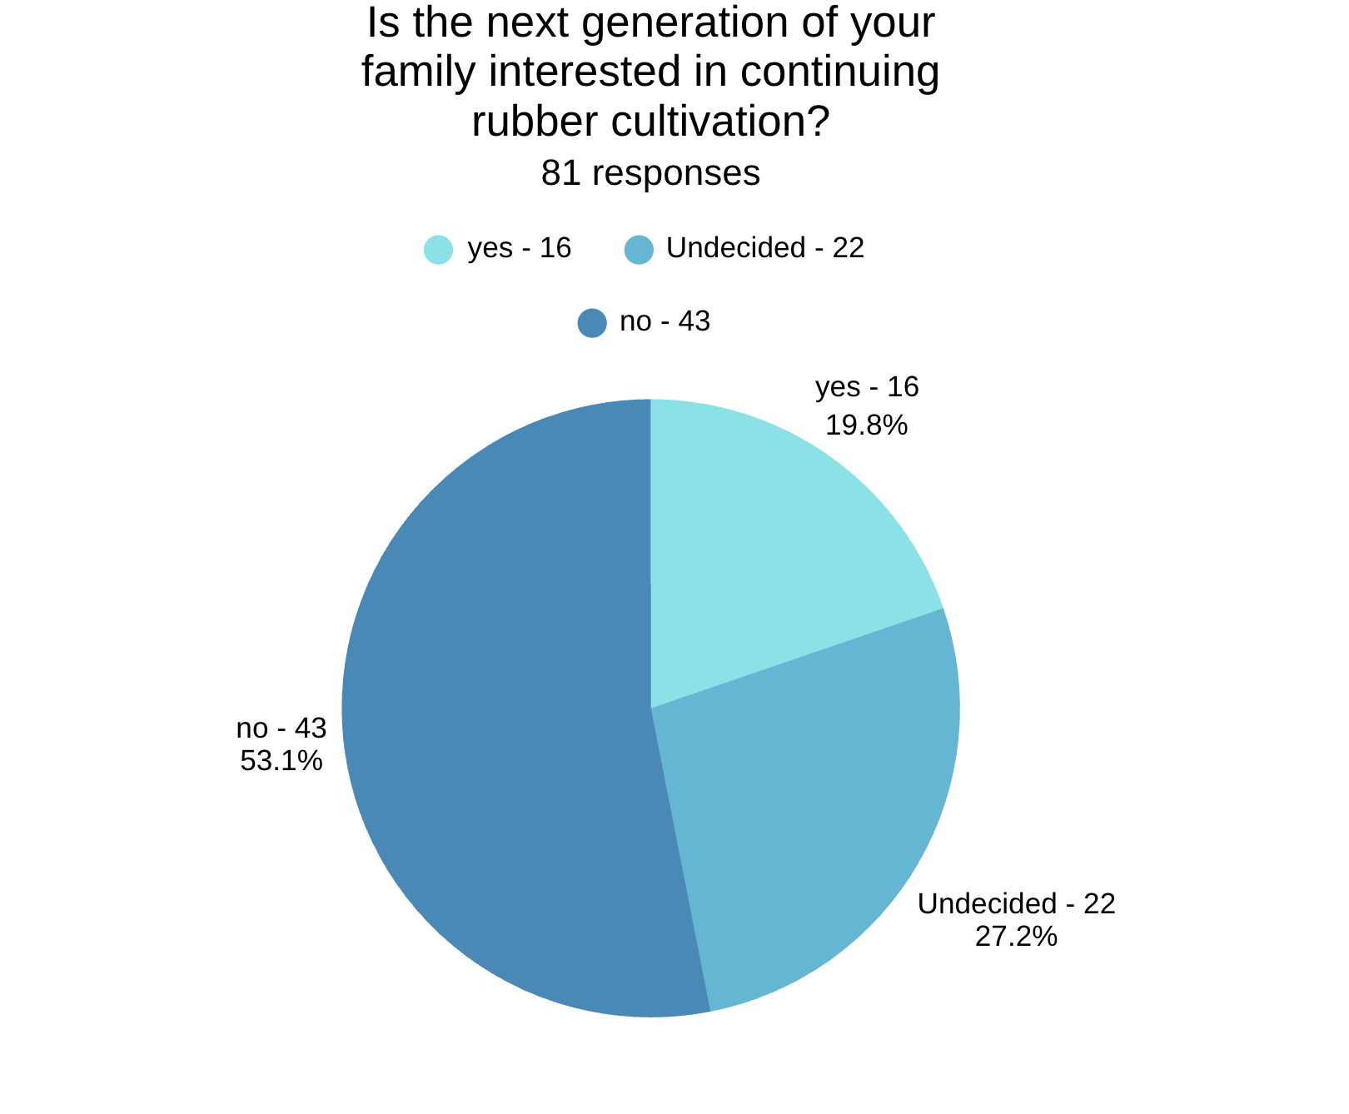

Figure 15- Interest of next generation (Source - primary survey by the authors)

The desirability of the next generation to continue rubber farming has dropped. Almost 50% have voted that the next generation is going to switch careers while 23.5% are yet to decide.
The results of this chapter reveal an interesting contradiction between current profitability perceptions and future uncertainty. Although more than half of the respondents consider rubber cultivation profitable, a considerable proportion remain uncertain about its long-term viability.
Most respondents expressed their intention to continue cultivating rubber, suggesting that the crop continues to provide economic value. Similarly, the majority are not planning to shift to alternative crops or reduce the area under cultivation. These findings indicate that despite existing challenges, rubber remains the preferred crop among most farmers. However, a significant proportion of respondents expressed uncertainty regarding future cultivation decisions. This uncertainty can be attributed to persistent concerns about labour shortages, price fluctuations, climate risks, and increasing production costs. The results suggest that while farmers are not currently abandoning rubber cultivation, they are cautious about its future prospects. A particularly important finding is the declining interest of the next generation in rubber farming. Nearly half of the respondents believe that younger family members are likely to pursue alternative careers. This reflects changing occupational aspirations, urbanisation, and the perception that agriculture offers lower returns compared to non-farm employment opportunities.
Therefore, the study concludes that economic uncertainties have not yet triggered large-scale crop substitution; however, they have created considerable doubt regarding the long-term sustainability of rubber cultivation, particularly among younger generations.

Objective 4 - Lastly, this chapter will evaluate the government support and policy effectiveness.

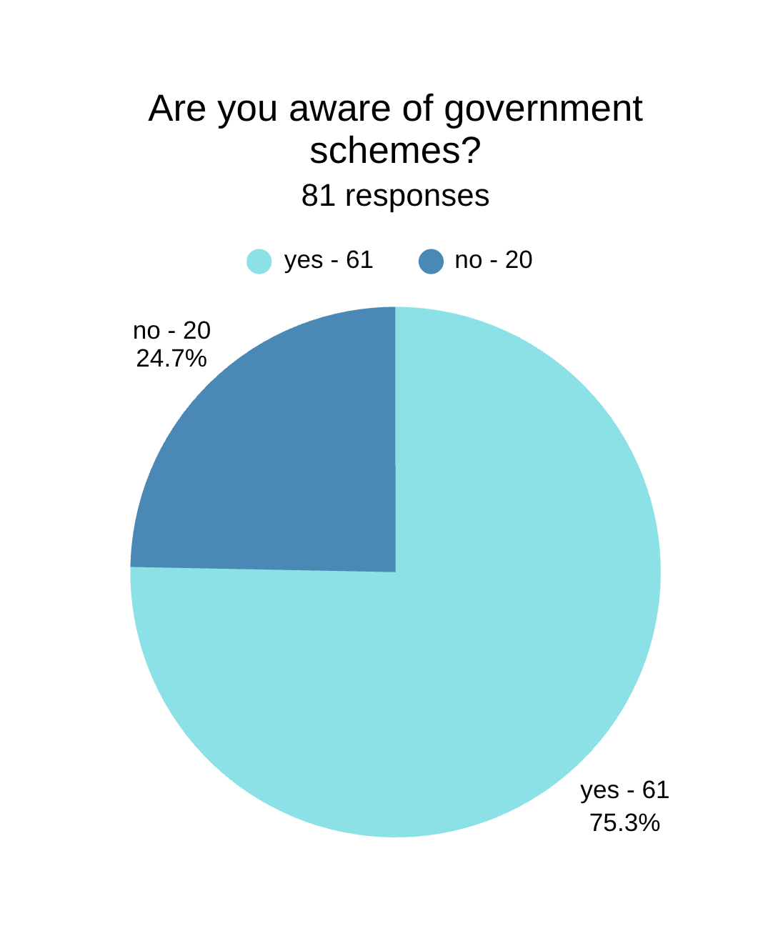

Figure 16- Awareness of government schemes (Source - primary survey by the authors)

While a huge percent of respondents seem to be aware of the government schemes, over 23% are unaware of possible benefits and subsidies provided by the government.
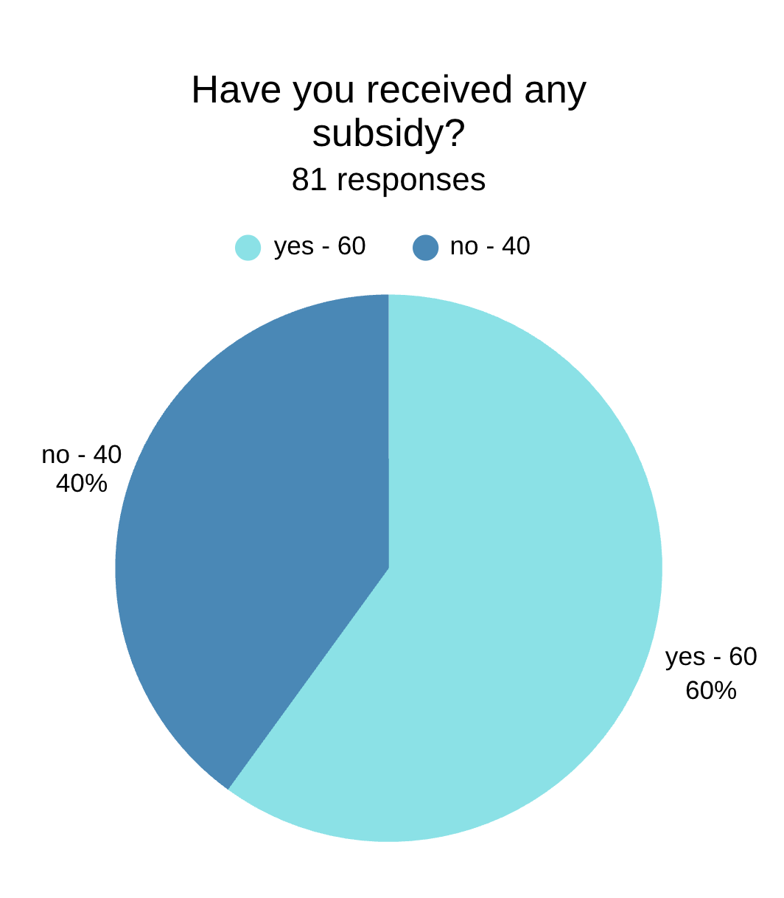
Figure 17- Subsidy (Source - primary survey by the authors)

The respondents who have claimed subsidies provided by the government and who have not are split in two as almost 50% have and 50% have not. Subsidies help the farmers earn more profits and oftentimes it is what helps make rubber farming economical.
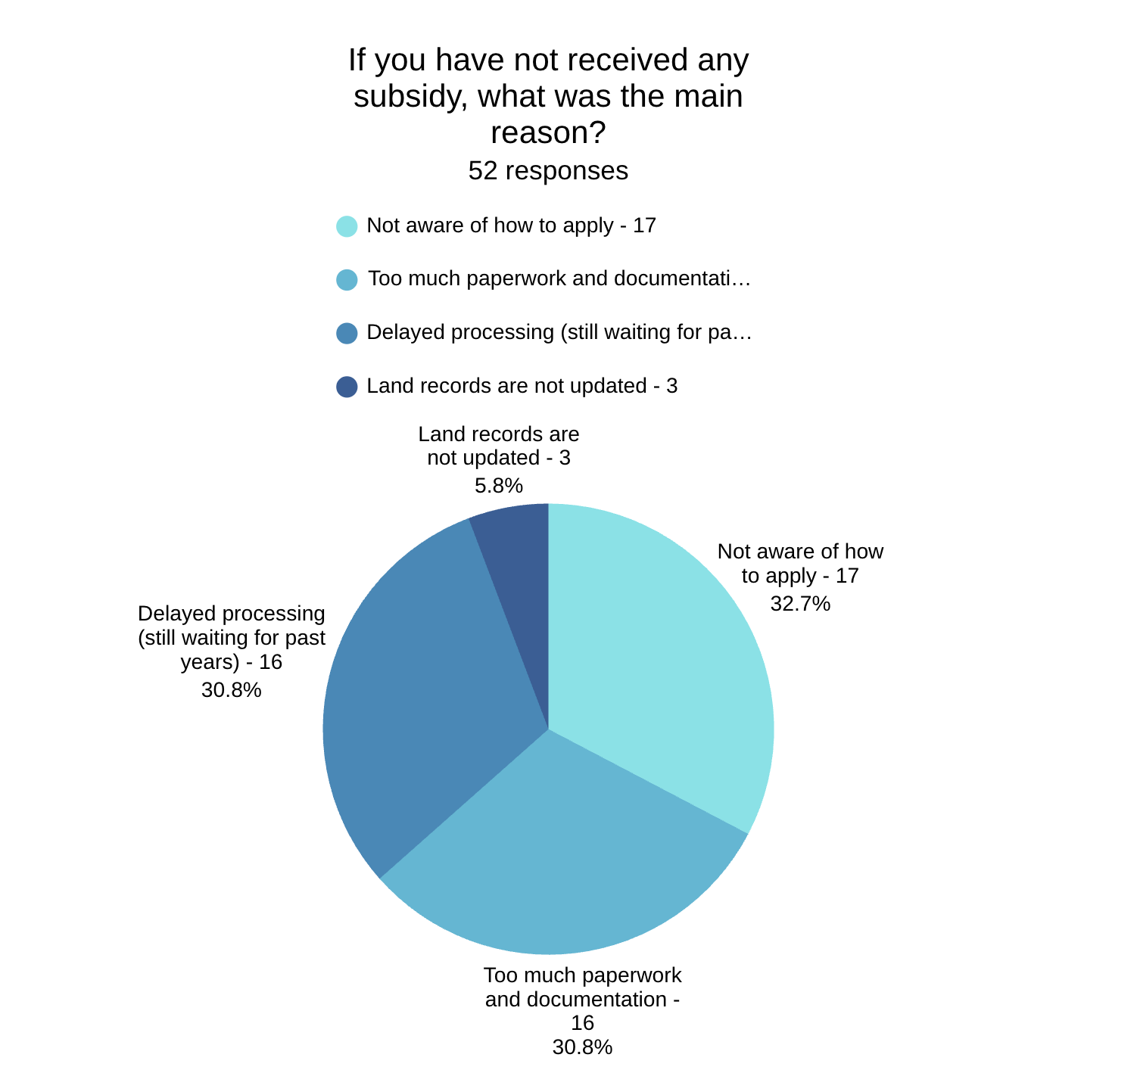

Figure 18- Reason for not receiving subsidy (Source - primary survey by the authors)

The most prevalent reason for why farmers have not received subsidies are because of lack of awareness on how to apply or the sheer amount of paper work to be done. Delayed processing of subsidies is also a major reason.

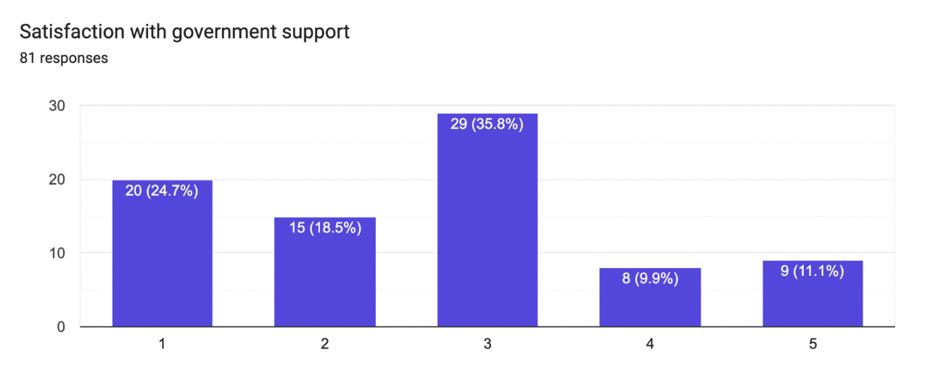Figure 19- Government support satisfaction(Source - primary survey by the authors)

The respondents are not overly satisfied with government support. More than ⅓ have rated their satisfaction a ⅗ while almost 24% have rated their satisfaction as a ⅕.

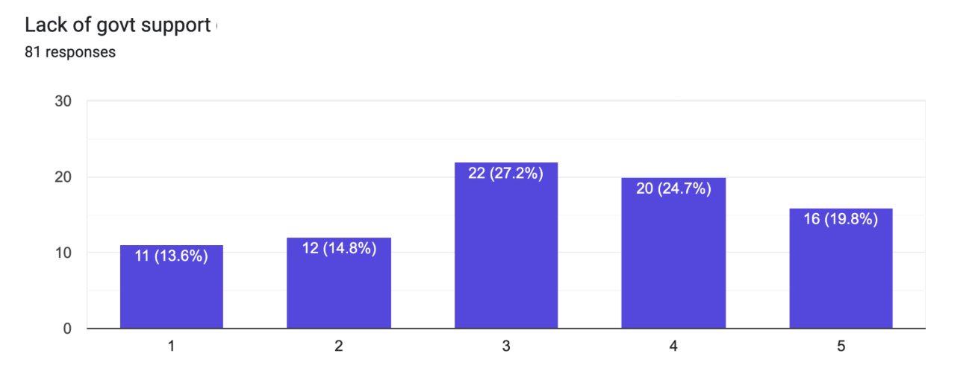
Figure 20- Lack of government support (Source - primary survey by the authors)

The intensity of the problem of lack of government support has seemingly varied from farmer to farmer. The responses are mostly scattered with most of the respondents voting ⅗ satisfaction with ⅘ right behind them.
The findings indicate that awareness of government schemes among rubber farmers is relatively high. However, a substantial proportion of respondents remain unaware of available benefits and support programmes, suggesting gaps in information dissemination.
The distribution of subsidy beneficiaries reveals that nearly half of the respondents have not received government assistance. This indicates that awareness alone does not guarantee access to benefits. Procedural complexities, inadequate guidance, documentation requirements, and delayed processing appear to hinder effective implementation. The responses regarding reasons for not receiving subsidies highlight administrative barriers as a major concern. Lack of awareness about application procedures, excessive paperwork, and delays in approval processes discourage farmers from accessing available support mechanisms. The satisfaction levels regarding government support are generally moderate. Most respondents rated their satisfaction at an average level, while a sizable proportion expressed dissatisfaction. This suggests that existing policies are providing some support but are not fully addressing the practical needs of cultivators.
Similarly, perceptions regarding inadequate government support varied across respondents, reflecting differences in individual experiences with government programmes. Overall, the findings suggest that while government interventions have contributed to supporting the sector, their effectiveness is constrained by implementation challenges, limited outreach, and bureaucratic hurdles. The results imply that strengthening extension services, simplifying subsidy procedures, improving awareness campaigns, and ensuring timely delivery of benefits could significantly enhance the effectiveness of government support for rubber farmers.

Conclusion
This paper deals with the economic state of rubber farmers, their future prospects and problems. The farmers of rubber in Kerala face a lot of difficulties in their trade. This study dives deeper into what specific problems they are facing. Constant dips in prices, high cost of production, and labour that is not only expensive but also hard to find, dissatisfaction with government support and lack of awareness are highly prevalent and important problems. Nowadays rubber cultivation is a challenge, with adequate support from government growers can manage the existing plantations and have a profitable trade. Awareness programmes for the youth to show them the importance of rubber cultivation and its profit possibilities are also important. In the end, the government should increase initiatives and understand the needs and problems faced by the farmers to effectively mitigate declining cultivation.

References -
Government of Kerala. (2022). Economic Review 2022. Kerala State Planning Board, Thiruvananthapuram. https://spb.kerala.gov.in/economic-review
Kerala State Planning Board. (2023). Economic Review 2023. Government of Kerala, Thiruvananthapuram. https://spb.kerala.gov.in/economic-review
As Indian rubber turns 120, northeast witnesses planting boom. (2022, December 10). The Week.https://www.theweek.in/theweek/business/2022/12/10/expansion-of-rubber-cultivation-in-north-east-india.html
Sinumon, T. G., & Mahalakshmi, K. (2020). A study on the problems faced by rubber growers in Kerala. International Journal of Management (IJM), 11(12), 4032–4038.
Anuja, A. R., Kar, A., Mathur, V. C., & Jha, G. K. (2012). Input delivery, processing and marketing of natural rubber: The role of producers' cooperatives in Kerala. Agricultural Economics Research Review, 25(Conf.), 379–386.
Sagging solidarity: There is a crisis facing Kerala's rubber producer societies. (2025, December 16).DowntoEarth.https://www.downtoearth.org.in/agriculture/sagging-solidarity-there-is-a-crisis-facing-keralas-rubber-producer-societies
LDF govt in Kerala hikes rubber subsidy ahead of election schedule release. (2024, March 16). RuralVoice.https://eng.ruralvoice.in/election-2024/hours-before-poll-schedule-announcement-ldf-govt-in-kerala-implements-revised-rubber-subsidy.html
George, G. P., & Sharma, H. O. (2020). Determinants of crop diversification in Kerala: A temporal analysis. Journal of Tropical Agriculture, 58(1). https://jtropag.kau.in/index.php/ojs2/article/view/882
Rubber Board of India. (2025). Indian Rubber Statistics. Ministry of Commerce and Industry, Government of India. https://rubberboard.gov.in/public
J Manag Res Anal. (2024). Cobweb phenomenon in rubber market of Kerala. Journal of Management Research and Analysis, 11(1). https://jmra.in/archive/volume/11/issue/1/article/16024
Nithin, et al. (2025). Comparative analysis of marketing channels for natural rubber in Kerala. Asian Journal of Agricultural Extension, Economics & Sociology, 13(6), 36–45.
Sinumon, T. G., & Mahalakshmi, K. (2020). A study on the problems faced by rubber growers in Kerala. International Journal of Management (IJM), 11(12), 4032–4038. https://iaeme.com/MasterAdmin/Journal_uploads/IJM/VOLUME_11_ISSUE_12/IJM_11_12_380.pdf
Anuja, A. R., Kar, A., Mathur, V. C., & Jha, G. K. (2012). Input delivery, processing and marketing of natural rubber: The role of producers' cooperatives in Kerala. Agricultural Economics Research Review, 25 (Conference Number), 379–386. https://www.researchgate.net/publication/265727417_Input_Delivery_Processing_and_Marketing_of_Natural_Rubber_The_Role_of_Producers'_Cooperatives_in_Kerala https://www.semanticscholar.org/paper/Input-Delivery%2C-Processing-and-Marketing-of-Natural-Anuja-Kar/9c8a122106ad07117b3bdb1efab2ea7c016f8d07

Comptroller and Auditor General of India (CAG). (2021). The Rubber Board: Performance audit on the development of rubber. Ministry of Commerce and Industry, Report No. 7. https://cag.gov.in/uploads/download_audit_report/2021/7_Chapter%203-061c1b9ccb340b8.29417418.pdf
Ali, O. P., & Manoj, P. K. (2018). Problems of rubber cultivators in Kerala: Some evidence from Ernakulam district. International Journal of Advanced and Innovative Research, 5(3), 107–116. https://www.researchgate.net/publication/379839637_Problems_of_Rubber_Cultivators_in_Kerala_Some_Evidence_from_Ernakulam_District
Mathew, S. (2022). An enquiry on the reasons for the fatigue of rubber cultivation in Kerala. SSRN Electronic Journal. https://papers.ssrn.com/sol3/papers.cfm?abstract_id=4068089
Sagging solidarity: There is a crisis facing Kerala's rubber producer societies. (2025, December 16). Down to Earth. https://www.downtoearth.org.in/agriculture/sagging-solidarity-there-is-a-crisis-facing-keralas-rubber-producer-societies
George, A., et al. (2023). An economic analysis of production and marketing of natural rubber in the midland plain regions of Kerala. Mysore Journal of Agricultural Sciences, 57(4), 25–34. https://www.uasbangalore.edu.in/images/2023-4th-Issue/3.pdf
Ali, O. P., & Manoj, P. K. (2020). Impact of falling price of rubber: A case study of Kothamangalam Taluk in Ernakulam District. Indian Journal of Economics and Development, 16(1), 118–124. https://doi.org/10.35716/ijed/19142
George, G. P., & Sharma, H. O. (2020). Determinants of crop diversification in Kerala: A temporal analysis. Journal of Tropical Agriculture, 58(1). https://jtropag.kau.in/index.php/ojs2/article/view/882
Pradeep, B., & Jacob, J. (2021). Kerala growers and their interest in rubber cultivation. Economic and Political Weekly, 56(34), 1–9. https://www.epw.in/engage/article/kerala-growers-and-their-interest-rubber
Rajasekharan, P., & Veeraputhran, S. (2002). Adoption of intercropping in rubber smallholdings in Kerala, India: A Tobit analysis. Agroforestry Systems, 56(1), 1–11. https://doi.org/10.1023/A:1021199928069
Blare, T., et al. (2022). Economic outcomes of rubber-based agroforestry systems: A systematic review and narrative synthesis. Agroforestry Systems, 96, 1015–1030. https://doi.org/10.1007/s10457-022-00734-x

