Review of Constant False Alarm Rate Algorithms in non-homogenous radar environments

Abstract
Many constant false alarm rate (CFAR) detection algorithms that have certain robustness for non-homogeneous clutter have been proposed. These algorithms can be classified into: Spatial CFAR, in which the threshold level is estimated by using the returns from the resolution cells, which are adjacent to the cell of interest. Temporal CFAR, in which the returns are gathered from previous scans in the same cell of interest to estimate the threshold value. Most of CFAR algorithms consider spatial CFAR, which uses the sliding-window CFAR technique, which slides in the reference cells in the period between two successive radar pulses. For the sliding-window technique, the set of reference cells comprises the neighbouring cells around the test cell in the range-Doppler (RD) map of the current radar scan. the spatial CFAR is classified into two groups: standalone CFAR, and combined CFAR. Based on the three radar field environments, the detection process formed the adaptive threshold required to detect the received radar cell signal. Many algorithms are used to design this adaptive threshold to satisfy a Constant False Alarm Rate (CFAR) according to the detection criteria used in the specified environment, in non-homogenous, homogenous, or multi-target environments.

Keywords—Clutter edge, adaptive thresholding, nonhomogeneous clutter, radar signal processing, hardware-efficient detection, multi-targets, Radar, algorithm, CFAR

- Introduction
In general, CFAR detectors produce the best performance when the background, such as thermal noise, is uniformly distributed. In practice, however, the received signal could contain unwanted background clutter such as land, rain, or sea clutter. The clutter could appear as a target in some cases, which makes target detection in the presence of background clutter more difficult. Therefore, it is important to understand the characteristics of the background clutter. The statistical model is one of the methods that are required for performance prediction, simulation, and design of the detection process [3]. Several methods and algorithms are used to deal with non-homogeneous and non-uniform environments. Rohling suggested ordered statistics (OS-CFAR); that idea was the beginning of many methods that are based on that algorithm [4], such as trimmed mean (TM-CFAR) and censored mean level detector (CMLD-CFAR).
Almost no CFAR algorithm deals with multi-targets inside the clutter cloud nor proposes this worst radar environment to happen. Although the algorithms yield good performance in a clutter-edge or multi-target environment, they require a robust algorithm to deal with this situation. A few of these algorithms may handle this situation at the expense of hardware complexity that requires high processing time, which also makes these algorithms unsuitable for real-time radar applications. The implementation of the combined CFAR methods as VI-CFAR requires complicated hardware and high processing time, making them unsuitable for real-time radar applications as well. For instance, VI-CFAR needs a circuit to test the environments’ statistics and a selection circuit between the three methods, in addition to the three CFAR implementing circuits (CA+GO+SO-CFARs). OS-CFAR which is the base of all new CFAR methods needs high processing time to place the samples in ascending order. The Censored mean level CFAR (CMLD-CFAR) [1] is suggested to improve OS-CFAR, wherein the largest ranked samples are discarded and the remaining samples are used for interference estimation [9]. However, the algorithm also uses the process of sample sorting from small to large to detect the largest samples to be subtracted and removed from background estimation, which means high processing time with complex hardware implement. The censored mean level detector CFAR was modified by Himonas [10] to improve its performance by suggesting new censoring procedures and constructing new algorithms. Also, in this method, it is not clear how to find a predetermined threshold used to censor the largest samples. Generalized censored mean level CFAR (GCMLD-CFAR) determines the number of interfering targets and censors their corresponding samples. It does not require any prior knowledge of the number of interfering targets and achieves robust performance. It splits the reference window into, for example, u and v, and censors the highest samples from u, and highest samples from v, and then take the average of the remaining samples. The algorithm of adaptive censored greatest-of CFAR (ACGO-CFAR) [11] has the same procedure as GCMLD but instead of taking the average of u and v, it will take Max (u, v).

- Problem statement.
A common assumption in most CFARs is that the statistics of the clutter or noise in the reference cells are known (usually taken to be Rayleigh), except for the scale factor. In many cases, however, the form of the clutter probability density function is not known. A non-parametric detector, also known as a distribution-free detector, is considered as a CFAR when the clutter statistics are not known. This situation is not taken into consideration when analysing CFAR algorithms since this environment seldom happens. While order statistics use the original values in order, rank-order statistics only use the ranks of the ordered observations. Therefore, the two statistics are quite different, even though they have similar labels. An example of rank-order statistics used with the nonparametric detector is the signed-rank test, which tests if the medians of the two samples are equal. Most rank-order statistics lead to non-parametric (distribution-free) procedures, while order statistics depend on the underlying population distribution.

- CFAR and Radar environments
The constant false alarm rate (CFAR) detectors are designed to avoid false detection, which could happen when using a fixed detection threshold. CFAR detectors estimate the statistics of the clutter to set a threshold varying adaptively with different background conditions. The adaptive threshold technique assumes that the probability density function of the noise is known except for a few unknown parameters. The surrounding reference cells are then used to estimate the unknown parameters, and the adaptive threshold value will be obtained by observing the noise or background clutter in the existence of the target. The threshold value is adjusted with the measured background. The threshold varies continuously according to the noise or the clutter environment found within a range interval surrounding the range cell under observation [1,2]. Adaptive threshold technique is based on the assumption that the probability density function of the noise is known except for a few unknown parameters. The surrounding reference cells are used to estimate the unknown parameters, and an adaptive threshold value will be obtained. From experimental data, the clutter backscattering coefficient (effective echoing area) can be modelled by the Rayleigh, exponential, or Weibull distribution or others depending on the type of clutter. If the clutter returns are Raleigh envelope distributed, and they are assumed to be identically distributed with the thermal noise, this constitutes the simplest clutter model. Sometimes the environment in which radar operates depends on factors that may yield statistically non-stationary signals with unknown variance at the receiver input. This non-homogeneous environment with clutter edges and non-uniform environments with unwanted multi-interfering target spikes needs a robust CFAR algorithm to deal with clutter edges and excise unwanted target spikes from the background noise estimation to achieve primary wanted target detection. Most of the CFAR algorithms consider spatial CFAR, which uses the sliding-window CFAR technique, which slides in the reference cells in the period between two successive radar pulses. For the sliding-window technique, the set of reference cells comprises the neighbouring cells around the test cell in the range-Doppler (RD) map of the current radar scan. Clutter-map CFAR can be combined with the sliding-window CFAR to give a better detection performance, and the spatial CFAR is classified into two groups: standalone CFAR and combined CFAR. To estimate the mean noise or clutter present in a specific range gate, other local range gates are used. Towards this end, most CFAR algorithms utilize a moving window. There are several components to the CFAR window. CUT is the range gate with which the mean noise or clutter is estimated and with which the threshold is set, while reference cells, or cells near CUT, are used to estimate the mean. Different CFAR algorithms utilize different mathematical estimations and make different decisions. Cell-averaging CFAR, for instance, takes the mean of the reference cells, while ordered-statistics CFAR orders the reference cells from smallest to largest to take the largest kth as the representative of the average noise. The CA-CFAR algorithm runs as follows:
- CA-CFAR estimates the unknown background power of the reference cell samples, assuming an independent and identical distribution of samples governed by Rayleigh and exponential PDFs.
- Compute the probability of detection and probability of false alarm.
- Compute the threshold multiplier from the probability of false alarm.
- Multiply the threshold with the samples’ power estimation, and the adaptive threshold is produced [3].
- Non homogeneous environments.
The presence of discontinuities in the background environment, such as that produced at the chaff or the clutter edges of the conventional cell-averaging (CA) CFAR detector, may cause the probability of false alarm to increase if CUT is immersed in the clutter region. On the other hand, when the test cell is in the clear region and a group of reference cells are in the clutter region, a masking effect results. Thus, depending on the location of the clutter edges, we want to choose the group of samples that are identically distributed with the noise in CUT to estimate the noise level correctly. If the test cell is in the clutter region and a clutter power transition is present in the reference window, the maximum of the sum of outputs of the leading and lagging range cells is chosen to represent the estimate of the noise level in the test cell. This yields the greatest-of-selection logic in the cell-averaging CFAR detector, which is referred to as the GO-CFAR detector. In the case where the test cell is in the clear region, the minimum of the sum of outputs of the leading and lagging range cells is chosen. This yields the smallest-of-selection logic in the cell-averaging CFAR detector, which is referred to as the SO-CFAR detector. The presence of interfering target returns in the reference window of the primary target causes the degradation of the probability of detection. Thus, assuming that several interfering targets are present in the leading or lagging range cells, the noise level estimate in the cell under test is chosen to be the minimum of the sum of outputs of the leading and lagging range cells (smallest-of-selection). There are some new methods to deal with non-homogeneous environments such as. The ordered data variability (ODV) CFAR and Maximum-likelihood (ML) CFAR for Weibull background also ACML-CFAR (adaptive censoring maximum-likelihood CFAR) detector is used in Weibull clutter as well as some older methods such as Excision-CFAR and Multi- step-CFAR, these methods will be discussed in details.
- ODV-CFAR.
. The ordered data variability (ODV) CFAR depends on the variability index (VI) to test the reference cell environment if it is homogeneous or not. VI is a second-order statistic that is a function of the estimated population mean and population variance [22]. To reduce the computational requirements associated with generating the VI statistic, the simplified statistic of VI is:
$VI=N\frac{\sum_{i=1}^{N}{{X_{i}}^{2}}}{{(\sum_{i=1}^{N}{X_{i})}}^{2}}$ (1)
Variability index (VI) is a homogeneity test statistic that offers good discriminating between homogeneous and non-homogeneous populations [21] [22]. The proposed CFAR detector based on ordered data variability (ODV) consists of the following two detection stages:
Stage 1: Decide if the whole reference cells, with which VI is computed, are homogeneous using the following hypothesis test:
VI ≤$K_{VI}$: Homogeneous
VI >$K_{VI}$: Non-homogeneous (2)
where $K_{VI}$ is a threshold.
Stage 2:
1) If the whole samples are declared to be homogeneous, taking T as the threshold multiplier, then a target is declared in the test cell if:
$X_{0 }>T_{N}\sum_{i=1}^{N}{X_{i}}$ (3)
2) If the whole samples are declared non-homogeneous, we order the whole samples and obtain the ordered samples as follows: {$X_{\left(1\right)}≤X_{\left(2\right)}≤….≤X_{\left(N\right)} \}$. Then, we divide the ordered samples into two groups:
$\left\{X_{\left(1\right)}≤X_{\left(2\right)}≤….≤X_{\left(j\right) }\right\}$, ${\{X}_{\left(j+1\right)}≤X_{\left(j+2\right)}≤….≤X_{\left(N\right)}\}$
Moreover, we assume that the samples within each group are relatively homogeneous and the samples in different groups are relatively non-homogeneous. Now we need to estimate the position of non-homogeneity. Eq. (2.69), show that if VI is smaller, the possibility that the samples are homogenous is increasing, so we compute:
$V\left(j\right)=j\frac{\sum_{i=1}^{j}{X_{\left(i\right)}^{2}}}{({\sum_{i=1}^{j}{X_{\left(i\right)}})}^{2}}$+ (N−j)$\frac{\sum_{i=j+1}^{N}{X_{\left(i\right)}^{2}}}{{\left(\sum_{i=j+1}^{N}{X_{\left(i\right)}}\right)}^{2}}$ (4)
where j=1, 2, ..., N −1, and then decide that k is the position of non-homogeneity.
Finally, a target is declared in the test cell if:
i)$X_{0}>T_{k}\sum_{i=1}^{k}{X_{\left(i\right)}}$, when k > N/2, or
ii)$X_{0}>T_{k}\sum_{i=k+1}^{N}{X_{\left(i\right)}}$, when k ≤ N/2
where T is the threshold multiplier. Therefore, ODV-CFAR dynamically switches to CA-CFAR, the smaller-ranked-cells CFAR, or the larger-ranked-cells CFAR depending on the outcome of the VI hypothesis test [21] [22].

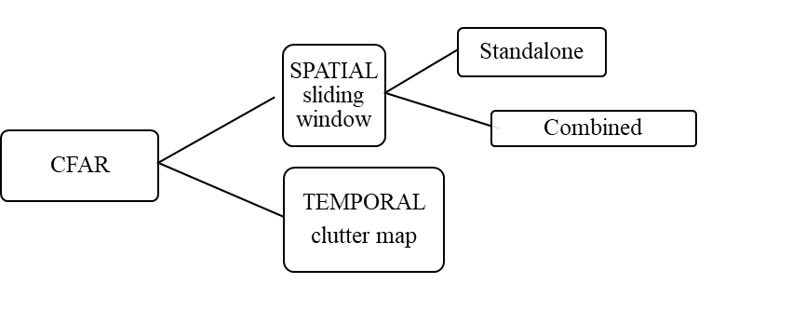
Figure 1: CFAR methods

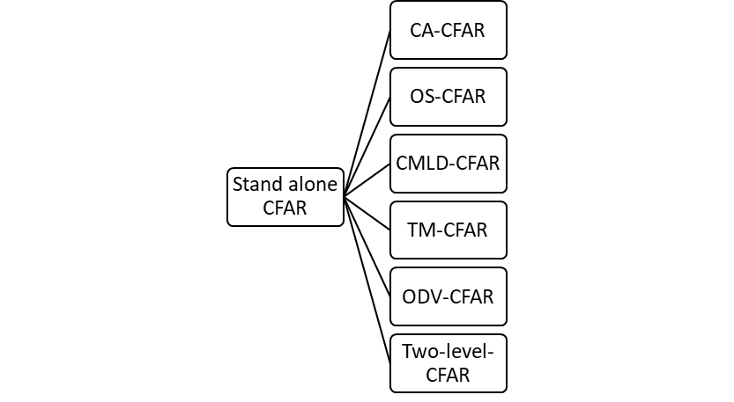
Figure 2: Standalone CFAR types
- Maximum-likelihood (ML) CFAR for Weibull background

This CFAR depends on Weibull PDF completely. The adaptive threshold of maximum-likelihood CFAR (ML-CFAR) is essentially based on the estimation of the scale parameter B and the shape parameter C of the Weibull distribution function as shown in Figure 2.21. There was a previous attempt to use either moment or ordered statistics but both techniques exhibited extensive CFAR loss. It has also been demonstrated that the loss is related to the variance of the estimated parameters [23]. To reduce the variance, and therefore the CFAR loss, a CFAR algorithm in which the parameters are estimated using maximum likelihood was developed. The maximum-likelihood (ML) algorithm is more computational-intensive than the other two approaches; however, modern processors may be able to handle the additional processing.
Figure 3: Maximum-likelihood (ML) CFAR

Even if not implemented, the expected performance of the ML algorithm can serve as a comparative reference for the simpler algorithms. Developing the ML-CFAR algorithm and analysing its performance would begin with the simple case in which the shape parameter is known, and proceeding to the case in which both parameters are unknown. For that general case, we will show that the maximum-likelihood (ML) CFAR’s threshold is implemented, as shown in Figure 2.21, by setting the adaptive threshold (T) according to:
$T=aα^{1/b}$ (5)
This essential equation gives the relationship between threshold T and the scale parameter a and shape parameter b [23]. It shows that when b decreases, then the threshold will increase, and vice versa, and this will help in constructing and understanding the exponential-based test model. When b=2, the Rayleigh PDF-based test model is constructed, and when b=1, the exponential PDF-based model is constructed, which is spikier than the Rayleigh PDF-based model.

- ACML-CFAR

A new ordered-statistics-based CFAR processor has been proposed by Qu et al [24]. ACML-CFAR (adaptive censoring maximum-likelihood CFAR) detector is used in Weibull clutter, as shown in Figure 2.22, it employs ordered data variability (ODV) to sensor several reference samples adaptively and then employ the rest to estimate the parameters of Weibull clutter, using the parameters to find the threshold. This method is more complicated than the original OS-CFAR and needs more processing time and hardware complexity but has more efficient background noise estimation and needs no prior knowledge of the number of interfering targets [5].
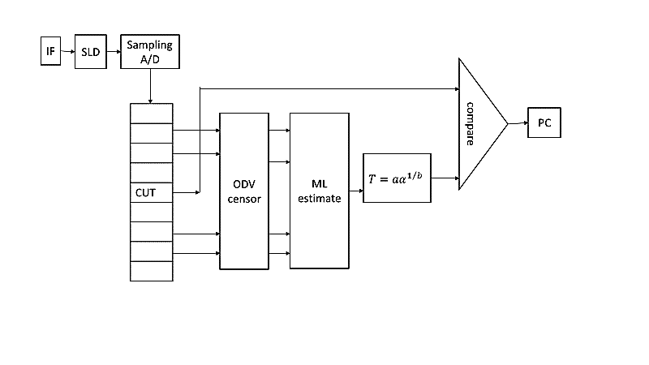
Figure 4: The Structure of the ACML-CFAR [24]

- Excision-CFAR
The excision CFAR detector is designed to detect signals in the presence of broadband noise and various strong interferers while keeping a constant false alarm rate. No prior knowledge of the nature of the interference is assumed [35].

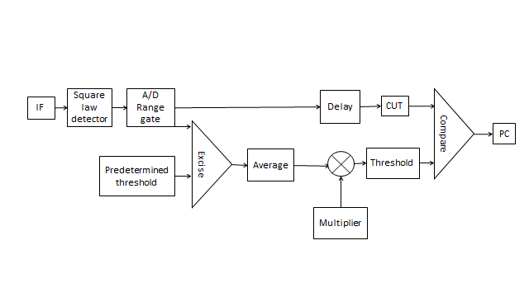
Figure 5: Excision-CFAR block diagram [35]

The received IF signal is applied to a square-law detector as shown in Figure 2.24, filtered, and then sampled. The set of samples is applied to an excisor which excises any sample that exceeds a predetermined threshold. The set of surviving samples at the excisor's output averaged [35]. The average value of the samples is multiplied by a predetermined detection coefficient and the result is used as a detection threshold. The design needs a timing circuit to synchronize the operations and also controller circuit to stop the shift register from receiving new data and to control the number of cells that enter the system and also, in this method there is no need for a sliding window [35]. Also, the excision CFAR detector is used in multipath fading mobile channels [36]. There are other methods like switching S-CFAR and adaptive switching AS-CFAR that used predetermined threshold by classifying the samples into two groups, first group for samples that did not pass the comparing with the threshold process, the second group for samples that pass the threshold comparison process, and the background estimation process depends on the number of samples in each group [37][38].
- Multi- step-CFAR
This This method is called sometimes censored cell average method CCA-CFAR in which the spike censored repeatedly until no spike is detected at the current cycle then the procedure terminated as shown in Figure 2.25.
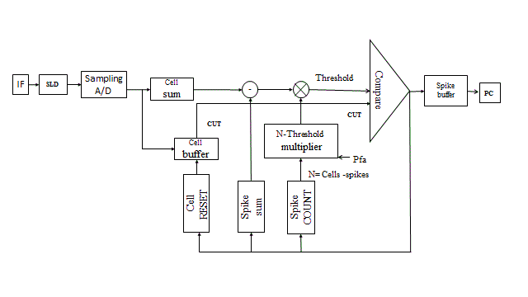
Figure 6: Multi-CFAR block diagram [38].
The block diagram shows that the design needs a timing circuit to synchronize the operations and also controller circuits to stop the shift register from receiving new data and to control the number of cells that enter the system and also, in this method there is no need for a sliding window [39][40].
- The Ordered-Statistics (OS) CFAR Theory
The order statistics of a random variable or random sample $z_{1}$, . . . , $z_{M}$ are the sample values placed in ascending order. They are denoted by$z_{1}≤z_{2}≤……….≤z_{k}≤…≤z_{M}$, these random variables denote the sample’s order statistics. The term order statistics refers to statistics that depend only on the order of the values. This algorithm is proposed for multi-target problems and needs prior knowledge of the number of targets expected. The algorithm contains two steps: the first step place the samples in ascending order of the reference cells as $z_{1}≤z_{2}≤……….≤z_{k}≤…≤z_{M}$ and the second step estimates the interference power as equal to the k^{th} sample in the ordered sequence [5][6].
As J = predetermined number of targets, M = total number of reference cells, and cells are ranked according to their input level, then the only condition for the OS-CFAR family to work properly is to choose the rank of the samples that is less than or equal to the result of subtracting the number of targets from the total number of reference cells:
K=M−J (2.53)
K is the rank of the cell whose input is selected to determine the threshold and if one chooses the rank of sample greater than k, the algorithm will fail. Taking $α$ as the multiplier factor, the threshold will be:
$Z_{T}=α*z_{k}$ (2.
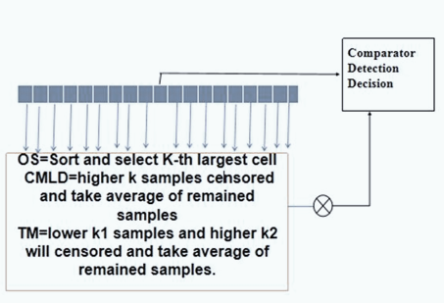

Figure 7: The development of OS-CFAR-based processors
Ordered-statistic (OS) CFAR was first used by Rohling [5], wherein the interference estimate is given by the amplitude of the k^{th}-ordered reference sample. This method uses the sorting-and-ranking process that needs long processing time and also needs a very complex hardware implementation. Therefore, we will see many methods that depend on the OS-CFAR algorithm could not be successfully implemented and expend high processing time. Two new OS-CFARs take the rank-and-sort process of each half of the reference window separately, therefore requiring only half the processing time of the original OS-CFAR. One is ordered-statistics greatest-of CFAR (OSGO-CFAR), while the other is ordered-statistics smallest-of CFAR (OSSO-CFAR) [7]. To overcome the problem of the high processing time of the sorting process in OS-CFAR, an anchor-based insertion sorting algorithm for OS-CFAR was proposed. This method work by control the sample that entered the reference window. The basic idea in this method is to control the process of shifting samples in the ordered reference window, since a new sample is inserted into the previously ordered reference window, samples whose value is larger than that of the new sample should move their position to make a room where the new sample would be placed [8].

- Testing model,
To test these methods, the radar environments will be created with models, and each algorithm will be applied separately to these models to examine the behavior of each of them in the worst radar environment and other environments. There are four factors of special importance when dealing with CFAR algorithms, as shown in Figure 3.5, which are the size of the window (M), multi-interfering targets, the closely spaced targets, and the clutter cloud length
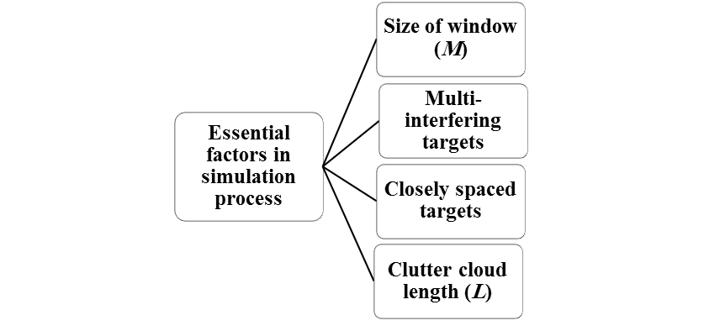
Figure 8: Essential factors in the simulation process
The entire 300 echo samples were generated by using MATLAB from Weibull CDF, represented by Eq. (3.1).
If x is the amplitude of the output voltage, the Weibull CDF is:
$Q\left(x\right)=1-e^{{\left(\frac{-x}{B}\right)}^{C}}$ (3.1)
The Weibull probability density function PDF (which is the derivative of CDF) is:
$p\left(x\right)=\left(\frac{C}{B}\right){\left(\frac{x}{B}\right)}^{C-1 }e^{({\frac{-x}{B})}^{C}}$ (3.2)
were, B = Scale parameter of Weibull distribution function
C = Shape parameter of Weibull distribution function
CFAR algorithm is tested by testing a model that is constructed from multi-targets that have different magnitudes, and to make the detection procedure more complicated than the other models, the multi-target is merged with a clutter cloud, and there are also closely separated targets that are located in different places. For more details, The testing model is constructed from multi-targets that have different magnitudes centered in the clutter cloud and there are closely spaced targets in different places. In detail, there are targets of magnitude 20 dB at the 40th, 25 dB at 50^{th,} and 15 dB at 45th and 55th cells; the clutter cloud with magnitude 20 dB starts from 100th to 200th cell position, which is centered by five closely spaced targets (two with 25 dB, two with 30 dB and one with 50 dB magnitudes); and there is one target of 25 dB magnitude at the 230th cell-centered between two targets of 15 dB magnitude at 225th and 235th cell locations, The test models assume that the cells of the reference window are independent and register the same statistics (usually assumed as Rayleigh PDF) since the samples were generated by using MATLAB from Weibull CDF. These samples have Weibull PDF at constant skewness (shape) parameter (which is usually taken equal to 2), and it is known from Eq. (3.2) that with skewness (shape) parameter equal to 2, the Weibull PDF will take the form of Rayleigh PDF, which was used in MATLAB. To make the third model spikier and more complicated, the model uses the exponential PDF instead of the Rayleigh PDF.

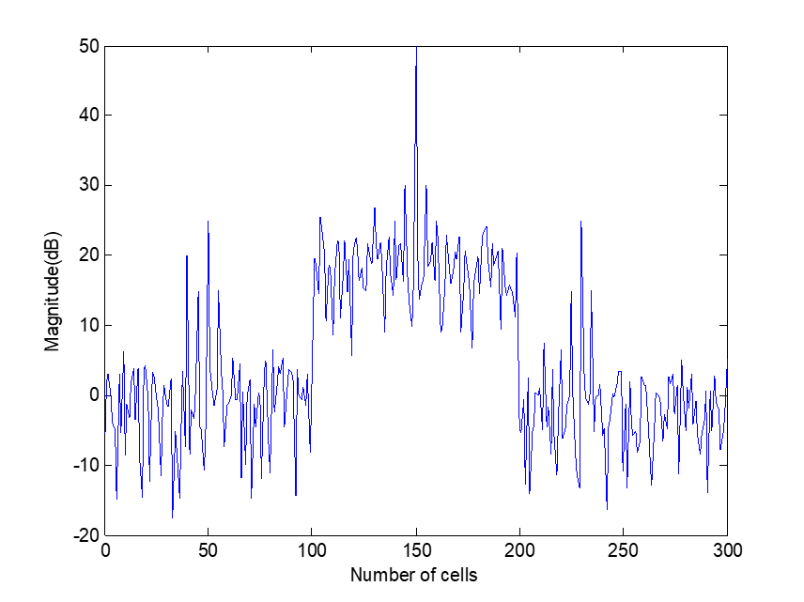
Figure 9: the test model

- Applying OS-CFAR on test model.
when OS-CFAR applied to the spiky exponential mode with M=32, P_{fa}=10⁻⁶, it detects most of the targets and dealt with the clutter cloud successfully.
When OSGO-CFAR was applied to spiky exponential PDF, with M=32, P_{fa}=10⁻⁶, its performance degraded suddenly and suffer from capture effect while the OS-CFAR a detect many targets and missed 4-small targets, as shown in Figure

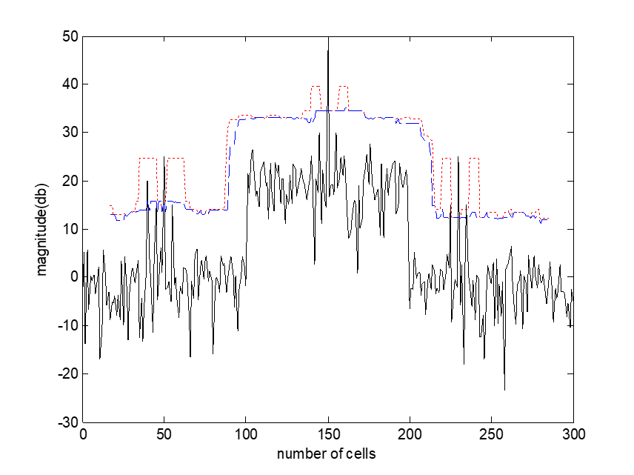
OSGO ….
OS---------
Echo _______

Figure 10: OS-CFAR family response

- Conclusion
CFAR algorithms consider the worst radar environments with multiple targets inside the clutter cloud to happen; therefore, it requires a robust algorithm to deal with this situation. It required a very complex algorithm for the worst radar environment that needed complex hardware with high processing time or used a two-stage censoring algorithm that made it not suitable for real-time applications. All of these algorithms may handle this situation at the expense of hardware complexity and high processing time that makes these algorithms unsuitable for real-time radar applications.
Among the well-known methods that deal with non-homogeneous and non-uniform radar environments are the combined CFARs, which use switching among the several methods and apply the suitable method after examining the environment type, for example, VI-CFAR as mentioned in previous work section [19][20]. Another is the two-level CFAR [44] that censors multi-targets in the first stage and then estimates the background noise from the remaining samples; since it uses a two-stage censoring algorithm, this CFAR, therefore, requires a more complex implementation for the worst radar environment, which makes it impractical for real-time applications. To find algorithms that can handle this situation without the expense of hardware complexity that needs high processing time, the idea of using spikes to find and subtract becomes necessary. Other suggestions are to use a neural network as a switching circuit between CFAR methods to improve CFAR performance in the nonhomogeneous environment [2] or use this method with a support vector machine as intelligent CFAR [2]. Also, in the military, it can be used for real-time decision-making in a war environment.
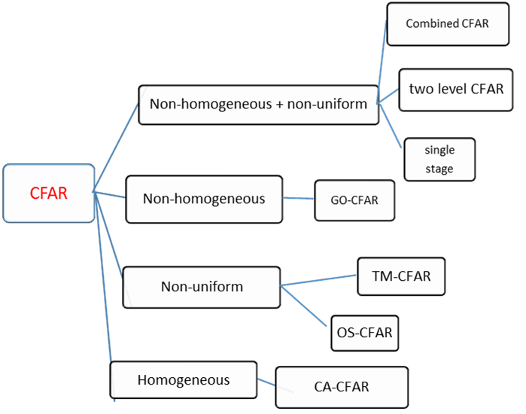
Figure 11: CFAR environments
REFERENCES
- M. I. Skolnik, Introduction to radar systems, 3rd edition. New York, McGraw-Hill, 2001.
- Kamal, M. S. (2024). Target detection circuit implementation for all radar environments. www.globalscientificjournal.com, volume12, issue 8, pp.1-12, Augst 2024. ISSN:2320-9186.
- F. Dario. “CA-CFAR detection performance in homogeneous Weibull clutter,” IEEE geoscience and remote sensing letters, vol. 16, no. 6, June 2019.
- R. Sor, “OS-CFAR based on thresholding approaches for target detection,” 2018 Fourth International Conference on Computing Communication Control and Automation, pp. 1–6, 2018.
- Yan, Z., Zhang, H., & Yan, B. (2026).” Detection and imaging of low-slow-small targets based on UAV-mounted millimeter-wave radar”. Results in Engineering, 30, 110089. https://doi.org/10.1016/j.rineng.2026.110089
- Kamal, M. S. (2023). Review of Radar Constant False Alarm Systems. International journal of scientific engineering and research (IJSER) 31-8-2023, Vol. 14, Issue 8.
- Lara, F., Moya, H., Tinoco, A., Lara-Cueva, R., Grijalva, F., & León, R. (2026). RUGRA: Design and implementation of a cost-effective radar processor for early warning radar. E-Prime – Nexus of Electrical, Electronic, and Intelligent Engineering, 17, 201160. https://doi.org/10.1016/j.eprime.2026.201160
- Reitz, P., Veihelmann, T., Franchi, N., & Lübke, M. (2025). Dual radar vision: A feature fusion approach for advanced object detection in IoT radar networks. https://doi.org/10.5281/zenodo.1

