
International Journal of Research and Scientific Innovation
An Open Access Peer Reviewed Journal, https://ijsri.org

TeamPilot : Managing Team Projects

Sandip Zadeª , Harsh Supeda^{b} , Harry Sompura^{b}, Durva Save^{d}

a Faculty ,Rajiv Gandhi Instutute Of Technology ,Mumbai- 400053
b,c,d Students, Rajiv Gandhi Instutute Of Technology ,Mumbai – 400053
Volume 01, Issue 01
April – 2026
E-ISSN: xxxx xxxx

ABSTRACT
TeamPilot, a full-stack, web-based project management and collaboration platform designed to facilitate seamless virtual teamwork, efficient project execution, and real-time communication. Built with modern web technologies including React.js for the frontend, Node.js and Express.js for the backend, and MongoDB for database management. TeamPilot provides a scalable, high-performance environment for distributed teams.
Keywords: Project Management System, Team Collaboration, Web-Based Application, Real-Time Communication

INTRODUCTION
In recent years, the rapid shift toward digital and remote work environments has significantly transformed how teams collaborate, communicate, and manage projects. Organizations increasingly rely on a variety of software tools to coordinate tasks, share information, and maintain productivity across geographically distributed teams. However, this reliance often results in fragmented workflows, where project management, communication, and collaboration functionalities are spread across multiple independent platforms. Such fragmentation not only increases operational complexity but also leads to inefficiencies, including delays in communication, lack of real-time synchronization, and increased dependency on third-party services. To address these challenges, there is a growing demand for integrated systems that can unify essential collaboration features into a single, cohesive platform. An ideal solution should provide seamless task management, real-time communication, and intelligent assistance while maintaining scalability, security, and ease of use. This need has led to the development of TeamPilot, a comprehensive collaboration platform designed to streamline team workflows by combining project tracking, instant messaging, video conferencing, and AI-driven support within a unified environment. TeamPilot leverages a modern full-stack JavaScript architecture to deliver high performance and real-time responsiveness. By integrating technologies such as React.js for dynamic user interfaces, Node.js and Express.js for backend processing, MongoDB for flexible data storage, and WebSockets for real-time communication, the platform ensures efficient data handling and synchronization across users. Additionally, the incorporation of WebRTC enables peer-to-peer audio and video communication without reliance on external services, while an AI-powered chatbot enhances user interaction through natural language processing and intelligent task

assistance.Through this integrated approach, TeamPilot aims to reduce the complexity of managing multiple tools, improve collaboration efficiency, and provide a scalable solution suitable for modern team environments.

RELATED WORK
The rapid evolution of digital technologies has significantly transformed project management practices, leading to the emergence of digitally integrated and collaborative environments. A comprehensive systematic review by Chen et al. (2025) highlights how digital transformation reshapes project workflows through the adoption of advanced technologies such as AI, cloud computing, and real-time analytics. The study identifies key research gaps and emphasizes the need for adaptive project management methodologies that can effectively respond to dynamic digital environments. Complementing this, Espiritu et al. (2024) present a case study on Project Management 4.0, focusing on remote collaboration. Their work examines the effectiveness of digital tools in managing distributed teams, while also addressing challenges such as communication barriers, productivity measurement, and coordination in virtual settings.

In the context of virtual teams, Bernat et al. (2023) provide a quantitative analysis demonstrating that stakeholder engagement and knowledge management play a crucial role in ensuring project success, particularly within hybrid and remote environments. Similarly, Swart et al. (2022) conduct a systematic review identifying critical success factors in digital collaboration, including trust, organizational culture, leadership, and effective communication tools. Their findings underline that while digital platforms enable collaboration, human and organizational factors remain central to achieving desired outcomes in project management.

In parallel, Chen and Li (2023) investigate database optimization strategies in NoSQL systems like MongoDB, focusing on indexing, query optimization, and efficient data modeling for large-scale applications. Together, these studies provide a strong technical foundation for developing scalable, secure, and efficient collaborative platforms such as TeamPilot.

SYSTEM ARCHITECTURE

TeamPilot is designed using a three-tier architecture combined with a modular approach to ensure scalability, maintainability, and efficient separation of concerns. This architectural model divides the system into distinct layers, each responsible for specific functionalities while working cohesively to deliver a seamless user experience. The Presentation Layer serves as the user interface of the system and is implemented using React.js. This layer is responsible for handling all user interactions, including dashboards, task views, project tracking interfaces, and communication panels. It provides a dynamic and responsive experience through component-based design and ensures smooth navigation across different sections of the application. The presentation layer communicates with the backend through RESTful APIs for standard operations such as data retrieval and updates, while WebSocket connections are used for real-time features like messaging, notifications, and live task synchronization.
The Application Layer acts as the core processing unit of TeamPilot and is developed using Node.js with the Express.js framework. This layer manages the business logic of the system, including task handling, project workflows, user authentication, and authorization mechanisms. It processes incoming requests from the frontend,

performs necessary computations, and interacts with the data layer to fetch or store information. Additionally, it integrates real-time communication services such as WebSockets (Socket.io) for instant updates and WebRTC for enabling peer-to-peer audio and video communication. This layer ensures that all system functionalities operate efficiently and securely.
The Data Layer is responsible for persistent data storage and management, utilizing MongoDB as the primary database. It stores structured and unstructured data such as user profiles, project details, task records, chat messages, and system logs in a flexible, document-oriented format. Mongoose is used as an Object Data Modeling (ODM) library to define schemas, enforce data validation, and simplify database interactions. This layer ensures data consistency, efficient querying, and scalability to handle large volumes of information.
In addition to the core layers, TeamPilot incorporates several supporting components to enhance functionality. The AI Service Module is responsible for chatbot operations and natural language processing, enabling intelligent user assistance and workflow automation. The Notification Service leverages WebSocket technology to deliver real-time alerts and updates, ensuring users remain informed about task changes and messages instantly. The Media Service utilizes WebRTC to manage audio and video communication, enabling seamless in-app virtual meetings without relying on external platforms.
Overall, this layered and modular architecture ensures that TeamPilot remains scalable, flexible, and efficient, while supporting real-time collaboration, secure data handling, and advanced features within a unified system.

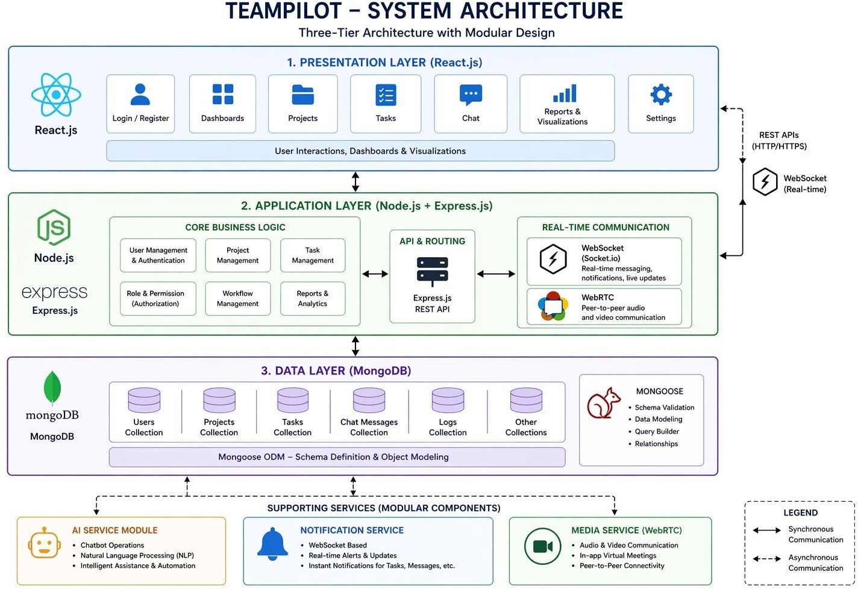
Fig. System Architecture

RESULTS AND DISCUSSION
TeamPilot demonstrated a high level of system reliability, performance efficiency, and functional correctness across all modules. A comprehensive set of test cases covering

authentication, task management, real-time communication, file handling, and AI-based interactions was executed. Core functionalities such as JWT-based login, task creation, WebSocket-driven real-time updates, chat messaging, and file uploads performed as expected, with accurate outputs and minimal latency. Integration testing confirmed seamless communication between the frontend, backend, and database, ensuring data consistency and stable system behavior.
The implementation of TeamPilot demonstrates notable improvements in managing projects, coordinating teams, and tracking tasks within a unified environment. The system successfully integrates core functionalities such as task creation, assignment, monitoring, and communication, enabling users to manage their workflows more efficiently. During evaluation, users were able to interact with the system in real time, which reduced manual errors commonly associated with traditional project management approaches. The responsive interface developed using React.js contributed to a smooth user experience, allowing seamless navigation across dashboards, task boards, and project views. Additionally, the three-tier architecture ensured stable system performance with minimal latency, even during multiple concurrent interactions, while the modular design supported flexibility and ease of future enhancements.

From a discussion perspective, the system effectively addresses key challenges in team collaboration and project monitoring by consolidating multiple functionalities into a single platform. This integration reduces reliance on external tools and enhances transparency in workflow management. However, certain limitations were identified during the analysis. The absence of a database restricts data persistence, making the system less suitable for long-term or large-scale applications. Furthermore, while the architecture supports modularity, scalability may be affected when handling a higher volume of users or data due to the lack of backend data management. Security is another aspect that requires improvement, as the current implementation provides only basic mechanisms and may not meet enterprise-level requirements.
Overall, the results indicate that TeamPilot serves as an effective lightweight solution for project management, particularly for small teams or academic purposes. With the incorporation of persistent storage, enhanced security features, and advanced capabilities such as analytics or AI-driven recommendations, the system can be further developed into a more robust and scalable platform suitable for real-world applications.

CONCLUSION
The development of TeamPilot, a full-stack, web-based project management and collaboration platform, successfully demonstrates the effective integration of modern web technologies, real-time communication mechanisms, and AI-driven automation to support seamless virtual teamwork. The system fulfills the primary objectives outlined during the design phase, namely, enabling distributed teams to collaborate efficiently, manage tasks intelligently, and maintain constant communication within a unified digital workspace. Through the combination of React.js for the frontend, Node.js and Express.js for backend services, and MongoDB for data persistence, TeamPilot achieves a high-performance, scalable, and modular architecture. The incorporation of

WebSockets enables instantaneous synchronization of data and updates across all connected clients, while WebRTC facilitates smooth peer-to-peer video and audio communication without dependency on external conferencing tools. The inclusion of a AI chatbot assistant further enhances user interaction by automating repetitive processes, offering contextual support, and simplifying navigation within the system.

ACKNOWLEDGEMENT
With all reverence, we thank Prof. Sandip Zade Department of Information Technology, Rajiv Gandhi Institute of Technology, Mumbai for continuous guidance, encouragement and inspiration throughout the course of this work.

REFERENCES
- Meta Platforms, Inc., “React – A JavaScript library for building user interfaces,” 2024. [Online].
Available: https://react.dev
- Node.js Foundation, “Node.js Documentation,” 2024. [Online]. Available: https://nodejs.org/en/docs
- MongoDB Inc., “MongoDB Documentation,” 2024. [Online]. Available: https://www.mongodb.com/docs
- Python Software Foundation, “Python Language Reference, Version 3.11,” 2024. [Online]. Available:
https://docs.python.org/3
- FastAPI Project, “FastAPI Documentation,” 2024. [Online]. Available: https://fastapi.tiangolo.com
- Atlassian Corporation Plc., “Trello – Collaborate, Manage Projects, and Reach New Productivity
Peaks,” 2024. [Online]. Available: https://trello.com
- Microsoft Corporation, “Microsoft Teams Documentation,” 2024. [Online]. Available: https://learn.microsoft.com/en-us/microsoftteams
- Asana, Inc., “Asana: Work on Big Ideas, Without the Busywork,” 2024. [Online]. Available:
https://asana.com
- I. Sommerville, Software Engineering, 10th ed., Pearson Education, 2016.
- R. S. Pressman and B. R. Maxim, Software Engineering: A Practitioner’s Approach, 9th ed., McGraw-Hill Education, 2020.
IEEE Computer Society, IEEE Standard for System and Software Requirements Specification (IEEE Std 830-1998), 2014.Hertzberg G., Spectra of diatomic molecules, Van Nostrand Reinhold Company, New York, (1950)
- Aksakalli, I. K.; Celik, T.; Can, A. B.; Tekinerdogan, B. “A ModelDriven Architecture for Automated
Deployment of Microservices.” Applied Sciences, 11(20), 9617 (2021).
- Petrangeli, Stefano; Pauwels, Dries; van der Hooft, Jeroen; Žiak, Matúš; Slowack, Jürgen; Wauters,
Tim; De Turck, Filip. “A Scalable WebRTCbased Framework for Remote Video Collaboration
Applications.” Multimedia Tools and Applications, (2018).
- Nakazato, Jin; Nakagawa, Kousuke; Itoh, Koki; Fontugne, Romain; Tsukada, Manabu; Esaki, Hiroshi.

“WebRTC over 5 G: A Study of Remote Collaboration QoS in Mobile Environment.”
Journal of Network
and Systems Management, 32(1), article 1 (2024).
- Mendes, Wendy; Richard, Albert; Tillo, TäheKai; Pinto, Gustavo; Gama, Kiev; Nolte, Alexander.
“Sociotechnical constraints and affordances of virtual collaboration – A study of four online hackathons.”
(2022).
- Gamage, Bashini J. “The Impact of Project Management in Virtual Environment: A Software Industry
Perspective.” (2016).
- Singh, N.; Hamid, Y.; Juneja, S.; et al. “Load Balancing and Service Discovery using Docker Swarm for
Microservicebased Big Data Applications.” Journal of Cloud Computing, 12, 4 (2023).
SpringerOpen.

--- *** ---

