“Innovative Approaches to Sustainability in Human Resource Management: A Review of Strategies, Challenges, and Future Directions”
Tanuja Tomer, Assistant Professor, School of Business Studies, Jigyasa University, Dehradun
Pulkit Tyagi, Assistant Professor, School of Business Studies, Jigyasa University, Dehradun
Abstract:
One of the most important factors influencing organizational sustainability in the rapidly changing field of sustainable business practices is human resource management, or HRM. Although previous studies have looked at specific facets of Sustainable HRM (S-HRM), there is still a lack of a thorough mapping of its conceptual framework. Using Multidimensional Scaling (MDS) and Latent Dirichlet Allocation (LDA) topic modelling, this study examines 784 academic publications to identify recurring themes and their structural connections. Green HR & Sustainability, Strategic HR Frameworks, Employee Behavior, Innovation & Manufacturing, and Leadership & Engagement are the five main pillars identified by the study. Green practices and leadership frameworks show a considerable convergence, according to the clustering analysis, while technology innovation and behavioural sustainability research are still rather different. The study offers an integrated multi-layered framework based on these discoveries, with leadership and engagement serving as behavioural catalysts, environmental and innovation results as strategic extensions, and strategic alignment as the foundation. This study promotes theoretical integration and identifies important interdisciplinary gaps for further research, especially in relation to digital transformation and global sustainability goals, by providing a methodical, data-driven roadmap of S-HRM scholarship.
Keywords: Sustainable Human Resource Management, Green HRM, Leadership, Topic Modelling, LDA, Multidimensional Scaling, Sustainability, Innovation, SDGs.
- Introduction
Sustainability has been a major concern for businesses all around the world in recent years. Businesses are realizing more and more how crucial it is to implement sustainable practices in order to solve environmental issues, satisfy stakeholders, and guarantee long-term profitability. Although environmental and operations management have historically been in charge of sustainability programs, human resource management (HRM) is increasingly being acknowledged as being essential to promoting sustainability in businesses. An organization's sustainability performance can be greatly impacted by HRM strategies, including hiring, training, performance management, and employee engagement (Abu-Mahfouz et al., 2023). Furthermore, HRM can stimulate innovation, ethical conduct, and cultural change—all of which are critical for creating long-lasting firms (Shahzad et al., 2023a).

Research that looks at creative ways to incorporate sustainability into HRM practices is still needed, even if the role of HRM in sustainability is becoming more widely acknowledged (Ullah, 2017a). By offering an extensive analysis of tactics, difficulties, and potential paths forward in sustainable HRM, this study aims to close this gap. The definition of sustainability in relation to HRM and the justification for implementing sustainable practices are presented at the beginning of the paper. After that, it looks at a number of methods for incorporating sustainability into HRM, including diversity and inclusion programs, ethical leadership, green HRM, and employee engagement.

The study then looks at the obstacles that organizations encounter when putting sustainable HRM strategies into practice, including cultural hurdles, resource limitations, and change aversion. The use of technology, data analytics, and the Sustainable Development Goals (SDGs) of the UN as frameworks for HRM practices are among the new trends and future directions in sustainable HRM that are covered in the paper's conclusion.

1.1Defining Sustainability in Human Resource Management
"Meeting the needs of the present without compromising the ability of future generations to meet their own needs" is the definition of sustainability (Ten Have & Gordijn, 2020). Sustainability in HRM refers to making sure that organizational procedures and activities are socially conscious, economically feasible, and environmentally sustainable (Herrera & de las Heras-Rosas, 2020). This covers a broad range of initiatives, including cutting carbon emissions, encouraging diversity in the workplace, bolstering employee wellbeing, and encouraging moral conduct. Sustainable human resource management acknowledges that businesses are linked to the environment and society, and that their decisions can have a significant impact on stakeholders and the earth (Mariappanadar, 2024).
Adopting sustainable HRM methods has several justifications. From a business standpoint, sustainability can result in lower expenses, a better reputation, and more staff satisfaction and output (Dangelico, 2015). Additionally, sustainable businesses are better able to draw in and keep top personnel, reduce risks, and take advantage of new market opportunities. Sustainable HRM supports environmental stewardship, social justice, and community well-being from a societal standpoint. Organizations can advance their long-term objectives and create shared value for stakeholders by coordinating HRM practices with sustainability goals (Karman, 2020).
- Discussion of Key Themes
To include sustainability into HRM procedures, a range of tactics can be used (Ullah, 2017b). These tactics can be modified to meet the particular requirements and conditions of every organization and are not exclusive of one another. Among the crucial tactics are:
  - Green HRM: According to Veerasamy et al. (2024), green HRM entails incorporating environmental factors into HRM procedures like hiring, training, performance reviews, and employee involvement. Initiatives to lower energy use, cut waste, and encourage environmentally friendly behavior among staff members may fall under this category. Green HRM seeks to match HR procedures with environmental goals and establish a sustainable culture inside the company (Shahzad et al., 2023b).
  - Ethical Leadership: Encouraging sustainability in enterprises requires ethical leadership. In their Behavior and decision-making, ethical leaders provide a good example for their staff by acting with honesty, openness, and responsibility (Dahiya et al., 2025). The interests of stakeholders are also given top priority by ethical leaders, who also take into account the moral ramifications of corporate actions on the environment and society.
  - Employee Engagement: In order to bring about significant change inside firms, it is imperative that employees be involved in sustainability projects. According to Yulianah et al. (2025), employee engagement entails giving workers the freedom to take part in decision-making, offering chances for learning and growth, and praising and rewarding sustainable conduct. Employee engagement increases the likelihood that they will adopt sustainability as one of their core principles and help the company reach its sustainability objectives.
  - Diversity and Inclusion: Encouraging diversity and inclusion is crucial to creating long-lasting companies that represent the interests and viewpoints of a varied workforce and community. Initiatives for diversity and inclusion seek to establish an inclusive, egalitarian, and respectful workplace where all staff members are encouraged to share their special skills and viewpoints (Tchamgop, 2025). Organizations may improve innovation, creativity, and decision-making while simultaneously advancing social justice and equality by cultivating diversity and inclusion.
  - Corporate Social Responsibility (CSR): According to Ardian Syah and Alnoor (2024), CSR is incorporating social and environmental factors into company operations and decision-making. By coordinating HR strategies with more general sustainability objectives, such lowering carbon emissions, fostering community development, and encouraging moral labour practices, sustainable HRM practices can assist CSR projects. CSR programs can improve an organization's standing with stakeholders, foster trust, and generate benefits for the environment and society as a whole (Yan et al., 2022).

- Challenges in Implementing Sustainable Human Resource Management Practices
Adopting sustainable HRM practices has numerous potential advantages, but there may be a number of obstacles that firms must overcome to put them into effect. Among the main difficulties are:

  - Resistance to Change: According to Ramadhani et al. (2024), resistance to change is a frequent obstacle to putting sustainable HRM strategies into reality. Workers may be hesitant to embrace new habits or routines, particularly if they believe that sustainability measures jeopardize their independence or job stability. Effective communication, stakeholder participation, and leadership support are necessary to overcome resistance to change (Lim et al., 2025).

  - Resource Constraints: Businesses may find it difficult to invest in sustainable HRM practices due to resource limitations, including a lack of funds, time, and experience. Due to their potential lack of resources and competence to carry out comprehensive sustainability measures, small and medium-sized firms (SMEs) may have particularly serious difficulties in this area (Martins et al., 2022). Prioritizing sustainability investments, utilizing outside alliances, and incorporating sustainability into essential business operations may be necessary to overcome resource limitations.

  - Cultural hurdles: Adoption of sustainable HRM methods may be hampered by cultural hurdles such opposing values, ignorance, and aversion to change. Efforts to encourage moral behavior and environmental stewardship may be hampered by organizational cultures that put short-term profits ahead of long-term sustainability (Alemu, 2025). It needs a supportive corporate culture that prioritizes sustainability, employee involvement, and leadership commitment to overcome cultural hurdles.

- Future Directions in Sustainable Human Resource Management
Notwithstanding the difficulties, there are a number of new developments and paths for sustainable HRM that present chances for businesses to improve their sustainability performance. Among the major trends are:

  - Technology Integration: According to Menon et al. (2024), integrating technology, such as artificial intelligence (AI), data analytics, and HR software, can improve the efficacy and efficiency of sustainable HRM. Technology can help with decision-making, virtual collaboration and communication, and the tracking and reporting of sustainability metrics.
  - Data Analytics: By offering insightful information about staff performance, preferences, and behaviour, data analytics can help businesses find ways to enhance their sustainability procedures (Bag et al., 2024). Organizations can create focused actions to lessen environmental effects and improve sustainability performance by examining data on energy use, trash production, and staff engagement.
  - United Nations Sustainable Development Goals (SDGs): According to Krannich and Reiser (2023), the SDGs offer a worldwide framework for tackling urgent social, economic, and environmental issues. By coordinating HR strategies with particular objectives, such as gender equality, decent work and economic growth, and climate action, sustainable HRM practices can help accomplish the SDGs (Vincent, 2025). Organizations can show their dedication to sustainability and support international initiatives to build a more equitable and sustainable society by incorporating the SDGs into HRM procedures.

- Methodology
This study used a bibliometric and text-mining approach to comprehend the state of Sustainable HRM research. A collection of 784 scholarly articles that concentrated on the relationship between innovation, sustainability, and human resource management was assembled.
  - Data Analysis Tool: Orange Data Mining, a visual programming tool for machine learning and data visualization, was used to perform the analysis. To assure data quality, the unstructured text data (titles and abstracts) was put through a preparation pipeline that includes lemmatization, tokenization, stop-word removal, and translation to lowercase.
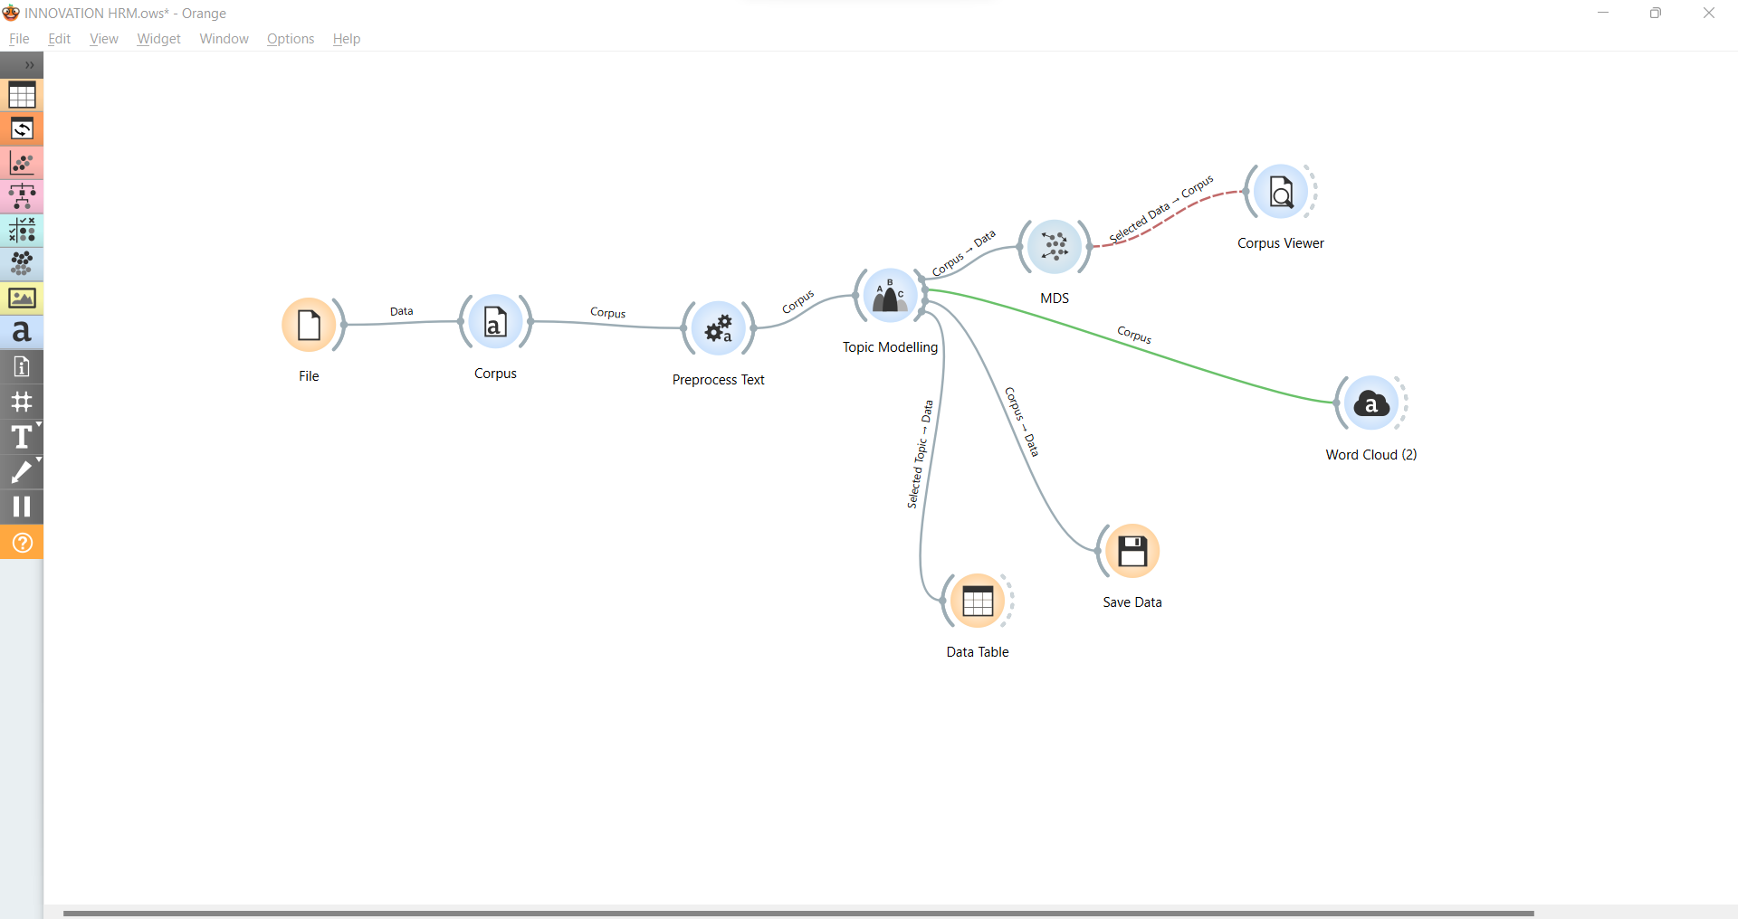
Figure 1: Orange Data Mining Process
  - Topic Modelling (LDA): To find underlying thematic structures in the corpus, we applied a generative statistical model called Latent Dirichlet Allocation (LDA). The model was set up to use keyword co-occurrence probabilities to detect five different subjects.
  - Visualization (MDS): Multidimensional Scaling (MDS) was used to show how these subjects relate to one another. This method made it possible to identify semantic clusters and "islands" of research concentration by projecting the high-dimensional topic data into a two-dimensional scatter plot.
6. Findings and Analysis: The 784 publications were effectively categorized into five different subject clusters using the LDA topic modelling process. Each topic was given the following label thanks to the examination of keyword probability scores:
Topic | Label | Key Term
Topic 1 | Green HR & Sustainability | Environmental initiatives, CSR
Topic 2 | Strategic HR Frameworks | Policy, strategy, goals
Topic 3 | Employee Behavior | Knowledge sharing, job satisfaction
Topic 4 | Innovation & Culture | Manufacturing, tech adoption
Topic 5 | Leadership & Engagement | Management style, employee engagement

Table 1: Identified Research Themes
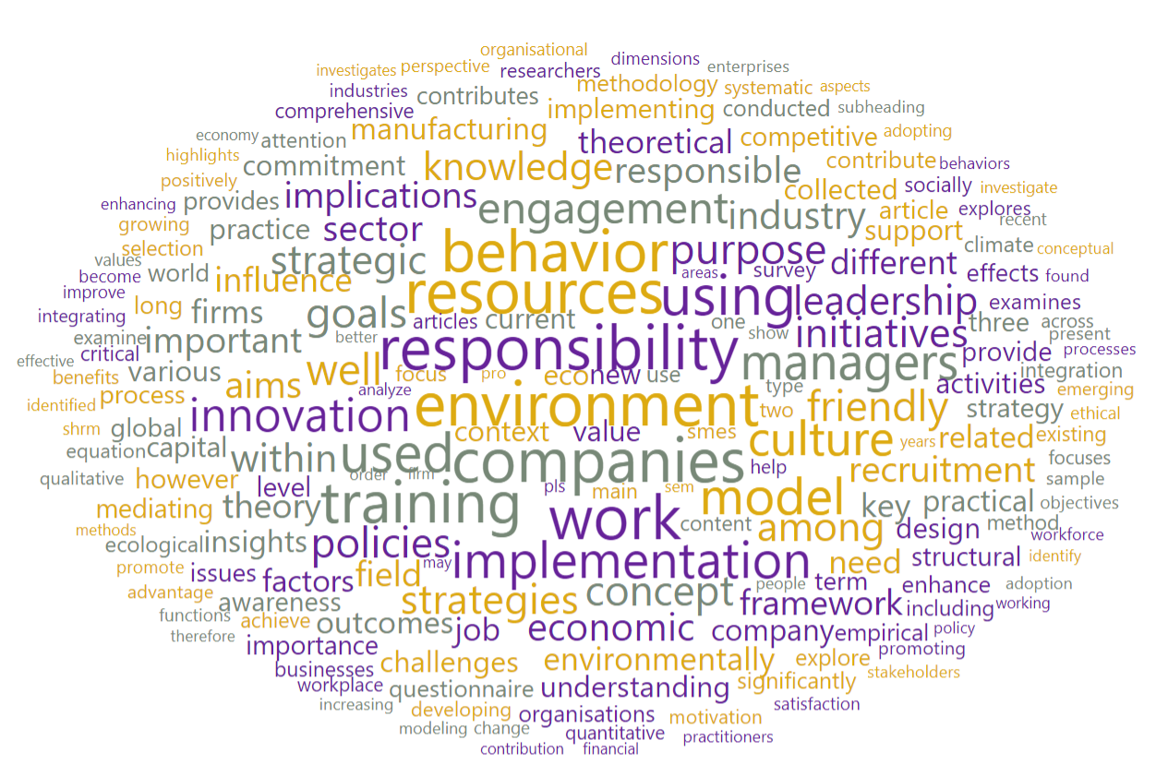
Figure 2: Word Cloud
6.1 Dominant Research Theme: Topic 1 (Green HR & Sustainability) is the most common theme in the present literature, according to a quantitative analysis of the "Dominant Topic" for each study. This demonstrates that environmental sustainability and "Green" practices are currently the main forces behind HR innovation.
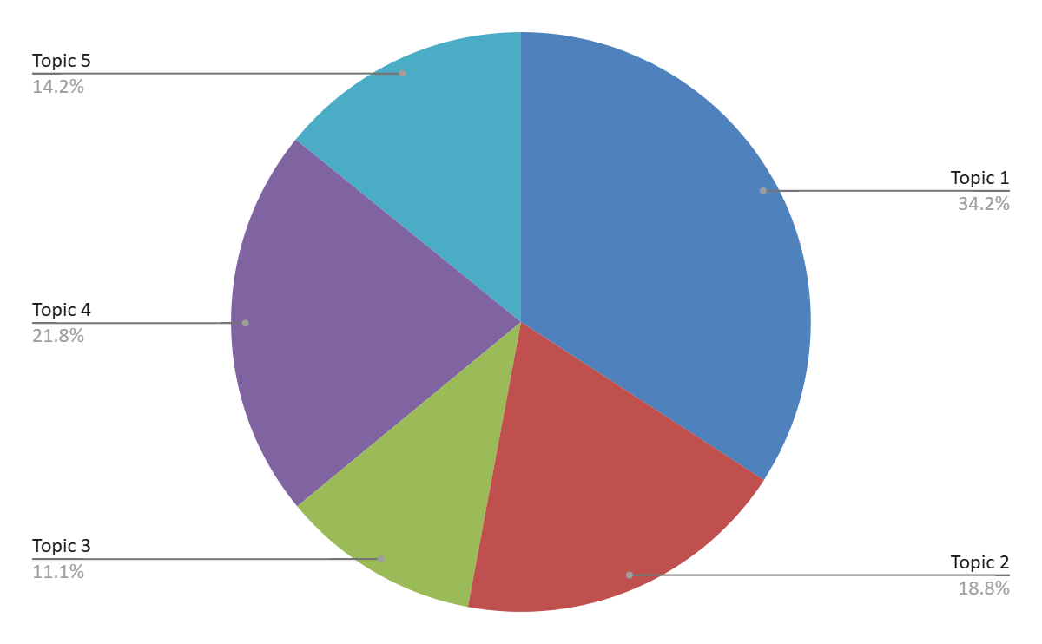
Figure 3: Commonality of Topics Across the analysed papers
6.2 Thematic Clustering through Multidimensional Scaling (MDS): Topic closeness based on probability distributions was visualized using Multidimensional Scaling (MDS) in order to investigate the structural linkages among the five themes that were found. Meaningful intellectual clustering within the field of Sustainable Human Resource Management (S-HRM) research is revealed by the resulting configuration.
The MDS map shows a substantial convergence between Leadership & Engagement (Topic 5) and Green HR & Sustainability (Topic 1), indicating that leadership-driven and engagement-oriented frameworks are increasingly being used to analyse environmental HR practices. Innovation & Manufacturing (Topic 4), on the other hand, seems to be more discrete, suggesting that research on technological sustainability is still somewhat isolated from behavioural HR discourse. Because it serves as a behavioural link between leadership initiatives and sustainability outcomes, employee behaviour (Topic 3) holds an intermediate position. In the meantime, Strategic HR Frameworks (Topic 2) serve as a structural anchor that connects operational sustainability practices with policy-level alignment.
All things considered, the clustering indicates that research on sustainable HRM is moving toward an integrated model where leadership-driven involvement is made possible by strategic alignment, which in turn promotes green initiatives and innovative results. Nonetheless, there are chances for more thorough multidisciplinary integration given the relative distance between behavioural sustainability and technology innovation.

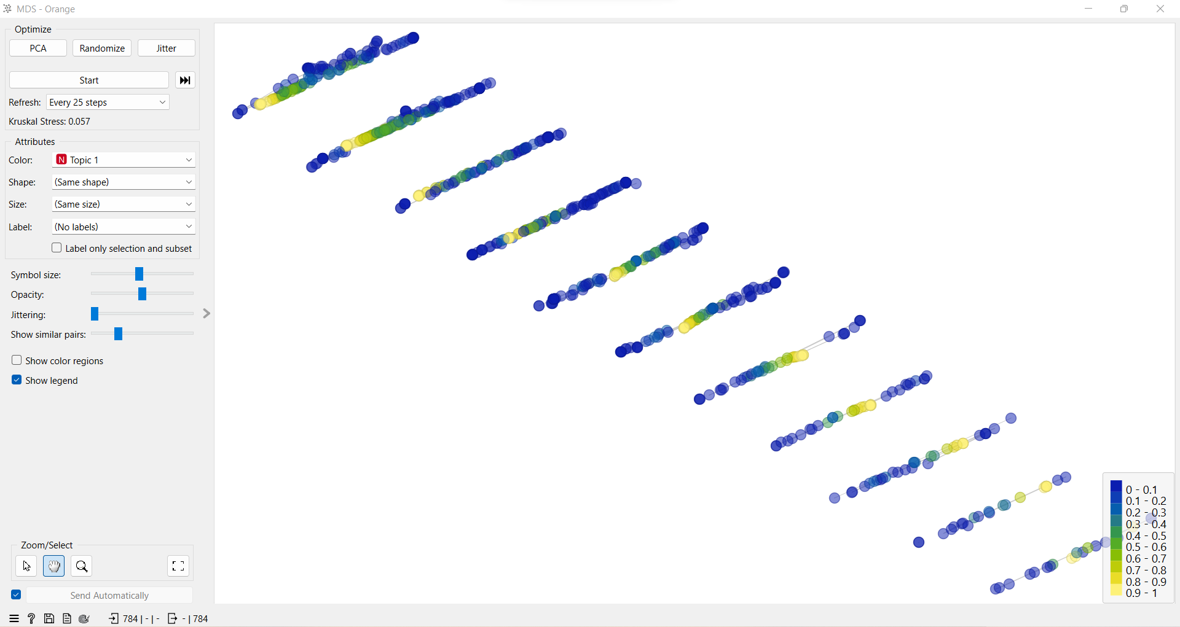
Topic 1: Sustainability & Green HR
Focuses on environmental activities that are included into HR procedures, including as eco-friendly hiring, training, CSR alignment, and employee conduct. In HR literature, it embodies the prevailing sustainability discourse.

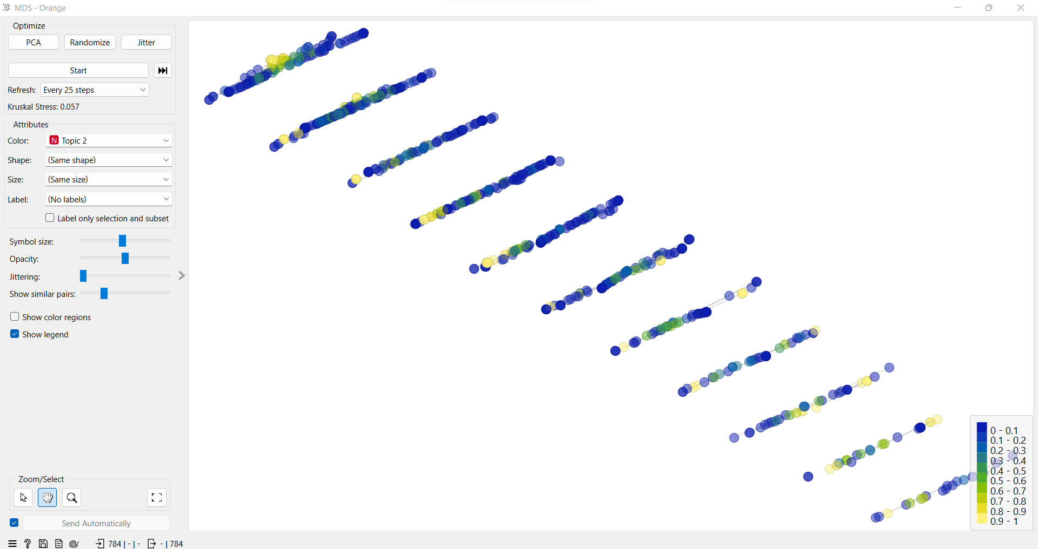
Topic 2: Strategic HR Frameworks
Focuses on long-term sustainability strategy, goal alignment, and policy integration in HR systems. It acts as the foundational layer enabling structured implementation of sustainable practices.
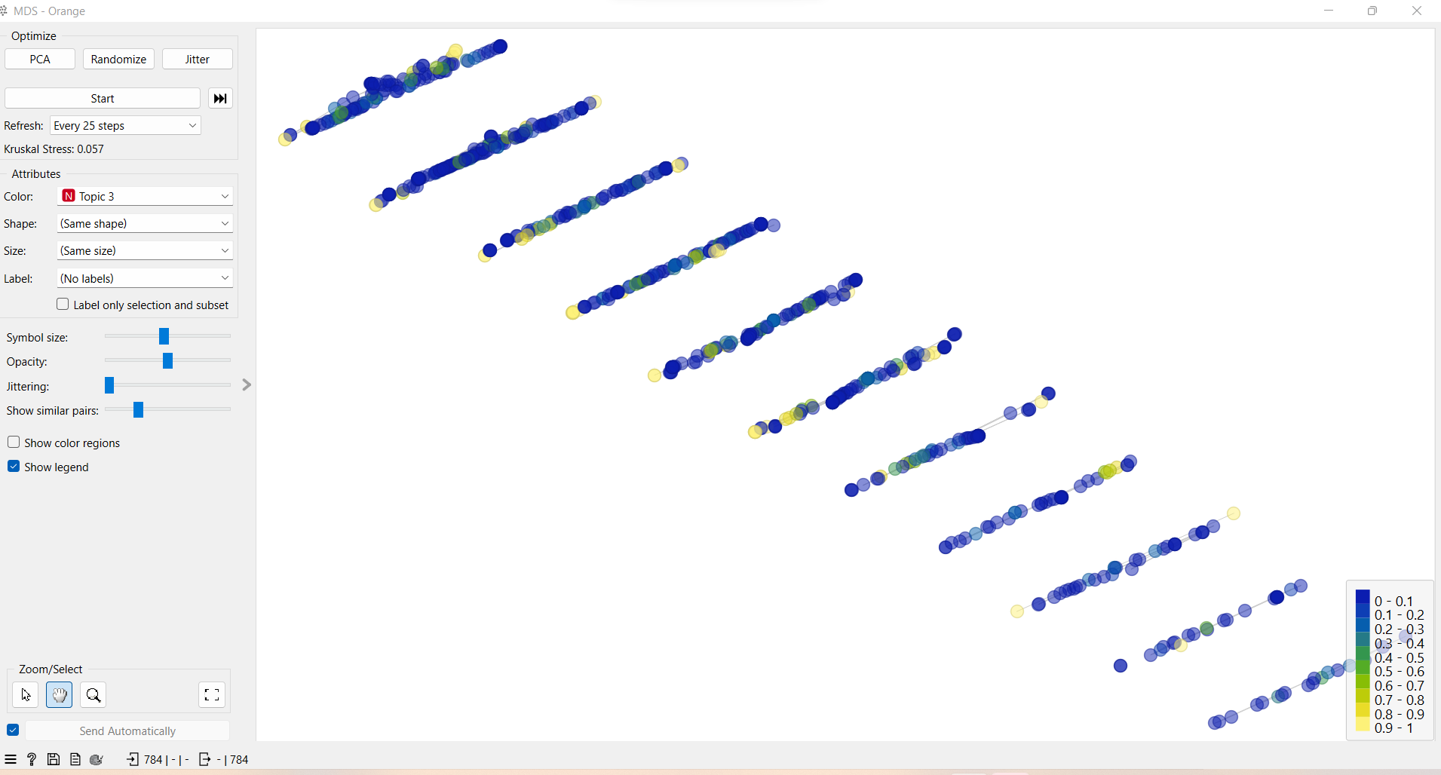
Topic 3: Knowledge Sharing & Employee Behavior
Focuses on pro-environmental behaviour, knowledge sharing, job happiness, and staff engagement. The human and psychological aspects of sustainability are emphasized in this theme.

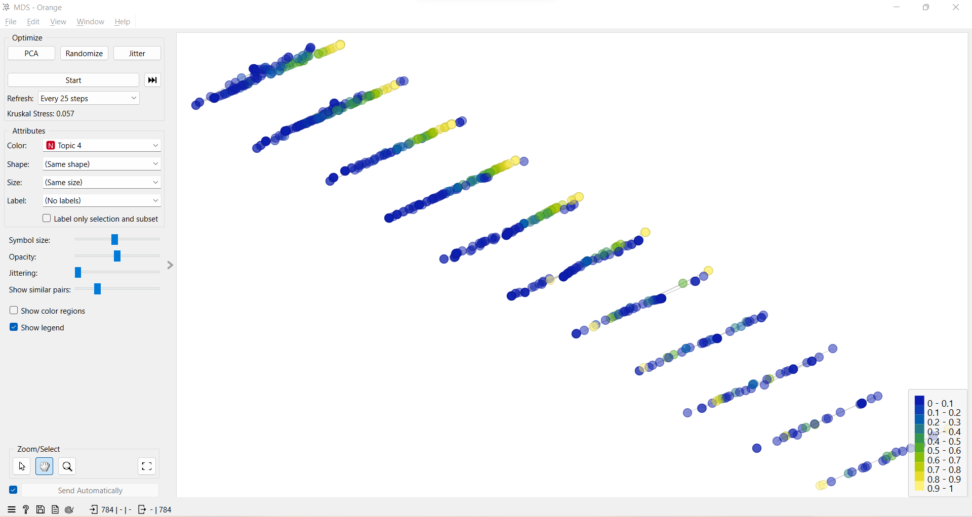
Topic 4: Manufacturing & Innovation
Focuses on Industry 4.0, technology adoption, and innovation driven by sustainability, especially in operational and production environments. The technology aspect of sustainable transformation is reflected in it.
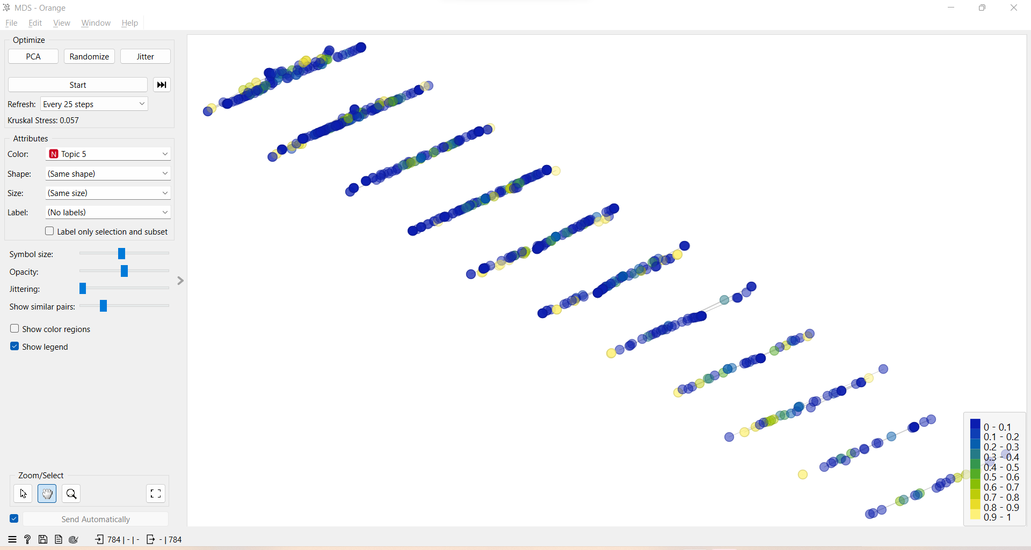
Topic 5: Engagement & Leadership
Investigates how employee engagement, transformational leadership, and ethical leadership affect sustainability performance. It links behavioural implementation with strategic vision.
6.3 Integrating Sustainable HRM Themes Conceptually
An integrated conceptual framework for Sustainable HRM study is shown in Figure 3, which is based on the MDS clustering results. Strategic HR Frameworks are positioned by the model as the fundamental layer that makes leadership-driven sustainability efforts possible. Innovation-oriented results and the adoption of Green HR practices are made possible by the behavioural accelerators that leadership and employee engagement provide. The framework shows how strategic aim, behavioural execution, and eventually environmental and technical innovation lead to sustainability in HRM. This integrated structure advances prior fragmented discussions by offering a multi-layered perspective of sustainable HRM aligned with global sustainability priorities.
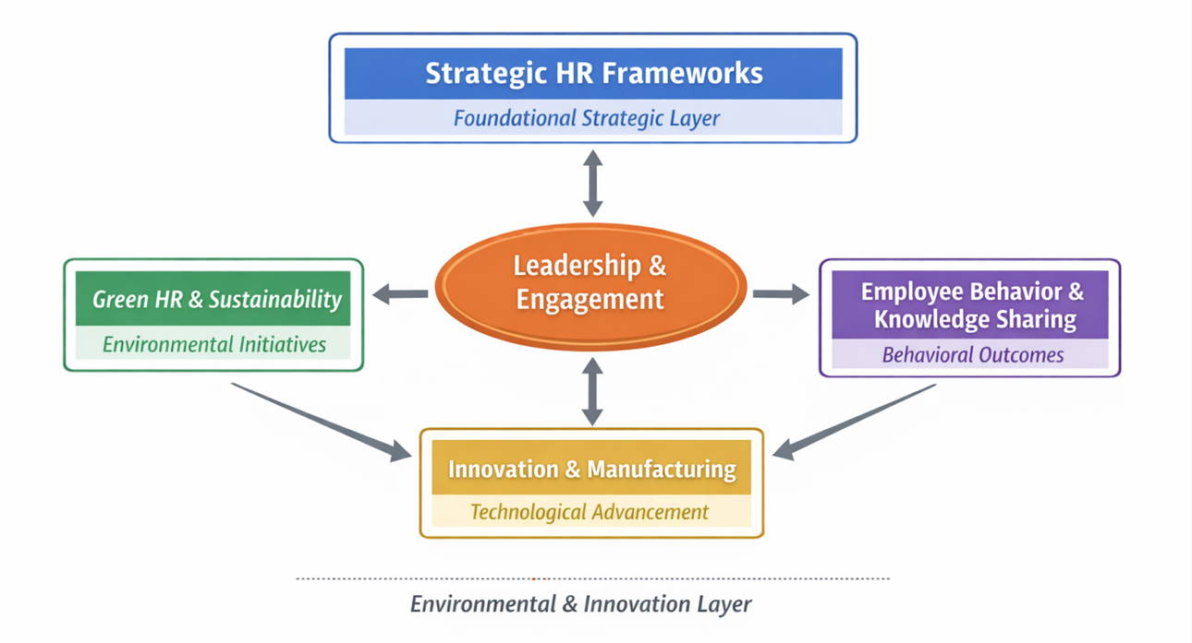
Figure 4: Integrating Sustainable HRM Theme
- Conclusion
Using LDA topic modelling and MDS visualization, this work analyses 784 academic publications to give a data-driven intellectual mapping of Sustainable Human Resource Management (S-HRM) research. Green HR & Sustainability, Strategic HR Frameworks, Employee Behavior, Innovation & Manufacturing, and Leadership & Engagement are the five main research pillars identified by the findings.

With a high convergence between Green HR practices and leadership theories, the clustering results show that current research on sustainable HRM is becoming more leadership-driven and environmentally focused. However, the proportional distance between technological innovation and behavioural sustainability indicates that there is still little multidisciplinary integration.

By viewing sustainable HRM as a multi-layered system where strategic alignment fosters employee engagement and leadership, which in turn spur environmental and innovative outcomes, the study adds to the body of previous work. This integrated viewpoint provides a formal understanding of how sustainability is incorporated into HRM scholarship, going beyond disjointed ideas.

Practically speaking, the results emphasize how crucial it is to coordinate leadership development, employee engagement programs, and HR strategy in order to attain significant sustainability performance. To improve sustainable results, organizations should prioritize leadership skills and digital transformation in addition to green policies.
Future studies should examine how digital analytics, behavioural sustainability models, and AI-enabled HR systems can be integrated, especially in light of global sustainability frameworks like the Sustainable Development Goals (SDGs) of the UN. It is still possible to advance theory and practice by bridging technology innovation with human-centered sustainability.

All things considered; by offering a methodical, data-driven path for further research and strategic implementation, this study adds to the expanding corpus of knowledge on sustainable HRM.

References:
Abu-Mahfouz, S., Abd Halim, M. S., Bahkia, A. S., Alias, N., & Tambi, A. M. (2023). Sustainable human resource management practices in organizational performance: The mediating impacts of knowledge management and work engagement. Journal of Entrepreneurship, Management and Innovation, 19(2), 57–97.
Alemu, B. A. (2025). Cultivating a culture of sustainability: the role of organizational values and leadership in driving sustainable practices. Business Ethics and Leadership, 9(1), 79–94.
Ardiansyah, M., & Alnoor, A. (2024). Integrating corporate social responsibility into business strategy: creating sustainable value. Involvement International Journal of Business, 1(1), 29–42.
Bag, S., Srivastava, G., Cherrafi, A., Ali, A., & Singh, R. K. (2024). Data‐driven insights for circular and sustainable food supply chains: an empirical exploration of big data and predictive analytics in enhancing social sustainability performance. Business Strategy and the Environment, 33(2), 1369–1396.
Dahiya, R., Selvakumar, P., Ahluwalia, G. K., Manjunath, T. C., & Anute, N. (2025). Ethical Leadership and Decision Making. In Advances in Ethical Work Climate and Employee Well-Being (pp. 45–66). IGI Global Scientific Publishing.
Dangelico, R. M. (2015). Improving firm environmental performance and reputation: The role of employee green teams. Business Strategy and the Environment, 24(8), 735–749.
Herrera, J., & de las Heras-Rosas, C. (2020). Corporate social responsibility and human resource management: Towards sustainable business organizations. Sustainability, 12(3), 841.
Karman, A. (2020). Understanding sustainable human resource management–organizational value linkages: The strength of the SHRM system. Human Systems Management, 39(1), 51–68.
Krannich, A.-L., & Reiser, D. (2023). United nations sustainable development goals 2030, the. In Encyclopaedia of sustainable management (pp. 3862–3867). Springer.
Lim, K., Bao, C., Li, Y., Wang, R., & Zhou, X. (2025). Managing resistance to change. In Future-proofing emerging technologies for business transformation (pp. 191–224). IGI Global Scientific Publishing.
Mariappan Adar, S. (2024). Sustainable Human Resource Management Strategies and Practices. Springer Books.
Martins, A., Branco, M. C., Melo, P. N., & Machado, C. (2022). Sustainability in small and medium-sized enterprises: A systematic literature review and future research agenda. Sustainability, 14(11), 6493.
Menon, S., Yadav, J., Chopra, A., & Thomas, J. (2024). Strategic integration of analytics and artificial intelligence in sustainable human resource management: Fostering HR excellence. 2024 11th International Conference on Reliability, Infocom Technologies and Optimization (Trends and Future Directions) (ICRITO), 1–5.
Ramadhani, W., Khuzaini, K., & Shaddiq, S. (2024). Resistance to change: Human resources issues in the implementation of Industry 4.0 technology. Proceeding: Islamic University of Kalimantan.
Shahzad, M. A., Jianguo, D., & Junaid, M. (2023a). Impact of green HRM practices on sustainable performance: mediating role of green innovation, green culture, and green employees’ behavior. Environmental Science and Pollution Research, 30(38), 88524–88547.
Shahzad, M. A., Jianguo, D., & Junaid, M. (2023b). Impact of green HRM practices on sustainable performance: mediating role of green innovation, green culture, and green employees’ behavior. Environmental Science and Pollution Research, 30(38), 88524–88547.
Tchamgop, D. (2025). Workplace diversity, inclusion and impact on employee satisfaction: how organizations promote diversity and inclusion in the workplace.
Ten Have, H., & Gordijn, B. (2020). Sustainability. Medicine, Health Care and Philosophy, 23(2), 153–154.
Ullah, M. M. (2017a). Integrating environmental sustainability into human resources management: A comprehensive review on green human resources management (Green HRM) Practices. Economics and Management, 6(1), 14–19.
Ullah, M. M. (2017b). Integrating environmental sustainability into human resources management: A comprehensive review on green human resources management (Green HRM) Practices. Economics and Management, 6(1), 14–19.
Veerasamy, U., Joseph, M. S., & Parayitam, S. (2024). Green human resource management and employee green behaviour: participation and involvement, and training and development as moderators. South Asian Journal of Human Resources Management, 11(2), 277–309.
Vincent, V. G. (2025). Building Inclusive and Sustainable Workplaces: HR Contribution to Gender Equality, Decent Work and Equity, Insights from Five Organizations.
Yan, X., Espinosa-Cristia, J. F., Kumari, K., & Cioca, L. I. (2022). Relationship between corporate social responsibility, organizational trust, and corporate reputation for sustainable performance. Sustainability, 14(14), 8737.
Yulianah, Y., Kuswara, G. B., Apriadi, D., Laelawati, K., & Sundari, A. (2025). Strategies to Increase Employee Engagement Through Employee Empowerment and Self-Development Programs. Jurnal Ekonomi, 14(04), 246–255.

