Mapping the Intellectual Structure of Halal Product Purchase Intention Research: A Bibliometric Analysis (2022–2026)

Abstract

Purpose – This research aims to examine the development of research on the intention to buy halal products in the period 2022-2026 by identifying the publications, authors, journals, organisations, countries, and thematic areas.
Design/approach/methodology – This study employs a bibliometric approach to examine research trends in halal product purchase intention. Data were retrieved from the Dimensions AI database, and 271 open-access journal articles published between 2022 and 2026 were selected based on predefined inclusion and exclusion criteria. The PRISMAS framework was used to guide the screening process.
Findings – The bibliometric results indicate that research on halal purchasing primarily focuses on the Theory of Planned Behaviour, halal awareness, halal certification, religiosity, trust, perceived value, and consumer behaviour.
Practical implication – This study identifies the leading research trends in the intention to buy halal products, as well as influential authors, institutions, countries, journals, keywords, and research themes. The findings provide researchers with a comprehensive overview of the intellectual structure and development of the field.
Originality/value – This study provides a comprehensive bibliometric evaluation of research on halal product purchase intention published between 2022 and 2026. It identifies the most influential authors, institutions, countries, keywords, and research themes, highlighting emerging trends and research gaps in the field.
Keywords: Purchase intention, halal products, Islamic marketing, consumer behaviour, bibliometric analysis, VOSviewer, and Dimensions AI.

- Introduction

The global halal industry has expanded beyond the traditional food sector to include cosmetics, pharmaceuticals, tourism, fashion, finance, and lifestyle products. This rapid expansion has attracted increasing scholarly attention, making halal product purchase intention one of the most extensively studied topics within Islamic marketing and consumer behaviour research. Numerous studies have examined the behavioural determinants of halal product purchase intention, highlighting the role of attitude, subjective norm, perceived behavioural control, halal awareness, trust, religiosity, and perceived value in shaping consumers’ purchase decisions (Wulandari et al., 2023; Irfany et al., 2023; Susilawati et al., 2023; Nora & Sriminarti, 2023; Koc et al., 2024). As the halal industry continues to evolve across diverse sectors and geographical contexts, understanding how this body of knowledge has developed has become increasingly important for identifying research trends, intellectual foundations, and future research opportunities.

At the same time, the rapid growth of digital platforms and social media has significantly transformed the way consumers interact with products, brands, and purchase decisions. Aji et al. (2020) demonstrate that social media marketing activities influence consumer engagement, electronic word of mouth (eWOM), brand perception, and purchase intention, highlighting the growing role of digital platforms in shaping consumer behaviour. Within the halal context, consumers' perceptions, trust, and purchase intent are increasingly formed by platforms such as TikTok, using influencers, brief videos, live streams, and user-generated content (Supriani et al., 2024). Consumer perceptions and behavioural intentions are significantly influenced by social media, consistent with research findings on electronic word of mouth (eWOM) and user-generated content (UGC) in the digital marketing sector (Wijaya et al., 2024). Recent research indicates that social media influencers considerably impact Muslim consumers' intentions to buy halal cosmetics through elements such as trust, credibility, religiosity, and social influence (Supriani et al., 2024).

The rapid digital transformation of markets has significantly reshaped consumer behaviour and the way halal products are promoted, evaluated, and purchased. Advanced in digital technologies, e-commerce, and social media have enabled consumers to access product information more easily, interact with brands, and exchange experiences through online communities. Research on the intention to purchase halal products has expanded beyond traditional behavioural determinants to examine the influence of digital marketing, electronic word of mouth, user-generated content trust, perceived value and social influence on consumers' purchase decisions (Irfany Irfany et al., 2023; Supriani et al., 2024; and Koc et al., 2024). Although purchase intention has expanded beyond traditional behavioural determinants, it now also examines the influence of digital marketing, electronic word of mouth, user-generated content trust, perceived value, and social influence on consumers' purchase decisions (Irfany Irfany et al., 2023; Supriani et al., 2024; and Koc et al., 2024). purchase intention has expanded beyond traditional behavioural determinants to examine the influence of digital marketing, electronic word of mouth, user-generated content trust, perceived value and social influence on consumers' purchase decisions (Irfany Irfany et al., 2023; Supriani et al., 2024; and Koc et al., 2024).

Moreover, participation in social media and digital marketing materials is increasingly influencing Generation Z's buying decisions in their halal buying process (Irfany et al., 2023). These trends indicate that digital platforms are becoming increasingly important for halal marketing and current Muslim consumers. Moreover, digital platforms can have multiple effects on geographic areas, consumer markets, and industries. Previous research on halal marketing has predominantly focused on halal awareness, religiosity, certification, and behavioural factors, and has not prioritised platform-specific environments such as TikTok or social media-related halal consumer behaviour, as observed in Supriani et al. (2024) and Koc et al. (2024).

Although research on halal product purchase intention has expanded considerably in recent years, the existing literature remains fragmented across different theories, product categories, geographical settings, and methodological approaches (Wulandari et al., 2023; Koc et al., 2024). Previous studies have primarily focused on identifying the behavioural determinants of halal purchase intention, including attitude, subjective norm, perceived behaviour control, religiosity, trust, halal awareness, and perceived value (Alam & Sayuti, 2011; Maichum et al., 2017; Bashir, 2019). The study of Synder (2019) generally adopted narrative or systematic literature review approaches by providing valuable syntheses of previous findings but offering limited insights into publication trends, collaboration networks, intellectual structures, and thematic evolution. In contrast, bibliometric analysis enables researchers to systematically map the intellectual structures of the research field, identify influential publications and collaboration networks, detect emerging research themes, and highlight future research opportunities (Donthu et al., 2021; Jamalova, 2024). Moreover, a comprehensive bibliometric analysis is needed to map the development of research on the intention to purchase halal products, identify existing knowledge gaps, and provide a foundation for future research.

Therefore, this study aims to provide a comprehensive bibliometric analysis of research on the intention to purchase halal products published between 2022 and 2026. This study employs biometric performance analysis and science mapping techniques to examine the intellectual structure of the field, focusing on publication trends, influential authors, institutions, countries, journal sources, collaboration networks, and thematic research clusters. Similar to a recent bibliometric study that has successfully mapped the evolution of technology adoption and consumer behaviour research (Jamalova, 2024), this study aims to provide a systematic overview of the development of halal product purchase intention research. This study contributes to the advancement of Islamic marketing and consumer behaviour literature by offering a comprehensive understanding of the development of halal product purchase intention research and providing valuable references for researchers, practitioners, and policymakers interested in the future direction of halal consumer research.

1.1 Research Questions

1. What is the level of interest in research in the years 2022-2026 that examines the intention to purchase halal products?
2. What are the main behavioural factors influencing the purchase of Islamic products within the framework of Islamic marketing and studies on halal consumer behaviour?
3. What are the main themes and research fields that are prevalent in the literature regarding the intention to purchase halal products, particularly in the contemporary digital and social environment?

2. Methodology

This study employed a bibliometric analysis approach to conduct a systematic review of the development of research on the intention to purchase Islamic products from 2022 to 2026. Bibliometric analysis is a standard approach used to analyse thematic structures, influential researchers, publication visibility, and intellectual connections in each research area. Pritchard (1969) defines bibliometrics as the application of statistical and quantitative methods to the analysis of bibliographic data, although this definition may not encompass all aspects of the field. Bibliometric analysis is a widely used approach to examine publication trends, leading authors, research themes, citation structures and the intellectual evolution of a particular field (Hassan et al., 2021). Moreover, bibliometric techniques enable researchers to explore, organise, and analyse large volumes of scientific literature, providing insights into the evolution of research, ongoing developments, and potential future directions (Lezama-Nicolás et al., 2018). Thus, bibliometric analysis is an appropriate method to systematically map the research landscape of halal product purchase intention.

This study only used the Dimensions AI database since it offers the following features: it offers reliable indexing, multidisciplinary coverage and scholarly publications which are accessible. The preliminary searches were conducted to broaden the literature coverage and avoid missing out on relevant studies to assess numerous combinations of Boolean searches, which included digital marketing and social media-related terms. The following terms were all added to keywords related to halal products and purchase intention: "digital marketing", "social media", "social networking sites", "TikTok" and "Instagram". Furthermore, different Boolean combinations were used to specifically focus on "TikTok" and "social media”. The results of these highly specific combinations were inconsistent and limited; however, they resulted in fewer than 50 relevant publications. The final search strategy was subsequently refined to further develop the previous search strategy, focusing on broader search terms related to halal purchase intentions and behavioural determinants.

This enhancement provided a more reliable bibliometric dataset and broader coverage of the literature. Ultimately, the Boolean search string was composed of terms that encompassed purchase intention, halal products, and behaviour determinants, including attitude, subjective norm, perceived behaviour control, perceived value, trust, religiosity, and halal awareness. These variables have frequently been associated with research on halal consumer behaviour and the Theory of Planned Behaviour (Zuhri et al., 2023; Koc et al., 2024). Extensive care was taken to design the inclusion criteria and to make sure that the publications chosen were relevant and of high quality. The analysis was limited to open-access journal articles that were published between 2022 and 2026.

Additionally, the study's scope was limited to the management sector to ensure alignment with consumer behaviour and Islamic marketing research. Therefore, books, book chapters, conference proceedings, and publications in languages other than English were explicitly excluded. A final dataset of 271 articles was selected for bibliometric analysis after the implementation of the inclusion and exclusion criteria. The study selection procedure concurred with the implementation of the PRISMA framework, which included identifying, screening, checking eligibility and inclusion. At the beginning, 527 documents were retrieved from the database.

The screening and eligibility process included only publications from the selected period, studies that were not eligible for inclusion and non-article documents. Finally, 271 journal articles were selected for analysis. Using VOSviewer, the collected data were analysed in terms of performance, bibliographic and co-citation analyses and co-word analyses. The aim of these analyses was to identify influential publications, journals, authors, organisations, countries, dominant keywords, and thematic research clusters in the literature on halal product buying intentions. Bibliometric mapping, in general, provides a comprehensive picture of the intellectual structure and thematic development of Islamic marketing research and halal consumer behaviour.

3. Results and Discussion

3.1 Search Strategy
Table 1. Inclusion criteria for bibliometric analysis

Dimensions AI Database | ALL
Search Keywords | ("Purchase Intention" OR "Buying Intention" OR " Consumer Intention" OR "Purchase behaviour") AND ("Halal Product" OR "Halal Products" OR "Islamic Product" OR "Halal Food" OR "Halal Cosmetics" OR "Halal Consumption") AND ("Attitude" OR "Subjective Norm" OR "Perceived Behavioural Control" OR "Perceived Behavioral Control") OR "Perceived Value" OR "Trust" OR "Religiosity" OR "Halal Awareness")
Publication Year | 2022-2026
Publication Type | Article
Open Access | All OA
Fields of Research | Management

The inclusion criteria are described in Table 1 and were chosen to ensure that the studies were of high quality and relevant. Data from the Dimensions AI database were extracted using keywords related to purchase intention, halal products and behavioural factors (trust, religiosity, perceived value, perceived behavioural control, subjective norm, and halal awareness). The analysis was limited to journal articles and studies published between 2022 and 2026. Additionally, to ensure consistency with consumer behaviour and Islamic marketing research, management was selected as the object of study. All the selected publications were based on attitudes, subjective norms, perceived behavioural control, and perceived value.

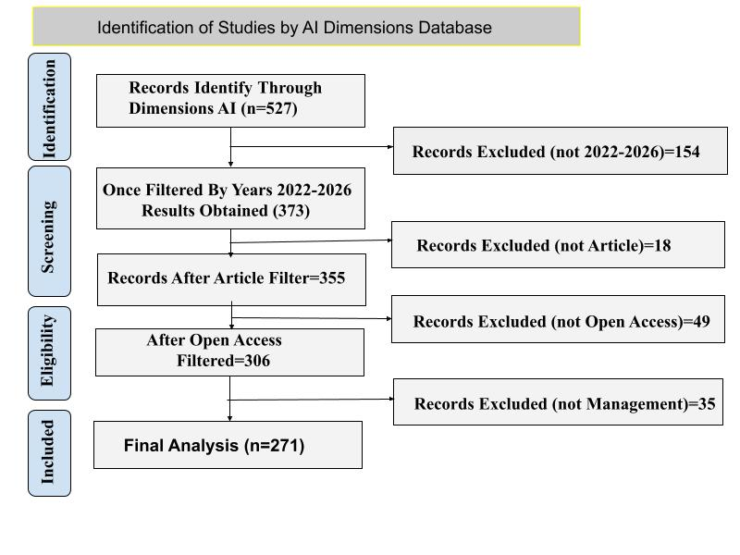
Figure 1. PRISMAS Flowchart
The PRISMA flowchart (Figure 1) shows the systematic procedure we used to identify, screen, and select studies for this bibliometric analysis. To perform identification, the pre-defined search strategy was used to fetch 527 records from the Dimensions AI database. In sifting, we did not include documents published from 2022 to 2026 and non-article
publications. The remaining studies were then evaluated in the eligibility stage according to predetermined inclusion criteria, such as studies classified under the management area and open-access studies. Studies that did not meet these criteria were excluded from the data set. During the last step of inclusion, 271 articles were chosen for bibliometric analysis. A systematic filtering procedure ensured that only relevant, accessible and methodologically consistent studies were included to enhance the reliability, transparency and quality of the bibliometric analysis.

3.2 Results
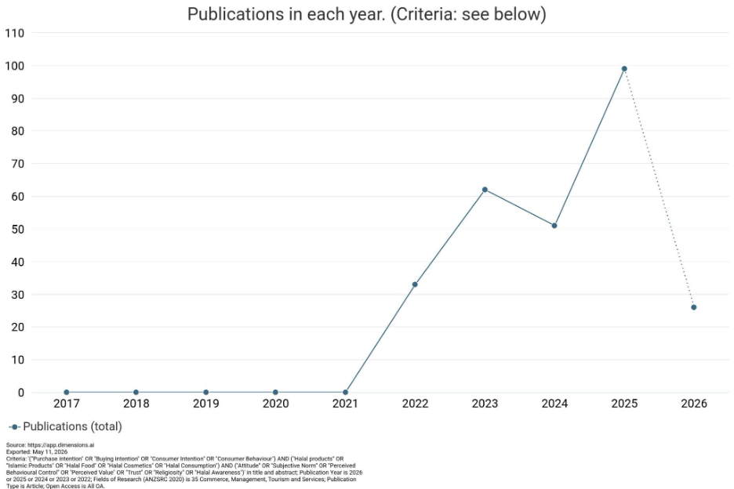
Figure 2. Publication and citation trends (2022–2026)

The Dimensions AI database data illustrates the trend analysis (Fig. 2) that shows the expansion of this research on the consumption of Islamic products over time. A total of 271 publications were analysed, with an average citation score of 2.50. The findings show a significant rise in the number of publications and citations from 2022 to 2025, reflecting a growing interest in Islamic marketing research and the study of halal consumer behaviour. With the rise in publications, this trend means that other factors such as religiosity, halal awareness, trust, and attitudes of consumers are now growing in importance when considering the factors that affect halal purchase intention. Moreover, the increased number of citations reflects a growing academic awareness of the research in this discipline and its influence. This discrepancy may be explained by the lower number of index publications in 2026 during the data retrieval period. This trend analysis shows that research on halal purchase intention is becoming increasingly important and continues to develop in the context of Islamic marketing.
3.3 Publication and citation trends

3.3.1 Performance Analysis by Documents
Table 2. Document-based performance analysis (Threshold = 58)

Rank | Authors | Title | Citations
1 | Pratama et al. (2023) | The effect of halal brand awareness on purchase intention in Indonesia: the mediating role of attitude | 60
2 | Koc et al. (2024) | The effects of trust and religiosity on halal products purchase intention: indirect effect of attitude | 50
3 | Yudha et al. (2024) | The Moderating Effect of Religiosity on Fashion Uniqueness and Consciousness in Halal Fashion Purchase | 40
4 | Karyani et al. (2024) | Intention to adopt a blockchain-based halal certification: Indonesian consumers' and regulatory perspectives | 37
5 | Yener (2022) | The effects of halal certification and product features on consumer behaviour: A scenario-based experiment | 26
6 | Nora & Sriminarti  (2023) | The Determinants of Purchase Intention Halal Products: The Moderating Role of Religiosity | 21
7 | Pradana et al. (2024) | Measuring Indonesian young consumers’ halal purchase intention of foreign-branded food products | 21
8 | Ramadhanti & Marsasi (2023) | The Influence of Attitudes and Halal Perceptions on Intention to Visit Halal Tourism Destinations | 13
9 | Susilawati et al. (2023) | The Influence of Religiosity and Halal Labelling on Purchase Intention of Non-Food Halal Products | 13
10 | Alimusaet et al. (2024) | Factors Determining Indonesian Muslim Behaviour in Purchasing Halal Food: A Preliminary Study | 12

The document-based performance analysis determines the most influential studies by counting the number of citations that the document received (citation count: 58). The study by Pratama, Hamidi, and Cahyono (2023) was the most influential one. The reviewers received sixty citations for this document. The next authors cited 50 times are Koc et al. (2024), who studied the importance of trust and religiosity in the understanding of halal purchasing intentions. Religiosity was cited 40 times and ranked third in the study by Yudha et al. (2024), which found that it had a moderating effect on buying behaviour towards halal fashion. Karyani et al. (2024) received 37 citations that highlighted consumer perspectives and blockchain-based halal certification. The citations received by the articles from Nora and Sriminarti (2023) were 21 citations; articles by Pradana, Rubiyati, and Marimon (2024) were 26 citations; and articles by Yener (2022) were 21 citations. The other contributions that received a significant number of citations were Ramadhanti and Marsasi (2023) (13 citations); Susilawati et al. (2023) (12 citations); and Alimusa et al. (2024) (12 citations). In general, the findings suggest that the scholarly relevance of halal consumer behaviour and Islamic marketing research has been rising, with the number of citations of studies about halal awareness, religiosity, trust, attitudes and halal certification rising.

3.3.2 Performance Analysis by Sources
Table 3. Source-based performance analysis (Threshold = 28)

Rank | Journals | Documents | Citations | Total Link Strength
1 | Jurnal Ekonomi Syariah Teori dan Terapan | 6 | 11 | 0
2 | Indonesian Journal of Halal Research | 5 | 71 | 4
3 | Asian Journal of Islamic Management (AJIM) | 4 | 5 | 1
4 | Journal of Halal Product and research | 4 | 7 | 1
5 | Journal of Consumer Sciences | 3 | 21 | 4
6 | International Review of Management and Marketing | 3 | 8 | 1
7 | Al-Kharaj: Journal Ekonomi, Keuangan & Bisnis Syariah | 3 | 2 | 0
8 | The Journal of Digital Marketing and Halal Industry | 3 | 10 | 0
9 | The Journal of Halal Research, Policy, and Industry | 3 | 5 | 0
10 | Cogent Business & Management | 3 | 67 | 3

The source-based performance analysis allows the identification of the most productive and influential periodicals based on a threshold of 28 points. The journal that received the first prize was Journal Ekonomi Syariah Teori dan Terapan, with citations of 11 and documents of 6 with no total link strength. It was replaced with the Indonesian Journal of Halal Research, with five publications and 71 maximum citations. Additionally, it had a total link strength of 4, suggesting a significant scholarly influence on research into halal purchase intentions. The Journal of Halal Products and Research and the Asian Journal of Islam (AJIM) have four publications that had low citation counts. Cogent Business & Management has 3 publications and 67 citations, which also shows strong academic visibility, even with fewer publications compared to the Journal of Consumer Sciences, which has 3 publications and 21 citations. Three papers were published in the Journal of Halal Research, Policy, and Industry; the Journal of Digital Marketing and the Halal Industry; Al-Kharaj: Journal Ekonomi, Keuangan & Bisnis Syariah and the International Review of Management and Marketing were cited less often.
3.3.3 Performance Analysis by Authors
Table 4. Author-based performance analysis (Threshold = 29)
Rank | Authors | Documents | Citations | Total link strength
1 | Huda, Nurul | 2 | 41 | 0
2 | Nura, Liza | 2 | 21 | 2
3 | Sriminarti, Nurul | 2 | 21 | 2
4 | Ratnasari, Ririn Tri | 2 | 14 | 0
5 | Hasim, Muhammad Asyraf | 2 | 10 | 0
6 | Maulani, Maghfira Rizky | 2 | 10 | 0
7 | Jatnika, Muhammad Dzulfaqori | 2 | 9 | 0
8 | Najib, Moh Farib | 2 | 9 | 0
9 | Rajandran, Thurga | 2 | 9 | 0
10 | Saleh, Hasan | 2 | 9 | 0

The author-level analysis of the performance is used to identify the most influential research for purchasing halal products, with a threshold of 29. No information was recorded on the total link strength, but both Huda and Nurul were found to be the first two with 2 publications and 41 citations, indicating that there is significant scholarly influence. Nurul, Liza, Sriminarti, and Nura's documents were classified as moderate collaboration within the research network and research productivity, as each had 21 citations and a total link strength of 2. In terms of citations, Hasim and Muhammad Asyraf earned 10 citations each from 2 documents, whereas Ratnasari and Ririn Tri earned 14 citations from 2 publications. Similarly, Jatnika, Muhammad Dzulfaqori, Najib, Moh Farib, Rajandran, Thurga and Saleh Hasan all had two publications each with 9 citations. While most authors had similar publication rates, there was a wide range of impact on citations. While they made the same number of documents as other authors, authors like Huda and Nurul received a higher level of scholarly recognition. In addition, the overall linkage between the authors is weak, suggesting a limited collaboration network in the field.
3.3.4 Performance Analysis by Organisations (Threshold = 26)
Table 5. Organisation-based performance analysis

Rank | Organisations | Documents | Citations | Total Link Strength
1 | Airlangga University | 10 | 81 | 2
2 | Islamic University of Indonesia | 5 | 23 | 1
3 | State University of Surabaya | 4 | 13 | 2
4 | State University of Padang | 3 | 0 | 3
5 | Muhammadiyah University of Yogyakarta | 3 | 8 | 2
6 | University of Brawijaya | 3 | 10 | 2
7 | Diponegoro University | 3 | 4 | 1
8 | Siliwangi University | 3 | 5 | 0
9 | Universitas Prasetiya Mulya | 2 | 1 | 5
10 | Gadjah Mada University | 2 | 37 | 1

The organisational performance analysis indicates that Indonesian universities have a significant impact on research publications on the behaviour of purchasing Islamic products and on a high level of research productivity. Airlangga University was the most visible institution, with a total link strength of 81 citations and 10 documents. This indicates that Airlangga University has well-represented the research field. The Islamic University of Indonesia was the second university with 5 publications and 23 citations, highlighting its relevance in Islamic marketing studies and halal consumer behaviour. Additionally, both the State University of Surabaya and the State University of Padang have produced several publications that have received varying levels of citations. Research influence, measured by the strength of the collaborative link and the number of publications, was found to be of medium strength for the University of Brawijaya and Muhammadiyah University of Yogyakarta. It is interesting that, although Gadjah Mada University's publication volume is quite low, it has received 37 citations for its two publications. Similarly, Universitas Prasetiya Mulya had a high total link strength of 5, indicating that its research network was very active in collaboration. The results indicated that the number of publications was not always linked to the level of academic influence attained; in other words, certain institutions achieved academic visibility with fewer publications.
3.3.5 Performance Analysis by Countries
Table 6. Country-based performance analysis (Threshold = 16)

Rank | Countries | Documents | Citations | Total Link Strength
1 | Indonesia | 75 | 313 | 27
2 | Malaysia | 14 | 79 | 9
3 | Turkey | 3 | 81 | 7
4 | Japan | 2 | 9 | 4
5 | Burnei | 2 | 12 | 3
6 | China | 2 | 2 | 3
7 | Bangladesh | 2 | 7 | 2
8 | Spain | 2 | 22 | 2
9 | Australia | 2 | 10 | 1
10 | Taiwan | 2 | 2 | 1

The country-based analysis shows how countries' contributions to the study of the intention to buy Islamic items are distributed around the world. Indonesia is the most important and productive country based on the number of publications. In Indonesia, 75 documents have been cited 313 times and have a total link strength of 27, making it the leading country in Islamic marketing research and halal consumer behaviour. With 14 publications and 79 citations, Malaysia further consolidated its reputation as an important contributor to Southeast Asia. Turkey's 81 citations are remarkable, being from a relatively small number of focused studies. Other countries provided relatively fewer publications with different citation impacts, including Japan, Brunei, China, Bangladesh, Spain, Australia and Taiwan. However, even though Spain was less productive in this example, it still had 22 citations from only 2 publications, indicating a high number of scholarly citations. Similarly, Australia had 10 citations from two publications, while China and Taiwan had relatively low citations. The findings indicate that Southeast Asian countries, especially Indonesia and Malaysia, have the highest number of publications related to the study of halal purchase intentions. However, there are a handful of non-Muslim nations that make substantial contributions through their influential research. The analysis highlights the growing international focus of research on halal consumer behaviour across various geographical regions.
3.3.6 Co-Citation Analysis
Table 7. Top 10 cited articles (Threshold = 29)
Rank | Authors | Title |  | Citations | Total Link Strength
1 | Pratama, A. A. N., Hamidi, M. L., & Cahyono, E. (2023). |  | The effect of halal brand awareness on purchase intention in Indonesia: the mediating role of attitude | 60 | 68
2 | Koc, F., Ozkan, B., Komodromos, M., Efendioglu, I. H., & Baran, T. (2024). |  | The effects of trust and religiosity on halal products purchase intention: indirect effect of attitude | 50 | 117
3 | Yudha, A. T. R. C., Huda, N., Maksum, M., Sherawali, S., & Wijayanti, I. (2024). |  | The Moderating Effect of Religiosity on Fashion Uniqueness and Consciousness in Halal Fashion Purchase | 40 | 11
4 | Karyani, E., Geraldina, I., Haque, M. G., & Zahir, A. (2024). |  | Intention to adopt a blockchain-based halal certification: Indonesian consumers' and regulatory perspectives | 37 | 12
5 | Yener, D. (2022). |  | The Effects of halal Certification and Product Features on Consumer Behaviour: A Scenario-Based Experiment | 26 | 95
6 | Nora, L., & Sriminarti, N. (2023). |  | The Determinants of Purchase Intention Halal Products: The Moderating Role of Religiosity | 21 | 92
7 | Pradana, M., Rubiyanti, N., & Marimon, F. (2024). |  | Measuring Indonesian young consumers’ halal purchase intention of foreign-branded food products | 21 | 71
8 | Ramadhanti, D., & Marsasi, E. G. (2023). |  | The Influence of Attitudes and Halal Perceptions on Intention to Visit Halal Tourism Destinations | 13 | 0
9 | Alimusa, L. O., Septiani, A. M., Ratnasari, R. T., & Aedy, H. (2024). |  | Factors Determining Indonesian Muslim Behaviour in Purchasing Halal Food: A Preliminary Study | 12 | 13
10 | Susilawati, C., Joharudin, A., Abduh, M., & Sonjaya, A. (2023). |  | The Influence of Religiosity and Halal Labelling on Purchase Intention of Non-Food Halal Products | 12 | 58

Based on the bibliographic coupling analysis, the top 10 documents shown in Table 7 are the most influential in research on the behaviour of purchasing Islamic items. The study by Pratama, Hamidi, & Cahyono (2023) was the most influential one due to its focus on the role of attitude as a mediator between the variables of halal brand awareness and purchase intention. Similarly, Koc et al. (2024) found strong bibliographic links in their study of religiosity and trust as indirect predictors of purchasing intention for Halal products, highlighting the indirect influence of attitudes on consumer behaviour. Yudha et al. (2024) built upon the literature by investigating the moderating effect of religiosity on the purchasing behaviour of halal fashion. Beyond Karyani et al. (2024), there are notable studies exploring the potential impact of blockchain on consumer trust and regulatory matters. Other key studies include those by Karyani et al. (2024), which analyse the implications of blockchain-based halal certification for consumer trust and regulatory considerations. Yener (2022) furthered the conversation in his research, which used a scenario-based experimental methodology to analyse halal certification, product attributes, and their connections. Nora and Sriminarti (2023), Pradana et al. (2024), and Susilawati et al. (2023) continued to make their contributions, highlighting the impact of religiosity, halal awareness, and halal labelling on purchase intentions. With a general overlook, the bibliographic coupling analysis shows that the most common themes that still connect academic research on halal consumer behaviour and Islamic marketing research are halal awareness, trust, religiosity, attitude and halal certification.

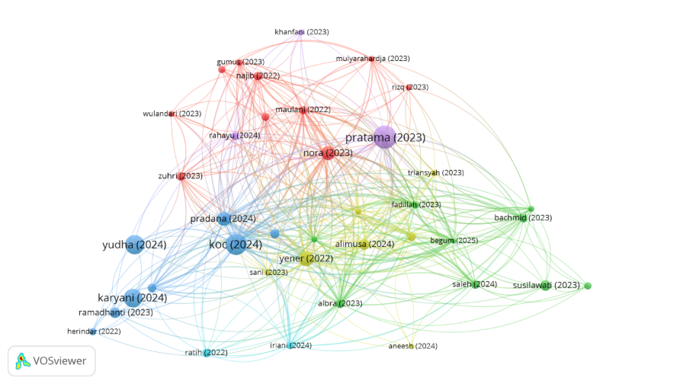
Figure 3. Co-citation analysis (VOSviewer Visualisation)

3.3.7 Co-Citation by Cluster
Table 8. Co-citation cluster analysis (Threshold = 35)

Cluster No. and Colour | Cluster Labels | No. of Articles | Representative Publications
Cluster 1  (Red) | Consumer Behavior, Halal Certification, halal food products and marketing strategy | 10 | Nora, L., & Sriminarti, N. (2023); Zuhri et al. (2023); Najib, Kusdiana, and Razli (2022); Najib, Kusdiana, and Razli (2022); Shahnia et al. (2024); Nurcahyono and Hanifah (2023), Gumus and Onurlubas (2023), Wulandari et al. (2023)
Cluster 2 (Green) | Muslim, Halal cosmetic Product, purchase intention and Religiosity | 9 | Albra et al. (2023), Saleh and Rajandran (2024), Susilawati et al. (2023), Fadillah et al. (2023), Bachmid and Noval (2023), Sari et al. (2023), Nawaz et al. (2024), Djakasaputra et al. (2023)
Cluster 3 (Blue) | Structural Equation Modeling and Theory of Planned Behaviour | 8 | Koc et al. (2024), Yudha et al. (2024), Karyani et al. (2024), Pradana, Rubiyanti, & Marimon (2024), Ramadhanti & Marsasi (2023), Susanty et al. (2025)
Cluster 4 (Yellow) | Purchase Intention, Halal Certification, Attitude, Halal Food Marketing | 7 | Yener (2022), Alimusa et al. (2024), Indrawan et al. (2022), Islam et al. (2023), Triansyah (2023), Aneesh and Siddiq (2024), Sani et al. (2023)

Table 8 presents the cluster analysis of literature related to the intention to buy Islamic items, providing information on the main thematic areas in the research field and classifying the studies based on bibliographic coupling patterns. There are 10 studies included in Cluster 1 (Red), which explores topics related to consumer behaviour, halal certification, halal culinary products and marketing strategies. This cluster highlights the role of halal awareness, religiosity, attitudes, and certification in influencing consumers' purchasing behaviour (Nora and Sriminarti, 2023; Zuhri et al., 2023; Shahnia et al., 2024; Nurcahyono and Hanifah, 2023; Gumus and Onurlubas, 2023; Wulandari et al., 2023). There are nine studies in Cluster 2 (green) that are related to Muslim consumers, the presence of halal cosmetic products, purchase intentions and strong behavioural impact. The effect of halal awareness, halal labelling, religiosity, and purchasing behaviour on halal purchase decisions was studied by Albra et al. (2023), Saleh and Rajandran (2024), Susilawati et al. (2023), Bachmid and Noval (2023), Sari et al. (2023), Nawaz et al. (2024), and Djakasaputra et al. (2023). There are eight studies in Cluster 3 (blue) that explore studies in Cluster 3 (blue) exploring the theory of planned behaviour (TPB), structural equation modelling (SEM), and the consumption of halal products. The studies explore behavioural factors such as trust, attitude, subjective norm and halal perceptions (Koc et al., 2024; Yudha et al., 2024; Karyani et al., 2024; Pradana, Rubiyanti, and Marimon, 2024; Ramadhanti and Marsasi, 2023; Ramadhanti and Marsasi, 2023; Susanty et al., 2025). Finally, Cluster 4 (yellow) consists of seven studies that focus on consumers' purchase intention, halal certification, attitude and halal food marketing (Yener, 2022; Alimusa et al., 2024; Indrawan et al., 2022; Islam et al., 2023; Triansyah, 2023; Aneesh and Siddiq, 2024; Sani et al., 2023), emphasising the value of psychological and certification factors in research on halal consumer behaviour.

3.3.8 Most Frequent Keywords in the Co-Occurrence Analysis
Table 9. Top 15 most frequent keywords
Rank | Keywords | Occurrences | Relevance
1 | Study | 272 | 1.4
2 | Purchase Intention | 248 | 1.12
3 | Product | 239 | 1.17
4 | Respondent | 155 | 0.56
5 | Attitude | 133 | 0.81
6 | Analysis | 97 | 0.7
7 | Sample | 75 | 0.81
8 | Significant Effect | 70 | 0.99
9 | Structural Equation Modelling | 66 | 0.99
10 | Halal Awareness | 66 | 0.29
11 | Subject Norm | 62 | 1.33
12 | Behaviour | 59 | 0.95
13 | Theory | 56 | 2.34
14 | Interest | 55 | 1.34
15 | Sem | 53 | 0.55

The co-occurrence analysis can be useful for gaining insights into the conceptual focal domains and the main research themes related to the intention to buy halal products. The findings revealed that researchers used the keyword "study" the most (272), followed by "purchase intention" (248) and "product" (239). Based on these findings, researchers consider purchase intention to be the most important research domain in the study of halal consumer behaviour. Other commonly used keywords in the literature were 'behaviour', 'structural equation modelling', 'subject norm' and 'halal awareness', which shows that researchers widely use quantitative studies and behavioural theories. Researchers still use the theory of planned behaviour to explain the purchase of halal products, as evidenced by the terms 'subjective norm and attitude norm' and 'attitude terms'. Besides, researchers increasingly prefer to use advanced statistical methods in halal marketing research, such as "PLS-SEM" and "structural equation modelling". Researchers use terms like "significant effect", "sample", and "respondent" to identify empirical quantitative studies, which are the most prevalent types of studies. The most prevalent types of studies are quantitative studies, which researchers identify using terms such as 'significant effect', 'sample', and 'respondent'. Overall, the results of keyword analysis show that the research on halal purchase intentions is closely related to the research on consumer behaviour, halal awareness, behavioural intention and statistical modelling. The findings indicate that the psychological, religious and marketing aspects that impact the decision of the academic to accept halal products have attracted the interest of the academics.

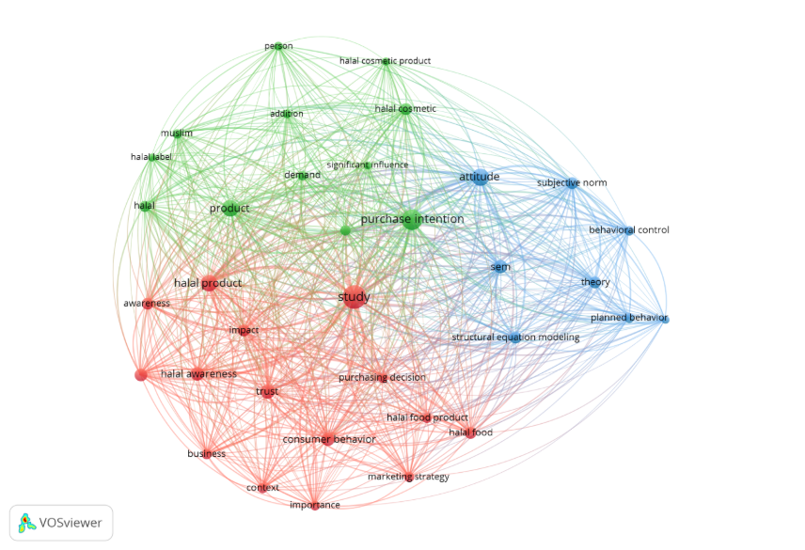
Figure 4. Co-Word Analysis (VOSviewer Visualisation)

The co-occurrence and co-word analysis network based on VOSviewer is presented in Figure 4, showing the interconnections among the keywords in the study of purchase intention for halal products. The chart below shows the strong relations between methodological, marketing and behavioural concepts from literature. The frequent use of the keywords 'purchase intention', 'product', and 'study' indicates their relevance in bridging different research foci. Theory-planned behaviour variables such as attitude, subjective norm, behaviour, and halal awareness repeatedly appear in the literature, indicating the widespread use of behavioural theories to explain halal consumer decisions. Moreover, the researchers found that quantitative empirical methods appear in approaches indicated by methodological terms such as "structural equation modelling", "SEM", "sample", and "respondent". Keywords such as 'significant effect', 'interest', and 'theory' emphasised the behavioural determinants influencing the intention to purchase halal products. Overall, the findings justify including methodological, religious, and behavioural perspectives in the study of halal consumer behaviour.

3.3.8.1 Co-Word Analysis

Table 10. Co-word analysis by thematic clusters
Cluster No. and Colour | Cluster Labels | No. of Articles | Representative Publications
Cluster 1 (Red) | Halal Awareness & Purchase Intention Influence | 16 | “Halal Awareness” “Halal Cosmetic Product” “Halal Label” “Purchase Intention" "Consumer" “Product” “Interest” “Significant Influence”
Cluster 2 (Green) | Theory of Planned Behaviour & Halal Product Consumption | 12 | “Attitude” “Consumer Behaviour” “Subjective Norm” "Planned Behaviour" “Halal Product” “PLS-SEM” “Structural Equation Modelling”
Cluster 3 (Blue) | Marketing Factors & Purchase Intention | 7 | “Brand Image” “Price” “Product Quality” “Consumer Purchase Intention”

The co-word analysis was followed by a process of identifying the most common research streams in the study of consumer intention to purchase halal products, which resulted in four main thematic clusters. The most articles were obtained for Cluster 1 (Red), titled “Halal Awareness and Purchase Intention Influence", with the following keywords: halal awareness, halal cosmetic products, halal labels, consumers, and significant influence. The focus for this cluster is on the importance of consumer awareness and knowledge in the purchasing of halal products. The theory of planned behaviour and halal "product consumption" focuses on behavioural variables such as attitude, consumer behaviour, subjective norms, planned behaviour, and structural equation modelling (cluster 2 – Green). This cluster demonstrates the theory of premeditated behaviour in the study of halal consumers. The variables in (cluster 3 – blue) are marketing variables such as brand image, product quality, price, and consumer purchase intention, and the results indicate the importance of brand and marketing strategy in halal product research. The multidimensional approach of this research can also be seen from the clustering structure, in which Islamic values, marketing viewpoints and behavioural theories are also involved. Moreover, the strong links within the clusters indicate that the integration of marketing determinants, consumer behaviour, halal awareness and religiosity in the conceptual framework is growing. Thematic clusters show the transformation of halal marketing research into an interdisciplinary academic discipline with multiple dimensions.

3.4 Content Analysis

Content analysis was used to identify the major themes and research streams in the literature regarding the intention to purchase halal products, complementing the bibliometric mapping. The chosen articles were manually reviewed and classified based on their focus. The analysis brought out several dominant themes, such as the theory of planned behaviour, halal awareness, halal certification, religiosity, trust, perceived value, attitude, subjective norm and perceived behavioural control. Moreover, some emerging studies have also started to explore the role of digital marketing, social media, e-commerce platforms, and online engagement of consumers in influencing the purchase intention of halal products. Content analysis also identified research gaps, particularly in social media-based halal consumption, platform-specific studies (e.g. TikTok), and the integration of behavioural and digital marketing perspectives. These results provide a more profound understanding of the intellectual structure of the field and suggest possible directions for future research.
4. Theoretical Implications
The findings demonstrate that the theory of planned behaviour remains the dominant theoretical lens for research on halal purchase intentions. Attitude, subjective norm, and perceived behavioural control consistently appear as central determinants, confirming the continued relevance of the TPB in understanding halal consumer behaviour. The findings of this bibliometric analysis have significant implications for businesses, policymakers, marketers and stakeholders in the halal industry. However, halal certification, trust, and transparency still significantly affect the intention to buy halal products. Yener (2022), Nora and Sriminarti (2023), and Susilawati et al. (2023) all discovered that halal certification, halal awareness, and trustworthy product data all have a significant effect on consumers' purchasing decisions. Therefore, businesses need to make sure that halal labelling is easily verifiable, authentic and visible to boost consumer confidence and loyalty to halal products. Secondly, marketing strategies should focus on strengthening positive perceptions and social influences among consumers, reflected in the behavioural determinants, attitudes, subjective norms, religiosity and perceived behavioural control. Research on the theory of planned behaviour shows that halal consumers' personal beliefs and their social and religious environments influence their behaviour. Hence, businesses should leverage digital marketing platforms to drive referrals from their customers, communicate with influencers, and incentivise consumers to engage with them. Thirdly, the increasing importance of digital platforms such as TikTok underscores the significance of social media marketing strategies in halal marketing. Short-form videos, live-streaming activities and user-generated content could have a significant impact on halal awareness, trust and purchase intention among Z-generation consumers. Moreover, the use of structural equation modelling (SEM) in the literature highlights the importance of applying data-driven methodologies to understand the behaviour of halal consumers and to make data-driven decisions.

5. Limitations and Future Research

This research has its limitations, as it provides useful information regarding the study of the intention to buy halal products, but it is limited to certain aspects of the research. Initially, exclusive use of the Dimensions AI database was implemented for the analysis. Dimensions AI offers comprehensive multidisciplinary coverage; however, the use of a single database may have led to the exclusion of relevant studies indexed in other databases, such as Scopus or Web of Science, which might not have been covered. Secondly, the study was limited by including only publications in the English language; this restriction may have led to the exclusion of relevant studies in other languages, especially those in non-English-speaking Muslim-majority nations. Third, the study included only articles from open-access journals, which ensured that the data set remained uniform and available. The analysis continues with subscription publications, conference proceedings, volumes, and book chapters. Fourth, the analysis of the bibliometrics was limited to the publications published between 2022 and 2026. During this period, the study has considered recent developments and new research trends; however, earlier influential studies may not have fully captured the breadth of research. Lastly, the preliminary Boolean searches, such as ‘TikTok’, ‘social media’, and ‘digital marketing’, yielded few bibliometric results, suggesting that research on halal consumer behaviour specifically related to these platforms is limited. Future research is suggested using a more in-depth examination of TikTok and other social media platforms, either with an empirical or comparative/mixed-methods approach, to gain a better and more comprehensive understanding of the effect of digital environments on the intention to buy halal products.
6. Discussion

This bibliometric analysis shows that the number of studies concerning halal intention to purchase has been increasing steadily, with strong growth in studies on halal awareness, religiosity, trust, attitude and halal certification. The increasing academic interest in the study of halal consumer behaviour and Islamic marketing studies is evidenced by the increase in publications and, as a result, in citations. This indicates that researchers are increasingly examining consumption from broader behavioural and marketing perspectives rather than solely from religious viewpoints.
Based on the results of the performance analysis, some of the studies that have influenced scholars' understanding of the halal consumer, such as the studies by Pratama et al. (2023), Koc et al. (2024), Yener (2022) and Nora and Sriminarti (2023) were identified. The findings of this study are consistent with those of other recent studies on halal marketing, which show that attitude, subjective norm, and trust remain important factors in halal purchase intentions. In addition, this suggests that halal certification functions not only as a religious assurance mechanism but also as a strategic marketing tool that strengthens consumer trust and reduces perceived uncertainty in buying these kinds of products. The evidence implies that the function of halal certification is both religious and marketing in the halal consumer decision-making process.
In addition, the findings indicate that Asian countries, such as Indonesia and Malaysia, are the most productive and influential in this discipline in Southeast Asia. The finding is consistent with previous studies on Islamic marketing by the researcher; this reflects the evolution of Southeast Asia as a major centre for halal marketing and Islamic consumer behaviour research due to the rapid expansion of the halal ecosystem within the region. However, the involvement of other countries, such as Turkey, China, Spain and Australia, demonstrates that the study of halal marketing is beginning to move beyond the confines of Muslim countries. The co-citation analysis and co-word analysis supported the ongoing importance of the theory of planned behaviour; this may explain why behavioural variables such as attitude, subjective norm, and perceived behaviour control continue to dominate research on halal consumer behaviour. The use of structural equation modelling (SEM) is another indicator of the increasing methodological maturity of halal marketing research. The existing studies, however, continue to pay little attention to digital and platform contexts and are primarily Indonesian and Malaysian.
Therefore, researchers have not extensively studied the impact of social media platforms, specifically TikTok. This suggests that researchers have underexplored platform-specific halal consumer environments, despite the growing influence of digital media on consumer purchasing decisions. While initial Boolean searches with TikTok-related keywords yielded little bibliometric information, the digital platforms' influence on consumer attitudes, trust, perceived value, and purchase intention should not be ignored. Thus, researchers need to conduct more research in the fields of influencer marketing, e-WOMs, live streaming, and user-generated content in halal digital consumer environments in the future.

7. Conclusion
This study provides a comprehensive bibliometric analysis in the field of purchase intention for halal products, published between 2022 and 2026. The research employed a comprehensive analysis of publication trends, influential figures, thematic shifts, and the intellectual structure in the field of halal consumer behaviour, using the Dimensions AI database. The finding demonstrates that the number of research articles related to halal purchase intention has increased considerably in recent years, suggesting that the area of halal consumption is significant in the domains of Islamic marketing and consumer behaviour and that Malaysia holds the highest influence in both the research and the publications. Moreover, halal awareness, religiosity, trust, attitude, subjective norm, perceived behavioural control, and halal certification were identified as control variables, with halal certification having the largest effect on the intention to purchase halal products.
The results also confirmed that the theory of planned behaviour is a model that can continue to explain the halal consumer choice and intention. Behavioural factors continue to play an important role in explaining halal consumers' decisions and intentions. The behaviour of halal consumers in clarifying their decisions and intentions has persisted, as evidenced by the intentions that have persisted in clarifying their decisions and intentions, as evidenced by the intentions that have persisted in terms of clarifying decisions made by halal consumers and their intentions. The bibliographic coupling analysis, co-citation analysis, and co-word analysis data showed that the study of halal purchase intentions is linked to a complex relationship in behavioural, religious, and marketing terms, as well as in its behavioural, religious, marketing, and methodological aspects. However, digital and platform-based factors (such as social media platforms like TikTok) appear to garner minimal attention. Platform-based considerations (like social media platforms like TikTok) seem to receive little attention.
Preliminary bibliometric results from Boolean searches using a limited number of keywords related to the digital platform TikTok remain scarce; however, it is important to recognise that the influence of digital platforms on the behaviour of halal consumers is also increasing. In addition to providing a systematic literature review of the literature available to date on the intention to purchase halal products, this study also reveals the influential phenomenon, dominant themes, and future research directions in the digital halal consumer landscape.

References

Alimusa, L. O., Septiani, A. M., Ratnasari, R. T., & Aedy, H. (2024). Factors determining Indonesian Muslim behaviour in purchasing halal food: A preliminary study. Etikonomi, 22(2), 263–276. https://doi.org/10.15408/etk.v22i2.26979
Shah Alam, S., & Mohamed Sayuti, N. (2011). Applying the Theory of Planned Behavior (TPB) in halal food purchasing. International journal of Commerce and Management, 21(1), 8-20. https://doi.org/10.1108/10569211111111676
Albra, W., Muchtar, D., Nurlela, N., Syafitri, R., Zaitun Nisa, F., & Aedy, H. (2023). The role of halal awareness in the relationship between religiosity and halal purchase intention. International Journal of Islamic Economics and Finance, 6(2), 312–336. https://doi.org/10.18196/ijief.v6i2.16685
Aneesh, A. K. A. A., & Siddiq, A. (2024). Behaviour of Muslim consumers towards halal food products: A review and bibliometric analysis. Journal of Halal Product and Research, 7(2), 199–209. https://doi.org/10.20473/jhpr.vol.7-.2.199-209
AzilahHusin, N., Ghazali, A., Roslan, F., & Bahrain, M. (2015). Halal medicine: Do doctors have the true awareness? Ijaber, 13(7), 5175-5186.
Bashir, A. M. (2019). Effect of halal awareness, halal logo and attitude on foreign consumers’ purchase intention. British Food Journal, 121(9), 1998-2015. https://doi.org/10.1108/BFJ-01-2019-0011
Bachmid, S., & Noval, N. (2023). Halal awareness plays a moderate role in the relationship between purchase intention, personal norms, and Muslim buying behaviour. BISNIS: Jurnal Bisnis dan Manajemen Islam, 10(2), 247–266. https://doi.org/10.21043/bisnis.v10i2.16653
Donthu, N., Kumar, S., Mukherjee, D., Pandey, N., & Lim, W. M. (2021). How to conduct a bibliometric analysis: An overview and guidelines. Journal of business research, 133, 285-296. https://doi.org/10.1016/j.jbusres.2021.04.070
Djakasaputra, A., Juliana, J., Aditi, B., Fachrurazi, F., & Mas’ad, M. A. (2023). The influence of halal certification, halal awareness, and brand image on interest in buying halal food products: An empirical study of consumers in Indonesia. International Journal of Islamic Business and Economics (IJIBEC), 7(2), 103–115. https://doi.org/10.28918/ijibec.v7i2.2003
Fadillah, H. N., Ridlwan, A. A., Suryaningsih, S. A., & Indrarini, R. (2023). Muslim millennials' buying behaviour of halal food & beverages in Indonesia: The mediating effect of purchase intention. Amwaluna: Jurnal Ekonomi dan Keuangan Syariah, 7(1), 11–28. https://doi.org/10.29313/amwaluna.v7i1.11146
Gumus, N., & Onurlubas, E. (2023). Investigation of factors affecting Generation Z's halal cosmetics adoption. Marketing and Management of Innovations, 14(1), 1–11. https://doi.org/10.21272/mmi.2023.1-01
Hassan, M. K., Alshater, M. M., Mumu, J. R., Sarea, A. M., & Azad, M. A. K. (2021). Bibliometric analysis of the Journal of Islamic Accounting and Business Research: Ten years review. COLLNET Journal of Scientometrics and Information Management, 15(1), 63-88. https://doi.org/10.1080/09737766.2021.1934603
Indrawan, B., Nurmita, N., Nengsih, T. A., Utami, W., Nasrudin, D., Tanti, T., Deliza, D., Herawati, R., Syafitri, R., & Santoso, P. (2022). The influence of attitude and need for cognition on students' purchase intention behaviour for halal food: a school clustering perspective. Indonesian Journal of Halal Research, 4(1), 26–34. https://doi.org/10.15408/etk.v22i2.26979
Irfany MI, Khairunnisa Y, and Tieman M (2024). "Factors influencing Muslim Generation Z consumers’ purchase intention of environmentally friendly halal cosmetic products." Journal of Islamic Marketing, Vol. 15 No. 1, pp. 221–243. https://doi.org/10.1108/JIMA-07-2022-0202
Jamalova, M. (2024). Modelling user behavior towards smartphones and wearable technologies: A bibliometric study and brief literature review. arXiv preprint arXiv:2405.01137. https://doi.org/10.3991/ijim.v18i12.48035
Karyani, E., Geraldina, I., Haque, M. G., & Zahir, A. (2024). Intention to adopt a blockchain-based halal certification: Indonesian consumers' and regulatory perspectives. Journal of Islamic Marketing, 15(7), 1766–1782. https://doi.org/10.1108/jima-03-2023-0069
Koc, F., Ozkan, B., Komodromos, M., Efendioglu, I. H., & Baran, T. (2024). The effects of trust and religiosity on the intention to purchase halal products: the indirect effect of attitude. EuroMed Journal of Business, 20(5), 141–165. https://doi.org/10.1108/emjb-01-2024-0004
Lezama-Nicolás, R., Rodríguez-Salvador, M., Río-Belver, R., & Bildosola, I. (2018). A bibliometric method for assessing technological maturity: the case of additive manufacturing. Scientometrics, 117(3), 1425-1452. https://doi.org/10.1007/s11192-018-2941-1
Maulani, M. R., Nuryakin, N., & Hidayah, N. (2022). Purchase intention of halal cosmetics: The mediating role of attitude. Etikonomi, 21(2), 383–398. https://doi.org/10.15408/etk.v21i2.24131
Maichum, K., Parichatnon, S., & Peng, K. C. (2017). The influence of attitude, knowledge and quality on purchase intention towards halal food: a case study of young non-Muslim consumers in Thailand. IRA-International Journal of Management & Social Sciences, 6(3). https://doi.org/10.21013/jmss.v6.n3.p3
Najib, M. F., Kusdiana, W., & Razli, I. A. (2022). Local halal cosmetic products purchase intention: Knowledge, religiosity, attitude, and Islamic advertising factors. Journal of Islamic Economic Laws, 5(2), 177–198. https://doi.org/10.23917/jisel.v5i2.19199
Nawaz, M. S., Sabir, I., Majid, M. B., & Rafique, A. (2024). Analysing the mediating roles of attitude and awareness in shaping the relationship between religiosity and the purchase intention of halal cosmetics. Journal of Islamic Thought and Civilisation, 14(2), 203–223. https://doi.org/10.32350/jitc.142.13
Nora, L., & Sriminarti, N. (2023). The determinants of purchase intention for halal products: The moderating role of religiosity. Journal of Consumer Sciences, 8(2), 220–233. https://doi.org/10.29244/jcs.8.2.220-233
Nurcahyono, N., & Hanifah, A. (2023). Determinants of intention to purchase halal cosmetics: A millennial and Z generation perspective. International Journal of Islamic Business Ethics, 8(1), 12–25. https://doi.org/10.30659/ijibe.8.1.12-25
Pradana, M., Rubiyanti, N., & Marimon, F. (2024). Measuring Indonesian young consumers’ halal purchase intentions for foreign-branded food products. Humanities and Social Sciences Communications, 11(1), 150. https://doi.org/10.1057/s41599-023-02559-0
Pratama, A. A. N., Hamidi, M. L., & Cahyono, E. (2023). The effect of halal brand awareness on purchase intention in Indonesia: The mediating role of attitude. https://doi.org/10.1080/23311975.2023.2168510
Pritchard, A. (1969). Statistical bibliography or bibliometrics. Journal of Documentation, 25, 348.
Ramadhanti, D., & Marsasi, E. G. (2023). The influence of attitudes and halal perceptions on the intention to visit halal tourism destinations. JESI (Jurnal Ekonomi Syariah Indonesia), 13(1), 54–73. https://doi.org/10.21927/jesi.2023.13(1).54-73
Sari, M., Rusydiana, A. S., Indra, I., & Avedta, S. (2023). How do halal components and marketing drive Muslim consumers? Journal of Digital Marketing and Halal Industry, 5(2), 143–166. https://doi.org/10.21580/jdmhi.2023.5.2.18782
Sani, A. A., Rahmayanti, D., Kamal, A.-H., Ilmiah, D., & Abdullah, N. B. (2023). Understanding consumer behaviour: Halal labelling and purchase intentions. Journal of Digital Marketing and Halal Industry, 5(1). https://doi.org/10.21580/jdmhi.2023.5.1.16543
Susanty, A., Puspitasari, N. B., Jie, F., Akhsan, F. A., & Jati, S. (2025). Consumer acceptance of halal food traceability systems: A novel integrated approach using modified UTAUT and DeLone & McLean models to promote sustainable food supply chain practices. Cleaner Logistics and Supply Chain, 15, 100226. https://doi.org/10.1016/j.clscn.2025.100226
Susilawati, C., Joharudin, A., Abduh, M., & Sonjaya, A. (2023). The influence of religiosity and halal labelling on the purchase intentions for non-food halal products. Indonesian Journal of Halal Research, 5(2), 77–89. https://doi.org/10.15575/ijhar.v5i2.22965
Saleh, H., & Rajandran, T. (2024). Relationship between non-Muslim consumer intention to purchase halal products with halal awareness, halal certification, halal marketing and halal knowledge: A systematic review. International Journal of Academic Research in Business and Social Sciences, 14(9), 416–426. https://doi.org/10.6007/ijarbss/v14-i9/22495
Supriani I, Ninglasari SY, & Iswati S (2025) published a study titled "How Social Media Influencers Shape Muslim Consumers' Purchase Intentions for Halal Cosmetics: The Role of Religiosity". Journal of Islamic Marketing, Vol. 16 No. 2 pp. 502–525, doi: https://doi.org/10.1108/JIMA-02-2024-0085
Shahnia, C., Permana, D., Harini, S., Endri, E., & Wahyuningsih, M. (2024). The effect of halal awareness, halal certification, and social service cafes on purchase intention in Indonesia: The mediating role of attitude. International Review of Management and Marketing, 14(3), 97–104. https://doi.org/10.32479/irmm.16186
Slam, K. M. A., Shahabuddin, A. M., Omeish, F., Bhuiyan, A. B., & Islam, S. (2023). Effects of brand awareness, religious belief, and brand trust on purchase intentions of halal products among young consumers. Innovative Marketing, 19(4), 247–256. https://doi.org/10.15575/ijhar.v4i1.13092
Snyder, H. (2019). Literature review as a research methodology: An overview and guidelines. Journal of Business Research, 104, 333-339. https://doi.org/10.1016/j.jbusres.2019.07.039
Triansyah, F. A. (2023). Focus research on halal food marketing. Journal of Management and Islamic Finance, 3(1), 121–131. https://doi.org/10.22515/jmif.v3i1.6634
Yener, D. (2022). The effects of halal certification and product features on consumer behaviour: A scenario-based experiment. International Journal of Management Studies, 29(2), 101–136. https://doi.org/10.32890/ijms2022.29.2.5
Yudha, A. T. R. C., Huda, N., Maksum, M., Sherawali, S., & Wijayanti, I. (2024). The moderating effect of religiosity on fashion uniqueness and consciousness in halal fashion purchases. Indonesian Journal of Halal Research, 6(2), 70–83. https://doi.org/10.15575/ijhar.v6i2.34614
Zuhri, S., Ilyas, I., Erwan, F., Syahputra, R. A., Sentia, P. D., & Noprita, Z. (2023). Structural equation modelling analysis of the purchase behaviour of halal products. Indonesian Journal of Halal Research, 5(1), 12–20. https://doi.org/10.15575/ijhar.v5i1.20170
Wijaya CO, Wijaya S, Jaolis F (2025). "The influence of social media content on attitude, destination image and intention of female Muslim travellers to visit halal destinations: comparison between UGC and FGC." Journal of Islamic Marketing, Vol. 16 No. 2, pp. 402–427. https://doi.org/10.1108/JIMA-O8-2023-0235
Wulandari, S. A., Sari, R. P., & Hadining, A. (2023). Analysis of customer behaviour and attitudes (general risk) on satisfaction, trust and halal awareness of purchase intentions in food delivery applications. Journal Dinamika Manajemen, 14(1), 99–110. https://doi.org/10.15294/jdm.v14i1.38386

