Role of Influencer Marketing in Brand Promotion: A Study on Hyundai Motor Company

Abstract
Influencer marketing has become an important digital marketing strategy in today’s competitive market. Companies use social media influencers to increase brand awareness, customer engagement, and product promotion. This study focuses on understanding the role of influencer marketing in promoting Hyundai Motor Company. The research examines how influencer marketing affects customer perception, brand image, trust, and purchase intention. The study concludes that influencer marketing helps Hyundai connect with young consumers and strengthen its market presence through digital platforms.

Keywords

Influencer Marketing, Brand Promotion, Hyundai, Social Media Marketing, Customer Engagement, Brand Awareness

Introduction
In the digital era, social media plays a major role in influencing customer decisions. Consumers are highly affected by the opinions and recommendations shared by influencers on platforms like Instagram, YouTube, and Facebook.
Influencer marketing is a marketing strategy where companies collaborate with influencers to promote products and services. In the automobile industry, influencer marketing helps brands create awareness, build trust, and attract customers.
Hyundai Motor Company is one of the leading automobile companies that actively uses influencer marketing and digital campaigns to promote its vehicles and improve customer This study aims to understand how influencer marketing supports Hyundai in brand

Theoretical Framework
promotion and customer attraction.

This study aims to understand how brand love influences customer behavior and long-term loyalty in the context of Maruti Suzuki vehicles.

Conceptual Background
Influencer marketing refers to the promotion of products through social media personalities who have a strong follower base and influence over audiences.
Important elements of influencer marketing include:

- Brand Awareness

- Customer Engagement

- Influencer Credibility

- Social Media Reach

- Customer Trust

- Purchase Intention

In the automobile sector, influencer marketing helps companies demonstrate vehicle features, customer experiences, and lifestyle value through digital content.
Hyundai uses influencer collaborations, online campaigns, and social media promotions to improve its brand visibility among young consumers.

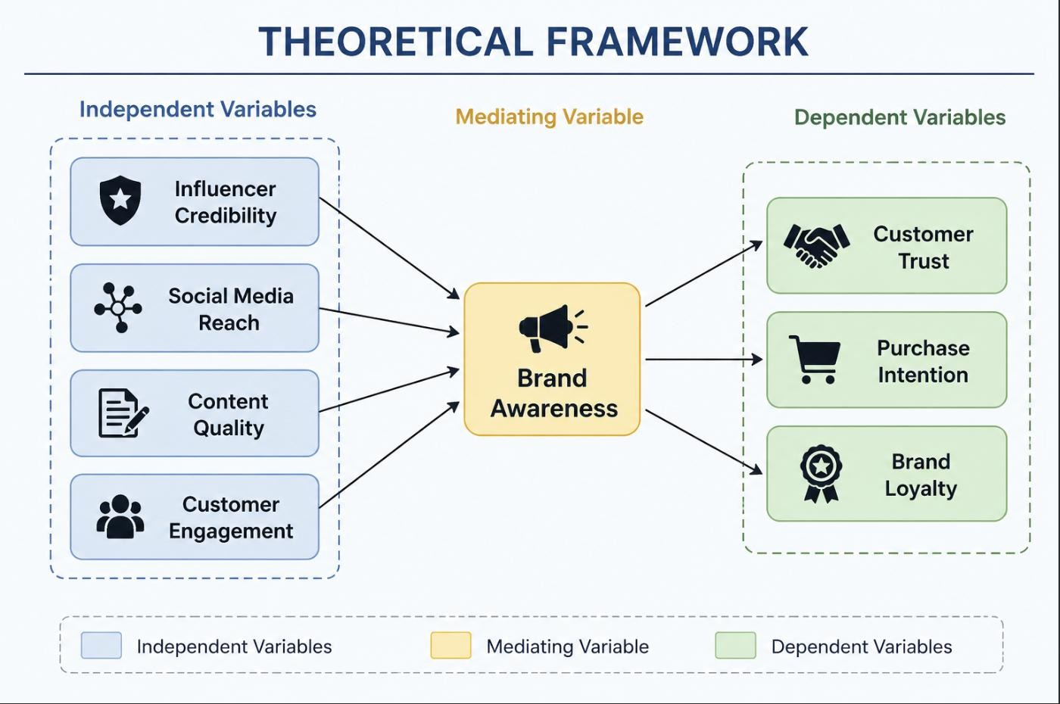

Independent Variables

  - Influencer Credibility
  - Social Media Reach
  - Content Quality
  - Customer Engagement

Mediating Variable

Brand Awareness

Dependent Variables

  - Customer Trust
  - Purchase Intention
  - Brand Loyalty

The framework suggests that influencer credibility and social media engagement positively influence brand awareness, which further improves customer trust and purchase intention toward Hyundai vehicles.

Methodological Advancement and Tools Research Approach
Theory-based research approach using concepts from digital marketing and consumer behavior.

Focus on understanding the impact of influencer marketing on brand promotion.

Research Design

Conceptual and analytical research design.

Study based on secondary data and existing marketing literature.

Data Sources

Secondary data sources include:

  - Research journals

  - Company reports

  - Social media campaigns

  - Marketing articles

  - Industry reports

Measurement Constructs
The study focuses on the following constructs:

- Influencer Marketing

- Brand Awareness
- Customer Engagement
- Brand Trust
- Purchase Intention
- Brand Loyalty

Analytical Techniques

- Literature Review

- Comparative Analysis

- Conceptual Framework Analysis

- Thematic Analysis

Tools and Technologies

- Microsoft Excel

- Google Scholar
- ResearchGate
- PowerPoint
- Social Media Analytics

Methodological Advancements

- Focus on digital marketing trends.

- Use of influencer marketing concepts in automobile branding.

- Integration of customer engagement and social media analysis.

- Use of secondary data for broader understanding.

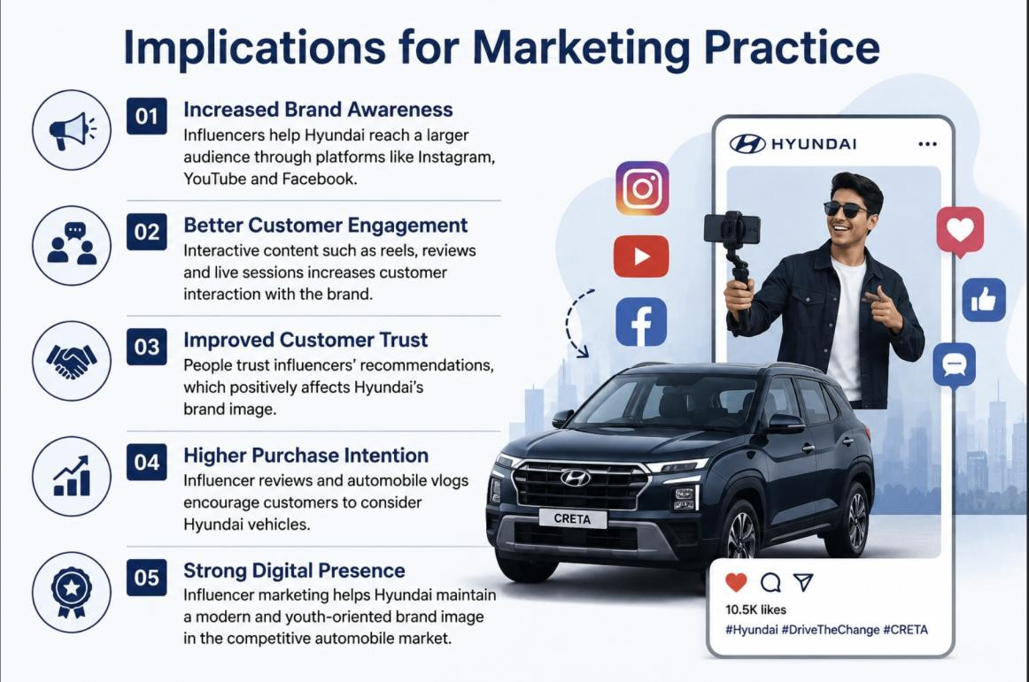

Implications for Marketing Practice

Better Brand Awareness

Influencers help Hyundai reach a larger audience through social media platforms.

Strong Customer Engagement

Interactive content increases customer interest and communication.

Improved Brand Trust

Consumers trust recommendations from influencers they follow.

Increased Purchase Intention

Positive influencer reviews encourage customers to consider Hyundai vehicles.

Digital Brand Positioning

Influencer campaigns help Hyundai maintain a modern and youth-friendly brand image.

Ethical Considerations in Maruti Suzuki Research
The study follows ethical practices such as:

  - Use of genuine secondary data
  - Proper citation of sources
  - No misleading information
  - Respect for customer privacy

Hyundai also follows ethical business practices related to:

  - Customer safety

  - Environmental responsibility

  - Honest advertising

Future Directions and Research Opportunities
Future studies can focus on:

  - Comparison with other automobile brands

  - Impact of AI influencers

  - Influencer marketing in electric vehicle promotion

  - Consumer behavior in rural and urban markets

  - Long-term impact of influencer campaigns

Conclusion
The study concludes that influencer marketing plays an important role in promoting Hyundai Motor Company. Social media influencers help increase brand awareness, customer engagement, and trust among consumers.
Influencer marketing also improves Hyundai’s digital presence and helps attract younger audiences. In today’s competitive market, influencer marketing has become an effective strategy for automobile brand promotion and customer connection.

References

- Kller, K. L. (1993). Customer-based brand equity.

- Aaker, D. A. (1996). Measuring brand equity.

- Chaudhuri, A., & Holbrook, M. B. (2001). Brand trust and loyalty.

- Brown, D., & Hayes, N. (2008). Influencer Marketing.

- Freberg, K. (2011). Social media influencers and public relations.

- Lou, C., & Yuan, S. (2019). Influencer marketing effectiveness.

- De Veirman, M. (2017). Instagram influencer impact.

- Schouten, A. (2020). Celebrity vs influencer marketing.

- Forbes Articles on Influencer Marketing.

- Hyundai Digital Marketing Reports.

