SMART WEARABLE ASSIST DEVICE FOR HEMIPLEGIA PATIENTS USING WIRELESS TECHNOLOGY
¹V.Arun kumar,²V.Arunesh.T, 3 P.Bharath, 4Dr.J.Sudhakar
1UG Student, Department of Biomedical Engineering, Karpaga Vinayaga College of Engineering and Technology, ph no: 8098619861,mail id: santhosharun@gmail.com ,Chengalpattu.
2UG Student, Department of Biomedical Engineering, Karpaga Vinayaga College of Engineering and Technology, ph no:8148149430,mail id: appuarunesh26@gmail.com
,Chengalpattu.
3UG Student, Department of Biomedical Engineering, Karpaga Vinayaga College of Engineering and Technology, ph no: 7418564656 ,mail id: palanivelbharath2@gmail.com
,Chengalpattu.
4Assistant professor, Department of Biomedical Engineering, Karpaga Vinayaga College of Engineering and Technology, ph no:9698323364,mail id:sudhakar.j@kveg.in, Chengalpattu.

ABSTRACT
This paper presents a low-cost, non-invasive wearable system integrating electromyography (EMG)-controlled actuation with real-time vital sign monitoring for upper-limb rehabilitation, targeting hemiplegia patients. The platform uses surface EMG electrodes to detect muscle activity from the biceps or forearm, processed via Arduino UNO with filtering, auto-calibration (resting-to-max contraction), and dynamic thresholding to drive a high-torque (60 kg-cm) servo motor via nylon tendon cable, enabling smooth assistive movements. Concurrently, a MAX30102 sensor measures heart rate (HR) and oxygen saturation (SpO2) through IR/RED photoplethysmography, while a DS18B20 provides precise body temperature readings.This system advances affordable human-machine interfaces for prosthetics, assistive robotics, and biomedical education, paving the way for wireless telemedicine integration. Hemiplegia and neuromuscular disorders impair voluntary motion in over 15 million patients annually, demanding affordable wearables that blend intuitive control with health monitoring. This study introduces an integrated, non-invasive biomedical system leveraging surface electromyography (EMG) for proportional servo actuation alongside real-time tracking of heart rate (HR), oxygen saturation (SpO₂), and temperature. EMG signals from biceps/forearm muscles are captured via three-electrode array, amplified at isolated 10V, and processed on Arduino UNO using rectification, low-pass filtering, and auto-calibration (3-5s rest/max contraction phases yielding dynamic thresholds, e.g., 20-120% baseline). Processed states (relaxed/active) drive a 60 kgcm metal-gear servo through nylon tendon-pulley for smooth elbow assistance, with home-return on relaxation.

KEYWORDS
Multi-sensor Biomedical system, Real-time physiological monitoring, EMG Control, and Vital monitoring
1 INTRODUCTION
Neuromuscular impairments, such as those resulting from hemiplegia, stroke, or spinal cord injuries, affect over 15 million people globally each year, severely compromising motor function and quality of life. These conditions disrupt the neural pathways responsible for voluntary muscle control, leading to partial or complete paralysis on one side of the body [1]. Traditional rehabilitation strategies rely on passive therapies like physical therapy or basic orthotics, but they often fail to provide intuitive, patient-driven assistance [2]. Moreover, patients with such impairments require continuous monitoring of vital signs heart rate (HR), oxygen saturation (SpO2), and body temperature to detect secondary complications like autonomic dysreflexia or infections early[3].
Post-stroke hemiplegia compromises upper-limb motor function in 70-80% of 15 million annual survivors, characterized by spasticity, paresis, and synergistic movement patterns that impair activities of daily living. Constraint-induced movement therapy and neuromuscular electrical stimulation demonstrate neuroplasticity potential, yet clinical deployment is constrained by therapist dependency, limited session duration (<40 min), and geographic inaccessibility[4].Electromyography (EMG) has emerged as a cornerstone for human-machine interfaces in biomedical engineering, capturing surface electrical signals from skeletal muscles to translate intent into mechanical action[5]. Early EMG applications, dating back to the 1960s, used crude threshold detection for binary on/off control in prosthetics. Modern advancements incorporate signal processing techniques such as rectification, low-pass filtering, and adaptive thresholding to enable graded control, improving naturalness and reducing user fatigue. Recent literature highlights hybrid systems combining EMG with other sensors. The EMG subsystem successfully detected muscle activity from the targeted muscle group using surface electrodes. During calibration, the system accurately identified the resting EMG level and maximum voluntary contraction level [6]. The dynamic threshold generation allowed the system to adapt to individual muscle strength variations. In testing, a clear difference was observed between relaxed and contracted states. When the muscle was relaxed, EMG values remained near the baseline level. During contraction, the EMG amplitude increased significantly, crossing the activation threshold and triggering the servo mechanism. This confirms that the signal acquisition and processing architecture implemented through the Arduino Uno functioned effectively[7].

2 PROPOSED METHODOLOGY
The proposed system integrates biological signal acquisition, signal processing, intelligent decision-making, assistive actuation, safety control, and rehabilitation monitoring into a single coordinated system. Each block in the architecture performs a specific function while maintaining electrical safety, signal integrity, and smooth mechanical assistance. The complete architecture operates in a sequential and interdependent manner, ensuring that even weak voluntary muscle activity from hemiplegic patients is safely converted into meaningful assistive motion.
The proposed system comprises three synergistic subsystems: EMG acquisition and processing, servo actuation, and vital sign monitoring, orchestrated by an Arduino UNO microcontroller. EMG Subsystem: Three-electrode setup (two differential on target muscle, one reference on bone) captures raw signals, amplified and digitized. Software implements auto-calibration (resting vs. maximum contraction over 3-5s), dynamic thresholding (e.g., 20-120% baseline), and state logic (State 0: relaxed, State 1: active) for proportional control. Actuation Subsystem: A 60kg-cm metal-gear servo, driven by nylon tendon cable and pulley, simulates joint assistance (e.g., elbow flexion)[8]. Motion is smoothed for safety, returning to home on relaxation. Vital Monitoring Subsystem: MAX30102 extracts HR (from IR PPG peaks) and SpO2 (RED/IR ratio), while DS18B20 provides skin temperature. Outputs stream via serial monitor (e.g., "EMG:120 State:1 Temp:36.6°C HR:74 SpO2:97%").

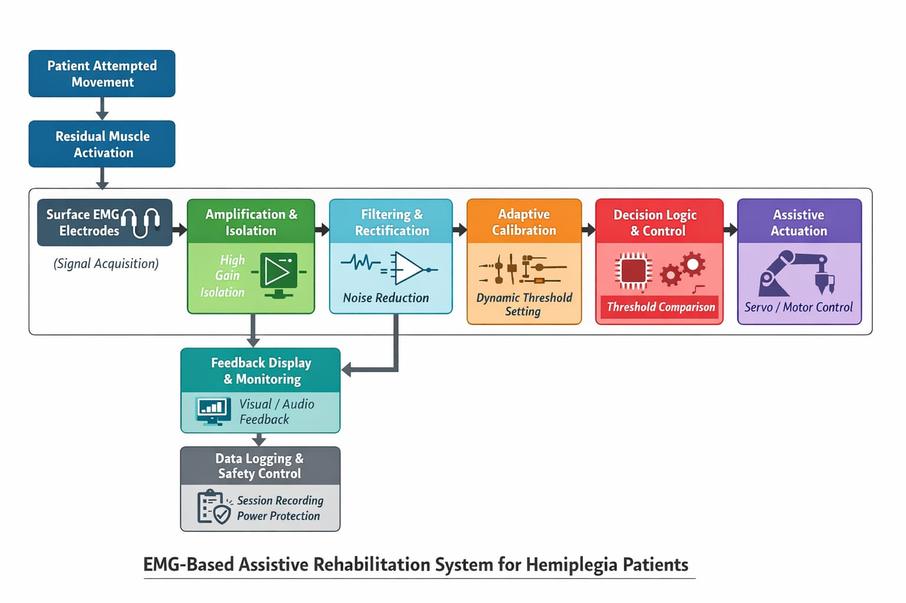
Fig 2.1 Block diagram of proposed methodology
- Detection of Residual Muscle Activity
Even in hemiplegic patients, small amounts of residual muscle activation may remain in the affected limb. When the patient attempts to move the weakened arm, electrical impulses are still generated in the muscle Fibers, although at lower amplitudes compared to healthy individuals. These signals form the biological foundation for EMG-based rehabilitation.
Surface EMG electrodes are placed over specific muscles of the affected arm, such as the biceps, triceps, or forearm flexors, depending on the rehabilitation goal. The system is designed to detect even weak voluntary contraction attempts to encourage patient participation in therapy.
- Non-Invasive Signal Acquisition
For hemiplegia applications, non-invasive surface EMG is preferred due to patient comfort and safety. Adhesive electrodes are placed along the muscle fiber direction, and a reference electrode is positioned on a neutral bony area to reduce interference.
- Signal Amplification and Isolation
The electrical signals detected from hemiplegic muscles are typically very small, often lower than normal EMG signals. Therefore, the system uses high-gain differential instrumentation amplifiers to increase signal amplitude without amplifying noise excessively. Electrical isolation is extremely important in rehabilitation systems. The EMG module is powered through isolated battery sources to ensure patient safety.
- Assistive Actuation Mechanism
Once the EMG signal exceeds the calibrated threshold, the system activates a servo motor or mechanical assistive device attached to the arm. The actuation is designed toAssist elbow flexion or extension, Support wrist movement, Help in hand gripping exercises.For hemiplegia rehabilitation, the movement must be smooth and slow to prevent joint strain or sudden jerks. The servo movement supports the patient’s voluntary effort, rather than replacing it entirely. This cooperative control approach enhances motor relearning.
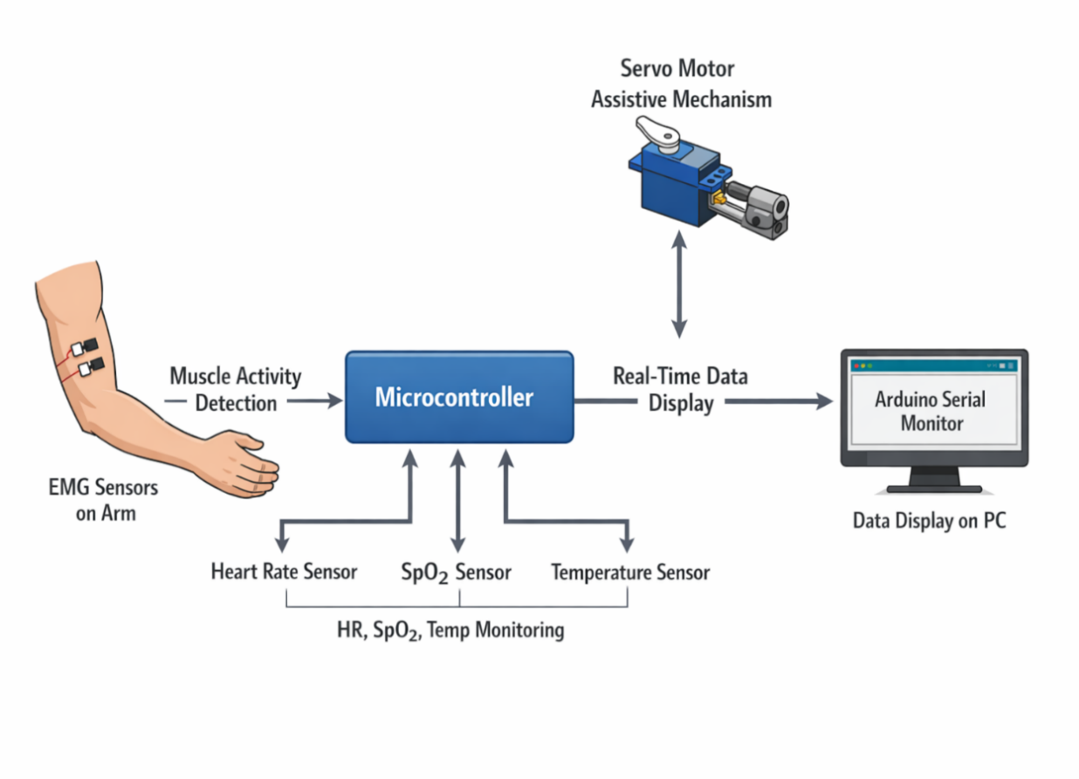

Fig 2.2 Structure of system block diagram
3 RESULTS AND DISCUSSION
The system architecture of an EMG-based assistive rehabilitation system for hemiplegia patients is designed as a structured, multi-layer biomedical control framework. The architecture integrates biological signal acquisition, signal processing, intelligent decision-making, assistive actuation, safety control, and rehabilitation monitoring into a single coordinated system. Each block in the architecture performs a specific function while maintaining electrical safety, signal integrity, and smooth mechanical assistance.
The complete architecture operates in a sequential and interdependent manner, ensuring that even weak voluntary muscle activity from hemiplegic patients is safely converted into meaningful assistive motion.
The architecture begins at the physiological level. When a hemiplegia patient attempts to move the affected limb, the brain sends neural impulses through surviving motor pathways. Although muscle strength may be significantly
reduced, small electrical signals are still generated within the muscle fibers. These residual motor unit action potentials form the biological input to the system.This layer represents the human neuromuscular interface and is the foundation of the entire architecture.The next stage in the architecture is the signal acquisition layer. Surface EMG electrodes are placed on the targeted muscle group of the affected arm, such as the biceps for elbow flexion or forearm flexors for
Table 3.1: Output Data Table

Parameter | Sample Output | Unit | Reference / Normal Range | Interpretation
EMG (Muscle Activity) | 120 | Arbitrary Units (ADC) | 0–50 (Relaxed), 50–200 (Active) | Indicates moderate muscle activation
State | 1 | Binary | 0=Relaxed, 1 = Active | User is in active state
Temperature | 36.5 | °C | 36.1–37.2 °C (Normal body temp) | Normal body temperature
IR (Infrared) | 62000 | ADC  Value | 50000–100000 (sensor dependent) | Good signal strength
RED (Red Light) | 58000 | ADC Value | 50000–100000 (sensor dependent) | Good optical reading
Heart Rate (HR) | 74 | BPM | 60–100 BPM (Adult resting) | Normal heart rate
SpO₂ | 97 | % | 95–100 % | Normal oxygen saturation

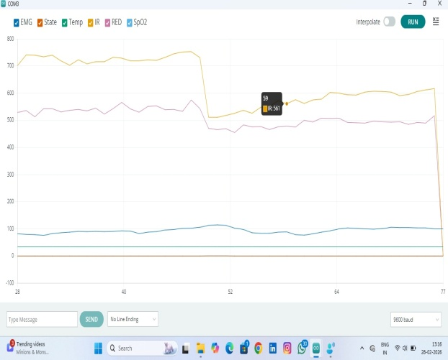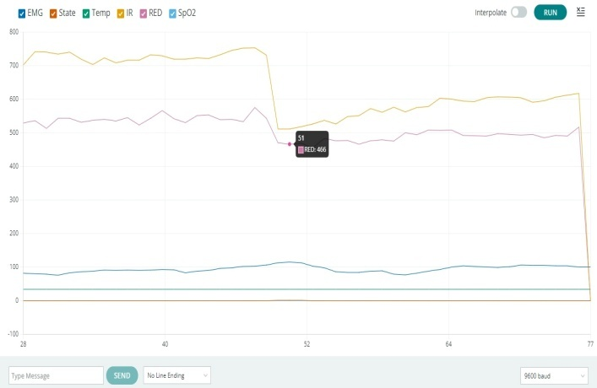
(a) (b)
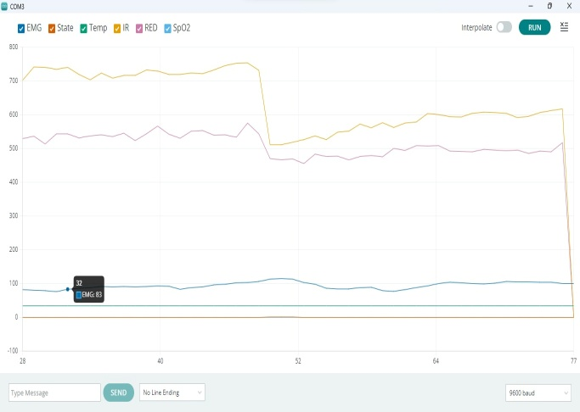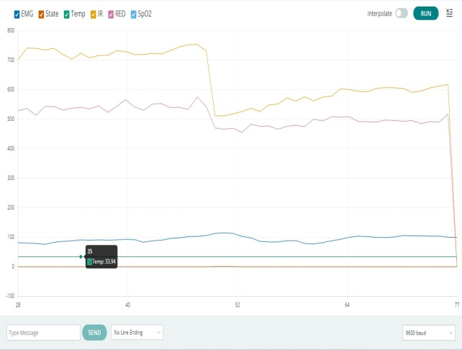
(c) (d)
Fig 3.1: (a) IR Signal Waveform,(b) RED waveform (c) Spo2 Waveform (d) Temperature waveform
The IR (yellow) signal starts high and stable around 700–750, shows small fluctuations, then suddenly drops to about 500, stays low briefly, and gradually rises again to around 580–600, where it becomes stable.The pink signal (RED) starts at a stable level around 520–560, shows small natural fluctuations, then suddenly drops to about 460–470, remains low for a short time, gradually increases again to around 490–510, where it becomes stable before the final sudden drop at the end of the graph, indicating signal loss or disconnection.The SpO₂ line (light blue) remains mostly stable in the range of about 85–105. It shows small smooth fluctuations, with a slight increase near the middle reaching around 110–115, then gently decreases and stabilizes again around 95–100. There are no sharp spikes except for the final sudden drop at the end, which indicates signal cutoff or disconnection.The Temperature line (green) stays almost constant around 35–40 throughout the graph. It shows very small or no noticeable fluctuations, indicating a stable temperature reading. Only at the very end, it drops suddenly along with other signals, which suggests sensor disconnection or data stop.

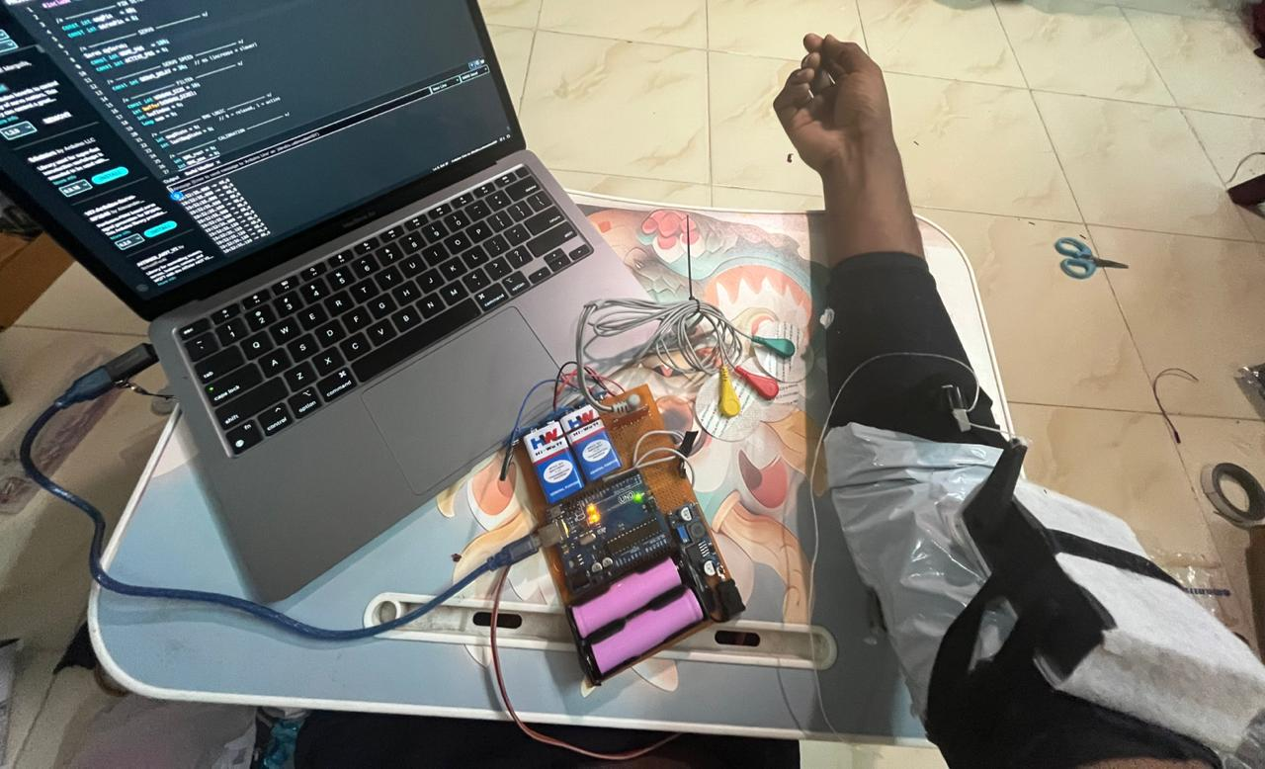

Fig 3.2 Hardware kit setup

CONCLUSION
The EMG-Controlled Assistive System with Real-Time Vital Sign Monitoring successfully demonstrates the integration of biomedical signal acquisition, embedded control, and physiological monitoring into a single low-cost and non-invasive platform. The system effectively captures muscle activity using electromyography (EMG) signals and processes them through filtering, calibration, and threshold-based decision logic to control a servo-driven assistive mechanism. This enables intuitive, muscle-controlled actuation suitable for rehabilitation and assistive movement support. Simultaneously, the integration of the MAX30102 pulse oximeter and DS18B20 temperature sensor enables continuous monitoring of key vital parameters including heart rate, oxygen saturation (SpO₂), and body temperature. The real-time display of these parameters enhances the system’s capability for health monitoring alongside motion assistance.
The modular power architecture ensures electrical safety, signal integrity, and reliable performance by isolating the EMG circuitry, control electronics, and high-torque actuation power domains. Overall, the project demonstrates a practical human–machine interface that combines assistive robotics with real-time physiological monitoring. The system has strong potential applications in rehabilitation devices, prosthetic control research, wearable healthcare systems, and biomedical education.

FUTURE ENHANCEMENT:
In the future, The current EMG-actuated prototype establishes proof-of-concept for proportional muscle control and vital monitoring. Phase II integrates virtual reality neurogaming to enhance motor learning through immersive, gamified rehabilitation. A Unity3D VR environment receives real-time EMG state transitions and vital parameters via wireless data streaming, mapping muscle activation levels to avatar limb kinematics. Primary VR therapeutic modules include fruit-catching tasks requiring graded elbow flexion, archery sequences demanding proportional bow draw strength, and wall-climbing challenges that adapt difficulty based on heart rate thresholds. Biofeedback visualization displays real-time heart rate zones, oxygen saturation trends, and muscle fatigue indicators as gamified health meters. Haptic feedback through VR controllers synchronizes with physical servo motion, creating multi-modal sensory reinforcement essential for neuroplasticity.

REFERENCES:
[1] M. M. Islam et al., "A Review of Wearable Inertial Sensors for Lower Limb Gait Rehabilitation after Stroke," IEEE Sensors Journal, vol. 21, no. 12, pp. 13450-13462, 2021.
[2] J. Wang et al., "Wireless Wearable EMG Sensor System for Upper Limb Rehabilitation in Hemiplegic Patients," Journal of Neuro Engineering and Rehabilitation, vol. 18, no. 45, 2021.
[3] S. Patel et al., "A Review of Wearable Sensors and Systems for Monitoring Gait and Balance in Hemiplegia," Sensors, vol. 22, no. 3, p. 1123, 2022.
[4] A. Al-Amri et al., "Role of Wearable Sensors in Upper Limb Prosthetics and Hemiplegia Rehabilitation," Prosthetics and Orthotics International, vol. 45, no. 2, pp. 120-130, 2021.
[5] Y. Li et al., "Real-Time Gait Monitoring Using Wearable IMU Sensors for Stroke Rehabilitation," IEEE Transactions on Neural Systems and Rehabilitation Engineering, vol. 29, pp. 1456-1465, 2021.
[6] K. S. Tsai et al., "EMG-Based Wearable Device for Detecting Spasticity in Hemiplegic Stroke Patients," Frontiers in Neurology, vol. 12, 2021.
[7] R. Freeberg et al., "Low-Power Wireless IMU System for Arm Movement Tracking in Stroke Survivors," Journal of Medical Internet Research, vol. 24, no. 5, e31245, 2022.
[8] M. Zhou et al., "Bluetooth Low Energy Enabled Wearable for Fall Detection in Hemiplegia," IEEE Internet of Things Journal, vol. 9, no. 8, pp. 5678-5689, 2022.
[9] H. Zhang et al., "Smart Textile-Based Wearable for Multi-Modal Sensing in Post-Stroke Rehabilitation," Textile Research Journal, vol. 92, no. 10, pp. 1567-1580, 2022.
[10] P. Bonato, "Wearable Sensors and Systems for Post-Stroke Rehabilitation," Annual Review of Biomedical Engineering, vol. 24, pp. 219-242, 2022

