Retractions in Neuroscience Literature:An Analytical Study Based on Retraction Watch Database
- Swetha^{1*} , K. Veeraramu²
¹Ph.D. Research Scholar.
²Research Supervisor Hindustan Institute of Technology and Sciences (Deemed to be University)
Padur, Chennai – 600 100, Tamil Nadu
*Corresponding Author
DOI: https://doi.org/10.47772/IJRISS.2026.10100046
Received: 29 December 2025; Accepted: 06 January 2026; Published: 20 January 2026
ABSTRACT
This study analysed the retraction of scientific articles in neuroscience between 1977 and 2026. The Retraction Watch database was utilised as a source, and 1,244 formally retracted documents were selected for analysis. A comprehensive examination of the variables was conducted, encompassing the publication and retraction dates, author affiliation, country of publication and rationale for retraction. The findings indicated that the first retracted article was published in 1977 and the number of retracted papers where in single digit till 2006 (n=8) The number of retracted papers reached triple digit for the first time in 2021 (n=115) and a peak of 200 in 2023. It has been observed that the retractions in neuroscience were very low before 2000 and witnessed a gradual increase from 2005 to 2015. However, after reaching the peak in 2023, the trend sharply reversed, with the number of retracted articles falling to 115 in 2024 and 35 by 2025. China (n=438, 35.21%) represented the largest share of retracted publications, followed by the United States (n=370, 29.74%), and India (n=85, 6.75%). It has been observed that the top 10 countries either individually or with collaboration with other countries published 99.28% of the total retracted publications (n=1235) in the field of neuroscience. There were 986 single-country papers (79.26%) while 258 (20.74%) are multi-country papers which revealed that there is international collaboration in the field of neuroscience research. Retractions in neuroscience has been done by 491 journals and 15 conferences. The highest number of retractions was done by PLoS One (n=57). A large portion comes from major academic publishers like Elsevier, Springer Nature, and Wiley. The top 10 journals retracted 221 articles (17.77%) and Q2 journals retracted the highest (n=102) followed by Q3 journals (n=51), Q4 journals (n=38) and Q1 journals (n=30). The University of Alabama at Birmingham, USA is the topper with the largest number of retracted publications (n=12) followed by North China University of Science and Technology, China (n=11), Central Michigan University, USA (n=10), Kobe Gakuin University, Japan (n=9) and University of Pennsylvania, USA (n=9). Of all the retractions, 286 out of 1244 articles were suspected of unreliable results, comprising 22.99% of the total retractions. This proportion was notably higher than that of other reasons viz., data concerns (n=237), image duplication (n=206), image issues (n=140), data fabrication/falsification (n=116) and paper mill (n=115). This clearly shows that data integrity issues such as unreliable results, data concerns are the biggest problem in neuroscience research. The findings of the study would be highly useful for the stakeholders in the field of neuroscience.
Keywords: Retraction, research ethics, academic misconduct, Retraction Watch database, neuroscience, neurology
INTRODUCTION
The dissemination of scientific knowledge through research publications in journals and other media assumes the integrity of shared information. Publishing in peer-reviewed journals is a crucial part of the research process, enabling researchers to share their findings effectively with the scientific community. The peer review process helps ensure that relevant work reaches the appropriate audience, enhances the quality of the research presented, and increases transparency by ensuring methods are replicable. While not flawless, there is evidence suggesting that peer review fulfils these roles, with articles often improving between their initial submission and final publication (Wager & Kleinert, 2013).
However, the globalization and rapid pace of scientific research have put research integrity to the test. A report in the journal Science in October 2018 showed that the number of retracted articles in academic journals increased nearly tenfold over the past decade, with around 60% due to fraud.
Retractions are official statements from a journal or publisher that a previously published research article or paper has been withdrawn from the scientific literature. It has been observed that a growing body of scientific literature has explored academic retractions across various countries and academic disciplines, with a focus on their trends, causes and implications. It is shocking to note that the Institute of Electrical and Electronics Engineers (IEEE) has retracted over 7,000 conference papers across various fields within a decade. Live wise, Hindawi reported a steady increase in retractions from 2009 to 2023, peaking at more than 10,000 articles in 2023 (Van Noorden, 2023).
The rising rates of retractions not necessarily because of misconduct increased, but because of better detection systems, increasing scrutiny and transparency and growth of watchdog platforms like Retraction Watch Database. The responsibility of identifying the errors falls to the entire stakeholders of academic and research fields, ranging from the authors, themselves to the reviewers, the editors, the publishers and even the readers. Retractions, serving as a corrective tool, flag issues including unreliability, misconduct, plagiarism, redundant publication, unauthorised use, legal issues, unethical research, compromised peer review, and undisclosed conflicts of interest, thereby safeguarding the integrity of research fields (Wager et al 2020).
Although efforts to analyse trends in retractions have been published in other medical specialities, our current understanding of Neuroscience is limited. Therefore, the aim of this study was to better characterise the nature and trends of retractions within a selection of Neuroscience literature over the past 30 years to gain insight into the integrity of research in the field of neuroscience.
Objectives
The scope of the study includes retracted papers in the field of Neuroscience retrieved from the Retraction Watch Database. The paper provides a thorough analysis of retractions in academic publications, addressing key aspects such as the total number of retractions, reasons behind retractions, the time gap between publications and retractions, the types of articles and the accessibility categories of these articles. The specific objectives of the study are as under:
- To analyse the growth pattern of retractions within the field of Neuroscience at global level
- To analyse the share of countries with their retraction counts and collaboration with other countries
- To analyse the share of journals and publishers with their retraction counts
- To analyse the leading institutes with the largest number of retracted publications in neuroscience
- To discern and categorize the type of retracted publications
- To identify and analyse the major reasons for retractions in neuroscience
- To analyse the retraction time lag by journals, publishers and countries
RESEARCH METHODOLOGY
The data for this study were retrieved from the Retraction Watch Database. The data was downloaded from the website on 15 April 2026 and saved as a .xlsx file. This approach ensures that the data are collected in a structured and organized manner, facilitating subsequent analysis. The collected data underwent a cleaning process to remove any irrelevant or redundant information. This step is crucial to ensure that the data are accurate, reliable and ready for analysis.
The cleaned data was processed and analysed using Excel software (2024 version). The analysis was aimed at answering the research questions, with a particular focus on understanding the reasons behind retractions. The study is delimited to only the Retraction Watch Database. This delimitation is in relation to the scope and data collection strategy, and it is important to consider when interpreting the results.
Limitations
The Retraction Watch Database has been used by the researchers for analysis of retractions in various disciplines since it is globally recognized as a largest database covering a large number of retracted publications across various disciplines. Therefore, the authors have used the database. However, reliance on a single data source is a limitation of this study as not all retractions may be captured across disciplines, languages and publishers by the database. This could introduce selection bias and affect the generalizability of the findings.
DISCUSSION AND FINDINGS
Frequency and rates of retraction
During the period from 1977 to 2026 i.e about 50 years, 1244 retracted articles were identified from the Retraction Watch Database. Figure 1 illustrates the temporal progression of document retractions in the domain of neuroscience during the period spanning from 1977 to 2026. The first retracted article was published in 1977 and the number of retracted papers where in single digit till 2006 (n=8) and for the first time 10 articles were retracted in 2007 and then the retracted publications were in double digit till 2020 (n=98). The number of retracted papers reached triple digit for the first time in 2021 (n=115) and a peak of 200 in 2023. It has been observed that the retractions in neuroscience were very low before 2000 and witnessed a gradual increase from 2005 to 2015. There was a sharp spike around 2018 – 2022 with a peak near 2023 (200 retractions in 2023). However, after reaching the peak in 2023, the trend sharply reversed, with the number of retracted articles falling to 115 in 2024 and 35 by 2025. The apparent decline in retractions between 2024 and 2025, is likely due to a time-lag effect in reporting and investigation processes as the normal time lag for retraction of articles in the field of neuroscience is 3.58 years and the median is 2.17 years.
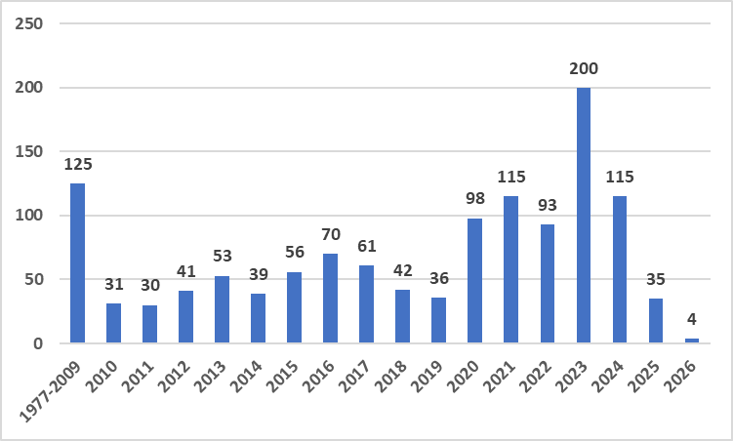
Figure 1 Evolution of number of retractions
Country analysis
Table 1 shows the top 20 countries, based on the affiliation of the corresponding author, of retracted articles. China (n=438, 35.21%) represented the largest share of retracted publications, followed by the United States (n=370, 29.74%), and India (n=85, 6.75%). It has been observed that the top 10 countries either individually or with collaboration with other countries published 99.28% of the total retracted publications (n=1235) in the field of neuroscience.
Table 1 The top 10 countries, based on affiliation of the corresponding author, of retracted articles from 1977 to 2026 (n = 1244).
Rank | Country | Number of Articles | Percentage share (%)
1 | China | 438 | 35.21
2 | United States | 370 | 29.74
3 | India | 84 | 6.75
4 | Germany | 70 | 5.63
5 | Japan | 66 | 5.31
6 | United Kingdom | 55 | 4.42
7 | Italy | 43 | 3.46
8 | Iran | 40 | 3.22
9 | Canada | 35 | 2.81
10 | Saudi Arabia | 34 | 2.73
 | Total | 1235 | 99.28

The study found the dominance of Asia which is vouched by the presence of China, India, Japan, Iran and Saudi Arabia in the top 10 countries with the highest retractions (n=662) which is about 53.21% of the total retracted publications in neuroscience globally. These numbers do not necessarily mean poorer research quality but they may reflect more chances of retractions when there is higher publication volume. Similarly, better detection systems and increased transparency in scientific publishing may also be the reason. It clearly vouches that there is more retractions in highly productive countries and emerging research nations like India and Iran are increasingly visible.
Analysis of Research Collaboration
Out of 1244 retracted papers in neuroscience, 986 (79.26%) are single-country papers while 258 (20.74%) are multi-country papers which revealed the international collaboration in the field of neuroscience research. It has been found that 4 out of 5 papers are produced within one country which indicates strong domestic research activity in many countries and also limited cross-border collaboration in many cases. It also reveals that this field dominated by national research. Involvement of international collaboration about 1 in 5 papers shows global cooperation exists in the field of neuroscience and supported by strategic international collaborations which is selective but not universal.
The study found that United States collaborates with almost all major countries like China, United Kingdom, Germany, Canada, India and acts as a global connector in neuroscience research networks and serves as the global research hub in neuroscience. China is the second largest collaborating country in the field of neuroscience research with United States, Australia and United Kingdom. It is also interesting to note that a strong intra-Europe collaboration exists among Germany, France, Italy, Netherlands and Sweden.
It has been observed that India is an emerging collaborator in the field of neuroscience research and the leading countries are United States, Saudi Arabia, United Kingdom and China. The top 10 leading collaborations are furnished in Table 2.
Table 2 Top 10 International collaboration, based on affiliation of the corresponding author, of retracted articles (n = 1244).
Rank | Country | Number of Articles | Percentage share (%)
1 | China – United States | 30 | 11.63
2 | Germany – United States | 19 | 7.36
3 | Canada – United States | 16 | 6.20
4 | Italy – United States | 15 | 5.81
5 | Japan – United States | 14 | 5.43
6 | India – Saudi Arabia | 13 | 5.04
7 | Germany – Italy | 11 | 4.26
8 | Egypt – Saudi Arabia | 11 | 4.26
9 | Germany- Switzerland | 10 | 3.88
10 | India – United States | 10 | 3.88
 | Total | 149 | 57.75

Analysis of Journals associated with retractions
As illustrated in Table 3, a thorough investigation has been done into the publishers and journals that have experienced the highest number of retracted articles in the field of neuroscience. Retractions in neuroscience has been done by 491 journals and 15 conferences. The highest number of retractions was done by PLoS One (n=57). Additionally, the study has evaluated the quality of these journals by assessing their impact quartile. With regard to publishers, a large portion comes from major academic publishers like Elsevier, Springer Nature, and Wiley. It is interesting to note that the top 10 journals retracted 221 articles (17.77%) were done by Elite journals like Nature, Core neuroscience journals, open-access mega journals and some controversial open access journals. The study also found that among the top 10 journals retracted neuroscience literature, Q2 journals retracted the highest (n=102) followed by Q3 journals (n=51), Q4 journals (n=38) and Q1 journals (n=30).
Table 3 Top 10 Journals retracted highest number of articles
S. No. | Journal | Publisher | Impact Factor (2025) | Quartile | No. of Articles
1 | PLoS One | Public Library of Science (PLOS) | 2.6 | Q2 | 57
2 | The Journal of Neuroscience | Society for Neuroscience | 4.0 | Q2 | 29
3 | Computational and Mathematical Methods in Medicine | Hindawi (Wiley) | - | Q4 | 23
4 | Brain Research | Elsevier | 2.6 | Q3 | 22
5 | Nature | Springer Nature | 48.5 | Q1 | 16
6 | Journal of Neurochemistry | Wiley | 4.0 | Q2 | 16
7 | Neuroscience | Elsevier | 2.8 | Q3 | 15
8 | Journal of Healthcare Engineering (Ceased) | Hindawi (Wiley) | - | Q4 | 15
9 | BioMed Research International | Hindawi (Wiley) | 2.3 | Q3 | 14
10 | Molecular Neurobiology | Springer Nature | 4.3 | Q1 | 14

Analysis of Publishers associated with retractions
Retraction of 1244 publications in the field of neuroscience was done by 112 unique publishers. Figure 2 shows the top 20 publishers with the highest retraction counts in neuroscience. Elsevier (n=210) and Springer (n=147) consistently dominate retraction counts. Hindawi (n=98), Wiley (n=92) and PLoS (63) rank in the third, fourth and fifth positions respectively, contributing moderately to retractions in neuroscience.
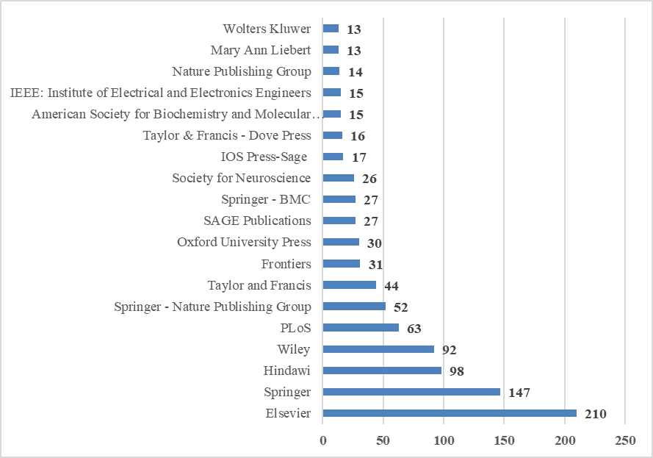
Figure 2 Top 20 Publishers with highest retractions in neuroscience
It has been found that the top 20 publishers retracted 950 publications (76.37%) while the remaining 92 publishers retracted 294 publications (23.63%). The study revealed that six publishers retracted articles between 10 and 12 while 44 publishers retracted publications between 2 and 8 while 42 publishers retracted only one publication each.
Analysis of Institutions associated with Retractions
The analysis of institutions associated with retraction in neuroscience revealed that the 1244 retracted publications are from the authors affiliated with 1873 institutes in which 374 publications are of authors from single institutes, 299 publications are collaborative work of authors from two institutes, 222 publications are out of collaborative work of authors from three institutes and 344 publications are collaborative work of authors from four or more institutes.
The University of Alabama at Birmingham, USA is the topper with the largest number of retracted publications (n=12) followed by North China University of Science and Technology, China (n=11), Central Michigan University, USA (n=10), Kobe Gakuin University, Japan (n=9) and University of Pennsylvania, USA (n=9).
Table 4 illustrates the top 20 institutes with the highest number of retractions in neuroscience. It has been found that out of the top 20 institutes, nine institutes are from the USA with 69 retractions followed by China with eight institutes (50 retractions), South Korea with two institutes (12 retractions) and Japan with one institute (9 retractions).
Table 4 Top 20 institutes with the highest retractions in neuroscience
Rank | Institute | Country | Frequency
1 | University of Alabama at Birmingham | USA | 12
2 | North China University of Science and Technology | China | 11
3 | Central Michigan University | USA | 10
4 | Kobe Gakuin University | Japan | 9
5 | University of Pennsylvania | USA | 9
6 | University of Texas at Austin | USA | 8
7 | Purdue University | USA | 8
8 | University of Pittsburgh | USA | 7
9 | Jilin University | China | 7
10 | Tongji University | China | 7
11 | Xi’an Jiaotong University | China | 6
12 | China Medical University | China | 6
13 | Chonnam National University | South Korea | 6
14 | Sungkyunkwan University | South Korea | 6
15 | University of Arizona | USA | 5
16 | East China Normal University | China | 5
17 | University of California, Los Angeles | USA | 5
18 | The Ohio State University | USA | 5
19 | Zhejiang University | China | 4
20 | Shanghai Jiao Tong University | China | 4

Analysis of Article Types
The analysis revealed that most retractions can be found in the category of research articles in the field of neuroscience. Articles are broadly categorized into four main categories: research articles (n=1041), clinical studies (n=76), review articles (n=40), conference papers (n=33) and others (54). The study finds that research articles contribute to the majority of retractions with 83.68%. Clinical studies constitute a noteworthy 6.11% of the retracted article types, and review articles also hold substantial representation, comprising 3.22% of all retractions. Conference papers contribute to the retractions with 2.65%. The remaining article types collectively contribute 4.34%. The data are illustrated in Figure 3.
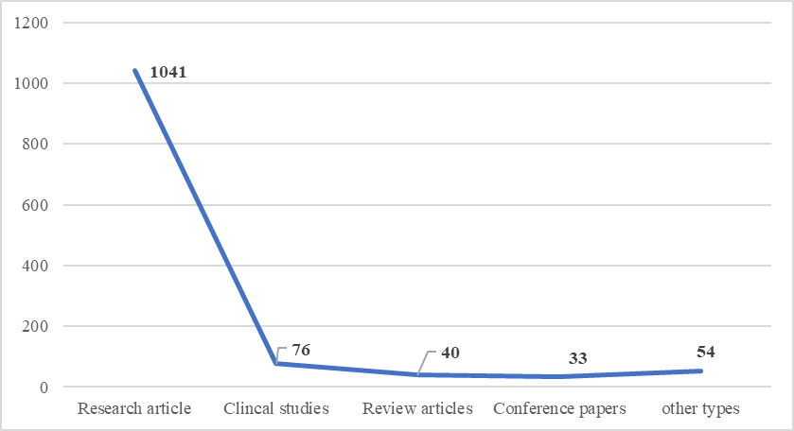
Figure 3 Types of articles retracted in neuroscience
Analysis of Reason for Retractions
Through the systematic analysis of retractions of 1244 retracted publications in neuroscience, it was revealed that these retractions comprised of many reasons and each retracted paper was attributed with at least one reasons and a maximum of six reasons. Of all the retractions, 286 out of 1244 articles were suspected of unreliable results, comprising 22.99% of the total retractions. This proportion was notably higher than that of other reasons viz., data concerns (n=237), image duplication (n=206), image issues (n=140), data fabrication/falsification (n=116) and paper mill (n=115). This clearly shows that data integrity issues such as unreliable results, data concerns are the biggest problem in neuroscience research. It has been noted that image manipulation/duplication is very common while paper mills are a significant modern issue. It is very important to note that not all retractions are due to fraud research but many may come from honest errors or irreproducibility. Pressure to publish may contribute to data manipulation and paper mill usage. Many studies revealed that the neuroscience field is especially sensitive due to complex experiments and hard-to-reproduce results. The other reasons for retraction of neuroscience publications are unreliable data (n=110), concerns about results/conclusions (n=104), error in data (n=92), misconduct by author (n=90) and referencing/attribution issues (n=89). Figure 4 illustrates the major reasons for retractions of publications in neuroscience.
The study also revealed that these retractions were done based on investigation by journal/ publisher (n=298, 23.95%), third-party investigations (n=184, 14.79%), institutional investigations (n=165, 13.26%) and other reasons not clearly mentioned (n= 597, 47.99%). This revealed that there is a strong post-publication scrutiny of papers by stakeholders.
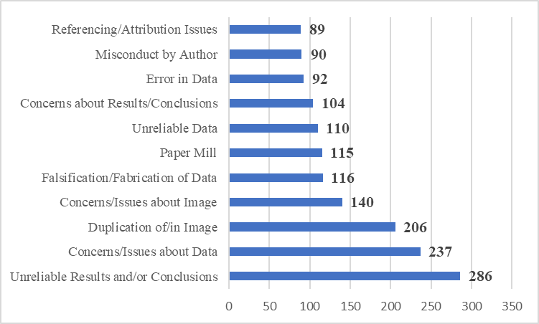
Figure 4 Reasons for retractions in neuroscience
The study clearly shows that data integrity issues such as unreliable results and data concerns are the biggest problem in neuroscience research as about 27% are data related problem, the biggest driver of retractions. It has been noted that image manipulation/duplication is very common as about 9% retractions are due to image related issues which is common in biomedical fields. Paper mills are a significant modern issue. It is very important to note that not all retractions are due to fraud research but many may come from honest errors or irreproducibility. Pressure to publish may contribute to data manipulation and paper mill usage. Many studies revealed that the neuroscience field is especially sensitive due to complex experiments and hard-to-reproduce results.
Analysis of Retraction Time Lag
Between 1977 and April 2026, retraction time lags for neuroscience publications exhibited significant variation, ranging from a single day to 31 years. The average retraction time lag was 3.58 years and the median is 2.17 years. The study revealed that about 22.02% papers were retracted within 1 year (n=274) and about 18.73% retracted within 1-2 years (n=233). While 13.67% papers were retracted within 2-3 years (n=170), it took about 3-5 years to retract 14.79% of the papers (n=184). About 5-10 years were taken to retract about 16.08% of the papers (n=200) while 94 papers were retracted between 10 and 20 years (7.56%). Only some problematic papers persist for decades and in this case 7 papers (0.56%) were retracted after 20 years. The details about retraction time lag in neuroscience is illustrated in Figure 5.
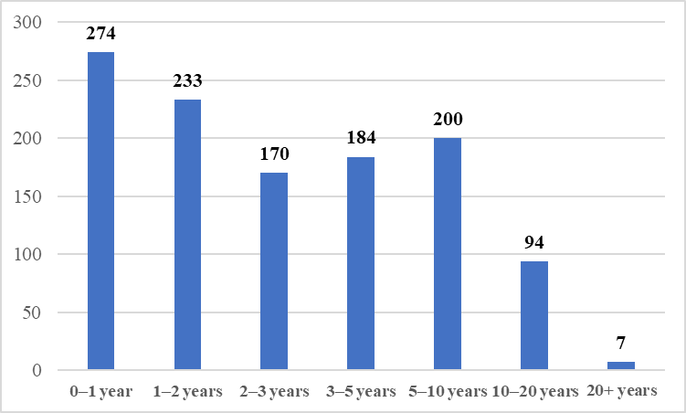
Figure 5 Reasons time lag
Analysis of Retraction Time Lag
Retraction Time Lag by Countries
The country-wise analysis of time lag revealed that publications from China, Iran, Egypt, Australia and UK are detected and retracted within 2 to 2.5 years which is considered as the fastest group of countries in retraction. Publications from India, South Korea and Germany are retracted between 3 to 4 years which is the typical global average time lag for retraction of papers and considered as mid group. Slowest detection and retraction of publications taken place in case of Japan (4.30 years), Canada (4.66 years), United States (5.36 years), Italy (5.71 years). These countries take 2 to 3 years longer than the fastest group. The reason for fastest retraction is linked to rapid investigation, crackdowns on paper mills and high scrutiny in recent years. The reason for slower retractions is linked to complex investigation processes, legal/institutional delays and older legacy papers being retracted late. The study found that the global average retraction time lag in neuroscience is 3.5 years and the fastest is 2 to 2.5 years while the slowest is 5 to 6 years. The details are presented in Figure 6.
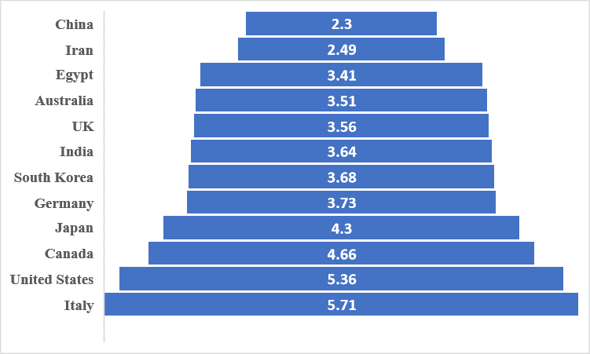
Figure 6 Average retraction time lag by Countries
Retraction Time Lag by Publishers
The study also tried to analyse time lag analysis by publisher and journal which revealed who retracts faster versus slower. Publishers like Hindawi, Frontiers, Taylor and Francis and Springer typically retract the publications within 1.5 to 3 years while Elsevier, Oxford University Press, Wiley, Springer Nature Group retract within 3-4 years while PLOS stands out with very long delays (7 years). The details of publishers and average lag in years are furnished in Figure 7.
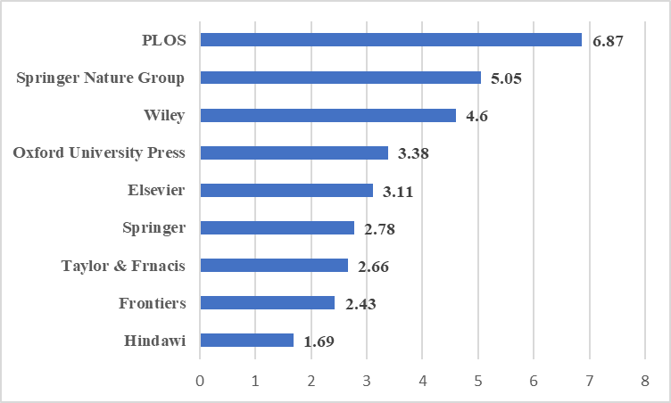
Figure 7 Average retraction time lag by publishers
Retraction Time Lag by Journals
The time lag analysis revealed that some journals retract the papers within 1 to 2 years while some journals take 2 to 4 years. There are many journals which take between 5 to 8 years also. Fast retractions often happen because of obvious problems like plagiarism, paper mills, etc., which can be detected easily and hence the journals perform bulk retractions. For example, Hindawi journals are well known for their rapid paper mill clean up. Slow retractions often mean complex, high-impact research, long investigations and legal/institutional review, etc. For example, Nature, Science, PNAS, PLoS One are known for their high scrutiny and deep investigations and hence retractions take years to confirm. To sum up the fastest retractions take place within 1 to 2 years, the average systems retracts within 3 to 4 years and the slowest systems consisting of high-impact journals take 5 to 7 years to retract the papers. It is very important to note that the time lag for retraction is decided by the type of misconduct, investigation depth and journal policies. The details are furnished in Table 5.
Table 5 Retraction time lag by journals
Journal | Average lag (years)
Fastest Journals
Computational & Mathematical Methods in Medicine | 1.26
Journal of Healthcare Engineering | 1.54
RSC Advances | 1.83
Moderate Journals
Neuroscience | 2.12
Scientific Reports | 2.63
Neuroscience Letters | 3.16
Molecular Neurobiology | 3.46
Slow Journals
Nature | 4.89
PNAS | 5.36
Science | 5.45
Journal of Biological Chemistry | 5.91
Journal of Neurochemistry | 6.07
PLoS One | 7.29

RECOMMENDATIONS
Reducing publication retractions requires collaborative efforts among the stakeholders of higher education and research consisting of researchers, institutions, reviewers, and publishers through stronger ethical oversight, transparent research practices, rigorous peer review, and enhanced accountability mechanisms.
The following are some of the important recommendations to help reduce and control the retraction of scientific publications;
- Academic systems should prioritize research quality and integrity over publication quantity to reduce academic and research misconduct.
- To improve accountability, clear definition of individual author contributions and verification of the accuracy of the work by all the authors should be mandated
- Journal Editors should carefully assess suspicious submissions, paper mill indicators, fabricated peer reviews, and unusually rapid manuscript production.
- To detect errors and discourage misconduct, open data, supplementary datasets, and reproducible methodologies should be encouraged.
- Institutions should provide mandatory training on research ethics, responsible authorship, data management, and publication practices for researcher scholars and students.
- Journals and publishers should adopt clear and consistent retraction guidelines, such as those recommended by the Committee on Publication Ethics.
- Journals should implement rigorous and transparent peer review, including statistical review, methodological assessment, and plagiarism screening.
- Proper Institutional Review Board (IRB) approval, informed consent procedures, and conflict-of-interest disclosures should be strictly enforced by the academic and research institutes.
- Publishers and editors should routinely screen manuscripts using quality plagiarism detection software and forensic tools for image duplication or manipulation as image manipulation is one of the major reasons for retraction of publications in biological sciences.
- Universities and funding agencies should promote honesty, transparency, and reproducibility as core research values and formulate a clear policy to deal with retractions so as to discourage academic and research misconduct.
CONCLUSION
In conclusion, our data indicate that over the past 49 years, paper retractions in the field of neuroscience have increase sharply, underscoring a significant issue of research misconduct. Retractions in the field of neuroscience have sporadically occurred in the 1970s but have increased exponentially since 2020. The increasing number of retractions have severely undermined the integrity of scientific research in this field. Of all the retractions, 286 out of 1244 articles were suspected of unreliable results, comprising 22.99% of the total retractions. Thus, academic misconduct is the predominant cause of retractions, with various complex reasons contributing to the growing problem. The findings of this study suggest that academic and research stakeholders consisting of research scholars, researchers, research management, journals, publishers should remain vigilant regarding retraction patterns and emphasize the importance of research integrity. The regulatory bodies of academic and research systems should come out with a clear ‘retraction policy’ and sensitize the stakeholders about the seriousness of the global problem. Already, the Ministry of Education, Government of India declared that they will introduce a negative score for the institutes with retracted publications under National Institutional Ranking Framework (NIRF) ranking of institutes. The regulatory bodies such as UGC, AICTE and other agencies dealing with various systems of education like medical, paramedical and allied sciences shall take initiatives to sensitize the stakeholders of education and research in India about his growing problem and train them to combat the menace.
REFERENCES
- Bhatt, B. (2021). A multi-perspective analysis of retractions in life sciences. Scientometrics, 126(5), 4039-4054.
- Bhattacharyya, S, Chatterjee N and Ramanathan A 2025. Understanding the patterns and magnitude of life science publication Retractions in the last four decades. Int. J Educ Integr 21(1): 17.
- Candal-Pedreira C, Ruano-Ravina A, Rey-Brandariz J, Mourino N, Ravara S, Aguiar P and Perez-Rios M. 2023. Evolution and characterization of health sciences paper retractions in Brazil and Portugal. Account Res 30(8), 725-742.
- Craig R, Cox A, Tourish D and Thorpe A 2020. Using retracted journal articles in psychology to understand research misconduct in the social sciences: What is to be done?. Res Policy, 49(4): 103930.
- Elango B 2022. Characteristics of retracted editorial articles in the biomedical literature. Scientometrics, 127(3),pp.1431-1438: https://doi.org/10.1007 / s11 192-021-04263-9
- Elango B, Kozak M and Rajendran P. 2019. Analysis of retractions in Indian science. Scientometrics 119, 1081–1094. https://doi.org/10.1007/s11192-019-03079-y
- Else H 2024. Biomed retractions have quadrupled in 20 years—Why?. Nature 630(8016): 280-281.
- Fang FC, Steen R G and Casadevall A. 2012. Misconduct accounts for the majority of retracted scientific publications. Proc Natl Acad Sci 109(42):17028-17033.
- Grieneisen ML, Zhang M (2012) A comprehensive survey of retracted articles from the scholarly literature. Plos One. https://doi.org/10.1371/journal.pone.0044118
- Islam AS, Mastoloni EM, Fenton J E and Coelho D H 2025. Article Retraction in Otolaryngology Journals: A Thirty Year Analysis. Clin Otolaryngol 50(3): 514-520.
- King, E. G., Oransky, I., Sachs, T. E., Farber, A., Flynn, D. B., Abritis, A., et al. (2018). Analysis of retracted articles in the surgical literature. The American Journal of Surgery, 216(5), 851–855.
- Lievore C, Rubbo P, Dos Santos C B, Picinin CT and Pilatti L A 2021. Research ethics: a profile of retractions from world class universities. Scientometrics, 126(8): 6871-6889.
- Mena J D, Ndoye M, Cohen A J, Kamal P and Breyer B N 2019. The landscape of urological retractions: the prevalence of reported research misconduct. BJU Int 124(1): 174-179.
- Misra D P, Ravindran V and Agarwal V 2018. Integrity of authorship and peer review practices: challenges and opportunities for improvement. J. Korean Med Sci 33(46): https://doi.org/10.3346/jkms.2018.33.e287
- Qi Q, Huang J, Wu Y, Pan Y, Zhuang J and Yang X 2024. Recent trends: Retractions of articles in the oncology field. Heliyon, 10(12). https://www.cell.com/heliyon/fulltext/S2405-8440(24)09038-8
- Retraction Watch Database (2026). Available at www.retractionwatchdatabase.org. Accessed on 15th April 2026.
- Rivera H and da Silva J A T 2021. Retractions, fake peer reviews, and paper mills. J. Korean Med Sci 36(24).
- Solomon D, Heckman C and Hubbard D E 2023. Retractions in Scopus: An engineering journal articles investigation. S & TL, 42(3): 353-366.
- Stavale R, Ferreira G I, Galvão J A M, Zicker F, Novaes M R C G, Oliveira C M D and Guilhem D. 2019. Research misconduct in health and life sciences research: A systematic review of retracted literature from Brazilian institutions. PLoS One, 14(4):.https://doi.org/10.1371/journal.pone.0214272
- Steen RG, 2011. Retractions in the scientific literature: is the incidence of research fraud increasing?. J Med Ethics 37 (4): 249-253.
- Tourish D and Craig R 2020. Research misconduct in business and management studies: Causes, consequences, and possible remedies. J Manag Inq 29(2): 174-187.
- Van Noorden R 2023. More than 10,000 research papers were retracted in 2023 – A new record. Nature, 624 (21/28):.479.
- Vuong Q H, 2020. The limitations of retraction notices and the heroic acts of authors who correct the scholarly record: An analysis of retractions of papers published from 1975 to 2019. Learn Publ 33(2): 119-130.
- Wager E, Barbour V, Yentis S and Kleinert on behalf of COPE Council 2010. Retractions: guidance from the Committee on Publication Ethics (COPE). Int J Polym Anal Charact 15(1): 2-6.
- Wang, T., Xing, Q.-R., Wang, H., & Chen, W. (2019). Retracted publications in the biomedical literature from open access journals. Science and Engineering Ethics, 25(3), 855–868.

