Assessment of Properties and the Influence on Compaction Characteristics, Settlement Behaviour, and Hydraulic Conductivity at Tanjung Dua Belas and Air Hitam Landfills

M Mukri¹, H A K Anuar^{2*,} N Khalid³ and A A Omar⁴
¹School of Civil Engineering, College of Engineering, UiTM Shah Alam, 40450, Selangor, Malaysia

ABSTRACT
This study investigates the geotechnical characteristics of soils obtained from two landfill sites in Selangor, Malaysia namely Tanjung Dua Belas and Air Hitam to evaluate their suitability as compacted landfill liner materials. Laboratory testing was conducted to determine physical properties, compaction behaviour under different energy levels, consolidation characteristics, and stress-dependent hydraulic conductivity under controlled conditions. The results indicate distinct differences in engineering performance between the two soils. Air Hitam soil achieved higher Maximum Dry Density (MDD) values ranging from 1.832 to 1.987 g/cm³ at lower Optimum Moisture Contents (OMC) between 11.92% and 19.48%, demonstrating superior compaction efficiency compared to Tanjung Dua Belas, which recorded MDD values between 1.410 and 1.565 g/cm³ with higher OMC ranging from 18.56% to 22.56%. Consolidation analysis showed lower settlement for Air Hitam (1.401 mm) compared to Tanjung Dua Belas (1.583 mm), indicating improved stiffness and reduced compressibility. Hydraulic conductivity decreased with increasing applied stress for both soils, with Air Hitam reducing from approximately 1.55 × 10⁻⁵ cm/s to 7.5 × 10⁻⁶ cm/s, while Tanjung Dua Belas decreased from 1.25 × 10⁻⁵ cm/s to 8.6 × 10⁻⁶ cm/s. Overall, the higher density, lower plasticity, reduced shrinkage, and improved impermeability of the Air Hitam soil contribute to enhanced stability and containment performance, indicating its comparatively better suitability for engineered landfill liner applications.
INTRODUCTION
Malaysia’s rapid population growth and industrialisation have significantly increased municipal solid waste (MSW) generation, thereby intensifying reliance on landfilling as the primary disposal method [1]. The performance of landfill facilities depends largely on the engineering behaviour of liner and cover materials, where geotechnical parameters such as compaction, settlement, and hydraulic conductivity play critical roles in maintaining structural stability and preventing environmental contamination [2]. Properly designed liner systems must demonstrate adequate density, minimal compressibility, and low permeability to effectively restrict leachate migration. Therefore, this study evaluates the relevant physical and engineering properties of selected soils and examines their influence on compaction characteristics, settlement behaviour, and hydraulic conductivity in order to establish meaningful correlations that can enhance landfill liner design and minimise environmental risks [3].
Although numerous studies have investigated individual soil properties, limited research has addressed the integrated relationship between physical characteristics and overall landfill engineering performance in the Malaysian context [4]. The absence of comprehensive data linking index properties with compaction response, consolidation behaviour, and hydraulic performance has introduced uncertainty in predicting the long-term behaviour of landfill liner materials [5]. This challenge is particularly significant in tropical regions such as Selangor, where fluctuations in moisture content and variations in mineral composition may substantially alter soil behaviour under load [6]. Consequently, a systematic assessment of the interrelationship between soil properties and engineering performance is required to reduce design uncertainties and improve landfill management strategies.
This study aims to address these gaps by determining the physical properties of soils obtained from the Tanjung Dua Belas and Air Hitam landfill sites. It further evaluates the compaction characteristics, consolidation behaviour, and hydraulic conductivity of the selected samples. In addition, the study analyses the relationships between physical properties and engineering behaviour to better understand their collective influence on landfill liner performance.
The scope of this research is limited to soil samples collected from two landfill sites in Selangor: Tanjung Dua Belas and Air Hitam. Laboratory investigations include the determination of particle density, grain size distribution, Atterberg limits, and pH, as well as compaction parameters such as optimum moisture content and maximum dry density. Settlement behaviour is examined through consolidation testing, while hydraulic conductivity is assessed using permeability tests conducted under controlled laboratory conditions. The findings are therefore representative of laboratory-scale evaluation and may not fully replicate field-scale performance. Furthermore, the conclusions drawn are specific to the selected landfill sites and may not be directly generalisable to all landfill conditions in Malaysia. Nonetheless, this study provides valuable insight into the interaction between material properties and engineering performance in landfill liner applications.
METHODOLOGY
Disturbed sampling was carried out to collect soil samples from two sanitary landfills in Selangor, which are Tanjung Dua Belas and Air Hitam. Approximately 90 kg of soil was excavated from a depth of about 0.5 m to represent the active zone influenced by leachate movement. The samples were air-dried, then oven-dried at 105–110 °C for 24 hours before testing to ensure uniform moisture conditions. All laboratory tests were performed in accordance with BS 1377:1990 and ASTM standards to ensure consistency, accuracy, and reliability of the results.
Physical Properties Test
A series of laboratory tests were conducted to determine the basic physical properties of the collected soil samples, including pH, particle density, particle size distribution, Atterberg limits, and shrinkage limit. The pH value was determined using a 1:2.5 soil-to-water ratio following BS 1377-3:1990, to assess the acidity or alkalinity of the samples. Particle density was obtained using the pycnometer method in accordance with BS 1377-2:1990. The particle size distribution was analysed through combined wet sieving and hydrometer analysis following BS 1377-2:1990 to classify the proportions of gravel, sand, silt, and clay. The Atterberg limits, including liquid limit, plastic limit, and plasticity index, were determined using BS 1377-2:1990 to evaluate the soil’s plasticity characteristics. The shrinkage limit was measured in accordance with BS 1377-2:1990 to assess the potential volume change of the soil upon drying. These tests provided essential information on the fundamental physical characteristics of the landfill soils, which are critical for evaluating their suitability in engineering applications.
Compaction test

The compaction characteristics of soil reflect its response to external loading and moisture variations, which are critical factors in the performance of landfill liners and covers. In this study, three compaction methods were conducted which is Standard Proctor Compaction (SPC), Reduced Proctor Compaction (RPC), and Modified Proctor Compaction (MPC), in accordance with BS 1377-4:1990 which is differentiate in table 3.1 below. For each method, soil passing through a 4.75 mm sieve was prepared, and the water content was adjusted at different intervals to determine the Optimum Moisture Content (OMC) and Maximum Dry Density (MDD). In the Standard Proctor Test, soil was compacted in a 1-litre mould in three layers, each subjected to 25 blows using a 2.5 kg rammer dropped from a 300 mm height. The Reduced Proctor Test adopted the same configuration but used 15 blows per layer to represent lighter compaction energy. The Modified Proctor Test employed a 4.5 kg rammer with a 457 mm drop height, compacting the soil in five layers of 25 blows each to replicate higher energy compaction conditions. After compaction, the bulk and moisture contents were determined to compute dry density values, which were plotted to establish compaction curves for comparison among the three methods.

Table 1. Sample Preparation for compaction Test
Test Procedure | Rammer (kg) | Falling Height (m) | No of blows | No of layers | Compactive Effort (kN-m/m³)
RPC | 2.5 | 0.305 | 15 | 3 | 356.7
SPC | 2.5 | 0.305 | 25 | 3 | 594.5
MPC | 4.5 | 0.457 | 25 | 5 | 2700.

Consolidation Test

The one-dimensional consolidation test was performed following BS 1377-5:1990 to examine the compressibility behaviour of the soil samples under vertical loading. The test was carried out using an oedometer apparatus to simulate the pressure typically exerted on landfill liner materials shown in figure 4. A saturated specimen was placed within a consolidation ring and sandwiched between porous stones to facilitate even drainage. A seating pressure of 6 kPa was first applied to ensure full contact, followed by incremental loads of 12, 25, 50, 100, 200, and 400 kPa, each maintained for one hour. Deformation readings were recorded using a dial gauge throughout the loading period. The unloading phase was conducted in two stages to assess rebound potential. Upon completion, the specimens were oven-dried to obtain their moisture content. The Coefficient of Consolidation (Cv) was determined using the square root of time approach, while the Compression Index (Cc) was calculated from the linear segment of the void ratio–log pressure (e–log p) relationship. The total consolidation settlement (Sc) was then derived based on classical consolidation theory.
Figure 4. Oedometer apparatus for consolidation test

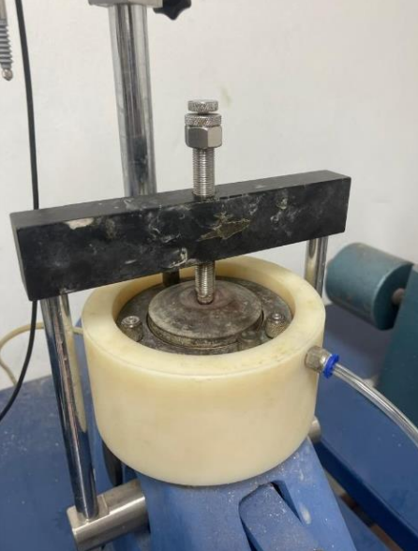
Hydraulic Conductivity Test
The hydraulic conductivity of the soils was evaluated using a modified oedometer setup designed to simulate vertical leachate movement under landfill-like pressure conditions shown in figure 5. The apparatus consisted of a standard consolidation ring connected to a constant head reservoir. Samples were compacted at their respective OMC values, and vertical pressures of 25, 50, 100, and 200 kPa were applied to replicate field overburden stresses. The flow rate through the saturated soil was recorded over a specified period, and hydraulic conductivity was computed using Darcy’s law. This procedure provided an assessment of soil permeability under controlled stress conditions, reflecting the influence of density and structure on fluid migration within landfill materials.
Figure 5. Setup of modified oedometer test
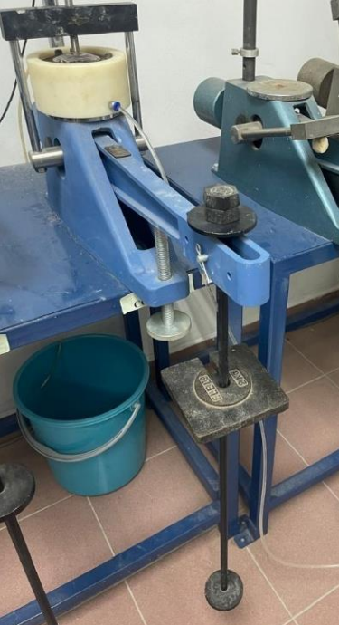
RESULTS AND DISCUSSION
Physical properties of soil
The chemical condition of the investigated soils was assessed through pH testing using a 1:2.5 soil-to-water ratio in accordance with BS 1377-3:1990. The measured values indicate that both soils exhibit strongly acidic behaviour, which is commonly associated with landfill environments subjected to prolonged leachate exposure. As shown in Table 2, the average pH recorded for the Tanjung Dua Belas sample was 2.81, while the Air Hitam sample exhibited a slightly higher value of 3.65. These results classify the soils as highly to very strongly acidic. Such acidity is typically linked to the presence of decomposed organic matter and sulphate-bearing compounds generated from municipal solid waste degradation. Previous investigations have reported comparable acidic characteristics in soils surrounding Malaysian landfill sites, indicating that continuous interaction with leachate contributes significantly to reduced pH levels [7]. Similar pH conditions have also been documented at the Air Hitam landfill, confirming that acidic soil behaviour is a common feature in active landfill environments [8]. The presence of strong acidity may influence mineral composition, soil fabric, and long-term engineering performance, particularly in liner systems where chemical stability and durability are essential. Therefore, although the soils exhibit chemical behaviour consistent with other Malaysian landfill liner materials, stabilization or treatment measures may be necessary to enhance their long-term performance and resistance to chemical degradation under aggressive landfill conditions.
Table 2. Tanjung Dua Belas and Air Hitam pH result
 | Tanjung Dua Belas | Air Hitam
1 | 2.96 | 3.7
2 | 2.79 | 3.66
3 | 2.69 | 3.6
Avg | 2.81 | 3.65
The particle density of the investigated soils was determined in accordance with BS 1377-2:1990 using the small pycnometer method to evaluate the mineralogical characteristics of the samples. The measured values indicate variation between the two landfill sites, reflecting differences in material composition. As shown in Table 3, the particle density of the Tanjung Dua Belas soil was 2.22 Mg/m³, whereas the Air Hitam soil recorded a higher value of 2.48 Mg/m³. The relatively lower particle density at Tanjung Dua Belas may suggest the presence of higher organic content or lighter mineral constituents within the soil matrix. In contrast, the higher particle density observed at Air Hitam implies a greater proportion of heavier mineral components, potentially including iron oxides or denser silicate minerals. Previous studies have reported that soils containing elevated organic matter typically exhibit reduced particle density values due to the lower specific gravity of organic materials [9]. Comparable findings have also been documented in Malaysian landfill liner investigations, where particle density values below 2.60 Mg/m³ were associated with organic-rich, fine-grained soils that significantly influence compaction behaviour and settlement performance [7]. These variations in particle density are important, as they directly affect soil compressibility, compaction response, and overall structural behaviour in landfill liner applications.
Table 3. Tanjung Dua Belas and Air Hitam Particle Density result
Sample | Specific Gravity | ρ_{w} (Mg/m³) | Particle Density (Mg/m³)
Tanjung Dua Belas | 2.277 | 0.9982 | 2.223
Air Hitam | 2.482 | 0.9982 | 2.478

The particle size distribution of the investigated soils was determined using combined sieve and hydrometer analyses in accordance with BS 1377-2:1990 to evaluate their gradation characteristics and suitability for landfill liner applications. The results indicate that both soils are predominantly fine-grained with a balanced distribution of silt, sand, clay, and gravel fractions. As detailed in Table 4 and illustrated in Figure 6, the Tanjung Dua Belas sample comprises 36.3% silt, 29.5% sand, 23.5% clay, and 10.7% gravel, whereas the Air Hitam sample contains 35.6% silt, 27.5% sand, 19.7% clay, and 17.2% gravel. Both soils exhibit fine contents (silt and clay fractions) exceeding 40%, significantly surpassing the minimum 8% fine fraction required by the Ministry of Housing and Local Government, Malaysia (MHLGM), as well as the 20% benchmark commonly recommended for landfill liner materials [8]. The presence of substantial fine content enhances particle packing and reduces void spaces, thereby contributing to improved compaction efficiency and lower hydraulic conductivity. Such gradation characteristics are advantageous for landfill liner systems, where low permeability and structural stability are essential to minimise leachate migration. Comparable particle size distributions have been reported in Malaysian landfill investigations, where fine-grained sandy silt with well-balanced gradation was shown to improve liner integrity and containment performance [7].
Figure 6. Tanjung Dua Belas and Air Hitam Particle Size Distribution result
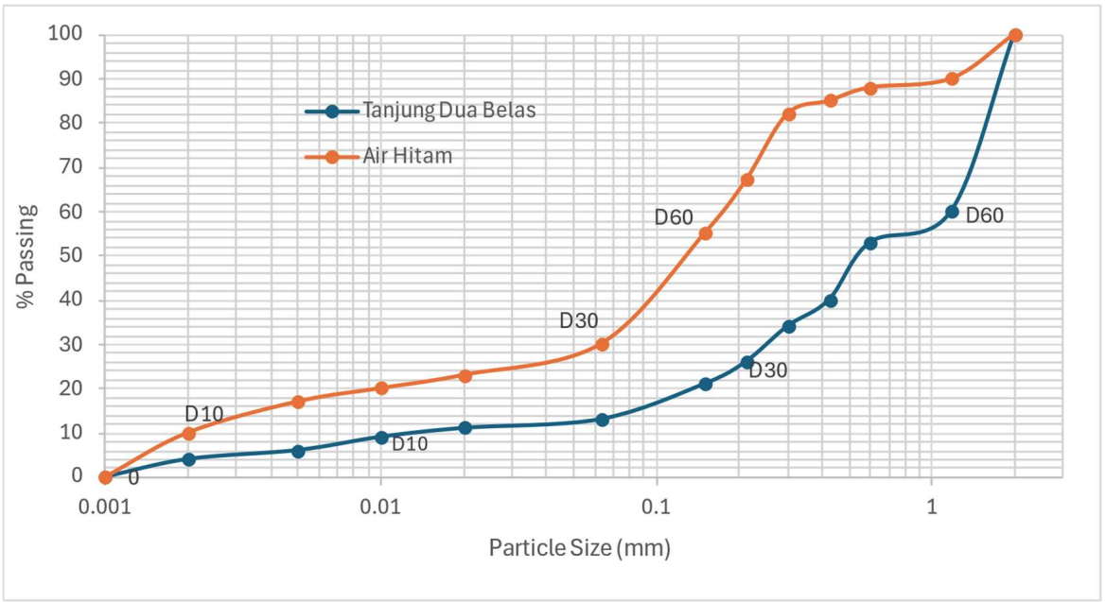
Table 4. Tanjung Dua Belas and Air Hitam Particle Size Distribution Summary
 | Tanjung Dua Belas | Air Hitam
Gravel (%)  Sand (%)  Silt (%)  Clay (%)  D₆₀ (mm)  D₅₀ (mm)  D₃₀ (mm) D₁₀ (mm)  Cu  Cg | 10.70  29.50  36.30  23.50  1.260  0.540  0.250  0.015  84.00  3.31 | 17.20  27.50  35.60  19.70  0.175  0.140  0.062  0.002  87.50  10.98
Soil Classification | Well Graded Sandy Silt | Gap Graded Sandy Silt

The plasticity characteristics of the investigated soils were determined in accordance with BS 1377-2:1990 to evaluate their consistency limits and potential behaviour under varying moisture conditions. The measured values indicate noticeable differences between the two landfill sites. As summarised in Table 5, the Tanjung Dua Belas soil recorded a liquid limit (LL) of 39.83%, a plastic limit (PL) of 16.85%, and a plasticity index (PI) of 22.98%. In comparison, the Air Hitam soil exhibited lower values, with an LL of 24.14%, a PL of 10.75%, and a PI of 13.39%. The relatively higher LL and PI values observed in the Tanjung Dua Belas soil suggest a greater proportion of active clay minerals and a stronger capacity to retain water within its structure. Such behaviour is typically associated with fine-grained soils containing higher clay content, which tend to demonstrate increased plasticity and moisture sensitivity [9]. Conversely, the lower plasticity values measured for the Air Hitam soil indicate a comparatively coarser composition with reduced clay fraction and improved workability. Similar behaviour has been reported in soils with increased sand content, where reduced plasticity contributes to greater stability and ease of compaction [2]. Although the higher plasticity of the Tanjung Dua Belas soil may enhance cohesion, it may also increase susceptibility to deformation and shrink–swell behaviour. In contrast, the moderate plasticity and improved stability characteristics of the Air Hitam soil suggest it may be more suitable for landfill liner applications under Malaysian climatic conditions, where moisture variations can significantly influence soil performance.

Table 5. Tanjung Dua Belas and Air Hitam Atterberg limit result
Sample | Liquid Limit (LL) | Plastic Limit (PL) | Plasticity Index (PI) | Soil  Classification
Tanjung Dua Belas | 39.83% | 16.85% | 22.98% | SILT of intermediate plasticity
Air Hitam | 24.14% | 10.75% | 13.39% | SILT of very high plasticity

The shrinkage behaviour of the investigated soils was evaluated in accordance with BS 1377-2:1990 to assess their volumetric stability under drying conditions. The measured linear shrinkage values indicate a significant difference between the two landfill sites. As summarised in Table 6, the Tanjung Dua Belas soil recorded a linear shrinkage of 6.61%, whereas the Air Hitam soil exhibited a considerably lower value of 1.44%. The higher shrinkage observed in the Tanjung Dua Belas sample reflects a greater proportion of fine particles and enhanced water retention capacity within its soil matrix. Soils containing higher clay fractions tend to retain more moisture within pore spaces, resulting in more pronounced volume reduction during drying. Previous research has demonstrated that fine-grained soils are more susceptible to volumetric changes due to their ability to hold and subsequently lose significant amounts of absorbed water [9]. Such shrinkage behaviour may increase the risk of desiccation cracking, particularly under fluctuating moisture conditions common in tropical environments. In contrast, the substantially lower shrinkage value recorded for the Air Hitam soil indicates improved dimensional stability and reduced susceptibility to drying-induced cracking. For landfill liner applications, where maintaining continuity and preventing crack formation are critical for long-term containment performance, the Air Hitam soil demonstrates more favourable behaviour.
Table 6. Tanjung Dua Belas and Air Hitam Linear Shrinkage result
Sample | Linear Shrinkage (%)
Tanjung Dua Belas | 6.61
Air Hitam | 1.14
Compaction characteristics of soil sample
The compaction characteristics of the investigated soils were evaluated using the Standard Proctor Compaction (SPC) test to determine the Maximum Dry Density (MDD) and Optimum Moisture Content (OMC). These parameters are essential for assessing the ability of soil to achieve adequate density and stability under controlled compactive effort. The obtained results, summarised in Table 7 and illustrated through the compaction curves in Figure 7, demonstrate distinct differences between the two landfill sites. The Air Hitam soil achieved a higher MDD of approximately 1.88 ^{g/cm}³ at an OMC of 12.15%, whereas the Tanjung Dua Belas soil recorded a lower MDD of 1.50 g/cm³ at a comparatively higher OMC of 18.56%. This variation indicates that the Air Hitam soil exhibits greater compaction efficiency and lower moisture dependency, characteristics commonly associated with soils containing a higher proportion of granular particles. In contrast, the higher optimum moisture requirement observed for the Tanjung Dua Belas soil reflects its finer texture and greater plasticity, which demand more water to achieve lubrication and effective particle rearrangement during compaction. These observations are consistent with previous studies on landfill cover materials in Malaysia, where soils with higher sand content and reduced plasticity were reported to achieve superior compaction performance under standard compactive effort due to improved particle interlocking and reduced moisture sensitivity [10].
Table 7. Summary of Tanjung Dua Belas and Air Hitam compaction result for SPC
Sample | Maximum Dry Density (g/cm³) | Optimum Moisture Content (%)
Tanjung Dua Belas | 1.5 | 18.56
Air Hitam | 1.88 | 12.15

Figure 7. Dry Density (g/cm³) vs Moisture Content for SPC

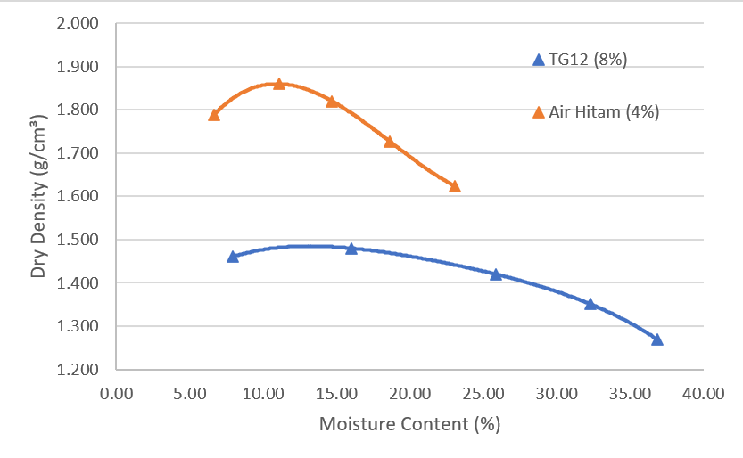

The compaction behaviour under reduced compactive effort was evaluated to examine the response of the soils to lower energy input conditions, which may better represent certain field scenarios. The obtained Reduced Proctor Compaction (RPC) results are summarised in Table 8, with the corresponding moisture–density relationship illustrated in Figure 8. The results indicate distinct variations between the two landfill soils. For the Air Hitam soil, the Maximum Dry Density (MDD) was approximately 1.832 g/cm³ at an Optimum Moisture Content (OMC) of 14.81%. In comparison, the Tanjung Dua Belas soil recorded a lower MDD of 1.410 g/cm³ at a substantially higher OMC of 22.56%. The characteristic parabolic shape of the compaction curve observed in both cases reflects the typical soil response, where dry density increases with increasing moisture content up to the optimum point, beyond which additional water occupies pore spaces and reduces dry density due to excess pore water pressure. The higher density and comparatively lower moisture requirement of the Air Hitam soil suggest a more granular texture and improved particle interlocking capability. Conversely, the higher moisture demand of the Tanjung Dua Belas soil is consistent with its finer and more plastic composition. Similar behaviour has been reported in laboratory studies where sandy or silty soils achieved greater compaction efficiency at lower water contents compared to fine-grained soils with higher plasticity [3].
Table 8. Summary of Tanjung Dua Belas and Air Hitam compaction result for RPC
Sample | Maximum Dry Density (g/cm³) | Optimum Moisture Content (%)
Tanjung Dua Belas | 1.410 | 22.56
Air Hitam | 1.832 | 14.81

Figure 8. Dry Density (g/cm³) vs Moisture Content for RPC

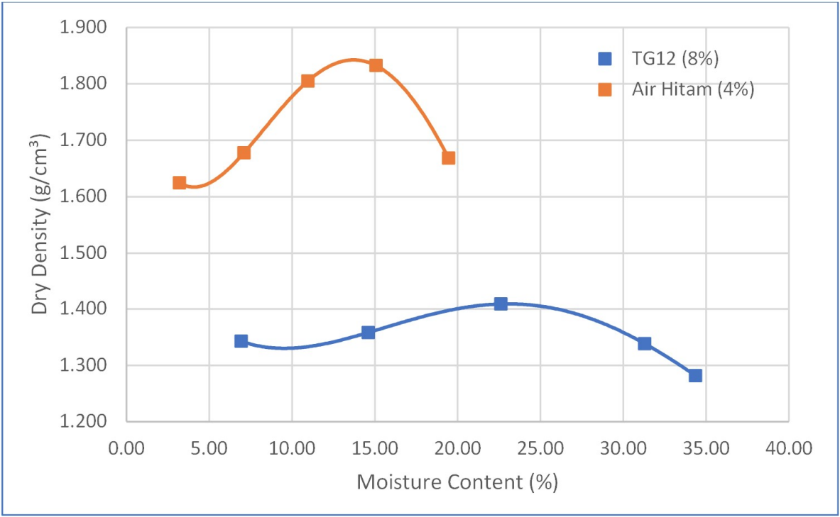

The compaction response under increased compactive effort was further evaluated using the Modified Proctor Compaction (MPC) test to examine the influence of higher energy input on soil densification. The obtained results are summarised in Table 9, with the corresponding moisture–density relationship illustrated in Figure 9. Distinct differences between the two landfill soils were observed under modified compaction conditions. The Air Hitam sample achieved a Maximum Dry Density (MDD) of 1.987 g/cm³ at an Optimum Moisture Content (OMC) of 11.92%, whereas the Tanjung Dua Belas soil reached a lower MDD of 1.565 g/cm³ at a higher OMC of 21.02%. The higher density achieved at relatively lower moisture content for the Air Hitam soil indicates a material with lower plasticity and better particle gradation, enabling stronger interparticle bonding and improved packing efficiency under increased compactive effort. In contrast, the Tanjung Dua Belas soil required greater moisture content to facilitate particle rearrangement and densification, which is consistent with its finer texture and higher plasticity characteristics. These differences demonstrate the significant influence of particle gradation and plasticity on compaction performance. Similar observations have been reported in Malaysian landfill studies, where effective moisture control was identified as a critical factor in achieving optimal density and long-term structural stability of liner materials [11].

Table 9. Summary of Tanjung Dua Belas and Air Hitam compaction result for RPC
Sample | Maximum Dry Density (g/cm³) | Optimum Moisture Content (%)
Tanjung Dua Belas | 1.565 | 21.02
Air Hitam | 1.987 | 19.48

Figure 9. Dry Density (g/cm³) vs Moisture Content for MPC

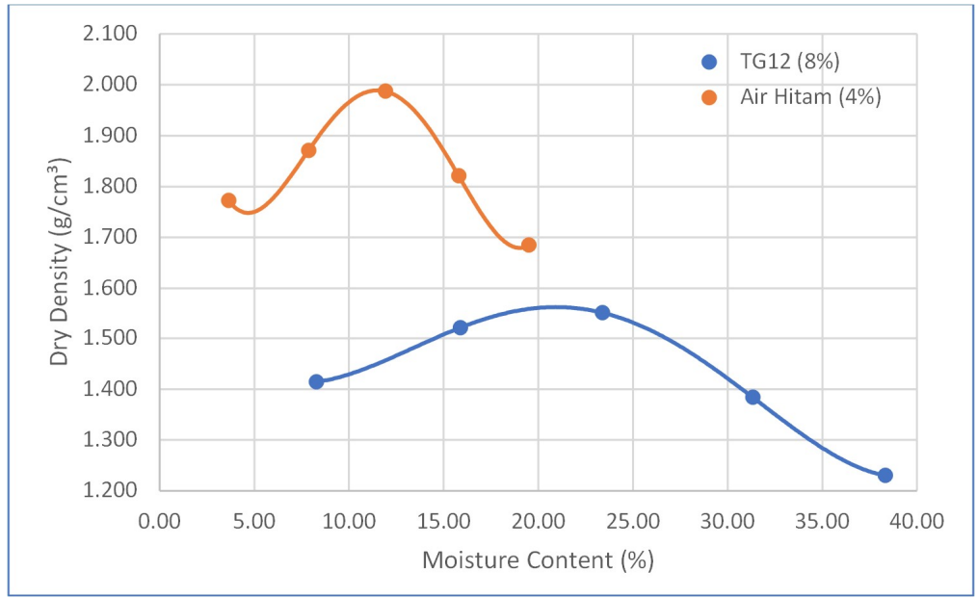

A comparative evaluation of the compaction characteristics between soils obtained from Tanjung Dua Belas and Air Hitam reveals clear differences in moisture–density response under varying compactive efforts. The detailed comparison is presented in Figure 10, highlighting variations in Optimum Moisture Content (OMC) and Maximum Dry Density (MDD) for both soils. The Tanjung Dua Belas soil exhibits a higher OMC ranging from 18.56% to 22.56%, accompanied by a lower MDD consistently below 1.600 g/cm³. In contrast, the Air Hitam soil demonstrates a comparatively lower OMC between 12.15% and 19.48%, while achieving significantly higher MDD values ranging from approximately 1.832 g/cm³ to 1.987 g/cm³. These variations reflect fundamental differences in soil composition. The Air Hitam soil, which contains a higher proportion of granular material, compacts more efficiently at lower moisture contents due to improved particle interlocking and reduced plasticity. Conversely, the finer and more plastic nature of the Tanjung Dua Belas soil necessitates greater moisture to facilitate particle lubrication and rearrangement during compaction. Across the three compaction methods, the Air Hitam soil demonstrates noticeable increases in density with increasing compactive effort, whereas the Tanjung Dua Belas soil shows only marginal improvement between the Standard and Modified Proctor tests. This suggests that increasing compaction energy does not substantially enhance densification for the finer-grained soil. Additionally, both soils compacted close to the Non-Air Void Line, indicating that the compaction procedures were effective in minimizing air voids and achieving satisfactory density conditions representative of field applications.
Figure 10. Dry Density (g/cm³) vs Moisture Content for all compaction test

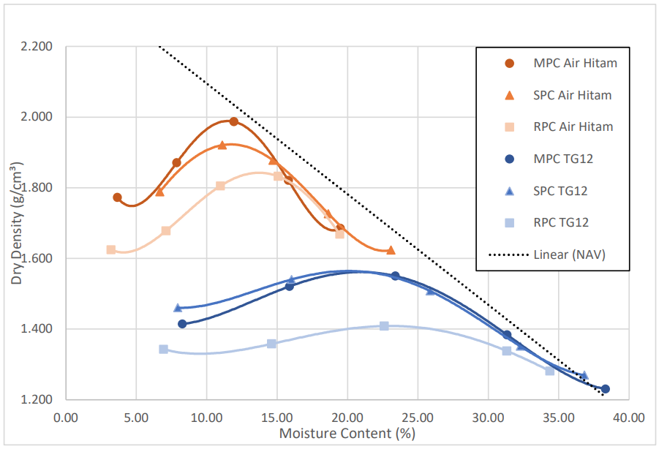
Consolidation behaviour of soil sample
The consolidation behaviour of the Air Hitam soil was evaluated to assess its compressibility and settlement characteristics under applied loading. The results, illustrated in Figure 11, indicate that the compression index (Cc) of the sample was 0.0565, reflecting a low level of compressibility. This relatively small Cc value suggests that the soil is comparatively dense and undergoes minimal volumetric compression when subjected to incremental loading. Such behaviour is commonly associated with coarse-grained or low-plasticity soils, which typically exhibit greater resistance to structural rearrangement under stress and demonstrate favourable long-term settlement performance. The coefficient of consolidation (Cv) for the Air Hitam sample ranged between 6.467 × 10⁻⁶ m²/s and 7.030 × 10⁻⁶ m²/s. A general decreasing trend was observed as the applied vertical pressure increased, indicating that pore-water dissipation becomes progressively slower under higher stress levels. This behaviour reflects the reduction in void ratio and permeability as the soil structure becomes more compacted during consolidation. The calculated settlement (Sc) was 1.401 mm, demonstrating limited compressive deformation and consistent structural response under incremental loading. These consolidation characteristics are likely influenced by the soil’s well-graded particle distribution, higher dry density, and lower plasticity, which collectively enhance stability and reduce the potential for excessive post-construction settlement. Overall, the Air Hitam soil exhibits favourable settlement behaviour for landfill liner applications, where dimensional stability and long-term structural reliability are critical performance requirements.
Figure 11. Void Ratio vs Applied pressure for Air Hitam

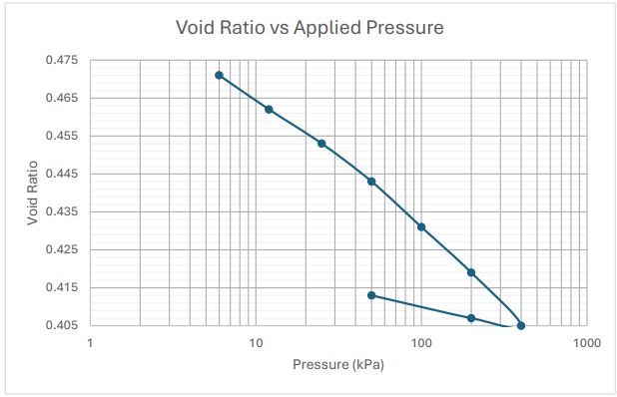

The consolidation response of the Tanjung Dua Belas soil was evaluated to determine its compressibility and settlement behaviour under incremental loading. The results, presented in Figure 12, indicate a compression index (Cc) of 0.0797, reflecting slightly higher compressibility compared to the Air Hitam soil, although it remains within the low-compressibility classification range. This value suggests that the soil undergoes moderate volumetric reduction when subjected to vertical stress. The coefficient of consolidation (Cv) was measured between 4.319 × 10⁻⁶ m²/s and 7.023 × 10⁻⁶ m²/s, with a general trend of decreasing pore-water dissipation as the applied pressure increased. The lower Cv value of 4.319 × 10⁻⁶ m²/s is considered anomalous and may have resulted from experimental variability or slight inconsistencies during testing. Nevertheless, the overall trend indicates progressive reduction in permeability and drainage rate as the soil structure becomes increasingly compressed under load. The calculated settlement (Sc) for the Tanjung Dua Belas sample was 1.583 mm, which is slightly higher than that recorded for the Air Hitam soil, signifying a comparatively more compressible response under similar loading conditions. This behaviour can be attributed to its higher moisture content, lower dry density, and intermediate plasticity, factors that contribute to modest volumetric changes during consolidation. Although the magnitude of settlement remains within acceptable limits for landfill liner applications, it highlights the importance of proper compaction control or stabilization measures to ensure long-term liner stability and to minimise the risk of cracking or differential settlement over time.
Figure 12. Void Ratio vs Applied pressure for Tanjung Dua Belas

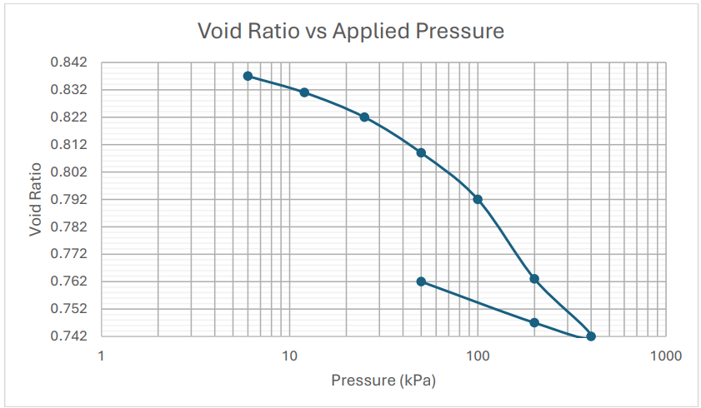
The comparative settlement characteristics of the Tanjung Dua Belas and Air Hitam soils indicate generally low compressibility for both materials, with compression index (Cc) values of 0.0797 and 0.0565, respectively. These relatively small Cc values reflect limited primary consolidation behaviour, suggesting that both soils possess sufficient stiffness for landfill liner applications where minimal deformation under load is required. The coefficient of consolidation (Cv) for the Air Hitam soil ranged from 6.467 × 10⁻⁶ m²/s to 7.030 × 10⁻⁶ m²/s, indicating comparatively efficient pore-water dissipation and a faster consolidation rate. In contrast, the Tanjung Dua Belas soil recorded slightly lower values ranging from 4.319 × 10⁻⁶ m²/s to 7.023 × 10⁻⁶ m²/s, reflecting marginally slower drainage characteristics under similar loading conditions. The total settlement (Sc) measured for Air Hitam was 1.401 mm, whereas Tanjung Dua Belas exhibited a slightly higher settlement of 1.583 mm, indicating comparatively greater compressibility. Previous investigations on Malaysian landfill soils have demonstrated that low-plasticity, well-graded materials generally exhibit reduced compressibility and improved structural stability, consistent with the trend observed in this study [10]. Similarly, soils characterised by higher dry density and lower plasticity have been reported to experience reduced long-term deformation in landfill containment systems [3]. Overall, the Air Hitam soil demonstrates more favourable settlement behaviour, offering enhanced dimensional stability and improved long-term reliability for engineered landfill liner applications.
Hydraulic conductivity of soil sample
The hydraulic conductivity behaviour of the investigated soils was evaluated under varying applied vertical stresses ranging from 0.25 kg/cm² to 2.00 kg/cm² using the modified oedometer permeability test. The measured values demonstrate a consistent reduction in permeability with increasing applied load, reflecting the stress-dependent response of compacted fine-grained soils. As summarised in Table 10, the decrease in hydraulic conductivity occurs as the applied stress compresses the soil matrix, reducing void spaces and restricting the continuity of flow channels within the pore structure. Similar stress-dependent reductions in permeability have been reported in clay-rich soils reinforced with recycled materials, where elevated vertical stresses significantly decreased hydraulic conductivity due to pore closure and densification effects [2]. The inverse relationship between applied stress and hydraulic conductivity is clearly illustrated in Figure 13, where both Air Hitam and Tanjung Dua Belas soils exhibit progressive permeability reduction with increasing load. The Air Hitam soil demonstrates a greater overall decrease, from approximately 1.55 × 10⁻⁵ cm/s to 7.5 × 10⁻⁶ cm/s. In comparison, the Tanjung Dua Belas soil shows a reduction from 1.25 × 10⁻⁵ cm/s to 8.6 × 10⁻⁶ cm/s, indicating comparatively lower sensitivity to applied stress. This behaviour suggests that the Air Hitam soil develops a denser and less permeable structure under compression, enhancing its effectiveness as a landfill liner material. The reduced hydraulic conductivity under increased loading conditions indicates improved resistance to leachate migration and supports its suitability for long-term containment performance under Malaysian field conditions.
Table 10. Summary of Tanjung Dua Belas and Air Hitam hydraulic conductivity result
Load (kg/cm³) | Air Hitam, k (cm/s) | Tanjung Dua Belas, k (cm/s)
0.25  0.5  1.0  2.0 | 1.57 x 10⁻⁵  1.29 x 10⁻⁵  1.02 x 10⁻⁵  7.51 x 10⁻⁵ | 1.25 x 10⁻⁵  1.14 x 10⁻⁵  9.99 x 10⁻⁵  8.64 x 10⁻⁵

Figure 13. Hydraulic conductivity (cm/s) vs Applied load for soil sample (kg/cm³)

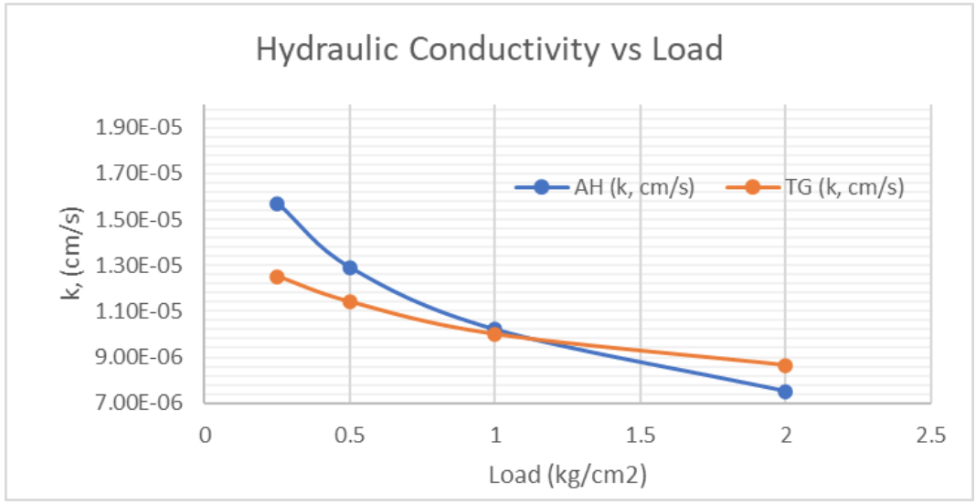
Compaction characteristics relationship with physical properties of soil
The compaction characteristics of soils obtained from Tanjung Dua Belas and Air Hitam demonstrate a clear relationship with their physical properties, particularly pH, particle density, plasticity, and shrinkage behaviour. The Maximum Dry Density (MDD) for Tanjung Dua Belas ranges from 1.410 to 1.565 g/cm³ with an Optimum Moisture Content (OMC) between 20.01% and 22.56%, whereas the Air Hitam soil achieves significantly higher MDD values ranging from 1.832 to 1.987 g/cm³ at comparatively lower OMC levels of 11.92% to 14.81%. The higher dry density and reduced moisture demand observed for Air Hitam can be attributed to its greater particle density (2.48 Mg/m³) and lower plasticity index (13.39%), which facilitate improved particle arrangement, enhanced interparticle contact, and reduced void ratio during compaction. In contrast, the Tanjung Dua Belas soil, characterised by lower particle density (2.22 Mg/m³) and a higher plasticity index (22.98%), requires greater moisture to achieve its maximum density due to its finer texture and stronger cohesive forces. This behaviour is consistent with findings that soils containing higher clay content and plasticity exhibit increased water demand and reduced compaction efficiency [12]. The influence of pH further supports this trend, as the more acidic Tanjung Dua Belas soil (pH 2.81) achieves lower dry density compared to the less acidic Air Hitam soil (pH 3.65). Acidic conditions can weaken particle flocculation and reduce interparticle bonding strength, thereby limiting compaction potential [13]. Additionally, the linear shrinkage values of 6.61% for Tanjung Dua Belas and 1.14% for Air Hitam indicate that soils with lower shrinkage tendency are more capable of forming denser structures during compaction. Previous research has demonstrated that reduced shrinkage behaviour and lower fines activity contribute to improved compaction performance [14]. These combined relationships are illustrated in Figure 14, where the interaction between liquid limit, plastic limit, and linear shrinkage clearly shows that soils with lower plasticity and shrinkage limits generally achieve higher MDD and more stable soil structures. Overall, the results confirm that the Air Hitam soil, characterised by higher particle density, lower plasticity, and minimal shrinkage, attains superior compaction characteristics compared to the Tanjung Dua Belas soil. This observation is consistent with previous studies on tropical residual soils, which reported similar trends linking physical properties to enhanced compaction performance [7].
Figure 14. Water content (%) vs Maximum Dry Density (g/cm³)
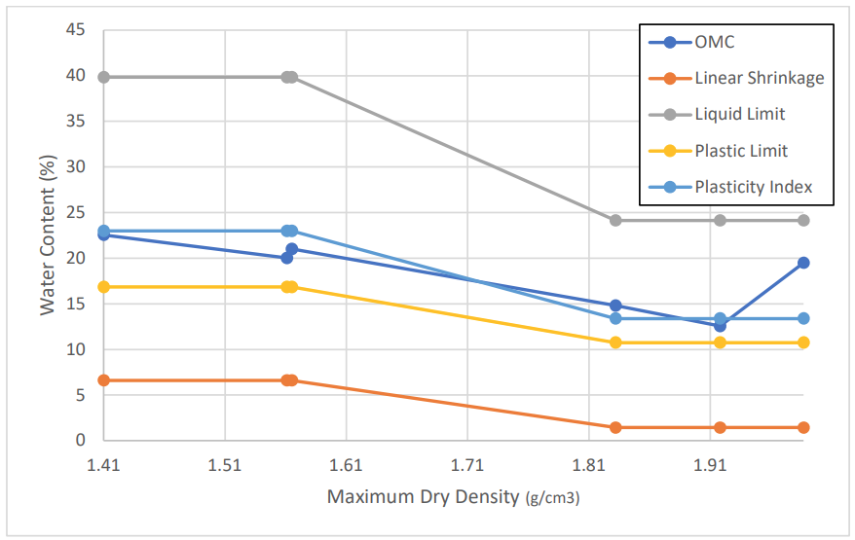
Consolidation behaviour relationship with physical properties of soil
The consolidation behaviour of the investigated soils is strongly influenced by their fundamental physical properties, including pH, particle density, plasticity, shrinkage limit, and particle size distribution. The more acidic Tanjung Dua Belas soil (pH 2.81) exhibits higher compressibility and settlement compared to the less acidic Air Hitam soil (pH 3.65). Acidic conditions can weaken interparticle bonding and reduce particle flocculation, thereby increasing susceptibility to deformation under load [13]. Particle density also plays a significant role in governing settlement response. The denser Air Hitam soil (2.48 Mg/m³) demonstrates lower compressibility compared to Tanjung Dua Belas (2.22 Mg/m³), consistent with findings that soils with higher particle density generally exhibit improved resistance to volumetric compression [3]. A similar trend is observed for shrinkage behaviour, where Tanjung Dua Belas, with a shrinkage value of 6.61%, undergoes greater volumetric change than Air Hitam (1.44%). Higher shrinkage potential often correlates with increased susceptibility to consolidation settlement due to structural rearrangement during moisture variation [5]. Plasticity further influences consolidation performance. The higher plasticity index of Tanjung Dua Belas (PI 22.98%) contributes to greater deformation compared to Air Hitam (PI 13.39%), as soils with higher plasticity typically retain more water and exhibit stronger cohesive forces that delay drainage but promote compressibility under sustained loading [23]. Compaction characteristics reinforce this relationship, where the Air Hitam soil, achieving an MDD of 1.88 g/cm³ at an OMC of 12.15%, forms a denser and more stable structure compared to Tanjung Dua Belas. Soils with higher dry density and lower plasticity are widely recognised to exhibit reduced compressibility and improved structural stability [14]. The measured consolidation settlements further confirm this pattern, with Tanjung Dua Belas recording 1.583 mm compared to 1.401 mm for Air Hitam. As illustrated in Figure 15, soils compacted at lower moisture content tend to experience reduced settlement due to limited pore-water expulsion and improved particle interlocking. Overall, the higher density and lower plasticity of the Air Hitam soil contribute to enhanced stability and reduced compressibility compared to the Tanjung Dua Belas soil.
Figure 15. Water content (%) vs Consolidation Settlement (mm)

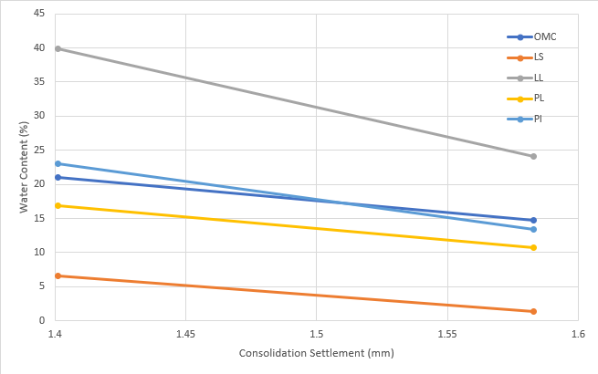
Hydraulic conductivity relationship with physical properties of soil
The hydraulic conductivity behaviour of soils from Tanjung Dua Belas and Air Hitam is strongly influenced by their physical properties, particularly pH, maximum dry density, and particle density. The measured hydraulic conductivity (k) values range between 6.00 × 10⁻⁶ cm/s and 1.70 × 10⁻⁵ cm/s, indicating moderate permeability characteristics for both soils under the tested conditions. The more acidic Tanjung Dua Belas soil (pH 2.81) exhibits comparatively higher k values, whereas the less acidic Air Hitam soil (pH 3.65) demonstrates lower permeability. Reduced acidity promotes improved particle aggregation and flocculation, which contributes to the formation of a more stable soil structure with fewer continuous flow paths [7]. A similar relationship is observed with respect to compaction density. Soils achieving higher Maximum Dry Density (MDD), such as Air Hitam with values reaching 1.987 g/cm³, exhibit lower hydraulic conductivity due to tighter particle packing and reduced void ratio. In contrast, the lower MDD recorded for Tanjung Dua Belas (as low as 1.410 g/cm³) corresponds to comparatively higher permeability. Particle density further supports this trend, as the higher particle density of Air Hitam (2.48 Mg/m³) contributes to a denser mineral framework and reduced pore connectivity compared to Tanjung Dua Belas (2.22 Mg/m³), thereby limiting water flow through the soil matrix [15]. The influence of moisture content on hydraulic conductivity is illustrated in Figure 16, where k values vary between 6.00 × 10⁻⁶ cm/s and 1.80 × 10⁻⁵ cm/s across a moisture range of 0–25%. The relatively weak correlation suggests that once adequate compaction is achieved, moderate variations in moisture content exert limited influence on permeability behaviour. This observation is consistent with previous findings indicating that density-controlled compaction plays a more dominant role than moisture variation in governing hydraulic conductivity [2]. Overall, the Air Hitam soil, characterised by higher density, lower plasticity, and stronger structural integrity, demonstrates lower hydraulic conductivity compared to the Tanjung Dua Belas soil, confirming its comparatively superior suitability for landfill liner applications.
Figure 16. Water content (%) vs Hydraulic Conductivity (cm/s)

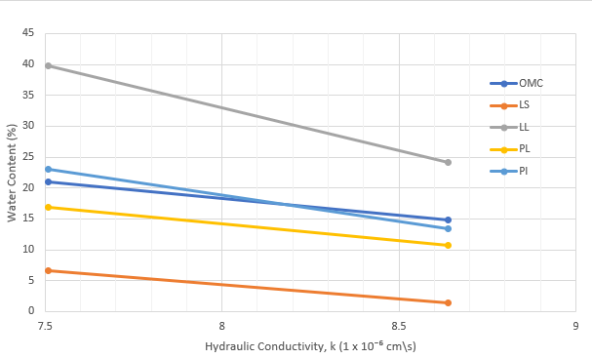
CONCLUSION
The study successfully assessed the physical, compaction, consolidation, and hydraulic properties of soils from Tanjung Dua Belas and Air Hitam landfills, fulfilling all research objectives. Laboratory tests revealed key differences in pH, particle density, shrinkage limit, particle size distribution, plasticity index, maximum dry density, and optimum moisture content, which directly influenced compaction and settlement behaviour. Air Hitam soil exhibited higher dry densities, lower moisture requirements, and more stable consolidation, reflecting lower compressibility and predictable performance. In contrast, Tanjung Dua Belas soil displayed higher plasticity, greater shrinkage, and finer particles, resulting in higher moisture demand, lower dry density, and slightly greater consolidation, but it demonstrated lower and more consistent hydraulic conductivity, indicating superior impermeability. These findings highlight that while Air Hitam offers better compaction efficiency and structural stability, Tanjung Dua Belas provides enhanced resistance to leachate flow, making both soils suitable for landfill liner applications depending on design priorities. Optimizing compaction, microstructural treatment, and admixtures like bentonite can further improve hydraulic performance, emphasizing that physical treatment and soil modification are often more influential than natural moisture content or pH. Future work should include in-situ testing and long-term monitoring to confirm laboratory observations under real landfill conditions
REFERENCES
- Adunoye, G. O. (2024). Study of relationships between compaction characteristics and selected index properties of soil. International Journal of Trend in Scientific Research and Development.
https://www.ijtsrd.com/papers/ijtsrd63428.pdf
- Alzara, M., Onyelowe, K. C., Ebid, A. M., Hanandeh, S., Yosri, A. M., & Alshammari, T. O. (2024). Modeling of the effect of gradation and compaction characteristics on the California Bearing Ratio of granular materials for subbase and landfill liner construction. Scientific Reports, 14(1), 23630.
https://doi.org/10.1038/s41598-024-74106-z
- Amadi, A. A., & Eberemu, A. O. (2012). Delineation of compaction criteria for acceptable hydraulic conductivity of lateritic soil-bentonite mixtures designed as landfill liners. Environmental Earth Sciences, 67(4), 999–1006.
https://doi.org/10.1007/s12665-012-1544-z
- Asadi, A., Huat, B. B. K., Hanafi, M. M., Mohamed, T. A., & Shariatmadari, N. (2011). Chemico-geomechanical sensitivities of tropical peat to pore fluid pH related to controlling electrokinetic environment. Journal of the Chinese Institute of Engineers, 34(4), 481–487.
https://doi.org/10.1080/02533839.2011.576491
- Chapuis, R. P. (2012). Predicting the saturated hydraulic conductivity of soils: A review. Bulletin of Engineering Geology and the Environment, 71(3), 401–434.
https://doi.org/10.1007/s10064-012-0418-7
- Dhadse, G. D., Ramtekkar, G., & Bhatt, G. (2022). Effect of particle size, moisture content and density on the hyperbolic model parameters for non-cohesive soil. International Journal of Engineering: Transactions B—Applications, 35(9), 1699–1706.
https://doi.org/10.5829/ije.2022.35.09c.04
- Dr. Prasanna, H. S., Harshitha, D., Singh, K., & Suhruth, S. (2017). Correlation of compaction characteristics of fine-grained soils using Atterberg limits. International Journal of Engineering Research and Technology, 6(6).
https://doi.org/10.17577/IJERTV6IS060051
- Emmanuel, E., Anggraini, V., Raghunandan, M. E., & Asadi, A. (2020). Utilization of marine clay as a bottom liner material in engineered landfills. Journal of Environmental Chemical Engineering, 8(4), 104048.
https://doi.org/10.1016/j.jece.2020.104048
- EsmaeilpourShirvani, N., TaghaviGhalesari, A., Tabari, M. K., & Choobbasti, A. J. (2019). Improvement of the engineering behavior of sand-clay mixtures using kenaf fiber reinforcement. Transportation Geotechnics, 19, 1–8.
https://doi.org/10.1016/j.trgeo.2019.01.004
- Khalid, U., & Rehman, Z. (2018). Evaluation of compaction parameters of fine-grained soils using standard and modified efforts. International Journal of Geo-Engineering, 9(1).
https://doi.org/10.1186/s40703-018-0083-1
- Lat, D. C., Noor, S. N. A., Razali, R., Rosli, H., & Rahman, N. S. (2023). Utilization of kenaf core fiber – marine clay mixture as a landfill liner material. Jurnal Kejuruteraan, 35(1), 117–122.
http://journalarticle.ukm.my/21944/
- Lieske, W., Sarkar, D., Goudarzy, M., & Wichtmann, T. (2024). On the impact of plastic fines on the compaction characteristics of sand. Geotechnical and Geological Engineering, 42(5), 3451–3469.
https://doi.org/10.1007/s10706-023-02738-5
- Mishra, A. K., & Sridharan, A. (2020). A critical study on shrinkage behaviour of clays. International Journal of Geotechnical Engineering, 14(1), 90–100.
https://doi.org/10.1080/19386362.2017.1405541
- Mukri, M., Zainuddin, A. N., Abdullah, N. A., & Ibrahim, N. (2018). Performance of different percentage on nano-kaolin as additives in soil liner application. Materials Today: Proceedings, 5, 2214–7853.
https://doi.org/10.1016/j.matpr.2018.02.123
- Nath, H., Kabir, M. H., Kafy, A. A., Rahaman, Z. A., & Rahman, M. T. (2023). Geotechnical properties and applicability of bentonite-modified local soil as landfill and environmental sustainability liners. Environmental and Sustainability Indicators, 18, 100241.
https://doi.org/10.1016/j.indic.2023.100241
- Nikbakht, M., Sarand, F. B., Dabiri, R., & Hajialilue Bonab, M. (2023). Investigation of the leachate effect on permeability and geotechnical characteristics of fine-grained soil modified using nanoclay–nanofiber composites. Water, 15(2), 294.
https://doi.org/10.3390/w15020294
- Onyelowe, K. C., Van, D. B., & Firoozi, A. A. (2021). Shrinkage parameters of modified compacted clayey soil for sustainable earthworks. Journal of the University Kebangsaan Malaysia, 33(1).
https://doi.org/10.17576/jkukm-2020-33(1)-13
- Phanikumar, B. R., & Ramanjaneya Raju, E. (2020). Compaction and strength characteristics of an expansive clay stabilised with lime sludge and cement. Soils and Foundations, 60(1), 129–138.
https://doi.org/10.1016/j.sandf.2020.01.007
- Rasheed, E. W., & Atemimi, Y. K. (2025). Effect of pH value on contaminated clay soil. Scientific Review Engineering and Environmental Sciences, 34(2), 183–197.
https://doi.org/10.22630/srees.10405
- Rodgers, M., & Mulqueen, J. (2006). Field-saturated hydraulic conductivity of unsaturated soils from falling-head well tests. Agricultural Water Management, 79(2), 160–176.
https://doi.org/10.1016/j.agwat.2005.02.011
- Simarmata, D. C. V., Satomi, T., & Takahashi, H. (2022). Study on mechanical properties of cemented soil reinforced by empty fruit bunch (EFB). International Journal of the Society of Materials Engineering for Resources, 25(1), 109–114.
https://doi.org/10.5188/ijsmer.25.109
- Teng, J., Kou, J., Zhang, S., & Sheng, D. (2019). Evaluating the influence of specimen preparation on saturated hydraulic conductivity using nuclear magnetic resonance technology. Vadose Zone Journal, 18(1), 1–7.
https://doi.org/10.2136/vzj2018.09.0179
- Widomski, M. K., Stępniewski, W., & Musz-Pomorska, A. (2018). Clays of different plasticity as materials for landfill liners in rural systems of sustainable waste management. Sustainability, 10(7), 2489.
https://doi.org/10.3390/su10072489
- Zhang, Z., & Zhang, M. (2024). A simple model for estimating the hydraulic conductivity of unsaturated soil. Applied Sciences, 14(3), 1254.
https://doi.org/10.3390/app14031254

