

Quantifying the Impact of Workload, Compensation, and Development Opportunities on Faculty Retention: A Multivariate Analysis

A Research Paper Presented to the Graduate Studies of La Consolacion University Philippines
In Partial Fulfilment of the Requirements for the Degree of Doctor of Information Technology

Vernie John B. Baltazar Pepito R. Guerrero Jr. Milagros V. Ortega Catherine B. Sorbito

La Consolacion University Philippines June 2025

Approval Sheet

This research entitled “Quantifying the Impact of Workload, Compensation, and Development Opportunities on Faculty Retention: A Multivariate Analysis” prepared and submitted by Vernie John B. Baltazar, Pepito R. Guerrero Jr., Milagros V. Ortega, Catherine B. Sorbito has been approved and accepted as partial fulfilment of the requirements for the Machine Learning Optimization.

DR. JOVY JAY CABRERA
Adviser

Acknowledgement

We would like to express our deepest gratitude to all those who supported and contributed to the completion of this research entitled “Quantifying the Impact of Workload, Compensation, and Development Opportunities on Faculty Retention: A Multivariate Analysis.”
First and foremost, our sincere thanks to Dr. Jovy Jay Cabrera, our Course Adviser, for his invaluable guidance, encouragement, and expert advice throughout the development of this study. His support has been instrumental in shaping the direction and quality of our work.
We also extend our appreciation to the faculty members of La Consolacion University of the Philippines for equipping us with the knowledge and skills necessary to undertake this research.
Finally, we are grateful to our families and peers for their continuous support and motivation during the entire duration of this endeavour.
This research has been approved and accepted as partial fulfilment of the requirements for the Machine Learning Optimization course.

Table of Contents

Page
List of Figures v

List of Tables …………………………………………………………….…… vi
List of Appendices …………………….……………………………….…….. vii
Chapter 1: The Problem and Its Background
Introduction ………………………………………………………….… 2
Literature Review……………………………………………….……… 2
Conceptual Framework ………………………………………………... 5
Significance of the Study ………………….…………………………… 7
Statement of the Problem ……………………………………………… 7
Hypothesis of the Study ……………...………………………………... 8
Definitions of Terms……………...…………………………….…........ 9
Scope and Limitation of the study ………………….…………………. 10
Chapter 2: Methodology of the Study
Methods and Techniques of the Study ………………………………... 13
Respondents of the Study.……………………………………………... 13
Instruments of the Study …………………………………………….... 13
Data Gathering Procedure ……………………………………………... 14
Data Gathering and Statistical Treatment ………………...…………… 15
Ethical Considerations ………...……………………………………...... 16
Chapter 3: Presentation, Analysis, and Interpretation of the Study
Results.……………………………………………... ……………….... 18
Discussion ……………………………………………...…………….... 19
Chapter 4: Summary of Findings, Conclusions, and Recommendations
Summary of Findings……………………………………………... …... 23
Recommendations……………………………………………...……..... 23
Summary of Recommendations………………………………………... 25

List of Figure
Page
- Conceptual Framework of the Study…………………….……… 5
- Scatterplot Matrix …………………………...…………...……... 20

List of Tables

Page
- OLS Regression Result from Python using pandas …………...… 18
- OLS Regression Result …………………………...…………...... 19

 | List of Appendices | Page
A | Research Instruments …………...…………………………...…. | 26
B | Accomplished Surveys …………………………...…………...... | 31
C | Faculty Matrix…………………………...…………................... | 39
D | Generated Survey Results …………………………...…………. | 40
E | Scoring and Interpretation Guide …………………………...…. | 42
F Faculty Retention Analysis …………………………...………… 43

ABSTRACT

This study investigates the combined and individual effects of workload, compensation, and career development opportunities on faculty retention in higher education institutions using a multivariate analysis approach. Faculty retention remains a significant concern, particularly in the Philippine academic context, where educators face increasing demands and limited resources. The research employed a quantitative, descriptive-correlational design, integrating secondary data from the UC Irvine Machine Learning Repository with primary data collected through a structured online survey. A total of 547 responses were analyzed using Ordinary Least Squares (OLS) regression to determine how the three predictor variables influence retention scores. The regression model yielded a high R-squared value of 0.685, indicating that 68.5% of the variation in retention scores can be explained by the combined impact of workload, compensation, and career development. Results revealed that workload has a significant negative effect on retention, while compensation and career development opportunities have significant positive effects, with the latter being the strongest predictor. The study concludes that targeted and synchronized institutional strategies, focused on reducing workload, improving compensation fairness, and expanding professional growth pathways are essential for enhancing faculty retention. Recommendations include the adoption of integrated retention frameworks, periodic workload assessments, transparent pay structures, and career advancement programs supported by ISO/IEC 25010-compliant systems. These findings provide a data-driven foundation for academic leaders and policymakers to improve faculty well-being and institutional stability.

Keywords: faculty retention, workload, compensation, career development, multivariate analysis, higher education, regression analysis, ISO/IEC 25010

CHAPTER I
THE PROBLEM AND ITS BACKGROUND

INTRODUCTION
Keeping faculty members engaged and committed is a growing challenge for colleges and universities in the country. As institutions work hard to maintain high standards in education, it is more important than ever to ensure that skilled and passionate educators choose to stay. However, many faculty members are feeling overwhelmed by heavy workloads, frustrated by limited opportunities for professional growth, discouraged by compensation that does not reflect their efforts. These issues are leading to higher turnover rates and growing dissatisfaction among faculty.
This study, titled "Quantifying the Impact of Heavy workload, Compensation, Career Development Opportunities on Faculty Retention: A Multivariate Analysis," aims to explore how these factors work together to influence a faculty member’s decision to stay at or leave an institution. While past studies have looked at these concerns individually, there is a real need to understand their combined effect through a more holistic, data-driven approach.
By using multivariate analysis, this study hopes to provide valuable insights that can help school administrators and policy makers make better decisions. The goal is to support the development of effective, long-term strategies that not only improve working conditions but also create an environment where faculty feel valued, supported, and motivated to stay.

LITERATURE REVIEW
Understanding why faculty members choose to stay or leave their institutions is a growing concern in higher education, especially in the Philippine setting. This literature review investigates what past studies have discovered about the main factors that influence faculty retention specifically workload, compensation, and opportunities for growth and development. By reviewing what researchers have already found, this section aims to uncover patterns, ongoing discussions, and gaps that still need to be addressed. More importantly, it helps explain why this study matters and how it builds on what is already known. Through this review, the study sets the stage for a deeper and more data-driven analysis using a multivariate approach.
The studies reviewed below include several that highlight the key factors influencing employee’s and faculty retention.

Faculty Retention: A Case Study of Lyceum of the Philippines University-Cavite researchers Anne Gaspar MBA S, San Mateo CPA R, Arias Jr MBA A. Published (2016) 387-396
This case study by Gaspar, San Mateo, and Arias (2016) investigated the multifaceted dynamics surrounding faculty retention and attrition at Lyceum of the Philippines University–Cavite. Employing a descriptive-survey methodology, the researchers disseminated a tailored questionnaire to 100 full-time and part-time faculty members, with its development grounded in human resource literature and interviews with academic personnel and administrators.
Findings indicated that proximity and ease of commute, alongside the institution’s perceived career development opportunities and esteemed academic reputation, were primary motivators for faculty to join LPU-Cavite. Aesthetic factors such as the campus infrastructure held comparatively minor influence. Faculty retention was largely attributed to collegial relationships, equitable treatment by superiors, conducive work conditions, and fulfillment of salary expectations—underscoring a greater emphasis on relational over monetary considerations.
Conversely, attrition was tied to external offers promising greater career advancement, enhanced remuneration, or stronger employment security. A lack of managerial support, insufficient recognition, and residential relocation also emerged as secondary factors. Interestingly, deteriorating peer relations ranked lowest among the reasons for potential departure.
To address these concerns, the researchers recommended strategic interventions such as subsidized on-campus accommodations, strengthened institutional branding, and faculty engagement initiatives including mandatory participation in organizational activities and annual team-building events. They further advocated for regular leadership training, systematic supervisory role rotations, and transparent financial disclosures to promote trust. Dissemination of a comprehensive faculty manual detailing compensation and employment rights was also advised. A longitudinal follow-up study was proposed five years hence to re-evaluate the evolving motivations behind faculty mobility.

ECE Educator Performance: Teaching Experience and Peer Teaching Ability through Basic Tiered Training researchers Soffianningrum I, YufiartiYetti E. Published in JPUD - Jurnal Pendidikan Usia Dini (2022) 16(1) 52-68
Over the years, many researchers have focused on what influences teacher performance, especially in the context of early childhood education (ECE). A key theme across studies is that both teaching experience and peer teaching skills play an important role in shaping how well teachers perform in the classroom.
Several studies found that teachers with more years of experience often demonstrate stronger teaching practices and better student outcomes (e.g., Adeyemi, 2008; Ünal & Unal, 2012). Meanwhile, peer teaching—where teachers learn from and with each other—

has been shown to improve professional skills, increase confidence, and enhance performance (e.g., Campolo et al., 2013; Rees et al., 2016; ten Cate, 2017).
Some local research, such as studies conducted in Cebu and other parts of the Philippines, emphasizes the importance of both proper training and continuous professional development for preschool teachers (Andrin et al., 2017). Other works also highlight the need for more support systems, better training alignment, and stronger institutional policies to ensure long-term improvement in teacher performance.
Overall, these studies suggest that while formal education and training are important, experience and collaboration with peers are just as crucial. This body of literature points to a clear need for educational institutions to invest not only in structured teacher development programs but also in peer-based learning opportunities to enhance teacher effectiveness—particularly for those in early childhood education.

Microanalysis of Employee Retention Strategies researcher Mendoza X, Tadeo J, Bulan R et al. Published in Jurnal Ekonomi, Bisnis & Entrepreneurship (2023) 17(1) 1-16
Maintaining top-tier personnel is difficult for convenience stores, as they must compete against larger businesses with higher budgets and more employee advantages. This study aimed to determine the employee retention management practices in selected convenience stores in Cavite, Philippines. It utilized a descriptive research design and convenience sampling technique to select the respondents. The data was acquired by utilizing self-constructed questionnaires and Likert-scale to determine the effectiveness of employee retention. The study found that most respondents who manage a convenience store have 1 to 9 employees, have been operating for 6 to 8 years, and were small enterprises. The study found that variables such as employee compensation, physical working environment, employee growth, engagement, and employee support were highly effective in retaining employees. The researchers recommend that employees seek a good organization that listens to them and cares about their general well-being. Respectively, managers and/or owners should develop efficient and effective strategies to retain and manage employees in a sustainable manner.

Factors Affecting Employee Retention in The Philippine Business Process Outsourcing Industry: Integrating Job Embeddedness Theory researchers Kurata Y, Belisario K, Mescala M, Valenzuela R.
According to several studies, Business Process Outsourcing (BPO), a well-known strategy by companies which operates the non-core functions of a company, is experiencing a downturn in the industry according to the huge turnout of employee attrition which impacts the company's performance and competitiveness. Thus, the study aims to identify factors affecting employee retention in the Philippine BPO industry by integrating Job Embeddedness Theory utilizing Minitab 19 Statistical software to perform Multiple Regression Analysis. A self-administered questionnaire was distributed through convenience sampling, gathering 710 respondents at least 18 years old and currently/previously employed in a Philippine BPO company. Results show that Rewards

and Recognition, Employee Engagement, Fit, Job Satisfaction are significant variables affecting employee retention among employees in the Philippine BPO Industry. The researchers have provided a strong model and important findings to easily understand the significant factors which will enable BPO companies in the Philippines to strategically position themselves by improving company policies to avoid unnecessary costs about monetary and performance-related setbacks.

Employee Retention Strategies of Hotel Industries in the Philippines Amidst the Pandemic researchers Galang J, Pablo J, Melad Q et al. Published Asian Journal of Applied Business and Management (2023) 2(1) 79-98
This study aimed to determine the strategies of accredited hotel industries in retaining their employees amidst the pandemic in Tuguegarao City, Cagayan, Philippines. A quantitative research design employing descriptive research method was used in the study. The respondents of the study were the human resource manager or hotel owner of each accredited hotels in Tuguegarao City using a questionnaire. The findings of the study confirm that fourteen (14) strategies are fully employed in the five accredited hotels. However, the strategy concerning about the remuneration of employees even if there is a reduction in their total salary due to the limited working scheme set by the government is employed.

CONCEPTUAL FRAMEWORK
To better understand the factors influencing faculty retention, this study follows an Input-Process-Output (IPO) model that presents the flow of the study.
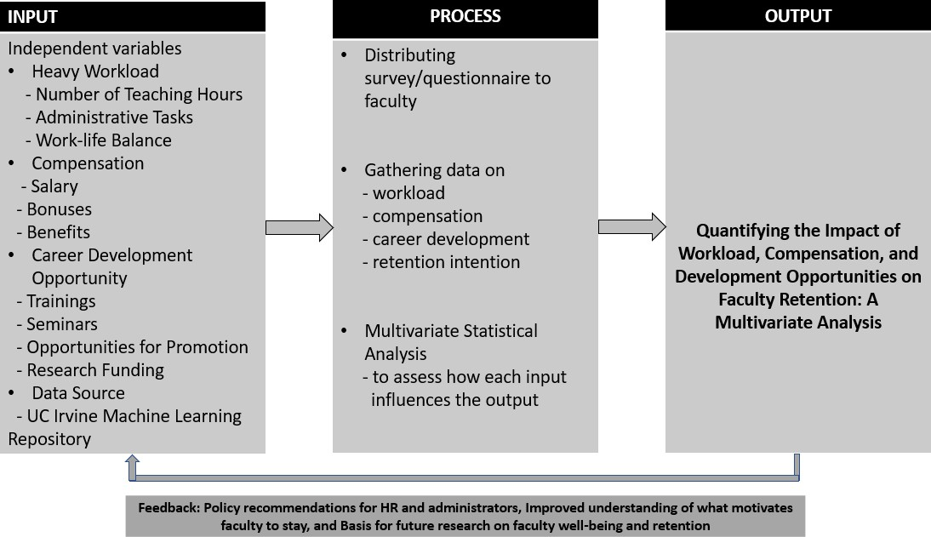

Figure 1 IPO Model
In these sections, each phase of the IPO model is explained in more detail to give a clearer picture of how this framework supports the study's goals and overall flow.

Input Phase
The input stage includes three primary factors believed to significantly impact a faculty member’s decision to remain at or leave an institution:
Workload – The quantity and intensity of academic and non-academic responsibilities assigned to faculty members.
Compensation – The fairness and adequacy of salaries, benefits, and other financial incentives.
Career Development Opportunities – The availability of training, promotions, research support, and professional growth pathways.
These factors reflect the everyday realities of faculty life, such as how much work they are expected to do, how equitably they are rewarded, and whether they see opportunities for professional advancement

Process Phase
This stage involves gathering data directly from faculty members through structured surveys or questionnaires. Their responses are analyzed using statistical methods, particularly multivariate analysis, to determine the individual and combined effects of the three input factors on faculty retention.
In evaluating any digital platforms or tools used in this study (e.g., for workload management, compensation systems, or training portals), the research adopts the ISO/IEC 25010 standard. This international model ensures that software quality is assessed in terms of functionality, reliability, usability, portability, security, compatibility and performance efficiency ensuring that any supporting systems used in the process meet acceptable standards.

Output Phase
The output of the study is a set of evidence-based findings that:
- Quantify the individual impact of each factor
- Show how the three factors interact
- Identify the strongest predictors of faculty retention.
These findings aim to support institutional leaders in designing and implementing targeted retention strategies.

Feedback
The final component of the IPO model is a feedback loop, where the results are applied to real-world contexts. The findings are intended to inform policies, improve work environments, and enhance support systems that contribute to long-term faculty retention. In future implementations, systems supporting faculty may also be continuously evaluated using ISO/IEC 25010 to ensure they remain effective, user-friendly, and aligned with institutional goals.

SIGNIFICANCE OF THE STUDY
This study is significant because it addresses one of the most pressing challenges in higher education today retaining qualified and motivated faculty members. As universities and colleges strive to uphold academic excellence, the stability and satisfaction of their teaching staff play a critical role in achieving long-term success. Understanding why faculty members choose to stay or leave is essential in shaping policies that foster a more supportive and sustainable academic environment.
By examining the combined effects of workload, compensation, and career development opportunities through multivariate analysis, this study goes beyond surface-level observations. It offers a comprehensive, data-driven perspective that can guide institutional leaders in making more informed and strategic decisions. The findings can serve as a foundation for crafting evidence-based retention programs that truly respond to the needs and concerns of educators.
For school administrators, this study can provide actionable insights on which factors most strongly influence faculty retention, helping them allocate resources more effectively and improve overall faculty well-being.
For policymakers and HR practitioners, it may serve as a valuable reference in designing fair and supportive workplace policies.
Lastly, for future researchers, this study opens doors to further exploration of faculty motivation, satisfaction, and institutional commitment in the context of educational quality and workforce sustainability.

STATEMENT OF THE PROBLEM
Faculty retention has become an increasing concern for higher education institutions striving to maintain quality education and institutional stability. Despite efforts to support educators, many faculty members continue to leave their posts due to factors such as overwhelming workloads, inadequate compensation, and limited opportunities for career development. While previous studies have examined these factors individually,

there is limited study that quantitatively assesses their combined impact on faculty retention.
This study aims to examine the combined impact of heavy workload, compensation, and career development opportunities on faculty retention in higher education institutions.
Specifically, it seeks to answer the following research questions:
- What is the individual impact of workload, compensation, and career development opportunities on faculty retention?
- How do these three factors interact to influence a faculty member’s decision to stay or leave?
- Which of these factors serve as the strongest predictors of faculty retention?
- What actionable recommendations can be derived from the findings to support institutional retention strategies?

HYPOTHESIS OF THE STUDY
To better understand what truly influences faculty members to stay or leave, this study explores the combined and individual effects of workload, compensation, and career development opportunities. By formulating and testing specific hypotheses, the researchers aim to uncover whether these factors significantly impact faculty retention and which among them serve as the strongest predictors. These insights will help institutions develop more effective and targeted strategies to support and retain their educators.
To address the main hypothesis: There is no significant combined effect of workload, compensation, and career development opportunities on faculty retention in higher education institutions.
To address the sub-hypotheses:
Individual Impact:
H₀₁: Workload does not have a significant individual effect on faculty retention.
H₀₂: Compensation does not have a significant individual effect on faculty retention.
H₀₃: Career development opportunities do not have a significant individual effect on faculty retention.
Interaction of Factors:
H₀₄: There is no significant interaction among workload, compensation, and career development opportunities in influencing faculty retention.

Strongest Predictor:
H₀₅: No single factor among workload, compensation, or career development is a stronger predictor of faculty retention than the others.
Actionable Recommendations:
H₀₆: The results do not provide sufficient evidence to formulate actionable recommendations for improving faculty retention based on workload, compensation, and career development opportunities.

DEFINITION OF TERMS
To promote clarity and understanding, this section defines the key terms used in the study. These terms reflect the real experiences of faculty in higher education and help readers better grasp the issues explored and the significance of the study’s findings.
Career Development Opportunities. Institutional programs and avenues provided to faculty for professional growth, such as training, promotion, mentoring, and further education.
Compensation. The salary, benefits, and financial incentives given to faculty members in exchange for their services.
Descriptive Statistics. Basic statistical methods used to summarize and describe the main features of a dataset.
Faculty Manual. A document that outlines policies, expectations, rights, and benefits for faculty members in an academic institution.
Faculty Retention. The ability of an educational institution to retain its teaching staff over time.
Higher Education Institutions (HEIs). Colleges, universities, and other post-secondary institutions that offer academic degrees and professional certifications.
Human Resource Policies. Guidelines and frameworks developed by the institution’s HR department to manage employee-related functions such as hiring, training, retention, and compensation.
Institutional Stability. The consistency and continuity of academic operations within a higher education institution, often supported by faculty retention.
Interaction Effect. The combined impact of two or more variables acting together on an outcome, which may differ from their individual effects.
Job Embeddedness. The degree to which an employee is connected to their job and organization through links, fit, and sacrifice.

Job Satisfaction. The level of contentment and fulfillment faculty members feel regarding their work, roles, and working conditions.
Multivariate Analysis. A statistical technique used to examine the relationships and effects of multiple independent variables on one or more dependent variables.
Predictor Variable. A variable that is used in statistical modeling to forecast or estimate the value of another variable.
Professional Growth. The continuous process of improving and expanding skills, knowledge, and career prospects of faculty members.
Regression Analysis. A statistical technique used to examine and model the relationship between a dependent variable and one or more independent variables, with the goal of understanding how the dependent variable changes in response to variations in the predictors.
Retention Strategies. Institutional policies, programs, and practices aimed at keeping faculty members committed and reducing turnover.
Statistical Significance. A determination that the relationship or effect observed in the data is unlikely to be due to chance.
Survey Questionnaire. A research tool consisting of a series of questions designed to gather information from respondents.
Turnover. The rate at which faculty members leave their institution, either voluntarily or involuntarily.
Workload. The amount and intensity of tasks, responsibilities, and teaching hours assigned to faculty members.

SCOPE AND LIMITATION OF THE STUDY
To provide a clearer understanding of the focus and boundaries of this study, this section outlines what the study covers and the limitations it faces. Defining the scope helps explain the specific areas and populations being studied, while identifying the limitations acknowledges the factors that may affect the interpretation and generalizability of the findings. Together, they offer a balanced view of what the study aims to achieve and the considerations to keep in mind when evaluating the results.

Scope
This study investigates what really matters when it comes to keeping faculty members in higher education institutions specifically focusing on three important areas: workload, compensation, and career development opportunities. These factors were chosen because they often shape a faculty member’s overall job experience and play a big role in their decision to stay at or leave an institution.

To better understand how these elements influence retention, the study uses a quantitative method and applies multivariate analysis, which allows the researcher to examine how the factors work individually and together.
The study focuses only on higher education institutions in the Philippines. The main participants are faculty members, both full-time and part-time, who provide insights by answering a survey questionnaire. This helps us identify trends and patterns based on their responses.
Through this study, the researchers aim to:
- See how each factor the workload, compensation, and development opportunities affect retention on its own.
- Understand how these factors interact when considered together.
- Discover which of the three has the strongest impact.
- Offer practical recommendations that institutions can use to support and retain their faculty more effectively.

Limitation
While this study offers valuable insights into faculty retention, there are several limitations to consider:
- Focused Location: The study is limited to higher education institutions in the Philippines. As such, the findings may not fully apply to institutions in other countries or regions with different educational systems, policies, and work cultures.
- Based on Self-Reported Feedback: Data was gathered through self-reported survey responses from faculty members. These responses are based on individual perceptions and experiences, which may introduce subjectivity or bias.
- Limited Variables: The study focuses specifically on workload, compensation, and career development opportunities. Other important factors—such as leadership style, job security, organizational culture, or work-life balance—are not included in this analysis.
- Cross-Sectional Design: The research captures data at a single point in time. This means it cannot track changes over time or establish direct cause-and-effect relationships.
- Sample Representation: The reliability of the results depends on the sample size and diversity of respondents. If certain types of institutions or faculty demographics are underrepresented, this could affect how well the findings reflect the broader academic landscape.
- Use of Pre-Existing Dataset: The research uses data obtained from the UC Irvine Machine Learning Repository, a publicly available dataset. While this source

provides a structured and accessible dataset for analysis, it may not reflect the most current faculty experiences or be tailored specifically to the Philippine higher education context.
- Statistical Method Constraints: Although multivariate analysis is a powerful tool for examining relationships between variables, it has limitations. It may not fully capture the complex human and institutional dynamics that influence faculty retention, and the results depend heavily on the quality of the data and the assumptions built into the model.

CHAPTER II METHODOLOGY OF THE STUDY

METHODS AND TECHNIQUES OF THE STUDY
This chapter outlines the research design, population, sampling method, data collection tools, and statistical techniques employed to examine the impact of workload, compensation, and career development opportunities on faculty retention.

RESEARCH DESIGN
The research used a quantitative, descriptive-correlational research design. It aimed to quantify the relationship between multiple independent variables workload, compensation, and career development opportunities and the dependent variable faculty retention. A multivariate analysis approach was employed to analyze the combined effect of these variables on faculty members’ intention to stay or leave their institutions.

RESPONDENTS OF THE STUDY
This research adopted a hybrid approach by utilizing both secondary and limited primary data sources. Primarily, the study made use of a pre-existing dataset from the UC Irvine Machine Learning Repository, which includes anonymized records detailing faculty attributes and retention indicators. This dataset contains variables such as workload, compensation, career development opportunities, and faculty retention status. Each entry represents an individual faculty member’s profile and serves as a unit of analysis for statistical modeling.
In addition to the secondary dataset, the researchers supplemented the study with targeted primary data insights to help contextualize findings within a more relevant educational setting. However, it is important to note the following limitations:
The primary dataset is not geographically specific to the Philippines. Some information may not represent the most current faculty experiences.
The context and variables from the secondary dataset are rooted in general academic environments and may vary from local higher education institutions.

INSTRUMENTS OF THE STUDY RESEARCH INSTRUMENT
This study did not rely solely on traditional research instruments such as surveys or interviews. Instead, it employed a hybrid approach by combining secondary data analysis with primary data collection. A structured, pre-existing dataset was obtained from the UC Irvine Machine Learning Repository, which includes anonymized faculty-related records.

These variables were carefully selected and coded based on their relevance to the study’s objectives.
To enhance the validity and contextual relevance of the findings, the researchers also administered a structured survey through Google Forms. This allowed the collection of current and localized data directly from respondents, providing primary insights that complemented the existing dataset.
The following variables were extracted, measured, and operationalized for analysis:
- Heavy Workload – measured through teaching hours, administrative duties, and work-life balance
- Compensation – salary, bonuses, and benefits
- Career Development Opportunities – participation in trainings/seminars, promotion opportunities, and access to research funding
- Faculty Retention – intention to stay in the institution and overall job satisfaction The secondary dataset provided consistent numerical data, which was suitable for
statistical techniques such as correlation and multiple regression analysis. Only minimal
preprocessing was applied, including basic data cleaning and coding, while preserving the original structure. The primary survey responses were used to validate and support the patterns observed in the secondary data.

DATA GATHERING PROCEDURES
This research employed a hybrid approach to data gathering by combining secondary data analysis with primary data collection. The primary source of data was a pre-existing structured dataset obtained from the UC Irvine Machine Learning Repository a trusted public source widely used for academic research. Additionally, the researchers conducted a survey via Google Forms to collect firsthand insights that aligned with the study’s objectives and local context.
The process of gathering and preparing the data involved the following steps:
- Accessing the Secondary Dataset
The dataset was downloaded from the UC Irvine Machine Learning Repository. As it is publicly available and intended for academic use, it served as a reliable and convenient foundation for the research.
- Selecting Relevant Data
From the complete dataset, only variables related to workload, compensation, career development, and faculty retention were selected to match the scope and objectives of the study.

- Collecting Primary Data
To enhance the contextual relevance of the findings, the researchers designed and distributed an online survey using Google Forms. This allowed for the collection of updated and localized responses from faculty members based on the same key variables.
- Preparing the Data
Both datasets were reviewed for consistency and completeness. For the secondary data, entries with missing or incomplete information were removed. For the survey responses, data were validated and cleaned to ensure quality and accuracy.
- Organizing the Information
The cleaned and verified data both secondary and primary were then organized and formatted to be compatible with the statistical tools used in the analysis.
- Data Privacy and Ethical Use
Although the secondary dataset was already anonymized and publicly accessible, all data were handled with care. Both datasets were securely stored and used strictly for academic and research purposes, in compliance with ethical standards.

DATA PROCESSING AND STATISTICAL TREATMENT
This research adopted a hybrid approach by utilizing both secondary data from the UC Irvine Machine Learning Repository and primary data collected through an online survey administered via Google Forms. Both datasets were carefully prepared and analyzed to ensure alignment with the study’s objectives and to provide a more contextual and comprehensive understanding of faculty retention factors.

Data Cleaning and Validation
Both secondary and primary data were reviewed for completeness and accuracy. Entries with missing, inconsistent, or erroneous values were removed or corrected to maintain data quality and integrity. Survey responses were screened to exclude incomplete submissions.

Variable Coding and Transformation
Key variables such as workload, compensation, career development opportunities, and faculty retention were selected and recoded into numerical formats where necessary. This step ensured compatibility across both datasets and facilitated consistent statistical analysis.

Descriptive Statistics
Basic statistical measures (e.g., mean, frequency, and percentage) were computed to summarize and describe general trends from both datasets, providing an overview of faculty experiences and intentions.

Correlation Analysis
The Pearson correlation coefficient was used to examine the strength and direction of relationships between the independent variables (workload, compensation, and career development opportunities) and the dependent variable (faculty retention), using data from both sources.

Multiple Regression Analysis
To assess the combined influence of the independent variables on faculty retention, multiple linear regression analysis was applied. This analysis helped identify the unique contribution of each factor while controlling for the others.

Software Tools
All statistical analysis was conducted using Python, specifically the pandas library for data preparation and statistical modeling.

ETHICAL CONSIDERATIONS
Ethical research practices were strictly observed throughout the study, especially due to the combination of secondary and primary data sources.

Use of Public and Anonymized Data
The secondary dataset from the UC Irvine Machine Learning Repository is publicly available, fully anonymized, and free of personally identifiable information. It was used in accordance with the repository's guidelines for academic and research purposes.

Informed Consent for Survey Participants
For the primary data collection, survey respondents were informed of the study's purpose, assured of confidentiality, and gave consent before participating. Responses were collected anonymously through Google Forms.

Responsible Data Use
All data both secondary and primary were used solely for educational and research purposes. No manipulation or misuse of information occurred, and the integrity of both datasets was maintained throughout the research process.

Acknowledgment of Limitations

The study acknowledged the limitations of using secondary data, including its lack of geographic specificity to the Philippines and potential outdatedness. The primary survey data helped bridge this gap by providing updated, localized insights.

Citation and Transparency
The original source of the secondary dataset was properly cited in the study to ensure transparency and academic integrity. Any modifications, transformations, or methods applied during analysis were fully documented.

Data Security
Both datasets were stored securely in password-protected files. Access was limited to the research team, and data were handled in accordance with ethical standards to ensure privacy and confidentiality.

CHAPTER 3
PRESENTATION, ANALYSIS, AND INTERPRETATION OF THE STUDY
This section presents the results of the multiple linear regression analysis performed to determine the effect of Workload, Compensation, and Career Development on Retention Scores among the participants.
To understand how each of these factors affects faculty retention both on their own and when considered together the study used a statistical method called Ordinary Least Squares (OLS) regression. This approach helped reveal clear patterns and relationships between the variables, offering a deeper look into what truly drives retention among faculty.
This section presents the results of the multiple linear regression analysis performed to determine the effect of Workload, Compensation, and Career Development on Retention Scores among the participants.

Table 1. OLS Regression Result from Python using pandas
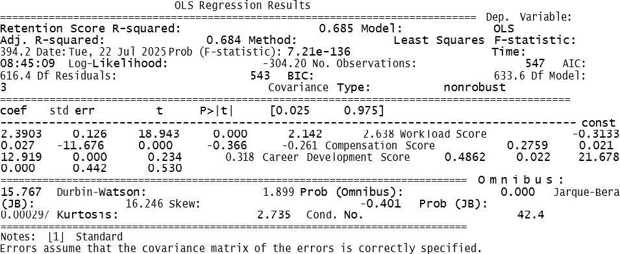

RESULTS
The results are presented in line with the study’s conceptual framework, following four key stages: Input, Process, Output, and Feedback. This structure ensures that the analysis is not only accurate but also useful for those in leadership roles who aim to create better working conditions and improve retention efforts across their institutions.
The models fit:
- R-squared: 0.685 or about 68.5% of the variation in retention scores is explained by the 3 predictors: workload score, compensation score, and career development score.
- Adjusted R-squared: 0.684 still high, means adding predictors improved the model.

- F-statistic: 394.2, p < 0.001 tests if at least one of the predictors significantly explains the dependent variable.
- Number of observations: 547 the researcher uses data from 547 cases.
Table 2 below the Ordinary Least Squares (OLS) results with multiple linear regression analysis conducted to examine the influence of Workload Score, Compensation Score, and Career Development Score on the Retention Score of respondents. The table presents the estimated coefficients, standard errors, t-values, p-values and 95% confidence intervals for each predictor variable.

Table 2. OLS Regression Result

Predictor Variable | Coefficient | Standard Error | t-Value | p-Value | 95% Coefficient Interval (Lower – Upper)
Constant (Intercept) | 2.3903 | 0.126 | 18.943 | 0.000 | 2.142-2.638
Workload Score | -0.3133 | 0.027 | - 11.676 | 0.000 | -0.366- -0.261
Compensation Score | 0.2759 | 0.021 | 12.919 | 0.000 | 0.234-0.318
Career Development Score | 0.4862 | 0.022 | 21.678 | 0.000 | 0.442-0530

DISCUSSION
The regression model tried to predict "Retention Score" based on the scores for Workload, Compensation, and Career Development. Below is an explanation of the key numbers.
R-squared value is equal to 0.685 which means that the model explains 68.5% of the variation in retention scores based on the three factors.
This is a strong result, indicating that Workload, Compensation, and Career Development are reliable predictors of faculty retention.
Factors like workload, compensation, and career development opportunities affects faculty retention here are as follows:

Workload:
Coefficient: value of -0.3133 → This is negative, which means that as Workload increases, Retention decreases. The heavier the workload, the less likely faculty are to stay. This confirms the common sentiment: burnout pushes people out.

Compensation:
Coefficient: value of +0.2759 → A positive relationship, so higher compensation = higher retention. This suggests that fair and competitive pay helps faculty stay in their institutions.

Career Development Opportunities:
Coefficient: value of +0.4862 → This is the strongest positive impact among the three. Faculty who perceives more chances for training, promotion, and growth are much more likely to stay. This highlights the importance of long-term investment in professional development.

Figure 2 Scatterplot Matrix

Figure 2.1 Retention Score vs Workload Score
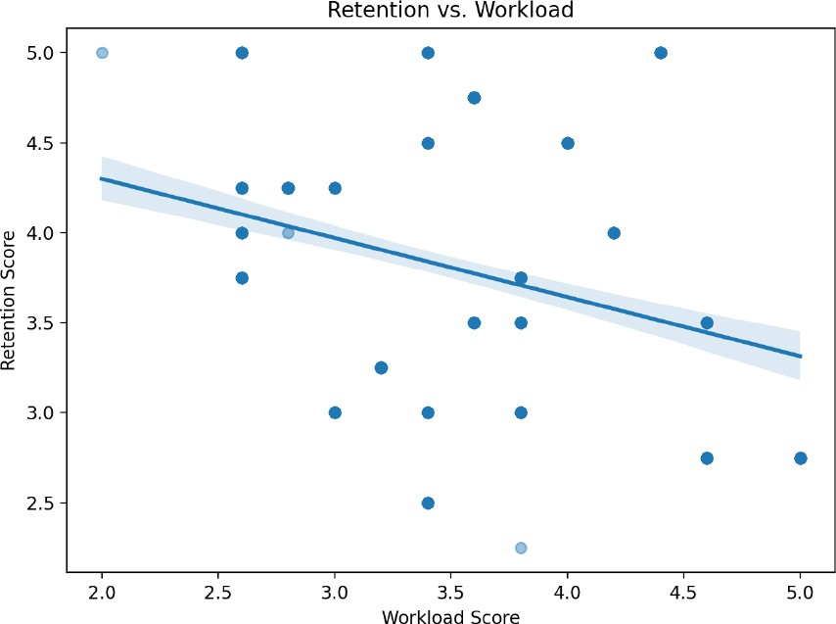
This scatterplot (Figure 2.1) shows the relationship between Retention Score and Workload Score. Each dot represents one respondent. As we can see, the trend line slopes downward, which means that as the workload score increases, the retention score tends to decrease. This suggests that heavier workloads may be linked to lower faculty retention in simpler terms, when faculty members feel overwhelmed, they might be less likely to stay.

Figure 2.2 Retention Score vs Compensation Score
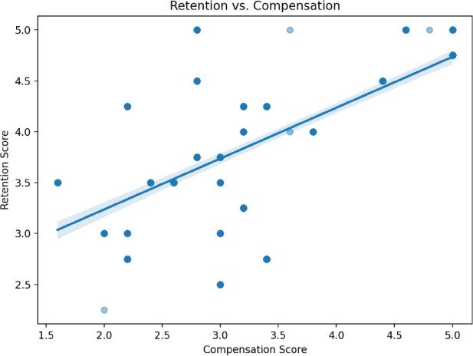
This scatterplot (Figure 2.2) illustrates the relationship between Retention Score and Compensation Score. Each dot represents one respondent’s data. The upward trend of the line shows a clear pattern: as compensation scores increase, so do retention scores. Simply put, when faculty feel they are fairly or better compensated, they are more likely to stay. This highlights how important fair and competitive pay is in keeping faculty members engaged and committed.

Figure 2.3 Retention Score vs Compensation Score
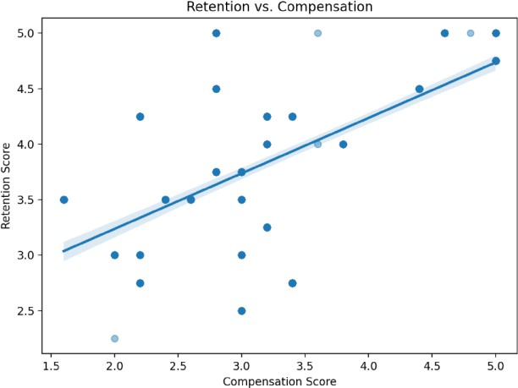

This scatterplot (Figure 2.3) presents the relationship between Retention Score and Career Development Score. Each dot reflects an individual's response. The upward-sloping line shows a positive relationship, meaning that as opportunities for career development improve, retention scores also tend to rise. In simple terms, when faculty feel supported in growing professionally, they are more likely to stay. This emphasizes the importance of

investing in training, mentorship, and advancement programs to keep educators motivated and committed.

Diagonal Histograms:
The diagonal cells show histograms of each variable’s distribution:
- Workload Score is clustered mostly between 2.5 to 4.
- Compensation Score is skewed, mostly between 2 and 4.
- Career Development Score is more spread out, ranging from 2 to nearly 7.
- Retention Score appears fairly balanced, clustering around 3.5 to 4.5.

Off-Diagonal Scatterplots:
Each off-diagonal cell shows a scatterplot of one variable against another:
- The cell where the row is Retention Score, and the column is Career Development Score shows how Career Development affects Retention.
- Career Development vs. Retention: There seems to be a positive relationship—higher development scores relate to higher retention scores.
- Compensation vs. Retention: Also shows a slight upward trend, suggesting a possible positive association.
- Workload vs. Retention: Appears more scattered, indicating weaker or no clear relationship.

CHAPTER IV
SUMMARY OF FINDINGS, CONCLUSIONS, AND RECOMMENDATIONS

SUMMARY OF FINDINGS
This chapter shares the findings of the study, "Quantifying the Impact of Workload, Compensation, and Development Opportunities on Faculty Retention." The research gathered insights from 547 faculty members working in different higher education institutions. Through a structured survey, participants shared their experiences and opinions about their workload, the fairness of their pay, and the opportunities they have for professional growth three important areas believed to influence whether they choose to stay at or leave their jobs.
OLS regression results into easy-to-understand parts. This output shows how Retention Score is affected by Workload, Compensation, and Career Development.
The regression model was statistically significant equal to394.2 and p < 0.001, indicating that the combination of the three predictor variables significantly explains the variation in retention scores. The model yielded an R-squared value of 0.685, suggesting that approximately 68.5% of the variance in retention score can be explained by Workload, Compensation, and Career Development.
All three predictor variables were found to be statistically significant p < 0.001. Career Development Score had the highest positive coefficient equal to 0.4862, followed by Compensation Score equal to 0.2759. In contrast, Workload Score had a negative coefficient equal to -0.3133, indicating an inverse relationship with retention.

RECOMMENDATIONS
This section presents actionable recommendations grounded in the findings of the study, “Quantifying the Impact of Workload, Compensation, and Development Opportunities on Faculty Retention.” These are directly aligned with the research problem and its four sub-questions, ensuring each recommendation addresses key areas that affect faculty retention.
Research Question 1: What is the individual impact of workload, compensation, and career development opportunities on faculty retention?
Recommendation 1: Reassess and Balance Faculty Workload
The study found that workload has a significant negative effect on retention. Institutions should evaluate current workload policies and seek to reduce non-
teaching tasks, overloads, and administrative burdens. Consider implementing workload monitoring systems and assigning support staff where needed. Lightening faculty workload

can reduce burnout and increase job satisfaction, which are essential to improving retention.
Recommendation 2: Ensure Competitive and Transparent Compensation Structures
Compensation showed a positive impact on retention. Regular compensation benchmarking and salary reviews should be conducted. Transparency in pay scales, promotion-related incentives, and financial rewards for research or service contributions can foster a stronger sense of fairness and value.
Recommendation 3: Expand Career Development Opportunities
Career development was found to be the strongest positive predictor of retention.
Institutions should invest in faculty development through training, research funding, promotion pipelines, and leadership opportunities. Structured mentorship programs and clear career paths can empower faculty to envision long-term growth within the institution.
Research Question 2: How do these three factors interact to influence a faculty member’s decision to stay or leave?
Recommendation 4: Develop Integrated Retention Strategies
The interaction among the three factors reveals that even when compensation is fair, excessive workload or limited development opportunities can still drive faculty away. Retention strategies should not address these areas in isolation. Instead, policies must consider the combined effects of work-life balance, financial security, and professional growth. A holistic approach includes supportive leadership, flexible scheduling, and alignment between institutional goals and individual aspirations.
Research Question 3: Which of these factors serve as the strongest predictors of faculty retention?
Recommendation 5: Prioritize Career Growth in Retention Programs
Since career development showed the greatest impact on retention, institutions should prioritize this in both planning and budgeting. Allocate resources for advanced degrees, research grants, participation in conferences, and recognition for scholarly contributions.
Promote a growth-oriented culture where advancement is seen as both achievable and supported.
Research Question 4: What actionable recommendations can be derived from the findings to support institutional retention strategies?
Recommendation 6: Establish a Feedback-Driven Retention Policy Framework.

The IPO model includes a feedback loop that encourages continuous improvement. Institutions should implement regular faculty engagement surveys and use these to inform data-driven policy updates.
Systems and platforms supporting faculty (e.g., HR portals, workload trackers, development programs) should be evaluated using ISO/IEC 25010 standards to ensure usability, functionality, and overall effectiveness. This dynamic feedback mechanism helps institutions stay responsive to evolving faculty needs.

CONCLUSION OF RECOMMENDATIONS
In summary, the recommendations outlined above are directly informed by the research problem and findings. By addressing each factor both individually and in combination, higher education institutions can design smarter, evidence-based policies that lead to higher faculty satisfaction, reduced turnover, and stronger institutional performance. A synchronized strategy that prioritizes balanced workload, fair compensation, and meaningful career growth backed by responsive systems and feedback will lay the foundation for long-term faculty retention.
All predictors have p-values below 0.05. The researchers reject the null hypothesis and conclude that workload, compensation, and career development significantly affect faculty retention.

APPENDICES
  - Research Instruments

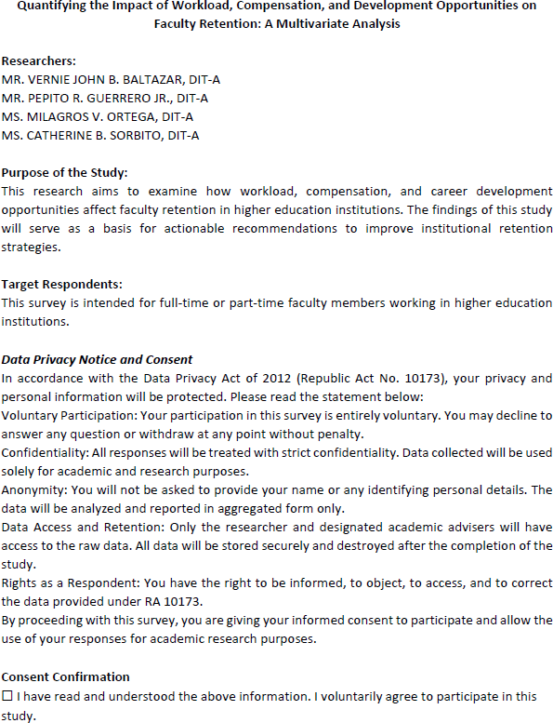

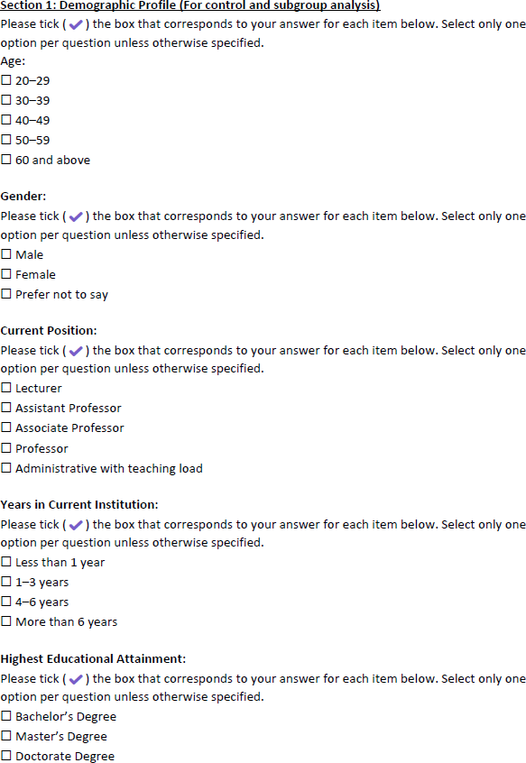

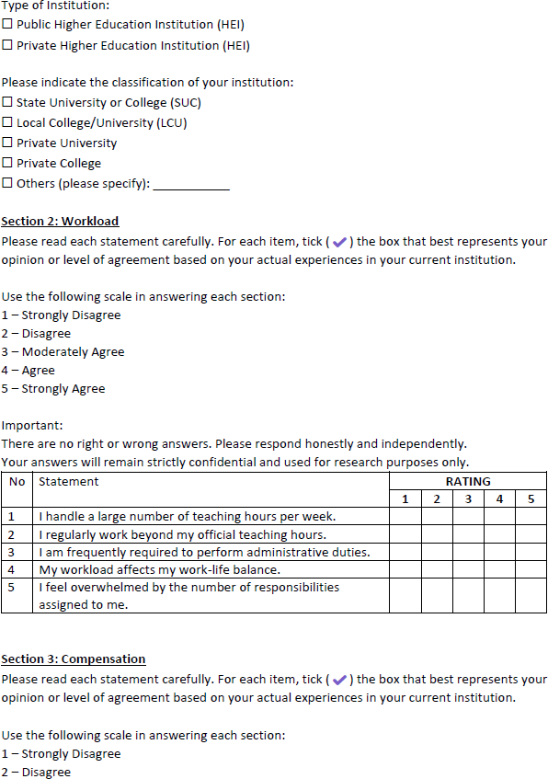

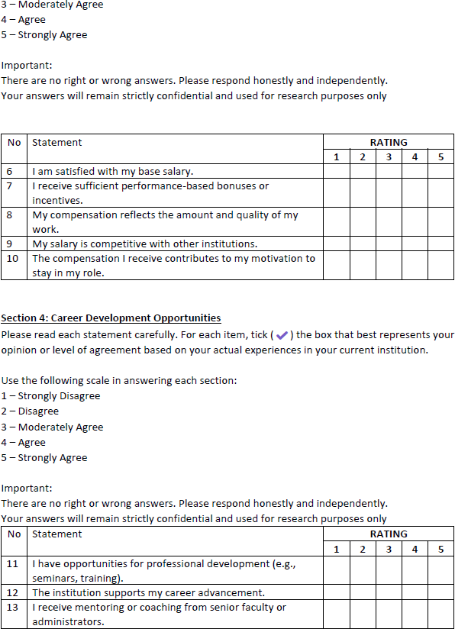

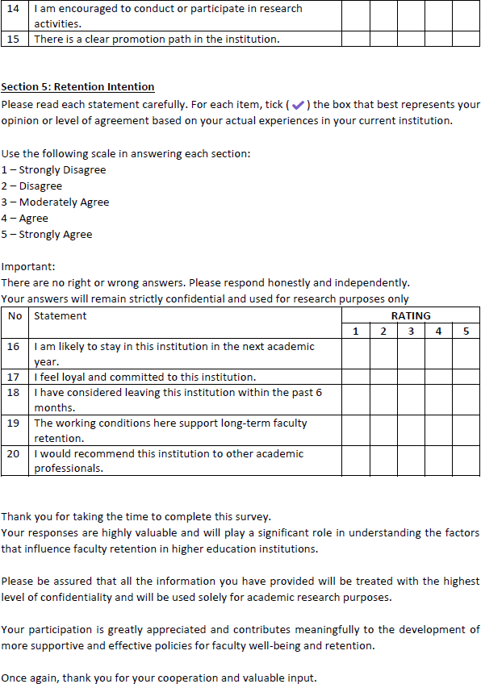

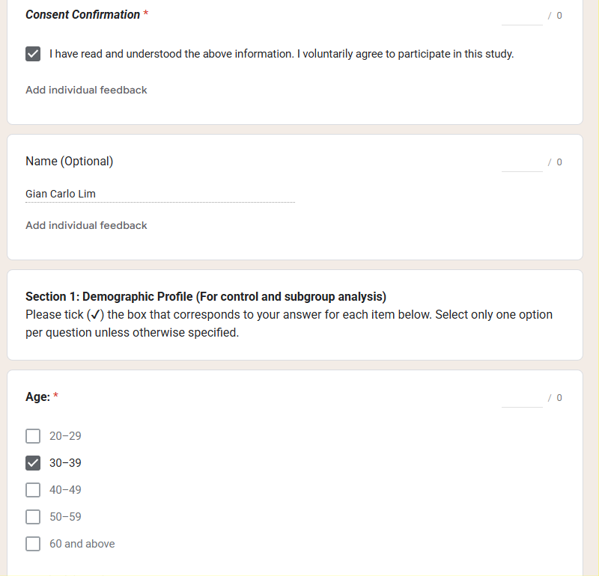
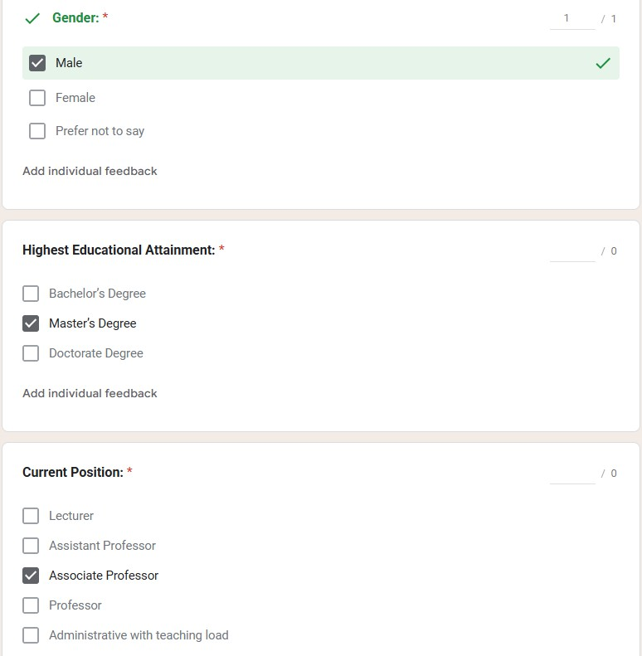
  - Accomplished Surveys

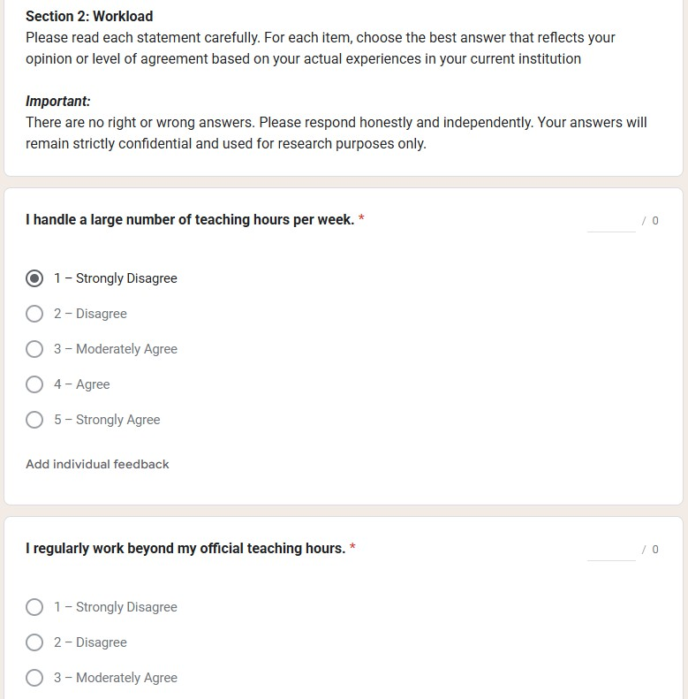
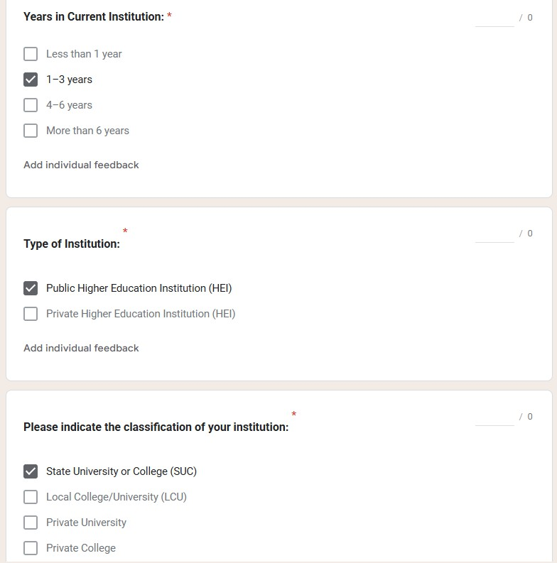

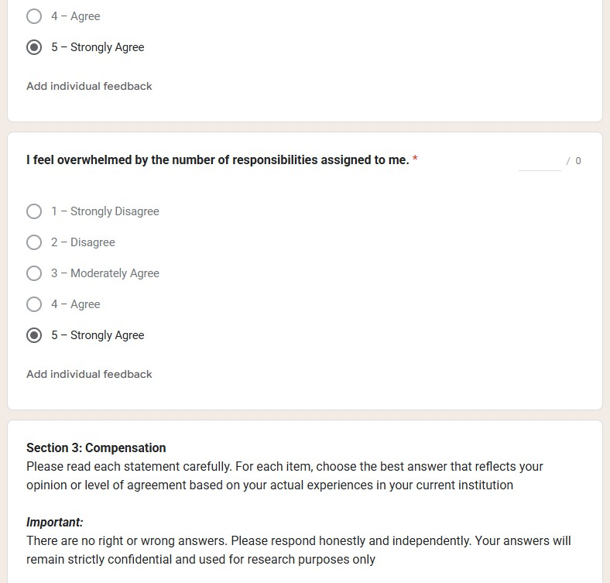
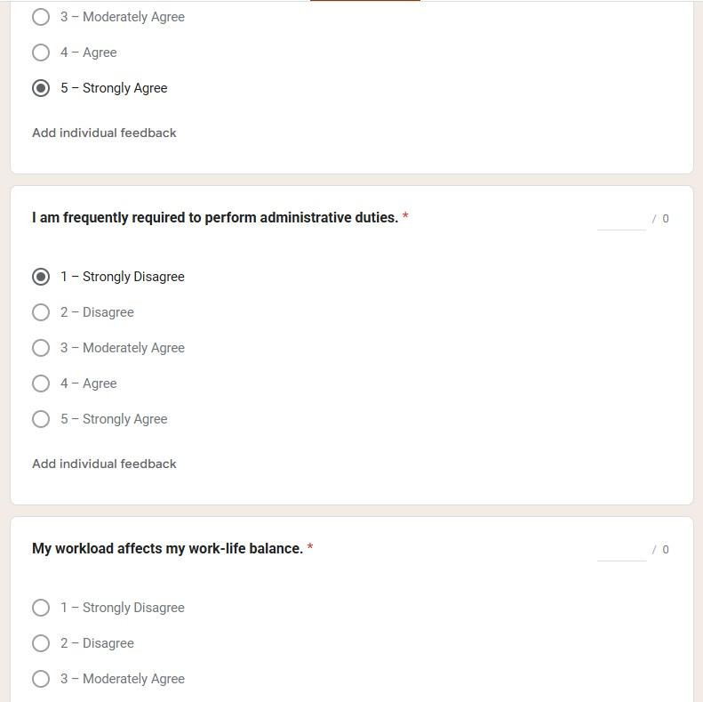

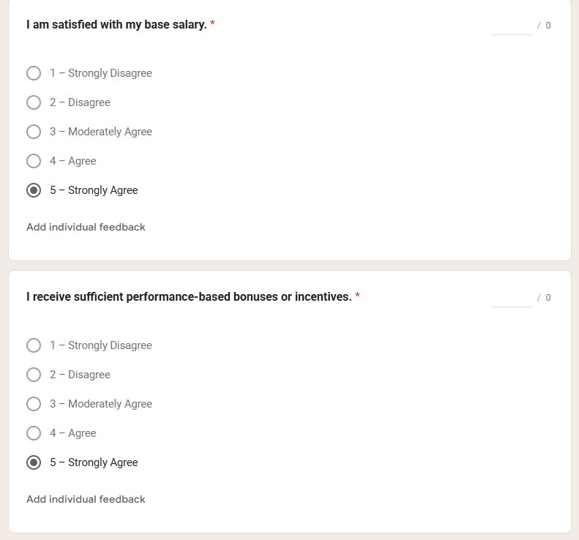

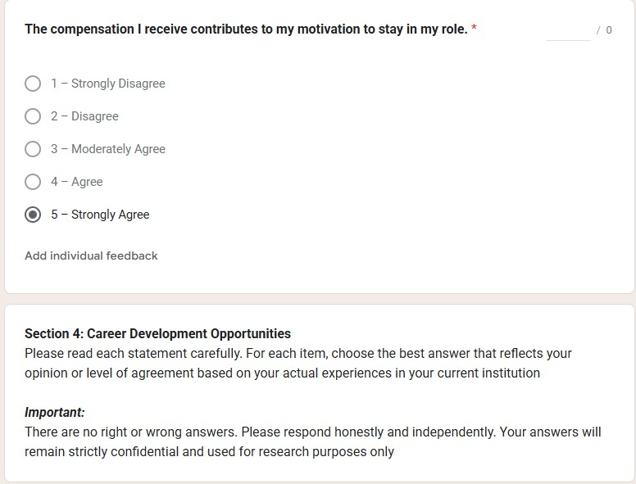
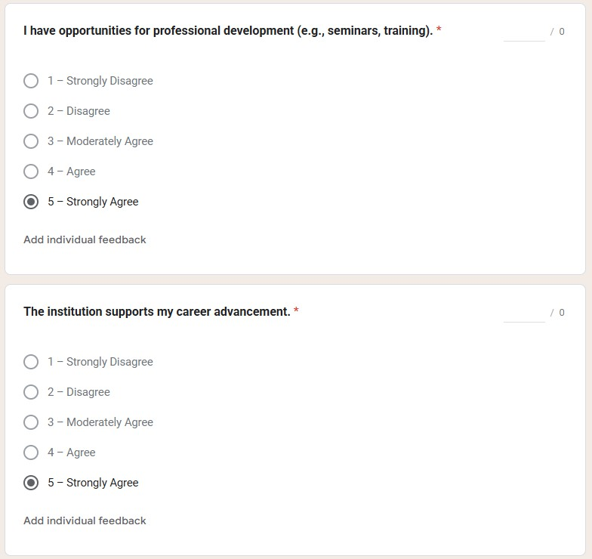

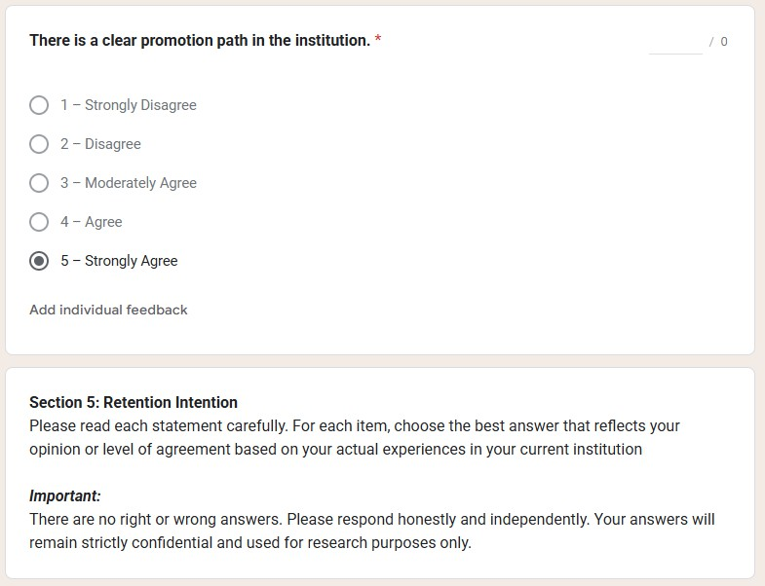
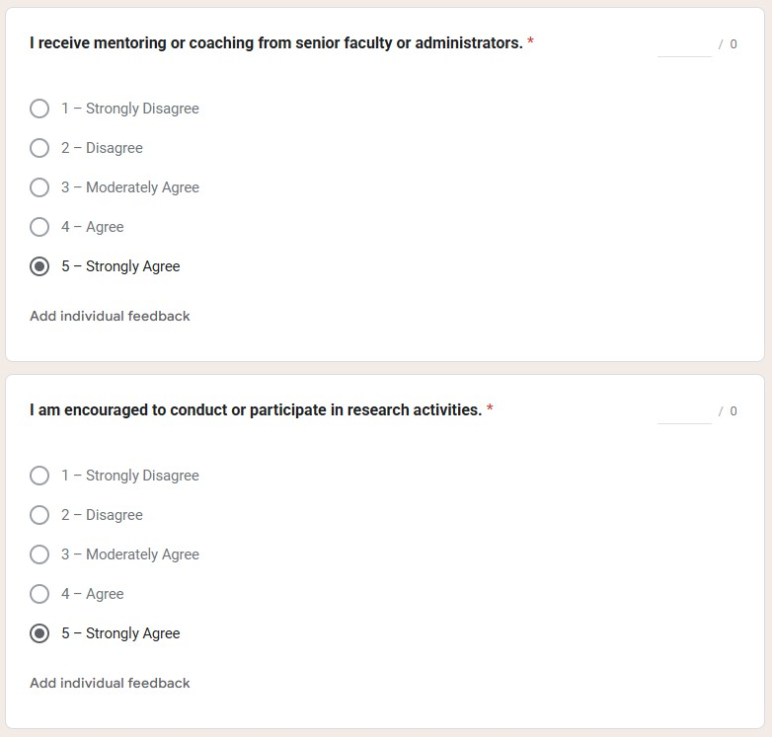

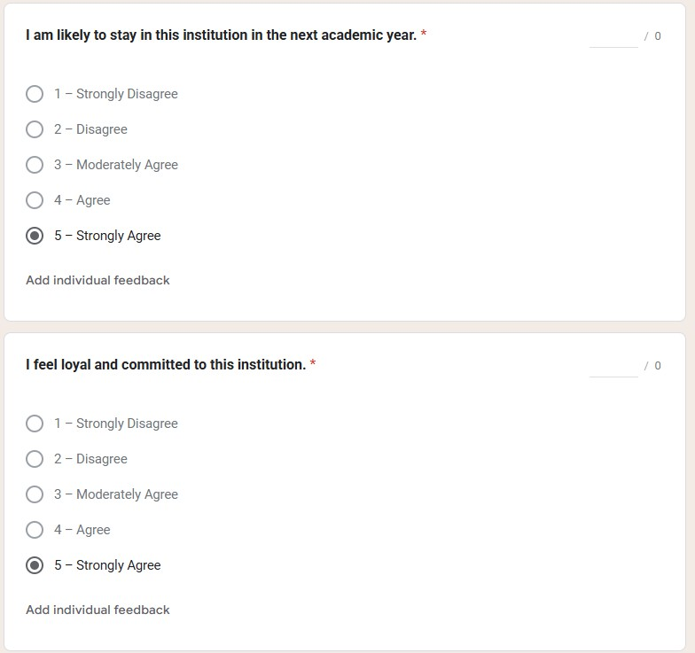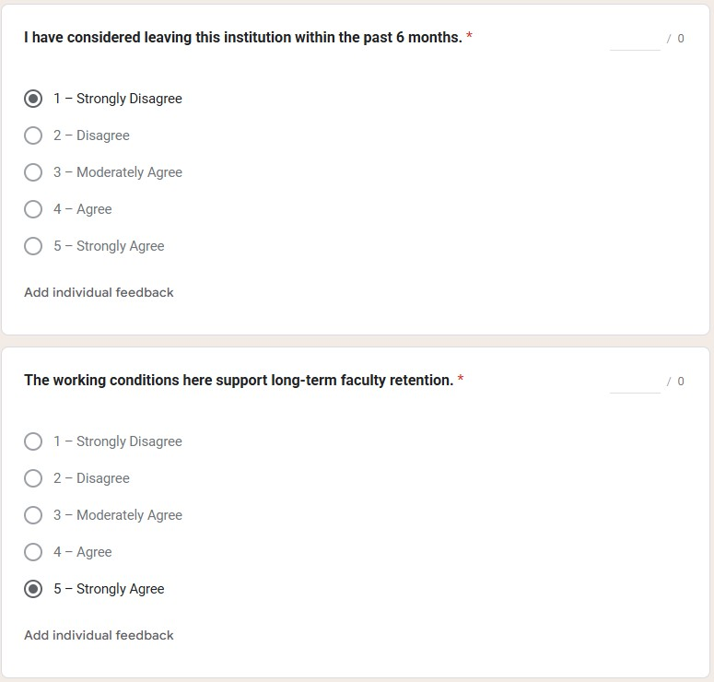

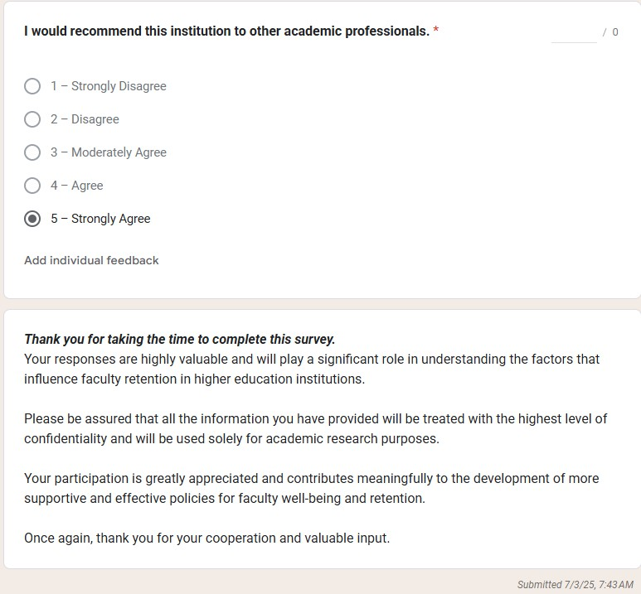

  - Faculty Matrix

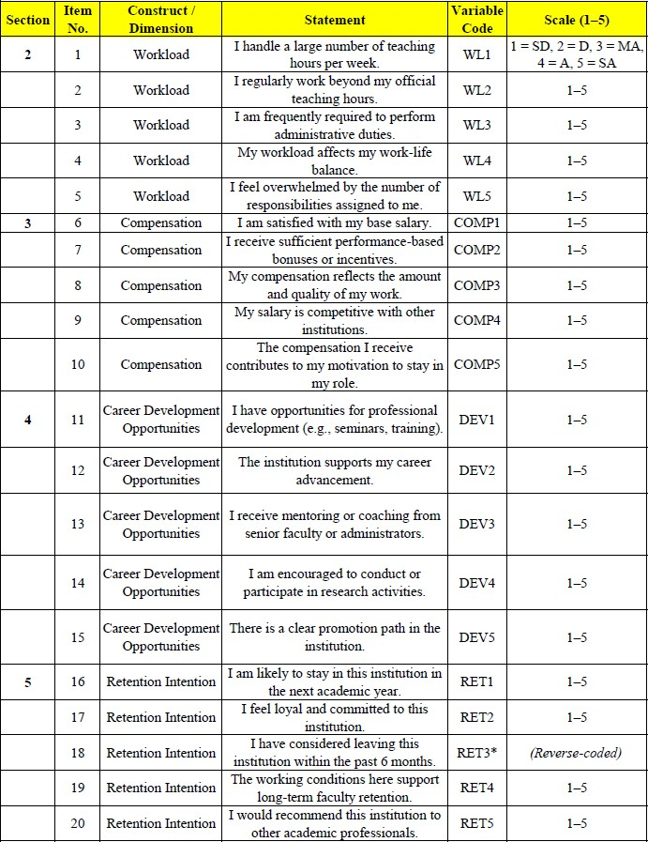

  - Generated Survey Result from 547 Responders

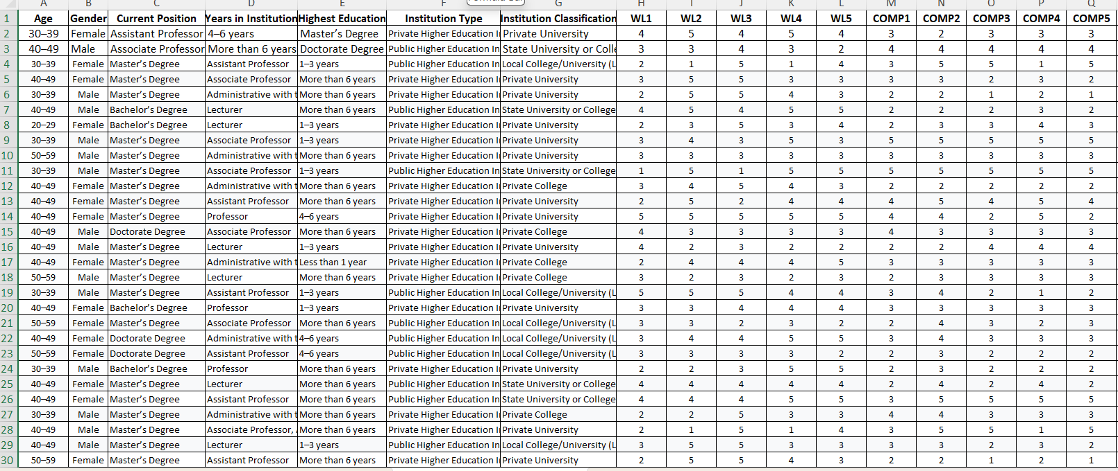
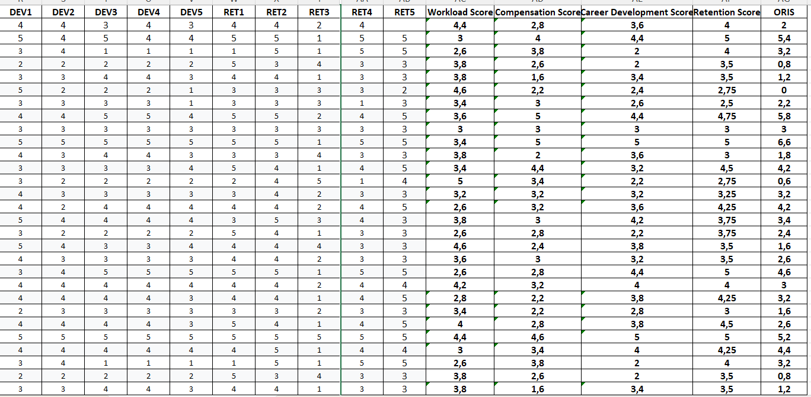

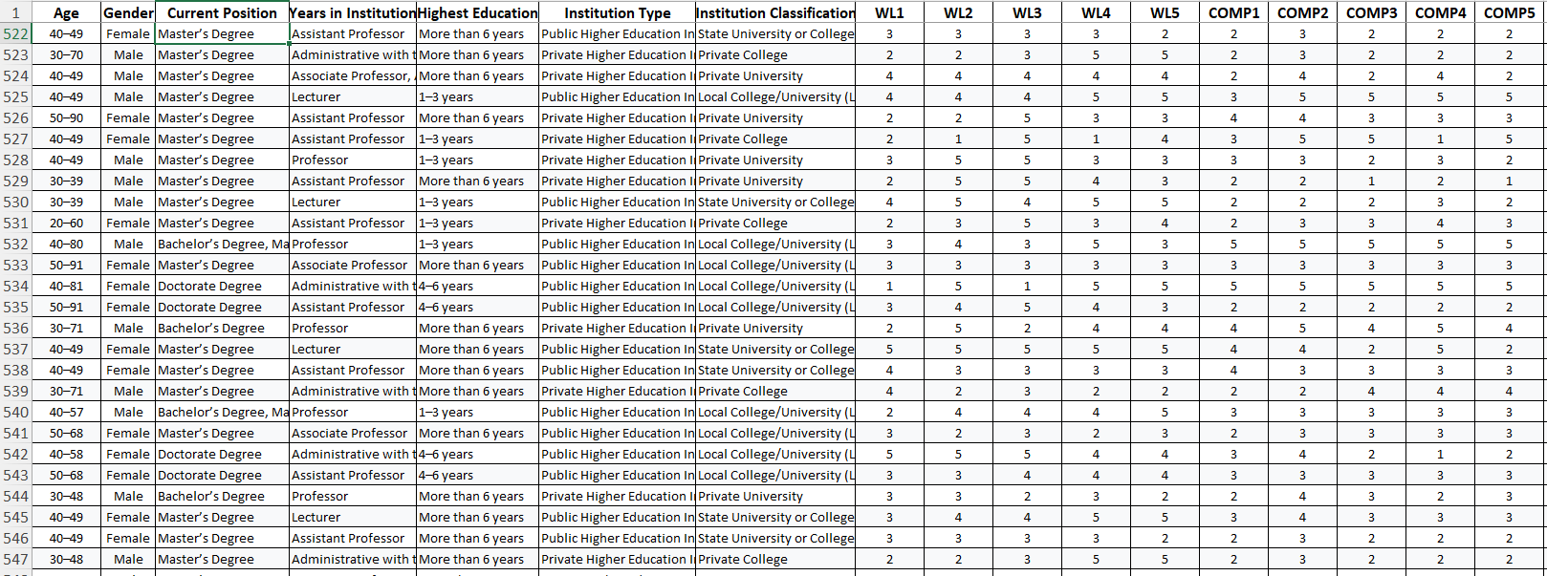
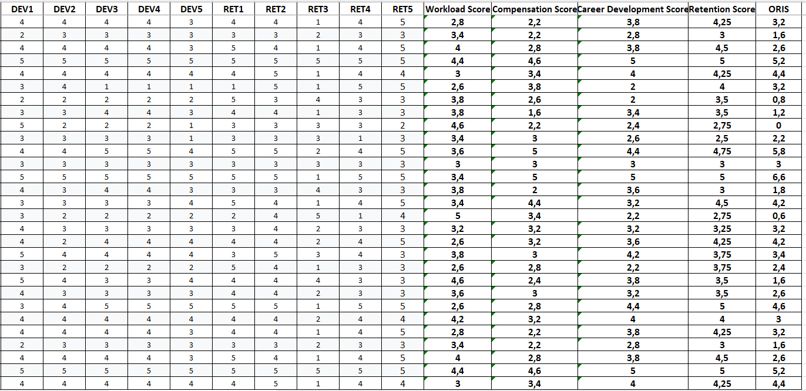

  - Scoring and Interpretation Guide
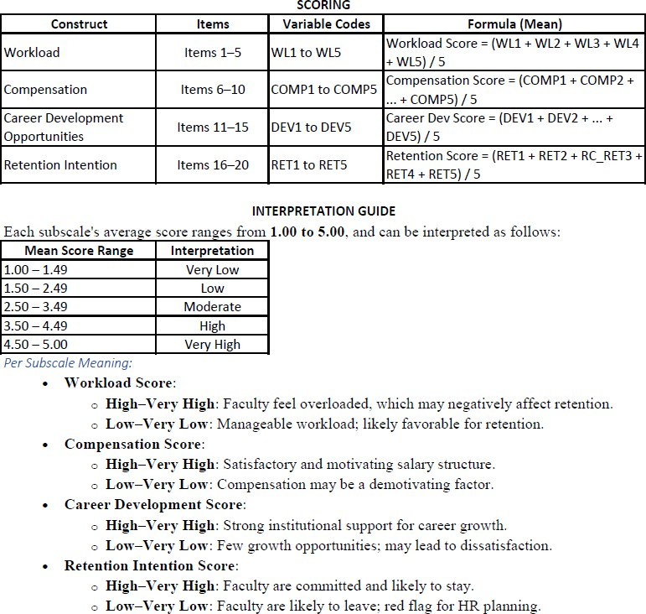

Questions:
SOP 1
1. Retain or not retain . hindi numeric, category or categorial

  - Faculty Retention Analysis
