Assessment of Transport Terminal Operation with Respect to Vehicle Assignment and Passengers´ Perspectives: Case Study at Hossana Town Bus Terminal

- INTRODUCTION
For as long as the human race has existed, transportation has played a significant role by facilitating trade, commerce, conquest, and social interaction, while consuming a considerable portion of time and resources. The essence of urban planning is to provide adequate and equitable service to all groups [1].
Transport is an absolutely necessary means to an end and allows people to carry out the diverse range of activities that make up daily life [2]. The transport system improves the social, economic, industrial, commercial progress and transfers the society into an organized one. To achieve the desired transportation balance and the system to be efficient, it is essential to provide organized facilities in the system, one such facility is a bus terminal. A bus terminal is the point at the start/end of a transport route, where the vehicles stop, reverse and wait, before departing on the return journey. It also serves as a station for passengers to board and alight. Evidently, at a bus terminal, parameters addressing passenger and operator requirements overlap [3]. It is the site for interchange between large volume of bus and passenger traffic.
This demands that the facilities at a bus terminal be planned systematically and that user requirements are addressed in such planning, or else the lack of an efficient and functional environment will lead to friction, ultimately compromising the attractiveness of the bus system [4].
The aim of this study is to assess operation in bus terminal in case of Hossana, Ethiopia. It is specifically focus on current situation of the terminal such as, way of vehicle assignment to respective route, conformity of terminal for passenger, safety and security concern are also other issue in the study.
Statement of the problem
Public transportation is an integral part of community infrastructure, providing access to mobility for both business and social purposes. Media has created negative perception of facilities and operations which cumulated into fears in the hearts of the users; there is over exaggeration of incidence of crimes against users and belongings. As a result of these people tend to make less use of public transport, and in extreme cases have to cancel journeys they might have made or often arrange for more expensive and less convenient modes of transport [5].
All special flows, with the exception of personal vehicular and pedestrian’s trips, involve movements between terminals. With the exceptions, all transport modes require assembly and distribution of their traffic. For example, passengers have to go to bus terminal first in order to reach their final destination. Terminals are therefore, essential links in transportation chain.
The 2014 E.C Hadiya Zone Roads Transport Department annual report highlighted significant operational challenges at the Hossana Bus Terminal. These included inconsistent schedules resulting in passenger uncertainty and travel disruptions; limited accessibility for passengers with disabilities; inadequate communication between staff and passengers; inefficient and outdated ticketing systems causing delays and errors; insufficient safety measures (inadequate lighting, security, and designated waiting areas); and a lack of basic amenities (seating, restrooms, and food services). Furthermore, the terminal's environment contributed to safety and security concerns, including incidents of crime (rape, murder, robbery, theft) and accidents. While existing research suggests that public transportation is generally safe, this study investigates passenger perceptions of safety and security at Hosanna’s terminal to assess the effectiveness of current operational practices. The aim is to provide a comprehensive evaluation of the terminal's performance.

- METHODOLOGY
Description of Study Area
Hosanna is found in Hadiya Zone, SNNPR, is located at 232km south from the capital Addis Ababa. It is found 7°30' 30''N to 7°35' 30''N latitudes and 37°48' 30''E to 37°54' 30''E longitudes [6].
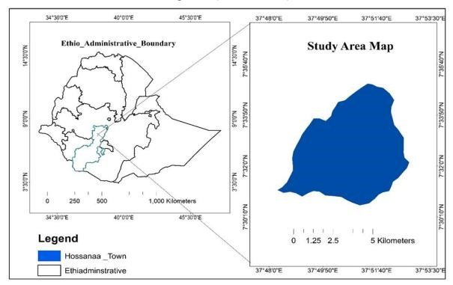: 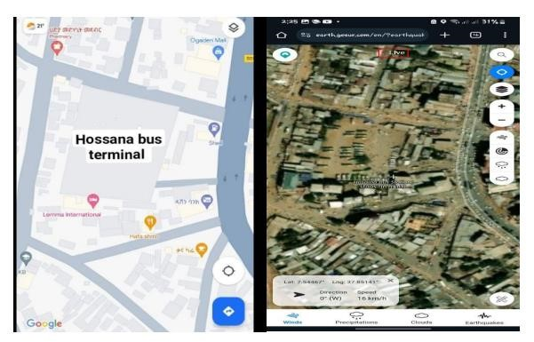
Figure 1:Geographic Location of Hossana Town
  - Research Strategy
Two types of research strategies are used as studies, qualitative and quantitative research. According to this thesis, both types were used. Regarding to qualitative the current environmental situation of the terminal was mentioned. In the other hand, quantitative research strategy was used to express number of passenger, number of vehicle and linear regression model of this paper.
  - Study Design
Descriptive design was used in this study with qualitative and quantitative data type collected from questionnaires, interviews and observations as primary data, data from terminal management team is used as secondary data.
2.3. Sample Size Distribution and Sampling Procedure
A. Sampling size
Hossana bus terminal operate for short, medium and long distance route. But the terminal is responsible to assign vehicle for short and medium distance route. While the rest, for LDR. 10 vehicle is assigned from Federal, public transport owner association.

The samples were selected randomly from the passengers.
SS=$\frac{Z² *(p) * (1-p) }{C² }$………equation 1
SS = Sample Size
Z = Z-value (e.g., 1.645 for a 90 present confidence level)
P = Percentage of population picking a choice, expressed as decimal (0.05 for sample size used)
C = Confidence interval, expressed as decimal (e.g., .04 = +/- 4percentage)
SS= (1.6452*0.05*0.95)/0.042=80
Assuming finite population and use the following formula
New SS=$\frac{SS }{C(1 + (SS - 1)/pop) }$…… equation 2
Where SS=80
Pop is average number of passenger’s researcher got from terminal =10,282
Therefore, New SS=92

B. Sampling procedure
Based on sample size determined above, 92 number of passenger were selected from selected terminal for distributing questionnaire. To get representative sampling, passengers to every 32th route operating from this terminal was selected using systematic sampling technique and on average 5 passengers was randomly selected from each of these routes. Finally, 4 representative officials and 3 representatives of nongovernmental association from JBT were selected using purposive sampling technique to get some fact about status of service. And questionnaire for passengers was in the form of interview since they were ready to journey.
  - Data analysis
Source of the data for this thesis was Questionnaire, interview, observation and desk study from the terminal. Questionnaire data collected from passengers and terminal management was analyzed by Microsoft excels. The proportional vehicle assignment throughout the routes, vehicle assignment model was developed using SPSS software. Finally, ARC GIS v10.7.1 and AUTO CAD 2020 was used to visualize a way of vehicles standing in the terminal.
  - Study variables
Dependent variable
- Transport Terminal Operation
Independent variables
- Number of passengers.
- Number of vehicles.
- Number of trips
- Security in terminal
- Comfort of terminal
- Passengers information system
- RESULTS AND DISCUSSION
Based on sample size determined, 92 survey questionnaires were distributed to passenger of JBT. However, from total 92 survey questionnaire, eight (8) were not fully and correctly answered and four (4) were not turned back. As a result, data presentation and analysis is based on response of 80 passengers’ vehicle supply and demand arrangement and result of questioner to identify terminal problem. The researcher got number of passengers by multiplying number of vehicles registered while exiting from the terminal by their number of seats in each vehicle for each respective route. It is assumed that there is no overloading in each vehicle counted and develop model for vehicle assignments.

Table 1:Summary of table for number of seats in vehicles
City | Number of seats
City | 11-12(M.bus) | 24-28 | 29-44 | 60-63(Bus)
Doyogena
Fonko
Wolkite
Butajira
Worabe
Wulbareg
Mare
Lera
Mazorya
Hawassa
Halaba
Wolayita
Durame
Adama
Homicho
Moresito
Gimbichu
Gombora
Jajura
Lisana
Wasegebeta
Busheana
Jewe
Kosy
Bonosa
Selela
Geja
Duna
Shashemene
Jimma
Hadero
Addis Abeba

3.1. Result of Desk Study
Vehicle Supply and Demand of Passengers
A. Average number of trip of vehicles per day
To know the assigned vehicles the five days’ data of vehicles trip registered at the exit and determine average of vehicles out going from the terminal per day. And then after comparing with number of vehicles proposed for a day in order to compare demand and supply of vehicles per day and following data is found. Here under, vehicles going to 31 routes were selected as a case-1 since daily trip available and for the rest six routes vehicles were exit once a week and that’s explained as case-2 in the analysis.

Table 2:One week’s data of vehicles trip in each day (From the bus terminal office)
Data of vehicles exit from terminal in date of 12/05/2016 -18/05/2016
No.of vehicle trip
No | Destination | 12/05/20  16 | 13/5/2016 | 14/5/2016 | 15/5/2016 | 16/5/2016 | 17/5/2016 | 18/5/2016 | Average/ day
1 | Hawassa | 12 | 15 | 10 | 13 | 11 | 12 | 14 | 12
2 | Halaba | 14 | 10 | 11 | 14 | 16 | 12 | 11 | 12
3 | Wolayita | 16 | 12 | 14 | 15 | 13 | 16 | 10 | 13
4 | Durame | 10 | 14 | 8 | 8 | 14 | 11 | 7 | 10
5 | Addis Abeba | 18 | 16 | 21 | 19 | 17 | 14 | 17 | 17
6 | Adama | 4 | 4 | 4 | 4 | 4 | 4 | 4 | 4
7 | Homecho | 50 | 43 | 45 | 47 | 37 | 49 | 28 | 42
8 | Moresito | 40 | 36 | 34 | 39 | 40 | 37 | 33 | 37
9 | Gimbichu | 46 | 43 | 40 | 44 | 29 | 31 | 39 | 38
10 | Gombora | 30 | 32 | 30 | 28 | 31 | 26 | 25 | 28
11 | Jajura | 26 | 29 | 24 | 26 | 22 | 23 | 20 | 24
12 | Lisana | 28 | 24 | 26 | 29 | 24 | 27 | 30 | 26
13 | Wasegebeta | 26 | 28 | 26 | 20 | 21 | 24 | 27 | 24
14 | Busiana | 29 | 25 | 20 | 19 | 25 | 29 | 29 | 25
15 | Jewe | 20 | 21 | 17 | 15 | 19 | 18 | 22 | 18
16 | Hadero | 12 | 14 | 11 | 13 | 12 | 12 | 10 | 12
17 | Doyogena | 18 | 19 | 17 | 14 | 16 | 18 | 24 | 18
18 | Fonko | 22 | 26 | 21 | 20 | 22 | 26 | 21 | 22
19 | Kosy | 11 | 9 | 7 | 11 | 12 | 10 | 9 | 9
20 | Bonosa | 8 | 6 | 9 | 10 | 7 | 5 | 7 | 7
21 | Selela | 7 | 6 | 7 | 7 | 8 | 6 | 6 | 6
22 | Geja | 6 | 6 | 6 | 4 | 7 | 6 | 6 | 5
23 | Duna | 52 | 47 | 39 | 41 | 51 | 38 | 50 | 45
24 | Wolkite | 42 | 37 | 42 | 40 | 41 | 40 | 42 | 40
25 | Butajira | 40 | 44 | 38 | 41 | 40 | 40 | 36 | 39
26 | Worabe | 22 | 20 | 22 | 22 | 19 | 17 | 18 | 20
27 | Wulbareg | 38 | 40 | 37 | 34 | 30 | 28 | 37 | 34
28 | Shashemene | 2 | 2 | 2 | 2 | 2 | 2 | 2 | 2
29 | Mazorya | 24 | 19 | 24 | 21 | 26 | 23 | 20 | 22
30 | Mare | 16 | 12 | 14 | 11 | 18 | 16 | 16 | 14
31 | Lera | 12 | 13 | 10 | 11 | 12 | 9 | 11 | 11
Total |  |  | 672 | 636 | 642 | 646 | 629 | 631 | 636

From the above table, we have seen that minimum number of vehicles released from the terminal is 2 and maximum number of vehicles trip exit from the terminal is 45. As observed from the above table, maximum numbers of passengers were travelled along Duna relative to other routes. And the next largest trips with respect to other were along Homecho route and it continues as their descending order such as Wolkite, Butajira, Gimbichu, Moresito, Gombora and Lisana routes.

Average Number of Passengers per Day Travel from Hossana Bus Terminal
Converting the above data to passenger’s number per day traveling to their respective route by multiplying with their number of seats in vehicles and following result is found.

Data of vehicles exit from terminal in date of 12/05/2016 -18/05/2016
average number of passengers per day
No | Destination | 12/05/20  16 | 13/5/2016 | 14/5/2016 | 15/5/2016 | 16/5/2016 | 17/5/2016 | 18/5/2016 | Average/ Day
1 | Hawassa | 528 | 660 | 440 | 572 | 484 | 528 | 616 | 546
2 | Halaba | 616 | 440 | 484 | 616 | 704 | 528 | 484 | 553
3 | Wolayita | 704 | 528 | 616 | 660 | 572 | 704 | 440 | 603
4 | Durame | 440 | 616 | 352 | 352 | 616 | 484 | 308 | 452
5 | Addis Abeba | 1134 | 1008 | 1323 | 1197 | 1071 | 882 | 1071 | 1098
6 | Adama | 176 | 176 | 176 | 176 | 176 | 176 | 176 | 176
7 | Homecho | 2200 | 1892 | 1980 | 2068 | 1628 | 2156 | 1232 | 1879
8 | Moresito | 1760 | 1584 | 1496 | 1716 | 1760 | 1628 | 1452 | 1628
9 | Gimbichu | 2024 | 1892 | 1760 | 1936 | 1276 | 1364 | 1716 | 1709
10 | Gombora | 1320 | 1408 | 1320 | 1232 | 1364 | 1144 | 1100 | 1269
11 | Jajura | 1144 | 1276 | 1056 | 1144 | 968 | 1012 | 880 | 1068
12 | Lisana | 1232 | 1056 | 1144 | 1276 | 1056 | 1188 | 1320 | 1181
13 | Wasegebeta | 1144 | 1232 | 1144 | 880 | 924 | 1056 | 1188 | 1081
14 | Busiana | 1276 | 1100 | 880 | 836 | 1100 | 1276 | 1276 | 1106
15 | Jewy | 880 | 924 | 748 | 660 | 836 | 792 | 968 | 829
16 | Hadero | 528 | 616 | 484 | 572 | 528 | 528 | 440 | 528
17 | Doyogena | 216 | 228 | 204 | 168 | 192 | 216 | 288 | 216
18 | Fonko | 264 | 312 | 252 | 240 | 264 | 312 | 252 | 270
19 | Kosy | 484 | 396 | 308 | 484 | 528 | 440 | 396 | 433
20 | Bonosa | 352 | 264 | 396 | 440 | 308 | 220 | 308 | 326
21 | Selela | 308 | 264 | 308 | 308 | 352 | 264 | 264 | 295
22 | Geja | 264 | 264 | 264 | 176 | 308 | 264 | 264 | 257
23 | Duna | 2288 | 2068 | 1716 | 1804 | 2244 | 1672 | 2200 | 1998
24 | Wolkite | 504 | 444 | 504 | 480 | 492 | 480 | 504 | 486
25 | Butajira | 480 | 528 | 456 | 492 | 480 | 480 | 432 | 478
26 | Worabe | 264 | 240 | 264 | 264 | 228 | 204 | 216 | 240
27 | Moresito | 1672 | 1760 | 1628 | 1496 | 1320 | 1232 | 1628 | 1533
28 | Shashemene | 88 | 88 | 88 | 88 | 88 | 88 | 88 | 88
29 | Mazoriya | 288 | 228 | 288 | 252 | 312 | 276 | 240 | 269
30 | Mary | 192 | 144 | 168 | 132 | 216 | 192 | 192 | 176
31 | Lera | 144 | 156 | 120 | 132 | 144 | 108 | 132 | 133
Total |  | 24,914 | 23,792 | 22,367 | 22,849 | 22,539 | 21,894 | 22,071 | 22,904

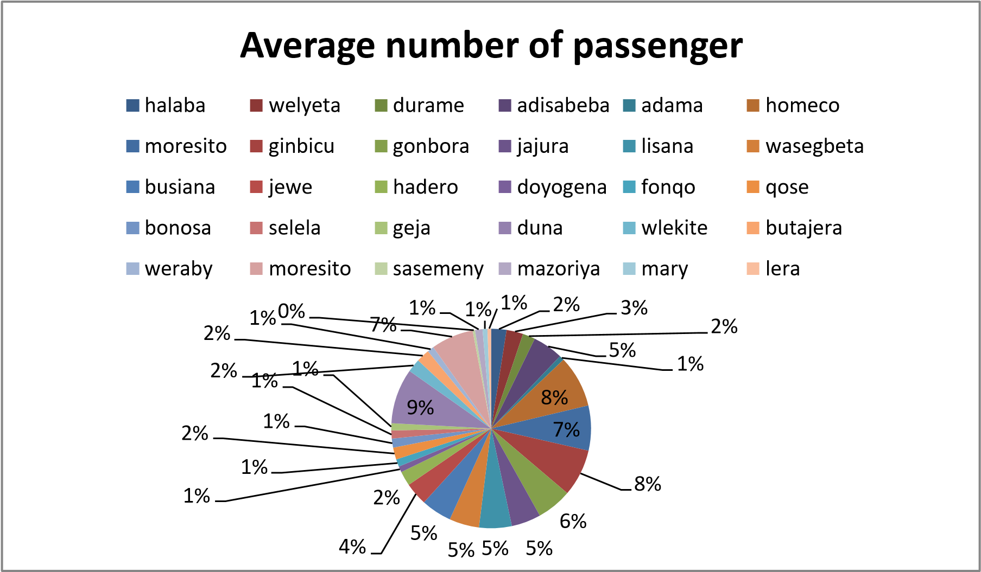
Figure 2:Average numbers of passengers’ trip per day

As shown in the chart 9% of total passengers were use the route along Duna. Next 8% of them use Homecho, Gimbichu routes. Whereas 7% of them travel to Moresito routes and 5% Addis Abeba, Jajura, Lisana, Wasegebeta and Busiana ways. In 4% of passengers use Jewe route, 3%welyeta road, 2%use Halaba, Hadero, Butajira, Kosy, Wolkite route. And Adama, Doyogena, Selela, Fonko, Mazoriya cover 1% of passengers.

B. Vehicles Supplied from the Terminal per Day
Based on the result found in desk study, the following table contains number of vehicles assigned per day as per monthly schedule of the terminal.

Table 3:Number of existing vehicles in schedule of the terminal per day (From the bus terminal office)
no. | Destination | No. Vehicle Assigned
1 | Jimma | 0
2 | Shashemene | 1
3 | Adama | 2
4 | Bonosa | 2
5 | Durame | 3
6 | Selela | 3
7 | Geja | 3
8 | Hawasa | 4
9 | Wolayita | 4
10 | Hadero | 4
11 | Kosy | 5
12 | Halaba | 6
13 | Addis Abeba | 6
14 | Mazoriya | 7
15 | Jewe | 8
16 | Wasegebeta | 10
17 | Wulbareg | 10
18 | Mary | 10
19 | Lera | 11
20 | Gombora | 12
21 | Lisana | 14
22 | Fonko | 14
23 | Busiana | 16
24 | Doyogena | 16
25 | Duna | 17
26 | Worabe | 17
27 | Moresito | 18
28 | Jajura | 18
29 | Gimbichu | 20
30 | Homecho | 21
31 | Butajira | 22
32 | Wolkite | 18
Total |  | 327
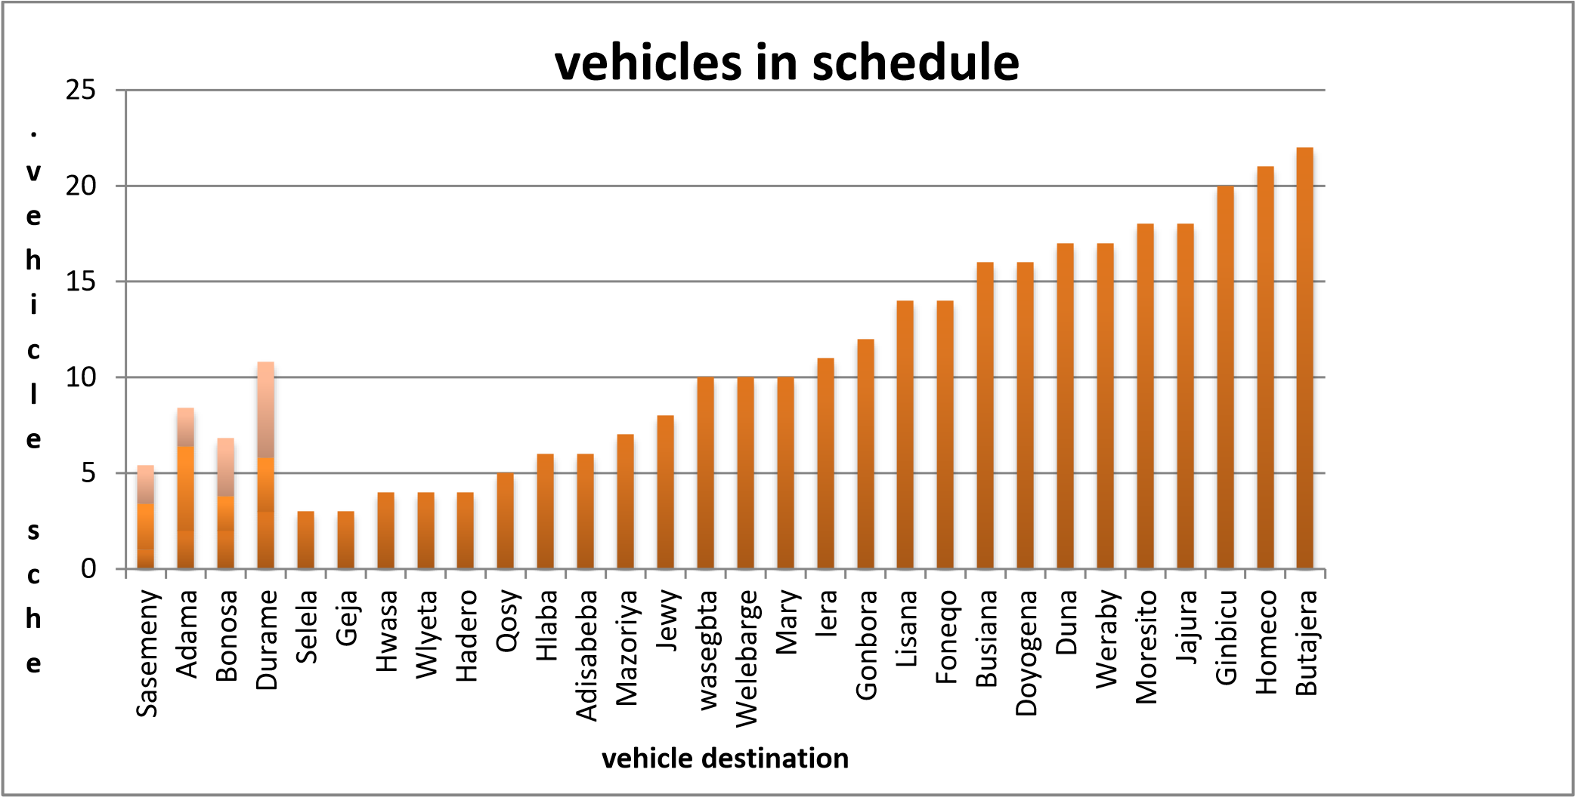
Figure 3:Numbers of existing vehicles assigned from terminal

From above data we have observed that number of vehicles assigned for routes such Doyogena, Jewe, Selela, Adama and Shashemene needs additional number of vehicles per day according to their trip. On the other hand, number of vehicles assigned for routes such as Butajira, Homecho, Gimbichu, Duna, Moresito, and Worabe are excess beyond the demand of passengers. Generally, vehicle distribution in the terminal is not uniform throughout every route according to data we observed.
In addition to desk study as data gained from interview of the member of official from the terminal, criteria for vehicle assignment was depend on the interest of the owner of the vehicles from non-governmental association in bus terminal that may lead to unfair distribution of vehicles throughout the routes. There are totally 9 non-governmental association having contribution in assigning vehicles to terminal based on data collected from the terminal. Roles of these associations in terminal are:
- They function as a third party between owner of vehicles and the terminal.
- They assign route for new vehicles which has no specified direction to work.
- They prepare monthly schedule of vehicle assignment and give to terminal in order to verify it.
- They collect 6% of passenger’s payment money from each vehicle in order to pay salary for their employee since they are non-governmental organization.
3.2. Result of Questionnaire to Identify Terminal Problem
Availability of sufficient vehicle in terminal
Based on question raised to passengers, concerning availability of sufficient number of vehicles, response is analyzed as follows.

Table 4:Passenger’s level of satisfaction based on availability of sufficient number of vehicles
 | Frequency | Percent | Cumulative Percent
very satisfied | 16 | 20 | 20
Satisfied | 28 | 35 | 55
Average | 20 | 25 | 80
Dissatisfied | 12 | 15 | 95
Very dissatisfied | 4 | 5 | 100
Total | 80 | 100

0
5
10
15
20
25
30
35
40
very satisfied
Satisfied
Average
Dissatisfied
Very dissatisfied
passenger satisfaction level in percent

Figure 4:Passenger’s satisfaction level on availability of sufficient number of vehicles

As observed in the results indicate, about 35% of respondent were satisfied with number of vehicles available and 20% of them also very satisfied. Whereas 15% of respondents were dissatisfied and 5% of them also very dissatisfied with availability of sufficient number of vehicles. and the remaining 25% of the respondents’ rate in range of average. Table above confirmed that large numbers of respondents react as they satisfy by on availability of sufficient number of vehicle since the answer was analyzed depend on the routes of passengers. But from the remaining respondents we can predict that as there was shortage of vehicles in some routes.
3.3. Availability of route information board
Passengers were asked about their level of satisfaction regarding to availability of route information board in bus terminal and answer is analyzed as follows.

Table 5:Passengers level of satisfaction availability of route information board in terminal
 | Frequency | Percent | Cumulative Percent
very satisfied | 4 | 5 | 5
Satisfied | 14 | 17.50 | 22.50
Average | 21 | 26.25 | 48.75
Dissatisfied | 23 | 28.75 | 77.50
Very dissatisfied | 18 | 22.50 | 100
Total | 80 | 100

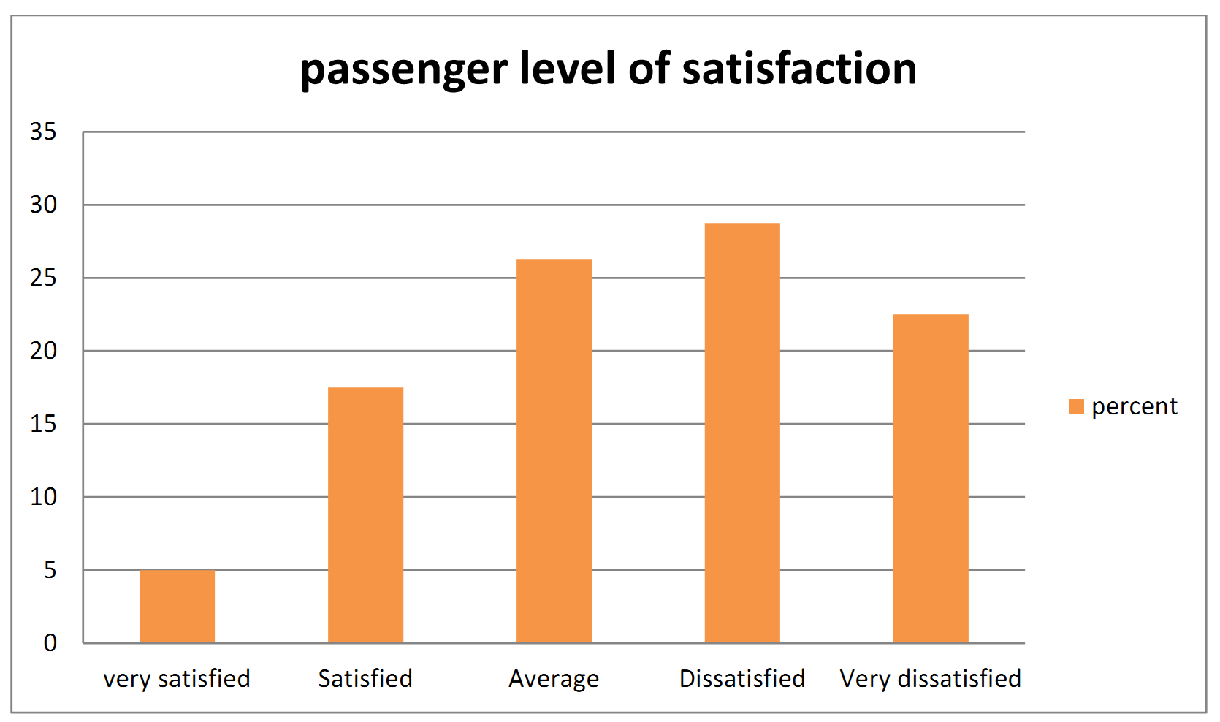
Figure 5:Passenger’s level of satisfaction availability of route information board in terminal

The demonstrated in the findings that more than 51.25% of respondents are dissatisfied (22.50% very dissatisfied and 28.75% were dissatisfied) regarding to the availability of information board in the terminal. On the other hand, 22.5% of respondents are satisfied (5% very satisfied and 17.50% are satisfied). Remaining 26.25% of respondents have rated their level of satisfaction as average. From this data it could be possible to infer that there is no clear indication sign or route information board that will direct the passenger in order to get their way easily (Hong Kong up to 2016).
The researcher has also observed that as there was no precise indicator at exit and entrance of the bus terminal. Hence passenger as well as vehicles were not identified while entering and exit from the terminal. In addition to that based on researcher observation there was no structured indicating mounted symbol showing vehicles with their respective route in order to make it easy to get their way for the passengers rather than calling passengers one by one. Moreover, in the terminal route information written on printed paper is attached on the wall which is not clearly visible for passengers as shown following.

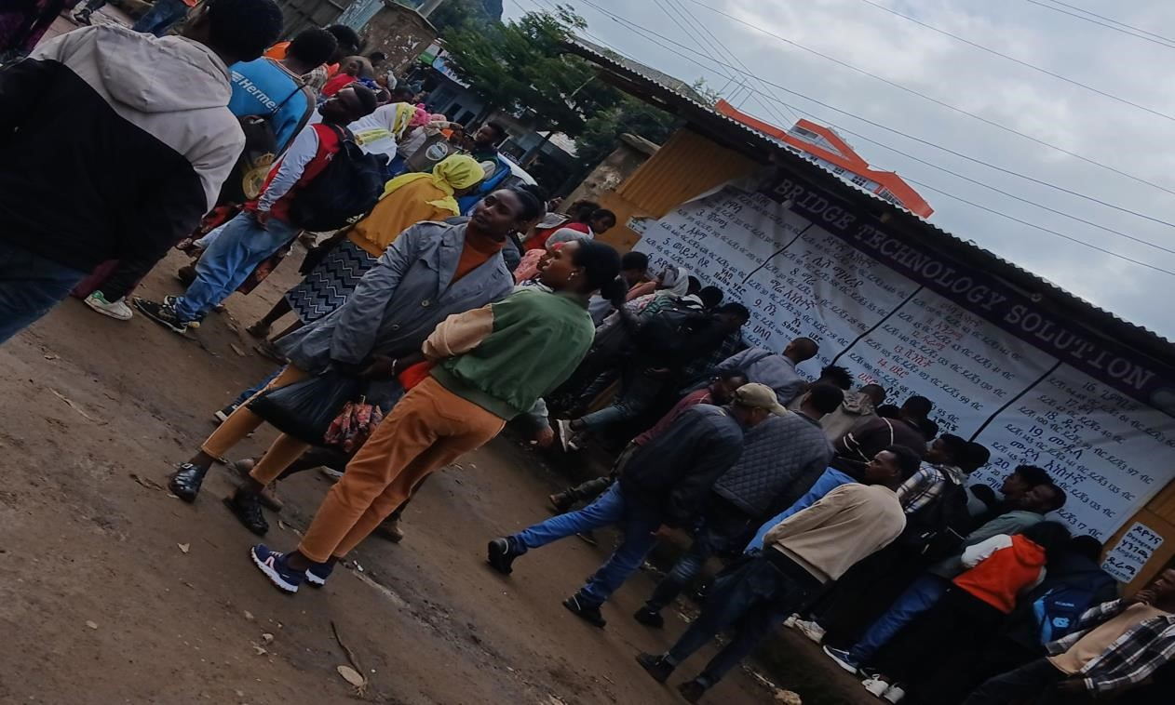
Figure 6:Route information (picture taken by researcher)

  - Security of passenger

Due to overcrowding at bus terminal passengers are most of the time vulnerable to pick pocketing and they lose their wallets and properties (Iles, 2005). Regarding to security of terminal, questions were forwarded to passengers to measure their level of satisfaction and result is analyzed as follows indicated by table and figure.

Table 6:Level of passenger’s satisfaction based on security of passengers in terminal
 | Frequency | Percent | Cumulative Percent
very satisfied | 11 | 13.75 | 13.75
Satisfied | 20 | 25 | 38.75
Average | 21 | 26.25 | 65
Dissatisfied | 22 | 27.50 | 92.50
Very dissatisfied | 6 | 7.50 | 100
Total | 80 | 100
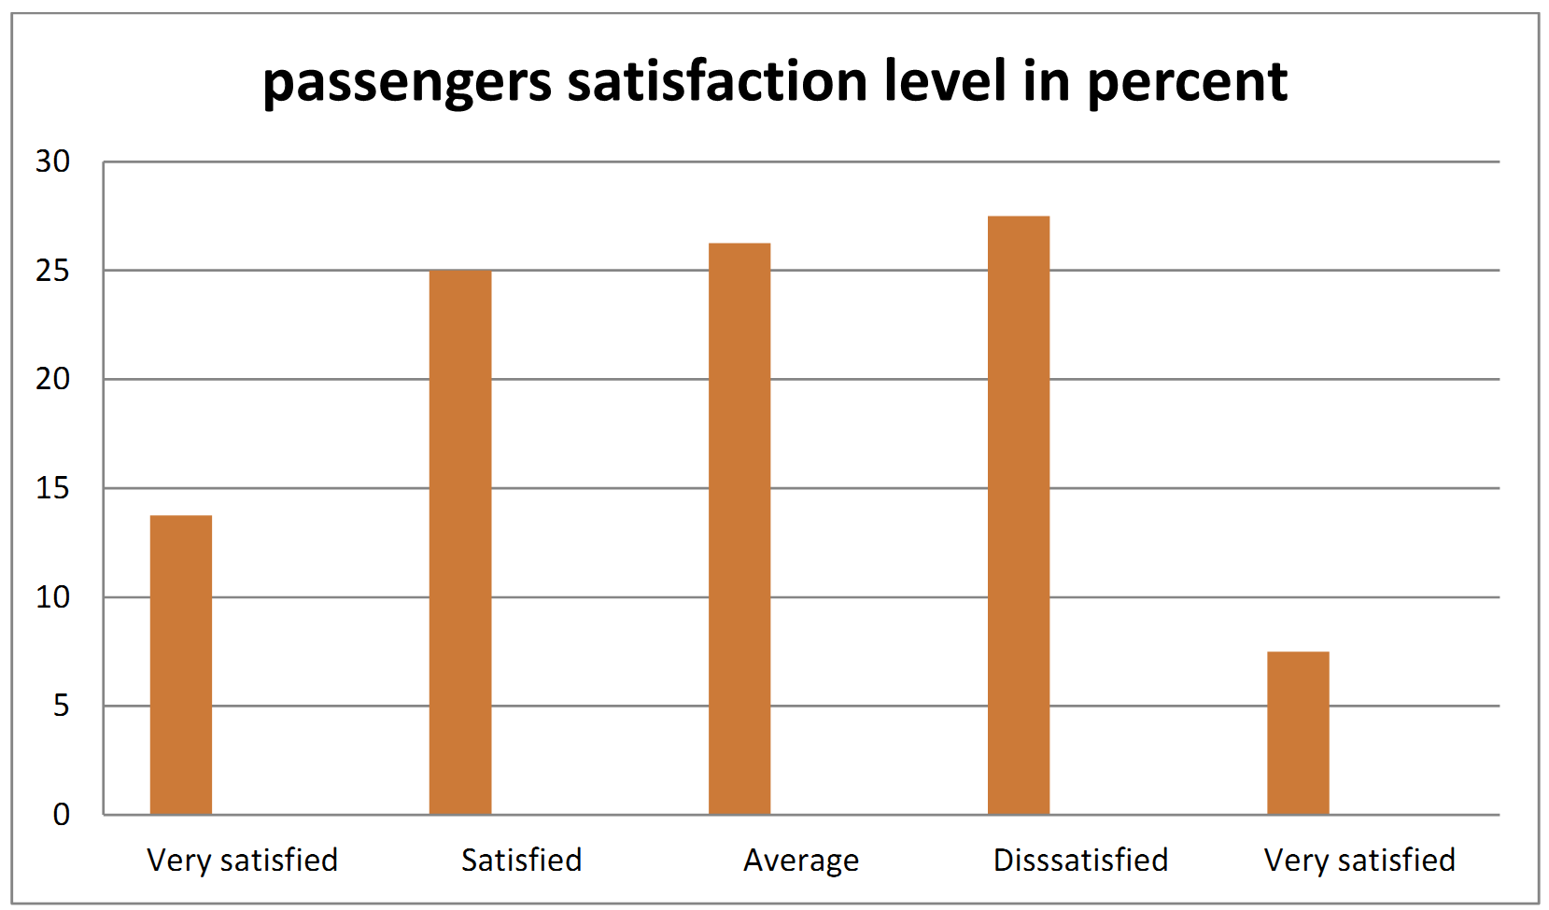
Figure 7:Passengers’ satisfaction about security from robbery in terminal

The above figure indicates that more than 41.75% of respondents are satisfied (13.75% very satisfied and 25% were satisfied) regarding to the availability security in the terminal. On the other hand, 35% of respondents are dissatisfied (7.50% very dissatisfied and 27.50% are dissatisfied). Remaining 23.25% of respondents have rated their level of satisfaction as average. From this data it could be possible to infer that there is a problem concerning security of passengers in terminal from robbery.
  - Comfort of passengers
For high comfort of passengers, good seats, cleanliness and shelters at bus terminal are some factors (Iles, 2005). To measure passenger’s satisfaction regarding comfort of the terminal questions were addressed to passengers and analyzed as follows.

A. Availability of Seat
Provision of seats at bus terminal is high priority item for elderly and ambulatory person with a disability. Standing for even short period proves to be uncomfortable, even painful and great impedes accessibility to terminal.

Table 7:Passengers’ level of satisfaction based on availability of seat for passengers in terminal
 | Frequency | Percent | Cumulative Percent
very satisfied | 5 | 6.25 | 6.25
Satisfied | 11 | 13.75 | 20
Average | 16 | 20 | 40
Dissatisfied | 25 | 31.25 | 71.25
Very dissatisfied | 23 | 28.75 | 100
Total | 80 | 100

0
5
10
15
20
25
30
35
Very satisfied
Satisfied
Average
Dissatisfied
Very satisfied
passenger satisfaction level in percent

Figure 8:Passengers’ level of satisfaction based on availability of seat for passengers in terminal

The above figure indicates that more than 60% of respondents are dissatisfied (28.75% very dissatisfied and 31.25% were dissatisfied) regarding to the availability seat in the terminal. On the other hand, 20% of respondents are satisfied (6.25% very satisfied and 13.75% are satisfied). Remaining 20% of respondents have rated their level of satisfaction as average.
The above data indicates that there is a problem concerning availability seats in the terminal. In addition to passenger’s response, the following also image from what researcher observe from study area. As we can see from image below, passengers were standing in order to wait for the vehicle going to their way.

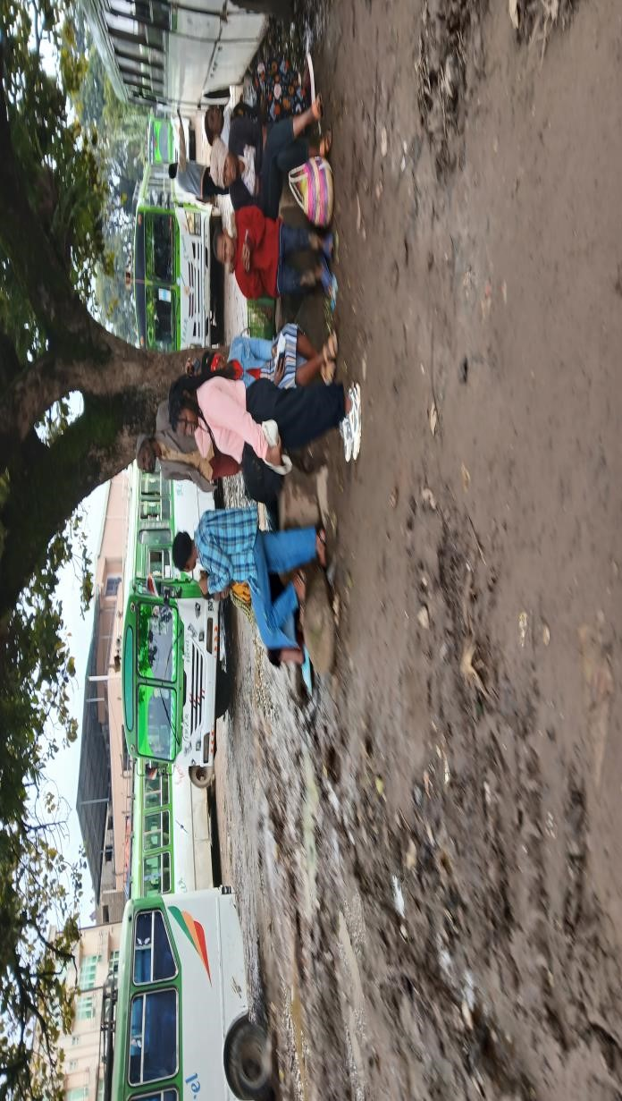
Figure 9:Image showing absence of seat for passengers (picture taken by researcher)

B. Cleanliness of terminal
Passengers were asked about their level of satisfaction concerning to cleanliness of the bus terminal and following result is found.
Table 8:Passenger’s satisfaction regarding to cleanliness of the terminal
 | Frequency | Percent | Cumulative Percent
very satisfied | 2 | 2.50 | 2.50
Satisfied | 13 | 16.25 | 18.75
Average | 16 | 20 | 38.75
Dissatisfied | 22 | 27.50 | 66.25
Very dissatisfied | 27 | 33.75 | 100
Total | 80 | 100

0
5
10
15
20
25
30
35
40
Very satisfied
Satisfied
Average
Dissatisfied
Very satisfied
passenger satisfaction in percent

Figure 10:Passenger’s satisfaction regarding cleanliness of terminal

The above figure indicates that more than 61.25% of respondents are dissatisfied (33.75% very dissatisfied and 27.50% were dissatisfied) regarding to cleanliness of bus terminal. On the other hand, 18.75% of respondents are satisfied (2.50% very satisfied and 16.25% are satisfied). Remaining 20% of respondents have rated their level of satisfaction as average. The above data indicates that the terminal is not clean. Even if toilet is available in the terminal, some of the people were not use the toilet they use space in the terminal other than the toilet based on researchers’ observation.
4.4 Remedial Solution to Problems
Based on the findings of the study the following recommendations are forwarded to improve mentioned problems according to specific objectives of this research.
Developed Model for Vehicle Assignment
To make number of vehicles supplied balance with number of passengers, linear regression model could be developed using software SPSS IBM version 21 for those 32 routes operate all day in a week. In order to analyze the model, the distance of the routes was classified according to trip per day as short, medium and long distance, i.e., <50km short, 51-142 medium and above 142km as long-distance route and summarize as follows. The road distance of research is from 18 km to 230 km and it is structured in to three parts according to the working model.

Table 9:Summary of daily vehicles and passenger’s distribution for short distance routes
Route | Existing scheduled No. vehicle | Average No. passenger. | No. seats per vehicle
Homecho | 21 | 1879 | 44
Moresito | 18 | 1628 | 44
Gimbichu | 20 | 1709 | 44
Gombora | 12 | 1269 | 44
Jajura | 18 | 1068 | 44
Lisana | 14 | 1181 | 44
Wasegebeta | 10 | 1081 | 44
Busiana | 16 | 1106 | 44
Jewe | 8 | 829 | 44
Doyogena | 16 | 216 | 12
Fonko | 16 | 270 | 12
Kosy | 14 | 433 | 44
Selela | 5 | 295 | 44
Geja | 2 | 257 | 44
Duna | 3 | 1998 | 44
Mare | 17 | 176 | 12
Lera | 11 | 133 | 12
Table 10:Summary of daily vehicles and passenger’s distribution for medium distance routes
Route | Existing scheduled No. vehicle | Average No. passenger. | No. seats per vehicle
Halaba | 6 | 553 | 44
Wolayita | 4 | 603 | 44
Durame | 3 | 452 | 44
Hadero | 4 | 528 | 44
Butajira | 22 | 478 | 12
Worabe | 17 | 240 | 12
Mazorya | 7 | 269 | 12
Wolkite | 18 | 486 | 12
Bonosa | 2 | 326 | 44

Table 11:Summary of daily vehicles and passenger’s distribution for long distance routes
Route | Existing scheduled No. vehicle | Average No. passenger. | No. seats per vehicle
Hawassa | 4 | 546 | 44
Addis Abeba | 6 | 1098 | 63
Adama | 2 | 176 | 44
Shashemene | 1 | 88 | 44
Jimma | 0 | - | 44

Then linear regression model is expressed in the form of, Y=α+β1x1 + β2X2+ β3X3 Where, Y represents number of vehicles should be assigned
X1 represents number of trips per day, X2 number of
Seat an X3 number of passengers α and β are constants displayed in above table
Therefore, Y= 16.7811+0.0053*pass-0.2358*seat was the equation developed for short distance routes according to this paper.
Table 12:Summary of proposed daily vehicles according to developed model for short distance route
Route | Existing scheduled No.veh | Averg  No.passen. | No.seats per vehicle | Predicted no. of vehicles
Homecho | 21 | 1879 | 44 | 16
Moresito | 18 | 1628 | 44 | 15
Gimbichu | 20 | 1709 | 44 | 15
Gombora | 12 | 1269 | 44 | 13
Jajura | 18 | 1068 | 44 | 12
Lisana | 14 | 1181 | 44 | 12
Wasegebeta | 10 | 1081 | 44 | 12
Busiana | 16 | 1106 | 44 | 12
Jewe | 8 | 829 | 44 | 10
Doyogena | 16 | 216 | 12 | 15
Fonko | 16 | 270 | 12 | 15
Kosy | 14 | 433 | 44 | 8
Selela | 5 | 295 | 44 | 7
Geja | 2 | 257 | 44 | 7
Duna | 3 | 1998 | 44 | 16
Mare | 17 | 176 | 12 | 14
Lera | 11 | 133 | 12 | 14

As observed in the results, there should be correction of vehicle assignment along some routes such as addition of vehicles needed for all routes. But it is clearly seen that vehicle assignment along route were not fair. and equation adjust such variation between the routes. Using the same procedure and insert the data for the rest table medium and the result seems as follows. Y=13.5565+0.0218*pass-0.4659*seat, equation developed for medium distance routes.
Y= 4.9725+0.007*pass-0.1054*seat, equation developed for long distance routes.

Table 13:: Summary of proposed daily vehicles according to developed model for Medium distance route
Route | Existing scheduled No. vehicle | Average  No. passenger. | No. seats per vehicle | Predicted no. of vehicles
Halaba | 6 | 553 | 44 | 5
Wolayita | 4 | 603 | 44 | 6
Durame | 3 | 452 | 44 | 2
Hadero | 4 | 528 | 44 | 4
Butajira | 22 | 478 | 12 | 18
Worabe | 17 | 240 | 12 | 13
Mazorya | 7 | 269 | 12 | 13
Wolkite | 18 | 486 | 12 | 18
Bonosa | 2 | 326 | 44 | 0

Table 14:: Summary of proposed daily vehicles according to developed model for long distance route
Route | Existing scheduled No. vehicle | Average  No. passenger. | No. seats per vehicle | Predicted no. of vehicles
Hawassa | 4 | 546 | 44 | 4
Addis Abeba | 6 | 1098 | 63 | 6
Adama | 2 | 176 | 44 | 1
Shashemene | 1 | 88 | 44 | 0
Jimma | 0 | - | 44 | 0
Based on the above table, adjustment of vehicle assignment along Addis Abeba route is observed based on the equation developed. Finally, when the above data is combined, it seems as follows.
No. | Destination | No. Veh.Assigend | No. Predicted Vehicle | Difference
1 | Homecho | 21 | 16 | 5
2 | Moresito | 18 | 15 | 3
3 | Ginbichu | 20 | 15 | 5
4 | Gombora | 12 | 13 | -1
5 | Jajura | 18 | 12 | 6
6 | Lisana | 14 | 12 | 2
7 | Wasegebeta | 10 | 12 | -2
8 | Busiana | 16 | 12 | 4
9 | Jewy | 8 | 10 | -2
10 | Doyogena | 16 | 15 | 1
11 | Fonko | 16 | 15 | 1
12 | Kosy | 14 | 8 | 6
13 | Selela | 5 | 7 | -2
14 | Geja | 2 | 7 | -5
15 | Duna | 3 | 16 | -13
16 | Mary | 17 | 14 | 3
17 | Lera | 11 | 14 | -3
18 | Halaba | 6 | 5 | 1
16 | Wlyeta | 4 | 6 | -2
20 | Durame | 3 | 2 | 1
21 | Hadero | 4 | 4 | 0
22 | Butajira | 22 | 18 | 4
23 | Worabe | 17 | 13 | 4
24 | Mazorya | 7 | 13 | -6
25 | Wolkite | 18 | 18 | 0
26 | Bonosa | 2 | 0 | 2
27 | Hawassa | 4 | 4 | 0
28 | Addis Abeba | 6 | 6 | 0
29 | Adama | 2 | 1 | 1
30 | Shashemene | 1 | 0 | 1
31 | Jemma | 0 | 0 | 0
32 | Wulbareg | 10 | 8 | 2
Total |  | 327 | 308

4.5 Solution to Problems Related to Service Given in Terminal
In order to improve problems identified in the terminal that passengers feel dissatisfied the following recommendation is stated.
- In order to avoid problems related to shortage of vehicles, terminal can follow the above model to assign sufficient number of vehicles for the routes.
- To improve problems related to availability of route information, the terminal should mount symbol in front of each routes to indicate vehicles going on that way rather than calling passengers one by one. In addition, the arrangements of vehicles standing should be sequential rather than they stand in the terminal here and there in order to be easily accessible for all and to make passengers use their time instead of wasting their time on searching the vehicle go to their way. Generally, modifying internal arrangement of the bus terminal as follows will improve mentioned problem. And there should be adequate provision of space within the site, for parking, maneuvering, loading and unloading to fulfil the operational requirements. (www.doeni.gov.uk).

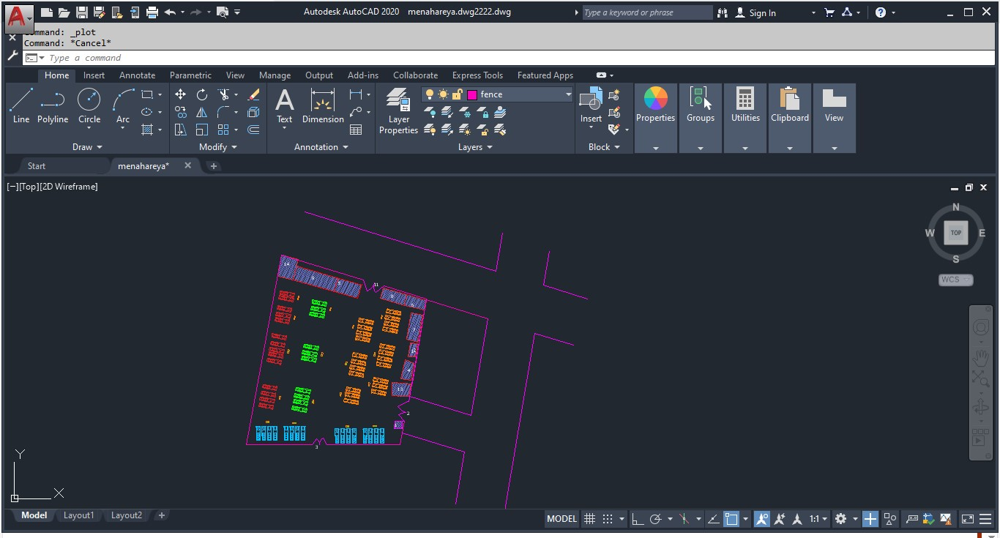
Figure 11: Recommended future layout of the area Description

- Guarder room
- Entrance gate for vehicle only
- Entrance gate for only passengers
- Mini media
- Routes information board
- Café
- Administration office
- Ticketing area
- Shelter
- Board indicating vehicles way
- Exit for vehicles
- Vehicle registration area
- Toilet
- Guarder room

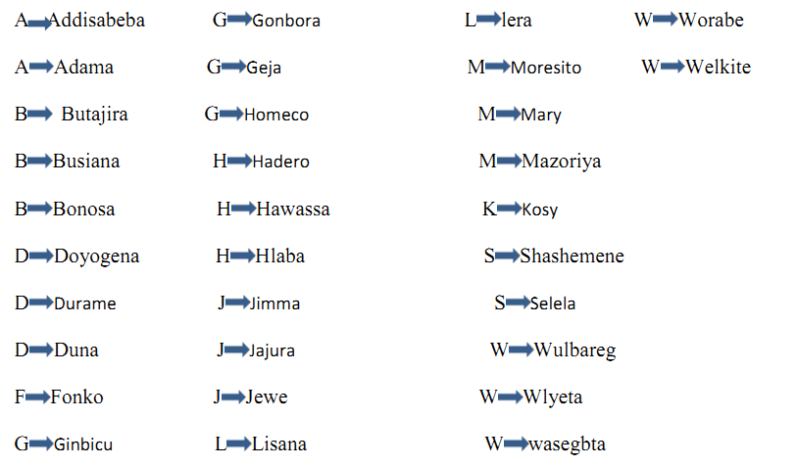
- To keep passengers secure, bus terminal should have good light specially morning at opening time, the level of overcrowding should be considered while terminal operates and conductor should have made passengers aware to keep themselves from thief, worker of the terminal should have identified from others by wearing uniform.
- To improve problem related to comfort, adequate seating capacity should be built at bus terminal under prepared shelter in the terminal, so that they can wait for the vehicle and the comfort can be improved.

Conclusion and Recommendation
- Conclusion

This research has assessed transport terminal operation with respect to vehicle assignment and passenger’s Perspectives at Hossana bus terminal. The study was mainly focus on investigating proportionality of vehicle assignment throughout the routes. The desk study data indicates, there was variation in vehicle assignment to the routes. For instance, average number of passengers travel along Addis Abeba was 1098, but vehicles assigned for Addis Abeba from the terminal were 6 and average numbers of passenger per day along Duna route were 1998, but there was no existing number of vehicles in monthly schedule of the terminal. This indicates that as there is no proportional assignment of vehicles throughout the routes. Therefore, from linear regression result the equation developed to get uniform distribution of vehicles, Y=16.7811+0.0053*pass-0.2358*seat, for routes categorized under short distance routes, Y=13.5565+0.0218*pass-0.4659seat, for medium distance routes and Y=4.9725+0.007*pass-0.1054*seat for long distance routes based on this thesis.

The most common problems related to transport service given to passengers and assess their level of satisfaction were, based on the availability of sufficient number of vehicles, availability of route information board in the terminal, security in the terminal and comfort of the terminal regarding to availability of seat in the terminal under shelter and cleanliness of the terminal. From the problems identified, respondents were asked about their level of satisfaction and agreement and based on availability of sufficient vehicles, 35% of them were satisfied, 15% dissatisfied and 25% were in between. Regarding to availability of route information board in the area, 17.50% were satisfied, 28.75% were dissatisfied and 26.25 of them were having average level of satisfaction. Based on security of the terminal 25% of passengers were satisfied, 27.50 % were dissatisfied and 26.25% of them have average level of satisfaction. Finally, regarding to comfort of terminal, concerning to availability of seat in terminal under shelter 13.75% of passengers were satisfied, 31.25% of them were dissatisfied and 20% of them were averagely satisfied and regarding to cleanliness of the terminal, 16.25% of them were satisfied, and 27.50% of them were dissatisfied and 20% of them were in average with cleanliness of the terminal.

- Recommendations

As demonstrated in the findings of the study the following recommendations are forwarded to improve mentioned problems in the terminal.
- There should be internal facilities in the terminal such as seats, light; route information board and daily clean the terminal.
- Vehicle assignment / distribution shall better if it is based on interest of passengers and depending on frequently used routes rather than owner’s interest.
- Terminal management team should prepare comment box for users in the terminal.
- Also it is better if there is included in monthly schedule for those all routes except Addis Abeba, Hadero, Wolkite and Hawasa as in addition.

DECLARATION STATEMENT

After aggregating input from all authors, I must verify the accuracy of the following information as the article's author.
▪ Conflicts of Interest/ Competing Interests: Based on my understanding, this article has no conflicts of interest.
▪ Funding Support: This article has not been funded by any organizations or agencies. This independence ensures
that the research is conducted with objectivity and without any external influence.
▪ Ethical Approval and Consent to Participate: The content of this article does not necessitate ethical approval or consent to participate with supporting documentation.
▪ Data Access Statement and Material Availability: The adequate resources of this article are publicly accessible.
The data and materials used for analysis in this manuscript are available at the corresponding author. It is possible to reasonably request the corresponding author. Also, all secondary and primary data used for the research are available in the hands of researchers.
Authors Contributions: Each author has individually contributed to the article. Sintayehu Alemayehu contributed by conducting research and writing the manuscript and contributed by, arranging, organizing, and directing the manuscript's full write-up. Tariku Kebede Tofu, Adamu Dessalegn Taddesse contributed to editing the manuscript. Thus, all authors reviewed the results and agreed on the final version of the manuscript.

References

[1]. Currie, G. (2004). Gap analysis of public transport needs: measuring spatial distribution of public transport needs and identifying gaps in the quality of public transport provision. Transportation Research Record, 1895(1), 137–146.
[2]. Hanson, S. (2004). The context of urban travel. The Geography of Urban Transportation, 3–29.
[3]. Codina, E., Marín, A., & López, F. (2013). A model for setting services on auxiliary bus lines under congestion. Top, 21, 48–83.
[4]. Malkoç, S. (2023). Fuzzy Logic Modelling of Route Choice in a Transportation Network. University of Twente.
[5]. Gutiérrez, J. (2009). Transport and Accessibility. International Encyclopedia of Human Geography: Volume 1-12, 1–12, V11-410-V11-417. https://doi.org/10.1016/B978-008044910-4.01030-0
[6]. Hosanna Town Finance and Economic Development Office. (2018). Socio-economic profile of Hossana Town.

