RESEARCH ARTICLE
FORMULATION AND EVALUATION OF HERBAL CREAM FOR SUPPORTING SKIN HEALTH AND CIRCADIAN BALANCE

ABSTRACT
In recent days, every person is facing a major problem with Insomnia, Stress, mental disturbance, dryness and sleep disturbances. So, Herbal-based topical formulations are increasingly preferred due to their safety profile and therapeutic effectiveness. Cedarwood oil possesses notable soothing and calming effects, Anti-inflammatory activity, Antioxidant activity, and Moisturising/supportive effect, whereas Chamomile oil is recognised for its stress reduction and nervous system relaxation, skin smoothing and healing activity, antioxidant activity, sedative and anxiolytic Activity.
The present work focuses on the development and evaluation of a Herbal Cream prepared using essential oils of Cedarwood oil and Chamomile oil by using the fusion method. The cream Base was formulated using Olive oil, stearic acid, cetyl alcohol and Emulsifying wax. The main aim was to create a stable, skin-compatible herbal cream with possible dermatological activity. METHOD: In our present study, we formulated 4 different formulations, F1, F2, F3, F4, by including different concentrations of liquid oil phase and water-based and evaluated by using various parameters such as physical appearance, viscosity, pH, phase separation, Spreadability, Stability studies, Irritability, wash ability, and got desirable results with all the tests. RESULTS: Among the four formulations (F1, F2, F3 and F4), the formulation F3 was having Pleasant Odour, Off-white in color, non-irritant to the skin and Stable. Also, the formulations F1, F3 and F4 showed no redness or edema or erythema and irritation during irritancy studies. Conclusion: The formulated herbal cream showed acceptable physical properties, stability, and good skin compatibility during evaluation. The combination of natural ingredients demonstrated supportive antioxidant, soothing, and skin-protective effects that may help maintain healthy skin and support skin circadian rhythm.
Keywords: Herbal Cream, Circadian Rhythm, Cedarwood Oil, Chamomile Oil, Peppermint Oil, Essential Oils, W/O Emulsion, Stability Study, Topical Formulation.
INTRODUCTION
Circadian rhythm refers to the natural 24-hour biological cycle that regulates various physiological, mental, and behavioral functions in living organisms. It is commonly known as the “body clock” and is mainly controlled by environmental cues such as light and darkness [1]. Circadian rhythms play an important role in regulating sleep–wake cycles, hormone secretion, digestion, metabolism, body temperature, and mood. The term “circadian” is derived from the Latin words circa meaning “about” and diem meaning “day”. In humans, the circadian rhythm is controlled by the supra chiasmatic nucleus (SCN), a group of neurons located in the hypothalamus of the brain. The SCN acts as the body’s biological clock and responds to light signals received from the retina. During the daytime, exposure to light suppresses melatonin secretion and promotes alertness, whereas darkness stimulates melatonin production by the pineal gland, helping to induce sleep. This coordinated regulation maintains a stable sleep–wake cycle and supports overall physiological balance [2].
Circadian rhythms are essential for maintaining normal health and well-being. Modern lifestyle factors such as artificial lighting, excessive screen exposure, irregular sleep schedules, shift work, stress, and late-night eating can disturb the body’s internal clock. Such disruptions may lead to various health problems including insomnia, obesity, diabetes, cardiovascular diseases, mood disorders, weakened immunity, and fatigue. Therefore, maintaining a healthy circadian rhythm is important for both physical and mental health. The circadian rhythm also influences daily patterns of alertness and performance. Melatonin secretion usually stops in the early morning, increasing alertness and preparing the body for daytime activities. Cognitive performance is highest during late morning hours, while physical performance peaks in the late afternoon. At night, melatonin secretion increases again, preparing the body for restorative sleep.
Importance of Circadian Rhythm in Human Health [4]
- Circadian rhythm is a natural biological cycle that regulates body functions over 24 hours.
- It helps control the sleep–wake cycle and maintains proper timing of daily activities.
- Circadian rhythm regulates the secretion of hormones such as melatonin and cortisol.
- It plays an important role in metabolism, digestion, appetite, and energy balance.
- Body temperature and alertness levels are also influenced by circadian rhythm.
- Disturbance in circadian rhythm may cause fatigue, stress, poor concentration, and mood changes.
- Long-term disruption may increase the risk of insomnia, obesity, diabetes, and cardiovascular disorders.
Mechanism of Circadian Rhythm Regulation [5]
- Circadian rhythm is mainly controlled by the Suprachiasmatic Nucleus (SCN) present in the hypothalamus of the brain.
- It receives light signals from the eyes and synchronizes body functions with day and night cycles.
- Exposure to sunlight during the day helps maintain alertness and normal body activities. During darkness, the pineal gland secretes the melatonin hormone.
- Melatonin is known as the “sleep hormone” because it promotes relaxation and sleep.
- Artificial light and screen exposure at night can suppress melatonin production.
- Proper coordination of SCN, light exposure, and melatonin helps maintain a balanced circadian rhythm.
Relationship Between Skin and Circadian Rhythm [6]
The skin has its own biological clock that follows the body’s circadian rhythm. This rhythm helps the skin adapt to changing environmental conditions during the day and night. The circadian clock is regulated by the suprachiasmatic nucleus (SCN) located in the hypothalamus, which receives light signals and synchronizes peripheral tissues, including the skin. Through this mechanism, the skin performs different physiological activities during daytime and night time to maintain skin health and protection.
The skin acts as the body’s first protective barrier and contains specialized structures such as hair follicles, sweat glands, and multiple cell layers that help prevent water loss, provide tactile sensation, and support hormone synthesis. Because environmental conditions continuously change, the skin has developed adaptive mechanisms that allow it to respond according to circadian signals [7]. Circadian variation affects several dermatological functions. During the daytime, the skin generally shows increased thickness, higher sebum production, elevated pH, and lower blood flow, which help protect the skin from environmental stressors such as ultraviolet radiation and pollution. At night, skin permeability and blood flow increase, while barrier recovery and repair activities become more active. However, moisture loss from the skin also increases during night time. These changes indicate that the skin undergoes repair and regeneration processes mainly during sleep. Disruption of the skin’s circadian rhythm can negatively affect skin health and contribute to the development of several skin problems such as hyperpigmentation, wrinkles, dullness, dryness, inflammation, premature ageing, and reduced barrier function. Factors such as irregular sleep, stress, excessive screen exposure, pollution, and ultraviolet radiation can disturb the natural rhythm of the skin and impair its normal physiological activities.
“Maintaining skin health according to circadian rhythm has become an important approach in topical skincare research. Herbal creams containing essential oils and natural bioactive compounds may support hydration, barrier repair, antioxidant protection, and soothing effects during the skin’s repair cycle. Therefore, formulation of a herbal cream for supporting skin health and circadian balance may provide a safe and natural therapeutic approach” [8].
Night-Time Skin Repair Cycle
- Cell renewal increases during sleep.
- Collagen synthesis becomes more active at night.
- Skin permeability increases at night.
- Transepidermal water loss may increase, so moisturization becomes important.
- Night-time repair helps maintain healthy skin barrier function.
REVIEW OF THE LITERATURE
A literature survey on the proposed topic was conducted by referring to various scientific journals, both online and offline, as well as different textbooks available in the college library. This survey found that no comparable items have been published on the proposed work, but a few related topics are listed below.
Sushmitha Bharadwaj H. G. (2025) et al. The article reviews the importance of circadian rhythm in maintaining physical and mental health by combining modern scientific evidence with Ayurvedic principles. It explains that proper daily routines (Dinacharya), healthy sleep habits, timely food intake, physical activity, and seasonal adjustments (Ritucharya) help regulate hormones, metabolism, and sleep quality. The review highlights that sunlight exposure, meal timing, relaxation practices like meditation and massage, and nutrient-rich foods support better circadian balance. Overall, the article shows that both Ayurveda and modern chronobiology emphasize lifestyle regulation for improving health, though further clinical research is needed to validate some traditional practices.
Samithambe Senthilnathan et al. The study by Senthilnathan and Sathiyasegar explains that circadian rhythm is the body’s internal biological clock that regulates physiological and behavioural functions in a 24-hour cycle, including sleep-wake patterns, metabolism, body temperature, and hormone release. The authors highlighted that maintaining a healthy circadian rhythm is essential for overall physical and mental well-being, while disruption may lead to health issues such as obesity, diabetes, depression, and sleep disorders. Factors like exposure to light, meal timing, physical activity, and regular sleeping habits play an important role in regulating circadian rhythm. The review concludes that a balanced circadian rhythm supports healthy body functioning and improved quality of life.
Sara Diogo Gonçalves (2025) et al. Cedarwood essential oil has been widely studied for its biological and therapeutic properties. Research shows that it contains active compounds such as cedrol, α-cedrene, β-cedrene, thujopsene, and widdrol, which contribute to its medicinal effects. Studies suggest that cedarwood oil has antimicrobial, antifungal, anti-inflammatory, antioxidant, and insecticidal properties. It is also used in aromatherapy, skincare, wound healing, and stress relief. However, the chemical composition varies among cedar species, affecting safety and effectiveness. Most existing studies are based on laboratory and animal research, while human clinical studies are still limited. Therefore, further research is needed to confirm its therapeutic potential and safety.
Sachin Aglawe (2020) et al. Chamomile oil has been extensively studied for its medicinal and therapeutic properties. Research shows that chamomile oil contains important bioactive compounds such as chamazulene, bisabolol, apigenin, quercetin, and luteolin, which contribute to its pharmacological effects. Studies indicate that chamomile oil has anti-inflammatory, antioxidant, antimicrobial, antiseptic, antispasmodic, and sedative properties. It is widely used in treating skin disorders, wounds, digestive problems, anxiety, insomnia, menstrual pain, and inflammation. Chamomile oil is also commonly applied in aromatherapy and cosmetic products because of its soothing effects. However, some studies report allergic reactions and side effects in sensitive individuals, especially those allergic to plants of the Asteraceae family. Overall, literature suggests that chamomile oil has strong therapeutic potential, but further clinical studies are needed to confirm its safety and effectiveness in humans.
Sanjay Choudhary (2024) et al. Skin follows a circadian rhythm, a 24-hour biological cycle that regulates functions such as hydration, barrier repair, sebum production, and cell regeneration. These changes help the skin adapt to day and night conditions. During the day, skin focuses on protection, while at night, repair and regeneration are more active.Research shows that disruption of the skin's circadian rhythm can lead to premature ageing, dryness, wrinkles, hyperpigmentation, and weakened barrier function. Proper skincare routines, including day and night creams with ingredients like Vitamin C, Vitamin E, and hyaluronic acid, may help support skin health and improve hydration and repair. Overall, maintaining skin circadian rhythm is important for healthy skin function and appearance.
Anupam Kr Sachan (2013) et al. According to Sachan et al. (2013), Peppermint Oil (Aetheroleum Menthae Piperitae) is an essential oil extracted via steam distillation from Mentha x piperita L. (Lamiaceae), primarily composed of the monoterpene menthol (30–55%) and menthone (14–32%). Pharmacologically, it acts as a calcium antagonist to provide dose-dependent antispasmodic and smooth muscle relaxant effects, making it clinically useful for treating irritable bowel syndrome (IBS), digestive disorders, flatulence, and postoperative nausea. Furthermore, the oil displays a robust in vitro antimicrobial spectrum against pathogens like Staphylococcus aureus and Escherichia coli, alongside a significant antiplasmid activity capable of eliminating bacterial resistance plasmids to help overcome multidrug resistance. From a quality control standpoint, this pungent, skin-cooling liquid must adhere to strict standards—including a relative density of 0.900–0.916 and a maximum acid value of 1.5—and must be stored in a tightly-closed, light-resistant container.
RESEARCH GAP
Although various topical cosmetic and pharmaceutical creams are available for skin care, limited herbal formulations are specifically designed to support skin health and the natural skin circadian cycle. Therefore, the present study focuses on the formulation and evaluation of a herbal cream containing essential oils to improve hydration, stability, skin compatibility, and support skin circadian balance.

DRUG PROFILE
- Cedarwood oil [9]
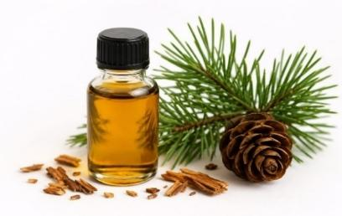
Figure No2: Cedarwood oil
- TAXONOMICAL CLASSIFICATION
Kingdom: Plantae
Family: Pinaceae / Cupressaceae
Genus: Cedrus / Juniperus
Species: Cedrus deodara, Juniperus virginiana, Cedrus atlantica
Synonym: Himalayan Cedar Oil, Deodar Cedar Oil
- Biological source: It consists of volatile oil obtained by steam distillation from the wood of Cedrus deodara and related species belongs to the Family Pinaceae.
- Geographical Source:
Cedarwood trees are native to the Himalayan regions, North Africa, and North America. Major producers include India, Morocco, the USA, and China.
- Macroscopic Characters:
- Colour: Pale yellow
- Odour: Woody and balsamic
- Appearance: Oily liquid
- Cultivation & Collection:
Cedarwood trees grow well in temperate and mountainous climates. They require well-drained soil and moderate rainfall. The trees are propagated by seeds and take many years to mature. The wood is collected from mature trees and subjected to steam distillation to obtain cedarwood oil.
- Chemical constituents: Cedrol (16-25%), Cedrene (20-35%), Thujopsene (10-25%)
- Pharmacological Activities:
    - Sleep-Promoting Activity: Cedarwood oil exhibits mild sedative activity primarily due to cedrol. Mechanism: Cedrol influences the autonomic nervous system, Produces calming effects on brain activity, Helps reduce hyperactivity and nervous tension.
    - Anxiolytic and Stress-Reducing Activity: Cedarwood oil helps reduce emotional stress and anxiety. Effects: Reduces nervous agitation, Promotes emotional balance, Produces grounding psychological effects
    - Anti-Inflammatory Activity: Cedarwood oil possesses significant anti-inflammatory properties. Mechanism: Reduces inflammatory mediators, Decreases skin redness and swelling, Soothes irritated tissues
    - Antioxidant Activity: Cedarwood oil contains sesquiterpenes with antioxidant potential. Functions: Neutralizes free radicals, Protects skin cells, Reduces oxidative damage
    - Skin Soothing and Sebum-Regulating Activity: Balance skin oil production , Reduce itching, Improve skin texture
- Chamomile oil [10]
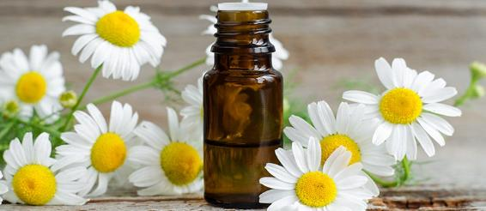
Figure 3: Chamomile oil
- TAXONOMICAL CLASSIFICATION
Kingdom: Plantae
Family: Asteraceae
Genus: Matricaria / Chamaemelum
Species: Matricaria chamomilla, Chamaemelum nobile
Synonym: German Chamomile oil, Blue Chamomile oil, Matricaria oil, Chamomile oil.
Biological source: It is obtained by steam distillation of the fresh or dried flower heads of Matricaria chamomilla Linn, which belongs to the Family Asteraceae.
- Geographical Source:
Chamomile is native to Europe and Western Asia. It is widely cultivated in Germany, Hungary, Egypt, France, and India.
- Macroscopic Characters:
- Colour: Deep blue to greenish blue
- Odour: Sweet and fruity
- Appearance: Volatile oily liquid
- Cultivation & Collection:
Chamomile grows well in temperate climates with well-drained sandy soil. It is propagated through seeds. Flower heads are harvested during the blooming season and dried. The oil is extracted mainly by steam distillation.
- Chemical constituents:- Bisabolol (10-25%), Bisabolol Oxide A&B (25-50%), Chamazulene (1-15%)
- Pharmacological Activities [11]:
  - Sedative and Anxiolytic Activity: Chamomile oil possesses mild sedative properties mainly due to apigenin and volatile terpenes. Mechanism: Apigenin binds to benzodiazepine receptors in the brain, Produces calming effects on the nervous system, Reduces mental stress and anxiety.
  - Anti-inflammatory Activity: Chamomile oil strongly inhibits inflammatory mediators. Mechanism: Suppresses prostaglandins and cytokines, Reduces skin irritation and redness.
  - Antioxidant Activity: Chamomile oil contains flavonoids and terpenoids with strong antioxidant potential. Functions: Neutralizes free radicals, Prevents oxidative stress, Protects skin cells from damage
  - Skin Soothing and Healing Activity: Chamomile oil accelerates skin repair. Pharmacological Effects: Enhances epithelial regeneration, Promotes wound healing, Moisturizes dry skin, Reduces itching.
  - Stress Reduction and Nervous System Relaxation: Psychological stress is one of the major causes of circadian rhythm disruption. Chamomile oil: Reduces cortisol-associated stress, Promotes parasympathetic relaxation, Enhances emotional calmness.
PHYTOCHEMICAL EVALUATION [12]
- Test for Flavonoids
Table 1: Test for flavonoid
SR. NO | TEST | OBSERVATION | INFERENCE OF CEDARWOOD OIL | INFERENCE OF CHAMOMILE OIL
1 | Alkaline Reagent Test  To 1ml of oil extract, add 0.5ml of 10% NaOH + a few drops of dilute HCL.  The yellow colour disappears after acid addition | The yellow colour disappears after the addition in both samples | Flavonoids present | Flavonoids present
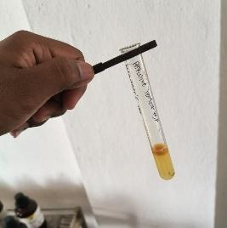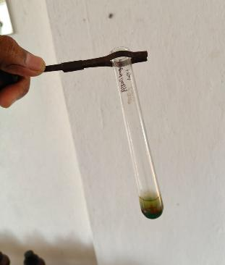
Figure 4: Alkaline Reagent Test for Cedarwood oil Figure 5: Alkaline Reagent Test for Chamomile Oil
- Test for Alkaloids
Table 2: Test for Alkaloids
SR. NO | TEST | OBSERVATION | INFERENCE OF CEDARWOOD OIL | INFERENCE OF CHAMOMILE OIL
1 | Mayer’s test  To a 1ml of oil extract add few drops of Mayer’s reagent are added. Cream, Pale yellow colour obtained. | No pale-yellow colour observed in both samples | Alkaloids Absent | Alkaloids Absent
2 | Dragendroff’s test  To a 1ml of oil extract, a few drops of Dragendorff’s reagent is added. Obtain yellow ppt | No yellow ppt observed in both samples | Alkaloids Absent | Alkaloids Absent
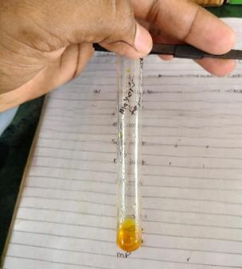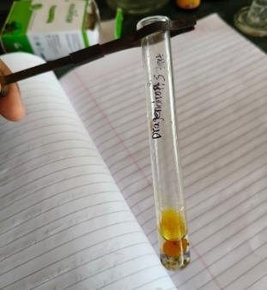
Figure 6: Mayar's test for Cedarwood oil Figure 7: Dragendroff’s test for cedarwood oil
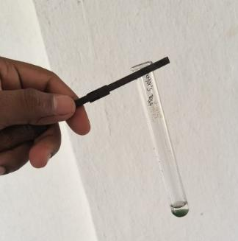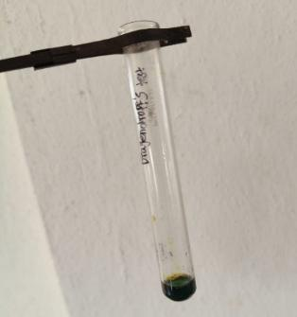
Figure 8: Mayar's test for chamomile oil Figure 9: Dragendroff’s test for chamomile oil
- Test for Phenolic Compound
Table 3: Test for Phenolic compound
SR. NO. | TEST | OBSERVATION | INFERENCE OF CEDARWOOD OIL | INFERENCE OF CHAMOMILE OIL
1. | Ferric Chloride Test  To 1ml of essential oil, add few drops of 5% Fecl3 solution. Green/blue/violet colouration | Green/blue colouration in Chamomile oil and no colour change in Cedarwood oil extract sample | Phenolic compound absent | Phenolic compound present
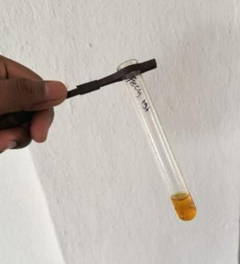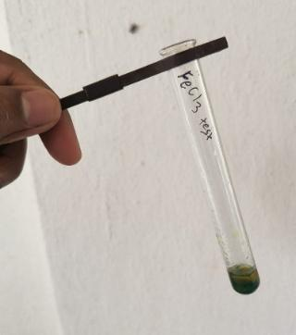
Figure 10: Ferric Chloride Test for cedarwood oil Figure 11: Ferric Chloride Test for chamomile oil
- Test for Saponin
Table 4: Test for saponin
SR. NO | TEST | OBSERVATION | INFERENCE OF CEDARWOOD OIL | INFERENCE OF CHAMOMILE OIL
1 | Shake the drug powder with water. stable foam formation. | Formation of stable foam with both samples | Saponins present | Saponins present
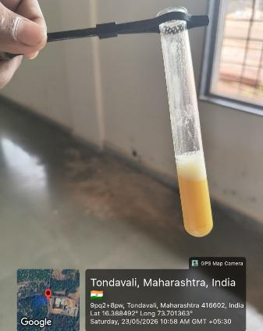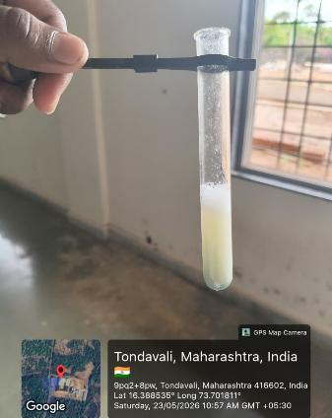
Figure 12: Test for Saponin for cedarwood oil Figure 13: Test for Saponin of chamomile oil
- Test for Terpenoids
Table 5: Test for Terpenoids
SR. NO | TEST | OBSERVATION | INFERENCE OF CEDARWOOD OIL | INFERENCE OF CHAMOMILE OIL
1. | Salkowski test  To 1ml of oil extract, add 1ml chloroform + 0.5ml concentrated H2SO4.  Reddish-brown ring at the interface | A Reddish-brown ring at the interface in both samples | Terpenoids present | Terpenoids present
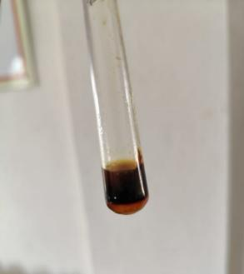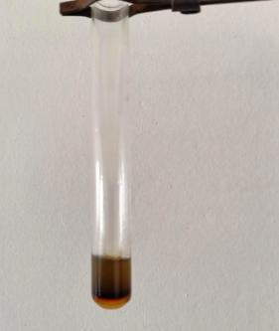
Figure 14: Salkowski test for cedarwood oil Figure 15: Salkowski test for chamomile oil

MATERIALS & METHODS
Materials: List of all ingredients with quantity
Table 6: Formulation table
Sr no. | Ingredients | F1 | F2 | F3 | F4 | Role of Ingredients
 | API’s
1. | Cedarwood oil | 0.3gm | 0.3gm | 0.3gm | 0.3gm | API- Relaxing & calming effect
2. | Chamomile oil | 0.3gm | 0.3gm | 0.3gm | 0.3gm | API- Smoothing & anti-inflammatry effect
 | Oil Phase
3. | Olive oil | 5gm | 7gm | 9gm | 7gm | Emollient & moisturizer
4. | Stearic acid | 1.5gm | 2gm | 2.5gm | 2gm | Thickening agent & consistency agent
5. | Cetyl alcohol | 0.8gm | 1gm | 1.2gm | 1gm | Co-emulsifier
6. | Emulsifying wax | 1.5gm | 2gm | 2.5gm | 3gm | Emulsifying agent
 | Aqueous Phase
7. | Dist. Water | 25.5gm | 22.8gm | 20gm | 22.3gm | Aqueous vehicle/Base
8. | Glycerin | 4gm | 4gm | 4gm | 4gm | Humactant
9. | Metyl paraben | 0.01gm | 0.01gm | 0.01gm | 0.01gm | Antimicrobial preservative
10. | Propyl paraben | 0.05gm | 0.05gm | 0.05gm | 0.05gm | Preservative
11. | Peppermint oil | 0.4gm | 0.5gm | 0.6gm | 0.5gm | Cooling sensation & fragrance agent

FORMULATION EVALUATION (F1 – F4):
- F1 (Low oil- Light cream): Decreased the oil phase, made the formulation a light texture, less greasy and more easily absorbed on skin. But it caused less moisturization and lower spreadability.
- F2 (Actual Formula): This batch represents the optimized formulation. It provides good balanced consistency, good moisturization, proper spreadability, and stable cream.
- F3 (High oil- Thick cream): Increased amount of olive oil made the formulation better moisturization, smoother feel. But it caused a more greasy, heavy texture and slower absorption.
- F4 (High Emulsifier):An increased amount of emulsifier made the formulation have better emulsion stability, smoother texture, and reduced phase separation. But it becomes thick/sticky, may reduce spreadability and possibly cause skin irritation if there is excess emulsifier.
METHOD: Method Used for Preparation: Fusion Method (Hot Process)
Procedure:
- Weighing of Ingredients: All required ingredients were weighed accurately using a weighing balance.
- Preparation of Oil Phase: The oil phase, consisting of Olive oil, stearic acid, cetyl alcohol, and Emulsifying wax was taken in a clean beaker and heated at 70–75°C on a water bath until completely melted.
- Preparation of Aqueous Phase: In another beaker, an aqueous phase containing distilled water, glycerin, methyl paraben, and propyl paraben was prepared and heated to the same temperature (70–75°C).
- Emulsification: The hot aqueous phase was added slowly into the oil phase with continuous stirring using a glass rod. Stirring continuously until a smooth and uniform cream base was formed.
- Final Processing and Packaging: Then Cedarwood oil, chamomile oil and peppermint oil were added during the cooling stage (35-40°c) and mixed properly to obtain uniform distribution. Finally, prepared circadian rhythm support cream was transferred into suitable airtight containers and stored in a cool and dry place.
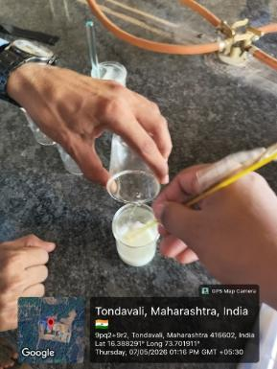
Figure 16 Fusion Method
Method of Application

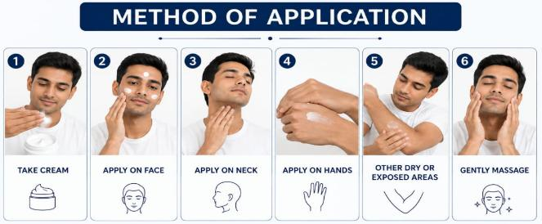

Figure 17: Method of Application
EVALUATION PARAMETERS OF CREAM [13]
- Physical Evaluation: The prepared formulations were inspected visually for their colour, odour, state, homogeneity and consistency.
Table 7: Physical Evaluation
Sr. no. | Parameter | F1 | F2 | F3 | F4
1. | Colour | Off-white | Off-white | Off-white | Off-white
2. | Odour | Pleasant | Pleasant | Pleasant | Pleasant
3. | State | Semisolid | Semisolid | Semisolid | Semisolid
4. | Consistency | Smooth/Uniform | Smooth/Uniform | Smooth/Uniform | Smooth/Uniform
5. | Homogeneity | Homogeneous | Homogeneous | Homogeneous | Homogeneous
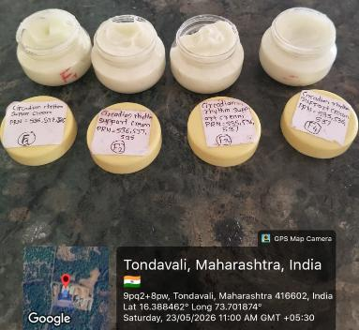
Figure 18: Physical Evaluation
- pH Determination: The pH of the formulation was measured by taking 1 gm of formulation in 100ml of water, then the pH of this solution was determined with the help of a pH meter. Ensure pH is within skin-compatible range ($≈$ 5.5-7)
Table 8: pH Determination
Sr. no. | Formulation | pH
1. | F1 | 6.03
2. | F2 | 6.50
3. | F3 | 6.15
4. | F4 | 5.96
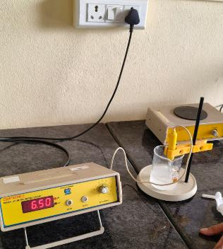
Figure 19: pH Determination
- Spreadability: Place a small amount of ointment between two glass slides. Apply a known weight on top. Measure the time taken for the slides to separate. Calculate spreadability; Spreadability =$\frac{M×L}{T}$ where,
M = weight tied to the upper slide (500gm), L =length ofglass slide (7.1cm), T = Time taken in seconds.
Table 9: Spreadability
Sr. No. | Formulation | Spreadability value | Spreadability Result
1. | F1 | 385.86 g.cm/sec | Excellent
2. | F2 | 141.90 g.cm/sec | Good
3. | F3 | 38.89 cm/sec | Poor
4. | F4 | 73.41 g.cm/sec | Moderate

Figure 20: Spreadability
- Viscosity: The prepared cream sample was taken in a clean beaker. A Brookfield viscometer with spindle No. 60 was used for the test. The spindle was immersed properly in the cream sample. The instrument was operated at the selected RPM. The spindle was allowed to rotate until a stable reading appeared. The viscosity was recorded in cps (centipoise).
Table 10: Viscosity
Sr. no. | Formulation | Viscosity | Result
1. | F1 | 9,485.7 cps | Poor Viscosity
2. | F2 | 10,817 cps | Good Viscosity
3. | F3 | 10,814 cps | Good Viscosity
4. | F4 | 10,089 cps | Good Viscosity
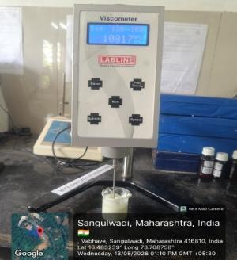
Figure 21: Viscosity
- Melting Point: A small amount of the sample was taken in a capillary tube sealed at one end. The sample was packed tightly inside the tube. The capillary tube was placed in the melting point apparatus. The temperature was increased slowly and continuously. The temperature at which the sample started and completely melted was noted. This temperature was recorded as the melting point of the sample.
Table 11: Melting Point
Sr. No. | Formulation | Melting Point
1. | F1 | 58°C
2. | F2 | 60°C
3. | F3 | 61°C
4. | F4 | 63°C
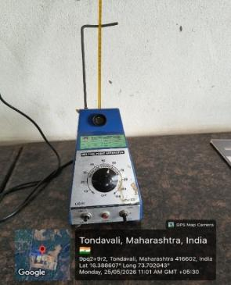
Figure 22 Melting point
- Washability: Apply a small amount of each formulation (F1, F2, F3, F4) on separate marked areas of the skin. Spread gently to form a thin film. Allow it to remain for 5 minutes. Wash each area with a small amount of water and gently rub with fingers or cotton. Observe the ease of removal and any residue left.
Table 12: Washability
Sr. no. | Formulation | Washability | Residue
1. | F1 | Easily Washable | Very Slight
2. | F2 | Very Easily Washable | None
3. | F3 | Moderately Washable | Oily Residue
4. | F4 | Easily Washable | Very Slight

Figure 23: Washability
- Irritancy Test: Select a healthy skin area (e.g., inner forearm). Clean the area with water and allow it to dry. Mark three separate sections on the skin and label them as F1, F2, and F3. Apply a small quantity of each formulation on the respective marked area. Spread gently to form a thin film. Leave the application undisturbed for 24 hours. After 24 hours, observe each area for: No erythema, redness, Swelling, Itching, or any irritation. Record the observations.
Table 13: Irritancy Test
Sr. no. | Formulation | Redness/Iching | Swelling | Irritation
1. | F1 | No | No | Non irritant
2. | F2 | No | No | Non irritant
3. | F3 | No | No | Non irritant
4. | F4 | No | No | Non irritant
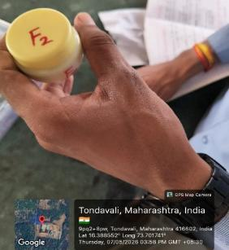
Figure 24: Irritancy Test
- After Feel Test: Emolliency, slipperiness and amount of residue left after the application of the fixed amount of cream were found to be good.
Table 14: After Feel Test
Sr. no. | Formulation | After Feel
1. | F1 | Good
2. | F2 | Good
3. | F3 | Good
4. | F4 | Good

Figure 25: After Feel Test
- Greasiness: The cream was applied to the skin surface as a smear, and its texture was evaluated to determine whether it was oily or greasy.
Table 15: Greasiness
Sr. no. | Formulation | Results
1. | F1 | Slightly greasy appearance
2. | F2 | Non-greasy
3. | F3 | Slightly Oily
4. | F4 | Non-greasy

Figure 26: Greasiness
- Phase Separation Test [14]: The formulated cream was kept intact in a closed container at 35°c not exposed to light. Phase separation was observed every 24 hrs for 30 days. Any change in phase separation was checked.
Table 16: Phase Separation Test
Sr. no. | Formulation | Phase Separation
1. | F1 | No phase separation observed
2. | F2 | No phase separation observed
3. | F3 | No phase separation observed
4. | F4 | A few water droplets visible
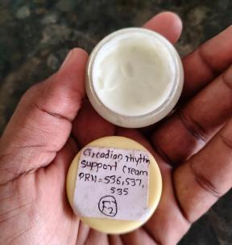
Figure 27: Phase Separation Test
- Stability Study: The prepared cream was stored in suitable containers at different temperature conditions. Samples were observed for changes in colour, odour, and appearance. The formulation was checked periodically for phase separation and consistency. pH and viscosity were also evaluated during the study period.
Table 17: Stability Study
Sr. no. | Formulation | Stability (40°C±2°C) | Stability (25°C±2°C)
1. | F1 | Stable | Stable
2. | F2 | Stable | Stable
3. | F3 | Slightly change observed | Stable
4. | F4 | Stable | Stable
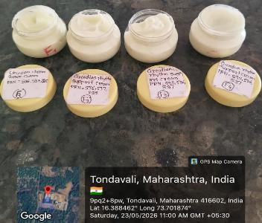
Figure 28: Stability Study
- Type of Emulsion Test: Take a small quantity of cream sample on a glass slide and add a water-soluble dye. If it disperses evenly in cream, this indicates O/W and is not uniform; it indicates a W/O emulsion.
Table 18: Type of Emulsion Test
Sr. no. | Formulation | Type of Emulsion
1. | F1 | W/O Emulsion
2. | F2 | W/O Emulsion
3. | F3 | W/O Emulsion
4. | F4 | W/O Emulsion
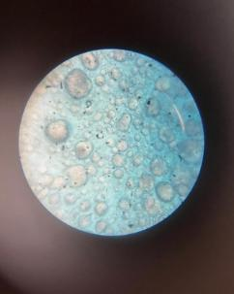
Figure 29: Type of Emulsion Test

RESULTS & DISCUSSION:
The Herbal Cream was successfully formulated and evaluated for its physical and functional properties. It showed a smooth texture, uniform consistency, good homogeneity, and satisfactory spreadability. The pH of the cream was within the skin-friendly range (6.50pH), making it suitable for topical application. No phase separation was observed, indicating good stability of the formulation.
The irritancy test showed no redness or irritation, suggesting that the cream is safe for external use. Herbal ingredients like cedarwood oil and chamomile oil may provide soothing, moisturizing, and protective effects on the skin. Overall, the formulation demonstrated good stability, safety, and potential benefits in supporting skin hydration and natural skin circadian rhythm.
Table 19: Result Table
Sr.No. | Parameter | Result
1 | Color | Off-white
2 | Odor | Pleasant
3 | State | Semisolid
4 | Consistency | Smooth
5 | Homogeneity | Homogeneous
6 | pH | 6.50
7 | Spreadability | 141.90 g.cm/sec
8 | Viscosity | 10817cps
9 | Melting point | 60°c
10 | Washability | Very easily washable
11 | Irritancy test | Non- irritant
12 | Afterfeel test | Good
13 | Greasiness | Non-greasy
14 | Phase Separation | No phase separation
15 | Stability | Stable
16 | Type of Emulsion | W/O Emulsion

CONCLUSION:
Formulation and Evaluation of Herbal Cream for Supporting Skin Health and Circadian Balance, containing essential oils, represents a successful combination of herbal therapeutics with modern cosmetic and pharmaceutical technology. The optimised cream formulation containing natural ingredients such as cedarwood oil, chamomile oil, peppermint oil, suitable emulsifying agents, and moisturizing bases demonstrated excellent pharmaceutical and cosmetic properties, including good homogeneity, smooth texture, satisfactory spreadability, appropriate viscosity, good washability, skin compatibility, and absence of irritation during evaluation studies. The fusion method used for cream preparation proved effective in producing a stable and uniform W/O emulsion with desirable consistency and enhanced patient acceptability. Stability studies indicated that the formulation remained physically stable under different storage conditions without phase separation or significant changes in appearance and pH. The developed herbal cream offers a natural and safe approach for supporting skin wellness and skin circadian rhythm balance while maintaining the preservative-minimised and herbal-based characteristics desirable for modern cosmetic applications.

FUTURE PROSPECTS:
1. Clinical Studies: Evaluate the cream on different skin types for hydration, relaxation, and skin repair effects.
2. Advanced Formulations: Develop nanoemulsion and gel-based systems for better absorption of essential oils.
3. Product Diversification: Introduce related products such as night serum, body lotion, and under-eye gel.
4. Stability Improvement: Use natural preservatives to enhance shelf life and formulation stability.
5. Safety Studies: Perform dermatological and irritation testing under different storage conditions.
6. Market Expansion: Develop eco-friendly packaging and obtain regulatory approval for commercialization.
7. Further Research: Study the antioxidant, soothing, and skin regeneration properties of the herbal ingredients.

References

[1] | A. B. M. L. M. R. &. T. R. Lyons, “Circadian rhythm and the skin: a review of the literature.,” The Journal of clinical and aesthetic dermatology, vol. 12, no. 9, p. 42, 2019.
[2] | S. E. B. G. a. B. O. Hettwer, “"Influence of cosmetic formulations on the skin's circadian clock.",” International Journal of Cosmetic Science, vol. 42, no. 4, pp. 313-319., 2020.
[3] | Y. Smith, “News-Medical.Net,” [Online]. Available: https://www.news-medical.net/health/Circadian-Rhythm.aspx. [Accessed 19 05 2026].
[4] | S. &. S. K. Senthilnathan, “Circadian Rhythm and Its Importance in Human Life,” Available at SSRN, p. 3441495, 2019.
[5] | M. U. &. A. S. M. Gillette, “Basic mechanisms of circadian rhythms and their relation to the sleep/wake cycle,” Neuroendocrine correlates of sleep/wakefulness. Boston, MA: Springer US, pp. 19-40, 2006.
[6] | S. S. S. K. A. &. K. V. Hagavane, “Review on cream as topical drug delivery system,” International Journal of Research in Pharmacy and Pharmaceutical Sciences, vol. 7, no. 1, pp. 21-30, 2022.
[7] | A. B. M. L. M. R. &. T. R. Lyons, “Circadian rhythm and the skin: a review of the literature.,” The Journal of clinical and aesthetic dermatology, vol. 12, no. 9, p. 42, 2019.
[8] | J. G. E. N. K. S. S. &. A. B. Duan, “The circadian clock and diseases of the skin,” FEBS letters, vol. 595, no. 19, pp. 2413-2436, 2021.
[9] | S. D. Gonçalves, “Cedarwood essential oil (Cedrus spp.): a forgotten pharmacological resource with emerging therapeutic potential,” Exploration of Drug Science, vol. 3, p. 1008131, 2025.
[10] | J. W. &. C. C. H. Yeom, “Herbal and natural supplements for improving sleep: a literature review.,” Psychiatry Investigation, vol. 21, no. 8, p. 810, 2024.
[11] | A. P. I. M. A. T. D. D. Vaishnavi Khot*, “Aromatherapy And Beyond: The Pharmacological Profile of,” IJPS journal, vol. 3, no. 6, pp. 3986-3992, 2025.
[12] | I. P. Commission., “Indian Pharmacopoeia (Vols. I–IV),” in Indian Pharmacopoeia, Ghaziabad, Ghaziabad, India: Ministry of Health and Family Welfare, Government of India., 2022.
[13] | S. K. M. S. S. V. &. I. M. Valarmathi, “Formulation and evaluation of herbal face cream.,” Research Journal of Pharmacy and Technology, vol. 13, no. 1, pp. 216-218, 2020.
[14] | S. S. B. A. S. &. A. S. A. Davkhar, “Formulation and Evaluation of Multipurpose Herbal Cream,” eLife, p. 23, 2023.
[15] | R. D. D. M. B. N. S. &. A. M. THARUMALAY, “The effects of circadian rhythm disruption towards metabolic stress and mental health: A review.,” Malaysian Journal of Health Sciences/Jurnal Sains Kesihatan Malaysia, vol. 18, no. 1, 2020.
[16] | Z. Lotfollahi, “ The anatomy, physiology and function of all skin layers and the impact of ageing on the skin.,” Wound Practice & Research: Journal of the Australian Wound Management Association , vol. 32, no. 1, pp. 6-10, 2024.
[17] | S. V. R. N. M. H. A. S. &. S. P. B. Sirsat, “A review on preparation and evaluation of herbal cold cream.,” World Journal of Pharmaceutical Research, vol. 11, no. 5, pp. 690-697, 2022.
[18] | V. a. A. K. N. Sher, “"Formulation of Herbal Cream using Tridax Procumbens.",” 2024.
[19] | A. V. F. V. C. &. F. A. Simões, “A tutorial for developing a topical cream formulation based on the quality by design approach,” ournal of pharmaceutical sciences, vol. 107, no. 10, pp. 2653-2662., 2018.

