LABOR: PHYSIOLOGY, MECHANISM, OBSTETRIC COMPLICATIONS, AND A HOMOEOPATHIC THERAPEUTIC PERSPECTIVE

ABSTRACT
Background: Labor is a complex physiological process involving coordinated maternal, fetal, endocrine, biochemical, and mechanical mechanisms that culminate in the expulsion of the fetus, placenta, and membranes. Despite advances in modern obstetric care, complications during labor and the puerperium continue to contribute significantly to maternal and neonatal morbidity. Homoeopathy has traditionally been employed as an adjunctive therapeutic approach for managing various labor-related conditions.
Keywords: Parturition; Mechanism of Labor; Obstetric Complications; Homoeopathic Therapeutics; Postpartum Hemorrhage; Retained Placenta; Puerperium;
Objective: To review the physiological aspects of normal labor, its stages, mechanisms, complications, and to highlight the homoeopathic management of common obstetric conditions encountered during labor and the puerperal period.
Methods: A narrative review was conducted using standard obstetric textbooks, homoeopathic materia medica, repertories, and clinical therapeutic references. Information regarding the onset, stages, and mechanism of labor was compiled alongside homoeopathic remedies indicated for abnormal labor, retained placenta, postpartum hemorrhage, urinary retention, puerperal infections, postpartum psychological disturbances, malpresentations, false labor pains, and post-dated pregnancy.
REVIEW OF LITERATURE
LABOR
DEFINITION: Series of events that take place in the genital organs in an effort to expel the viable products of conception (foetus, placenta and the membranes) out of the womb through the vagina into the outer world is called ‘labor’. ¹
Delivery is the expulsion or extraction of a viable fetus out of the womb. ¹
NORMAL LABOR (EUTOCIA): Labor is called normal if it fulfils the following criteria: 1. Spontaneous in onset and at term 2. With vertex presentation 3. Without undue prolongation 4. Natural termination with minimal aids 5. Without having any complications affecting the health of the mother and/or the baby. ¹
CAUSES OF ONSET OF LABOR
The precise mechanism of initiation of human labor is still obscure. Endocrine, biochemical and mechanical stretch pathways as obtained from animal experiments, however, put forth the following hypotheses.¹
1.Uterine distension: Stretching effect on the myometrium by the growing fetus and liquor amnii can explain the onset of labor at least in twins or polyhydramnios. Uterine stretch increases gap junction proteins, receptors for oxytocin and specific contraction associated proteins (CAPs).
2. Fetoplacental contribution: Cascade of events activate fetal hypothalamic-pituitary-adrenal axis prior to onset of labor → increased CRH → increased release of ACTH → fetal adrenals → increased cortisol secretion → accelerated production of estrogen and prostaglandins from the placenta (Fig. 13.1).
3. Estrogen: The probable mechanisms are:
— Increases the release of oxytocin from maternal pituitary.
— Promotes the synthesis of myometrial receptors for oxytocin (by 100–200 folds), prostaglandins and increase in gap junctions in myometrial cells.
— Accelerates lysosomal disintegration in the decidual and amnion cells resulting in increased prostaglandin (PGF2α) synthesis.
— Stimulates the synthesis of myometrial contractile protein—
actomyosin through cAMP.
— Increases the excitability of the myometrial cell membranes.
4.Progesterone: Increased fetal production of dehydroepiandrosterone sulfate (DHEA-S) and cortisol inhibits the conversion of fetal pregnenolone to progesterone. Progesterone levels therefore fall before labor. It is the alteration in the estrogen: progesterone ratio rather than the fall in the absolute concentration of progesterone, which is linked with prostaglandin synthesis.
5. Prostaglandins: They are the important factors, which initiate and maintain labor. The major sites of synthesis of prostaglandins are—amnion, chorion, decidual cells and myometrium. Synthesis is triggered by—rise in estrogen level, glucocorticoids, mechanical stretching in late pregnancy, increase in cytokines (IL–1, 6, TNF), infection, vaginal examination and separation or rupture of the membranes. Prostaglandins enhance gap junction (intramembranous gap between two cells through which stimulus flows) formation.
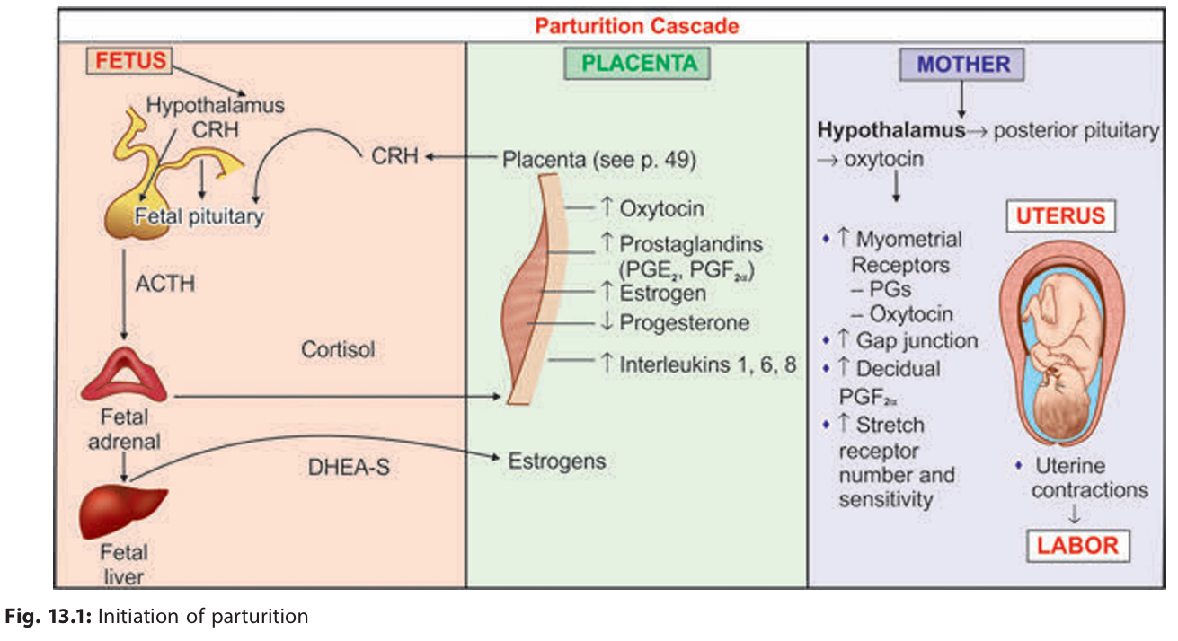
FALSE PAIN (Synonym: false labor, spurious labor): It is found more in primigravidae thanin parous women. It usually appears prior to the onset of true labor pain by 1 or 2 weeks in primigravidae and by a few days in multiparae. Such pains are probably due to stretching of the cervix and lower uterine segment with consequent irritation of the neighboring ganglia. ¹
PRELABOR (Synonym: premonitory stage): The premonitory stage may begin 2–3 weeks before the onset of true labor in primigravidae and a few days before in multiparae. The features are inconsistent and may consist of the following: ¹
1.Lightening: A few weeks prior to the onset of labor especially in primigravidae, the presenting part sinks into the true pelvis. It is due to active pulling up of the lower pole of the uterus around the presenting part. It signifies incorporation of the lower uterine segment into the wall of the uterus. This diminishes the fundal height and hence minimizes the pressure on the diaphragm (Figs 13.2A and B). The mother experiences a sense of relief from the mechanical cardiorespiratory embarrassment. There may be frequency of micturition or constipation due to mechanical factor—pressure by the engaged presenting part. It is a welcome sign as it rules out cephalopelvic disproportion and other conditions preventing the head from entering the pelvic inlet. ¹
2.Cervical changes: A few days prior to the onset of labor, cervix becomes ripe. A ripe cervix is (a) soft, (b) 80% effaced (<1.5 cm in length), (c) admits one finger easily, and (d) cervical canal is dilatable. ¹
3.Appearance of false pain
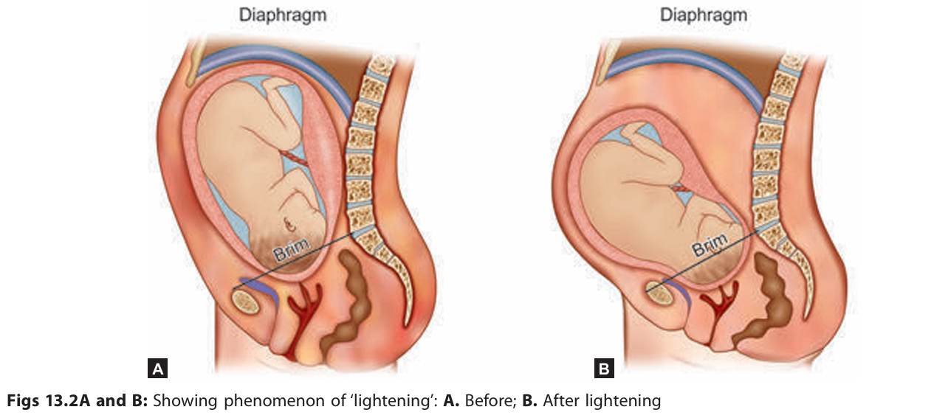
LABOR PAIN: Throughout pregnancy, painless Braxton Hicks contractions with simultaneous hardening of the uterus occur. The contractions are irregular and do not increase in frequency or regularity. These contractions change their character, become more powerful, intermittent and are associated with pain. Pain more often felt in front of the abdomen or radiating toward the thighs. True labor pain is characterized by:¹
(i) Painful uterine contractions at regular intervals,
(ii) Frequency of contractions increase gradually,
(iii) Intensity and duration of contractions increase progressively,
(iv) Associated with ‘show’,
(v) Progressive effacement and dilatation of the cervix,
(vi) Descent of the presenting part,
(vii) Formation of the ‘bag of forewaters’ and
(viii) Not relieved by enema or sedatives

Show : With the onset of labor, there is profuse cervical mucoid discharge. Simultaneously, there is slight oozing of blood from rupture of capillary vessels of the cervix and from the raw decidual surface caused by separation of the membranes due to stretching of the lower uterine segment. Expulsion of cervical mucus plug mixed with blood is called ‘show’. ¹
Dilatation of internal os: With the onset of labor pain, the cervical canal begins to dilate more in the upper part than in the lower, the former being accompanied by corresponding stretching of the lower uterine segment. ¹
Formation of ‘bag of waters’: Due to stretching of the lower uterine segment, the membranes are detached easily because of its loose attachment to the poorly formed decidua. With the dilatation of the cervical canal, the lower pole of the fetal membranes becomes unsupported and tends to bulge into the cervical canal. As it contains liquor, which has passed below the presenting part, it is called ‘bag of waters’. During uterine contraction with consequent rise of intra-amniotic pressure, this bag becomes tense and convex. After the contractions pass off, the bulging may disappear completely. This in association with regular contractions and cervical changes are signs of onset of labor. However, in some cases the membranes are so well applied to the head that the finding may not be detected. ¹
STAGES OF LABOR: Conventionally, events of labor are divided into three stages: ¹
1.First stage: It starts from the onset of true labor pain and ends with full dilatation of the cervix. It is, in other words, the ‘cervical stage’ of labor. Its average duration is 12 hours in primigravidae and 6 hours in multiparae.
2.Second stage: It starts from the full dilatation of the cervix (not from the rupture of the membranes) and ends with expulsion of the fetus from the birth canal. It has got two phases: (1) The propulsive or passive phase—starts from full dilatation up to the descent of the presenting part to the pelvic floor. (2) The expulsive or active phase is distinguished by maternal bearing down efforts and ends with delivery of the baby. Its average duration is 2 hours in primigravidae and 30 minutes in multiparae.
3.Third stage: It begins after expulsion of the fetus and ends with expulsion of the placenta and membranes (afterbirths). Its average duration is about 15 minutes in both primigravidae and multiparae. The duration is, however, reduced to 5 minutes in active management.
4.Fourth stage: It is the stage of observation for at least 1 hour after expulsion of the afterbirths. During this period maternal vitals, uterine retraction and any vaginal bleeding are monitored. Baby is examined. These are done to ensure that both the mother and baby are well.
EVENTS IN FIRST STAGE OF LABOR
The first stage is chiefly concerned with the preparation of the birth canal so as to facilitate expulsion of the fetus in the second stage. The main events that occur in the first stage are—(a) dilatation and effacement of the cervix and (b) full formation of lower uterine segment. ¹
Dilatation Of Cervix: Prior to the onset of labor, in the prelabor phase (phase-1) there may be a certain amount of dilatation of cervix, especially in multiparae and in some primigravidae. Important structural components of the cervix are—
(a) smooth muscle (5–20%),
(b) collagen
(c) the ground substance.
Predisposing factors which favor smooth dilatation are—
a. Softening of the cervix
b. Fibromusculoglandular hypertrophy
c. Increased vascularity
d. Accumulation of fluid in between collagen fibers
e. Breaking down of collagen fibrils by enzymes collagenase and elastase, and
f. Change in the various glycosaminoglycans (e.g. increase in hyaluronic acid, decrease in dermatan sulfate) in the matrix of the cervix. These are under the action of hormones—estrogen, progesterone and relaxin. ¹
Effacement or Taking Up of Cervix: Effacement is the process by which the muscular fibers of the cervix are pulled upward and merges with the fibers of the lower uterine segment. The cervix becomes thin during first stage of labor or even before that in primigravidae. In primigravidae, effacement precedes dilatation of the cervix, whereas in multiparae, both occur simultaneously (Figs 13.6A and B). Expulsion of mucus plug is caused by effacement. ¹
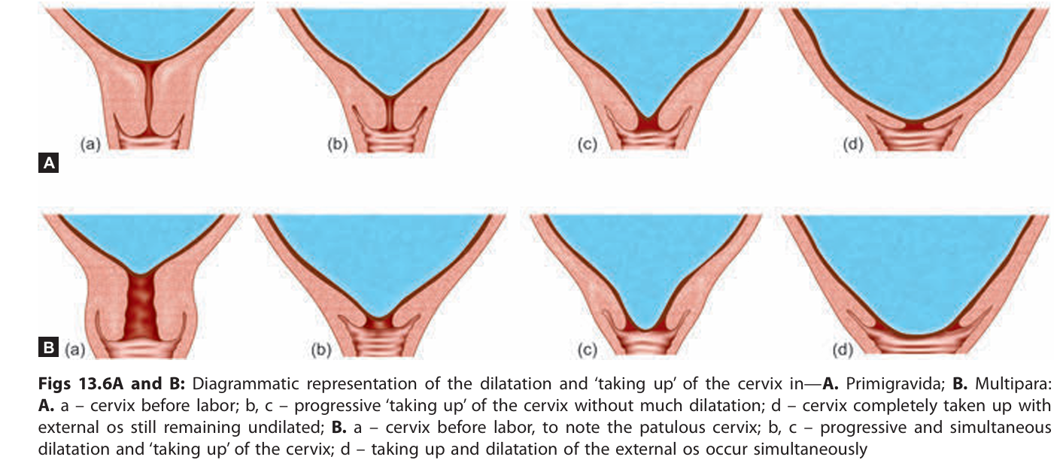
Lower Uterine Segment: Before the onset of labor, there is no complete anatomical or functional division of the uterus. During labor the demarcation of an active upper segment and a relatively passive lower segment is more pronounced. The wall of the upper segment becomes progressively thickened with progressive thinning of the lower segment (Figs 13.7A to C). This is pronounced in late first stage, especially after rupture of the membranes and attains its maximum in second stage. A distinct ridge is produced at the junction of the two, called physiological retraction ring which should not be confused with the pathological retraction ring—a feature of obstructed labor. Lower segment of uterus is characterized by following features (Table 13.1): ¹
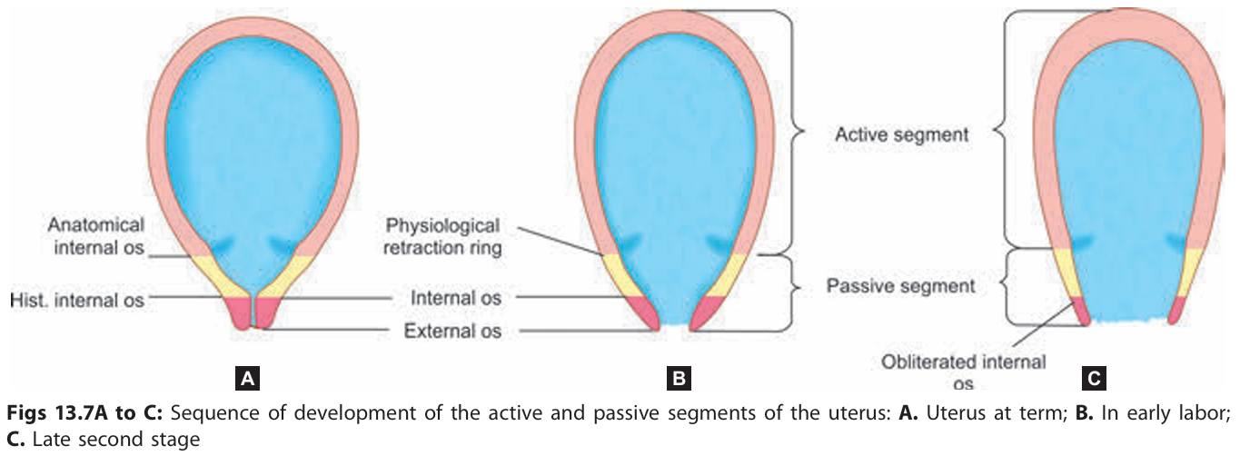

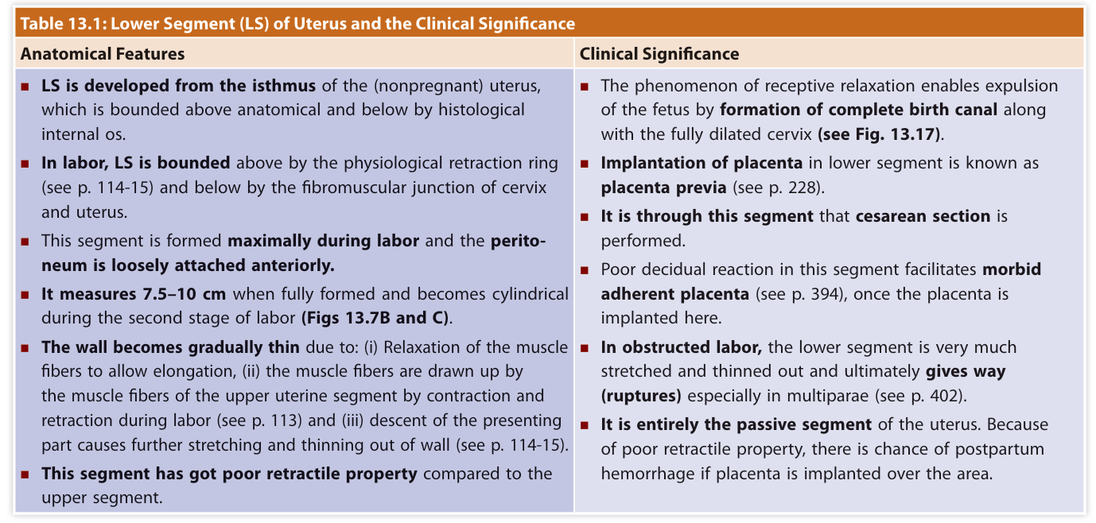
EVENTS IN SECOND STAGE OF LABOR
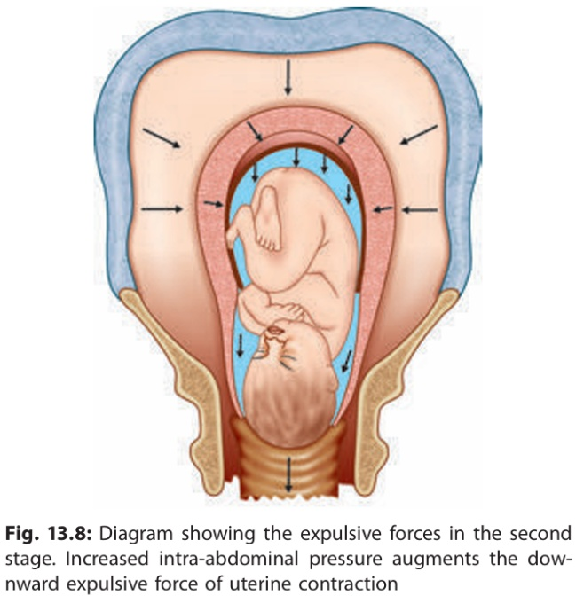
The second stage begins with the complete dilatation of the cervix and ends with the expulsion of the fetus. This stage is concerned with the descent and delivery of the fetus through the birth canal. Second stage has two phases: ¹
1. Propulsive—from full dilatation until head touches the pelvic floor.
2. Expulsive—since the time mother has irresistible desire to ‘bear down’ and push until the baby is delivered.
EVENTS IN THIRD STAGE OF LABOR
The third stage of labor comprises the phase of placental separation; its descent to the lower segment and finally its expulsion with the membranes. ¹
Placental Separation: At the beginning of labor, the placental attachment roughly corresponds to an area of 20 cm (8") in diameter. There is no appreciable diminution of the surface area of the placental attachment during first stage. During the second stage, there is slight but progressive diminution of the area following successive retractions, which attains its peak immediately following the birth of the baby.
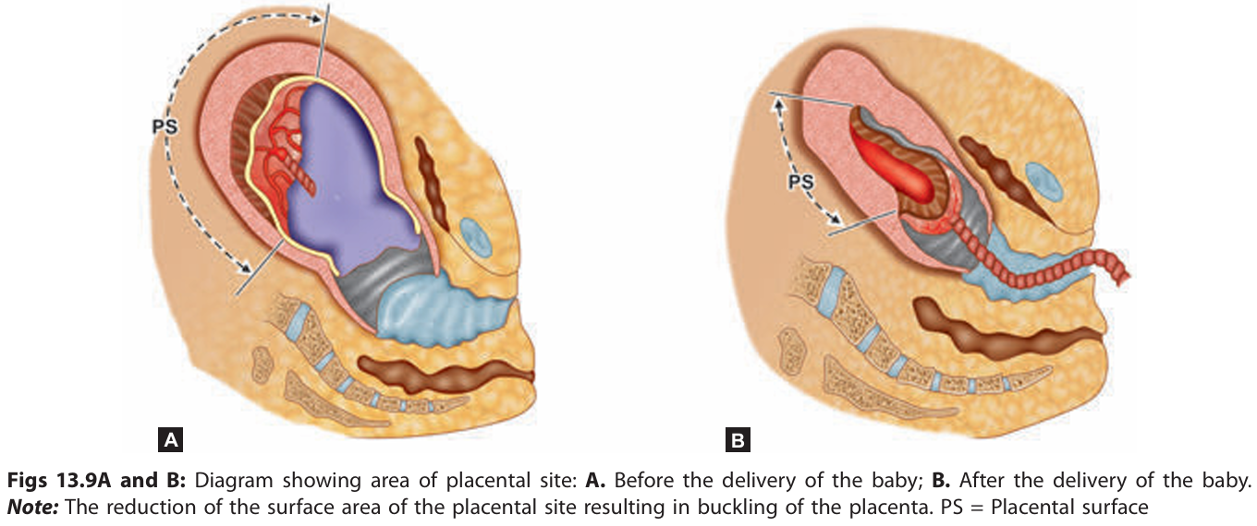
Mechanism of separation: Marked retraction reduces effectively the surface area at the placental site to about its half. But as the placenta is inelastic, it cannot keep pace with such an extent of diminution resulting in its buckling (Figs 13.9A and B). A shearing force is instituted between the placenta and the placental site which brings about its ultimate separation. The plane of separation runs through deep spongy layer of decidua basalis so that a variable thickness of decidua covers the maternal surface of the separated placenta. There are two ways of separation of placenta (Figs 13.10A and B).
(1) Central separation (Schultze): Detachment of placenta from its uterine attachment starts at the center resulting in opening up of few uterine sinuses and accumulation of blood behind the placenta (retroplacental hematoma). With increasing contraction, more and more detachment occurs facilitated by weight of the placenta and retroplacental blood until whole of the placenta gets detached.
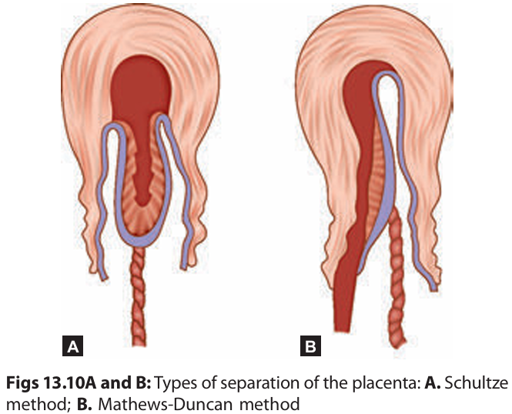
(2) Marginal separation (Mathews-Duncan): Separation starts at the margin as it is mostly unsupported. With progressive uterine contraction, more and more areas of the placenta get separated. Marginal separation is found more frequently.

Separation of Membranes: The membranes, which are attached loosely in the active part, are thrown into multiple folds. Those attached to the lower segment are already separated during its stretching. The separation is facilitated partly by uterine contraction and mostly by weight of the placenta as it descends down from the active part.
The membranes so separated carry with them remnants of decidua vera giving the outer surface of the chorion its characteristic roughness.
Expulsion of Placenta : After complete separation of the placenta, it is forced down into the flabby lower uterine segment or upper part of the vagina by effective contraction and retraction of the uterus. Thereafter, it is expelled out either by voluntary contraction of abdominal muscles (bearing down efforts) or by manual procedure.

MECHANISM OF NORMAL LABOR
The series of movements that occur on the head in the process of adaptation during its journey through the pelvis is called mechanism of labor. ¹
MECHANISM: In normal labor, the head enters the brim more commonly through the available transverse diameter (70%) and to a lesser extent through one of the oblique diameters. Accordingly, the position is either occipitolateral or oblique occipitoanterior. Left occipitoanterior is little more common than right occipitoanterior as the left oblique diameter is encroached by the rectum.
As the occipitolateral position is the most common, the mechanism of labor in such position will be described. The principal movements are:
(1) Engagement
(2) descent
(3) flexion
(4) internal rotation
(5) crowning
(6) extension
(7) restitution
(8) external rotation
(9) expulsion of the trunk.
Although the various movements are described separately but in reality, the movements at least some, may be going on simultaneously. ¹
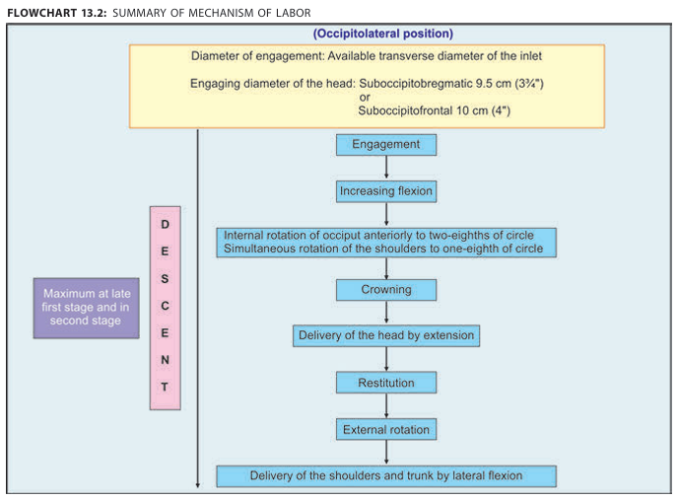
- Engagement
In an occiput presentation, passage of the biparietal diameter through the pelvic inlet defines engagement. The fetal head may engage during the last few weeks of pregnancy or not until after labor commences. In many multiparas and some nulliparas, the fetal head is freely movable above the pelvic inlet at labor onset and is often referred to as "floating." In one study of 5341 nulliparas, lack of fetal head engagement before labor onset did not affect vaginal delivery rates in either spontaneous or induced labor (Segel, 2012).
In most cases, the vertex enters the pelvis with the sagittal suture lying in the transverse pelvic diameter. Left occiput transverse (LOT) position is slightly more common than right occiput transverse (ROT) position (Caldwell, 1934). However, the sagittal suture may not lie exactly midway between the symphysis and the sacral promontory. The sagittal suture frequently is deflected off the midline, either posteriorly toward the promontory or anteriorly toward the symphysis (Fig. 22-5). Such lateral deflection to a more anterior or posterior position in the pelvis is called asynclitism. If the sagittal suture approaches the sacral promontory, more of the anterior parietal bone presents itself to the examining fingers, and the condition is called anterior asynclitism. If, however, the sagittal suture lies close to the symphysis, more of the posterior parietal bone will present, and the condition is called posterior asynclitism. With extreme asynclitism, an ear may be palpable.
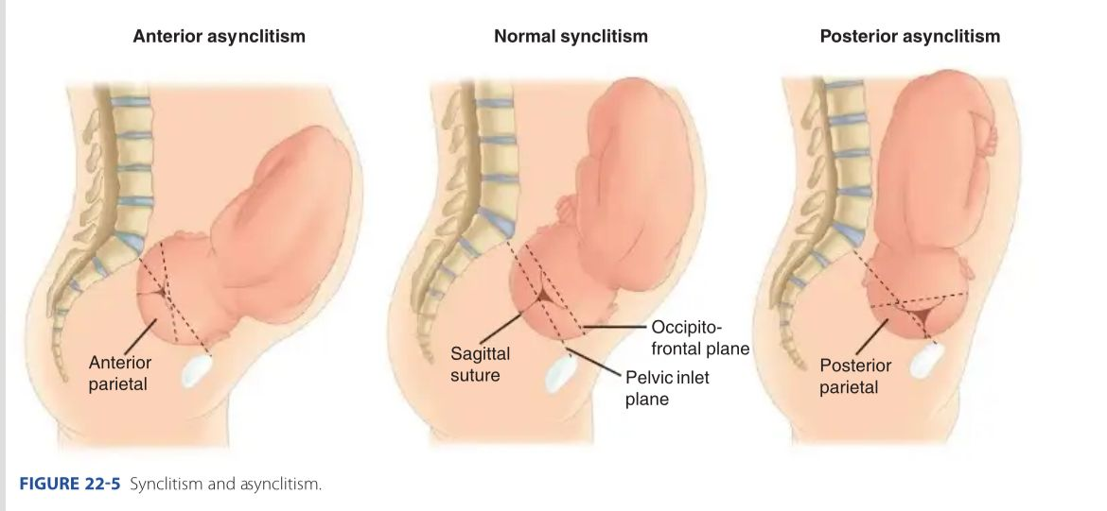
Moderate degrees of asynclitism are the rule in normal labor. Successive fetal head shifting from posterior to anterior asynclitism aids descent. However, if severe, the condition is a common reason for cephalopelvic disproportion even with an otherwise normal-sized pelvis. ²
- Descent
This movement is the first requisite for vaginal birth. In nul-liparas, engagement may take place before labor onset, and further descent may not follow until second-stage labor. In multiparas, descent usually begins with engagement. Descent stems from one or more of three forces: (1) direct myometrial pressure of the fundus upon the breech with contractions, (2) bearing-down efforts of maternal abdominal muscles, and (3) extension and straightening of the fetal body. ²
- Flexion
As soon as the descending head meets resistance, whether from the cervix, pelvic walls, or pelvic floor, it normally flexes. With this movement, the chin draws closer to the fetal thorax, and the appreciably shorter suboccipitobregmatic diameter replaces the longer occipitofrontal diameter (Fig. 29-1). This is an essential requisite for descent because it allows the smallest head diameter to progress. ²
- Internal Rotation
This movement turns the occiput gradually away from the transverse axis. Usually the occiput rotates anteriorly toward the symphysis pubis. LOT positions transition to left occiput anterior (LOA) positions (Fig. 22-6). ROT positions rotate to right occiput anterior (ROA) positions. Less commonly, the head may rotate posteriorly toward the hollow of the sacrum to generate occiput posterior positions. Internal rotation is essential for completion of labor, except when the fetus is unusually small. ²
- Extension
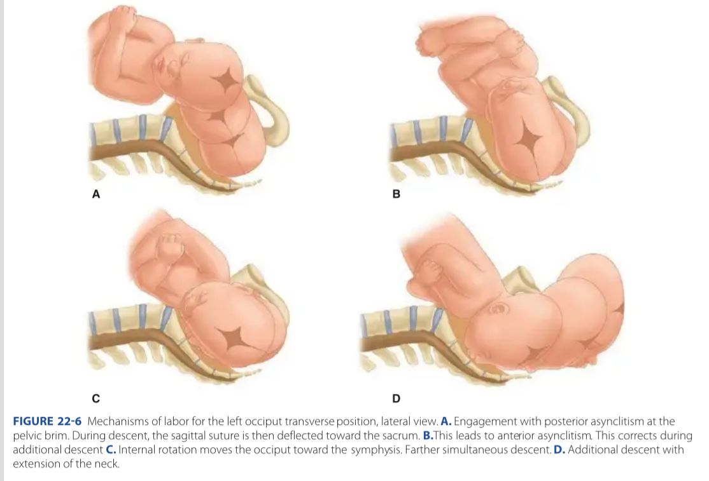
After internal rotation, the sharply flexed head reaches the vulva and undergoes extension. If the sharply flexed head, on reaching the pelvic floor, did not extend but was driven farther downward, it would impinge on the posterior portion of the perineum and would eventually be forced through the perineal tissues. When the head presses on the pelvic floor, however, two forces come into play. The first force, exerted by the uterus, acts more poste-riorly, and the second, supplied by the resistant pelvic floor and the symphysis, acts more anteriorly. The resultant vector is in the direction of the vulvar opening, thereby causing head extension.

This brings the base of the occiput into direct contact with the inferior margin of the symphysis pubis (see Fig. 22-6).
With progressive distention of the perineum and vaginal opening, an increasingly large portion of the occiput gradually appears. The head is born as the occiput, anterior fontanel, brow, nose, mouth, and chin pass successively over the perineal body. Immediately after its delivery, the head drops so that the chin lies over the maternal anus. ²
- External Rotation
The delivered head next undergoes restitution .If the occiput was originally directed toward the maternal left, it rotates toward the mother's left ischial tuberosity. If it was originally directed toward the right, the occiput rotates to the right. With restitution, the head reaches a transverse position. The fetal body aligns its bisacromial
diameter, which is the distance across the shoulders, with the anteroposterior diameter of the pelvic outlet. Thus, one shoulder is anterior behind the symphysis and the other is posterior. ²
- Expulsion Almost immediately after external rotation, the anterior shoulder appears under the symphysis pubis, and the perineum soon becomes distended by the posterior shoulder. After delivery of the shoulders, the rest of the body quickly passes. If the anterior shoulder tightly wedges behind the symphysis, shoulder dystocia is diagnosed.²

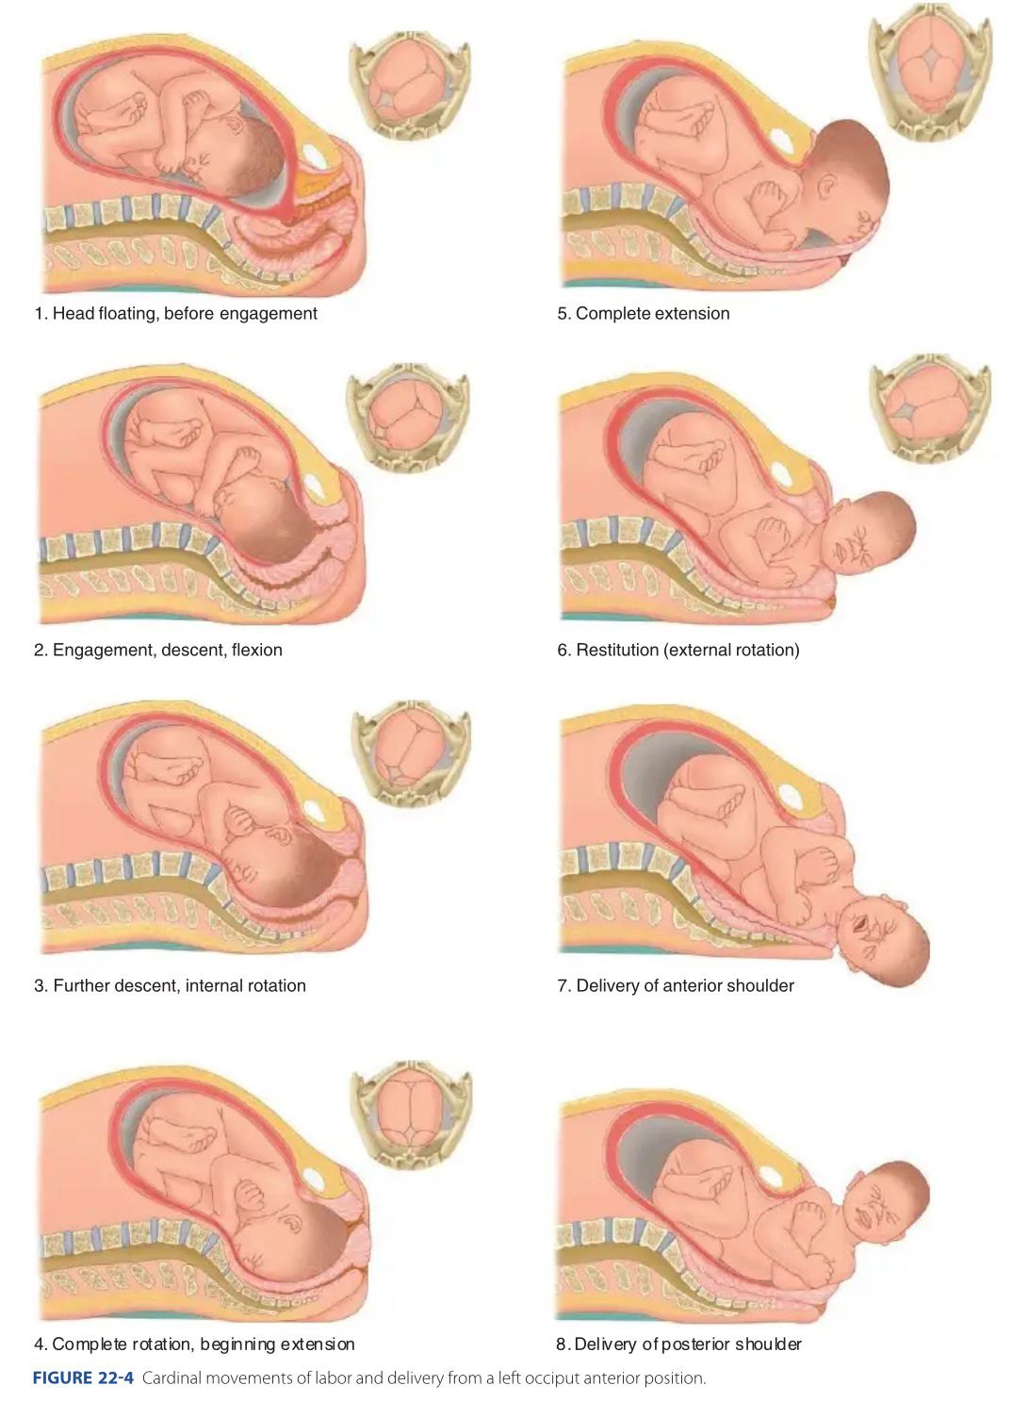

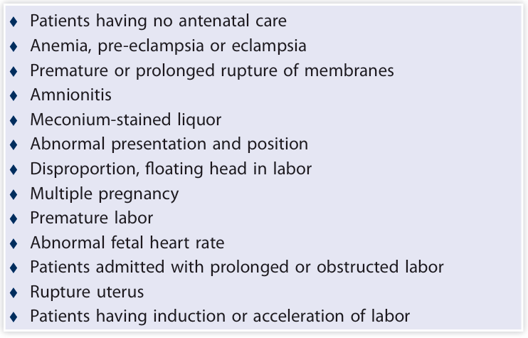
COMPLICATIONS OF LABOR: The cases should be reas sessed during late pregnancy and labor . Attention is turned to detect the risks that may develop during labor. Some important points to be considered are: ¹
POSTPARTUM COMPLICATIONS: An uneventful labor may suddenly turn into an abnormal one in the form of PPH retained placenta, shock or inversion or sepsis may develop later on. The condition of the neonate should be assessed after delivery. The following categories of neonate are at high risk:
Apgar score below 7
Hypoglycaemia
Anaemia Birth weight less than 2500 g or more than 4 kg
Major congenital abnormalities
Convulsions
Foetal infection Jaundice
Respiratory distress syndrome
Persistent cyanosis
Haemorrhagic diathesis.
Some workers have introduced a scoring system for screening of highrisk cases; such a scoring system is not essential. However, if one wants to introduce a scoring system, local factors and experience of previous management should be taken into consideration before attaching a particular score to any abnormality. ¹
MANAGEMENT OF LABOR:
It is evident that elective caesarean section is necessary in a high-risk case. Some cases may need induction of labor after 37–38 completed weeks of gestation. Those cases who go into labor spontaneously or after induction, need close monitoring during labor for the assessment of progress of labor or for any evidence of the fetal hypoxia. ¹
HOMEOPATHIC APPROACH
- ABNORMAL OR PROLONGED LABOR

1.Belladonna ³
Particular indication:
Labour pains: violent, come suddenly, last indefinitely and cease suddenly. Pains are usually in short attacks, causes redness of face and eyes. pupils dilated and dimness of vision. Pulse full, hard and tense: pulsations in all the arteries Sensation of bearing down as if the contents of abdomen would issue through the vagina; better standing or sitting erect. Dragging pain around the loins, in sacrum. Acuteness of all the senses, restless, constantly changing position, cannot bear to be touched.
Useful in confinement of woman who has her children late in life.
2.Cimicifuga Racemosa ³

Particular indications:
Sharp lancinating electric like pains in various parts with irritation in the region of ovaries and uterus; worse least noise Darting pain across the abdomen from hip to hip. During labour: shivers in the first stage, convulsions from nervous excitement, rigid os. Labour pain severe, tedious, spasmodic with fits or cramps in legs with much exertion. After-pains, worse in the groins
*When given during last month of pregnancy shortens labour, if symptoms correspond" - H. C. Allen
3. Pulsatilla ³
Particular indications
Pains: spasmodic, excites palpitation, suffocation and fainting During labour, must have fresh air, wants doors and windows open Pains rapidly shifting from one part to another with constant chilliness.
- Chamomilla ³
Particular indications
Pains: seem unendurable, drives to despair; intolerable, sends the doctor and nurse away, then calls again. Labour pain: spasmodic, distressing, wants to get away from them; says she must and will get up Pains: tearing down the legs. press upward. Patient cannot endure anyone near him, is cross and cannot bear to be spoken to, uncivil, aversion to talking, answers peevishly; ugly in behaviour. Rigidity of os, after pains very acute and distressing.
- Secale Cornutum ³
Ailments from: Uterine atony.
Particular Indications
Labour pains: irregular, too weak, feeble or ceasing. Cervix is loose and open, no expulsive action.During labour: fainting, hour glass contraction.
Suited to women of thin, scrawny, feeble and cachetic appearance: pale and sunken countenance; with internal burning and external coldness; irritable and nervous temperament
- Pituitaria Glandula ³
Particular indications
Pituitaria helps to stimulate muscular activity and overcomes uterine inertia. For uterine inertia in second stage of labour where the os is fully dilated. Associated symptoms: high blood pressure. vertigo, difficult mental concentration, confusion and fullness in frontal region
- Caulophyllum Thalictroides ³
Ailments from: Uterine atony.
Particular indications: A woman's remedy with want of tonicity in the uterus with deficient pains; the contractions of uterus are too feeble to expel the contents; the patient being exhausted and fretful. Labour pains: intermittent, paroxysmal and spasmodic; which fly in all directions. Shivering without progress, helps to revive labour pains and further progresses labour. Spasmodic rigid os, delayed labour, needle like pricking pain in cervix.
Will correct deranged vitality and produce efficient pains, if symptoms agree"- H. C. Allen.
- Magnesium Phosphoricum ³
Particular indications
Labour pains: sharp, cutting, stabbing, shooting, stitching; lightning like in coming and going. Intermittent, almost unbearable, driving patient to frenzy; rapidly changing place. Constricting sensation, as if a band was drawn tightly around Cramping, neuralgic affections. Tired, exhausted.
- RETAINED PLACENTA

- Secale Cornutum ³
Ailments after: Uterine atony.
Particular indications
Retained placenta with PPH and a bearing down sensation. Intense after pains. Passive haemorrhage: thin, black, watery with a strong tendency to putrescence. Muscles feel weak and exhausted. Septic placenta; suited to women of thin, scrawny, feeble and cachectic appearance, pale and sunken countenance; with internal burning and external coldness: irritable and nervous temperament.
- Sabina ³
Ailments after: Uterine atony, premature labour.
Particular indications
Retained placenta with intense after pain. Pain from sacrum to pubes and from below upwards, shooting up the vagina. Promotes expulsion of foreign bodies from uterus. Haemorrhage of bright red blood; partly fluid, partly clotted.

- Caulophyllum Thalictroides ³
Ailments from: Uterine atony with feeble uterine contraction.
Particular indications
Retained placenta with toe weak contraction of the uterus that fails to expel placenta out. Passive haemorrhage after labour, blood goes oozing for hours after labour. Labour pains short, irregular, spasmodic, needle like pricking pain in cervix.
- Arnica Montana ³
Particular indications
Retained placenta after a long exhaustive labour with violent after pain. Some lame, bruised feeling of the parts after labour.
“Prevents post-partum haemorrhage and puerperal complications"- H. C. Allen.

- POSTPARTUM HAEMORRHAGE (PPH)

- Hamamelis Virginica ³
Ailments after: Injury or trauma during delivery.
Particular indications
Haemorrhage dark, profuse, passive with bearing down pain in back. Intense soreness of abdomen. Passive venous congestion with haemorrhoids or varicose veins.
- Sabina ³
Ailments after: Premature labour, retained placenta.
Particular indications
Haemorrhage: profuse, bright red; partly fluid, partly clotted. Promotes expulsion of foreign body or moles from uterus, intense after pains. Pain from sacrum to pubes and from below upwards, shooting up the vagina.
- Trillium Pendulum ³
Ailments from: Displacement of uterus during delivery.
Particular indications
PPH with fainting attacks and dizziness, gushing of bright red blood. Cramping pain in uterus. Sensation as if hips and back was falling to pieces: better tight bandages.
Associated symptoms: anaemia, cold limbs, dim sight, palpitations and tachycardia, obstruction and noises in the car.
- Secale Cornutum ³
Ailments from: Uterine inertia.
Particular indications
PPH with retained placenta. Passive haemorrhage in thin, feeble, cachectic women. During labour, no expulsive action as if everything is relaxed Intense after pains, too long and too painful hour-glass contraction Sensation of formication all over. Haemorrhage of thin, black, watery blond with a strong tendency to putrescence.
- Ustilago Maydis ³
Ailments from: Uterine atony.
Particular Indications
Postpartum haemorrhage blood is bright red, sometimes black. stringy and clotted. Flabby condition of the uterus, lack of muscle tone, unable to deliver placenta. Pains are feeble, dilated and relaxed os, cervix bleeds easily. Palpitation with feeble pulse, colicky pain in the abdomen and painful contraction of the muscles of extremities.
- Belladonna ³
Particular Indications
Haemorrhage: hot, gushing. bright red. Retained placenta with intense after pains Spasmodic contraction of uterus. Heat, redness, throbbing and burning.
- Cinnamomum Ceylancium ³
Particular indications
Weak and debilitated, feeble and anaemic with a history of menorrhagia. Postpartum haemorrhage, profuse flow of bright red blood, not mixed with clots Bearing down feeling. Blood: thin and pale. Anaemic, cold extremities and pallor of skin; sleepy.
- RETENTION OF URINE

- Arnica Montana ³
Ailments after: Traumatic injury during delivery, strains.
Particular Indications:
Retention of urine after prolonged third stage of labour. Great soreness of the parts; much aching and pressing in bladder. Intermittent dribbling and constant urging.
- Staphysagria ³
Ailments after: Perineal lacerations, surgical operations.
Particular indications:
Retention of urine after difficult labour; Great urging for urine but has to sit for hours. Burning in urethra while urinating. Sensation as if drop of urine were rolling continuously along the urethra; worse after walking; better urinating. Genitals very sensitive, worse sitting down.
- Aconitum Napellus ³
Ailments after: Fear, fright.
Particular indications
Retention of urine after delivery with screaming and restlessness. Urine scanty, scalding, red, hot and painful. Intense fear and anxiety.

- Causticum ³
Ailments after: Surgical interventions during delivery, overstretching of parts.
Particular indications
Retention of urine due to overstretching of bladder that loses its tonicity, bladder muscles get paralysed and lose the power to evacuate. Frequent and urgent desire but few drops or small quantity may dribble away. Urine spurts on coughing, sneezing; dribbling: passes better sitting Burning pain in urethra at night.
- Opium ³
Ailments after: Fright, surgical intervention.
Particular indications
Retention of urine after labour, from contraction of sphincter or paralysis of fundus of bladder. Slow to start, feeble stream. Loss of power or sensibility of bladder after laparotomy.
- Gelsemium Sempervirens ³
Ailments after: fright, anxiety, depressing emotions.
Particular indications
Retention of urine due to nervous excitement and shock, due 1o paralytic condition of detrusor and sphincter muscles Bladder distended up to navel: constant dribbling of urine; but not a drop flows on making the greatest effort; no pain, net even on pressure.
Frequent urging with scanty emission and tenesmus of bladder. Dullness, dizziness and drowsiness accompany most of the ailments.
- PUERPERAL FEVER / SEPSIS (INFECTIONS)

- Pyrogenium ³
Ailments from: Blood poisoning.
Particular indications
Septic puerperal infections, puerperal peritonitis, pelvic cellulitis, Septic fever, quickly oscillating temperature; Pulse quick, out of all proportion to temperature. Profuse sweat, but sweating does not cause a fall in temperature All the discharges including lochia are horribly offensive.
- Baptisia Tinctoria ³
Particular indications
Chill at 11 a.m. with delirium. In whatever position the patient lies, the parts rested upon feel sore and bruised. Stupor, falls asleep while being spoken to or in the midst of answer. Hyperpyrexia relieved by perspiration. Offensiveness of all discharges.
- Arnica Montana ³
Ailments after: Traumatic injuries during delivery, strains.
Particular indications
Fever with shivering. Bruised, soreness all over body. Thirst during chill,upper part of the body warm, lower cold. Stupor, when spoken to answers correctly but unconsciousness and delirium returns at once.
- Arsenicum Album ³
Particular indications
High grade fever with periodicity. Short chill, prolonged heat and very little or no perspiration. Discharges are horribly offensive. Frequent thirst for small quantity of water at frequent intervals. Restlessness, prostration, anxiety, fear of death.
- Aconitum Napellus ³
Particular indications
First stage of fever, acute, sudden and violent Cold stage most marked, cold waves pass all over. Skin dry and hot; face red or pale and red alternately Increased thirst for large quantity of cold water at frequent intervals: sweat ameliorates all symptoms. Intense nervous restlessness; tossing about in agony Anxiety; fear, predicts the time of death.
- Belladonna ³
Particular indications
High fever with comparative absence of toxaemia. Burning heat and internal coldness; hot head and cold limbs No thirst in fever. Sweat only on head.
- Secale Cornutum ³
Particular indications
Puerperal fever with putrid discharges, tympanitis, coldness and suppressed urine. Internal burning, icy coldness extremity, yet averse to covering. Skin cold, dry with cold clammy sweat. Lochia brownish, offensive. Puerperal sepsis with retained and septic placenta.
- PROLONGED LOCHIA

- Secale Cornutum ³
Particular indications
Dark and offensive lochia. Surface cold to touch, yet cannot bear to be covered Sensation of burning in whole body as of sparks of fire falling on the body. Associated with: suppression of milk, puerperal fever, putrid discharges.
Relationship: Compare Erig. (bloody lochia returns after motion).
- Kreosotum ³
Particular indications
Lochia: dark, brown, lumpy, offensive, acrid; intermit. Violent corrosive itching of pudenda and vagina. Awful burning as if red hot coal in pelvis. Discharge of clots with foul smell Rapid decomposition of fluids and secretions.
- Carbolicum Acidum ³
Particular indications
Lochia: acrid, offensive and copious. Puerperal fever with offensive discharges; tenderness over uterus and right iliac fossa. Pustules around vulvae containing bloody pus cause itching and burning. Constipation with horribly offensive breath. Involuntary stool of intolerable odour.
Associated symptoms: Agonizing backache across loins with dragging down the thigh, great prostration, appetite decreased, desire for stimulants and tobacco.
Relationship: Compare-Ars., Carb-v, and Kreos. (offensive lochia).
- POSTPARTUM PSYCHOSIS

- Cimicifuga Racemosa ³
Ailments from: Fright, disappointment.
Particular indications
Puerperal melancholia; great depression with dreams of impending Puerperal mania; delusions, thinks she is going crazy, tries to injure herself. Fear of death, of being alone; at night. Sensation as if a heavy, black cloud had settled all over her so that there is darkness and confusion. “Illusion of a rat or mouse running under chair.”
Mental symptoms alternate with physical symptoms.
- Ignatia Amara ³
Ailments from: Long concentrated grief, shock, worry, fright, disappointment.
Particular indications
Melancholic, sad, tearful, hides her grief; introspective Fear of thieves, of trifles, of things coming near him. Changeable mood, silently brooding. Not communicative, involuntary sighing and sobbing Hysterical, sudden outburst of tears or laughter.
- Natrium Muriaticum ³
Ailments after: Disappointment, fright, fits of passion, grief.
Particular indications
Irritable, gets into a passion about trifles Hysterical, alternate laughing and weeping. Marked depression with a pessimistic attitude; suffers from a deep inner grief, which she tries to hide from others. Haunted with thoughts that something unpleasant will happen. Weeping mood, wants to he alone to cry; silent grief. Dwells on past unpleasant memories, great depression of spirits Absentminded, scattered thoughts. Awkward, hasty; drops things from nervous weakness.
- Sepia Officinalis ³
Particular indications
Puerperal depression, great sadness during lactation. Very sad, weeps when asked about her symptoms, wants to commit suicide. Indifferent to one she loves best, to her child’s cry, does not nurse her own child. Aversion to company, yet dreads to be alone; aversion to physical work.
- Aurum Metallicum ³
Ailments after: Grief, fright, anger, contradiction, reserved displeasure.
Particular indications
Profound melancholy, disgust of life, desire to commit suicide Imagines she is unfit for this world, never can succeed, wishes to be alone. Profound despondency, laughing alternate with weeping; want of self-confidence. Feeling of self-condemnation and utter worthlessness.
- Veratrum Album ³
Ailments from: Fright, shock, disappointment.
Particular indications
Puerperal mania; desire to cut and tear things, with lewd, lascivious talks; amorous or religious. Melancholic, sits brooding in silence, wants to be alone Sits in a stupid manner, notices nothing; sullen indifference Delusions of impending misfortune. Cannot bear to be left alone, yet persistently refuses to talk.
- MALPOSITIONS AND MALPRESENTATIONS

- Pulsatilla ³
Particular indications
Almost said to be specific for mal-presentations or malpositions.
As per the research study conducted by CCRH, New Delhi. recommended dose is Puls. 200, 2 doses, each dose at an interval of one week after 28 weeks; when liquor is adequate.
Note: It should always be remembered that any of the constitutional medicines can be tried for such cases on symptomatic indications.
- FALSE LABOUR PAIN

- Nux Vomica ³
Ailments from: Anger, loss of sleep. sedentary habits, mental exertion.
Particular indications
False labour pain with frequent ineffectual desire for stool and urine; especially in 7th month Pain: tingling, sticking and aching. Very irritable, cannot bear to be touched.
- Chamomilla ³
Ailments from: Anger, vexation.
Particular indications
Labour pain pressing upwards; spasmodic, distressing, tearing. Dragging pain towards uterus like labour pain with frequent urging to urinate. Oversensitive to pain, pain is unendurable with numbness She is hot and thirsty, cross and inclined to scold.
- Pulsatilla ³
Particular indications
Labour like pain in uterus; must bend double. Pains rapidly shifting from one part to another, accompanied with constant chilliness. Suffocative and fainting spells.
- Belladonna ³
Particular indications
False labour pain comes and goes suddenly. Pain in short intervals, causing redness of face and eyes, fullness of head and throbbing of carotids. Dragging pain in loin, bearing down sensation. Cutting pain from hip to hip. Acuteness of all the senses, restless, constantly changing position, cannot bear to be touched.
- Caulophyllum Thalictroides ³
Particular indications
False labour pains during last month of pregnancy with want of tonicity of uterus. Labour like pain fly in all directions, fly about to breast Short, irregular, spasmodic, tormenting pains; no progress being made. Leucorrhoea with moth spots on forehead.
- Cimicifuga Racemosa ³
Particular indications
False labour pain; the pain donot force downwards but extends across abdomen with sleeplessness Severe spasmodic pain worse least noise, When given in last months of pregnancy shortens labour, if symptoms correspond"' - H. C. Allen.
- Kalium Carbonicum ³
Particular indications
False pains; sharp cutting pains across loins: pains stitching and shooting. Violent backache wants the back pressed. Excessive flatulence, distension of abdomen as if it would burst. Oversensitive to pain, noise and touch.
- Gelsemium Sempervirens ³
Ailments from: Depressing emotions, fright, anxiety and bad news, atony of uterus.
Particular indications
False labor pain, pain non-progressive, goes upward or upward and backward; feeling as if muscular power was weakened, which arises from a weakness of will power. Loss of muscular power to contract effectively and expel the foetus. With every pain, the child seems to ascend instead of descend. Cramps in abdomen and legs during pregnancy. Hysterical women with rigid and unyielding cervical os: no dilatation; with nervous excitement. Dullness, dizziness, drowsiness, diplopia and polyuria.
- POST-DATED PREGNANCY

- Opium ³
Ailments after: Fright.
Particular indications
Labour pain wanting; Uterus feels soft, no contractions Violent or painful motion of the foetus. Painlessness, sepor, sweaty skin.
- Caulophyllum Thalictroides ³
Particular indications
Want of tonicity of uterus. Extraordinary rigidity of os. Pain weak, deficient, the patient is exhausted and fretful. Erratic pain; pain fly in all directions; shivering without progress.
REPERTORIAL APPROACH
The rubrics for the above conditions are :
PARTURITION, LABOR, CONVULSIONS (eclampsia): Acon., Aeth., Aml-ns., Arn., Bell., Canth., Cham., Chlol., Cic., Cimic., Coff., Cupr., Cupr-ar., Gels., Glon., Hydr-ac., Hyos., Ign., Ip., Kali-br., Merc-c., Merc-d., Oena., Op., Pilo., Plat., Sol-n., Spira., Stram., Verat-v., Zinc. ⁴
Pain, false Labor: Bell., Cham., Caul., Cimic., Gels., Nux-v., Puls., Sec.,Vib. ⁴
Spasmodic, irregular, intermittent, ineffectual, fleeting: Amn., Art-v., Bell, Borx., Caul., Caust., Cham., Chin., Chlol., Cimic., Cinnm., Cofff., Gels., Kali-c., Kali-p., Nat-m., Nux-v., Op., Pituin., Puls., Sacch., Sec. ⁴
Labor delayed: Kali-p., Pituin. ⁴
Labor premature: Sabin.
PLACENTA, Retained: Arn., Canth., Caul., Chin., Cimic., Ergot., Goss.,
Hydr., Ign., Puls., Sabin., Sec., Visc. ⁴
RIGID OS: Acon., Bell., Caul., Cham., Cimic., Gels., Lob., Verat-v. ⁴
PUERPERIUM (Lying in period): After-pains: Acon., Aml-ns., Arn., Bell., Calc., Caul., Carb-v., Cham., Cimic., Cocc., Coff., Cupr., Cupr-ar., Gels., Ign., Kali-c., Lach., Nux-v., Puls., Pyrog., Rhus-t., Sabin., Sec., Sep., Vib., Vib-p., Xan. ⁴
HEMORRHAGE (Metrorrhagia),
From parturition, abortion: Caul., Cham., Chin., Croc., Ip., Mill., Nit-ac.,
Sabin., Sec., Thlas. (See Pregnancy.) ⁴
From retained placenta: Sabin., Sec., Stram. ⁴
Hemorrhage (flooding, post partum): Acet-ac., Am-m.,Aml-ns., Arn., Ars., Bell., Caul., Cham., Chin., Cinnm., Croc., Cycl., Ferr., Ger., Ham., Hyos., Ign., Lp., Kali-c., Mill., Nit-ac., Puls., Sabin., Sec., Tril-p., Ust. ⁴
LOCHIA, Acrid: Bapt., Kreos., Nit-ac., Pyrog. ⁴
Lochia, bloody: Chr-ac., Tril-p.
Lochia, bloody, dark: Caul., Cham., Kreos., Nit-ac., Pyrog., Sec.
Puerperal fever (milk fever): Acon., Bry., Calc., Cham.
Puerperal fever, septic (septicemia): Acon., Ail., Arn., Ars., Bapt., Bell., Bry., Calc., Carb-ac., Canth., Cham., Chinin-s., Cimic., Crot-h., Echi., Hydrc-ac., Hyos., Kali-c., Kali-p., Lach., Lyc., Merc., Merc-c., Nux-v., Puls., Pyrog., Rhus-t., Sec., Sep., Ter., Verat-v. ⁴
Puerperal mania: Bell., Cann-i., Cimic., Hyos., Plat., Senec., Stram., Verat- V., Zinc. (See MIND.) ⁴
Puerperal melancholia: Agn., Aur., Cimic., Plat., Puls. ⁴
Puerperal metritis: Bell., Canth., Lach., Nux-v., Til. Puerperal peritonitis: Acon., Bell., Bry., Merc-c., Pyrog., Sulph., Ter. ⁴
Puerperal phlebitis after forceps delivery: All-c. ⁴
Urinary retention, suppression: Acon., Arn., Bell., Equis-h., Hyos., Op., Staph., Stram. ⁴
COMPLAINTS AFTER PUERPERIUM, Acne on chin: Sep. ⁴
Constipation: Lil-t., Lyc., Mez., Verat.
Hair falls out: Carb-v., Nat-m., Sep.
Hemorrhoids: Ham.
UTERUS, Atony, weakness, relaxation: Abies-c., Alet., Aloe, Alst., Alum., Bell-p., Caul., Chin., Ferr-i., Helon., Lappa, Lil-t., Puls., Rhus-a., Sabin., Sec., Sep., Tril-p., Ust. (See Displacements.) ⁴

Repertorial Considerations
Common rubrics useful in obstetric prescribing include:
- False labor pains
- Retained placenta
- Postpartum hemorrhage
- Puerperal fever
- Urinary retention
- Uterine atony

RESULTS: Labor progresses through four stages characterized by cervical dilatation, fetal descent, placental separation, and postpartum observation. Various physiological and hormonal factors, including prostaglandins, estrogens, progesterone, and fetoplacental interactions, contribute to its initiation and maintenance. Homoeopathic medicines such as Belladonna, Caulophyllum thalictroides, Cimicifuga racemosa, Pulsatilla, Secale cornutum, Hamamelis virginica, Pyrogenium, and others demonstrate symptom-specific applicability in managing labor abnormalities and puerperal complications. Repertorial analysis further supports remedy selection based on individualized clinical presentations.
CONCLUSION: A comprehensive understanding of the physiology and mechanism of labor, combined with individualized homoeopathic prescribing, may provide supportive care in selected obstetric conditions. While homoeopathy has a long-standing traditional role in maternity care, further well-designed clinical studies are required to establish its efficacy, safety, and integration into evidence-based obstetric practice.
ACKNOWLEDGEMENT:
The authors would like to express sincere gratitude to Director Dr. Umesh Akkaladevi. Prof. Dr. Srinivas Babu Kathi Principal. Hamsa Homeopathy Medical College, Hospital & Research Centre, for their valuable support and encouragement.

CONFLICT OF INTEREST
The authors declare that there is no conflict of interest regarding the publication of this article.
REFERENCES
- Dutta DC. Textbook of Obstetrics: Including Perinatology and Contraception. 10th ed. New Delhi: Jaypee Brothers Medical Publishers; 2023.
- Cunningham FG, Leveno KJ, Dashe JS, Hoffman BL, Spong CY, Casey BM. Williams Obstetrics. 26th ed. New York: McGraw Hill Education; 2022.
- Naik K. Handbook of Homoeopathic Therapeutics on Obstetrics and Gynaecology. 1st ed. New Delhi: B Jain Publishers Pvt Ltd; 2012.
- Boericke W. Boericke’s New Manual of Homoeopathic Materia Medica with Repertory: Including Indian Drugs, Nosodes, Rare and Uncommon Remedies, Mother Tinctures, Relationships, Sides of the Body and Drug Affinities. 3rd rev and aug ed. New Delhi: B Jain Publishers Pvt Ltd; 2017.
- Allen HC. Keynotes and Characteristics with Comparisons of Some of the Leading Remedies of the Materia Medica with Bowel Nosodes. New Delhi: B Jain Publishers; 1978.
- Banerjea SK. Miasmatic Diagnosis: Practical Tips with Clinical Comparisons. Rev ed. New Delhi: B Jain Publishers; 2003.
- Choudhury NM. A Study on Materia Medica. New Delhi: B Jain Publishers Pvt Ltd; 2004.
- Clarke JH. A Dictionary of Practical Materia Medica. Vol. 1–3. New Delhi: B Jain Publishers Pvt Ltd; 2005.
- Dewey WA. Practical Homoeopathic Therapeutics. Reprint ed. New Delhi: B Jain Publishers; 2003.
- Dutta DC. Textbook of Gynaecology. 6th ed. Kolkata: New Central Book Agency Pvt Ltd; 2006.
- Farrington EA. Comparative Materia Medica. Reprint ed. New Delhi: B Jain Publishers Pvt Ltd; 1993.
- Farrington EA. Clinical Materia Medica. Reprint ed. New Delhi: B Jain Publishers Pvt Ltd; 1990.
- Hering C. Guiding Symptoms of Our Materia Medica. Vol. 1–5. Rearranged and augmented ed. New Delhi: B Jain Publishers Pvt Ltd; 2003.
- Kent JT. Repertory of the Homoeopathic Materia Medica. Reprint ed. Kolkata: Sett Dey & Co.; 1990.
- Kulkarni S. Gynaecologic and Obstetric Therapeutics. Reprint ed. New Delhi: B Jain Publishers Pvt Ltd; 2008.
- Lippe AV. Keynotes and Red Line Symptoms of the Materia Medica. Reprint ed. New Delhi: B Jain Publishers Pvt Ltd; 2006.
- Mohanty N. New Textbook of Homoeopathic Materia Medica. New Delhi: B Jain Publishers Pvt Ltd; 1997.
- Murphy R. Lotus Materia Medica. Indian ed. New Delhi: B Jain Publishers Pvt Ltd; 2002.
- Schroyens F. Synthesis Repertory. 8.1 ed. New Delhi: B Jain Publishers Pvt Ltd; 2002.
- Speight P. A Comparison of the Chronic Miasms: Psora, Pseudo-psora, Syphilis, Sycosis. Reprint ed. New Delhi: B Jain Publishers; 1998.
- Tyler ML. Homoeopathic Drug Pictures. Reprint ed. New Delhi: B Jain Publishers; 1996.
- Vermeulen F. Concordant Materia Medica. New Delhi: Indian Books and Periodicals Publishers.
- Central Council for Research in Homoeopathy. Homoeopathy for Mother and Child Care: Training Manual. Vol. 1. New Delhi: Central Council for Research in Homoeopathy; 2009.

