Stock-Hive: A scalable Stock Market Analytics and Visualization Framework
Navneet Mishra, Kaif Nayab khan, Navneet Dubey
Project Guide: Mr. Nigmendra Pratap Yadav
Department of Artificial Intelligence and Data Science
IIMT College Of Engineering, Greater Noida, Pin-201308, India.
Email: navneetmishra00309@gmail.com

Abstract- This paper presents Stock-Hive, A scalable stock market analytics and visualization framework designed to simulate a real-time stock analytics environment. The system enables users to monitor stock price movements, analyse historical trends, and interpret market behaviour through interactive visualization techniques.

The platform utilizes structured datasets inspired by major stock exchanges such as NSE and BSE to provide a reliable and efficient analytical interface. It incorporates features such as dynamic charting, candlestick visualization, curated financial news, watchlist tracking, and a simulated trading environment for beginner-level practice.

The application is developed using modern frontend technologies, ensuring a responsive and user-friendly experience. The system demonstrates how financial data can be effectively processed and visualized to support informed decision-making and enhance user understanding of market dynamics.

Keywords - Stock Market Analysis, Real-Time Analytics, Financial Data Visualization, NSE, BSE, Web-Based Dashboard, Candlestick Charts, CSV Data Processing, Watchlist System, Stock Simulation, User Interface Design, React Application

I. INTRODUCTION

The rapid digitization of financial systems has significantly transformed the way users access, interpret, and analyse stock market data. Modern stock analysis platforms provide interactive dashboards, advanced visualization tools, and data-driven insights that help users understand market behaviour more effectively.

In this context, there is an increasing need for systems that can present financial data in a structured, intuitive, and user-friendly manner while maintaining performance and scalability. Efficient data visualization and modular system design play a crucial role in enabling users to explore and interpret stock trends with clarity.

This paper presents Stock-Hive, a web-based financial data visualization and analysis platform designed to provide a comprehensive and interactive analytical environment. The system focuses on delivering meaningful insights through structured datasets inspired by major stock exchanges such as NSE and BSE, enabling users to observe stock price movements and analyse historical trends effectively.

The proposed system integrates multiple functional components, including dynamic chart visualization, candlestick representations, financial news integration, watchlist tracking, and a simulated trading environment. These features collectively create a unified platform for exploring market behaviour and understanding stock performance in a simplified yet effective manner.

The application follows a modular architecture, ensuring scalability, responsiveness, and maintainability. By combining data visualization techniques with an intuitive user interface, the platform aims to provide a seamless analytical experience and serve as a foundation for more advanced financial applications.

II. SYSTEM ARCHITECTURE

The architecture of Stock-Hive is designed using a modular and layered approach to ensure scalability, flexibility, and efficient data handling. The system integrates both real-time data fetching mechanisms and structured historical data storage to provide a comprehensive stock analysis environment.

The application is divided into three primary layers: the User Interface Layer, the Data Integration and Processing Layer, and the Visualization Layer. These layers work collaboratively to transform raw financial data into meaningful insights.
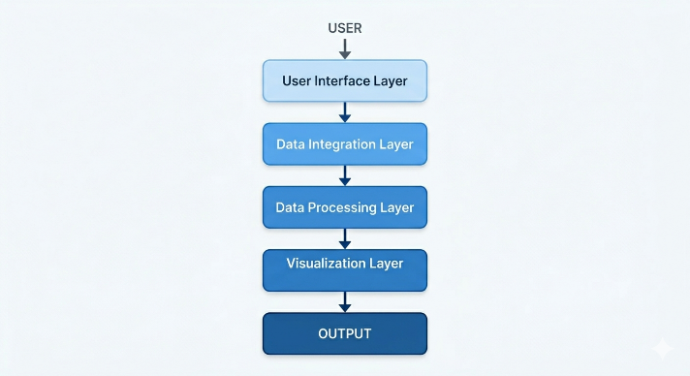

Fig. 1. Layered architecture of the proposed system

A. User Interface Layer

The User Interface Layer is responsible for handling user interactions and rendering visual components such as the navigation bar, stock cards, search functionality, watchlist module, and simulation interface.

Built using React, this layer follows a component-based architecture, enabling dynamic updates and responsive user experience.

B. Data Integration and Processing Layer

The Data Integration and Processing Layer is responsible for fetching, processing, and managing stock market data. The system primarily retrieves stock price data and related information through external financial APIs, enabling near real-time updates and dynamic content rendering.

The fetched data is processed within the application to extract relevant parameters such as price, volume, and time-series values. Filtering mechanisms are applied to allow users to analyse data across multiple timeframes including daily, weekly, monthly, and yearly intervals.

C. Visualization Layer

The Visualization Layer is responsible for transforming processed data into graphical representations. It includes charting modules that display stock trends using line graphs and candlestick patterns.

This layer enables users to interpret market behaviour effectively through visual analytics.

D. Modular Component Design

The system follows a modular design approach where each feature, including chart rendering, data fetching, watchlist management, and simulation, is implemented as an independent component. This enhances scalability and allows seamless integration of additional features such as real-time APIs and analytics modules.

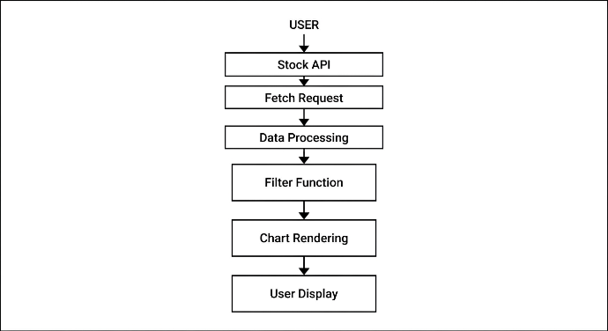

Fig. 2. System Architecture

III. METHODOLOGY

The methodology focuses on transforming raw financial data into meaningful visual insights through a structured processing pipeline. The system follows a sequential workflow involving data acquisition, processing, filtering, and visualization.

A. Data Acquisition

The platform retrieves stock market data through external financial APIs, enabling dynamic and near real-time updates. In addition, CSV-based datasets are maintained for historical data storage and offline access within the information module.

B. Data Fetching and Processing

API requests are initiated from the frontend to obtain stock-related data such as price, timestamp, and volume. The fetched data is processed and structured into a uniform format suitable for analysis and visualization.

C. Data Filtering Mechanism

A flexible filtering mechanism is implemented to enable multi-scale analysis of stock trends. Based on user input, the dataset is dynamically segmented into predefined intervals such as daily (1D), weekly (1W), monthly (1M), and yearly (1Y).

The filtering process extracts relevant subsets of time-series data while maintaining chronological consistency. This allows users to analyse short-term fluctuations as well as long-term trends effectively. The mechanism is optimized to operate efficiently on dynamically fetched datasets, ensuring smooth transitions and responsive visualization.

D. Data Visualization

The processed and filtered data is rendered using graphical components such as line charts and candlestick representations, enabling intuitive interpretation of stock price movements.

E. User Interaction and Modules

The platform supports interactive functionalities including stock selection, search operations, watchlist tracking, and expandable chart views. Additional modules such as financial news representation, simulation environment, and historical data viewer enhance the analytical capabilities of the system.

IV. SYSTEM FEATURES AND FUNCTIONALITIES

The proposed system integrates multiple functional modules designed to provide a comprehensive and interactive stock analysis environment. Each component contributes to enhancing data interpretation, user interaction, and analytical capability.^{[1][2]}

A. Real-Time Data Representation

The platform provides a near real-time analytical interface by dynamically fetching stock-related data from external sources. This enables continuous updates of stock prices and supports responsive visualization of market trends^{[3]}.

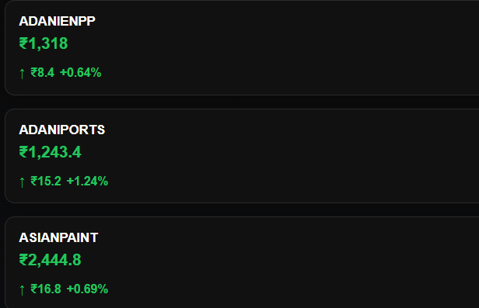

Fig. 3. Data Representation

B. Advanced Charting and Visualization

The system incorporates graphical visualization techniques, including line charts and candlestick representations, to illustrate stock price movements over time.^{[4][5]}

Multi-timeframe filtering allows users to analyse data across various intervals such as daily, weekly, monthly, and yearly views, facilitating both short-term and long-term analysis.

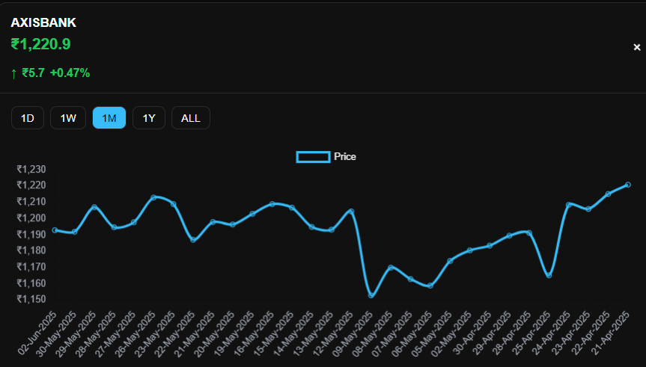

Fig. 4. Price visualisation using chart

C. Financial News Integration

A dedicated news module is integrated to present relevant financial and market-related updates. This feature enables users to correlate stock performance with external economic events, supporting informed analysis and decision-making.

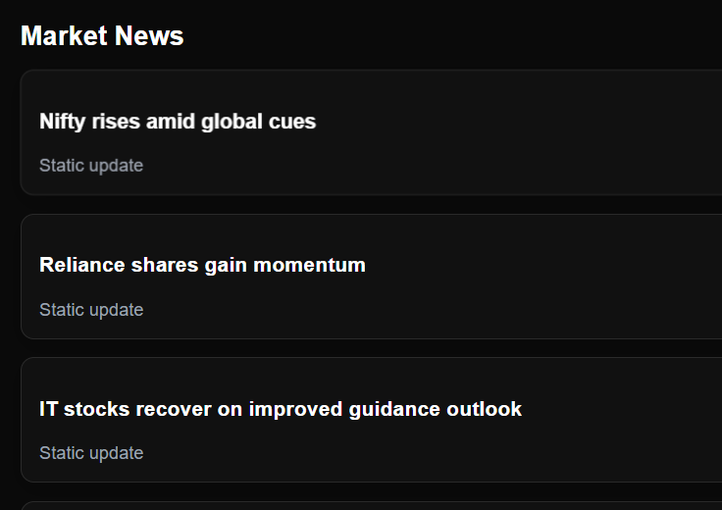

Fig. 5. Dedicated News Feed

D. Watchlist Management System

The platform includes a watchlist component that allows users to monitor selected stocks in a centralized interface. This feature enhances usability by enabling quick access to frequently tracked assets.

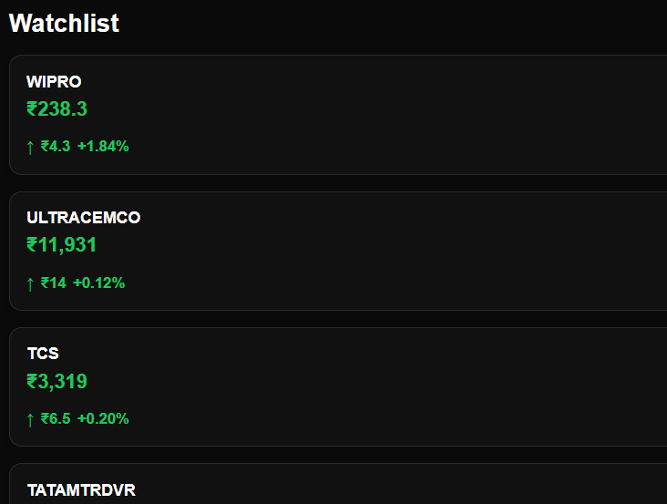

Fig. 6. Watchlist

E. Historical Data Access and CSV Support

The system provides access to historical stock records in CSV format, allowing users to view detailed tabular data and perform offline analysis. This enhances transparency and supports data-driven exploration^{.[8][9]}

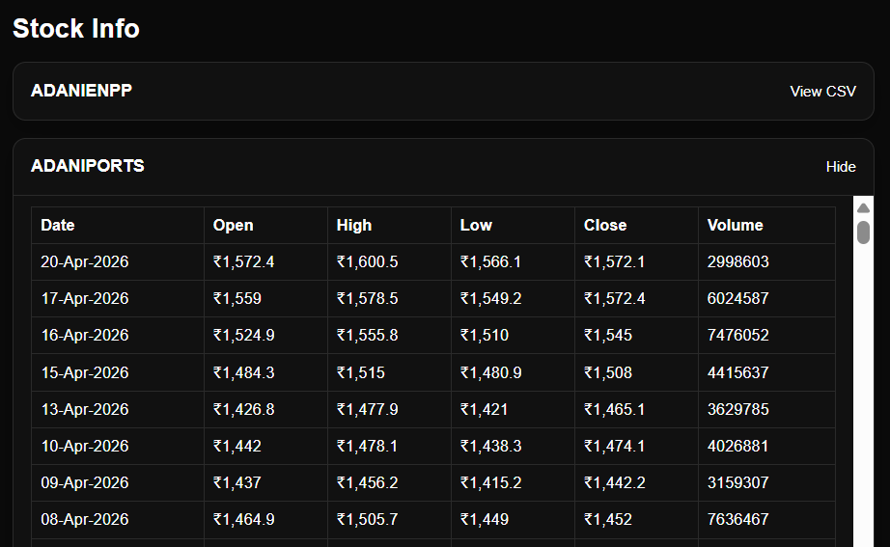
Fig. 7. Access to Historic Data

F. Stock Simulation Environment

A simulated trading module is incorporated to provide a risk-free environment where users can experiment with stock selection strategies using virtual capital. This feature is particularly useful for beginners to understand market behaviour and decision-making processes.

G. User Interface and Experience Design

The platform serves a clean and intuitive user interface, incorporating responsive layouts, smooth transitions, and interactive components. The design ensures efficient navigation and enhances the engagement^{[10]}.


Fig. 8. Navigation Bar

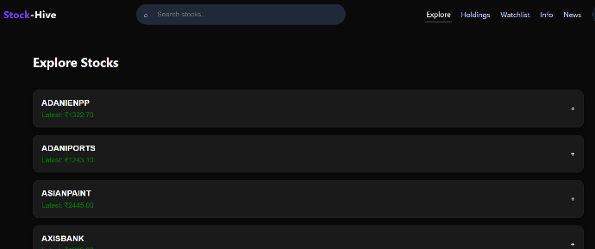

Fig. 9. Home-page

H. Modular and Scalable Design

The system follows a modular architecture where individual components such as data fetching, visualization, and user interaction are independently structured. This approach improves scalability, maintainability, and future extensibility of the platform.

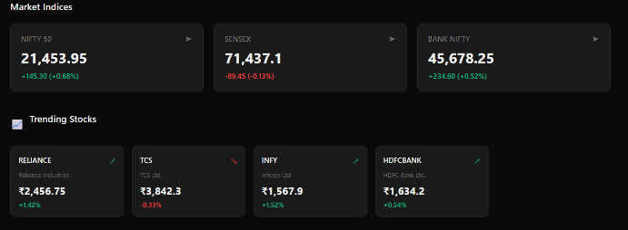

Fig. 10. Customisable Dashboard

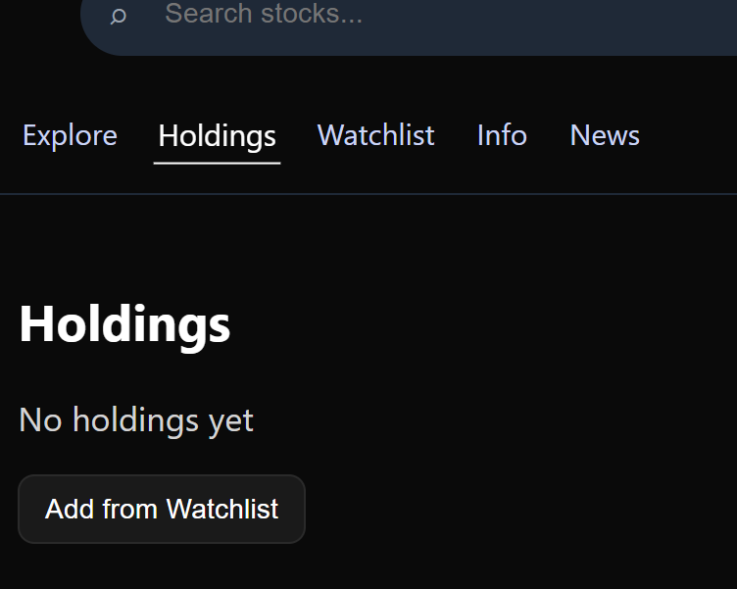

Fig. 3. Holdings Section

V. RESULTS AND ANALYSIS

The developed system successfully demonstrates the ability to visualize stock market data in an interactive and user-friendly manner. The platform enables dynamic representation of stock price movements through graphical components, allowing users to explore trends across multiple timeframes. The integration of data fetching mechanisms ensures responsive updates, while the modular design supports smooth interaction across different components of the system.

The implemented filtering mechanism plays a key role in enhancing data interpretability by enabling multi-scale analysis of stock trends. Users can efficiently analyse short-term fluctuations as well as long-term patterns, improving their understanding of market behaviour. Additionally, the combination of visualization, news representation, and simulation features contributes to an overall intuitive and engaging analytical experience.

VI. CONCLUSION

The proposed system demonstrates an effective approach to visualizing and analysing stock market data through an interactive and user-centric platform. By integrating dynamic data representation, multi-timeframe filtering, and modular design, the system provides a comprehensive environment for understanding market trends.

The combination of visualization, news integration, watchlist tracking, and simulation features enhances both usability and analytical capability. The platform serves as a foundation for further development, with potential extensions including real-time API integration, advanced analytics, and personalized user features.

VII. ACKNOWLEDGEMENT

The authors would like to express their sincere gratitude to their project guide and faculty members for their valuable guidance, support, and encouragement throughout the development of this work.

The authors also acknowledge the department and institution for providing the necessary resources and infrastructure required for the successful completion of this project.

Finally, the authors would like to thank all team members for their collaboration, dedication, and contributions that made this work possible.

VIII. REFERENCES

[1] React Documentation, “React – A JavaScript library for building user interfaces,”
Available: https://react.dev/

[2] Chart.js Documentation, “Chart.js – Simple yet flexible JavaScript charting,” Available: https://www.chartjs.org/docs/latest/

[3] PapaParse Documentation, “PapaParse – Powerful CSV parser for JavaScript,” Available: https://www.papaparse.com/docs

[4] National Stock Exchange of India, “NSE India Official Website,” Available: https://www.nseindia.com/

[5] Bombay Stock Exchange, “BSE India Official Website,” Available: https://www.bseindia.com/

[6] Yahoo Finance, “Stock Market Data Platform,” Available: https://finance.yahoo.com/

[7] Investopedia, “Stock Market Analysis Concepts,” Available: https://www.investopedia.com/

[8] Alpha Vantage, “Free Stock Market API for Real-Time and Historical Data,” Available: https://www.alphavantage.co/

[9] Finnhub, “Financial Market Data API,” Available: https://finnhub.io/

[10] Twelve Data, “Stock Market API for Real-Time and Historical Data,” Available: https://twelvedata.com/

[11] Data Visualization Catalogue, “Guide to Data Visualization Techniques,” Available: https://www.data-to-viz.com/

[12] IEEE, “IEEE Paper Formatting Guidelines,” Available: https://www.ieee.org/conferences/publishing/templates.html

[13] P. Somani, S. Talele, and S. Sawant, “Stock Market Prediction Using Hidden Markov Model,” in IEEE 7th Joint International Information Technology and Artificial Intelligence Conference, 2014.

[14] D. Bhuriya, G. Kaushal, A. Sharma, and U. Singh, “Stock Market Prediction Using Linear Regression,” in International Conference on Electronics, Communication and Aerospace Technology (ICECA), 2017.
[15] D. Bhuriya, G. Kaushal, A. Sharma, and U. Singh, “Survey of Stock Market Prediction Using Machine Learning Approach,” in International Conference on Electronics, Communication and Aerospace Technology (ICECA), 2017.

[16] Stock Price Predictor, “Stock Price Predictor,” Available: GitHub repository.

[17] V. K. S. Reddy, “Stock Market Prediction Using Machine Learning,” International Research Journal of Engineering and Technology (IRJET), vol. 5, no. 10, 2018.

