Multi-Agent Collaboration for Multimodal Storytelling: A Creative AI Framework for Comic and Audio-Visual Narrative Generation

INTRODUCTION
Advancements in generative artificial intelligence in the recent past have facilitated high-fidel content generation on text, image, and audio content. Large language models and diffusion systems yield stunning outputs, but it is mentioned that their application into more coherent storytelling models is technically challenging. The most common barrier is the cross-modality coherence, i.e., the visual and auditory product should comply with the textual restrictions. The current pipelines are characterized by character drifts and time gaps which produce fragmented artifacts which break the immersion. Moreover, conventional measures often do not reflect the narrative alignment subtleties.This paper suggests a multi-agent model that employs an expert-critic paradigm to overcome such drawbacks. The system resembles the workflow collaboration of humans through assigning specific agents to particular tasks such as narrative
planning and sensory synthesis. One of the central critic agents repeatedly checks inter-agent consistency, and feedback is given to improve the outputs, until semantic consistency is met.
A. Key Contributions of This Work
Multi-Agent Storytelling Framework: We propose a new multi-agent system based on story generation. The various agents are designed to accomplish a certain modality or task: a text-generation agent (LLM) writes the story; a voice agent (TTS) performs expressive narration; a vision agent (text-to- image/video) creates matching illustrations or animation; and an audio agent creates background music. A general manager mediates their communication. The design is based on the fact that recent systems such as MM-StoryAgent and AgentStory have shown that rich multimodal stories can be generated by coordinated LLM-based agents.
Structured Narrative Planning: Our system integrates classic storytelling theories into the workflow of its agents to enhance their storytelling coherence and involvement. Indicatively, plot planning agent relies on the five-act dramaturgical model proposed by Freytag and functions by Propp to describe dramatic lines. Agents write in stages by brainstorming about the story, outlining the story, and later writing out expanded chapters. This collaborative and multi- turn writing (analogous to the multi-stage pipeline of Xu et al.) assists in adding conflict, pacing, and resolution to the writing, producing richer and more structured plots.
Immersive Multimodal Output: Our system integrates classic storytelling theories into the workflow of its agents to enhance their storytelling coherence and involvement. Indicatively, plot planning agent relies on the five-act dramaturgical model proposed by Freytag and functions by Propp to describe dramatic lines. Agents write in stages by brainstorming about the story, outlining the story, and later writing out expanded chapters. This collaborative and multi- turn writing (analogous to the multi-stage pipeline of Xu et al.) assists in adding conflict, pacing, and resolution to the writing, producing richer and more structured plots. Immersive Multimodal Output: Our platform closely combines text-based story with synchronized multimedia. The individual story lines are automatically turned into animations and audio. Practically, with a narrative chunk, the vision agent creates (or animates) the scene with the right

characters (according to role-based prompts), the narrator agent reads aloud and the music agent creates corresponding soundtrack. Co-ordinating text-to-speech, text-to- image/video, and text-to-music output enables the system to come up with a seamless multimedia story.
Collectively these elements provide a powerful system of collaborative multimodal storytelling. Our method enables us to produce rich, narrative, videos and audio-visual stories by using a number of different AI agents and combining their complementary knowledge to overcome the critical failures of single agent or single mode solutions. This production leads to more adaptive, interactive educational narrative tools, in which AI agents collaborate to generate creativity and learning.

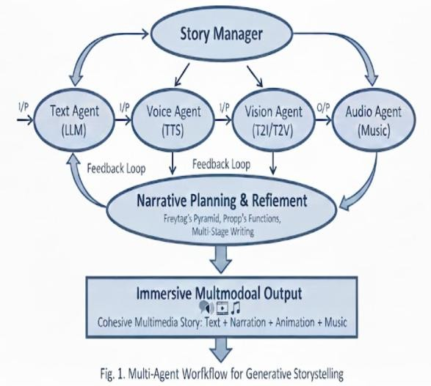

MM STORY AGENT
The Multi Modal Story Agent (MM-StoryAgent) adopts a multi-agent pipeline approach to produce coherent and multi modal stories collaboratively. The system coordinates production of specialized agents, namely, a TextAgent, that would produce the structure of the narrative (screens, dialogue, character arcs), etc. one ImageAgent, creating the consistent illustrations, AudioAgents, creating narration, sound effects and music, and finally, one Video Agent that would put the whole media together. A CritiqueAgent compares the output of a cross-module with a coherence score and may trigger an iterative refinement cycle after this comparison (e.g. re-writing or regenerating inputs) until the coherence score is high enough. The coherence measure we use is a quantitative one which includes cross-modal coherence (text-image, etc. similarity) and emotion/style consistency. It can be extended with pipelines: data flow between agents is standardized using the JSON format, and new elements can be easily added to it (such as the different TTS engine, or an image generative component). The pipeline is in favor of several output formats. It forms a series of illustrated box panels and captions in comic presentation. All pictures are synchronized with the generated voiceover and music in the VideoAgent in the narrated video mode, a picture of each scene is displayed while it is being narrated (with very minor camera pan/ zoom effects), the appropriate sound effect is overlaid and background music is played throughout. There is continuous flow with the help of scene transitions (e.g. fades or slides). The all-modalities
created-in-parallel end-to-end approach is what results in creating an immersive story experience.
- Attractiveness-Oriented Story Agent
The TextAgent is a multi-stage, creative workflow story composer. The first one is brainstorming, which is simulated as a conversation between an expert/story-consultant and a novice writer. Each turn the beginner inquires about the characters, themes or twists of the plots and the expert gives hints, or asks questions. This view-based Q&A (based on multi-perspective view question asking of STORM) reveals all the rich story information and explains objectives. An example would be that, a specialist would question why a lonely robot dreams and how it alters its perception of the world because of the dream. This discussion helps to remove misconceptions and contribute to the innovations. Based on the final discussion, the agent puts together a sequence of crucial events and scenarios. The brainstorming data is fed to an Outline module, which then takes the data and puts it in a logical sequence of beats (story points, conflicts, etc.). From this, an outline is created which is then completed in narrative text by a chapter-level writer. Continuity is maintained by creating each scene or chapter sequentially (conditioning on the previous one(s) being created). This is a planned process which is staged, with the use of question and answer planning, outline writing followed by sequential writing to result in a well structured story that meets the prompt as required by the user.

- Modality-Specific Agents
Once the narrative text has been complete, there are specific agents that create the multimodal assets:
Image Agent: The ImageAgent creates an illustration on each scene. It filters the text in the scene and removes the non-visual parts of the text, such as inner thoughts, sounds, and others, so that it focuses on the setting, action, and character description. The agent does role extraction, which means he/she first identifies all key characters, and then assigns them given attributes (e.g. a young girl with green eyes, red scarf) that are present in all the prompts. Similar to AgentStory, which creates detailed consistent descriptions of subjects using LLM agents. The results are then fed into the state-of-the-art diffusion model (e.g. Stable Diffusion XL or StoryDiffusion) to generate the images of the scenes. Audio Agents: Spoken Narration, Sound Effects, Music are the 3 channels of Audio generation, provided by Audio Agents. The Speech Agent reads the input narration of the story text and outputs the narration with expression using a high-quality TTs model (e.g., voice cloning based on ElevenLabs or open source CosyVoice). Simultaneously, a Sound Effect Agent takes action cues out of the text (e.g. thunder crashes, footsteps approaching), and with the help of a model such as AudioLDM 2 (or retrieved samples) generates the corresponding sound effects. A Music Agent perceives the emotional context of the situation (i.e. suspenseful, happy) and recreates background music with help of a model such as MusicGen or finds appropriate songs. The quality of each audio prompt can be (iteratively) refined, to correspond to the emotion of the story.
Video Composition Agent: The VideoAgent is a tool for merging all the video assets to create the complete storytelling video. It matches every image with its narration clip of a piece of narration of t seconds, it displays the image

of the scene of t seconds (with a slight effect of pan/zoom Ken Burns). The sound effect of the scene is superimposed throughout that time and the selected piece of music plays on in the background. Scenes (e.g. crossfades or slides) give a continuity between scenes. The result is a video (or animated slideshow) of stories that are visually cohesive and synced in time with the music and voice, and also emotionally coherent.
On the whole, it is a modular architecture: it is possible to add new modalities or alternative models by plugging in new replacement agents. More importantly, MM-StoryAgent can achieve alignment and consistency without having to fine- tune large models - it works by using intelligent prompting and feedback. MM-Story Agent provides high quality stylistically-coherent multimodal stories by using multi-agent generation coupled with automated critique.
The CritiqueAgent computes a Multimodal Coherence Metric (MCM) that is the average of four metrics: text– image alignment (0.30), sentiment alignment (0.25), style consistency (0.25), and temporal consistency (0.20). Each dimension is scaled to [0, 1] and selective regeneration is done - if the score of the given dimension is lower than the coherence threshold, then it is re-queued for regeneration, rather than repeating of the entire pipeline.
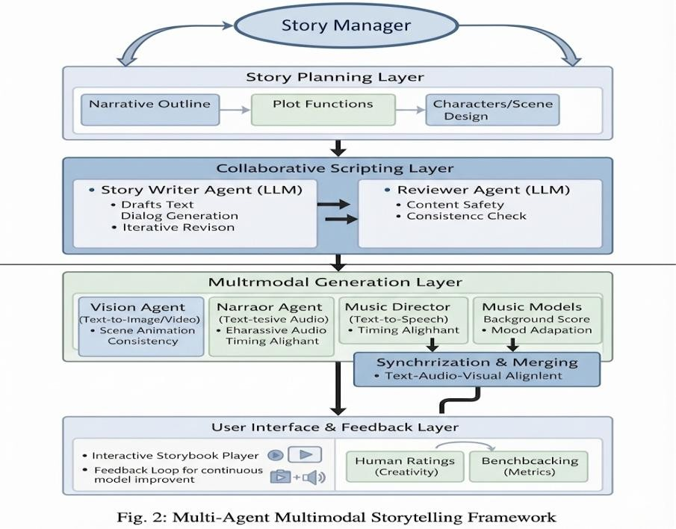

EXPERIMENT AND EVALUATION
- Experimental Setup
A benchmark protocol was used to test the proposed AMNO framework using 50 prompts across the three story types: Narrated videos, comics, and educational explainers. There are three parts to each prompt: target style, target format, and target duration. For comparison, the following two modes of generation were used: Base line mode: No critique-loop refinement, linear pipeline single pass mode. Full AMNO mode: Whole pipeline of critique-refine and selected modality regeneration. A set of records
accompanying each run record the random seed, prompt ID, generation mode, generated artifacts, number of iterations, critique score, and output manifests which supports the reproducibility. To test the entire software pipeline without paying for API usage, a deterministic offline mode was added, that consists of template-based story generation and the generation of local scene-card images, synthetic audio tones, local video composition, as well as heuristic critique scoring
- Evaluation Metric
Multimodal Coherence Metric (MCM): The MCM is a weighted sum of four dimensions, which is used to measure multimodal alignment.
MCM = 0.30 × (Text–Image Alignment) + 0.25 × (Sentiment Alignment) + 0.25 × (Style Consistency) + 0.20
× (Temporal Consistency)
The components are normalized in the range [0, 1]. Apart from the MCM score, the Critique Agent also provides a score which corresponds to coherence, which is given at the scene level ranging from 0-1, with higher scores indicating higher multimodal alignment.
- Offline Pilot Results
At this time the only option for paid API access is to run a deterministic offline pilot on three benchmark prompts yielding six full runs, both modes. The summary of the results is given in table.

Metric | Baseline | Full AMNO | Efficiency Gain
Mean critique | 0.79 | 0.91 | +0.12
Success | 3/3 | 3/3 | No failures
W / T / L | — | 3/0/0 | All pairs improved

The AMNO Improvement Mean critique score is 0.79, there were three successful runs, three pairs successful and no failures.The number of successful runs is 3/3, the number of pairs that are successful are 3/3, and the number of failures are 0/3, the AMNO Improvement Mean critique score is
0.79. Full AMNO mode resulted in an average gain of 0.12 (or a 15.19% relative gain from the baseline) in the heuristic critique score across all three sets of prompts compared to the baseline. In the deterministic offline situation, the findings support the coherence of the framework's internal coherence signal's successful implementation of the critique and refine loop.
- Limitations
This study will be evaluated as a workflow validation study, rather than a full generative model benchmark. Heuristic critique scores are measures of internal consistency and may not be a true reflection of the subjective human perception of the quality of the narrative. Experiments based on the API may face challenges in terms of nondeterminism and rates limits by the external model providers. Human qualitative judgment is still needed for the MCM scores to be predictive of real human judgment of quality.

RELATED WORK
Large Language Models
Large-scale language models (LLMs) are very successful in their performance and generalization abilities because they are pre-trained with a large mass of language. As an example, the LLaMA models (Touvron et al., 2023) prove the idea that a model of 13B parameters can outperform GPT-3 on various tasks. These LLMs are generally widely learned and are accomplished in a variety of language tasks. LLMs are being used more frequently to do creative writing and storytelling by the researchers. One is STORM (Shao et al., 2024), which uses an LLM to generate Wikipedia-style articles but just fine-tunes a foundation LLM in this instance, with a specific focus on writing a creative story. Multi-agent systems with LLMs as brains This is also being applied as the brain for the HuggingGPT (2024) system, which plans tasks with an LLM and calls external tools, or the Autogen (2023) system, which uses an LLM as a conversational agent that breaks down tasks into sub-tasks between tools. In both cases the LLM decomposes the complex tasks into simple delegation to other modules – central planners. Here are a few examples of ways that artists could structure the work of an LLM and employ various tools. Significant new systems are:
- STORM (Shao et al., 2024): An LLM which is an automatically written system which writes articles in style of Wikipedia. >A foundation model and its fine-tuning on creative and narrative writing tasks.
- The HuggingGPT (Shen et al., 2024): This is one type of agent architecture where an LLM brain breaks down the user's request and delegates it to an external AI. Description: This approach involves a multi-agent conversational platform, which utilizes an LLM to devise sub-tasks and allocate them to multiple agent tools.
These are some of the works we are using to inspire our design of an LLM-based story agent which interpolates the textual story and other modality-specific generators. The advancements of continuous data (images, audio etc.) Generative modeling have also been high.
The first algorithms like Variational Autoencoders (Kingma and Welling, 2013) and Generative Adversarial Networks (Goodfellow et al., 2014) provided an effective architecture for learning to learn complex distributions. Also, Resende and Mohamed (2015) suggested to use normalizing flows to create arbitrarily complex posterior to boost the flexibility of generative models. The new best models, however, are diffusion models: models that are refined by repeatedly denoising random noise, which result in extremely diverse and high-quality examples. The pipelines based on diffusion are already dominant in image, video, and audio synthesis. In fact, latent diffusion generators (e.g. Stable Diffusion), or even the Imagen Video (Ho et al., 2022) model are able to produce state-of-the-art high-resolution image generation, whereas a cascade of video diffusion models can produce multi-second high-quality videos when using text prompts (Imagen Video). They also have been used for audio, such as Grad-TTS (Popov et al., 2021) or AudioLDM (Liu et al., 2023) generating speech and music from text descriptions. Recent approaches in this vision research are based on consistency between frames: StoryDiffusion (Zhou et al., 2024) and DreamStory (He et al., 2024) propose self-
attention mechanisms that ensure accurate character identity and style in a series of generated images. For the most part, at the moment, the generative experts are:
Image synthesis: Image synthesis Latent diffusion models (e.g. Stable Diffusion): Models that have state-of-the-art high resolution image synthesis.
Video synthesis Video Generators: Diffusion based video generators (such as Imagen Video) that can convert text inputs into short high definition videos. On-text high realism audio generation models: Audio synthesis Speech and music diffusion models (e.g. Grad-TTS, AudioLDM) that can generate high-realism audio on-text. AI| Specialized diffusion models that guarantee consistent appearance across story images of characters and scenes across a sequence of story images Storybook consistency Storydiffusion Dreamstory Diffusion models that are optimized to maintain the appearance of characters and scenes across a sequence of images of a story.
These modality specific models are our story experts in MM-StoryAgent, where units of the story are generated (goods speech, music, sound effects and images). The story parts are converted to prompts for the right agent, and the assets created into a running, narrated video. This is possible due to the modular nature of our system whereby any component (e.g. an image or audio generator) can be upgraded into a more advanced model in the future and hence with time the overall quality of the storybook videos will keep on improving.

CONCLUSION
We have proposed a multi-agent coherent multimodal narrative generation system, AMNO, in this paper. The system provides a common scene-node representation to coordinate and link text, image, audio, video and critique agents and an iterative refinement process in a closed loop. The framework makes it more efficient and explainable than end-to-end regeneration methods and it is able to select incoherent modalities for targeted regeneration by using the critique-and-refine mechanism. It was not a trivial matter, so it was check-off-line with a deterministic pilot program and it turned out that the entire AMNO mode has led to an internal critique score improvement of 15.19% from 0.79 to
0.91 (no pipeline failures). This is a deterministic off-line pilot to validate the AMNO framework and provide an example experiment that can be repeated in future with the help of API-based and human evaluation. Future work will involve the following: (1) running the 50-prompt benchmark with real generative models; (2) blindly feeding it to human subjects for coherence rating; (3) calculating the correlation between MCM scores and coherence ratings by human subjects; (4) extending the framework to be used for interactive story editing; and (5) making generative process cheaper, by making better use of which aspects to regenerate for each prompt. In summary, AMNO provides a practical and reproducible framework for researching the multimodal coherence of AI-generated narratives and lays the groundwork for future empirical studies on a large scale.

Acknowledgment
I would like to express my sincere gratitude to Geetika Sharma ma’am for her invaluable guidance and support throughout this research. Her insights and encouragement were instrumental in the successful completion of this project. Additionally, I acknowledge the resources provided by Galgotias University which greatly facilitated my research efforts.
References
- Y. Zhang et al., “MM-StoryAgent: A Multi-Agent Framework for Multimodal Storytelling via Agent Communication,” arXiv preprint arXiv:2503.05242, 2025.

- H. Liu et al., “Role-Based Narrative Control for Story Generation with Large Language Models,” in Proc. Findings of the Association for Computational Linguistics: EMNLP, 2025, pp. 1–12.

- A. Kumar et al., “Automated Story Generation: Evaluating the Effectiveness of Large Language Models,” arXiv preprint arXiv:2511.13476, 2025.
- J. Copet et al., “Simple and Controllable Music Generation,” arXiv preprint arXiv:2306.05284, 2023.

- C.Huang et al., “Make-An-Audio:Text-to-Audio Generation with Prompt-Based Control,” arXiv preprint arXiv:2306.05284, 2023.

- Emergent Mind, “Multimodal LLM-Driven Iterative Refinement,” [Online].Available:https://www.emergentmind.com/topics/multimodal-llm- driven-iterative-refinement

- Y. Wang et al., “Pretrained Multimodal Models for Structured
Information Integration,” arXiv preprint arXiv:2402.14207, 2024.
- Milvus AI, “Common Evaluation Metrics for Multimodal AI Systems,” [Online].Available:https://milvus.io/ai-quick-reference/what-are-some- common-evaluation-metrics-for-multimodal-ai

- S. Hong et al., “Large Language Models as Multi-Agent Planners,” in Proc. EMNLP, 2023, pp. 1–12.

- D. P. Kingma and M. Welling, “Auto-Encoding Variational Bayes,”in
Proc. Int. Conf. Learning Representations (ICLR), 2014.

- I. Goodfellow et al., “Generative Adversarial Nets,”
in Proc. Adv. Neural Inf. Process. Syst. (NeurIPS), 2014, pp. 2672–2680.

- D. Rezende and S. Mohamed, “Variational Inference with Normalizing Flows,”arXiv preprint arXiv:1505.05770, 2015.

- R. Rombach et al., “High-Resolution Image Synthesis with Latent Diffusion Models,”in Proc. IEEE Conf. Computer Vision and Pattern Recognition (CVPR), 2022, pp. 10684–10695.

