Impact of Exchange Rate Fluctuations on India’s Import and Export Sector

ABSTRACT
This study examines the impact of exchange rate movements on India’s import and export sectors. Using secondary data from RBI (Reserve Bank of India), EXIM (Export Import) Bank, government reports and research journals, this study finds out that Rupee depreciation improve export-oriented sectors like IT, textiles and agricultural sectors by making Indian products and services competitive in global market. However, import-dependent industries like petroleum, electronics, gems and jewellery face increasing costs, inflation, and higher debt burdens. This research highlight the role of factors like inflation, interest rates and geopolitical tensions in exchange rate fluctuations. This study recommends hedging strategies, domestic substitutes, MSME support and Rupee internationalization to reduce dependency of international currency like Dollar.
Key Words: Exchange rate, Fluctuation, Inflation, Currency, Depreciation, Appreciation, Export, Import.

INTRODUCTION
- Background of the Study: The study focus on the impact of exchange rate on the domestic Import and Export sectors. Study also highlights that how Reserve Bank of India (RBI) actively manages it. Depreciation of Rupee in context of Dollar causes inflation, trade deficit, make import expensive and business profitability.

- Problem Statement: Study find out that depletion in Rupee causes trade deficit and outflow of foreign currency. More outflow of foreign currency causes sever inflation and demand imbalance in India. RBI perform active role in managing exchange rate, but the impact is only for a short period.

- Objectives of the Research: India is a heavily import dependent country on many commodities like crude oil, gold, semi-conductors, etc. A developing economy just like an India, deeply integrated with the global financial markets or global trade. A negative swing in the exchange rate create challenges and problems for many sectors like a aviation & airlines, oil or refining companies, auto ancillaries (selected segment), paints & chemicals, gold or pharma.
Objective of the research is to identify domestic substitutes so that dependence on foreign market can be minimized and find out the ways to eliminate the negative effect of exchange rate fluctuations.

RESEARCH METHODOLOGY
The study is based on secondary date collected from Reserve Bank of India (RBI), Ministry of Commerce and Industry, Research Journal, Government Reports, Economic times, EXIM Bank Reports.

LITERATURE REVIEW
A study published in the International Journal of Novel Trends and Innovation (IJNTI) in 2026 states that the impact of exchange rate fluctuations differs from one industry to another. Industries like petroleum, they depend mostly on imported raw materials i.e. crude oil. They are more affected during time of Rupee depreciation because their production costs rise quickly. In contrast, sectors like IT and textiles gain some advantage because they depend very little on imported materials and can sell their outputs more competitively in global markets. The study also focus that if a continuous currency fluctuations exist, then it creates uncertainty for MSMEs, as many smaller firms do not have proper financial tools to manage exchange rate risks.
Similarly, research done by N. Sohrabji (2024) points out that exchange rate fluctuations influence India’s trade pattern unevenly. India still relies heavily on imported machinery, capital goods, and infrastructure equipments. These things cannot be easily replaced by domestic production. Therefore, a weaker Rupee increases import costs and increases the trade deficit in current account. On the other hand, when the Rupee appreciates, Indian exports become relatively expensive for foreigners in international markets. Due to this appreciation in Rupee, foreign buyers shift to cheaper alternatives offered by other emerging economies. This will gradually reduce the India’s export earnings.

OVERVIEW OF INDIA’S TRADE DYNAMICS (from Financial Year April 01, 2016- March 31, 2017 to April 01, 2025- March 31, 2026)

Table Reference: Economic Times of India
Financial year (FY) | Goods + Services Exported (in Billions) | Goods + Services Imported (in Billions) | Trade Deficit (in Billions) | Average Dollar rate per Rupee
FY 2016-2017 | $ 442.15 | $ 487.81 | $ 45.66 | $ 67.10
FY 2017-2018 | $ 498.61 | $ 583.11 | $ 84.50 | $64.50
FY 2018-2019 | $ 538.90 | $ 631.29 | $ 93.22 | $ 69.89
FY 2019-2020 | $ 528.45 | $ 598.61 | $ 70.16 | $ 70
FY 2020-2021 | Major impact of Covid-19
FY 2020-2021 | $ 493.19 | $ 505.94 | $ 12.75 | $ 74.20
FY 2021-2022 | $ 676.53 | $ 760.06 | $ 83.53 | $ 74.50
FY 2022-2023 | $ 770.18 | $ 892.18 | $ 122 | $ 80.39
FY 2023-2024 | $ 778.21 | $ 854.80 | $ 76.59 | $ 82.80
FY 2024-2025 | $ 820.93 | $ 915.19 | $ 94.26 | $ 84.60
FY 2025-2026 | $ 860.09 | $ 979.40 | $ 119.30 | $ 90

CAUSES OF EXCHANGE RATE FLUCTUATION
Exchange rate fluctuation is mainly derived by demand and supply of currency. If people demand more currency then the value that currency will appreciate (increase) and if people sell currency the value of that currency will depreciate (decrease). The primary reason that shift this demand and supply cab be categorized into economic, financial and geopolitical factors. The key derivers are mentioned below

- Inflation:
A country having a lower inflation rate usually has a strong currency than other countries. This happens because the purchasing power of the people is high. On the other side, if a country faces high inflation, the value of its currency depreciates because the purchasing power of the people falls.

The data below outlines the Average Annual Inflation Rate (CPI) alongside the Average USD to LKR Exchange Rate (LKR is the currency of Sri Lanka) covering the periods from 2019 through early 2022.

Inflation and USD/LKR Exchange Rate Table (2019 – 2022)

Year | Average Annual Inflation Rate (CPI) | Average Exchange Rate  (USD to LKR)
2019 | 3.53 % | 178.50 LKR
2020 | 6.15 % | 185.50 LKR
2021 | 7.01 % | 198.00 LKR
2022 | 49.72 % | 325.00 LKR

In 2022, Sri Lanka declared a sovereign default. Rising fuel and food prices caused hyperinflation in the country.

- Interest Rate:
When the Reserve Bank of India increases its repo rate (Repurchase Agreement rate), borrowing for commercial banks becomes more costly. Therefore, instead of borrowing money from the RBI, banks prefer to attract funds from the public. To encourage people to save money in banks, banks offer higher interest rates on deposits and savings accounts. As a result, deposit interest rates increase.
Foreign investors are then attracted to invest their money in India because they receive better returns compared to many other countries. They bring more dollars into India and purchase Indian rupees. This increases the supply of dollars and create demand for rupees, this leading to an appreciation of the rupee (making it stronger).
On the other hand, if the RBI decreases its repo rate, foreign investors may no longer find India as attractive for investment because other countries may offer better investment opportunities. In that situation, they sell rupees and demand dollars. This increases the demand for dollars and leads to the depreciation of the rupee.
Therefore, the RBI manages interest rates carefully to maintain a balance in the exchange rate while also ensuring that borrowing does not become too difficult for domestic borrowers. The impact of change in Repo rate is illustrated given below:

RBI Action | Foreign capital | Demand for INR (₹) | Exchange Rate Impact
Repo Rate Hike | Inflow (Money enters) | Increases | Appreciation (Rupee gets stronger)
Repo Rate Cut | Outflow (Money leaves) | Decreases | Depreciation  (Rupee gets weaker)

- Economic Growth Rate:
GDP growth reflects the fundamental health, productivity, and competitiveness of an economy. If a country’s GDP increases, global corporations and institutional investors consider that country more attractive for investment. As a result, they invest in that country and establish factories and businesses there. To take advantage of these opportunities, they convert their foreign currency into the domestic currency of the growing economy. This increases the supply of foreign currency and raises the demand for the domestic currency. As a result, the domestic currency goes appreciates against foreign currencies.
However, higher GDP growth does not always guarantee the appreciation of the domestic currency. In certain circumstances, it may create the opposite effect. Due to higher GDP growth, the purchasing power of people in the country increases, and they may spend more on imported goods and services. For this purpose, they convert domestic currency into foreign currency. This can lead to a current account deficit.
That is why the Reserve Bank of India uses a managed floating exchange rate system to maintain stability in the economy.

- Current Account Balance:
The current account balance and foreign exchange fluctuations are directly linked to the principle of demand and supply of currency. There are three forms of the current account: current account deficit, current account surplus, and balanced current account.
A current account deficit occurs when expenses or payments on imports exceed the total net income earned from exports, investments, and transfers. In this situation, the demand for foreign currency increases, which leads to the depreciation of the domestic currency. Under such conditions, the country is considered a debtor to the rest of the world.
On the other hand, a current account surplus occurs when the total net income from exports, investments, and transfers exceeds the total payments made on imports. In this situation, foreigners demand more of the domestic currency, which leads to the appreciation of the domestic currency. In this case, the country is considered a creditor to the rest of the world.

- Political Stability:
Political stability encourages the international investors’ confidence. Political stability assures global investors that their assets are safe, profitable, and predictable. A sudden change in government due to civil unrest, widespread corruption, or scandals can create fluctuations in the foreign exchange market. In such situations, global investors feel insecure about their investments and often engage in panic selling of assets such as bonds and stocks. Investors convert their invested currency into safer currencies such as the US Dollar and the Swiss Franc. A sudden increase in the supply of domestic currency leads to its depreciation. On the other hand, a stable government attracts new global investors and Foreign Direct Investment (FDI). Investors purchase land, establish factories, and acquire domestic companies because they believe that there will be no sudden changes in tax structures, trade agreements, or foreign policies in the future. For all these activities, they require domestic currency. Therefore, they convert their foreign currency into domestic currency, which increases the demand for the domestic currency and, as a result, leads to its appreciation.

- Geo-political conflict:
Geopolitical conflicts and tensions have a direct and deep impact on exchange rate fluctuations. During situations of wars or political tensions, severe sanctions may be imposed by other countries, which disrupt the flow of capital and the supply of goods and services. Investors feel risk and often engage in panic selling of their investments. They prefer to convert their money into safe-haven currencies such as the United States Dollar (USD), Swiss Franc (CHF), and Japanese Yen (JPY). Due to the sudden increase in demand for these currencies, their values appreciate significantly.
Case illustration – Ukraine–Russia War (February 2022)
During Russia’s invasion of Ukraine, several Western countries imposed sanctions on Russia. Billions of dollars of Russian funds were frozen by these countries. As a result, the value of the Russian Ruble fluctuated sharply, moving from an average of around 75 Rubles per USD to nearly 130–140 Rubles per USD at one point. This happened because both Russian citizens and global investors engaged in panic selling of their investments and shifted their funds into safer currencies such as the USD. This situation represented a sharp depreciation of the Ruble.
At the same time, the Euro (EUR) also depreciated against the USD because many European countries were heavily dependent on Russia’s natural gas supply.

TRENDS IN INDIA’S EXPORTS
In financial year 2025-2026, the total export was recorded at 860.09 billion Dollars. A quick summary of all exported commodities and services is illustrated by Pie chart, is given below:
The Export of Merchandise in Financial year 2025-2026 was $ 441.28 billion. The key drivers of Export were Gems & Jewellery (7.0%), Drugs & Pharma (8.0%), Electronics (12.0%), Petroleum Products (18.0%), Engineering Goods (26.0%), Others (29.0%). (Figure 6.1)

The Export of Services in Financial year 2025-2026 was $ 4181.28 billion. The key drivers of Export were Professional/Consulting (8.0%), Travel (10.0%), Business Services (GCC) (25.0%), Software & IT (48.0%), others (9.0%) (Figure 6.2)

Composition of Merchandise Exports (FY 2025-2026) (Figure 6.1)
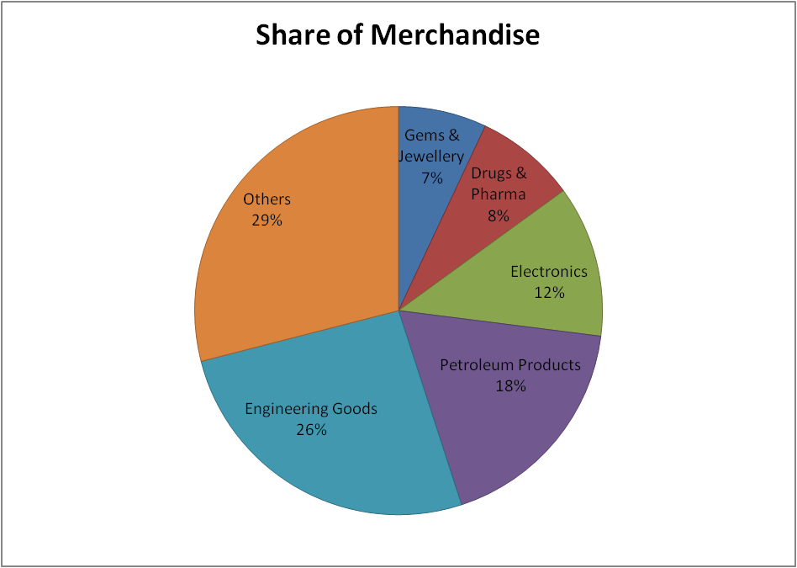

Composition of Services Exports (FY 2025-2026) (Figure 6.2)
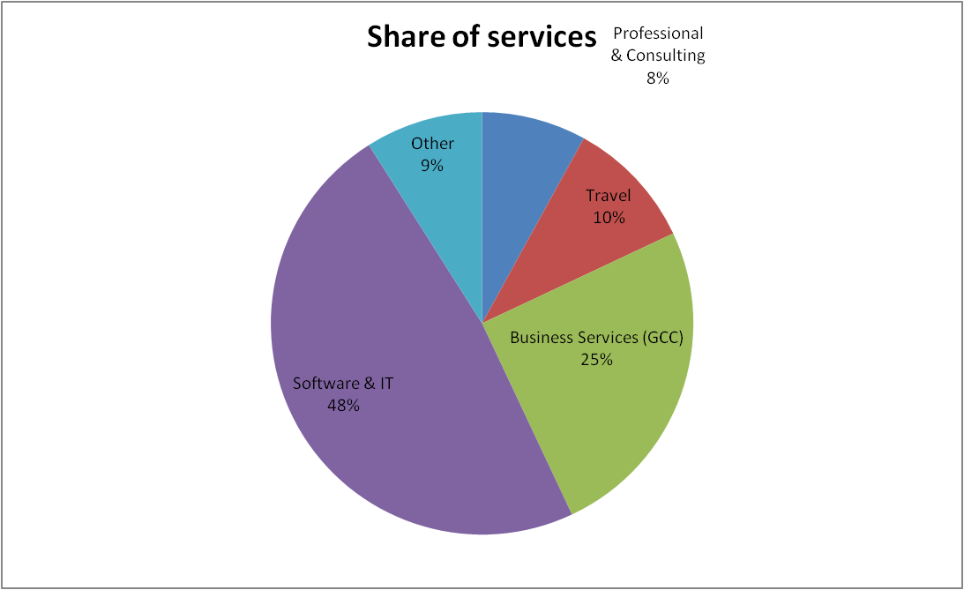

TRENDS IN INDIA’S IMPORTS
The total import (both Merchandise and Services) in Financial Year 2025-2026 was $ 979.40.

The total Import of services in Financial Year 2025-2026 was $ 204.42 billion. The proportion of all drivers was Software & IT licensing (10.4%), Business Services (22.1%), Travel (Foreign & Education) (26.5%), Transport/ Freight (34.2%), Financial & Others (6.8%). (Figure 6.3)

Composition of Services Imports (FY 2025-2026) (Figure 6.3)
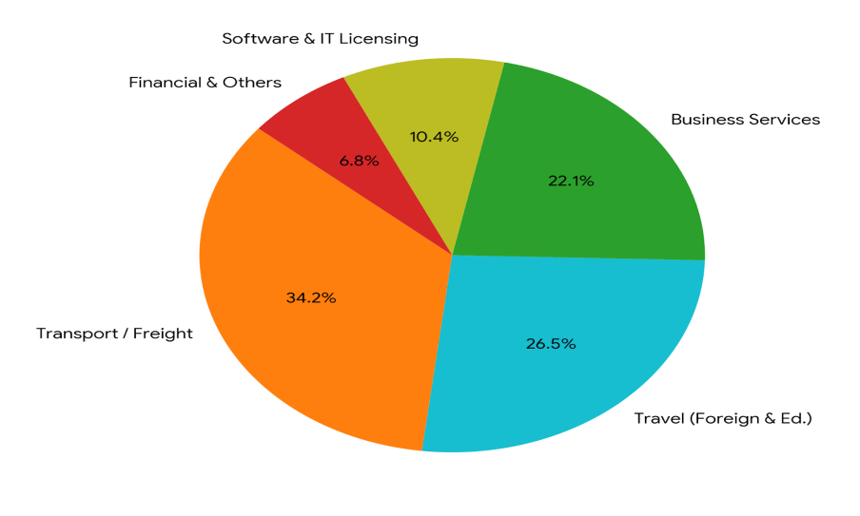

The total Import of merchandise (goods) was $ 774.98 billion (79.13% of total import). The key drivers of import were chemicals & plastics (8.2%), Machinery & Transport (10.5%), Gold & Precious Stones (11.2%), Electronic Goods (12.8%), Crude Oil & Petroleum (30.5%), Others (26.8%). (Figure 6.4)

Composition of Services Imports (FY 2025-2026) (Figure 6.4)
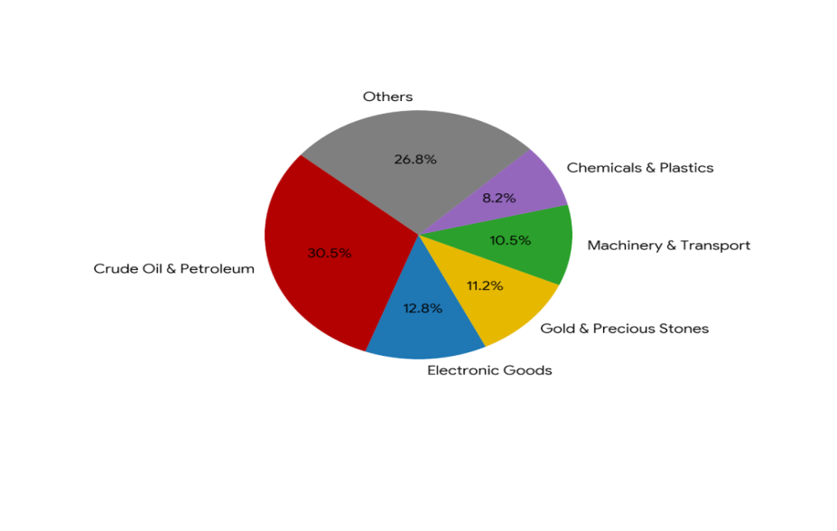

IMPACT ON THE EXPORT SECTOR
The economic principle of Price Theory explains that a weaker Indian Rupee (INR) against US Dollar (USD), majorly boost export sectors. When the Rupee (INR) depreciates in its value, it instantly makes domestic exporters and manufacturers more competitive on the global market.
Think of it this way: say an Indian exporter prices a product at ₹70,000. If the exchange rate sits at $1 = ₹89, a foreign buyer has to fork out about $786.52. But if the Rupee slips and the rate hits $1 = ₹96, that same product suddenly costs the foreigner just $729.17. To the international buyer, Indian goods just got a whole lot cheaper compared to the rest of the world, making them much more likely to buy from India. Essentially, that 7.86% dip in the Rupee translates to a 7.29% price cut in the global market. This price cushion can even help absorb the blow if a foreign government decides to hit Indian goods with import taxes or tariffs.
That said, the windfall from a weaker currency isn't handed out equally. It really boils down to how much an industry relies on imports, splitting exporters into two distinct camps:
First, you have the high-benefit sectors with low import intensity. These are businesses like IT outsourcing, software services, textiles, and leather. They sell their services and goods to global market but depend almost entirely on local Indian labor and homegrown raw materials. Because they don't buy anything from overseas, a weaker Rupee is pure upside for them.
On the flip side, you have low-benefit sectors that are highly import-intensive. When the Rupee weakens, importing things becomes incredibly expensive because it takes more INR just to buy a single Dollar. For industries like gems and jewellery, electronics, automobiles, chemicals, and engineering goods, this is a massive headache. They rely heavily on foreign inputs—whether that's raw gold, precious stones, microchips, advanced components, crude oil derivatives, or base metals. For these businesses, any pricing edge they get on the export side gets wiped out by the skyrocketing bills they have to pay to bring those raw materials into the country in the first place.

IMPACT ON THE IMPORT SECTOR
When the Indian Rupee (INR) depreciates against the US Dollar (USD), it negatively impacts India’s import sectors. This is because India has to pay more in domestic currency to the rest of the world for the goods and services it being purchases. The depreciation of the domestic currency makes imports more expensive and increases the import bill.
The negative impact caused by the weakening of the domestic currency can be categorized into three parts:
- Import Inflation:
Import inflation means price rises that come from overseas countries. It reduces the purchasing power of Indian households. One of India’s major imports is crude oil, and international oil payments are generally made in US Dollars. A sudden depreciation of the Rupee against the Dollar increases the payment burden on India.
For example, if 1 barrel of crude oil costs at $80 and the exchange rate is 1 USD = ₹80, then India has to pay ₹6,400 per barrel. Now assume the exchange rate fluctuates from 1 USD = ₹80 to 1 USD = ₹90. In this case, India will have to pay ₹7,200 per barrel.
This depreciation of the Rupee creates a domino effect. To recover the increased cost, Indian oil companies such as Indian Oil Corporation and Bharat Petroleum raise fuel prices at petrol pumps. As fuel prices rise, transportation and freight charges also increase.
As a result, the prices of milk, cement, vegetables, consumer goods, and many other daily-use products go up because most goods in India are transported by road. A weakening Indian currency can therefore create severe inflationary conditions in the country.
- Capital Goods and Technology (The Modernization Tax):
Capital goods refer to heavy machinery and advanced or updated technology. Better technology helps in producing goods and services more efficiently. Every country needs such technologies for growth and modernization. However, when the domestic currency depreciates, modernization becomes more expensive.
For example, suppose a large Indian company needs $1 million to purchase a modern robotic machine. If the exchange rate is 1 USD = ₹80, the cost of machine in India will be around ₹8 crore. Now imagine the exchange rate changes from 1 USD = ₹80 to 1 USD = ₹90. The cost of the same machine will rise to ₹9 crore.
Due to currency' depreciation, companies often delay modernization and expansion because prices of imported machinery and technology goes too high.
- Foreign Debt Servicing:
Many large Indian companies borrow funds from global banks and international investors. This practice is known as External Commercial Borrowings (ECB). These loans are taken in US Dollars and must also be repaid in Dollars.
For example, suppose an Indian company has borrows $100 million from a foreign bank, when the exchange rate is 1 USD = ₹80. The company converts the amount into ₹8,00,00,00,000 and utilises it for its operations.
However, during the repayment period, if the exchange rate moves from 1 USD = ₹80 to 1 USD = ₹90, the company will now need ₹ 9,00,00,00,000 to repay the same principal amount. In this way, the repayment burden increases by ₹ 1,00,00,00,000 simply because of the depreciation of the Rupee. This can create serious financial pressure on the company. A profit making company can turn into loss making one overnight.

MITIGATION STRATEGIES OF EXCHANGE RATE FLUCTUATION

- Netting:
Netting means bypassing the Foreign Exchange (FX) market. Netting can be explained with this simple example. Suppose A Ltd. is situated in India and B Ltd. is situated in USA. A Ltd. imported processing chips from B Ltd worth $ 200,000. B Ltd. imported from A ltd. computers worth $ 150,000. Without Netting A Ltd. will pay $ 200,000 to B Ltd and B Ltd. will pay 150,000 to A Ltd. It will increase the bank charges because here cash transfer was $ 350,000. By using efficient Netting, A Ltd. will pay only $ 50,000 to B Ltd.

- Leading and Lagging:
It means altering the timing of payment and receipt based on exchange rate trends. If Indian company expected that exchange rate will high in future, then this company will pay the bill immediately “lead”. On the contrary, if they expected that exchange rate will down in future, then they hold the payment for some time “lag”.
- Forward contracts:
Forward contracts are the agreements to fix the exchange rate in future. By using these contracts, company has no worry about exchange rate fluctuation. They will deal on the agreed rate only.

- Home currency Invoicing:
It means that all foreign bills will be paid using domestic currency only.
The Reserve Bank of India (RBI) has initiated the “Rupee Internationalization” process to reduce dependence on the United States Dollar by setting up Special Rupee Vostro Accounts (SRVAs) and expanding the Unified Payments Interface (UPI) network globally. Countries such as Nepal, Bhutan, United Arab Emirates (through the Local Currency Settlement System (LCSS)), Russia, Sri Lanka, Singapore, Mauritius, and Oman are already involved in Rupee-based transactions. Negotiations with more than 20 countries are currently underway for trade settlements in Rupees. The RBI has also allowed foreign institutional banks from regions and countries such as African nations, the Gulf Cooperation Council (GCC), Kazakhstan, Germany, and the United Kingdom to open Special Rupee Vostro Accounts.

CONCLUSION & RECOMMENDATIONS
- At the micro level, companies should use hedging strategies to mitigate the risks arising from exchange rate volatility. Financial instruments such as forward and futures contracts are considered more useful for this purpose.

- Companies should also prefer settlement and invoicing in domestic currency for foreign trade transactions. Examples include the INR–Dirham mechanism with the United Arab Emirates and the INR–Ruble trade structure with Russia.

- At the macro level, India has a large number of MSMEs with strong export potential, but many of them still lack the financial infrastructure required to afford expensive bank hedging instruments. The government should identify such sectors and provide adequate support in the form of subsidies and financial assistance.

- Industries such as petroleum and jewellery require a large amount of raw materials imported from abroad. During periods of major Rupee depreciation, the government should reduce import duties or other related taxes. This strategy may help mitigate inflationary pressures or economic crises in India.

- During Rupee appreciation, Indian industries such as IT sector, textiles, and agricultural products may face difficulties in selling their goods and services in global markets. In such situations, Indian products may seem more expensive to foreign buyers, who may prefer to purchase from other countries that supply same products relatively cheaper than India. In this situation government should provides assistance as much as possible. Government should try to present Indian brands in Global markets very professionally.

- The government can save foreign exchange reserves by identifying substitutes for imported products. India has inelastic imports of crude oil, electronic goods, semiconductors, capital goods, and coal. These imports require large amounts of US Dollars and leads to major outflows of foreign exchange reserves.

- India should shift toward EVs and solar power to help reduce the trade deficit gap. The government should invest more in research and development to identify effective domestic alternatives and substitutes. It should also enter into agreements with foreign companies that have expertise and dominance in these sectors to establish manufacturing units in India.

- The image and reputation of Indian products in global markets also need for improvement. Greater emphasis should be placed on research and development to improve product quality and durability.

- India should also understand and implement global standards in its products and services.

- To foster greater inflows of foreign currency into India, the domestic tourism and travel sector should be promoted more effectively.

- There are many products and services that are imported despite making only a limited contribution to economic development. The government should increase import duties on such products. For example, the government recently increased import duties on gold imports. The total effective import duty on gold bullion in India was raised from 6% to 15%. (w.e.f. May13, 2026 )

REFERENCES
- International Journal of Novel Trends and Innovation (IJNTI). (2026). Sectoral variation in foreign exchange exposure and vulnerability thresholds of small-scale enterprise architectures. International Journal of Novel Trends and Innovation, 4(2), 112–128.
- Ministry of Commerce and Industry. (2026). Annual aggregate trade performance metrics and commodity-wise import-export dynamics (Report FY 2025–26). New Delhi: Government of India.
- Reserve Bank of India. (2026). Handbook of statistics on the Indian economy and foreign exchange management operations database. Mumbai: Reserve Bank of India.
- Sohrabji, N. (2024). Asymmetric trade transmission channels and structural current account dynamics in emerging market economies: The case of India. Journal of International Trade & Economic Development, 33(3), 415–433.

