Comparative Analysis of Various Approaches in Managed Pressure Drilling for Enhanced Well Control and Efficiency
[Jagroop Singh Yadav]¹, [Dr. Harsh Vardhan]²
Department of Mathematics
Shri Venkateshwara University, Gajraula, Uttar Pradesh, India
email: [jagroop21@gmail.coml]
ABSTRACT
Managed Pressure Drilling (MPD) has matured over the past decade from a specialist technique applied to challenging wells into a mainstream drilling capability spanning ultra-HPHT exploration, deepwater development, unconventional tight-gas multi-well campaigns, and naturally fractured sour-gas reservoirs. Despite this maturation, the operational question of which MPD variant should be applied to a given well has been addressed in the literature case-by-case rather than through structured comparative synthesis. This paper presents the first cross-case comparative analysis of fourteen MPD case-study publications drawn from the SPE and IADC literature of 2015–2025. A six-dimensional analytical framework — covering well-control sensitivity, narrow-margin navigation, non-productive-time reduction, rate-of-penetration enhancement, cementing/tripping reliability, and economic performance — is developed inductively from the recurring performance themes in the literature and applied uniformly across the corpus. The principal findings are that MPD achieves qualitatively superior detection sensitivity (approximately one to two orders of magnitude better than conventional pit-volume kick detection); that variant choice is consequential and the corpus supports defensible variant-to-situation matching across three confidence tiers; that NPT reduction is well demonstrated while ROP enhancement evidence remains asymmetrically thinner; and that economic performance depends critically on the multi-well-campaign versus single-well distinction. An application-domain selection map matching ten canonical operational situations to corpus-preferred MPD variants is presented as the principal decision-support output.
Keywords: Managed pressure drilling; well control; narrow-margin navigation; comparative case analysis; CBHP; PMCD; ABP; CML; selection map; drilling engineering.
1. INTRODUCTION
The hydrocarbon industry continues its progression into operational settings of increasing geological complexity. Deepwater and ultra-deepwater development, ultra-high-pressure high-temperature (HPHT) exploration, naturally fractured sour-gas reservoirs, and tight-gas multi-well campaigns now constitute mainstream rather than exceptional operational categories. These settings share a common geological characteristic: a narrow operating window between formation pore pressure and fracture gradient. Conventional drilling, which manages annular pressure primarily through hydrostatic mud-weight selection, lacks the precision and rapid responsiveness that narrow-margin operations demand. Influxes are detected through pit-volume monitoring with sensitivity typically on the order of 10–25 barrels, and the response to detected influxes proceeds through the multi-step shut-in-and-circulate-out kick-kill procedure that requires hours to complete and substantial overbalance margin to execute safely.
Managed Pressure Drilling (MPD) was developed precisely to address these limitations. By introducing a controllable surface back-pressure as a fourth pressure-management lever — alongside hydrostatic, friction, and bottom-hole-pressure contributions — MPD enables the operator to walk the annular pressure along the narrow line between pore pressure and fracture gradient rather than positioning the annular pressure at a fixed overbalance tolerable at every depth. The closed-annulus architecture, with a Rotating Control Device (RCD) at the wellhead, a controllable choke manifold on the return line, and a Coriolis flow meter providing real-time return-flow measurement, also provides an order-of-magnitude improvement in influx detection sensitivity through real-time mass-balance comparison of pump-in and return-flow rates.
Despite over a decade of operational deployment across multiple continents, the published MPD literature has been characterised by individual case-study reporting rather than by structured comparative synthesis. Operators contemplating MPD adoption for specific well projects, service providers planning research and development investment, regulators framing policy across jurisdictions, and academic researchers seeking to identify research priorities all lack a consolidated evidential basis for understanding how MPD variants compare across operational settings. This paper addresses that gap through structured cross-case comparative analysis of the SPE and IADC published literature from 2015–2025.
2. METHODOLOGY
2.1 Corpus Definition
The corpus comprises fourteen technical papers drawn from the SPE and IADC published literature between 2015 and 2025, selected to span the operational, geographical, and technical variety of contemporary MPD practice. Selection criteria comprised: (i) inclusion in OnePetro or equivalent peer-review-screened technical-publication infrastructure; (ii) substantive operational reporting beyond procedural overview; (iii) representation of distinct operational variants or operational contexts; (iv) publication date within the 2015–2025 window; and (v) sufficient analytical content to support framework application. The resulting corpus spans North America (3 approaches), Asia-Pacific (5), the Middle East (2), Europe and South America (1 each), and laboratory/test-rig settings (2).
2.2 Six-Dimensional Analytical Framework
The analytical framework was developed inductively through iterative thematic analysis of the corpus. Six dimensions emerged as the recurring performance themes against which the published cases report operational outcomes: (D1) well-control sensitivity, encompassing detection thresholds, response latency, and mode robustness; (D2) narrow-margin navigation, quantifying the operating-window width within which the approach maintained successful drilling; (D3) non-productive-time (NPT) and invisible-lost-time reduction; (D4) rate-of-penetration (ROP) enhancement against conventional baselines; (D5) cementing and tripping reliability under MPD-managed conditions; and (D6) economic performance, including capital, mobilisation, and operational cost categories.
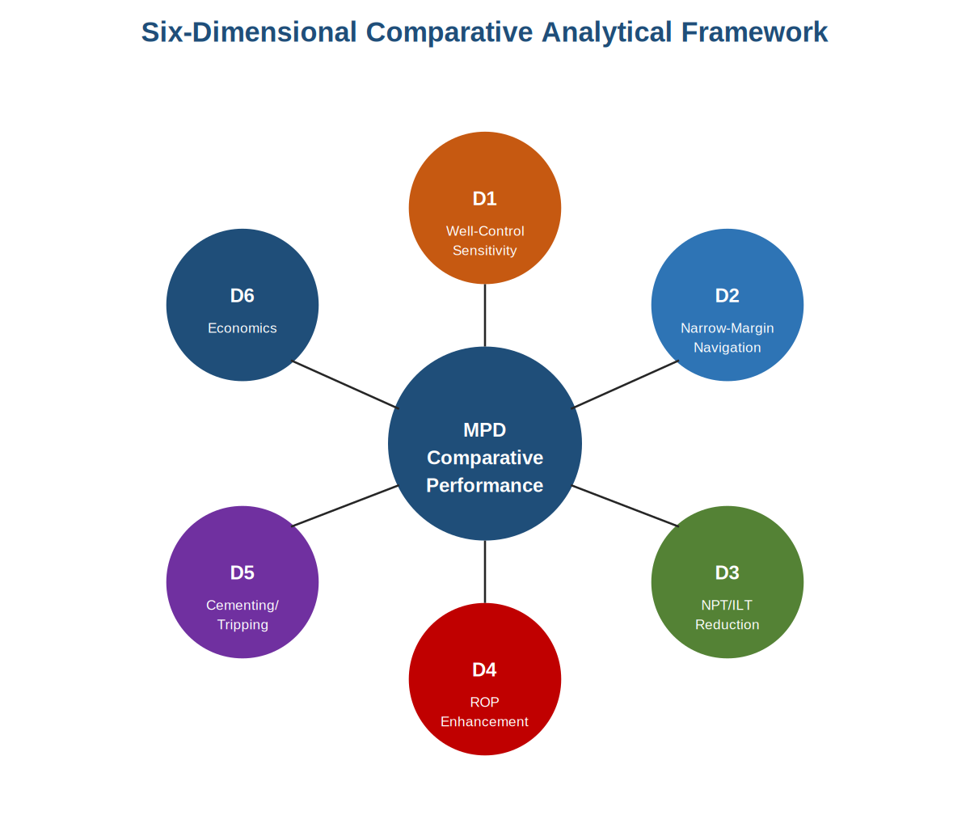
Figure 1. Six-dimensional comparative analytical framework. Dimensions D1 through D6 are inductively derived from the recurring performance themes in the corpus and applied uniformly to each approach.
2.3 Five-Section Data-Extraction Protocol
Each corpus paper was processed through a uniform five-section reading template: (§1) operational context — geography, operator, well architecture, reservoir conditions, operating window; (§2) MPD configuration — variant, equipment spread, operational procedures, distinctive features; (§3) operational outcomes — well-control events, NPT, ROP, cementing results, economics; (§4) critical analysis — enabling factors, limitations, generalisability, evidential strength; and (§5) framework assessment — primary/secondary/absent classification of the approach against each of the six dimensions D1 through D6. The uniform application of the protocol across the fourteen approaches produces commensurable per-approach outputs that support the cross-case synthesis.
3. RESULTS: CROSS-CASE FINDINGS
3.1 Well-Control Effectiveness
The most robust cross-case finding is the qualitatively superior detection sensitivity of MPD-equipped drilling. Eleven of the fourteen corpus approaches provide specific detection-sensitivity evidence, with quantitative outcomes including the Saudi 53-well CBHP campaign's 3 gpm Coriolis-derived detection threshold (Approach 13), the UK North Sea HPHT infill's containment of a 0.06 m³ influx in a single circulation (Approach 11), and the West Canadian Dynamic Well Control deployment's sub-barrel simulation outcomes (Approach 1). Figure 2 compares these detection-sensitivity outcomes against conventional pit-volume detection, showing approximately one to two orders of magnitude improvement.
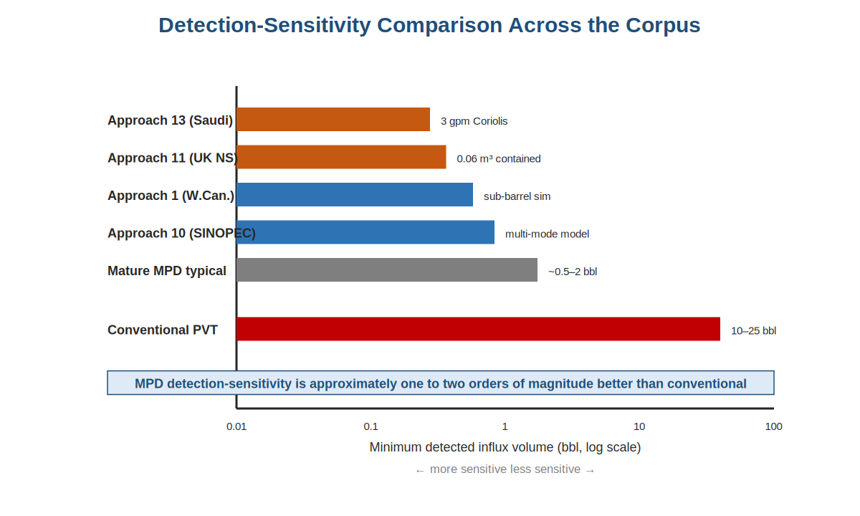
Figure 2. Detection-sensitivity comparison across the corpus. MPD configurations achieve approximately one to two orders of magnitude better minimum-detection performance than conventional pit-volume kick detection.
The detection-sensitivity advantage is consistent across operational contexts spanning onshore tight-gas, offshore HPHT, deepwater development, and naturally fractured sour-gas reservoirs. The mechanism is consistent: closed-loop annulus, Coriolis return-flow measurement, and real-time mass-balance comparison enable detection of influxes well below the pit-volume threshold that conventional drilling relies on. The aggregate well-control finding extends to response latency (qualified by the test-rig-rather-than-field status of fully autonomous response) and mode robustness (with MPD's well-control advantage now demonstrated across drilling, connection, tripping, and cementing operations).
3.2 Drilling Efficiency Outcomes
The corpus supports strong evidence base for NPT reduction and a thinner evidence base for direct ROP enhancement. NPT-reduction outcomes include the Gulf of Thailand campaign's approximately twenty-day saving against the conventional baseline (Approach 3), the SINOPEC multi-mode detection model's reported NPT reduction of sixty percent or greater (Approach 10), and the contingency-casing-string elimination demonstrated repeatedly across the corpus (Approaches 2, 14, and others). ROP-enhancement evidence is more limited: only the Saudi 53-well campaign (Approach 13) provides a clean field-scale ROP comparison against a conventional baseline, with operational-team-learning effects across the campaign confounding direct attribution of ROP improvement to the MPD configuration alone. The asymmetric evidence base is one of the principal evidence gaps identified.
3.3 Economic Performance
The cross-case evidence on economic performance is dominated by the operator-authored business-case analyses of the Shell deepwater Gulf of Mexico ABP study (Approach 8) and the Vito Phase-2 CML campaign (Approach 14). Both demonstrate that MPD's economic case depends critically on the multi-well-campaign versus single-well distinction: campaign-scale amortisation of mobilisation costs and operational-team learning across multiple wells produce a strongly positive economic case in multi-well applications, while single-well economic justification requires substantially larger per-well operational benefits to overcome the up-front cost. Service-provider-authored economic reporting in the remainder of the corpus tends to under-represent the incremental online costs that operator-authored analyses surface candidly, an asymmetry that has implications for the strength of conclusions drawn from the published literature.
3.4 Application-Domain Selection Map
The principal decision-support output of the analysis is the application-domain selection map, which matches each canonical operational situation in the corpus to the corpus-preferred MPD variant with explicit confidence-tier calibration. Table 1 presents an abbreviated form of the map. Tier-1 entries are supported by multiple corpus approaches with consistent outcomes and can be adopted directly; Tier-2 entries are supported by single approaches with substantive evidence and should be treated as working hypotheses requiring operational-context verification; Tier-3 entries are supported by foundational or prospective evidence and should be treated as directional indications rather than as direct deployment recommendations.
Table 1. Abbreviated application-domain selection map.
Operational situation | Preferred MPD variant | Confidence
HPHT exploration | CBHP | Tier 1
Ultra-HPHT (T > 200 °C) | CBHP + advanced ECD model | Tier 1
Tight-gas horizontal multi-well | CBHP + CCS | Tier 1
Ultra-HPHT liner cementing | MPC | Tier 2
Deepwater MODU operations | ABP | Tier 2
Deepwater curved PP/FG | CML | Tier 2
Sour-gas fractured reservoir | CBHP, gas-tight RCD | Tier 2
Mature reservoir / depleted zones | PMCD | Tier 3
Autonomous-response well control | CBHP + automated WC | Tier 3

4. DISCUSSION
Three principal observations from the cross-case synthesis warrant discussion. First, the variant-choice consequentiality finding has direct operational implications. The Vito Phase-2 deepwater campaign (Approach 14) provides the corpus's clearest single illustration through its CML-vs-ABP-vs-conventional comparison on a common operational substrate. Operators contemplating MPD adoption should approach the decision in two stages: a first-stage decision on whether to adopt MPD (resting primarily on the well-control and narrow-margin-navigation evidence), and a second-stage decision on which variant to adopt (resting on the operational-situation-to-variant matching that the selection map supports). Operators treating the decision as single-stage may achieve acceptable outcomes but will not capture the full value of the variant-matching evidence.
Second, the asymmetry between strong NPT-reduction evidence and thinner ROP-enhancement evidence reflects the structure of the published literature rather than any inherent technological limitation. Operators report NPT-reduction outcomes more readily than ROP-enhancement outcomes because NPT reduction has direct cost implications that drive publication. ROP enhancement requires careful counterfactual construction against a conventional baseline that is not always available in single-well deployments. The implication for the field is that systematic ROP-comparison studies, ideally through joint-industry-project mechanisms, would close one of the principal quantitative-evidence gaps identified by the analysis.
Third, the foundational contributions of the corpus — particularly the gas-tight RCD qualification to API 16RCD documented in Approach 5 and the autonomous-response test-rig demonstration of Approach 12 — represent technological investments whose full operational value has yet to be captured. Both establish technological capabilities whose field-operational deployment is more recent and less comprehensively documented than the capabilities themselves. Service providers investing in field-validation and commercial-deployment of these foundational technologies are positioning themselves to capture disproportionate operational-value share as the market for MPD continues to develop.
5. CONCLUSIONS
Structured cross-case comparative analysis of fourteen SPE and IADC MPD case-study publications from 2015–2025 supports the following principal conclusions:
(1) MPD achieves qualitatively superior detection sensitivity across all operational contexts in the corpus, approximately one to two orders of magnitude better than conventional pit-volume kick detection. This is the most robust cross-case finding the corpus supports.
(2) Variant choice is consequential and the corpus supports defensible variant-to-situation matching across three confidence tiers. The application-domain selection map (Table 1) is the principal decision-support output.
(3) NPT-reduction evidence is well demonstrated across the corpus while direct ROP-enhancement evidence is asymmetrically thinner. This asymmetry is a feature of the published literature's reporting patterns and is identified as a specific evidence gap.
(4) Economic performance depends critically on the multi-well-campaign versus single-well distinction, with operator-authored analyses carrying disproportionate evidential weight relative to service-provider-authored reporting.
(5) Specific evidence gaps — autonomous-response field validation, regional economic calibration, and dedicated PMCD case coverage — define a structured research agenda for the continuing development of the field. Field validation of autonomous well control through multi-well campaigns is identified as the highest-priority unresolved research question.
The methodological contribution of the analysis — the petroleum-engineering-specific adaptation of the structured-comparative-review research tradition — is offered as a template for adjacent comparative questions in drilling engineering and broader petroleum engineering, including wellbore-strengthening technique comparison, drilling-automation-system comparison, and completion-technology comparison.
ACKNOWLEDGMENTS
The authors acknowledge the authors of the fourteen SPE and IADC technical papers that constitute the analytical corpus, whose substantive operational reporting makes structured comparative analysis possible. The authors also acknowledge the SPE and IADC for maintaining the technical-publication infrastructure on which the analysis depends, and Shri Venkateshwara University, Gajraula, for the institutional support that has enabled this research.
REFERENCES
[1] Kinik, K., et al. (2015). "Constant Bottom-Hole Pressure Managed Pressure Drilling and Dynamic Well Control: Western Canada Field Application." SPE 168948-PA.
[2] Tan, K. M., et al. (2015). "Successful Application of Managed Pressure Cementing in an Ultra-HPHT Well Offshore Malaysia." SPE/IADC 173041-MS.
[3] Loux, B., et al. (2015). "Constant Bottom-Hole Pressure Managed Pressure Drilling Application in Ultra-High-Temperature Wells, Gulf of Thailand." SPE 176046-MS.
[4] Bao Ta Quoc (2016). "HPHT Best Practices and Lessons Learned in Offshore Vietnam Using Managed Pressure Drilling." IADC/SPE 180637-MS.
[5] Mahmood, F., et al. (2017). "Industry-First Qualification of a Rotating Control Device for Gas-Tight Service per API 16RCD." SPE/IADC 185290-MS.
[6] Safipour, R., and Mavaddat, Y. (2017). "Managed Pressure Drilling Planning Study for a High-Sulphur Fractured Reservoir in Southwest Iran." SPE 188694-MS.
[7] Yin, Q., et al. (2020). "A Field Case Study of Managed Pressure Drilling in Ultra-HPHT Offshore Well, South China Sea." SPE 191060-PA.
[8] Moghazy, S., et al. (2019). "Building the Business Case for Air- or Light-Fluid-Bypass Managed Pressure Drilling in Deepwater Gulf of Mexico Operations." SPE/IADC 194538-MS.
[9] Arellano, J. (2020). "Application of Managed Pressure Drilling and Continuous Circulation System in the Perla Gas Field, Offshore Venezuela." SPE 199065-MS.
[10] Fan, H., et al. (2021). "A Comprehensive Gas-Influx Detection Model for Multi-Mode Managed Pressure Drilling Operations in the Fuling Shale Gas Field." IADC/SPE 201001-MS.
[11] Kamal, R., et al. (2021). "Managed Pressure Drilling on an HPHT Infill Well in the UK Central Graben North Sea." SPE/IADC 202107-MS.
[12] Atchison, B., and Wuest, C. (2021). "Integration of Managed Pressure Drilling with Automated Well Control: Test-Rig Demonstration." IADC/SPE 206385-MS.
[13] Uddin, M., et al. (2024). "Constant Bottom-Hole Pressure Managed Pressure Drilling Across Fifty-Three Horizontal Wells in a Saudi Unconventional Tight-Gas Field." SPE/IADC 219602-MS.
[14] Limaye, A., et al. (2025). "Phase-2 Controlled Mud-Level Managed Pressure Drilling on a Five-Well Deepwater Campaign at the Vito Field, Gulf of Mexico." IADC/SPE 228374-MS.

