Web Appointment and Record System for Tub N Cup Pet Grooming Café Using First Come First Serve Scheduling

Mhelhenrich  Dela Peña | Josh Venedict  Virtucio Mendoza | Adrian Delos  Reyes Placido | Renz Sydney  Yabut
mhelhenrich.delapena@gmail.com | joshvenedictmendoza09@gmail.com | adrianplacido08@gmail.com | renzyabut9@gmail.com
 | Adrian Paano | Kevin Roi Castro
 | adrian. paano@arellano.edu.ph | kevinroi.castro @arellano.edu.ph

(SY 2025-2026) Arellano University, Pasig Campus

ABSTRACT
A web-based appointment and record management system titled “Web Appointment and Record System for Tub N Cup Pet Grooming Café Using First-Come, First-Served (FCFS) Scheduling” was designed and developed for Tub N Cup Pet Grooming Café, a local business that offers pet grooming services, to address inefficiencies caused by manual appointment handling, long waiting times, and disorganized customer records. The system enables pet owners to schedule grooming appointments online, maintain digital pet records, and reduce reliance on walk-in scheduling, thereby improving overall service efficiency. The platform was developed using HTML, CSS, and JavaScript for the front-end interface, PHP and Laravel for back-end processing, and MySQL for database management within a XAMPP environment. The First-Come, First-Served (FCFS) scheduling method was implemented to ensure fair and systematic appointment prioritization.

The study employed a quantitative descriptive research design and followed the Agile-based System Development Life Cycle (SDLC) in developing and evaluating the system. System evaluation was conducted using the ISO/IEC 25010 software quality model, focusing on functionality, reliability, efficiency, usability, security, and portability. A total of 100 respondents, consisting of 50 user respondents and 50 technical respondents, participated in the evaluation using a structured questionnaire and a 4-point Likert scale. Results showed high levels of acceptance and satisfaction, with overall weighted mean scores of 3.5 from user respondents and 3.3 from technical respondents, both interpreted as Strongly Agree. These findings indicate that the developed system is effective, reliable, and user-friendly, and can serve as a practical digital solution for improving appointment management and customer experience in a pet grooming business environment.

Keywords: Web-based appointment system; Pet grooming services; First-Come, First-Served (FCFS); Record management system; ISO/IEC 25010; Software quality evaluation

INTRODUCTION
In recent years, service-oriented businesses have increasingly adopted web-based systems to improve operational efficiency and service management. Digital appointment scheduling systems allow businesses to organize service requests systematically, reduce waiting times, and minimize scheduling conflicts. In many service-based appointment systems, requests are processed based on the order in which they are received to ensure fairness and consistency in service delivery (Kilinc, 2020). Fair treatment among customers with similar service requirements is an important consideration in appointment scheduling, and this is commonly achieved through the use of the First-Come, First-Served (FCFS) principle (Li et al., 2021). A comprehensive review of appointment scheduling approaches identified FCFS as a frequently used baseline rule in service and healthcare systems due to its simplicity and transparency (Ala et al., 2022). Queueing and simulation studies have shown that FCFS scheduling provides predictable service flow and manageable waiting times in real-world service environments (Yifter et al., 2023). Service queue implementation in community health centers commonly follows a FIFO or First-Come, First-Served discipline to ensure orderly and fair service delivery among clients (MDPI Proceedings, 2023). Many appointment-based systems continue to rely on FCFS scheduling because it is easy to implement and is perceived by customers as fair and transparent (Zhu, 2024).

At Tub N Cup Pet Grooming Café, appointments and customer records are primarily managed through walk-in transactions and manual record-keeping. This current setup often results in scheduling conflicts, delays, and difficulty in tracking customer and pet information. The absence of an automated appointment system makes it challenging to manage multiple service requests systematically, which affects staff productivity and overall service efficiency. Without a structured scheduling rule, appointment prioritization may become inconsistent, leading to customer dissatisfaction and operational inefficiencies.

In response to these challenges, this study developed a web-based appointment and customer management system for Tub N Cup Pet Grooming Café. The system integrates the First-Come, First-Served (FCFS) scheduling algorithm to ensure fair and systematic appointment prioritization while improving the efficiency of appointment handling and record management. By automating the scheduling process using FCFS, the system aims to enhance service flow, reduce waiting time, and improve overall customer satisfaction and operational performance.
The specific objectives of the study are as follows:

- To design a web platform that securely stores customer profiles and pet information for easy access and efficient management.
- To create a scheduling system that enables the creation, updating, and deletion of grooming appointments using the First-Come, First-Served (FCFS) prioritization method.
- To implement a record-keeping system for monitoring customer transactions and maintaining pet grooming history.
- To ensure that the system complies with ISO/IEC 25010 standards, emphasizing functionality, reliability, efficiency, usability, security, and portability.

SCOPE
This study focuses on the development of a web-based appointment and record management system for Tub N Cup Pet Grooming Café. The scope of the system is limited to the following functionalities:

- The system allows customers to create, update, and manage grooming appointments through an online platform using the First-Come, First-Served (FCFS) scheduling method.
- The system stores and manages customer profiles and pet information, including grooming history and transaction records.
- The system provides administrative access for managing appointments, monitoring customer transactions, and generating basic reports.
- System evaluation is conducted based on selected ISO/IEC 25010 software quality characteristics, namely functionality, reliability, efficiency, usability, security, and portability.

LIMITATION
This study is subject to several limitations. The developed system is designed exclusively for Tub N Cup Pet Grooming Café and may not be directly applicable to other pet grooming businesses with different operational requirements. The system is web-based and requires a stable internet connection for optimal performance. Additionally, the study focuses primarily on appointment scheduling and record management; advanced data analytics features such as predictive modeling, trend forecasting, and automated demand analysis are not included in the current system design. Features such as online payment processing, mobile application access, and third-party system integration are also beyond the scope of this study. The evaluation results are based on user and technical respondent feedback within the defined scope and may vary if applied in a broader context.

THEORETICAL FRAMEWORK
The First-Come, First-Served (FCFS) principle is a commonly applied approach for managing service requests by prioritizing tasks based on the order in which they are received. This principle emphasizes fairness and systematic processing, ensuring that all requests are handled sequentially without bias. In appointment-based services, FCFS provides a transparent and organized method for managing schedules and reducing waiting time.

In the developed system for Tub N Cup Pet Grooming Café, the FCFS principle is applied to manage grooming appointments by processing customer requests in sequence. This approach enables the system to organize appointments efficiently, minimize scheduling conflicts, and ensure equitable service delivery, making it suitable for a pet grooming service environment.

CONCEPTUAL FRAMEWORK
The conceptual framework of the study is based on the Input–Process–Output–Feedback (IPOF) model, illustrating how the system components interact to achieve the desired outcomes.

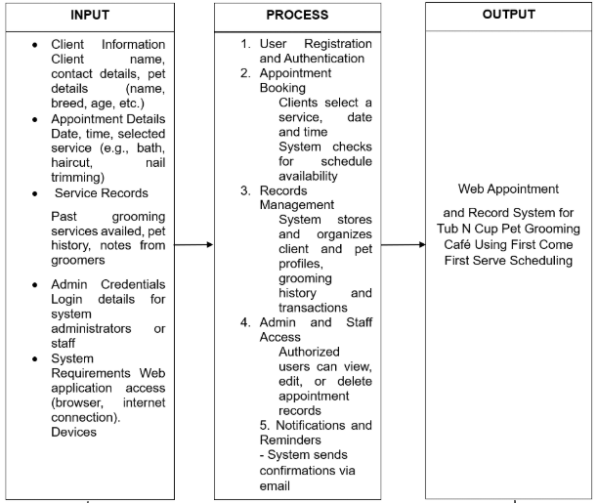
Figure 1: Input-Process-Output Model
Input
The inputs of the system include customer information, pet details, appointment requests, grooming service data, and administrative records provided by both customers and staff.

Process
The processes involve appointment scheduling using the First-Come, First-Served (FCFS) method and record management. These processes are executed through the web-based system to ensure systematic handling of appointments and accurate data storage.

Output
The outputs include organized appointment schedules, updated customer and pet records, and improved operational efficiency of the pet grooming café.

Feedback
Feedback is obtained from system users and administrators through system evaluation and usage results. This feedback supports continuous system improvement and ensures that the system meets user needs and service requirements.

SIGNIFICANCE OF THE STUDY
This study is significant as it demonstrates how web-based technologies can be applied to improve service efficiency in small pet grooming businesses. The results of the study provide practical and academic value to the following stakeholders:

- To Tub N Cup Pet Grooming Café (Business Owners and Management): The system offers an automated solution for managing appointments and customer records, helping reduce scheduling conflicts, improve service efficiency, and support data-driven decision-making.
- To Pet Owners (Customers): Customers benefit from a more convenient appointment scheduling process, reduced waiting times, and easier access to their pets’ grooming records.
- To Employees and Staff: The system simplifies appointment handling and record management, reducing manual workload and improving overall workflow efficiency.
- To IT Professionals: The study serves as a reference for system developers and IT practitioners in designing, implementing, and evaluating web-based appointment and record management systems using recognized software quality standards.
- To Future Researchers: This study serves as a reference for future research related to web-based appointment systems and information system development for service-oriented businesses.

REVIEW OF RELATED LITERATURE
The adoption of web-based appointment and record management systems has been widely recognized for its role in improving operational efficiency and customer satisfaction in service-oriented businesses. Studies highlight that automated scheduling systems reduce waiting times, minimize scheduling conflicts, and improve workflow efficiency, while digital record management enhances data accuracy and accessibility. These findings emphasize the value of integrating structured scheduling approaches and user-centered system design in developing effective digital solutions.

Research in the pet care industry has shown that organized service delivery and accessible grooming services contribute to improved customer experiences and operational efficiency. McDonald et al. (2022) examined grooming-related challenges and emphasized the importance of service accessibility, organization, and systematic processes in meeting client needs within pet care services. Their findings support the use of digital platforms to enhance service coordination and customer satisfaction.

Additionally, user acceptance remains a key consideration in system implementation. Davis (1989) explained that perceived usefulness and perceived ease of use significantly influence users’ willingness to adopt new technologies. This supports the application of usability-focused development standards, such as ISO/IEC 25010, to ensure that web-based systems are effective, user-friendly, and acceptable to both end-users and technical evaluators.

SYNTHESIS
The reviewed literature underscores the importance of web-based appointment and record management systems in improving service efficiency and customer satisfaction in service-oriented industries. Studies indicate that manual processes often lead to long waiting times, scheduling conflicts, and difficulties in maintaining accurate records, while automated systems streamline service coordination and improve data accessibility (McDonald et al., 2022).

Furthermore, research highlights that system usability and user acceptance are critical to the successful adoption of digital platforms. Users are more likely to utilize systems that are perceived as useful and easy to use, as explained by the Technology Acceptance Model (Davis, 1989). Integrating structured scheduling methods such as First-Come, First-Served (FCFS) ensures fairness in service delivery, while system monitoring supports informed operational decision-making. Synthesizing these concepts, the present study demonstrates how a web-based appointment and record management system, evaluated using ISO/IEC 25010 standards, can enhance service efficiency and customer satisfaction in a pet grooming business environment.

METHODOLOGY OF THE STUDY
Research Design
The study employed a quantitative descriptive research design to develop and evaluate a web-based appointment and record management system for Tub N Cup Pet Grooming Café. This research design was appropriate as it focused on describing the system’s performance, usability, and effectiveness based on user and technical evaluations. Quantitative data were collected through structured questionnaires to assess the quality of the developed system using established software evaluation standards.

Data Gathering Procedure
Data were gathered through a survey using a structured survey questionnaire designed to evaluate the developed system based on the selected ISO/IEC 25010 software quality characteristics. The survey questionnaire was administered online using Google Forms to ensure ease of access and efficient data collection. The instrument utilized a 4-point Likert scale, with weights ranging from 4 (meaning "strongly agree") to 1 (meaning "strongly disagree"), to measure respondents’ perceptions of the system’s quality. Prior to answering the survey, respondents were oriented on the purpose of the study and the system functionalities to ensure informed and accurate responses.

System Development Methodology
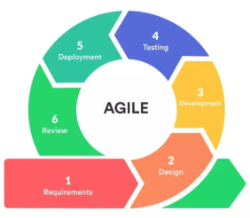
Figure 2: SDLC Agile Model
As shown in Figure 2, the system was developed using an Agile-based System Development Life Cycle (SDLC) approach. This methodology emphasizes iterative development, continuous feedback, and flexibility in system design. The Agile SDLC enabled the researchers to analyze requirements, design system features, implement functionalities, test system performance, and refine the system based on feedback. This approach ensured that the developed system met user requirements and aligned with the operational needs of Tub N Cup Pet Grooming Café.

System Architecture
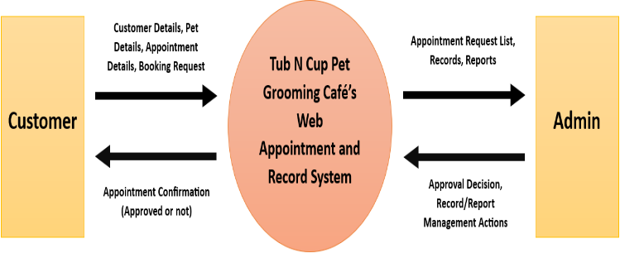
Figure 3: Context Diagram
As shown in Figure 3, the context diagram of the Web Appointment and Record System for Tub N Cup Pet Grooming Café illustrates the overall interaction between the system and its external entities, namely the Customer and the Admin. The system is represented as a single central process that manages all data exchanges between these entities. Customers provide customer details, pet details, and appointment requests when booking grooming services, and in return, they receive confirmation and status updates regarding their appointments. The Admin interacts with the system by approving appointment requests and managing customer records and reports, while the system provides access to appointment lists and stored records. The diagram defines the system boundary and demonstrates the flow of data between users and the web-based platform without detailing the internal processes of the system.

RESPONDENTS OF THE STUDY
The respondents of this study are divided into two groups: (a) the user group, which consists of the owner, staff, and customers of Tub N Cup Pet Grooming Café who evaluated the system based on ISO/IEC 25010 characteristics related to functionality, and usability; and (b) the technical group, composed of IT professionals and IT students who assessed the system in terms of reliability, efficiency, security, and portability. Each group consisted of fifty (50) respondents, for a total of 100 participants selected based on their relevance to the evaluation of the system using the ISO/IEC 25010 software quality model. Data from both groups were collected through a survey questionnaire distributed via Google Forms, ensuring a comprehensive evaluation from both user and technical perspectives.

DEVELOPMENT AND EVALUATION PROCEDURE
The web-based system was developed using a combination of front-end and back-end technologies to ensure full functionality and efficient performance. Visual Studio Code served as the source code editor, while Laravel (PHP) was used as the web application framework with Livewire enabling dynamic user interface interactions without extensive JavaScript usage. MySQL was utilized as the relational database management system, and GitHub supported source code version control and collaborative development, while the First-Come, First-Served (FCFS) algorithm was implemented to manage appointment scheduling based on the order of requests. System development was conducted using computer hardware with a minimum requirement of a dual-core 2.0 GHz processor, 4 GB RAM, 500 GB HDD or SSD storage, a display resolution of at least 1280 × 720, and access to the internet through commonly used web browsers such as Google Chrome and Microsoft Edge.

After the completion of system development and initial testing, the system was evaluated to determine its quality and acceptability using the ISO/IEC 25010 software quality model. A structured survey questionnaire was used as the evaluation instrument and was distributed to user and technical respondents through Google Forms. Respondents evaluated the system based on their interaction with its features, and responses were measured using a 4-point Likert scale. The data collected from the evaluation served as the basis for subsequent statistical analysis to assess the overall effectiveness and quality of the system.

DATA ANALYSIS PLAN
The data gathered through the survey questionnaire were analyzed to evaluate the developed system using the ISO/IEC 25010 software quality standards. The evaluation focused on the following ISO/IEC 25010 quality characteristics:

- Functionality – to determine whether the system provides features that meet user requirements.
- Reliability – to assess the consistency and stability of the system during operation.
- Efficiency – to evaluate system response time and efficient use of resources.
- Usability – to measure ease of use, learnability, and user satisfaction.
- Security – to assess the system’s ability to protect data and prevent unauthorized access.
- Portability – to determine the system’s adaptability across different environments.

The study employed the following statistical tools to analyze the collected data:

• Frequency and Percentage – to summarize the distribution of respondents and responses.
• Weighted Mean – to determine the level of agreement of respondents for each ISO/IEC 25010 quality characteristic.

A 4-point Likert scale was also used to measure user satisfaction, ranging from “1” (Strongly Disagree) to “4” (Strongly Agree), to quantify respondents’ perceptions, ranging from Strongly Disagree to Strongly Agree. The absence of a neutral option encouraged respondents to provide a definite evaluation of the system. The results of the analysis served as the basis for determining the overall effectiveness and quality of the system in accordance with ISO/IEC 25010 standards.

THE SYSTEM
This section presents the developed web-based appointment and record management system for Tub N Cup Pet Grooming Café. The following figures illustrate the core system interfaces that demonstrate the implementation of the study’s objectives, particularly in scheduling, record-keeping, and system monitoring. Only functional system components directly related to the research objectives and system evaluation are presented.

Key Features/User Interfaces include:
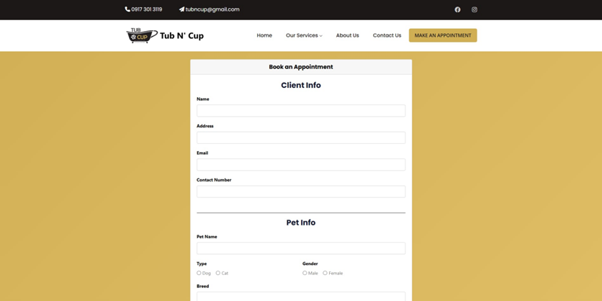
Figure 4: Appointment Booking Page
Figure 4 shows the booking page where customers submit grooming appointment requests by selecting preferred dates and services. This interface supports the First-Come, First-Served (FCFS) scheduling technique by processing requests in the order they are received.

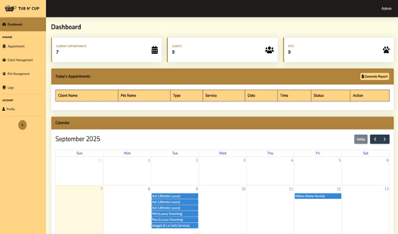
Figure 5: Dashboard Page
Figure 5 presents the dashboard page, which provides administrators with an overview of appointments and system activities. This interface enables efficient monitoring of daily operations.

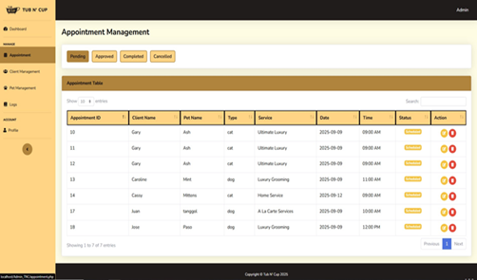
Figure 6: Appointment Management Page
Figure 6 illustrates the appointment management page where administrators can view, update, approve, or cancel appointments. This interface helps ensure organized scheduling and minimizes appointment conflicts.

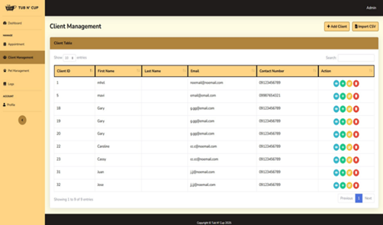
Figure 7: Client Management Page
Figure 7 displays the client management page used to store and manage customer profiles. This interface supports organized record-keeping and easy access to client information.

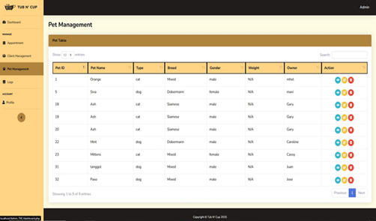
Figure 8: Pet Management Page
Figure 8 shows the pet management page where pet details and grooming histories are recorded. This interface enables accurate tracking of pet-related information for service continuity.

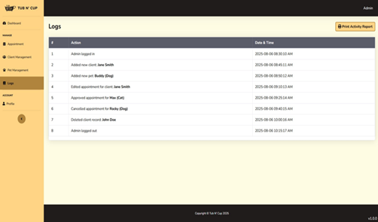
Figure 9: Logs Page
Figure 9 presents the logs page that records system activities and transaction histories. This interface supports system monitoring and operational accountability.

ASSESSMENT: SUMMARY OF RESPONDENTS ON THE SYSTEM
This section presents the evaluation results of one hundred (100) respondents, composed of fifty (50) user evaluators and fifty (50) technical evaluators, based on the ISO/IEC 25010 software quality model.

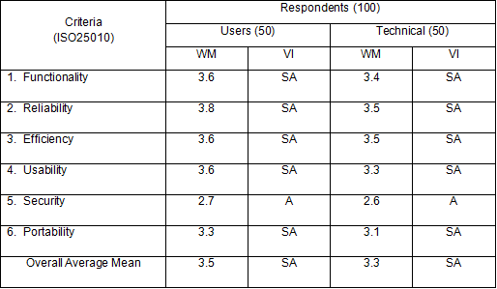
Table 1: Summary and Comparison of Evaluations of Respondents
The summary presented in Table 1 indicates that the developed system was well received by both respondent groups, with user respondents providing a slightly higher overall rating (3.5) than technical respondents (3.3). Most of the evaluated criteria were interpreted as “Strongly Agree,” reflecting a high level of satisfaction with the system’s overall performance. The security criterion, while receiving comparatively lower ratings, remained within an acceptable level based on the respondents’ assessments.

ETHICAL CONSIDERATIONS
Ethical considerations were strictly observed throughout the conduct of the study to ensure the protection and rights of all participants. Participation in the system evaluation was voluntary, and respondents were informed of the purpose of the study before completing the survey questionnaire. Confidentiality and anonymity of the respondents were maintained, and no personally identifiable information was collected or disclosed during data gathering and analysis. All data collected through Google Forms were used solely for academic purposes and were handled responsibly to ensure accuracy, integrity, and compliance with ethical research standards.

SUMMARY
This study focused on the design, development, and evaluation of a web-based scheduling and customer management system for Tub N Cup Pet Grooming Café to address inefficiencies in manual appointment handling and record-keeping. The system integrated appointment scheduling using the First-Come, First-Served (FCFS) technique along with customer and pet record management to improve service organization and reduce waiting time. System development followed an Agile-based SDLC approach and utilized standard web technologies to ensure accessibility and reliability. The system was evaluated by user and technical respondents using the ISO/IEC 25010 software quality model, and the results indicated that the system effectively met functional, reliability, efficiency, usability, security, and portability, making it suitable for implementation in a pet grooming business environment.

CONCLUSION
The study successfully designed, developed, and evaluated a web-based scheduling and customer management system for Tub N Cup Pet Grooming Café to address inefficiencies associated with manual appointment scheduling and record-keeping. The integration of the First-Come, First-Served (FCFS) scheduling technique, along with customer and pet record management, improved service organization and reduced waiting time for customers. Evaluation results based on the ISO/IEC 25010 software quality model indicate that the system met the required standards for functionality, reliability, efficiency, usability, security, and portability, demonstrating high acceptability among both user and technical respondents. Overall, the findings confirm that the developed system is effective and suitable for implementation in Tub N Cup Pet Grooming Café.

RECOMMENDATION
The developed system was primarily designed to provide an online scheduling platform that can be easily accessed and managed by users of Tub N Cup Pet Grooming Café; however, further improvements are recommended to enhance its overall functionality and usability. One recommended enhancement is the integration of an online store within the existing system, allowing the pet grooming salon to offer its products directly through the platform, thereby enabling customers to schedule grooming appointments, browse products, place orders, and avail delivery services for added convenience. For the administrative side, it is recommended to implement a transaction management module that records sales, generates reports, and provides data visualization tools such as graphs and charts, which would support monitoring of daily and monthly sales performance and facilitate informed decision-making.

In addition, future development may incorporate basic data analytics features to analyze appointment patterns and service demand, which could assist management in improving scheduling efficiency and operational planning. Strengthening system security measures, including improved user authentication and data protection mechanisms, is also recommended to ensure the confidentiality and integrity of customer and transaction data within the system.

REFERENCES
- Ala, A., Chen, J., & Li, X. (2022). Appointment scheduling problems in healthcare service systems: A comprehensive review. Journal of Healthcare Engineering, 2022, 1–18. https://doi.org/10.1155/2022/5819813

- Davis, F. D. (1989). Perceived usefulness, perceived ease of use, and user acceptance of information technology. MIS Quarterly, 13(3), 319–340. https://doi.org/10.2307/249008

- Kilinc, D. (2020). Priority-based access for outpatient clinical appointment scheduling. SSRN Electronic Journal. https://doi.org/10.2139/ssrn.3602222

- Li, J., Liu, M., & Zhang, Y. (2021). Fairness-oriented appointment scheduling with first-come-first-served rules. Computers & Industrial Engineering, 158, 107401. https://doi.org/10.1016/j.cie.2021.107401

- McDonald, S. E., Sweeney, J., Niestat, L., & Doherty, C. (2022). Grooming-related concerns among companion animals: Preliminary data on an overlooked topic and considerations for animals’ access to health-related services. Frontiers in Veterinary Science, 9, 827348. https://doi.org/10.3389/fvets.2022.827348

- MDPI Proceedings. (2023). Analysis of first-come-first-served queue discipline in a community health service center. Proceedings, 39(1), 72. https://doi.org/10.3390/proceedings2023039072

- Yifter, T., Bekele, D., & Alemu, S. (2023). Modeling and simulation of queueing systems to improve service performance using first-come-first-served discipline. Cogent Engineering, 10(1), 2274522. https://doi.org/10.1080/23311916.2023.2274522

- Zhu, Y. (2024). Nonsequential appointment scheduling under first-come-first-served policies. Journal of Service Science and Management, 17(1), 45–60. https://doi.org/10.1177/10591478231224926

